Extended data
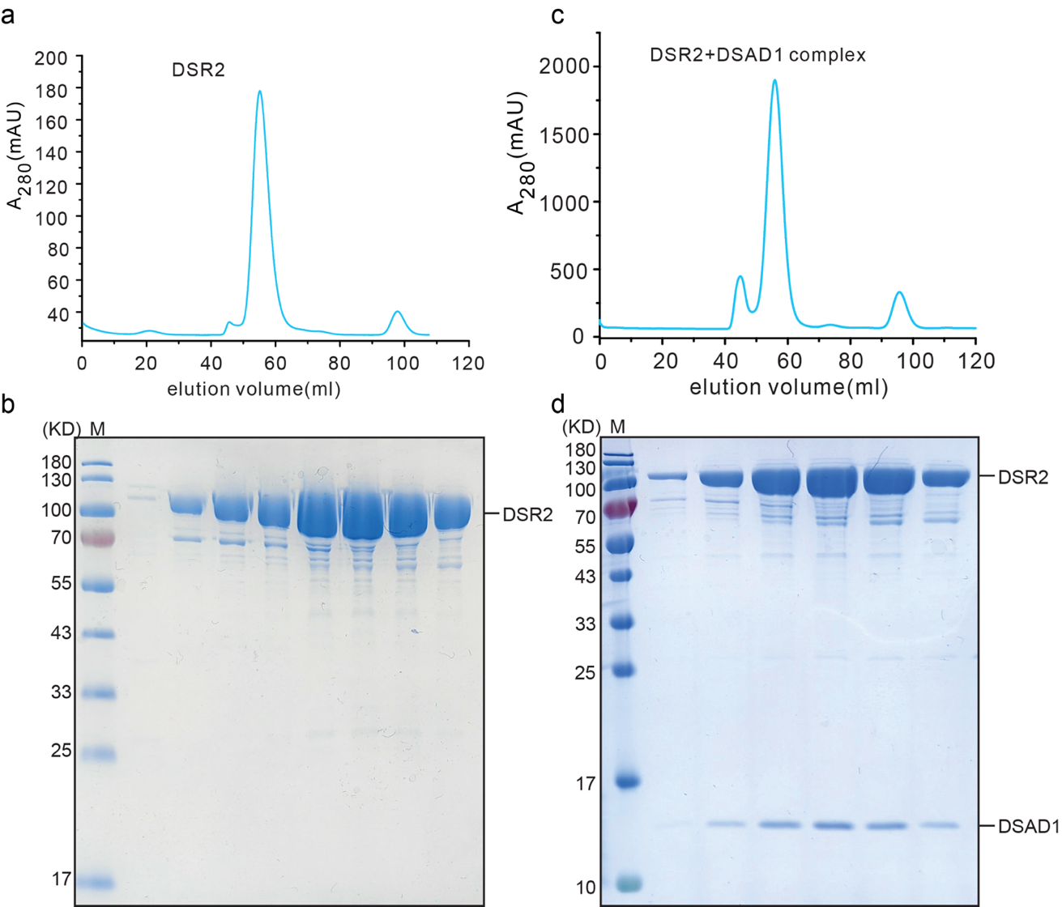
Extended Data Fig. 1 | Purification of DSR2 and DSR2-DSAD1 complex. a, The gel filtration profile of DSR2 proteins on S200 column. b, The SDS-PAGE combined Coomassie Brilliant Blue staining showing the protein quality of DSR2. c, The gel filtration profile of DSR2-DSAD1 complex proteins on S200 column. d, The SDS-PAGE combined Coomassie Brilliant Blue staining showing the protein quality of DSR2-DSAD1 complex.

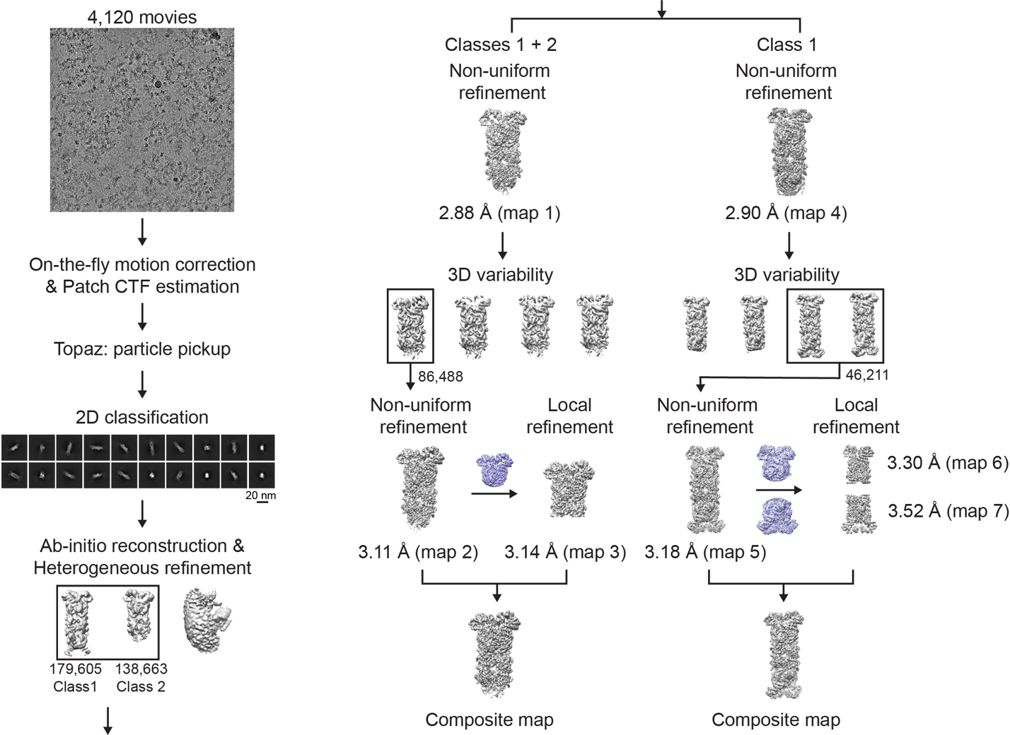
Extended Data Fig. 2 | Structure determination of DSR2 tetramer. Workflow of the cryo-EM data processing to obtain the 3D reconstructions of DSR2 tetramer. Seven cryo-EM maps (labeled maps 1-7) were obtained for the whole structure.

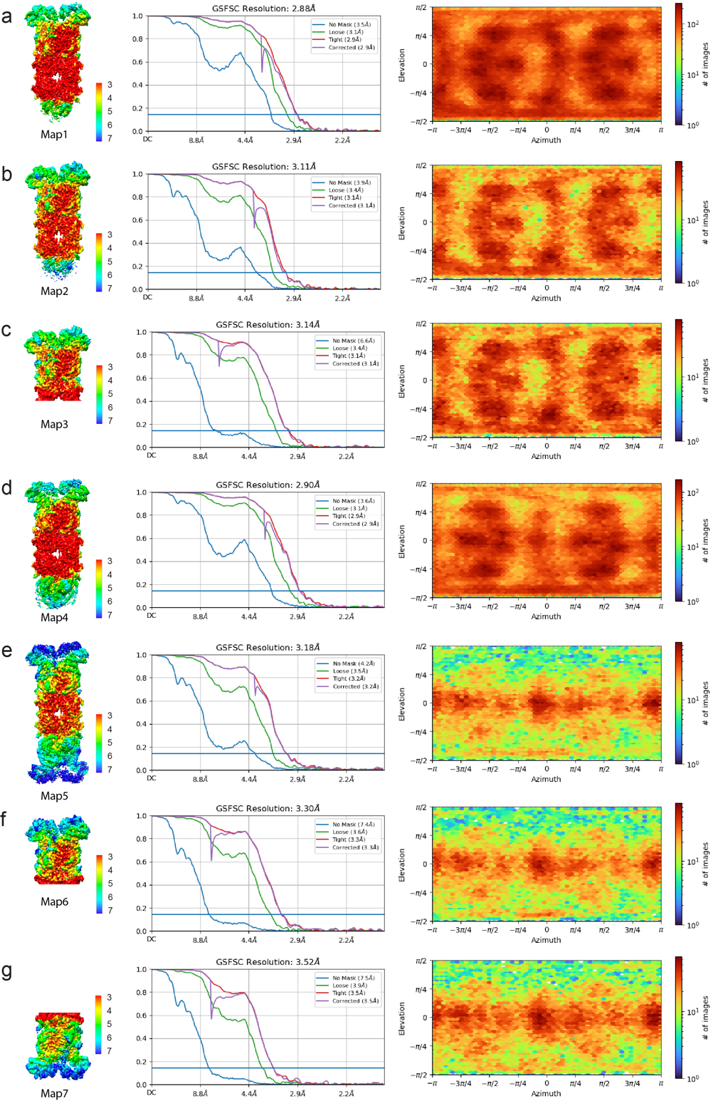
Extended Data Fig. 3 | The resolution analysis of DSR2 tetramer. a-g, Local resolution maps and Fourier shell correlation (FSC) curves of DSR2 tetramer. The local resolution maps (a-g) correspond to the different cryo-EM maps 1-7 depicted in Extended Data Fig. 2.
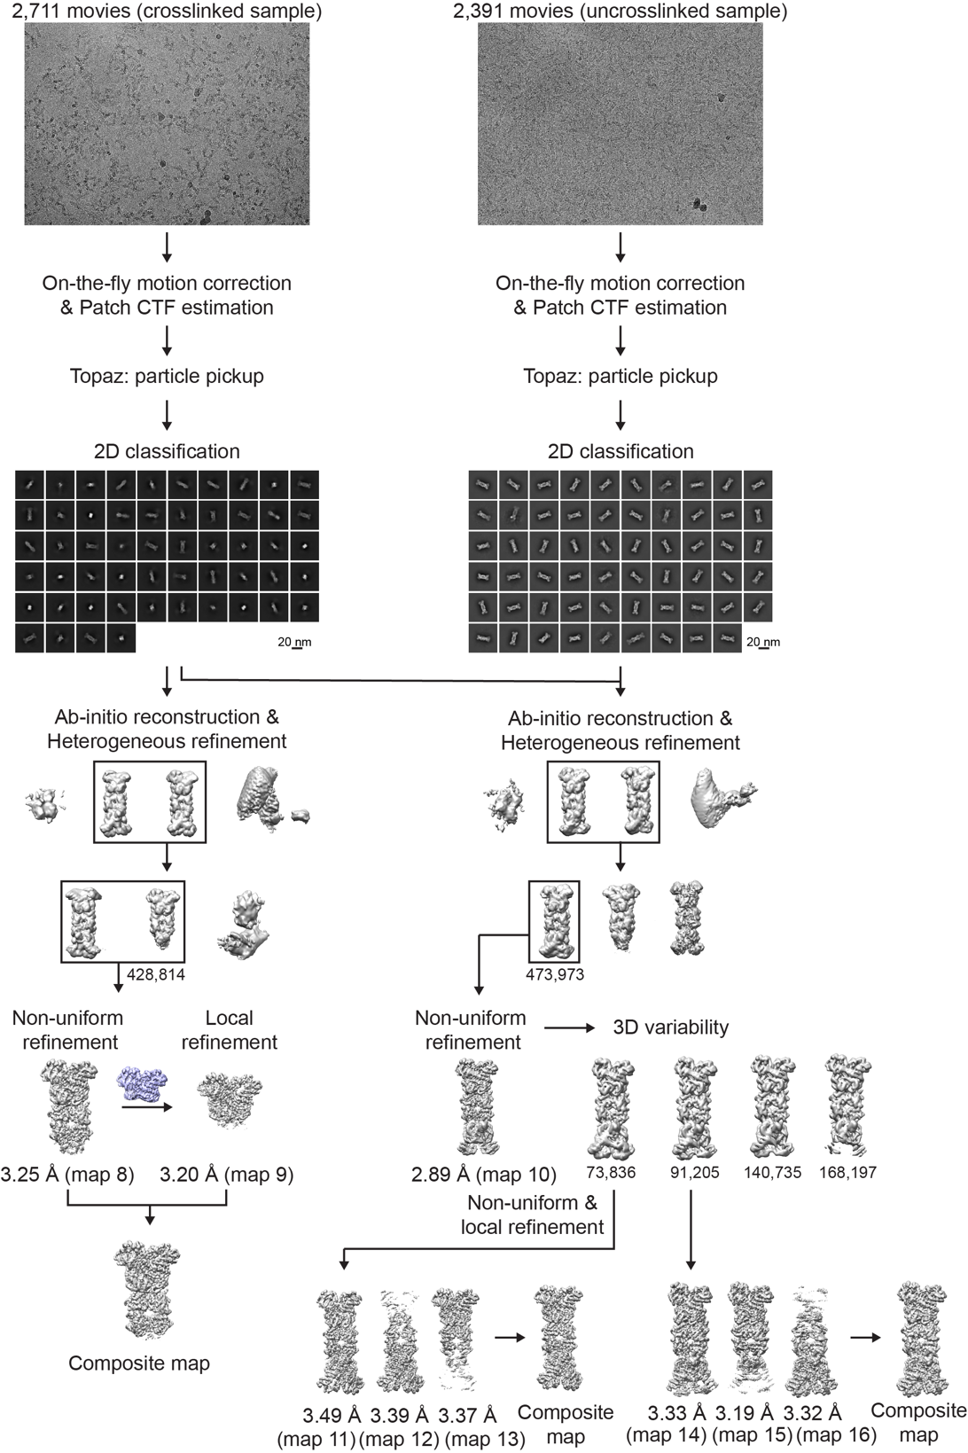
Extended Data Fig. 4 | Structure determination of DSR2-DSAD1 complex. Workflow of the cryo-EM data processing to obtain the 3D reconstructions of DSR2-DSAD1 complex. Nine cryo-EM maps (labeled maps 9-16) were obtained for the whole structure.
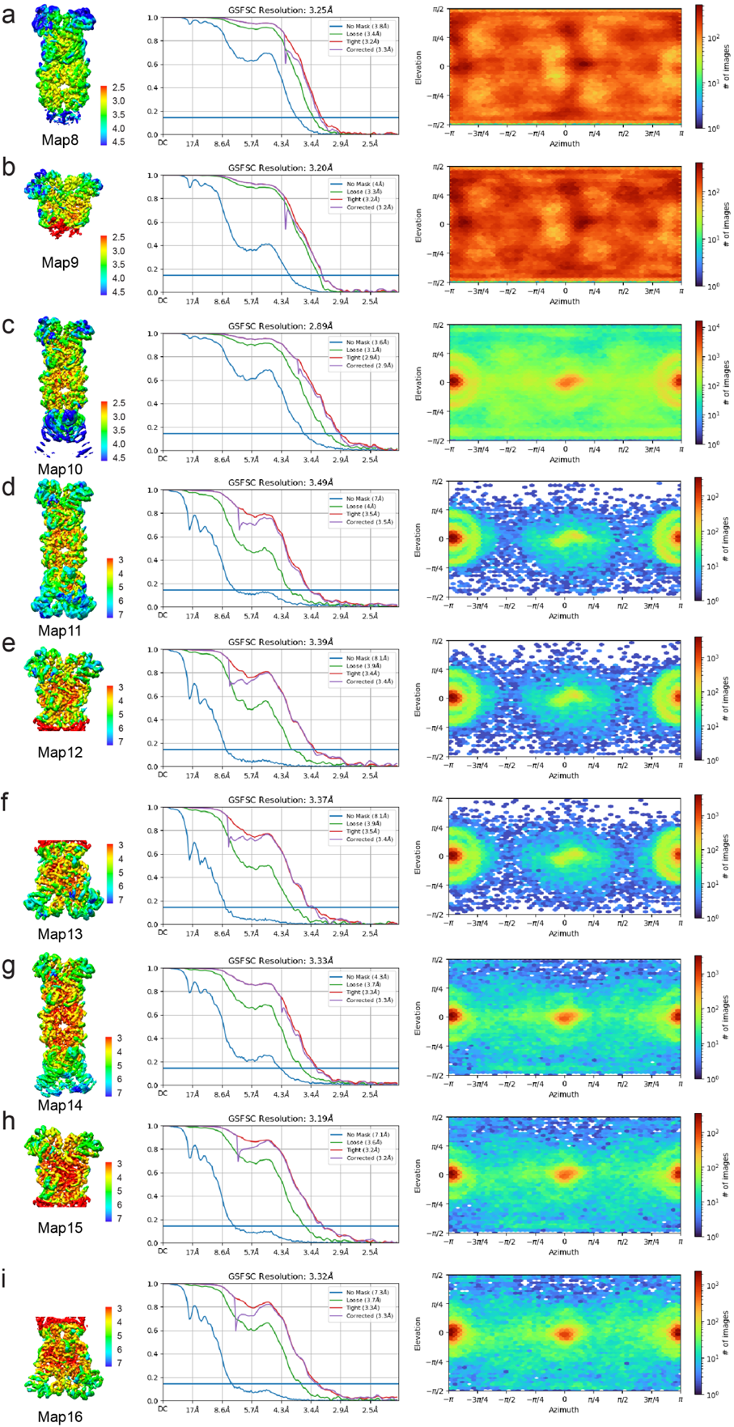
Extended Data Fig. 5 | The resolution analysis of DSR2-DSAD1 complex. a-i, Local resolution maps and Fourier shell correlation (FSC) curves of DSR2-DSAD1 complex. The local resolution maps (a-i) correspond to the different maps (8-16) depicted in Extended Data Fig. 4.
Extended Data Table 1 | Cryo-EM data collection, refinement and validation statistics for DSR2
 | DSR2 (H171A)  (crosslinked)  (EMDB-xxxx)  (PDB xxxx) | (EMDB-xxxx)  (PDB xxxx)
Data collection and processing
Magnification | 130,000×
Voltage (kV) | 300
Electron exposure (e–/Å²) | 50
Defocus range (μm) | -1 – -1.5
Pixel size (Å) | 0.92
Symmetry imposed | C1
Final particle images (no.) | 86,488 | 46,211
Map resolution (Å)  FSC threshold | 3.11  0.143 | 3.18  0.143
Refinement
Model resolution (Å)  FSC threshold | 3.3  0.5 | 3.4  0.5
Map sharpening B factor (Å²) | 61.3 | 51.9
Model composition  Non-hydrogen atoms  Protein residues  Ligands | 15869  1902  0 | 31736  3804  0
B factors (Å²)  Protein  Ligand | 77.29 | 125.08
R.m.s. deviations  Bond lengths (Å)  Bond angles (°) | 0.004  0.744 | 0.004  0.704
Validation  MolProbity score  Clashscore  Poor rotamers (%) | 2.71  17.08  5.49 | 2.7  16.23  4.55
Ramachandran plot  Favored (%)  Allowed (%)  Disallowed (%) | 93.68  6.06  0.27 | 91.84  7.73  0.43

Extended Data Table 2 | Cryo-EM data collection, refinement and validation statistics for DSR2-DSAD1 complex
 | DSR2-DSAD1  (crosslinked)  (EMDB-xxxx)  (PDB xxxx) | DSR2-DSAD1 (uncrosslinked) (EMDB-xxxx)  (PDB xxxx) | (EMDB-xxxx)  (PDB xxxx)
Data collection and processing
Magnification | 81,000× | 81,000×
Voltage (kV) | 300 | 300
Electron exposure (e–/Å²) | 50 | 50
Defocus range (μm) | -1.5 – -2 | -1.5 – -2
Pixel size (Å) | 1.0773 | 1.0773
Symmetry imposed | C1 | C1 | C1
Final particle images (no.) | 428,814 | 73,836 | 91,205
Map resolution (Å)  FSC threshold | 3.25  0.143 | 3.49  0.143 | 3.33  0.143
Refinement
Model resolution (Å)  FSC threshold | 3.3  0.5 | 3.7  0.5 | 3.5  0.5
Map sharpening B factor (Å²) | 140.9 | 89.6 | 84.2
Model composition  Non-hydrogen atoms  Protein residues  Ligands | 16793  2017  0 | 33586  4034  0 | 33586  4034  0
B factors (Å²)  Protein  Ligand | 96.72 | 119.19 | 108.10
R.m.s. deviations  Bond lengths (Å)  Bond angles (°) | 0.003  0.851 | 0.005  0.935 | 0.004  0.902
Validation  MolProbity score  Clashscore  Poor rotamers (%) | 2.71  10.37  7.39 | 3.08  19.33  7.28 | 2.98  17.12  7.63
Ramachandran plot  Favored (%)  Allowed (%)  Disallowed (%) | 91.31  8.19  0.5 | 86.11  13.13  0.75 | 89.13  10.20  0.68

