Supplementary Materials
Recycling of incinerated sewage sludge ash and waste glass powder in alkali-activated slag/glass powders for sewer rehabilitation

Keke Sun, Hafiz Asad Ali, Yamei Cai, Dongxing Xuan, Chi Sun Poon*

Department of Civil and Environmental Engineering and Research Centre for Resources Engineering Towards Carbon Neutrality, The Hong Kong Polytechnic University, Hung Hom, Kowloon, Hong Kong, China

*Corresponding author: cecspoon@polyu.edu.hk;

S 1. Visual imagery of AAMs specimens before exposure.
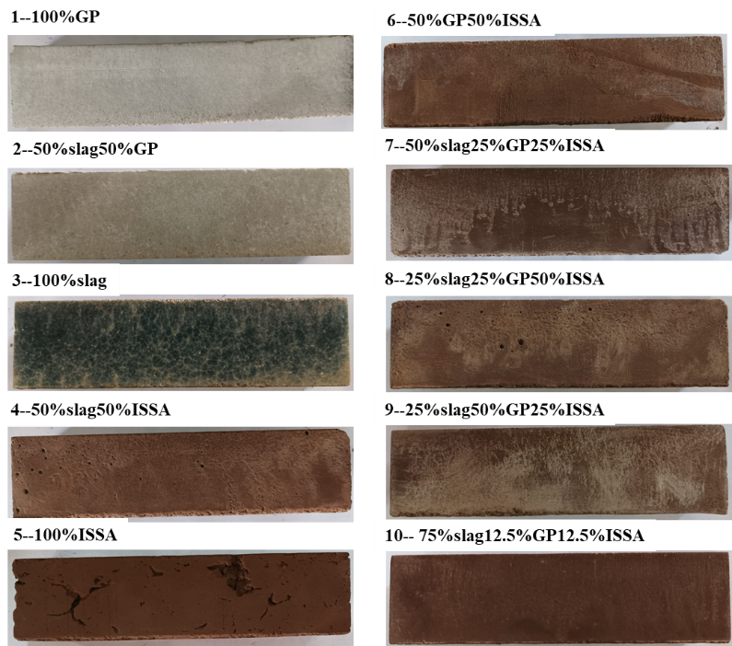
Fig.S1 Visual imagery of AAMs specimens before exposure.
S 2. Cross-section morphologies of the AAMs after the sewage corrosion
After sewage corrosion, the specimens 2, 3, 7 and 10 contained three clear zones, namely, the outermost 2~3 cm of heavily corroded zone, neutralization zone (between the red and yellow lines), and non-corroded zone (inside the yellow line).
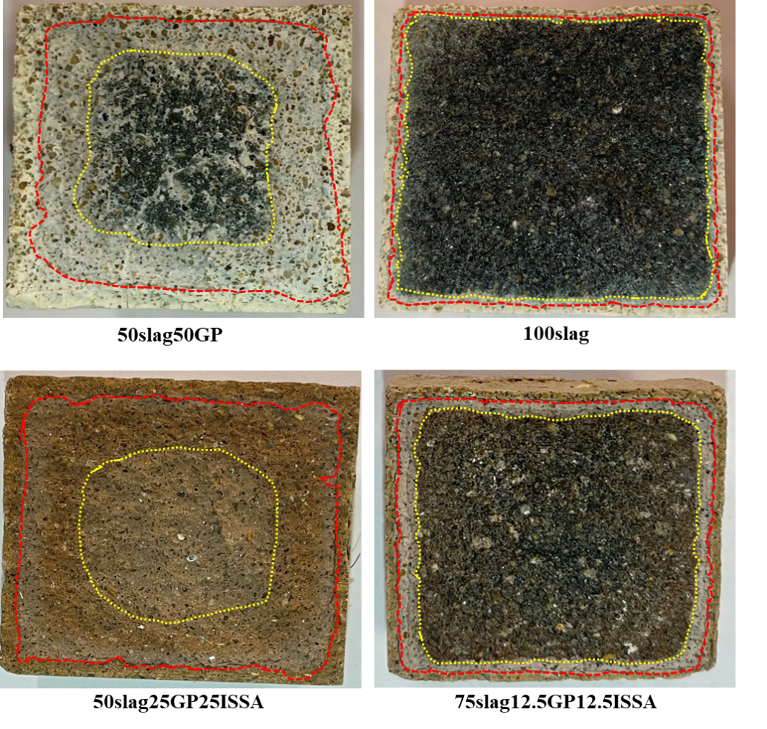
Fig.S2 Cross-section morphologies of the AAMs after the sewage corrosion

