The following blots are from the same western bloting experiment. Since the number of protein samples is larger than that one gel can hold, we set two control samples and two experimental samples in one gel, a total of 5 gels holding 20 samples.
Control Chitosan
Control Chitosan
Control Chitosan

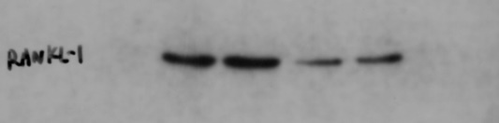
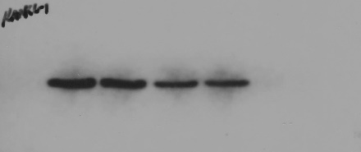
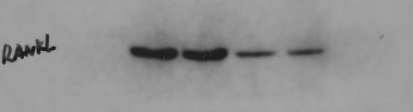
RANKL

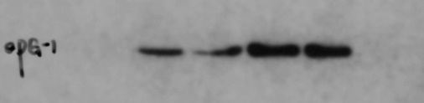
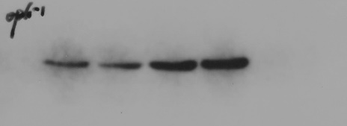
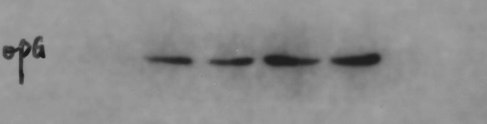
OPG

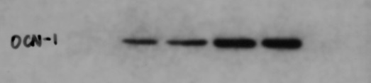
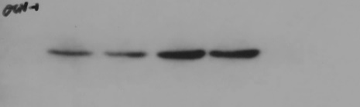
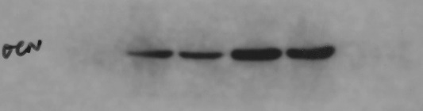
OCN

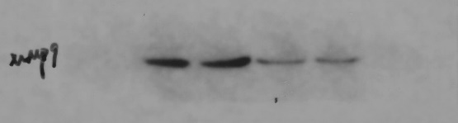
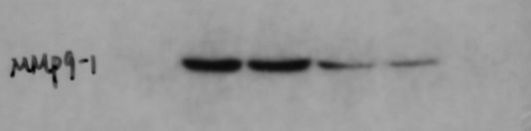
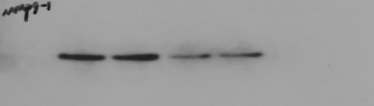
MMP9

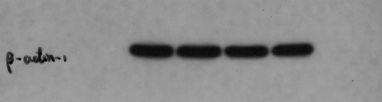
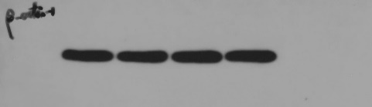
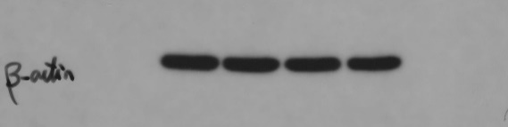

GAPDH

Control Chitosan
Control Chitosan
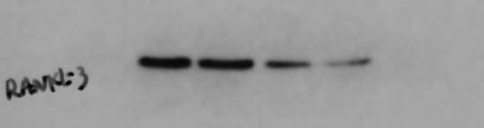
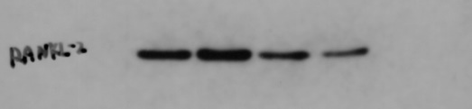
RANKL

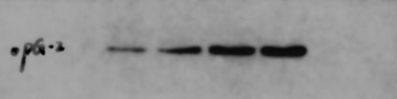
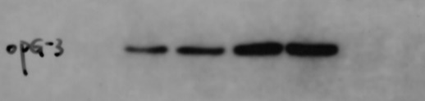
OPG

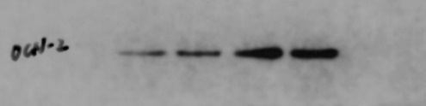
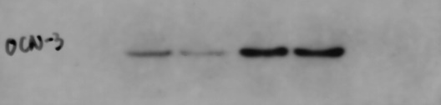
OCN

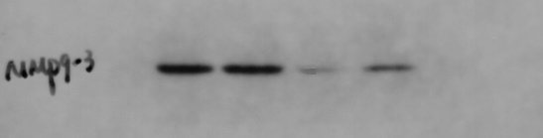
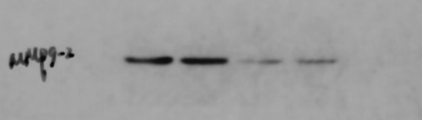
MMP9

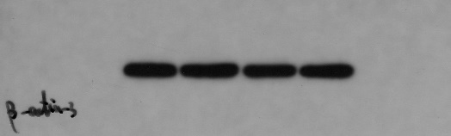
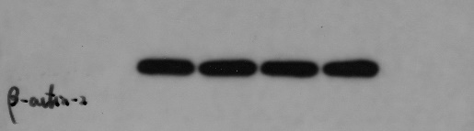
GAPDH

The original, unprocessed versions are as follows:
