The samples derive from the same experiment and that blots were processed in parallel.

Control Chitosan
Control Chitosan
Control Chitosan

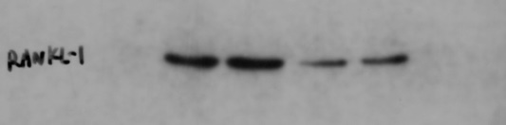
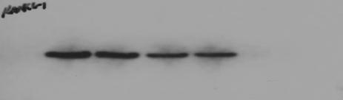
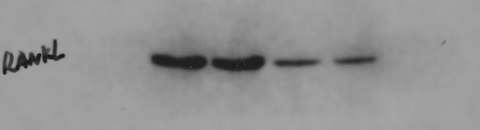
RANKL

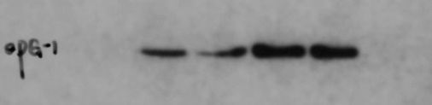
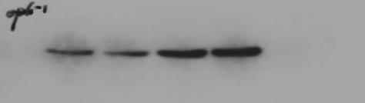
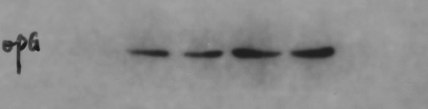
OPG

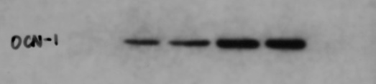
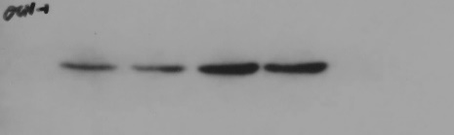
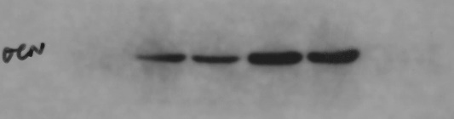
OCN

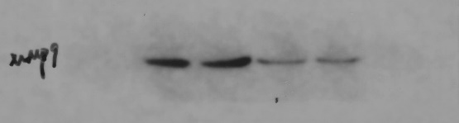
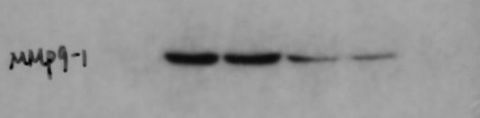
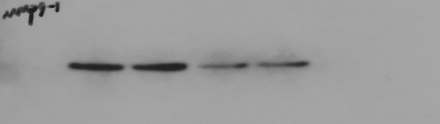
MMP9

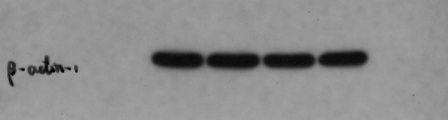
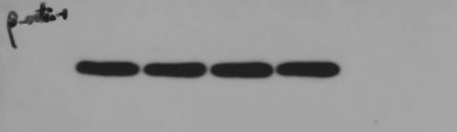
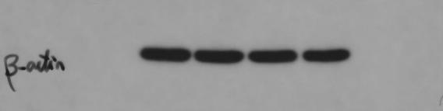

β-actin

Control Chitosan
Control Chitosan

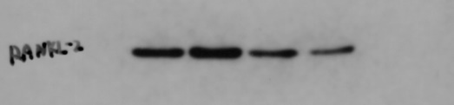
RANKL

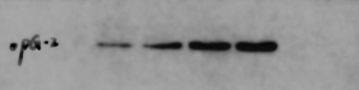
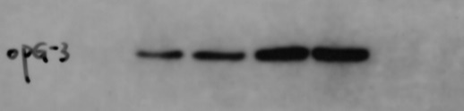
OPG

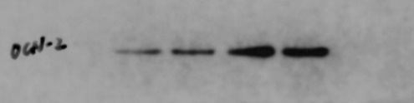
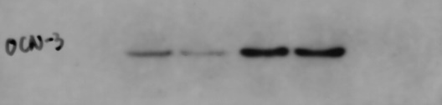
OCN


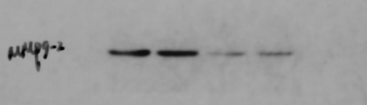
MMP9

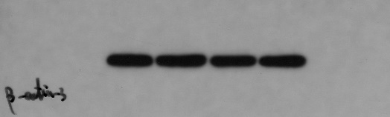
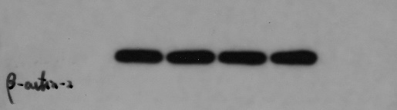
β-actin

