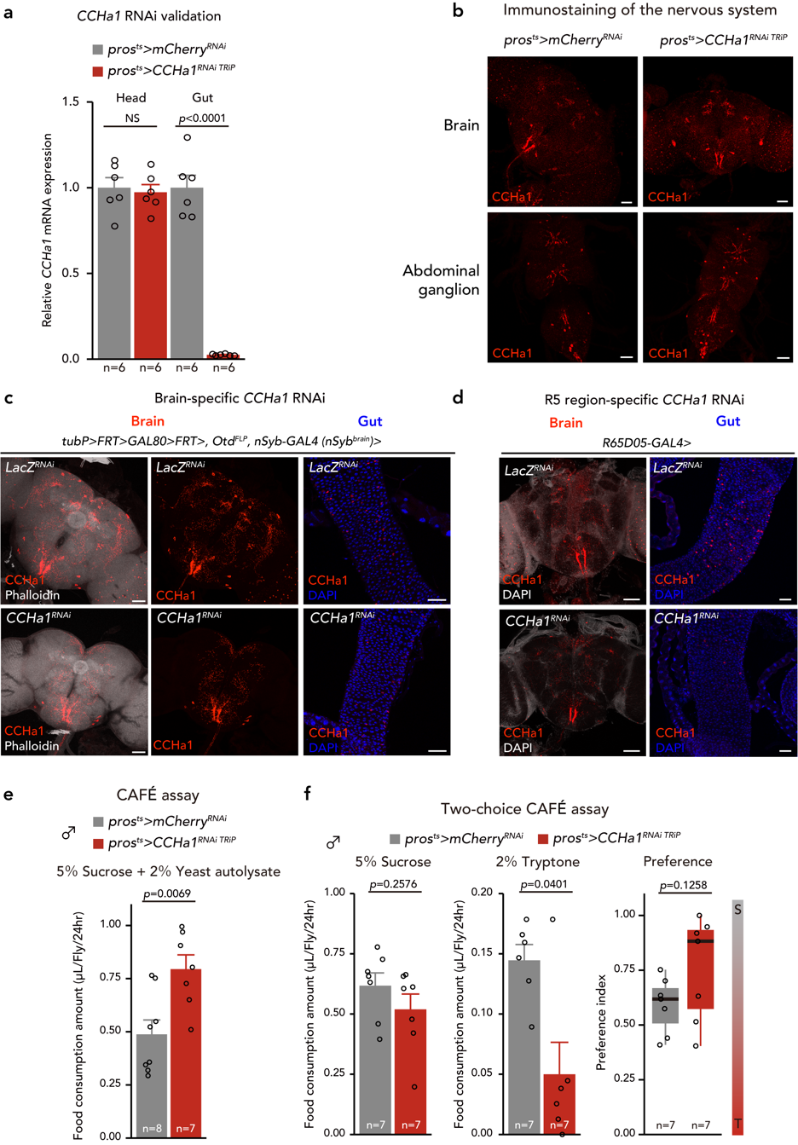
Extended Data Figure 1. Tissue specific CCHa1 knockdown
a, RT-qPCR analysis of CCHa1 mRNA levels of the brain and midgut of control or gut specific CCHa1 RNAi flies. b, Immunostaining images of the brain and abdominal ganglion from control or gut specific CCHa1 RNAi flies. CCHa1 (Red) signals are shown. Scale bar, 50 µm. c, Immunostaining images of the brain and midgut from control or brain specific CCHa1 RNAi flies. CCHa1 (Red), phalloidin (white), DAPI (blue) signals are shown. Scale bar, 50 µm. d, Immunostaining images of the brain and midgut from control or R65D05-GAL4-mediated CCHa1 RNAi flies. CCHa1 (Red), DAPI (white or blue) signals are shown. Scale bar, 50 µm. d, Feeding amount of control or gut specific CCHa1 RNAi male flies measured by CAFÉ assay. e, Two-choice feeding experiment with CAFÉ assay. Consumptions of sucrose (left), tryptone (centre), and preference (right) are shown. In the preference graph, S means sucrose, T means tryptone.
In all graph, the number of samples assessed (n) are shown in the graphs. For all bar graphs, mean and SEM are shown with all data points.
Statistics: two-tailed Student’s t test (a, e, f). p-values are shown in the graphs.
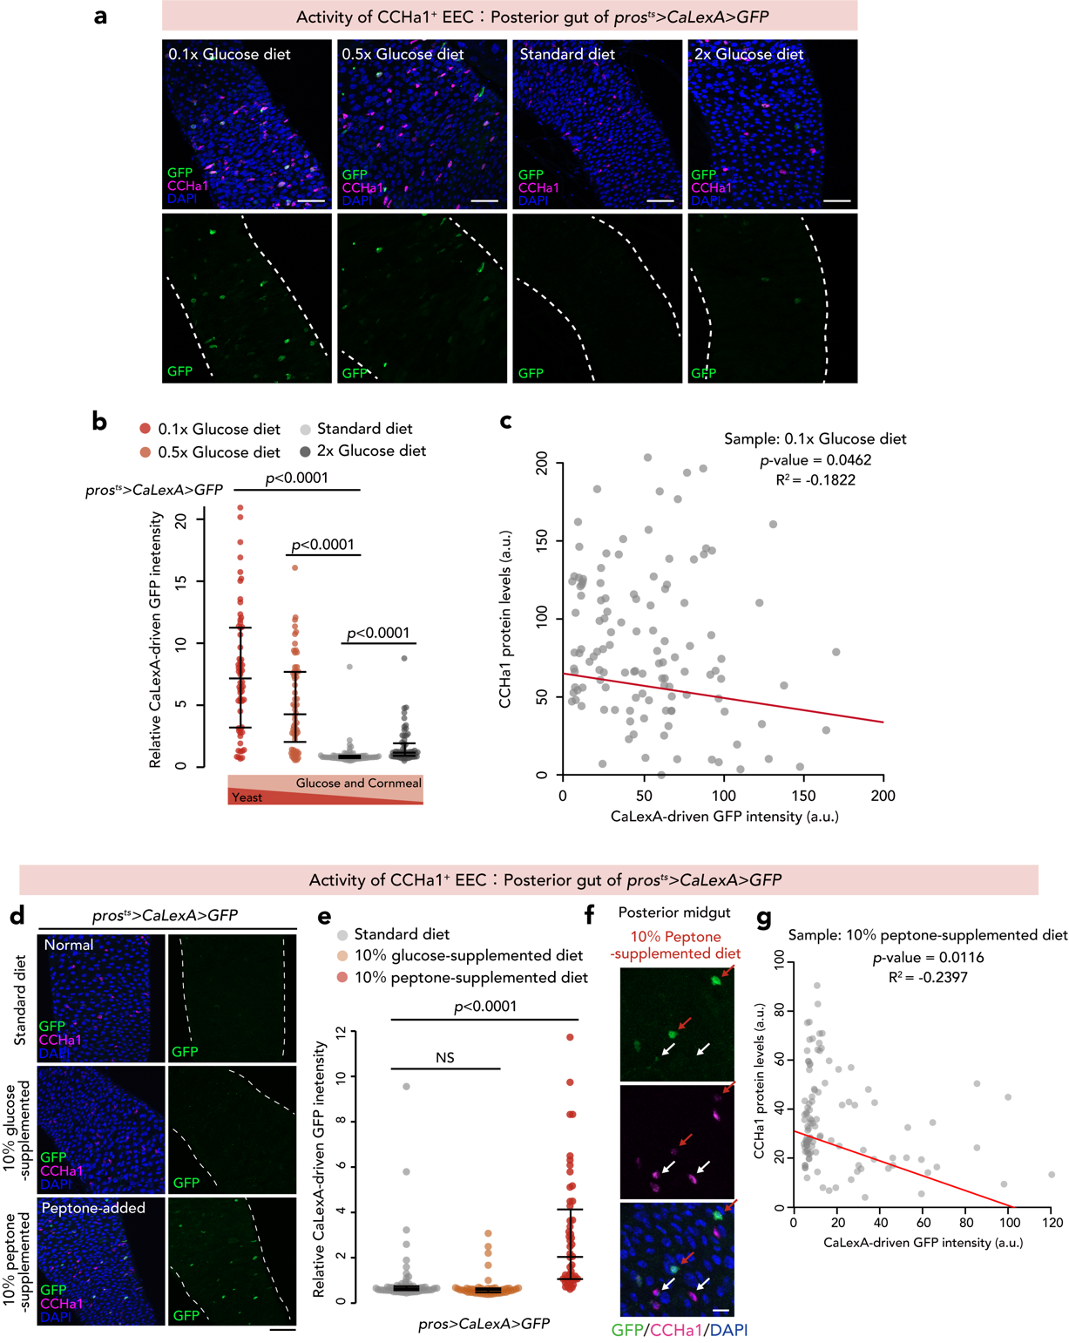
Extended Data Figure 2. High-protein, low-carbohydrate diets activate CCHa1⁺ EECs
a, Immunostaining images of the midgut from pros^{ts}>CaLexA>GFP flies maintained on each medium. GFP (green), CCHa1 (magenta), and DAPI (blue) are shown. In bottom images, white broken lines show the outlines of the midgut. Scale bar, 20 µm. b, Quantifications of the GFP signal of the CCHa1⁺ EECs of pros^{ts}>CaLexA>GFP flies maintained as in (a). c, A scatterplot of GFP signal intensity and anti-CCHa1 antibody signal intensity of 0.1x glucose diet condition in a, and b. d, Immunostaining images of the midgut from pros^{ts}>CaLexA>GFP flies maintained on each medium. GFP (green), CCHa1 (magenta), and DAPI (blue) are shown. In right images, white broken lines show the outlines of the midgut. Scale bar, 20 µm. e, Quantification of the GFP signal of the CCHa1⁺ EECs of pros^{ts}>CaLexA>GFP flies maintained as in (d). f, Magnified images of the midgut of a 10％ peptone-supplemented diet-fed fly. GFP (green), CCHa1 (magenta), and DAPI (blue) are shown. Red or white arrows indicate the EECs, which show high GFP, low CCHa1 signals or low GFP, high CCHa1 signals, respectively. g, A scatterplot of the GFP signal intensity and anti-CCHa1 antibody signal intensity of the 10％ peptone-supplemented diet condition.
For dot plots in b, and e, median, first quartile, and third quartile lines are shown.
Statistics: Wilcoxon rank sum test with Holm’s correction (b, e), Pearson's product moment correlation coefficient (c, g). p-values are shown in the graphs.

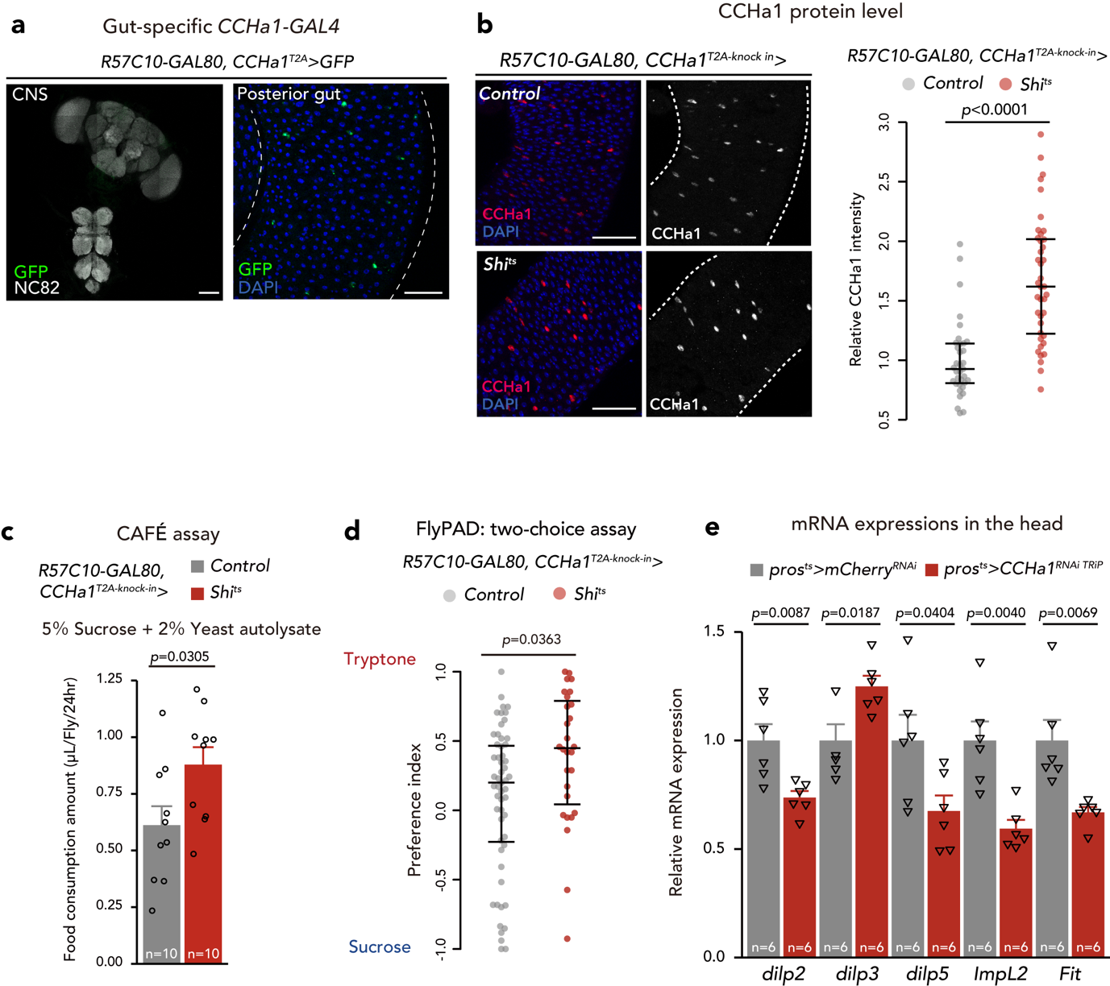
Extended Data Figure 3. CCHa1-R in sNPF neurons regulates feeding preference
a, Immunostaining image of the central nervous system (left) and gut (right) from CCHa1-T2A-knock-in-GAL4, R57C10-GAL80>stingar flies. GFP (green), NC82 (white: left), and DAPI (blue: right) are shown. Scale bar, 50 µm (left), 20 µm (right). b, Immunostaining images (left) and quantifications of CCHa1 signal intensity of EECs of control and shibire^{ts}-mediated CCHa1⁺ EEC-inhibited flies. CCHa1 (red: white), and DAPI (blue) are shown. In right images, white broken lines show the outlines of the midgut. Scale bar, 20 µm. c, Feeding amount of control or CCHa1⁺ EEC-inactivated flies measured with the CAFÉ assay. d, Preference index calculated by the number of sips of sucrose and tryptone of control or CCHa1⁺ EEC-inactivated flies measured using the flyPAD system. e, RT-qPCR analysis of mRNA levels of the head of control or gut specific CCHa1 RNAi flies.
In all graphs, numbers of samples assessed (n) are shown in the graphs. For all bar graphs, the mean and SEM are shown with all data points. For all dot plots, median, first quartile, and third quartile lines are shown.
Statistics: Wilcoxon rank sum test (b, d), two-tailed Student’s t test (c, e). p-values are shown in the graphs.
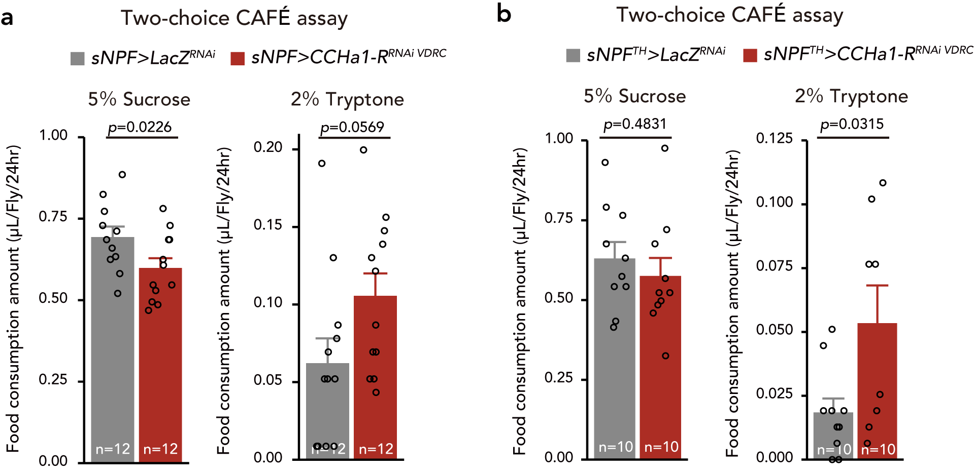
Extended Data Figure 4. Tissue specific CCHa1 knockdown
a, b, Two-choice feeding experiment with the CAFÉ assay. Consumption of sucrose (left), tryptone (right) is shown.
In all graphs, numbers of samples assessed (n) are shown in the graphs. For all bar graphs, the mean and SEM are shown with all data points.
Statistics: two-tailed Student’s t test (a, b). p-values are shown in the graphs.
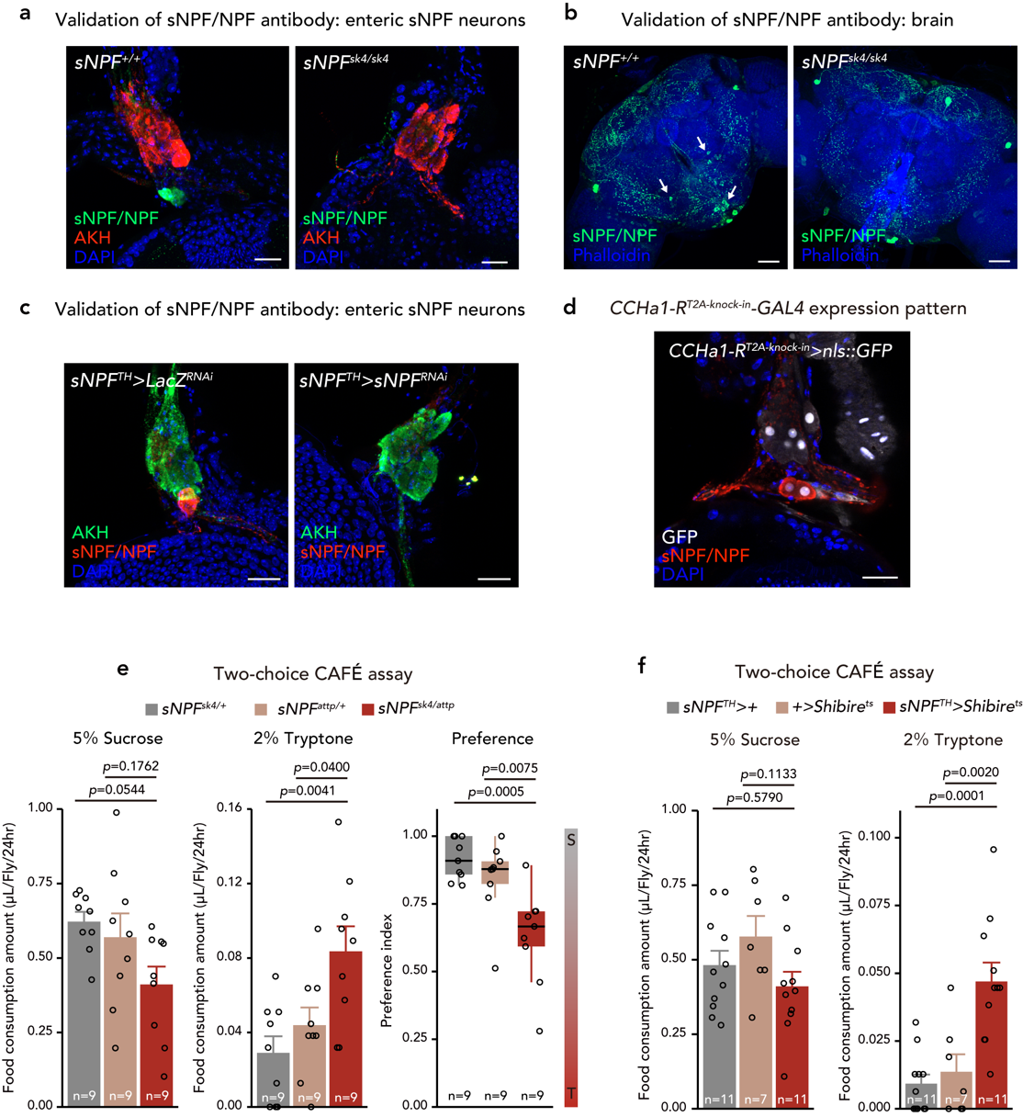
Extended Data Figure 5. sNPF controls feeding preference
a, b, Immunostaining image of HCG (a) and brain (b) from control (left) or sNPF null mutant flies (right). sNPF/NPF (green), AKH (red: corpora cardiaca), and DAPI (blue) are shown in a. sNPF/NPF (green), and phalloidin (blue) are shown in b. White arrows point to neurons in which the sNPF signal disappeared in sNPF null mutants. Scale bar, 20 µm. c, Immunostaining image of the HCG from control (left) or enteric sNPF neuron-specific sNPF RNAi flies (right). sNPF/NPF (red), AKH (green: corpora cardiaca), and DAPI (blue) are shown. Scale bar, 20 µm. d, Immunostaining image of the HCG from CCHa1-R-^{T2A-knock-in}>stingar flies. GFP (white), sNPF/NPF (red), and DAPI (blue) are shown. Scale bar, 20 µm. e, Two-choice feeding experiment with CAFÉ assay. Consumption of sucrose (left), tryptone (centre), and preference (right) is shown. In the preference graph, S means sucrose, T means tryptone. f, Two-choice feeding experiment with CAFÉ assay. Consumption of sucrose (left), and tryptone (right) are shown.
In all graphs, numbers of samples assessed (n) are shown in the graphs. For all bar graphs, the mean and SEM are shown with all data points.
Statistics: one-way ANOVA followed by Tukey's multiple comparisons test (e, f). p-values are shown in the graphs.

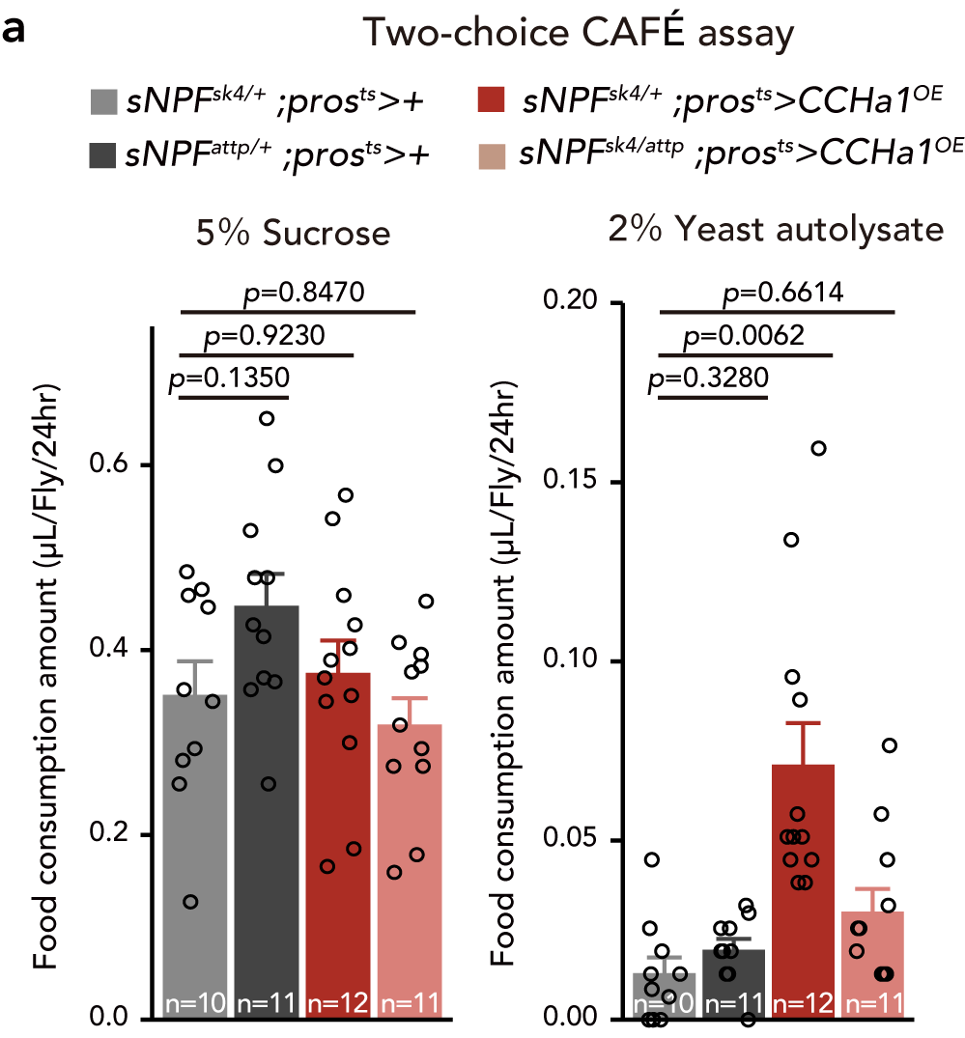
Extended Data Figure 6. CCHa1 overexpression in sNPF null mutant background
a, two-choice feeding experiment with CAFÉ assay. Consumption of sucrose (left), and yeast autolysate (right) is shown.
Numbers of samples assessed (n) are shown in the graphs. For all bar graphs, means and SEMs with all data points are shown.
Statistics: One-way ANOVA followed by Dunnett’s test (a). p-values are shown in the graphs.
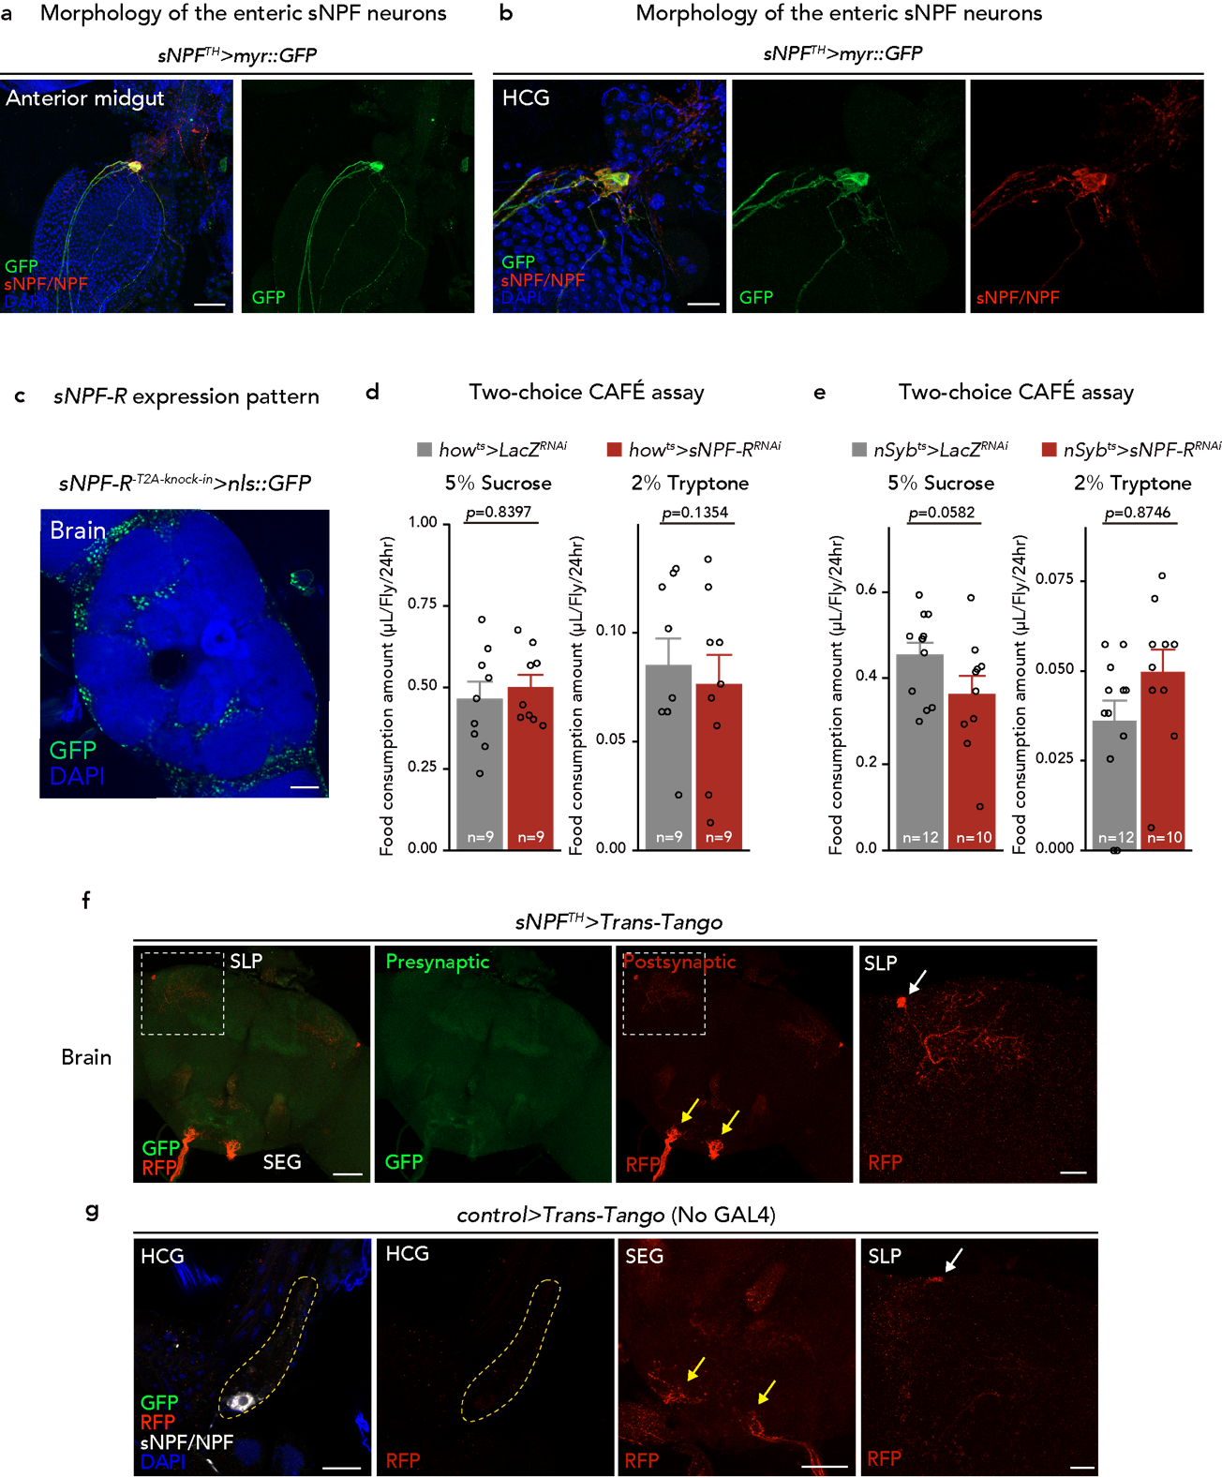
Extended Data Figure 7. Morphology and characterization of enteric sNPF neurons
a, b, Immunostaining images of the anterior midgut (a) and HCG (b) from sNPF^{TH}>myr::GFP flies. GFP (green), sNPF/NPF (red), and DAPI (blue) are shown. Scale bar, 50 µm in (a), 20 µm in (b). c, d, Two-choice feeding experiment with the CAFÉ assay of control or muscle specific (c), or neuronal (d) sNPF-R RNAi flies. Consumption of sucrose (left), and tryptone (right) is shown. e, Immunostaining images of the brain of sNPF^{TH}>Trans-Tango fly. GFP (presynaptic neurons; green), RFP (postsynaptic neuron; red), and DAPI (blue) are shown. White broken lines indicate SLP region of the brain. Yellow arrows show RFP⁺ neurons in the SEG. White arrow shows RFP⁺ neurons in the SLP. f, Immunostaining images of the brain and HCG of control (no GAL4: +>Trans-Tango) fly. GFP (presynaptic neurons; green), RFP (postsynaptic neuron; red), sNPF/NPF (white), and DAPI (blue) are shown. Yellow broken lines indicate the HCG. Yellow arrows show RFP⁺ neurons in the SEG. White arrow shows RFP⁺ neurons in the SLP.
In all graph, numbers of samples assessed (n) are shown in the graphs. For all bar graphs, the mean and SEM are shown with all data points.
Statistics: two-tailed Student’s t test (c, d). p-values are shown in the graphs.

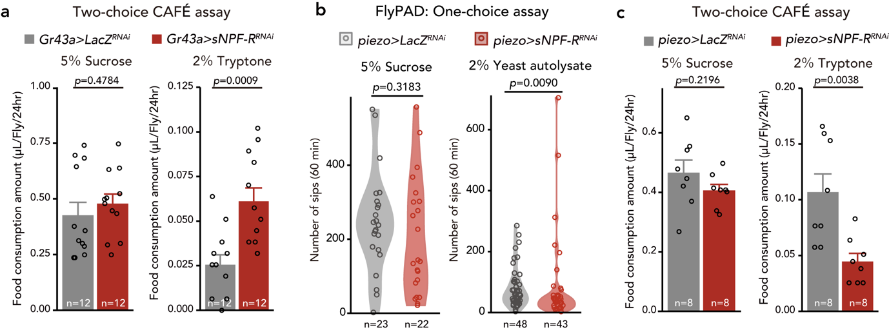
Extended Data Figure 8. Tissue specific sNPF-R knockdown
a, c, Two-choice feeding experiment with CAFÉ assay. Consumption of sucrose (left), tryptone (right) is shown. b, Number of sips on sucrose (left) and yeast autolysate (right) of piezo⁺ cell specific sNPF-R RNAi or control flies measured using the flyPAD system.
In all graphs, numbers of samples assessed (n) are shown in the graphs. For all bar graphs, mean and SEM are shown with all data points.
Statistics: two-tailed Student’s t test (a, c), Wilcoxon rank sum test (b). p-values are shown in the graphs.

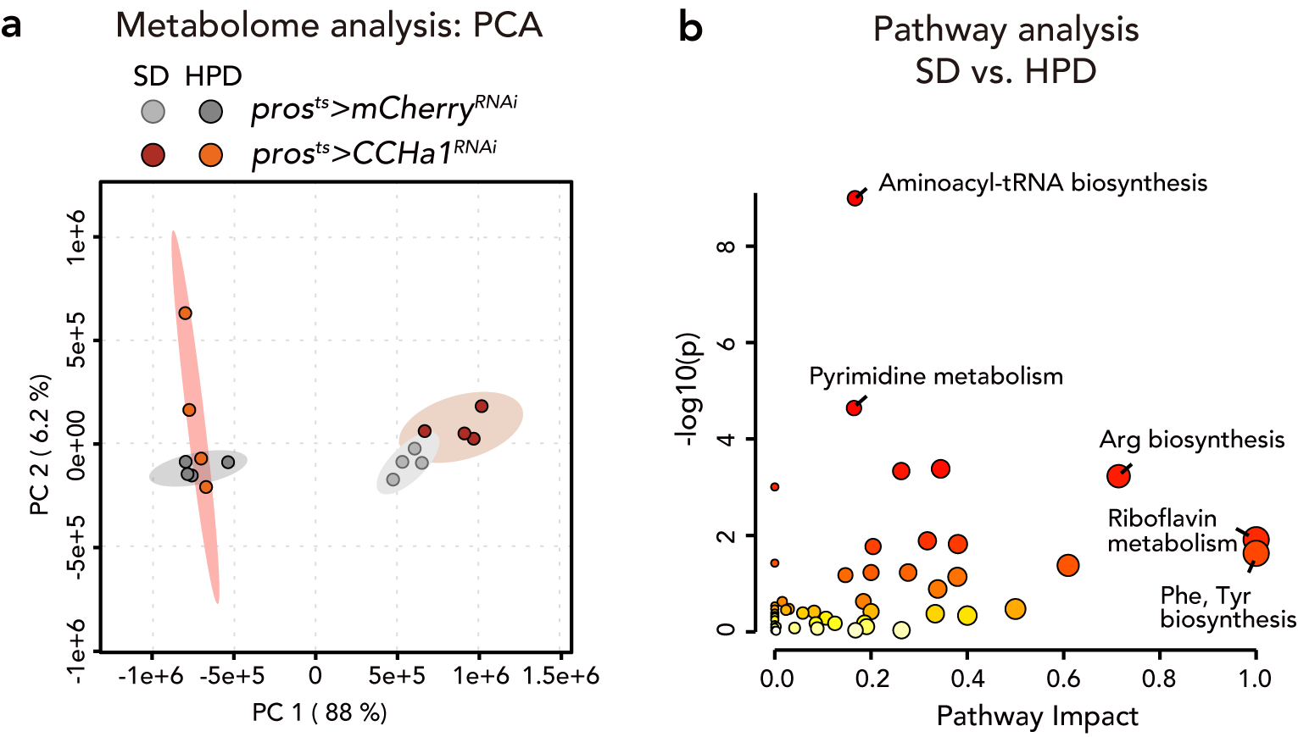
Extended Data Figure 9. Effect on metabolites profile by high-protein diet and CCHa1 knockdown
a, Principal component analysis (PCA) of water-soluble metabolites in control and gut-specific CCHa1 RNAi flies maintained on a standard diet (SD) or high-protein diet (HPD). Ellipses of clusters show the 95% confidence regions for each sample group. b, Pathway analysis plot of statistically significantly affected water-soluble metabolite of control flies (pros^{ts}>mCherry^{RNAi}) between SD and HPD condition.

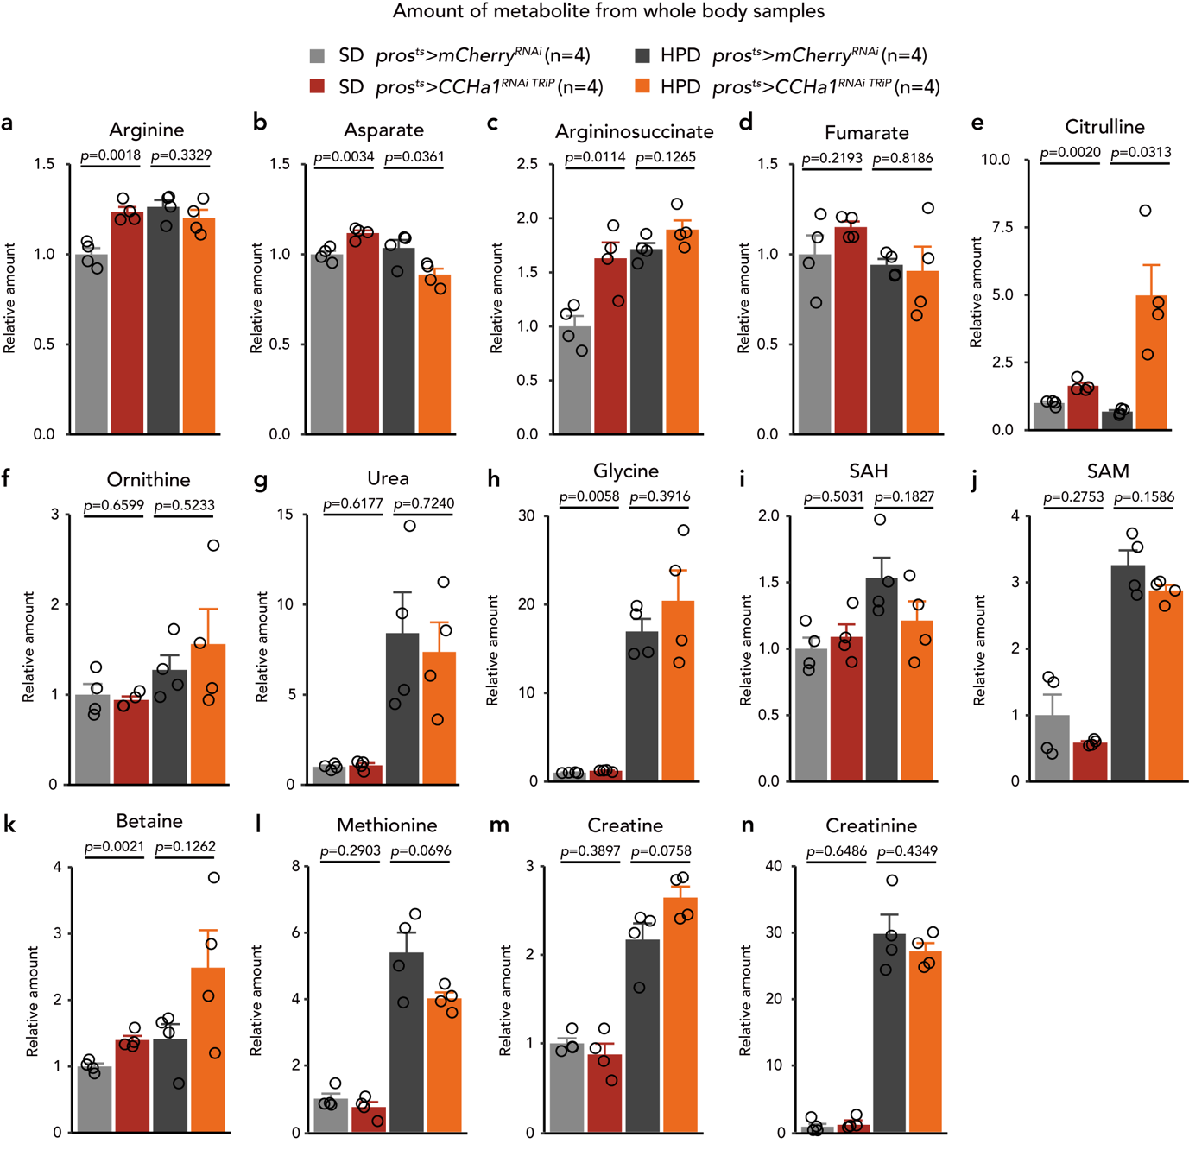
Extended Data Figure 10. Effect on amino acid profile by high-protein diet
a-n, Relative changes in the amounts of metabolites in whole body samples of pros^{ts}>mCherry^{RNAi} or pros^{ts}>CCHa1^{RNAi} flies maintained on standard diet (SD) or high-protein diet (HPD). Metabolite levels were directly analyzed by LC-MS/MS. The values are standardised by SD pros^{ts}>mCherry^{RNAi}.
In all graphs, numbers of samples assessed (n) are shown in the graphs. For all bar graphs, means are shown.
Statistics: two-tailed Welch’s t test (a, b). p-values are shown in the graphs.
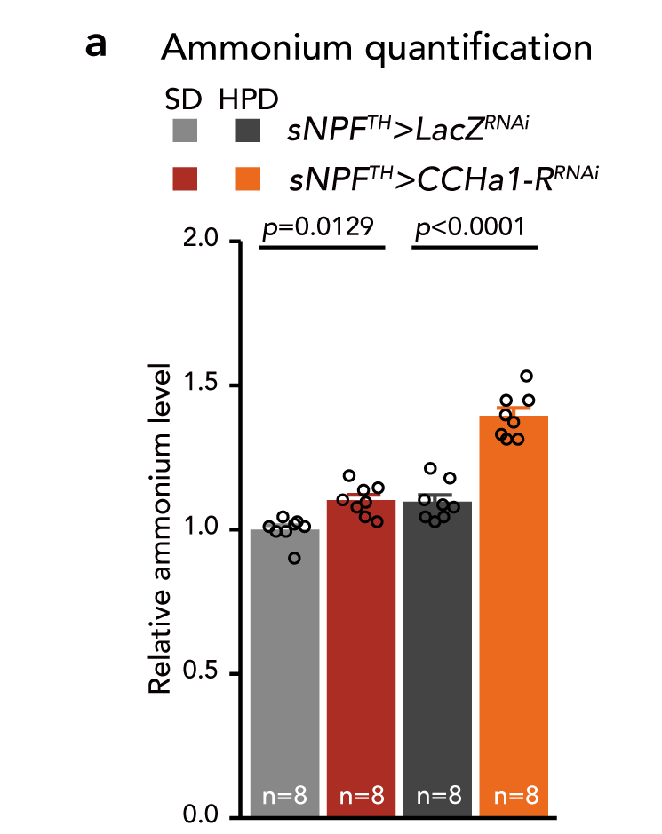
Extended Data Figure 11. Effect on amino acid profile by high-protein diet
a, Measurement of ammonium levels from whole body samples of control and enteric sNPF neurons specific CCHa1-R RNAi flies.
Numbers of samples assessed (n) are shown in the graphs. Means are shown in the bar graph.
Statistics: one-way ANOVA followed by Tukey's multiple comparisons test (a). p-values are shown in the graphs.

