SS⁺

SS⁻

C⁻

C⁺

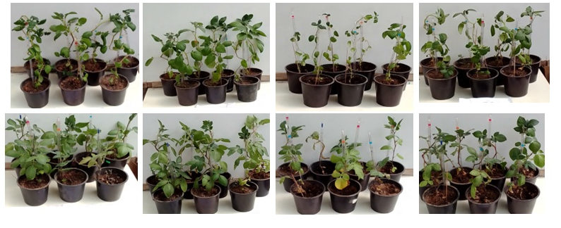
Claustar
Spunta

Supplementary Fig. 1: Morphology of plants after 40 days
C : Plants under standard conditions
SS : Plants under salt stress conditions
inoculated (+) and non inoculated (-) with Bacillus mojavensis I4

