Supplementary Figure S1. Correlation heat maps of t Pearson correlation for 18 samples. Pearson correlation was calculated using Log2 (FPKM) of expression values. LCK: the leaves of control LNa6h: the leaves under saline-alkali stress at 6 h LNa12h: the leaves under saline-alkali stress at 12 h RCK: the roots of control RNa6h: the roots under saline-alkali stress at 6 h RNa12h: the roots under saline-alkali stress at 12 h
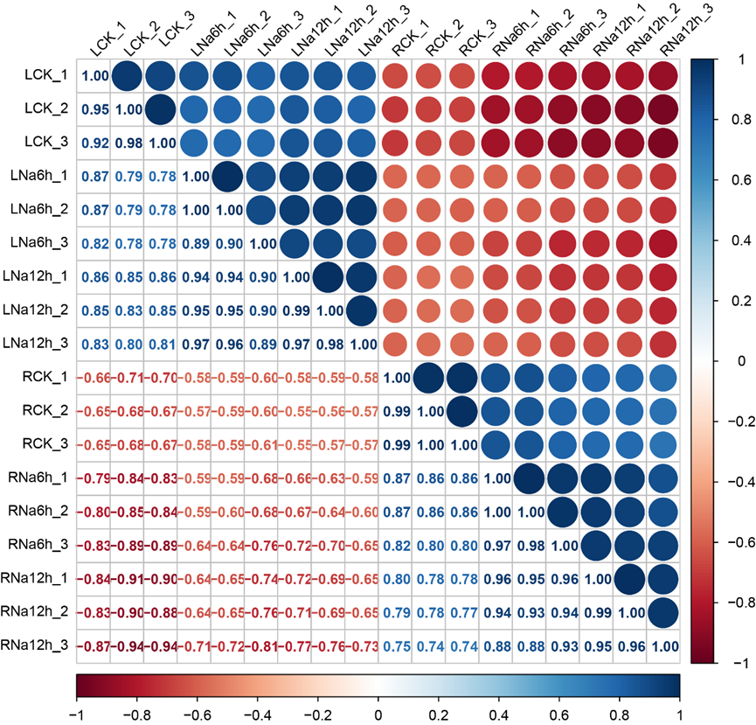

Supplementary Table S1. Sample reads quality of 18 libraries

Sample | Raw_reads | Raw_bases | Clean_reads | Clean_bases | Error_rate | Q20 | Q30 | GC_pct
LCK_1 | 47893940 | 7.18G | 45173146 | 6.78G | 0.03 | 97.45 | 92.85 | 47.75
LCK_2 | 47998592 | 7.2G | 43732092 | 6.56G | 0.03 | 97.72 | 93.31 | 46.4
LCK_3 | 52162424 | 7.82G | 49901076 | 7.49G | 0.03 | 97.35 | 92.48 | 47.84
LNa6h_1 | 45989142 | 6.9G | 43514088 | 6.53G | 0.03 | 97.43 | 92.72 | 47.23
LNa6h_2 | 46022154 | 6.9G | 43203508 | 6.48G | 0.03 | 97.23 | 92.22 | 47.6
LNa6h_3 | 44850488 | 6.73G | 41650554 | 6.25G | 0.03 | 96.71 | 91.04 | 46.43
LNa12h_1 | 44102478 | 6.62G | 41714000 | 6.26G | 0.03 | 97.38 | 92.59 | 47.18
LNa12h_2 | 45964412 | 6.89G | 43417572 | 6.51G | 0.03 | 97.27 | 92.34 | 47.14
LNa12h_3 | 45002476 | 6.75G | 41702990 | 6.26G | 0.03 | 97.63 | 93.18 | 46.7
RCK_1 | 45829908 | 6.87G | 43426242 | 6.51G | 0.03 | 97.45 | 92.66 | 45.6
RCK_2 | 50391166 | 7.56G | 46671834 | 7.0G | 0.03 | 97.44 | 92.65 | 44.9
RCK_3 | 46468958 | 6.97G | 43680678 | 6.55G | 0.03 | 97.1 | 91.94 | 45.71
RNa6h_1 | 45698972 | 6.85G | 44501112 | 6.68G | 0.03 | 97.46 | 92.68 | 46.37
RNa6h_2 | 43450222 | 6.52G | 41848308 | 6.28G | 0.03 | 97.48 | 92.76 | 45.71
RNa6h_3 | 43843240 | 6.58G | 41814864 | 6.27G | 0.03 | 97.64 | 93.12 | 45.49
RNa12h_1 | 43086974 | 6.46G | 41200432 | 6.18G | 0.03 | 97.59 | 93.11 | 46.06
RNa12h_2 | 42640688 | 6.4G | 40659818 | 6.1G | 0.03 | 97.26 | 92.35 | 46.11
RNa12h_3 | 45594650 | 6.84G | 43494484 | 6.52G | 0.03 | 97.47 | 92.81 | 45.58

Supplementary Table S2. Phenotypic data of 18 samples
Sample | SOD activity(U/g) | CAT activity(U/g) | POD activity(U/g) | PPO activity(U/g) | Na+/K+ ratio
LCK_1 | 59.26 | 13.22 | 530.53 | 15.96 | 0.74
LCK_2 | 61.04 | 12.66 | 431.66 | 14.87 | 0.84
LCK_3 | 61.51 | 11.85 | 506.27 | 15.41 | 0.79
LNa6h_1 | 104.57 | 8.33 | 664.45 | 21.31 | 0.80
LNa6h_2 | 105.35 | 7.64 | 615.80 | 22.71 | 0.70
LNa6h_3 | 109.25 | 8.28 | 723.52 | 19.81 | 0.75
LNa12h_1 | 90.17 | 26.80 | 1317.37 | 19.09 | 1.14
LNa12h_2 | 97.39 | 30.64 | 1577.45 | 20.86 | 1.42
LNa12h_3 | 99.51 | 28.41 | 1518.36 | 19.92 | 1.28
RCK_1 | 49.13 | 22.27 | 615.80 | 32.41 | 2.25
RCK2_ | 53.16 | 25.18 | 612.72 | 42.26 | 2.74
RCK3_ | 54.41 | 27.41 | 689.79 | 31.53 | 2.45
RNa6h_1 | 42.90 | 40.73 | 1677.45 | 106.12 | 6.19
RNa6h_2 | 48.20 | 41.35 | 1648.64 | 125.51 | 6.77
RNa6h_3 | 49.24 | 40.71 | 1647.73 | 87.72 | 5.77
RNa12h_1 | 39.66 | 105.26 | 2966.67 | 78.74 | 9.84
RNa12h_2 | 43.23 | 113.58 | 2992.22 | 66.76 | 9.42
RNa12h_3 | 42.07 | 109.34 | 3037.35 | 77.74 | 9.45

Supplementary Table S3. Primer sequences for qRT-PCR testing in this study
Name | Forward primer | Reverse primer
(q)MdPP2C29Like | GCTTGTTGGTTGTGCTAA | TCAGTTATATCCTCAGTGTTCA
(q)MdCIPK19 | AAGCACATCAAGTTCTACATT | GTAATCTTTCTTCTGGTCTCAA
(q)MdbHLH80Like | ATCAGTGACCGCATAAGG | TCATCTAACATATCCGCAGTAT
(q)MdPP2C39 | GGACTATGGAAGGTGATGA | CCGAAATCTTACGACTATACAG
(q)MdMYB5Like | ACAGATGGTCACTAATAGCA | CCTCTTCTTCTTATTGTTCTCAT
(q)MdWRKY31 | TCATTGGCGGATCTTACT | CATTGGCATTGTTGTTGTT
(q)MdWRKY23 | TTGTTGTGACTACTTATGAAGG | ACGGCTCTACTTGTTGAT
(q)MdWRKY69 | GCCACTATCACTATCATATTCTC | AAGATTGTTAGTCCTCCTCAT
(q)MdPHL7Like | CACTCAAAGCGTCAGATG | TAGAGGCAGATTAGATGTAGC
(q)MdCML18 | AAGTCTCCAGCCAATTCA | ATCTCCGTTACGATCCATT
(q)MdWRKY10 | TGCTGATGAACCTAATGC | CTGTGACCGTCTTATGTG
(q)MdNAC1 | ATATTATGACGGAGACCTCAA | ATTCATCAACTGCCACATC
(q)MdActin | TGACCGAATGAGCAAGGAAATTACT | TACTCAGCTTTGGCAATCCACATC

