Supplementary material

Supplementary Figure S1. Comparison of abundance differences at the bacterial genus or species level between the baseline sputum of the stable group (n = 21) and the sputum of the treatment group (initiation of antibiotics group; n = 14).

(A) Gemella (Wilcoxon rank-sum test, p = 0.017)
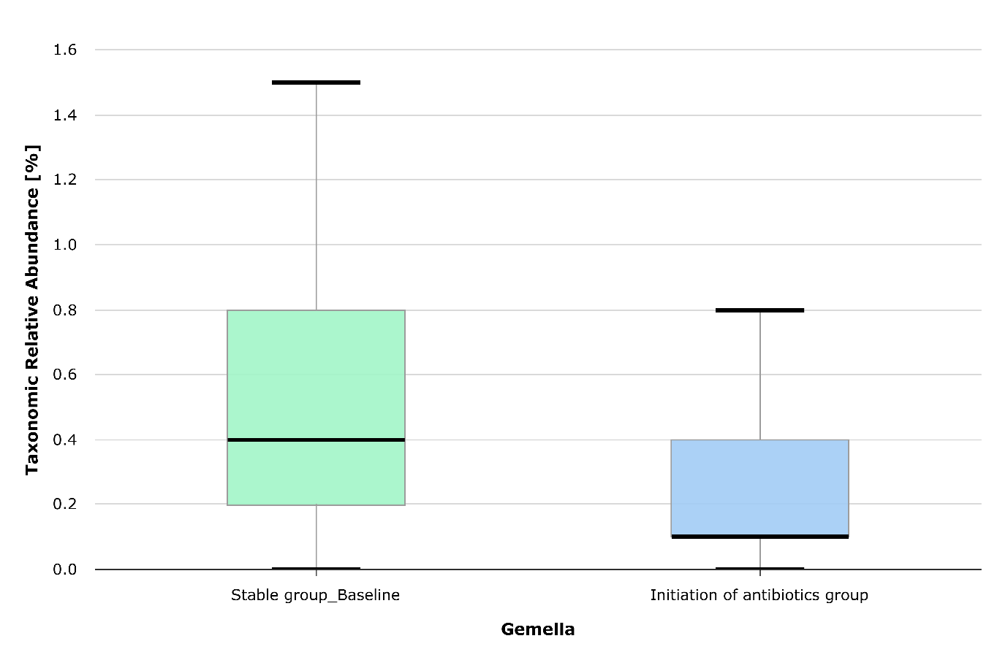

(B) Porphyromonas pasteri (Wilcoxon rank-sum test, p = 0.053)
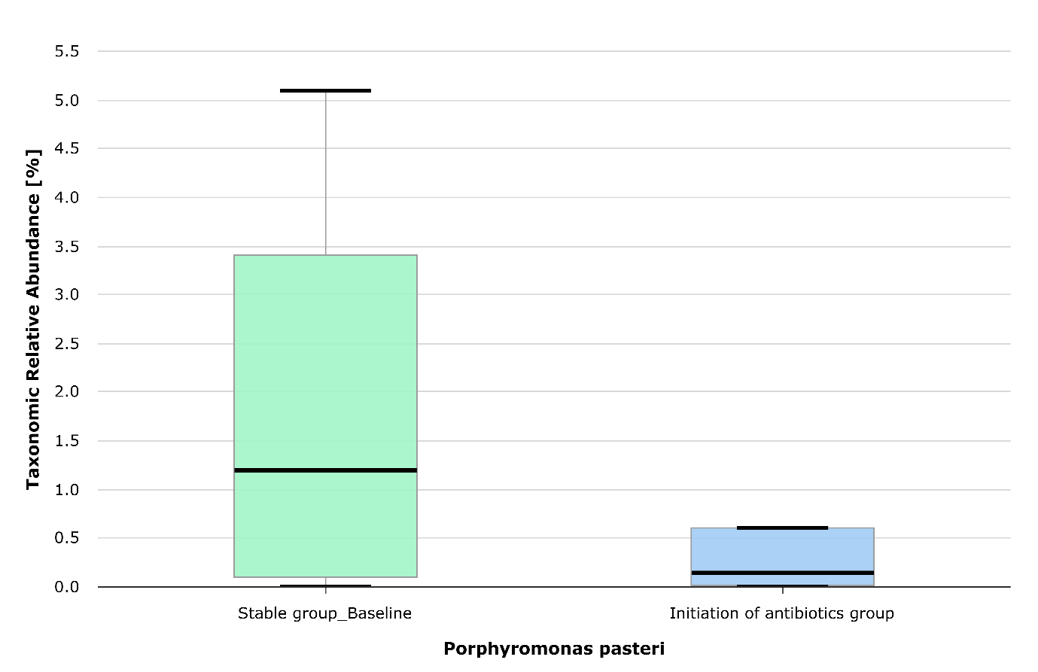

(C) Haemophilus parahaemolyticus (Wilcoxon rank-sum test, p = 0.024)
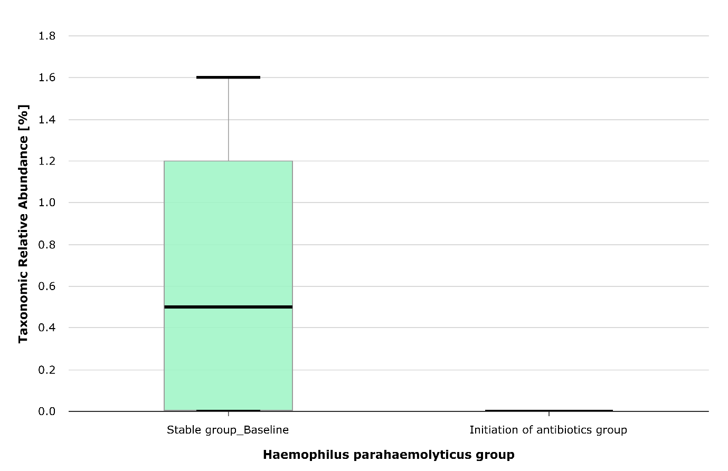
(D) Prevotella nanceiensis (Wilcoxon rank-sum test, p = 0.045)
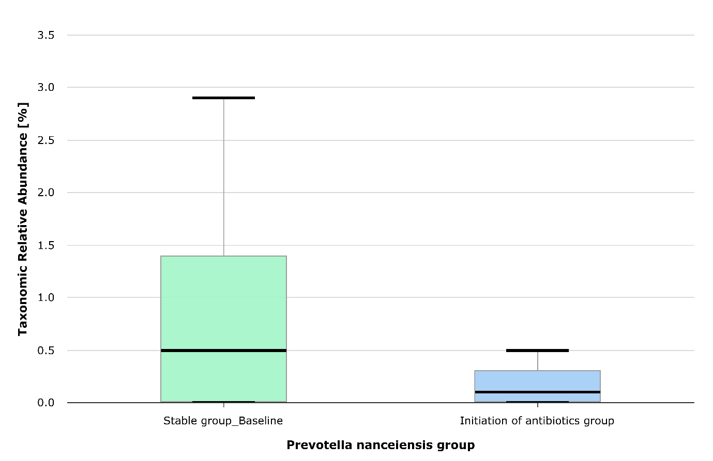

(E) Gemella haemolysans (Wilcoxon rank-sum test, p = 0.022)
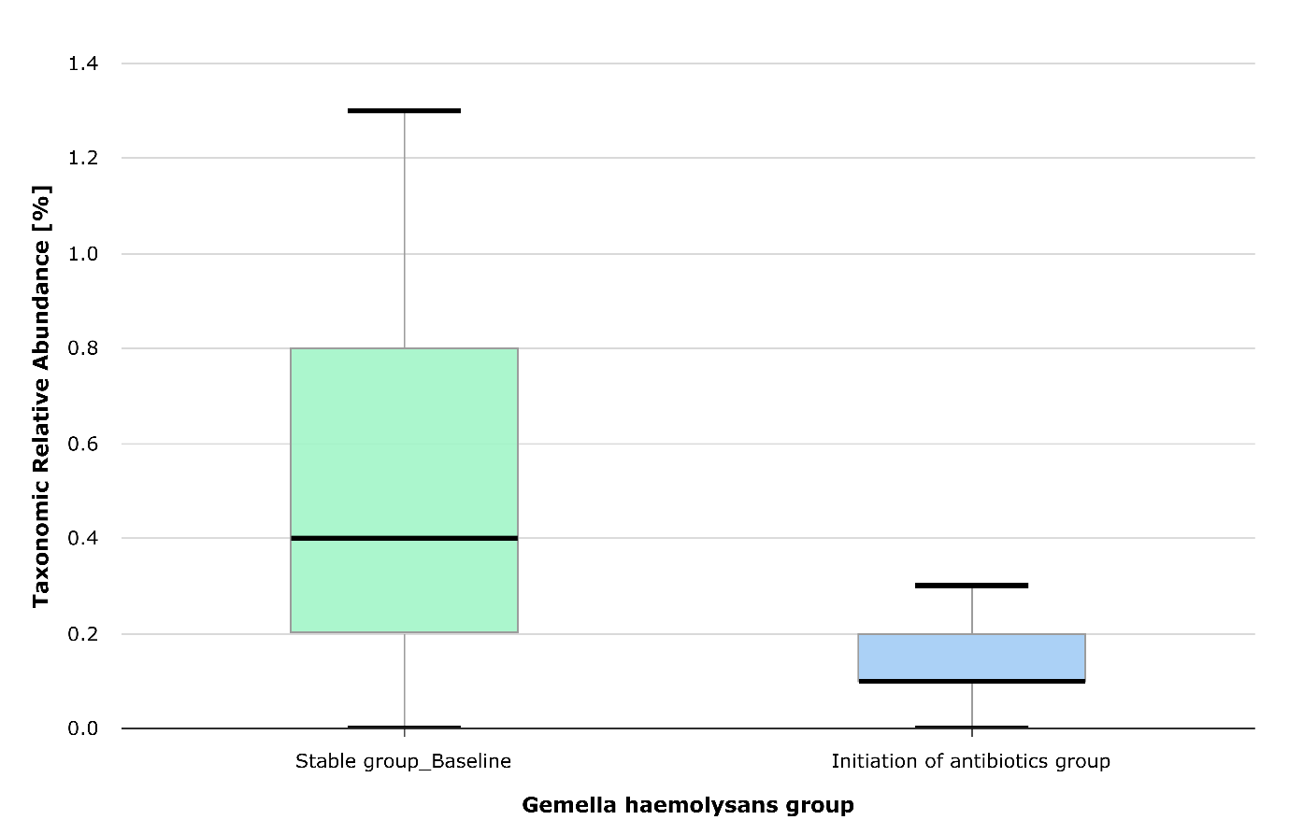
Supplementary Figure S2. Beta-diversity between baseline sputum (n = 21) and follow-up sputum (n = 13) in the stable group. Beta-diversity analysis using Generalized UniFrac did not show significant differences in bacterial taxa distribution between the two specimen groups. Furthermore, the LEfSe analysis did not identify taxa with significant abundance exceeding an LDA effect size of > 3.
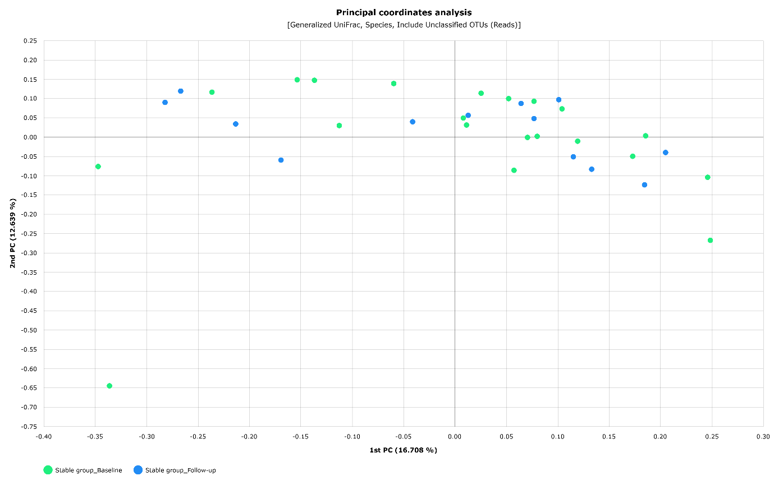

Supplementary Figure S3. Comparison of abundance differences in bacterial taxa between the baseline sputum of patients with spontaneous culture conversion (n = 9) and patients with persistent culture positivity (n = 12) in the stable group.

(A) Bergeyella (Wilcoxon rank-sum test, p = 0.043)
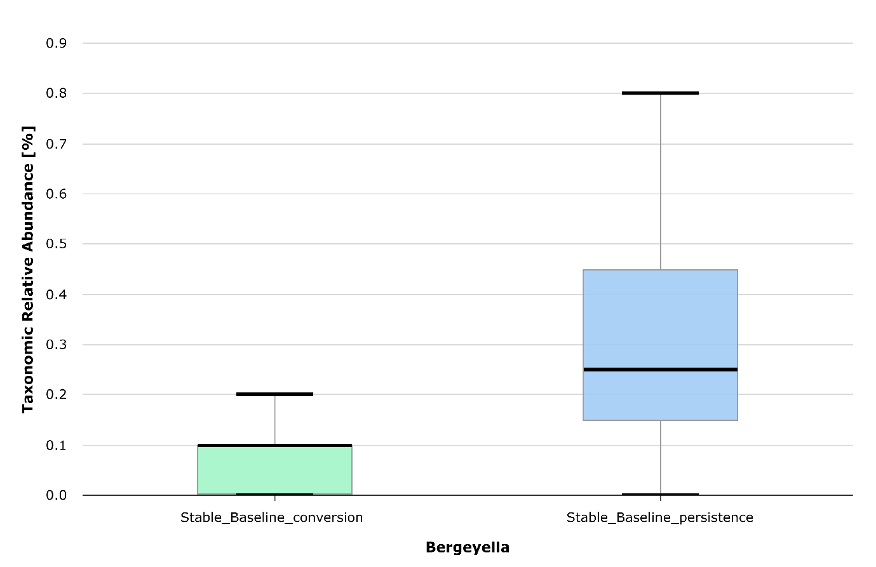

(B) Prevotella oris (Wilcoxon rank-sum test, p = 0.036)

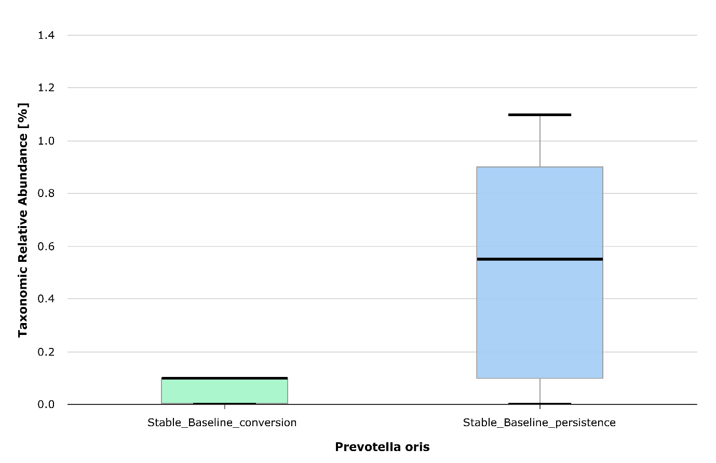
Supplementary Figure S4. Comparison of abundance differences in bacterial taxa between the sputum of treatment success (n = 7) and treatment-refractory (n = 7) patients in the treatment group.

(A) Haemophilus (Wilcoxon rank-sum test, p = 0.025)
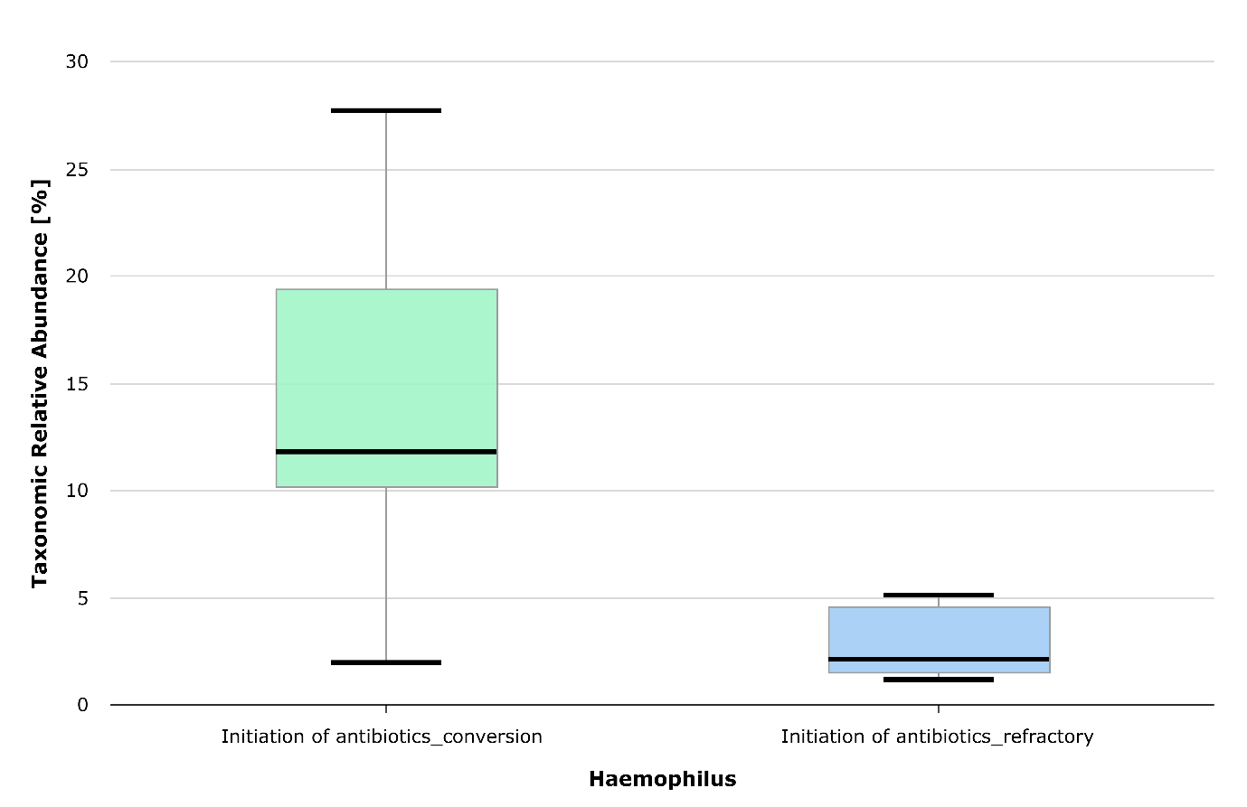

(B) Rothia (Wilcoxon rank-sum test, p = 0.025)
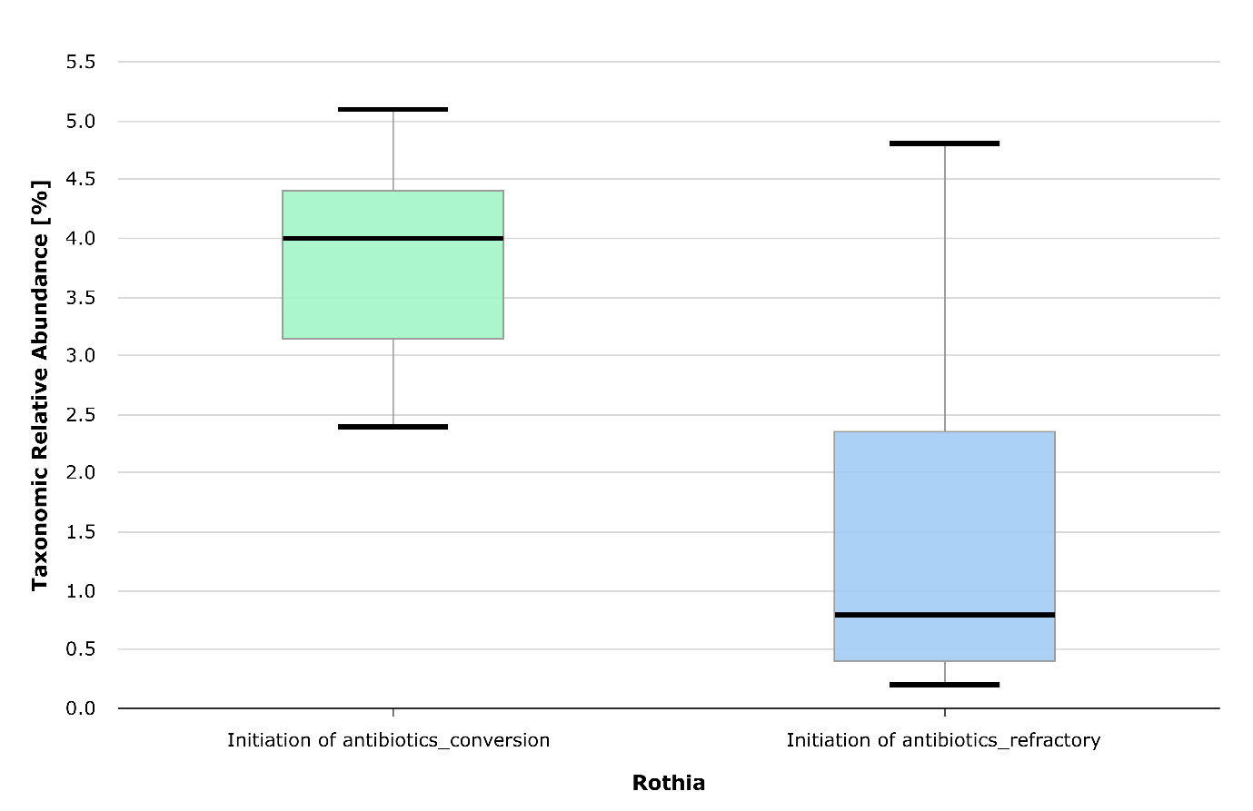

(C) Atopobium (Wilcoxon rank-sum test, p = 0.030)
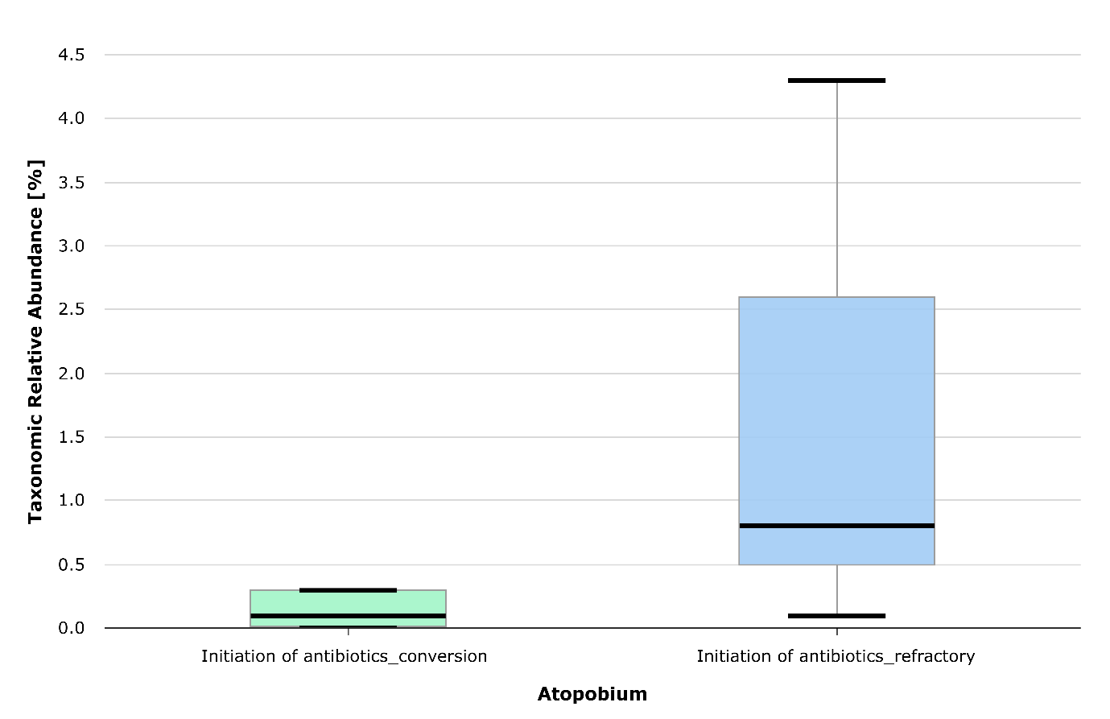

(D) Parvimonas (Wilcoxon rank-sum test, p = 0.048)
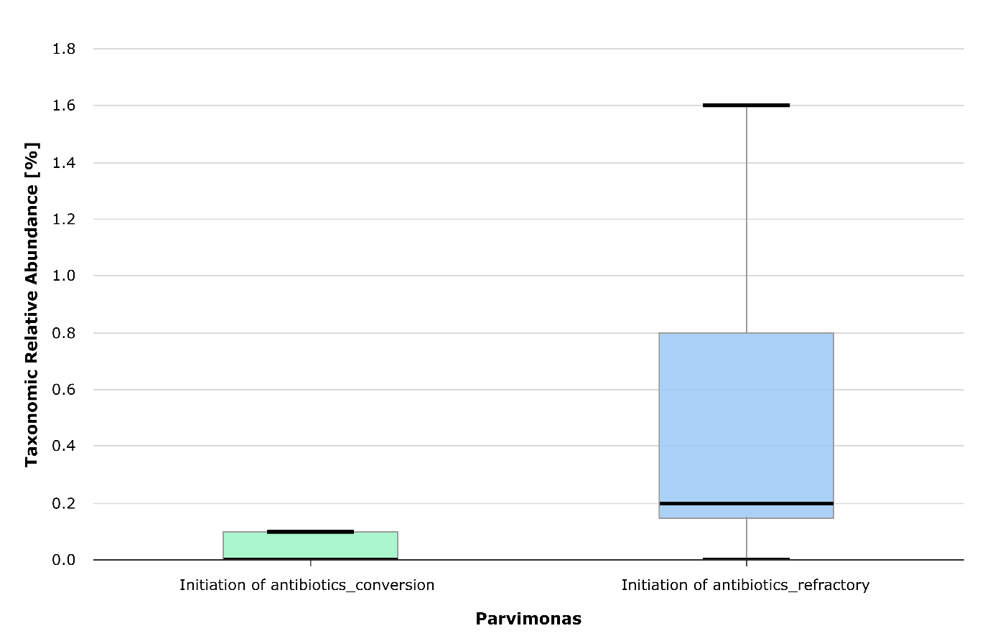

(E) Haemophilus parainfluenzae group (Wilcoxon rank-sum test, p = 0.013)
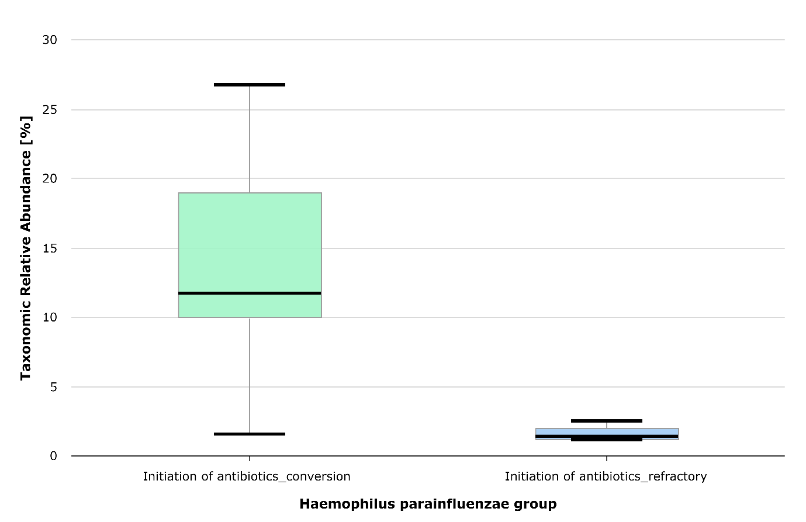
Supplementary Figure S5. Difference in bacterial species richness of sputum at treatment initiation between the treatment-success patients (n = 7) and the treatment-refractory patients (n = 7) (Jackknife, Wilcoxon rank-sum test, p = 0.035).
