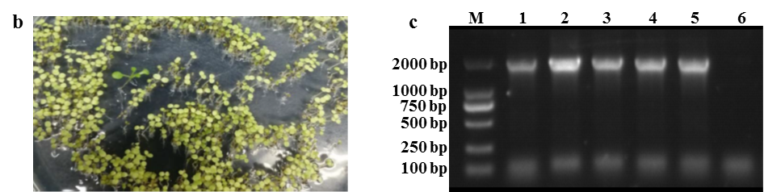

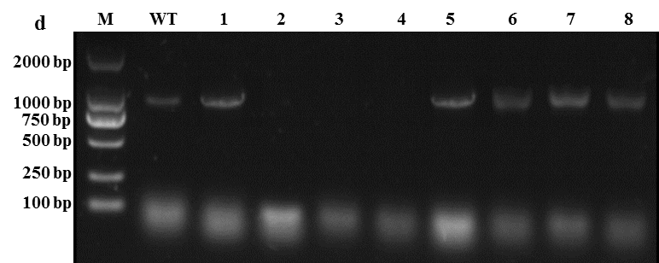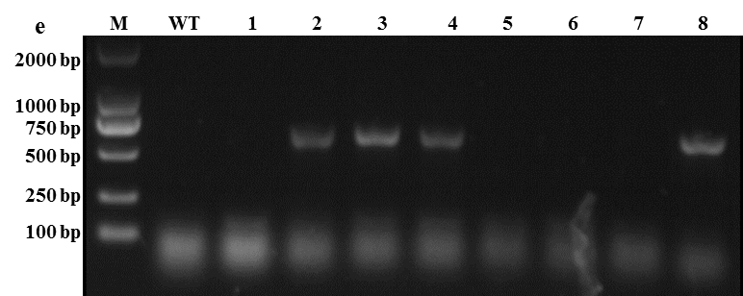
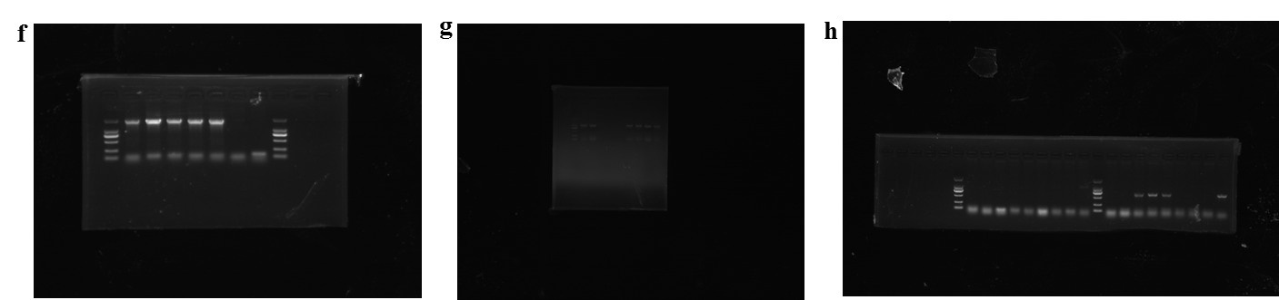
Figure S3. The Identifications for homozygous PsMDL2-overexpressing plants and mdl2 mutant lines of Arabidopsis. (a) Construction of plant expression vector of pBI121/CaMV35S::PsMDL2 used for transgenic Arabidopsis. (b) Screening of Kan resistance for transgenic Arabidopsis with PsMDL2 overexpression. (c) PCR detection for the homozygous plants of transgenic Arabidopsis with PsMDL2 overexpression. M represented DNA marker, lines 1-5 were homozygous plants of transgenic Arabidopsis, and line 6 was identified as the WT. (d) PCR amplification using both LP and RP primers. (e) PCR amplification using both BP and RP primers. M represented DNA marker, WT was used as the control, lines 5-7 was identified as the WT, line 8 was heterozygous mutants, and the others were homozygous mutants. (f) The original full-length gel image matched to the cropped version in Figure S3c. (g) The original full-length gel image matched to the cropped version in Figure S3d. (g) The original full-length gel image matched to the cropped version in Figure S3e.

