Supplemental Material:

Blockade of the platelet-driven CXCL7-CXCR1/2 inflammatory axis prevents murine cerebral aneurysm formation and rupture

Kamil W. Nowicki, MD, PhD,¹ Aditya Mittal, BS,¹ Joseph S. Hudson, MD,¹ Michael P. D’Angelo, MD,² Michael M. McDowell, MD,¹ Catherine Cao,¹ Rohit Mantena,¹ Abhishek Jauhari, PhD¹, Robert M. Friedlander, MD, MA¹

1. Department of Neurological Surgery, University of Pittsburgh School of Medicine, Pittsburgh, PA
2. Department of Radiology, University of Pittsburgh School of Medicine, Pittsburgh, PA

Expanded Methods:

Animals
All animal experimentation was performed under an Institutional Animal Care and Use Committee-approved protocol.

Mouse Intracranial Aneurysm Model
Murine intracranial aneurysms were created in female 8-12 week-old C57BL/6 mice (Charles River Laboratories, Wilmington, MA) using a method described previously and the scheme is shown in Supplementary Figure 1. Experimental scheme using different small molecule inhibitors is shown in Supplementary Figure 2.

Immunohistochemistry of Mouse and Human Aneurysm Specimens
Murine aneurysm specimens were first fixed in 4% PFA for 24 hours, and then dehydrated in 18% sucrose solution. Tissues were mounted in Tissue-Tek OCT compound (Sakura Finetek USA, Torrance, CA) and sectioned at 5 μm. Heat mediated antigen retrieval in Dako Target Retrieval Solution (Dako, Carpinteria, CA) was performed for all murine immunohistochemistry studies. Following a block in 2% normal horse serum (S-2000, Vector Labs) for 1 hour, the specimens were incubated with rat anti-MECA-32 antibody (BD 550563, BD Biosciences, San Jose, CA) to visualize endothelial cells, rabbit anti-CXCL1/GRO-α antibody (ab86436, Abcam), overnight at 4 ºC, and washed. For immunohistochemistry of human aneurysm samples, the tissues were fixed in 4% PFA and embedded in paraffin. After tissue sectioning at 5 μm, the samples were de-paraffinized by xylene and ethanol. Heat mediated antigen retrieval in 10 μM Sodium Citrate buffer pH 6.5 for all samples was performed. The staining protocol for CXCL1/GRO-α was then followed exactly as for immunohistochemistry of mouse aneurysm specimens except that mouse anti-human CD31 antibody (IR61061-2, Dako) was used in place of MECA-32 to visualize the endothelial cell layer. The secondary antibodies used were Alexa Fluor 488 donkey anti-rat antibody (A-21208, Life Technologies), Alexa Fluor 488 donkey anti-rabbit antibody (A-21206, Life Technologies), Alexa Fluor 568 donkey anti-rabbit antibody (A-21206, Life Technologies), and Alexa Fluor 594 donkey anti-mouse antibody (A-21203, Life Technologies) and were incubated for 1 hour at room temperature. Finally, for both murine and human specimens, nuclei were counterstained with DAPI (H-1200, Vector Labs, Burlingame, CA).

Blood Pressure Measurements in the Mouse Intracranial Aneurysm Model
Blood pressure measurements in the intracranial model was performed via the tail-cuff method using CODA Noninvasive Blood Pressure System with 4 activated channels (Kent Scientific, Torrington, CT 06790, USA). Systolic blood pressure measurements were not found to be significantly different across different at 2 weeks between different groups (Supplementary Figure 4).

Statistical Analysis

REACTOME Data Model Analysis
In silico analysis of in vitro data using REACTOME data model was used to evaluate for network of 718 biological interactions.^{1,2} All non-human interactors were converted to their human equivalents. IntAct interactors were included to expand background analysis. Pathways and interactions with p-values < 0.01 were considered as marginally significant, < 0.0027 as significant (3-sigma), and < 0.00006 as highly significant (5-sigma) (Supplementary Figure 5).

References:

1. Griss J, Viteri G, Sidiropoulos K, Nguyen V, Fabregat A, Hermjakob H. ReactomeGSA - Efficient Multi-Omics Comparative Pathway Analysis. Mol Cell Proteomics. 2020 Sep 9. doi: 10.1074/mcp. PubMed PMID: 32907876.

2. Sidiropoulos K, Viteri G, Sevilla C, Jupe S, Webber M, Orlic-Milacic M, Jassal B, May B, Shamovsky V, Duenas C, Rothfels K, Matthews L, Song H, Stein L, Haw R, D'Eustachio P, Ping P, Hermjakob H, Fabregat A. Reactome enhanced pathway visualization. Bioinformatics. 2017 Nov 1;33(21):3461-3467. doi: 10.1093/bioinformatics/btx441. PubMed PMID: 29077811.

Tables:
Supplementary Table 1. Patient Demographics and Characteristics

Variable | Cerebral Aneurysm Patients | Control Patients | p-value
Total Patients, n | 21 | 19
Age, mean, median +/- (Interquartile Range) | 54.5, 55 +/- 6.75 | 54.3, 55 +/- 13 | 0.96
Female Sex, n (%) | 13 (61.9%) | 11 (57.9%) | >0.999
Current or Former Smoker, n (%) * | 12 out of 21 (57.1%) | 5 out of 8 (62.5%) | >0.999
Aspirin Use, n (%) | 3 (14.3%) | 2 (10.5%) | >0.999
Size in maximum dimension (mm), mean (Standard Deviation) | 6.8 +/- 3.6 | N/A | N/A
Ruptured Aneurysms, n (%) | 2 out of 21 (9.5%) | N/A | N/A

*tobacco use status was only recorded for 8 out of the 19 control patients

Figures:

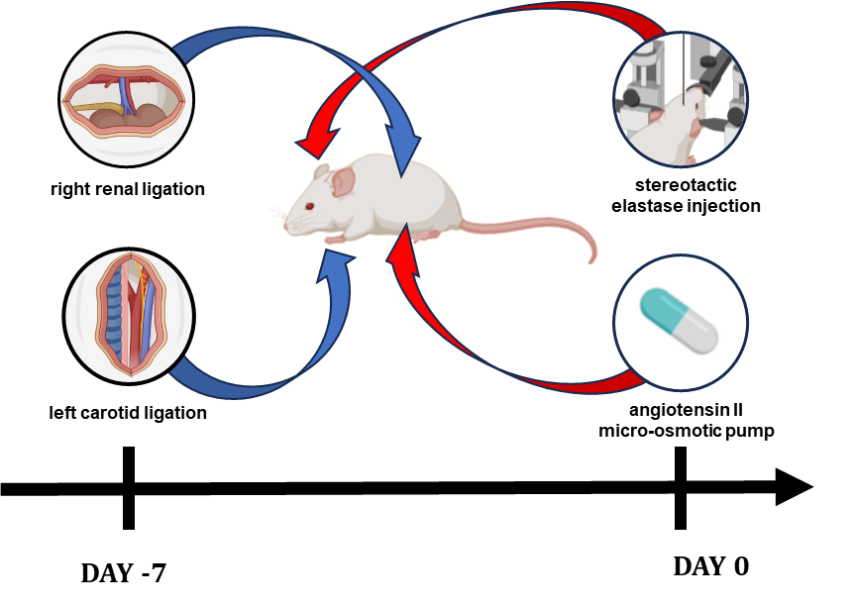

Supplementary Figure 1. Murine intracranial aneurysm model.
The model requires four surgeries on two separate days. First, on day -7, the left common carotid artery and the right renal artery are ligated to induce hypertension. One week later, an Alzet micro-osmotic pump model 1004 is implanted subdermally to deliver Angiotensin II at 1000ng/kg/min, and 10 uL of 0.8% porcine elastase in normal saline is injected into the right basal cistern using stereotactic coordinates: 1.2 mm rostral of bregma, 0.7 mm lateral of midline and 5.3 mm ventral of the dorsal aspect of the skull. The animals are then fed a high-fat (50%) hypertensive diet with 8% NaCl and 0.12% BAPN for the remainder of the experimental period. Created with BioRender.com.

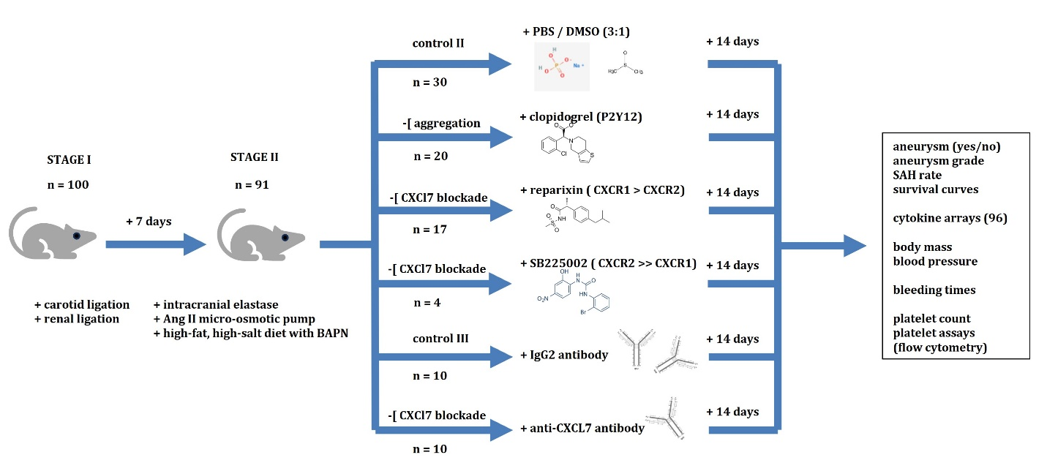

Supplementary Figure 2. Treatment scheme for the murine cerebral aneurysm formation model.

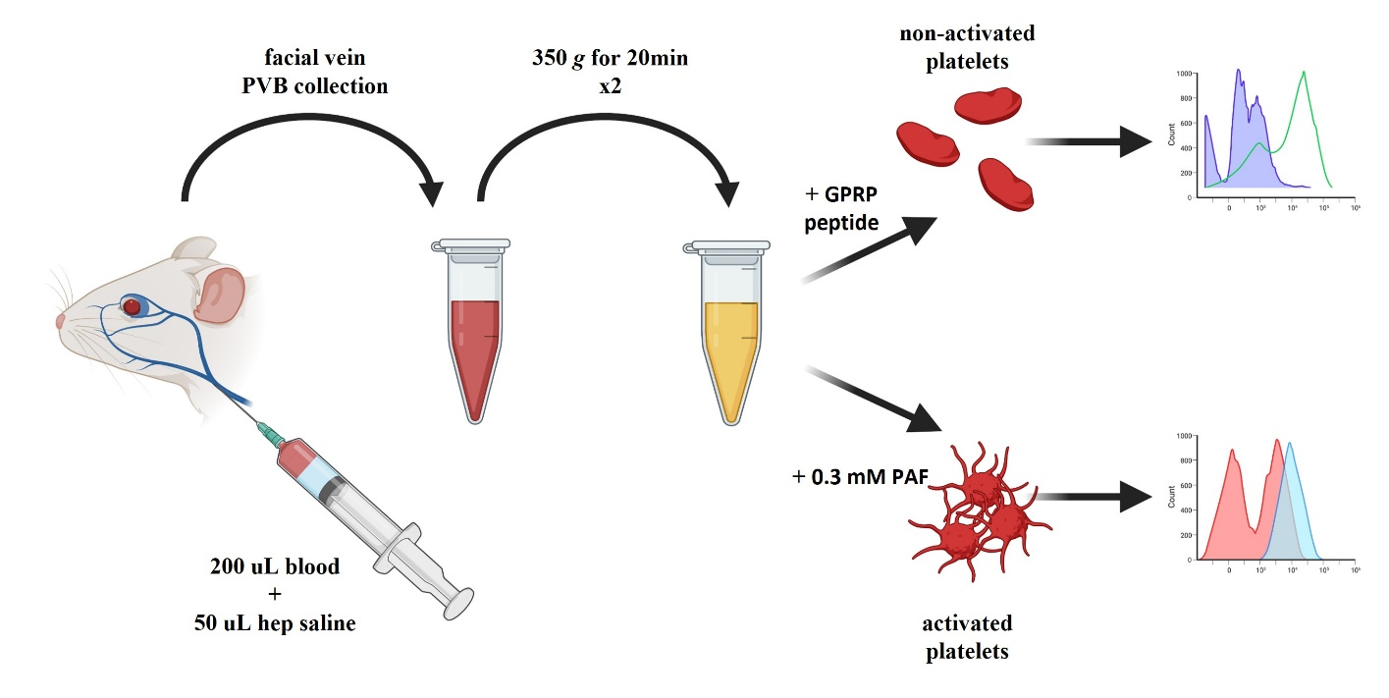
Supplementary Figure 3. Peripheral blood collection scheme and platelet isolation for functional assays. Created with BioRender.com.

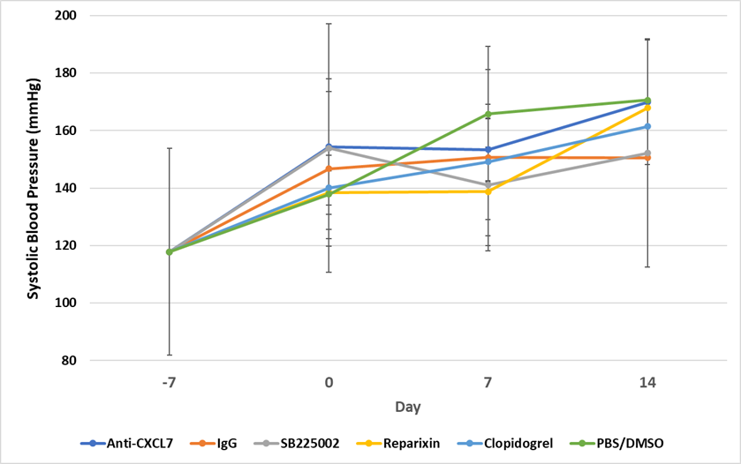

Supplementary Figure 4. Systolic blood pressure measurements.
No significant differences were noted between different treatment regimens at 2 weeks post aneurysm induction.

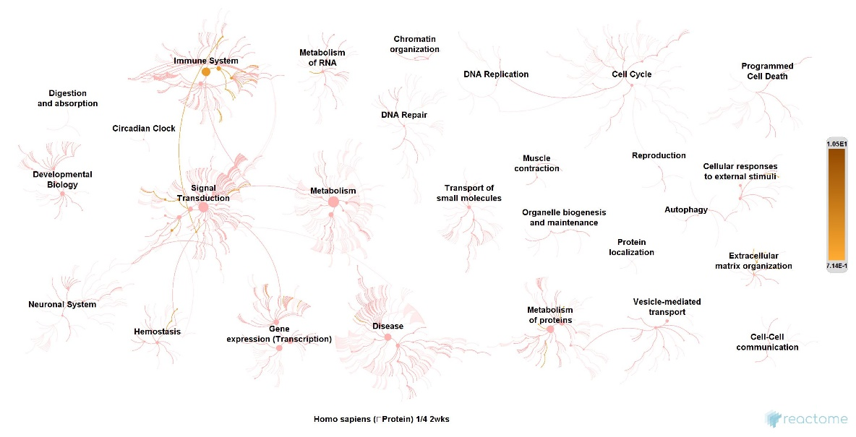
Supplementary Figure 5. REACTOME analysis
Analysis in silico using REACTOME was used to evaluate for network of 718 biological interactions. Pathways with p-values < 0.01 were considered as marginally significant, < 0.0027 as significant (3-sigma), and < 0.00006 as highly significant (5-sigma). Downstream target interactions implicated platelet activation and degranulation, NLRP3 inflammasome, oxidative damage, and interactions with lipid metabolism.

