Supporting Information
Cobalt-Catalyzed Cross-Electrophile Coupling of Alkynyl Sulfides with Unactivated Chlorosilanes
Donghui Xing, Jinlin Liu, Dingxin Cai, Bin Huang, Huanfeng Jiang, Liangbin Huang*
State Key Laboratory of Pulp & Paper Engineering, Key Laboratory of Functional Molecular Engineering of Guangdong Province, School of Chemistry and Chemical Engineering, South China University of Technology, Guangzhou 510640, China.
E-mail: huanglb@scut.edu.cn.

Table of Contents
1. General Information 1
2. Optimization of Reaction Conditions 2
2.1 General Procedure for the Optimization Reactions 2
Table S1: Screening of Additives 3
Table S2: Screening of Solvents 4
Table S3: Screening of Ligands 5
Table S4: Screening of Cobalt Catalysts 6
Table S5: Screening of Other Reaction Parameters. 7
3. Synthesis of Substrates 8
3.1. Synthesis of Alkynyl Sulfides 8
3.2. Synthesis of Chlorosilanes 20
4. Experimental Procedures and Characterization of Products 21
4.1. General Procedure F 21
4.2. Characterization Data of Products 21
4.3. Gram-Scale Experiment 49
4.4. Product Derivatizations 49
5. Mechanistic studies 54
5.1. Radical trapping experiments 54
5.2. Radical clock experiment 54
5.3. Control experiments 55
6. NMR Spectra 57
7. Reference 176

1. General Information
Reagents and Solvents
Unless otherwise noted, all chemicals used in the preparation of starting materials were commercially available and were used as received without further purifications. Metal catalysts and ligands were purchased from Acros, Laajoo, Energy Chemical, Bidepharm, and Accela. Other chemicals were purchased from Macklin, Adamas, and Innochem, and were directly used without further purifications.
Anhydrous solvents were purchased from Energy Chemical and Innochem. Toluene was distilled from sodium/benzophenone and stored under nitrogen before use.
Analytical Methods
¹H, ¹³C and ¹⁹F NMR spectra were recorded using a Bruker DRX-400 spectrometer or a Bruker DRX-500 spectrometer using CDCl₃ as solvent. The chemical shifts are referenced to signals at 7.26 and 77.0 ppm, respectively, and chloroform is solvent with TMS as the internal standard. Chemical shifts are reported in parts per million (ppm), multiplicities are indicated by s (singlet), d (doublet), t (triplet), q (quartet), m (multiplet) and br (broad). Coupling constants (J) are reported in Hertz. Melting points were measured using a melting point instrument. Mass spectra were recorded on a Thermo Scientific ISQ gas chromatograph-mass spectrometer. GC analyses were performed on an Agilent 7890B GC equipped with HP-5 columns (30 m × 320 μm × 0.25 μm), FID detectors, and hydrogen as the carrier gas. GC/MS analyses were performed on a Shimadzu GCMS-QP2010SE equipped with an RTX-5MS column (30 m × 0.25 mm × 0.25 μm) with a quadrupole mass analyzer using helium as the carrier gas. TLC was performed by using commercially prepared 100-400 mesh silica gel plates and visualization was effected at 254 nm.

2. Optimization of Reaction Conditions

2.1 General Procedure for the Optimization Reactions
The procedure was conducted in a nitrogen-filled glove box. To a reaction vial equipped with a magnetic stir bar was added the indicated catalyst (10 mol%), ligand (15 mol%), and reductant (0.20 mmol, 2.0 equiv). A solution of substrate 1a (17.8 mg, 0.10 mmol, 1.0 equiv) and TMSCl (32.6 mg, 0.30 mmol, 3.0 equiv) in 1.0 mL of the indicated solvent was then added by syringe, and the resultung mixture was maintained with stirring at room temperature for 4-6 h. After the indicated reaction time, the mixture was diluted with EtOAc (10 mL) and washed with water. The organic phase was then dried over anhydrous Na₂SO₄, filtered, and concentrated in vacuo. The residue was dissolved with 2 mL EtOAc and subjected to GC analysis with dodecane as the internal standard.

Table S1: Screening of Additives
Entry | additive | Yield (%)^{[a,b]}
1 | -- | 43
2 | NaI | 38
3 | LiI | 36
4 | LiBr | 40
5 | LiCl | 41
6 | MgCl₂ | 35
7 | MgBr₂ | 37
8 | ZnCl₂ | 33
9 | ZnI₂ | 31
^{[a]} All reactions were performed on a 0.10 mmol scale. ^{[b]} Yield was determined by GC analysis with dodecane as an internal standard.

Table S2: Screening of Solvents
Entry | Solvent | Yield (%)^{[a,b]}
1 | DMF | 43
2 | DMA | 31
3 | NMP | 39
4 | DMSO | n.d.
5 | MeCN | trace
6 | DCE | n.d.
7 | THF | trace
8 | dioxane | n.d.
9 | toluene | n.d.
10 | hexane | n.d.
^{[a]} All reactions were performed on a 0.10 mmol scale. ^{[b]} Yield was determined by GC analysis with dodecane as an internal standard.

Table S3: Screening of Ligands
^{[a]} All reactions were performed on a 0.10 mmol scale. ^{[b]} Yield was determined by GC analysis with dodecane as an internal standard.

Table S4: Screening of Cobalt Catalysts
Entry | [Co] | Yield (%)^{[a,b]}
1 | CoI₂ | 87
2 | CoBr₂ | 38
3 | CoCl₂ | 69
4 | Co(acac)₂ | 70
5 | Co(acac)₃ | 73
6 | Co(OAc)₂ | 72
^{[a]} All reactions were performed on a 0.10 mmol scale. ^{[b]} Yield was determined by GC analysis with dodecane as an internal standard.

Table S5: Screening of Other Reaction Parameters.
Entry | Variations | Yield (%)^{[a,b]}
1 | none | 87(85)^{[c]}
2 | 0 °C instead of rt | n.d.
3 | 70 °C instead of rt | 72
4 | Mn instead of Zn | n.d.
5 | Mn instead of Zn | 67^{[d]}
6 | Mn instead of Zn | 35^{[e]}
7 | w/o Zn | n.d.
8 | w/o CoI₂ | n.d.
9 | w/o tpy | n.d.
10 | 2 equiv TMSCl | 86
11 | 3 equiv Zn | 82
12 | DMF(0.2M) | 47
13 | NiI₂ | 45
14 | Fe(acac)₂ | n.d.
15 | CrCl₂ | 29
^{[a]} All reactions were performed on a 0.10 mmol scale. ^{[b]} Yield was determined by GC analysis with dodecane as an internal standard. ^{[c]} Isolated yield after flash chromatography on silica gel. ^{[d]} Using 1 equiv ZnI₂ as the additive. ^{[e]} Using 1 equiv Zn(OTf)₂ as the additive; n.d. = no detected; w/o = without.

3. Synthesis of Substrates

3.1. Synthesis of Alkynyl Sulfides
The alkynyl sulfides used in this paper:
All the substrates above were synthesized according to the literature reports.^{[1]} All spectroscopic data of known molecules match those previously reported in the literature. Some new alkynyl sulfides were synthesized with the following procedures.
General Procedure A (Most of the substrates were synthesized by this method)
According to our previous literature procedure^{[1b]}, the respective 1,2,3-thiadiazole (1.0 equiv), K₃PO₄ (2.0 equiv) and MeI (2.0 equiv) were suspended in MeCN at room temperature and stirred for 24 h at 70 ºC. The mixture was quenched by 1N-HCl. Then the reaction mixture was diluted with ethyl acetate, washed with water, the organic phases were dried over anhydrous Na₂SO₄, filtered and concentrated in vacuum. The residue was purified by flash column chromatography on silica gel with petroleum ether/ethyl acetate as the eluent to afford the corresponding products.
General Procedure B
According to a literature procedure^{[1c]}, the respective (hetero)aryl iodide (1.0 equiv), Pd(PPh₃)Cl₂ (1 mol%), CuI (10 mol%) and K₂CO₃ (6.0 equiv) were added to a Schlenk flask equipped with a PTFE-coated stir bar under argon. 1-methylthio-2-(trimethylsilyl)-ethyne (1.2 equiv) and solvent MeOH/Et₃N/THF (0.25 M, 1:2:2 v:v:v) were added and the reaction mixture was stirred for 16 h at rt. Upon completion, the reaction mixture was filtered, concentrated in vacuo and the crude material was purified by column chromatography on silica gel to afford the desired products.
General Procedure C
According to a literature procedure^{[1e]}, a mixture of arylacetylene (1.0 equiv), TolSO₂SMe (1.5 equiv), CuI (5.0 mol %), Xantphos (6.0 mol %), and K₂CO₃ (1.5 equiv) was suspended in DMSO at room temperature and stirred for 24 h at the same temperature. After filtration of the mixture through a pad of Celite, the filtrate was concentrated under reduced pressure. To the residue was added ethyl acetate and the mixture was washed with aqueous saturated solution of sodium bicarbonate and brine, and then dried (Na₂SO₄). After filtration, the filtrate was concentrated under reduced pressure. The crude residue was purified by column chromatography using silica gel with petrol ether/ethyl acetate as the eluent to afford the corresponding products.
General Procedure D
According to a literature procedure^{[2]}, a suspension of methyl 4-((methylthio)ethynyl)benzoate (1.0 equiv) in a 1:1 mixture of MeOH/H₂O (40 mL) was treated with NaOH (3.0 equiv). The mixture was stirred at 40 ºC for 2 h. The mixture was then diluted with H₂O and the MeOH was mostly removed in vacuo. The H₂O solution was washed with ether, acidified to pH 1 with 2 M HCl solution and extracted with EtOAc. The combined EtOAc extracts were washed with brine, dried over MgSO₄, and concentrated in vacuo to give corresponding carboxylic acid as a white solid.
General Procedure E
According to a literature procedure^{[3]}, to a 50 mL heat-gun dried round bottom flask were added 10 mL dry methylene chloride (DCM), 4-((methylthio)ethynyl)benzoic acid (1.0 equiv). The round bottom flask with the DCM and 4-((methylthio)ethynyl)benzoic acid were posed into an ice bath. Then oxalyl chloride (1.1 equiv) and two drops DMF were added into the flask. The gas formation was observed. The mixture remained stirring for another 1 hour at room temperature. Then desired coupling amine or alcohol (1.1 equiv), NEt₃ (1.1 equiv) in 3 mL DCM were added into the previous mixture dropwise at 0 ºC. After the addition, the mixture were kept stirring for another 8 hours at room temperature. The mixture was concentrated in vacuo, the residue was directly purified by flash column chromatography on silica gel to give the desired product (amide or ester).
Characterization of New Alkynyl Sulfides
((4-(benzyloxy)phenyl)ethynyl)(methyl)sulfane (1b)
It’s synthesized according to general procedure A. White solid, 73% yield (flash column chromatography eluent, petrol ether/ ethyl acetate = 100/1).
¹H NMR (400 MHz, Chloroform-d) δ 7.78 – 7.25 (m, 7H), 6.94 (s, 2H), 5.09 (s, 2H), 2.48 (s, 3H).
¹³C NMR (101 MHz, Chloroform-d) δ 158.7, 136.5, 133.4, 128.6, 128.1, 127.4, 115.7, 114.8, 79.1, 70.0, 19.5.
Melting point: 63-64 °C
HRMS-ESI (m/z): [M+H]⁺ Calcd for C₁₆H₁₅OS 255.0838; Found: 255.0833.

4-((methylthio)ethynyl)phenyl acetate (1f)
It’s synthesized according to general procedure A. Yellow oil, 63% yield (flash column chromatography eluent, petrol ether/ ethyl acetate = 50/1).
¹H NMR (500 MHz, Chloroform-d) δ 7.33 (d, J = 8.6 Hz, 2H), 6.95 (d, J = 8.6 Hz, 2H), 2.37 (s, 3H), 2.19 (s, 3H).
¹³C NMR (126 MHz, Chloroform-d) δ 169.0, 150.2, 132.5, 121.5, 120.9, 90.9, 81.0, 21.0, 19.2.
HRMS-ESI (m/z): [M+H]⁺ Calcd for C₁₁H₁₁O₂S 207.0474; Found: 207.0471.

methyl((4-(trifluoromethoxy)phenyl)ethynyl)sulfane (1g)
It’s synthesized according to general procedure A. Yellow oil, 88% yield (flash column chromatography eluent, petrol ether/ ethyl acetate = 100/1).
¹H NMR (500 MHz, Chloroform-d) δ 7.42 (d, J = 8.8 Hz, 2H), 7.13 (d, J = 8.1 Hz, 2H), 2.47 (s, 3H).
¹³C NMR (126 MHz, Chloroform-d) δ 148.7, 132.9, 122.2, 120.8, 120.4 (q, J = 257.7 Hz), 90.5, 82.2, 19.3.
¹⁹F NMR (471 MHz, Chloroform-d) δ -57.85.
HRMS-ESI (m/z): [M+H]⁺ Calcd for C₁₀H₈F₃OS 233.0242; Found: 233.0239.

N,N-dimethyl-4-((methylthio)ethynyl)benzamide (1o)
It’s synthesized according to general procedure E. White solid, 51% yield (flash column chromatography eluent, petrol ether/ ethyl acetate = 5/1).
¹H NMR (500 MHz, Chloroform-d) δ 7.41 – 7.34 (m, 2H), 7.33 – 7.27 (m, 2H), 3.04 (s, 3H), 2.91 (s, 3H), 2.44 (s, 3H).
¹³C NMR (126 MHz, Chloroform-d) δ 170.7, 135.3, 130.9, 127.0, 124.6, 91.1, 82.7, 39.3, 35.2, 19.2.
Melting point: 69-70 °C
HRMS-ESI (m/z): [M+H]⁺ Calcd for C₁₂H₁₄NOS 220.0791; Found: 220.0788.

4-((methylthio)ethynyl)benzoic acid (1p)
It’s synthesized according to general procedure D. White solid, 96% yield.
¹H NMR (500 MHz, DMSO-d₆) δ 13.07 (s, 1H), 7.93 (d, J = 7.4 Hz, 2H), 7.52 (d, J = 7.5 Hz, 2H), 2.55 (s, 3H).
¹³C NMR (126 MHz, DMSO-d₆) δ 166.8, 130.9, 130.1, 129.6, 127.0, 91.1, 85.4, 19.0.
Melting point: 209-210 °C
HRMS-ESI (m/z): [M-H]⁺ Calcd for C₁₀H₇O₂S 191.0172; Found: 191.0164.

((4-ethynylphenyl)ethynyl)(methyl)sulfane (1r)
It’s synthesized according to general procedure B. Yellow oil, 78% yield (flash column chromatography eluent, petrol ether/ ethyl acetate = 100/1).
¹H NMR (500 MHz, Chloroform-d) δ 7.41 (d, J = 8.4 Hz, 2H), 7.34 (d, J = 8.5 Hz, 2H), 3.15 (s, 1H), 2.48 (s, 3H).
¹³C NMR (126 MHz, Chloroform-d) δ 132.0, 131.1, 123.9, 121.5, 91.4, 83.5, 83.2, 78.8, 19.3.
HRMS-ESI (m/z): [M+H]⁺ Calcd for C₁₁H₉S 173.0419; Found: 173.0418.

6-((methylthio)ethynyl)quinoline (1ae)
It’s synthesized according to general procedure B. Brown solid, 68% yield (flash column chromatography eluent, petrol ether/ ethyl acetate = 100/1).
¹H NMR (400 MHz, Chloroform-d) δ 8.89 – 8.80 (m, 1H), 8.07 – 7.93 (m, 2H), 7.87 – 7.78 (m, 1H), 7.68 – 7.59 (m, 1H), 7.40 – 7.28 (m, 1H), 2.48 (s, 3H).
¹³C NMR (101 MHz, Chloroform-d) δ 150.7, 147.3, 135.5, 131.8, 130.5, 129.4, 127.8, 121.6, 91.5, 82.7, 19.3.
Melting point: 38-39 °C
HRMS-ESI (m/z): [M+H]⁺ Calcd for C₁₂H₁₀NS 200.0528; Found: 200.0527.

5-((methylthio)ethynyl)benzo[b]thiophene (1ah)
It’s synthesized according to general procedure A. Yellow oil, 83% yield (flash column chromatography eluent, petrol ether/ ethyl acetate = 100/1).
¹H NMR (500 MHz, Chloroform-d) δ 7.91 – 7.87 (m, 1H), 7.79 (d, J = 8.3 Hz, 1H), 7.46 (d, J = 5.4 Hz, 1H), 7.38 (dd, J = 8.4, 1.6 Hz, 1H), 7.29 (d, J = 5.4 Hz, 1H), 2.50 (s, 3H).
¹³C NMR (126 MHz, Chloroform-d) δ 139.46, 139.45, 127.32, 127.26, 126.9, 123.6, 122.3, 119.2, 92.0, 80.2, 19.4.
HRMS-ESI (m/z): [M+H]⁺ Calcd for C₁₁H₉S₂ 205.0140; Found: 205.0139.

9-methyl-2-((methylthio)ethynyl)-9H-carbazole (1ai)
It’s synthesized according to general procedure B. Yellow oil, 60% yield (flash column chromatography eluent, petrol ether/ ethyl acetate = 100/1).
¹H NMR (500 MHz, Chloroform-d) δ 8.07 (d, J = 1.1 Hz, 1H), 7.91 (d, J = 7.7 Hz, 1H), 7.42 (dd, J = 8.4, 1.6 Hz, 1H), 7.38 – 7.33 (m, 1H), 7.21 (d, J = 8.2 Hz, 1H), 7.14 – 7.11 (m, 2H), 3.61 (s, 3H), 2.39 (s, 3H).
¹³C NMR (126 MHz, Chloroform-d) δ 141.2, 140.5, 129.6, 126.1, 124.4, 122.5, 122.2, 120.3, 119.3, 113.2, 108.6, 108.3, 93.0, 78.1, 29.0, 19.6.
HRMS-ESI (m/z): [M+H]⁺ Calcd for C₁₆H₁₄NS 252.0841; Found: 252.0837.

2-((methylthio)ethynyl)dibenzo[b,d]furan (1aj)
It’s synthesized according to general procedure A. White solid, 51% yield (flash column chromatography eluent, petrol ether/ ethyl acetate = 100/1).
¹H NMR (400 MHz, Chloroform-d) δ 8.08 – 8.01 (m, 1H), 7.91 (d, J = 7.6 Hz, 1H), 7.57 – 7.44 (m, 4H), 7.35 (t, J = 7.8 Hz, 1H), 2.52 (s, 3H).
¹³C NMR (101 MHz, Chloroform-d) δ 156.5, 155.7, 130.9, 127.6, 124.4, 124.2, 123.5, 123.0, 120.7, 117.9, 111.7, 111.7, 91.8, 79.7, 19.4.
Melting point: 63-64 °C
HRMS-ESI (m/z): [M+H]⁺ Calcd for C₁₅H₁₁OS 239.0525; Found: 239.0521.

5,6-dimethoxy-2-((1-(4-((methylthio)ethynyl)benzoyl)piperidin-4-yl)methyl)-2,3-dihydro-1H-inden-1-one (1ak)
It’s synthesized according to general procedure E. White solid, 74% yield (flash column chromatography eluent, petrol ether/ ethyl acetate = 3/1).
¹H NMR (500 MHz, Chloroform-d) δ 7.43 (d, J = 8.3 Hz, 2H), 7.34 (d, J = 8.3 Hz, 2H), 7.17 (s, 1H), 6.87 (s, 1H), 4.70 (s, 1H), 3.94 (d, J = 28.9 Hz, 6H), 3.84 – 3.64 (m, 1H), 3.33 – 3.23 (m, 1H), 3.02 (s, 1H), 2.86 – 2.66 (m, 3H), 2.49 (s, 3H), 2.01 – 1.58 (m, 5H), 1.46 – 1.29 (m, 2H).
¹³C NMR (126 MHz, Chloroform-d) δ 207.3, 169.5, 155.5, 149.4, 148.5, 135.4, 131.1, 129.0, 126.9, 124.6, 107.2, 104.2, 91.2, 82.7, 56.2, 56.0, 47.9, 44.9, 42.4, 38.5, 34.5, 33.3, 32.3, 31.3, 19.3.
Melting point: 133-134 °C
HRMS-ESI (m/z): [M+H]⁺ Calcd for C₂₇H₃₀NO₄S 490.2408; Found: 490.2403.

(4-(8-chloro-5,6-dihydro-11H-benzo[5,6]cyclohepta[1,2-b]pyridin-11-ylidene)piperidin-1-yl)(4-((methylthio)ethynyl)phenyl)methanone (1al)
It’s synthesized according to general procedure E. White solid, 83% yield (flash column chromatography eluent, petrol ether/ ethyl acetate = 1/1).
¹H NMR (500 MHz, Chloroform-d) δ 8.28 (s, 1H), 7.46 – 7.24 (m, 5H), 7.13 – 6.95 (m, 4H), 4.20 – 3.95 (m, 1H), 3.55 (s, 1H), 3.36 – 3.10 (m, 4H), 2.78 – 2.68 (m, 2H), 2.54 – 2.17 (m, 7H).
¹³C NMR (126 MHz, Chloroform-d) δ 169.7, 156.4, 146.4, 139.4, 137.6, 136.0, 134.8, 134.4, 133.2, 131.9, 131.4, 131.0, 130.2, 128.8, 126.7, 126.0, 124.7, 122.2, 91.1, 82.9, 48.3, 43.1, 31.4, 31.3, 30.2, 19.1, 17.0.
Melting point: 91-92 °C
HRMS-ESI (m/z): [M+H]⁺ Calcd for C₂₉H₂₆ClN₂OS 511.1967; Found: 511.1964.

3,7-dimethyloct-6-en-1-yl 4-((methylthio)ethynyl)benzoate compound with 4-((methylthio)ethynyl)phenyl 5-(2,5-dimethylphenoxy)-2,2-dimethylpentanoate (1:1) (1ao)
It’s synthesized according to general procedure B. Yellow oil, 46% yield (flash column chromatography eluent, petrol ether/ ethyl acetate = 20/1).
¹H NMR (500 MHz, Chloroform-d) δ 7.41 (d, J = 6.8 Hz, 2H), 7.00 (d, J = 7.4 Hz, 1H), 6.97 (d, J = 6.9 Hz, 2H), 6.67 (d, J = 7.3 Hz, 1H), 6.62 (s, 1H), 3.98 (s, 2H), 2.48 (d, J = 1.8 Hz, 3H), 2.31 (s, 3H), 2.17 (s, 3H), 1.87 (s, 4H), 1.36 (s, 6H).
¹³C NMR (126 MHz, Chloroform-d) δ 176.1, 156.8, 150.7, 136.5, 132.6, 130.3, 123.6, 121.6, 120.8, 120.7, 111.9, 91.0, 80.9, 67.7, 42.5, 37.1, 25.2, 25.1, 21.4, 19.3, 15.8.
HRMS-ESI (m/z): [M+H]⁺ Calcd for C₂₄H₂₉O₃S 357.2244; Found: 357.2240.

(3S,8S,9S,10R,13R,14S,17R)-10,13-dimethyl-17-((R)-6-methylheptan-2-yl)-2,3,4,7,8,9,10,11,12,13,14,15,16,17-tetradecahydro-1H-cyclopenta[a]phenanthren-3-yl 4-((methylthio)ethynyl)benzoate (1ap)
It’s synthesized according to general procedure E. White solid, 50% yield (flash column chromatography eluent, petrol ether/ ethyl acetate = 20/1).
¹H NMR (500 MHz, Chloroform-d) δ 7.95 (d, J = 8.3 Hz, 2H), 7.42 (d, J = 8.2 Hz, 2H), 5.45 – 5.37 (m, 1H), 4.89 – 4.79 (m, 1H), 2.49 (s, 3H), 2.45 (d, J = 7.7 Hz, 2H), 2.04 – 1.95 (m, 3H), 1.90 (d, J = 13.4 Hz, 1H), 1.86 – 1.79 (m, 1H), 1.78 – 1.62 (m, 2H), 1.59 – 1.44 (m, 6H), 1.35 (dd, J = 15.3, 8.3 Hz, 3H), 1.24 – 1.08 (m, 7H), 1.06 (s, 3H), 1.03 – 0.96 (m, 3H), 0.92 (d, J = 6.5 Hz, 3H), 0.87 (dd, J = 6.6, 2.1 Hz, 6H), 0.68 (s, 3H).
¹³C NMR (126 MHz, Chloroform-d) δ 165.4, 139.5, 130.7, 129.7, 129.4, 127.8, 122.8, 91.6, 84.8, 74.7, 56.6, 56.1, 50.0, 42.3, 39.9, 39.5, 38.2, 37.0, 36.6, 36.2, 35.8, 31.89, 31.82, 28.2, 28.0, 27.8, 24.3, 23.8, 22.8, 22.5, 21.0, 19.3, 18.7, 11.8.
Melting point: 132-133 °C
HRMS-ESI (m/z): [M+H]⁺ Calcd for C₃₇H₅₃O₂S 587.4279; Found: 587.4275.

((2-bromophenyl)ethynyl)(methyl)sulfane (1as)
It’s synthesized according to general procedure A. Yellow oil, 91% yield (flash column chromatography eluent, petrol ether/ ethyl acetate = 100/1).
¹H NMR (500 MHz, Chloroform-d) δ 7.59 – 7.53 (m, 1H), 7.41 (dd, J = 7.7, 1.5 Hz, 1H), 7.25 – 7.20 (m, 1H), 7.15 – 7.09 (m, 1H), 2.52 (s, 3H).
¹³C NMR (126 MHz, Chloroform-d) δ 132.7, 132.3, 128.9, 126.9, 125.5, 124.9, 90.6, 86.5, 19.4.
HRMS-ESI (m/z): [M+H]⁺ Calcd for C₉H₈BrS 226.9525; Found: 226.9521.

4-((methylthio)ethynyl)phenyl 4-methylbenzenesulfonate (1au)
It’s synthesized according to general procedure A. Yellow oil, 81% yield (flash column chromatography eluent, petrol ether/ ethyl acetate = 50/1).
¹H NMR (400 MHz, Chloroform-d) δ 7.65 (d, J = 8.3 Hz, 2H), 7.30 – 7.25 (m, 4H), 6.92 – 6.87 (m, 2H), 2.41 (s, 3H), 2.39 (s, 3H).
¹³C NMR (101 MHz, Chloroform-d) δ 148.7, 145.4, 132.4, 131.7, 129.6, 128.2, 122.21, 122.19, 90.3, 82.4, 21.4, 19.0.
HRMS-ESI (m/z): [M+H]⁺ Calcd for C₁₆H₁₅O₃S₂ 319.0457; Found: 319.0455.

4-((methylthio)ethynyl)phenyl trifluoromethanesulfonate (1av)
It’s synthesized according to general procedure A. Yellow oil, 70% yield (flash column chromatography eluent, petrol ether/ ethyl acetate = 100/1).
¹H NMR (400 MHz, Chloroform-d) δ 7.52 – 7.45 (m, 2H), 7.23 (d, J = 8.8 Hz, 2H), 2.51 (s, 3H).
¹³C NMR (101 MHz, Chloroform-d) δ 148.6, 133.0, 124.1, 121.4, 120.3, 90.0, 83.7, 19.2.
¹⁹F NMR (376 MHz, Chloroform-d) δ -72.79.
HRMS-ESI (m/z): [M+H]⁺ Calcd for C₁₀H₈F₃O₃S₂ 296.9861; Found: 296.9857.

2-((methylthio)ethynyl)phenyl trifluoromethanesulfonate (1aw)
It’s synthesized according to general procedure A. Yellow oil, 67% yield (flash column chromatography eluent, petrol ether/ ethyl acetate = 100/1).
¹H NMR (500 MHz, Chloroform-d) δ 7.51 (dd, J = 7.5, 1.9 Hz, 1H), 7.39 – 7.31 (m, 2H), 7.29 – 7.26 (m, 1H), 2.54 (s, 3H).
¹³C NMR (126 MHz, Chloroform-d) δ 149.5, 133.1, 129.2, 128.1, 121.5, 118.7 (q, J = 320.5 Hz), 118.5, 89.6, 85.1, 18.9.
¹⁹F NMR (471 MHz, Chloroform-d) δ -73.67.
HRMS-ESI (m/z): [M+H]⁺ Calcd for C₁₀H₈F₃O₃S₂ 296.9861; Found: 296.9860.

4-bromo-2-((methylthio)ethynyl)phenyl trifluoromethanesulfonate (1ax)
It’s synthesized according to general procedure A. Yellow oil, 45% yield (flash column chromatography eluent, petrol ether/ ethyl acetate = 100/1).
¹H NMR (500 MHz, Chloroform-d) δ 7.61 (d, J = 2.4 Hz, 1H), 7.44 (dd, J = 8.8, 2.4 Hz, 1H), 7.12 (d, J = 8.8 Hz, 1H), 2.52 (s, 3H).
¹³C NMR (126 MHz, Chloroform-d) δ 148.3, 135.5, 132.0, 122.9, 121.4, 120.4, 118.6 (q, J = 320.6 Hz), 91.7, 84.1, 18.9.
HRMS-ESI (m/z): [M+H]⁺ Calcd for C₁₀H₇BrF₃O₃S₂ 374.8967; Found: 374.8961.

((3-bromo-4-methoxyphenyl)ethynyl)(methyl)sulfane (1ay)
It’s synthesized according to general procedure A. Yellow oil, 75% yield (flash column chromatography eluent, petrol ether/ ethyl acetate = 100/1).
¹H NMR (500 MHz, Chloroform-d) δ 7.60 (d, J = 1.9 Hz, 1H), 7.32 (dd, J = 8.5, 1.9 Hz, 1H), 6.78 (d, J = 8.5 Hz, 1H), 3.87 (s, 3H), 2.44 (s, 3H).
¹³C NMR (126 MHz, Chloroform-d) δ 155.9, 136.3, 132.1, 116.9, 111.4, 111.2, 90.1, 80.5, 56.2, 19.3.
HRMS-ESI (m/z): [M+H]⁺ Calcd for C₁₀H₁₀BrOS 256.9630; Found: 256.9626.

((5-bromo-2-chlorophenyl)ethynyl)(methyl)sulfane (1az)
It’s synthesized according to general procedure A. Yellow oil, 66% yield (flash column chromatography eluent, petrol ether/ ethyl acetate = 100/1).
¹H NMR (400 MHz, Chloroform-d) δ 7.54 (d, J = 2.3 Hz, 1H), 7.31 (dd, J = 8.6, 2.3 Hz, 1H), 7.22 (d, J = 8.6 Hz, 1H), 2.51 (s, 3H).
¹³C NMR (101 MHz, Chloroform-d) δ 134.9, 134.2, 131.6, 130.4, 125.1, 119.7, 89.0, 87.7, 19.4.
HRMS-ESI (m/z): [M+H]⁺ Calcd for C₉H₇BrClS 260.9135; Found: 260.9131.

((5-bromo-2-fluoro-4-methoxyphenyl)ethynyl)(methyl)sulfane (1ba)
It’s synthesized according to general procedure A. White solid, 98% yield (flash column chromatography eluent, petrol ether/ ethyl acetate = 100/1).
¹H NMR (500 MHz, Chloroform-d) δ 7.54 (d, J = 7.6 Hz, 1H), 6.60 (d, J = 10.8 Hz, 1H), 3.86 (s, 3H), 2.45 (s, 3H).
¹³C NMR (126 MHz, Chloroform-d) δ 162.9 (d, J = 252.0 Hz), 156.8 (d, J = 9.7 Hz), 136.6 (d, J = 2.5 Hz), 105.6 (d, J = 3.6 Hz), 105.1 (d, J = 17.1 Hz), 100.0 (d, J = 26.6 Hz), 85.9 (d, J = 3.2 Hz), 83.5, 56.5, 19.3.
¹⁹F NMR (471 MHz, Chloroform-d) δ -107.58.
Melting point: 39-40 °C
HRMS-ESI (m/z): [M+H]⁺ Calcd for C₁₀H₉BrFOS 274.9536; Found: 274.9532.

((2-chloro-4,5-difluorophenyl)ethynyl)(methyl)sulfane (1bb)
It’s synthesized according to general procedure A. Yellow oil, 67% yield (flash column chromatography eluent, petrol ether/ ethyl acetate = 100/1).
¹H NMR (400 MHz, Chloroform-d) δ 7.25 – 7.18 (m, 2H), 2.51 (s, 3H).
¹³C NMR (126 MHz, Chloroform-d) δ 150.1 (dd, J = 125.0, 13.5 Hz), 148.1 (dd, J = 119.8, 13.5 Hz), 130.9 (dd, J = 7.9, 3.5 Hz), 120.6 (d, J = 19.4 Hz), 119.9 (dd, J = 7.8, 4.1 Hz), 118.4 (d, J = 20.7 Hz), 88.2 (d, J = 2.1 Hz), 86.9 (t, J = 2.2 Hz), 19.2.
¹⁹F NMR (376 MHz, Chloroform-d) δ -133.31 – -133.44 (m), -138.68 – -138.80 (m).
HRMS-ESI (m/z): [M+H]⁺ Calcd for C₉H₆ClF₂S 218.9841; Found: 218.9839.

((2,4-dichloro-5-fluorophenyl)ethynyl)(methyl)sulfane (1bc)
It’s synthesized according to general procedure A. Yellow oil, 71% yield (flash column chromatography eluent, petrol ether/ ethyl acetate = 100/1).
¹H NMR (400 MHz, Chloroform-d) δ 7.42 (d, J = 6.8 Hz, 1H), 7.18 (d, J = 9.1 Hz, 1H), 2.52 (s, 3H).
¹³C NMR (101 MHz, Chloroform-d) δ 156.2 (d, J = 249.5 Hz), 130.8 (d, J = 3.5 Hz), 130.6, 123.1 (d, J = 8.9 Hz), 121.2 (d, J = 19.3 Hz), 119.6 (d, J = 23.8 Hz), 89.7, 87.3 (d, J = 2.5 Hz), 19.3.
¹⁹F NMR (376 MHz, Chloroform-d) δ -117.47.
HRMS-ESI (m/z): [M+H]⁺ Calcd for C₉H₆Cl₂FS 234.9546; Found: 234.9542.

4,4,5,5-tetramethyl-2-(4-((methylthio)ethynyl)phenyl)-1,3,2-dioxaborolane (1be)
It’s synthesized according to general procedure A. Yellow solid, 44% yield (flash column chromatography eluent, petrol ether/ ethyl acetate = 10/1).
¹H NMR (500 MHz, Chloroform-d) δ 7.72 (d, J = 8.0 Hz, 2H), 7.39 (d, J = 8.0 Hz, 2H), 2.48 (s, 3H), 1.34 (s, 12H).
¹³C NMR (126 MHz, Chloroform-d) δ 134.5, 130.3, 126.0, 92.1, 83.9, 82.6, 24.8, 19.4.
Melting point: 77-78 °C
HRMS-ESI (m/z): [M+H]⁺ Calcd for C₁₅H₁₉BO₂S 274.1308; Found: 274.1301.

3.2. Synthesis of Chlorosilanes
The chlorosilanes used in this paper:
All the substrates above were purchased from Macklin, Energy Chemical and Innochem and used directly.

4. Experimental Procedures and Characterization of Products

4.1. General Procedure F
The procedure was conducted in a nitrogen-filled glove box. To a reaction vial equipped with a magnetic stir bar was added CoI₂ (6.3 mg, 0.02 mmol), L8 (7.0 mg, 0.03 mmol), Zn (26.2 mg, 2 equiv). A solution of 1 (0.2 mmol) and chlorosilane 2 (0.4 mmol) in DMF (2.0 mL) was added. The reaction vial was sealed and removed from the glove box. The mixture was stirred at room temperature for 4 h, subsequently quenched with water (10.0 mL) and extracted with ethyl acetate (3 × 15.0 mL). The combined organic layers were washed with water, brine, dried over anhydrous Na₂SO₄, and concentrated under reduced pressure. The residue was purified by flash chromatography on silica gel to afford product.

4.2. Characterization Data of Products
((4-methoxyphenyl)ethynyl)trimethylsilane (3a)
Prepared according to general procedure F using ((4-methoxyphenyl)ethynyl)(methyl)sulfane (35.6 mg, 0.2 mmol), TMSCl (43.5 mg, 0.4 mmol), CoI₂ (6.3 mg, 0.02 mmol), L8 (7.0 mg, 0.03 mmol), Zn (26.2 mg, 0.4 mmol), DMF (2.0 mL) at room temperature for 4 h. The crude material was purified by flash chromatography on silica gel to provide the title compound 3a as a colorless oil (35.0 mg, 85% yield). Characterization data matched those reported in the literature.^{[4]}
¹H NMR (500 MHz, Chloroform-d) δ 7.41 (d, J = 8.4 Hz, 2H), 6.82 (d, J = 8.4 Hz, 2H), 3.80 (s, 3H), 0.25 (s, 9H).
¹³C NMR (126 MHz, Chloroform-d) δ 159.7, 133.4, 115.2, 113.8, 105.2, 92.4, 55.2, 0.0.

((4-(benzyloxy)phenyl)ethynyl)trimethylsilane (3b)
Prepared according to general procedure F using ((4-(benzyloxy)phenyl)ethynyl)(methyl)sulfane (50.8 mg, 0.2 mmol), TMSCl (43.5 mg, 0.4 mmol), CoI₂ (6.3 mg, 0.02 mmol), L8 (7.0 mg, 0.03 mmol), Zn (26.2 mg, 0.4 mmol), DMF (2.0 mL) at room temperature for 4 h. The crude material was purified by flash chromatography on silica gel to provide the title compound 3b as a yellow oil (48.0 mg, 86% yield).
¹H NMR (400 MHz, Chloroform-d) δ 7.47 – 7.30 (m, 7H), 6.93 – 6.87 (m, 2H), 5.07 (s, 2H), 0.26 (s, 9H).
¹³C NMR (126 MHz, Chloroform-d) δ 158.9, 136.5, 133.5, 128.6, 128.1, 127.5, 115.5, 114.7, 105.1, 92.5, 69.9, 0.0.
HRMS-ESI (m/z): [M-H]⁺ Calcd for C₁₈H₁₉OSi 279.1211; Found: 279.1210.

((3,4-dimethoxyphenyl)ethynyl)trimethylsilane (3c)
Prepared according to general procedure F using ((3,4-dimethoxyphenyl)ethynyl)(methyl)sulfane (41.6 mg, 0.2 mmol), TMSCl (43.5 mg, 0.4 mmol), CoI₂ (6.3 mg, 0.02 mmol), L8 (7.0 mg, 0.03 mmol), Zn (26.2 mg, 0.4 mmol), DMF (2.0 mL) at room temperature for 4 h. The crude material was purified by flash chromatography on silica gel to provide the title compound 3c as a yellow oil (43.0 mg, 93% yield). Characterization data matched those reported in the literature.^{[5]}
¹H NMR (400 MHz, Chloroform-d) δ 7.08 – 7.04 (m, 1H), 6.95 (d, J = 1.8 Hz, 1H), 6.75 (d, J = 8.3 Hz, 1H), 3.85 (s, 6H), 0.23 (s, 9H).
¹³C NMR (101 MHz, Chloroform-d) δ 149.6, 148.4, 125.3, 115.2, 114.5, 110.7, 105.2, 92.3, 55.78, 55.76, 0.0.

([1,1'-biphenyl]-4-ylethynyl)trimethylsilane (3d)
Prepared according to general procedure F using ([1,1'-biphenyl]-4-ylethynyl)(methyl)sulfane (44.8 mg, 0.2 mmol), TMSCl (43.5 mg, 0.4 mmol), CoI₂ (6.3 mg, 0.02 mmol), L8 (7.0 mg, 0.03 mmol), Zn (26.2 mg, 0.4 mmol), DMF (2.0 mL) at room temperature for 4 h. The crude material was purified by flash chromatography on silica gel to provide the title compound 3d as a white solid (45.0 mg, 90% yield). Characterization data matched those reported in the literature.^{[6]}
¹H NMR (500 MHz, Chloroform-d) δ 7.44 – 7.41 (m, 2H), 7.38 (s, 4H), 7.28 (t, J = 7.6 Hz, 2H), 7.19 (t, J = 7.4 Hz, 1H), 0.12 (s, 9H).
¹³C NMR (126 MHz, Chloroform-d) δ 141.2, 140.3, 132.4, 128.8, 127.6, 127.0, 126.8, 122.0, 105.0, 94.8, 0.0.

((4-(tert-butyl)phenyl)ethynyl)trimethylsilane (3e)
Prepared according to general procedure F using ((4-(tert-butyl)phenyl)ethynyl)(methyl)sulfane (40.8 mg, 0.2 mmol), TMSCl (43.5 mg, 0.4 mmol), CoI₂ (6.3 mg, 0.02 mmol), L8 (7.0 mg, 0.03 mmol), Zn (26.2 mg, 0.4 mmol), DMF (2.0 mL) at room temperature for 4 h. The crude material was purified by flash chromatography on silica gel to provide the title compound 3e as a yellow oil (41.0 mg, 89% yield). Characterization data matched those reported in the literature.^{[7]}
¹H NMR (500 MHz, Chloroform-d) δ 7.41 (d, J = 8.4 Hz, 2H), 7.32 (d, J = 8.3 Hz, 2H), 1.31 (s, 9H), 0.25 (s, 9H).
¹³C NMR (126 MHz, Chloroform-d) δ 151.7, 131.7, 125.2, 120.1, 105.4, 93.3, 34.8, 31.1, 0.0.

4-((trimethylsilyl)ethynyl)phenyl acetate (3f)
Prepared according to general procedure F using 4-((methylthio)ethynyl)phenyl acetate (41.2 mg, 0.2 mmol), TMSCl (43.5 mg, 0.4 mmol), CoI₂ (6.3 mg, 0.02 mmol), L8 (7.0 mg, 0.03 mmol), Zn (26.2 mg, 0.4 mmol), DMF (2.0 mL) at room temperature for 4 h. The crude material was purified by flash chromatography on silica gel to provide the title compound 3f as a colorless solid (30.0 mg, 65% yield). Characterization data matched those reported in the literature.^{[8]}
¹H NMR (500 MHz, Chloroform-d) δ 7.47 (d, J = 8.7 Hz, 2H), 7.03 (d, J = 8.7 Hz, 2H), 2.29 (s, 3H), 0.24 (s, 9H).
¹³C NMR (126 MHz, Chloroform-d) δ 169.0, 150.6, 133.1, 121.5, 120.8, 104.2, 94.3, 21.1, -0.1.

trimethyl((4-(trifluoromethoxy)phenyl)ethynyl)silane (3g)
Prepared according to general procedure F using methyl((4-(trifluoromethoxy)phenyl)ethynyl)sulfane (46.4 mg, 0.2 mmol), TMSCl (43.5 mg, 0.4 mmol), CoI₂ (6.3 mg, 0.02 mmol), L8 (7.0 mg, 0.03 mmol), Zn (26.2 mg, 0.4 mmol), DMF (2.0 mL) at room temperature for 4 h. The crude material was purified by flash chromatography on silica gel to provide the title compound 3g as a colorless oil (41.0 mg, 79% yield). Characterization data matched those reported in the literature.^{[7]}
¹H NMR (500 MHz, Chloroform-d) δ 7.50 – 7.46 (m, 2H), 7.14 (d, J = 8.1 Hz, 2H), 0.25 (s, 9H).
¹³C NMR (126 MHz, Chloroform-d) δ 149.0, 133.5, 122.0, 120.7, 120.4 (q, J = 257.8 Hz), 103.5, 95.3, -0.2.
¹⁹F NMR (471 MHz, Chloroform-d) δ -57.84.

triisopropyl(4-((trimethylsilyl)ethynyl)phenoxy)silane (3h)
Prepared according to general procedure F using triisopropyl(4-((methylthio)ethynyl)phenoxy)silane (64.0 mg, 0.2 mmol), TMSCl (43.5 mg, 0.4 mmol), CoI₂ (6.3 mg, 0.02 mmol), L8 (7.0 mg, 0.03 mmol), Zn (26.2 mg, 0.4 mmol), DMF (2.0 mL) at room temperature for 4 h. The crude material was purified by flash chromatography on silica gel to provide the title compound 3h as a yellow oil (60.0 mg, 87% yield). Characterization data matched those reported in the literature.^{[9]}
¹H NMR (500 MHz, Chloroform-d) δ 7.34 (d, J = 8.6 Hz, 2H), 6.80 (d, J = 8.6 Hz, 2H), 1.27 – 1.21 (m, 3H), 1.09 (d, J = 7.4 Hz, 18H), 0.24 (s, 9H).
¹³C NMR (126 MHz, Chloroform-d) δ 156.6, 133.4, 119.9, 115.6, 105.3, 92.5, 17.9, 12.6, 0.1.

trimethyl((4-(methylthio)phenyl)ethynyl)silane (3i)
Prepared according to general procedure F using methyl(4-((methylthio)ethynyl)phenyl)sulfane (38.8 mg, 0.2 mmol), TMSCl (43.5 mg, 0.4 mmol), CoI₂ (6.3 mg, 0.02 mmol), L8 (7.0 mg, 0.03 mmol), Zn (26.2 mg, 0.4 mmol), DMF (2.0 mL) at room temperature for 4 h. The crude material was purified by flash chromatography on silica gel to provide the title compound 3i as a yellow oil (40.0 mg, 91% yield). Characterization data matched those reported in the literature.^{[10]}
¹H NMR (500 MHz, Chloroform-d) δ 7.15 (d, J = 8.5 Hz, 2H), 6.93 (d, J = 8.4 Hz, 2H), 2.25 (s, 3H), 0.03 (s, 9H).
¹³C NMR (126 MHz, Chloroform-d) δ 139.6, 132.2, 125.7, 119.4, 104.9, 94.1, 15.3, 0.0.

N-(4-((trimethylsilyl)ethynyl)phenyl)acetamide (3j)
Prepared according to general procedure F using N-(4-((methylthio)ethynyl)phenyl)acetamide (41.0 mg, 0.2 mmol), TMSCl (43.5 mg, 0.4 mmol), CoI₂ (6.3 mg, 0.02 mmol), L8 (7.0 mg, 0.03 mmol), Zn (26.2 mg, 0.4 mmol), DMF (2.0 mL) at room temperature for 4 h. The crude material was purified by flash chromatography on silica gel to provide the title compound 3j as a white solid (19.0 mg, 41% yield). Characterization data matched those reported in the literature.^{[11]}
¹H NMR (500 MHz, Chloroform-d) δ 7.30 (d, J = 8.5 Hz, 2H), 7.25 (d, J = 8.5 Hz, 2H), 2.01 (s, 3H), 1.51 (s, 1H), 0.08 (s, 9H).
¹³C NMR (126 MHz, Chloroform-d) δ 168.3, 138.1, 132.8, 119.1, 118.8, 104.8, 93.7, 24.7, 0.0.

((4-fluorophenyl)ethynyl)dimethyl(phenyl)silane (3k)
Prepared according to general procedure F using ((4-fluorophenyl)ethynyl)(methyl)sulfane (33.2 mg, 0.2 mmol), PhMe₂SiCl (68.0 mg, 0.4 mmol), CoI₂ (6.3 mg, 0.02 mmol), L8 (7.0 mg, 0.03 mmol), Zn (26.2 mg, 0.4 mmol), DMF (2.0 mL) at room temperature for 4 h. The crude material was purified by flash chromatography on silica gel to provide the title compound 3k as a colorless oil (47.0 mg, 93% yield). Characterization data matched those reported in the literature.^{[12]}
¹H NMR (400 MHz, Chloroform-d) δ 7.76 – 7.69 (m, 2H), 7.51 (ddd, J = 8.1, 5.2, 2.5 Hz, 2H), 7.43 (dd, J = 4.3, 2.2 Hz, 3H), 7.07 – 6.98 (m, 2H), 0.53 (s, 6H).
¹³C NMR (126 MHz, Chloroform-d) δ 162.7 (d, J = 250.1 Hz), 136.9, 134.0 (d, J = 8.5 Hz), 133.7, 129.5, 127.9, 119.1 (d, J = 3.5 Hz), 115.5 (d, J = 22.1 Hz), 105.6, 91.8, -0.9.
¹⁹F NMR (471 MHz, Chloroform-d) δ -109.99.

((2-fluorophenyl)ethynyl)dimethyl(phenyl)silane (3l)
Prepared according to general procedure F using ((2-fluorophenyl)ethynyl)(methyl)sulfane (33.2 mg, 0.2 mmol), PhMe₂SiCl (68.0 mg, 0.4 mmol), CoI₂ (6.3 mg, 0.02 mmol), L8 (7.0 mg, 0.03 mmol), Zn (26.2 mg, 0.4 mmol), DMF (2.0 mL) at room temperature for 4 h. The crude material was purified by flash chromatography on silica gel to provide the title compound 3l as a colorless oil (35.0 mg, 69% yield). Characterization data matched those reported in the literature.^{[13]}
¹H NMR (500 MHz, Chloroform-d) δ 7.76 – 7.69 (m, 2H), 7.53 – 7.48 (m, 1H), 7.44 – 7.40 (m, 3H), 7.35 – 7.29 (m, 1H), 7.11 – 7.06 (m, 2H), 0.53 (s, 6H).
¹³C NMR (126 MHz, Chloroform-d) δ 163.1 (d, J = 252.4 Hz), 136.7, 133.9, 133.8, 130.4 (d, J = 8.0 Hz), 129.5, 127.9, 123.8 (d, J = 3.8 Hz), 115.5 (d, J = 20.9 Hz), 111.7 (d, J = 15.8 Hz), 99.6, 98.0 (d, J = 3.3 Hz), -0.9.
¹⁹F NMR (471 MHz, Chloroform-d) δ -109.23.

4-((trimethylsilyl)ethynyl)benzonitrile (3m)
Prepared according to general procedure F using 4-((methylthio)ethynyl)benzonitrile (34.6 mg, 0.2 mmol), TMSCl (43.5 mg, 0.4 mmol), CoI₂ (6.3 mg, 0.02 mmol), L8 (7.0 mg, 0.03 mmol), Zn (26.2 mg, 0.4 mmol), DMF (2.0 mL) at room temperature for 4 h. The crude material was purified by flash chromatography on silica gel to provide the title compound 3m as a white solid (22.0 mg, 55% yield). Characterization data matched those reported in the literature.^{[4]}
¹H NMR (500 MHz, Chloroform-d) δ 7.58 (d, J = 8.5 Hz, 2H), 7.53 (d, J = 8.5 Hz, 2H), 0.26 (s, 9H).
¹³C NMR (126 MHz, Chloroform-d) δ 132.4, 131.9, 128.0, 118.4, 111.8, 103.0, 99.6, -0.3.

methyl 4-((trimethylsilyl)ethynyl)benzoate (3n)
Prepared according to general procedure F using methyl 4-((methylthio)ethynyl)benzoate (41.2 mg, 0.2 mmol), TMSCl (43.5 mg, 0.4 mmol), CoI₂ (6.3 mg, 0.02 mmol), L8 (7.0 mg, 0.03 mmol), Zn (26.2 mg, 0.4 mmol), DMF (2.0 mL) at room temperature for 4 h. The crude material was purified by flash chromatography on silica gel to provide the title compound 3n as a yellow oil (26.0 mg, 57% yield). Characterization data matched those reported in the literature.^{[14]}
¹H NMR (500 MHz, Chloroform-d) δ 7.96 (d, J = 8.2 Hz, 2H), 7.51 (d, J = 8.2 Hz, 2H), 3.91 (s, 3H), 0.26 (s, 9H).
¹³C NMR (126 MHz, Chloroform-d) δ 166.5, 131.8, 129.7, 129.3, 127.7, 104.0, 97.7, 52.2, -0.2.

N,N-dimethyl-4-((trimethylsilyl)ethynyl)benzamide (3o)
Prepared according to general procedure F using N,N-dimethyl-4-((methylthio)ethynyl)benzamide (43.8 mg, 0.2 mmol), TMSCl (43.5 mg, 0.4 mmol), CoI₂ (6.3 mg, 0.02 mmol), L8 (7.0 mg, 0.03 mmol), Zn (26.2 mg, 0.4 mmol), DMF (2.0 mL) at room temperature for 4 h. The crude material was purified by flash chromatography on silica gel to provide the title compound 3o as a yellow oil (41.0 mg, 84% yield). Characterization data matched those reported in the literature.^{[4]}
¹H NMR (500 MHz, Chloroform-d) δ 7.45 (d, J = 8.3 Hz, 2H), 7.32 (d, J = 8.3 Hz, 2H), 3.03 (s, 3H), 2.93 (s, 3H), 0.22 (s, 9H).
¹³C NMR (126 MHz, Chloroform-d) δ 170.8, 136.0, 131.8, 126.9, 124.4, 104.1, 95.7, 39.4, 35.3, -0.2.

4-((trimethylsilyl)ethynyl)benzoic acid (3p)
Prepared according to general procedure F using 4-((methylthio)ethynyl)benzoic acid (38.4 mg, 0.2 mmol), TMSCl (43.5 mg, 0.4 mmol), CoI₂ (6.3 mg, 0.02 mmol), L8 (7.0 mg, 0.03 mmol), Zn (26.2 mg, 0.4 mmol), DMF (2.0 mL) at room temperature for 4 h. The crude material was purified by flash chromatography on silica gel to provide the title compound 3p as a white solid (31.0 mg, 71% yield). Characterization data matched those reported in the literature.^{[15]}
¹H NMR (500 MHz, Chloroform-d) δ 8.97 (s, 1H), 8.05 (d, J = 8.3 Hz, 2H), 7.55 (d, J = 8.3 Hz, 2H), 0.27 (s, 9H).
¹³C NMR (126 MHz, Chloroform-d) δ 171.6, 132.0, 130.0, 128.8, 128.7, 103.9, 98.3, -0.2.

dimethyl(phenyl)((4-vinylphenyl)ethynyl)silane (3q)
Prepared according to general procedure F using methyl((4-vinylphenyl)ethynyl)sulfane (34.8 mg, 0.2 mmol), PhMe₂SiCl (68.0 mg, 0.4 mmol), CoI₂ (6.3 mg, 0.02 mmol), L8 (7.0 mg, 0.03 mmol), Zn (26.2 mg, 0.4 mmol), DMF (2.0 mL) at room temperature for 4 h. The crude material was purified by flash chromatography on silica gel to provide the title compound 3q as a yellow oil (39.0 mg, 75% yield).
¹H NMR (500 MHz, Chloroform-d) δ 7.68 – 7.59 (m, 2H), 7.39 (d, J = 8.2 Hz, 2H), 7.35 – 7.30 (m, 3H), 7.27 (d, J = 8.2 Hz, 2H), 6.65 – 6.57 (m, 1H), 5.69 (d, J = 17.6 Hz, 1H), 5.22 (d, J = 10.9 Hz, 1H), 0.44 (s, 6H).
¹³C NMR (126 MHz, Chloroform-d) δ 137.8, 136.2, 133.7, 132.2, 129.4, 127.9, 126.6, 126.0, 122.2, 115.0, 106.8, 92.7, -0.8.
HRMS-ESI (m/z): [M+H]⁺ Calcd for C₁₈H₁₉Si 263.1251; Found: 263.1249.

((4-ethynylphenyl)ethynyl)dimethyl(phenyl)silane (3r)
Prepared according to general procedure F using ((4-ethynylphenyl)ethynyl)(methyl)sulfane (34.4 mg, 0.2 mmol), PhMe₂SiCl (68.0 mg, 0.4 mmol), CoI₂ (6.3 mg, 0.02 mmol), L8 (7.0 mg, 0.03 mmol), Zn (26.2 mg, 0.4 mmol), DMF (2.0 mL) at room temperature for 4 h. The crude material was purified by flash chromatography on silica gel to provide the title compound 3r as a white solid (46.0 mg, 88% yield).
¹H NMR (400 MHz, Chloroform-d) δ 7.72 – 7.67 (m, 2H), 7.46 – 7.39 (m, 7H), 3.18 (s, 1H), 0.51 (s, 6H).
¹³C NMR (126 MHz, Chloroform-d) δ 136.7, 133.7, 131.9, 129.5, 127.9, 126.0, 123.3, 122.3, 105.9, 94.4, 83.1, 79.1, -0.9.
Melting point: 85-86 °C
HRMS-ESI (m/z): [M+H]⁺ Calcd for C₁₈H₁₇Si 261.1094; Found: 261.1091.

3-(4-((trimethylsilyl)ethynyl)phenoxy)propan-1-ol (3s)
Prepared according to general procedure F using 3-(4-((methylthio)ethynyl)phenyl)propan-1-ol (41.2 mg, 0.2 mmol), TMSCl (43.5 mg, 0.4 mmol), CoI₂ (6.3 mg, 0.02 mmol), L8 (7.0 mg, 0.03 mmol), Zn (26.2 mg, 0.4 mmol), DMF (2.0 mL) at room temperature for 4 h. The crude material was purified by flash chromatography on silica gel to provide the title compound 3s as a yellow oil (36.0 mg, 73% yield). Characterization data matched those reported in the literature.^{[16]}
¹H NMR (400 MHz, Chloroform-d) δ 7.42 – 7.37 (m, 2H), 6.83 – 6.79 (m, 2H), 4.10 (t, J = 6.0 Hz, 2H), 3.85 (t, J = 5.9 Hz, 2H), 2.05 – 2.01 (m, 2H), 1.88 (s, 1H), 0.23 (s, 9H).
¹³C NMR (126 MHz, Chloroform-d) δ 158.9, 133.5, 115.3, 114.3, 105.1, 92.5, 65.5, 60.2, 31.8, 0.0.

N-ethyl-4-((trimethylsilyl)ethynyl)aniline (3t)
Prepared according to general procedure F using N-ethyl-4-((methylthio)ethynyl)aniline (38.2 mg, 0.2 mmol), TMSCl (43.5 mg, 0.4 mmol), CoI₂ (6.3 mg, 0.02 mmol), L8 (7.0 mg, 0.03 mmol), Zn (26.2 mg, 0.4 mmol), DMF (2.0 mL) at room temperature for 4 h. The crude material was purified by flash chromatography on silica gel to provide the title compound 3t as a brown solid (25.0 mg, 58% yield).
¹H NMR (500 MHz, Chloroform-d) δ 7.06 (d, J = 8.7 Hz, 2H), 6.25 (d, J = 8.6 Hz, 2H), 3.54 (s, 1H), 2.92 (q, J = 7.2 Hz, 2H), 1.02 (t, J = 7.1 Hz, 3H), 0.00 (s, 9H).
¹³C NMR (126 MHz, Chloroform-d) δ 148.5, 133.3, 112.0, 110.8, 106.5, 91.0, 38.1, 14.7, 0.2.
Melting point: 88-89 °C
HRMS-ESI (m/z): [M+H]⁺ Calcd for C₁₃H₂₀NSi 218.1359; Found: 218.1360.

dimethyl(phenyl)(4-phenylbut-1-yn-1-yl)silane (3u)
Prepared according to general procedure F using methyl(4-phenylbut-1-yn-1-yl)sulfane (35.2 mg, 0.2 mmol), PhMe₂SiCl (68.0 mg, 0.4 mmol), CoI₂ (6.3 mg, 0.02 mmol), L8 (7.0 mg, 0.03 mmol), Zn (26.2 mg, 0.4 mmol), DMF (2.0 mL) at room temperature for 4 h. The crude material was purified by flash chromatography on silica gel to provide the title compound 3u as a colorless oil (51.0 mg, 97% yield). Characterization data matched those reported in the literature.^{[12]}
¹H NMR (500 MHz, Chloroform-d) δ 7.57 – 7.49 (m, 2H), 7.33 – 7.27 (m, 3H), 7.22 (t, J = 7.5 Hz, 2H), 7.16 (d, J = 7.3 Hz, 3H), 2.80 (t, J = 7.5 Hz, 2H), 2.50 (t, J = 7.5 Hz, 2H), 0.33 (s, 6H).
¹³C NMR (126 MHz, Chloroform-d) δ 140.5, 137.4, 133.6, 129.2, 128.5, 128.3, 127.8, 126.3, 108.5, 83.3, 34.9, 22.2, -0.7.

(cyclohexylethynyl)dimethyl(phenyl)silane (3v)
Prepared according to general procedure F using (cyclohexylethynyl)(methyl)sulfane (30.8 mg, 0.2 mmol), TMSCl (43.5 mg, 0.4 mmol), CoI₂ (6.3 mg, 0.02 mmol), L8 (7.0 mg, 0.03 mmol), Zn (26.2 mg, 0.4 mmol), DMF (2.0 mL) at room temperature for 4 h. The crude material was purified by flash chromatography on silica gel to provide the title compound 3v as a colorless oil (42.0 mg, 86% yield). Characterization data matched those reported in the literature.^{[12]}
¹H NMR (400 MHz, Chloroform-d) δ 7.74 – 7.64 (m, 2H), 7.42 – 7.38 (m, 3H), 2.50 (t, J = 8.9 Hz, 1H), 1.93 – 1.83 (m, 2H), 1.82 – 1.72 (m, 2H), 1.59 – 1.49 (m, 3H), 1.41 – 1.30 (m, 3H), 0.43 (s, 6H).
¹³C NMR (101 MHz, Chloroform-d) δ 137.9, 133.7, 129.1, 127.7, 113.7, 81.6, 32.5, 30.1, 25.8, 24.8, -0.5.

(3,3-dimethylbut-1-yn-1-yl)dimethyl(phenyl)silane (3w)
Prepared according to general procedure F using (3,3-dimethylbut-1-yn-1-yl)(methyl)sulfane (25.6 mg, 0.2 mmol), TMSCl (43.5 mg, 0.4 mmol), CoI₂ (6.3 mg, 0.02 mmol), L8 (7.0 mg, 0.03 mmol), Zn (26.2 mg, 0.4 mmol), DMF (2.0 mL) at room temperature for 4 h. The crude material was purified by flash chromatography on silica gel to provide the title compound 3w as a colorless oil (35.0 mg, 81% yield). Characterization data matched those reported in the literature.^{[17]}
¹H NMR (400 MHz, Chloroform-d) δ 7.68 – 7.62 (m, 2H), 7.41 – 7.36 (m, 3H), 1.28 (s, 9H), 0.38 (s, 6H).
¹³C NMR (101 MHz, Chloroform-d) δ 138.0, 133.7, 129.1, 127.7, 118.0, 79.6, 30.9, 28.2, -0.4.

(cyclohex-1-en-1-ylethynyl)dimethyl(phenyl)silane (3x)
Prepared according to general procedure F using (cyclohex-1-en-1-ylethynyl)(methyl)sulfane (30.4 mg, 0.2 mmol), TMSCl (43.5 mg, 0.4 mmol), CoI₂ (6.3 mg, 0.02 mmol), L8 (7.0 mg, 0.03 mmol), Zn (26.2 mg, 0.4 mmol), DMF (2.0 mL) at room temperature for 4 h. The crude material was purified by flash chromatography on silica gel to provide the title compound 3x as a colorless oil (45.0 mg, 94% yield). Characterization data matched those reported in the literature.^{[13]}
¹H NMR (400 MHz, Chloroform-d) δ 7.72 – 7.59 (m, 2H), 7.40 – 7.36 (m, 3H), 6.27 – 6.22 (m, 1H), 2.20 – 2.14 (m, 2H), 2.14 – 2.08 (m, 2H), 1.68 – 1.57 (m, 4H), 0.43 (s, 6H).
¹³C NMR (101 MHz, Chloroform-d) δ 137.5, 136.7, 133.7, 129.2, 127.8, 120.7, 109.0, 88.7, 29.0, 25.7, 22.2, 21.4, -0.7.

(E)-trimethyl(4-phenylbut-3-en-1-yn-1-yl)silane (3y)
Prepared according to general procedure F using (E)-methyl(4-phenylbut-3-en-1-yn-1-yl)sulfane (34.8 mg, 0.2 mmol), TMSCl (43.5 mg, 0.4 mmol), CoI₂ (6.3 mg, 0.02 mmol), L8 (7.0 mg, 0.03 mmol), Zn (26.2 mg, 0.4 mmol), DMF (2.0 mL) at room temperature for 4 h. The crude material was purified by flash chromatography on silica gel to provide the title compound 3y as a yellow oil (31.0 mg, 78% yield). Characterization data matched those reported in the literature.^{[4]}
¹H NMR (500 MHz, Chloroform-d) δ 7.38 (d, J = 7.1 Hz, 2H), 7.35 – 7.27 (m, 3H), 7.01 (d, J = 16.3 Hz, 1H), 6.18 (d, J = 16.3 Hz, 1H), 0.24 (s, 9H).
¹³C NMR (126 MHz, Chloroform-d) δ 142.4, 136.1, 128.74, 128.7, 126.3, 108.0, 104.4, 96.9, -0.1.

((9H-fluoren-2-yl)ethynyl)trimethylsilane (3z)
Prepared according to general procedure F using ((9H-fluoren-2-yl)ethynyl)(methyl)sulfane (47.2 mg, 0.2 mmol), TMSCl (43.5 mg, 0.4 mmol), CoI₂ (6.3 mg, 0.02 mmol), L8 (7.0 mg, 0.03 mmol), Zn (26.2 mg, 0.4 mmol), DMF (2.0 mL) at room temperature for 4 h. The crude material was purified by flash chromatography on silica gel to provide the title compound 3z as a white solid (46.0 mg, 88% yield). Characterization data matched those reported in the literature.^{[4]}
¹H NMR (500 MHz, Chloroform-d) δ 7.77 (d, J = 7.5 Hz, 1H), 7.71 (d, J = 7.9 Hz, 1H), 7.67 (s, 1H), 7.58 – 7.50 (m, 2H), 7.39 (t, J = 7.4 Hz, 1H), 7.33 (t, J = 7.4 Hz, 1H), 3.88 (s, 2H), 0.31 (s, 9H).
¹³C NMR (126 MHz, Chloroform-d) δ 143.6, 143.0, 142.0, 141.0, 130.8, 128.5, 127.2, 126.9, 125.0, 121.1, 120.2, 119.6, 105.9, 94.0, 36.7, 0.

trimethyl(naphthalen-2-ylethynyl)silane (3aa)
Prepared according to general procedure F using methyl(naphthalen-2-ylethynyl)sulfane (39.6 mg, 0.2 mmol), TMSCl (43.5 mg, 0.4 mmol), CoI₂ (6.3 mg, 0.02 mmol), L8 (7.0 mg, 0.03 mmol), Zn (26.2 mg, 0.4 mmol), DMF (2.0 mL) at room temperature for 4 h. The crude material was purified by flash chromatography on silica gel to provide the title compound 3aa as a white solid (36.0 mg, 80% yield). Characterization data matched those reported in the literature.^{[4]}
¹H NMR (500 MHz, Chloroform-d) δ 8.02 (s, 1H), 7.82 – 7.75 (m, 3H), 7.53 – 7.47 (m, 3H), 0.31 (s, 9H).
¹³C NMR (126 MHz, Chloroform-d) δ 132.89, 132.86, 132.0, 128.6, 127.8, 127.77, 127.72, 126.7, 126.5, 120.4, 105.5, 94.5, 0.0.

dimethyl(phenyl)(thiophen-2-ylethynyl)silane (3ab)
Prepared according to general procedure F using 2-((methylthio)ethynyl)thiophene (30.8 mg, 0.2 mmol), TMSCl (43.5 mg, 0.4 mmol), CoI₂ (6.3 mg, 0.02 mmol), L8 (7.0 mg, 0.03 mmol), Zn (26.2 mg, 0.4 mmol), DMF (2.0 mL) at room temperature for 4 h. The crude material was purified by flash chromatography on silica gel to provide the title compound 3ab as a yellow oil (38.0 mg, 78% yield). Characterization data matched those reported in the literature.^{[18]}
¹H NMR (400 MHz, Chloroform-d) δ 7.74 – 7.67 (m, 2H), 7.45 – 7.40 (m, 3H), 7.32 – 7.29 (m, 1H), 7.28 – 7.26 (m, 1H), 7.00 – 6.96 (m, 1H), 0.53 (s, 6H).
¹³C NMR (126 MHz, Chloroform-d) δ 136.6, 133.7, 132.9, 129.5, 127.9, 127.6, 126.9, 122.9, 99.1, 96.6, -1.0.

dimethyl(phenyl)(thiophen-3-ylethynyl)silane (3ac)
Prepared according to general procedure F using 3-((methylthio)ethynyl)thiophene (30.8 mg, 0.2 mmol), TMSCl (43.5 mg, 0.4 mmol), CoI₂ (6.3 mg, 0.02 mmol), L8 (7.0 mg, 0.03 mmol), Zn (26.2 mg, 0.4 mmol), DMF (2.0 mL) at room temperature for 4 h. The crude material was purified by flash chromatography on silica gel to provide the title compound 3ac as a colorless oil (41.0 mg, 85% yield). Characterization data matched those reported in the literature.^{[13]}
¹H NMR (500 MHz, Chloroform-d) δ 7.65 – 7.60 (m, 2H), 7.45 (d, J = 2.8 Hz, 1H), 7.35 – 7.31 (m, 3H), 7.18 – 7.15 (m, 1H), 7.09 (d, J = 5.0 Hz, 1H), 0.43 (s, 6H).
¹³C NMR (126 MHz, Chloroform-d) δ 136.9, 133.7, 130.1, 129.9, 129.4, 127.9, 125.2, 122.2, 101.6, 91.8, -0.8.

3-((dimethyl(phenyl)silyl)ethynyl)pyridine (3ad)
Prepared according to general procedure F using 3-((methylthio)ethynyl)pyridine (29.8 mg, 0.2 mmol), TMSCl (43.5 mg, 0.4 mmol), CoI₂ (6.3 mg, 0.02 mmol), L8 (7.0 mg, 0.03 mmol), Zn (26.2 mg, 0.4 mmol), DMF (2.0 mL) at room temperature for 4 h. The crude material was purified by flash chromatography on silica gel to provide the title compound 3ad as a colorless oil (31.0 mg, 65% yield). Characterization data matched those reported in the literature.^{[12]}
¹H NMR (400 MHz, Chloroform-d) δ 8.78 – 8.74 (m, 1H), 8.57 (dd, J = 4.9, 1.6 Hz, 1H), 7.83 – 7.77 (m, 1H), 7.71 (dd, J = 7.3, 2.2 Hz, 2H), 7.43 (dd, J = 4.9, 1.8 Hz, 3H), 7.29 – 7.24 (m, 1H), 0.54 (s, 6H).
¹³C NMR (101 MHz, Chloroform-d) δ 152.7, 148.9, 138.9, 136.4, 133.7, 129.6, 128.0, 122.9, 120.1, 103.0, 96.2, -1.0.

6-((trimethylsilyl)ethynyl)quinoline (3ae)
Prepared according to general procedure F using 6-((methylthio)ethynyl)quinoline (39.8 mg, 0.2 mmol), TMSCl (43.5 mg, 0.4 mmol), CoI₂ (6.3 mg, 0.02 mmol), L8 (7.0 mg, 0.03 mmol), Zn (26.2 mg, 0.4 mmol), DMF (2.0 mL) at room temperature for 4 h. The crude material was purified by flash chromatography on silica gel to provide the title compound 3ae as a yellow oil (20.0 mg, 44% yield).
¹H NMR (500 MHz, Chloroform-d) δ 8.89 (d, J = 3.0 Hz, 1H), 8.09 (d, J = 8.2 Hz, 1H), 8.03 (d, J = 8.7 Hz, 1H), 7.96 (s, 1H), 7.78 – 7.71 (m, 1H), 7.43 – 7.38 (m, 1H), 0.28 (s, 9H).
¹³C NMR (126 MHz, Chloroform-d) δ 150.9, 147.6, 135.9, 132.4, 131.6, 129.4, 127.9, 121.7, 121.5, 104.4, 95.9, -0.1.
HRMS-ESI (m/z): [M+H]⁺ Calcd for C₁₄H₁₆NSi 226.1047; Found: 226.1044.

(benzofuran-5-ylethynyl)trimethylsilane (3af)
Prepared according to general procedure F using 5-((methylthio)ethynyl)benzofuran (37.6 mg, 0.2 mmol), TMSCl (43.5 mg, 0.4 mmol), CoI₂ (6.3 mg, 0.02 mmol), L8 (7.0 mg, 0.03 mmol), Zn (26.2 mg, 0.4 mmol), DMF (2.0 mL) at room temperature for 4 h. The crude material was purified by flash chromatography on silica gel to provide the title compound 3af as a yellow oil (37.0 mg, 86% yield).
¹H NMR (500 MHz, Chloroform-d) δ 7.74 (s, 1H), 7.62 (d, J = 2.1 Hz, 1H), 7.42 (s, 2H), 6.73 (d, J = 2.1 Hz, 1H), 0.27 (s, 9H).
¹³C NMR (126 MHz, Chloroform-d) δ 154.7, 145.8, 128.4, 127.4, 125.2, 117.7, 111.4, 106.5, 105.5, 92.5, 0.0.
HRMS-ESI (m/z): [M+H]⁺ Calcd for C₁₃H₁₅OSi 215.0887; Found: 215.0884.

1-methyl-5-((trimethylsilyl)ethynyl)-1H-indole (3ag)
Prepared according to general procedure F using 1-methyl-5-((methylthio)ethynyl)-1H-indole (40.2 mg, 0.2 mmol), TMSCl (43.5 mg, 0.4 mmol), CoI₂ (6.3 mg, 0.02 mmol), L8 (7.0 mg, 0.03 mmol), Zn (26.2 mg, 0.4 mmol), DMF (2.0 mL) at room temperature for 4 h. The crude material was purified by flash chromatography on silica gel to provide the title compound 3ag as a dark-brown oil (38.0 mg, 84% yield). Characterization data matched those reported in the literature.^{[4]}
¹H NMR (500 MHz, Chloroform-d) δ 7.81 (s, 1H), 7.37 – 7.33 (m, 1H), 7.23 (d, J = 8.5 Hz, 1H), 7.05 (d, J = 3.1 Hz, 1H), 6.46 (d, J = 3.0 Hz, 1H), 3.76 (s, 3H), 0.29 (s, 9H).
¹³C NMR (126 MHz, Chloroform-d) δ 136.4, 129.7, 128.1, 125.4, 125.3, 113., 109.1, 107.1, 101.3, 91.0, 32.8, 0.2.

(benzo[b]thiophen-5-ylethynyl)trimethylsilane (3ah)
Prepared according to general procedure F using 5-((methylthio)ethynyl)benzo[b]thiophene (40.8 mg, 0.2 mmol), TMSCl (43.5 mg, 0.4 mmol), CoI₂ (6.3 mg, 0.02 mmol), L8 (7.0 mg, 0.03 mmol), Zn (26.2 mg, 0.4 mmol), DMF (2.0 mL) at room temperature for 4 h. The crude material was purified by flash chromatography on silica gel to provide the title compound 3ah as a white solid (35.0 mg, 76% yield). Characterization data matched those reported in the literature.^{[10]}
¹H NMR (500 MHz, Chloroform-d) δ 7.96 (s, 1H), 7.80 (d, J = 8.3 Hz, 1H), 7.47 – 7.41 (m, 2H), 7.29 (d, J = 5.4 Hz, 1H), 0.28 (s, 9H).
¹³C NMR (126 MHz, Chloroform-d) δ 139.8, 139.4, 127.6, 127.4, 127.3, 123.6, 122.3, 119.0, 105.4, 93.6, 0.0.

9-methyl-2-((trimethylsilyl)ethynyl)-9H-carbazole (3ai)
Prepared according to general procedure F using 9-methyl-2-((methylthio)ethynyl)-9H-carbazole (50.2 mg, 0.2 mmol), TMSCl (43.5 mg, 0.4 mmol), CoI₂ (6.3 mg, 0.02 mmol), L8 (7.0 mg, 0.03 mmol), Zn (26.2 mg, 0.4 mmol), DMF (2.0 mL) at room temperature for 4 h. The crude material was purified by flash chromatography on silica gel to provide the title compound 3ai as a yellow solid (49.0 mg, 88% yield).
¹H NMR (500 MHz, Chloroform-d) δ 8.05 – 8.03 (m, 1H), 7.85 (d, J = 7.7 Hz, 1H), 7.39 (dd, J = 8.4, 1.5 Hz, 1H), 7.30 – 7.26 (m, 1H), 7.15 (d, J = 8.2 Hz, 1H), 7.08 – 7.04 (m, 2H), 3.58 (s, 3H), 0.12 (s, 9H).
¹³C NMR (126 MHz, Chloroform-d) δ 141.3, 140.6, 129.6, 126.1, 124.4, 122.6, 122.3, 120.4, 119.4, 113.1, 108.6, 108.3, 106.7, 91.6, 29.0, 0.2.
Melting point: 86-87 °C
HRMS-ESI (m/z): [M+H]⁺ Calcd for C₁₈H₂₀NSi 278.1360; Found: 278.1357.

(dibenzo[b,d]furan-3-ylethynyl)trimethylsilane (3aj)
Prepared according to general procedure F using 3-((methylthio)ethynyl)dibenzo[b,d]furan (47.6 mg, 0.2 mmol), TMSCl (43.5 mg, 0.4 mmol), CoI₂ (6.3 mg, 0.02 mmol), L8 (7.0 mg, 0.03 mmol), Zn (26.2 mg, 0.4 mmol), DMF (2.0 mL) at room temperature for 4 h. The crude material was purified by flash chromatography on silica gel to provide the title compound 3aj as a white solid (45.0 mg, 85% yield). Characterization data matched those reported in the literature.^{[19]}
¹H NMR (500 MHz, Chloroform-d) δ 7.90 (s, 1H), 7.73 (d, J = 7.7 Hz, 1H), 7.41 – 7.36 (m, 2H), 7.32 – 7.26 (m, 2H), 7.16 (d, J = 7.5 Hz, 1H), 0.12 (s, 9H).
¹³C NMR (126 MHz, Chloroform-d) δ 156.6, 155.9, 131.2, 127.6, 124.5, 124.3, 123.6, 123.0, 120.7, 117.7, 111.8, 111.6, 105.2, 93.1, 0.0.

5,6-dimethoxy-2-((1-(4-((trimethylsilyl)ethynyl)benzoyl)piperidin-4-yl)methyl)-2,3-dihydro-1H-inden-1-one (3ak)
Prepared according to general procedure F using 5,6-dimethoxy-2-((1-(4-((methylthio)ethynyl)benzoyl)piperidin-4-yl)methyl)-2,3-dihydro-1H-inden-1-one (92.6 mg, 0.2 mmol), TMSCl (43.5 mg, 0.4 mmol), CoI₂ (6.3 mg, 0.02 mmol), L8 (7.0 mg, 0.03 mmol), Zn (26.2 mg, 0.4 mmol), DMF (2.0 mL) at room temperature for 4 h. The crude material was purified by flash chromatography on silica gel to provide the title compound 3ak as a yellow solid (64.0 mg, 65% yield).
¹H NMR (500 MHz, Chloroform-d) δ 7.47 (d, J = 8.1 Hz, 2H), 7.32 (d, J = 8.1 Hz, 2H), 7.15 (s, 1H), 6.85 (s, 1H), 4.68 (s, 1H), 3.95 (s, 3H), 3.89 (s, 3H), 3.68 (s, 1H), 3.29 – 3.21 (m, 1H), 3.00 – 2.66 (m, 4H), 1.97 – 1.55 (m, 5H), 1.43 – 1.30 (m, 2H), 0.24 (d, J = 1.6 Hz, 9H).
¹³C NMR (126 MHz, Chloroform-d) δ 207.2, 169.6, 149.5, 148.5, 136.0, 131.9, 129.1, 126.8, 124.4, 107.3, 104.4, 104.2, 95.8, 56.2, 56.1, 45.0, 38.5, 34.6, 33.3, 30.6, 29.6, -0.2.
Melting point: 147-148 °C
HRMS-ESI (m/z): [M+H]⁺ Calcd for C₂₉H₃₆NO₄Si 490.2408; Found: 490.2403.

(4-(8-chloro-5,6-dihydro-11H-benzo[5,6]cyclohepta[1,2-b]pyridin-11-ylidene)piperidin-1-yl)(4-((trimethylsilyl)ethynyl)phenyl)methanone (3al)
Prepared according to general procedure F using (4-(8-chloro-5,6-dihydro-11H-benzo[5,6]cyclohepta[1,2-b]pyridin-11-ylidene)piperidin-1-yl)(4-((methylthio)ethynyl)phenyl)methanone (96.8 mg, 0.2 mmol), TMSCl (43.5 mg, 0.4 mmol), CoI₂ (6.3 mg, 0.02 mmol), L8 (7.0 mg, 0.03 mmol), Zn (26.2 mg, 0.4 mmol), DMF (2.0 mL) at room temperature for 4 h. The crude material was purified by flash chromatography on silica gel to provide the title compound 3al as a yellow oil (42.0 mg, 41% yield).
¹H NMR (500 MHz, Chloroform-d) δ 8.23 (s, 1H), 7.32 (d, J = 8.2 Hz, 3H), 7.19 (d, J = 8.2 Hz, 2H), 6.99 (d, J = 26.2 Hz, 4H), 4.09 – 3.92 (m, 1H), 3.56 – 3.34 (m, 1H), 3.29 – 3.14 (m, 3H), 2.73 – 2.63 (m, 2H), 2.37 – 2.03 (m, 4H), 1.12 – 1.09 (m, 1H), 0.09 (s, 9H).
¹³C NMR (126 MHz, Chloroform-d) δ 169.7, 156.5, 146.4, 139.4, 137.9, 137.4, 136.8, 135.7, 134.5, 133.5, 133.1, 131.9, 130.4, 129.0, 126.8, 126.2, 124.6, 122.4, 104.1, 95.9, 48.5, 43.3, 31.6, 31.5, 29.7, 14.2, -0.2.
HRMS-ESI (m/z): [M+H]⁺ Calcd for C₃₁H₃₂ClN₂OSi 511.1967; Found: 511.1964.

3,7-dimethyloct-6-en-1-yl 4-((trimethylsilyl)ethynyl)benzoate (3am)
Prepared according to general procedure F using 3,7-dimethyloct-6-en-1-yl 4-((methylthio)ethynyl)benzoate (66.0 mg, 0.2 mmol), TMSCl (43.5 mg, 0.4 mmol), CoI₂ (6.3 mg, 0.02 mmol), L8 (7.0 mg, 0.03 mmol), Zn (26.2 mg, 0.4 mmol), DMF (2.0 mL) at room temperature for 4 h. The crude material was purified by flash chromatography on silica gel to provide the title compound 3am as a yellow oil (37.0 mg, 52% yield).
¹H NMR (500 MHz, Chloroform-d) δ 7.96 (d, J = 8.5 Hz, 2H), 7.51 (d, J = 8.5 Hz, 2H), 5.12 – 5.07 (m, 1H), 4.38 – 4.32 (m, 2H), 2.06 – 1.95 (m, 2H), 1.85 – 1.77 (m, 1H), 1.67 (s, 3H), 1.66 – 1.62 (m, 1H), 1.60 (s, 3H), 1.43 – 1.37 (m, 1H), 1.32 – 1.17 (m, 2H), 0.97 (d, J = 6.5 Hz, 3H), 0.26 (s, 9H).
¹³C NMR (126 MHz, Chloroform-d) δ 166.1, 131.8, 131.4, 130.1, 129.3, 127.6, 124.5, 104.1, 97.6, 63.7, 37.0, 35.5, 29.5, 25.7, 25.4, 19.5, 17.6, -0.2.
HRMS-ESI (m/z): [M+H]⁺ Calcd for C₂₂H₃₃O₂Si 357.2244; Found: 357.2240.

(1R,2S,5R)-2-isopropyl-5-methylcyclohexyl 4-((trimethylsilyl)ethynyl)benzoate (3an)
Prepared according to general procedure F using (1R,2S,5R)-2-isopropyl-5-methylcyclohexyl 4-((methylthio)ethynyl)benzoate (66.0 mg, 0.2 mmol), TMSCl (43.5 mg, 0.4 mmol), CoI₂ (6.3 mg, 0.02 mmol), L8 (7.0 mg, 0.03 mmol), Zn (26.2 mg, 0.4 mmol), DMF (2.0 mL) at room temperature for 4 h. The crude material was purified by flash chromatography on silica gel to provide the title compound 3an as a yellow oil (40.0 mg, 56% yield). Characterization data matched those reported in the literature.^{[20]}
¹H NMR (500 MHz, Chloroform-d) δ 7.97 (d, J = 8.4 Hz, 2H), 7.51 (d, J = 8.4 Hz, 2H), 4.97 – 4.89 (m, 1H), 2.12 (d, J = 11.8 Hz, 1H), 1.99 – 1.90 (m, 1H), 1.73 (d, J = 11.5 Hz, 2H), 1.60 – 1.51 (m, 2H), 1.17 – 1.05 (m, 2H), 0.95 – 0.88 (m, 7H), 0.79 (d, J = 7.0 Hz, 3H), 0.26 (s, 9H).
¹³C NMR (126 MHz, Chloroform-d) δ 165.5, 131.8, 130.4, 129.3, 127.5, 104.2, 97.4, 75.1, 47.2, 40.9, 34.3, 31.4, 26.5, 23.6, 22.0, 20.7, 16.5, -0.2.

4-((trimethylsilyl)ethynyl)phenyl 5-(2,5-dimethylphenoxy)-2,2-dimethylpentanoate (3ao)
Prepared according to general procedure F using 4-((methylthio)ethynyl)phenyl 5-(2,5-dimethylphenoxy)-2,2-dimethylpentanoate (79.2 mg, 0.2 mmol), TMSCl (43.5 mg, 0.4 mmol), CoI₂ (6.3 mg, 0.02 mmol), L8 (7.0 mg, 0.03 mmol), Zn (26.2 mg, 0.4 mmol), DMF (2.0 mL) at room temperature for 4 h. The crude material was purified by flash chromatography on silica gel to provide the title compound 3ao as a white solid (70.0 mg, 83% yield).
¹H NMR (500 MHz, Chloroform-d) δ 7.48 (d, J = 8.7 Hz, 2H), 7.02 (d, J = 7.5 Hz, 1H), 6.99 (d, J = 8.7 Hz, 2H), 6.69 (d, J = 7.3 Hz, 1H), 6.65 (s, 1H), 4.00 (t, J = 5.1 Hz, 2H), 2.33 (s, 3H), 2.19 (s, 3H), 1.93 – 1.85 (m, 4H), 1.38 (s, 6H), 0.27 (s, 9H).
¹³C NMR (126 MHz, Chloroform-d) δ 176.0, 156.9, 151.1, 136.5, 133.1, 130.4, 123.7, 121.6, 120.9, 120.7, 112.0, 104.4, 94.2, 67.8, 42.5, 37.2, 25.3, 25.2, 21.4, 15.8, 0.0.
Melting point: 66-67 °C
HRMS-ESI (m/z): [M+H]⁺ Calcd for C₂₆H₃₅O₃Si 423.2350; Found: 423.2344.

(3S,8S,9S,10R,13R,14S,17R)-10,13-dimethyl-17-((R)-6-methylheptan-2-yl)-2,3,4,7,8,9,10,11,12,13,14,15,16,17-tetradecahydro-1H-cyclopenta[a]phenanthren-3-yl 4-((trimethylsilyl)ethynyl)benzoate (3ap)
Prepared according to general procedure F using (3S,8S,9S,10R,13R,14S,17R)-10,13-dimethyl-17-((R)-6-methylheptan-2-yl)-2,3,4,7,8,9,10,11,12,13,14,15,16,17-tetradecahydro-1H-cyclopenta[a]phenanthren-3-yl 4-((methylthio)ethynyl)benzoate (112.0 mg, 0.2 mmol), TMSCl (43.5 mg, 0.4 mmol), CoI₂ (6.3 mg, 0.02 mmol), L8 (7.0 mg, 0.03 mmol), Zn (26.2 mg, 0.4 mmol), DMF (2.0 mL) at room temperature for 4 h. The crude material was purified by flash chromatography on silica gel to provide the title compound 3ap as a white solid (72.0 mg, 62% yield).
¹H NMR (500 MHz, Chloroform-d) δ 7.96 (d, J = 8.4 Hz, 2H), 7.50 (d, J = 8.4 Hz, 2H), 5.42 (d, J = 3.6 Hz, 1H), 4.88 – 4.81 (m, 1H), 2.48 – 2.44 (m, 2H), 2.04 – 1.97 (m, 3H), 1.93 – 1.89 (m, 1H), 1.87 – 1.81 (m, 1H), 1.76 – 1.69 (m, 1H), 1.64 – 1.55 (m, 3H), 1.53 – 1.45 (m, 4H), 1.39 – 1.32 (m, 3H), 1.26 (t, J = 10.1 Hz, 2H), 1.22 – 1.17 (m, 2H), 1.14 – 1.09 (m, 3H), 1.06 (s, 3H), 1.03 – 0.98 (m, 3H), 0.92 (d, J = 6.5 Hz, 3H), 0.88 – 0.86 (m, 6H), 0.69 (s, 3H), 0.26 (s, 9H).
¹³C NMR (126 MHz, Chloroform-d) δ 165.4, 139.6, 131.8, 130.4, 129.3, 127.5, 122.8, 104.2, 97.4, 74.8, 56.7, 56.2, 50.1, 42.3, 39.7, 39.5, 38.2, 37.0, 36.6, 36.2, 35.8, 31.9, 31.9, 28.2, 28.0, 27.9, 24.3, 23.8, 22.8, 22.6, 21.1, 19.4, 18.7, 11.9, -0.2.
Melting point: 200-201 °C
HRMS-ESI (m/z): [M+H]⁺ Calcd for C₃₉H₅₉O₂Si 587.4279; Found: 587.4275.

((4-chlorophenyl)ethynyl)trimethylsilane (3aq)
Prepared according to general procedure F using ((4-chlorophenyl)ethynyl)(methyl)sulfane (36.4 mg, 0.2 mmol), TMSCl (43.5 mg, 0.4 mmol), CoI₂ (6.3 mg, 0.02 mmol), L8 (7.0 mg, 0.03 mmol), Zn (26.2 mg, 0.4 mmol), DMF (2.0 mL) at room temperature for 4 h. The crude material was purified by flash chromatography on silica gel to provide the title compound 3aq as a colorless solid (31.0 mg, 75% yield). Characterization data matched those reported in the literature.^{[8]}
¹H NMR (500 MHz, Chloroform-d) δ 7.26 (d, J = 8.5 Hz, 2H), 7.14 (d, J = 8.5 Hz, 2H), 0.12 (s, 9H).
¹³C NMR (126 MHz, Chloroform-d) δ 134.5, 133.2, 128.5, 121.6, 103.8, 95.3, -0.1.

((4-bromophenyl)ethynyl)trimethylsilane (3ar)
Prepared according to general procedure F using ((4-bromophenyl)ethynyl)(methyl)sulfane (45.2 mg, 0.2 mmol), TMSCl (43.5 mg, 0.4 mmol), CoI₂ (6.3 mg, 0.02 mmol), L8 (7.0 mg, 0.03 mmol), Zn (26.2 mg, 0.4 mmol), DMF (2.0 mL) at room temperature for 4 h. The crude material was purified by flash chromatography on silica gel to provide the title compound 3ar as a colorless solid (40.0 mg, 80% yield). Characterization data matched those reported in the literature.^{[8]}
¹H NMR (500 MHz, Chloroform-d) δ 7.43 (d, J = 8.4 Hz, 2H), 7.32 (d, J = 8.4 Hz, 2H), 0.25 (s, 9H).
¹³C NMR (126 MHz, Chloroform-d) δ 133.4, 131.5, 122.7, 122.1, 103.9, 95.6, -0.1.

((2-bromophenyl)ethynyl)trimethylsilane (3as)
Prepared according to general procedure F using ((2-bromophenyl)ethynyl)(methyl)sulfane (45.2 mg, 0.2 mmol), TMSCl (43.5 mg, 0.4 mmol), CoI₂ (6.3 mg, 0.02 mmol), L8 (7.0 mg, 0.03 mmol), Zn (26.2 mg, 0.4 mmol), DMF (2.0 mL) at room temperature for 4 h. The crude material was purified by flash chromatography on silica gel to provide the title compound 3as as a yellow oil (37.0 mg, 74% yield). Characterization data matched those reported in the literature.^{[21]}
¹H NMR (500 MHz, Chloroform-d) δ 7.58 – 7.55 (m, 1H), 7.49 (dd, J = 7.7, 1.6 Hz, 1H), 7.26 – 7.21 (m, 1H), 7.18 – 7.13 (m, 1H), 0.28 (s, 9H).
¹³C NMR (126 MHz, Chloroform-d) δ 133.6, 132.4, 129.5, 126.9, 125.8, 125.3, 103.0, 99.6, -0.2.

((4-iodophenyl)ethynyl)trimethylsilane (3at)
Prepared according to general procedure F using ((4-iodophenyl)ethynyl)(methyl)sulfane (54.8 mg, 0.2 mmol), TMSCl (43.5 mg, 0.4 mmol), CoI₂ (6.3 mg, 0.02 mmol), L8 (7.0 mg, 0.03 mmol), Zn (26.2 mg, 0.4 mmol), DMF (2.0 mL) at room temperature for 4 h. The crude material was purified by flash chromatography on silica gel to provide the title compound 3at as a white solid (35.0 mg, 58% yield). Characterization data matched those reported in the literature.^{[22]}
¹H NMR (500 MHz, Chloroform-d) δ 7.63 (d, J = 8.4 Hz, 2H), 7.18 (d, J = 8.4 Hz, 2H), 0.24 (s, 9H).
¹³C NMR (126 MHz, Chloroform-d) δ 137.4, 133.4, 122.6, 104.0, 95.9, 94.4, -0.1.

4-((trimethylsilyl)ethynyl)phenyl 4-methylbenzenesulfonate (3au)
Prepared according to general procedure F using 4-((methylthio)ethynyl)phenyl 4-methylbenzenesulfonate (63.6 mg, 0.2 mmol), TMSCl (43.5 mg, 0.4 mmol), CoI₂ (6.3 mg, 0.02 mmol), L8 (7.0 mg, 0.03 mmol), Zn (26.2 mg, 0.4 mmol), DMF (2.0 mL) at room temperature for 4 h. The crude material was purified by flash chromatography on silica gel to provide the title compound 3au as a white solid (56.0 mg, 81% yield).
¹H NMR (400 MHz, Chloroform-d) δ 7.66 (d, J = 8.3 Hz, 2H), 7.36 (d, J = 8.5 Hz, 2H), 7.28 (d, J = 8.3 Hz, 2H), 6.90 (d, J = 8.5 Hz, 2H), 2.42 (s, 3H), 0.22 (s, 9H).
¹³C NMR (101 MHz, Chloroform-d) δ 149.3, 145.5, 133.2, 131.9, 129.7, 128.5, 122.3, 122.1, 103.5, 95.5, 21.6, -0.2.
Melting point: 98-99 °C
HRMS-ESI (m/z): [M+H]⁺ Calcd for C₁₈H₂₁O₃SSi 345.0975; Found: 345.0970.

4-((trimethylsilyl)ethynyl)phenyl trifluoromethanesulfonate (3av)
Prepared according to general procedure F using 4-((methylthio)ethynyl)phenyl trifluoromethanesulfonate (59.2 mg, 0.2 mmol), TMSCl (43.5 mg, 0.4 mmol), CoI₂ (6.3 mg, 0.02 mmol), L8 (7.0 mg, 0.03 mmol), Zn (26.2 mg, 0.4 mmol), DMF (2.0 mL) at room temperature for 4 h. The crude material was purified by flash chromatography on silica gel to provide the title compound 3av as a yellow oil (50.0 mg, 78% yield). Characterization data matched those reported in the literature.^{[23]}
¹H NMR (400 MHz, Chloroform-d) δ 7.56 – 7.50 (m, 2H), 7.23 – 7.19 (m, 2H), 0.25 (s, 9H).
¹³C NMR (101 MHz, Chloroform-d) δ 149.0, 133.8, 123.8, 121.3, 120.3, 102.8, 96.7, -0.2.

2-((trimethylsilyl)ethynyl)phenyl trifluoromethanesulfonate (3aw)
Prepared according to general procedure F using 2-((methylthio)ethynyl)phenyl trifluoromethanesulfonate (59.2 mg, 0.2 mmol), TMSCl (43.5 mg, 0.4 mmol), CoI₂ (6.3 mg, 0.02 mmol), L8 (7.0 mg, 0.03 mmol), Zn (26.2 mg, 0.4 mmol), DMF (2.0 mL) at room temperature for 4 h. The crude material was purified by flash chromatography on silica gel to provide the title compound 3aw as a yellow oil (48.0 mg, 75% yield).
¹H NMR (500 MHz, Chloroform-d) δ 7.42 (d, J = 7.5 Hz, 1H), 7.26 – 7.21 (m, 1H), 7.17 (t, J = 7.5 Hz, 1H), 7.12 (d, J = 8.1 Hz, 1H), 0.12 (s, 9H).
¹³C NMR (126 MHz, Chloroform-d) δ 150.2, 134.1, 129.9, 128.0, 121.5, 120.0 (q, J = 321.1 Hz), 118.1, 102.8, 97.2, -0.5.
¹⁹F NMR (471 MHz, Chloroform-d) δ -73.60.
HRMS-ESI (m/z): [M+H]⁺ Calcd for C₁₂H₁₄F₃O₃SSi 323.0380; Found: 323.0374.

4-bromo-2-((trimethylsilyl)ethynyl)phenyl trifluoromethanesulfonate (3ax)
Prepared according to general procedure F using 4-bromo-2-((methylthio)ethynyl)phenyl trifluoromethanesulfonate (74.8 mg, 0.2 mmol), TMSCl (43.5 mg, 0.4 mmol), CoI₂ (6.3 mg, 0.02 mmol), L8 (7.0 mg, 0.03 mmol), Zn (26.2 mg, 0.4 mmol), DMF (2.0 mL) at room temperature for 4 h. The crude material was purified by flash chromatography on silica gel to provide the title compound 3ax as a yellow oil (51.0 mg, 64% yield).
¹H NMR (500 MHz, Chloroform-d) δ 7.70 (d, J = 2.3 Hz, 1H), 7.49 (dd, J = 8.8, 2.3 Hz, 1H), 7.14 (d, J = 8.8 Hz, 1H), 0.26 (s, 9H).
¹³C NMR (126 MHz, Chloroform-d) δ 149.1, 136.6, 132.9, 123.0, 121.3, 120.0, 118.6 (q, J = 320.7 Hz), 104.6, 95.8, -0.6.
¹⁹F NMR (471 MHz, Chloroform-d) δ -73.44.
HRMS-ESI (m/z): [M+H]⁺ Calcd for C₁₂H₁₃BrF₃O₃SSi 398.9339; Found: 398.9336.

((3-bromo-4-methoxyphenyl)ethynyl)trimethylsilane (3ay)
Prepared according to general procedure F using ((3-bromo-4-methoxyphenyl)ethynyl)(methyl)sulfane (51.2 mg, 0.2 mmol), TMSCl (43.5 mg, 0.4 mmol), CoI₂ (6.3 mg, 0.02 mmol), L8 (7.0 mg, 0.03 mmol), Zn (26.2 mg, 0.4 mmol), DMF (2.0 mL) at room temperature for 4 h. The crude material was purified by flash chromatography on silica gel to provide the title compound 3ay as a white solid (42.0 mg, 75% yield).
¹H NMR (500 MHz, Chloroform-d) δ 7.66 (d, J = 2.0 Hz, 1H), 7.38 (dd, J = 8.5, 2.0 Hz, 1H), 6.79 (d, J = 8.5 Hz, 1H), 3.88 (s, 3H), 0.24 (s, 9H).
¹³C NMR (126 MHz, Chloroform-d) δ 156.1, 136.7, 132.3, 116.7, 111.3, 111.2, 103.4, 93.8, 56.2, -0.1.
Melting point: 62-63 °C
HRMS-ESI (m/z): [M+H]⁺ Calcd for C₁₂H₁₆BrOSi 283.0148; Found: 283.0144.

((5-bromo-2-chlorophenyl)ethynyl)trimethylsilane (3az)
Prepared according to general procedure F using ((5-bromo-2-chlorophenyl)ethynyl)(methyl)sulfane (52.0 mg, 0.2 mmol), TMSCl (43.5 mg, 0.4 mmol), CoI₂ (6.3 mg, 0.02 mmol), L8 (7.0 mg, 0.03 mmol), Zn (26.2 mg, 0.4 mmol), DMF (2.0 mL) at room temperature for 4 h. The crude material was purified by flash chromatography on silica gel to provide the title compound 3az as a yellow oil (39.0 mg, 68% yield).
¹H NMR (500 MHz, Chloroform-d) δ 7.63 (d, J = 2.4 Hz, 1H), 7.35 (dd, J = 8.6, 2.4 Hz, 1H), 7.24 (d, J = 8.6 Hz, 1H), 0.27 (s, 9H).
¹³C NMR (126 MHz, Chloroform-d) δ 136.0, 135.1, 132.4, 130.5, 124.9, 119.6, 102.0, 99.8, -0.3.
HRMS-ESI (m/z): [M+H]⁺ Calcd for C₁₁H₁₃BrClSi 286.9653; Found: 286.9651.

((5-bromo-2-fluoro-4-methoxyphenyl)ethynyl)trimethylsilane (3ba)
Prepared according to general procedure F using ((5-bromo-2-fluoro-4-methoxyphenyl)ethynyl)(methyl)sulfane (54.8 mg, 0.2 mmol), TMSCl (43.5 mg, 0.4 mmol), CoI₂ (6.3 mg, 0.02 mmol), L8 (7.0 mg, 0.03 mmol), Zn (26.2 mg, 0.4 mmol), DMF (2.0 mL) at room temperature for 4 h. The crude material was purified by flash chromatography on silica gel to provide the title compound 3ba as a yellow oil (36.0 mg, 60% yield).
¹H NMR (500 MHz, Chloroform-d) δ 7.62 (d, J = 7.5 Hz, 1H), 6.62 (d, J = 10.7 Hz, 1H), 3.88 (s, 3H), 0.25 (s, 9H).
¹³C NMR (126 MHz, Chloroform-d) δ 163.1 (d, J = 252.7 Hz), 157.1 (d, J = 9.7 Hz), 136.98 (d, J = 2.7 Hz), 136.97, 105.60 (d, J = 3.6 Hz), 105.6, 105.1 (d, J = 17.2 Hz), 100.1 (d, J = 26.6 Hz), 99.6 (d, J = 3.2 Hz), 96.5, 56.6, -0.2.
¹⁹F NMR (471 MHz, Chloroform-d) δ -107.31 (dd, J = 10.7, 7.5 Hz).
HRMS-ESI (m/z): [M+H]⁺ Calcd for C₁₂H₁₄BrFOSi 301.0054; Found: 301.0050.

((2-chloro-4,5-difluorophenyl)ethynyl)trimethylsilane (3bb)
Prepared according to general procedure F using ((2-chloro-4,5-difluorophenyl)ethynyl)(methyl)sulfane (43.6 mg, 0.2 mmol), TMSCl (43.5 mg, 0.4 mmol), CoI₂ (6.3 mg, 0.02 mmol), L8 (7.0 mg, 0.03 mmol), Zn (26.2 mg, 0.4 mmol), DMF (2.0 mL) at room temperature for 4 h. The crude material was purified by flash chromatography on silica gel to provide the title compound 3bb as a yellow oil (35.0 mg, 71% yield).
¹H NMR (400 MHz, Chloroform-d) δ 7.30 (dd, J = 10.3, 8.2 Hz, 1H), 7.22 (dd, J = 9.8, 7.3 Hz, 1H), 0.27 (s, 9H).
¹³C NMR (126 MHz, Chloroform-d) δ 151.4 – 149.4 (m), 149.2 – 147.0 (m), 132.1 – 131.4 (m), 121.5 (d, J = 19.8 Hz), 119.8 – 119.6 (m), 118.5 (d, J = 20.6 Hz), 101.3 (d, J = 1.8 Hz), 99.1, -0.3.
¹⁹F NMR (376 MHz, Chloroform-d) δ -132.53 (d, J = 21.4 Hz), -138.88 (d, J = 21.4 Hz).
HRMS-ESI (m/z): [M-H]⁺ Calcd for C₁₁H₁₀ClF₂Si 243.0214; Found: 243.0224.

((2,4-dichloro-5-fluorophenyl)ethynyl)trimethylsilane (3bc)
Prepared according to general procedure F using ((2,4-dichloro-5-fluorophenyl)ethynyl)(methyl)sulfane (46.8 mg, 0.2 mmol), TMSCl (43.5 mg, 0.4 mmol), CoI₂ (6.3 mg, 0.02 mmol), L8 (7.0 mg, 0.03 mmol), Zn (26.2 mg, 0.4 mmol), DMF (2.0 mL) at room temperature for 4 h. The crude material was purified by flash chromatography on silica gel to provide the title compound 3bc as a white solid (40.0 mg, 77% yield).
¹H NMR (500 MHz, Chloroform-d) δ 7.41 (d, J = 6.7 Hz, 1H), 7.24 (d, J = 9.0 Hz, 1H), 0.26 (s, 9H).
¹³C NMR (126 MHz, Chloroform-d) δ 156.2 (d, J = 249.7 Hz), 131.8, 130.7, 122.9 (d, J = 8.5 Hz), 122.1 (d, J = 19.2 Hz), 120.6 (d, J = 23.7 Hz), 102.6, 99.2 (d, J = 2.4 Hz), -0.3.
¹⁹F NMR (471 MHz, Chloroform-d) δ -117.48 – -117.55 (m).
Melting point: 37-38 °C
HRMS-ESI (m/z): [M+H]⁺ Calcd for C₁₁H₁₂Cl₂FSi 258.9956; Found: 258.9951.

((4-(3-chloropropoxy)phenyl)ethynyl)trimethylsilane (3bd)
Prepared according to general procedure F using ((4-(3-chloropropoxy)phenyl)ethynyl)(methyl)sulfane (48.0 mg, 0.2 mmol), TMSCl (43.5 mg, 0.4 mmol), CoI₂ (6.3 mg, 0.02 mmol), L8 (7.0 mg, 0.03 mmol), Zn (26.2 mg, 0.4 mmol), DMF (2.0 mL) at room temperature for 4 h. The crude material was purified by flash chromatography on silica gel to provide the title compound 3bd as a white solid (36.0 mg, 72% yield).
¹H NMR (500 MHz, Chloroform-d) δ 7.42 – 7.38 (m, 2H), 6.83 – 6.79 (m, 2H), 4.10 (t, J = 5.9 Hz, 2H), 3.73 (t, J = 6.3 Hz, 2H), 2.26 – 2.19 (m, 2H), 0.24 (s, 9H).
¹³C NMR (126 MHz, Chloroform-d) δ 158.8, 133.5, 115.5, 114.3, 105.1, 92.5, 64.3, 41.4, 32.2, 0.0.
Melting point: 37-38 °C
HRMS-ESI (m/z): [M+H]⁺ Calcd for C₁₄H₂₀ClOSi 267.0966; Found: 267.0962.

trimethyl((4-(4,4,5,5-tetramethyl-1,3,2-dioxaborolan-2-yl)phenyl)ethynyl)silane (3be)
Prepared according to general procedure F using 4,4,5,5-tetramethyl-2-(4-((methylthio)ethynyl)phenyl)-1,3,2-dioxaborolane (54.8 mg, 0.2 mmol), TMSCl (43.5 mg, 0.4 mmol), CoI₂ (6.3 mg, 0.02 mmol), L8 (7.0 mg, 0.03 mmol), Zn (26.2 mg, 0.4 mmol), DMF (2.0 mL) at room temperature for 4 h. The crude material was purified by flash chromatography on silica gel to provide the title compound 3be as a white solid (51.0 mg, 85% yield). Characterization data matched those reported in the literature.^{[4]}
¹H NMR (500 MHz, Chloroform-d) δ 7.73 (d, J = 8.1 Hz, 2H), 7.45 (d, J = 8.2 Hz, 2H), 1.34 (s, 12H), 0.25 (s, 9H).
¹³C NMR (126 MHz, Chloroform-d) δ 134.4, 131.1, 125.8, 105.2, 95.5, 83.9, 24.9, -0.1.

ethyl((4-methoxyphenyl)ethynyl)dimethylsilane (4a)
Prepared according to general procedure F using ((4-methoxyphenyl)ethynyl)(methyl)sulfane 1a (35.6 mg, 0.2 mmol), chloro(ethyl)dimethylsilane (48.8 mg, 0.4 mmol), CoI₂ (6.3 mg, 0.02 mmol), L8 (7.0 mg, 0.03 mmol), Zn (26.2 mg, 0.4 mmol), DMF (2.0 mL) at room temperature for 4 h. The crude material was purified by flash chromatography on silica gel to provide the title compound 4a as a yellow oil (42.0 mg, 96% yield).
¹H NMR (500 MHz, Chloroform-d) δ 7.41 (d, J = 8.9 Hz, 2H), 6.82 (d, J = 8.8 Hz, 2H), 3.80 (s, 3H), 1.05 (t, J = 7.9 Hz, 3H), 0.67 (q, J = 7.9 Hz, 2H), 0.21 (s, 6H).
¹³C NMR (126 MHz, Chloroform-d) δ 159.7, 133.5, 115.3, 113.8, 105.6, 91.5, 55.2, 8.2, 7.3, -2.2.
HRMS-ESI (m/z): [M+H]⁺ Calcd for C₁₃H₁₉OSi 219.1200; Found: 219.1197.

butyl((4-methoxyphenyl)ethynyl)dimethylsilane (4b)
Prepared according to general procedure F using ((4-methoxyphenyl)ethynyl)(methyl)sulfane 1a (35.6 mg, 0.2 mmol), butylchlorodimethylsilane (60.0 mg, 0.4 mmol), CoI₂ (6.3 mg, 0.02 mmol), L8 (7.0 mg, 0.03 mmol), Zn (26.2 mg, 0.4 mmol), DMF (2.0 mL) at room temperature for 4 h. The crude material was purified by flash chromatography on silica gel to provide the title compound 4b as a yellow oil (41.0 mg, 83% yield).
¹H NMR (500 MHz, Chloroform-d) δ 7.41 (d, J = 8.8 Hz, 2H), 6.82 (d, J = 8.8 Hz, 2H), 3.80 (s, 3H), 1.46 – 1.37 (m, 4H), 0.92 (t, J = 7.0 Hz, 3H), 0.74 – 0.65 (m, 2H), 0.22 (s, 6H).
¹³C NMR (126 MHz, Chloroform-d) δ 159.7, 133.5, 115.4, 113.8, 105.5, 91.8, 55.2, 26.2, 26.1, 16.0, 13.8, -1.6.
HRMS-ESI (m/z): [M+H]⁺ Calcd for C₁₅H₂₃OSi 247.1513; Found: 247.1513.

((4-methoxyphenyl)ethynyl)dimethyl(3-phenylpropyl)silane (4c)
Prepared according to general procedure F using ((4-methoxyphenyl)ethynyl)(methyl)sulfane 1a (35.6 mg, 0.2 mmol), chlorodimethyl(3-phenylpropyl)silane (84.8 mg, 0.4 mmol), CoI₂ (6.3 mg, 0.02 mmol), L8 (7.0 mg, 0.03 mmol), Zn (26.2 mg, 0.4 mmol), DMF (2.0 mL) at room temperature for 4 h. The crude material was purified by flash chromatography on silica gel to provide the title compound 4c as a yellow oil (59.0 mg, 96% yield).
¹H NMR (500 MHz, Chloroform-d) δ 7.30 (d, J = 8.7 Hz, 2H), 7.19 (t, J = 7.5 Hz, 2H), 7.14 – 7.07 (m, 3H), 6.72 (d, J = 8.8 Hz, 2H), 3.69 (s, 3H), 2.60 (t, J = 7.6 Hz, 2H), 1.73 – 1.65 (m, 2H), 0.67 – 0.61 (m, 2H), 0.12 (s, 6H).
¹³C NMR (126 MHz, Chloroform-d) δ 159.7, 142.6, 133.5, 128.5, 128.2, 125.6, 115.3, 113.8, 105.8, 91.6, 55.2, 39.4, 25.9, 16.0, -1.6.
HRMS-ESI (m/z): [M+H]⁺ Calcd for C₂₀H₂₅OSi 308.1596; Found: 308.1586.

4-(((4-methoxyphenyl)ethynyl)dimethylsilyl)butanenitrile (4d)
Prepared according to general procedure F using ((4-methoxyphenyl)ethynyl)(methyl)sulfane 1a (35.6 mg, 0.2 mmol), 4-(chlorodimethylsilyl)butanenitrile (64.4 mg, 0.4 mmol), CoI₂ (6.3 mg, 0.02 mmol), L8 (7.0 mg, 0.03 mmol), Zn (26.2 mg, 0.4 mmol), DMF (2.0 mL) at room temperature for 4 h. The crude material was purified by flash chromatography on silica gel to provide the title compound 4d as a yellow oil (47.0 mg, 91% yield).
¹H NMR (500 MHz, Chloroform-d) δ 7.39 (d, J = 8.8 Hz, 2H), 6.82 (d, J = 8.7 Hz, 2H), 3.80 (s, 3H), 2.42 (t, J = 7.0 Hz, 2H), 1.86 – 1.79 (m, 2H), 0.86 – 0.80 (m, 2H), 0.24 (s, 6H).
¹³C NMR (126 MHz, Chloroform-d) δ 159.9, 133.5, 119.7, 114.8, 113.8, 106.6, 90.3, 55.2, 20.6, 20.4, 15.8, -1.8.
HRMS-ESI (m/z): [M+H]⁺ Calcd for C₁₅H₂₀NOSi 258.1309; Found: 258.1305.

((4-methoxyphenyl)ethynyl)dimethyl(phenyl)silane (4e)
Prepared according to general procedure F using ((4-methoxyphenyl)ethynyl)(methyl)sulfane 1a (35.6 mg, 0.2 mmol), chlorodimethyl(phenyl)silane (68.0 mg, 0.4 mmol), CoI₂ (6.3 mg, 0.02 mmol), L8 (7.0 mg, 0.03 mmol), Zn (26.2 mg, 0.4 mmol), DMF (2.0 mL) at room temperature for 4 h. The crude material was purified by flash chromatography on silica gel to provide the title compound 4e as a yellow oil (45.0 mg, 85% yield). Characterization data matched those reported in the literature.^{[12]}
¹H NMR (500 MHz, Chloroform-d) δ 7.63 – 7.58 (m, 2H), 7.35 (d, J = 8.8 Hz, 2H), 7.32 – 7.27 (m, 3H), 6.73 (d, J = 8.8 Hz, 2H), 3.69 (s, 3H), 0.39 (s, 6H).
¹³C NMR (126 MHz, Chloroform-d) δ 159.9, 137.3, 133.7, 133.6, 129.3, 127.9, 115.1, 113.8, 106.9, 90.3, 55.2, -0.7.

((4-methoxyphenyl)ethynyl)(methyl)diphenylsilane (4f)
Prepared according to general procedure F using ((4-methoxyphenyl)ethynyl)(methyl)sulfane 1a (35.6 mg, 0.2 mmol), chloro(methyl)diphenylsilane (92.8 mg, 0.4 mmol), CoI₂ (6.3 mg, 0.02 mmol), L8 (7.0 mg, 0.03 mmol), Zn (26.2 mg, 0.4 mmol), DMF (2.0 mL) at room temperature for 4 h. The crude material was purified by flash chromatography on silica gel to provide the title compound 4f as a yellow oil (44.0 mg, 67% yield). Characterization data matched those reported in the literature.^{[24]}
¹H NMR (500 MHz, Chloroform-d) δ 7.70 (d, J = 6.9 Hz, 4H), 7.48 (d, J = 8.5 Hz, 2H), 7.38 (q, J = 5.5, 5.0 Hz, 6H), 6.84 (d, J = 8.3 Hz, 2H), 3.80 (s, 3H), 0.75 (s, 3H).
¹³C NMR (126 MHz, Chloroform-d) δ 160.1, 135.6, 134.6, 133.7, 129.6, 127.9, 114.9, 113.9, 108.5, 88.6, 55.3, -1.9.

isopropyl((4-methoxyphenyl)ethynyl)dimethylsilane (4g)
Prepared according to general procedure F using ((4-methoxyphenyl)ethynyl)(methyl)sulfane 1a (35.6 mg, 0.2 mmol), chloro(isopropyl)dimethylsilane (54.4 mg, 0.4 mmol), CoI₂ (6.3 mg, 0.02 mmol), L8 (7.0 mg, 0.03 mmol), Zn (26.2 mg, 0.4 mmol), DMF (2.0 mL) at room temperature for 4 h. The crude material was purified by flash chromatography on silica gel to provide the title compound 4g as a yellow oil (28.0 mg, 61% yield).
¹H NMR (500 MHz, Chloroform-d) δ 7.41 (d, J = 8.8 Hz, 2H), 6.82 (d, J = 8.8 Hz, 2H), 3.80 (s, 3H), 1.05 (d, J = 7.3 Hz, 6H), 0.92 – 0.86 (m, 1H), 0.18 (s, 6H).
¹³C NMR (126 MHz, Chloroform-d) δ 159.7, 133.5, 115.4, 113.8, 105.8, 90.9, 55.3, 17.4, 14.1, -3.7.
HRMS-ESI (m/z): [M+H]⁺ Calcd for C₁₄H₂₁OSi 233.1356; Found: 233.1355.

cyclohexyl((4-methoxyphenyl)ethynyl)dimethylsilane (4h)
Prepared according to general procedure F using ((4-methoxyphenyl)ethynyl)(methyl)sulfane 1a (35.6 mg, 0.2 mmol), chloro(cyclohexyl)dimethylsilane (70.4 mg, 0.4 mmol), CoI₂ (6.3 mg, 0.02 mmol), L8 (7.0 mg, 0.03 mmol), Zn (26.2 mg, 0.4 mmol), DMF (2.0 mL) at room temperature for 4 h. The crude material was purified by flash chromatography on silica gel to provide the title compound 4h as a yellow oil (29.0 mg, 54% yield).
¹H NMR (500 MHz, Chloroform-d) δ 7.41 (d, J = 8.8 Hz, 2H), 6.82 (d, J = 8.8 Hz, 2H), 3.80 (s, 3H), 1.83 – 1.75 (m, 4H), 1.30 – 1.15 (m, 6H), 0.77 – 0.70 (m, 1H), 0.16 (s, 6H).
¹³C NMR (126 MHz, Chloroform-d) δ 159.7, 133.5, 115.4, 113.8, 105.8, 91.1, 55.3, 27.9, 27.3, 26.9, 25.8, -3.6.
HRMS-ESI (m/z): [M+H]⁺ Calcd for C₁₇H₂₅OSi 273.1669; Found: 273.1664.

1-((4-methoxyphenyl)ethynyl)-1,1,2,2,2-pentamethyldisilane (4i)
Prepared according to general procedure F using ((4-methoxyphenyl)ethynyl)(methyl)sulfane 1a (35.6 mg, 0.2 mmol), 1-chloro-1,1,2,2,2-pentamethyldisilane (66.4 mg, 0.4 mmol), CoI₂ (6.3 mg, 0.02 mmol), L8 (7.0 mg, 0.03 mmol), Zn (26.2 mg, 0.4 mmol), DMF (2.0 mL) at room temperature for 4 h. The crude material was purified by flash chromatography on silica gel to provide the title compound 4i as a white solid (49.0 mg, 94% yield).
¹H NMR (500 MHz, Chloroform-d) δ 7.23 (d, J = 8.9 Hz, 2H), 6.65 (d, J = 8.8 Hz, 2H), 3.63 (s, 3H), 0.10 (s, 6H), -0.00 (s, 9H).
¹³C NMR (126 MHz, Chloroform-d) δ 159.6, 133.4, 115.7, 113.8, 107.3, 91.3, 55.2, -2.5, -2.9.
Melting point: 30-31 °C
HRMS-ESI (m/z): [M+H]⁺ Calcd for C₁₄H₂₃OSi₂ 263.1282; Found: 263.1288.

allyl((4-methoxyphenyl)ethynyl)dimethylsilane (4j)
Prepared according to general procedure F using ((4-methoxyphenyl)ethynyl)(methyl)sulfane 1a (35.6 mg, 0.2 mmol), allylchlorodimethylsilane (53.6 mg, 0.4 mmol), CoI₂ (6.3 mg, 0.02 mmol), L8 (7.0 mg, 0.03 mmol), Zn (26.2 mg, 0.4 mmol), DMF (2.0 mL) at room temperature for 4 h. The crude material was purified by flash chromatography on silica gel to provide the title compound 4j as a yellow oil (40.0 mg, 87% yield).
¹H NMR (500 MHz, Chloroform-d) δ 7.41 (d, J = 8.7 Hz, 2H), 6.82 (d, J = 8.7 Hz, 2H), 5.93 – 5.82 (m, 1H), 4.98 – 4.90 (m, 2H), 3.80 (s, 3H), 1.71 (d, J = 8.0 Hz, 2H), 0.23 (s, 6H).
¹³C NMR (126 MHz, Chloroform-d) δ 159.8, 134.1, 133.5, 115.1, 113.8, 113.8, 106.1, 90.9, 55.2, 24.1, -2.2.
HRMS-ESI (m/z): [M+H]⁺ Calcd for C₁₄H₁₉OSi 231.1200; Found: 231.1198.

((4-methoxyphenyl)ethynyl)dimethyl(vinyl)silane (4k)
Prepared according to general procedure F using ((4-methoxyphenyl)ethynyl)(methyl)sulfane 1a (35.6 mg, 0.2 mmol), chlorodimethyl(vinyl)silane (48.0 mg, 0.4 mmol), CoI₂ (6.3 mg, 0.02 mmol), L8 (7.0 mg, 0.03 mmol), Zn (26.2 mg, 0.4 mmol), DMF (2.0 mL) at room temperature for 4 h. The crude material was purified by flash chromatography on silica gel to provide the title compound 4k as a yellow oil (41.0 mg, 95% yield).
¹H NMR (500 MHz, Chloroform-d) δ 7.21 (d, J = 8.9 Hz, 2H), 6.61 (d, J = 8.9 Hz, 2H), 6.07 – 5.95 (m, 1H), 5.87 – 5.81 (m, 1H), 5.74 – 5.66 (m, 1H), 3.59 (s, 3H), 0.10 (s, 6H).
¹³C NMR (126 MHz, Chloroform-d) δ 159.8, 136.8, 133.5, 132.9, 115.1, 113.8, 106.3, 90.3, 55.2, -1.4.
HRMS-ESI (m/z): [M+H]⁺ Calcd for C₁₃H₁₇OSi 217.1043; Found: 217.1042.

((4-methoxyphenyl)ethynyl)(methyl)(phenyl)(vinyl)silane (4l)
Prepared according to general procedure F using ((4-methoxyphenyl)ethynyl)(methyl)sulfane 1a (35.6 mg, 0.2 mmol), chloro(methyl)(phenyl)(vinyl)silane (72.8 mg, 0.4 mmol), CoI₂ (6.3 mg, 0.02 mmol), L8 (7.0 mg, 0.03 mmol), Zn (26.2 mg, 0.4 mmol), DMF (2.0 mL) at room temperature for 4 h. The crude material was purified by flash chromatography on silica gel to provide the title compound 4l as a yellow oil (46.0 mg, 83% yield).
¹H NMR (500 MHz, Chloroform-d) δ 7.77 – 7.70 (m, 2H), 7.50 (d, J = 8.8 Hz, 2H), 7.45 – 7.39 (m, 3H), 6.86 (d, J = 8.9 Hz, 2H), 6.40 – 6.30 (m, 1H), 6.23 – 6.15 (m, 1H), 6.07 – 5.98 (m, 1H), 3.83 (s, 3H), 0.60 (s, 3H).
¹³C NMR (126 MHz, Chloroform-d) δ 160.0, 135.4, 135.0, 134.6, 134.2, 133.6, 129.5, 127.9, 114.9, 113.9, 108.0, 88.3, 55.2, -2.5.
HRMS-ESI (m/z): [M+H]⁺ Calcd for C₁₈H₁₉OSi 279.1199; Found: 279.1208.

triethyl((4-methoxyphenyl)ethynyl)silane (4m)
Prepared according to general procedure F using ((4-methoxyphenyl)ethynyl)(methyl)sulfane 1a (35.6 mg, 0.2 mmol), chlorotriethylsilane (60.0 mg, 0.4 mmol), CoI₂ (6.3 mg, 0.02 mmol), L8 (7.0 mg, 0.03 mmol), Zn (26.2 mg, 0.4 mmol), DMF (2.0 mL) at room temperature for 4 h. The crude material was purified by flash chromatography on silica gel to provide the title compound 4m as a colorless oil (35.0 mg, 71% yield). Characterization data matched those reported in the literature.^{[25]}
¹H NMR (500 MHz, Chloroform-d) δ 7.33 (d, J = 8.8 Hz, 2H), 6.74 (d, J = 8.7 Hz, 2H), 3.72 (s, 3H), 0.97 (t, J = 7.9 Hz, 9H), 0.59 (q, J = 7.9 Hz, 6H).
¹³C NMR (126 MHz, Chloroform-d) δ 159.7, 133.5, 115.6, 113.8, 106.4, 89.8, 55.3, 7.5, 4.5.

tributyl((4-methoxyphenyl)ethynyl)silane (4n)
Prepared according to general procedure F using ((4-methoxyphenyl)ethynyl)(methyl)sulfane 1a (35.6 mg, 0.2 mmol), tributylchlorosilane (93.6 mg, 0.4 mmol), CoI₂ (6.3 mg, 0.02 mmol), L8 (7.0 mg, 0.03 mmol), Zn (26.2 mg, 0.4 mmol), DMF (2.0 mL) at room temperature for 4 h. The crude material was purified by flash chromatography on silica gel to provide the title compound 4n as a yellow oil (45.0 mg, 69% yield).
¹H NMR (500 MHz, Chloroform-d) δ 7.22 (d, J = 8.7 Hz, 2H), 6.64 (d, J = 8.7 Hz, 2H), 3.63 (s, 3H), 1.26 – 1.17 (m, 12H), 0.74 (t, J = 6.9 Hz, 9H), 0.52 – 0.46 (m, 6H).
¹³C NMR (126 MHz, Chloroform-d) δ 159.6, 133.5, 115.7, 113.8, 106.3, 90.7, 55.3, 26.5, 26.2, 13.8, 13.2.
HRMS-ESI (m/z): [M+H]⁺ Calcd for C₂₁H₃₅OSi 331.2452; Found: 331.2447.

4.3. Gram-Scale Experiment
Prepared according to general procedure F using ((3-bromo-4-methoxyphenyl)ethynyl)(methyl)sulfane (1.54 g, 6 mmol), TMSCl (1.3 g, 12 mmol), CoI₂ (94.0 mg, 0.3 mmol), L8 (105.0 mg, 0.45 mmol), Zn (0.79 g, 12 mmol), DMF (40.0 mL) at room temperature for 8 h. The crude material was purified by flash chromatography on silica gel to provide the title compound 3ay as a white solid (1.2 g, 71% yield).

4.4. Product Derivatizations
According to a literature procedure^{[26]}, to a solution of TBAF (10 mol % in dry THF) was added alkynylsilane 3ay (0.25 mmol) at room temperature. To this was added 1-(4-bromophenyl)-2,2,2-trifluoroethan-1-one (0.2 mmol) and then the reaction mixture was stirred at room temperature for 12 min. This was followed by the addition of 1 M aqueous HCl (1.0 mL) and further stirring for 15 min at room temperature. The reaction mixture was neutralized with aqueous NaHCO₃ and then it was extracted with ethyl acetate. The organic layers were collected and dried with anhydrous Na₂SO₄ followed by solvent removal under reduced pressure. The crude product was purified by flash chromatography on silica gel to give CF₃-substituted tertiary propargyl alcohols 5a in 64% yield (59 mg) as a yellow oil.
¹H NMR (400 MHz, Chloroform-d) δ 7.72 – 7.63 (m, 3H), 7.58 – 7.53 (m, 2H), 7.43 (dd, J = 8.5, 2.0 Hz, 1H), 6.86 (d, J = 8.5 Hz, 1H), 3.92 (s, 3H), 3.34 (s, 1H).
¹³C NMR (126 MHz, Chloroform-d) δ 157.1, 136.7, 134.3, 132.6, 131.4, 128.9, 124.0, 121.9 (q, J = 286.4 Hz), 114.0, 111.59, 111.55, 86.9, 83.6, 73.0 (q, J = 32.7 Hz), 56.4.
HRMS-ESI (m/z): [M+H]⁺ Calcd for C₁₇H₁₂Br₂F₃O₂ 462.9151; Found: 462.9149.

According to a literature procedure^{[27]}, to a CH₃CN solution (1 mL) in a screw-cap vial under N₂ atmosphere, alkynylsilane 3ay (0.25 mmol), o-hydroxybenzaldehyde (0.3 mmol), secondary amine (0.20 mmol), DMAP (0.2 mmol), Cu(OTf)₂ (5 mol%), and CuCl (5 mol%) were successively added, and the vial was then sealed with a cap containing a PTFE septum. The reaction mixture was heated at 100 ºC for 6 h. After completion of the reaction, the mixture was directly subjected to silica gel without the usual extraction, and was purified by flash column chromatography to give the corresponding 3-aminobenzofuran 5b in 76% yield (61 mg) as a yellow oil.
¹H NMR (400 MHz, Chloroform-d) δ 7.72 – 7.64 (m, 2H), 7.48 (d, J = 1.7 Hz, 1H), 7.39 (d, J = 7.8 Hz, 1H), 7.25 – 7.14 (m, 5H), 6.82 (d, J = 8.4 Hz, 1H), 4.09 (s, 2H), 3.88 – 3.85 (m, 9H), 3.18 (t, 5H).
¹³C NMR (101 MHz, Chloroform-d) δ 154.5, 153.4, 149.8, 133.3, 131.7, 128.7, 128.4, 125.9, 123.5, 122.1, 119.9, 111.9, 111.7, 111.6, 67.6, 56.2, 52.5, 31.0.
HRMS-ESI (m/z): [M+H]⁺ Calcd for C₂₀H₂₁BrNO₃ 402.0699; Found: 402.0695.
According to a literature procedure^{[28]}, to a MeCN solution (1 mL) in a screw-capped vial under an N₂ atmosphere, alkynylsilane 3ay (0.24 mmol), aldehyde (0.20 mmol), amine (0.24 mmol), Cu(OTf)₂ (5 mol%) and CuCl (5 mol%) were successively added, and the vial was sealed with a cap containing a PTFE septum. The reaction mixture was heated at 100 °C until the reaction was completed as monitored by TLC. After the reaction, the mixture was directly subjected to SiO₂ gel without the usual extraction, and was purified by flash column chromatography (hexane–EtOAc) to give the corresponding propargyl amines 5c in 84% yield (70mg) as a yellow oil.
¹H NMR (400 MHz, Chloroform-d) δ 7.70 (d, J = 2.0 Hz, 1H), 7.51 (d, J = 8.6 Hz, 2H), 7.44 – 7.39 (m, 1H), 6.94 – 6.87 (m, 2H), 6.83 (d, J = 8.5 Hz, 1H), 4.70 (s, 1H), 3.90 (s, 3H), 3.81 (s, 3H), 3.77 – 3.67 (m, 4H), 2.66 – 2.53 (m, 4H).
¹³C NMR (101 MHz, Chloroform-d) δ 159.2, 155.9, 136.4, 132.1, 129.7, 129.6, 116.5, 113.5, 111.4, 111.3, 86.5, 85.0, 67.1, 61.4, 56.2, 55.2, 49.8.
HRMS-ESI (m/z): [M+H]⁺ Calcd for C₂₁H₂₃BrNO₃ 416.0856; Found: 416.0847.

According to the modified literature procedure^{[29]}, a 10 mL sealed tube equipped with a magnetic stirring bar was charged with ZnCl₂ (10 mol%), alkynylsilane 3ay (0.20 mmol, 1.0 equiv), 2-pyrone (0.40 mmol, 2.0 equiv) and DCE (1.0 mL). The reaction mixture was stirred at 140 °C for 12 h. The mixture was then filtered through silica gel pad. The filtrate was concentrated, and the residue was purified by column chromatography on silica gel to yield the desired product 5d as a yellow oil in 73% yield (57 mg).
¹H NMR (400 MHz, Chloroform-d) δ 7.78 – 7.70 (m, 2H), 7.43 – 7.37 (m, 2H), 7.14 – 7.09 (m, 1H), 6.89 (d, J = 8.4 Hz, 1H), 3.94 (s, 3H), 3.59 (s, 3H), -0.01 (s, 9H).
¹³C NMR (101 MHz, Chloroform-d) δ 168.8, 155.0, 146.1, 141.2, 137.4, 135.4, 134.4, 131.7, 129.6, 129.6, 126.7, 110.4, 110.3, 56.1, 51.9, 0.5.

According to a literature procedure^{[30]}, a 10 mL sealed tube equipped with a magnetic stirring bar was charged with AuCl₃ (3 mol%), alkynylsilane 3ay (0.20 mmol, 1.0 equiv), o-alkynylbenzaldehyde (0.40 mmol, 2.0 equiv) and DCE (1.0 mL). The reaction mixture was stirred at 80 °C for 12 h. The mixture was then filtered through silica gel pad. The filtrate was concentrated, and the residue was purified by column chromatography on silica gel to yield the desired product 5e as a yellow oil in 49% yield (48 mg).
¹H NMR (400 MHz, Chloroform-d) δ 8.20 (s, 1H), 7.95 (d, J = 8.1 Hz, 1H), 7.72 – 7.38 (m, 7H), 7.29 (t, J = 7.7 Hz, 2H), 7.22 – 7.05 (m, 1H), 6.87 – 6.59 (m, 1H), 3.83 (s, 3H), 0.08 (s, 9H).
¹³C NMR (101 MHz, Chloroform-d) δ 199.9, 155.0, 140.1, 138.2, 137.9, 136.9, 136.7, 135.5, 133.9, 133.2, 131.6, 130.3, 129.3, 128.8, 128.3, 128.3, 127.7, 126.4, 125.2, 110.5, 110.0, 56.1, 0.6.

According to a literature procedure^{[31]}, in an argon-filled glove box, a 4-mL vial equipped with a magnetic stirrer bar was charged sequentially with CoBr₂ (10 mol%), dcype (10 mol%), zinc powder (1 equiv), salicylaldehyde (0.60 mmol), and alkynylsilane 3ay (0.20 mmol), followed by the addition of DMSO (0.5 mL). The vial was closed and removed from the glove box, and the mixture was stirred at 80 °C for 24 h. Upon cooling to room temperature, the reaction mixture was diluted with ethyl acetate (3 mL) and filtered through a pad of silica gel with additional ethyl acetate (10 mL) as an eluent. The organic solution was concentrated under reduced pressure, and the residue was purified by flash chromatography on silica gel to afford the desired product 5f in 69% yield (45 mg) as a white solid.
¹H NMR (400 MHz, Chloroform-d) δ 8.16 (dd, J = 7.9, 1.5 Hz, 1H), 7.65 – 7.59 (m, 1H), 7.49 – 7.44 (m, 2H), 7.39 – 7.34 (m, 2H), 7.01 – 6.96 (m, 2H), 3.88 (s, 3H), 0.06 (s, 9H).
¹³C NMR (101 MHz, Chloroform-d) δ 182.5, 169.1, 161.3, 156.2, 133.4, 130.8, 128.2, 125.6, 124.8, 122.8, 118.0, 117.6, 113.5, 55.4, -0.6.
Spectroscopic data for 5f match those previously reported in the literature.^{[31]}

According to a literature procedure^{[32]}, a 5 mL sealed tube equipped with a magnetic stirring bar was charged with Co(acac)₂ (10 mol%), DPPE (10 mol%), ortho-formylphenylboronic acid (0.30 mmol), alkynylsilane 3ay (0.20 mmol, 1.0 equiv), and MeCN (1 mL). The reaction mixture was stirred at 80 ^{ο}C for 12 h. The mixture was then filtered through silica gel pad. The filtrate was concentrated, and the residue was purified by column chromatography on silica gel to yield the desired product 5g as a yellow oil in 81% yield (63 mg).
¹H NMR (400 MHz, Chloroform-d) δ 7.59 – 7.52 (m, 2H), 7.45 (d, J = 7.5 Hz, 1H), 7.37 – 7.31 (m, 1H), 7.29 – 7.22 (m, 2H), 6.95 (d, J = 8.4 Hz, 1H), 5.31 (s, 1H), 3.96 (s, 3H), 0.19 (s, 9H).
¹³C NMR (101 MHz, Chloroform-d) δ 159.2, 155.6, 146.2, 144.6, 139.5, 134.0, 130.8, 129.4, 128.5, 125.5, 123.6, 122.7, 111.2, 111.2, 80.4, 56.2, 0.3.
HRMS-ESI (m/z): [M-H]⁺ Calcd for C₁₉H₂₀BrO₂Si 387.0421; Found: 387.0412.

According to a literature procedure^{[33]}, a 5 mL sealed tube equipped with a magnetic stirring bar was charged with Co(acac)₂ (10 mol%), DPPE (10 mol%), alkynylsilane 3ay (0.20 mmol, 1.0 equiv), o-methoxyphenylboronic acid (0.30 mmol, 1.5 equiv), and MeCN (1.0 mL). The reaction mixture was stirred at 80 °C for 12 h. The mixture was then filtered through silica gel pad. The filtrate was concentrated, and the residue was purified by column chromatography on silica gel to yield the desired product 5h as a yellow oil in 65% yield (50 mg).
¹H NMR (400 MHz, Chloroform-d) δ 7.50 (d, J = 7.1 Hz, 1H), 7.46 (d, J = 2.1 Hz, 1H), 7.44 – 7.37 (m, 1H), 7.28 – 7.19 (m, 3H), 6.95 (d, J = 8.4 Hz, 1H), 3.95 (s, 3H), 0.23 (s, 9H).
¹³C NMR (101 MHz, Chloroform-d) δ 197.5, 156.9, 155.9, 148.5, 145.9, 134.6, 134.1, 130.0, 129.8, 128.1, 126.8, 123.2, 123.2, 111.2, 111.0, 56.2, 0.2.
HRMS-ESI (m/z): [M+H]⁺ Calcd for C₁₉H₂₀BrO₂Si 387.0410; Found: 387.0404.

5. Mechanistic studies

5.1. Radical trapping experiments
General Procedure. The procedure was conducted in an argon-filled glove box. To a reaction tube equipped with a magnetic stir bar was added CoI₂ (3.2 mg, 0.01 mmol), L8 (3.5 mg, 0.015 mmol), and Zn (13 mg, 0.2 mmol). A solution of alkynyl sulfide 1a (17.8 mg, 0.1 mmol), chlorosilane 2e (34.0 mg, 0.2 mmol), and alkene 6 (0.3 mmol, 3 equiv) in DMF (1.0 mL) was added. The reaction tube was sealed and removed from the glove box. After stirring at room temperature for 4 h, the reaction mixture was diluted with ethyl acetate (5 mL) and washed with water. A 0.2 mL of solution was collected, diluted with ethyl acetate (1 mL), and used for GC analysis.

5.2. Radical clock experiment
General Procedure. The procedure was conducted in an argon-filled glove box. To a reaction tube equipped with a magnetic stir bar was added CoI₂ (6.3 mg, 0.02 mmol), L8 (7.0 mg, 0.03 mmol), and Zn (26.2 mg, 0.4 mmol). A solution of alkynyl sulfide 1a (35.6 mg, 0.2 mmol) and chlorosilane 2o (88.0 mg, 0.4 mmol) in DMF (2.0 mL) was added. The reaction tube was sealed and removed from the glove box. After stirring at room temperature for 4 h, the reaction was quenched with water (20 mL) and the mixture solution was extracted with ethyl acetate (3 × 15 mL). The combined organic layers were washed with water, brine, dried over anhydrous Na₂SO₄. A 0.4 mL of solution was collected, diluted with ethyl acetate (1 mL), and used for GC analysis. The rest was concentrated in vacuum, and the residue was purified by flash chromatography on silica gel to afford product 4o (55.0 mg, 87% yield) as a yellow oil.
3-(((4-methoxyphenyl)ethynyl)dimethylsilyl)propyl methacrylate (4o)
¹H NMR (400 MHz, Chloroform-d) δ 7.46 – 7.34 (m, 2H), 6.88 – 6.77 (m, 2H), 6.11 (s, 1H), 5.58 – 5.51 (m, 1H), 4.16 (t, J = 6.9 Hz, 2H), 3.80 (s, 3H), 1.95 (s, 3H), 1.87 – 1.76 (m, 2H), 0.78 – 0.67 (m, 2H), 0.23 (s, 6H).
¹³C NMR (126 MHz, Chloroform-d) δ 167.5, 159.8, 136.5, 133.5, 125.1, 115.1, 113.8, 106.1, 90.9, 66.9, 55.2, 23.3, 18.3, 12.3, -1.7.
HRMS-ESI (m/z): [M+H]⁺ Calcd for C₁₈H₂₅O₃Si 317.1567; Found: 317.1566.

5.3. Control experiments
General Procedure 5.3. (a). The procedure was conducted in an argon-filled glove box. To a reaction tube equipped with a magnetic stir bar was added CoI₂ (3.2 mg, 0.01 mmol), L8 (3.5 mg, 0.015 mmol), and Zn (13.1 mg, 0.2 mmol). A solution of alkynyl sulfide 1a (17.8 mg, 0.1 mmol) in DMF (1.0 mL) was added. The reaction tube was sealed and removed from the glove box. After stirring at room temperature for 4 h, the reaction was quenched with water (10 mL) and the mixture solution was extracted with ethyl acetate (3 × 10 mL). The combined organic layers were washed with water, brine, dried over anhydrous Na₂SO₄. A 0.3 mL of solution was collected, diluted with ethyl acetate (1 mL). The yields were determined by GC-MS analysis with dodecane as an internal standard.
General Procedure 5.3. (b). The procedure was conducted in an argon-filled glove box. To a reaction tube equipped with a magnetic stir bar was added CoI₂ (3.2 mg, 0.01 mmol), L8 (3.5 mg, 0.015 mmol), and Zn (13.1 mg, 0.2 mmol). A solution of chlorosilane 2l (18.3 mg, 0.1 mmol) in DMF (1.0 mL) was added. The reaction tube was sealed and removed from the glove box. After stirring at room temperature for 4 h, the reaction was quenched with water (10 mL) and the mixture solution was extracted with ethyl acetate (3 × 10 mL). The combined organic layers were washed with water, brine, dried over anhydrous Na₂SO₄. A 0.3 mL of solution was collected, diluted with ethyl acetate (1 mL), and used for GC-MS analysis.
General Procedure 5.3. (c). The procedure was conducted in an argon-filled glove box. To a reaction tube equipped with a magnetic stir bar was added CoI₂ (3.2 mg, 0.01 mmol), L8 (3.5 mg, 0.015 mmol), and Zn (13.1 mg, 0.2 mmol). A solution of alkynyl sulfide 1a (18.7 mg, 0.1 mmol), chlorosilane 2l (36.6 mg, 0.2 mmol) and H₂O (5.4 mg, 0.3 mmol) in DMF (1.0 mL) was added. The reaction tube was sealed and removed from the glove box. After stirring at room temperature for 4 h, the reaction was quenched with water (10 mL) and the mixture solution was extracted with ethyl acetate (3 × 10 mL). The combined organic layers were washed with water, brine, dried over anhydrous Na₂SO₄. A 0.4 mL of solution was collected, diluted with ethyl acetate (1 mL), and used for GC-MS analysis.

6. NMR Spectra
1b; ¹H NMR (400 MHz, CDCl₃); ¹³C NMR (101 MHz, CDCl₃)
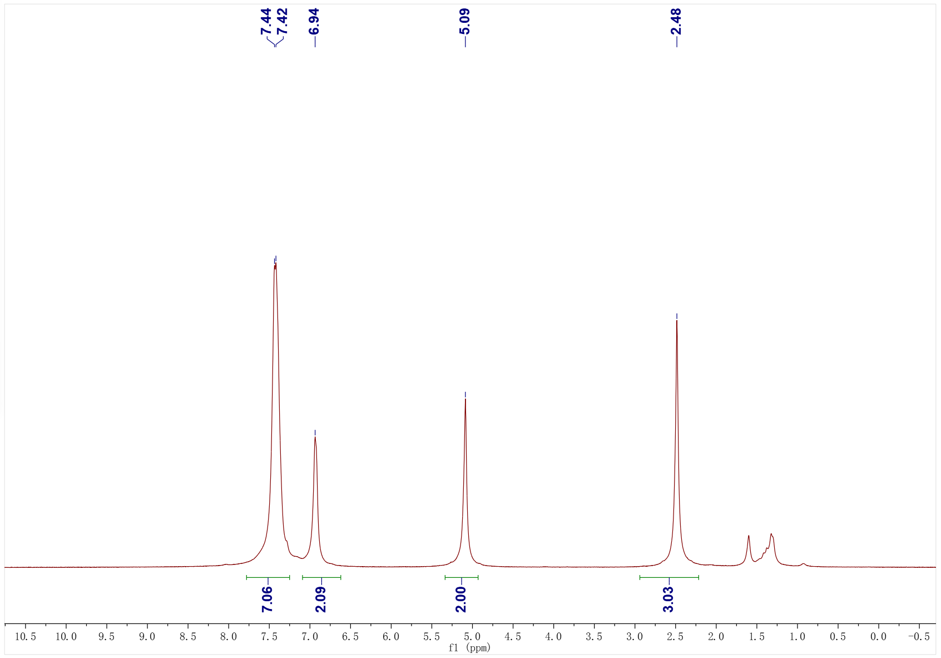
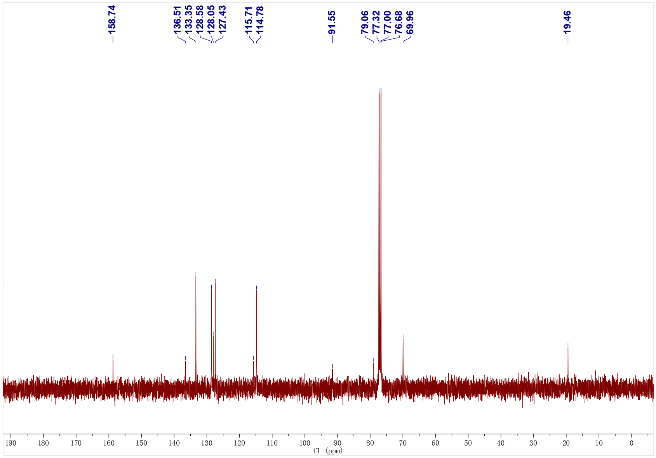
1f; ¹H NMR (500 MHz, CDCl₃); ¹³C NMR (126 MHz, CDCl₃)
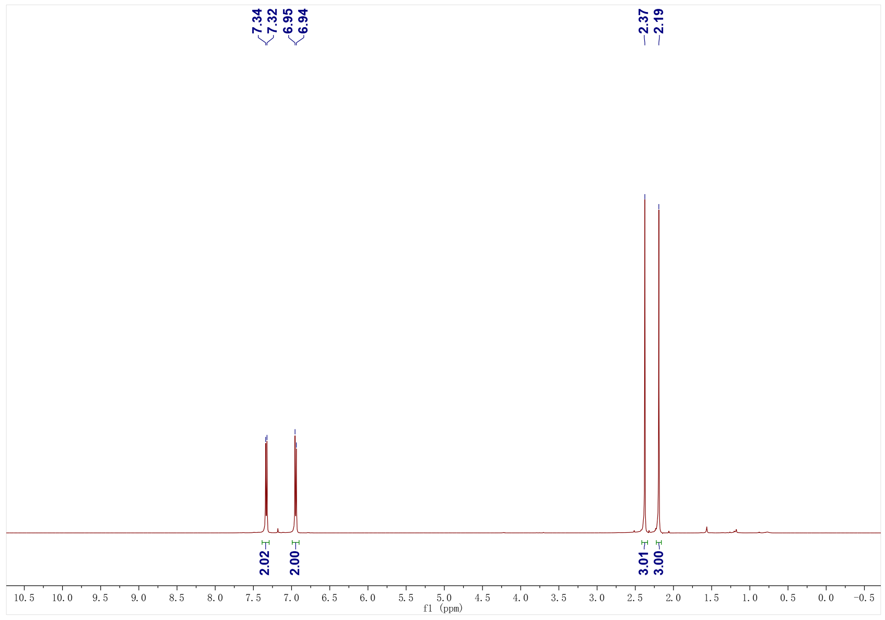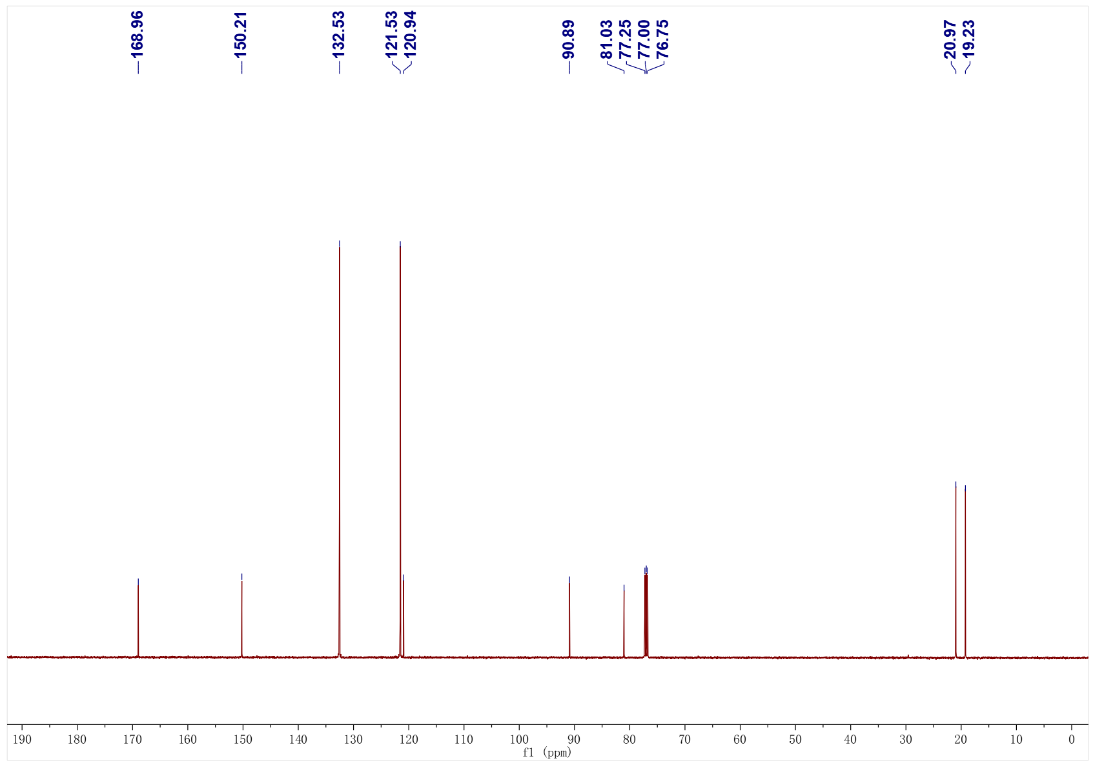
1g; ¹H NMR (500 MHz, CDCl₃); ¹³C NMR (126 MHz, CDCl₃)
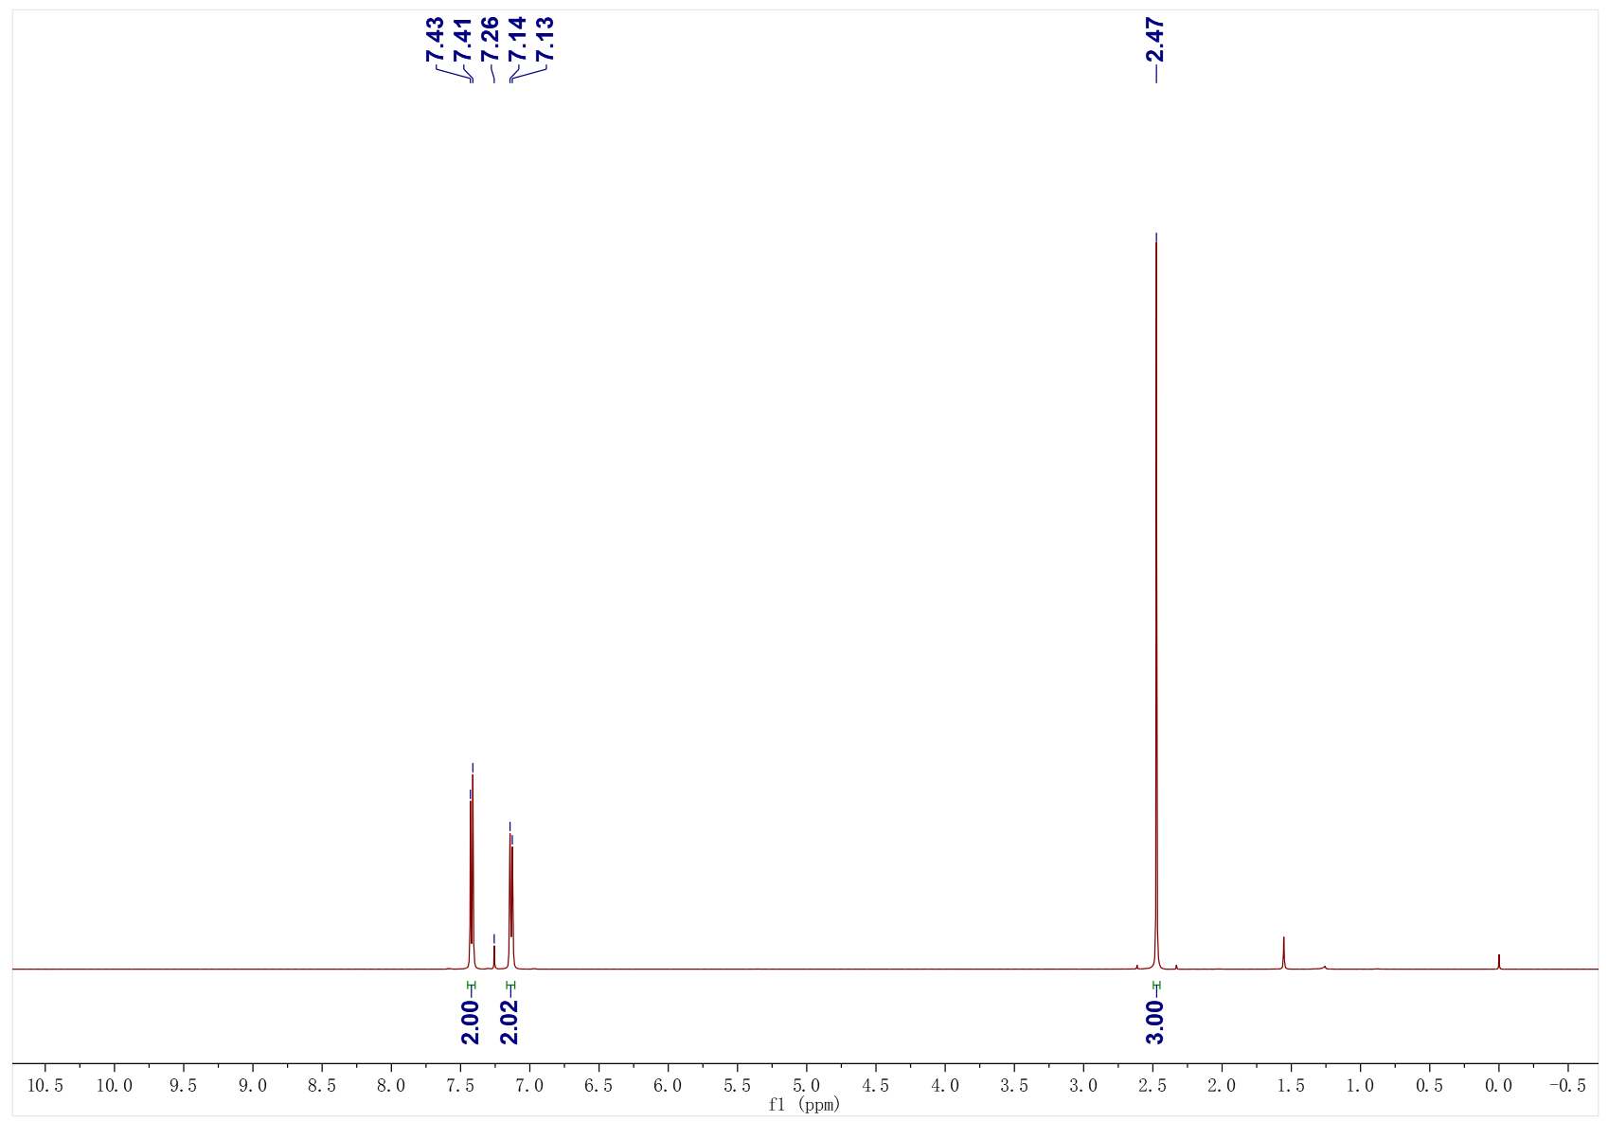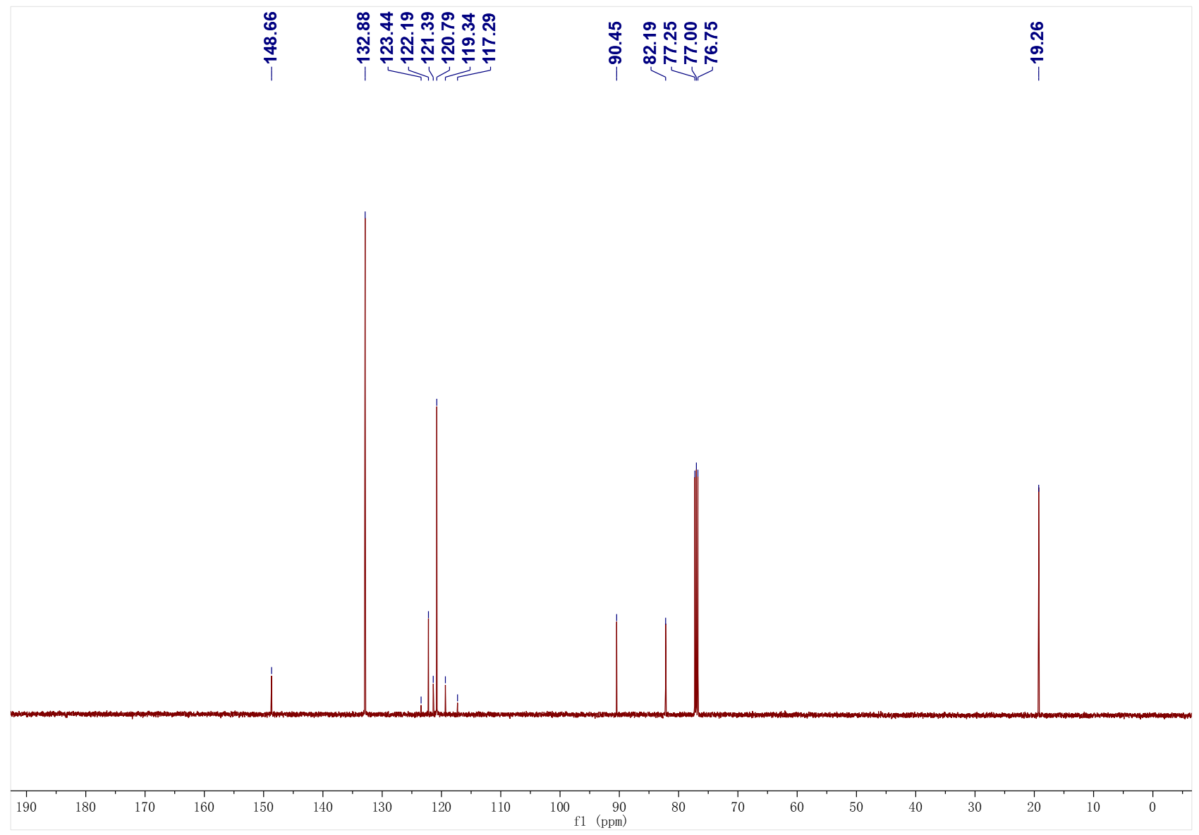

1g; ¹⁹F NMR (471 MHz, CDCl₃)
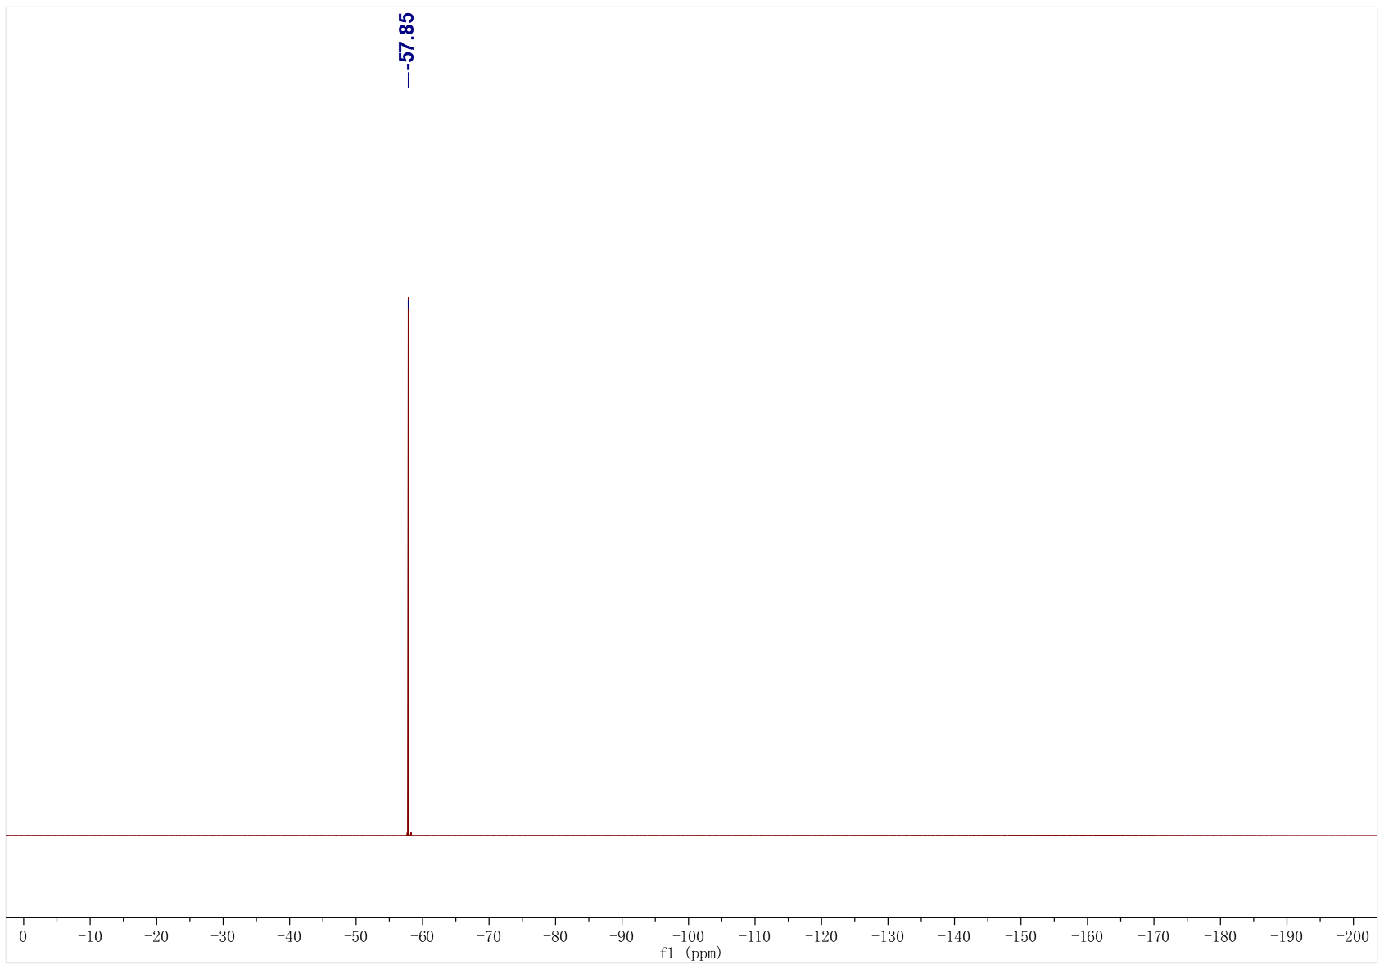
1o; ¹H NMR (500 MHz, CDCl₃); ¹³C NMR (126 MHz, CDCl₃)
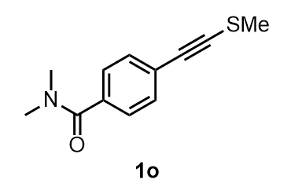
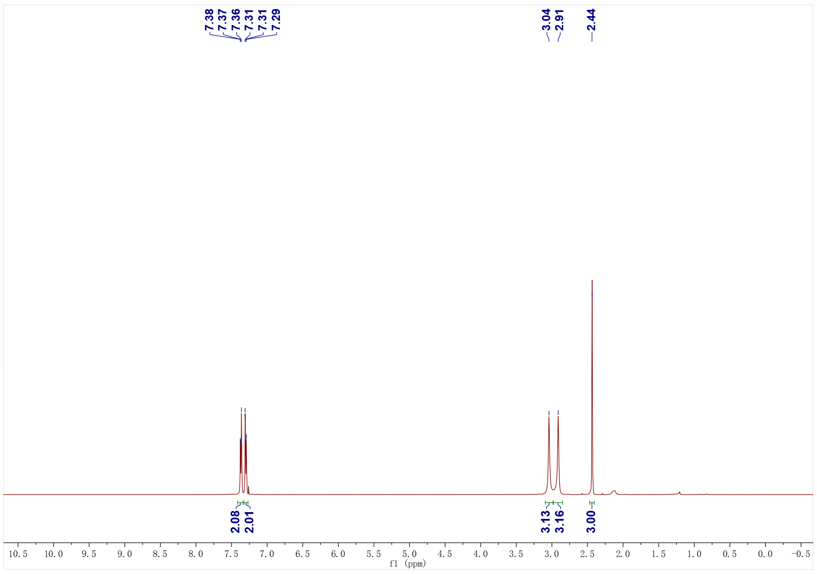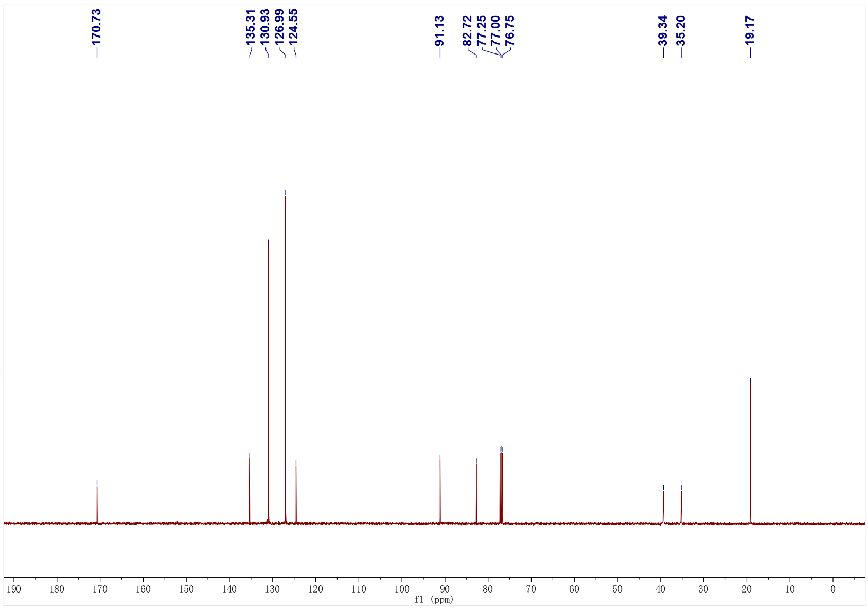
1p; ¹H NMR (500 MHz, CDCl₃); ¹³C NMR (126 MHz, CDCl₃)
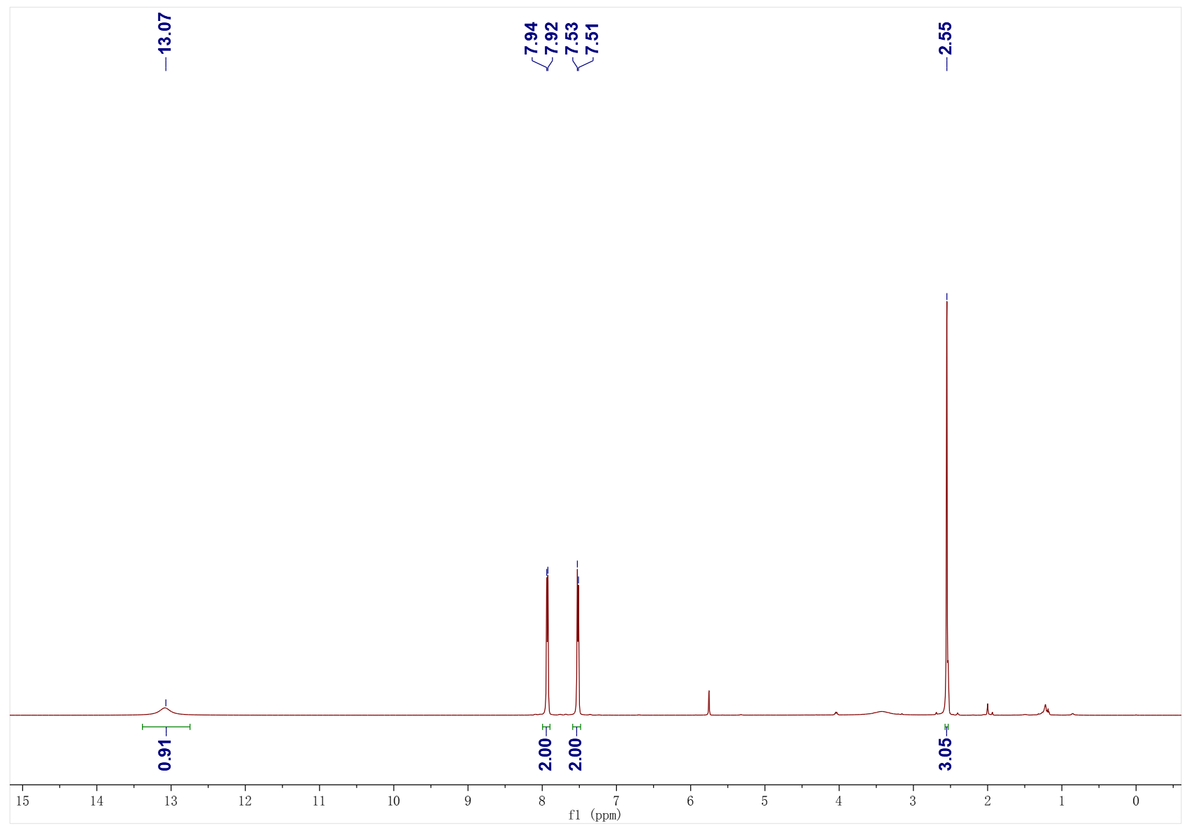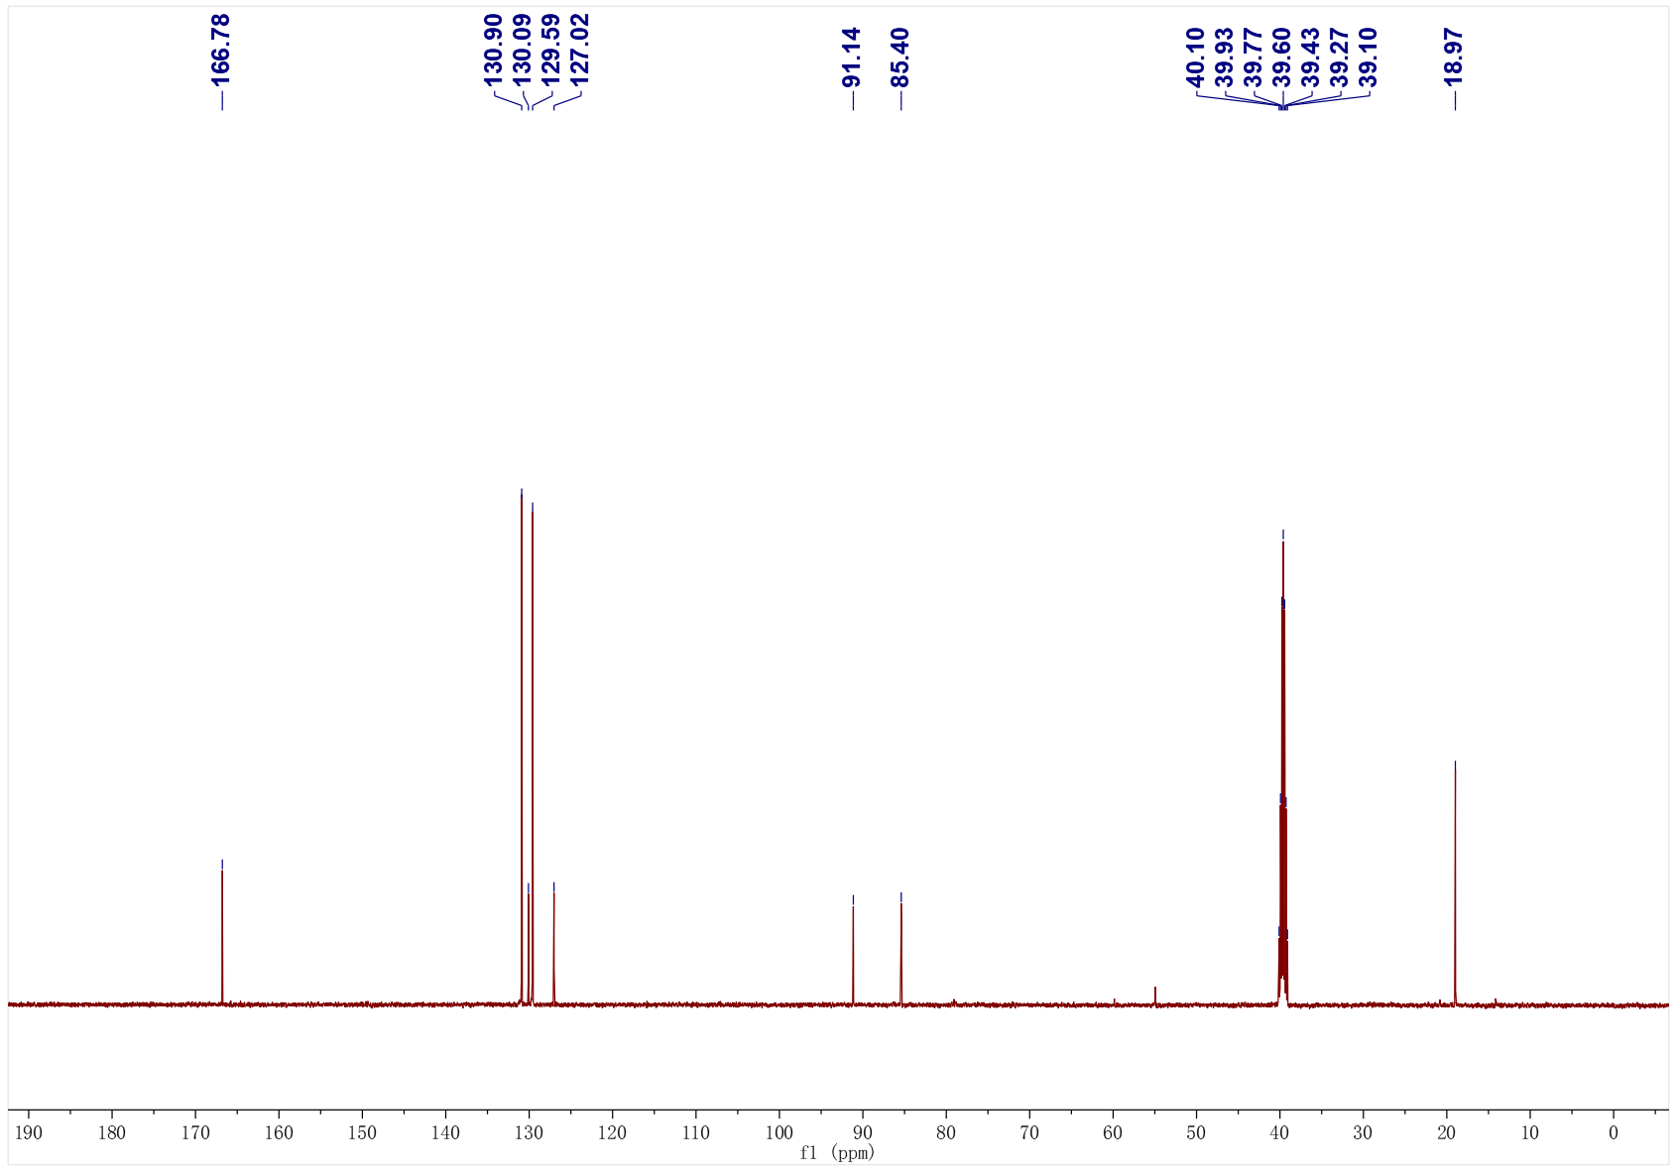
1r; ¹H NMR (500 MHz, CDCl₃); ¹³C NMR (126 MHz, CDCl₃)
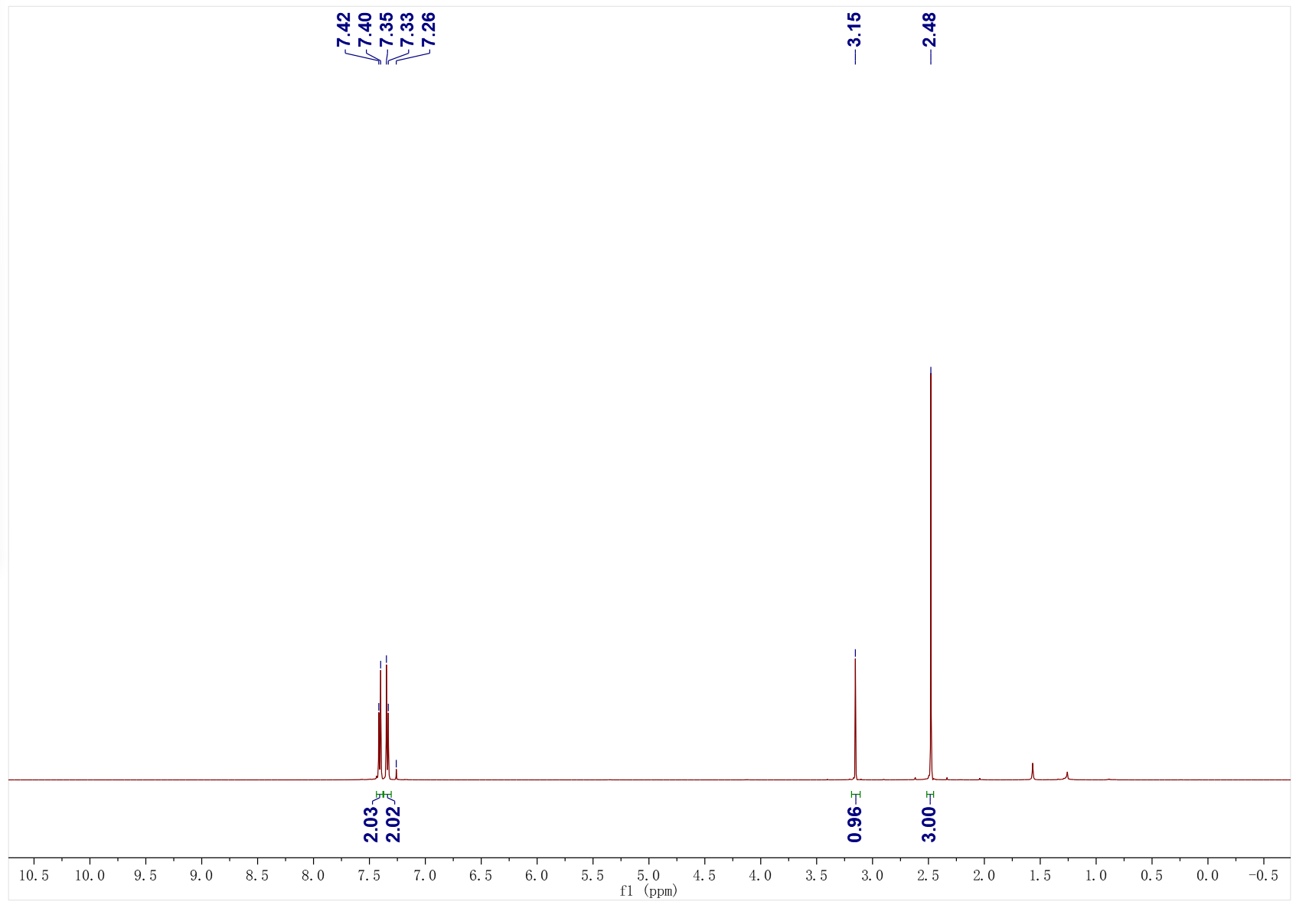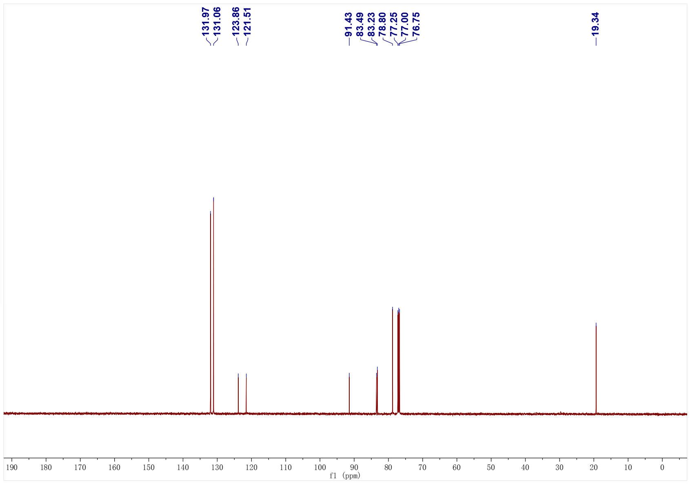
1ae; ¹H NMR (400 MHz, CDCl₃); ¹³C NMR (101 MHz, CDCl₃)
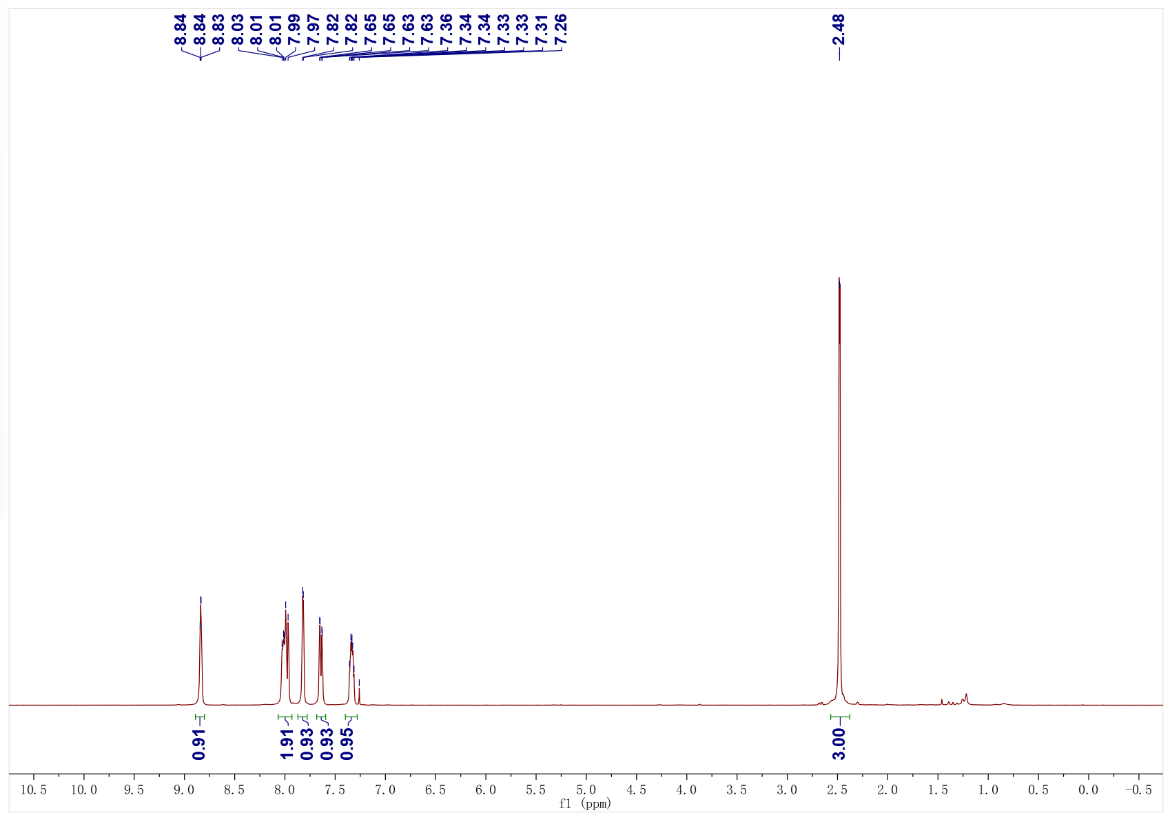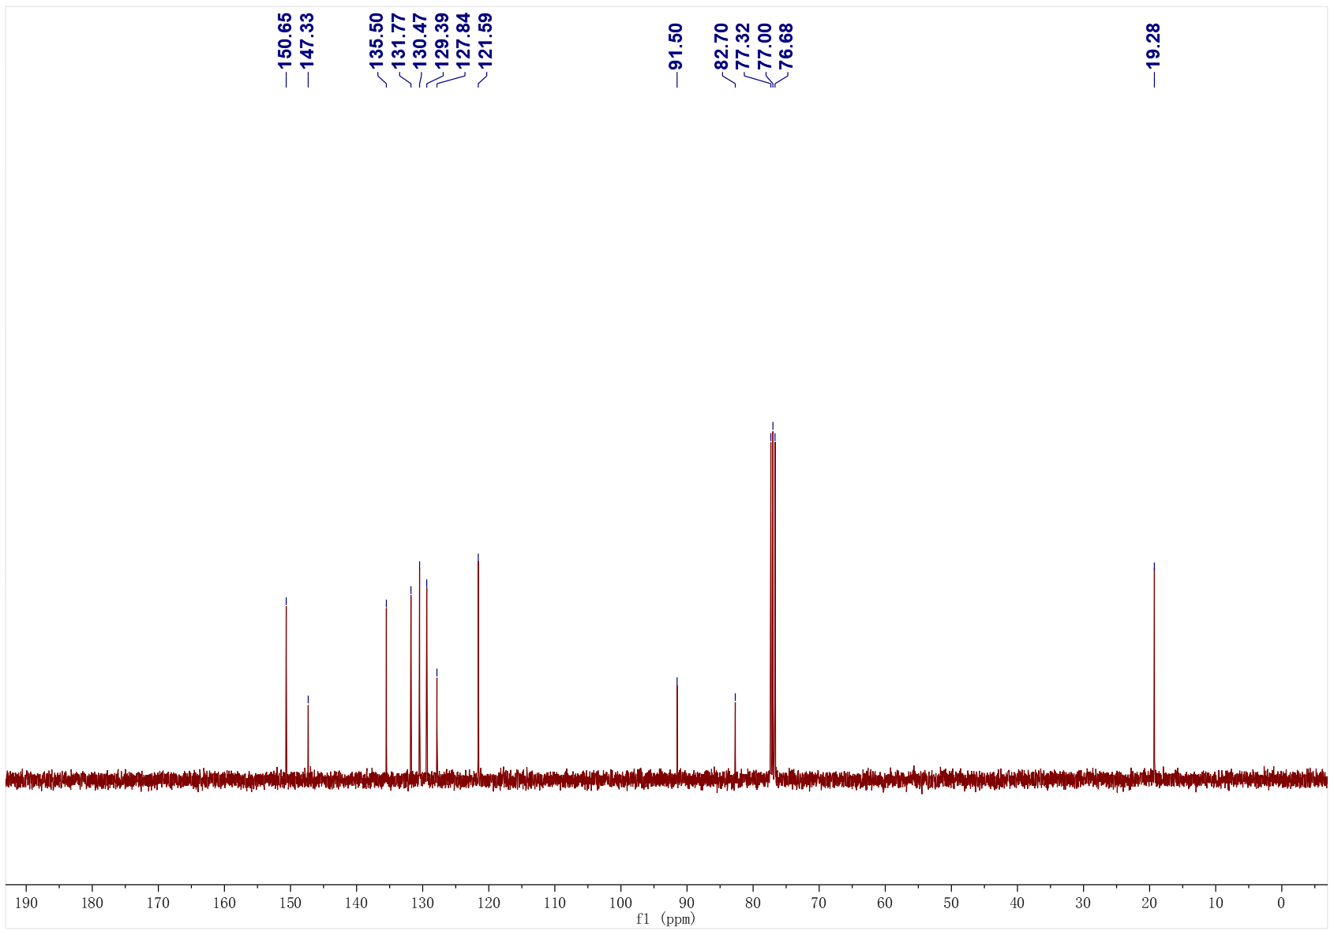
1ah; ¹H NMR (500 MHz, CDCl₃); ¹³C NMR (126 MHz, CDCl₃)
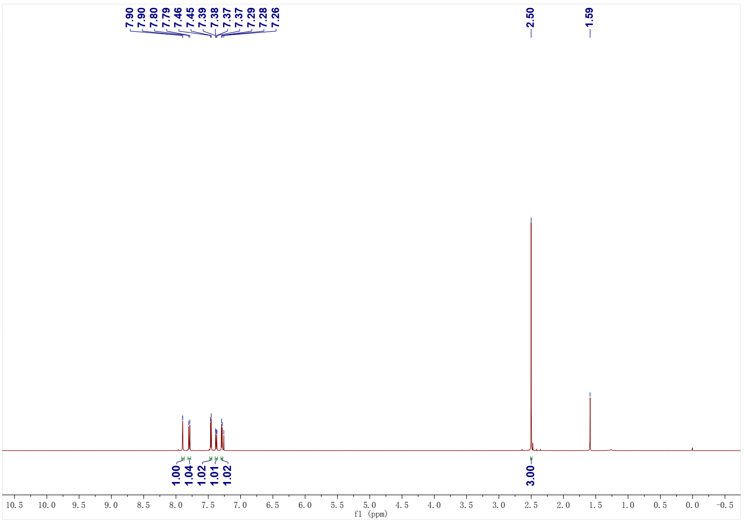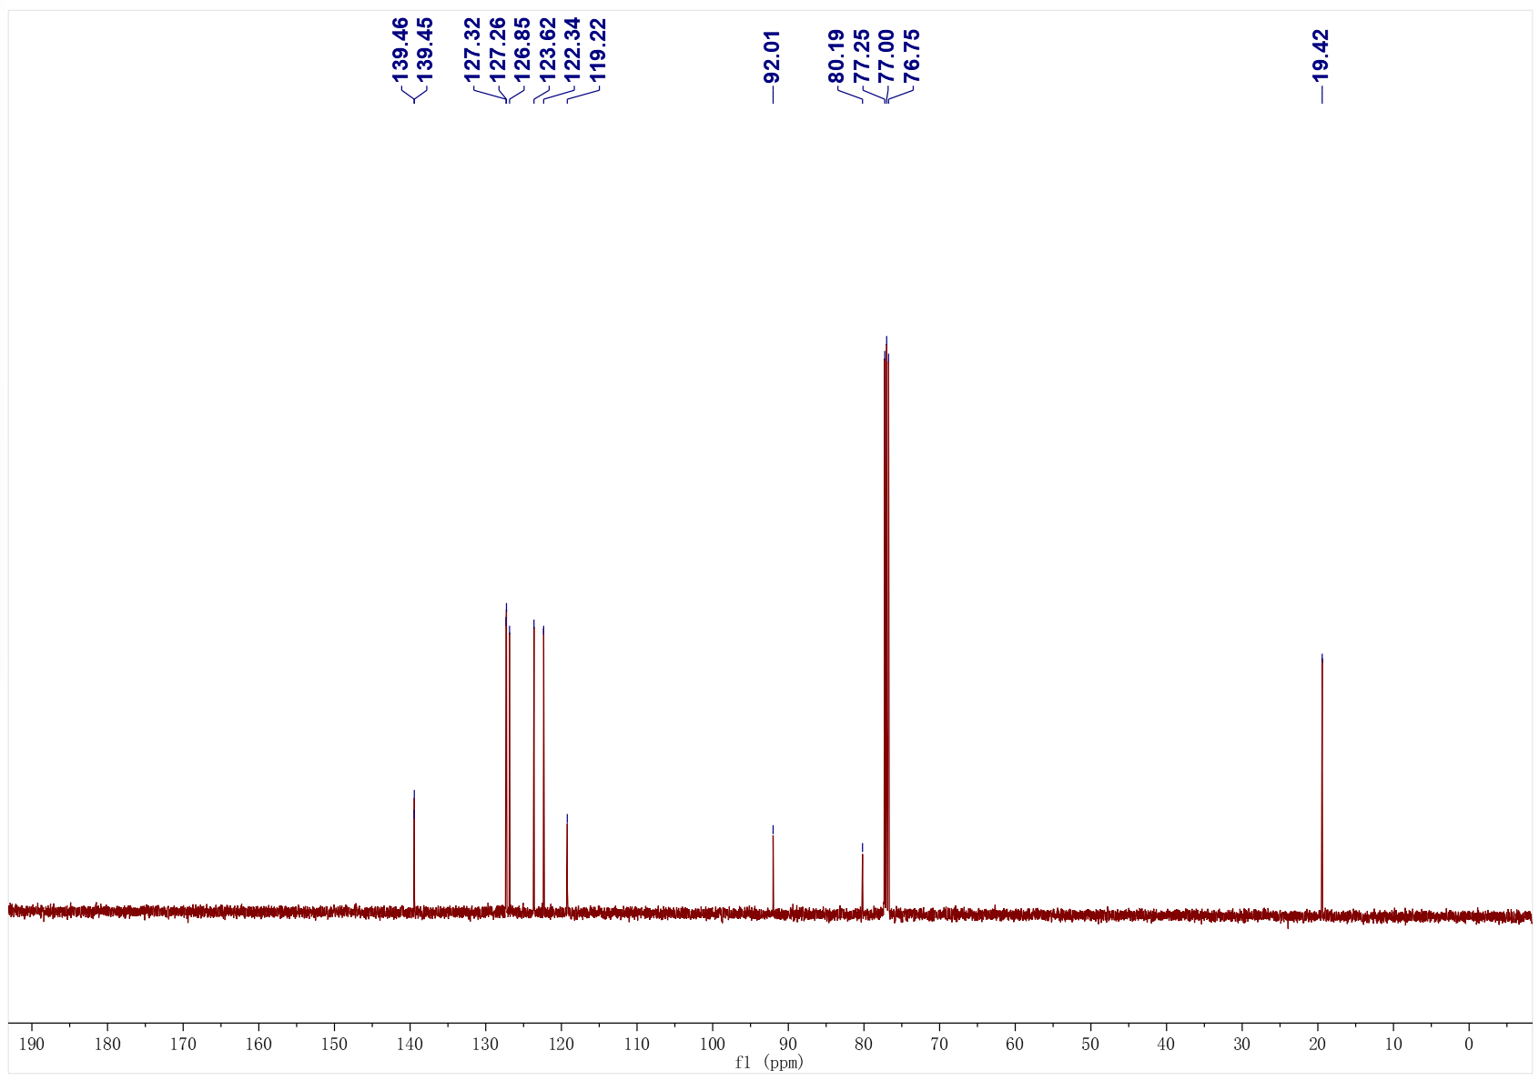

1ai; ¹H NMR (500 MHz, CDCl₃); ¹³C NMR (126 MHz, CDCl₃)
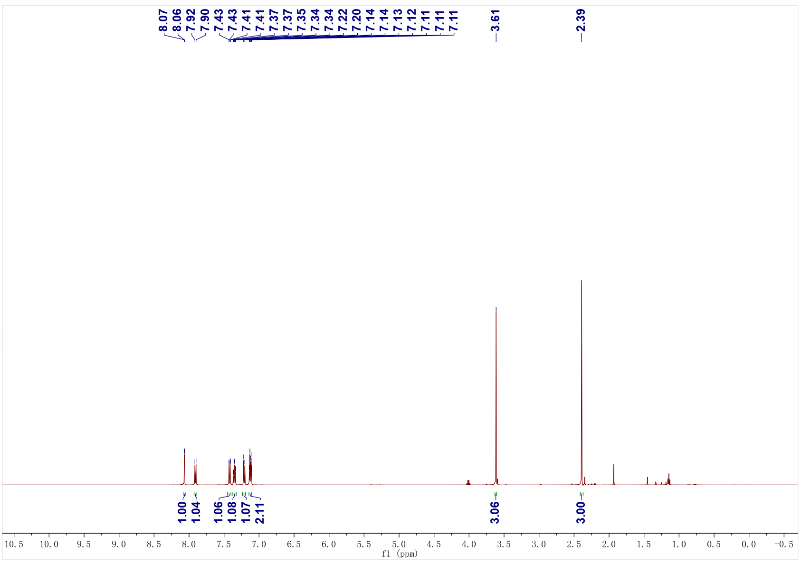
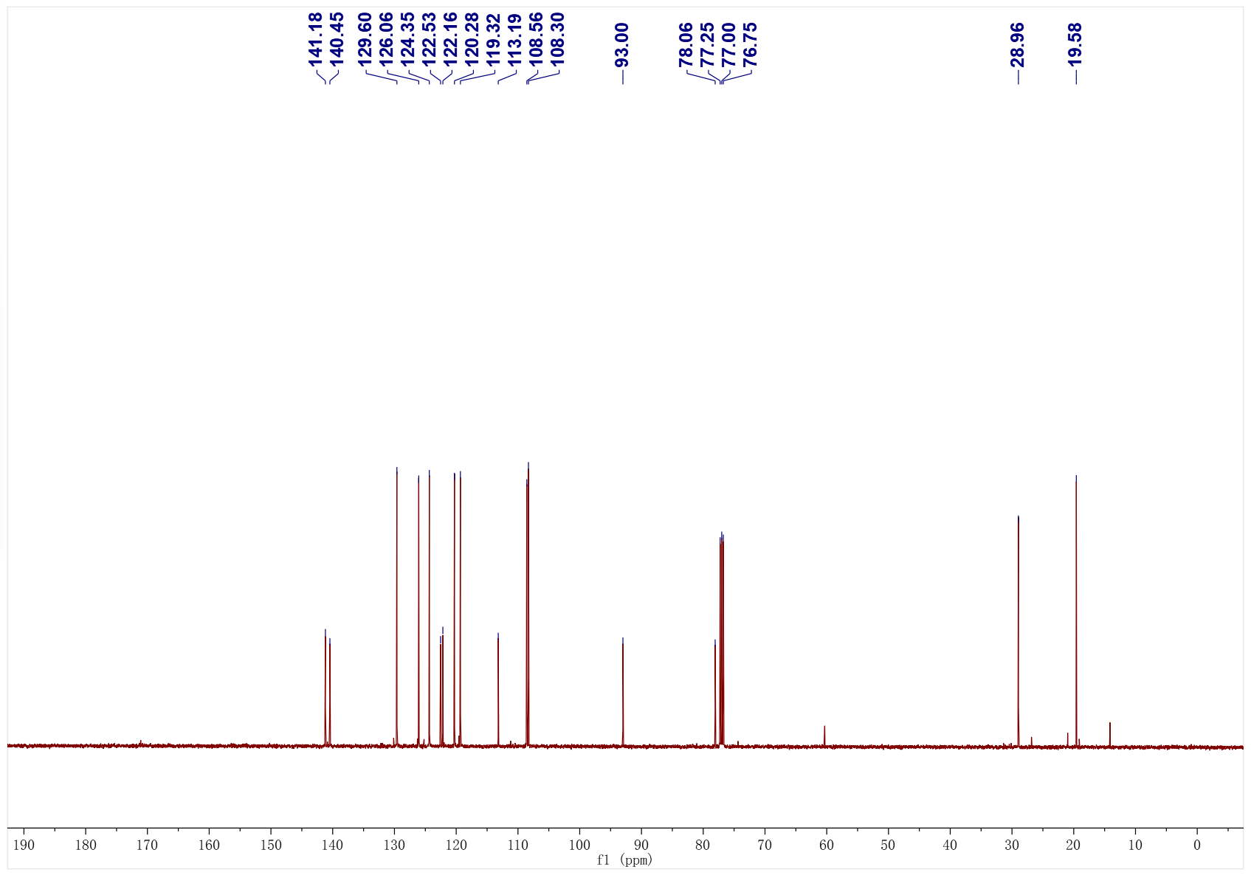
1aj; ¹H NMR (400 MHz, CDCl₃); ¹³C NMR (101 MHz, CDCl₃)
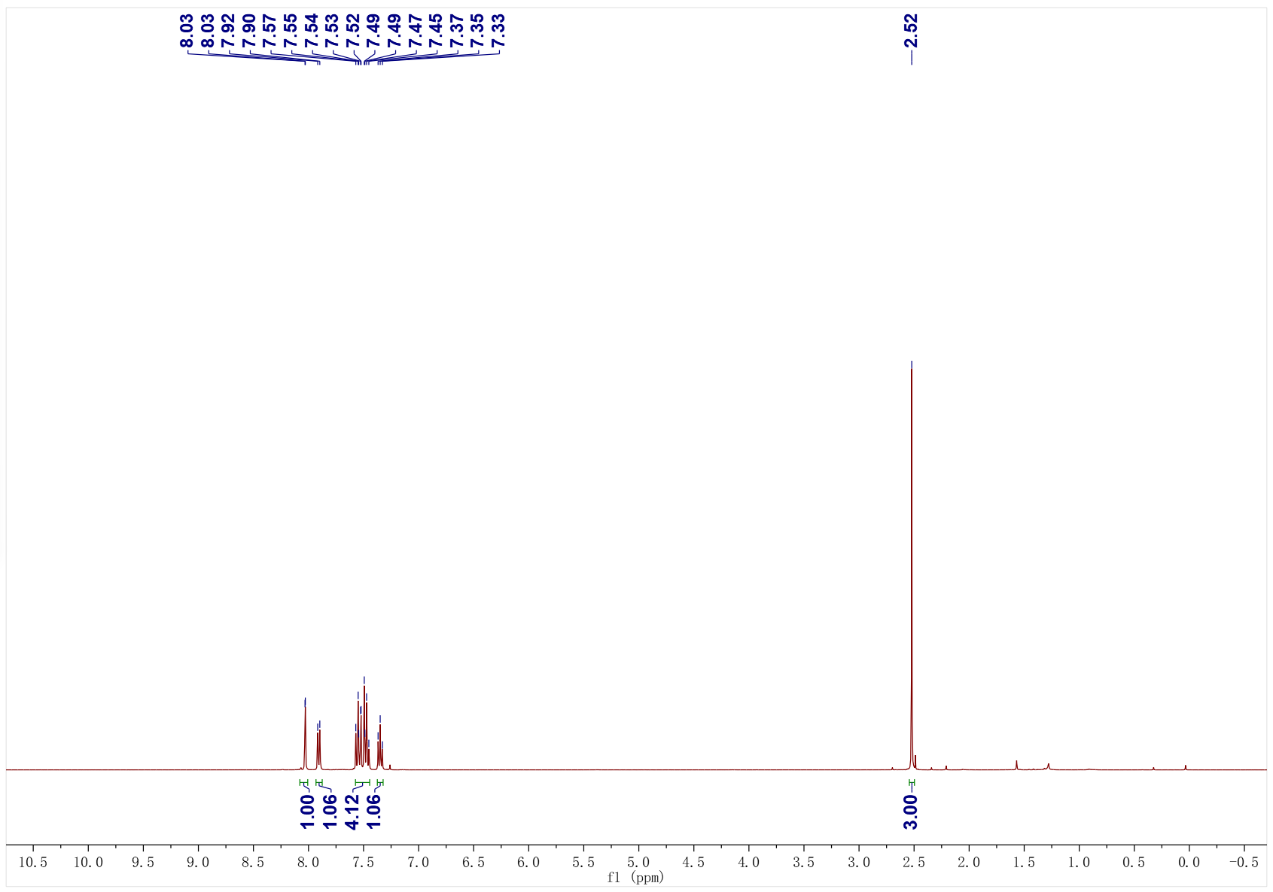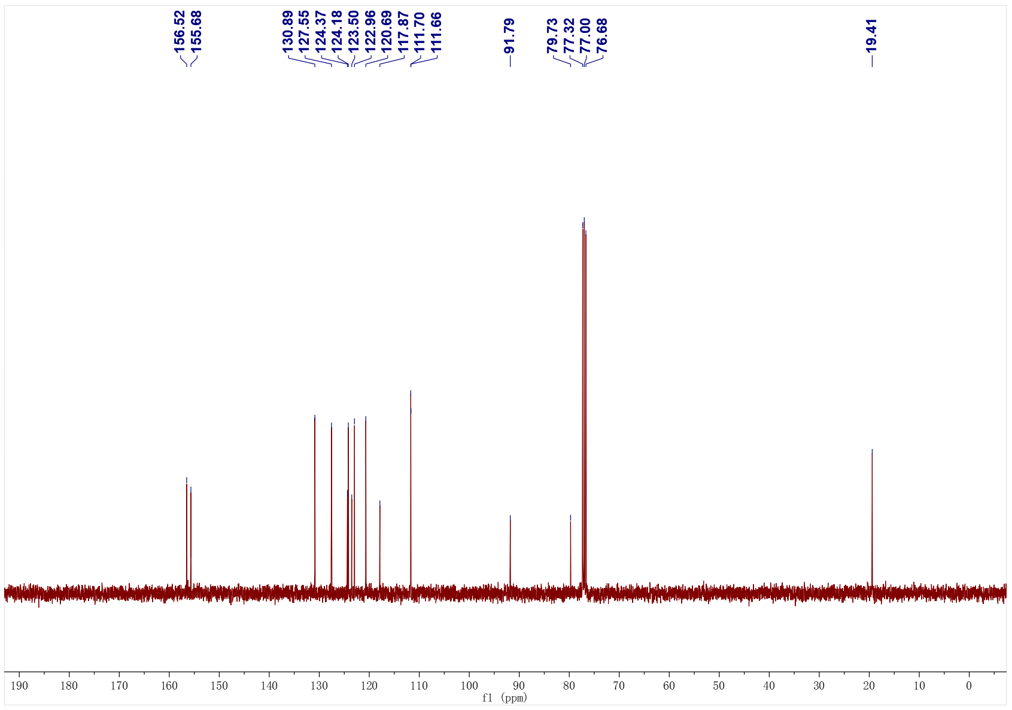

1ak; ¹H NMR (500 MHz, CDCl₃); ¹³C NMR (126 MHz, CDCl₃)
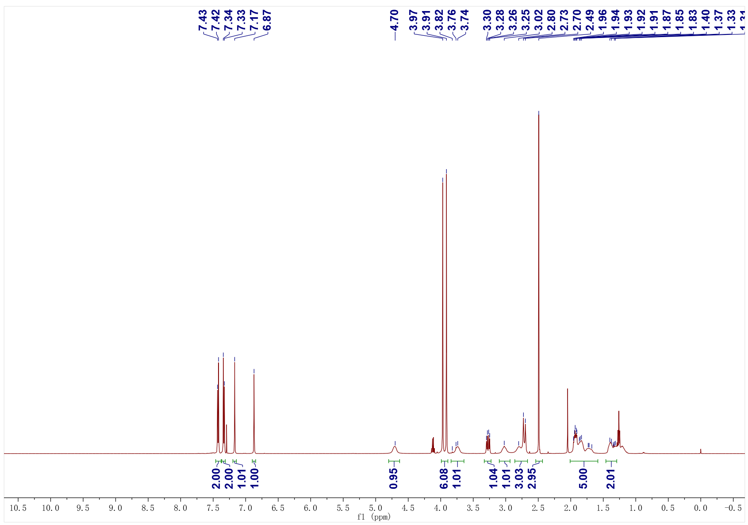
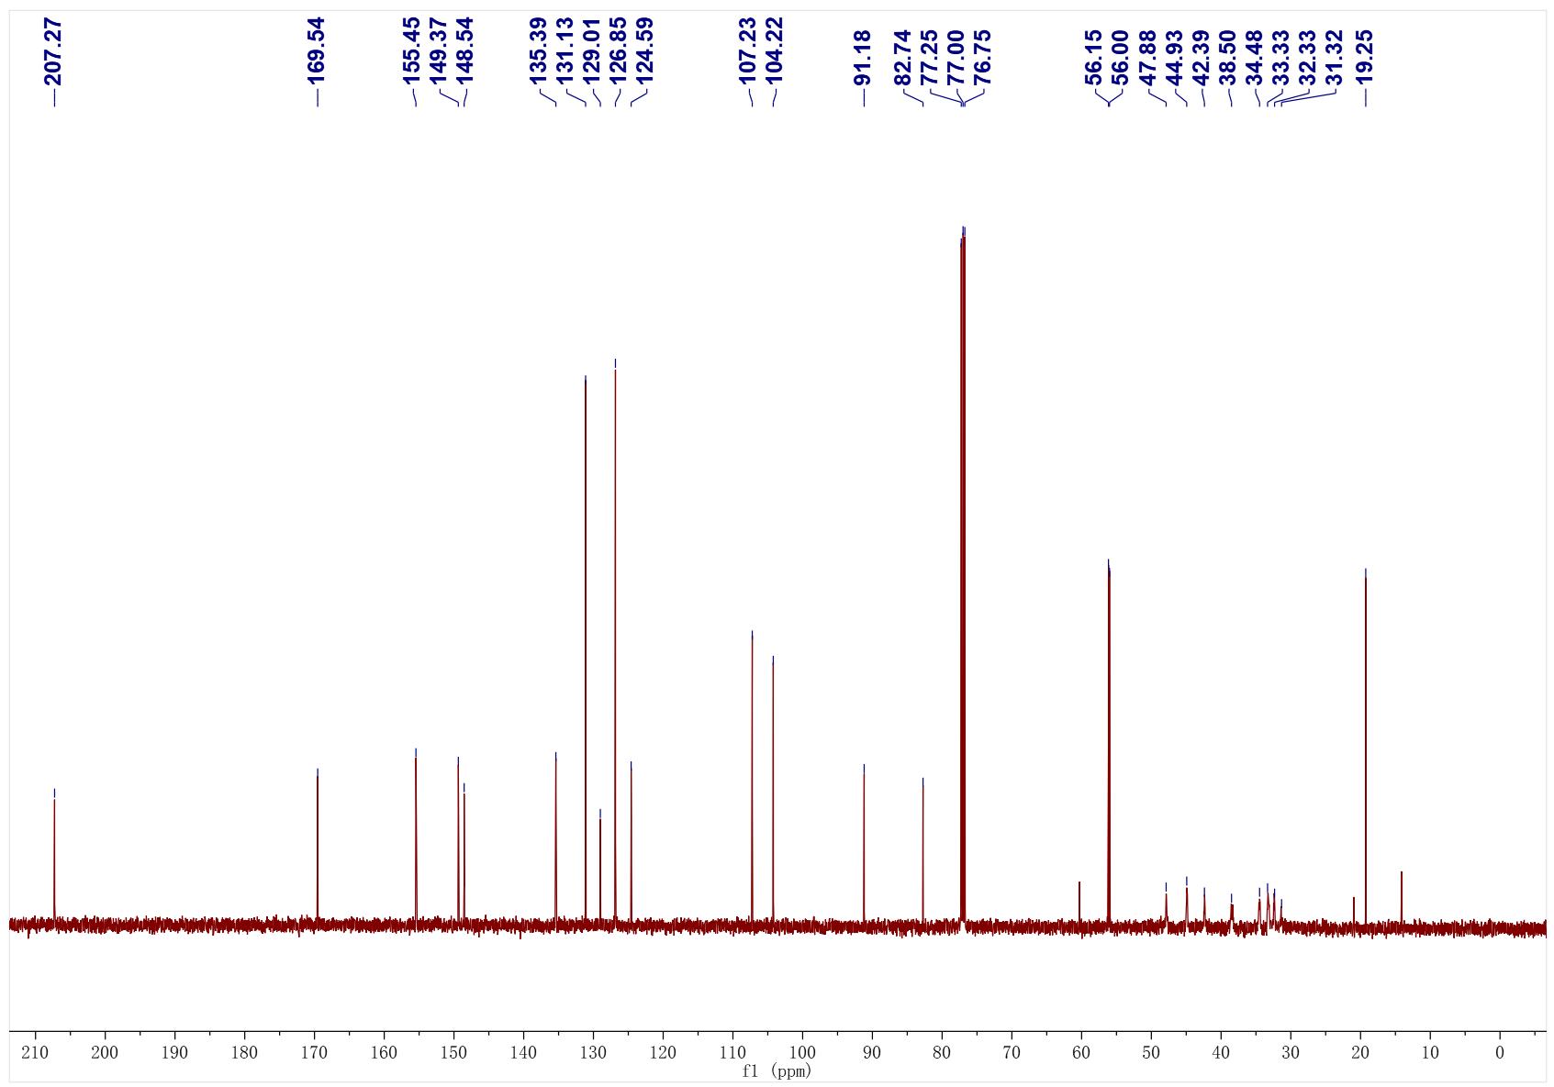
1al; ¹H NMR (500 MHz, CDCl₃); ¹³C NMR (126 MHz, CDCl₃)
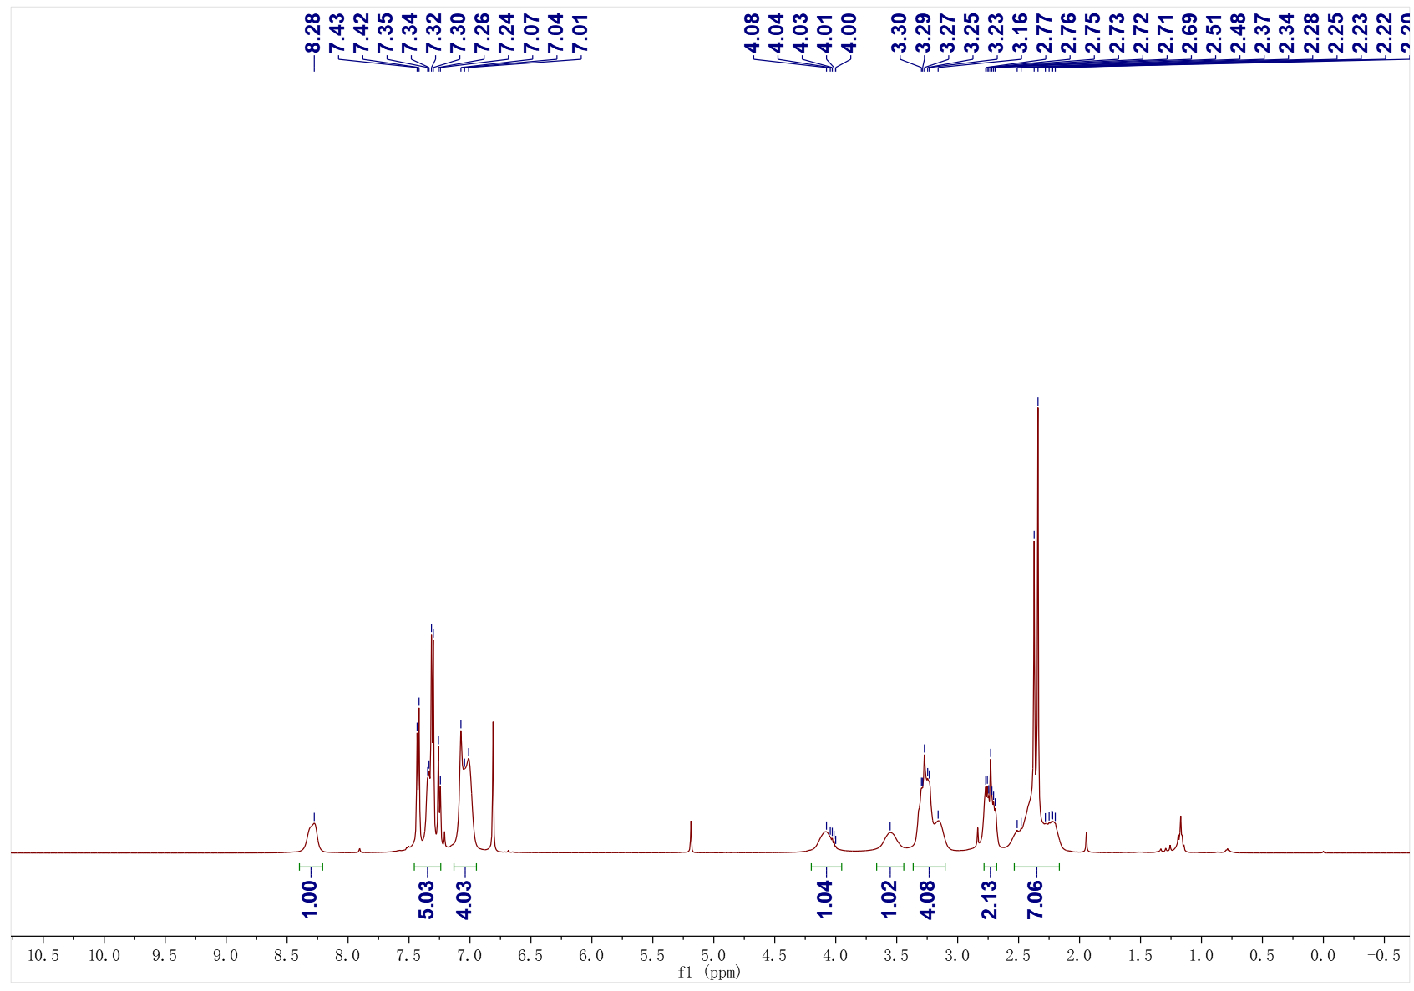
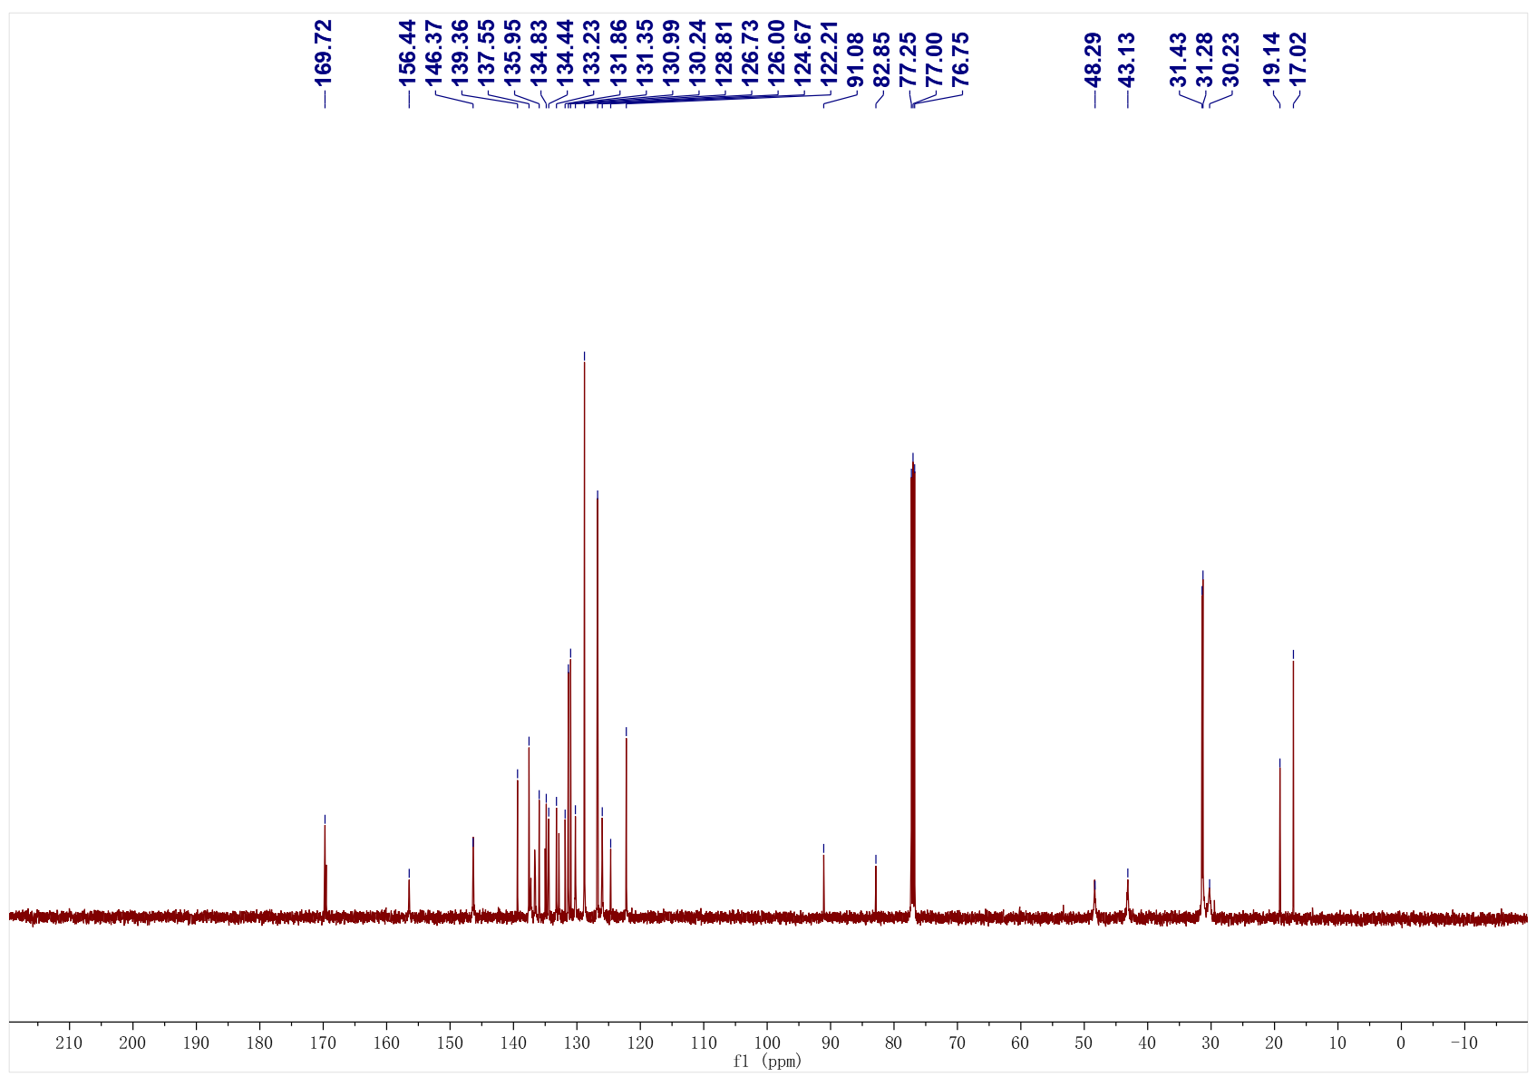
1ao; ¹H NMR (500 MHz, CDCl₃); ¹³C NMR (126 MHz, CDCl₃)
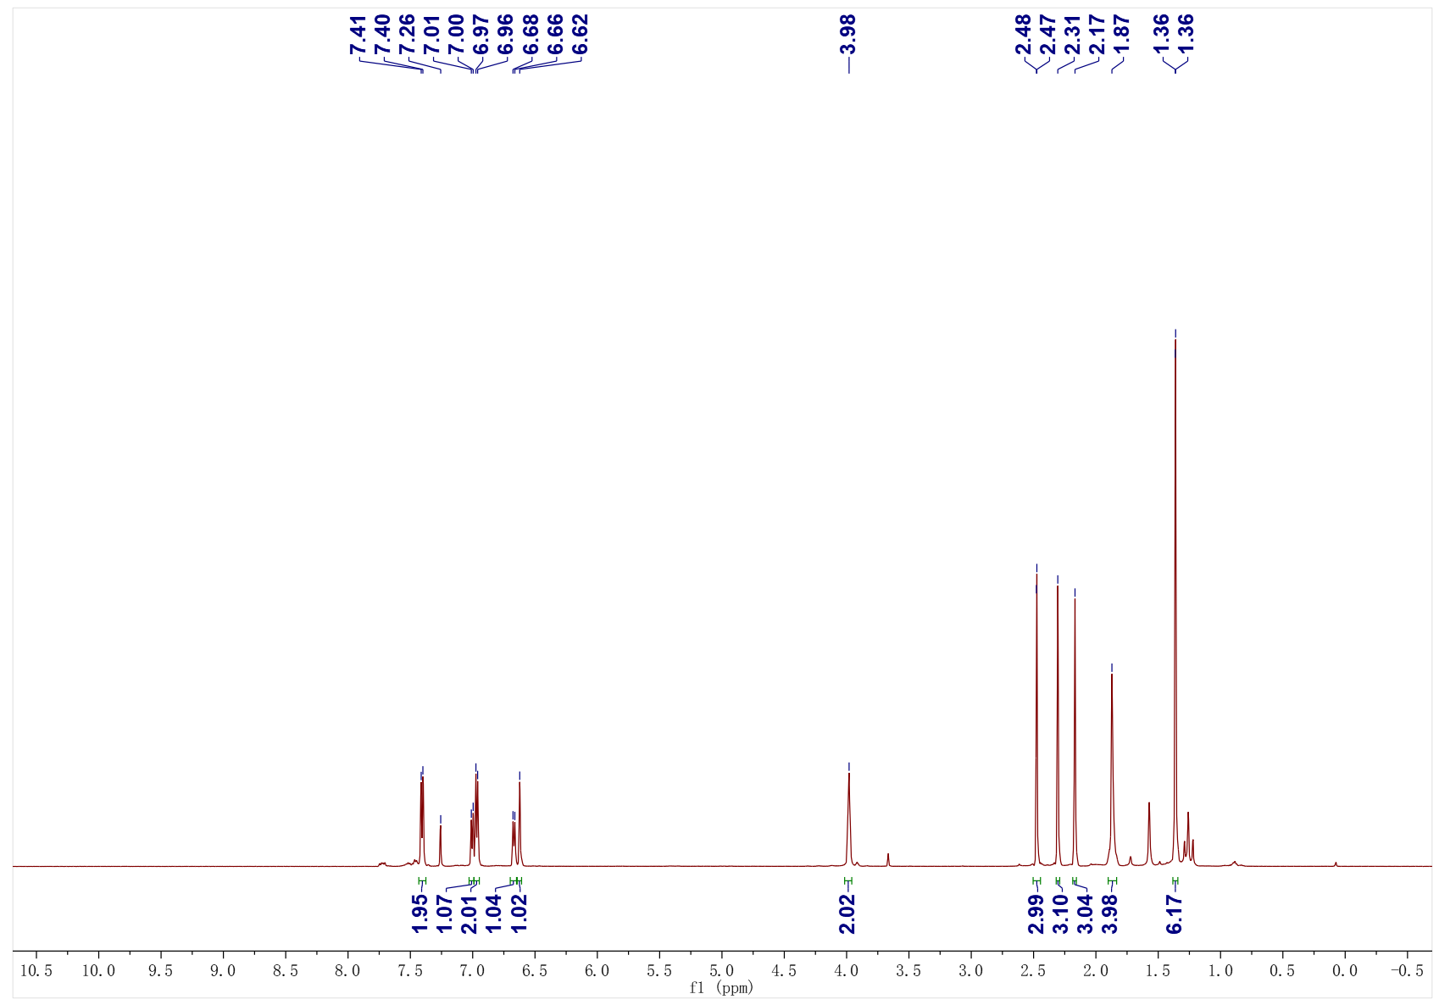
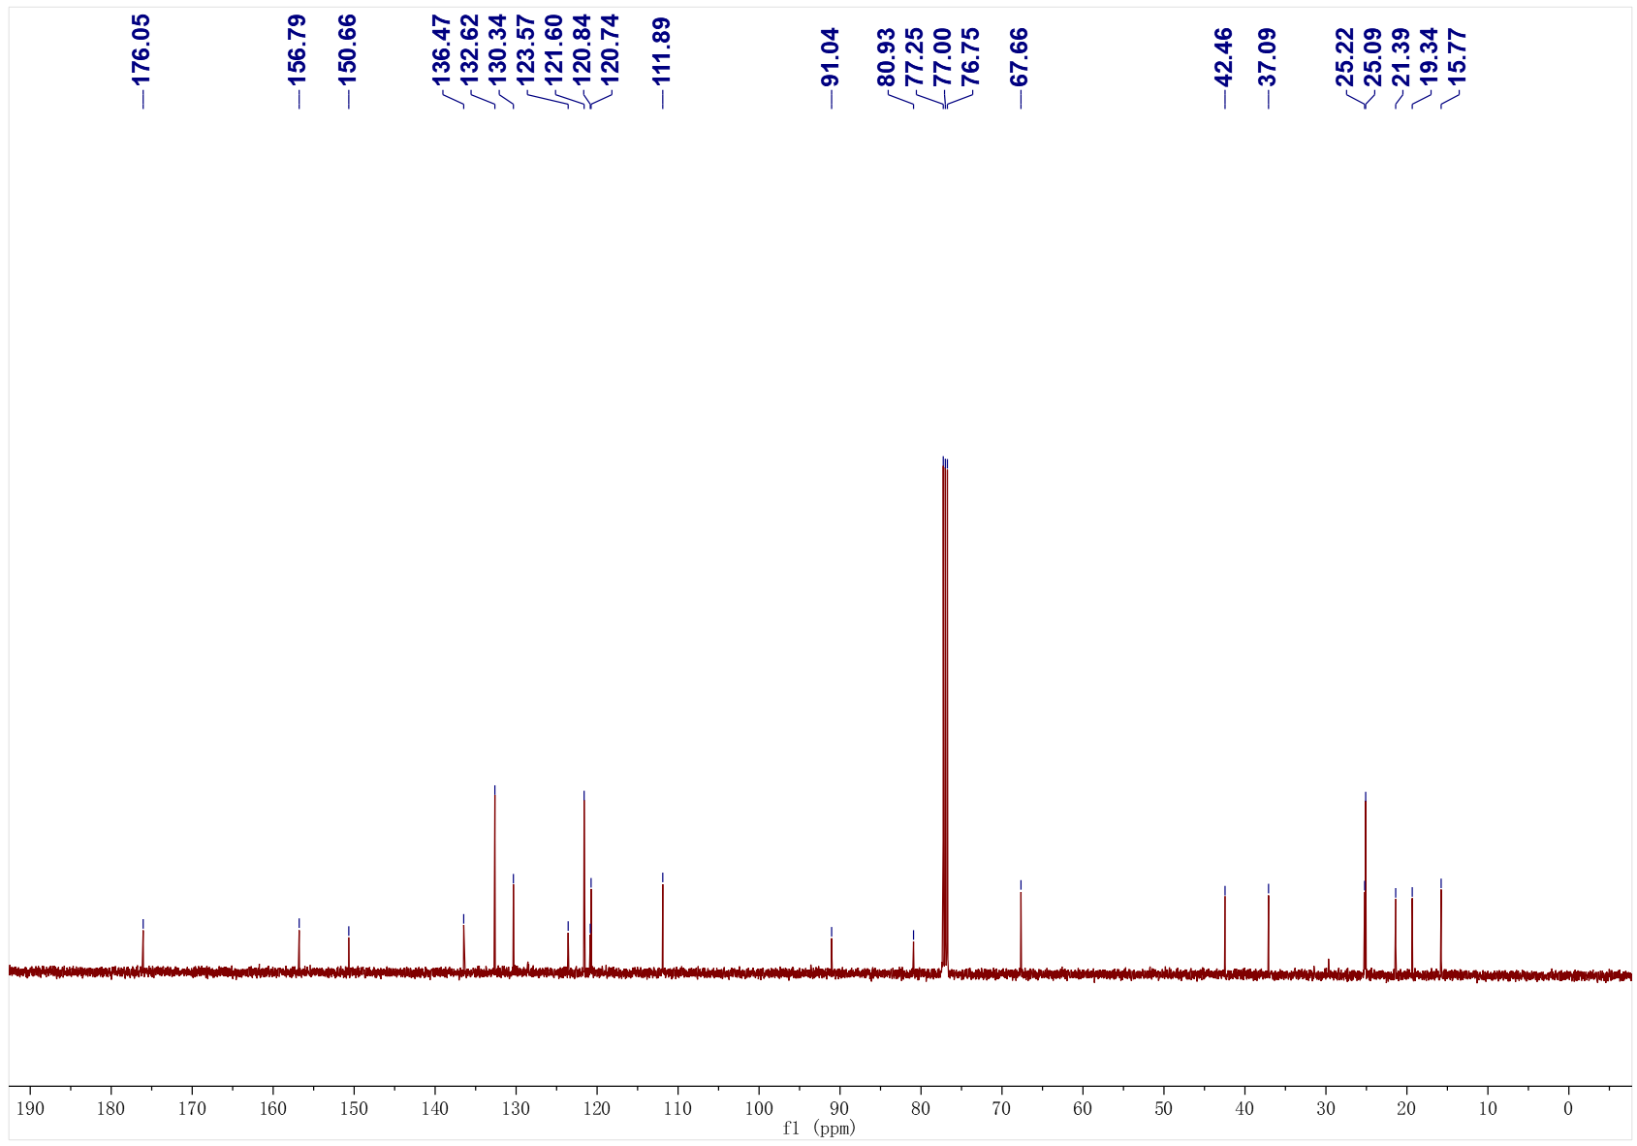
1ap; ¹H NMR (500 MHz, CDCl₃); ¹³C NMR (126 MHz, CDCl₃)
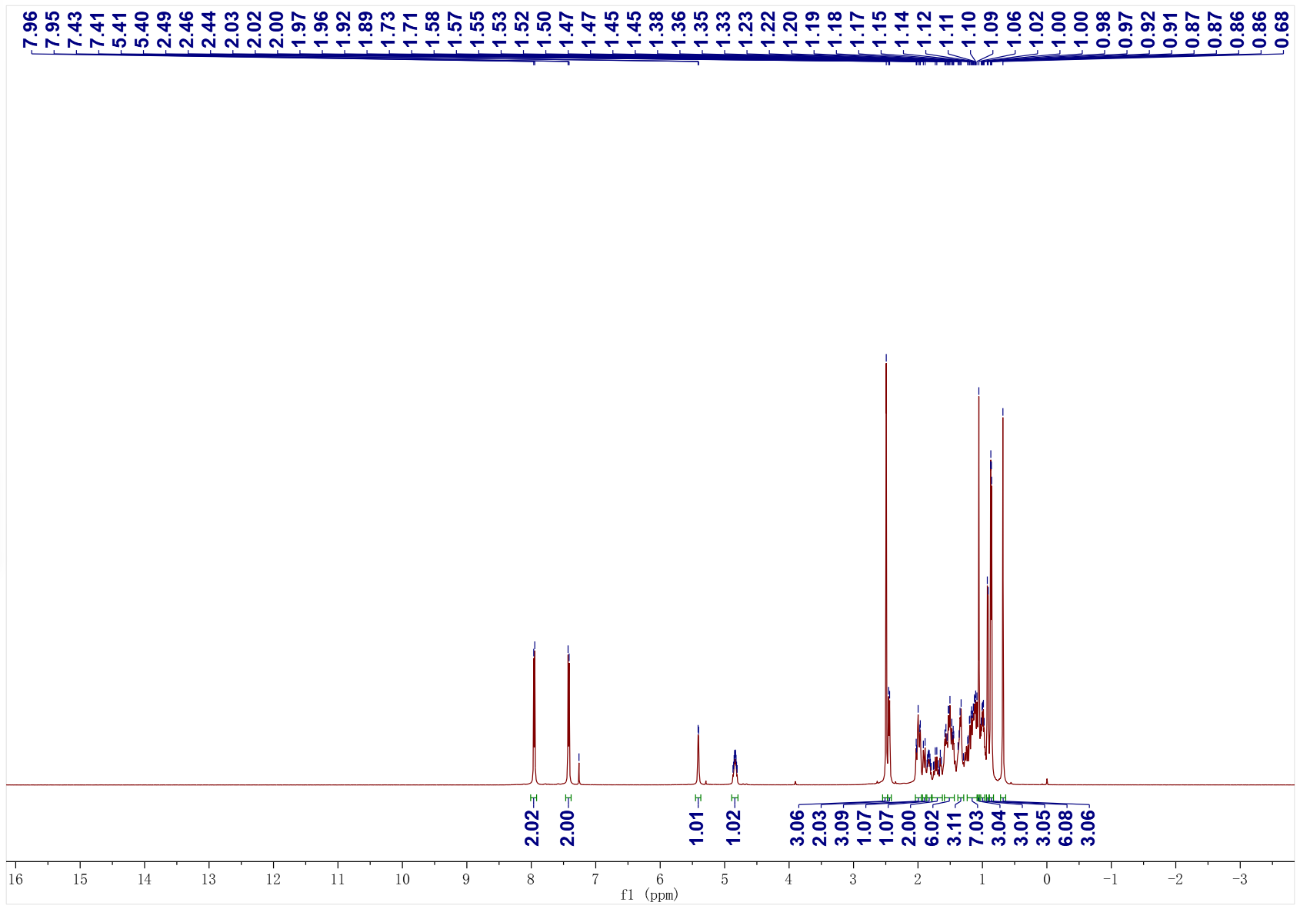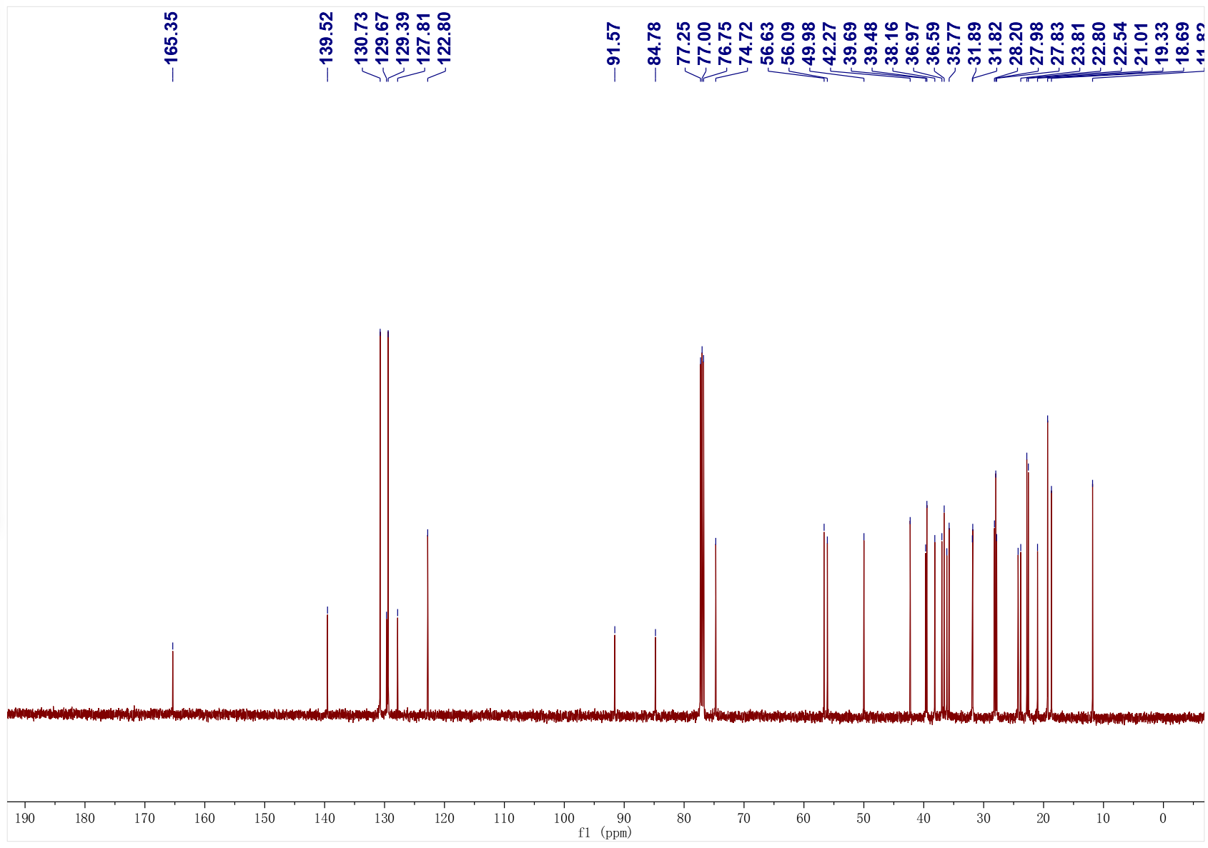
1as; ¹H NMR (500 MHz, CDCl₃); ¹³C NMR (126 MHz, CDCl₃)
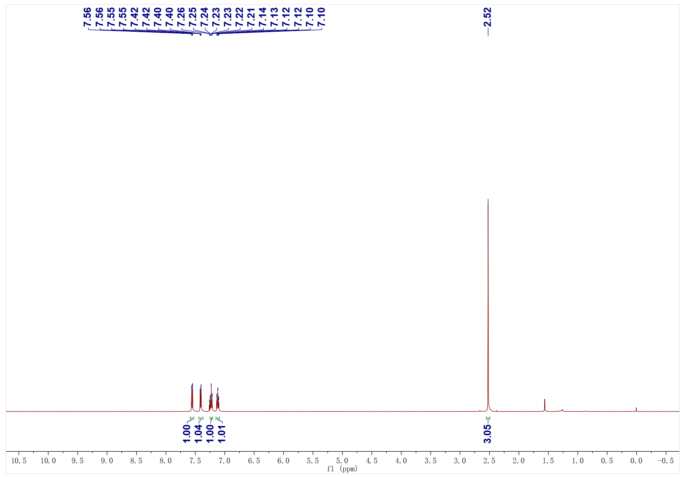
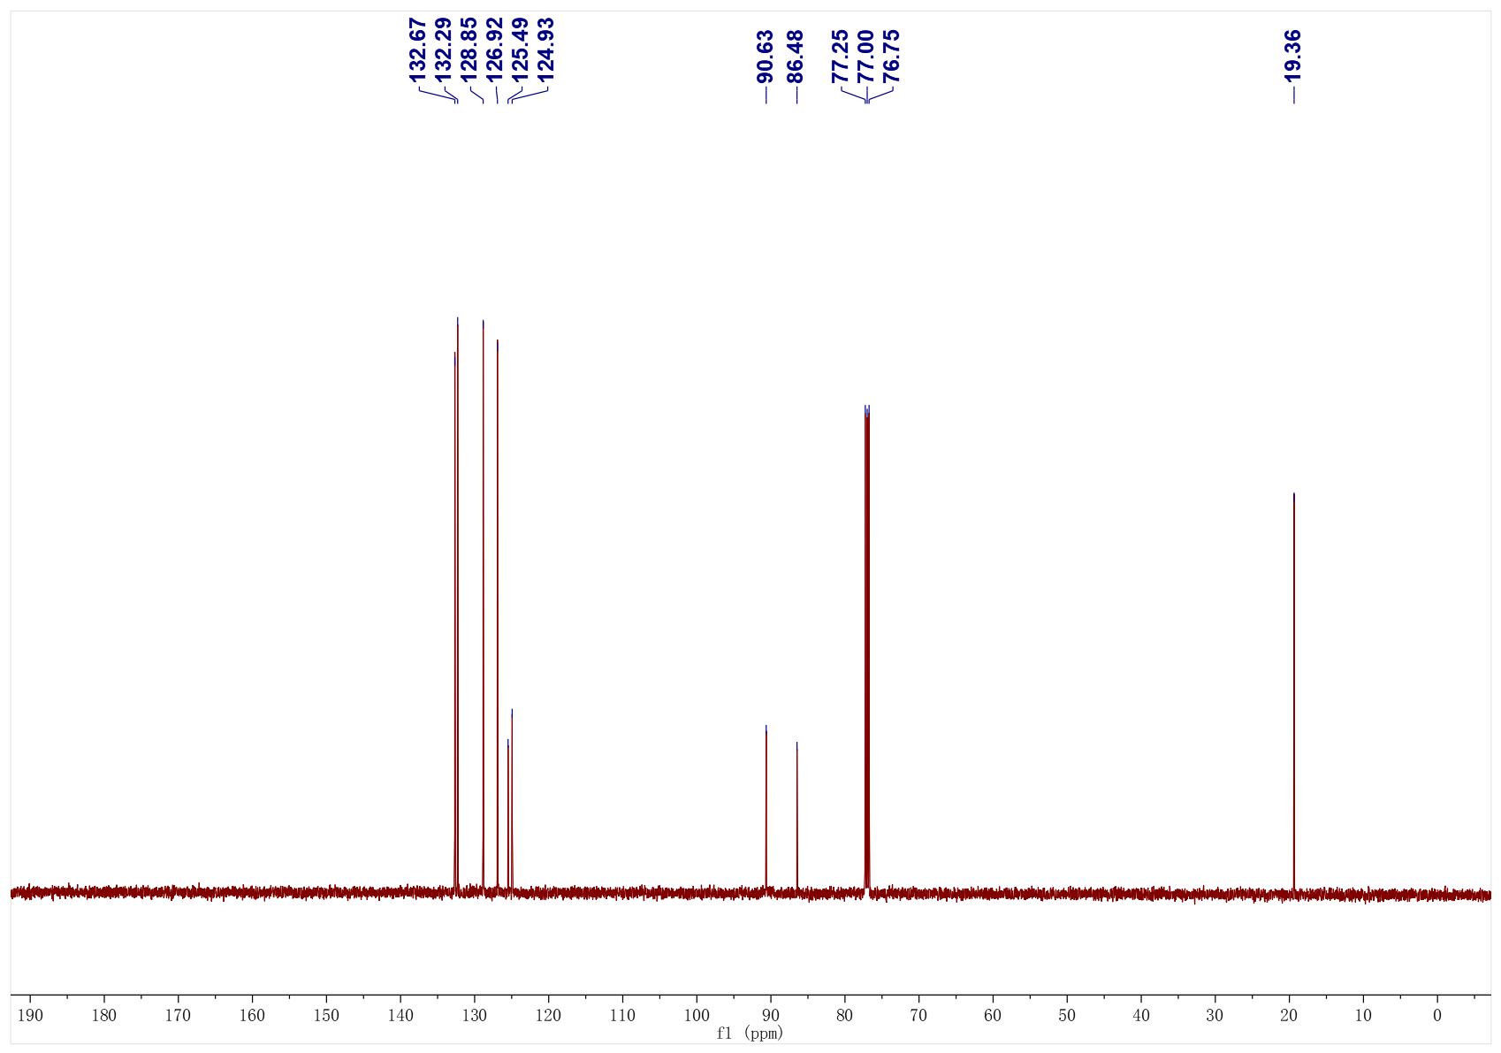
1au; ¹H NMR (400 MHz, CDCl₃); ¹³C NMR (101 MHz, CDCl₃)
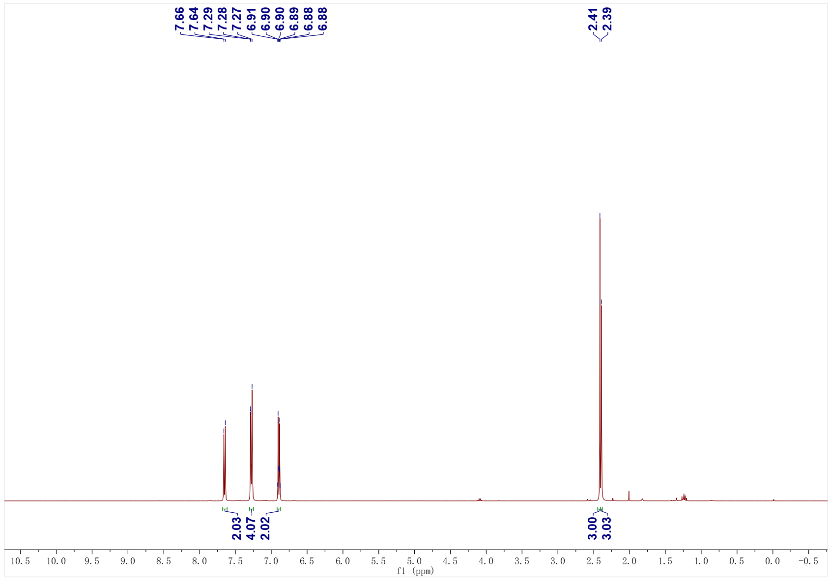
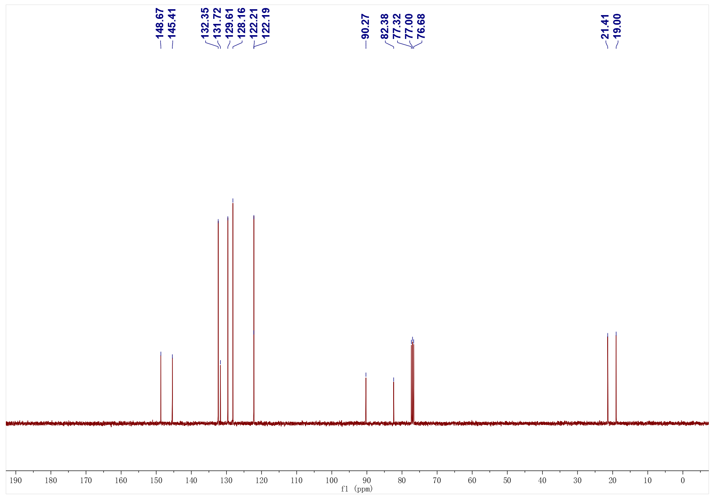
1av; ¹H NMR (400 MHz, CDCl₃); ¹³C NMR (101 MHz, CDCl₃)
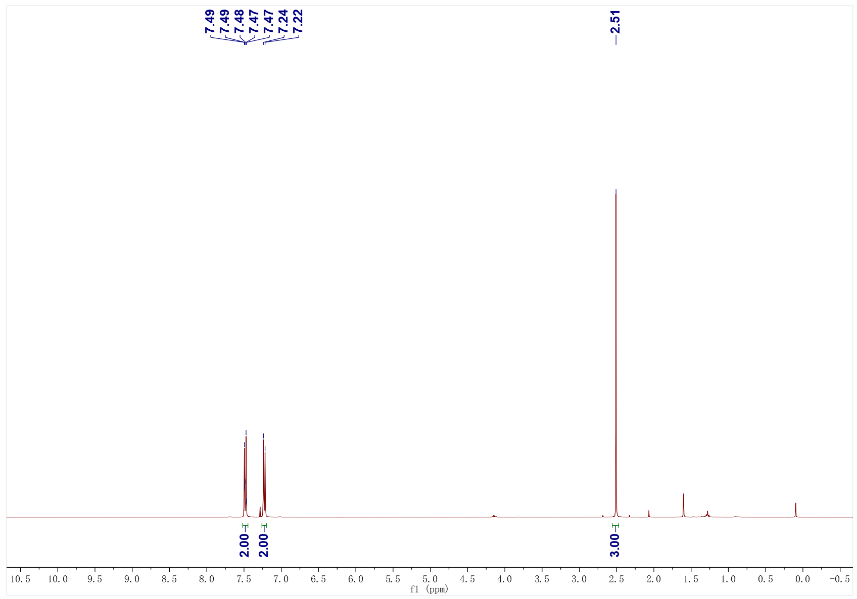
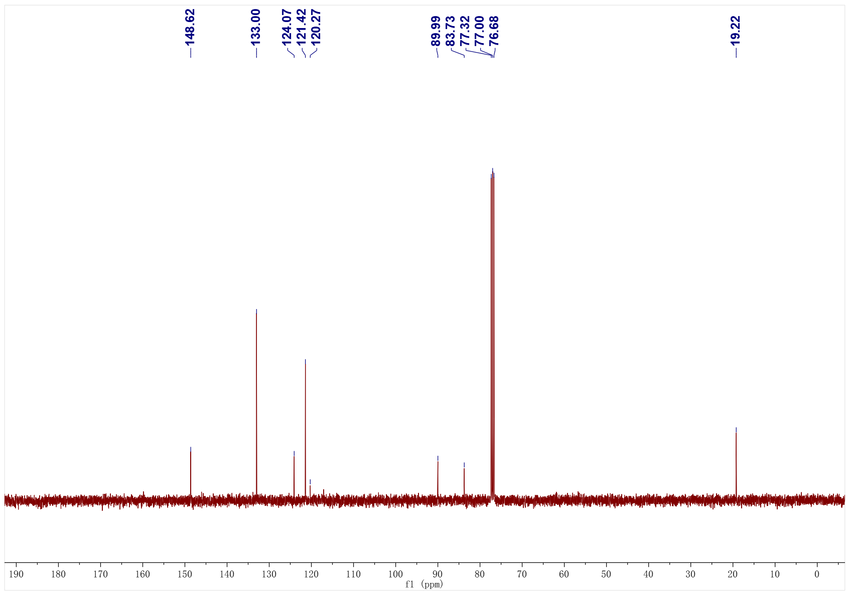
1av; ¹⁹F NMR (376 MHz, CDCl₃)
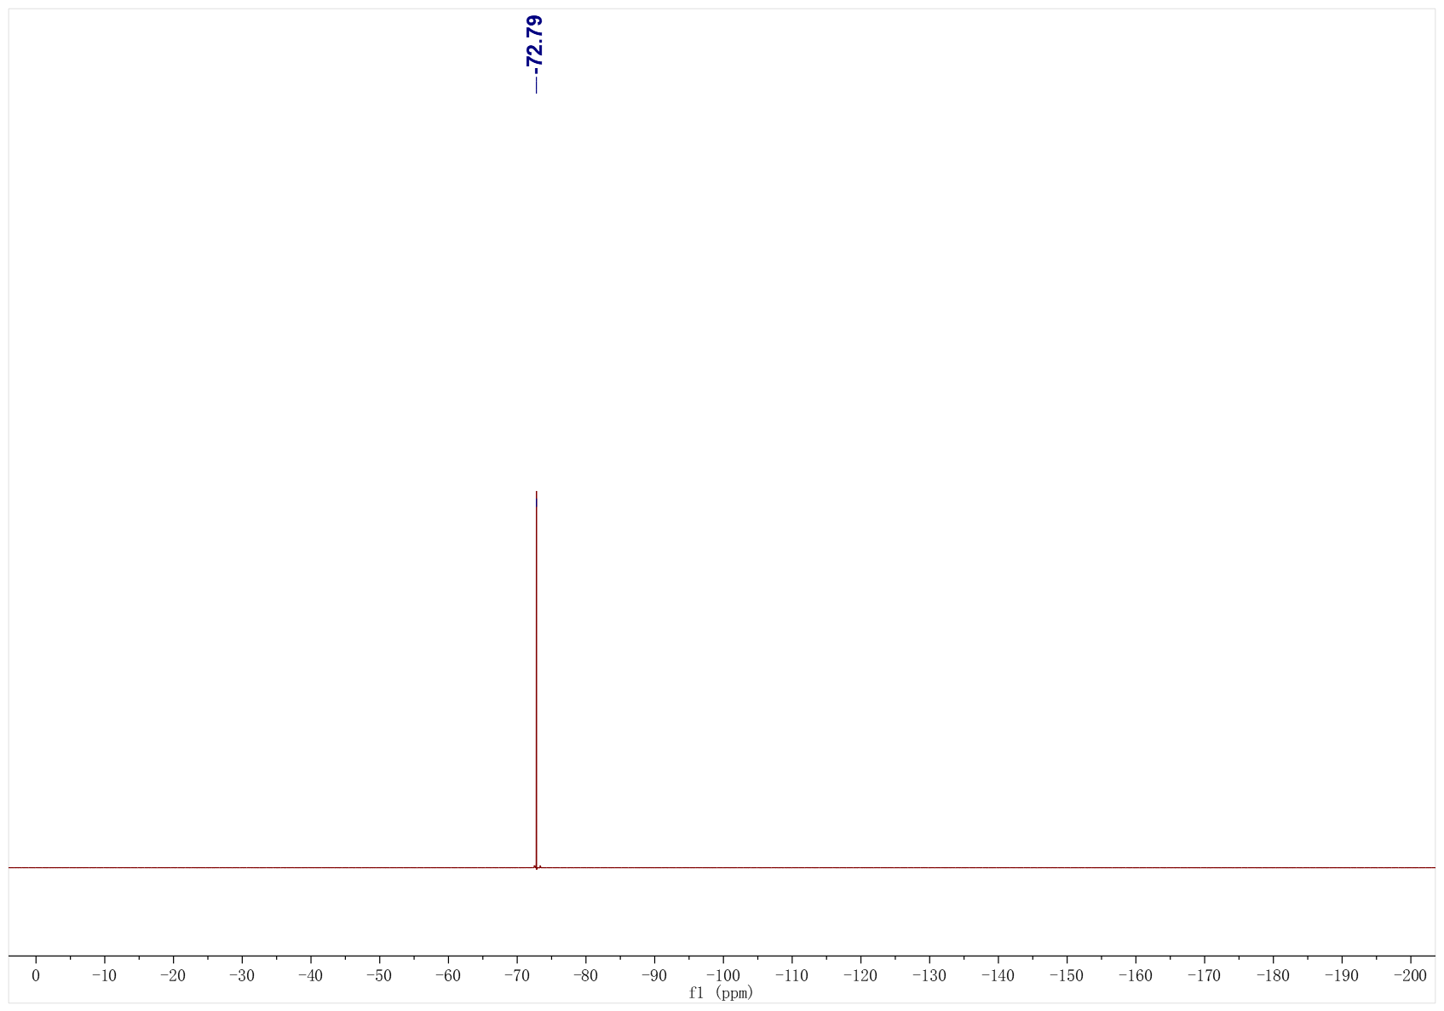
1aw; ¹H NMR (500 MHz, CDCl₃); ¹³C NMR (126 MHz, CDCl₃)
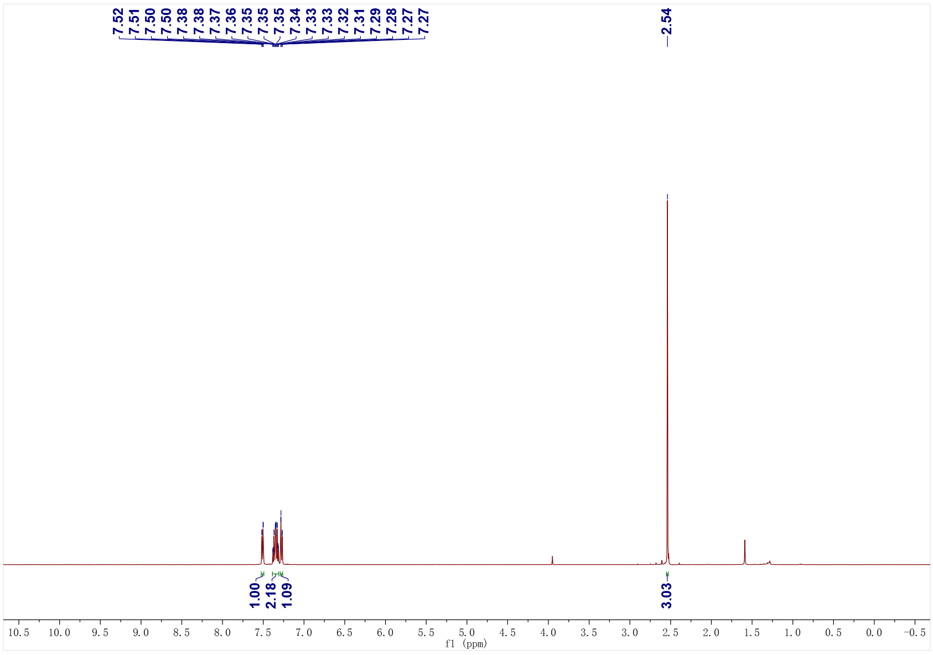
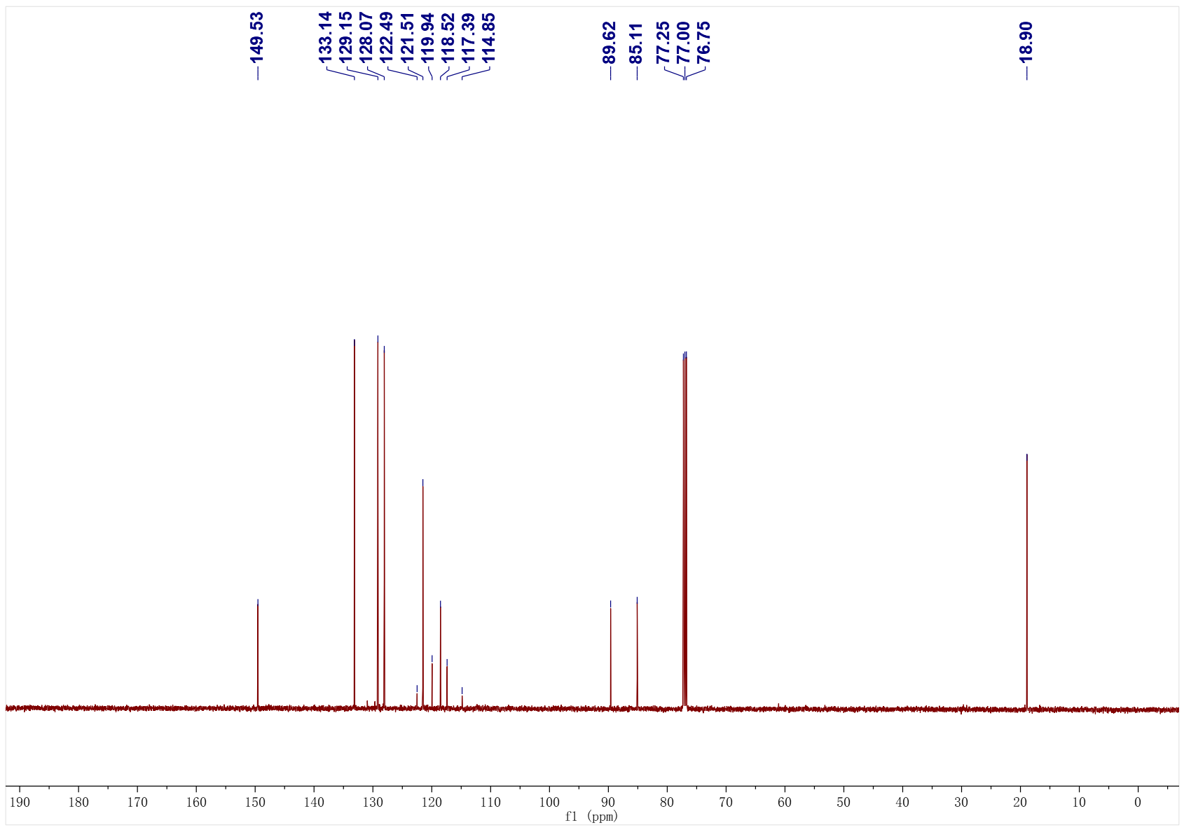
1aw; ¹⁹F NMR (471 MHz, CDCl₃)
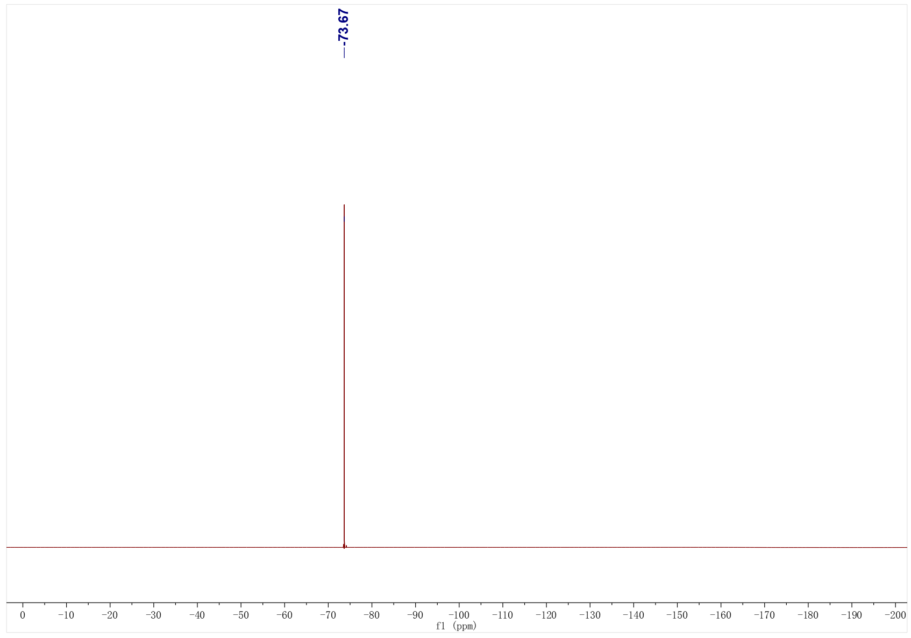

1ax; ¹H NMR (500 MHz, CDCl₃); ¹³C NMR (126 MHz, CDCl₃)
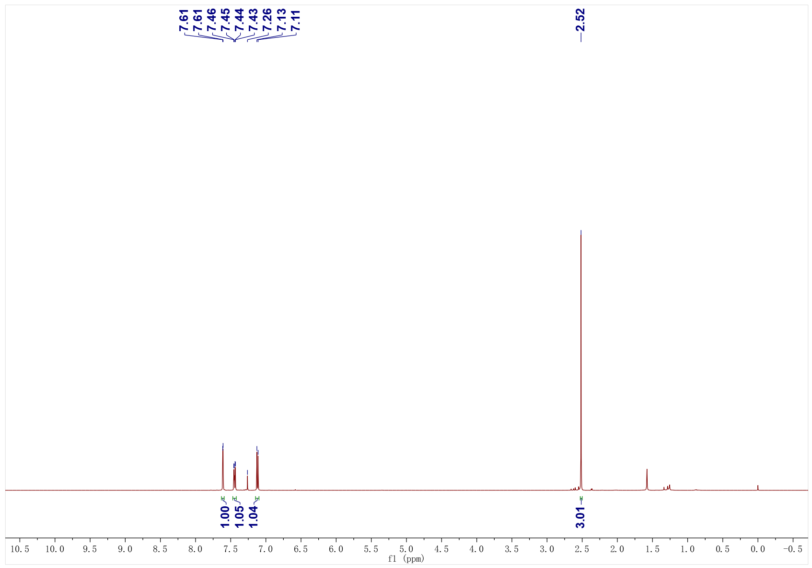
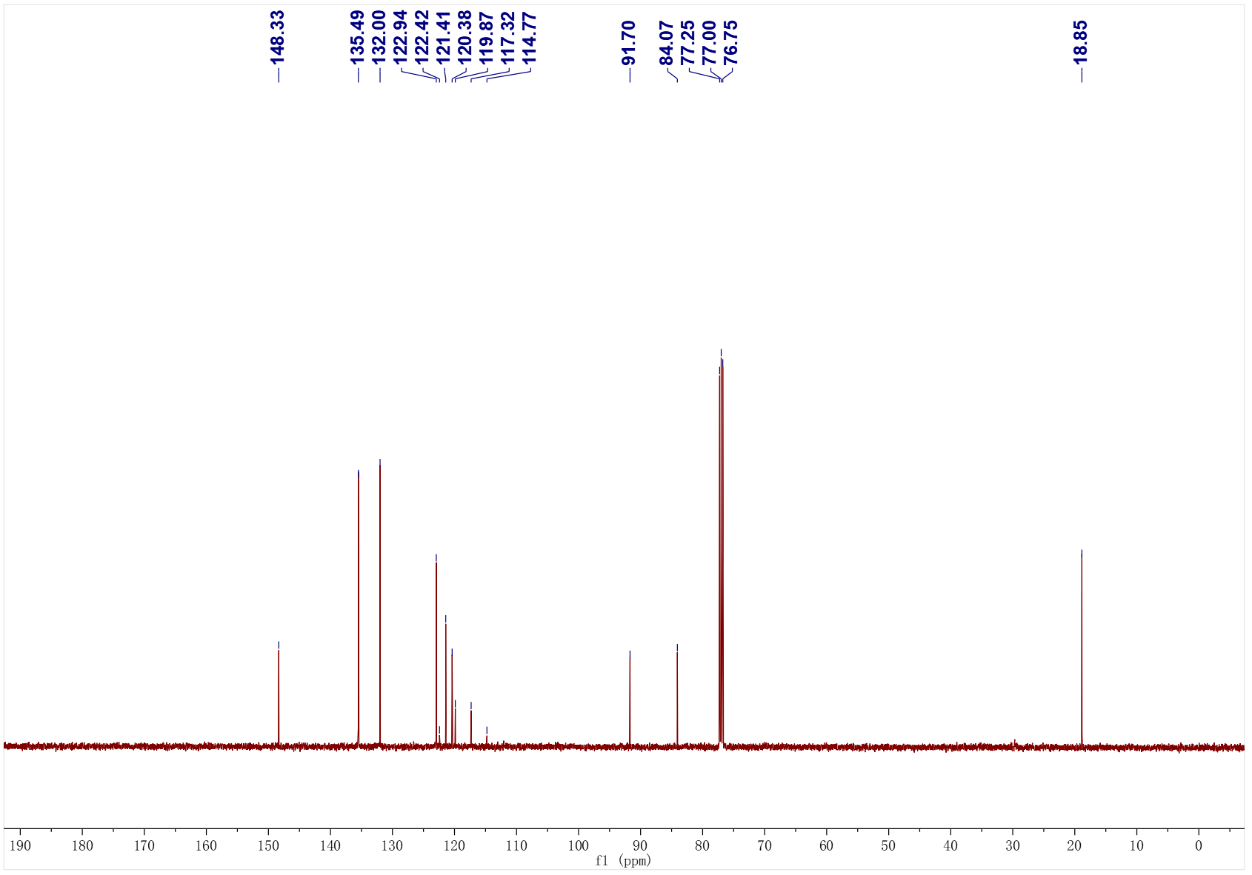
1ay; ¹H NMR (500 MHz, CDCl₃); ¹³C NMR (126 MHz, CDCl₃)
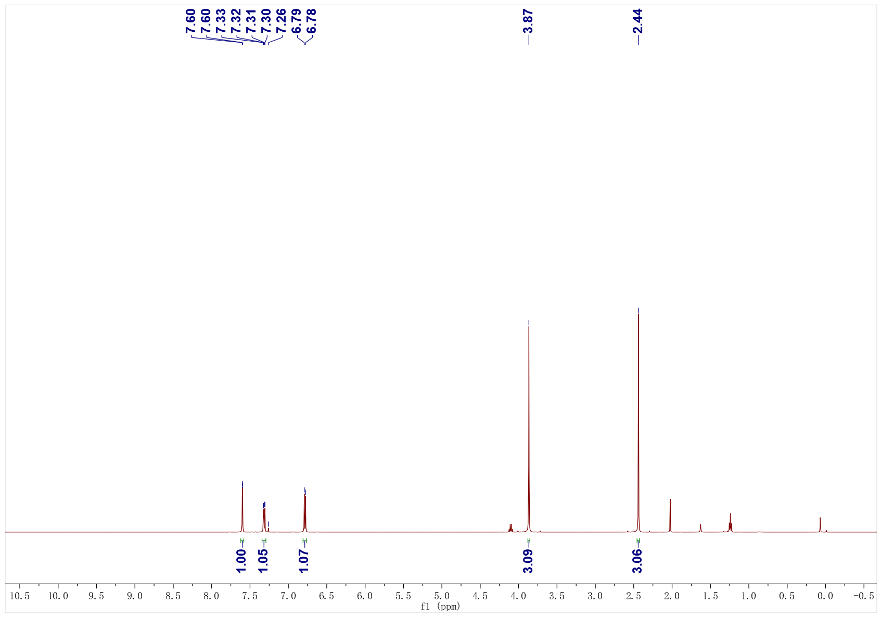
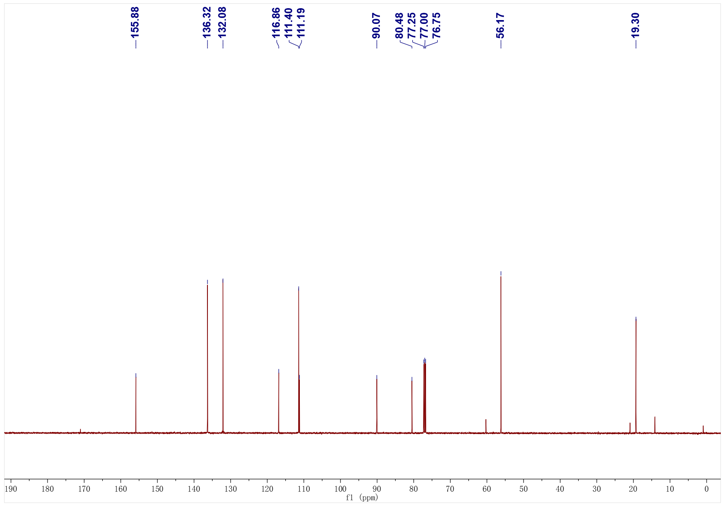
1az; ¹H NMR (400 MHz, CDCl₃); ¹³C NMR (101 MHz, CDCl₃)
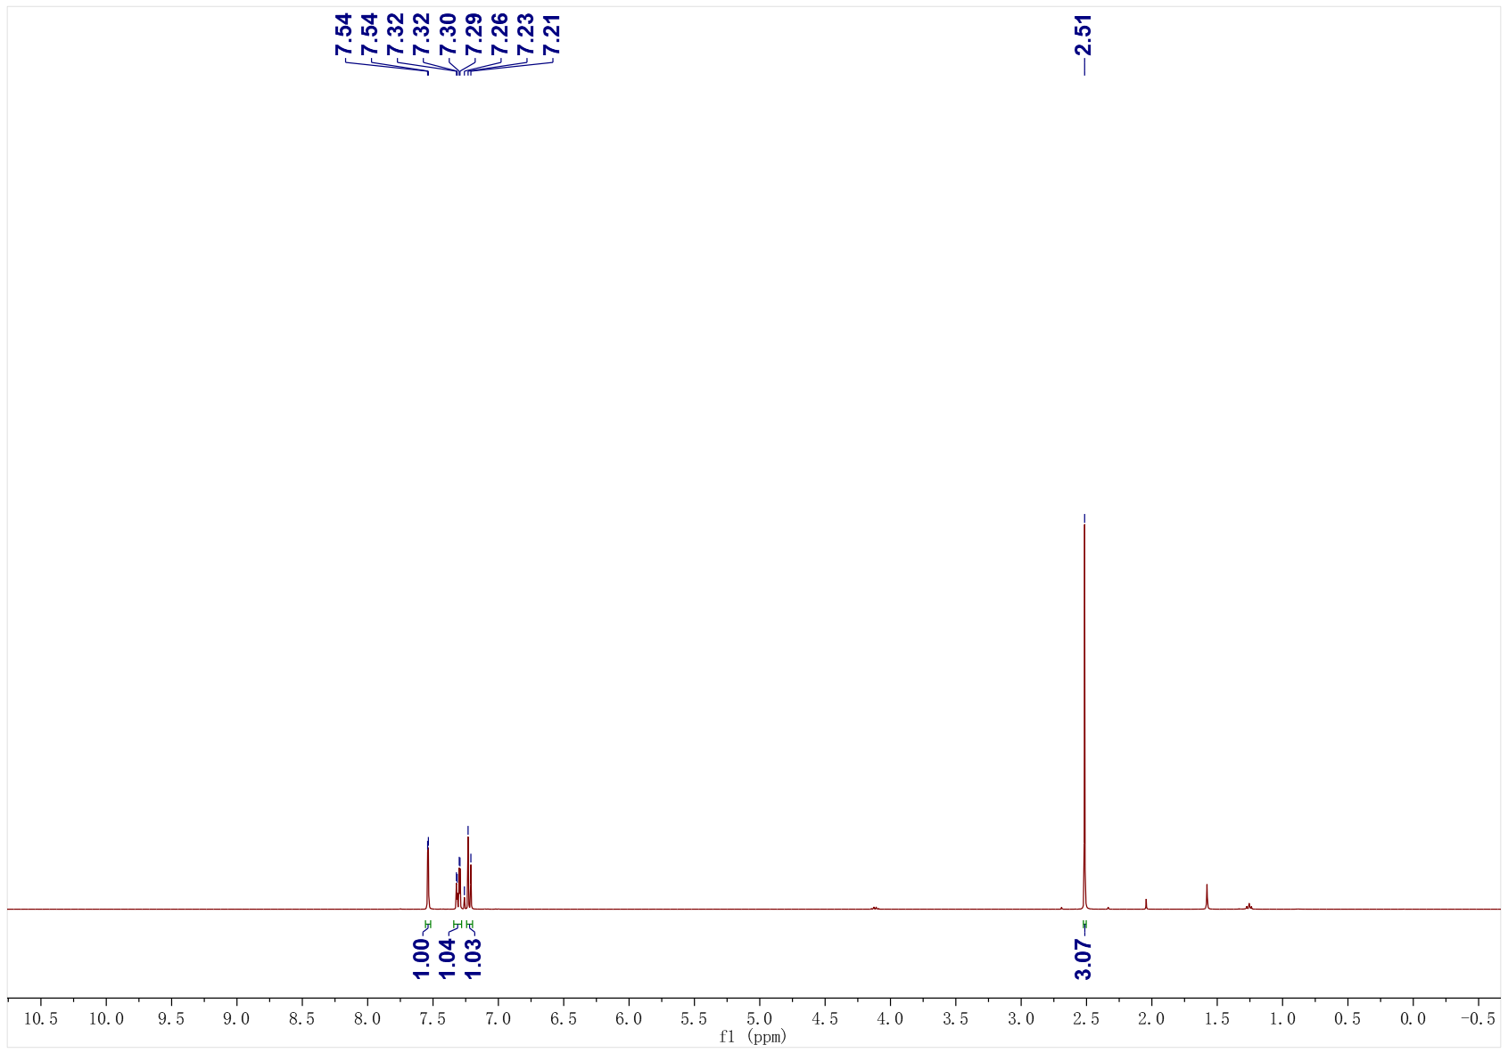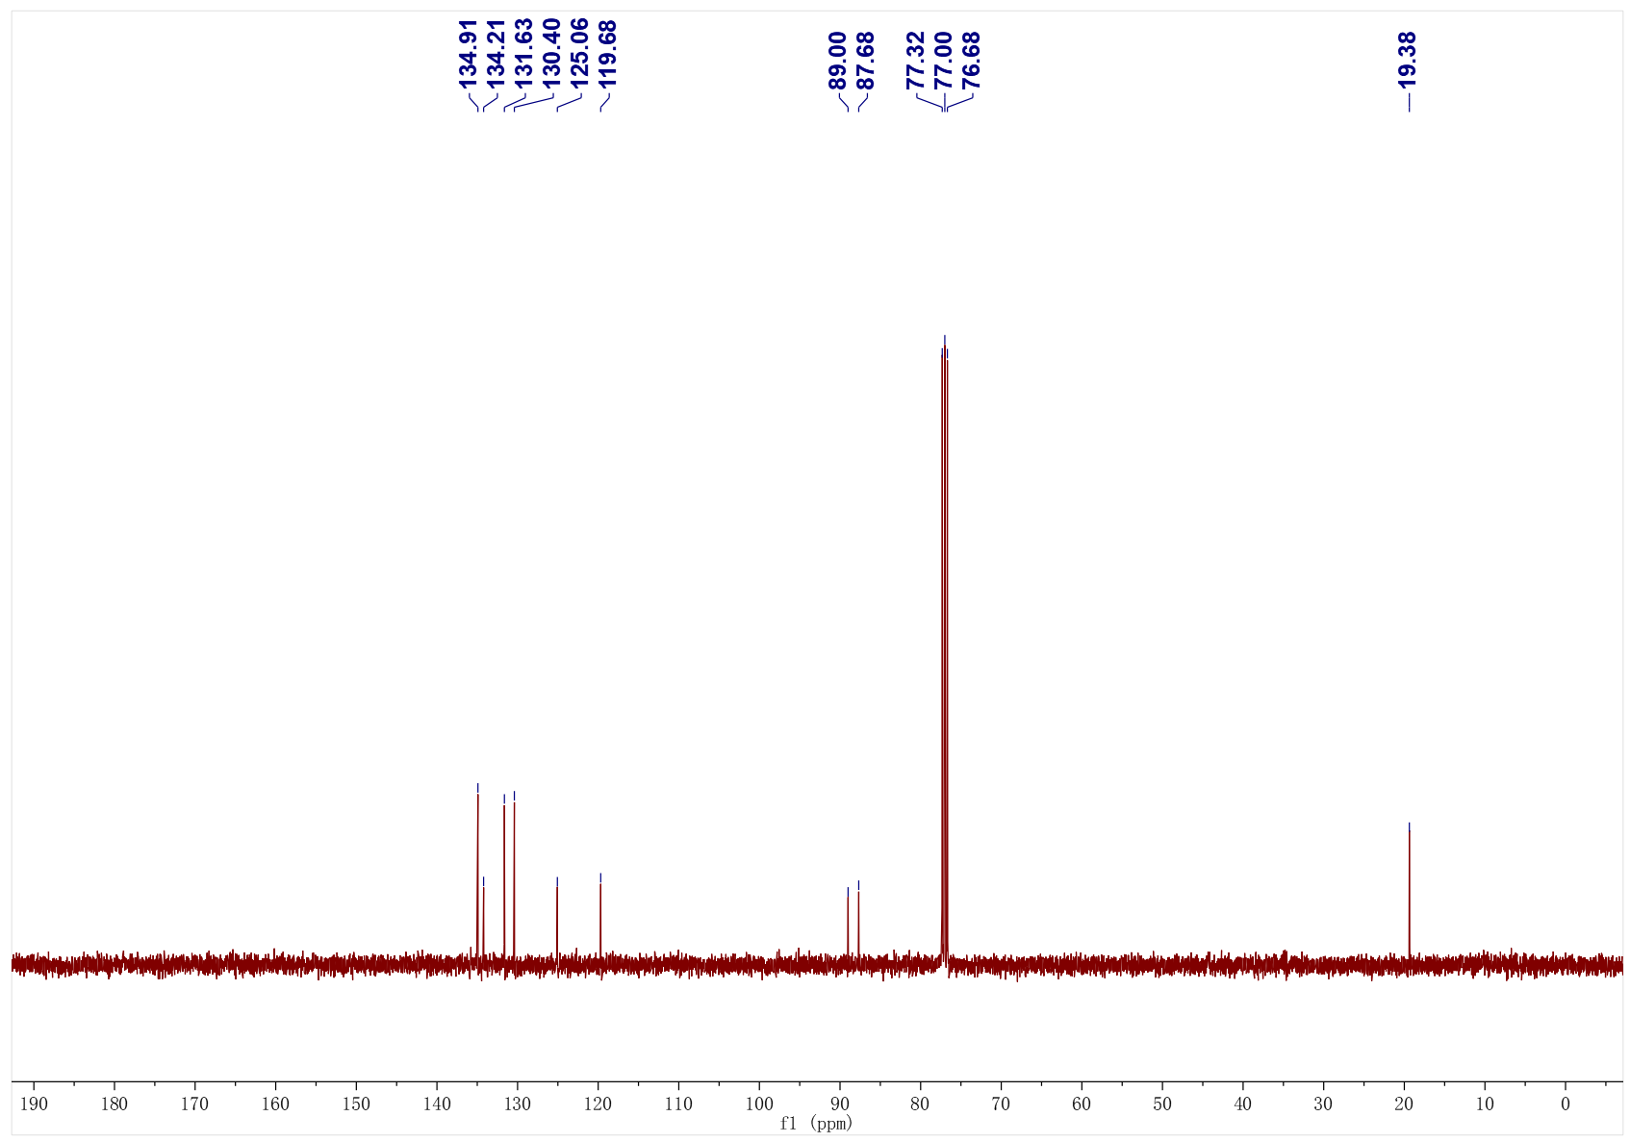
1ba; ¹H NMR (500 MHz, CDCl₃); ¹³C NMR (126 MHz, CDCl₃)
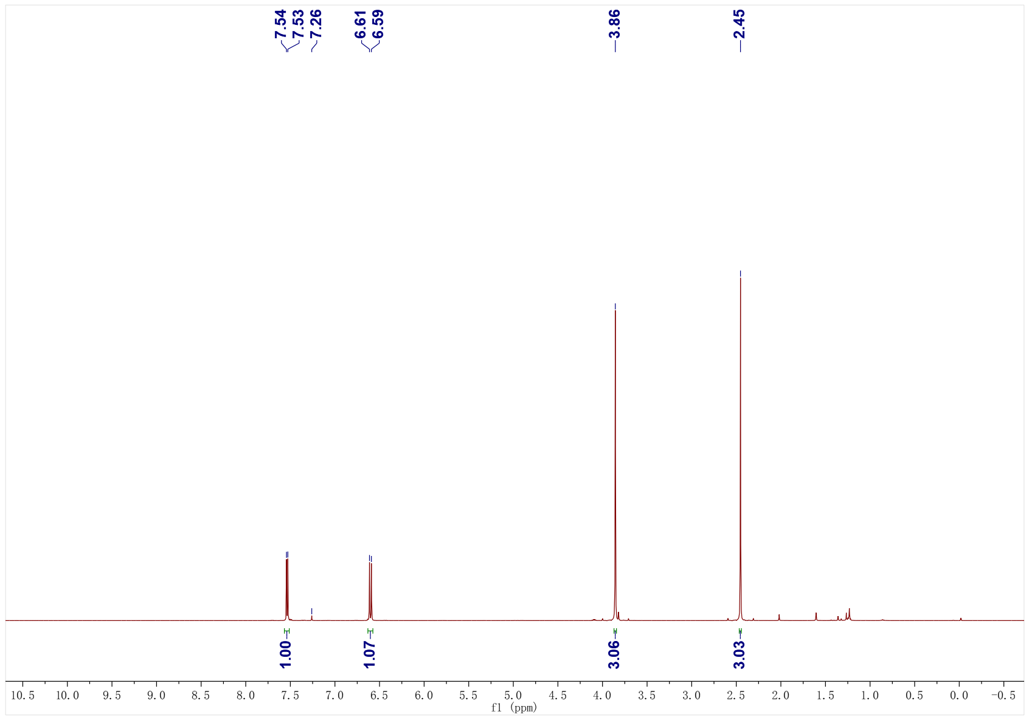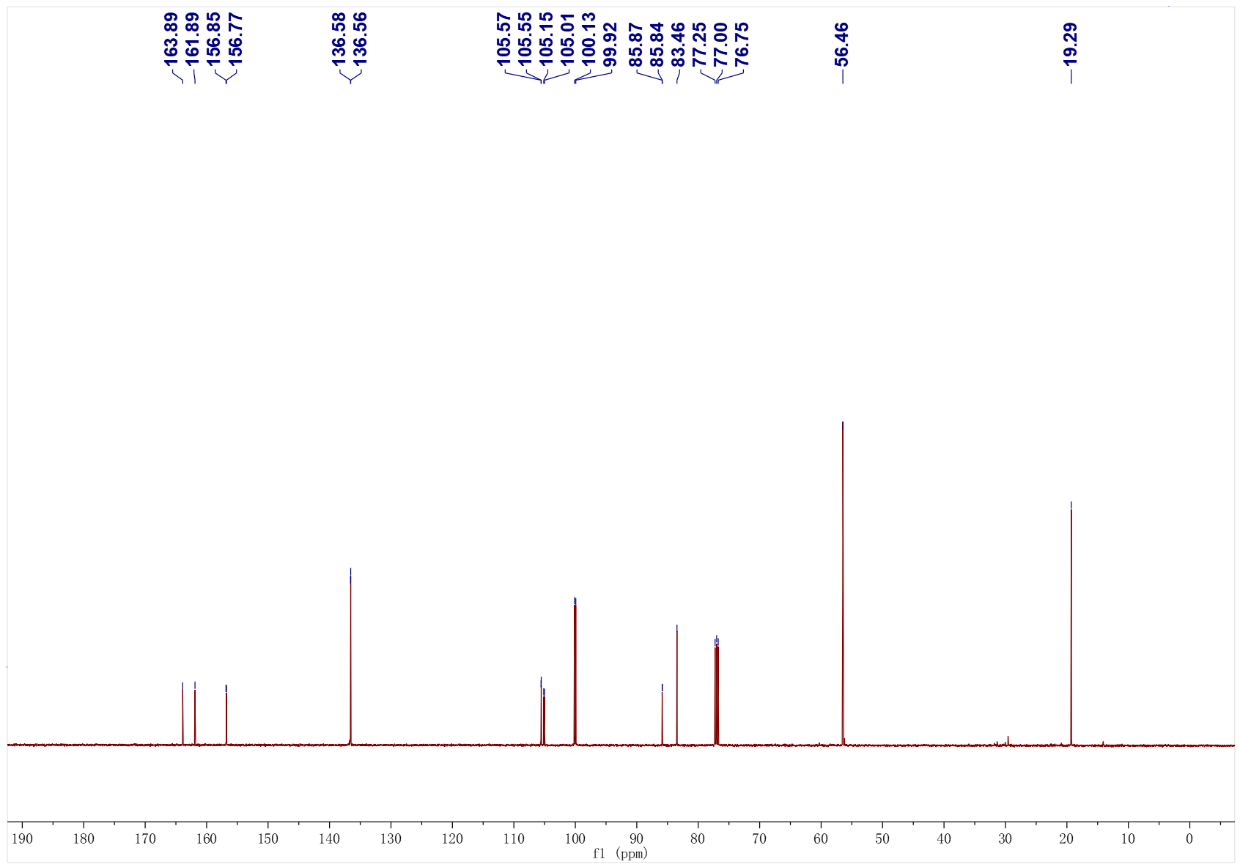

1ba; ¹⁹F NMR (471 MHz, CDCl₃)
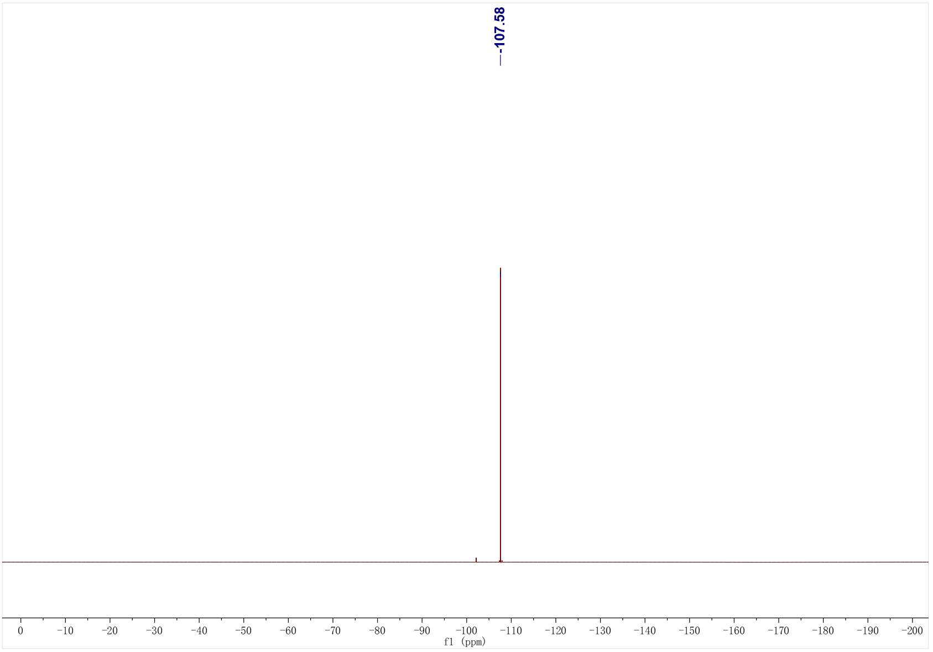

1bb; ¹H NMR (400 MHz, CDCl₃); ¹³C NMR (126 MHz, CDCl₃)
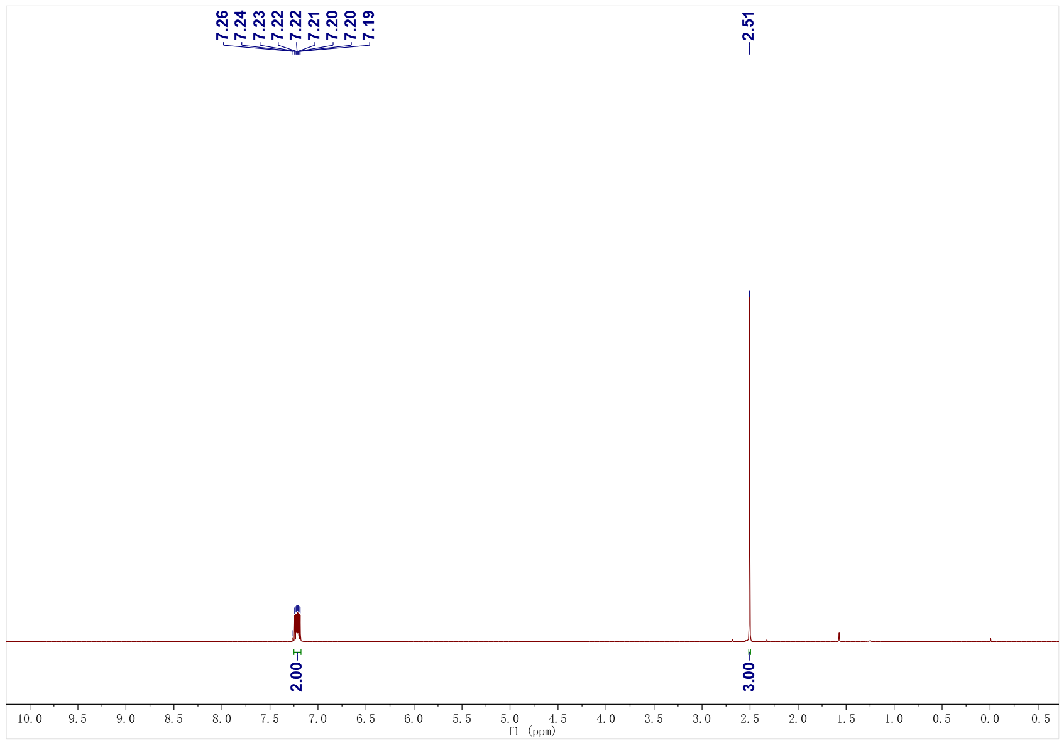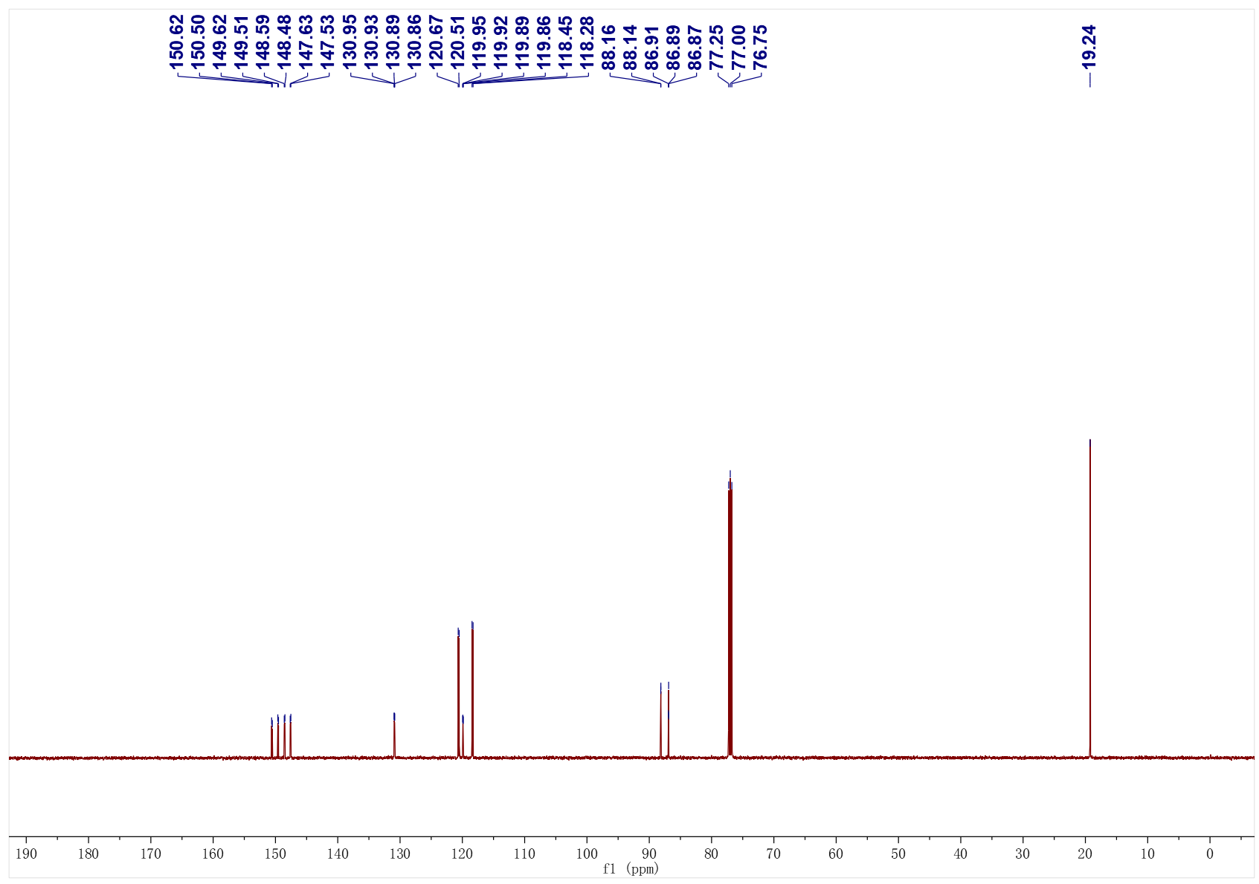

1bb; ¹⁹F NMR (376 MHz, CDCl₃)
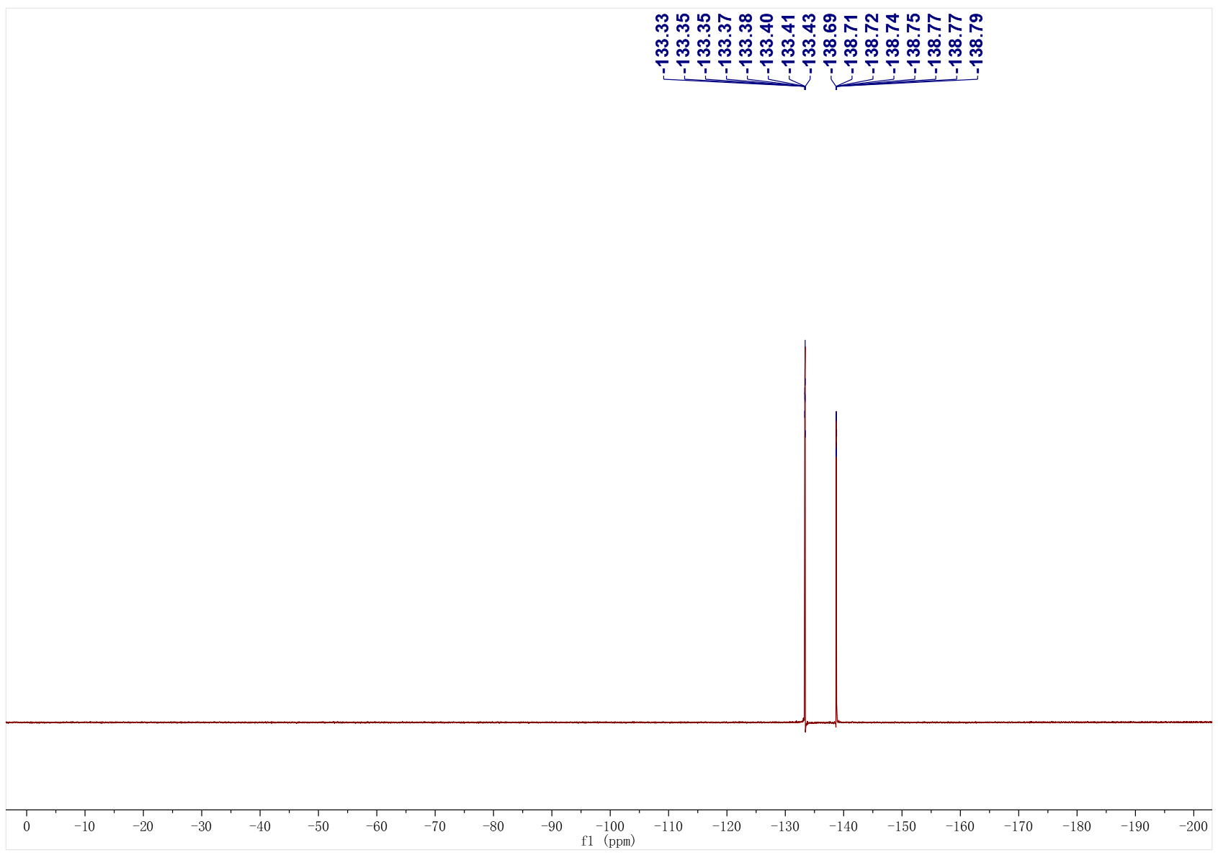
1bc; ¹H NMR (400 MHz, CDCl₃); ¹³C NMR (101 MHz, CDCl₃)
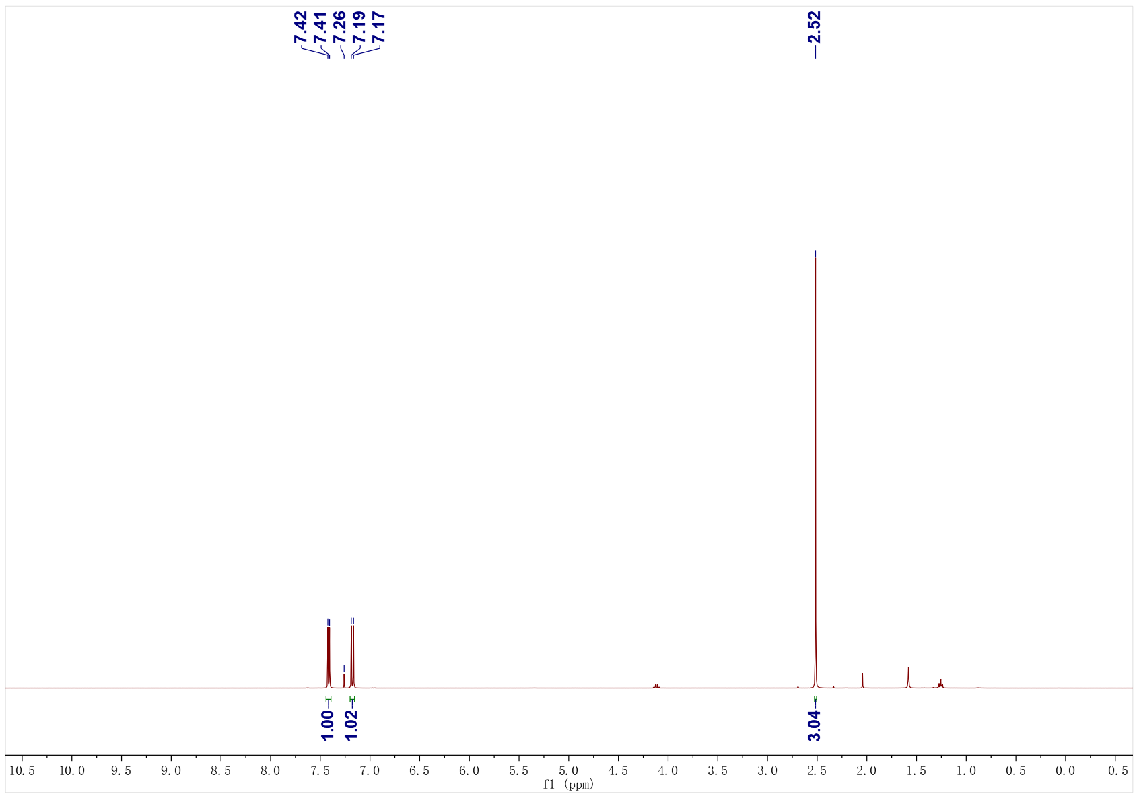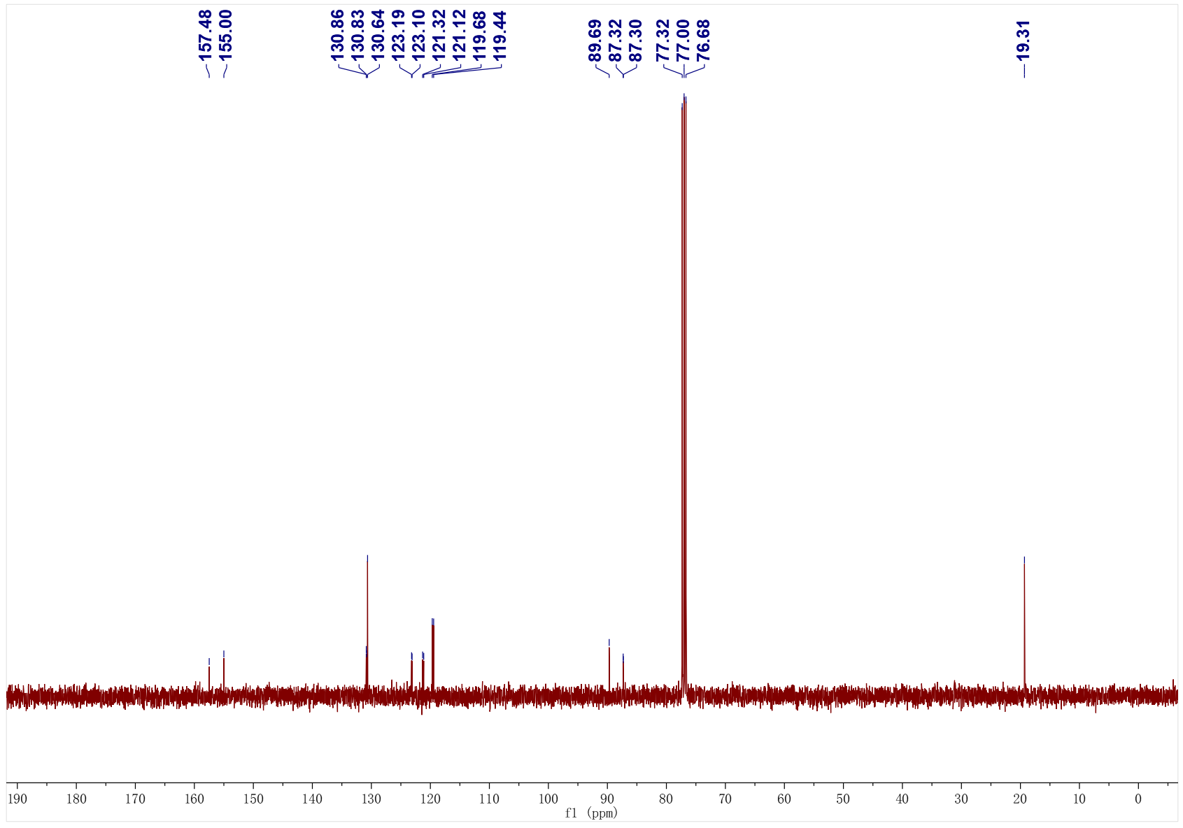

1bc; ¹⁹F NMR (376 MHz, CDCl₃)
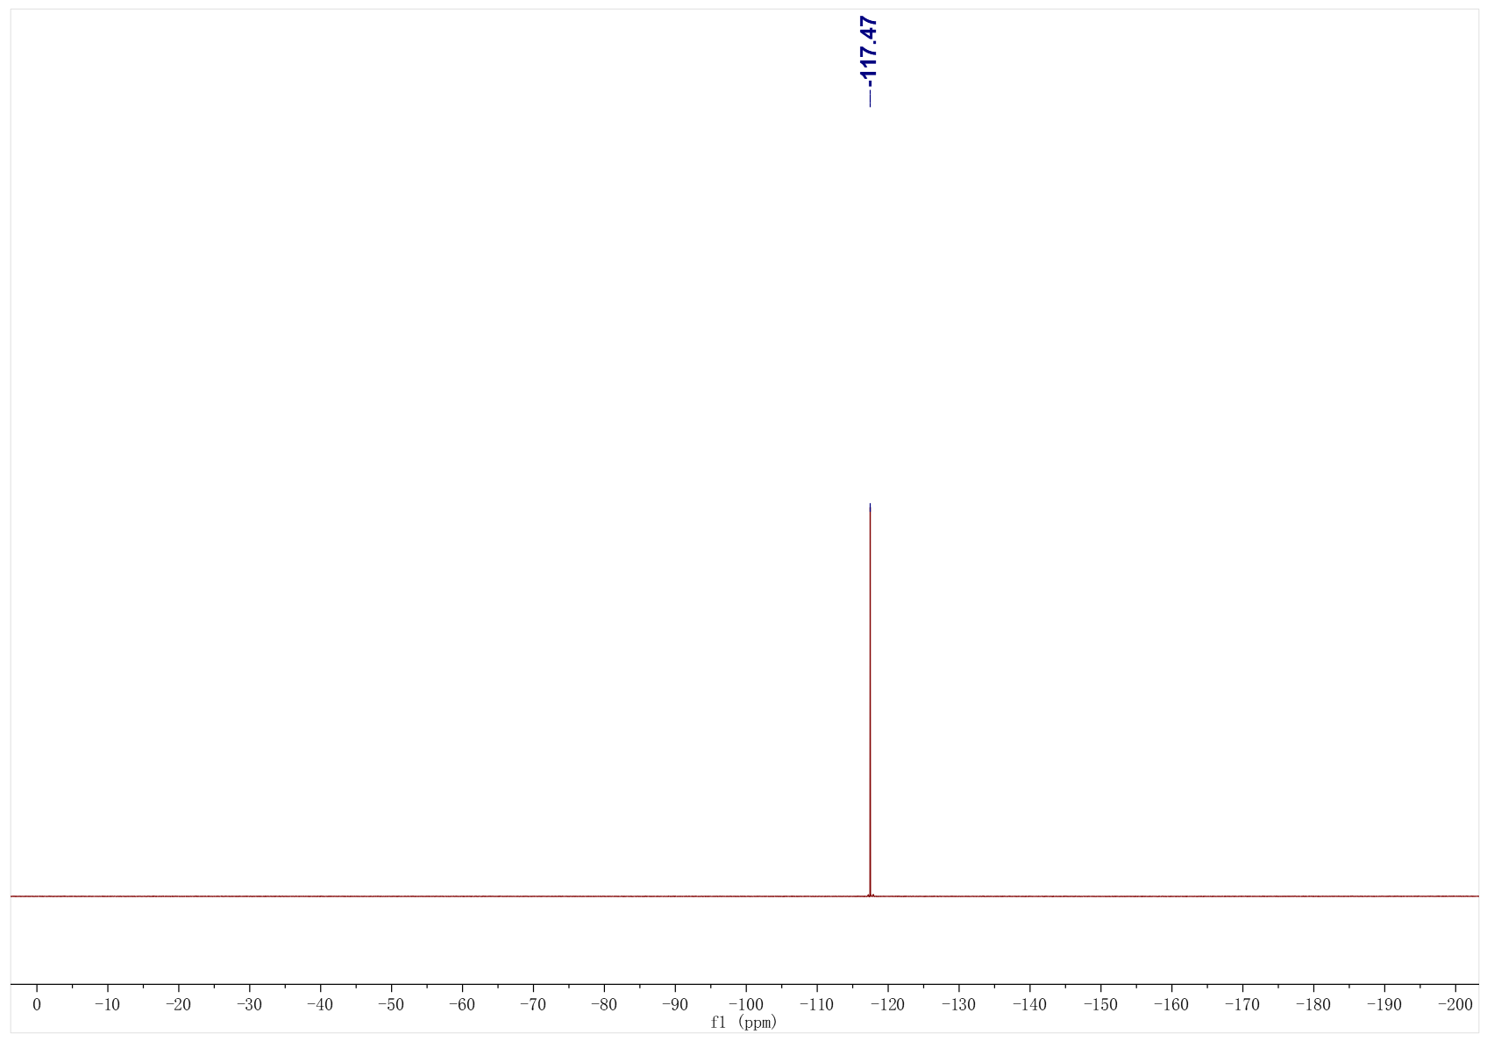
1be; ¹H NMR (500 MHz, CDCl₃); ¹³C NMR (126 MHz, CDCl₃)
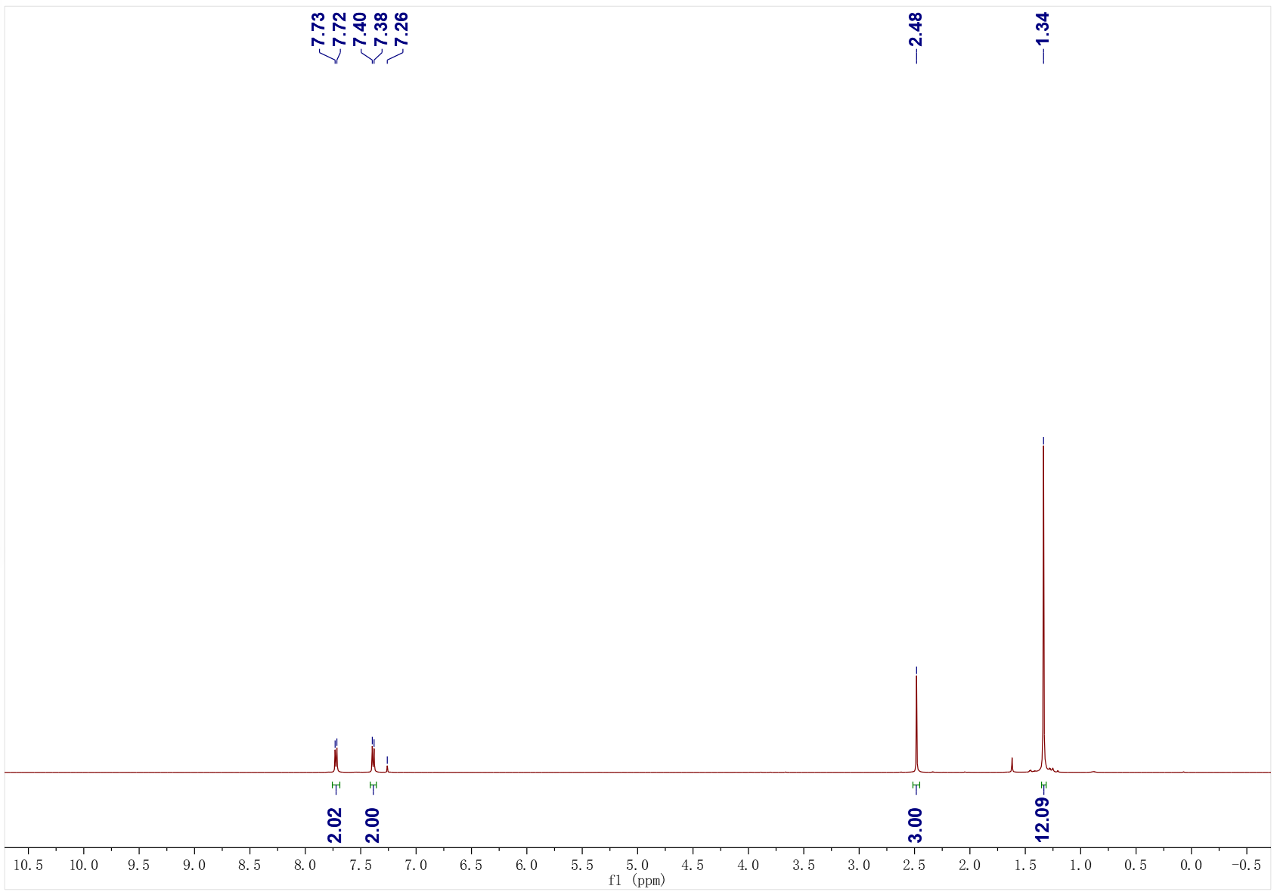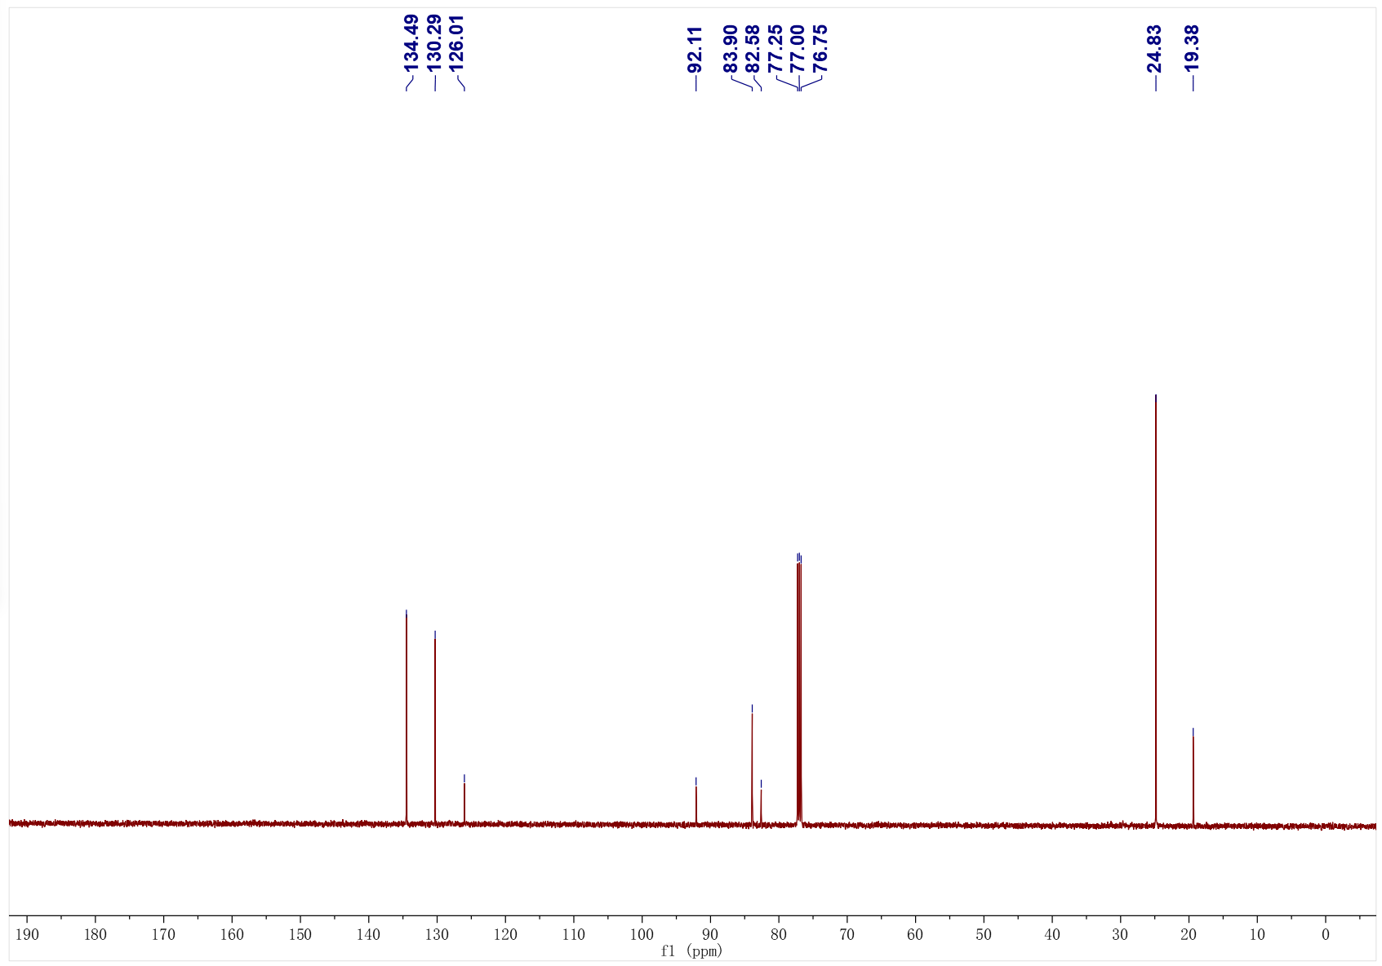

3a; ¹H NMR (500 MHz, CDCl₃); ¹³C NMR (126 MHz, CDCl₃)
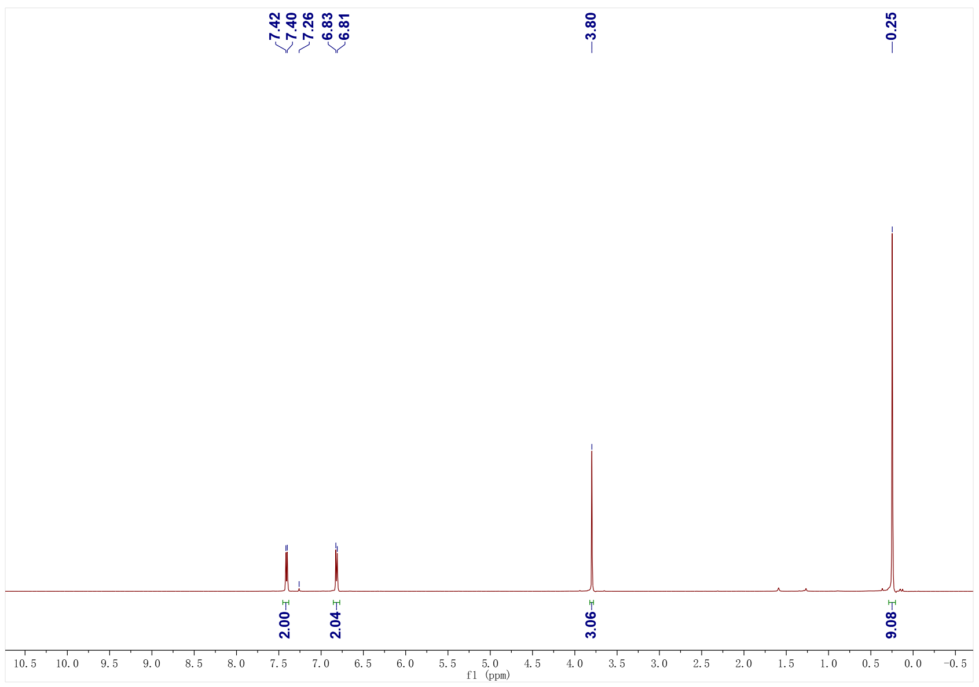
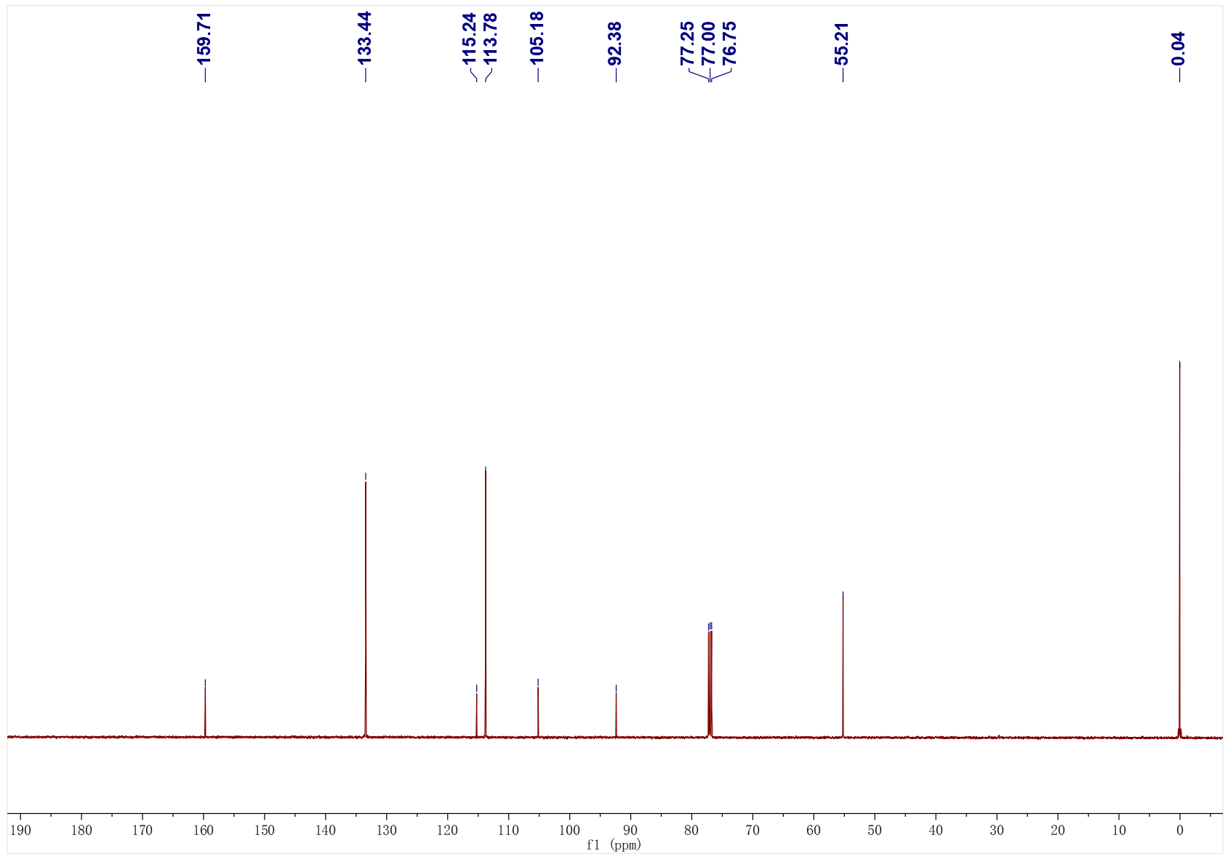
3b; ¹H NMR (400 MHz, CDCl₃); ¹³C NMR (126 MHz, CDCl₃)
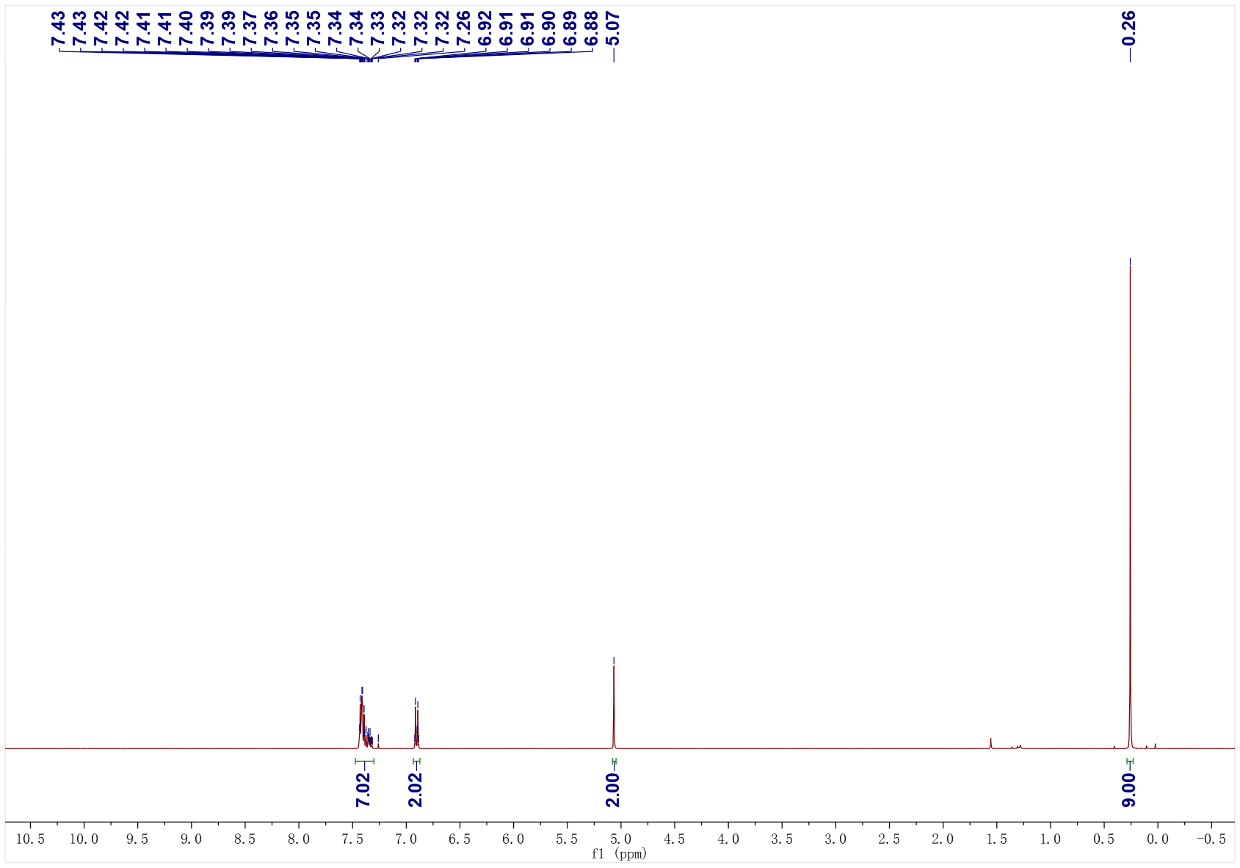
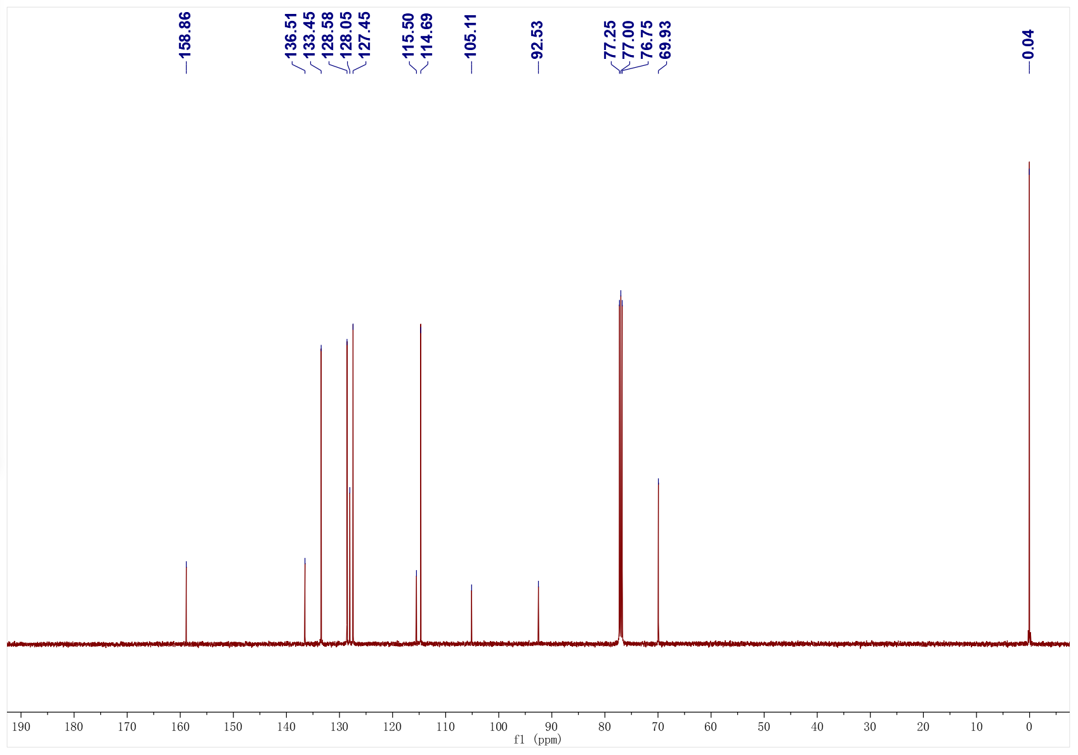
3c; ¹H NMR (400 MHz, CDCl₃); ¹³C NMR (101 MHz, CDCl₃)
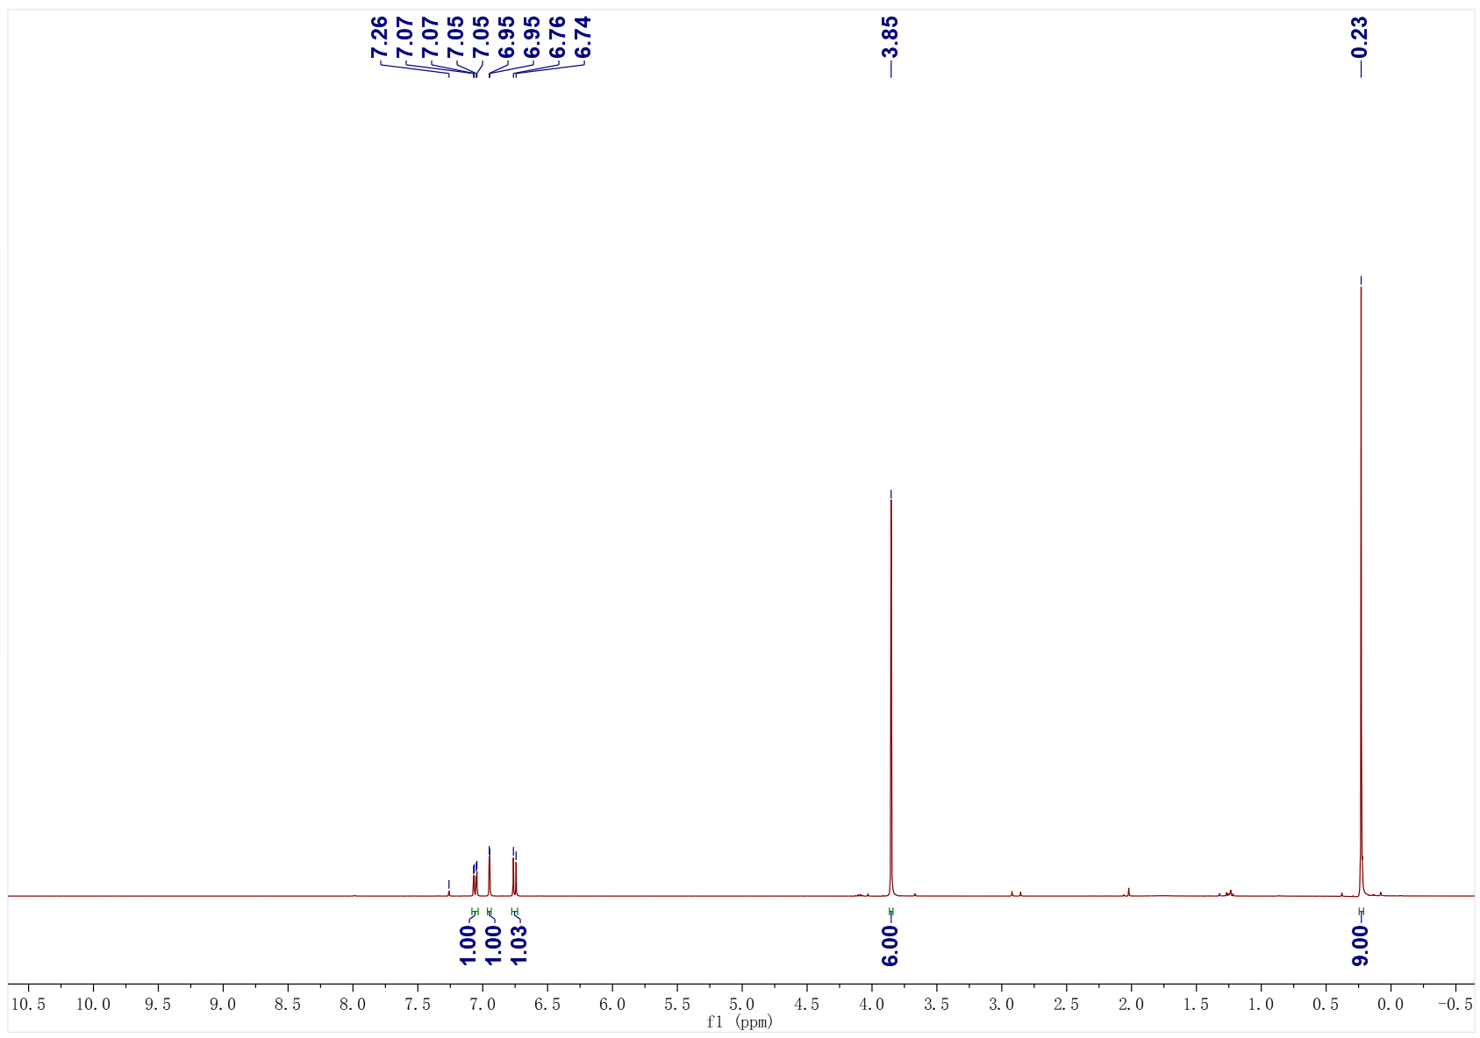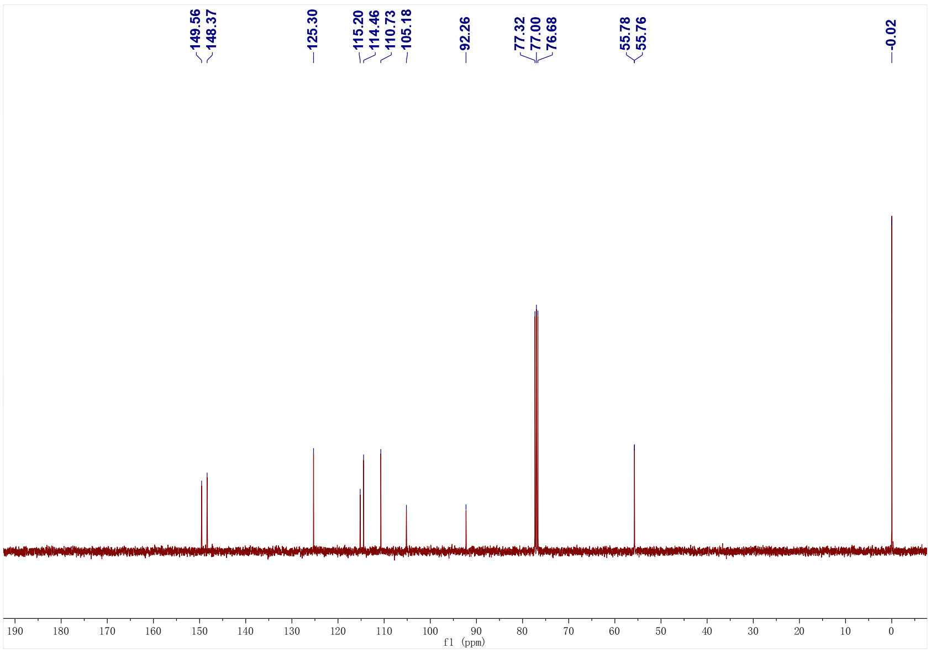
3d; ¹H NMR (500 MHz, CDCl₃); ¹³C NMR (126 MHz, CDCl₃)
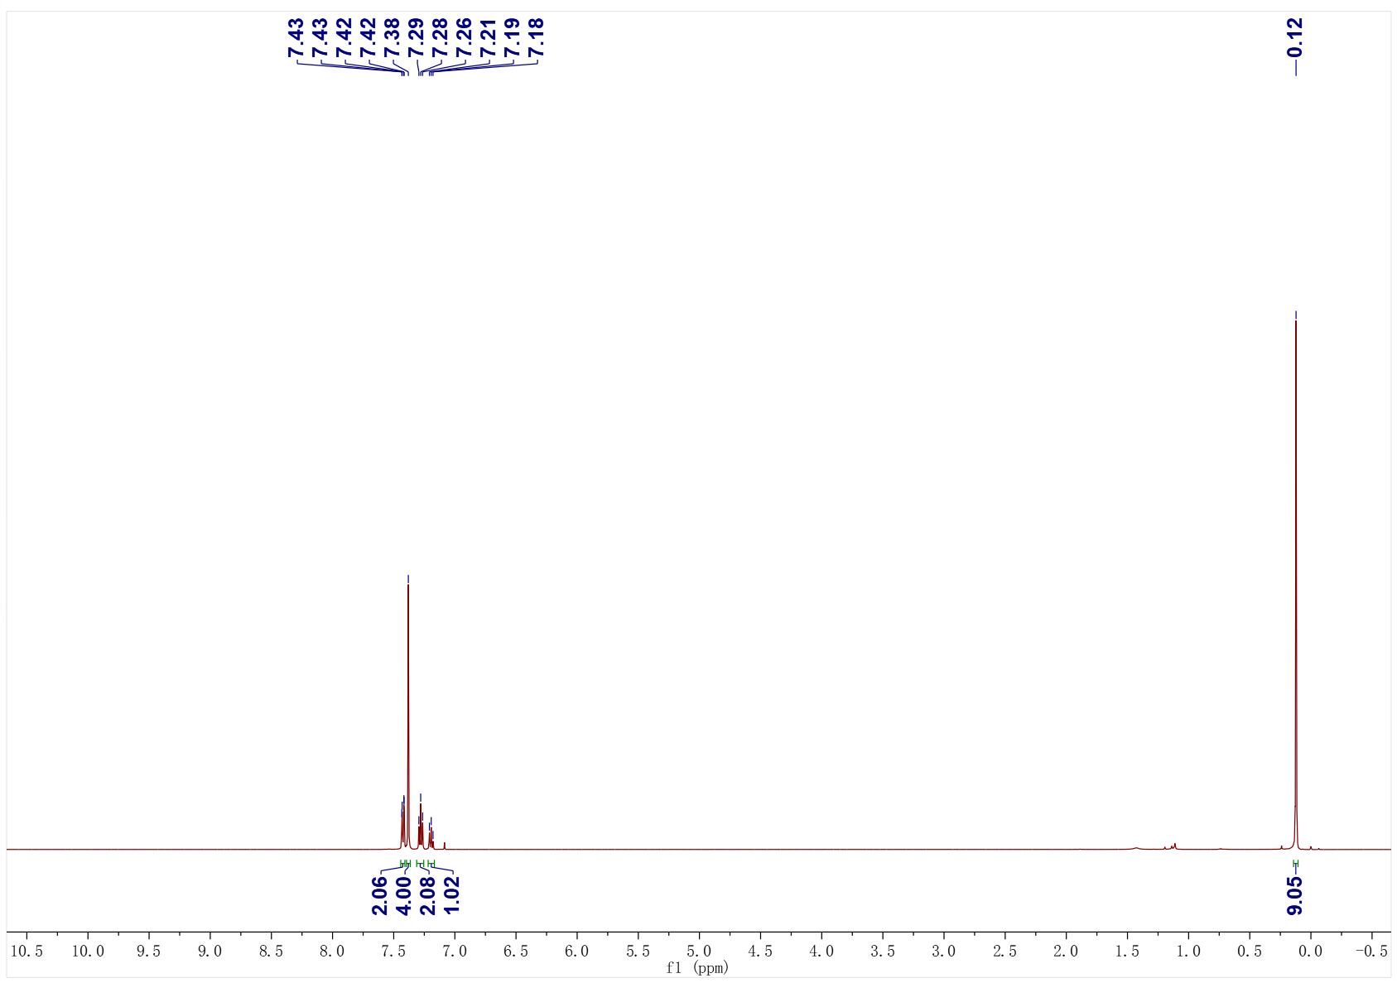
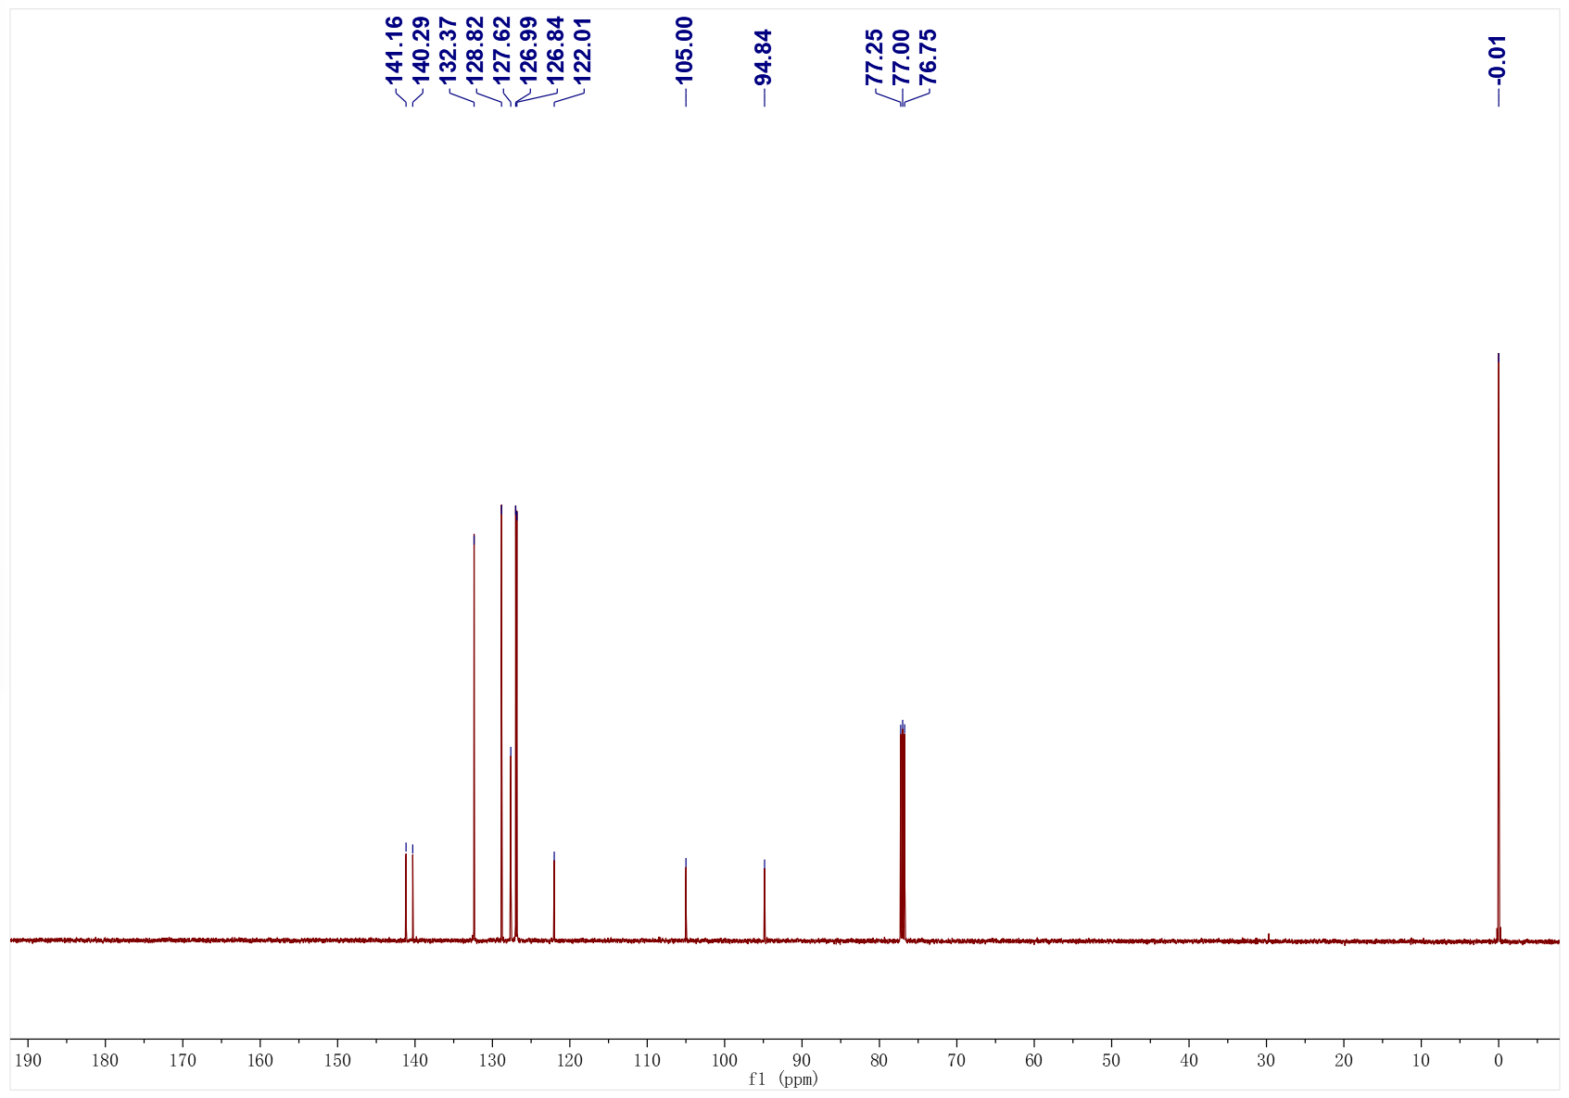
3e; ¹H NMR (500 MHz, CDCl₃); ¹³C NMR (126 MHz, CDCl₃)
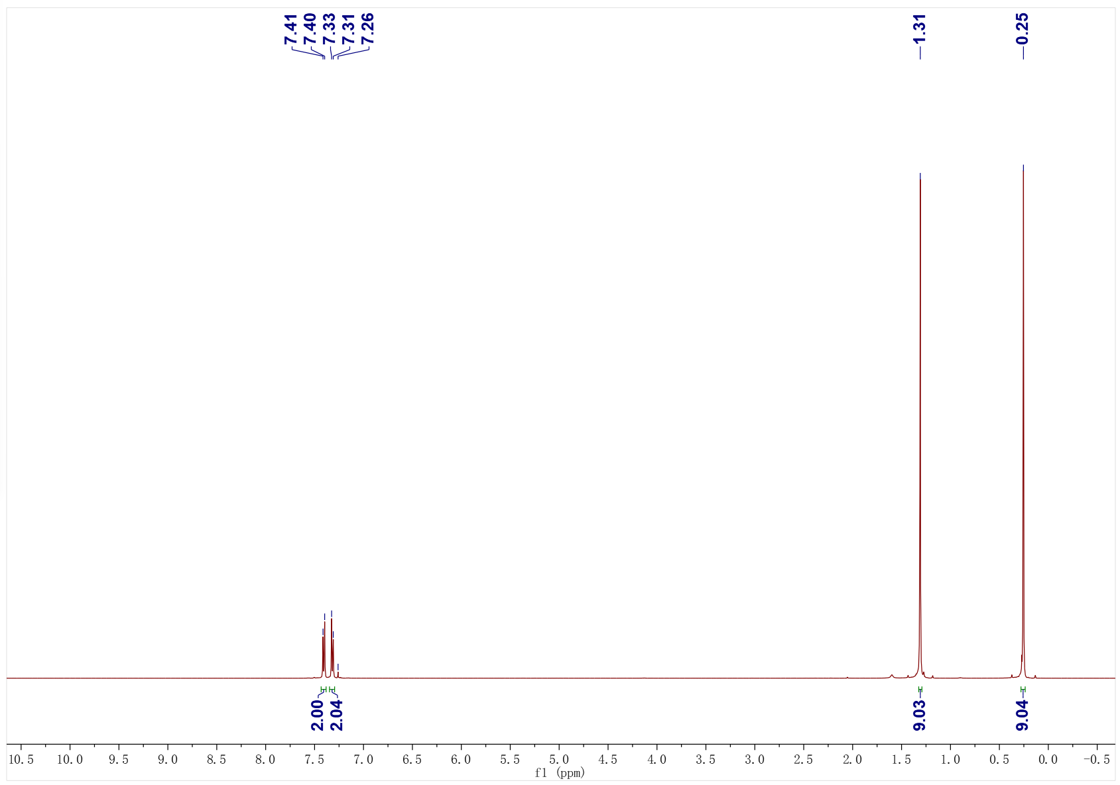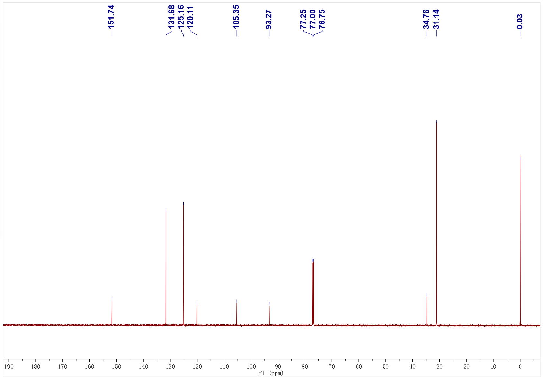
3f; ¹H NMR (500 MHz, CDCl₃); ¹³C NMR (126 MHz, CDCl₃)
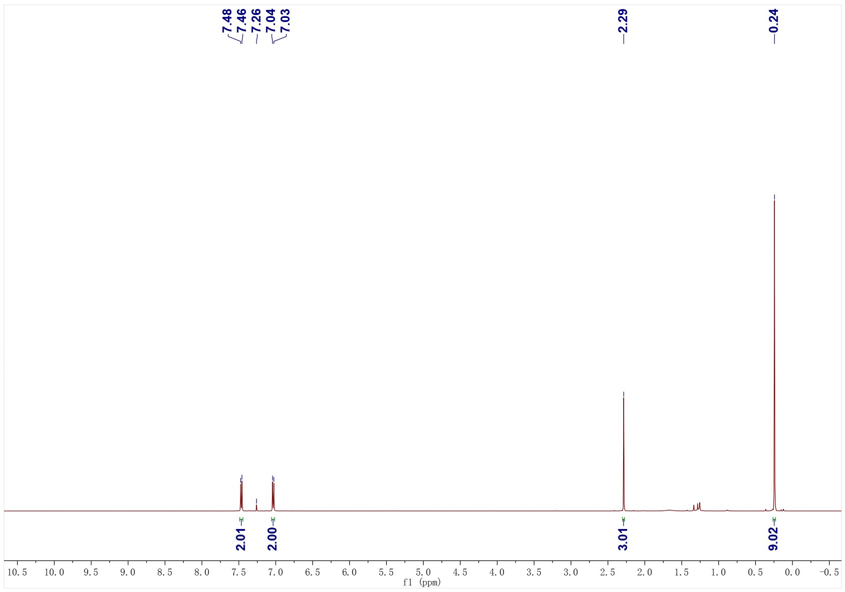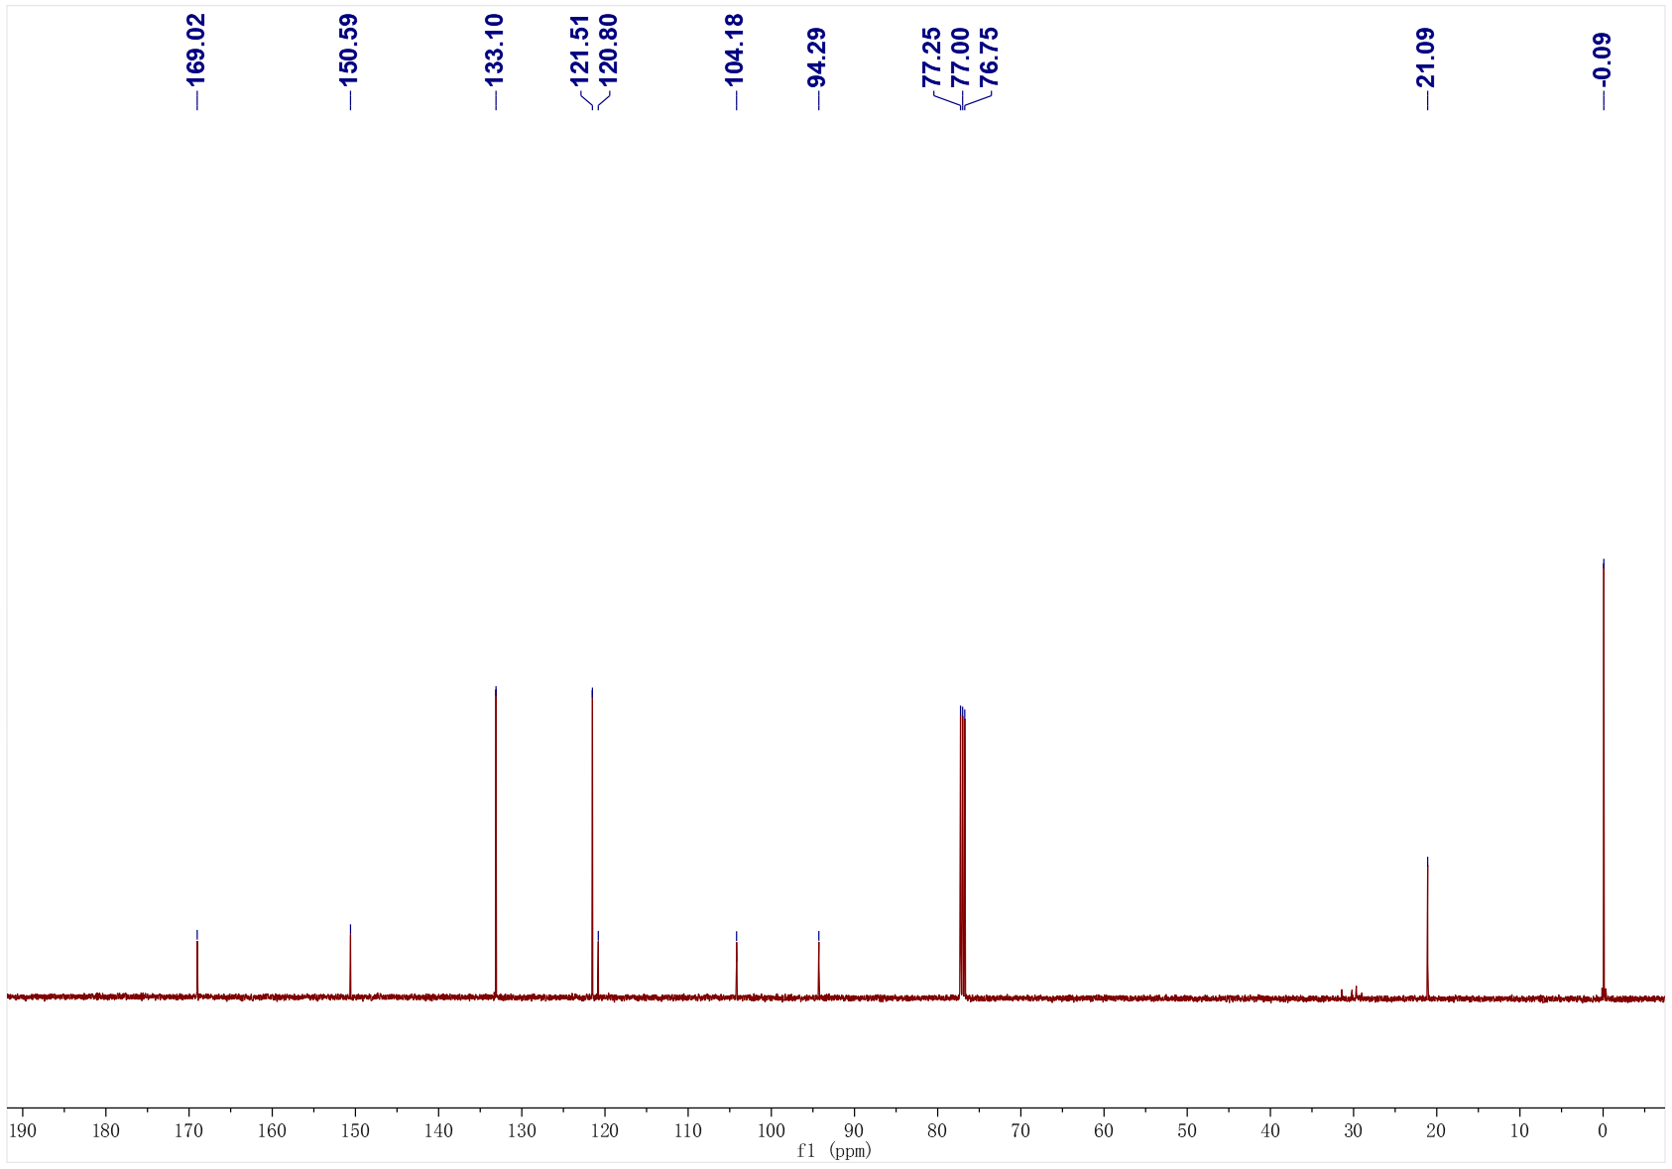
3g; ¹H NMR (500 MHz, CDCl₃); ¹³C NMR (126 MHz, CDCl₃)
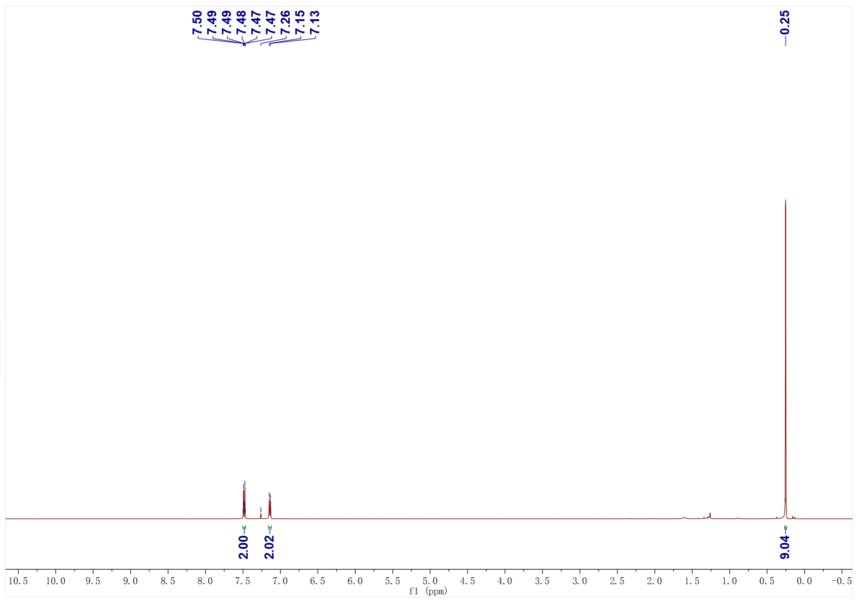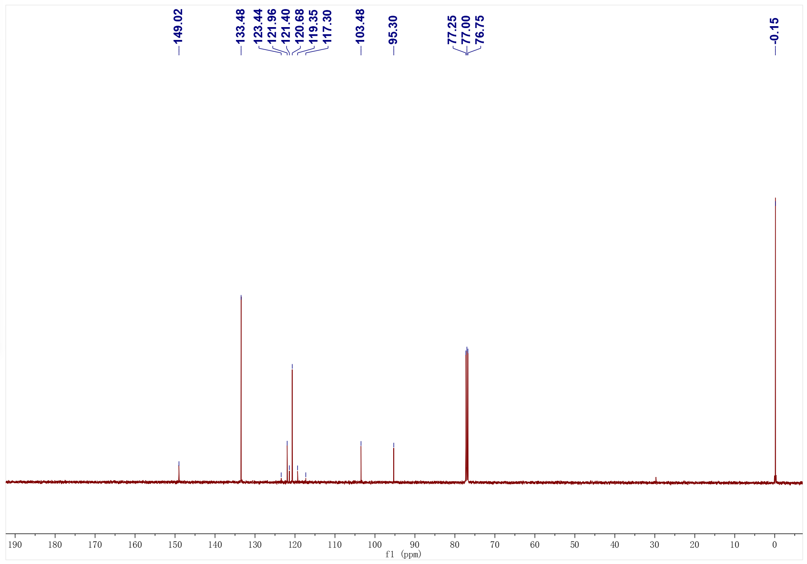
3g; ¹⁹F NMR (471 MHz, CDCl₃)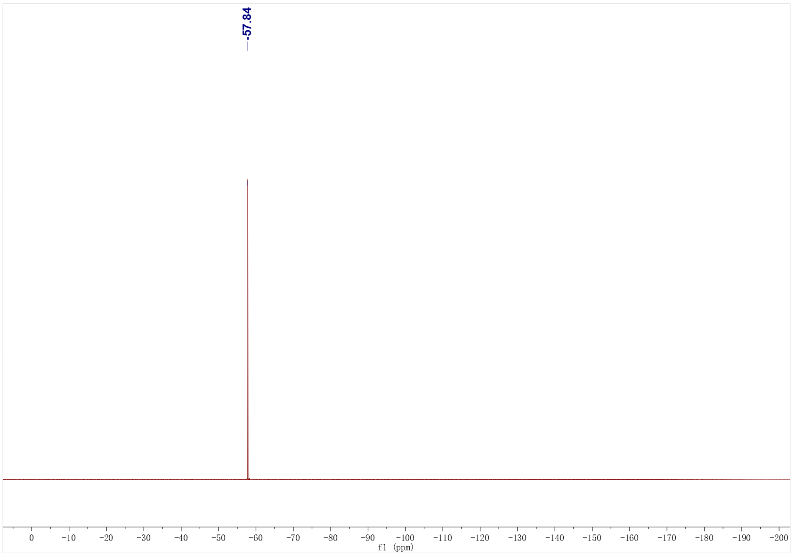
3h; ¹H NMR (500 MHz, CDCl₃); ¹³C NMR (126 MHz, CDCl₃)
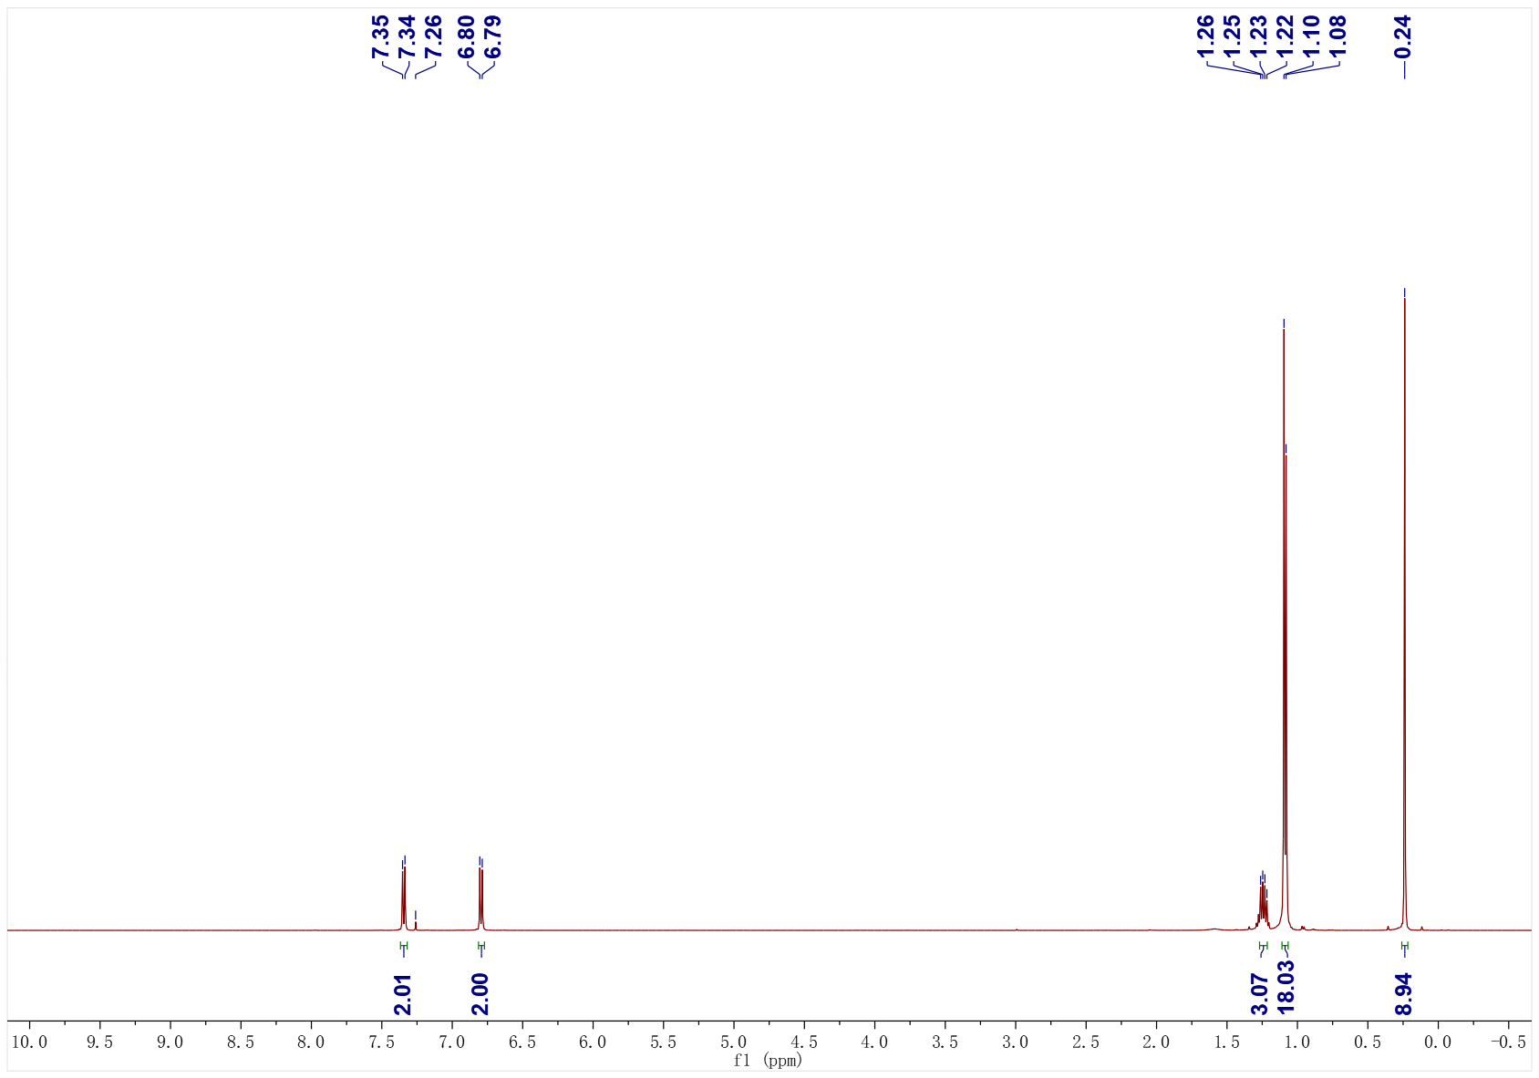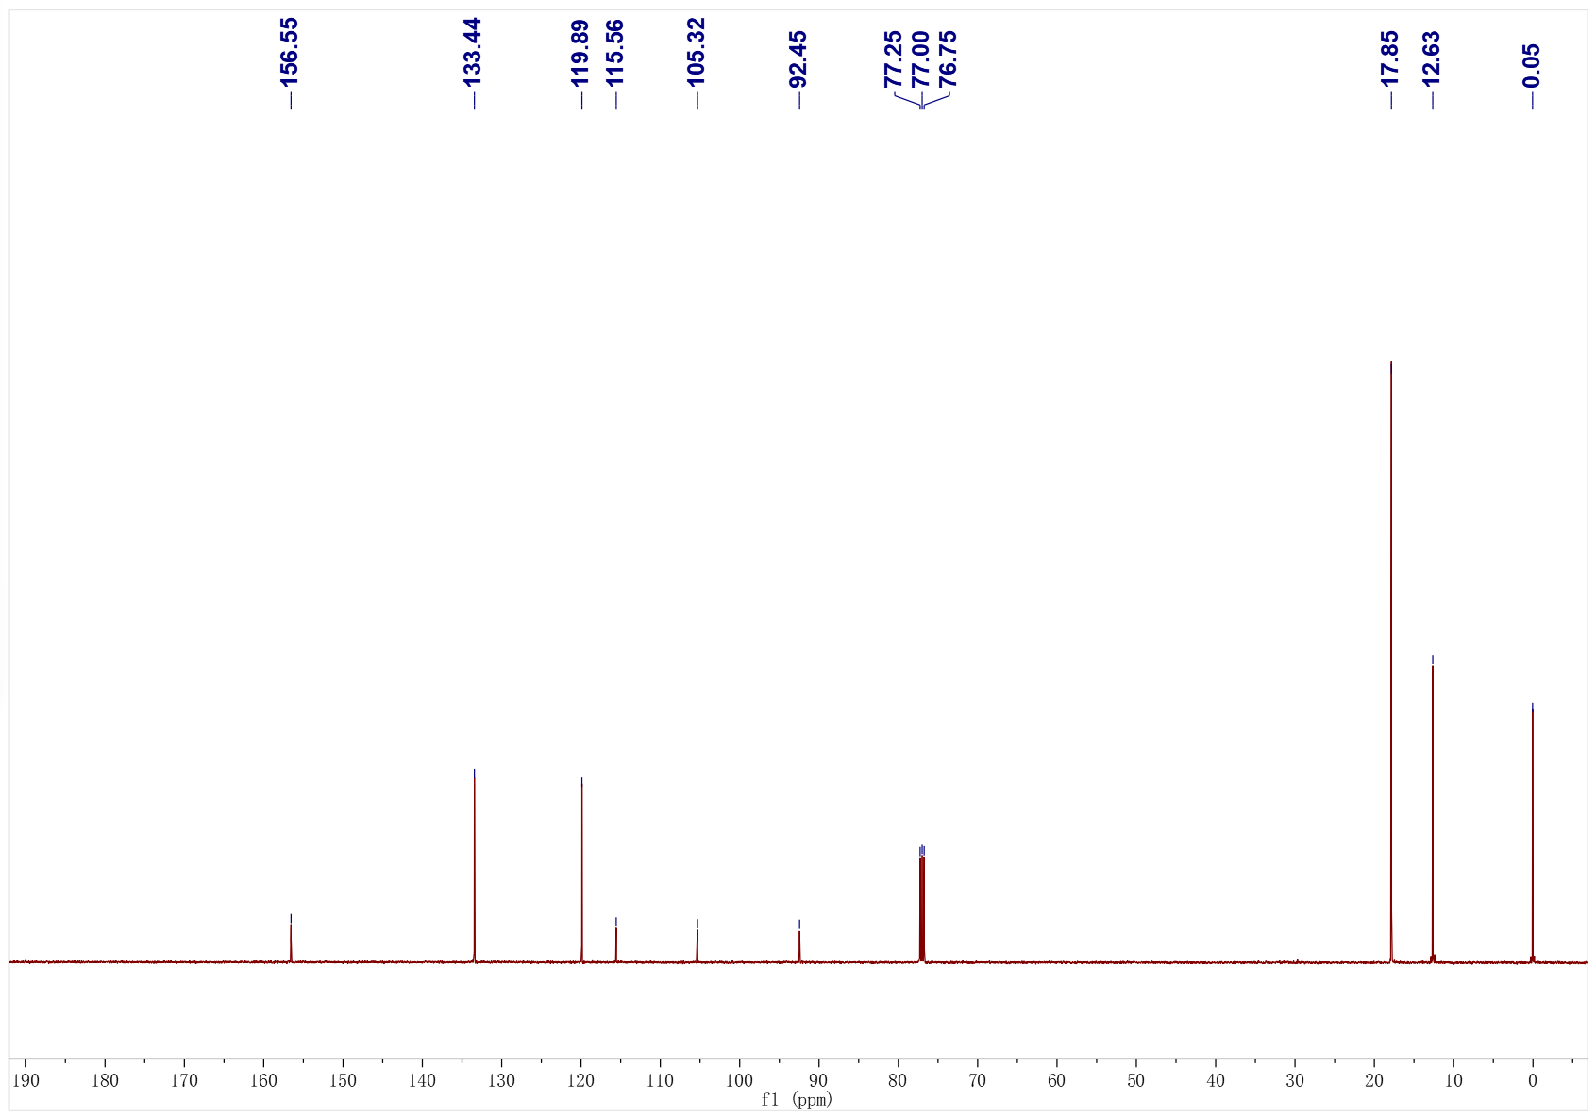
3i; ¹H NMR (500 MHz, CDCl₃); ¹³C NMR (126 MHz, CDCl₃)
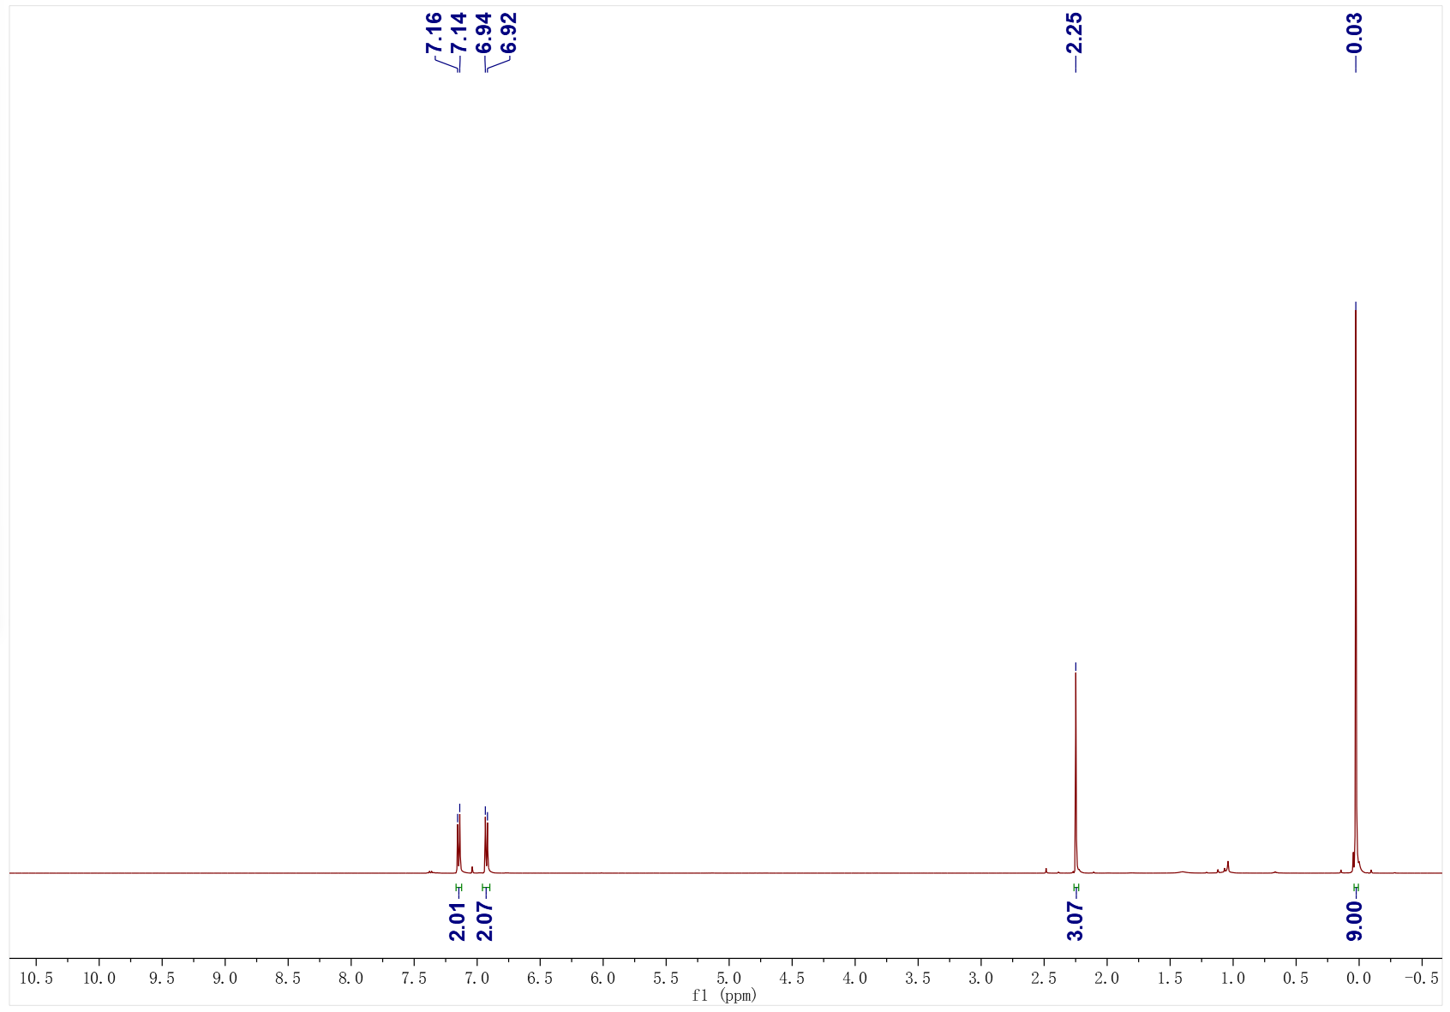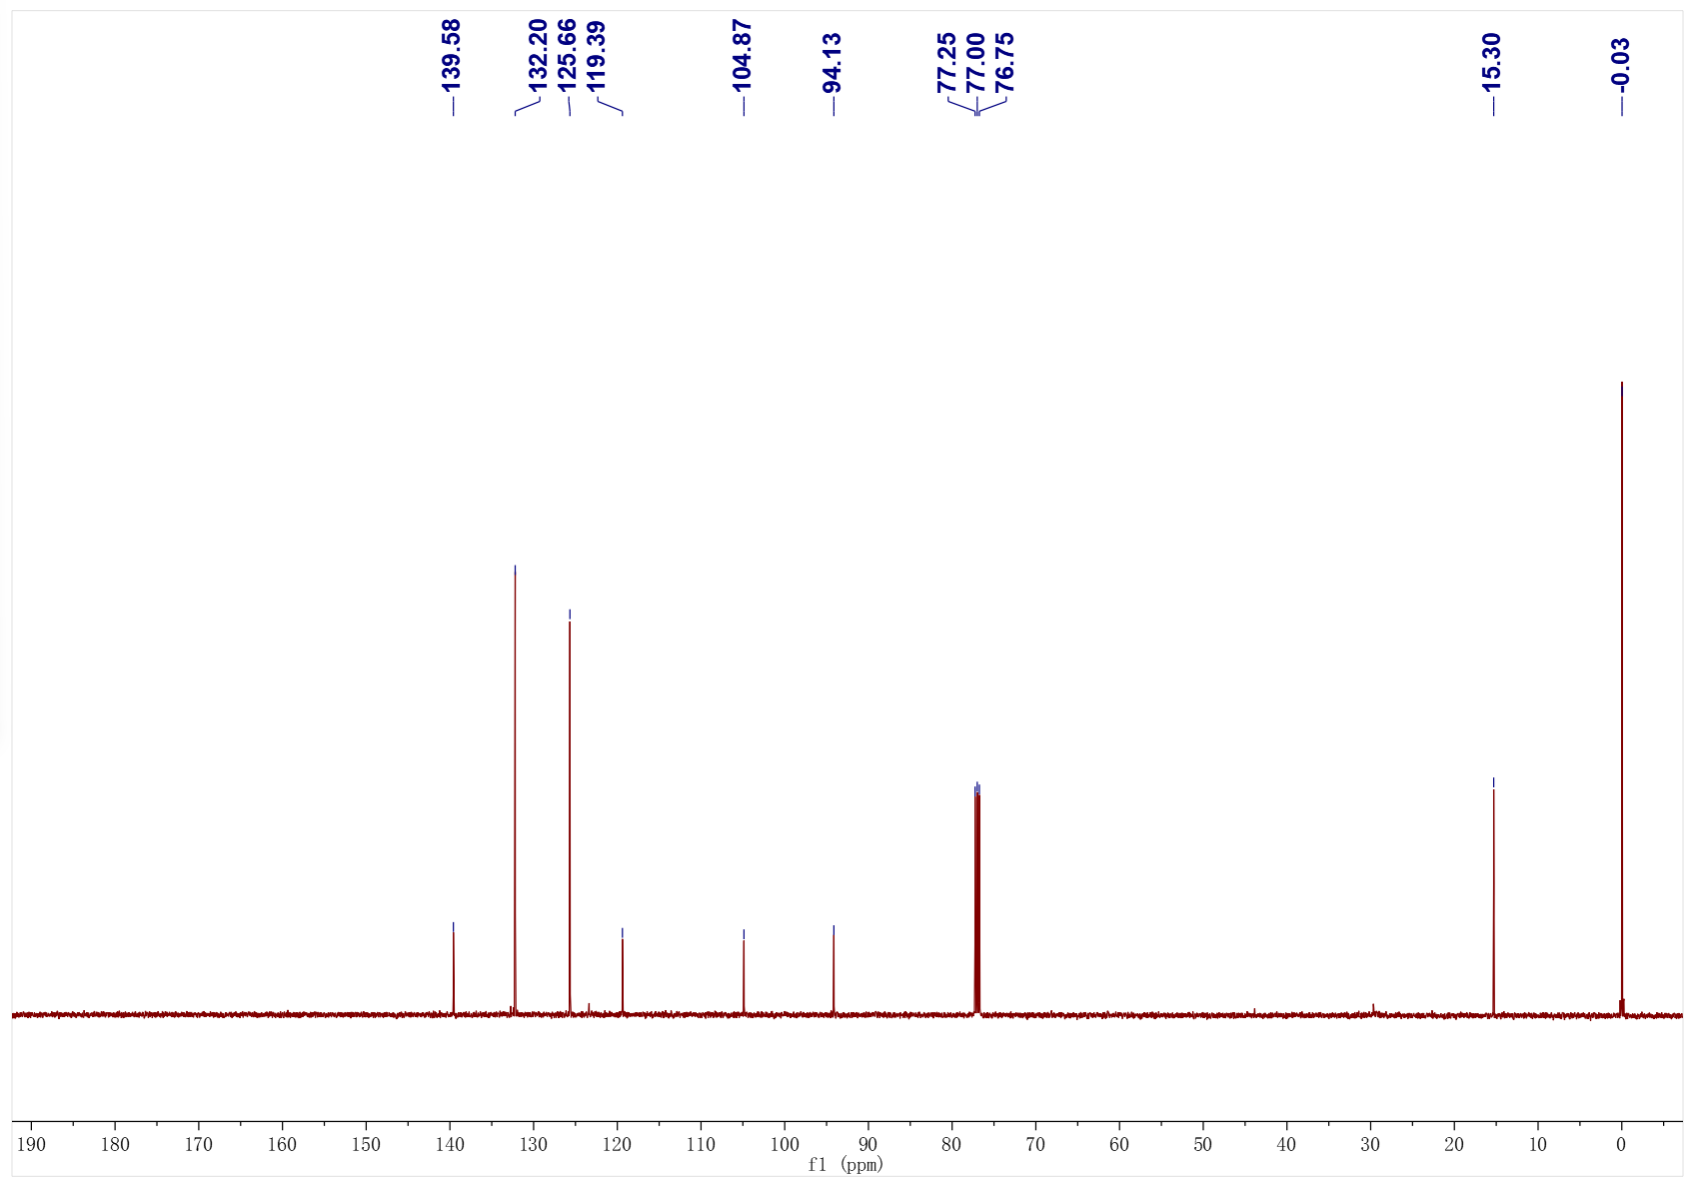
3j; ¹H NMR (500 MHz, CDCl₃); ¹³C NMR (126 MHz, CDCl₃)
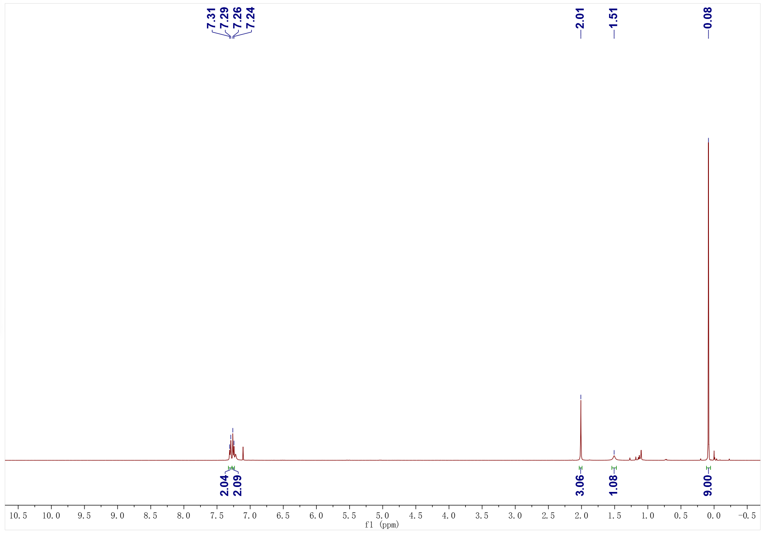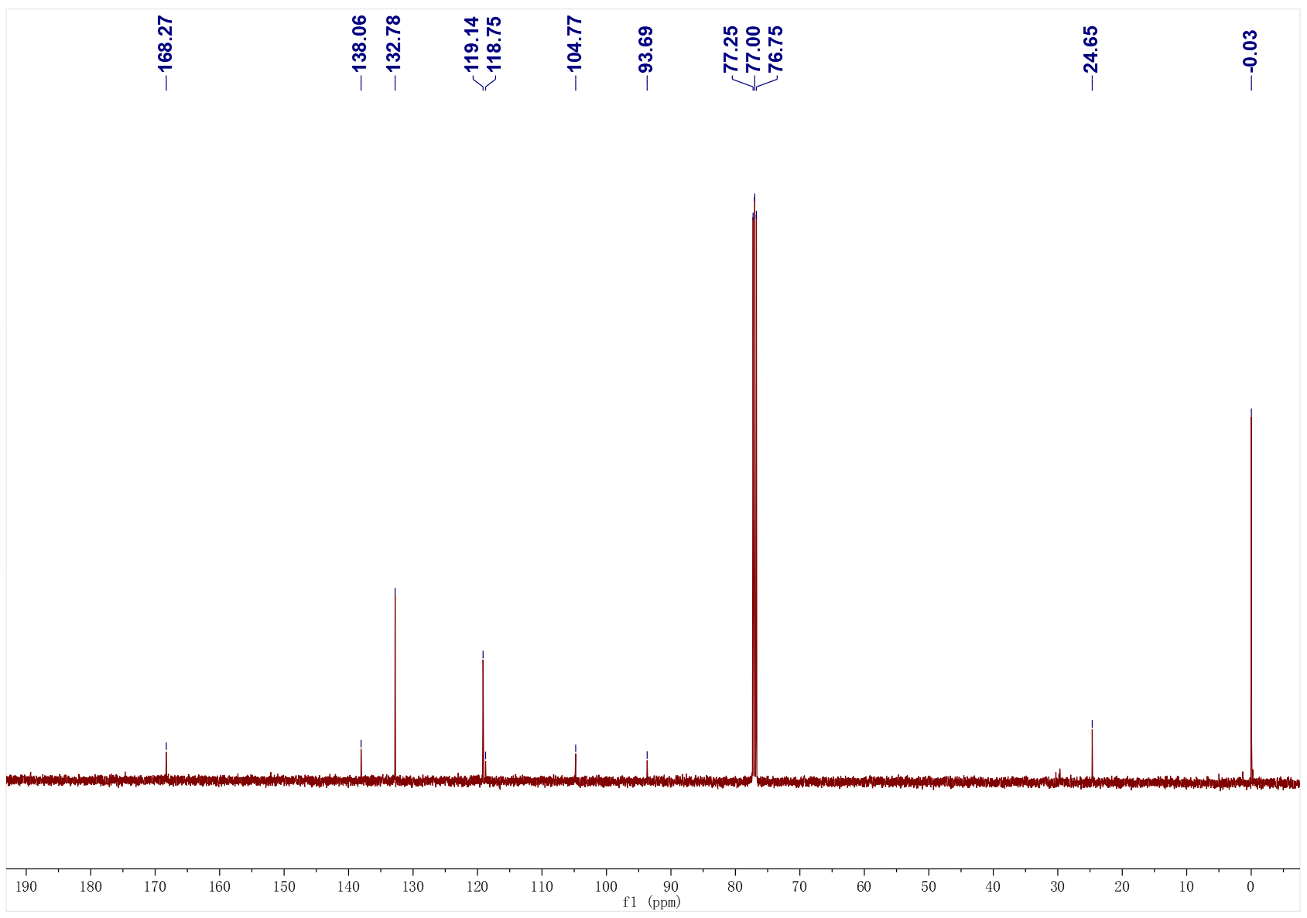
3k; ¹H NMR (400 MHz, CDCl₃); ¹³C NMR (126 MHz, CDCl₃)
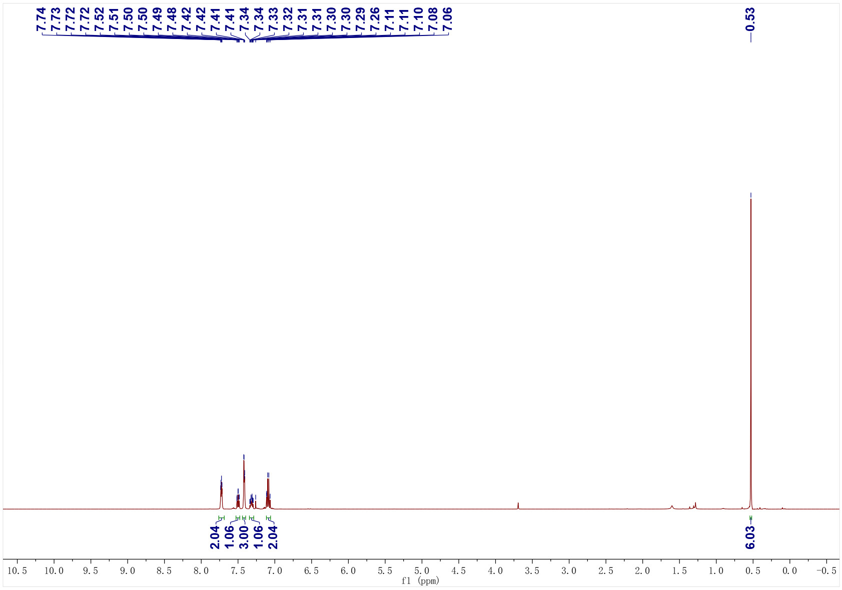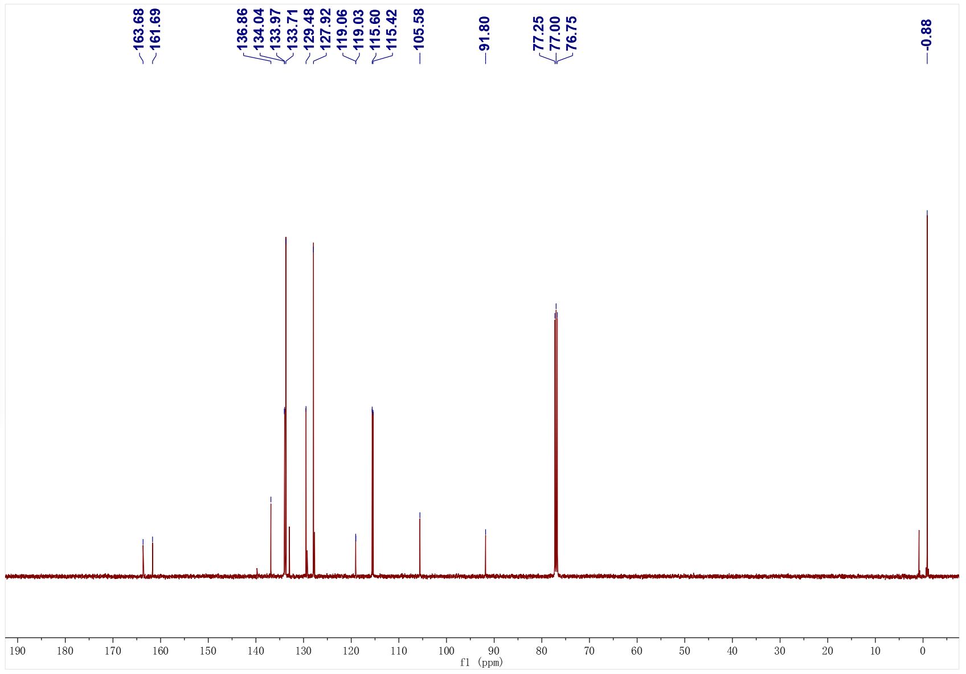
3k; ¹⁹F NMR (471 MHz, CDCl₃)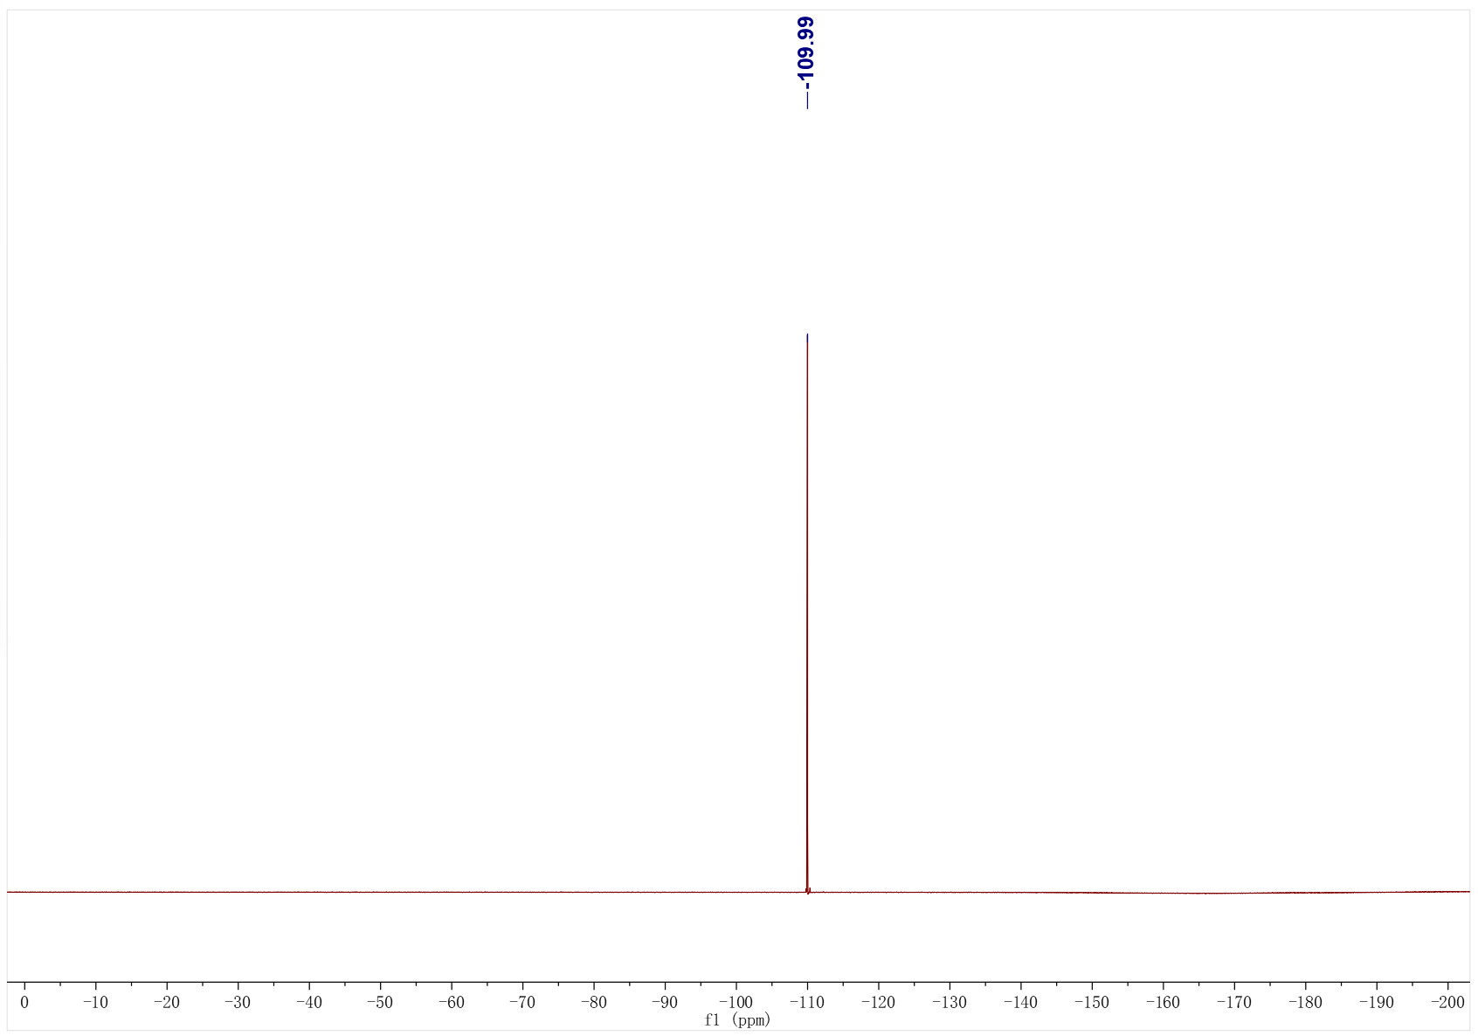
3l; ¹H NMR (500 MHz, CDCl₃); ¹³C NMR (126 MHz, CDCl₃) 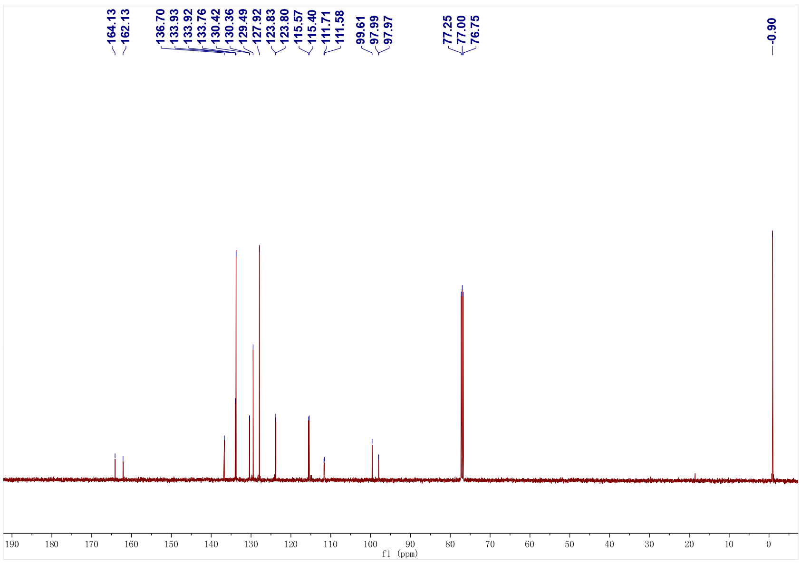

3l; ¹⁹F NMR (471 MHz, CDCl₃)
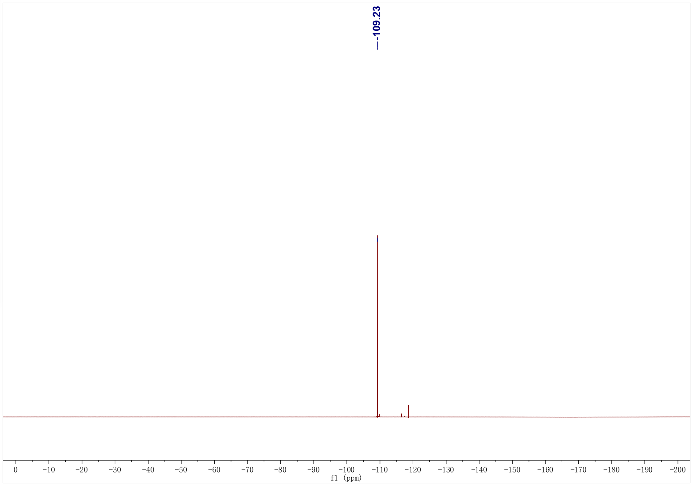
3m; ¹H NMR (500 MHz, CDCl₃); ¹³C NMR (126 MHz, CDCl₃) 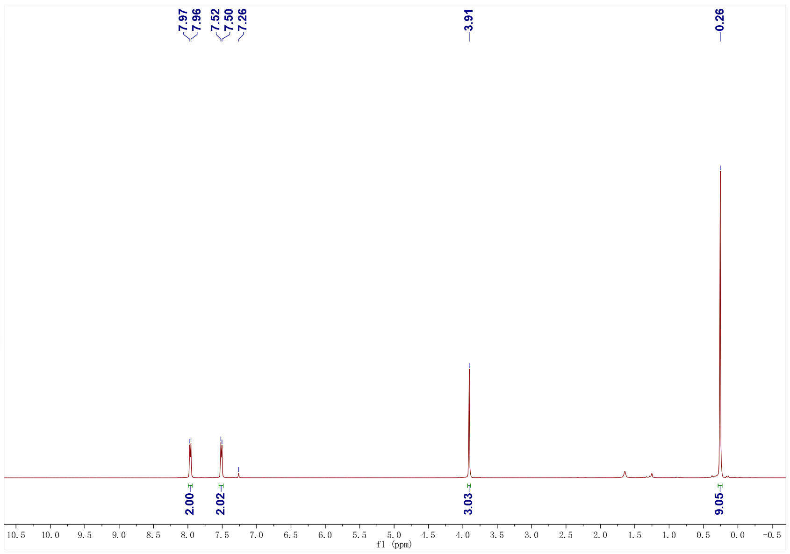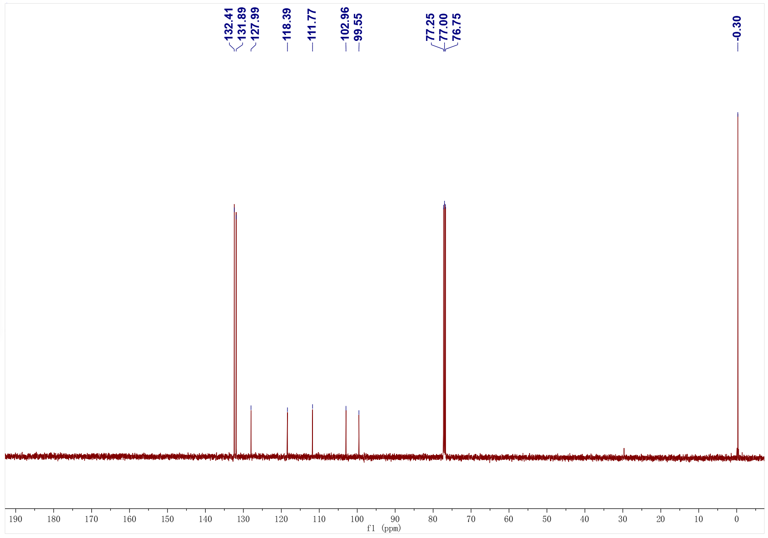
3n; ¹H NMR (500 MHz, CDCl₃); ¹³C NMR (126 MHz, CDCl₃)
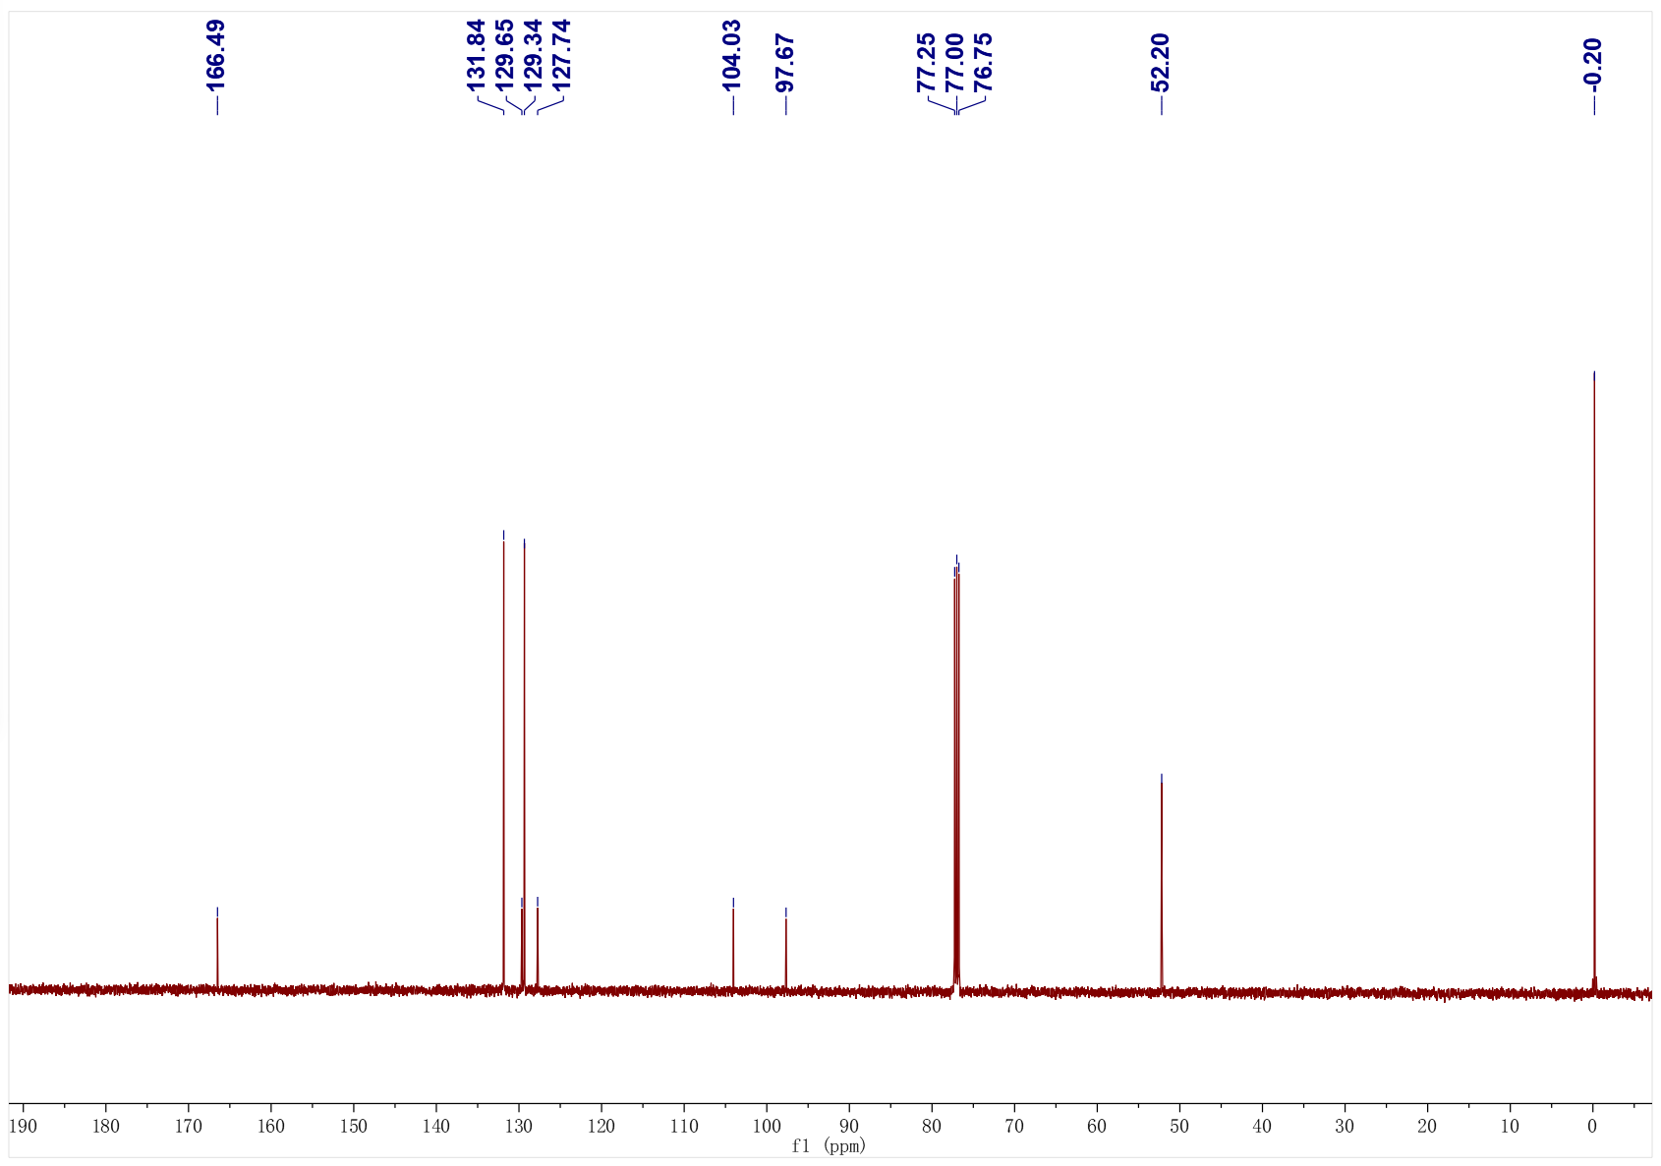
3o; ¹H NMR (500 MHz, CDCl₃); ¹³C NMR (126 MHz, CDCl₃)
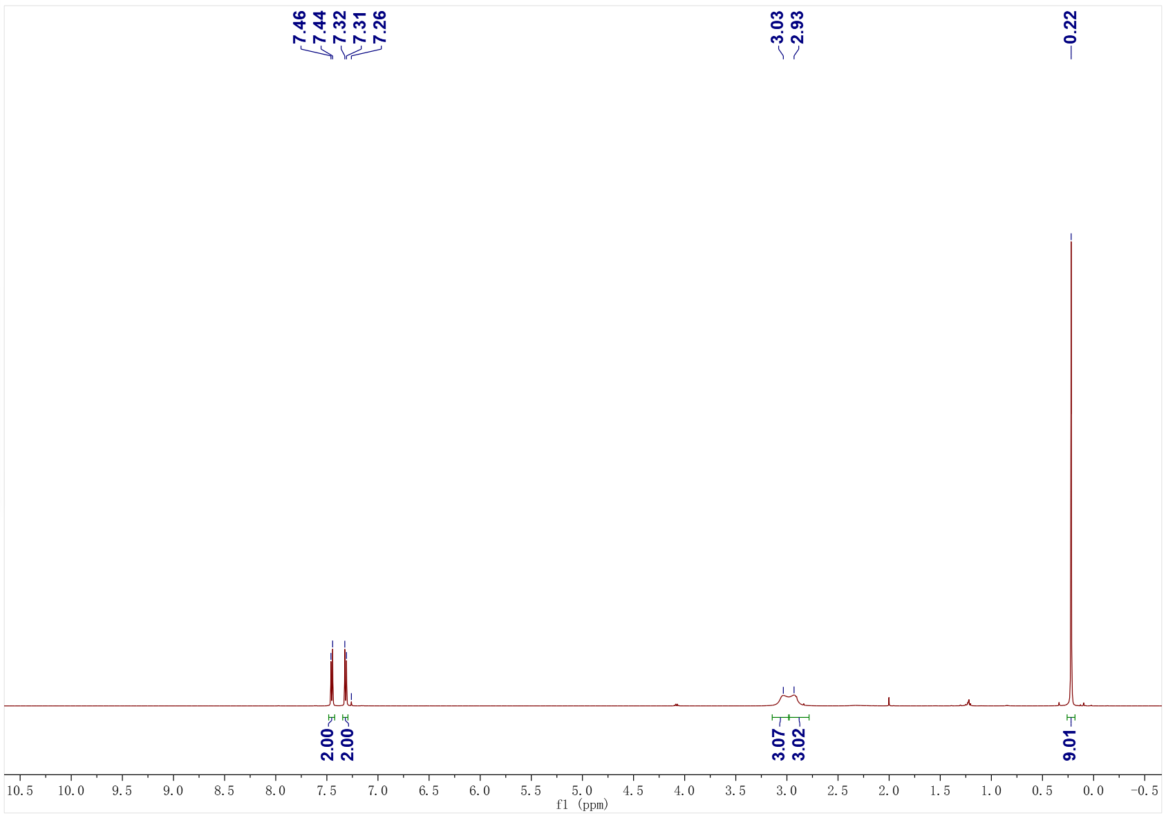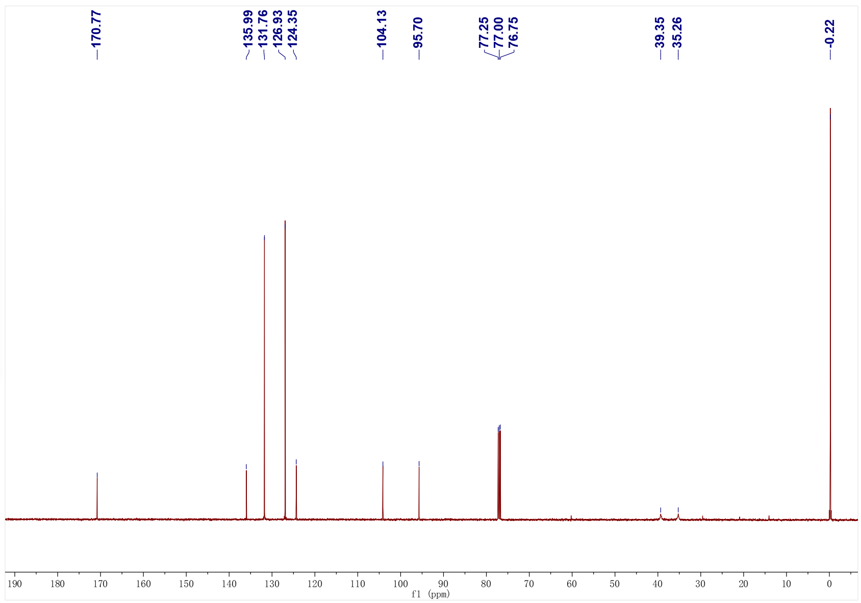
3p; ¹H NMR (500 MHz, CDCl₃); ¹³C NMR (126 MHz, CDCl₃)
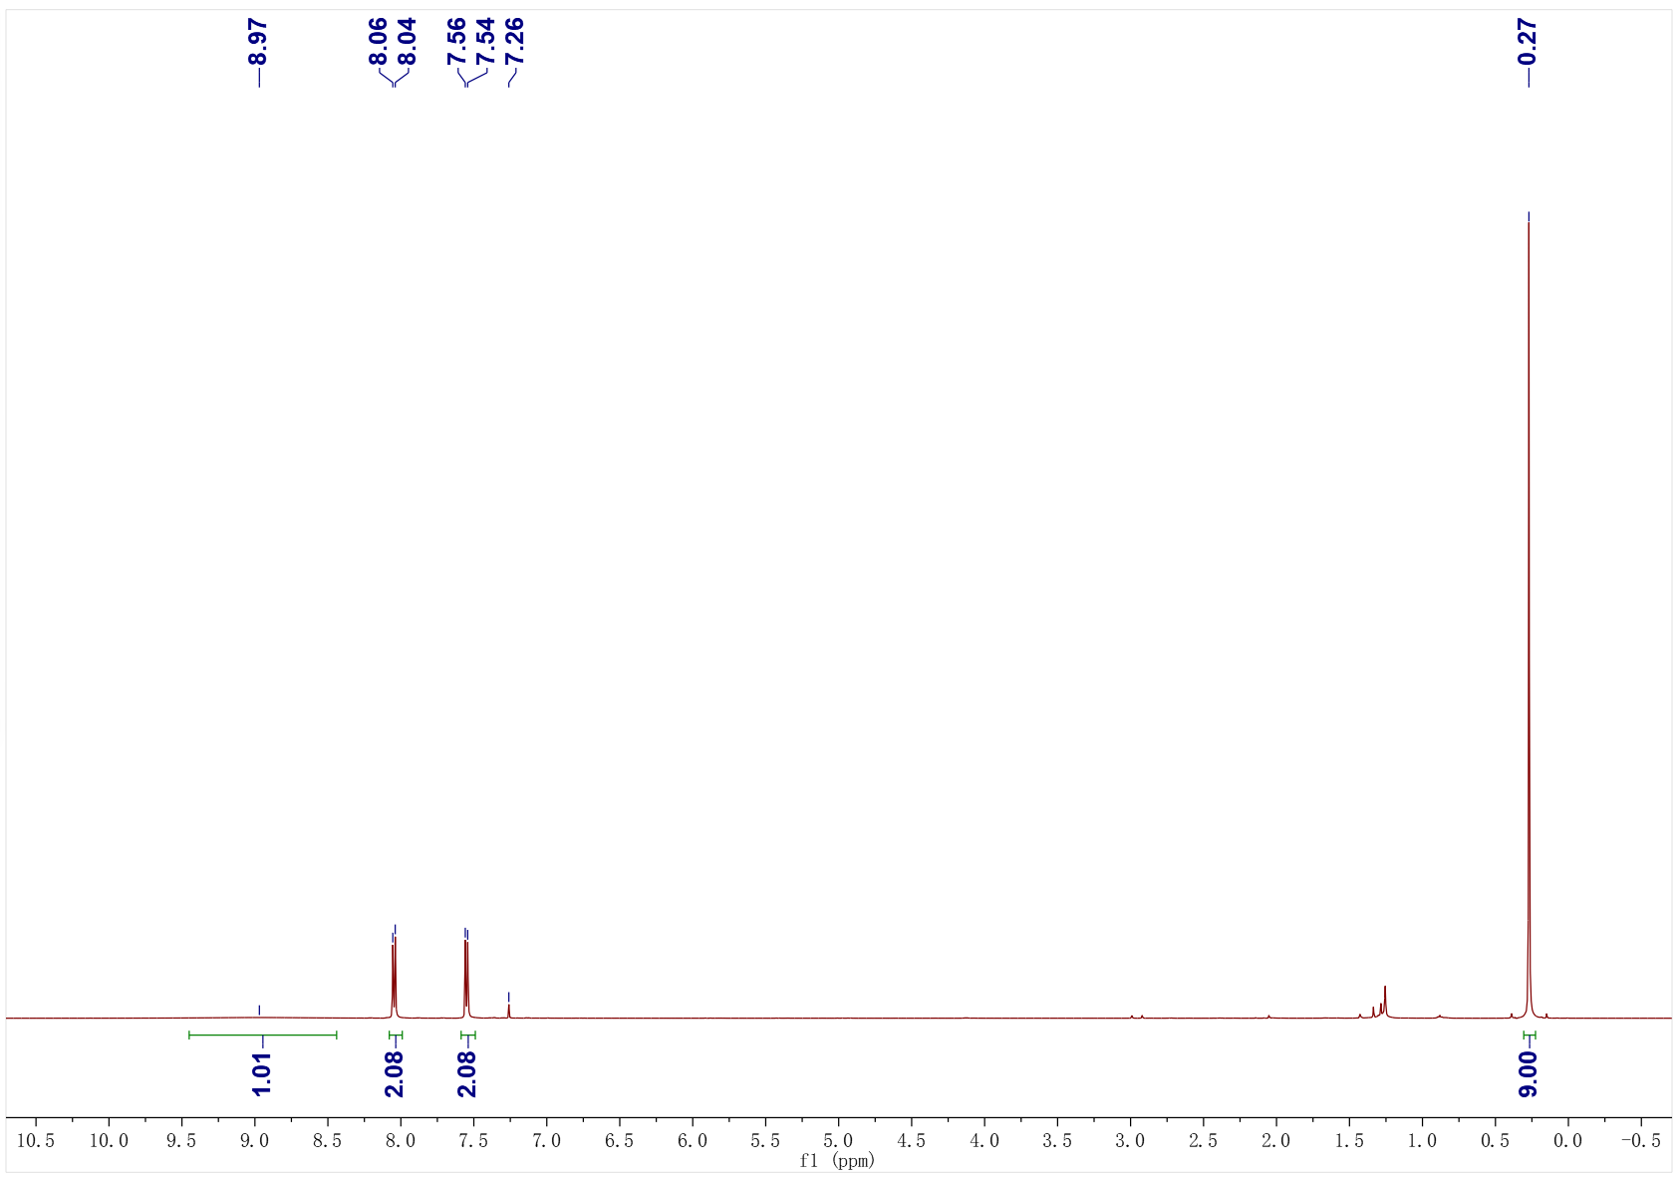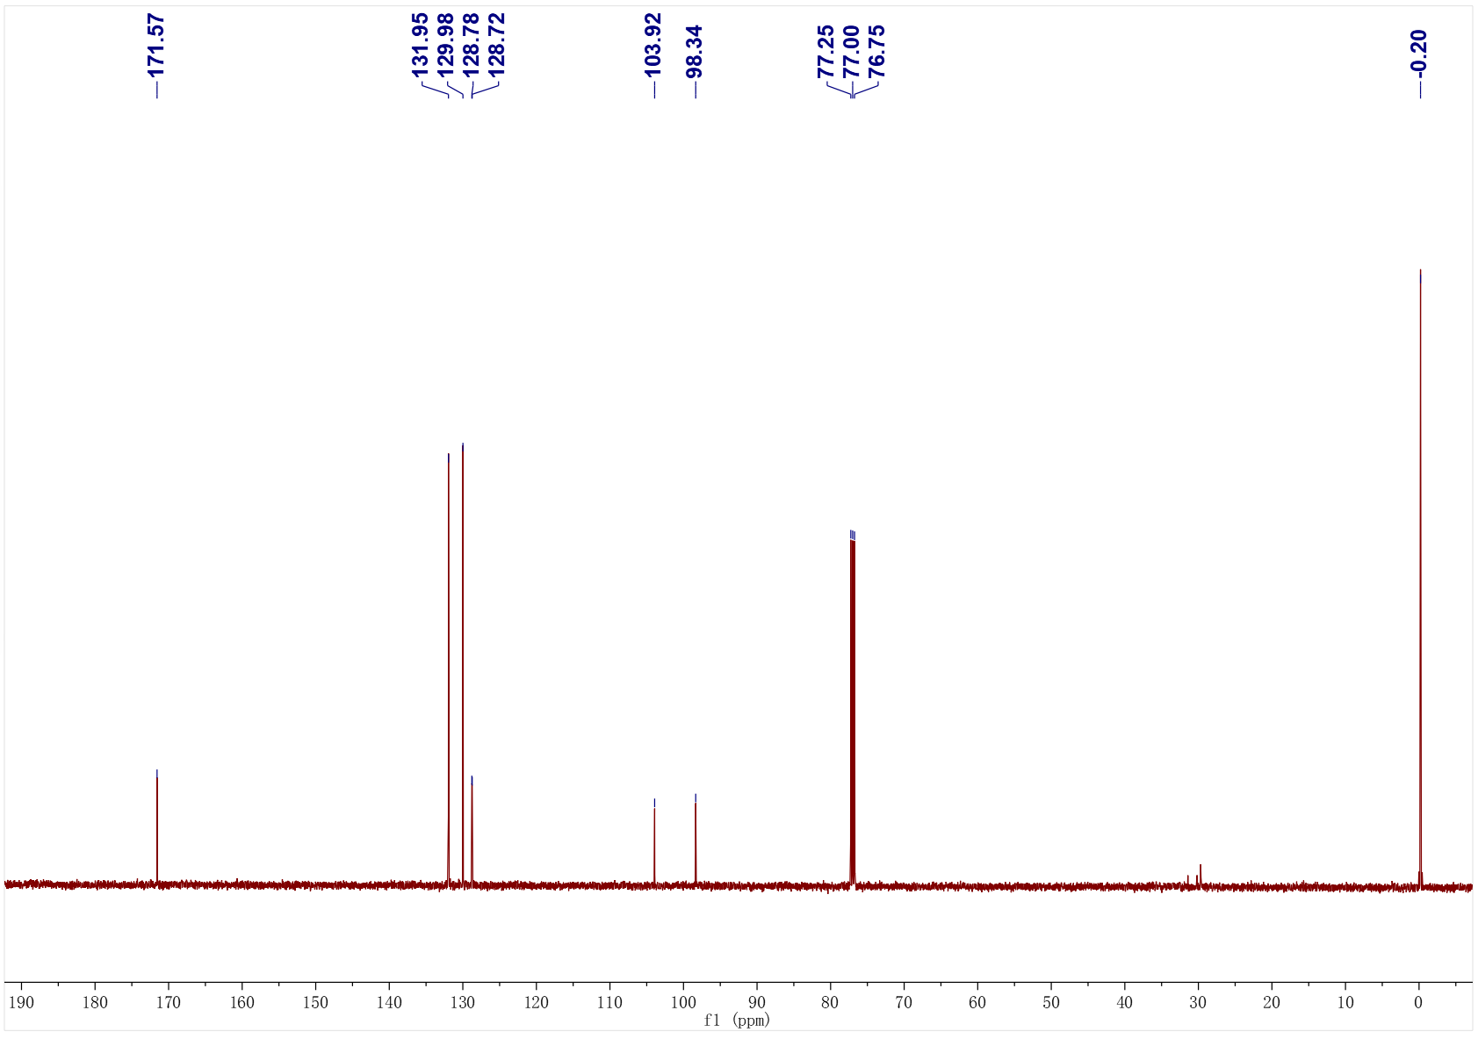
3q; ¹H NMR (500 MHz, CDCl₃); ¹³C NMR (126 MHz, CDCl₃)
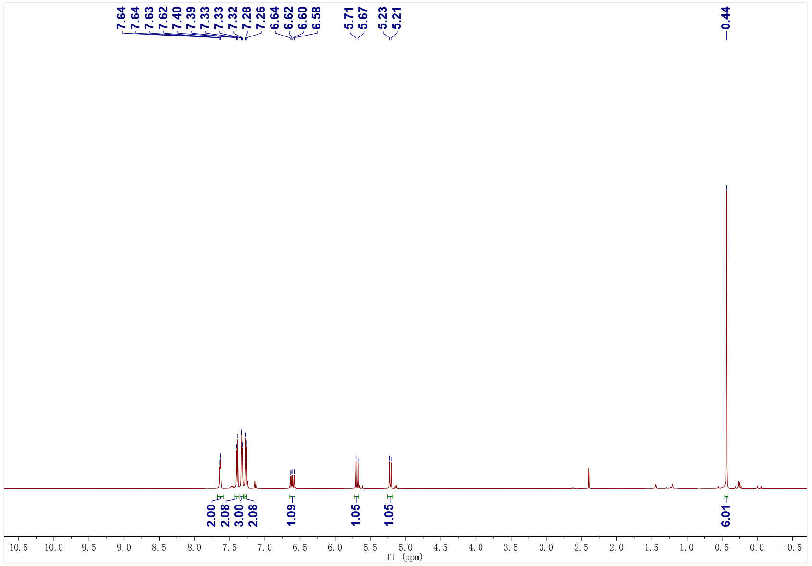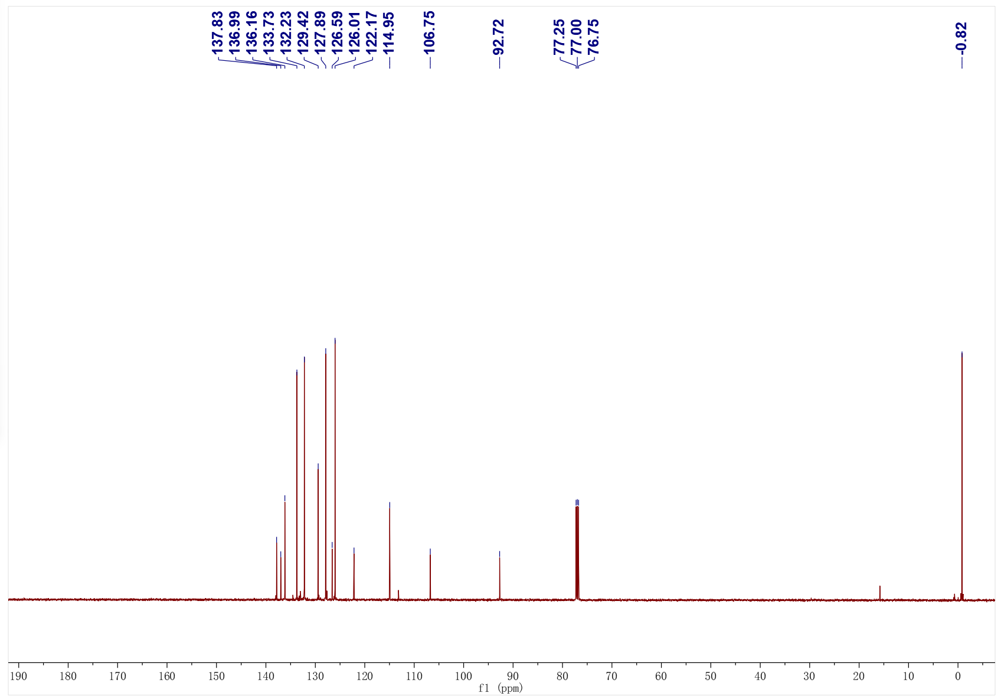
3r; ¹H NMR (400 MHz, CDCl₃); ¹³C NMR (126 MHz, CDCl₃)
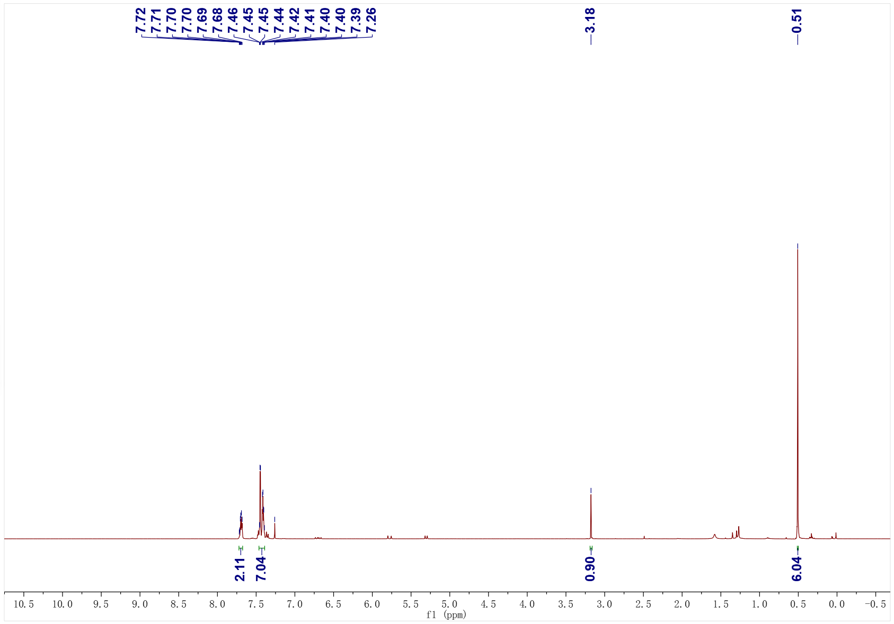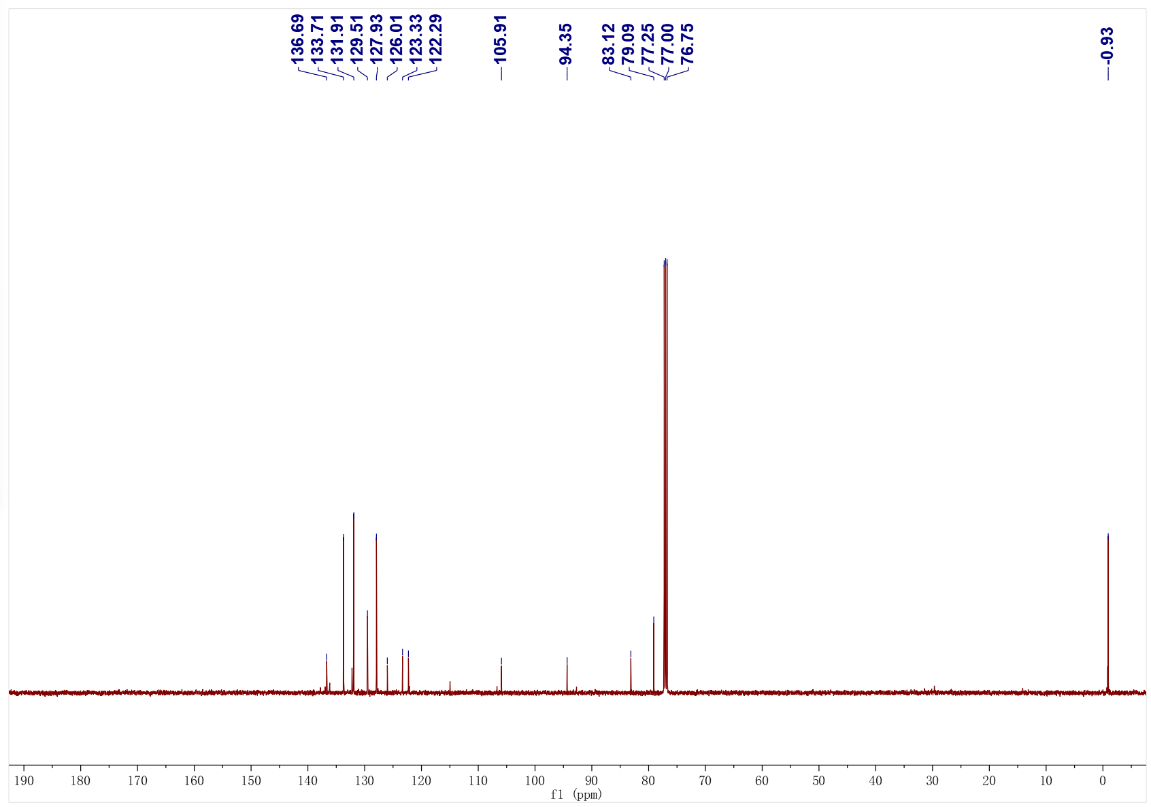
3s; ¹H NMR (400 MHz, CDCl₃); ¹³C NMR (126 MHz, CDCl₃)
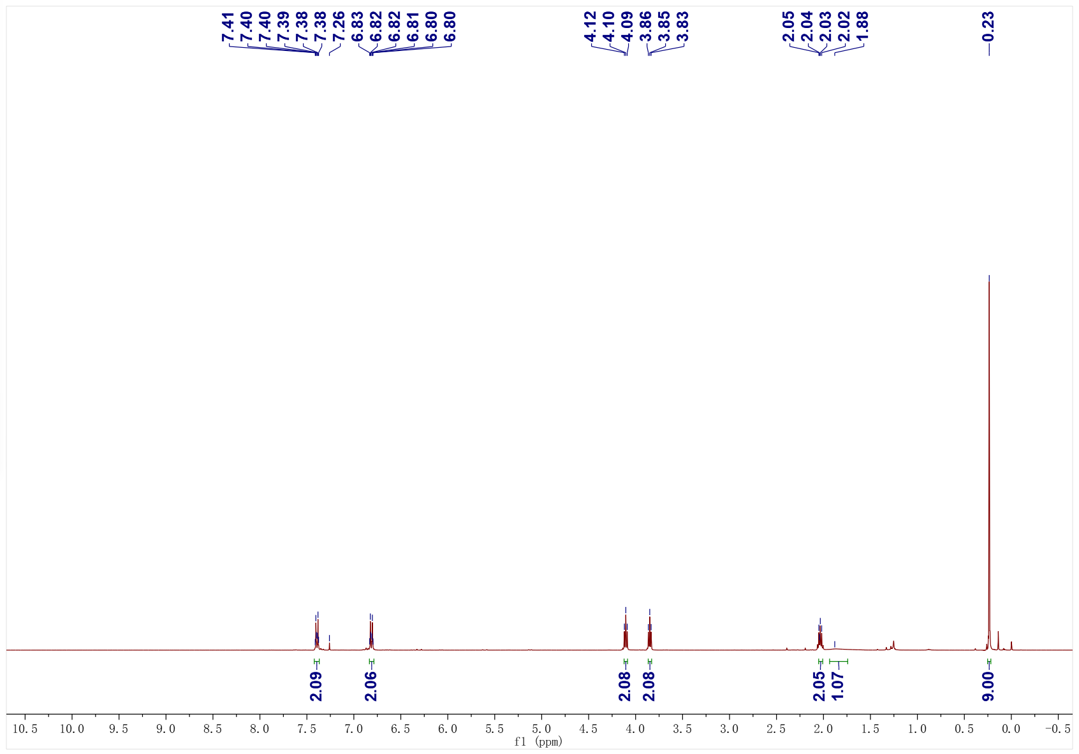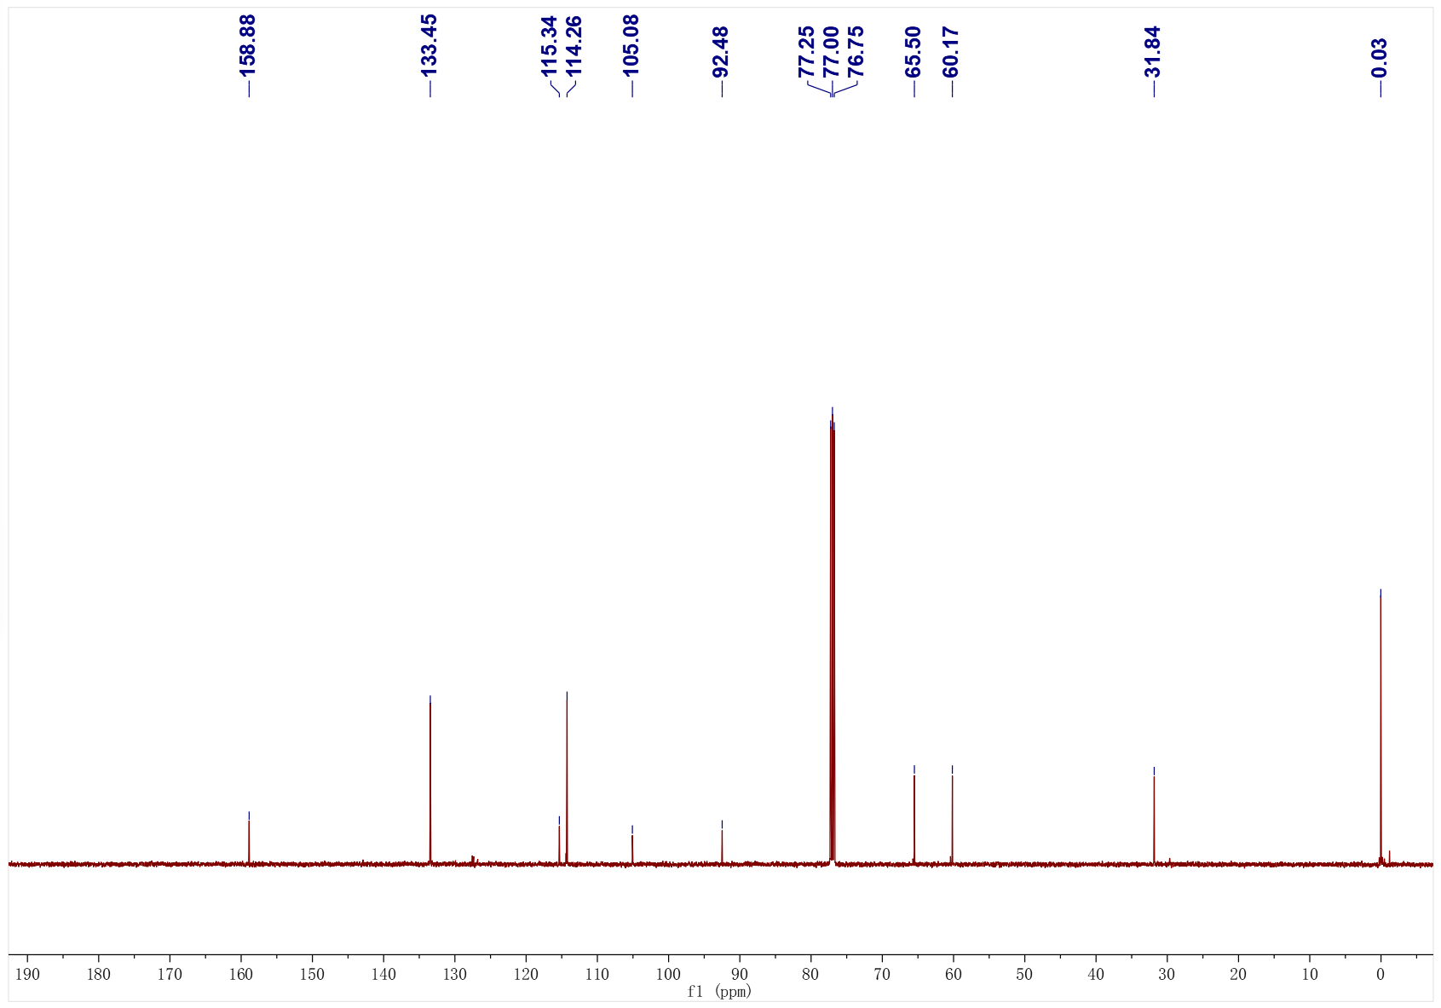
3t; ¹H NMR (500 MHz, CDCl₃); ¹³C NMR (126 MHz, CDCl₃)
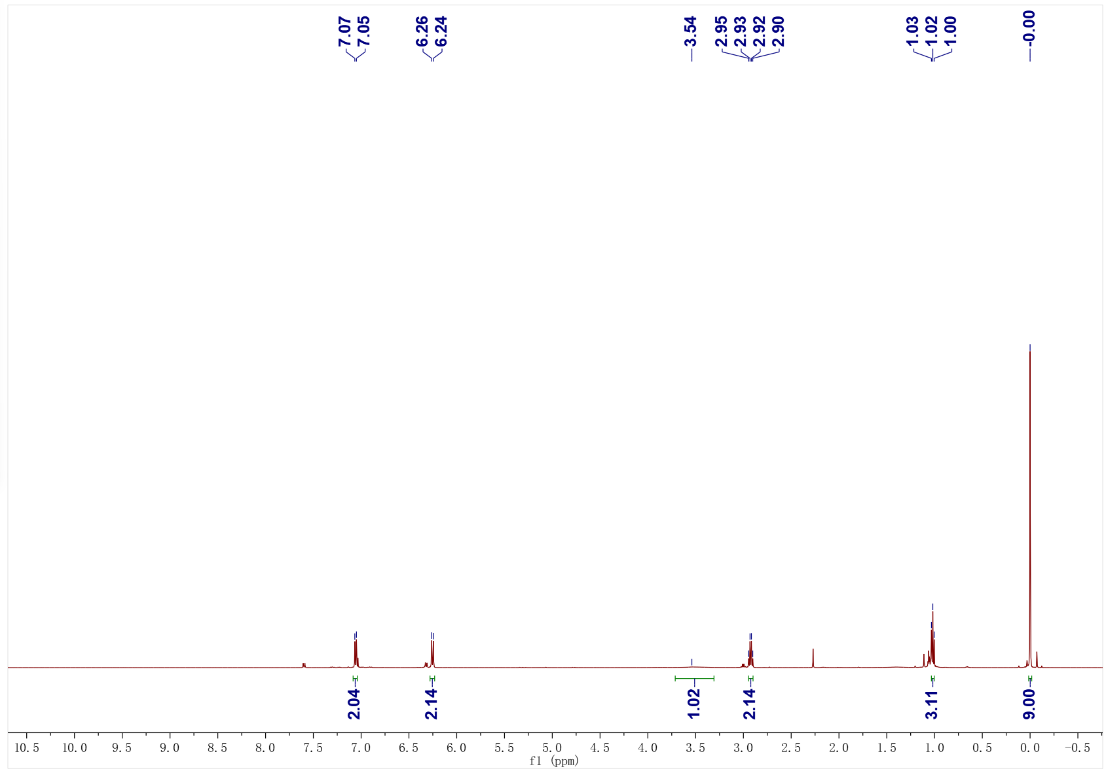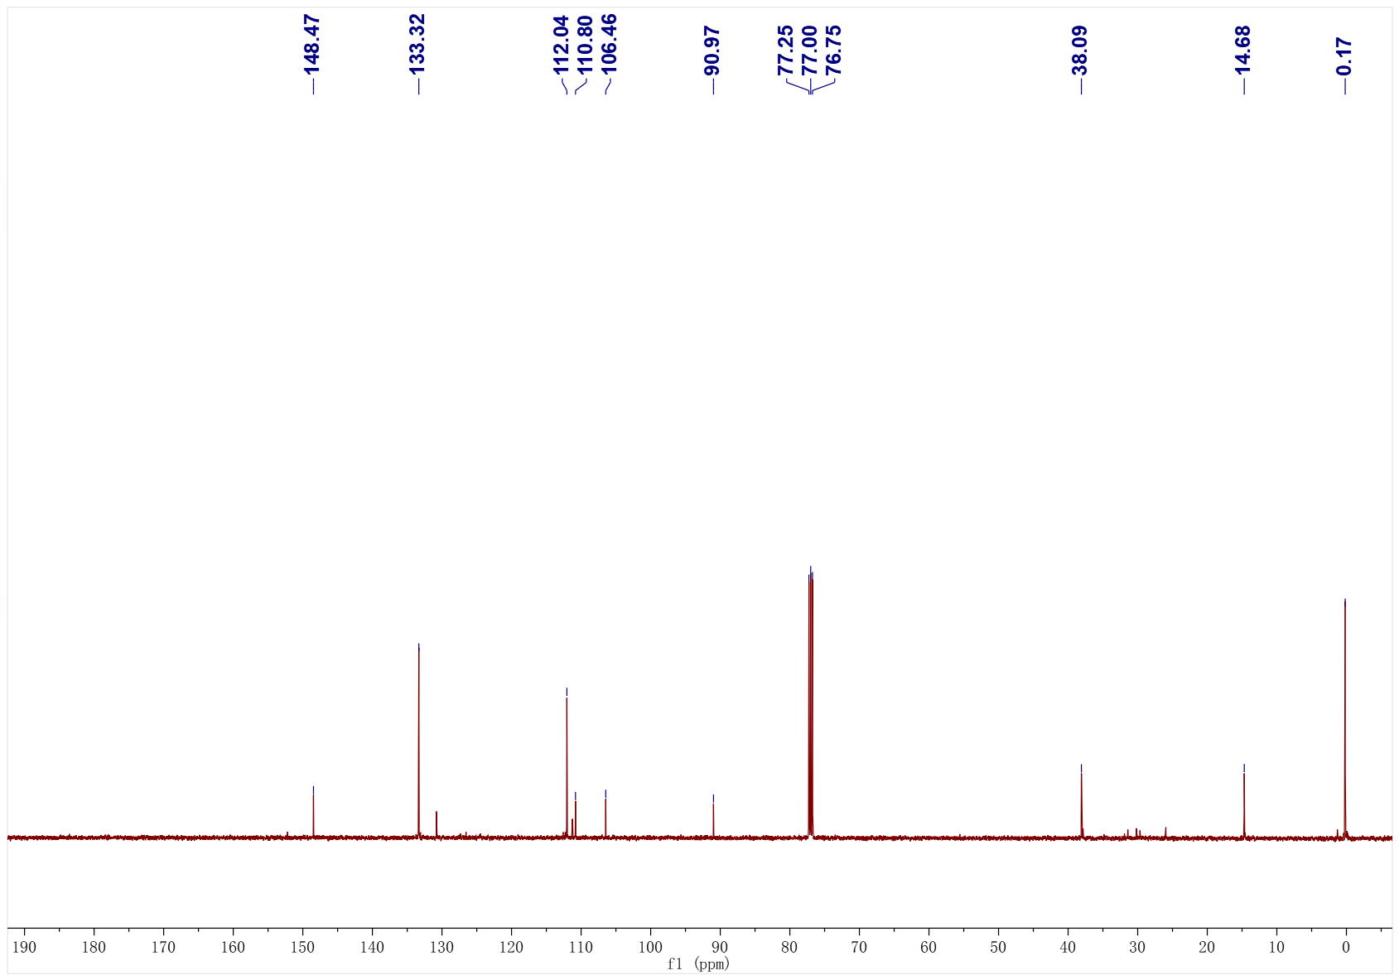
3u; ¹H NMR (500 MHz, CDCl₃); ¹³C NMR (126 MHz, CDCl₃)
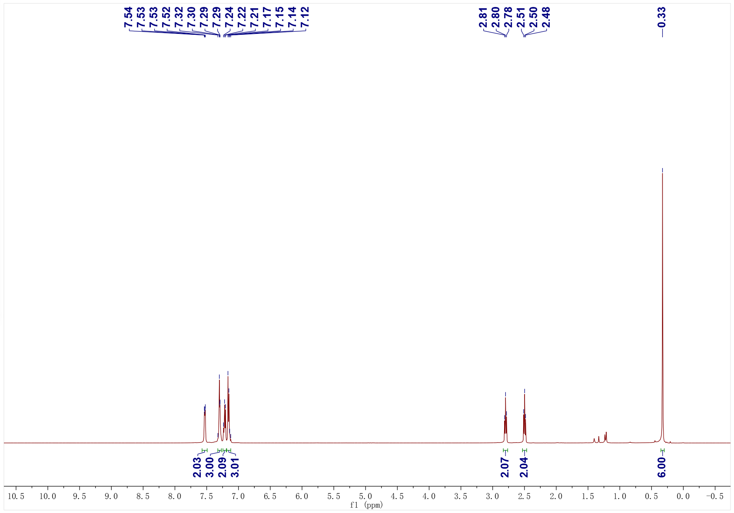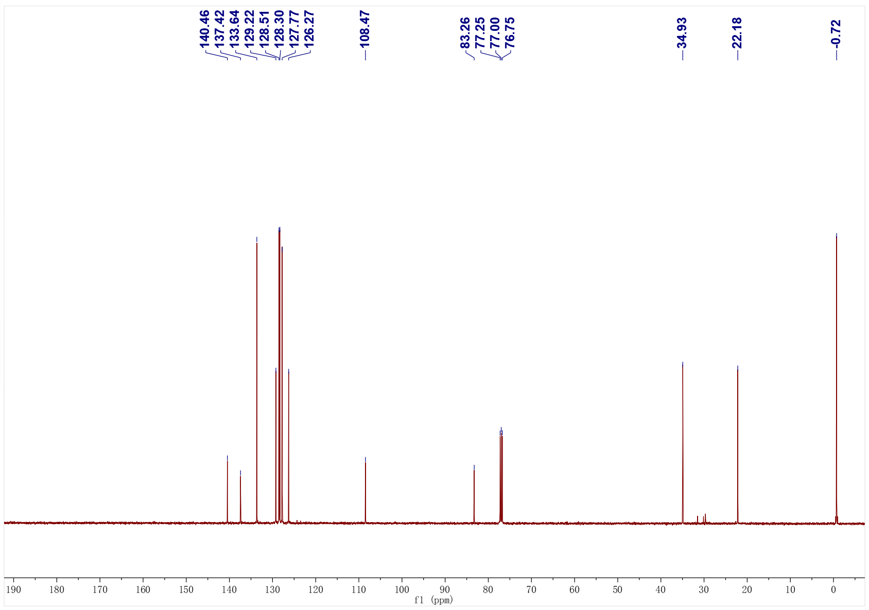
3v; ¹H NMR (400 MHz, CDCl₃); ¹³C NMR (101 MHz, CDCl₃)
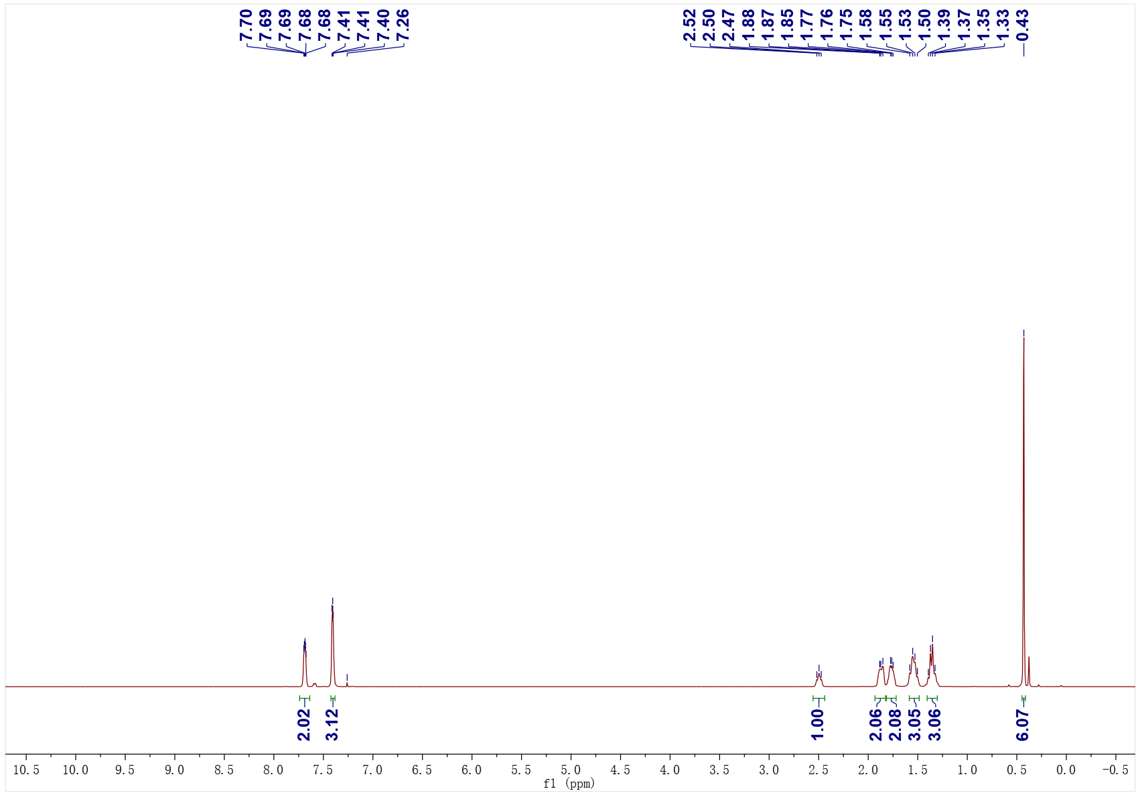
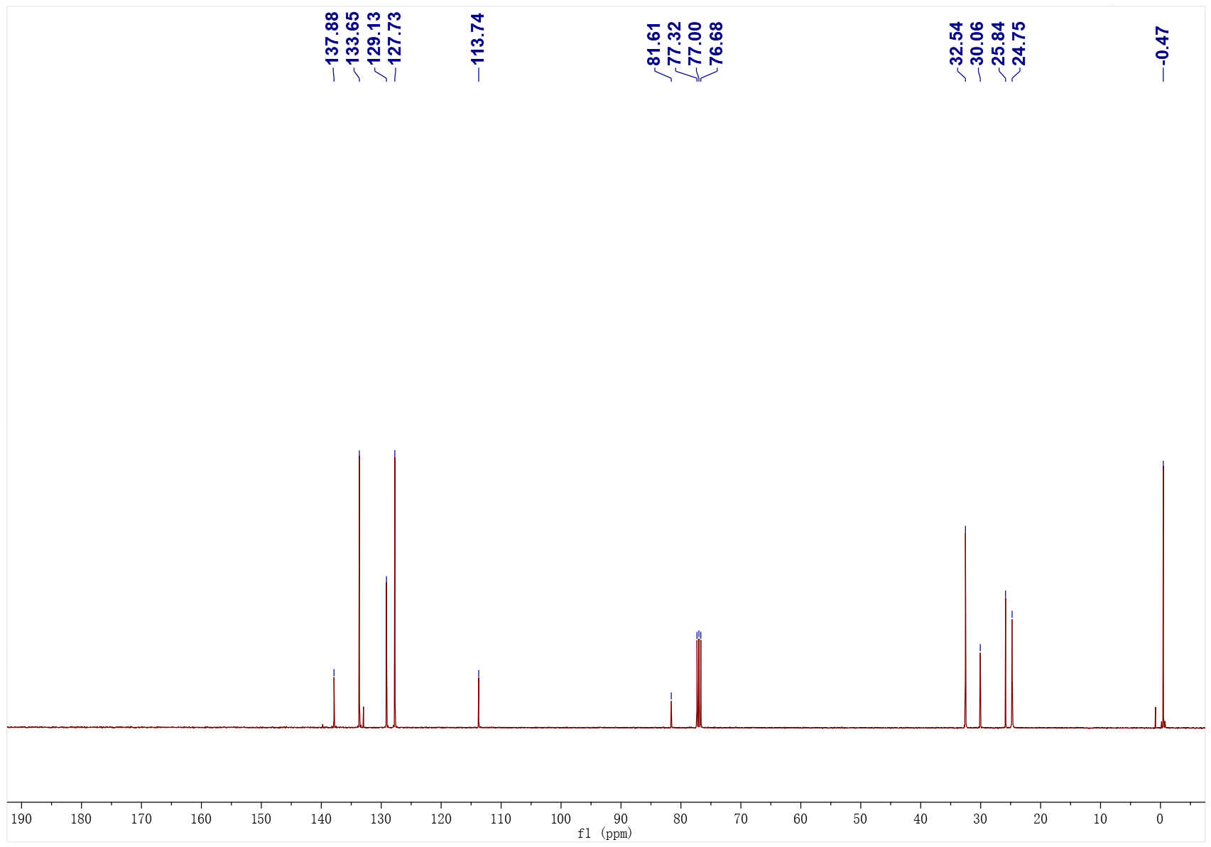
3w; ¹H NMR (400 MHz, CDCl₃); ¹³C NMR (101 MHz, CDCl₃)
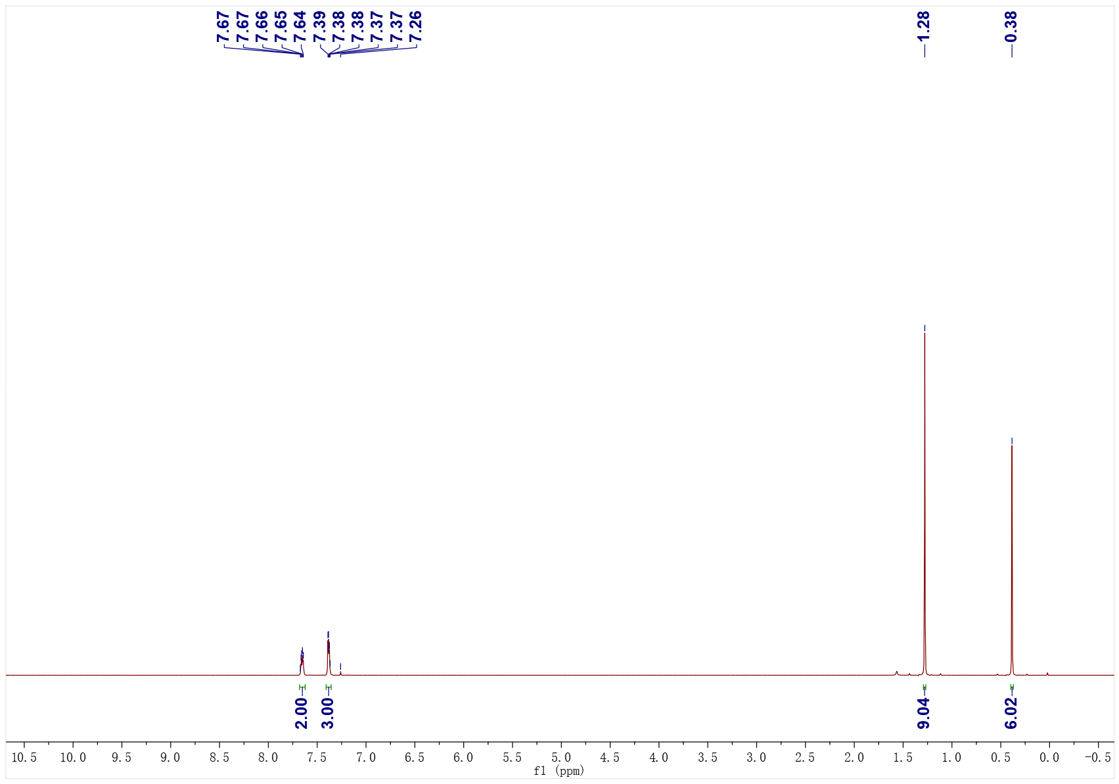
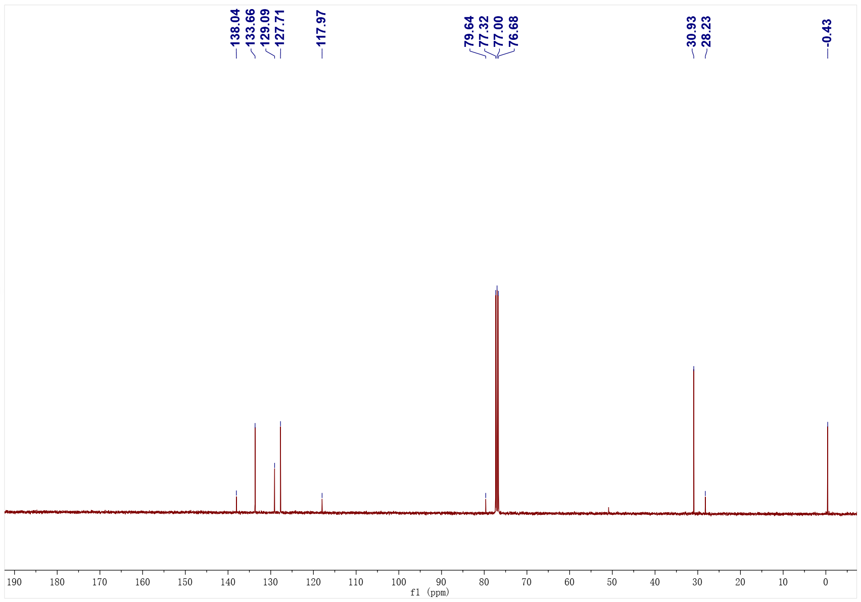
3x; ¹H NMR (400 MHz, CDCl₃); ¹³C NMR (101 MHz, CDCl₃)
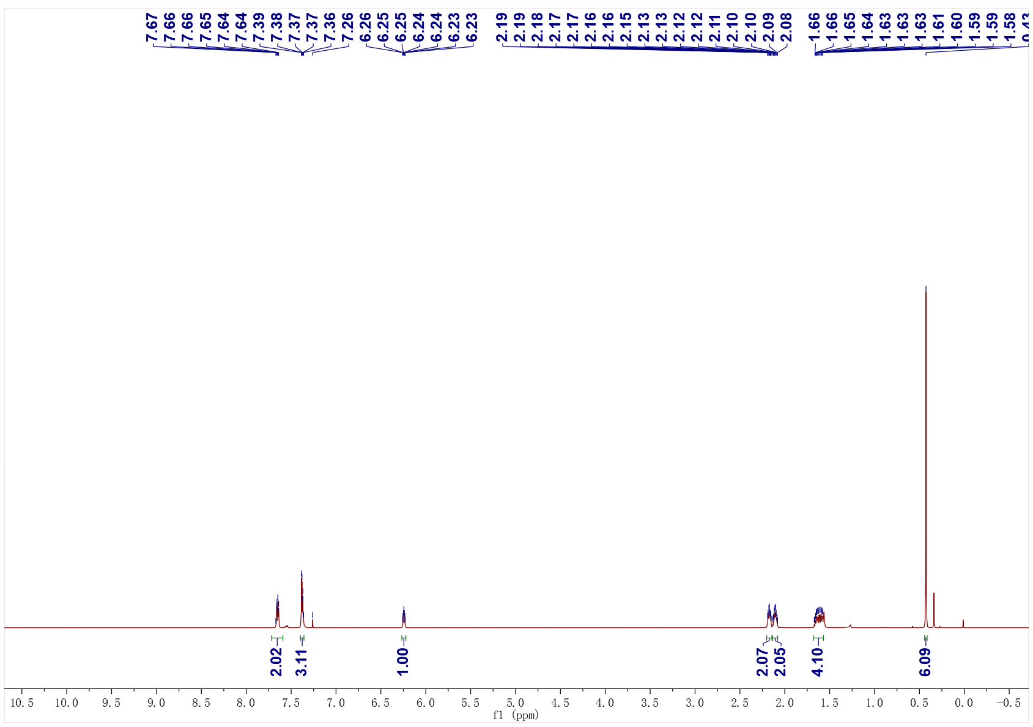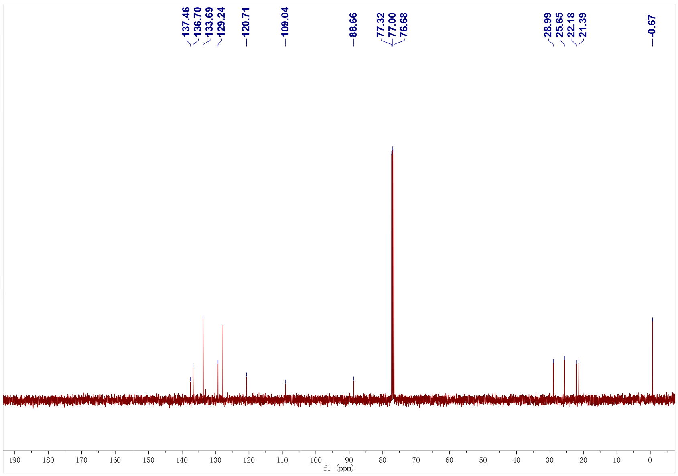
3y; ¹H NMR (500 MHz, CDCl₃); ¹³C NMR (126 MHz, CDCl₃)
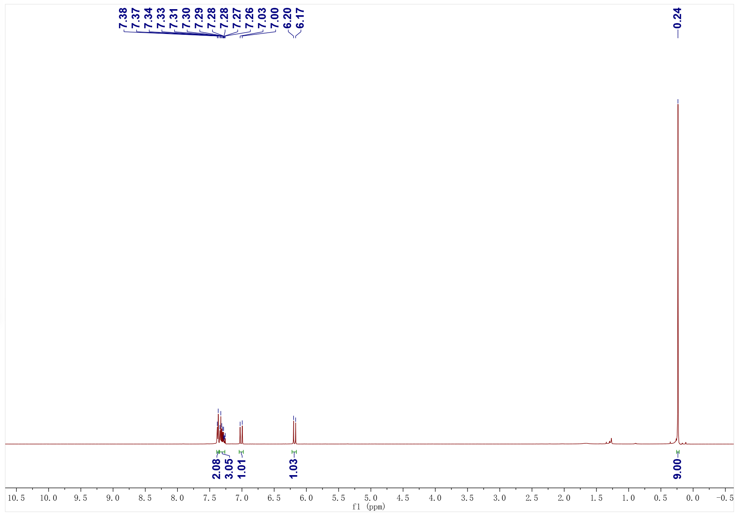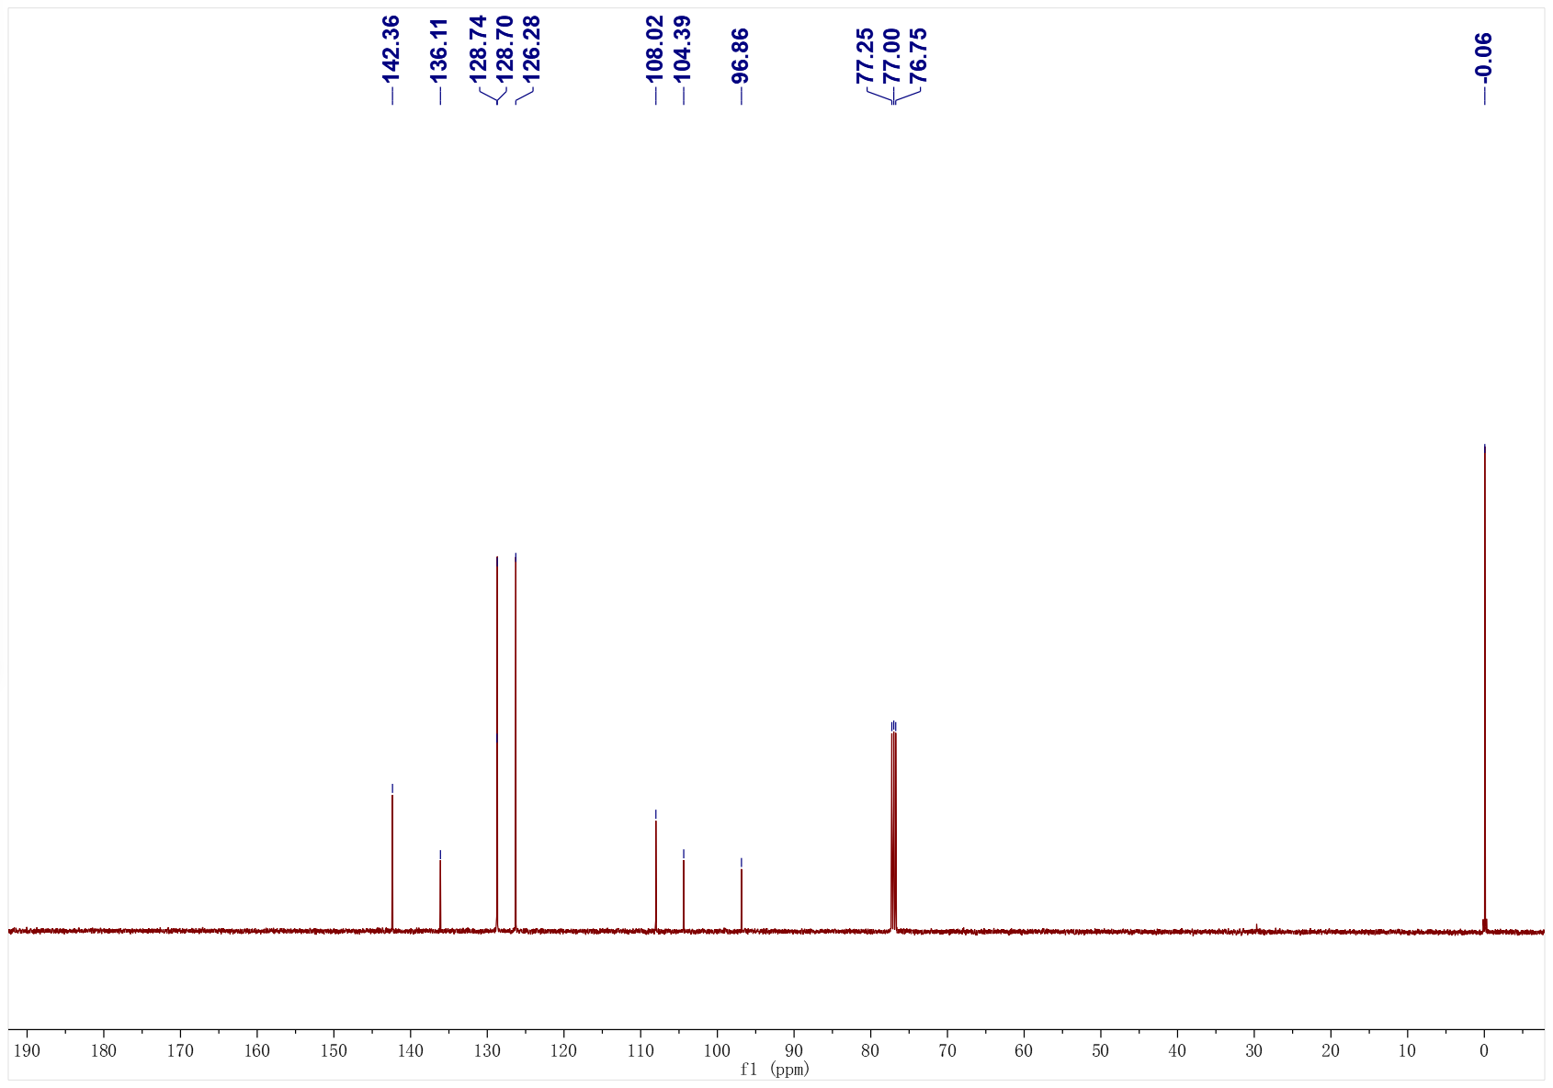
3z; ¹H NMR (500 MHz, CDCl₃); ¹³C NMR (126 MHz, CDCl₃)
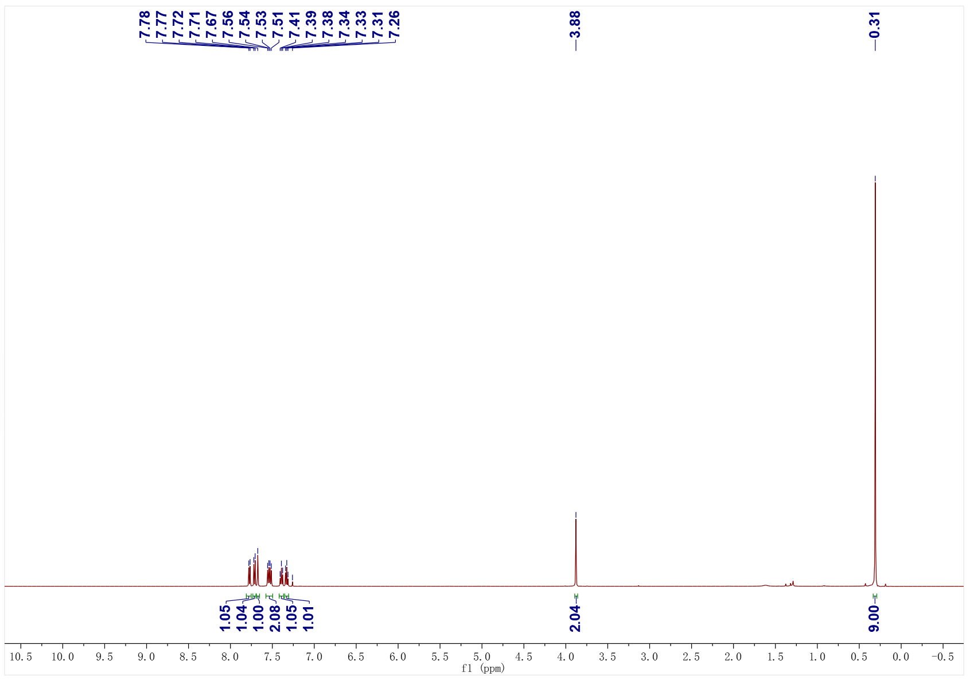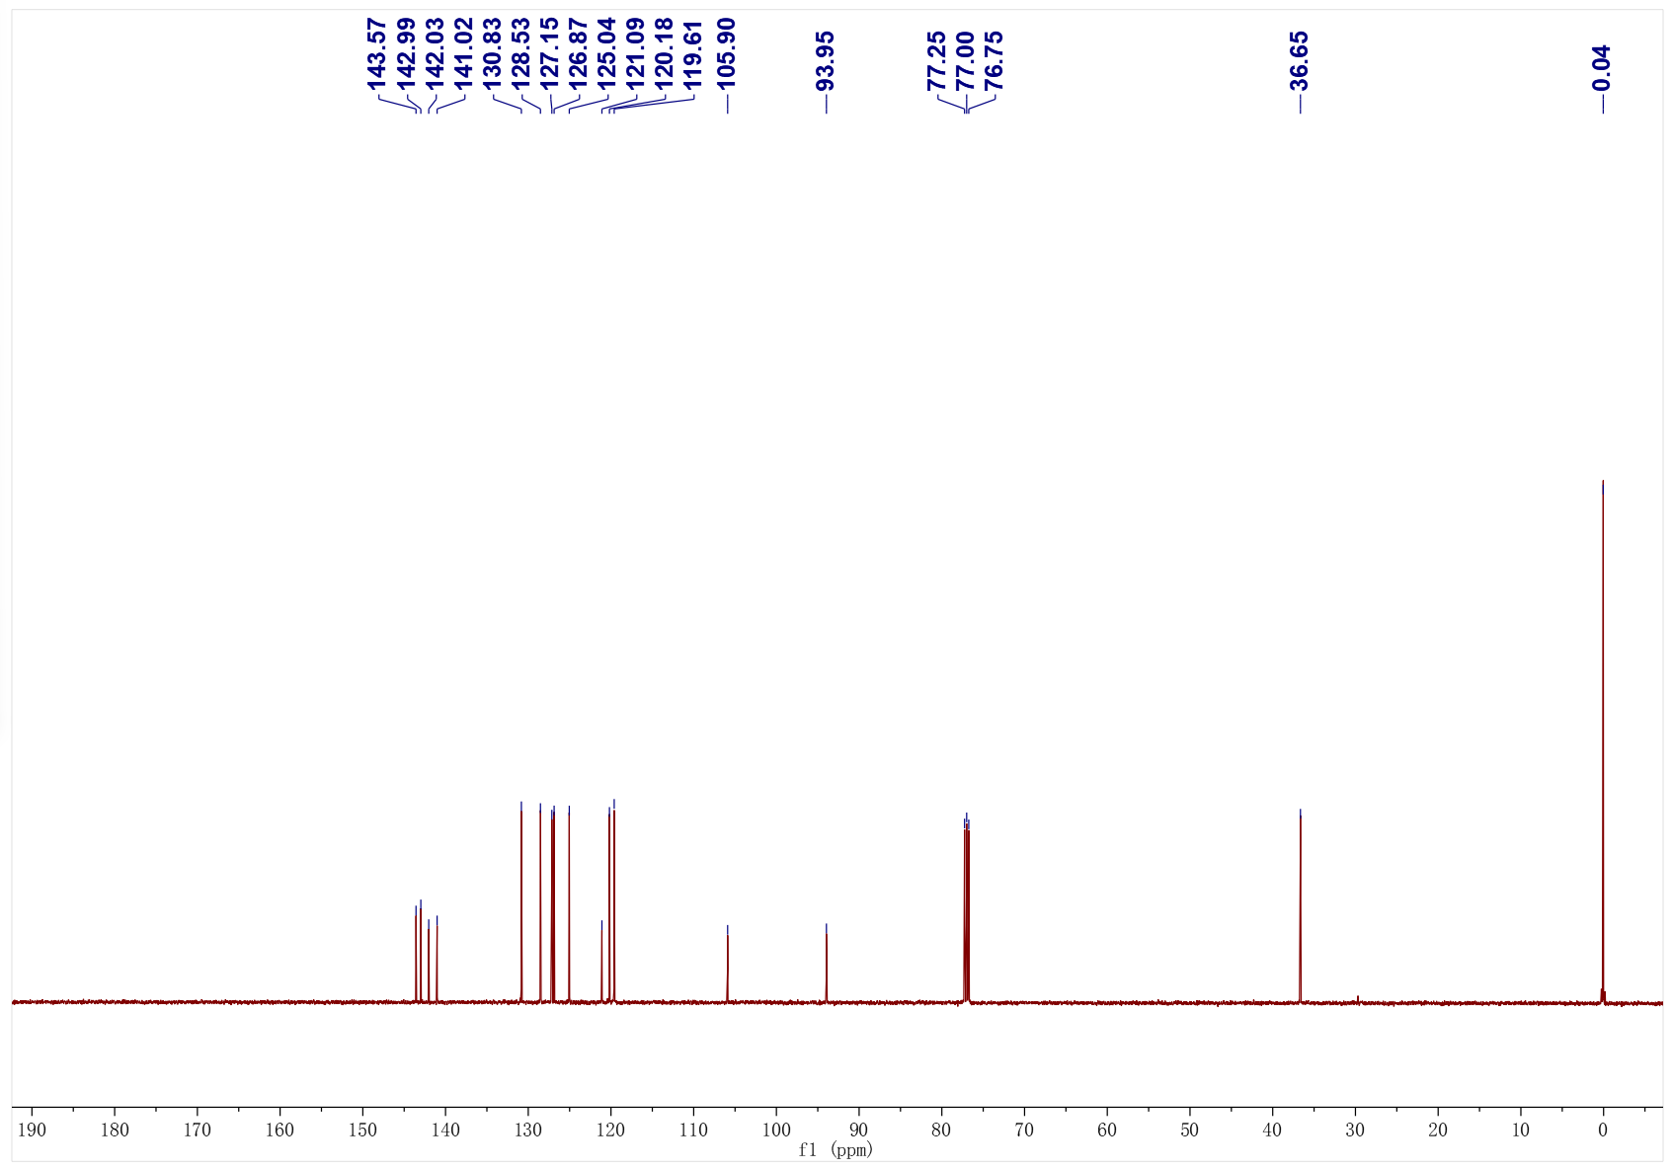
3aa; ¹H NMR (500 MHz, CDCl₃); ¹³C NMR (126 MHz, CDCl₃)
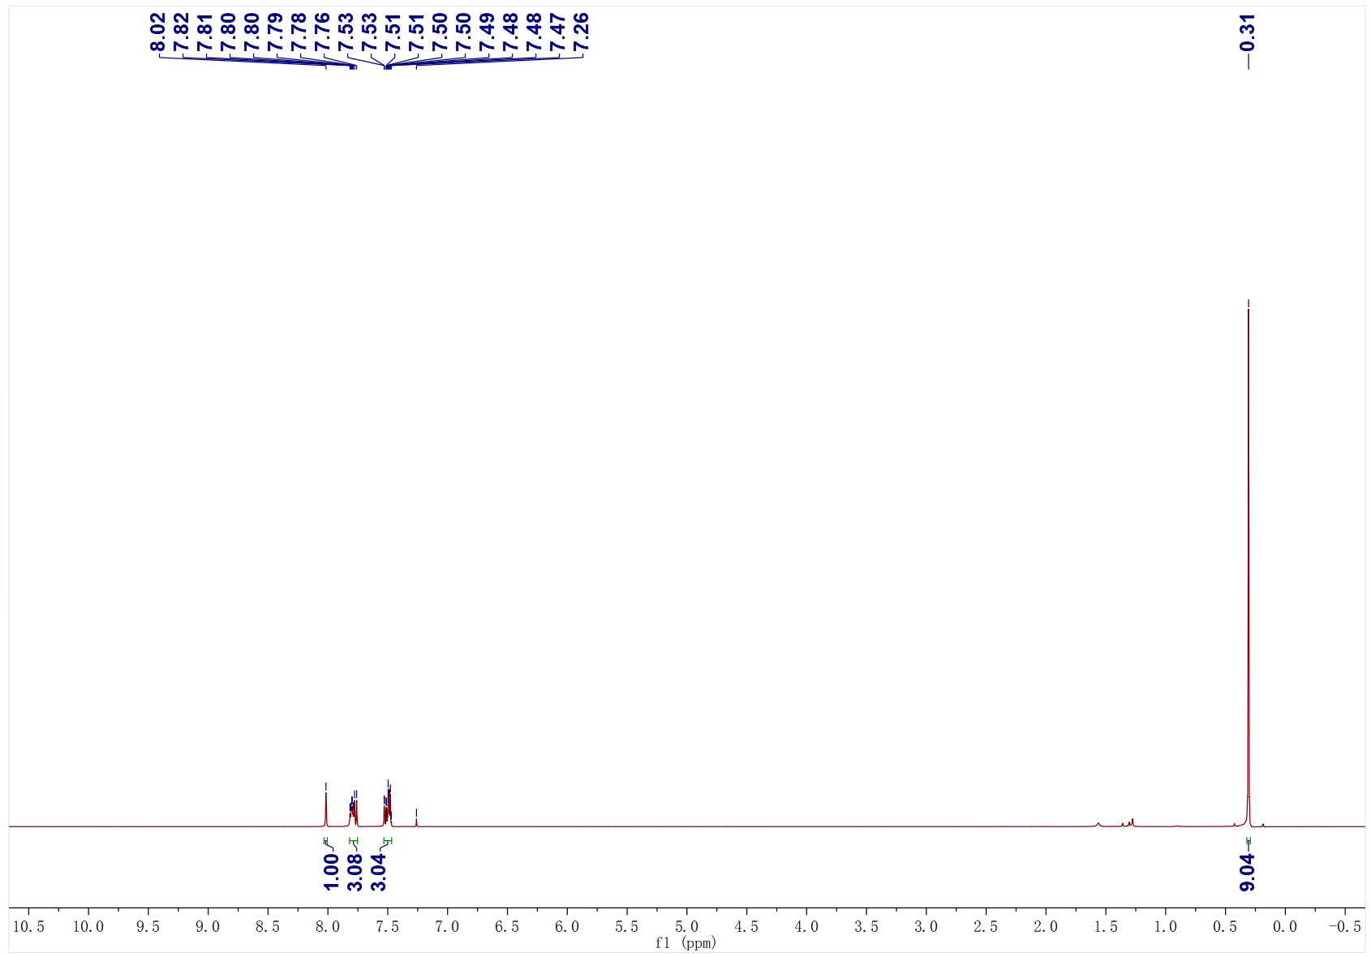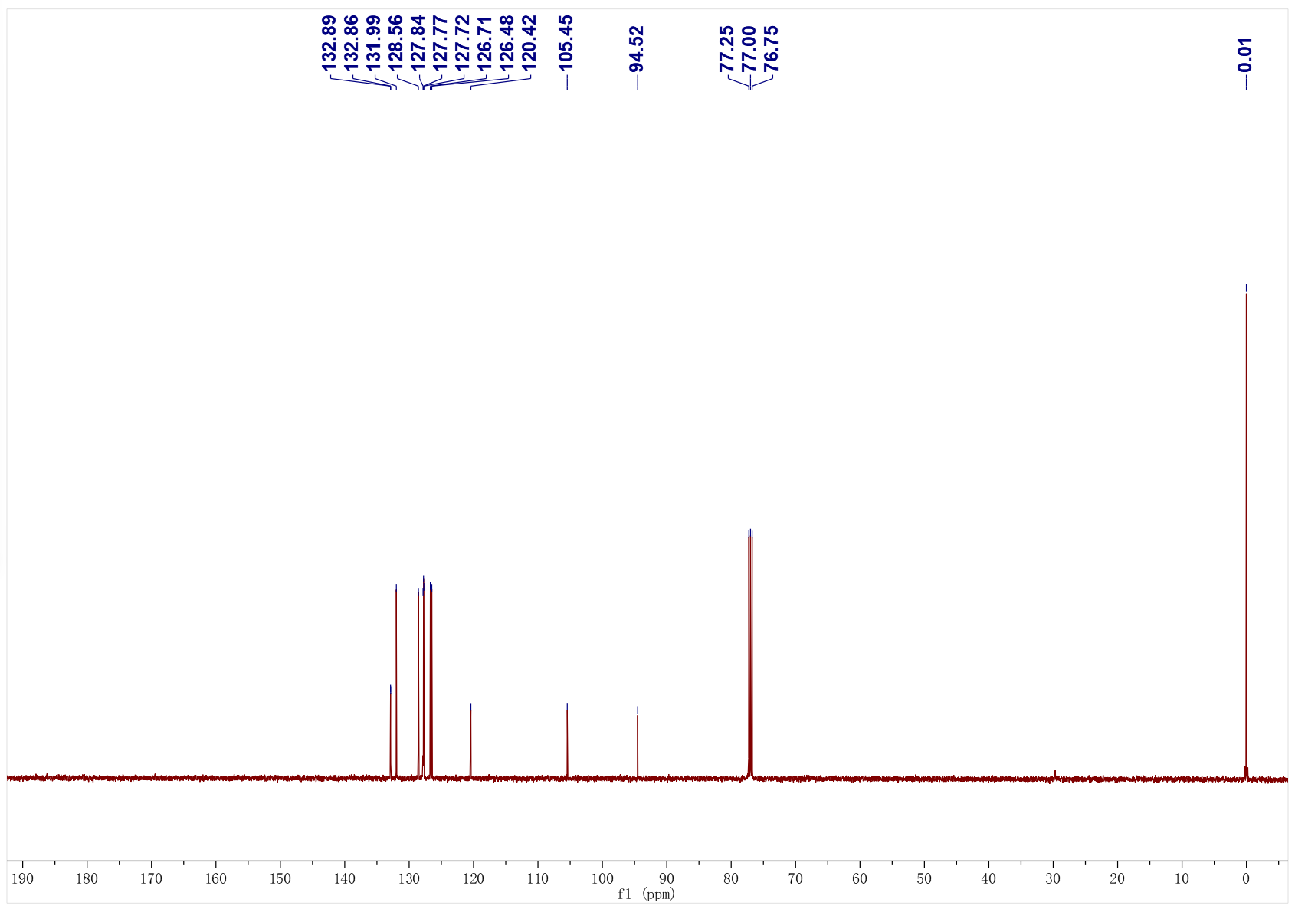
3ab; ¹H NMR (400 MHz, CDCl₃); ¹³C NMR (126 MHz, CDCl₃)
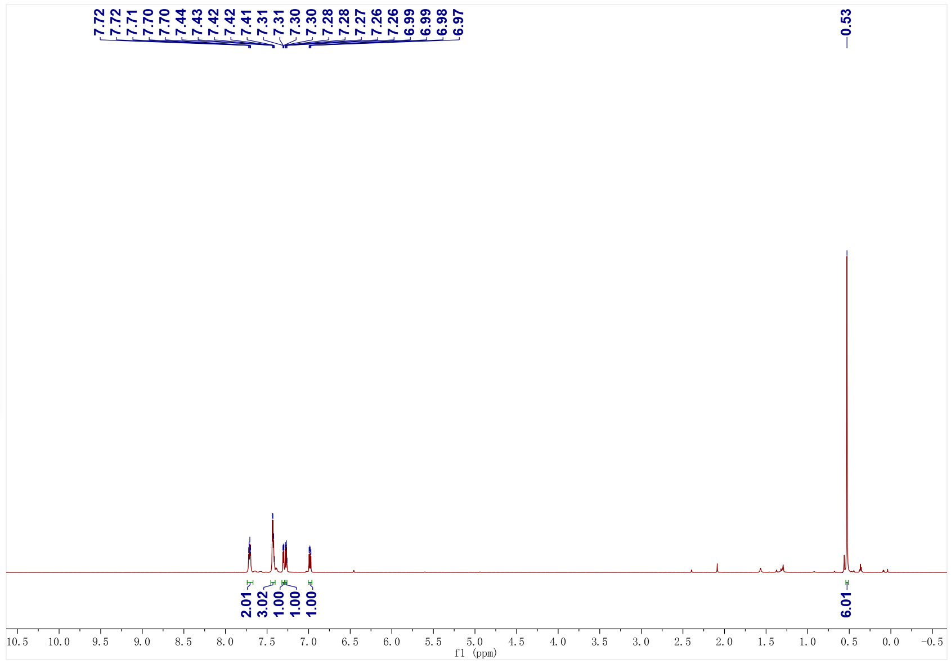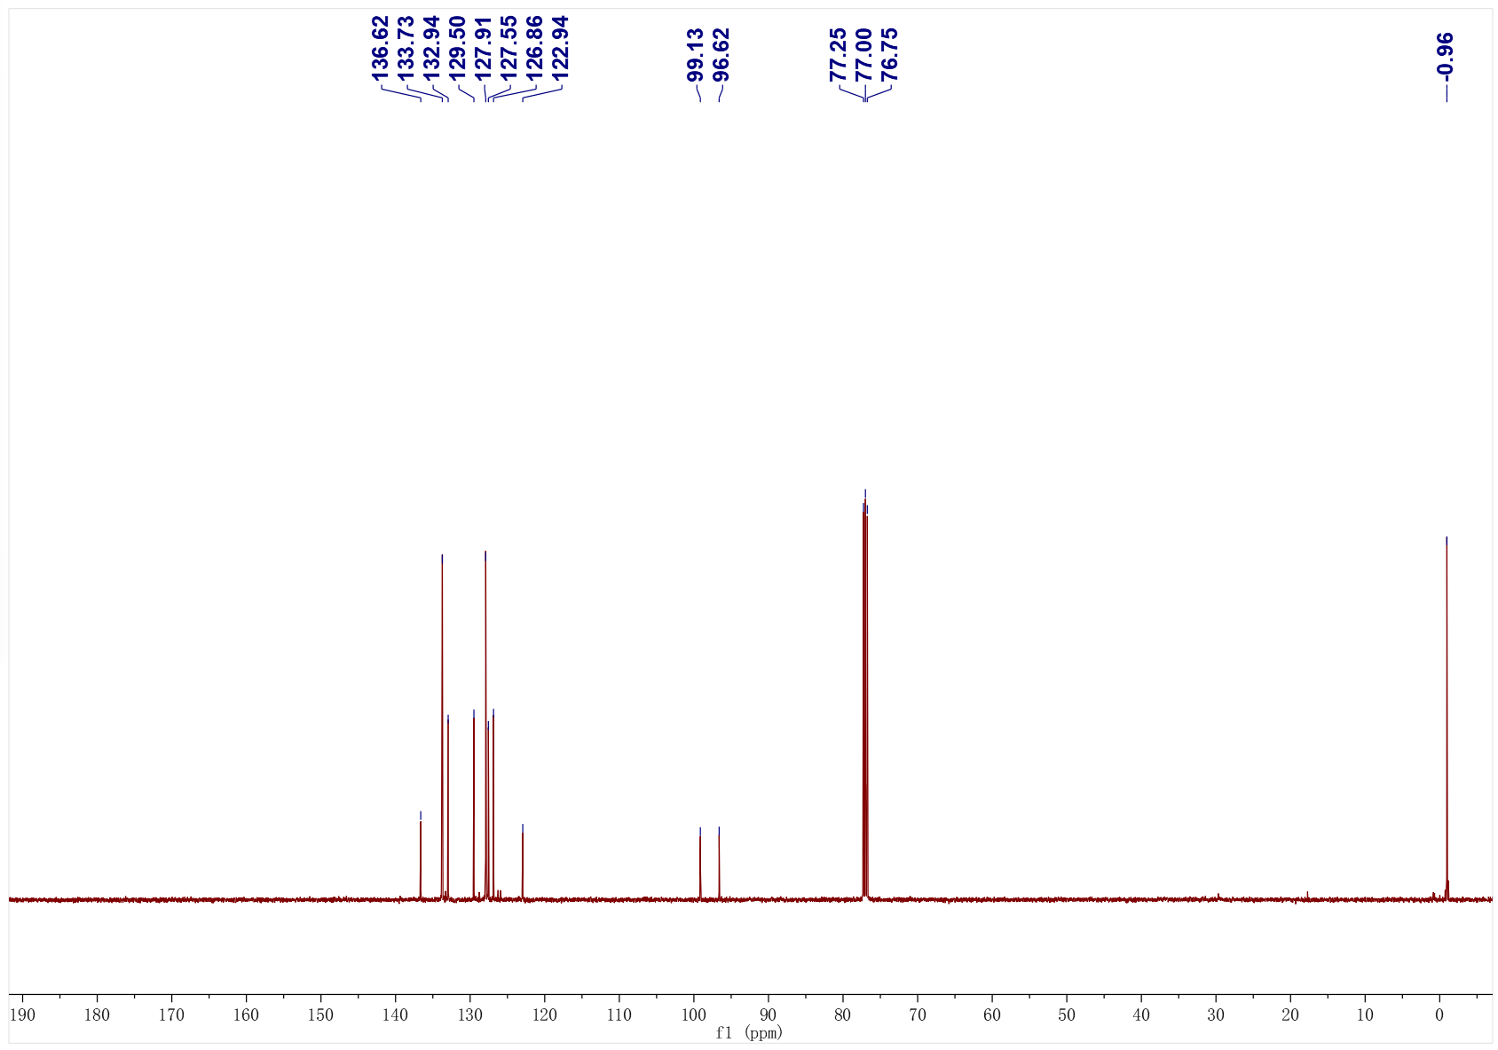
3ac; ¹H NMR (500 MHz, CDCl₃); ¹³C NMR (126 MHz, CDCl₃)
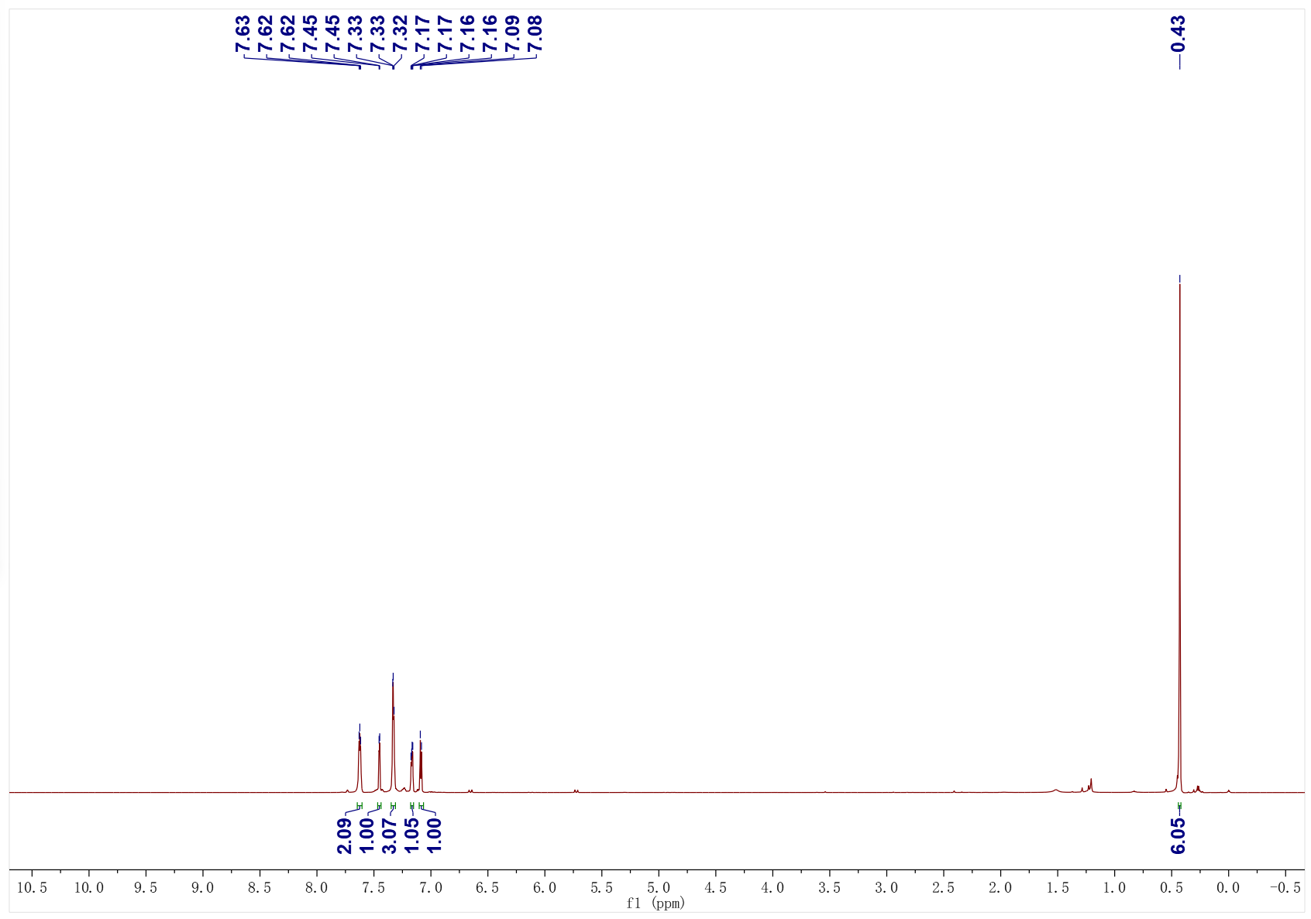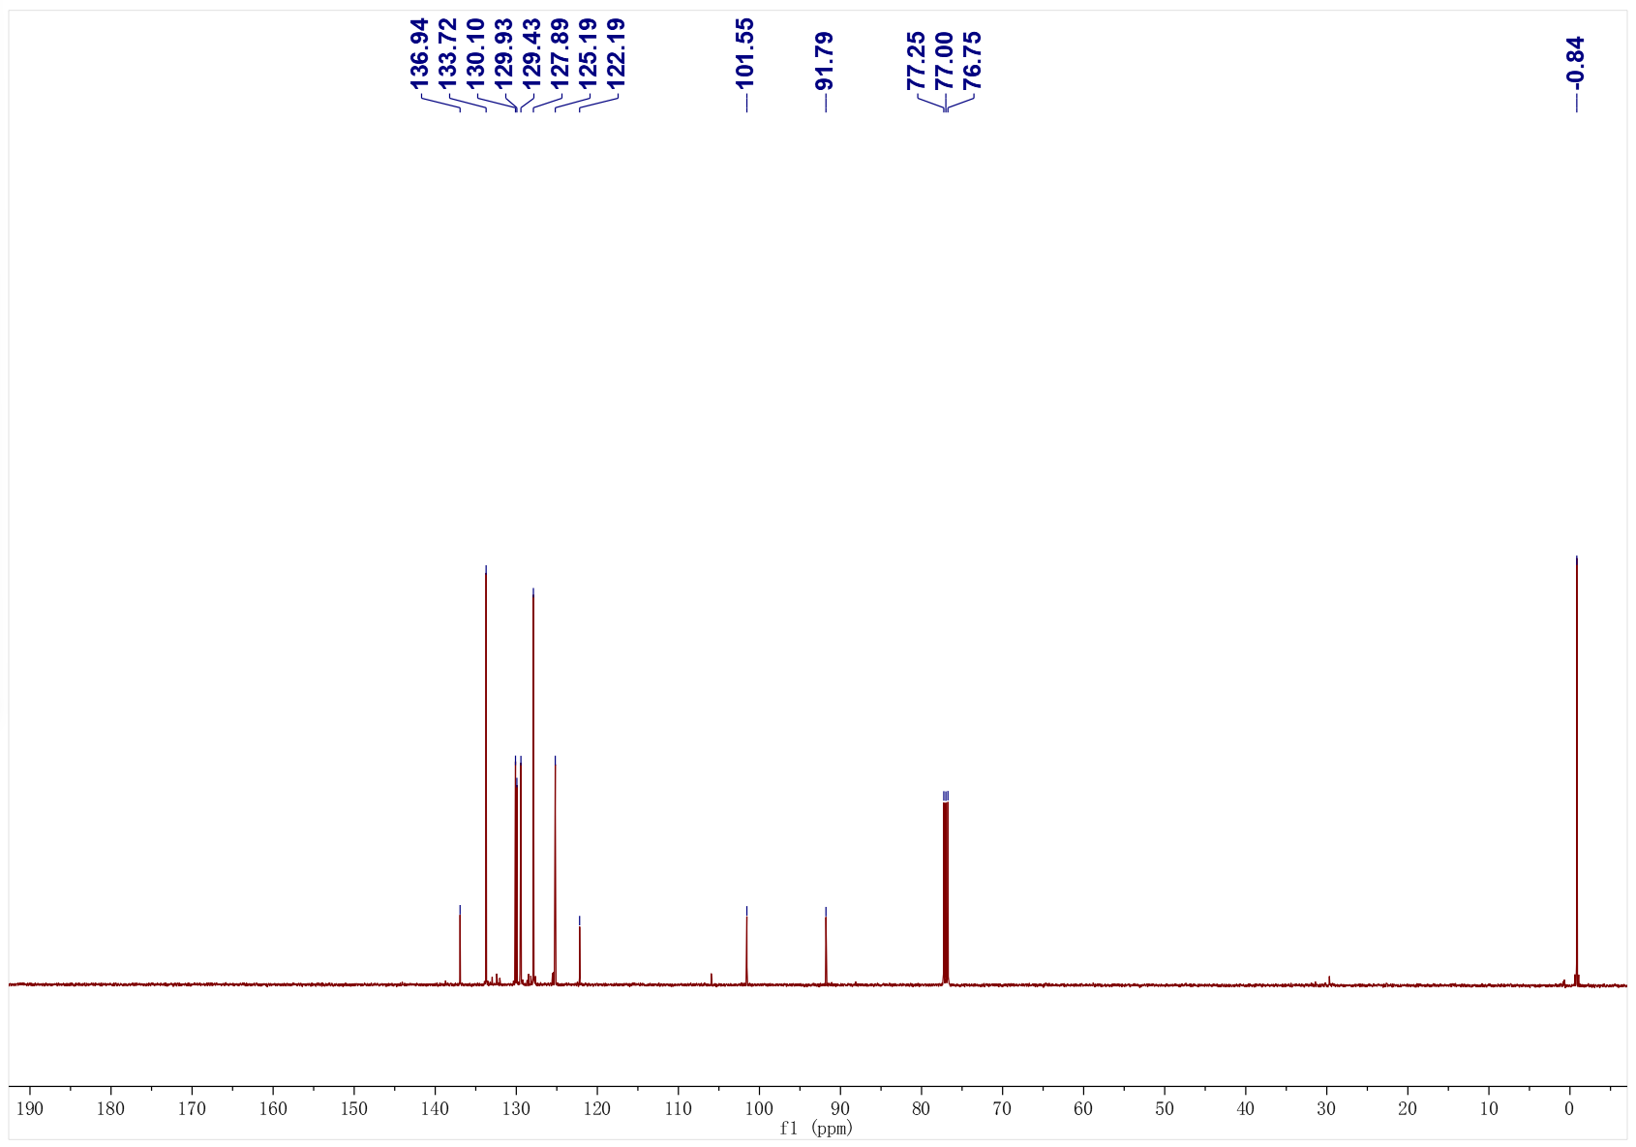
3ad; ¹H NMR (500 MHz, CDCl₃); ¹³C NMR (126 MHz, CDCl₃)
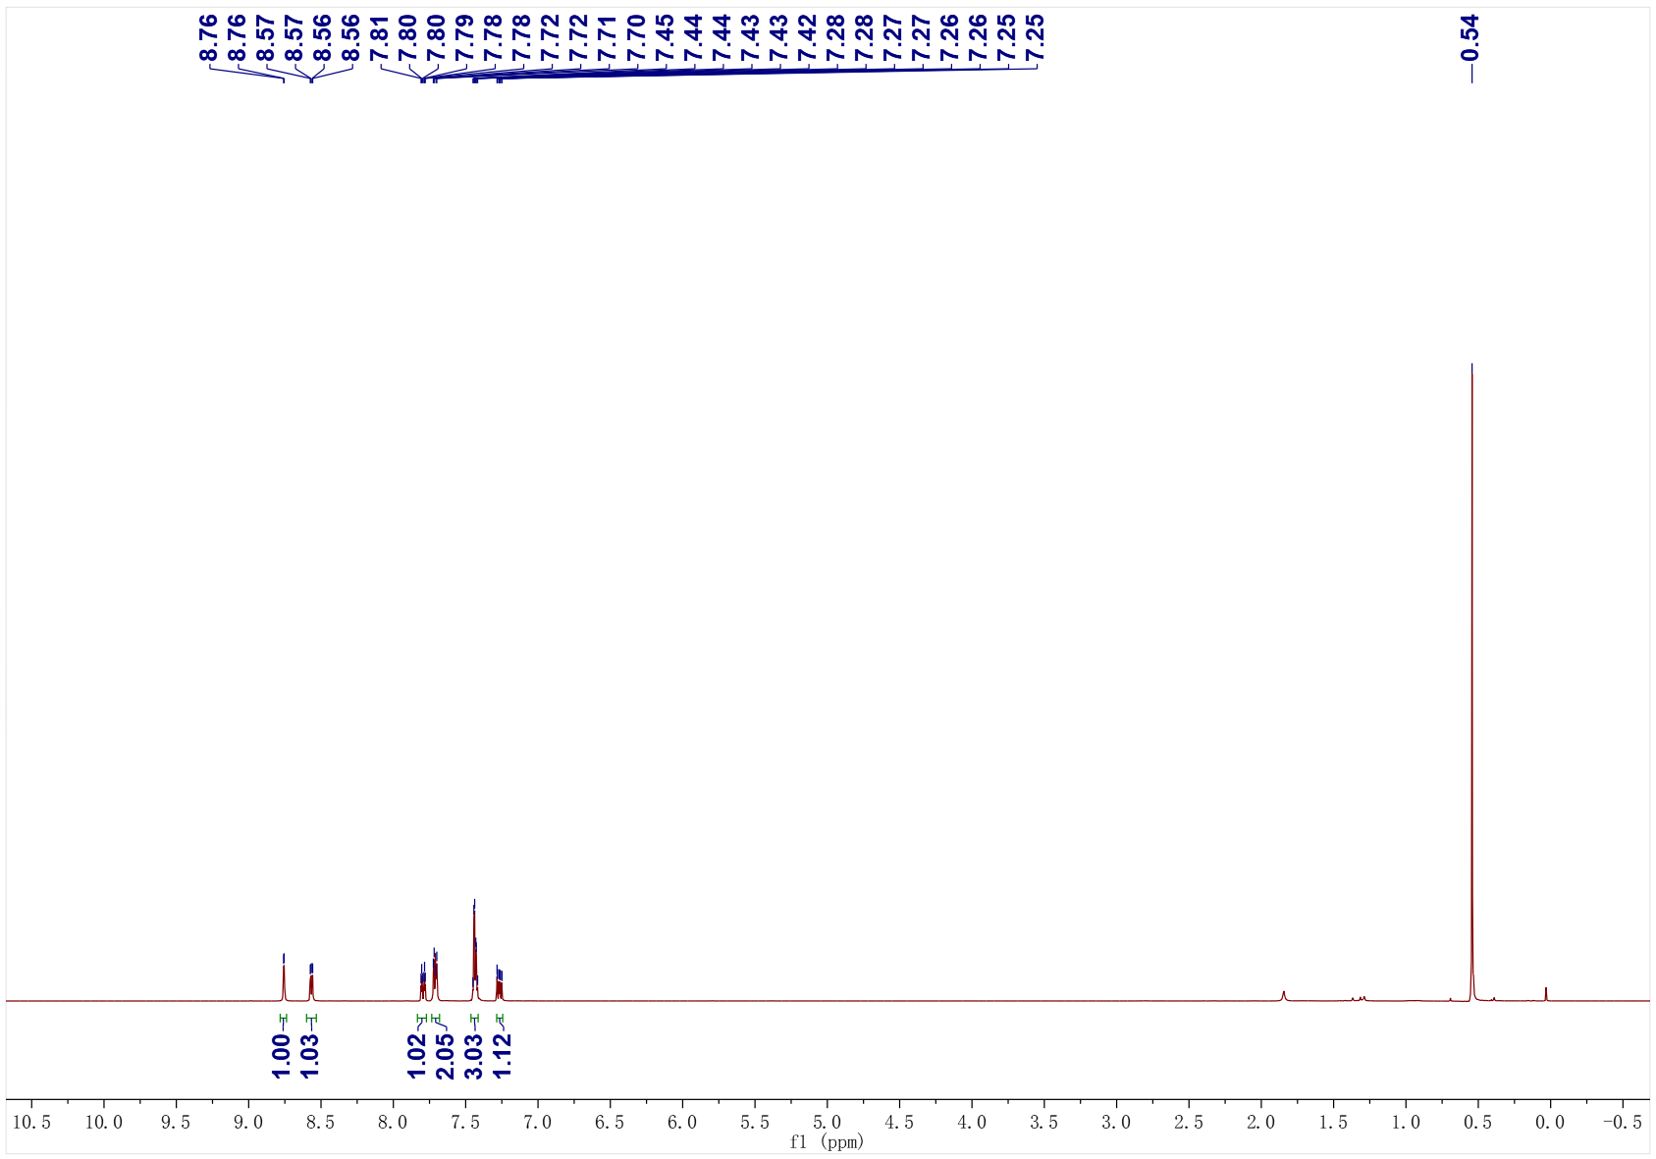
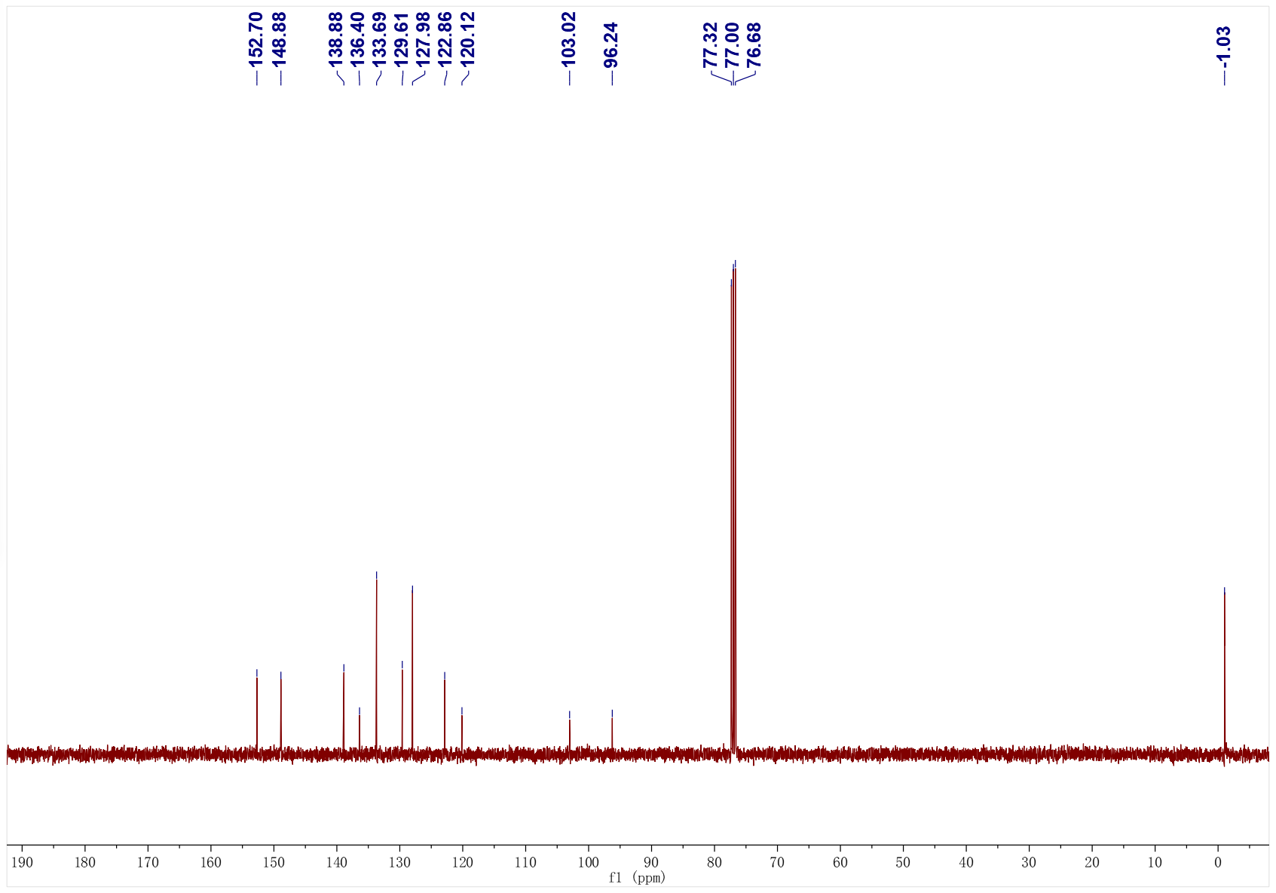
3ae; ¹H NMR (500 MHz, CDCl₃); ¹³C NMR (126 MHz, CDCl₃)
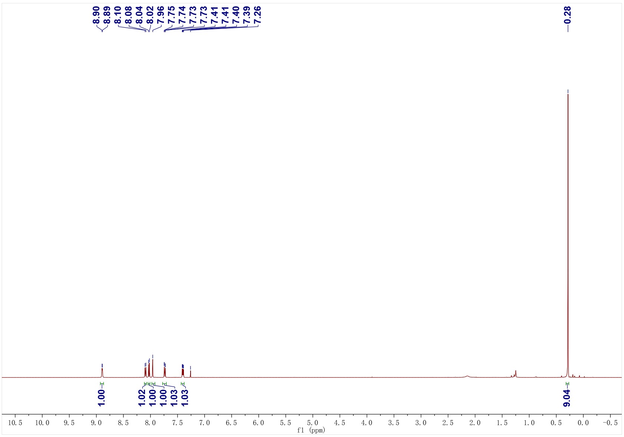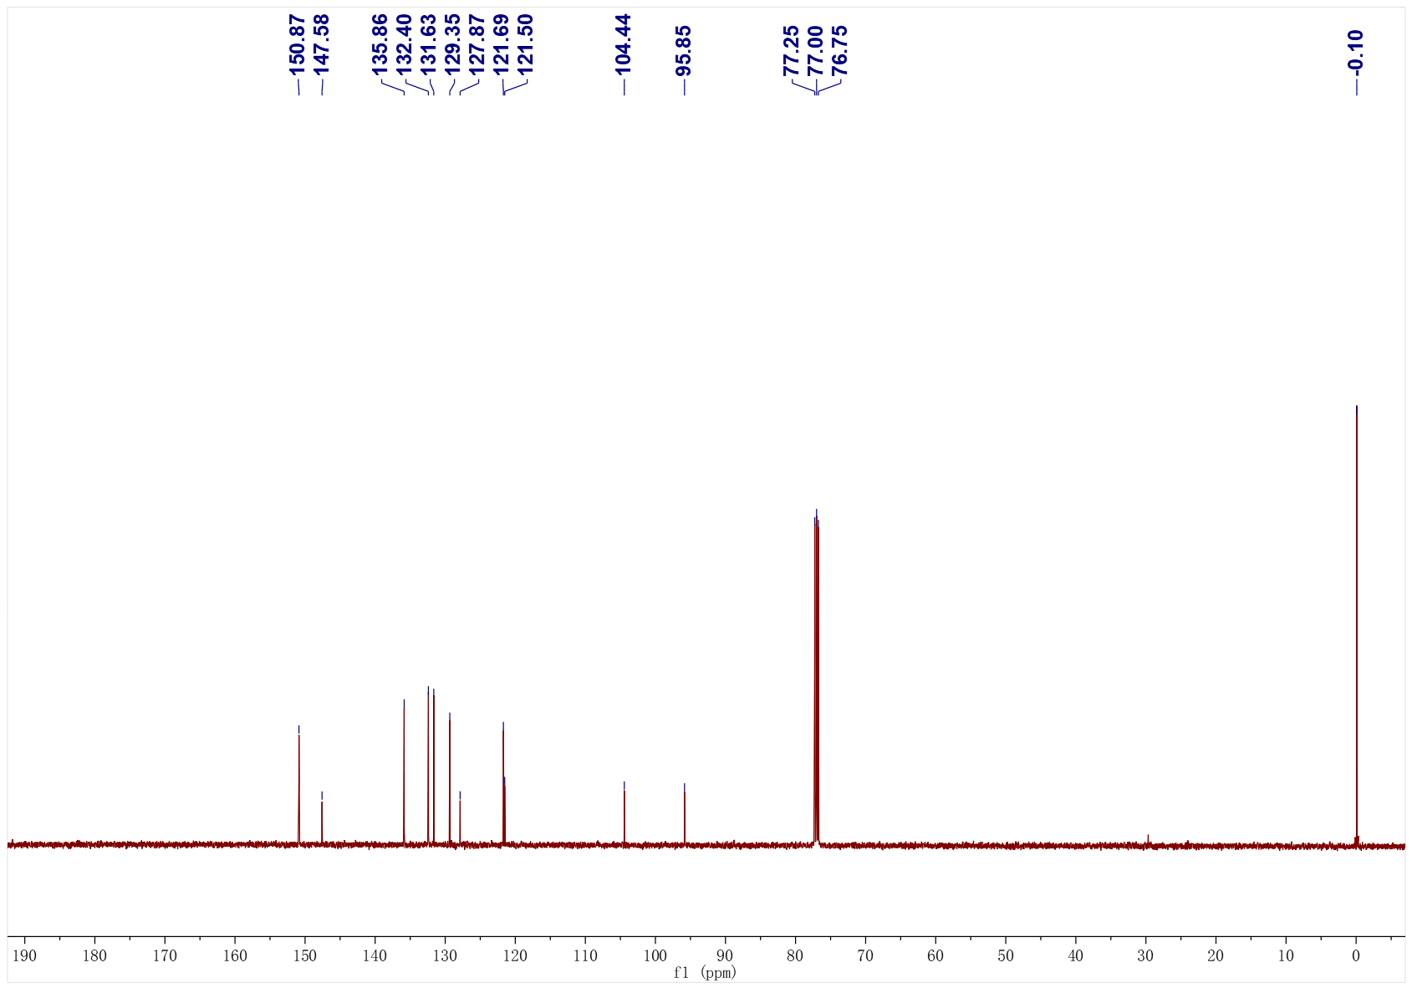
3af; ¹H NMR (500 MHz, CDCl₃); ¹³C NMR (126 MHz, CDCl₃)
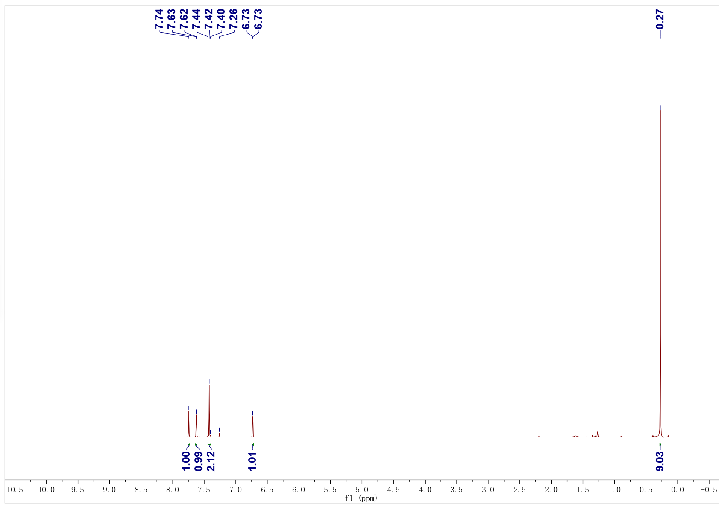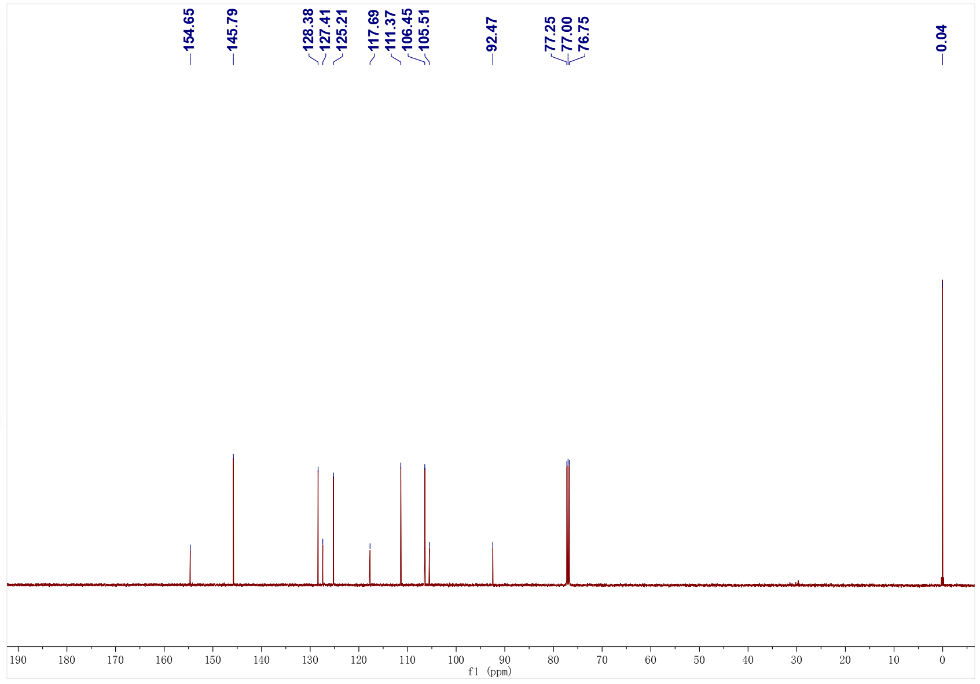
3ag; ¹H NMR (500 MHz, CDCl₃); ¹³C NMR (126 MHz, CDCl₃)
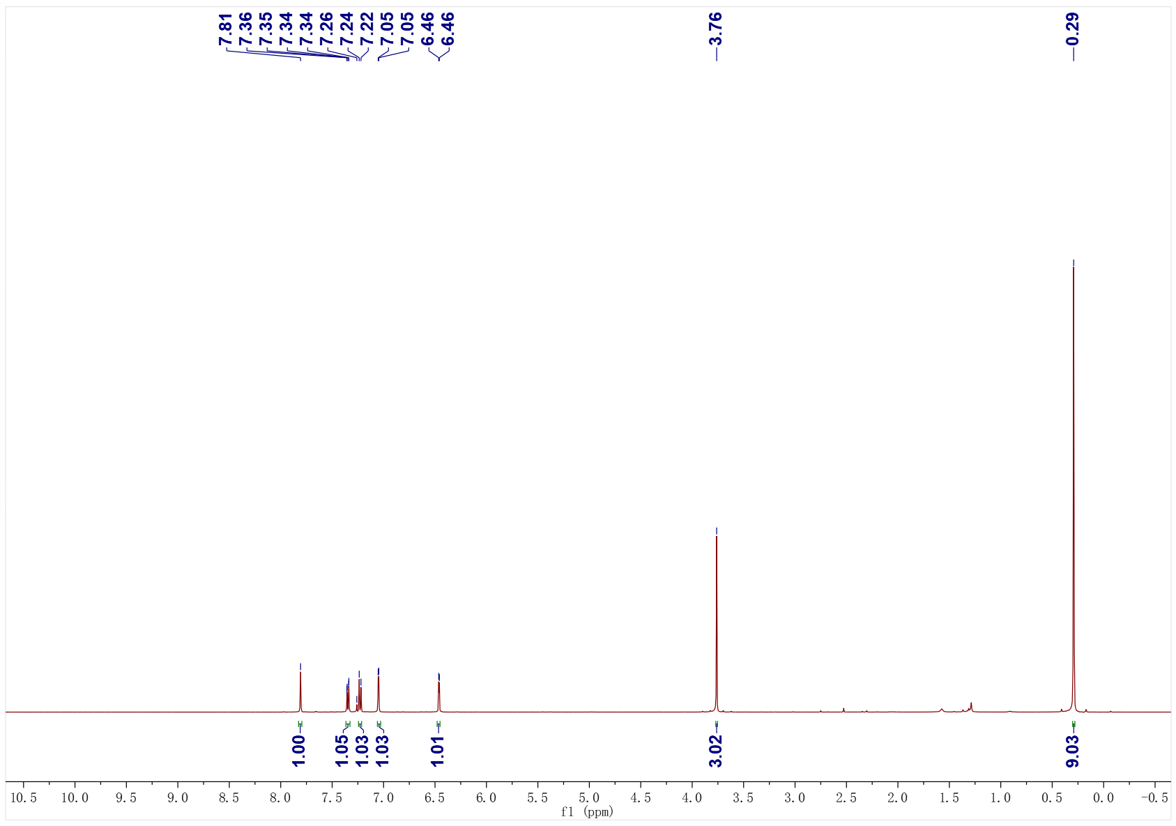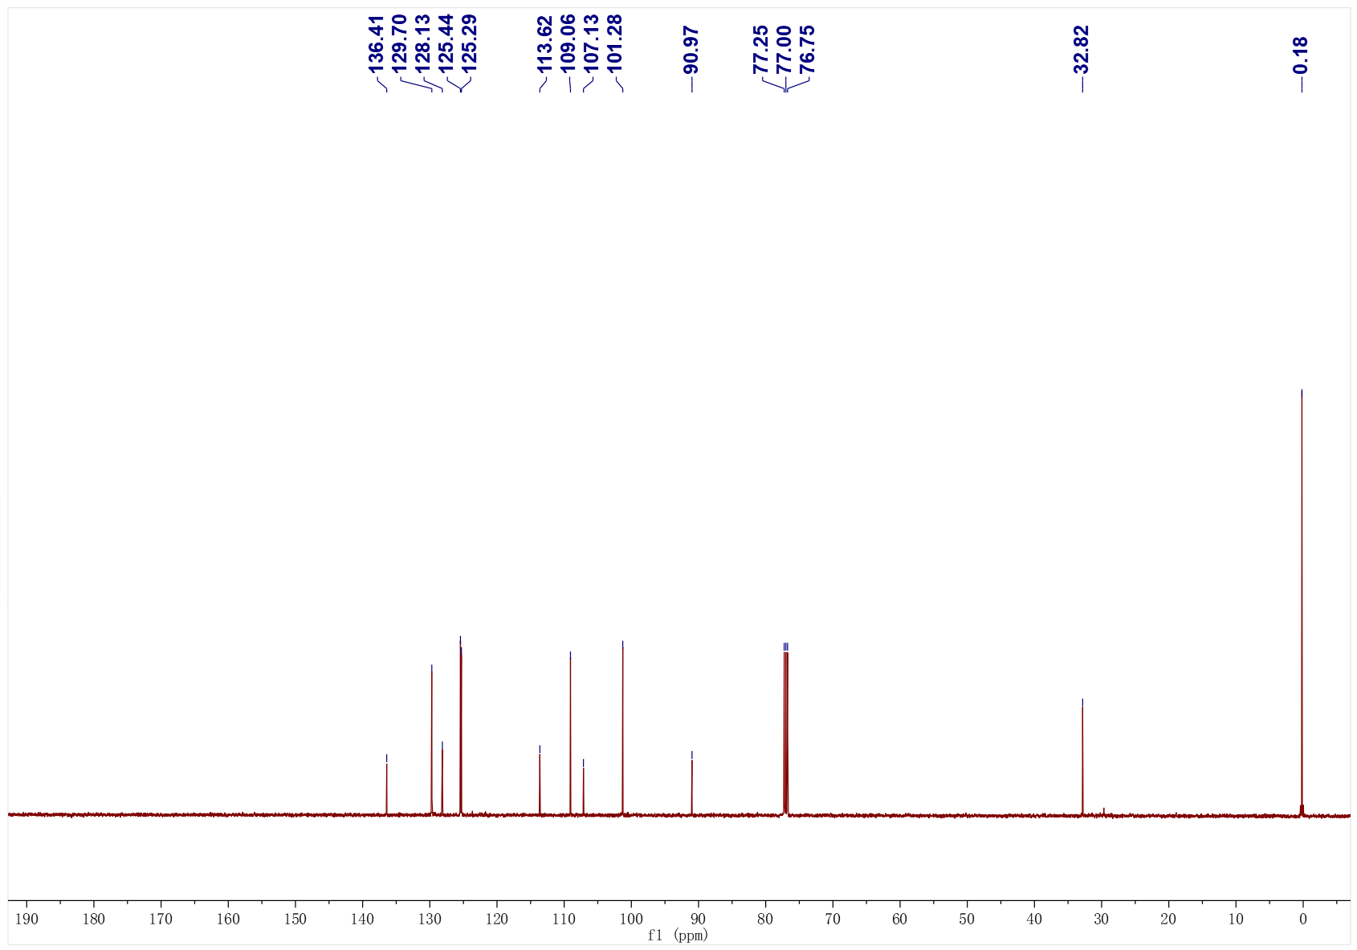
3ah; ¹H NMR (500 MHz, CDCl₃); ¹³C NMR (126 MHz, CDCl₃)
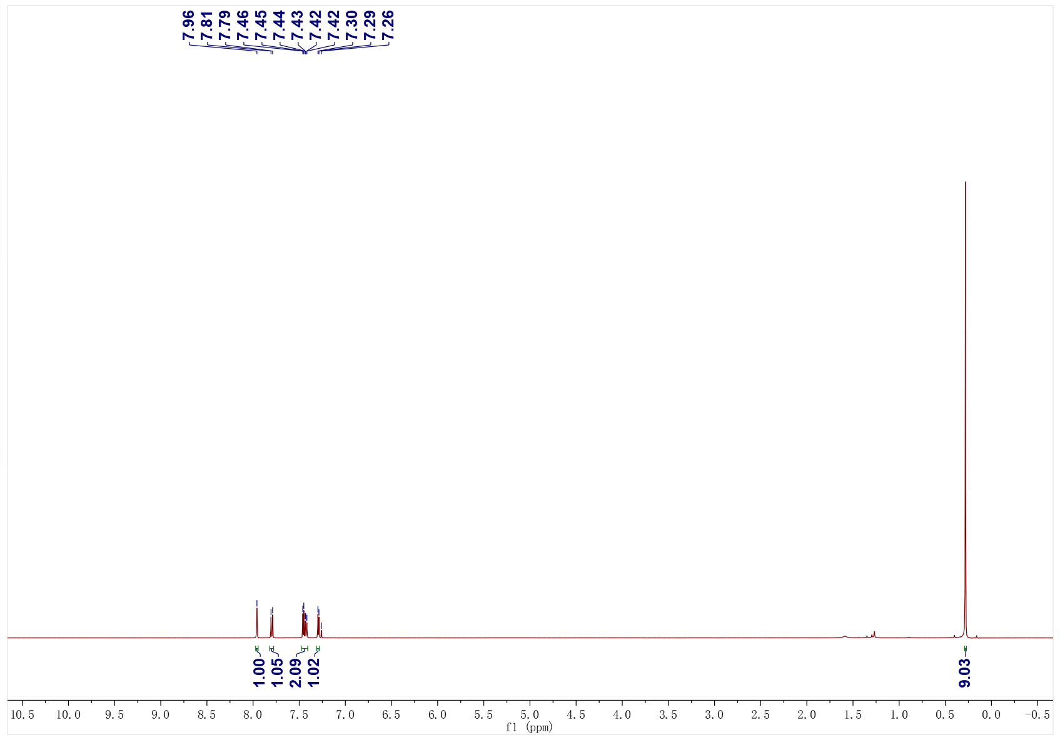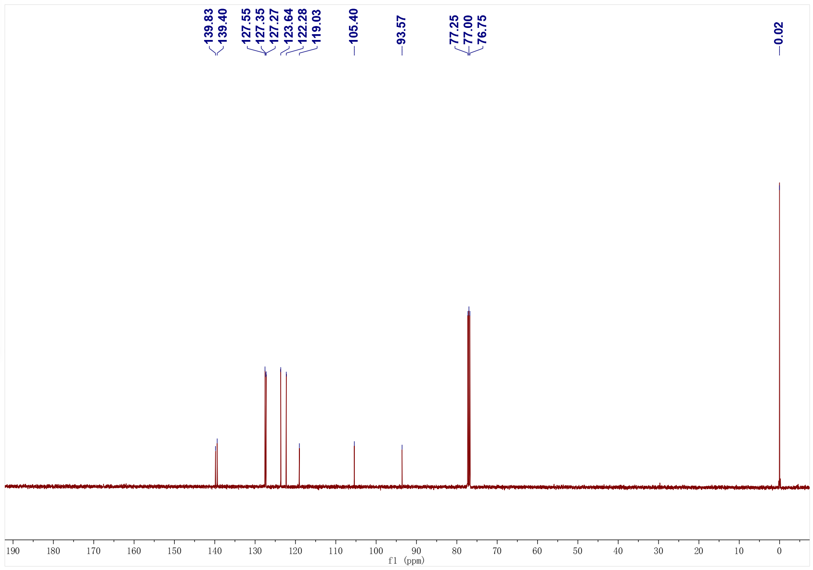
3ai; ¹H NMR (500 MHz, CDCl₃); ¹³C NMR (126 MHz, CDCl₃)
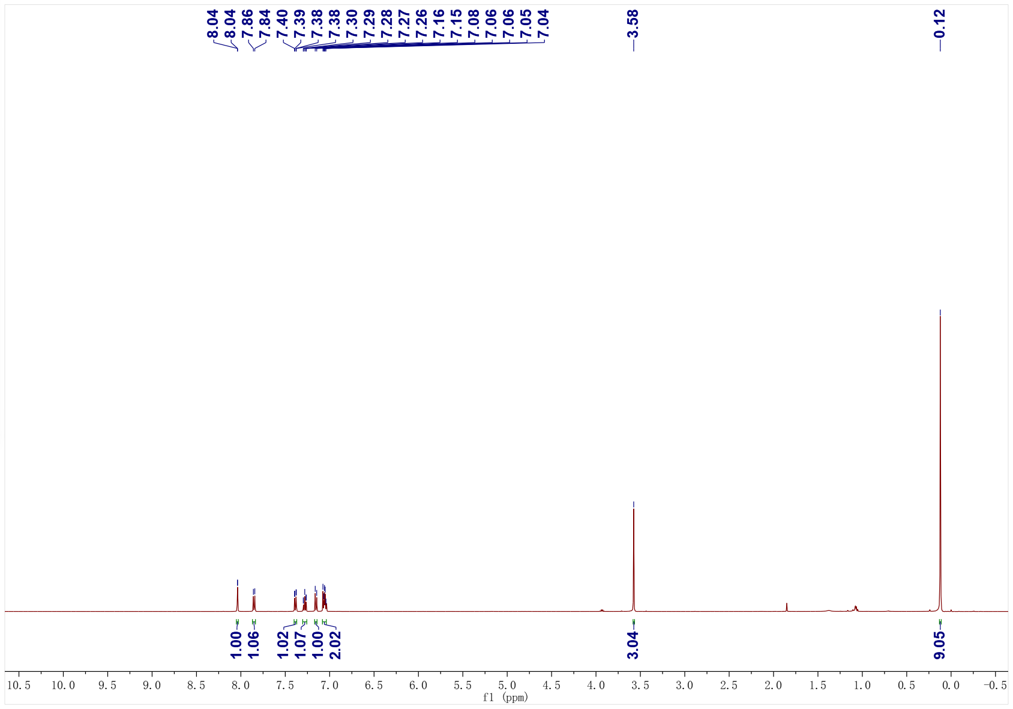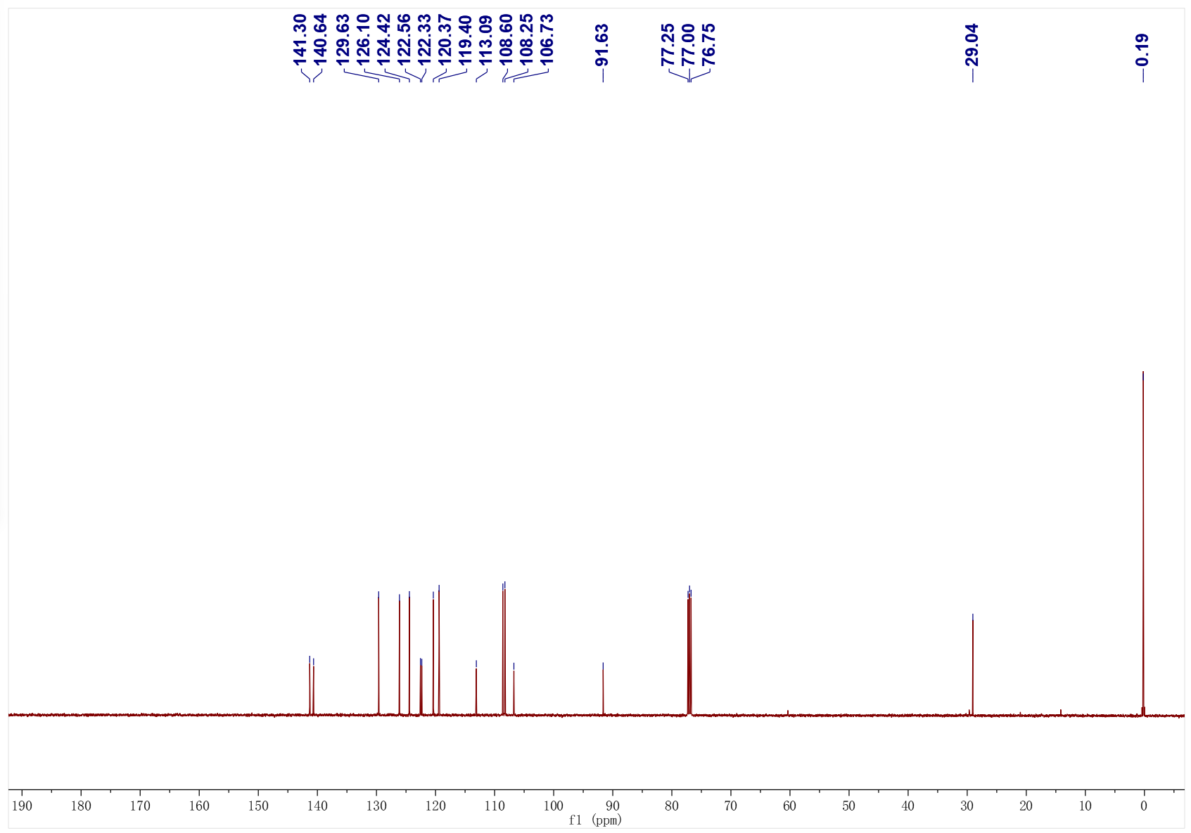
3aj; ¹H NMR (500 MHz, CDCl₃); ¹³C NMR (126 MHz, CDCl₃)
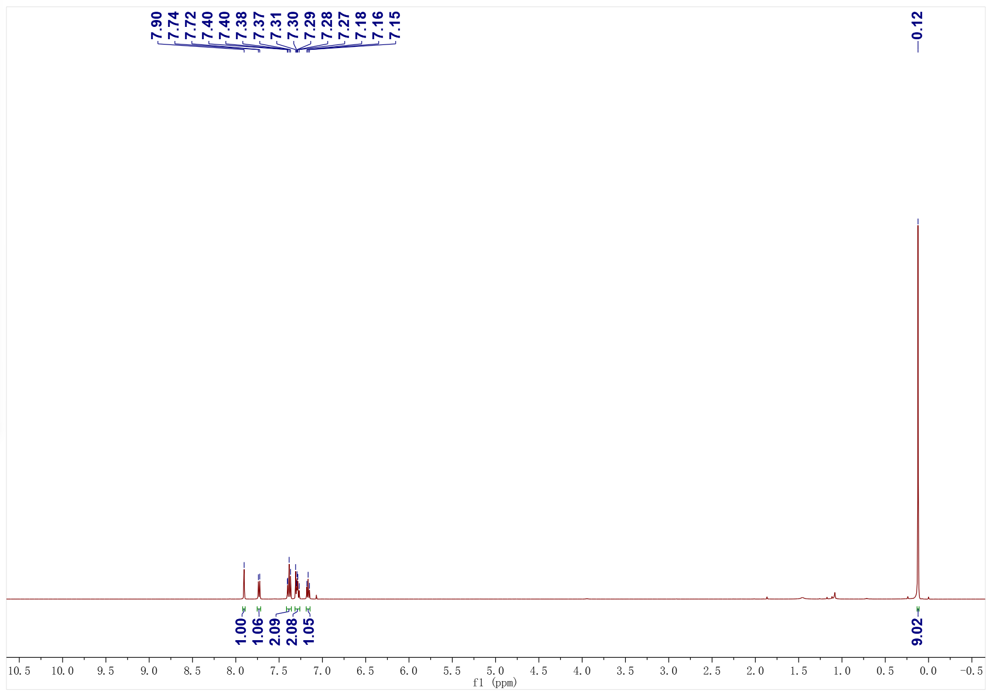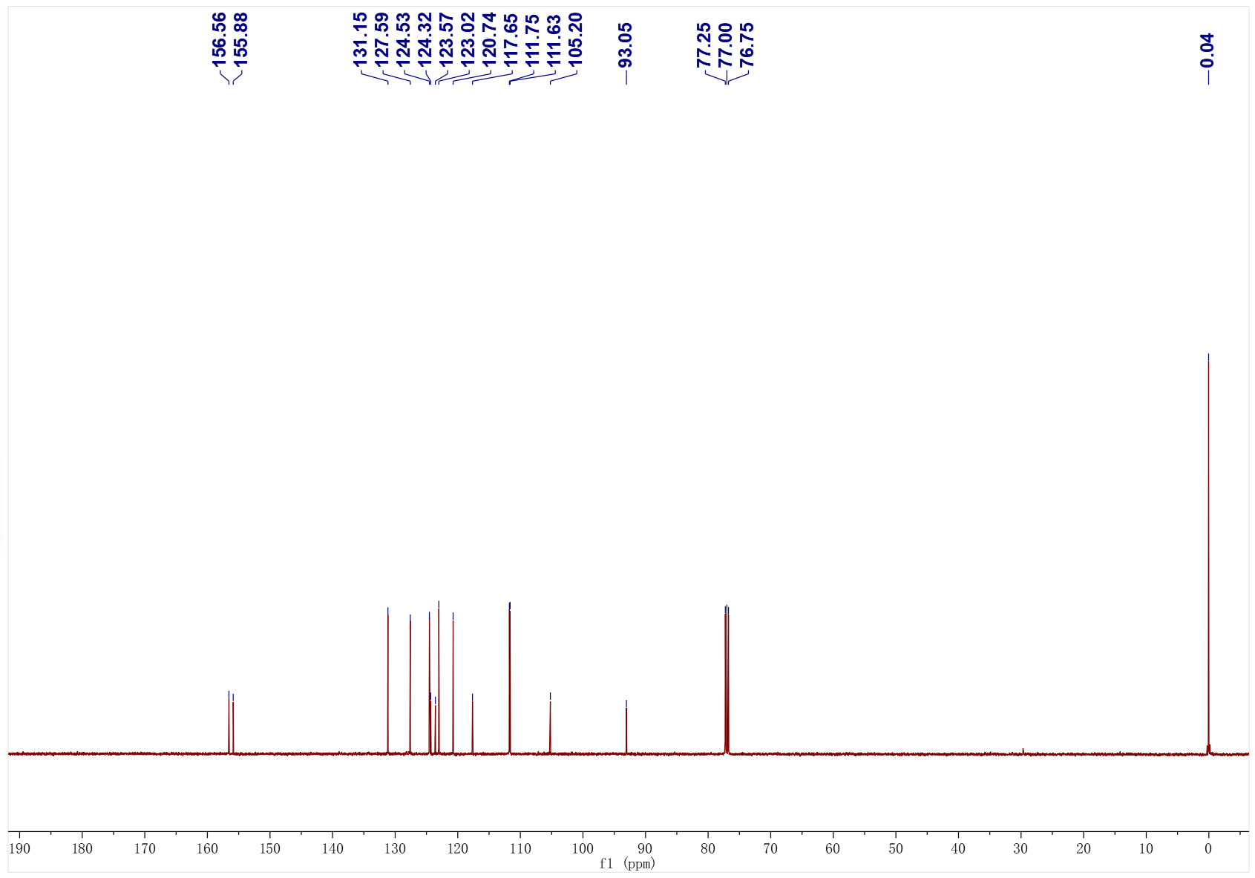
3ak; ¹H NMR (500 MHz, CDCl₃); ¹³C NMR (126 MHz, CDCl₃)
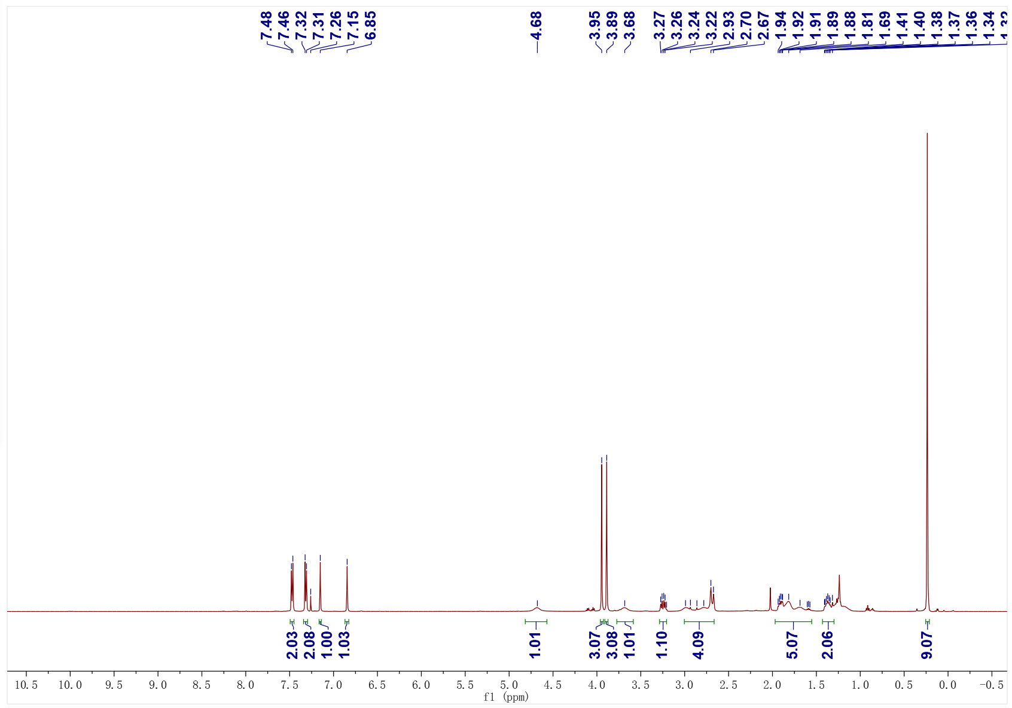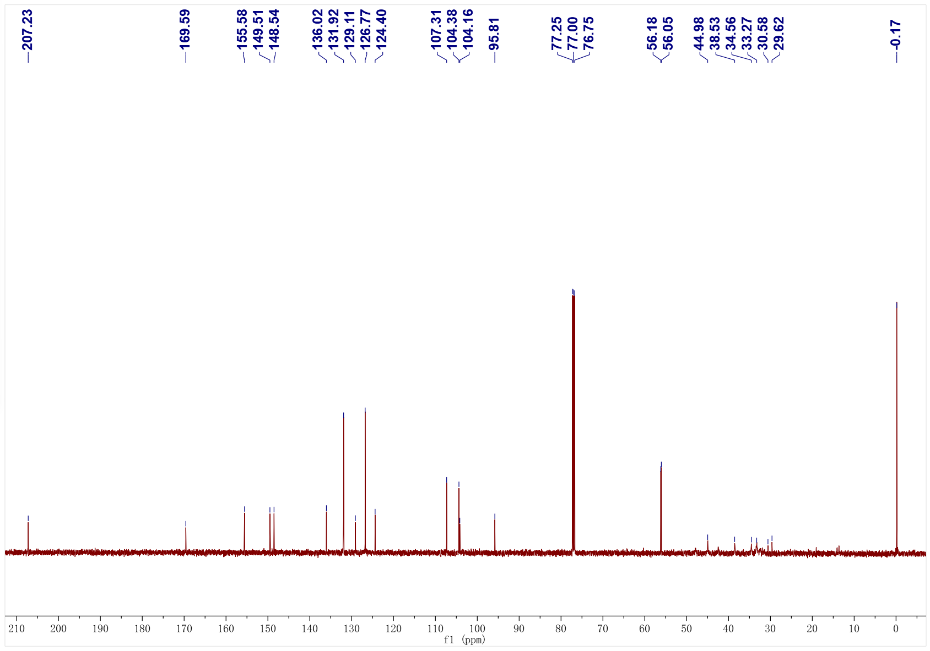
3al; ¹H NMR (500 MHz, CDCl₃); ¹³C NMR (126 MHz, CDCl₃)
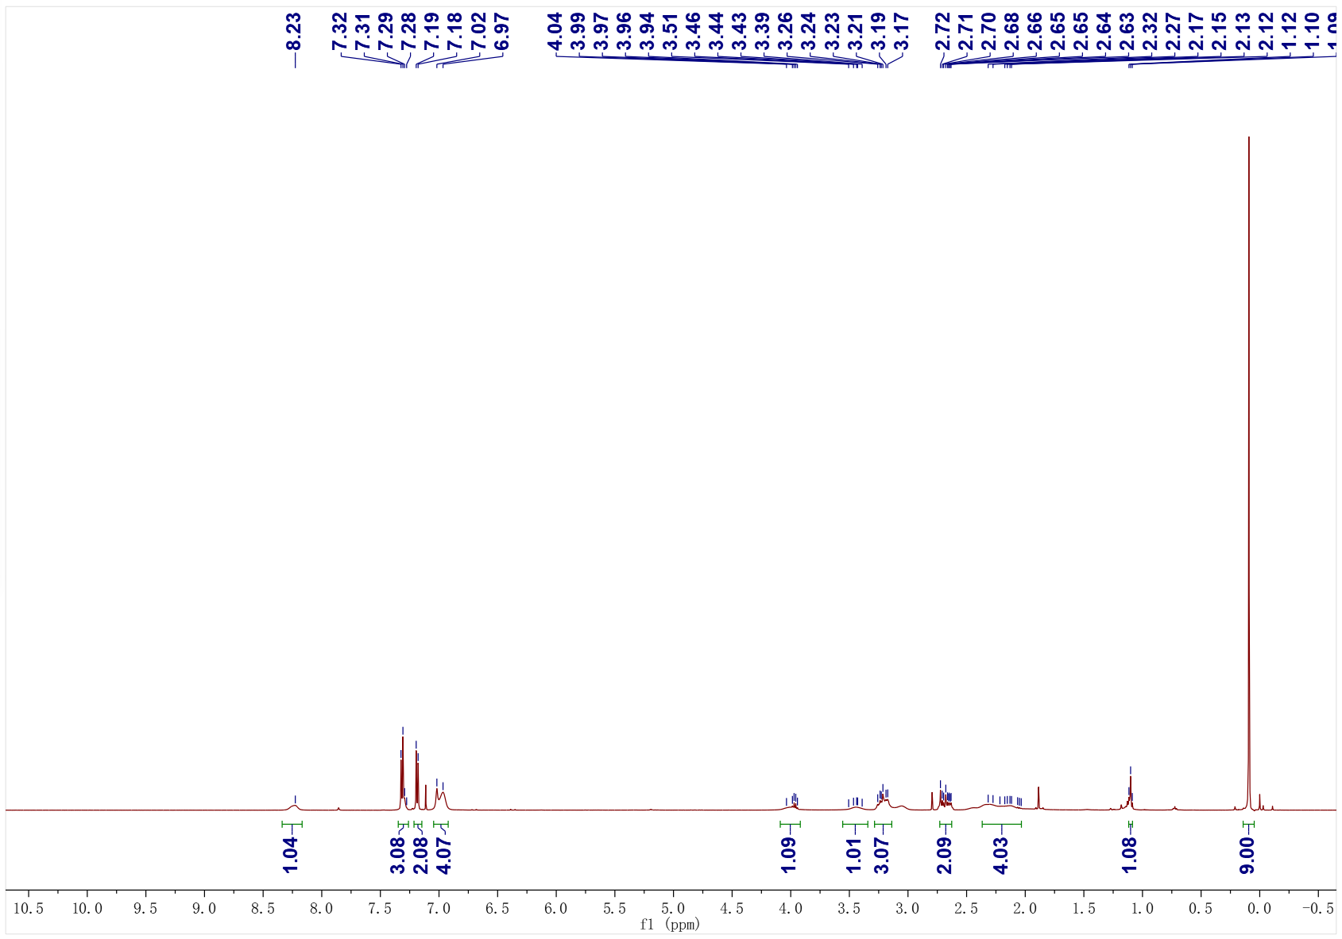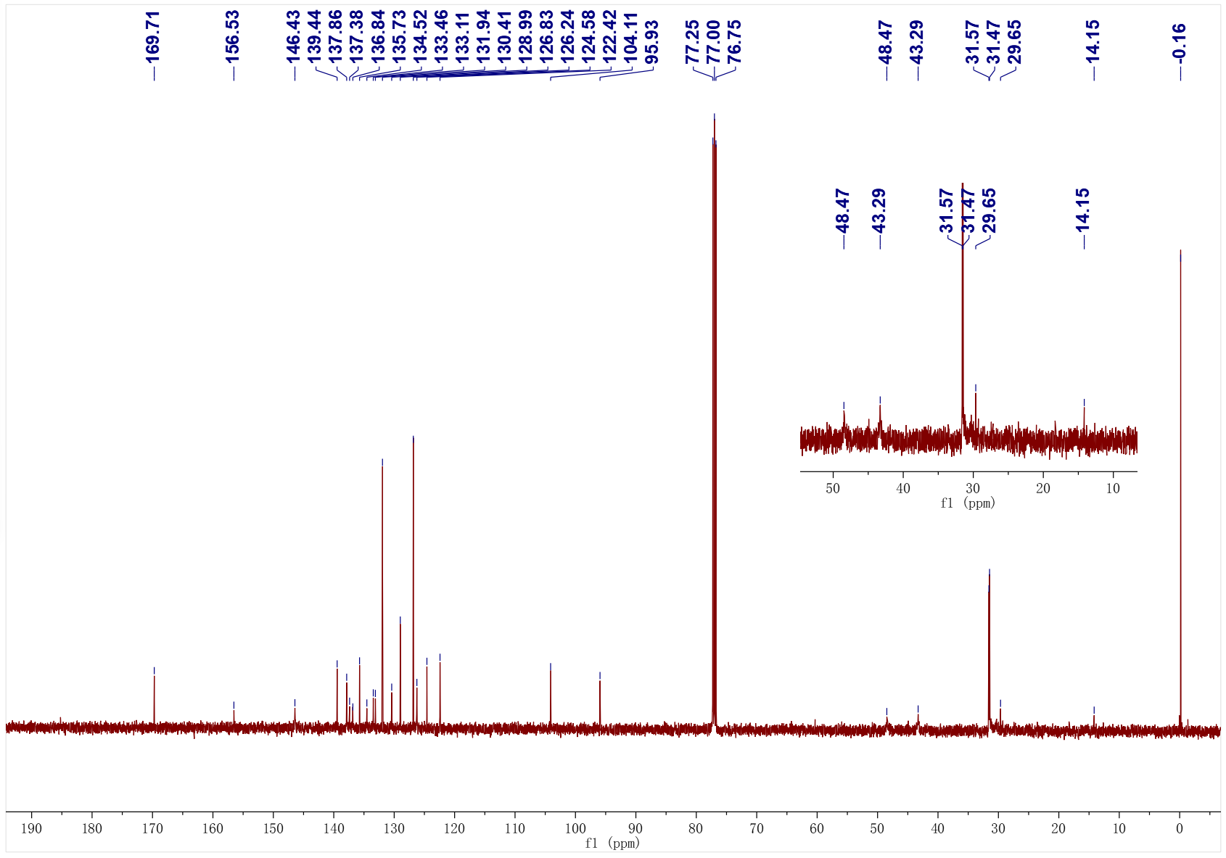
3am; ¹H NMR (500 MHz, CDCl₃); ¹³C NMR (126 MHz, CDCl₃)
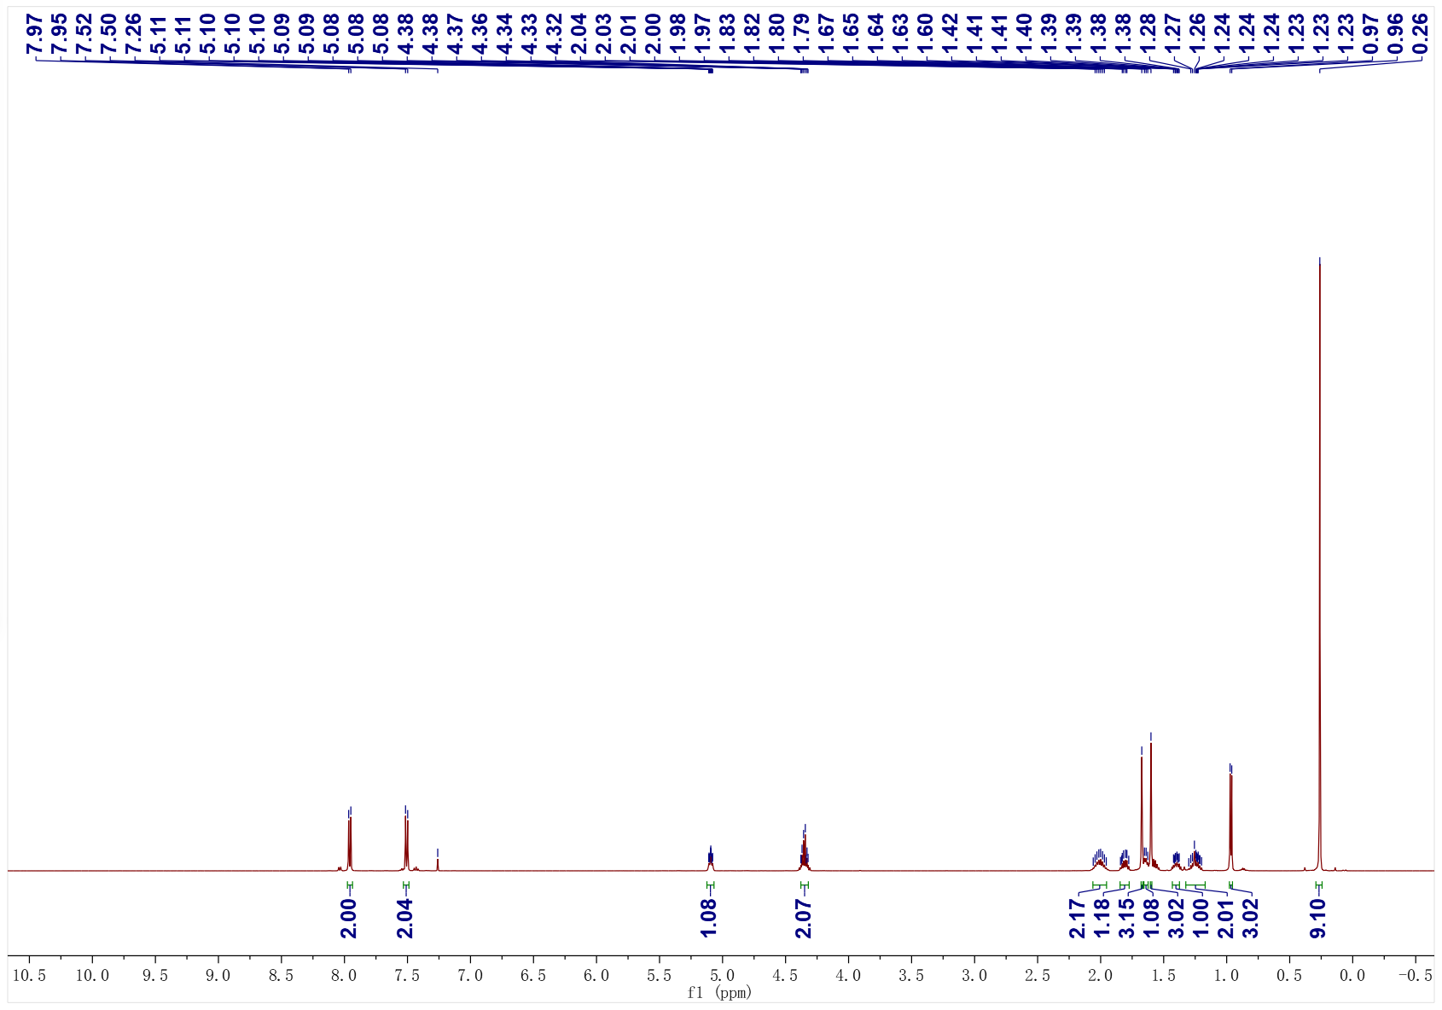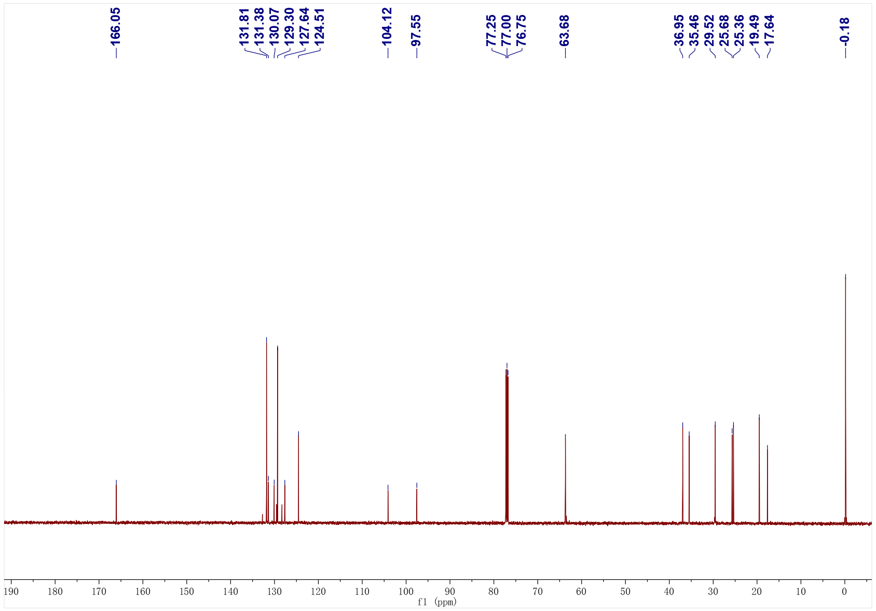
3an; ¹H NMR (500 MHz, CDCl₃); ¹³C NMR (126 MHz, CDCl₃)
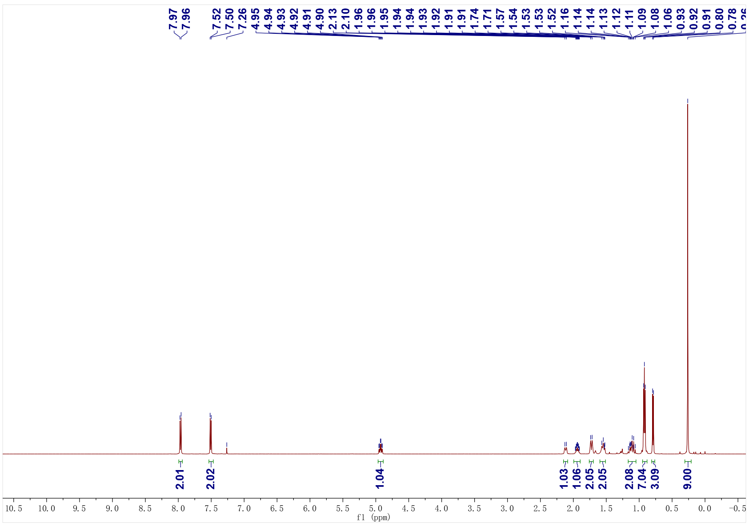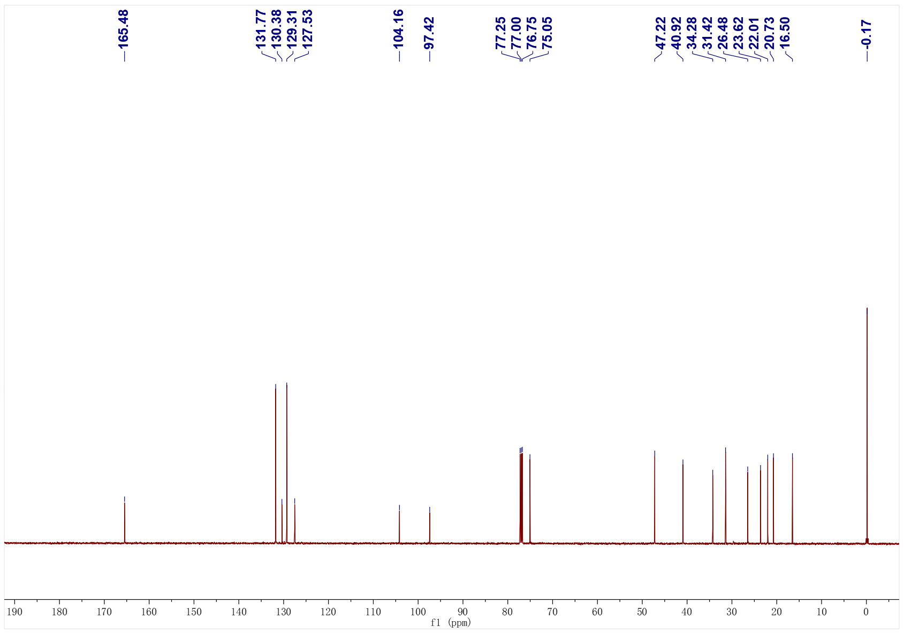
3ao; ¹H NMR (500 MHz, CDCl₃); ¹³C NMR (126 MHz, CDCl₃)
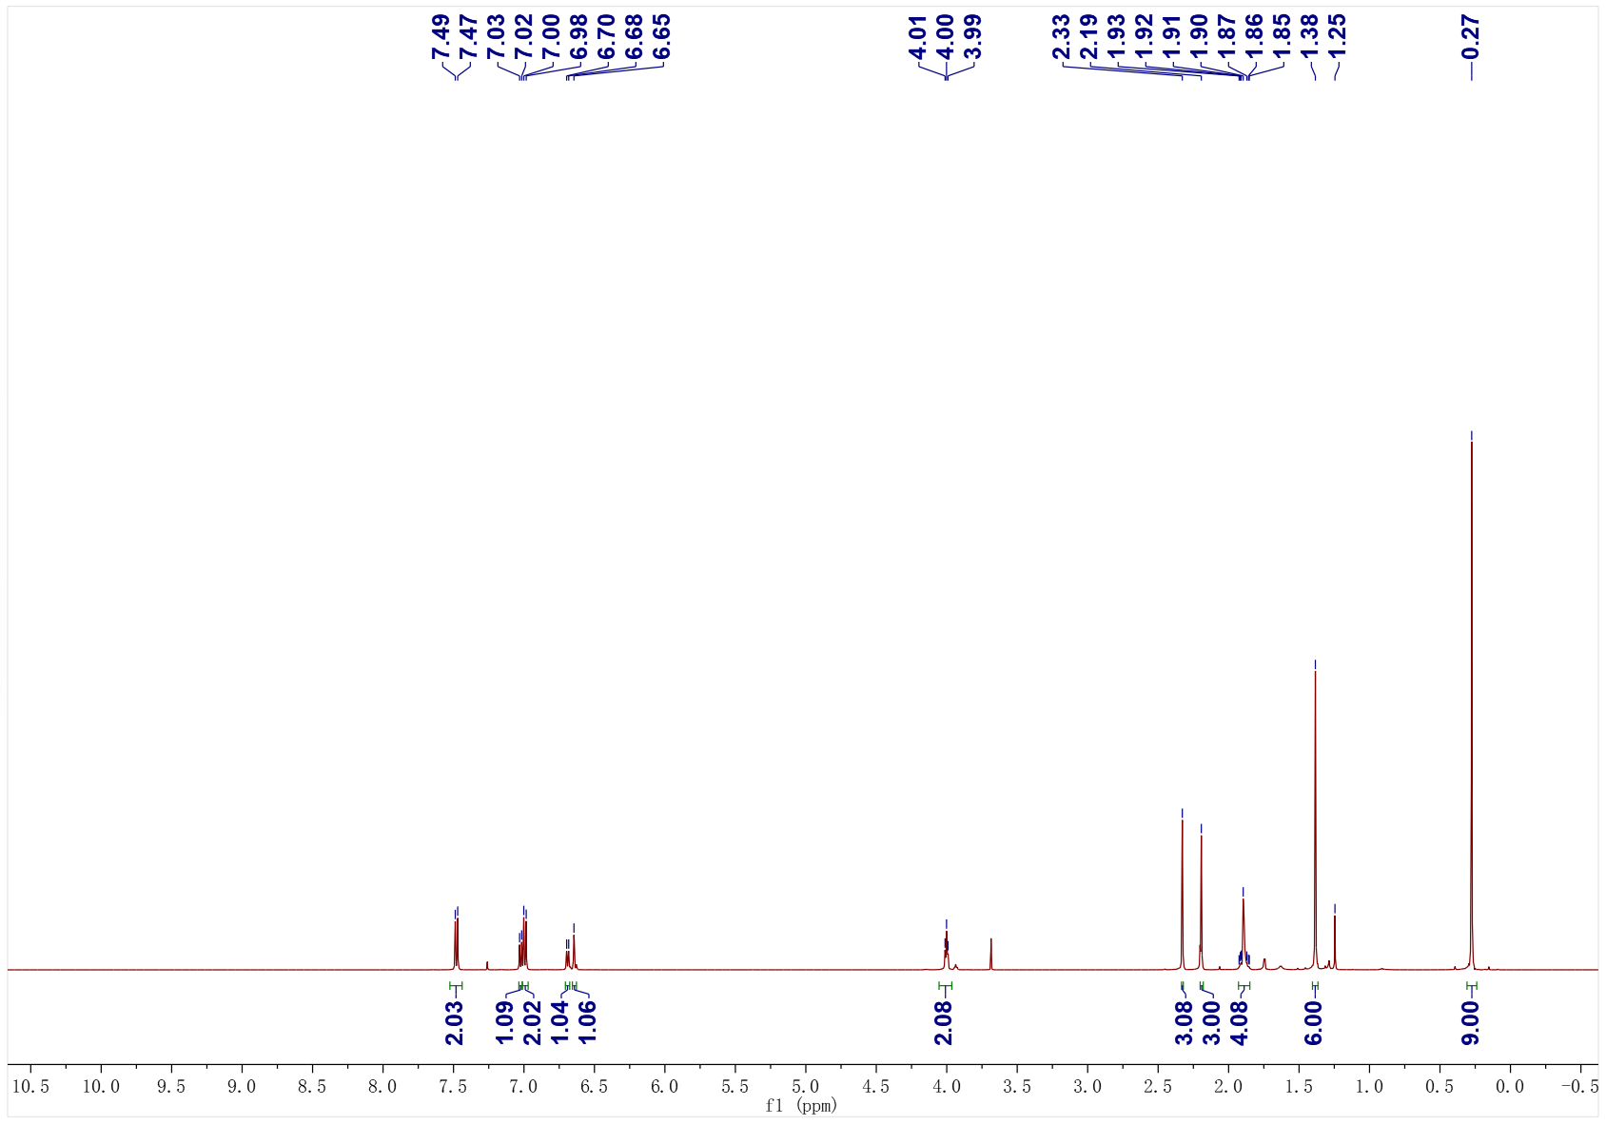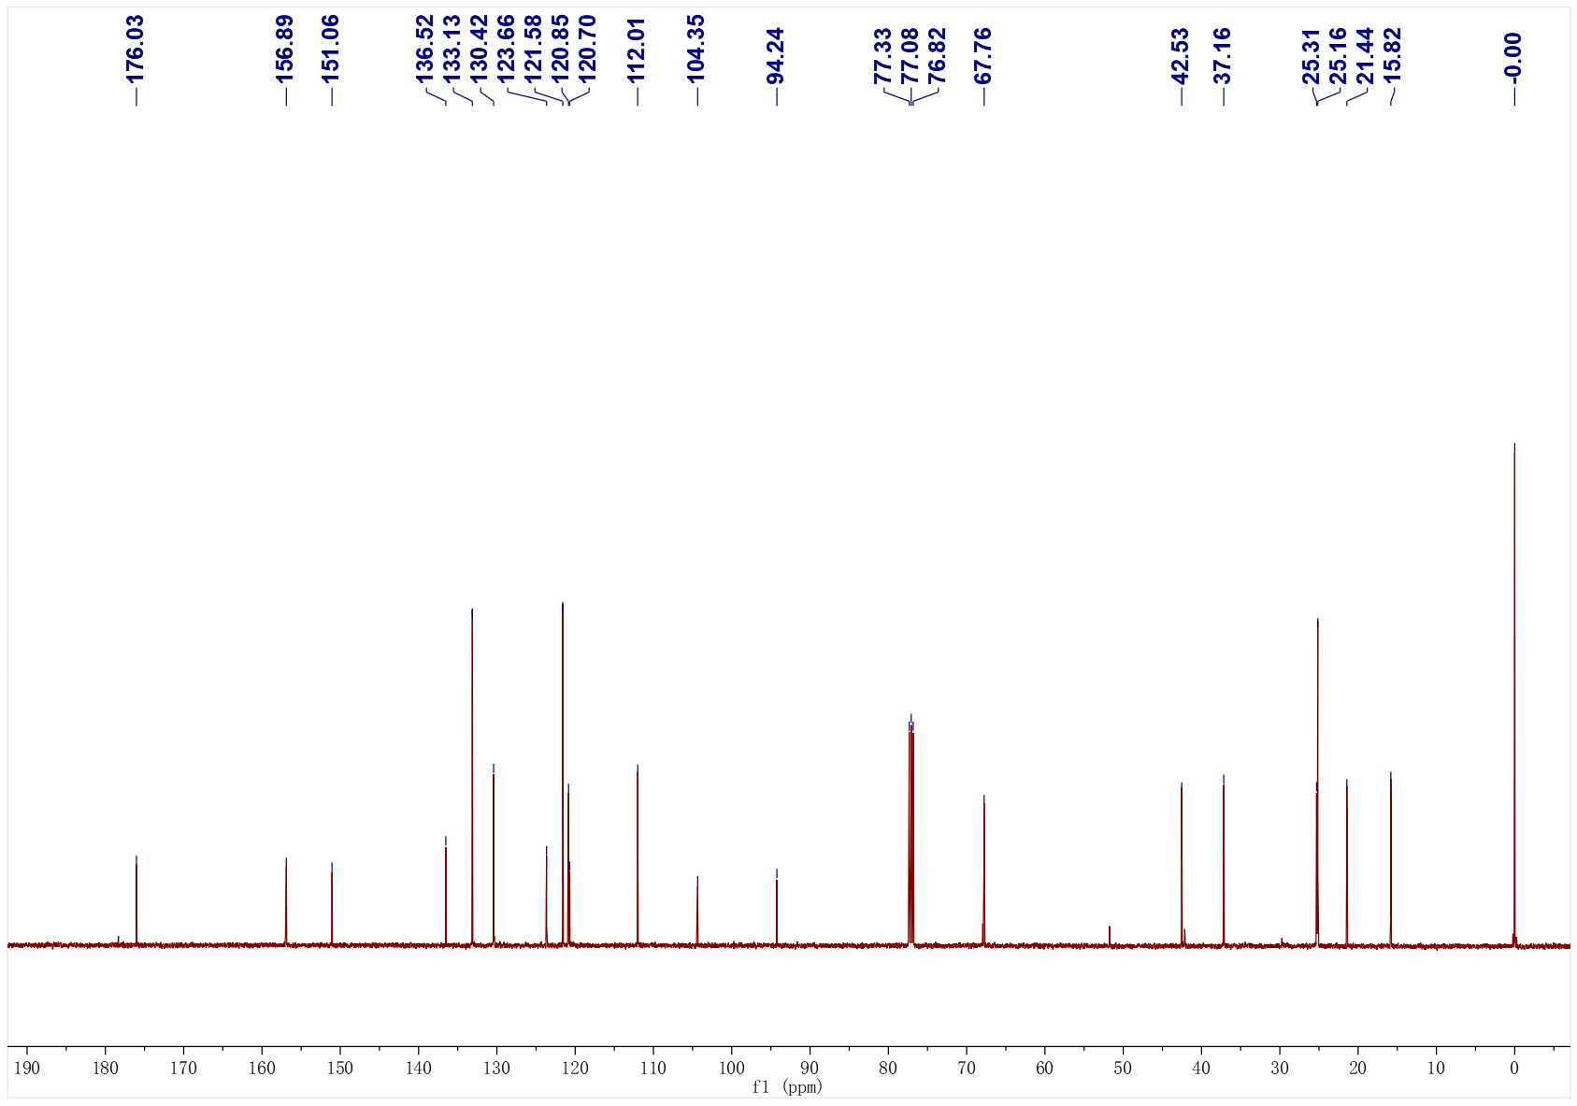
3ap; ¹H NMR (500 MHz, CDCl₃); ¹³C NMR (126 MHz, CDCl₃)
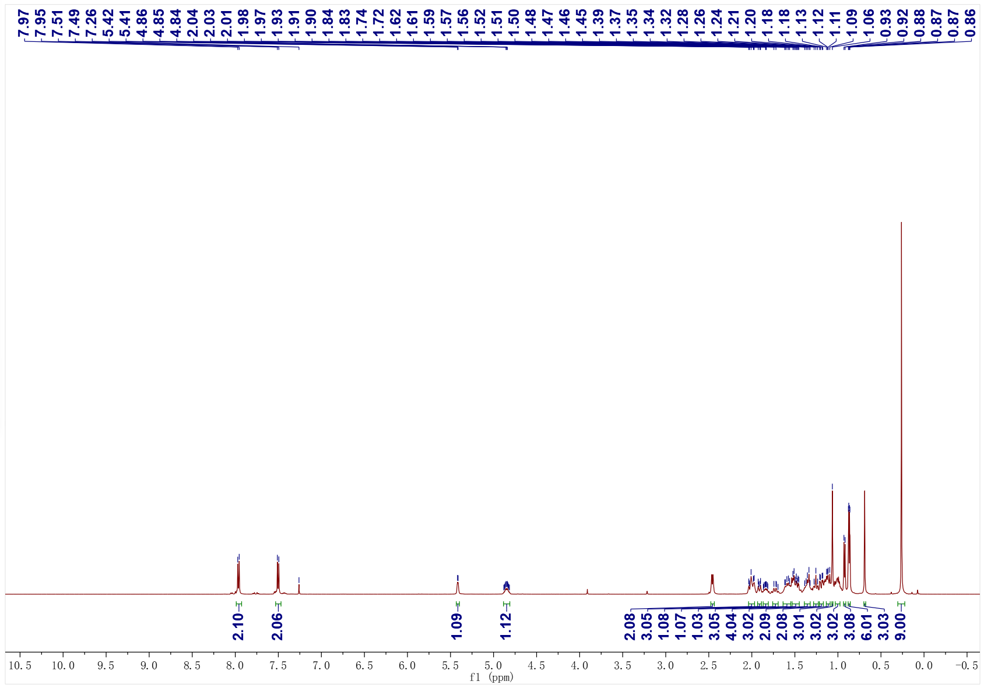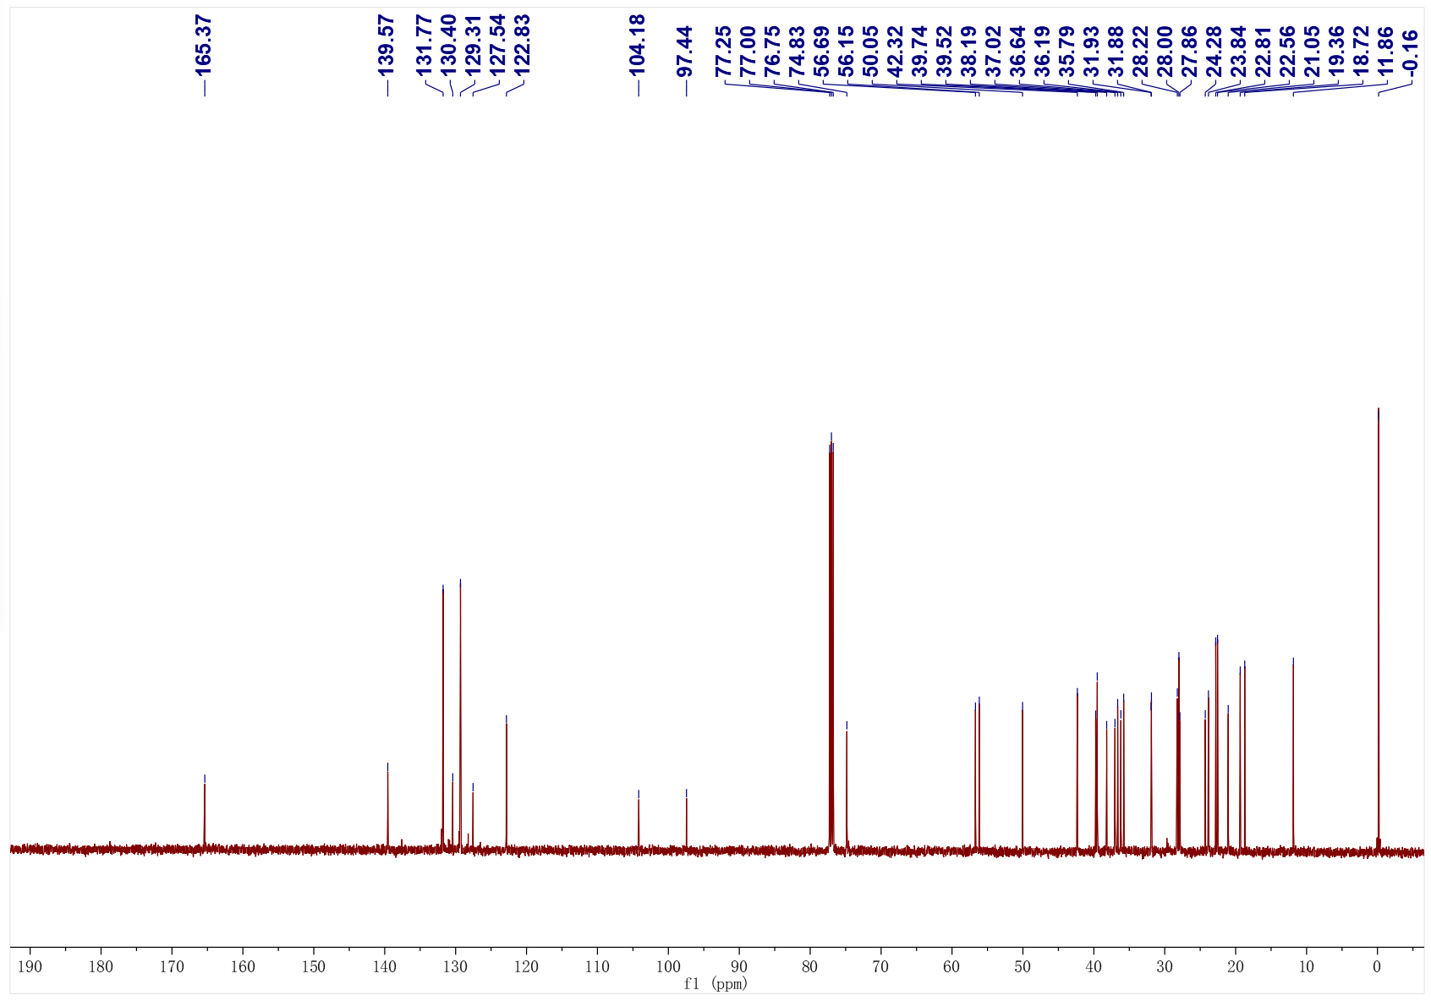
3aq; ¹H NMR (500 MHz, CDCl₃); ¹³C NMR (126 MHz, CDCl₃)
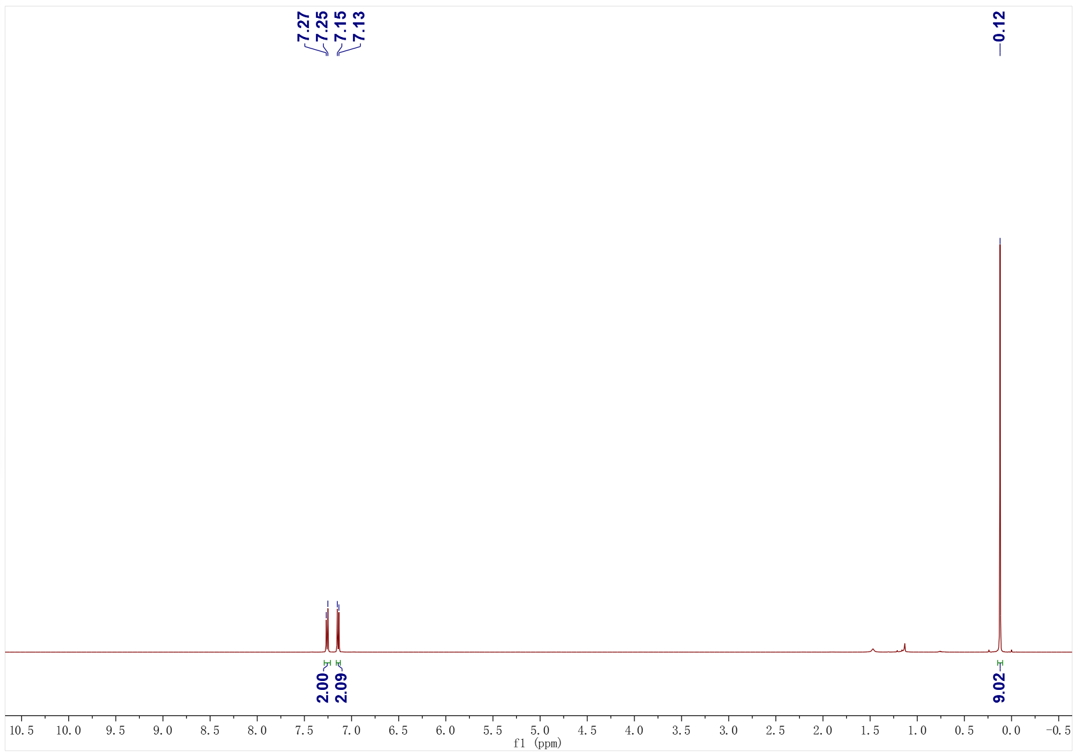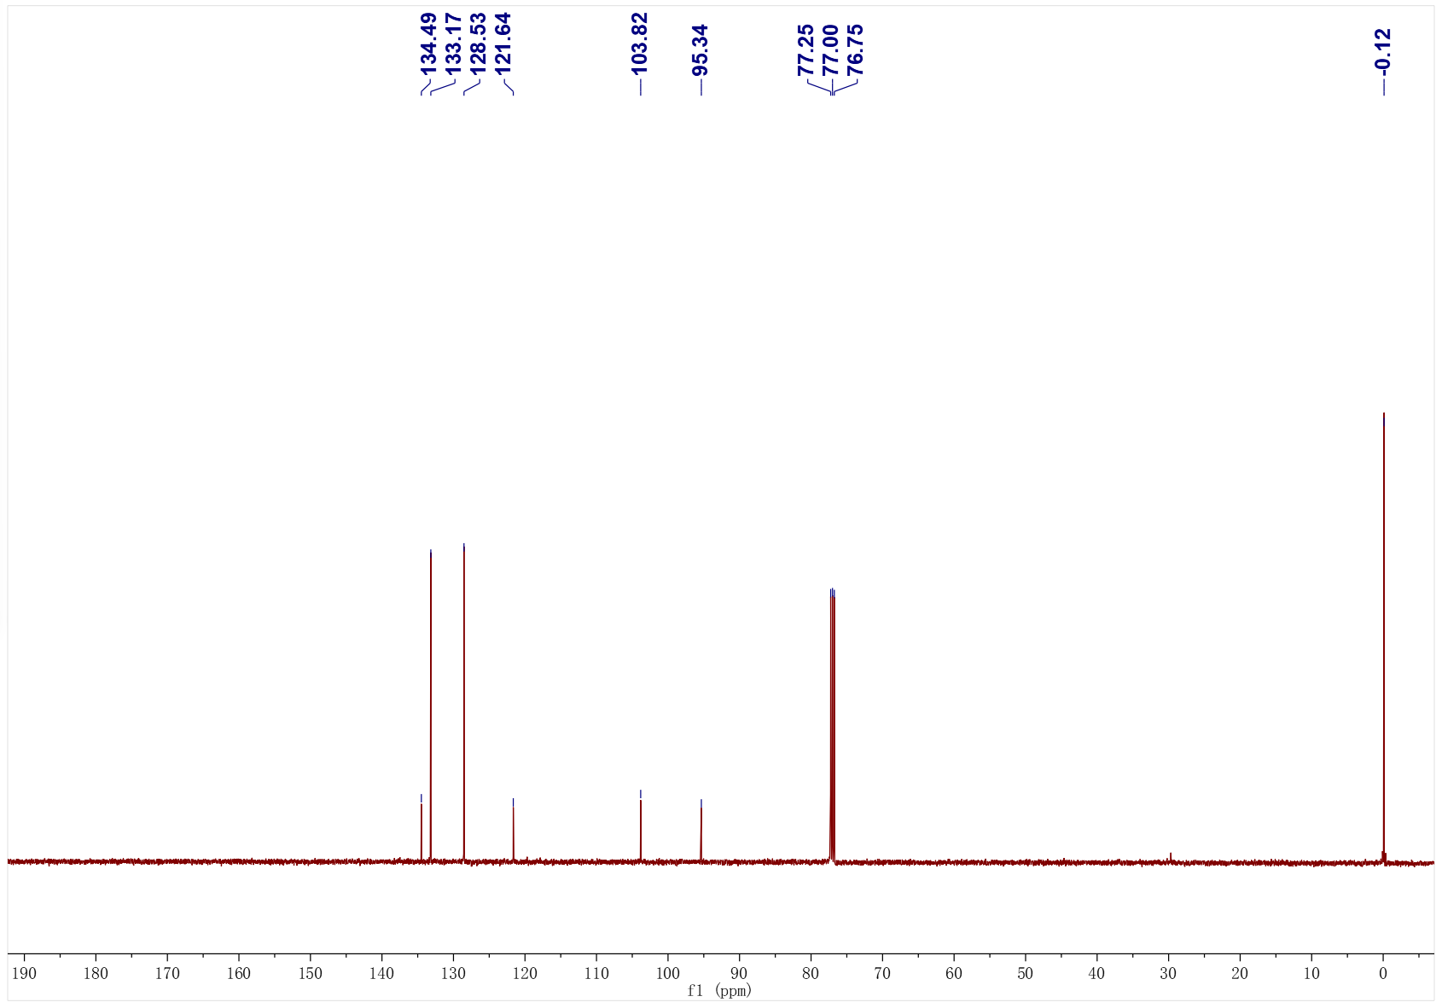
3ar; ¹H NMR (500 MHz, CDCl₃); ¹³C NMR (126 MHz, CDCl₃)
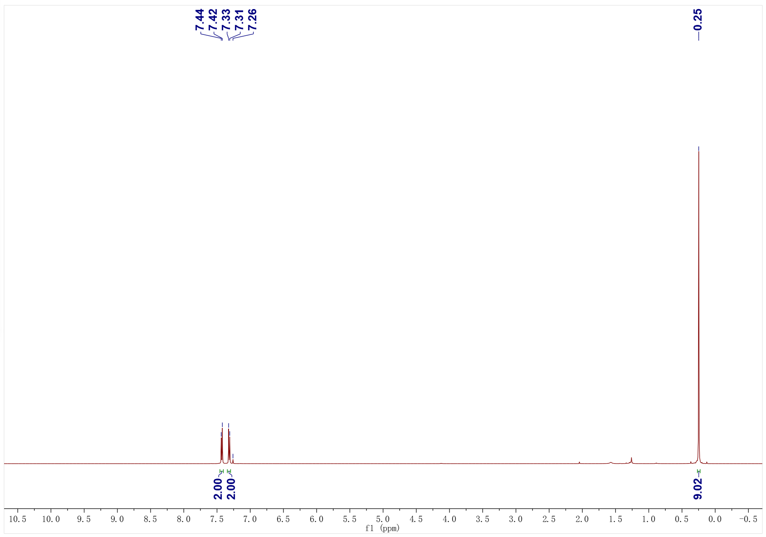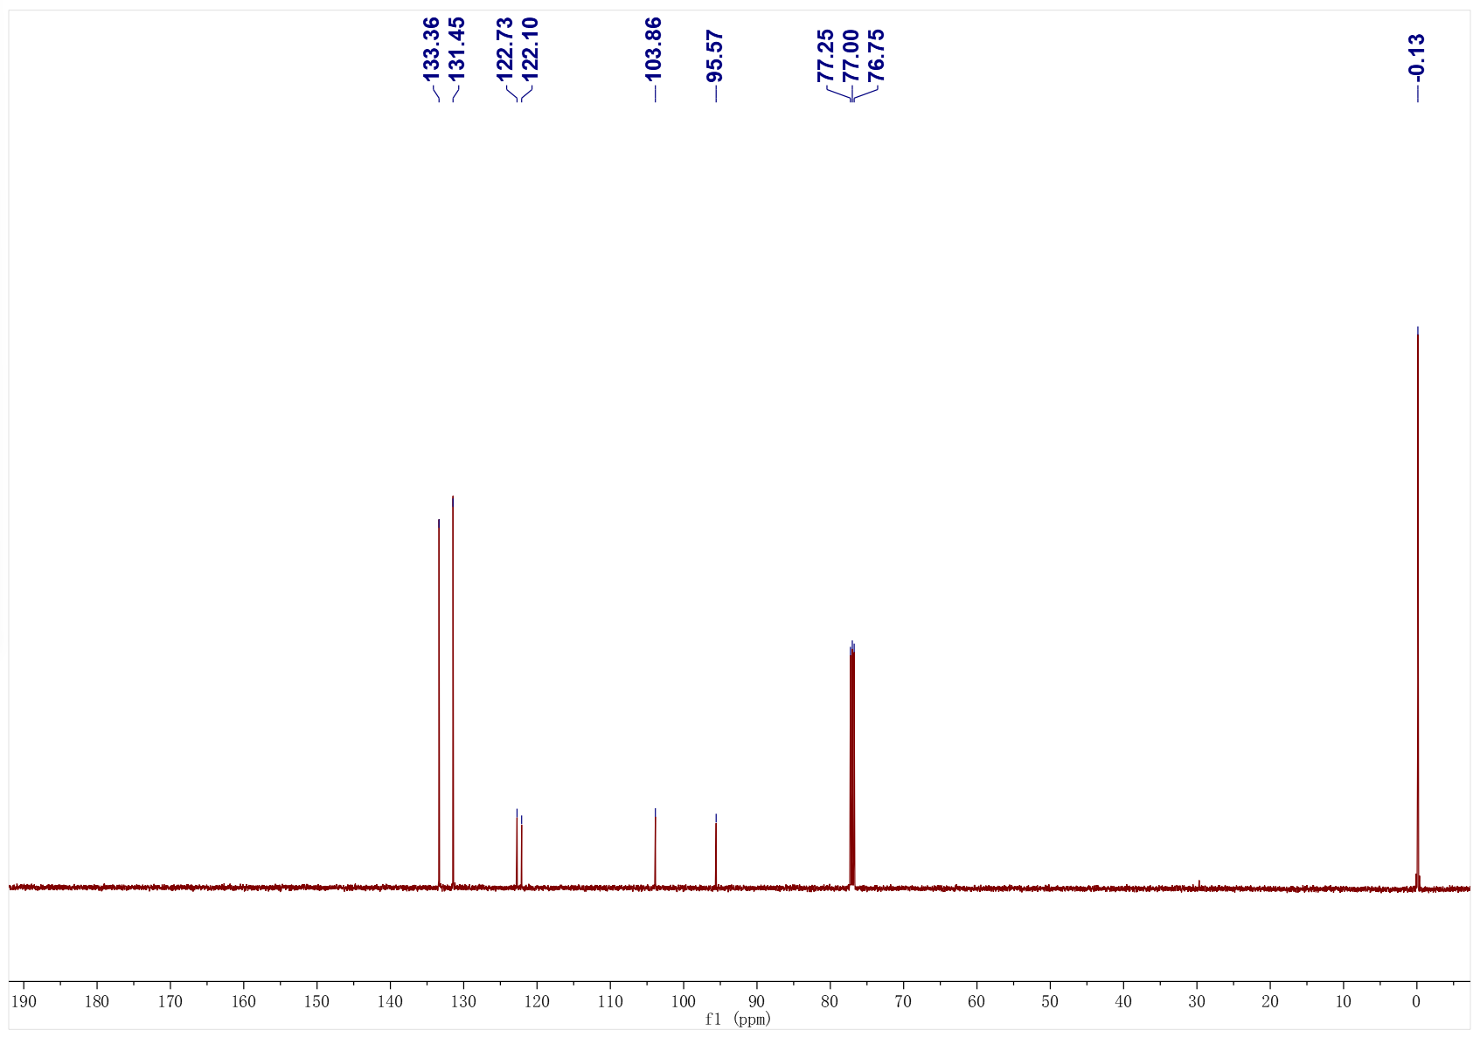
3as; ¹H NMR (500 MHz, CDCl₃); ¹³C NMR (126 MHz, CDCl₃)
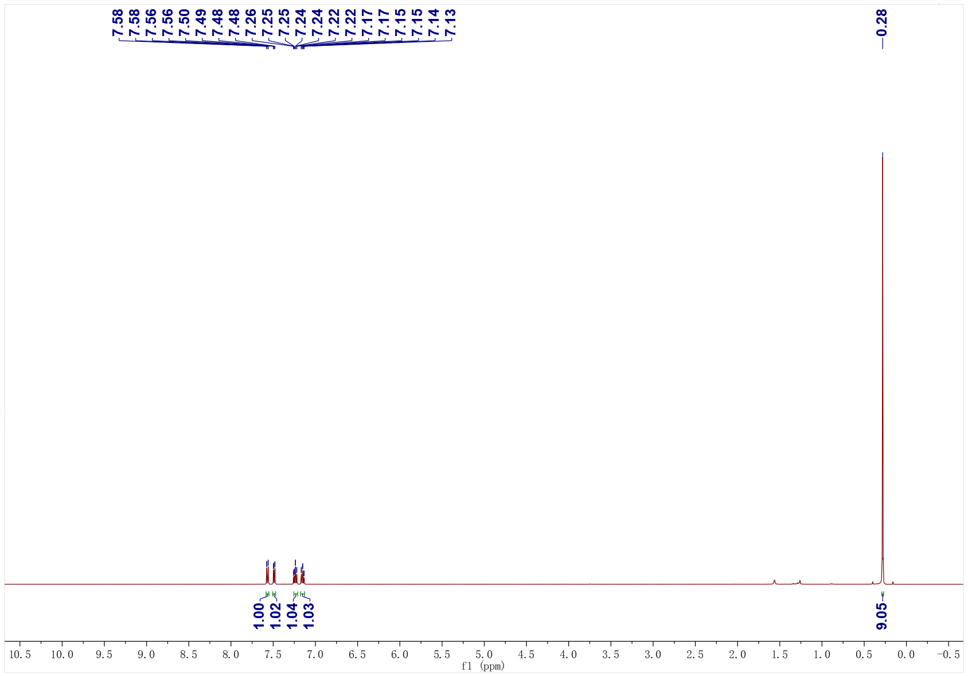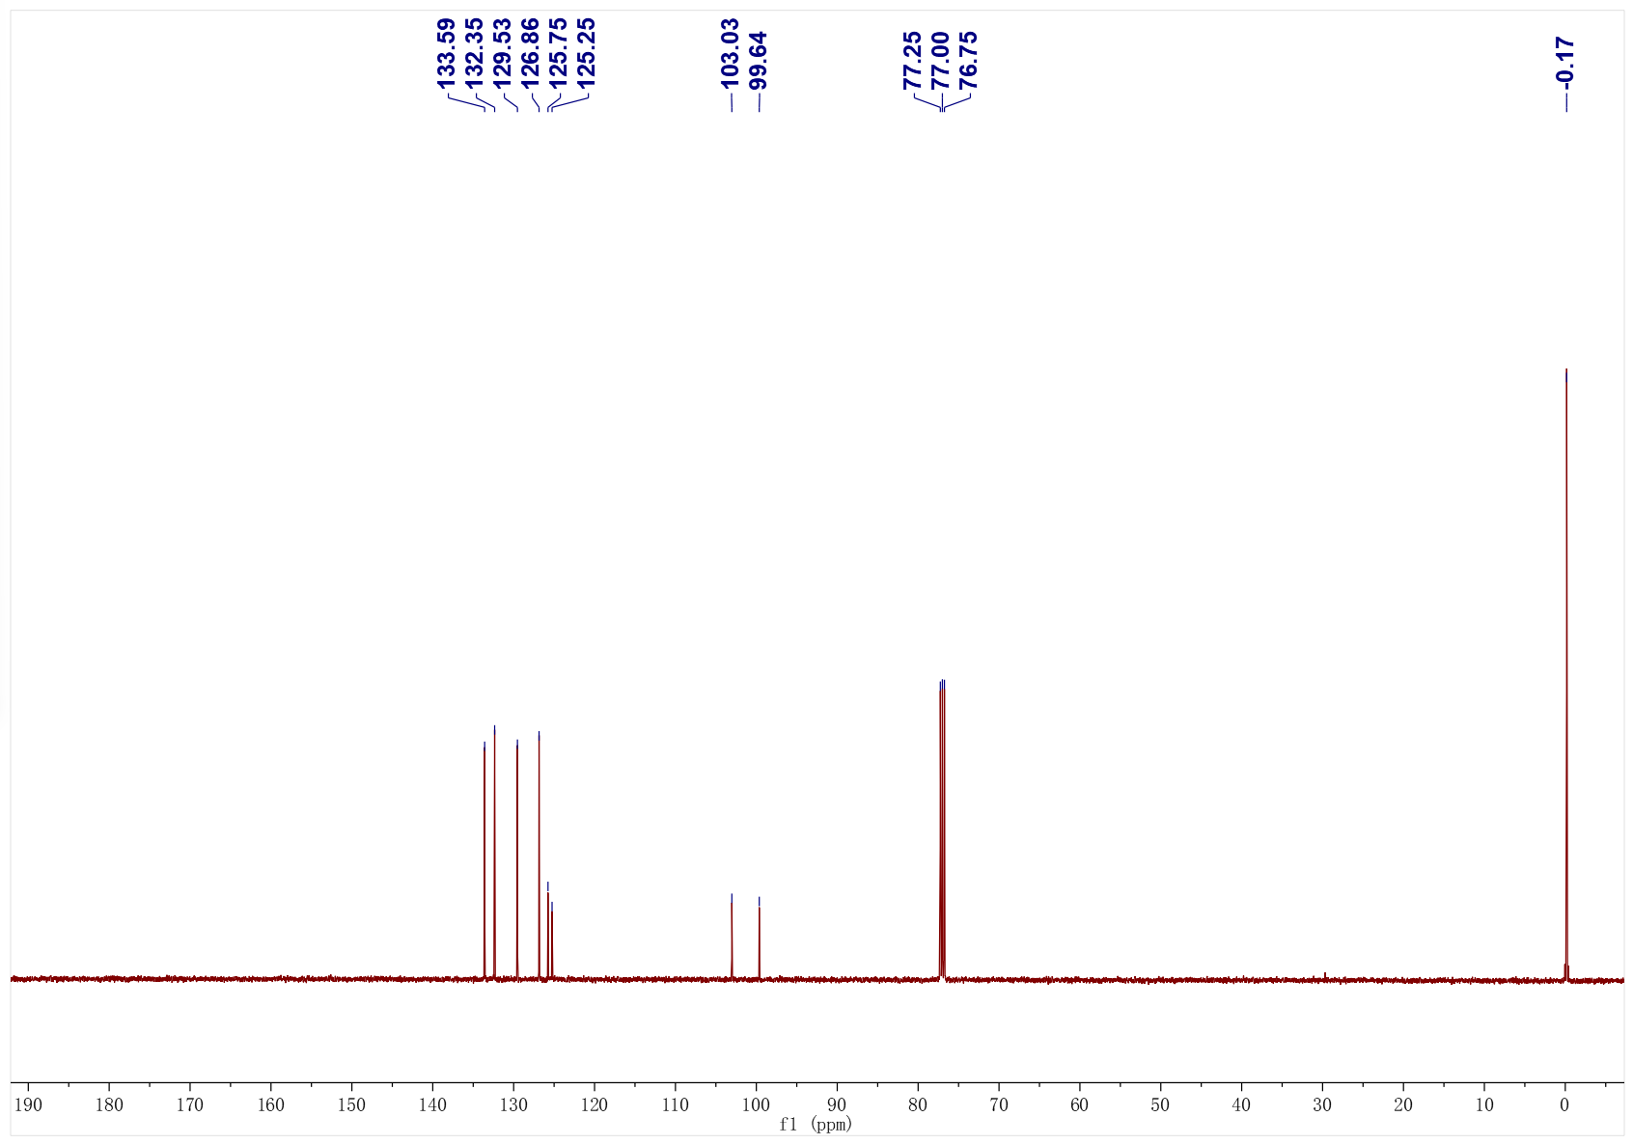
3at; ¹H NMR (500 MHz, CDCl₃); ¹³C NMR (126 MHz, CDCl₃)
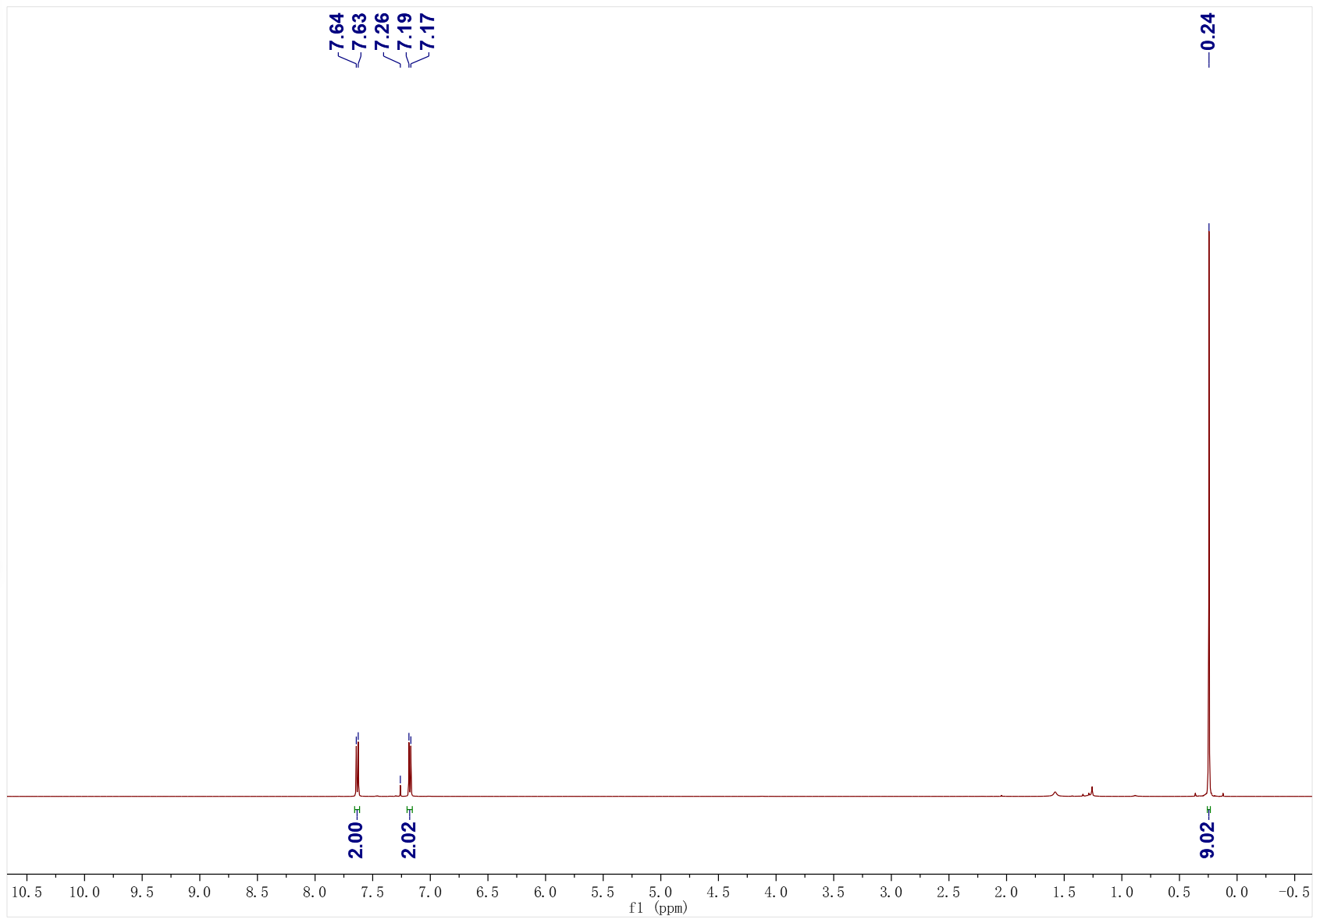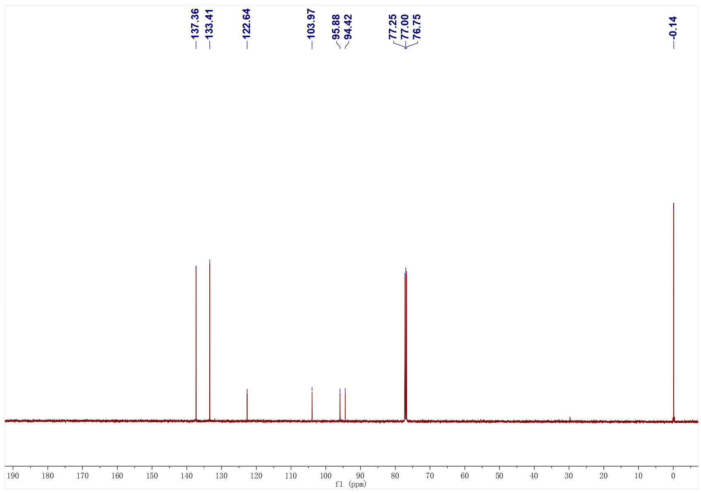
3au; ¹H NMR (400 MHz, CDCl₃); ¹³C NMR (101 MHz, CDCl₃)
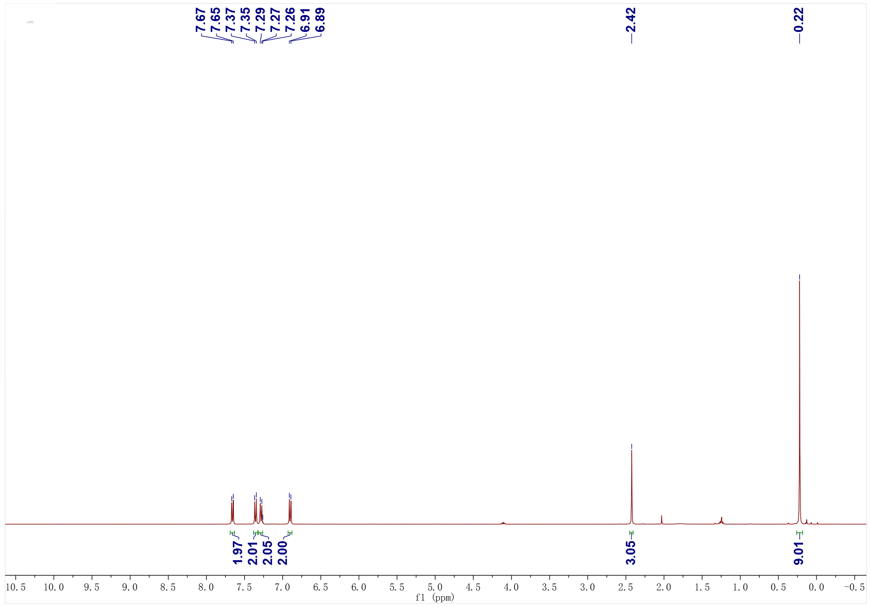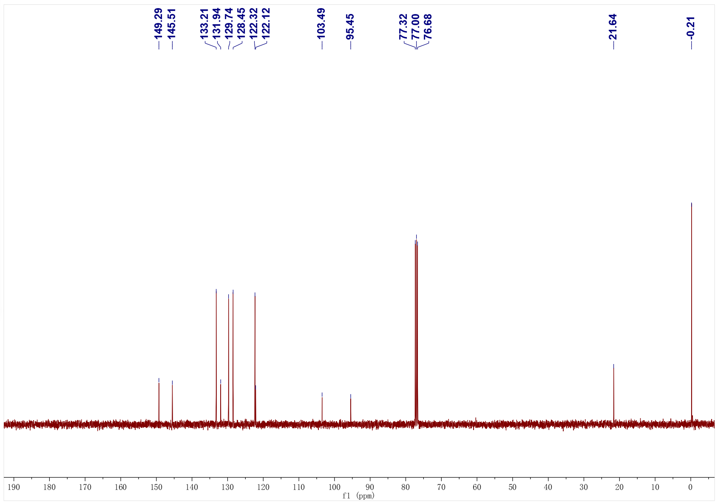
3av; ¹H NMR (400 MHz, CDCl₃); ¹³C NMR (101 MHz, CDCl₃)
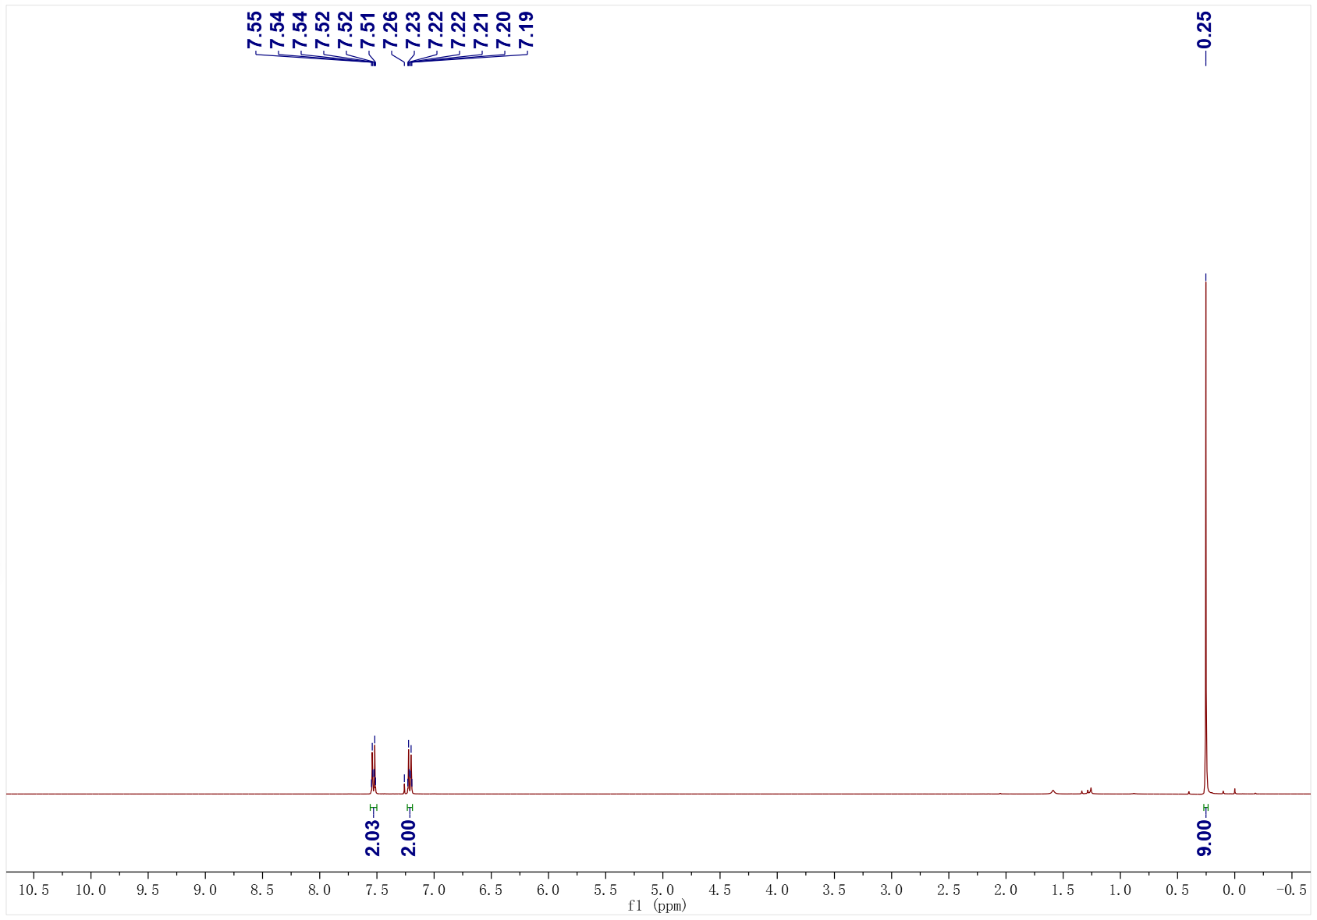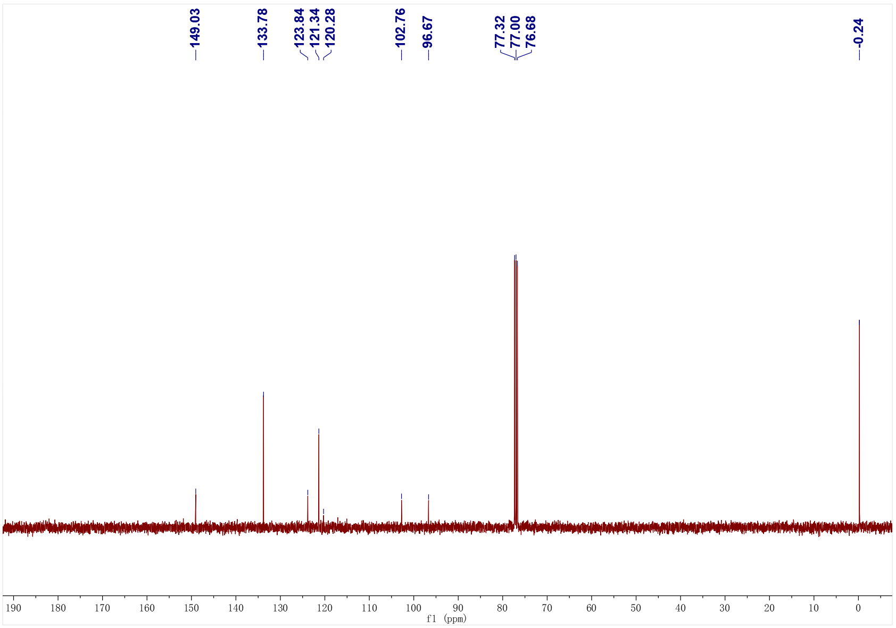
3aw; ¹H NMR (500 MHz, CDCl₃); ¹³C NMR (126 MHz, CDCl₃)
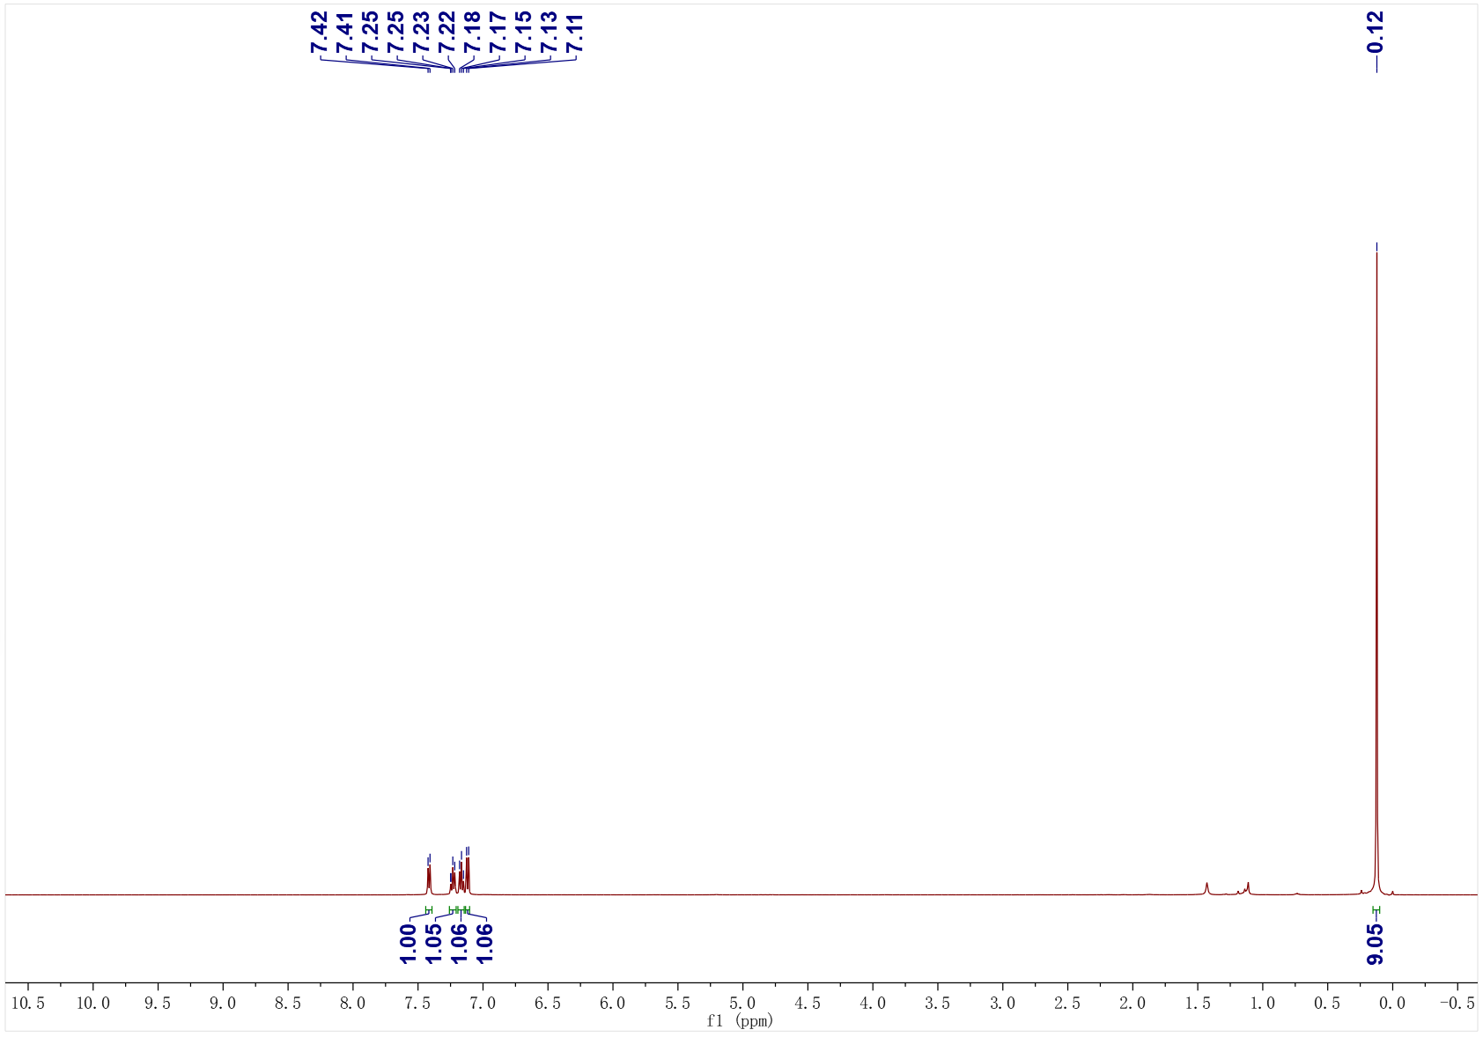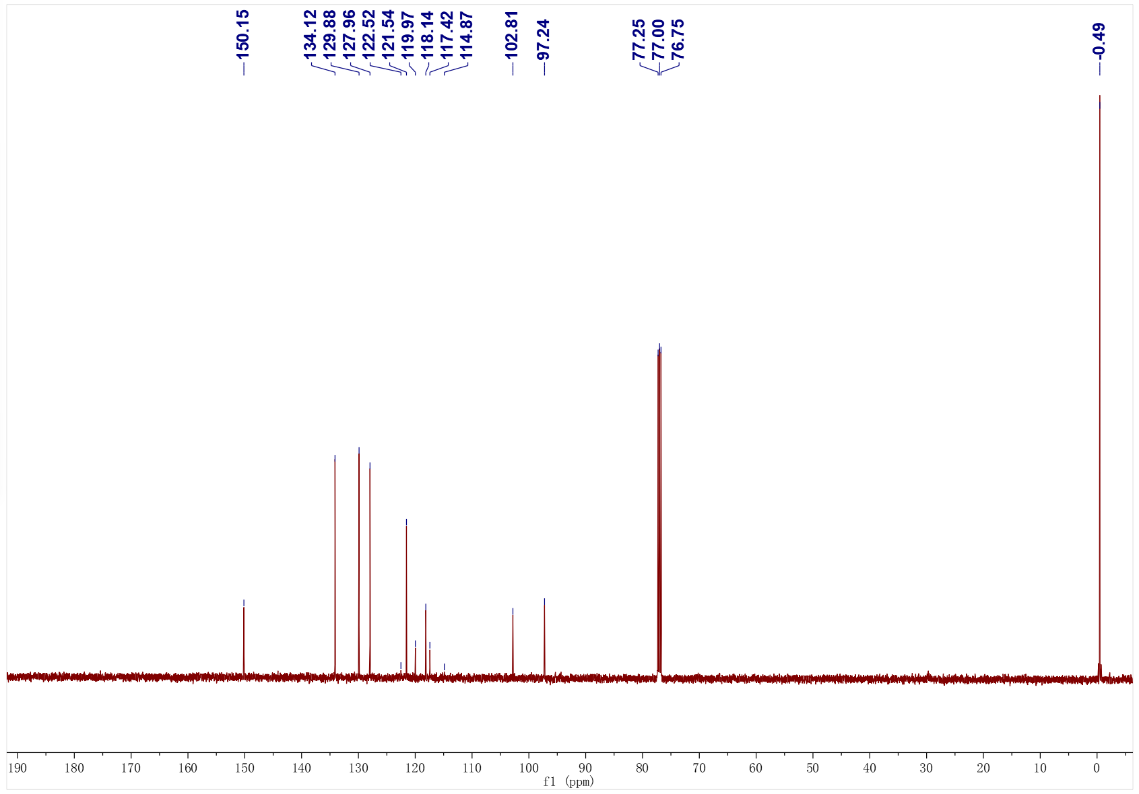
3aw; ¹⁹F NMR (471 MHz, CDCl₃)
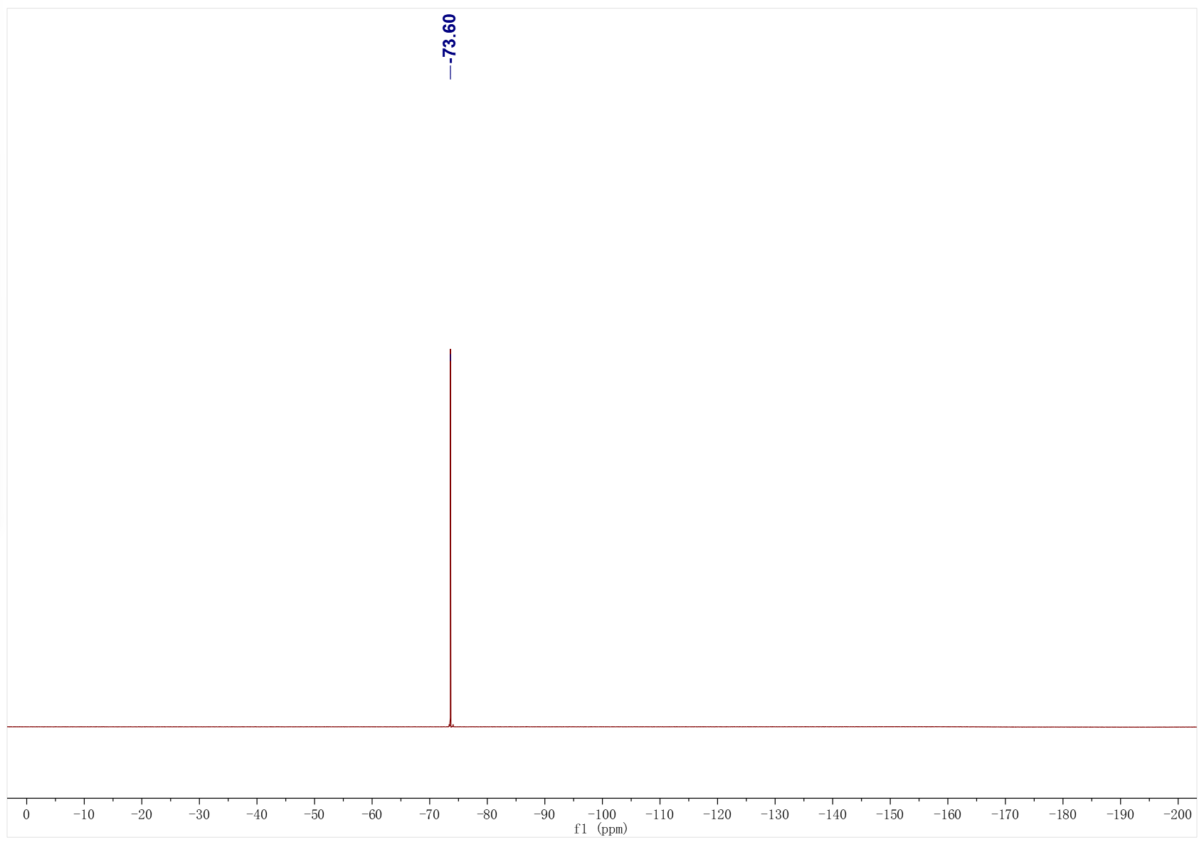
3ax; ¹H NMR (500 MHz, CDCl₃); ¹³C NMR (126 MHz, CDCl₃)
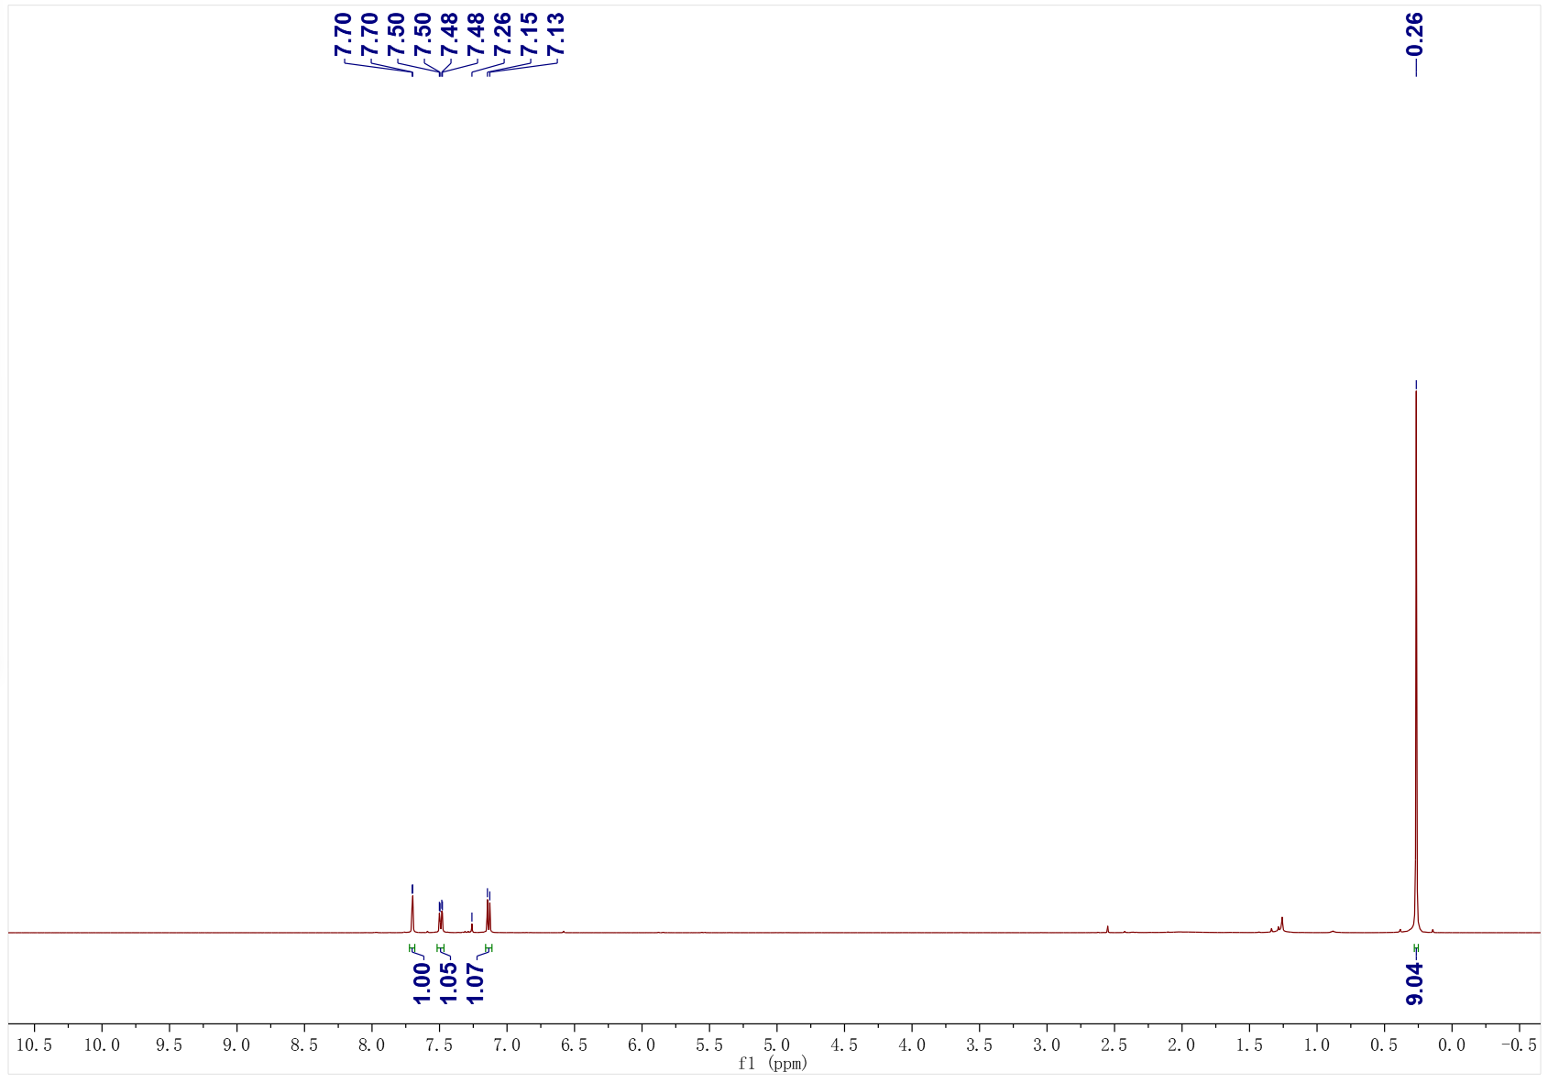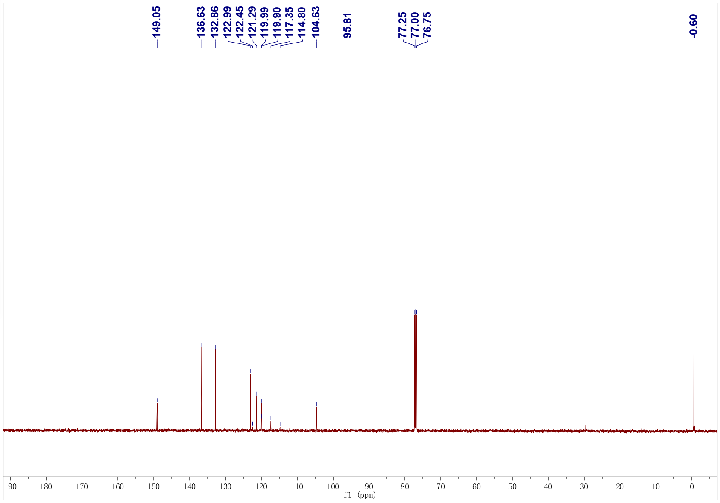
3ax; ¹⁹F NMR (471 MHz, CDCl₃)
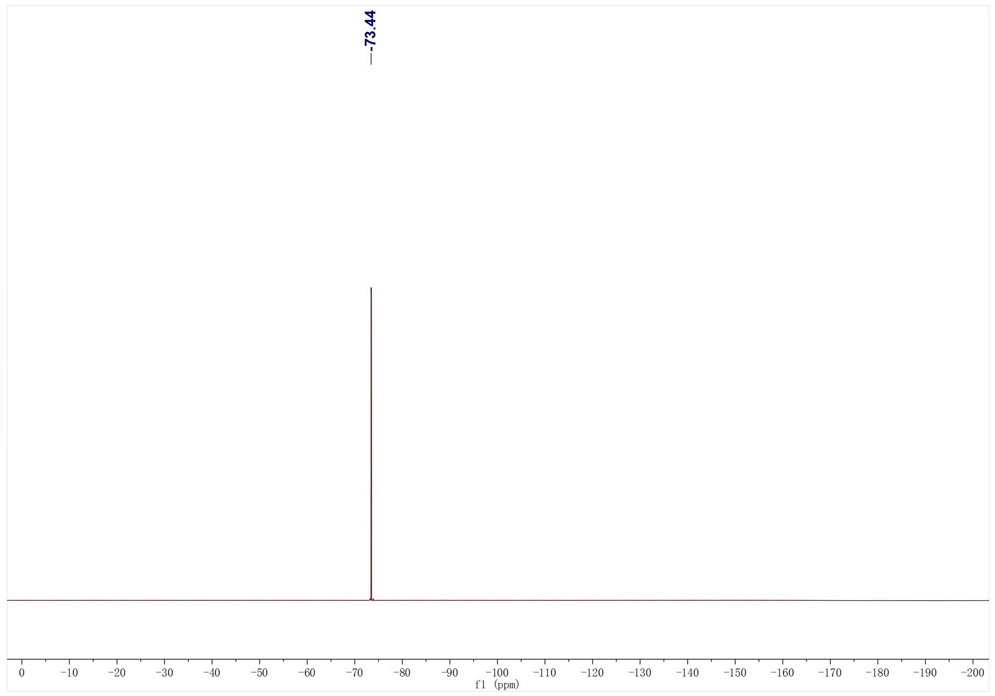
3ay; ¹H NMR (500 MHz, CDCl₃); ¹³C NMR (126 MHz, CDCl₃)
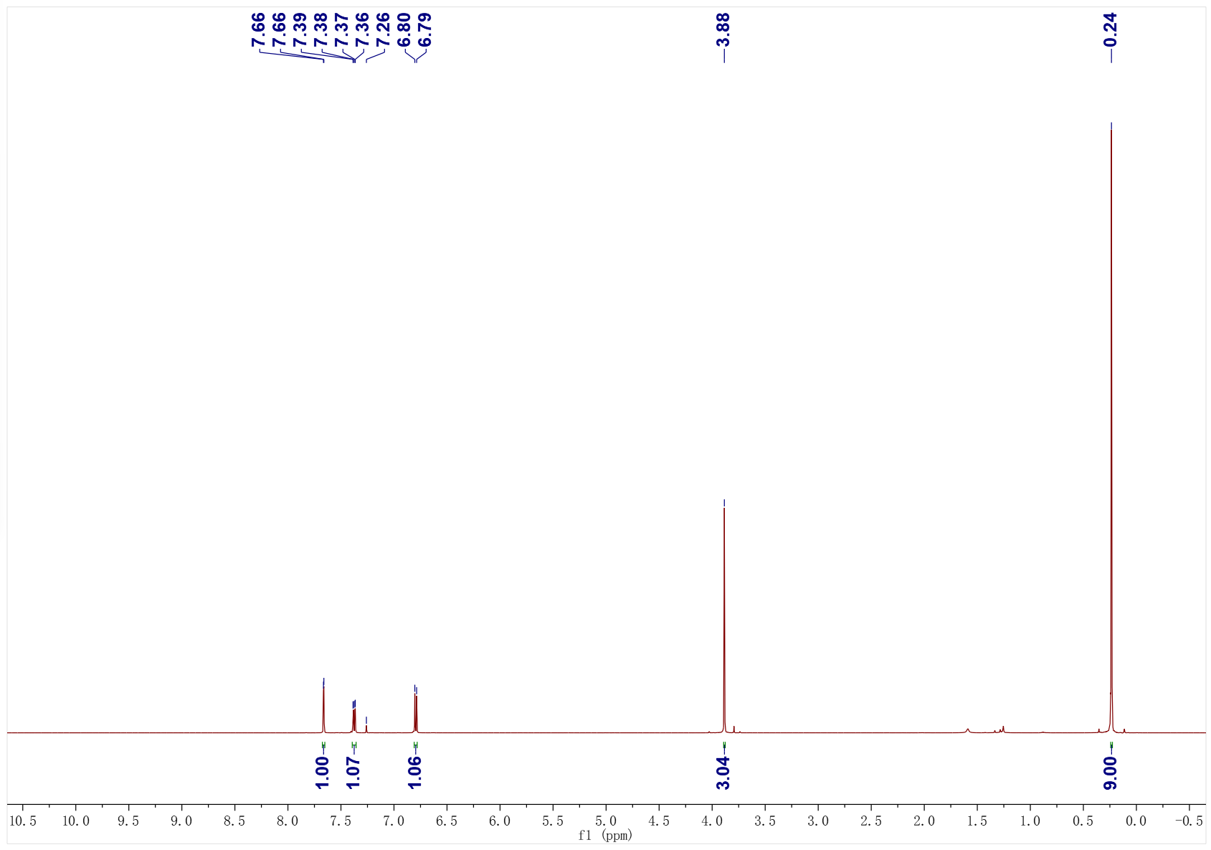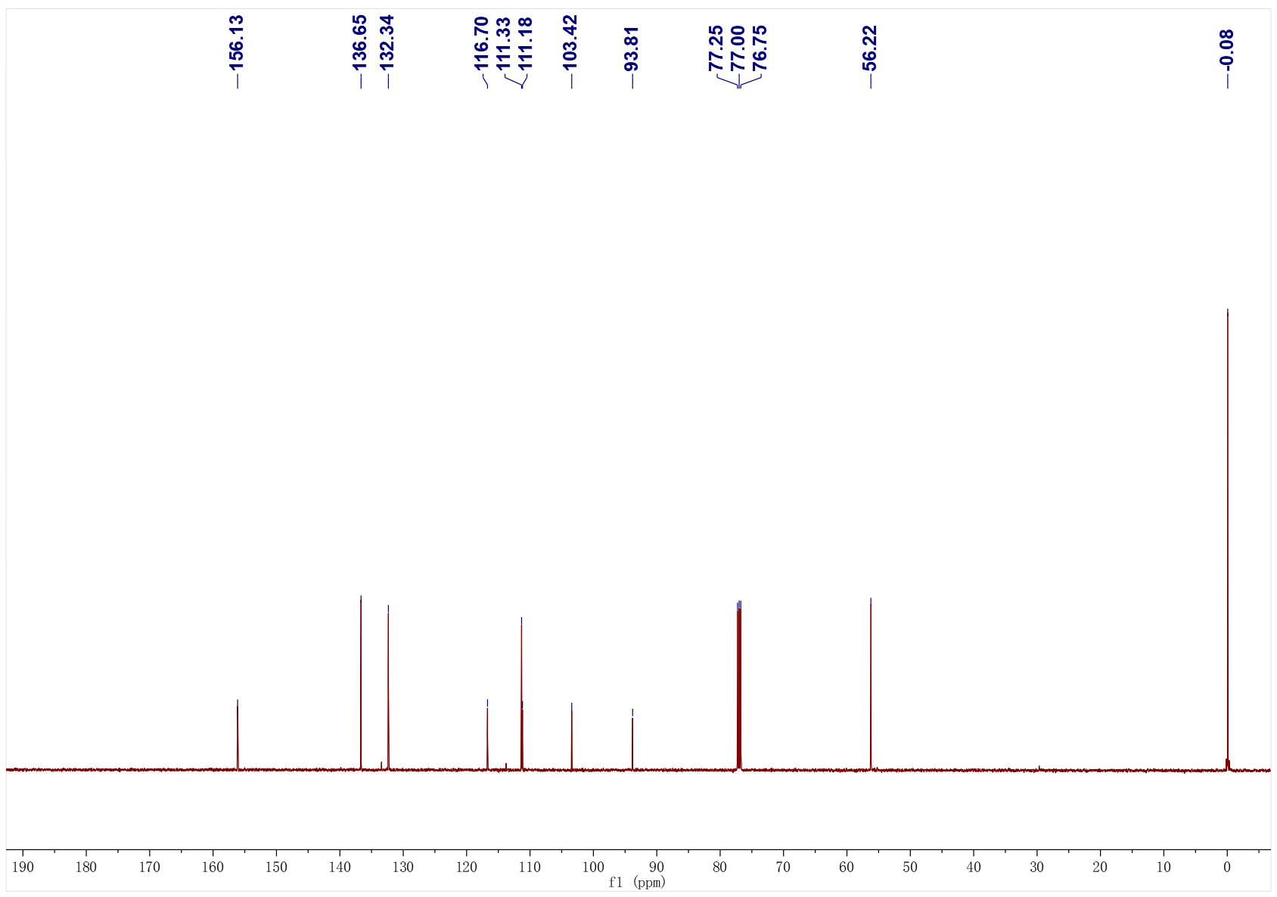
3az; ¹H NMR (500 MHz, CDCl₃); ¹³C NMR (126 MHz, CDCl₃)
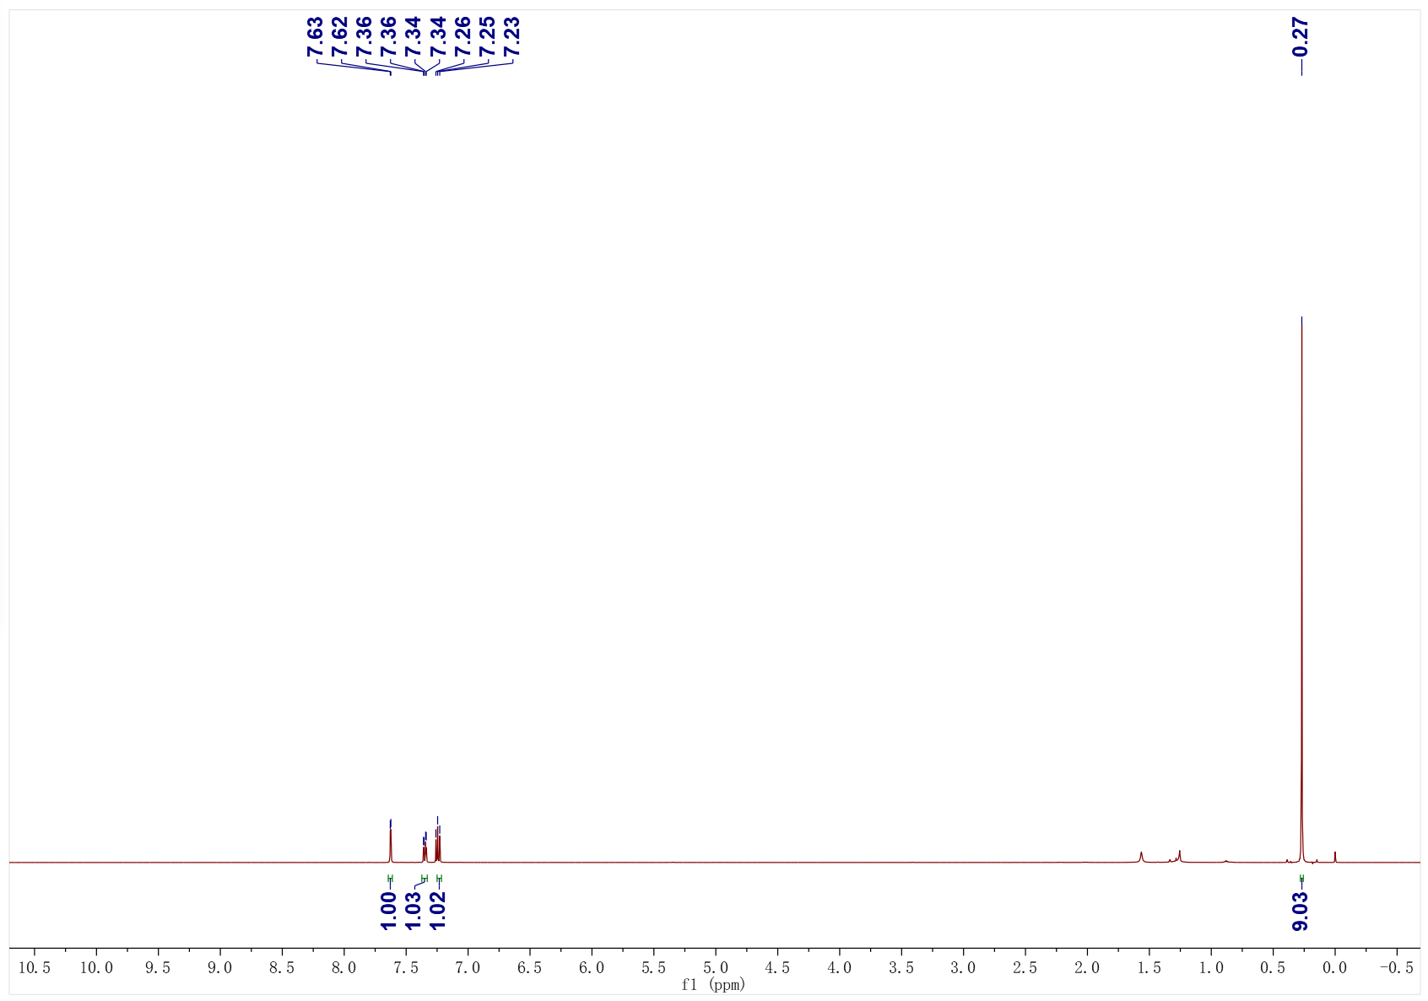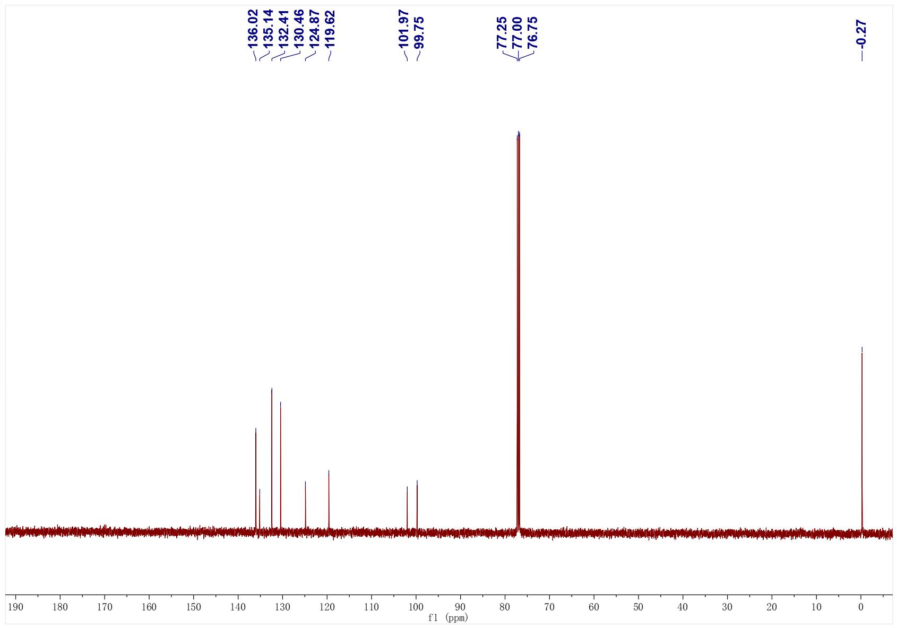
3ba; ¹H NMR (500 MHz, CDCl₃); ¹³C NMR (126 MHz, CDCl₃)
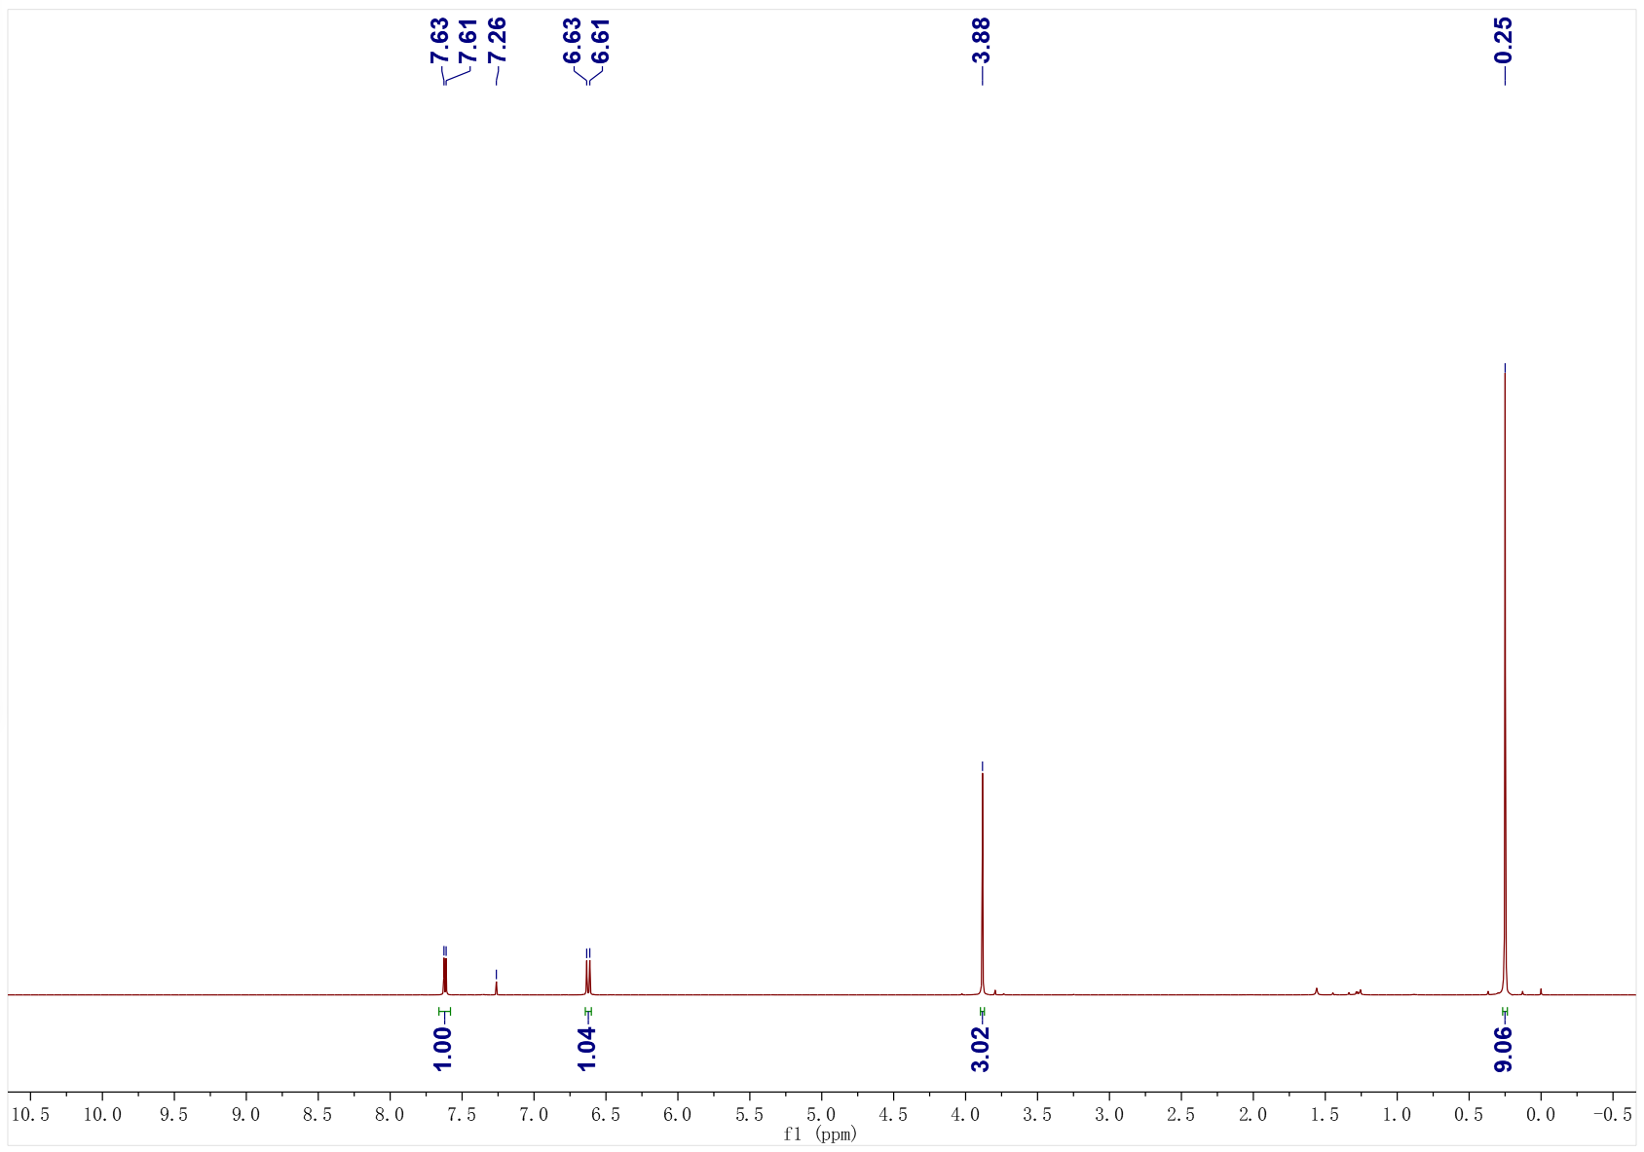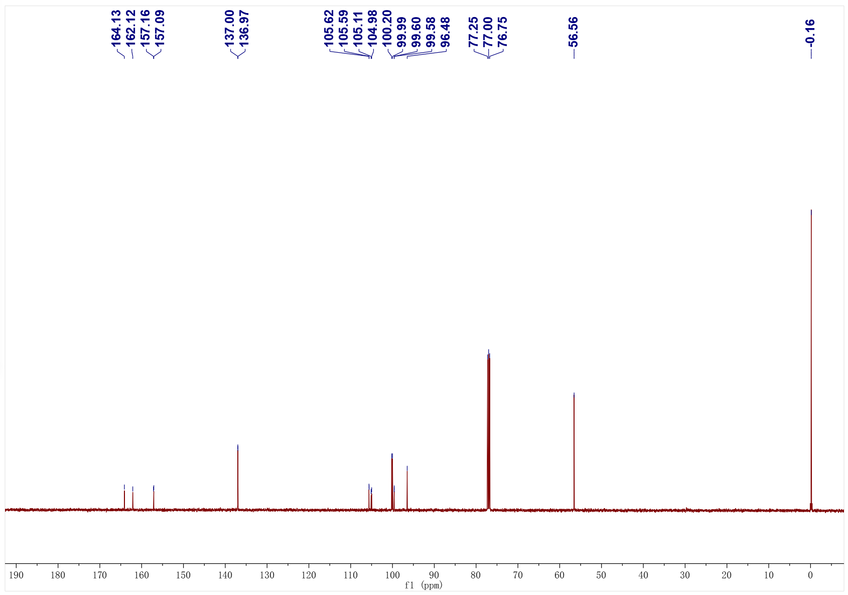
3ba; ¹⁹F NMR (471 MHz, CDCl₃)
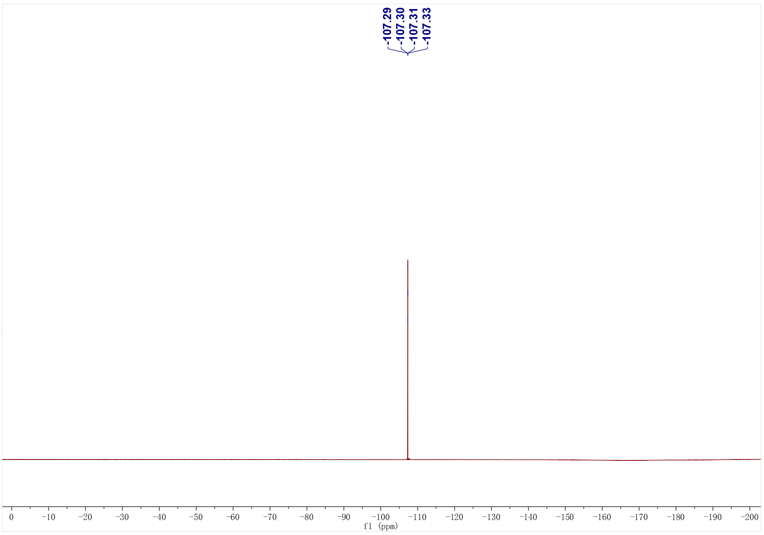
3bb; ¹H NMR (400 MHz, CDCl₃); ¹³C NMR (126 MHz, CDCl₃)
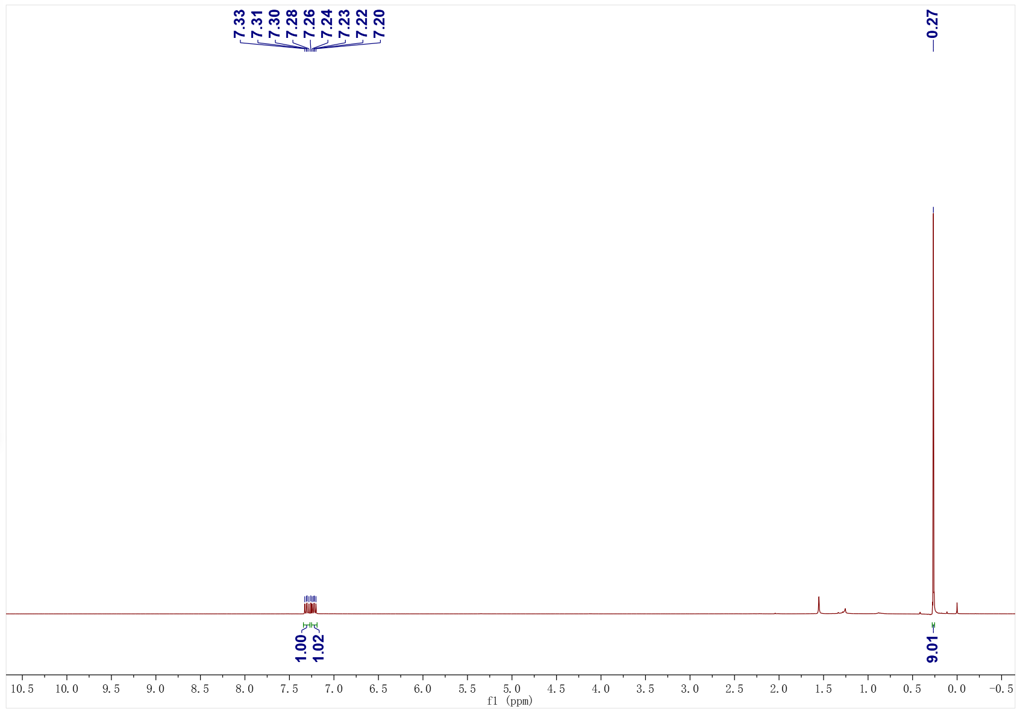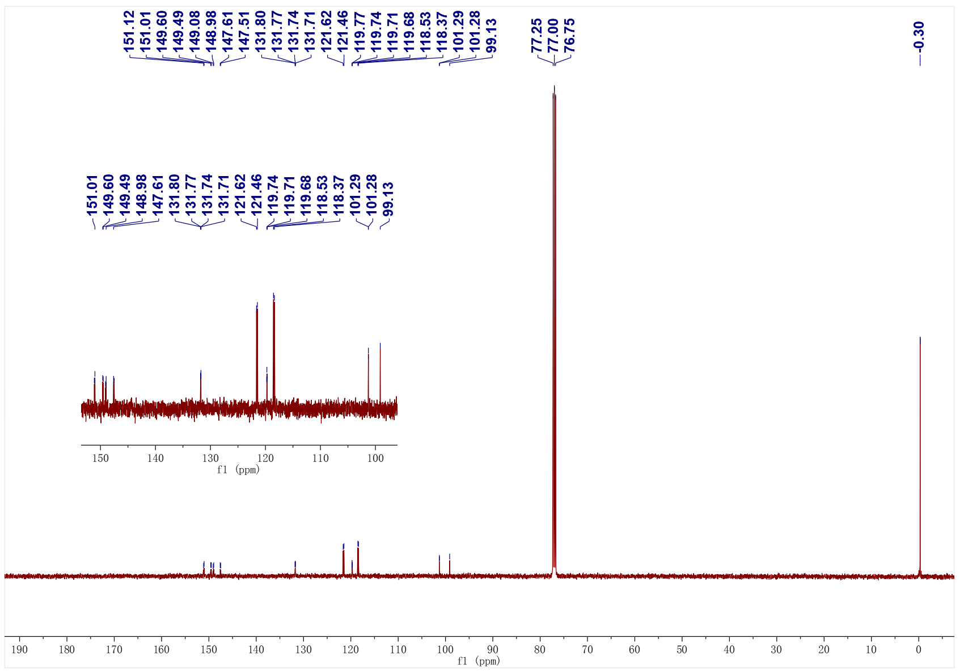
3bb; ¹⁹F NMR (376 MHz, CDCl₃)
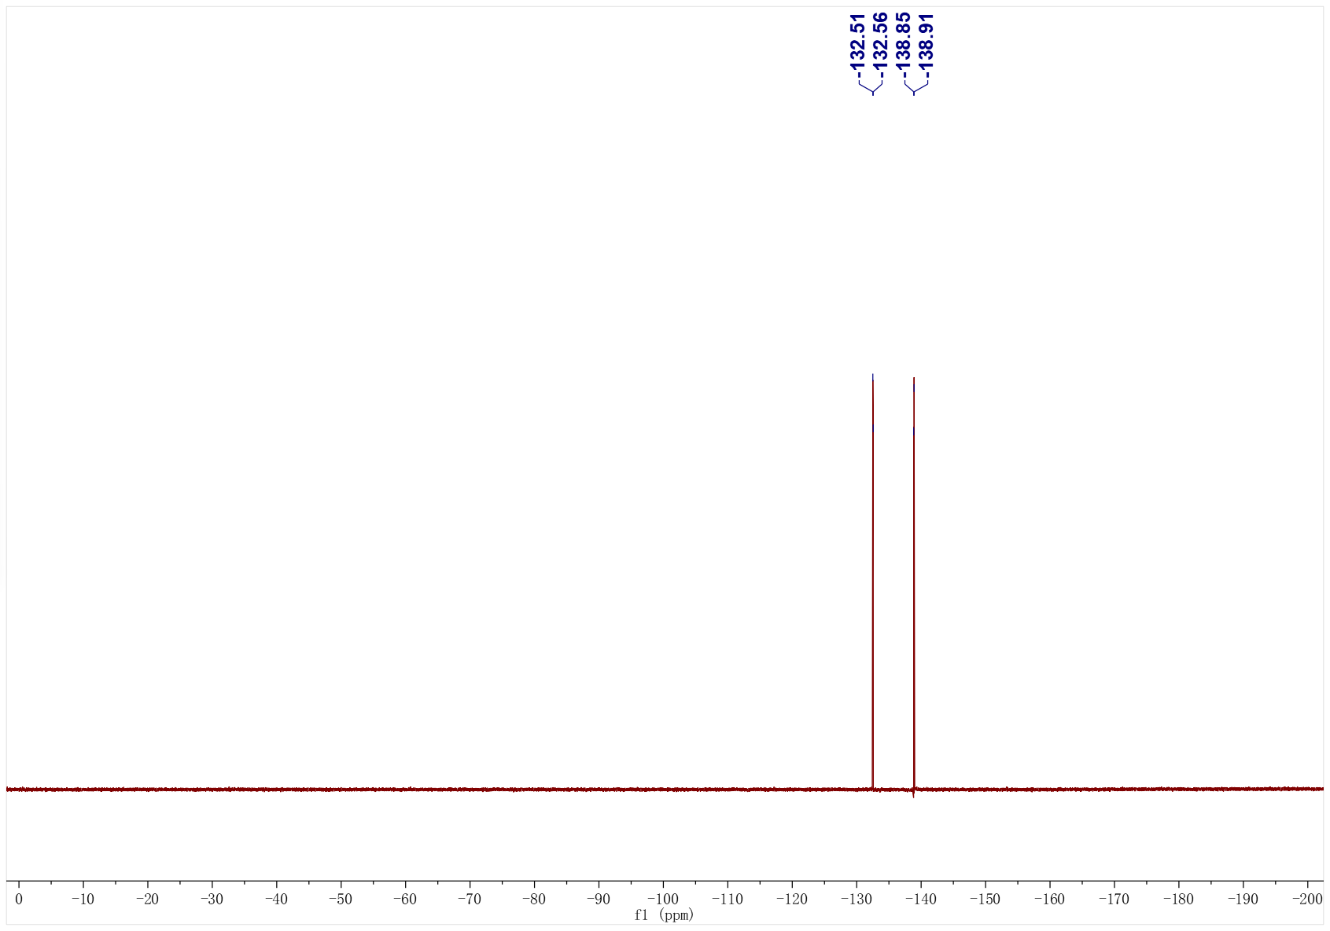

3bc; ¹H NMR (500 MHz, CDCl₃); ¹³C NMR (126 MHz, CDCl₃)
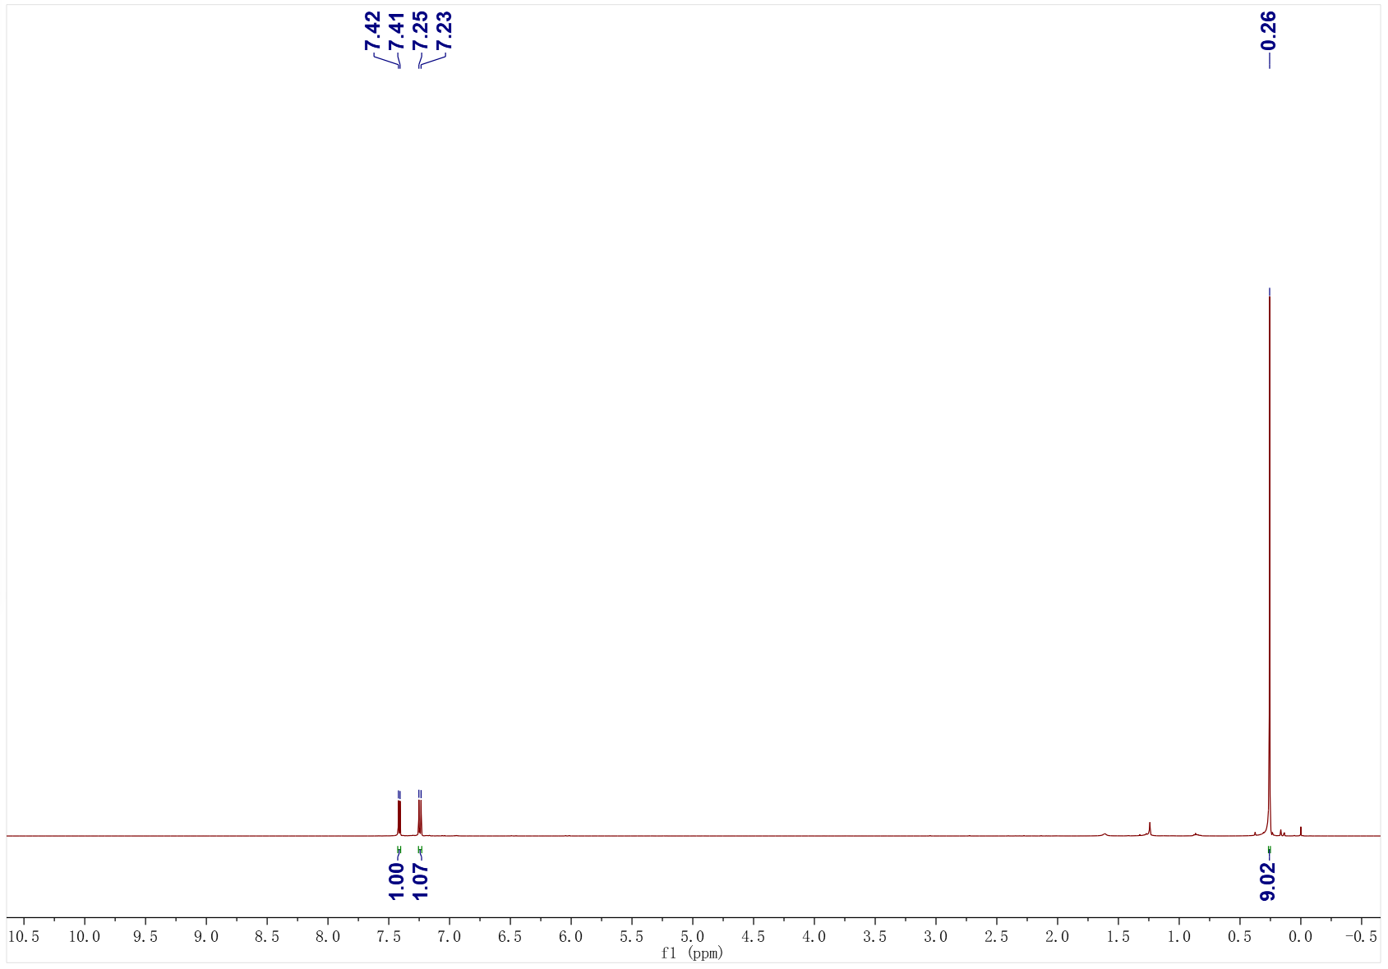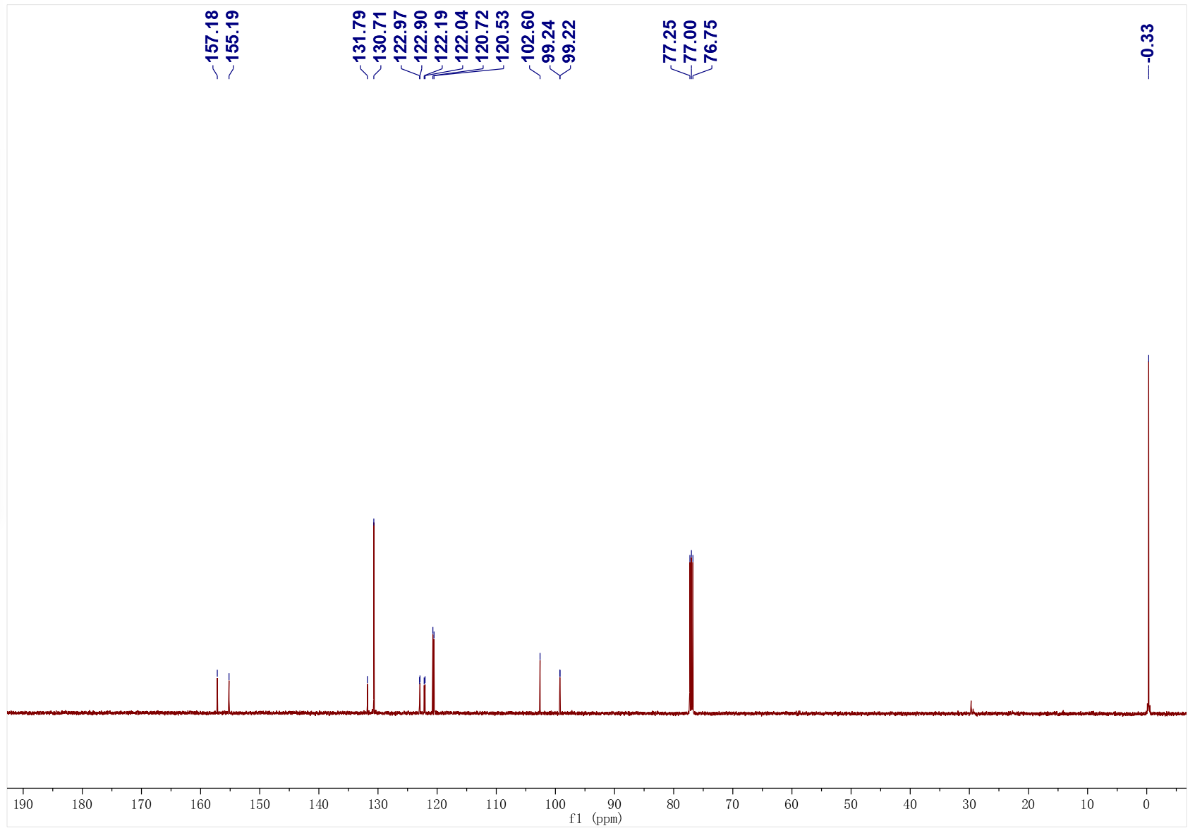

3bc; ¹⁹F NMR (471 MHz, CDCl₃)
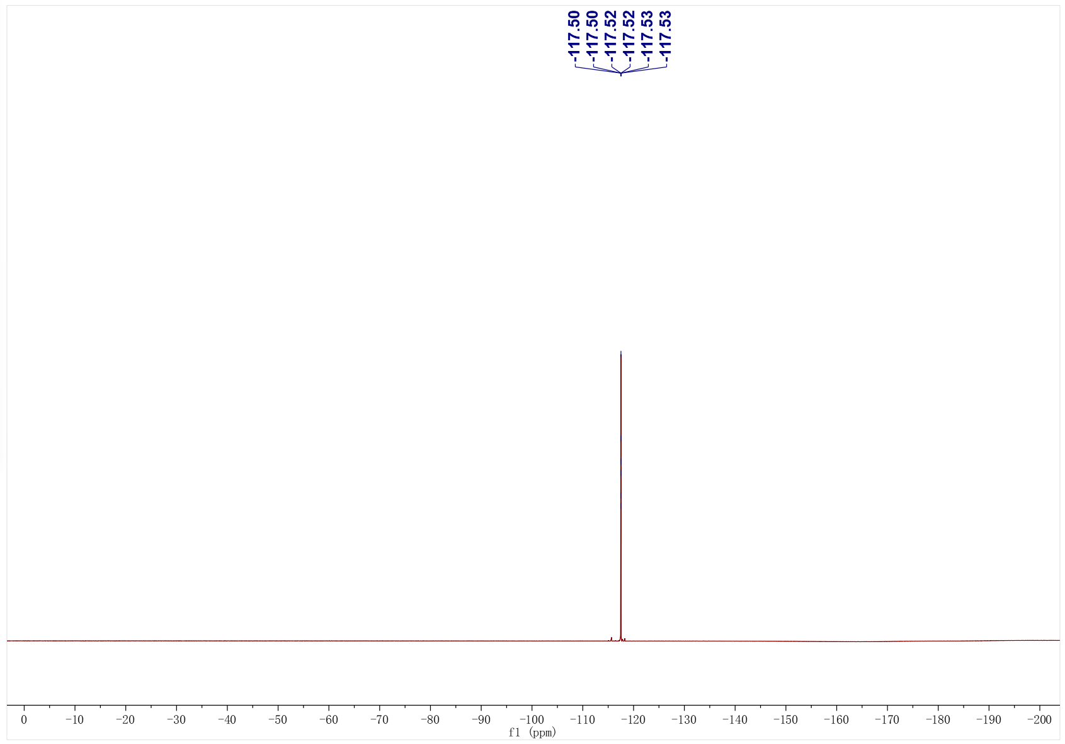
3bd; ¹H NMR (500 MHz, CDCl₃); ¹³C NMR (126 MHz, CDCl₃)
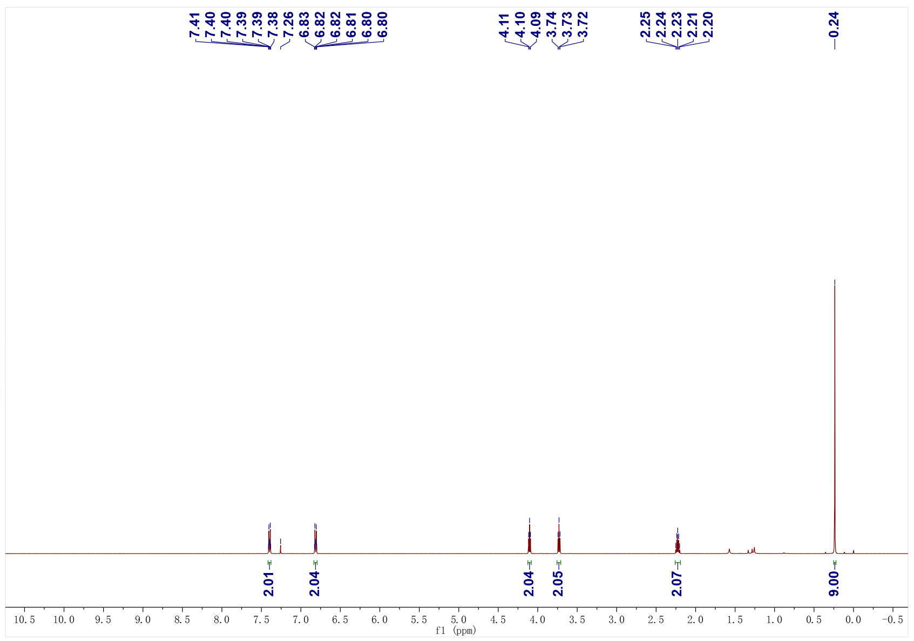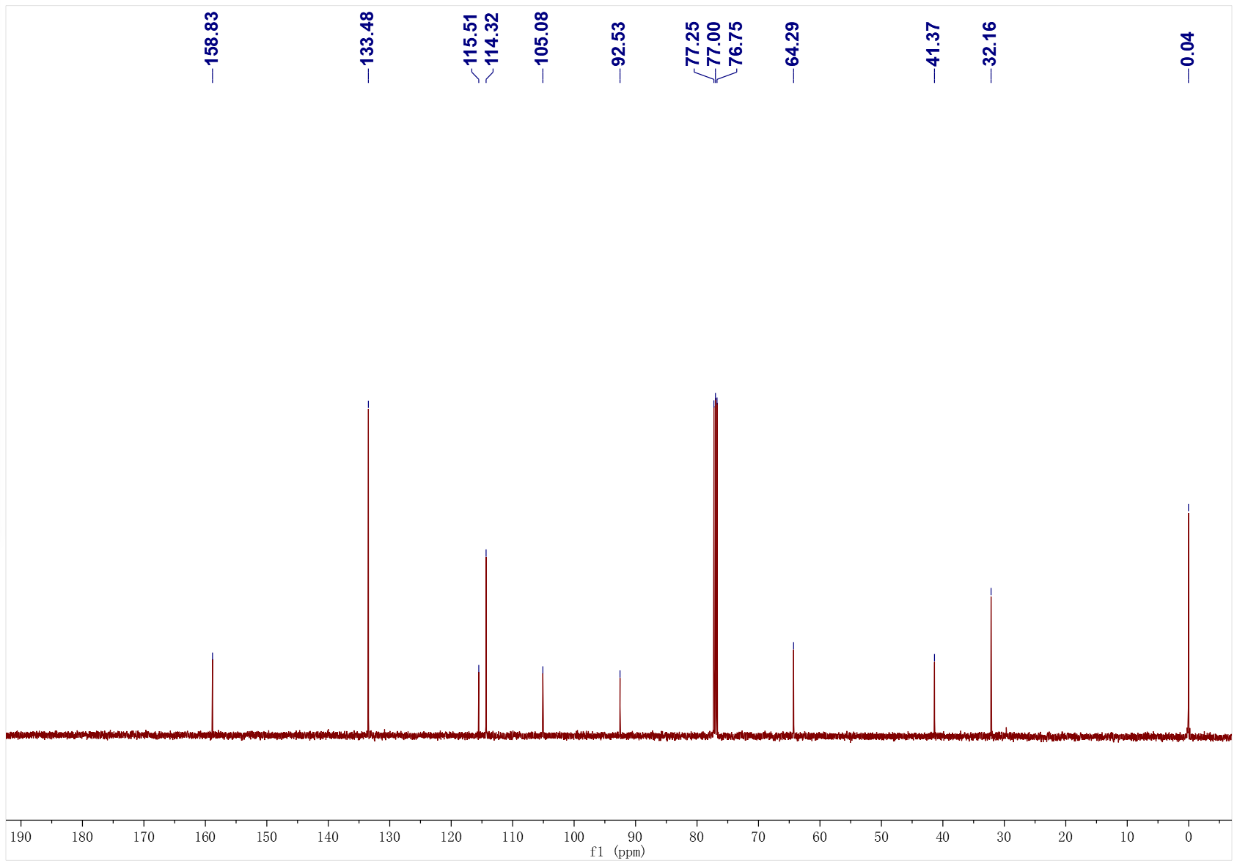
3be; ¹H NMR (500 MHz, CDCl₃); ¹³C NMR (126 MHz, CDCl₃)
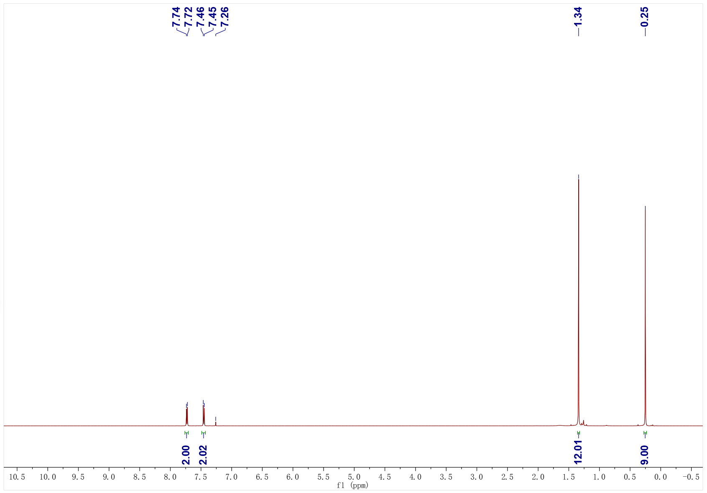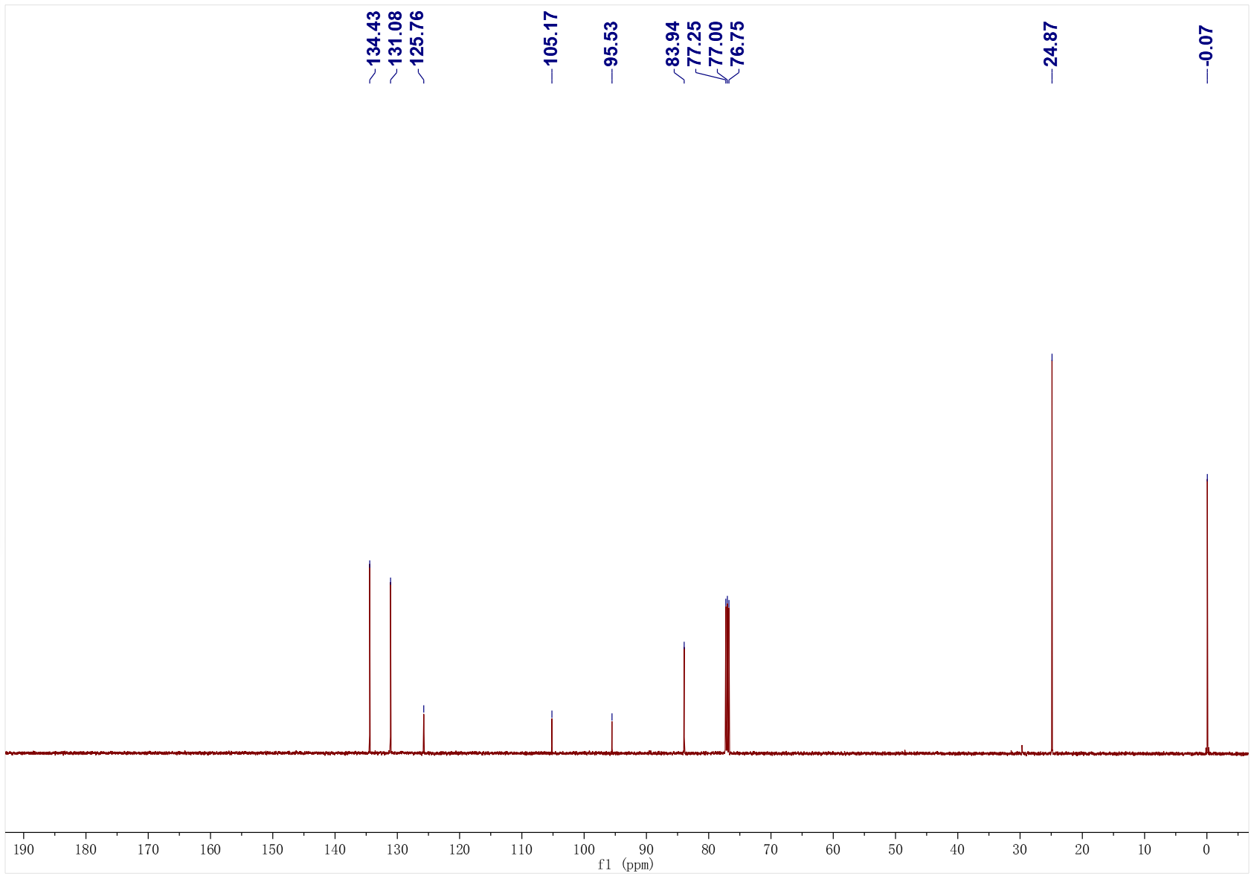
4a; ¹H NMR (500 MHz, CDCl₃); ¹³C NMR (126 MHz, CDCl₃)
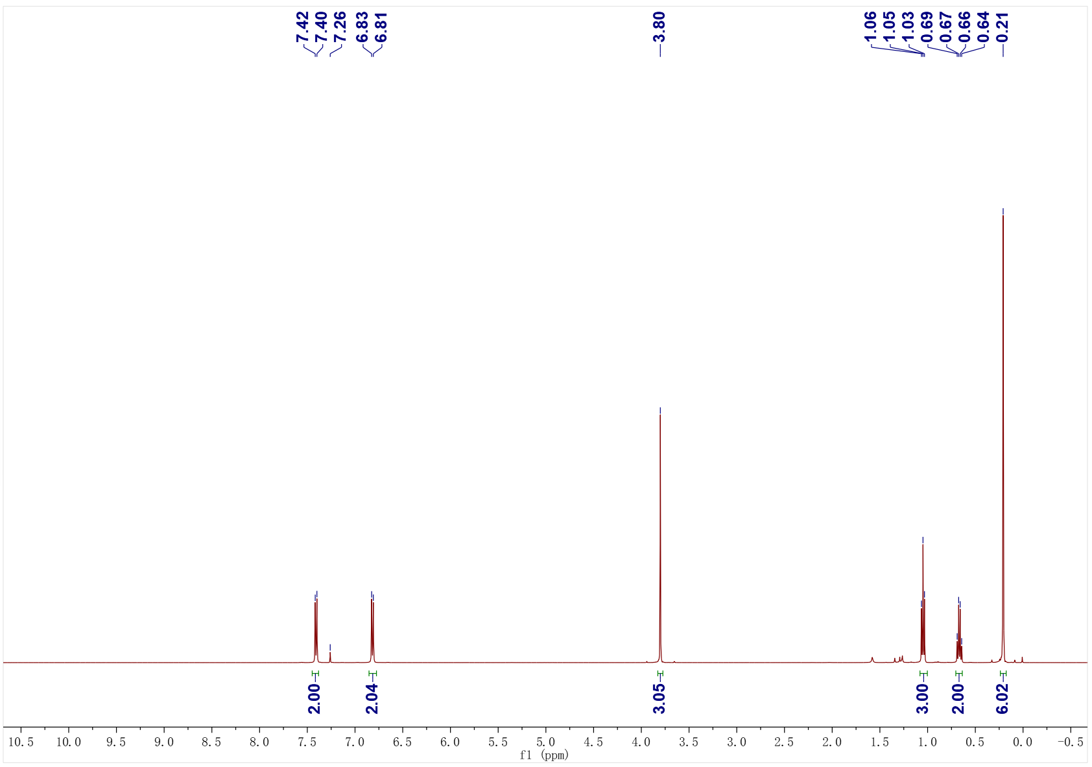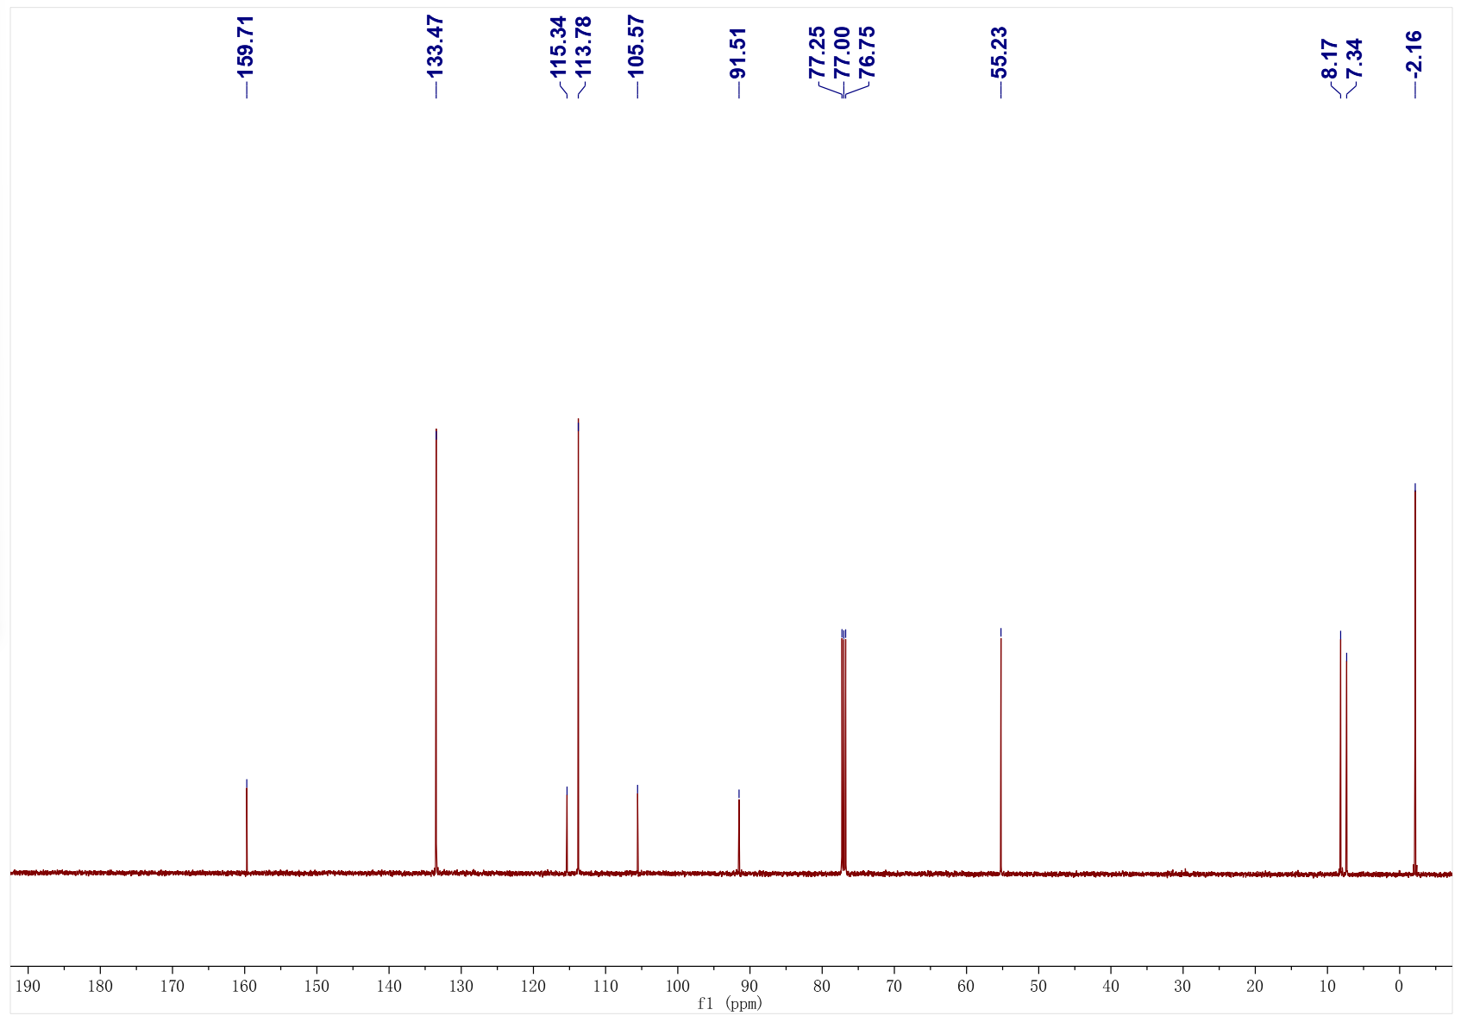
4b; ¹H NMR (500 MHz, CDCl₃); ¹³C NMR (126 MHz, CDCl₃)
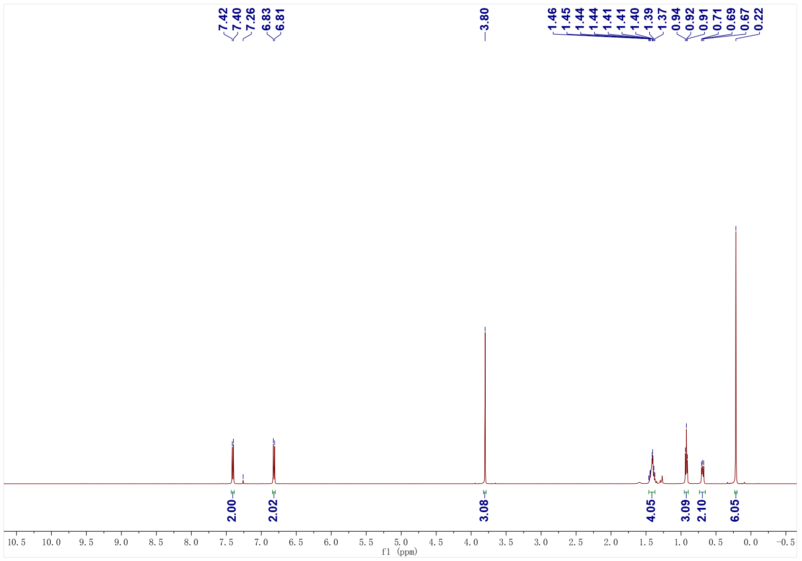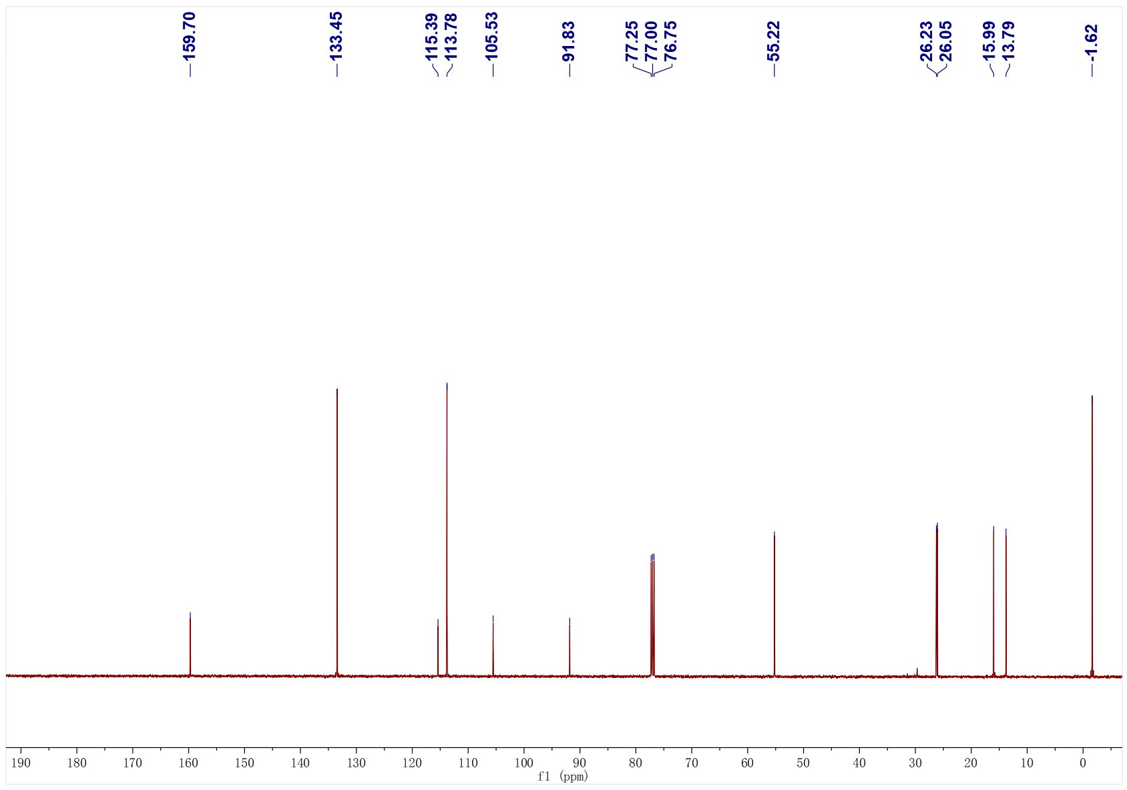
4c; ¹H NMR (500 MHz, CDCl₃); ¹³C NMR (126 MHz, CDCl₃)
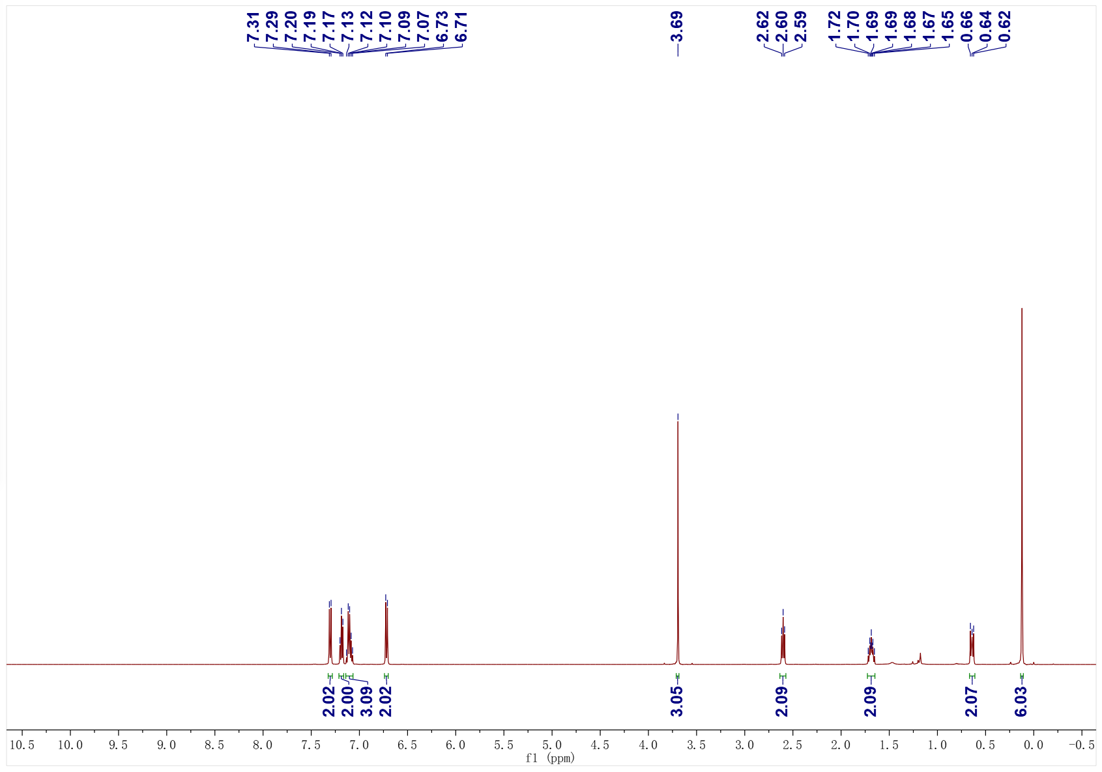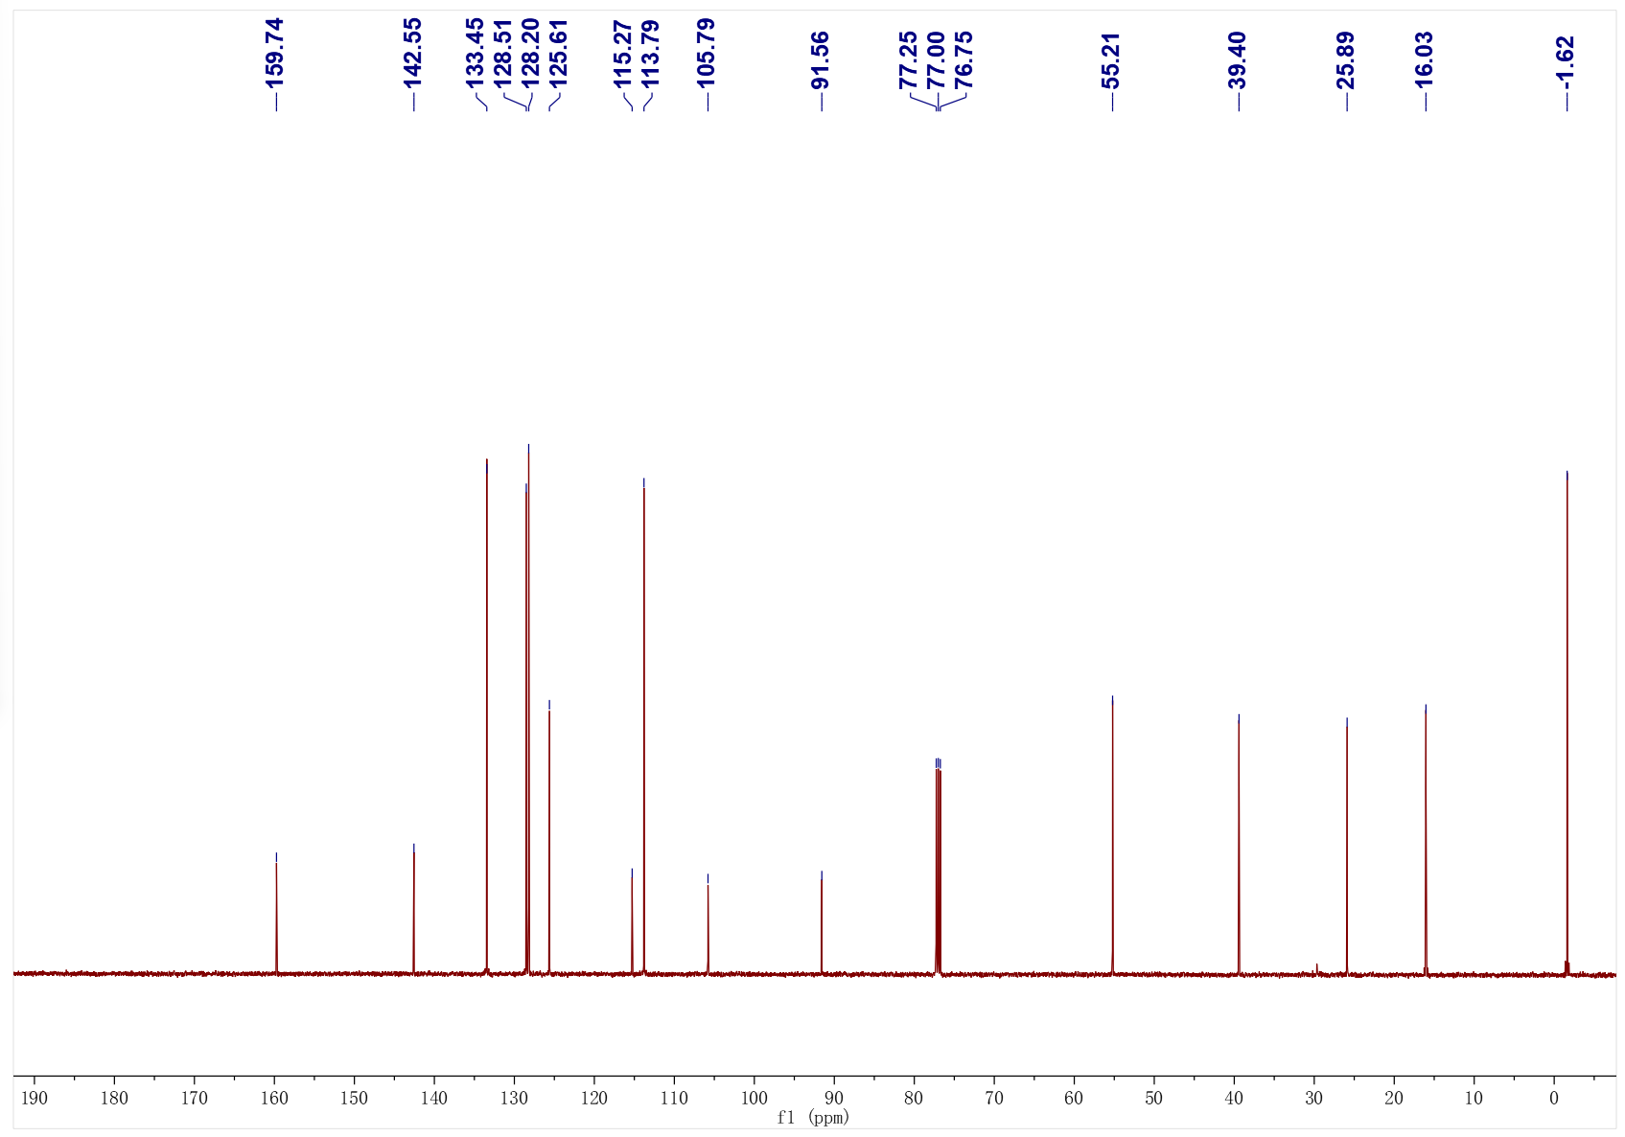
4d; ¹H NMR (500 MHz, CDCl₃); ¹³C NMR (126 MHz, CDCl₃)
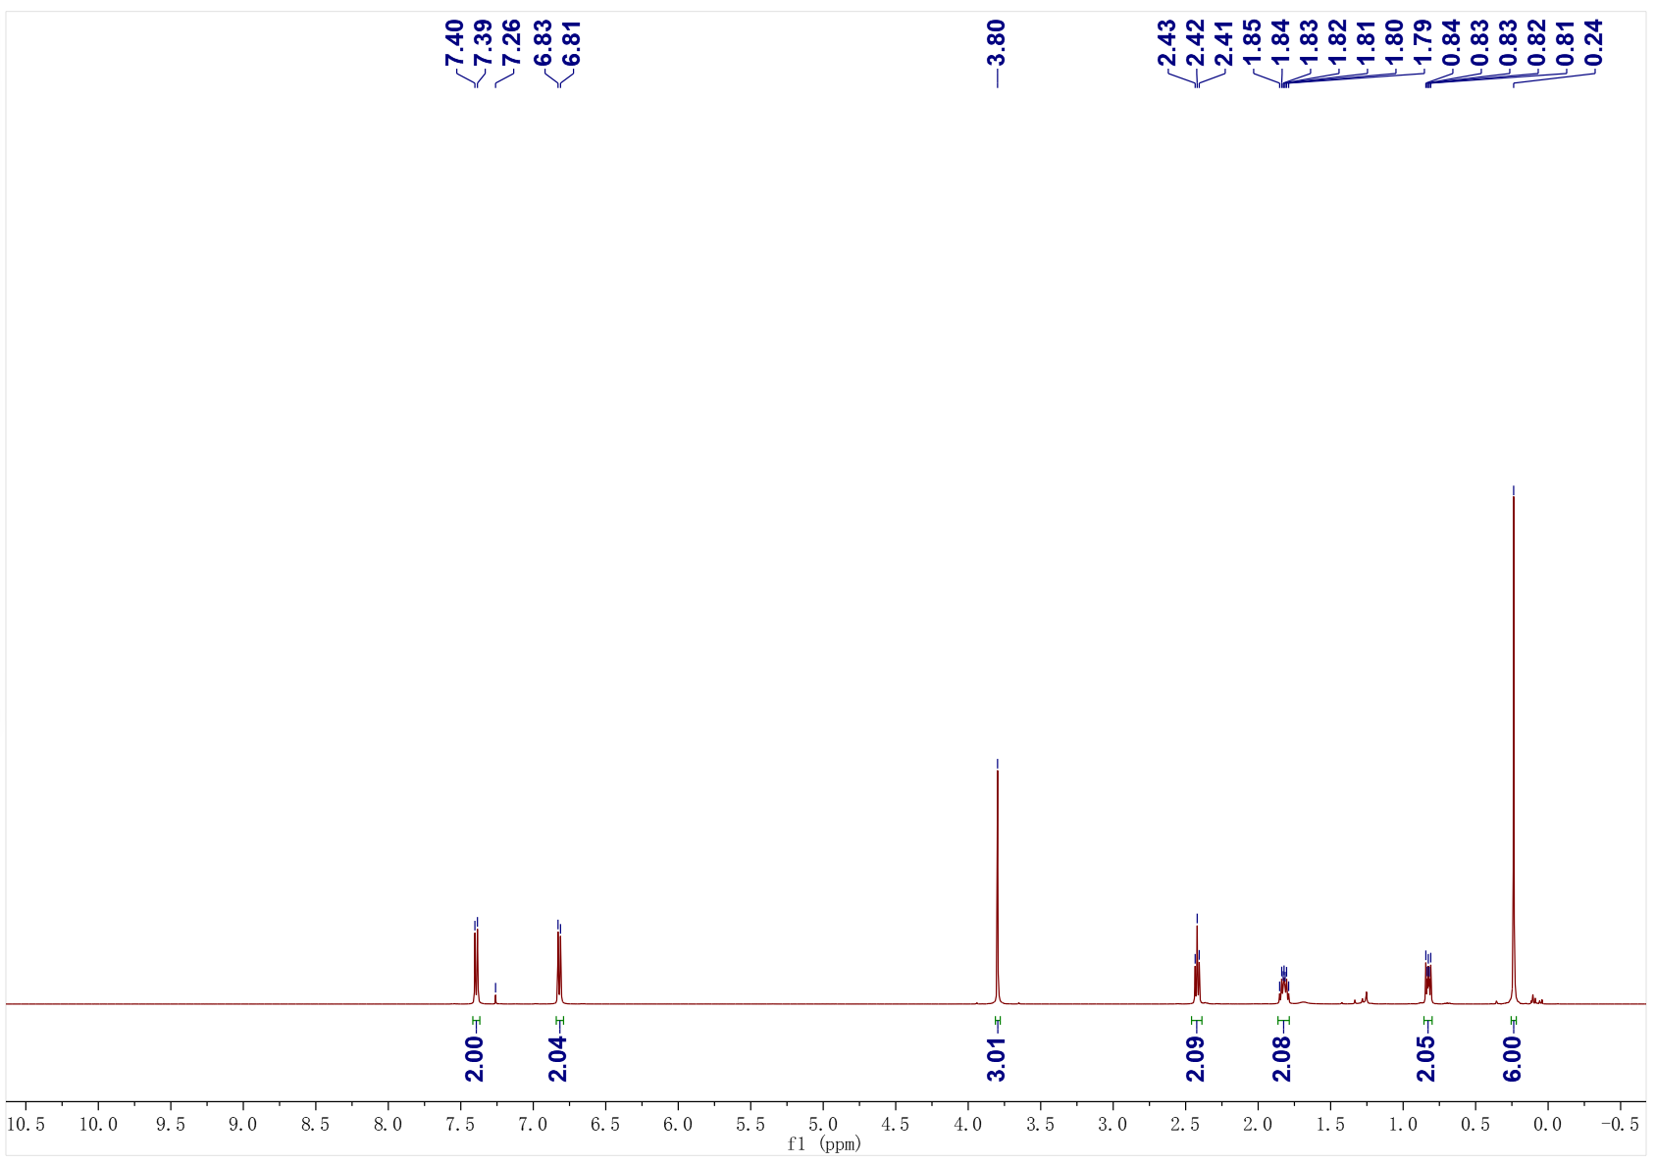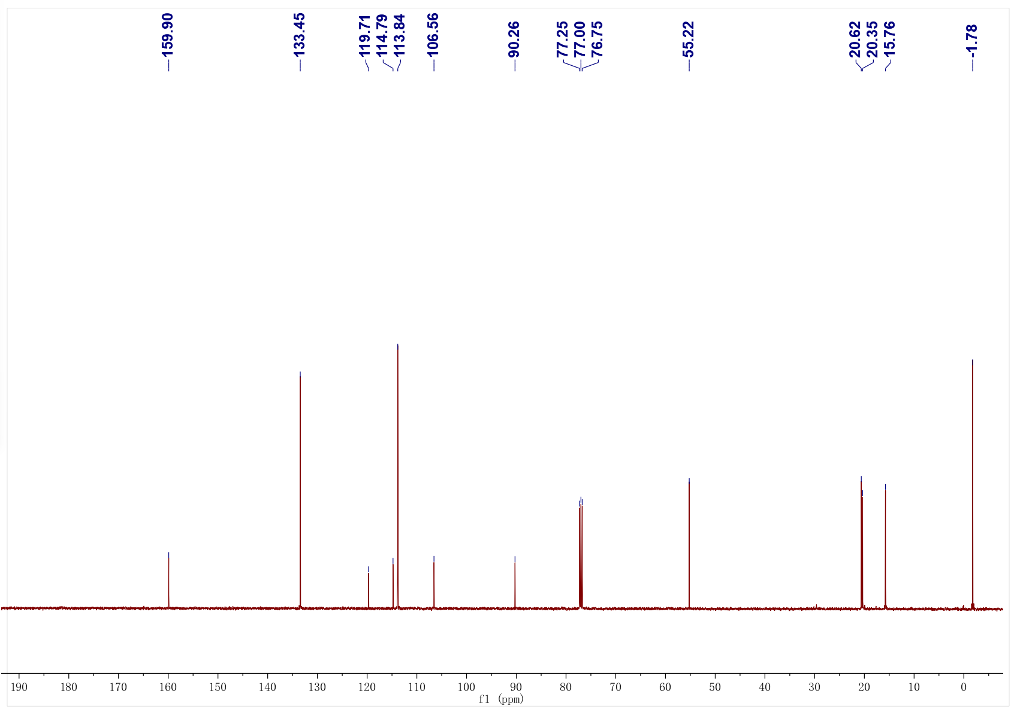
4e; ¹H NMR (500 MHz, CDCl₃); ¹³C NMR (126 MHz, CDCl₃)
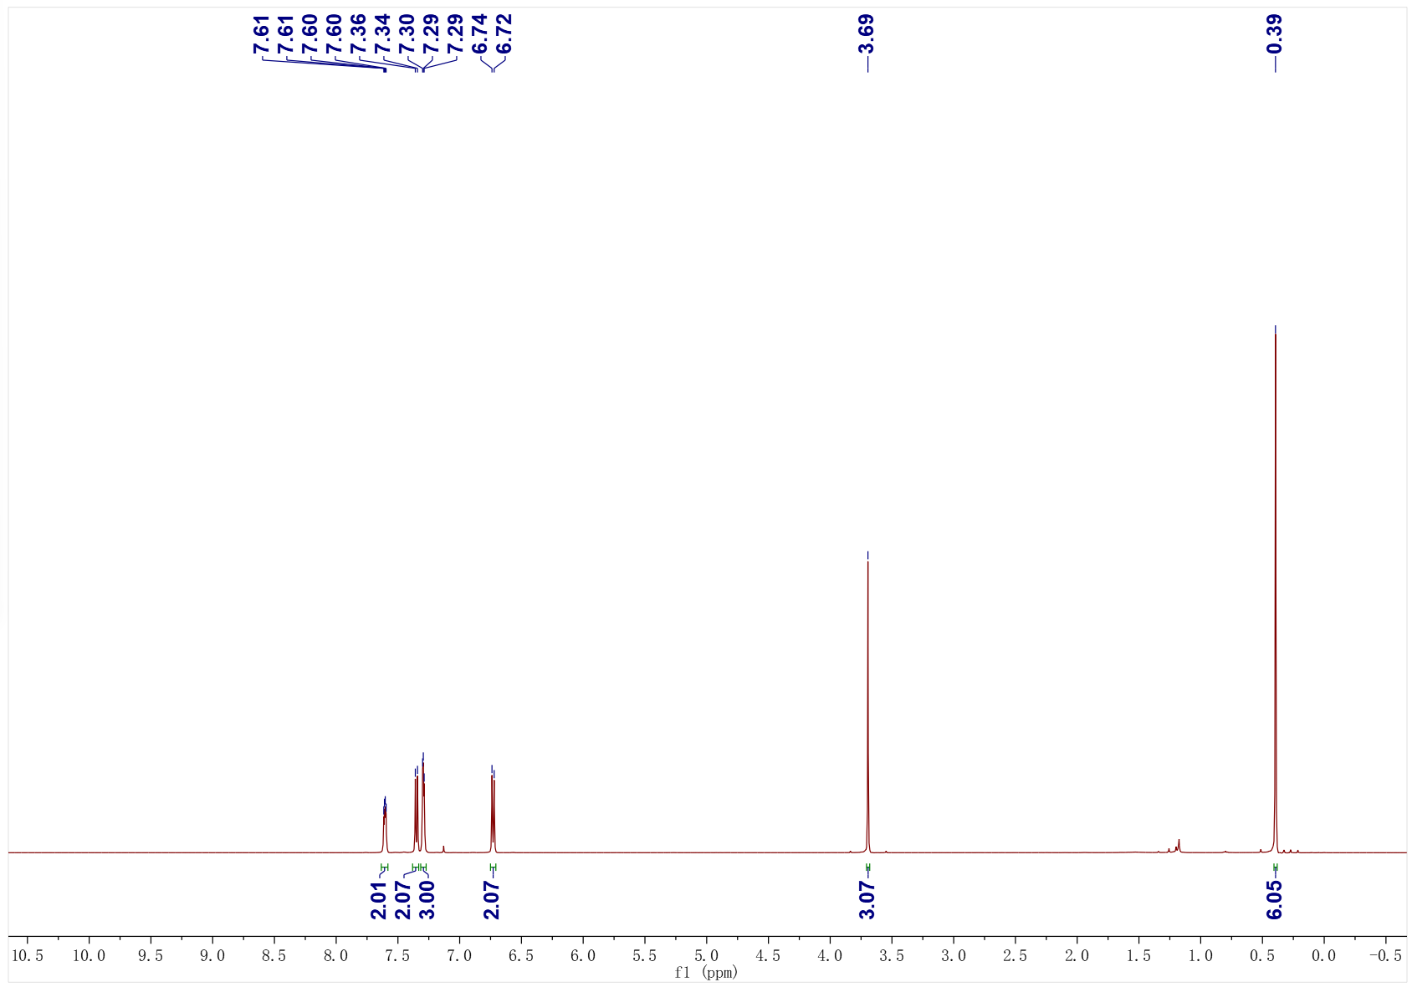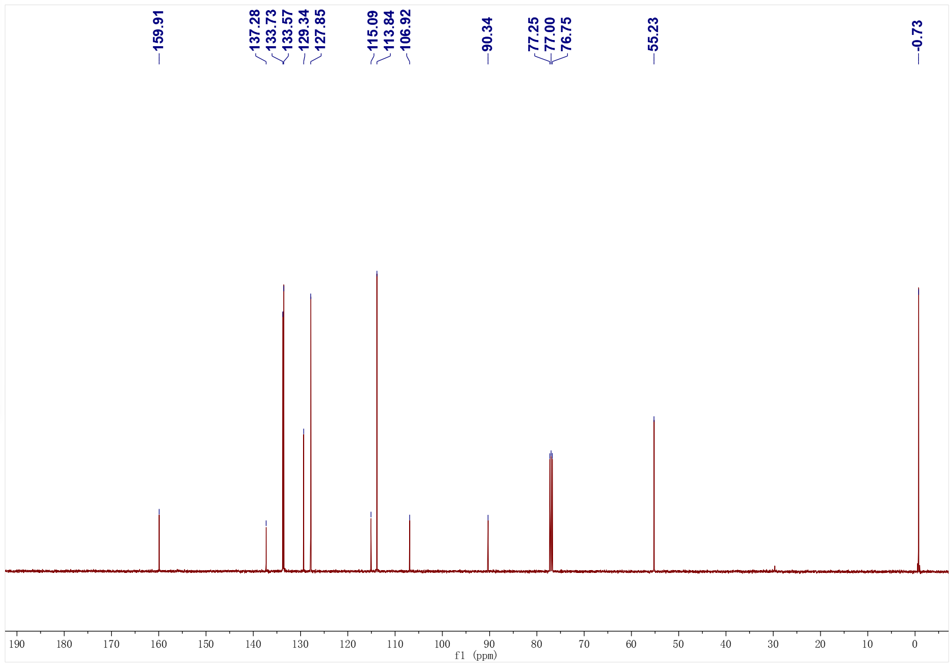
4f; ¹H NMR (500 MHz, CDCl₃); ¹³C NMR (126 MHz, CDCl₃)
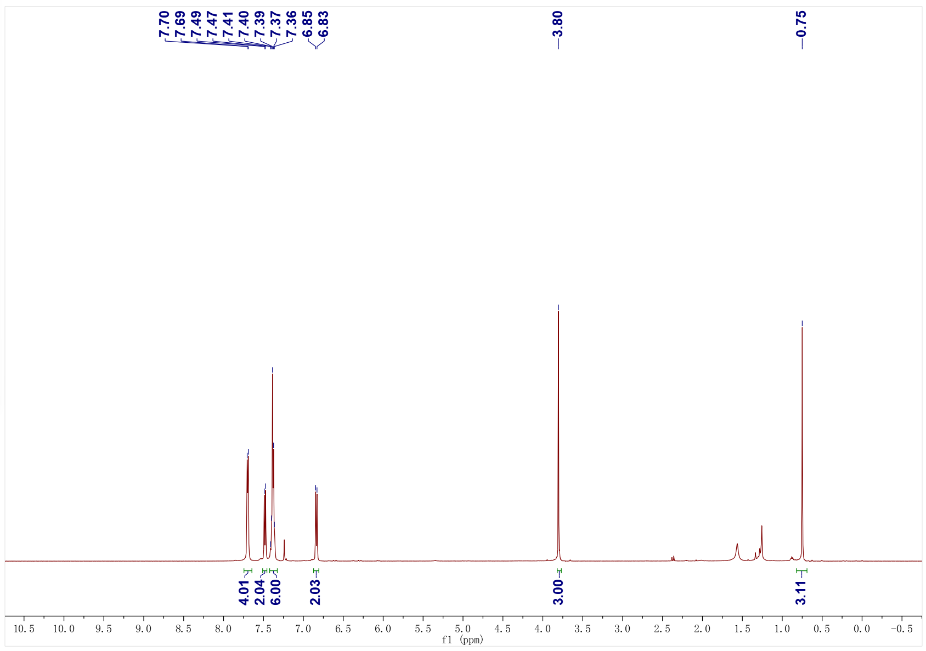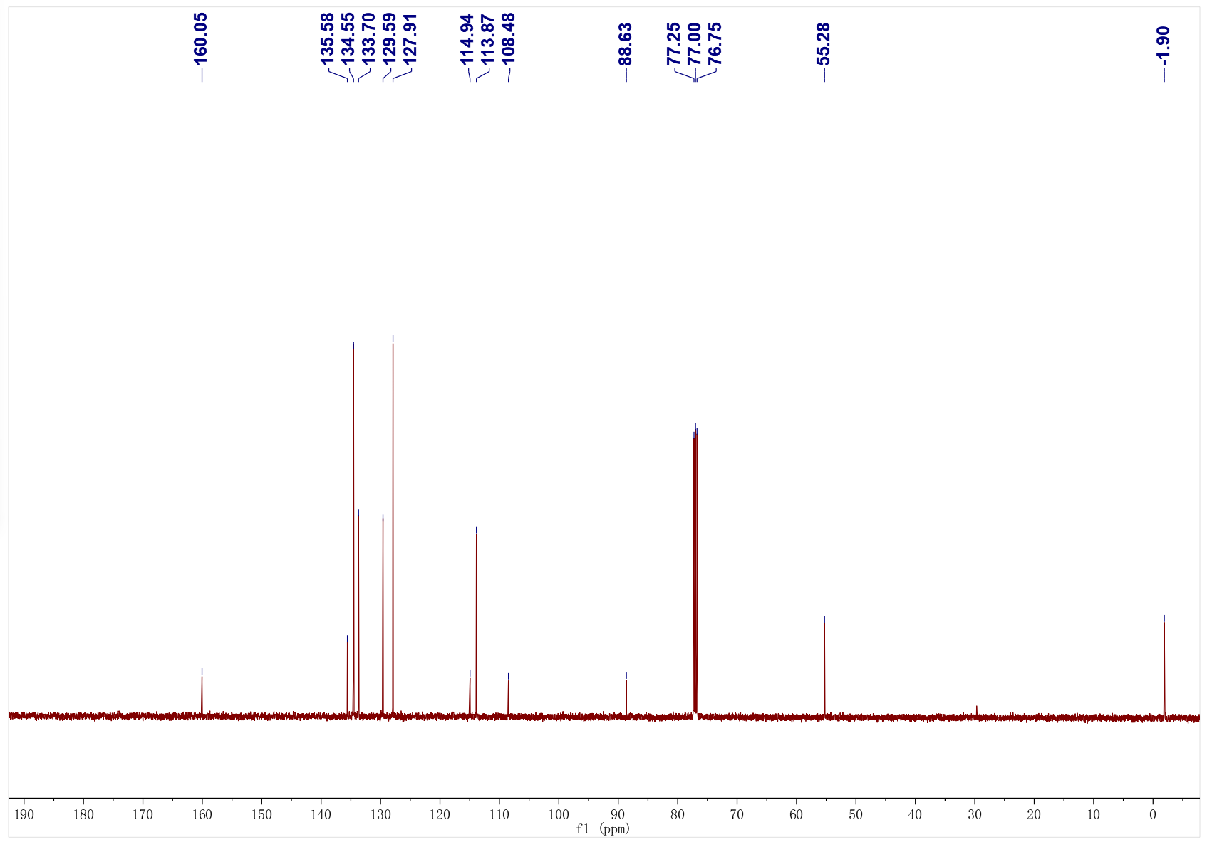
4g; ¹H NMR (500 MHz, CDCl₃); ¹³C NMR (126 MHz, CDCl₃)
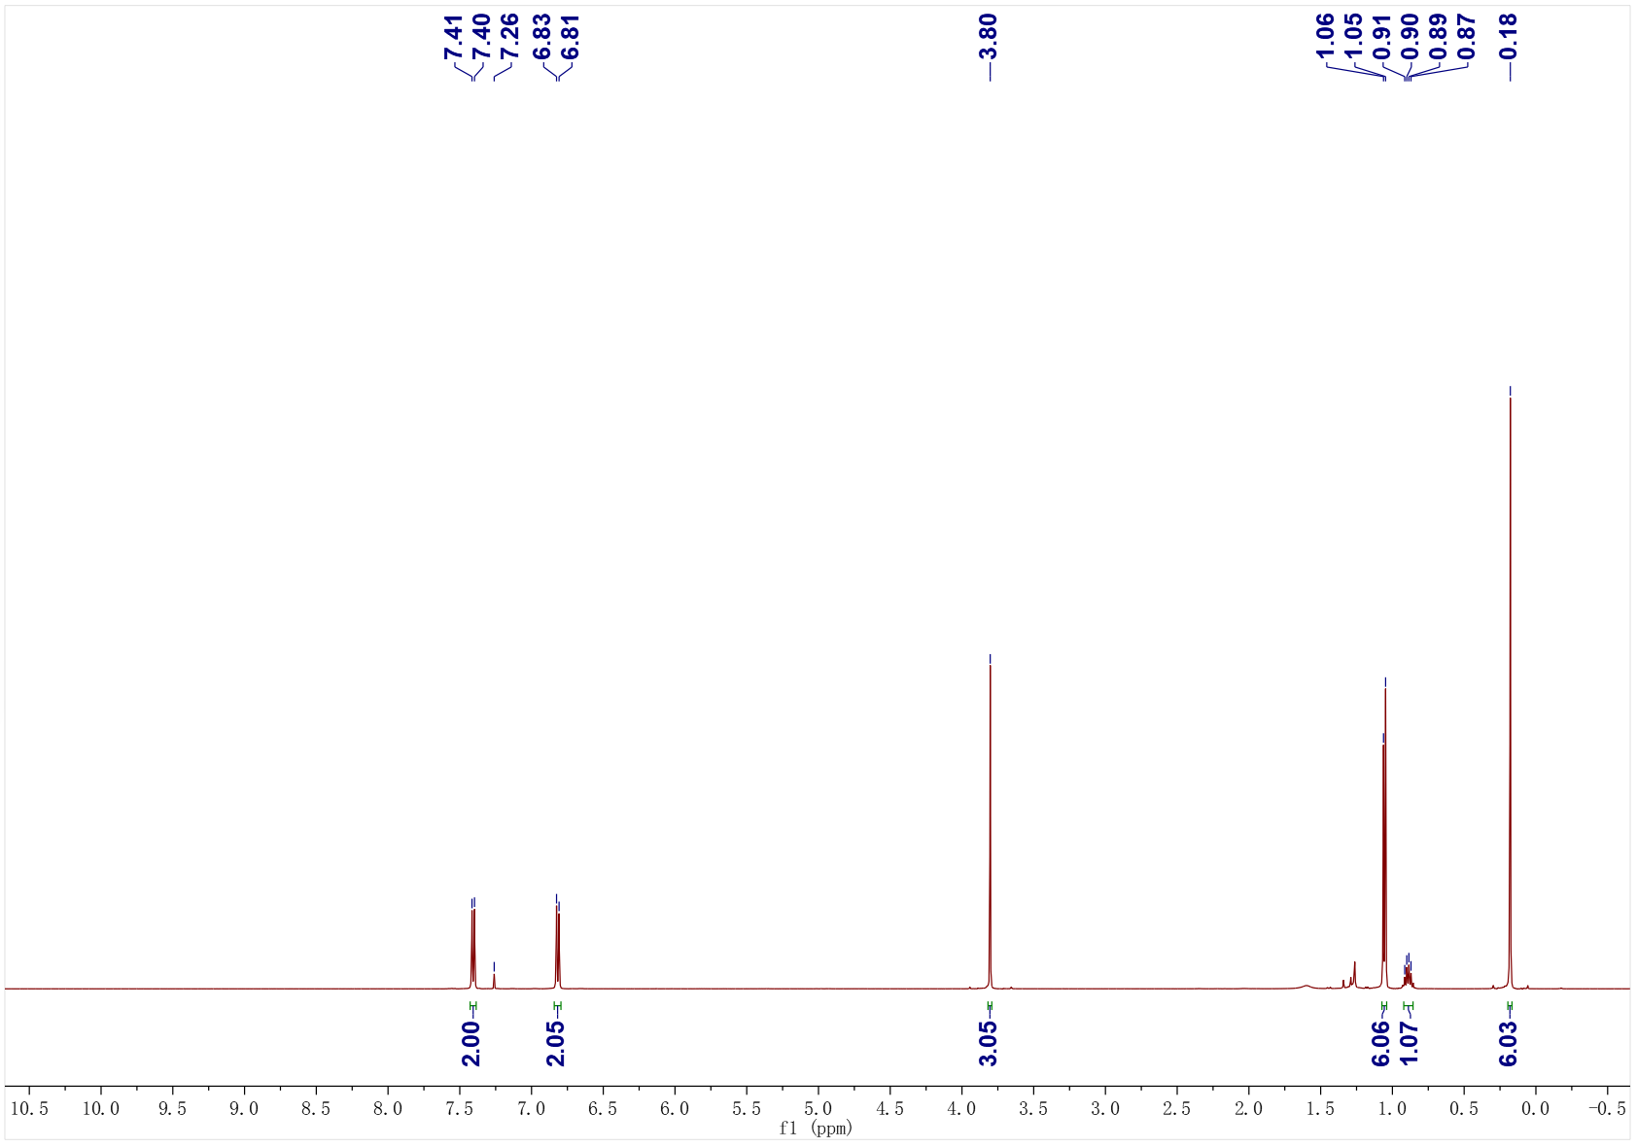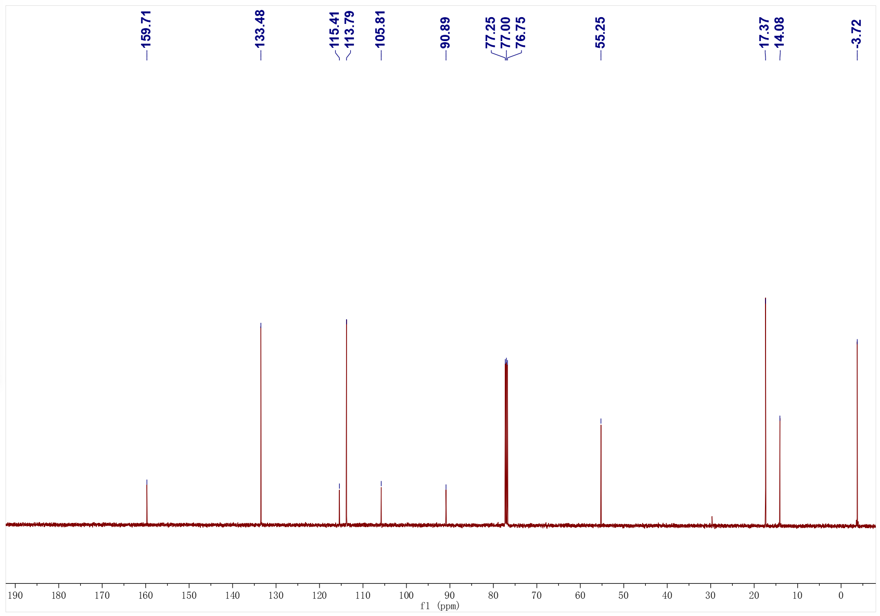
4h; ¹H NMR (500 MHz, CDCl₃); ¹³C NMR (126 MHz, CDCl₃)
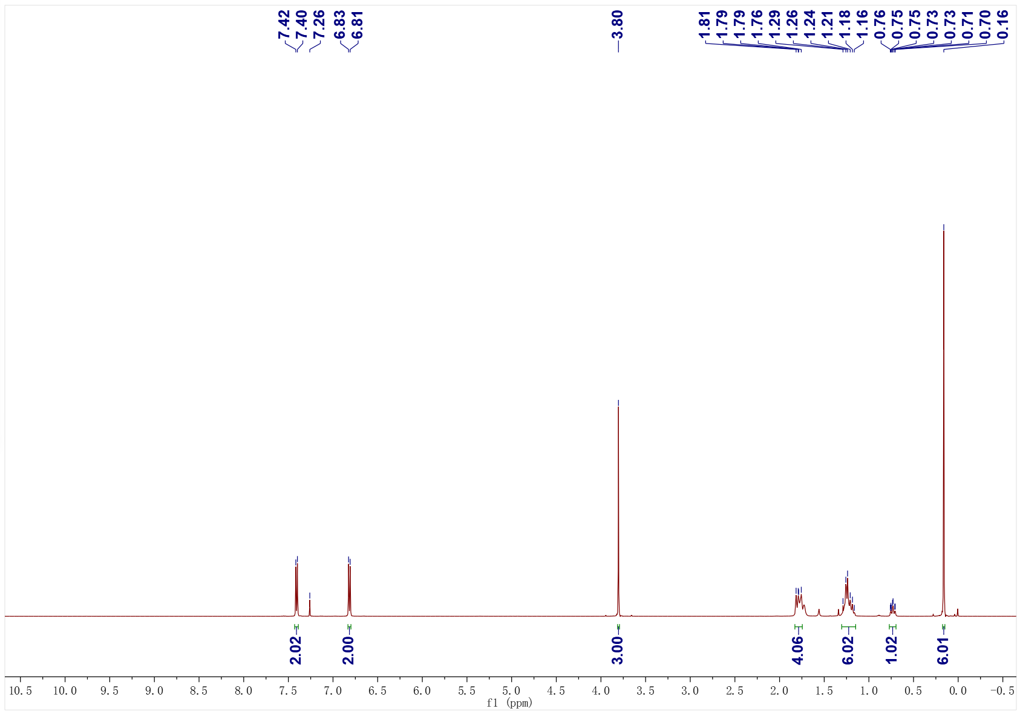
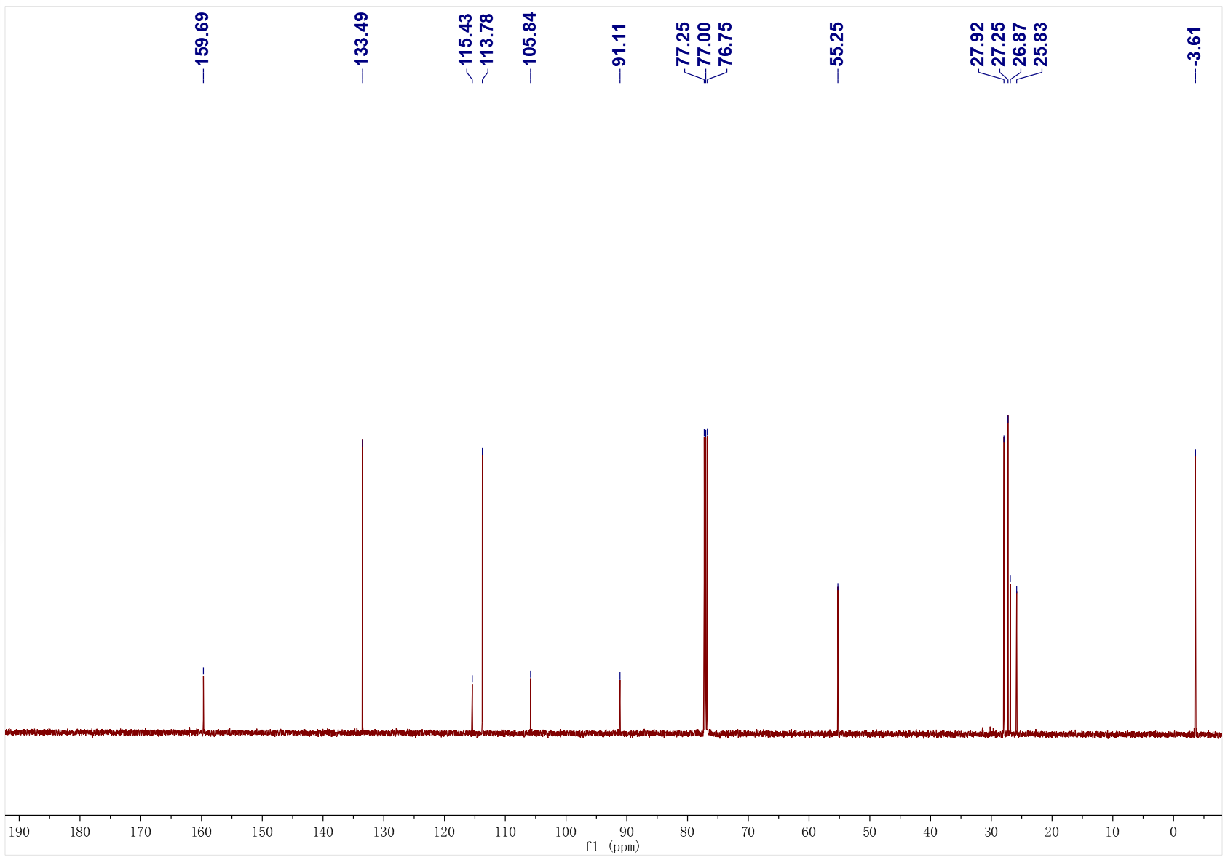
4i; ¹H NMR (500 MHz, CDCl₃); ¹³C NMR (126 MHz, CDCl₃)
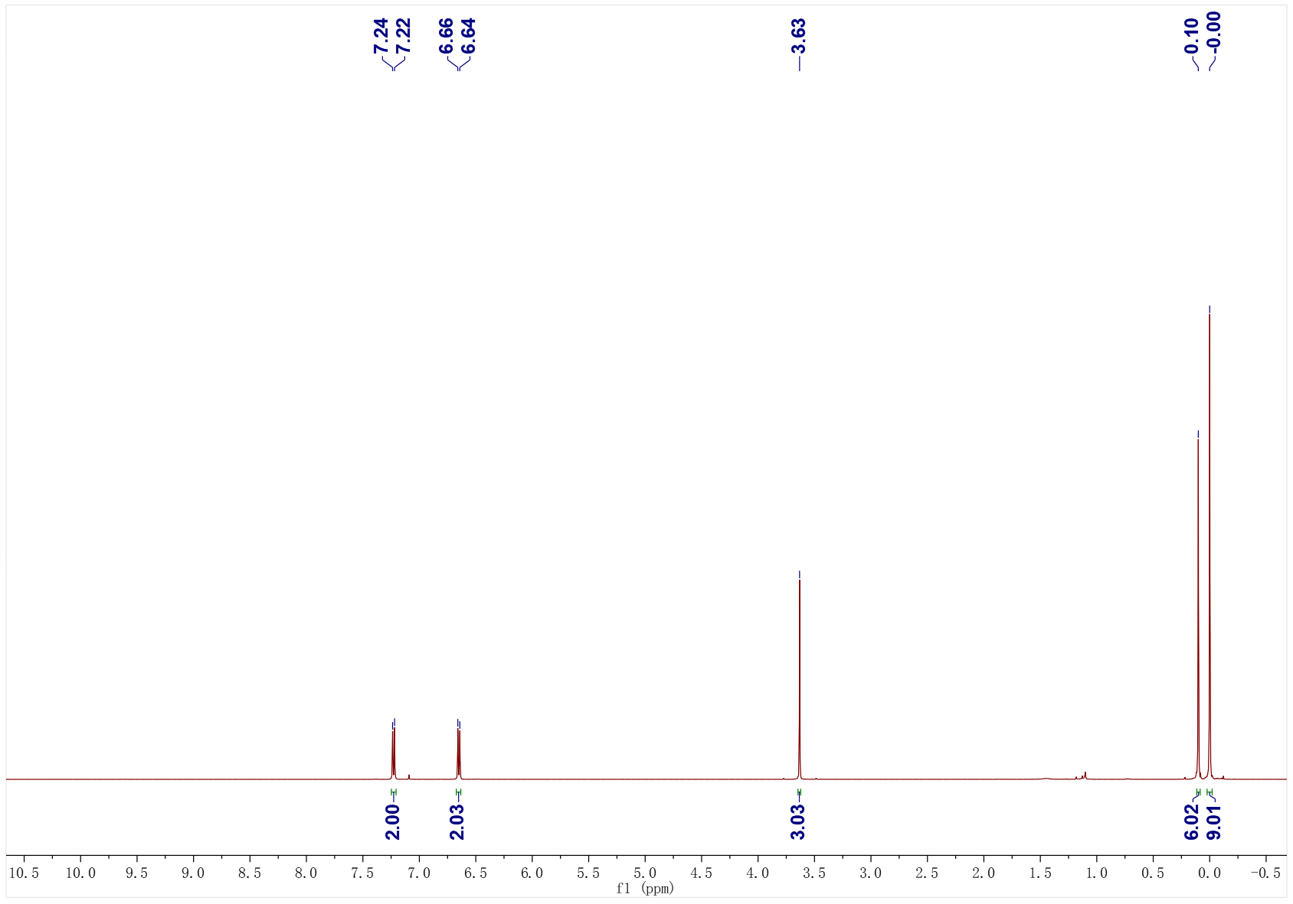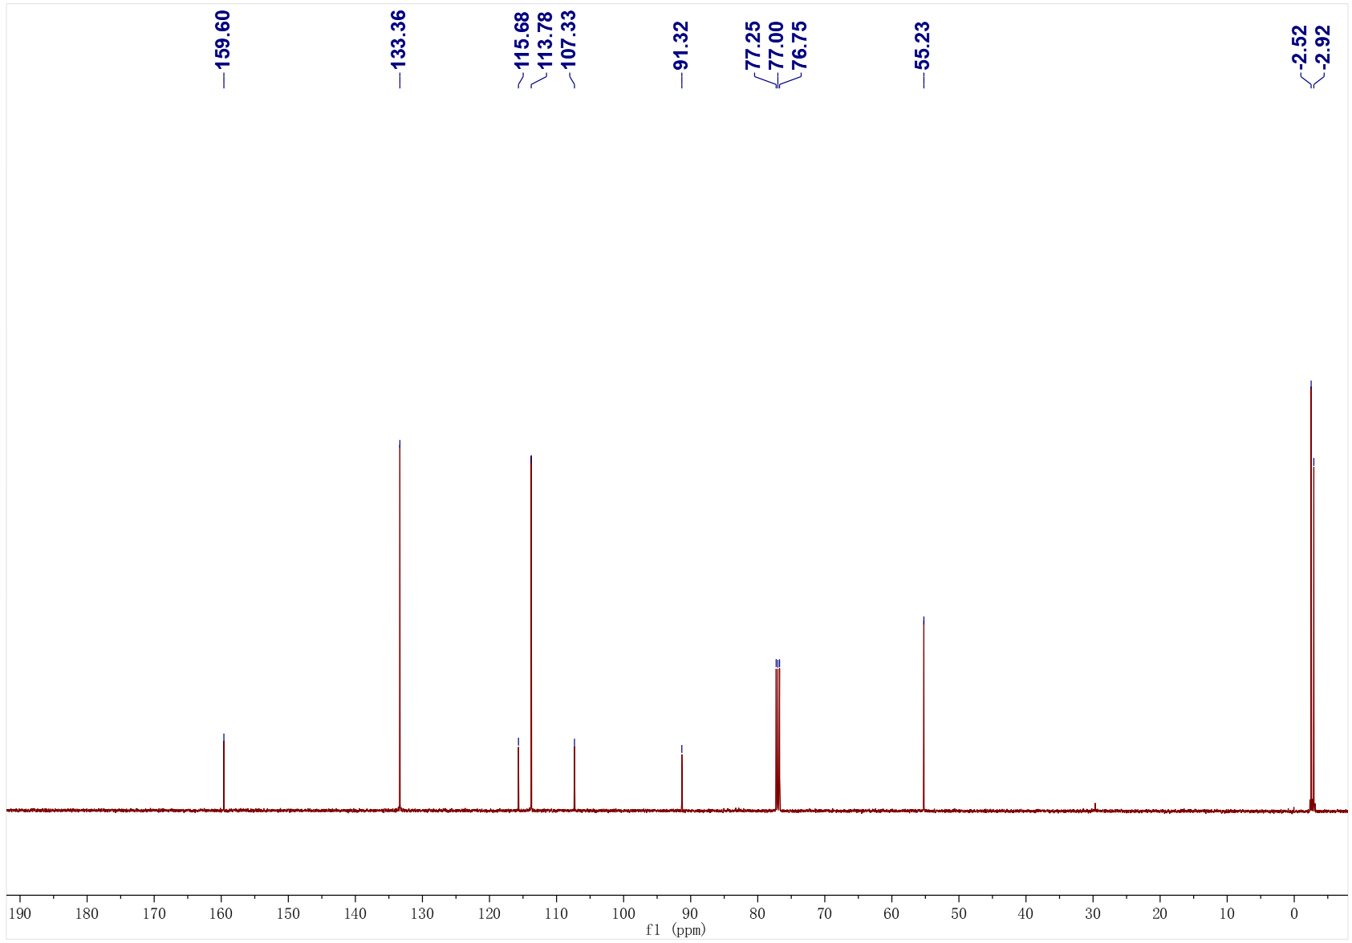
4j; ¹H NMR (500 MHz, CDCl₃); ¹³C NMR (126 MHz, CDCl₃)
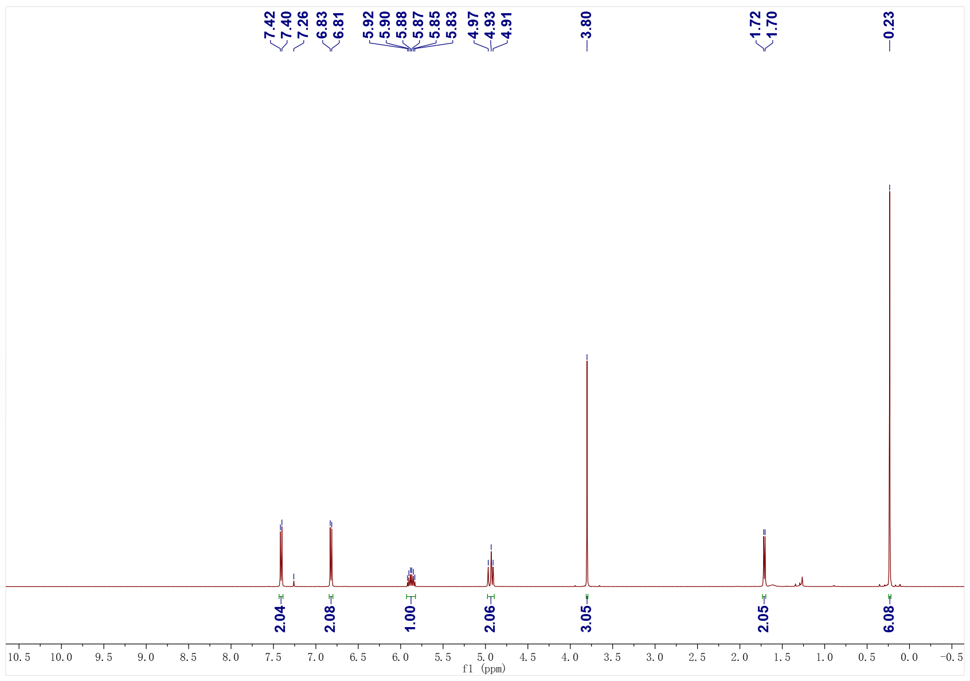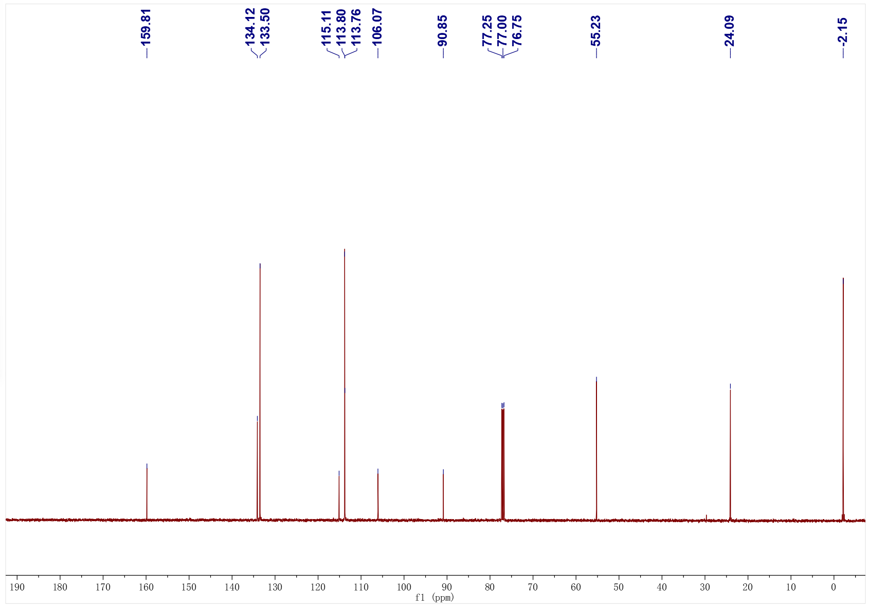
4k; ¹H NMR (500 MHz, CDCl₃); ¹³C NMR (126 MHz, CDCl₃)
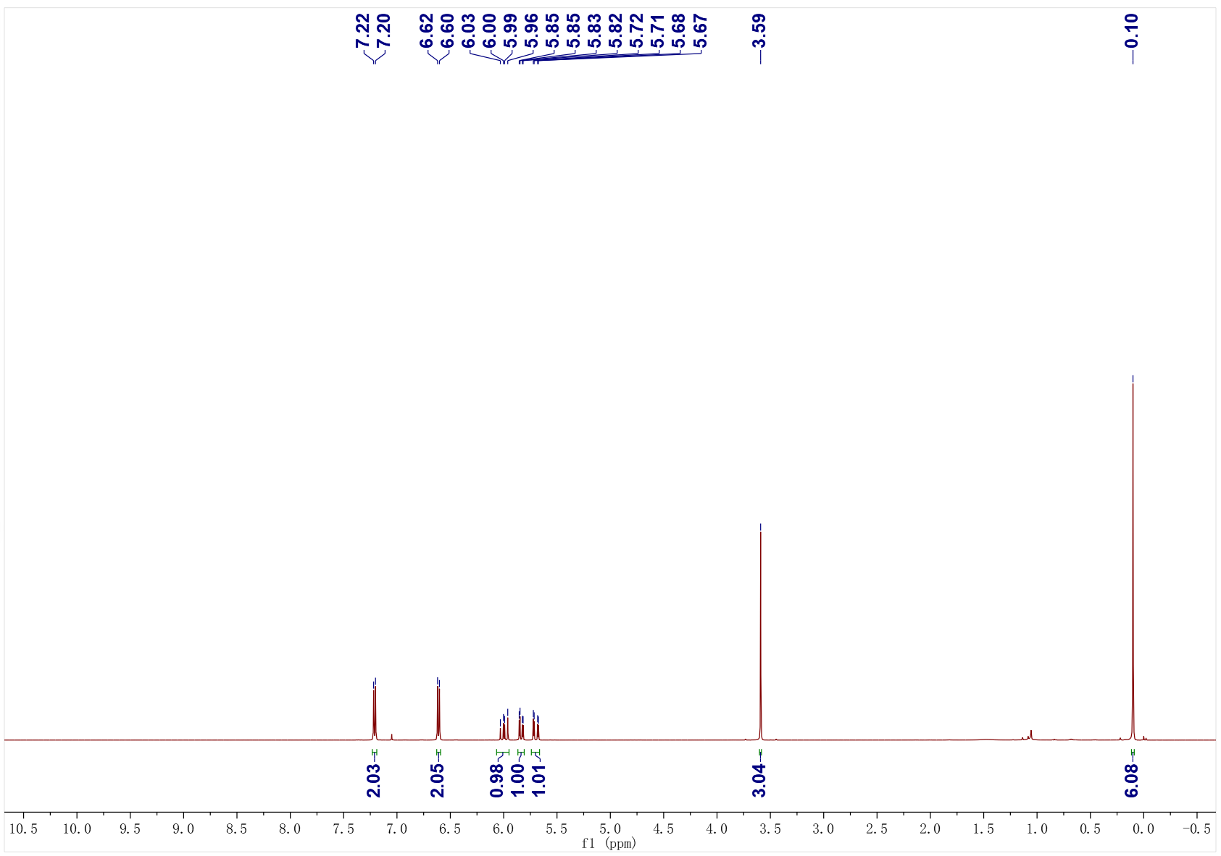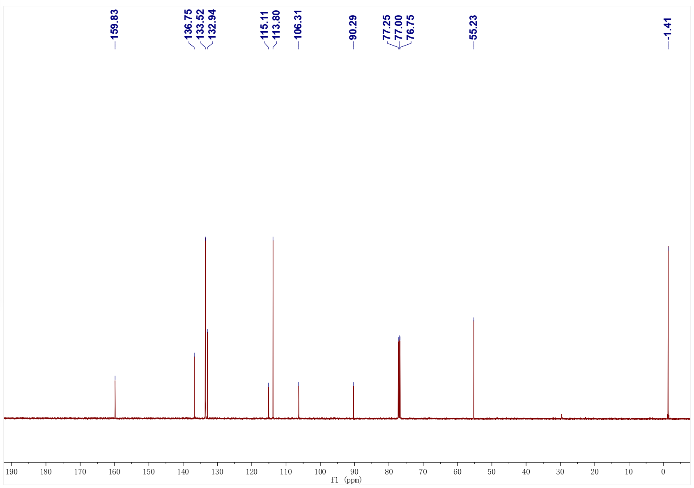
4l; ¹H NMR (500 MHz, CDCl₃); ¹³C NMR (126 MHz, CDCl₃)
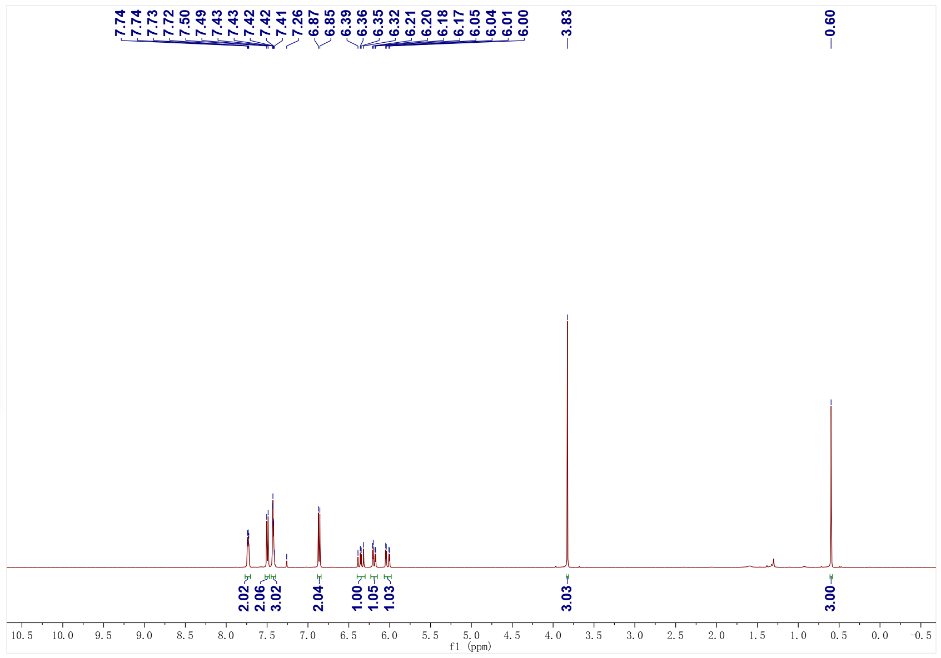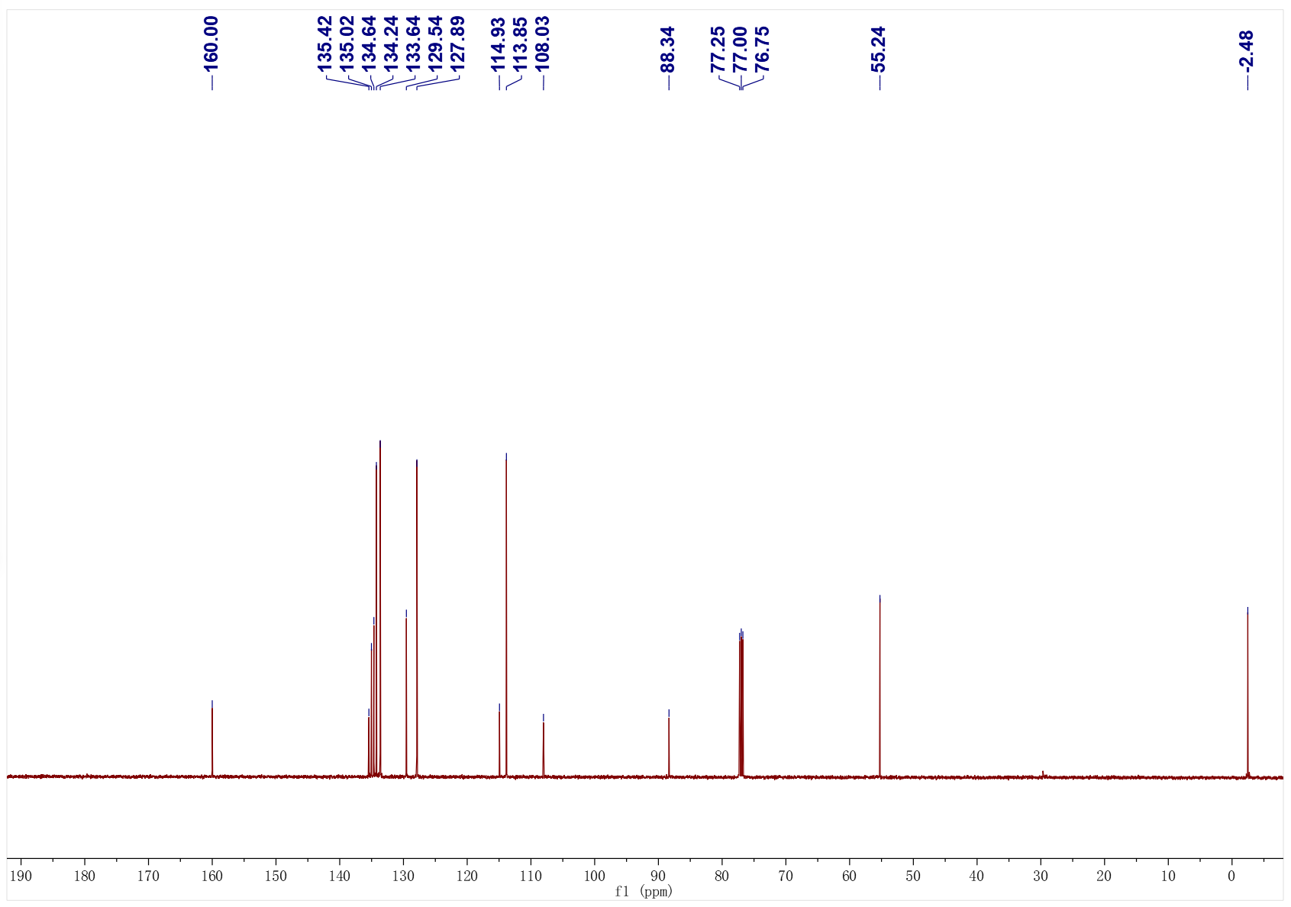
4m; ¹H NMR (500 MHz, CDCl₃); ¹³C NMR (126 MHz, CDCl₃)
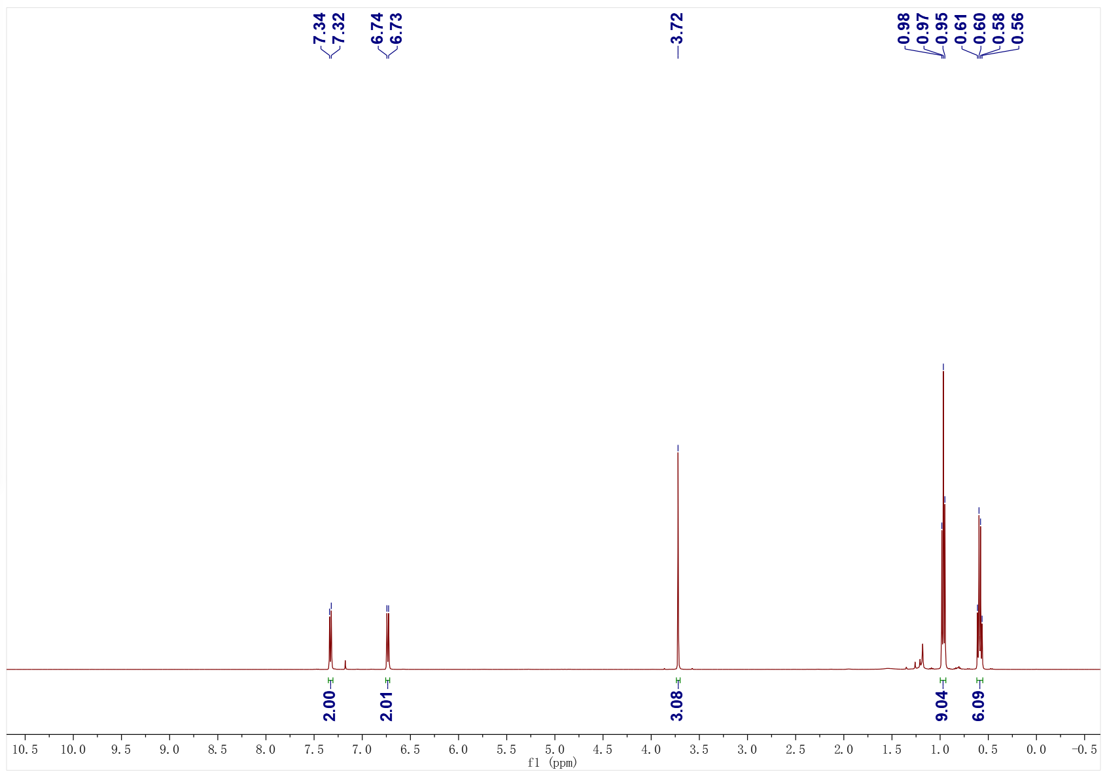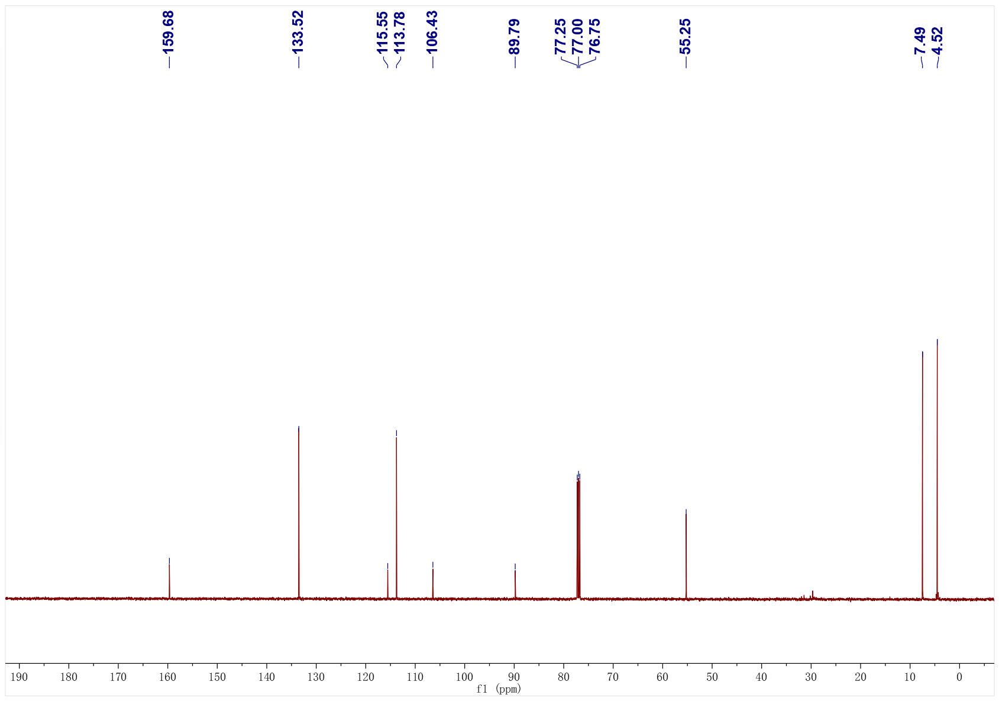
4n; ¹H NMR (500 MHz, CDCl₃); ¹³C NMR (126 MHz, CDCl₃)
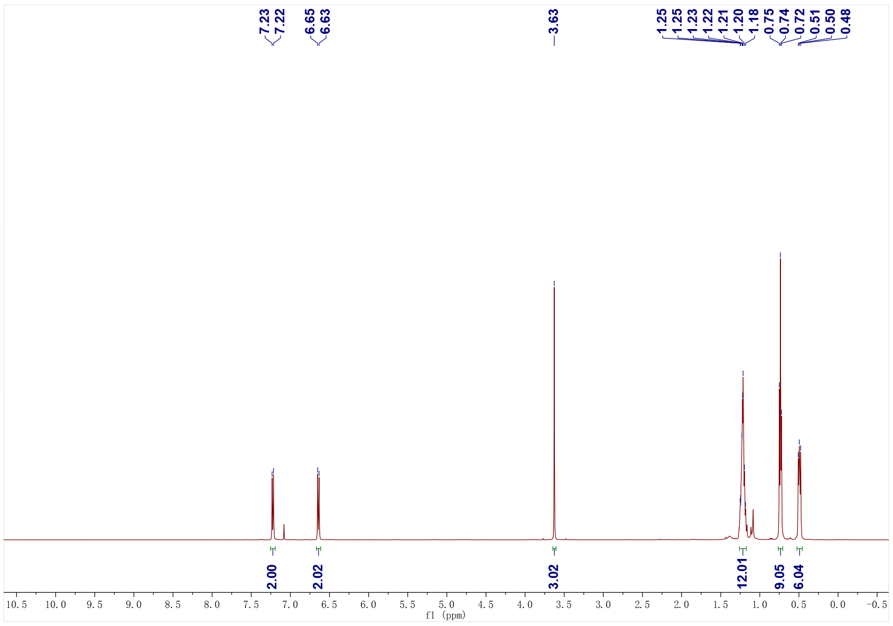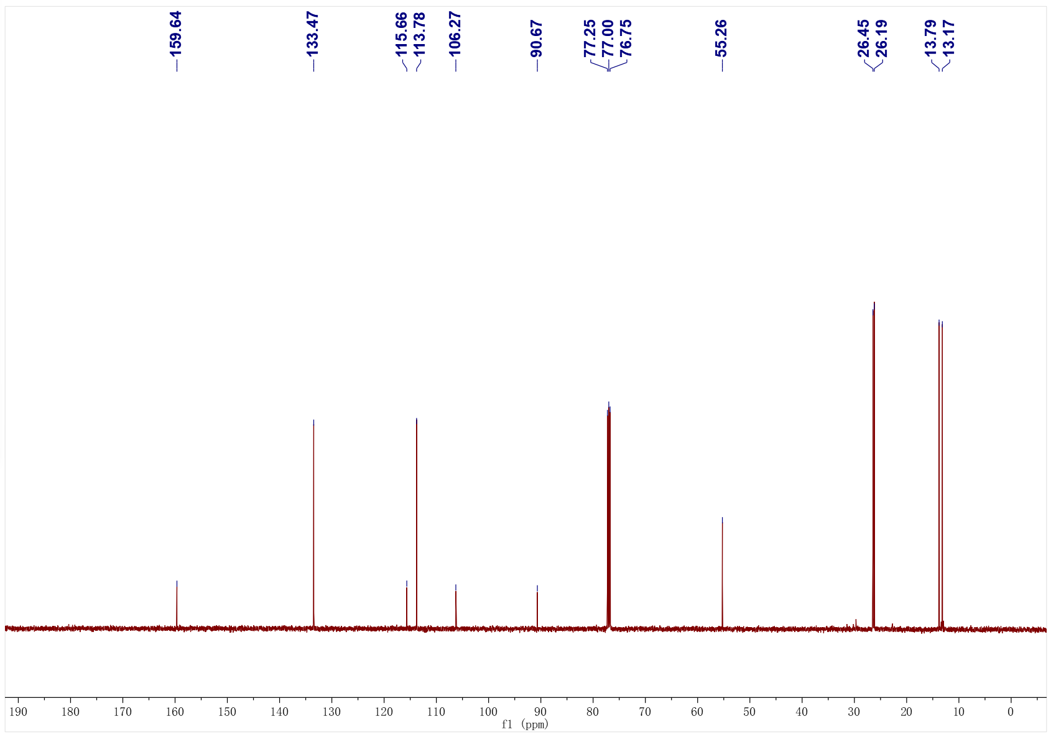
4o; ¹H NMR (400 MHz, CDCl₃); ¹³C NMR (126 MHz, CDCl₃)
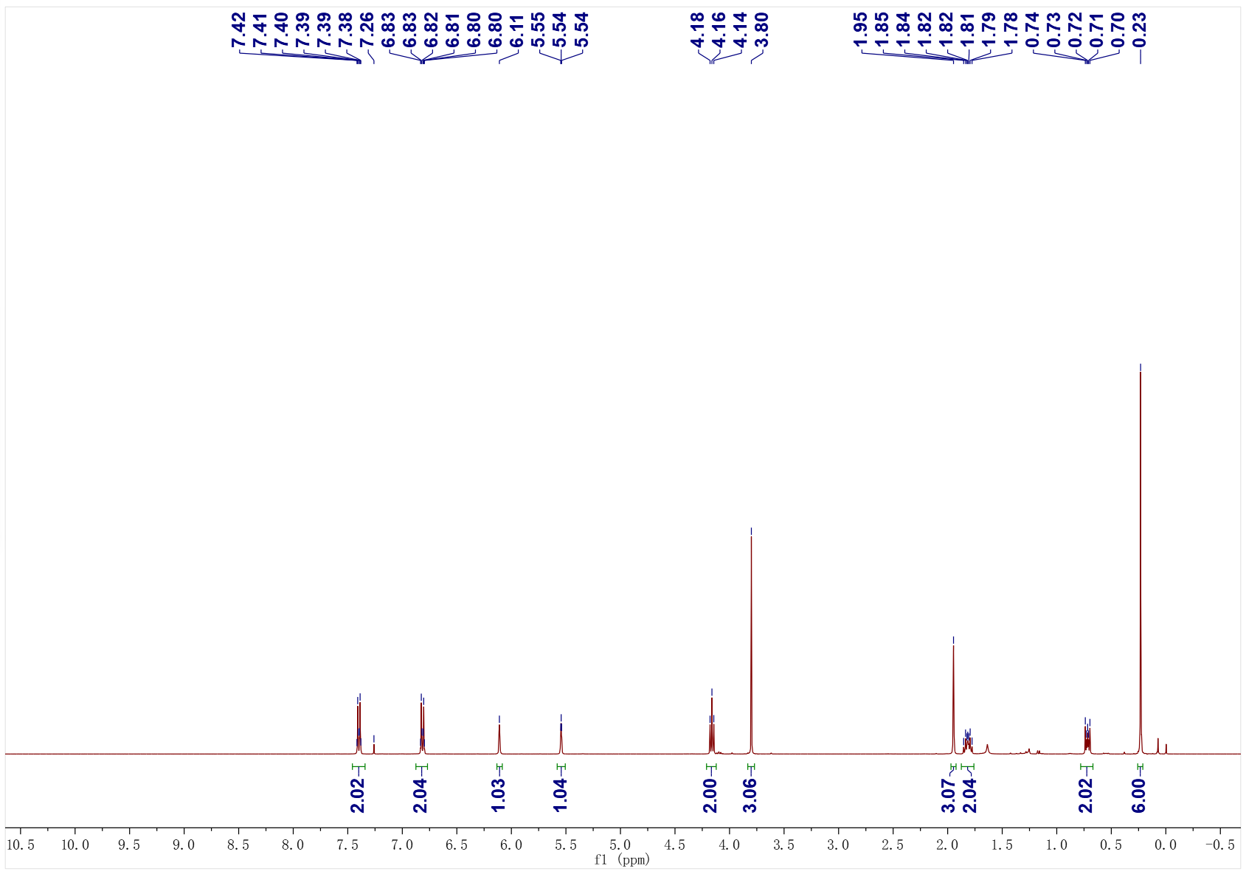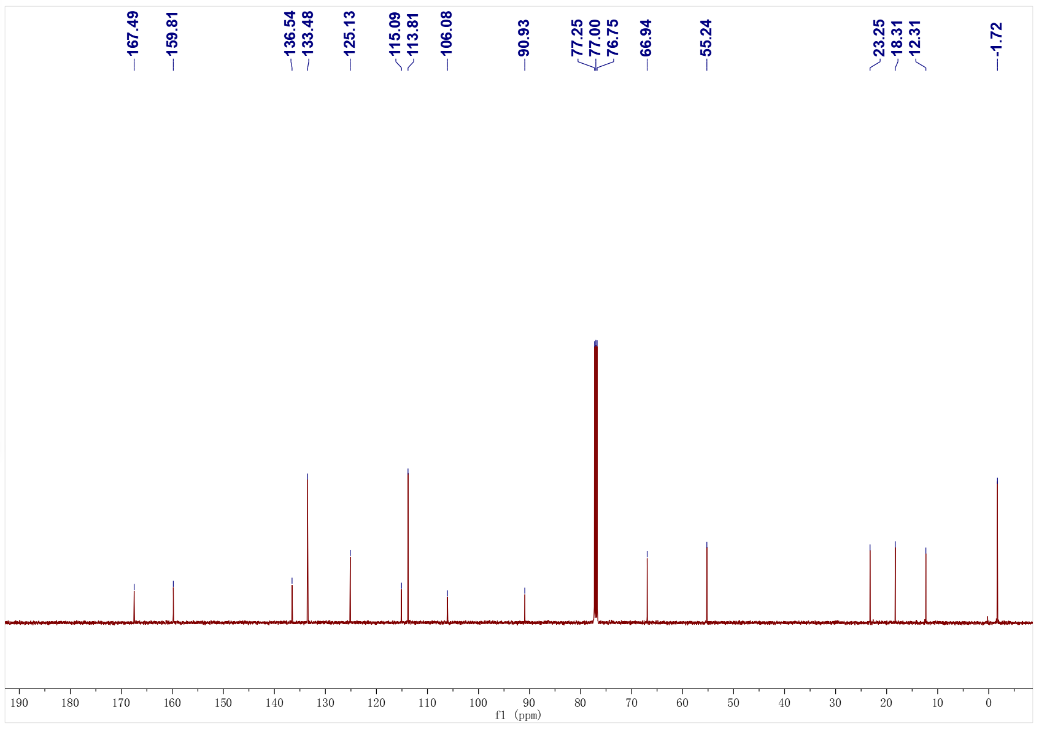
5a; ¹H NMR (400 MHz, CDCl₃); ¹³C NMR (126 MHz, CDCl₃)
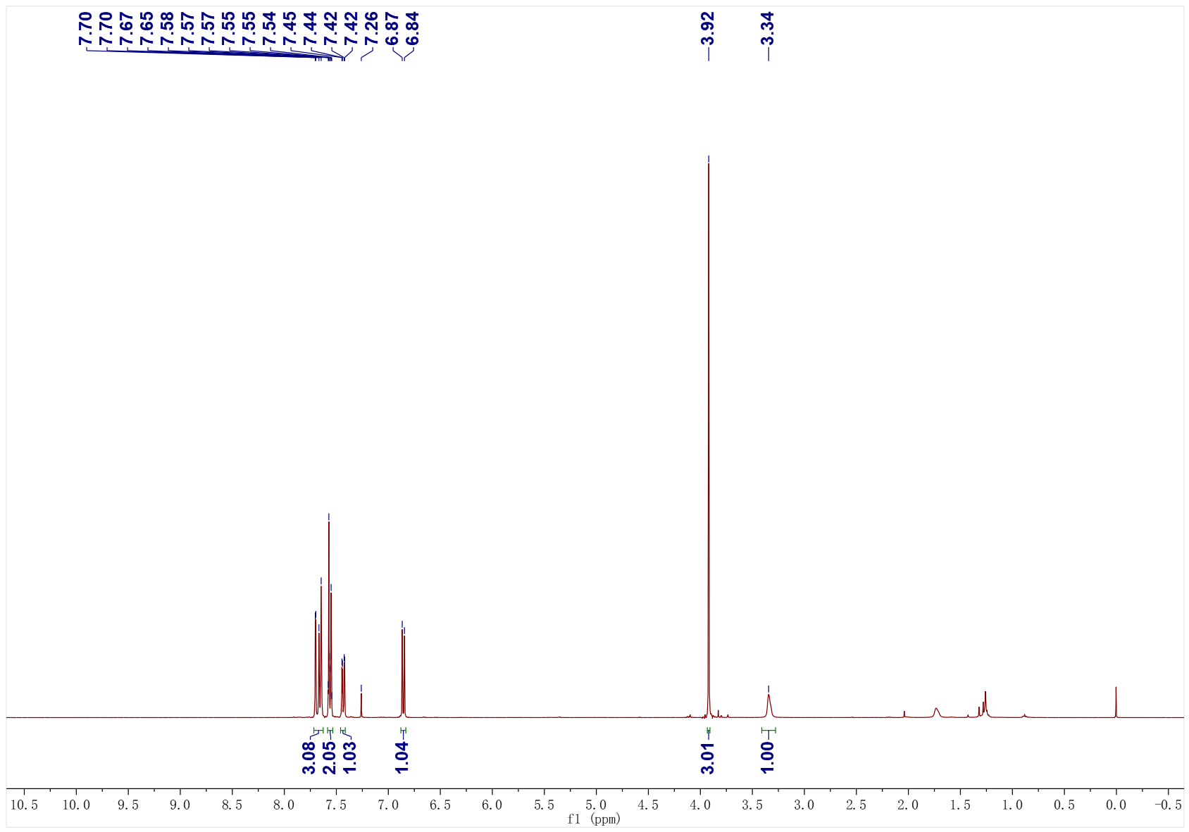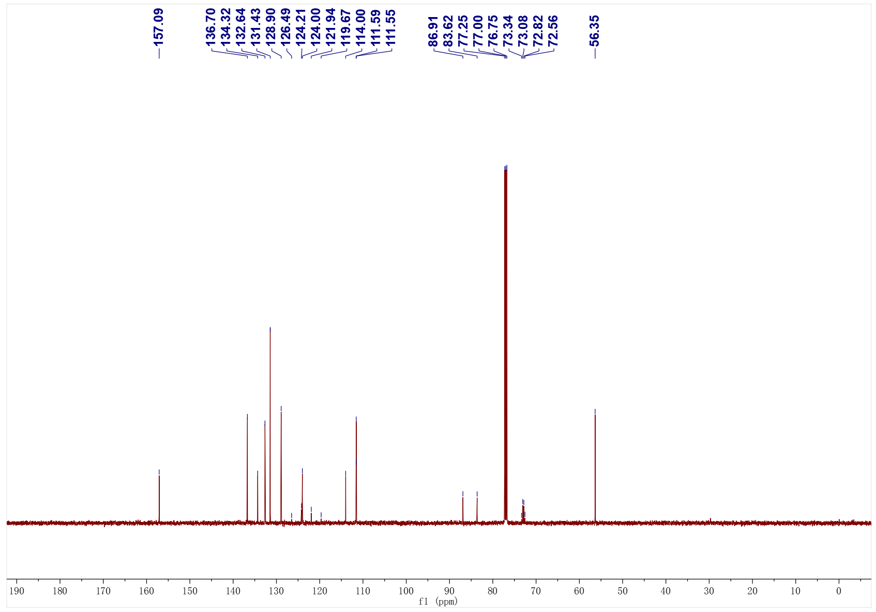
5b; ¹H NMR (400 MHz, CDCl₃); ¹³C NMR (101 MHz, CDCl₃)
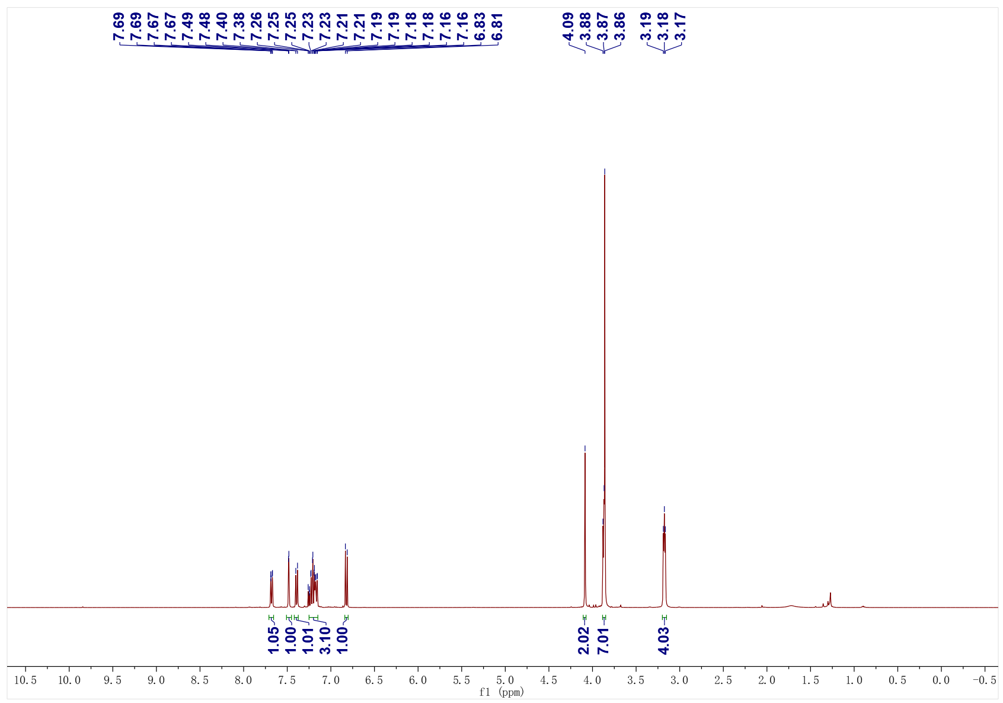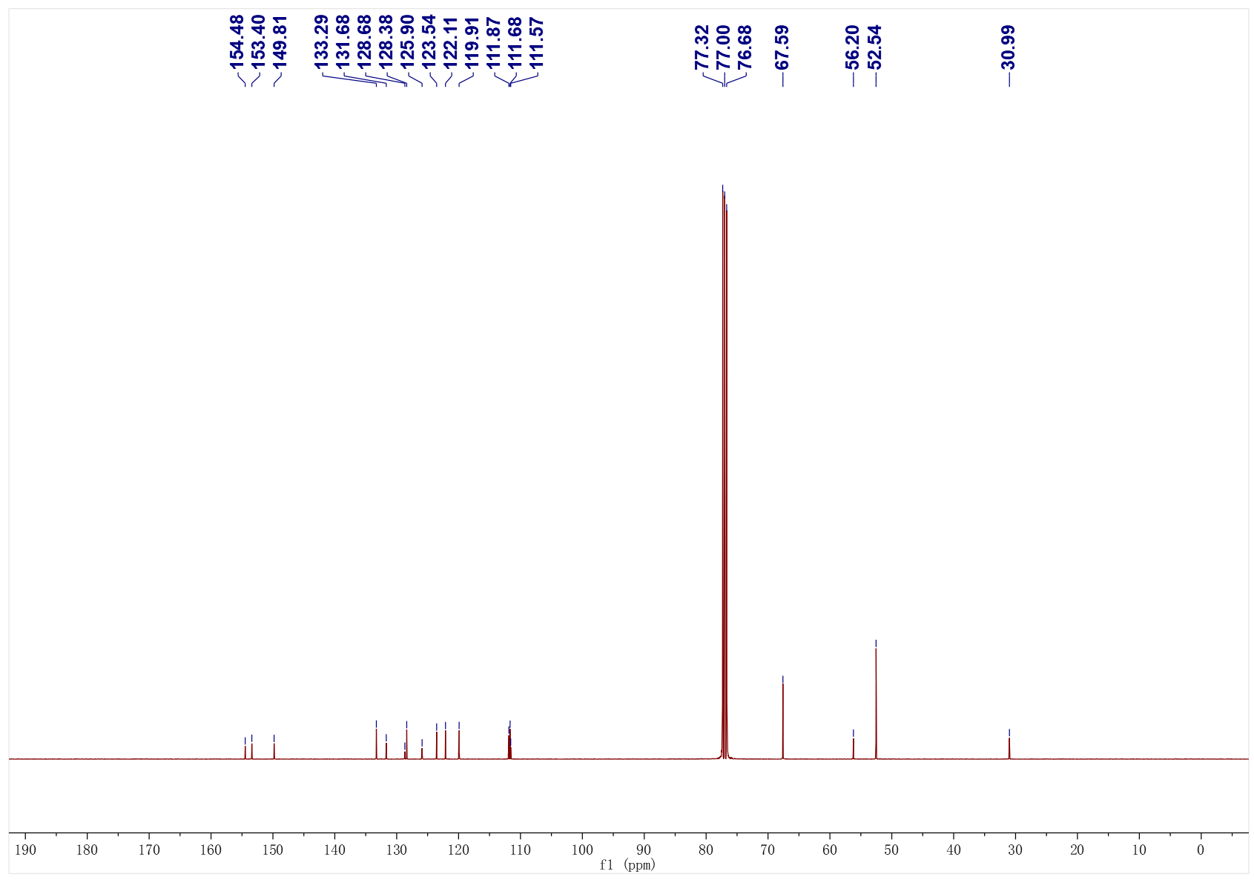
5c; ¹H NMR (400 MHz, CDCl₃); ¹³C NMR (101 MHz, CDCl₃)
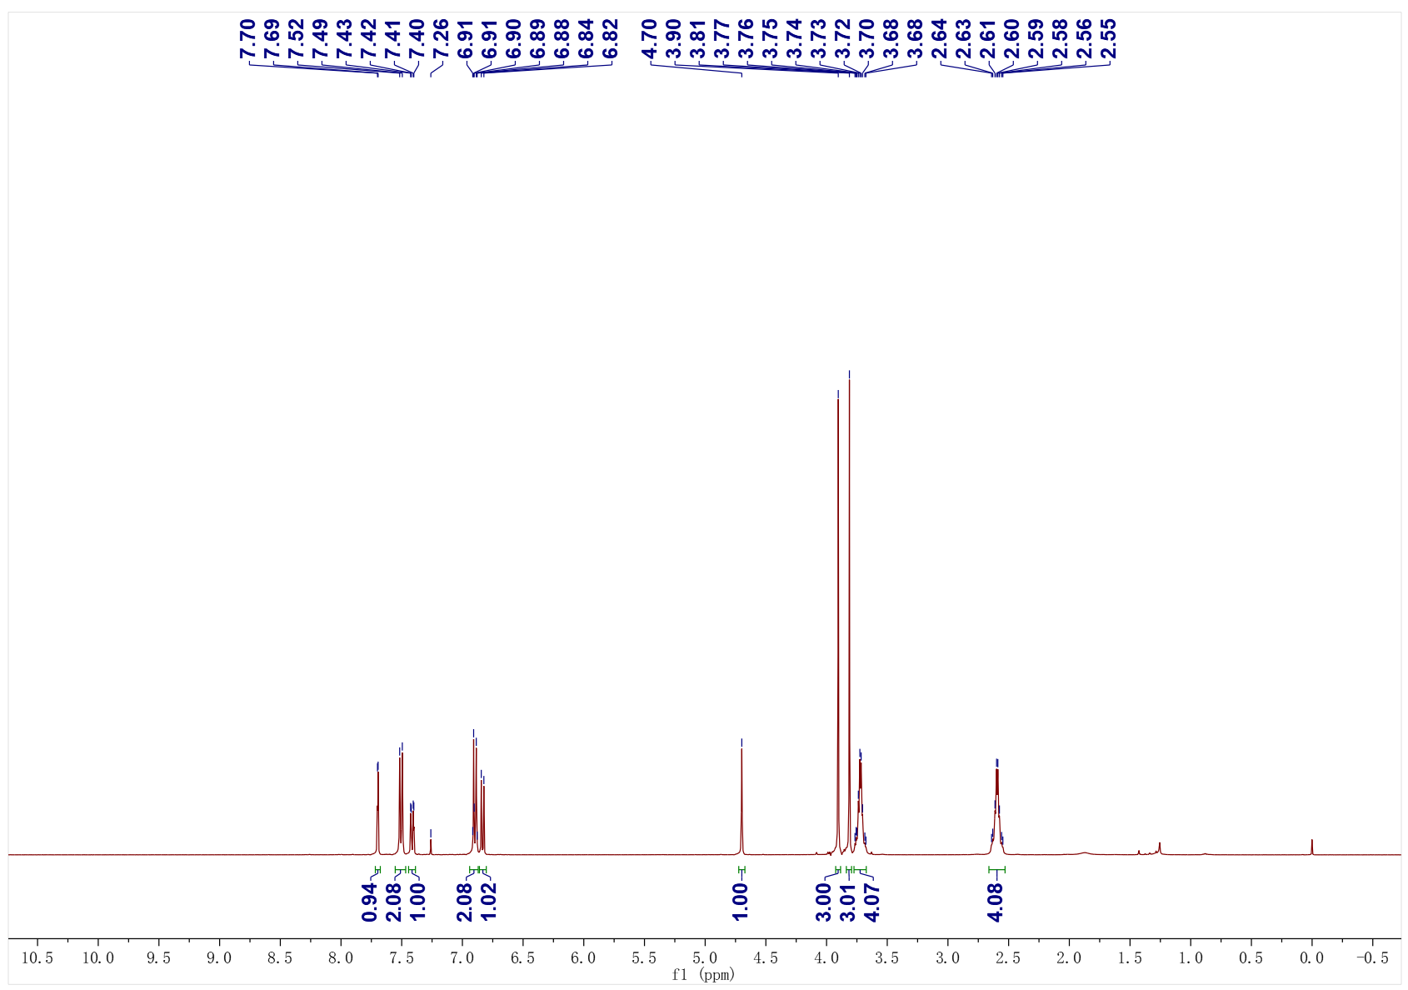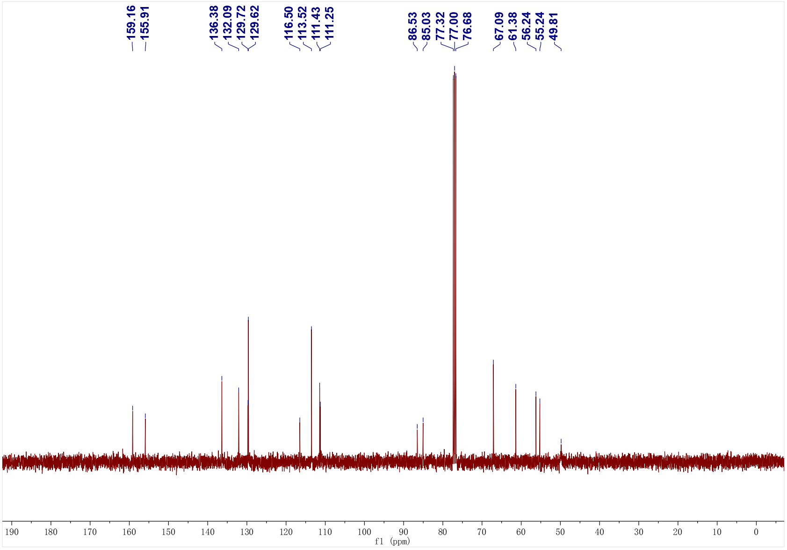
5d; ¹H NMR (400 MHz, CDCl₃); ¹³C NMR (101 MHz, CDCl₃)
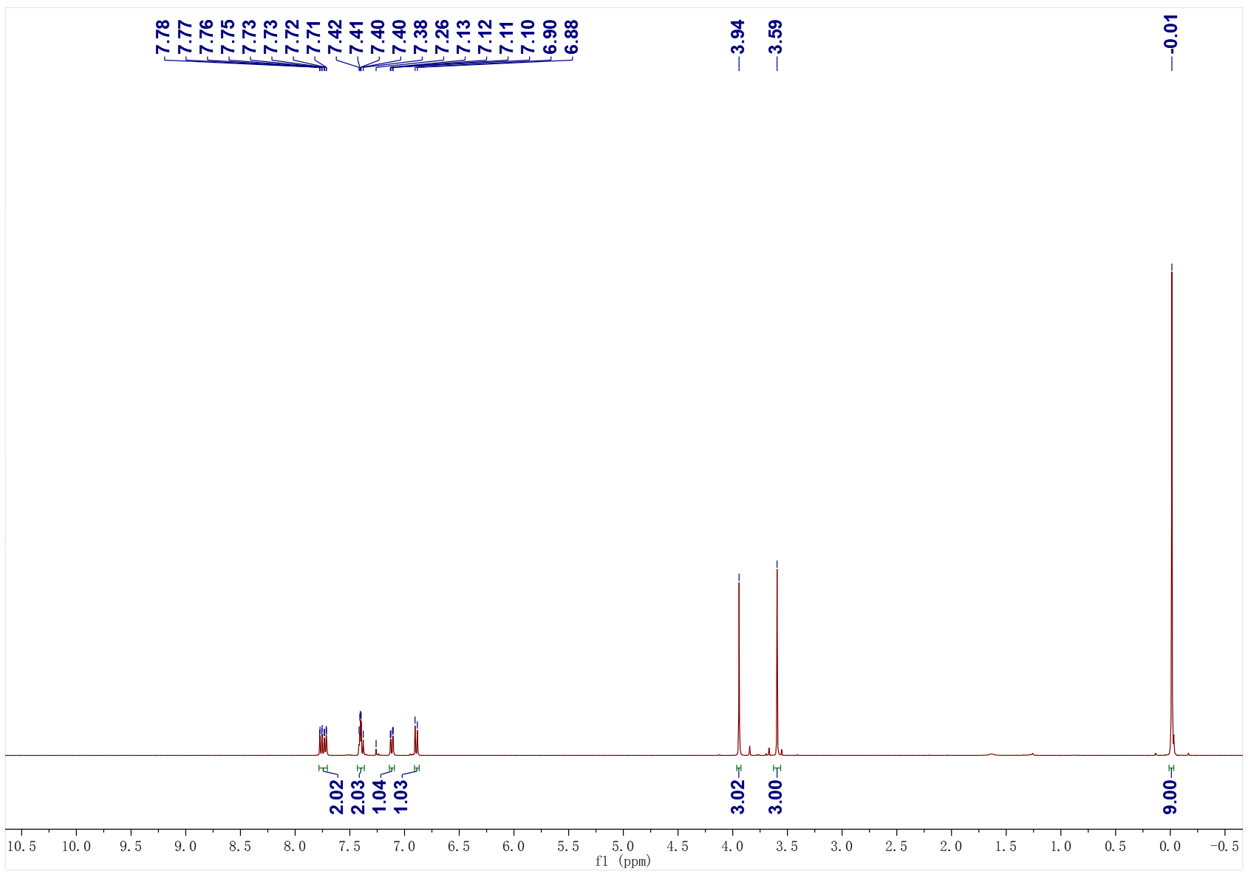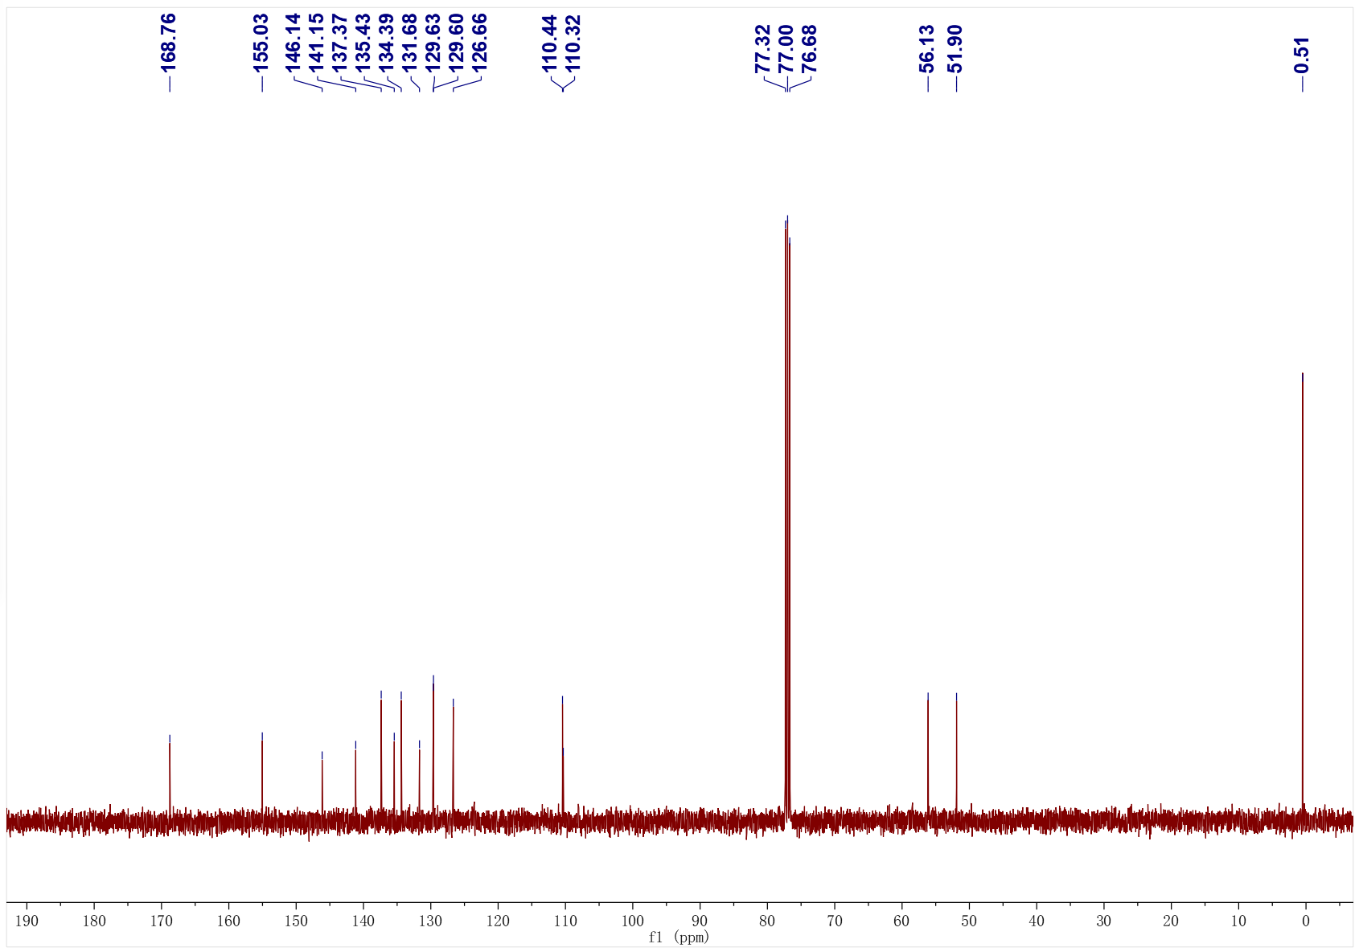
5e; ¹H NMR (400 MHz, CDCl₃); ¹³C NMR (101 MHz, CDCl₃)
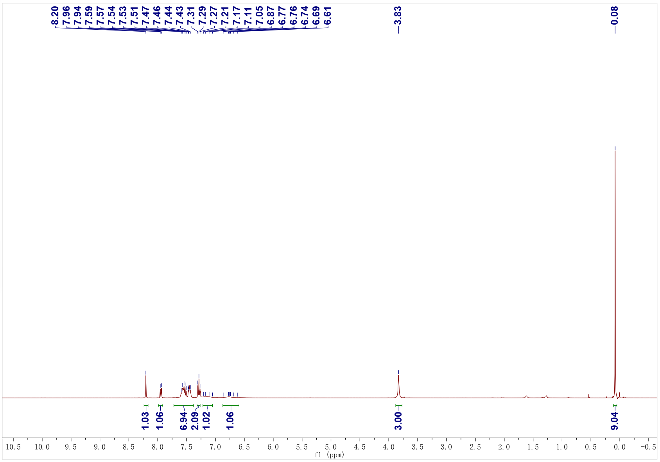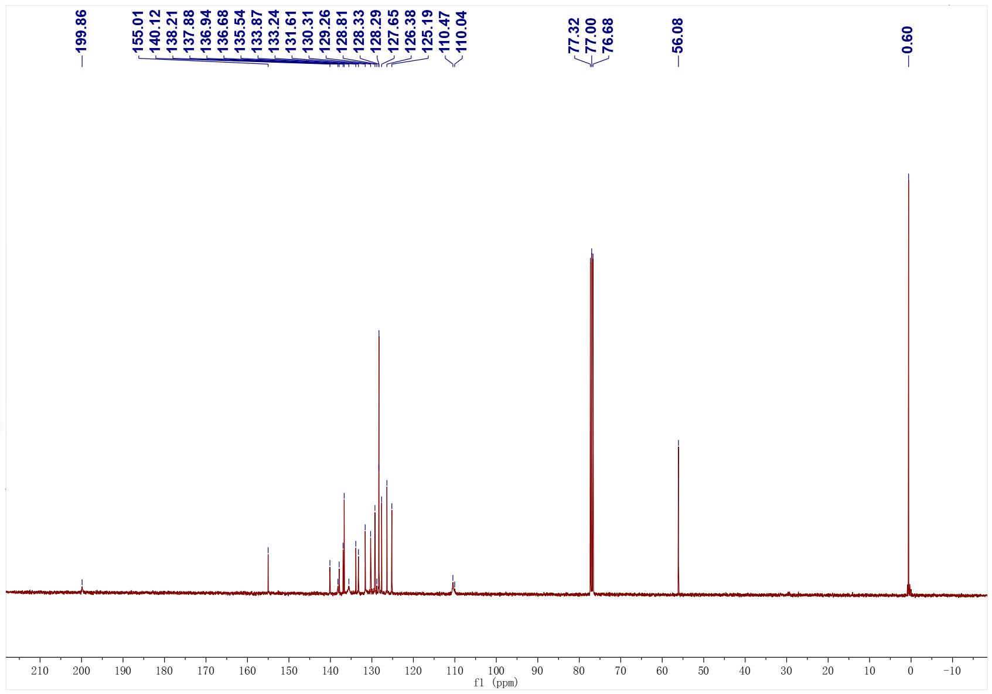
5f; ¹H NMR (400 MHz, CDCl₃); ¹³C NMR (101 MHz, CDCl₃)
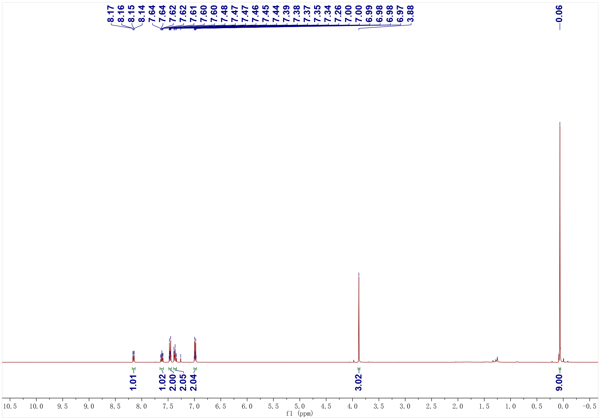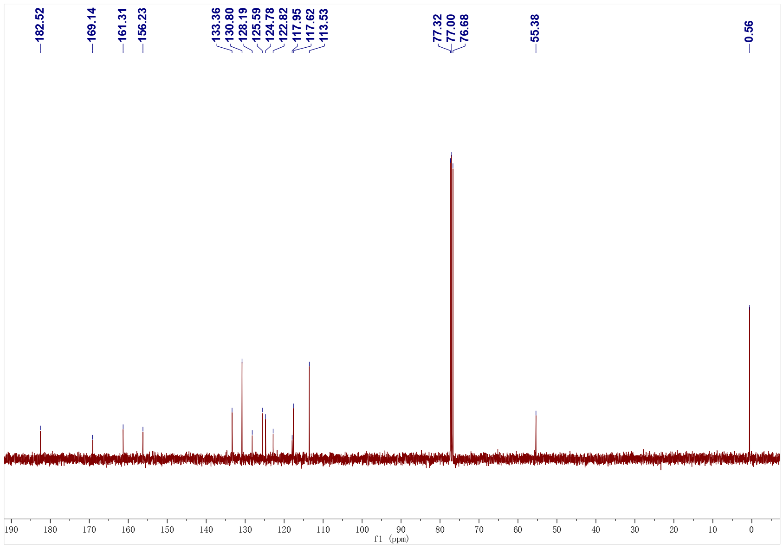
5g; ¹H NMR (400 MHz, CDCl₃); ¹³C NMR (101 MHz, CDCl₃)
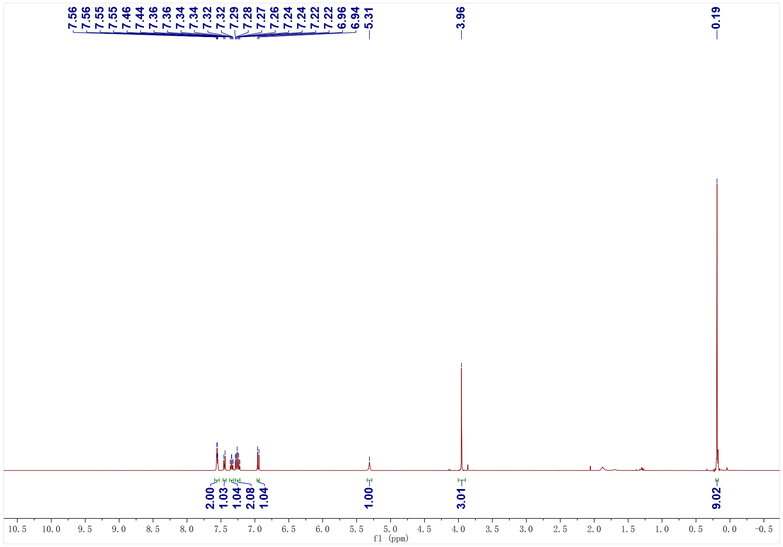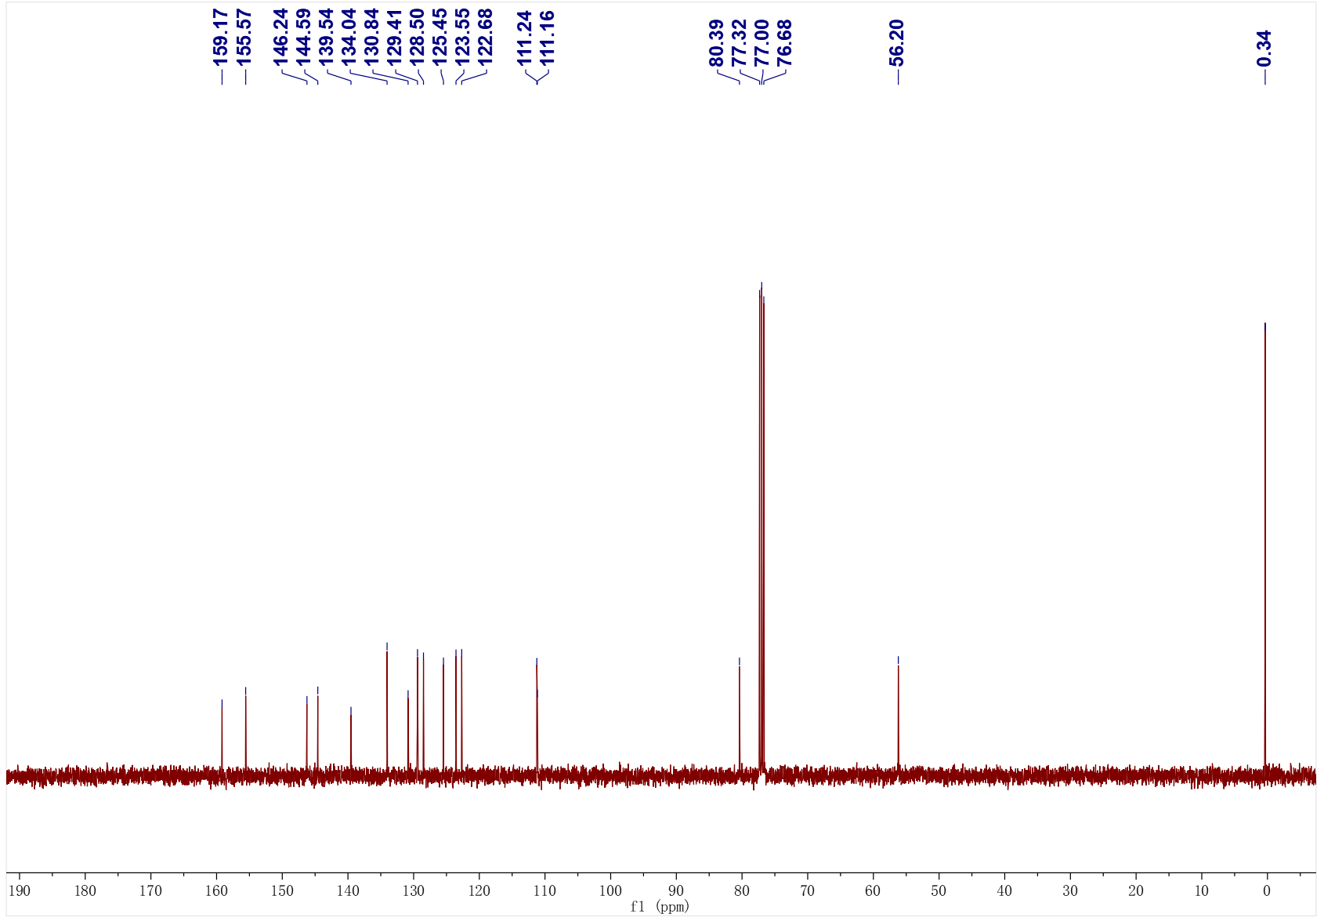
5h; ¹H NMR (400 MHz, CDCl₃); ¹³C NMR (101 MHz, CDCl₃)
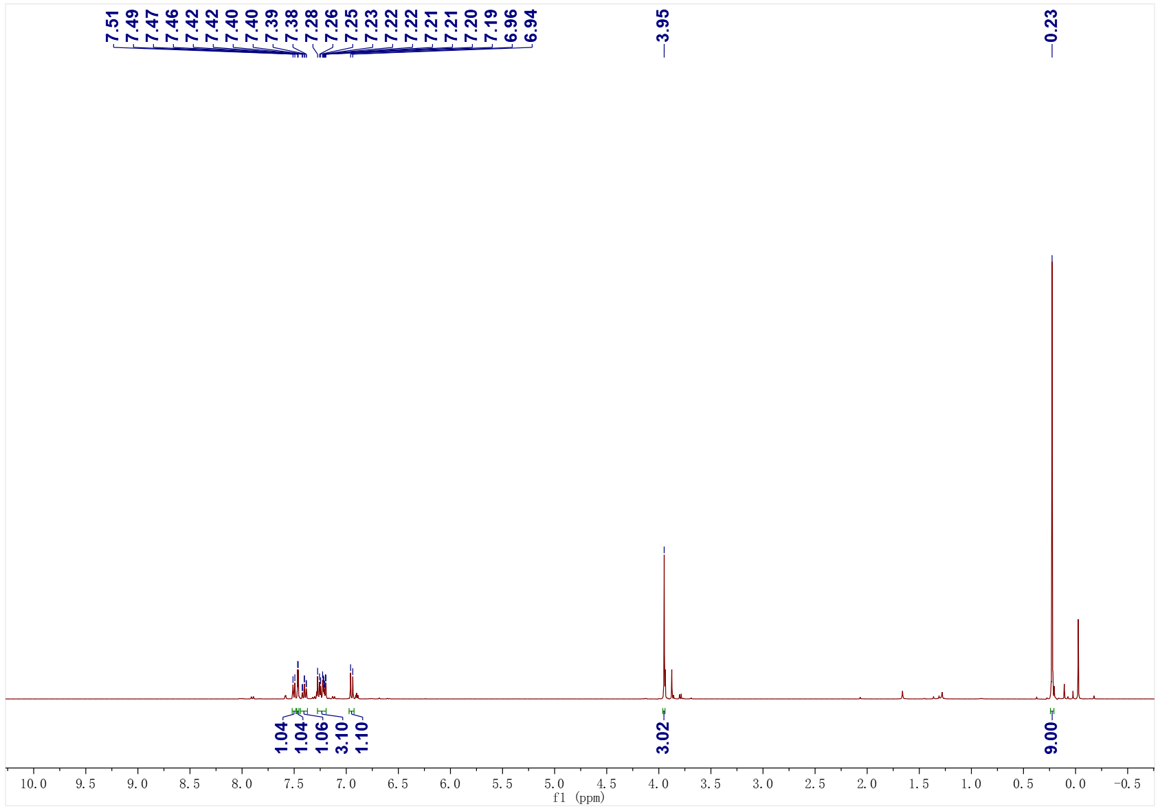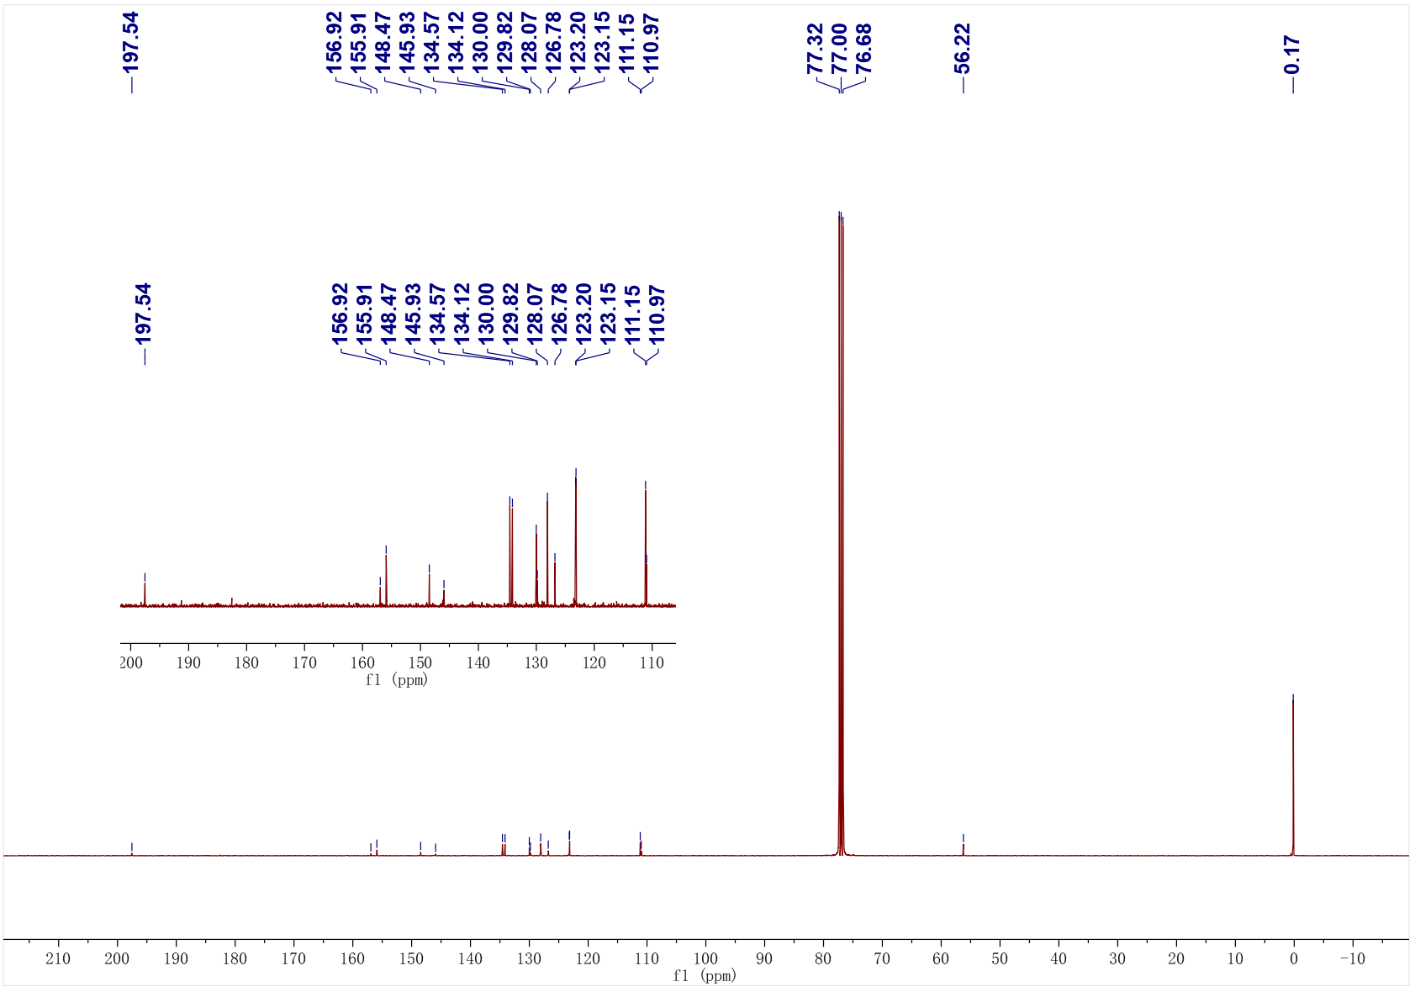

7. Reference
[1] a) S. Chang, D. Xing, Y. Zheng, L. Huang, Org. Lett. 2023, 25, 5350-5355; b) D. Xing, M. Feng, Y. Zheng, B. Huang, H. Jiang, L. Huang, Org. Chem. Front. 2023, 10, 3603-3611; c) Y. Cao, Y. Huang, P. R. Blakemore, Eur. J. Org. Chem. 2022, e202200498; d) P. E. Simm, P. Sekar, J. Richardson, P. W. Davies, ACS Catal. 2021, 11, 6357-6362; e) K. Kanemoto, S. Yoshida, T. Hosoya, Org. Lett. 2019, 21, 3172-3177.
[2] J.-L. Tu, H. Gao, M. Luo, L. Zhao, C. Yang, L. Guo, W. Xia, Green Chem. 2022, 24, 5553-5558.
[3] W. Liu, Z. Chen, L. Li, H. Wang, C.-J. Li, Chem. Eur. J. 2016, 22, 5888-5893.
[4] H. Helbert, P. Visser, J. G. H. Hermens, J. Buter, B. L. Feringa, Nat. Catal. 2020, 3, 664-671.
[5] J. Oliver-Meseguer, I. Dominguez, R. Gavara, A. Leyva-Perez, A. Corma, ChemCatChem. 2017, 9, 1429-1435.
[6] I. Kownacki, B. Orwat, B. Marciniec, A. Kownacka, Tetrahedron Lett. 2014, 55, 548-550.
[7] A. A. Rajkiewicz, N. Wojciechowska, M. Kalek, ACS Catal. 2020, 10, 831-841.
[8] T. Kawatsu, S. Kataoka, N. Fukaya, J.-C. Choi, K. Sato, K. Matsumoto, Acs Omega 2021, 6, 12853-12857.
[9] S. Lv, F. Xu, Y. Fan, K. Ding, Z. Li, J. Med. Chem. 2023, 66, 2851-2864.
[10] P. Boehm, N. Kehl, B. Morandi, Angew. Chem., Int. Ed. 2023, 62, e202214071; Angew. Chem. 2023, 135, e202214071.
[11] C.-X. Xu, C.-H. Ma, F.-R. Xiao, H.-W. Chen, B. Dai, Chin. Chem. Lett. 2016, 27, 1683-1685.
[12] A. A. Toutov, K. N. Betz, D. P. Schuman, W.-B. Liu, A. Fedorov, B. M. Stoltz, R. H. Grubbs, J. Am. Chem. Soc. 2017, 139, 1668-1674.
[13] M. Wissing, A. Studer, Chem. Eur. J. 2019, 25, 5870-5874.
[14] V. Percec, J. G. Rudick, M. Peterca, M. Wagner, M. Obata, C. M. Mitchell, W. D. Cho, V. S. K. Balagurusamy, P. A. Heiney, J. Am. Chem. Soc. 2005, 127, 15257-15264.
[15] T. M. El Dine, R. Jimmidi, A. Diaconu, M. Fransolet, C. Michiels, J. De Winter, E. Gillon, A. Imberty, T. Coenye, S. P. Vincent, J. Med. Chem. 2021, 64, 14728-14744.
[16] S. Picard, E. J. Cueto-Diaz, E. Genin, G. Clermont, F. Acher, D. Ogden, M. Blanchard-Desce, Chem. Commun. 2013, 49, 10805-10807.
[17] B. Marciniec, B. Dudziec, I. Kownacki, Angew. Chem., Int. Ed. 2006, 45, 8180-8184.
[18] R. Rossi, A. Carpita, T. Messeri, synth. Comm., 1991, 21, 1875-1888.
[19] H. Y. Cho, S. K. Woo, G. T. Hwang, Molecules 2012, 17, 12061-12071.
[20] G. Albano, F. Zinna, F. Urraci, M. A. M. Capozzi, G. Pescitelli, A. Punzi, L. Di Bari, G. M. Farinola, Chem. Eur. J. 2022, 28, e202201178.
[21] C. Koerner, P. Starkov, T. D. Sheppard, J. Am. Chem. Soc. 2010, 132, 5968-+.
[22] K. Nozawa-Kumada, M. Inagi, Y. Kondo, Asian J. Org. Chem. 2017, 6, 63-66.
[23] S. N. Greszler, H. A. Reichard, G. C. Micalizio, J. Am. Chem. Soc. 2012, 134, 2766-2774.
[24] T. Tsuchimoto, M. Fujii, Y. Iketani, M. Sekine, Adv. Synth. Catal. 2012, 354, 2959-2964.
[25] Q.-C. Gan, Z.-Q. Song, C.-H. Tung, L.-Z. Wu, Org. Lett. 2022, 24, 5192-5196.
[26] V. R. Chintareddy, K. Wadhwa, J. G. Verkade, J. Org. Chem. 2011, 76, 4482-4488.
[27] N. Sakai, N. Uchida, T. Konakahara, Tetrahedron Lett. 2008, 49, 3437-3440.
[28] N. Sakai, N. Uchida, T. Konakahara, Synlett 2008, 1515-1519.
[29] M.-M. Xu, X.-Y. You, Y.-Z. Zhang, Y. Lu, K. Tan, L. Yang, Q. Cai, J. Am. Chem. Soc. 2021, 143, 8993-9001.
[30] N. Asao, K. Takahashi, S. Lee, T. Kasahara, Y. Yamamoto, J. Am. Chem. Soc. 2002, 124, 12650-12651.
[31] J. Yang, N. Yoshikai, Angew. Chem., Int. Ed. 2016, 55, 2870-2874; Angew. Chem. 2016, 128, 2920-2924.
[32] M. Ueda, T. Ueno, Y. Suyama, I. Ryu, Tetrahedron Lett. 2017, 58, 2972-2974.
[33] M. Ueda, T. Ueno, Y. Suyama, I. Ryu, Chem. Commun. 2016, 52, 13237-13240.

