Supplemental Figure 1

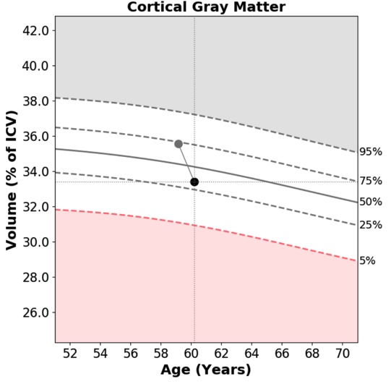
Saline
MSC-NP

Supplemental Figure 1. Increased grey matter volume in subjects following MSC-NP treatment. Lesion QuantTM Flair lesion report displaying age and sex matched volumetric assessment of cortical gray matter normalized as a percentage of intracranial volume (ICV) in 2 representative subjects from the saline group (top panel) and 2 representative subjects from the MSC-NP group (bottom panel). Grey dots and black dots represent gray matter volume at baseline and after 1 year of treatment, respectively.

