Supplementary Materials

Table of Contents
Tables 2
Table S1. Characteristics of Included Studies 2
Table S2. Pulse Oximetry Study Bias by Skin Pigmentation 8
Table S3. Pulse Rate Study Bias by Skin Pigmentation 13
Table S4. Heterogeneity Pulse Rate Bias by Skin Tone 15
Table S5. Sensitivity Analyses of Pulse Rate Bias by Skin Pigmentation 16
Table S6. Pulse Oximetry Sensitivity Analysis with Crooks et al. (2022) Removed 17
Table S7. Shi et al. (2022)28 Manuscripts Not Included 18
Table S8. Coding Skin Tone, Race, and Ethnicity to Low, Medium, and High Skin Pigmentation Categories 19
Table S9. Excluded Manuscripts 20
Figures 27
Figure S1. Funnel Plot Pulse Oximetry 27
Figure S2. Funnel Plot Pulse Rate 28
Materials 29
Search Report: PPG and Skin of Color 29
Data Extraction 34
Additional Details on Method for Statistical Analysis 35

Tables

Table S1. Characteristics of Included Studies
Study (Author, Year) | Sample Size | Test Device Evaluated | Reference Device | SaO₂ (%) Range | Participant Population | Research Setting | Skin Pigmentation Method
Pulse Oximetry
Abrams 2003¹ | 200 | Nellcor N-200 | Radiometer ABL-520 | Not reported | Medical- Adult patients with cirrhosis | Inpatient | Race- Black and White
Adler 1998² | 298 | Nellcor D-25 | 4-wavelength spectro-photometer, or co-oximeter (Radiometer OSM3) | 50 to 99 | Medical- Adult emergency room patients | Inpatient | Skin Tone- Munsell color system categorized into light, medium, or dark
Andrist 2022³ | 1,061 | Not Reported | Not Reported | Not Reported | Medical- Pediatric | Inpatient | Race
Barker 2023⁴ | 75 | Masimo SET® pulse oximeters with RD-SET® sensors | Radiometer ABL-835 Flex CO-Oximeter | 70 to 100 | Mixed- Healthy and mild systemic disease | Research- Lab | Race
Bickler 2005⁵ | 23 | -Nellcor N-595 with Nellcor OxiMax A finger probe  -Novametrix 513s models (two types)  -Nonin Onyx models (two types) | Radiometer OSM3 | 60 to 100 | Healthy- non-smoking | Research- Lab | Ethnicity- light (Northern European) and dark (African-American)
Bothma 1996⁶ | 100 | Simed S100e  Nihon Koden  Ohmeda 3740 | IL482 Co-oximeter System | 87·8 to 99·2 | Medical- critically ill adult patients | Inpatient | Skin Tone- EEL reflectance spectrophotometer. All participants had dark skin tone
Burnett 2022⁷ | 46,253 | Unspecified Nellcor and Masimo devices | GEMStat Premier 3000 | Not Reported | Medical- patients receiving anesthesia | Inpatient | Race and Ethnicity
Crooks 2022⁸ | 2,997 | Not reported | Not reported | Not reported | Medical- COVID-19 | Inpatient | Race
Ebmeier 2018⁹ | 394 | Marquette Rac-4A monitors with Masimo sensors and Philips IntelliVue  MP70 monitors with Philips  Adult Reusable SpO₂  sensors | Radiometer ABL 800 FLEX arterial  blood gas analyser | Not reported | Medical- multiple conditions | Inpatient | Ethnicity
Fawzy 2022¹⁰ | 1,216 | Not reported | ABL825, ABL827, or ABL90 blood gas analyzers | Not reported | Medical- COVID-19 | Inpatient | Race and Ethnicity
Feiner 2007¹¹ | 36 | Nellcor N-595 (OxiMax A adhesive probe)  Nellcor N-595 (a clip-type probe)  Masimo Radical (clip probe)  Masimo Radical (adhesive disposable probe)  Nonin 9700 (clip-type probe)  Nonin 9700 (disposable adhesive probe) | Radiometer OSM3 multiwavelength oximeter | 60 to 100 | Healthy- non-smoking | Research- Lab | Ethnicity- light (Caucasian), intermediate (Hispanic, Indian, Filipino, Vietnamese), and dark (African American) categories
Foglia 2017¹² | 36 | Nellcor Oximax (Covidien)  Masimo Rainbow SET Radical 7 | Siemens Rapidlab 1265 | 60 to 92 | Medical- Infants with cyanotic congenital heart disease and oxygen saturation <90% | Inpatient | Skin Tone- Munsell Color System
Jubran 1990¹³ | 54 | Nellcor pulse oximeter with disposable or reusable probes  Ohmeda-Biox3700 pulse oximeter with reusable probe | CO-oximetry | Not reported | Medical- Critically ill, ventilator-dependent patients | Inpatient | Race- Black and White
McGovern 1996¹⁴ | 8 | Ohmeda 3700 | IL 482 Co-oximeter | Not reported | Medical- Adults with stable condition with severe COPD | Research- Lab | Race- All White
Muñoz 2008¹⁵ | 846 | Minolta Pulsox-7 | IL 682 co-oximeter | Not reported | Medical- Adults under assessment for long-term home oxygen therapy | Outpatient | Race- All White
Pilcher 2020¹⁶ | 400 | Carescape B450 monitor with Nellcor probe  GE Dash 3000  Masimo Radical 7  Masimo SET Quartz (unspecified)  Masimo SET Quartz Q400  Nonin 2120  Nonin 2140  Nonin Avant (unspecified)  Nonin Avant 4000  Nonin Avant 9700  Nonin Lifesense Medair  Novametrix Model 512  Ohmeda Biox 3700E with a GE TruSignal or Nellcor probe  Philips Intellivue MP70 with a GE TruSignal Nellcor or Philips probe  Welch Allyn with a Nellcor probe | Radiometer ABL800 | 72 to 100 | Medical- Hospitalized adult patients | Inpatient and Outpatient | Skin Tone- Fitzpatrick Scale categorized into light, medium, dark
Ruppel 2023¹⁷ | 774 | Not reported | Not reported | Not reported | Medical- cardiac catheterization | Inpatient | Race
Sudat 2023¹⁸ | 8,735 | Not reported | Not reported | Not reported | Medical- multiple conditions | Inpatient | Race
Thrush 1994¹⁹ | 25 | Critikon Dinamap Plus Model 8700  Critikon Oxyshuttle  Ohmeda 3700  Catalyst Research MiniOx IV | IL482 co-oximeter | 80 to 100 | Healthy- non-smoking adults | Research- Lab | Race- All White
Valbuena 2022²⁰ | 372 | Not reported | Not reported, blood gas analysis | Not reported | Medical- Adult patients with respiratory failure or COVID-19 | Inpatient | Race and Ethnicity- White, Black, Hispanic, and Asian
Vesoulis 2021²¹ | 294 | Nellcor SpO₂ module with Neonatal-Adult MAX-N adhesive SpO₂ sensor (Covidien) (used with either Philips IntelliVue MP70 or MX800 monitors) | Radiometer ABL800 Flex | Not reported | Medical- Preterm infants at neonatal intensive care unit | Inpatient | Race- White and Black
Wiles 2022²² | 194 | Nellcor reusable SpO₂ probes or Mindray disposable SpO₂ probes (GE Healthcare B1x5 M/P monitor) | RAPIDpoint 500 analyser (Siemens Healthcare GmbH) | Not reported | Medical- Adult patients with COVID-19 pneumonitis | Inpatient | Race- Asian, Black, White, and Other
Zeballos 1991²³ | 33 | Hewlett-Packard HP-47201A  Ohmeda Biox IIA | IL282 co-oximeter | Not reported | Healthy- non-smoking volunteers | Research- Lab | Race- All Black
Pulse Rate
Bent et al. (2020)²⁴ | 53 | Empatica E4  Apple Watch  Fitbit Charge  Garmin Vivosmart 3  Xiaomi Miband  Biovotion Everion | BittiumFaros 180, Bittium Inc. | NA | Healthy | Research- Lab | Skin Tone- Fitzpatrick Scale  1 (n = 7)  2 (n = 8)  3 (n = 10)  4 (n = 9)  5 (n = 9)  6 (n = 10)
Nelson et al. (2019)²⁵ | 1 | Apple Watch 3  Fitbit Charge 2 | Vrije Universiteit Ambulatory Monitoring System | NA | Healthy | Research- Real World | Skin Tone- Fitzpatrick Scale  1 (n = 1)
Sanudo 2019²⁶ | 45 | Apple Watch (version not reported) | Polar Chest Strap | NA | Healthy | Research- Lab | Skin Tone- Fitzpatrick Scale  2 (n = 15)  3 (n = 15)  4 (n = 15)
Chow 2020²⁷ | 40 | Garmin Vivosmart HR+  Xiaomi Mi Band 2 | Polar H7 Chest Strap | NA | Healthy | Research- Lab | Ethnicity and Skin Tone- East Asian, Fitzpatrick Scale 3 and 4

Table S2. Pulse Oximetry Study Bias by Skin Pigmentation
Study | Device | Sample | Data Pairs | Mean Bias | SE | Skin Pigmentation Group
Adler et al. 1998 | Nellcor D-25 | 145 | 145 | 2·50 | 0·38 | light
Andrist et al. 2022 | Not Specified | 878 | 7018 | 3·50 | 0·17 | light
Barker et al. 2023 | Masimo SET¬Æ pulse oximeters | 36 | 3982 | -0·05 | 0·23 | light
Bickler et al. 2005 | Nonin Onyx | 10 | 200 | -0·21 | 0·47 | light
Bickler et al. 2005 | Novametrix 513 | 10 | 200 | 1·15 | 0·60 | light
Bickler et al. 2005 | Nellcor D-25 | 10 | 220 | -0·27 | 0·68 | light
Burnett et al. 2022 | Not Specified- Hospital Standard Pulse Oximeter | 22089 | 70722 | 0·20 | 0·04 | light
Crooks et al. 2022 | Not Specified- Hospital Standard Pulse Oximeter | 3946 | 3946 | 3·20 | 13·24 | light
Ebmeier et al. 2018 | Philips (IntelliVue MP70) | 98 | 98 | -0·17 | 0·22 | light
Ebmeier et al. 2018 | Masimo (GE Marquette Rac-4A) | 142 | 142 | 1·07 | 0·16 | light
Fawzy et al. 2022 | Not Specified- Hospital Standard Pulse Oximeter | 460 | 460 | 0·75 | 0·09 | light
Feiner et al. 2007 | Masimo Radical (Clip) | 12 | 263 | 0·21 | 0·52 | light
Feiner et al. 2007 | Nellcor N-595 (clip) | 12 | 263 | 0·36 | 0·50 | light
Feiner et al. 2007 | Nonin 9700 (clip) | 12 | 263 | -0·95 | 0·45 | light
Feiner et al. 2007 | Masimo Radical (adhesive) | 12 | 263 | -0·64 | 0·68 | light
Feiner et al. 2007 | Nellcor N-595 & OxiMax (adhesive) | 12 | 263 | 1·04 | 0·47 | light
Feiner et al. 2007 | Nonin 9700 (adhesive) | 12 | 263 | 0·52 | 0·41 | light
Foglia et al. 2017 | Masimo Radical (Rainbow) | 21 | 21 | 0·20 | 0·83 | light
Foglia et al. 2017 | Nellcor OxiMax | 19 | 19 | 3·00 | 1·15 | light
Jubran et al. 1990 | Nellcor/Ohmeda Biox 3700 | 25 | 55 | 2·20 | 0·36 | light
McGovern et al. 1996 | IL 482 Co-oximeter | 8 | 8 | -1·7 | 1·03 | light
Munoz et al. 2008 | Minolta pulse oximeter | 846 | 846 | 0·47 | 0·08 | light
Pilcher et al. 2020 | 14 models | 242 | 242 | -1·2 | 0·11 | light
Ruppel et al. 2023 | Not Specified- Hospital Standard Pulse Oximeter | 573 | 573 | 0·88 | 0·13 | light
Sudat et al. 2023 | Not Specified- Hospital Standard Pulse Oximeter | 10514 | 35127 | 1·53 | 0·05 | light
Thrush et al. 1994 | Dinamap Plus 8700 | 22 | 88 | 0·00 | 0·65 | light
Thrush et al. 1994 | Dinamap Plus 8700 | 22 | 88 | 1·00 | 0·43 | light
Thrush et al. 1994 | Dinamap Plus 8700 | 22 | 88 | 1·00 | 0·43 | light
Thrush et al. 1994 | Dinamap Plus 8700 | 22 | 88 | 1·00 | 0·22 | light
Thrush et al. 1994 | Ohmeda Oxyshuttle | 22 | 88 | 2·00 | 0·65 | light
Thrush et al. 1994 | Ohmeda Oxyshuttle | 22 | 88 | 1·00 | 0·65 | light
Thrush et al. 1994 | Ohmeda Oxyshuttle | 22 | 88 | 0·00 | 0·43 | light
Thrush et al. 1994 | Ohmeda Oxyshuttle | 22 | 88 | 1·00 | 0·22 | light
Thrush et al. 1994 | MiniOx IV | 22 | 88 | 1·00 | 0·65 | light
Thrush et al. 1994 | MiniOx IV | 22 | 88 | 0·00 | 0·87 | light
Thrush et al. 1994 | MiniOx IV | 22 | 88 | 1·00 | 0·43 | light
Thrush et al. 1994 | MiniOx IV | 22 | 88 | 0·00 | 0·43 | light
Thrush et al. 1994 | Ohmeda 3700 | 22 | 88 | 1·00 | 1·08 | light
Thrush et al. 1994 | Ohmeda 3700 | 22 | 88 | 0·00 | 0·65 | light
Thrush et al. 1994 | Ohmeda 3700 | 22 | 88 | 2·00 | 0·43 | light
Thrush et al. 1994 | Ohmeda 3700 | 22 | 88 | 1·00 | 0·43 | light
Valbuena et al. 2022 | Not Specified- Hospital Standard Pulse Oximeter | 186 | 675 | 0·30 | 0·54 | light
Vesoulis et al. 2021 | nelcor MAX-N | 170 | 2342 | 0·72 | 0·68 | light
Wiles et al. 2022 | Nelcor GE B1x5 M/P | 135 | 4197 | -0·28 | 0·09 | light
Adler et al. 1998 | Nellcor D-25 | 105 | 105 | 2·80 | 0·51 | medium
Burnett et al. 2022 | Not Specified- Hospital Standard Pulse Oximeter | 8916 | 29344 | -0·41 | 0·08 | medium
Crooks et al. 2022 | Not Specified- Hospital Standard Pulse Oximeter | 246 | 246 | 5·10 | 14·74 | medium
Ebmeier et al. 2018 | Philips (IntelliVue MP70) | 89 | 89 | -0·45 | 0·22 | medium
Ebmeier et al. 2018 | Masimo (GE Marquette Rac-4A) | 48 | 48 | -0·11 | 0·26 | medium
Fawzy et al. 2022 | Not Specified- Hospital Standard Pulse Oximeter | 278 | 278 | 0·79 | 0·14 | medium
Feiner et al. 2007 | Masimo Radical (clip) | 7 | 154 | 0·99 | 0·85 | medium
Feiner et al. 2007 | Nellcor N-595 (clip) | 7 | 154 | 0·64 | 0·65 | medium
Feiner et al. 2007 | Nonin 9700 (clip) | 7 | 154 | 0·03 | 0·78 | medium
Feiner et al. 2007 | Masimo Radical (adhesive) | 7 | 154 | -0·34 | 0·80 | medium
Feiner et al. 2007 | Nellcor N-595 & OxiMax (adhesive) | 7 | 154 | 0·83 | 0·95 | medium
Feiner et al. 2007 | Nonin 9700 (adhesive) | 7 | 154 | 0·51 | 1·07 | medium
Pilcher et al. 2020 | 14 models | 157 | 157 | -1·10 | 0·13 | medium
Valbuena et al. 2022 | Not Specified- Hospital Standard Pulse Oximeter | 135 | 481 | 0·27 | 0·53 | medium
Wiles et al. 2022 | Not Specified | 34 | 1241 | 0·33 | 0·19 | medium
Abrams et al. 2002 | Nellcor N200 | 16 | 16 | 3·60 | 0·33 | dark
Adler et al. 1998 | Nellcor D-25 | 34 | 34 | 2·20 | 0·63 | dark
Andrist et al. 2022 | Not Specified | 183 | 2005 | 4·30 | 0·37 | dark
Barker et al. 2023 | Masimo SET¬Æ pulse oximeters | 39 | 3201 | -0·20 | 0·23 | dark
Bickler et al. 2005 | Nonin Onyx | 11 | 119 | 0·15 | 0·47 | dark
Bickler et al. 2005 | Novametrix 513 | 11 | 119 | 1·83 | 0·67 | dark
Bickler et al. 2005 | Nellcor 5-595 | 11 | 209 | 1·29 | 0·64 | dark
Bothma et al. 1996 | Simed S100e | 100 | 100 | 1·20 | 0·19 | dark
Bothma et al. 1996 | Nihon Koden | 100 | 100 | 0·85 | 0·25 | dark
Bothma et al. 1996 | Ohmeda 3740 (finger) | 100 | 100 | 0·55 | 0·20 | dark
Bothma et al. 1996 | Ohmeda 3740 (ear) | 100 | 100 | -1·00 | 0·24 | dark
Burnett et al. 2022 | Not Specified- Hospital Standard Pulse Oximeter | 5177 | 16011 | -0·60 | 0·13 | dark
Crooks et al. 2022 | Not Specified- Hospital Standard Pulse Oximeter | 151 | 151 | 5·40 | 15·99 | dark
Ebmeier et al. 2018 | IntelliVue MP70 | 8 | 8 | -2·24 | 0·61 | dark
Ebmeier et al. 2018 | GE Marquette Rac-4A | 4 | 4 | -1·10 | 0·20 | dark
Fawzy et al. 2022 | Not Specified- Hospital Standard Pulse Oximeter | 478 | 478 | 1·16 | 0·13 | dark
Feiner et al. 2007 | Masimo Radical (clip) | 17 | 372 | 2·14 | 0·73 | dark
Feiner et al. 2007 | Nellcor N-595 (clip) | 17 | 371 | 2·04 | 0·52 | dark
Feiner et al. 2007 | Nonin 9700 (clip) | 17 | 372 | -0·63 | 0·29 | dark
Feiner et al. 2007 | Masimo Radical (adhesive) | 17 | 372 | -0·24 | 0·70 | dark
Feiner et al. 2007 | Nellcor N-595 (Oximax, adhesive) | 17 | 359 | 2·13 | 0·60 | dark
Feiner et al. 2007 | Nonin 9700 (adhesive) | 17 | 371 | 1·26 | 0·52 | dark
Foglia et al. 2017 | Masimo Radical | 14 | 14 | 1·60 | 1·28 | dark
Foglia et al. 2017 | Nellcor Oximax | 14 | 14 | 5·40 | 1·36 | dark
Jubran et al. 1990 | Nellcor/Ohmeda Biox 3700 | 29 | 43 | 3·30 | 0·50 | dark
Ruppel et al. 2023 | Not Specified- Hospital Standard Pulse Oximeter | 201 | 201 | 2·61 | 0·22 | dark
Sudat et al. 2023 | Not Specified- Hospital Standard Pulse Oximeter | 2616 | 8626 | 2·45 | 0·14 | dark
Valbuena et al. 2022 | Not Specified- Hospital Standard Pulse Oximeter | 51 | 195 | 1·70 | 1·44 | dark
Vesoulis et al. 2021 | Nellcor MAX-N | 124 | 2044 | 1·73 | 0·84 | dark
Wiles et al. 2022 | Not Specified | 19 | 599 | 0·75 | 0·33 | dark
Zeballos et al. 1991 | Hewlett-Packard 47201A | 33 | 33 | -0·40 | 0·30 | dark
Zeballos et al. 1991 | Ohmeda Biox IIA | 33 | 33 | 2·10 | 0·35 | dark
Zeballos et al. 1991 | Hewlett-Packard 47201A | 11 | 11 | -0·80 | 0·51 | dark
Zeballos et al. 1991 | Ohmeda Biox IIA | 11 | 11 | 3·50 | 0·84 | dark
Zeballos et al. 1991 | Hewlett-Packard 47201A | 22 | 22 | -4·80 | 1·47 | dark
Zeballos et al. 1991 | Ohmeda Biox IIA | 22 | 22 | 9·80 | 1·47 | dark

Table S3. Pulse Rate Study Bias by Skin Pigmentation
Study | Device | Sample | Data Pairs | Mean Bias | SE | Skin Pigmentation Group
Bent et al. 2020 | Empatica E4 | 15 | 41655 | -0·63 | 4·71 | light
Bent et al. 2020 | Fitbit Charge 2 | 15 | 3127 | -4·06 | 3·80 | light
Bent et al. 2020 | Biovotion Everion | 14 | 48367 | -4·82 | 5·57 | light
Bent et al. 2020 | Apple Watch 4 | 15 | 3841 | -0·38 | 2·45 | light
Bent et al. 2020 | Xiaomi Miband 3 | 15 | 6724 | -2·96 | 4·67 | light
Bent et al. 2020 | Garmin Vivosmart 3 | 15 | 11188 | -3·47 | 3·30 | light
Nelson et al. 2019 | Fitbit Charge 2 | 1 | 1446 | -3·47 | 6·17 | light
Nelson et al. 2019 | Apple Watch 3 | 1 | 394 | -180 | 7·40 | light
Sanudo et al. 2019 | Apple Watch (Version not reported) | 15 | 15 | -1·50 | 0·86 | light
Bent et al. 2020 | Apple Watch 4 | 19 | 4263 | -0·19 | 2·28 | medium
Bent et al. 2020 | Fitbit Charge 2 | 19 | 3763 | -4·09 | 4.44 | medium
Bent et al. 2020 | Garmin Vivosmart 3 | 19 | 12988 | -5·49 | 4·24 | medium
Bent et al. 2020 | Xiaomi Miband 3 | 19 | 6288 | -3·77 | 5·19 | medium
Bent et al. 2020 | Empatica E4 | 19 | 48843 | -1·53 | 5·34 | medium
Bent et al. 2020 | Biovotion Everion | 15 | 48312 | -5·16 | 6·01 | medium
Chow et al. 2020 | Garmin Vivosmart HR+ | 80 | 86440 | -0·55 | 1·13 | medium
Chow et al. 2020 | Xiaomi Mi Band 2 | 80 | 86440 | -1·35 | 1·69 | medium
Sanudo et al. 2019 | Apple Watch (Version not reported) | 30 | 30 | -1·50 | 0·51 | medium
Bent et al. 2020 | Xiaomi Miband 3 | 16 | 6922 | -2·93 | 4·66 | dark
Bent et al. 2020 | Biovotion Everion | 16 | 49194 | -4·87 | 6·35 | dark
Bent et al. 2020 | Garmin Vivosmart 3 | 18 | 12313 | -3·28 | 3·01 | dark
Bent et al. 2020 | Apple Watch 4 | 19 | 4631 | -0·39 | 2·22 | dark
Bent et al. 2020 | Fitbit Charge 2 | 19 | 3512 | -5·42 | 4·07 | dark
Bent et al. 2020 | Empatica E4 | 19 | 45744 | -0·98 | 4·56 | dark

Table S4. Heterogeneity Pulse Rate Bias by Skin Tone
Device Type | Skin Tone Category | Level | Percent of Total Variance | I² | $τ$²
Pulse Rate | Light | Level 1 | 89·00% | - | 9·62
 |  | Level 2 | 11·00% | 11 | 1·19
 |  | Level 3 | 0·00% | 0 | 0·00
 | Medium | Level 1 | 74·99% | - | 3·24
 |  | Level 2 | 25·01% | 25·01 | 1·08
 |  | Level 3 | 0·00% | 0 | 0·00
 | Dark* | Level 1 | 86·30% | - | 13·65
 |  | Level 2 | 13·70% | 13·7 | 2·17
 |  | Level 3 | - | - | -
 | Combined | Level 1 | 69·34% | - | 4·24
 |  | Level 2 | 3·90% | 20·29 | 0·24
 |  | Level 3 | 26·76% | 0·87 | 1·64
Pulse Oximetry | Light | Level 1 | 2·55% | - | 0·03
 |  | Level 2 | 51·01% | 51·01 | 0·61
 |  | Level 3 | 46·44% | 46·44 | 0·55
 | Medium | Level 1 | 4·69% | - | 0·05
 |  | Level 2 | 14·14% | 14·14 | 0·16
 |  | Level 3 | 81·16% | 81·16 | 0·94
 | Dark | Level 1 | 1·53% | - | 0·08
 |  | Level 2 | 98·46% | 98·62 | 5·48
 |  | Level 3 | 0·00% | 0 | 0·00
 | Combined | Level 1 | 1·45% | - | 0·04
 |  | Level 2 | 84·02% | 84·02 | 2·37
 |  | Level 3 | 14·53% | 14·53 | 0·41
Note: Rho = 0·9, * = Pulse Rate only had one study for dark skin tone and was a two-level model

Table S5. Sensitivity Analyses of Pulse Rate Bias by Skin Pigmentation
⍴ | Device Type | Skin Pigmentation Category | Unit | Pooled Mean Bias (95% CI) | Pooled SD (SE) | 95% LoA | A_{rms} % | Overall I² (between and within heterogeneity)
0·3 | Pulse Oximetry | Light | percent | 0·70 (0·16 to 1·24) | 3·90 (1·36) | -6·93 to 8·34 | 3·96** | 97·52% (67·25% and 30·27%)
 |  | Medium | percent | 0·29 (-0·63 to 1·21) | 4·71 (1·71) | -9·93 to 9·51 | 4·71** | 95·32% (94·51% and 0·81%)
 |  | Dark | percent | 1·27 (0·61 to 1·94) | 3·96 (1·30) | -6·48 to- 9·03 | 4·15** | 98·04 (0·00% and 98·04%)
0·3 | Pulse Rate | Light | bpm | -1·54 (-2·57 to -0·52) | 7·54 (2·13) | -16·32* to 13·23* | – | 0·00% (0·00% and 0·00%)
 |  | Medium | bpm | -1·34 (-3·94 to 1·25) | 9·05 (1·75) | -19·07* to 16·39* | – | 0·00% (0·00% and 0·00%)
 |  | Dark | bpm | -1·43 (-16·49 to 13·6) | 16·89 (1·31) | -34·54* to 31·68* | – | 0·00% (NA and 0·00%)
0·6 | Pulse Oximetry | Light | percent | 0·70 (0·17 to 1·24) | 3·90 (1·36) | -6·94 to 8·34 | 3·96** | 97·50% (58·83% and 38·67%)
 |  | Medium | percent | 0·29 (-0·64 to 1·21) | 4·71 (1·71) | -8·93 to 9·51 | 4·71** | 95·35% (92·49% and 2·86%)
 |  | Dark | percent | 1·27 (0·59 to 1·95) | 3·96 (1·30) | -6·49 to 9·03 | 4·15** | 98·26% (0·00% and 98·26%)
0·6 | Pulse Rate | Light | bpm | -1·43 (-3·34 to 0·47) | 7·54 (2·13) | -16·21* to 13·34* | – | 0·00% (0·00% and 0·00%)
 |  | Medium | bpm | -1·28 (-5·05 to 2·49) | 9·05 (1·75) | -19·01* to 16·45* | – | 0·00% (0·00% and 0·00%)
 |  | Dark | bpm | -0·50 (-20·72 to 19·72) | 16·89 (1·31) | -33·61* to 32·61* | – | 0·00% (NA and 0·00%)
Note: ⍴ was used in CHE models to pool both mean bias and SD; Bold = statistically significant; * = exceeds ANSI Standards for Pulse Rate; ** = exceeds FDA Guidance for Pulse Oximetry. Arms = accuracy root mean square, LoA = limits of agreement, CI = confidence interval, SD = standard deviation, SE = standard error.

Table S6. Pulse Oximetry Sensitivity Analysis with Crooks et al. (2022) Removed
Skin Tone Category | Pooled Mean Bias (95% CI) | Pooled SD (SE) | 95% LoA | A_{rms} % | Overall I² (between and within heterogeneity)
Light | 0·70 (0·17 to 1·22) | 2·91 (1·15) | -5·02 to 6·41 | 3·00 | 97·51% (46·5% and 51·01%)
Medium | 0·27 (-0·65 to 1·19) | 2·90 (1·28) | -5·41 to 5·95 | 2·91 | 95·63% (81·45% and 14·18%)
Dark | 1·26 (0·58 to 1·94) | 3·16 (1·17) | -4·93 to 7·46 | 3·40* | 98·51% (0·00% and 98·51%)
Combined | 0·82 (0·29 to 1·35) | 2·85 (1·13) | -4·77 to 6·41 | 2·97 | 98·59% (14·37% and 84·23%)
Note: ⍴= 0.9 was used in CHE models to pool both mean bias and SD; Bold = statistically significant; * = exceeds FDA Guidance for Pulse Oximetry. Arms = accuracy root mean square, LoA = limits of agreement, CI = confidence interval, SD = standard deviation, SE = standard error.

Table S7. Shi et al. (2022)²⁸ Manuscripts Not Included
Author | Reason
Avant 1997 | Could not confirm if bias was calculated as test - reference or reference - test
Hinkelbein 2006 | Examined nail polish and not skin tone
Hinkelbein 2007 | Examined nail polish and not skin tone

Table S8. Coding Skin Tone, Race, and Ethnicity to Low, Medium, and High Skin Pigmentation Categories
Skin pigmentation measurement methods | The number of classification categories as reported | Low (light) skin pigmentation | Medium skin pigmentation | High (dark) skin pigmentation
Fitzpatrick scale | Three categories | ‘Light (Type I to Type II)’, or ‘light (score of 1 or 2)’ | ‘Medium (Type III to  Type IV)’, or ‘medium (score of 3 or 4)’ | ‘Dark (Type V to Type VI)’, or ‘dark (score of 5 or 6)’
Munsell color  system | Three categories | ‘Light’ | ‘Medium’ | ‘Dark’
Using race and ethnicity to indicate skin pigmentation | Three categories | ‘Light (Caucasian)’ | ‘Intermediate (Hispanic, Indian, Filipino, Vietnamese)’ | ‘Dark (African American)’
Objective quantification using a reflectance spectrophotometer | One category |  |  | ‘Dark pigmentation’
Note: Adapted from Shi et al. (2022)²⁸

Table S9. Excluded Manuscripts
Study | Reason For Exclusion
Banerjee et al. 2020 | Abstract
Bhoyar et al. 2010 | Abstract
Blanchet et al. 2021 | Abstract
Foglia et al. 2016 | Abstract
Kapur et al. 2011 | Abstract
Nickel et al. 2018 | Abstract
Sathiyakumar et al. 2011 | Abstract
Vybornova et al. 2021 | Abstract
Cui et al. 1990 | Benchtop testing, no human subjects
Fallow et al. 2013 | Benchtop testing, no human subjects
Mark et al. 2021 | Benchtop testing, no human subjects
Avant et al. 1997 | Cannot confirm how mean bias was calculated
Arnold et al. 2019 | Collected race, but did not report on it
Gillinov et al. 2017 | Collected race, but did not report on it
Huynh et al. 2021 | Collected race, but did not report on it
Reddy et al. 2018 | Collected race, but did not report on it
Seshadri et al. 2020 | Collected race, but did not report on it
Hochstadt et al. 2020 | Collected skin tone but did not report data categorized by skin tone
Webster et al. 2021 | Collected skin tone but did not report data categorized by skin tone
Giggins et al. 2022 | Collected skin tone but did not report data categorized by skin tone
Stove et al. 2023 | Combined Fitzpatrick Skin Scale Types 1-3 into one category
Blondel et al. 2021 | Could not obtain full text
Gutmann et al. 2003 | Could not obtain full text
Housset et al. 1957 | Could not obtain full text
Lee et al. 1992 | Could not obtain full text
Yan et al. 2017 | Device uses PPG and ECG
Scardulla et al. 2018 | Device uses PPG and ECG
Mantri et al. 2022 | Device utilized audio and PPG
Jang et al. 2020 | Did not comment on primary endpoints of interest
Nikseresht et al. 2021 | Did not comment on primary endpoints of interest
Velichkovska et al. 2022 | Did not comment on primary endpoints of interest
Mukherjee et al. 2018 | Did not comment on primary endpoints of interest
Murphy et al. 2018 | Did not comment on primary endpoints of interest
Gibney et al. 2010 | Did not comment on primary endpoints of interest
Huang et al. 2021 | Did not comment on primary endpoints of interest
Nachman et al. 2022 | Did not comment on primary endpoints of interest
Hussain et al. 2009 | Did not discuss PPG and/or skin tone
Kashimutt et al. 2014 | Did not discuss PPG and/or skin tone
Bonafide et al. 2020 | Did not discuss PPG and/or skin tone
Lipchak et al. 2021 | Did not discuss PPG and/or skin tone
Ojeda et al. 2020 | Did not discuss PPG and/or skin tone
Rahnama'i et al. 2006 | Did not discuss PPG and/or skin tone
Rodriguez-Quinonez et al. 2012 | Did not discuss PPG and/or skin tone
Sartor et al. 2021 | Did not discuss PPG and/or skin tone
Vandeput et al. 1990 | Did not discuss PPG and/or skin tone
Bangash et al. 2022 | Does not provide required statistics
Henry et al. 2022 | Does not provide required statistics
Hermand et al. 2019 | Does not provide required statistics
Lee et al. 1993 | Does not provide required statistics
Puranen et al. 2020 | Does not provide required statistics
Ray et al. 2021 | Does not provide required statistics
Ries et al. 1989 | Does not provide required statistics
Shcherbina et al. 2017 | Does not provide required statistics
Sjoding et al. 2020 | Does not provide required statistics
Wiles et al. 2022 | Does not provide required statistics
Wong et al. 2021 | Does not provide required statistics
Brooks et al. 2020 | Does not provide required statistics
Ceci et al. 1988 | Does not provide required statistics
Escourrou et al. 1990 | Does not provide required statistics
Espinosa et al. 2020 | Does not provide required statistics
Etiwy et al. 2019 | Does not provide required statistics
Gabrielczyk et al. 1988 | Does not provide required statistics
Harris et al. 2019 | Does not provide required statistics
Harris et al. 2016 | Does not provide required statistics
Harskamp et al. 2021 | Does not provide required statistics
Horton et al. 2017 | Does not provide required statistics
Menghini et al. 2019 | Does not provide required statistics
Pasadyn et al. 2019 | Does not provide required statistics
Ries et al. 1985 | Does not provide required statistics
Ross et al. 2014 | Does not provide required statistics
Schallom et al. 2018 | Does not provide required statistics
Smyth et al. 1986 | Does not provide required statistics
Spierer et al. 2015 | Does not provide required statistics
Stewart et al. 1991 | Does not provide required statistics
Valbuena et al. 2022 | Does not provide required statistics
Wallen et al. 2016 | Does not provide required statistics
Wang et al. 1985 | Does not provide required statistics
Pipek et al. 2021 | Does not provide required statistics
Harrison et al. 2011 | Duplicate record of another record this search
Harrison et al. 2011 | Duplicate record of another record this search
Pipek et al. 2021 | Duplicate record of another record this search
Ralston et al. 1991 | Duplicate record of another record this search
Ralston et al. 1991 | Duplicate record of another record this search
Wong et al. 2022 | Duplicate record of another record this search
Sjoding et al. 2021 | Duplicate record of another record this search
Adler et al. 1998 | Duplicate record of another record this search
Avant et al. 1997 | Duplicate record of another record this search
Bickler et al. 2005 | Duplicate record of another record this search
Bothma et al. 1996 | Duplicate record of another record this search
Brooks et al. 2020 | Duplicate record of another record this search
Ebmeier et al. 2018 | Duplicate record of another record this search
Escourrou et al. 1990 | Duplicate record of another record this search
Feiner et al. 2007 | Duplicate record of another record this search
Foglia et al. 2017 | Duplicate record of another record this search
Gabrielczyk et al. 1988 | Duplicate record of another record this search
Harris et al. 2016 | Duplicate record of another record this search
Harris et al. 2019 | Duplicate record of another record this search
Harskamp et al. 2021 | Duplicate record of another record this search
Hinkelbein et al. 2006 | Duplicate record of another record this search
Hinkelbein et al. 2007 | Duplicate record of another record this search
Jubran et al. 1990 | Duplicate record of another record this search
Lee et al. 1993 | Duplicate record of another record this search
Ries et al. 1985 | Duplicate record of another record this search
Ries et al. 1989 | Duplicate record of another record this search
Ross et al. 2014 | Duplicate record of another record this search
Schallom et al. 2018 | Duplicate record of another record this search
Smyth et al. 1986 | Duplicate record of another record this search
Stewart et al. 1991 | Duplicate record of another record this search
Valbuena et al. 2021 | Duplicate record of another record this search
Vesoulis et al. 2021 | Duplicate record of another record this search
Wiles et al. 2021 | Duplicate record of another record this search
Zeballos et al. 1991 | Duplicate record of another record this search
Wong et al. 2022 | Erratum
Sjoding et al. 2021 | Erratum
Bent et al. 2021 | Erratum
Whitehead-Clarke et al. 2021 | Letter
Okunlola et al. 2022 | Meta-analysis
Shi et al. 2022 | Meta-analysis
Garrett et al. 2023 | No skin tone, race, or ethnicity
Bai et al. 2018 | No skin tone, race, or ethnicity
Bellenger et al. 2021 | No skin tone, race, or ethnicity
Benedetti et al. 2021 | No skin tone, race, or ethnicity
Berryhill et al. 2020 | No skin tone, race, or ethnicity
Boudreaux et al. 2018 | No skin tone, race, or ethnicity
Cadmus-Bertram et al. 2017 | No skin tone, race, or ethnicity
Cao et al. 2022 | No skin tone, race, or ethnicity
de Zambotti et al. 2016 | No skin tone, race, or ethnicity
Dooley et al. 2017 | No skin tone, race, or ethnicity
Gorny et al. 2017 | No skin tone, race, or ethnicity
Held et al. 2022 | No skin tone, race, or ethnicity
Hettiarachchi et al. 2019 | No skin tone, race, or ethnicity
Kinnunen et al. 2020 | No skin tone, race, or ethnicity
Kroll et al. 2016 | No skin tone, race, or ethnicity
Mendelson et al. 1988 | No skin tone, race, or ethnicity
Miller et al. 2022 | No skin tone, race, or ethnicity
Muggeridge et al. 2021 | No skin tone, race, or ethnicity
Nuuttila et al. 2021 | No skin tone, race, or ethnicity
Renevey et al. 2018 | No skin tone, race, or ethnicity
Sarhaddi et al. 2022 | No skin tone, race, or ethnicity
Schubert et al. 2018 | No skin tone, race, or ethnicity
Schuurmans et al. 2020 | No skin tone, race, or ethnicity
Sen-Gupta et al. 2019 | No skin tone, race, or ethnicity
Stucky et al. 2021 | No skin tone, race, or ethnicity
Wang et al. 2017 | No skin tone, race, or ethnicity
List et al. 1991 | Non-English text
Dyer et al. 2020 | Not a primary study (commentary on another study)
Ferrari et al. 2022 | Not a primary study (commentary on another study)
Holder et al. 2022 | Not a primary study (commentary on another study)
Norton et al. 2022 | Not a primary study (commentary on another study)
Papaioannou et al. 2017 | Not a primary study (commentary on another study)
Philip et al. 2021 | Not a primary study (commentary on another study)
Ploen et al. 2016 | Oral presentation
Todd et al. 2021 | Oral presentation
Mukherjee et al. 2020 | Prototype device
Harrison et al. 2011 | Published in textbok, not peer reviewed
Królak et al. 2020 | Published in textbok, not peer reviewed
Sjoding et al. 2021 | Reply
Tobin et al. 2022 | Reply
Colvonen et al. 2021 | Response
Agache et al. 1994 | Review Paper
Aldallal et al. 2019 | Review paper
Fine et al. 2021 | Review Paper
Hay et al. 1987 | Review Paper
Hunasikatti et al. 2021 | Review Paper
Kamal et al. 1989 | Review paper
Knight et al. 2022 | Review paper
Ralston et al. 1991 | Review paper
Ray et al. 2021 | Review paper
Taylor et al. 1986 | Review paper
Tobin et al. 2022 | Review Paper
Ajmal et al. 2021 | Simulation, no human subjects
Flynn et al. 2021 | Simulation, no human subjects
Chatterjee et al. 2019 | Simulation, no human subjects
Fine et al. 2020 | Simulation, no human subjects
Hinkelbein et al. 2007 | Studied the effect of nail polish and not skin tone
Hinkelbein et al. 2006 | Studied the effect of nail polish and not skin tone
Emery et al. 1987 | Study noted significant difficulty in classifying subject skin tone
Baek et al. 2018 | Studying pulse oximetry but reference is not blood gas
Mendelson et al. 1987 | Studying pulse oximetry but reference is not blood gas
Olmo Arroyo et al. 2017 | Studying pulse oximetry but reference is not blood gas
Bickler et al. 2013 | Studying pulse oximetry but reference is not blood gas
Cahan et al. 1990 | Studying pulse oximetry but reference is not blood gas
Smith et al. 2019 | Studying pulse oximetry but reference is not blood gas
Stell et al. 2022 | Studying pulse oximetry but reference is not blood gas
Witting et al. 2008 | Studying pulse oximetry but reference is not blood gas
Schröder et al. 2023 | Studying pulse oximetry but reference is not blood gas
Ahmed et al. 2018 | Studying pulse rate but reference is not ECG
Preejith et al. 2016 | Studying pulse rate but reference is not ECG
Spaccarotella et al. 2022 | Studying pulse rate but reference is not ECG
Powell et al. 2013 | Survey data, not directly studying PPG

Figures
a.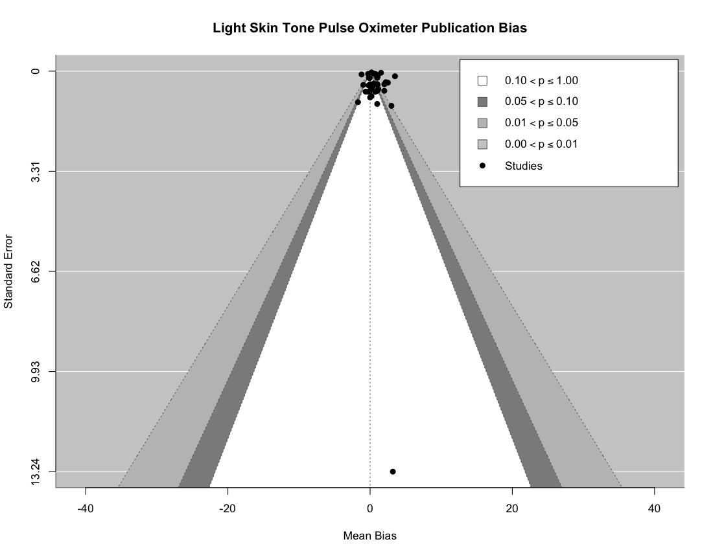b. 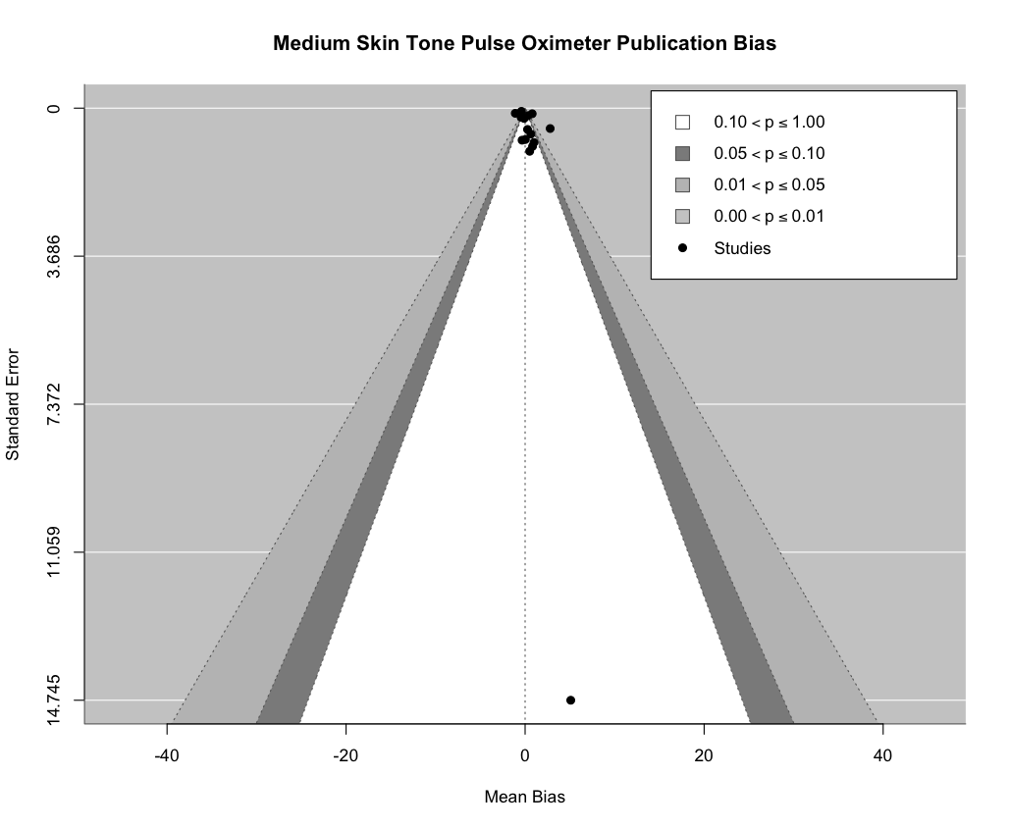
c. 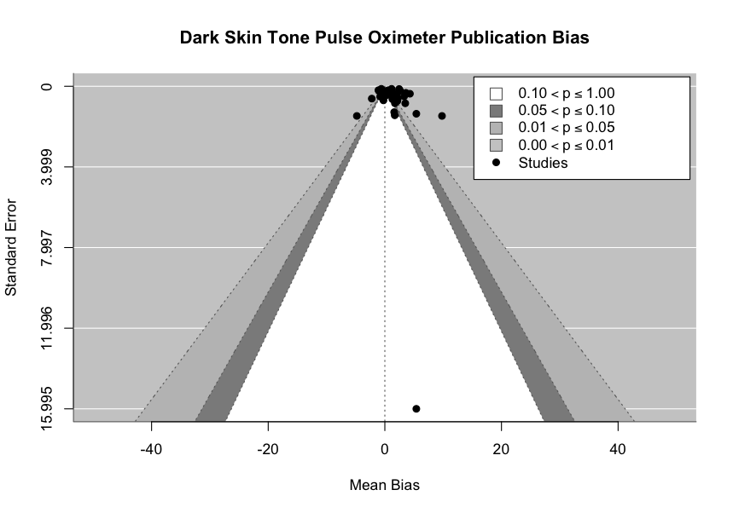

Figure S1. Funnel Plots Pulse Oximetry

A. Light Skin Pigmentation, B. Medium Skin Pigmentation, C. Dark Skin Pigmentation. These plot individual study effect estimates against their respective precision, represented by the standard error. On these plots, the vertical axis shows the effect size, while the horizontal axis shows the standard error. When there is no bias, the plot looks like an inverted funnel; larger, more precise studies cluster towards the top, closer to the true effect size, and smaller, less precise studies spread towards the bottom, indicating a wider spread in effect estimates. Asymmetry in the funnel plot can hint at potential publication bias, but it might also indicate other biases or study heterogeneity.

a.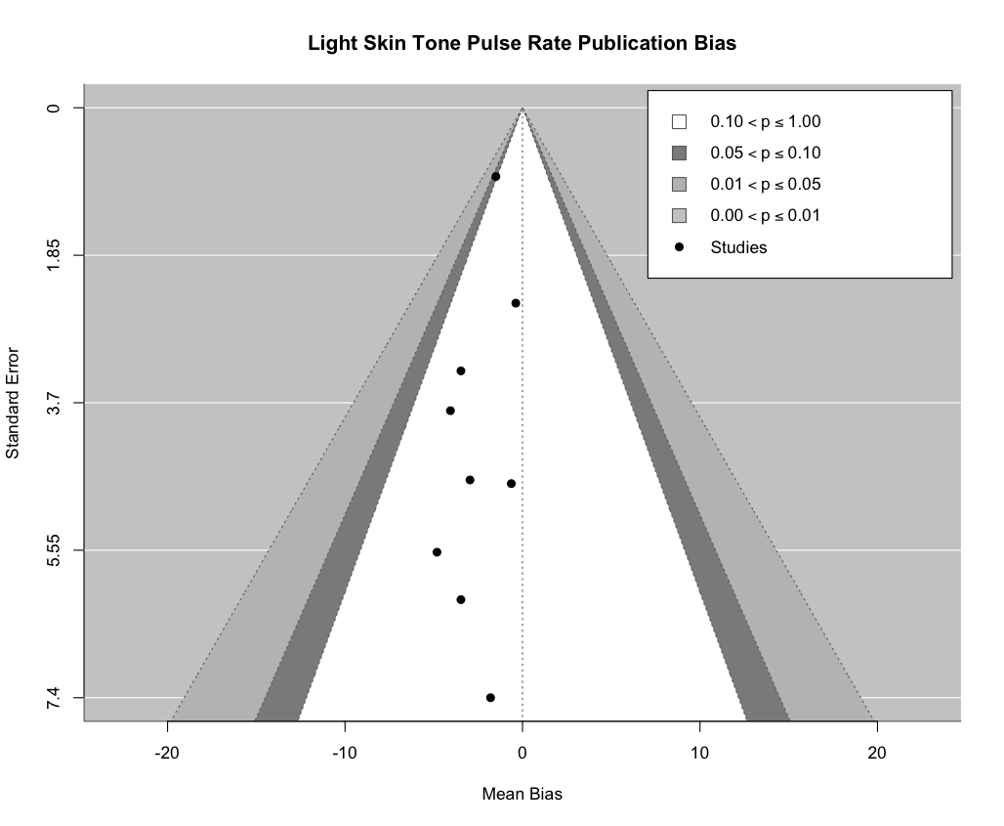b. 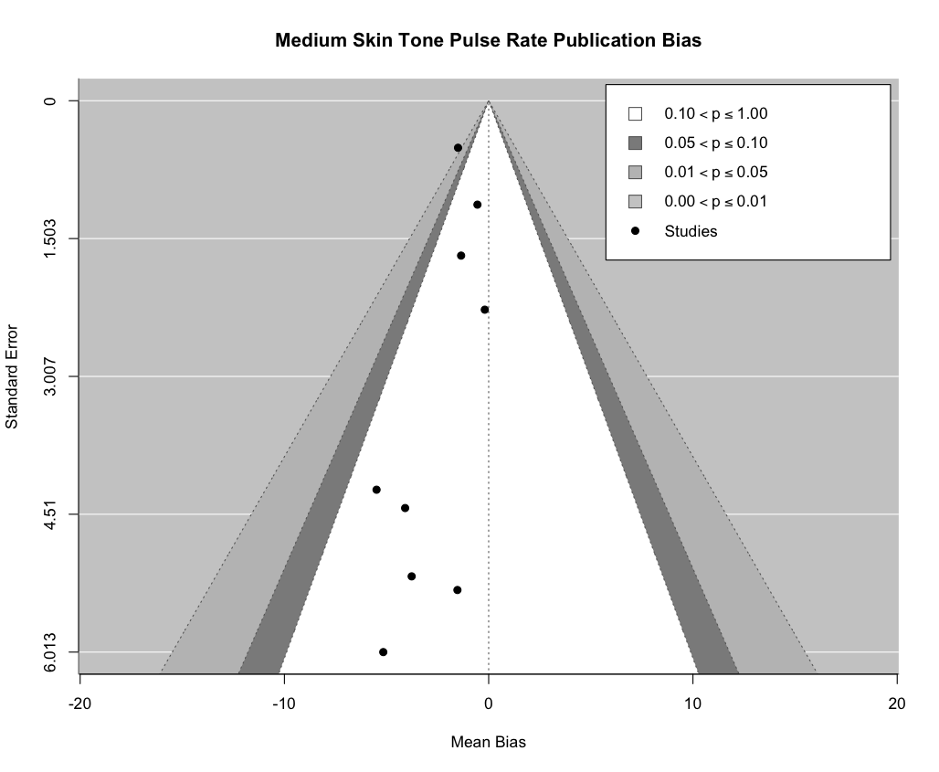
c.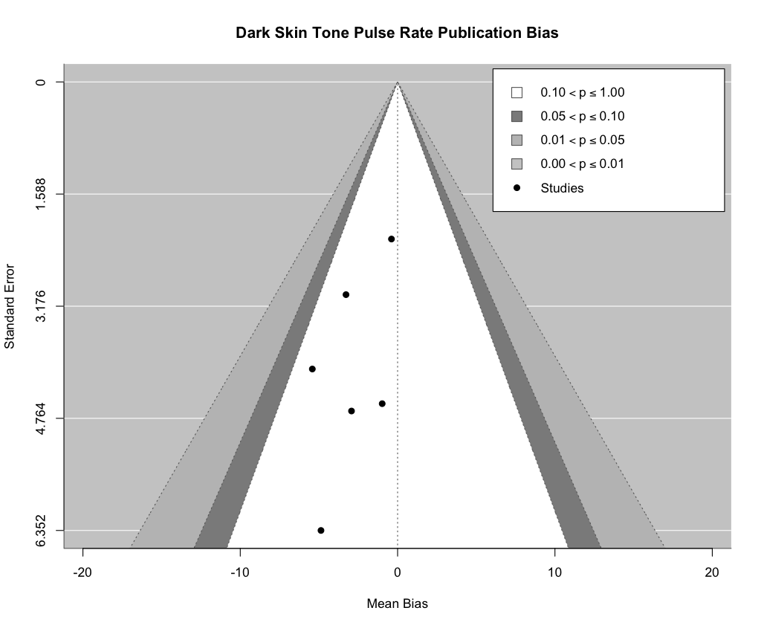

Figure S2. Funnel Plot Pulse Rate
A. Light Skin Pigmentation, B. Medium Skin Pigmentation, C. Dark Skin Pigmentation. These plot individual study effect estimates against their respective precision, represented by the standard error. On these plots, the vertical axis shows the effect size, while the horizontal axis shows the standard error. When there is no bias, the plot looks like an inverted funnel; larger, more precise studies cluster towards the top, closer to the true effect size, and smaller, less precise studies spread towards the bottom, indicating a wider spread in effect estimates. Asymmetry in the funnel plot can hint at potential publication bias, but it might also indicate other biases or study heterogeneity.

Materials

Search Report: PPG and Skin of Color

Whitney A Townsend, MLIS
whitneyt@umich.edu
All searches run from inception of the database to 04/15/2022 unless otherwise noted
All searches run without limits unless otherwise noted
Original PubMed search strategy translated and adapted to other databases using http://sr-accelerator.com/#/polyglot and the searcher's discretion.

Please cite:
SR Accelerator Polyglot search translation tool²⁹.

Databases
- PubMed (PubMed.gov)
- Embase.com (including Embase Classic)
- Scopus.com
- Web of Science Core Collection (SCI-EXPANDED, SSCI, A&HCI, CPCI-S, CPCI-SSH, BKCI-S, BKCI-SSH, ESCI, CCR-EXPANDED)
- CINAHL Complete (Ebsco)
- ClinicalTrials.gov

Total results before deduplication: 8582
Total results after initial DistillerSR deduplication: 5082 (3500 duplicates removed)

SEARCH NOTES:

Antiquated, non-standard, and potentially offensive terms for racial and ethnic groups were included in search strategies in order to conduct a sensitive, comprehensive search for relevant studies. Language has changed over time and varies geographically and by community, so a thorough search must include the terms that have been used in past and present literature. The authors recognize and acknowledge the inappropriate and harmful nature of these terms.

PubMed - 1548 on 4/15/22
(("Race Factors"[MeSH Terms] OR "Skin Pigmentation"[MeSH Terms] OR Racial Groups [MeSH Terms] OR "Indigenous Peoples"[MeSH Terms] OR "Arabs"[MeSH Terms] OR Jews[mesh] OR Roma[mesh] OR "Ethnicity"[MeSH Terms] OR
pigment*[tiab] OR racial[tiab] OR race[tiab] OR biracial[tiab] OR bi-racial[tiab] OR multiracial[tiab] OR multi-racial[tiab] OR "multiple race"[tiab] OR "multiple races"[tiab] OR racism[tiab] OR racist[tiab] OR African*[tiab] OR Black[tiab] OR Blacks[tiab] OR negro*[tiab] OR Native American*[tiab] OR Indian*[tiab] OR Indigenous[tiab] OR First Nation People*[tiab] OR "Native People"[tiab] OR Inuit*[tiab] OR Arab[tiab] OR Arabs[tiab] OR Arabic[tiab] OR "Middle East*"[tiab] OR Asian*[tiab] OR Asiatic*[tiab] OR Hispanic*[tiab] OR Latin*[tiab]
OR Hawaiian*[tiab] OR Pacific Islander*[tiab] OR Aborigin*[tiab] OR "people of color"[tiab] OR "people of colour"[tiab] OR BIPOC[tiab] OR "skin of color"[tiab] OR "skin of colour"[tiab] OR "brown skin"[tiab] OR "black skin"[tiab] OR "dark skin"[tiab] OR "dark skinned"[tiab] OR "darker skin"[tiab] OR melanin[tiab] OR ethnic*[tiab] OR skin tone*[tiab] OR skin color*[tiab] OR skin colour*[tiab] OR "skin phototypes"[tiab] OR hyperpigmentation[tiab] OR hypopigmentation[tiab] OR dyschromia[tiab]) AND (Photoplethysmography[MeSH Terms] OR PPG[tiab] OR
Photoplethysmogra*[tiab] OR Plethysmogra*[tiab] OR Optometric*[tiab] OR "Apple Watch"[tiab] OR Alivecor[tiab] OR Kardiamobile[tiab] OR Pulse oximeter*[tiab] OR pulse-ox*[tiab] OR Cuffless[tiab] OR "Empatica E4"[tiab] OR "Finger probe*"[tiab] OR Fitbit[tiab] OR "Smart watch*"[tiab] OR smartwatch*[tiab] OR Xiaomi[tiab] OR Biovotion[tiab] OR "Basis peak"[tiab] OR "Polar M600"[tiab] OR Misfit[tiab] OR Withings[tiab] OR Mio[tiab] OR Samsung[tiab] OR PulseON[tiab] OR TomTom[tiab] OR Empatica[tiab] OR Optoelectronic[tiab] OR "reflection index*"[tiab] OR "stiffness index*"[tiab])) NOT (animals[mesh] NOT humans[mesh])

Embase - 2652 on 4/15/22
((Race/exp OR "Skin Pigmentation"/exp OR "Ancestry Group"/exp OR "Ethnic Group"/exp OR Jew/exp OR Ethnicity/exp OR Racism/exp OR pigment*:ti,ab OR racial:ti,ab OR race:ti,ab OR biracial:ti,ab OR bi-racial:ti,ab OR multiracial:ti,ab OR multi-racial:ti,ab OR "multiple race":ti,ab OR "multiple races":ti,ab OR racism:ti,ab OR racist:ti,ab OR African*:ti,ab OR Black:ti,ab OR Blacks:ti,ab OR negro*:ti,ab OR "Native American*":ti,ab OR Indian*:ti,ab OR Indigenous:ti,ab OR "First Nation People*":ti,ab OR "Native People":ti,ab OR Inuit*:ti,ab OR Arab:ti,ab OR Arabs:ti,ab OR Arabic:ti,ab OR "Middle East*":ti,ab OR Asian*:ti,ab OR Asiatic*:ti,ab OR Hispanic*:ti,ab OR Latin*:ti,ab OR Hawaiian*:ti,ab OR "Pacific Islander*":ti,ab OR Aborigin*:ti,ab OR "people of color":ti,ab OR "people of colour":ti,ab OR BIPOC:ti,ab OR "skin of color":ti,ab OR "skin of colour":ti,ab OR "brown skin":ti,ab OR "black skin":ti,ab OR "dark skin":ti,ab OR "dark skinned":ti,ab OR "darker skin":ti,ab OR melanin:ti,ab OR ethnic*:ti,ab OR "skin tone*":ti,ab OR "skin color*":ti,ab OR "skin colour*":ti,ab OR "skin phototypes":ti,ab OR hyperpigmentation:ti,ab OR hypopigmentation:ti,ab OR dyschromia:ti,ab) AND ('photoelectric plethysmography'/exp OR PPG:ti,ab OR Photoplethysmogra*:ti,ab OR Plethysmogra*:ti,ab OR Optometric*:ti,ab OR "Apple Watch":ti,ab OR Alivecor:ti,ab OR Kardiamobile:ti,ab OR "Pulse oximeter*":ti,ab OR pulse-ox*:ti,ab OR Cuffless:ti,ab OR "Empatica E4":ti,ab OR "Finger probe*":ti,ab OR Fitbit:ti,ab OR "Smart watch*":ti,ab OR smartwatch*:ti,ab OR Xiaomi:ti,ab OR Biovotion:ti,ab OR "Basis peak":ti,ab OR "Polar M600":ti,ab OR Misfit:ti,ab OR Withings:ti,ab OR Mio:ti,ab OR Samsung:ti,ab OR PulseON:ti,ab OR TomTom:ti,ab OR Empatica:ti,ab OR Optoelectronic:ti,ab OR "reflection index*":ti,ab OR "stiffness index*":ti,ab)) NOT ([animals]/lim NOT [humans]/lim)

Scopus - 2654 on 4/15/22
( TITLE-ABS-KEY ( pigment* ) OR TITLE-ABS-KEY ( racial ) OR TITLE-ABS-KEY ( race ) OR TITLE-ABS-KEY ( biracial ) OR TITLE-ABS-KEY ( bi-racial ) OR TITLE-ABS-KEY ( multiracial ) OR TITLE-ABS-KEY ( multi-racial ) OR TITLE-ABS-KEY ( {multiple race} ) OR TITLE-ABS-KEY ( {multiple races} ) OR TITLE-ABS-KEY ( racism ) OR TITLE-ABS-KEY ( racist ) OR TITLE-ABS-KEY ( african* ) OR TITLE-ABS-KEY ( black W/3 skin ) OR TITLE-ABS-KEY ( negro* ) OR TITLE-ABS-KEY ( "Native American*" ) OR TITLE-ABS-KEY ( indian* ) OR TITLE-ABS-KEY ( indigenous ) OR TITLE-ABS-KEY ( "First Nation People*" ) OR TITLE-ABS-KEY ( {Native People} ) OR TITLE-ABS-KEY ( inuit* ) OR TITLE-ABS-KEY ( arab ) OR TITLE-ABS-KEY ( arabs ) OR TITLE-ABS-KEY ( arabic ) OR TITLE-ABS-KEY ( "Middle East*" ) OR TITLE-ABS-KEY ( asian* ) OR TITLE-ABS-KEY ( asiatic* ) OR TITLE-ABS-KEY ( hispanic* ) OR TITLE-ABS-KEY ( latin* ) OR TITLE-ABS-KEY ( hawaiian* ) OR TITLE-ABS-KEY ( "Pacific Islander*" ) OR TITLE-ABS-KEY ( aborigin* ) OR TITLE-ABS-KEY ( {people of color} ) OR TITLE-ABS-KEY ( {people of colour} ) OR TITLE-ABS-KEY ( bipoc ) OR TITLE-ABS-KEY ( {skin of color} ) OR TITLE-ABS-KEY ( {skin of colour} ) OR TITLE-ABS-KEY ( {brown skin} ) OR TITLE-ABS-KEY ( {black skin} ) OR TITLE-ABS-KEY ( {dark skin} ) OR TITLE-ABS-KEY ( {dark skinned} ) OR TITLE-ABS-KEY ( {darker skin} ) OR TITLE-ABS-KEY ( melanin ) OR TITLE-ABS-KEY ( ethnic* ) OR TITLE-ABS-KEY ( {skin tone} ) OR TITLE-ABS-KEY ( {skin tones} ) OR TITLE-ABS-KEY ( {skin color} ) OR TITLE-ABS-KEY ( {skin colors} ) OR TITLE-ABS-KEY ( {skin colour} ) OR TITLE-ABS-KEY ( {skin colours} ) OR TITLE-ABS-KEY ( {skin phototypes} ) OR TITLE-ABS-KEY ( hyperpigmentation ) OR TITLE-ABS-KEY ( hypopigmentation ) OR TITLE-ABS-KEY ( dyschromia ) )
AND
( TITLE-ABS-KEY ( ppg ) OR TITLE-ABS-KEY ( photoplethysmogra* ) OR TITLE-ABS-KEY ( plethysmogra* ) OR TITLE-ABS-KEY ( optometric* ) OR TITLE-ABS-KEY ( {Apple Watch} ) OR TITLE-ABS-KEY ( alivecor ) OR TITLE-ABS-KEY ( kardiamobile ) OR TITLE-ABS-KEY ( "Pulse oximeter*" ) OR TITLE-ABS-KEY ( pulse-ox* ) OR TITLE-ABS-KEY ( cuffless ) OR TITLE-ABS-KEY ( "Empatica E4" ) OR TITLE-ABS-KEY ( "Finger probe*" ) OR TITLE-ABS-KEY ( fitbit ) OR TITLE-ABS-KEY ( "Smart watch*" ) OR TITLE-ABS-KEY ( smartwatch* ) OR TITLE-ABS-KEY ( xiaomi ) OR TITLE-ABS-KEY ( biovotion ) OR TITLE-ABS-KEY ( "Basis peak" ) OR TITLE-ABS-KEY ( "Polar M600" ) OR TITLE-ABS-KEY ( withings ) OR TITLE-ABS-KEY ( samsung ) OR TITLE-ABS-KEY ( pulseon ) OR TITLE-ABS-KEY ( tomtom ) OR TITLE-ABS-KEY ( empatica ) OR TITLE-ABS-KEY ( optoelectronic ) OR TITLE-ABS-KEY ( "reflection index" ) OR TITLE-ABS-KEY ( "stiffness index" ) )

Web of Science Core Collection - 1543 on 4/15/22
((TS="Race Factors" OR TS="Skin Pigmentation" OR TS="Racial Groups" OR TS="Indigenous Peoples" OR TS=Arabs OR TS=Jews OR TS=Roma OR TS=Ethnicity OR (TI=pigment* OR AB=pigment*) OR (TI=racial OR AB=racial) OR (TI=race OR AB=race) OR (TI=biracial OR AB=biracial) OR (TI=bi-racial OR AB=bi-racial) OR (TI=multiracial OR AB=multiracial) OR (TI=multi-racial OR AB=multi-racial) OR (TI="multiple race" OR AB="multiple race") OR (TI="multiple races" OR AB="multiple races") OR (TI=racism OR AB=racism) OR (TI=racist OR AB=racist) OR (TI=African* OR AB=African*) OR ((TI=Black OR AB=Black) AND (TI=skin OR AB=skin)) OR (TI=negro* OR AB=negro*) OR (TI="Native American*" OR AB="Native American*") OR (TI=Indian* OR AB=Indian*) OR (TI=Indigenous OR AB=Indigenous) OR (TI="First Nation People*" OR AB="First Nation People*") OR (TI="Native People" OR AB="Native People") OR (TI=Inuit* OR AB=Inuit*) OR (TI=Arab OR AB=Arab) OR (TI=Arabs OR AB=Arabs) OR (TI=Arabic OR AB=Arabic) OR (TI="Middle East*" OR AB="Middle East*") OR (TI=Asian* OR AB=Asian*) OR (TI=Asiatic* OR AB=Asiatic*) OR (TI=Hispanic* OR AB=Hispanic*) OR (TI=Latin* OR AB=Latin*) OR (TI=Hawaiian* OR AB=Hawaiian*) OR (TI="Pacific Islander*" OR AB="Pacific Islander*") OR (TI=Aborigin* OR AB=Aborigin*) OR (TI="people of color" OR AB="people of color") OR (TI="people of colour" OR AB="people of colour") OR (TI=BIPOC OR AB=BIPOC) OR (TI="skin of color" OR AB="skin of color") OR (TI="skin of colour" OR AB="skin of colour") OR (TI="brown skin" OR AB="brown skin") OR (TI="black skin" OR AB="black skin") OR (TI="dark skin" OR AB="dark skin") OR (TI="dark skinned" OR AB="dark skinned") OR (TI="darker skin" OR AB="darker skin") OR (TI=melanin OR AB=melanin) OR (TI=ethnic* OR AB=ethnic*) OR (TI="skin tone*" OR AB="skin tone*") OR (TI="skin color*" OR AB="skin color*") OR (TI="skin colour*" OR AB="skin colour*") OR (TI="skin phototypes" OR AB="skin phototypes") OR (TI=hyperpigmentation OR AB=hyperpigmentation) OR (TI=hypopigmentation OR AB=hypopigmentation) OR (TI=dyschromia OR AB=dyschromia)) AND (ALL=Photoplethysmography OR (TI=PPG OR AB=PPG) OR (TI=Photoplethysmogra* OR AB=Photoplethysmogra*) OR (TI=Plethysmogra* OR AB=Plethysmogra*) OR (TI=Optometric* OR AB=Optometric*) OR (TI="Apple Watch" OR AB="Apple Watch") OR (TI=Alivecor OR AB=Alivecor) OR (TI=Kardiamobile OR AB=Kardiamobile) OR (TI="Pulse oximeter*" OR AB="Pulse oximeter*") OR (TI=pulse-ox* OR AB=pulse-ox*) OR (TI=Cuffless OR AB=Cuffless) OR (TI="Empatica E4" OR AB="Empatica E4") OR (TI="Finger probe*" OR AB="Finger probe*") OR (TI=Fitbit OR AB=Fitbit) OR (TI="Smart watch*" OR AB="Smart watch*") OR (TI=smartwatch* OR AB=smartwatch*) OR (TI=Xiaomi OR AB=Xiaomi) OR (TI=Biovotion OR AB=Biovotion) OR (TI="Basis peak" OR AB="Basis peak") OR (TI="Polar M600" OR AB="Polar M600") OR (TI=Misfit OR AB=Misfit) OR (TI=Withings OR AB=Withings) OR (TI=Mio OR AB=Mio) OR (TI=Samsung OR AB=Samsung) OR (TI=PulseON OR AB=PulseON) OR (TI=TomTom OR AB=TomTom) OR (TI=Empatica OR AB=Empatica) OR (TI=Optoelectronic OR AB=Optoelectronic) OR (TI="reflection index*" OR AB="reflection index*") OR (TI="stiffness index*" OR AB="stiffness index*")))

CINAHL Complete - 360 on 4/15/22
(((MH "Race Factors+") OR (MH "Skin Pigmentation+") OR (MH "Racial Groups+") OR (MH "Indigenous Peoples+") OR (MH Arabs+) OR (MH Jews+) OR (MH Roma+) OR (MH Ethnicity+) OR (TI pigment* OR AB pigment*) OR (TI racial OR AB racial) OR (TI race OR AB race) OR (TI biracial OR AB biracial) OR (TI bi-racial OR AB bi-racial) OR (TI multiracial OR AB multiracial) OR (TI multi-racial OR AB multi-racial) OR (TI "multiple race" OR AB "multiple race") OR (TI "multiple races" OR AB "multiple races") OR (TI racism OR AB racism) OR (TI racist OR AB racist) OR (TI African* OR AB African*) OR (TI Black OR AB Black) OR (TI Blacks OR AB Blacks) OR (TI negro* OR AB negro*) OR (TI "Native American*" OR AB "Native American*") OR (TI Indian* OR AB Indian*) OR (TI Indigenous OR AB Indigenous) OR (TI "First Nation People*" OR AB "First Nation People*") OR (TI "Native People" OR AB "Native People") OR (TI Inuit* OR AB Inuit*) OR (TI Arab OR AB Arab) OR (TI Arabs OR AB Arabs) OR (TI Arabic OR AB Arabic) OR (TI "Middle East*" OR AB "Middle East*") OR (TI Asian* OR AB Asian*) OR (TI Asiatic* OR AB Asiatic*) OR (TI Hispanic* OR AB Hispanic*) OR (TI Latin* OR AB Latin*) OR (TI Hawaiian* OR AB Hawaiian*) OR (TI "Pacific Islander*" OR AB "Pacific Islander*") OR (TI Aborigin* OR AB Aborigin*) OR (TI "people of color" OR AB "people of color") OR (TI "people of colour" OR AB "people of colour") OR (TI BIPOC OR AB BIPOC) OR (TI "skin of color" OR AB "skin of color") OR (TI "skin of colour" OR AB "skin of colour") OR (TI "brown skin" OR AB "brown skin") OR (TI "black skin" OR AB "black skin") OR (TI "dark skin" OR AB "dark skin") OR (TI "dark skinned" OR AB "dark skinned") OR (TI "darker skin" OR AB "darker skin") OR (TI melanin OR AB melanin) OR (TI ethnic* OR AB ethnic*) OR (TI "skin tone*" OR AB "skin tone*") OR (TI "skin color*" OR AB "skin color*") OR (TI "skin colour*" OR AB "skin colour*") OR (TI "skin phototypes" OR AB "skin phototypes") OR (TI hyperpigmentation OR AB hyperpigmentation) OR (TI hypopigmentation OR AB hypopigmentation) OR (TI dyschromia OR AB dyschromia)) AND ((MH Photoplethysmography+) OR (TI PPG OR AB PPG) OR (TI Photoplethysmogra* OR AB Photoplethysmogra*) OR (TI Plethysmogra* OR AB Plethysmogra*) OR (TI Optometric* OR AB Optometric*) OR (TI "Apple Watch" OR AB "Apple Watch") OR (TI Alivecor OR AB Alivecor) OR (TI Kardiamobile OR AB Kardiamobile) OR (TI "Pulse oximeter*" OR AB "Pulse oximeter*") OR (TI pulse-ox* OR AB pulse-ox*) OR (TI Cuffless OR AB Cuffless) OR (TI "Empatica E4" OR AB "Empatica E4") OR (TI "Finger probe*" OR AB "Finger probe*") OR (TI Fitbit OR AB Fitbit) OR (TI "Smart watch*" OR AB "Smart watch*") OR (TI smartwatch* OR AB smartwatch*) OR (TI Xiaomi OR AB Xiaomi) OR (TI Biovotion OR AB Biovotion) OR (TI "Basis peak" OR AB "Basis peak") OR (TI "Polar M600" OR AB "Polar M600") OR (TI Misfit OR AB Misfit) OR (TI Withings OR AB Withings) OR (TI Mio OR AB Mio) OR (TI Samsung OR AB Samsung) OR (TI PulseON OR AB PulseON) OR (TI TomTom OR AB TomTom) OR (TI Empatica OR AB Empatica) OR (TI Optoelectronic OR AB Optoelectronic) OR (TI "reflection index*" OR AB "reflection index*") OR (TI "stiffness index*" OR AB "stiffness index*")))

ClinicalTrials.gov - 185 on 4/15/22
Other Terms: Photoplethysmography

GoogleScholar
Skin Tone, Skin Pigmentation, Race, Ethnicity, Photoplethysmography, pulse oximetry, pulse rate, accuracy, bias.

DRAFT SEARCH METHODS:
The following databases were searched from inception to March 15, 2022 in order to identify relevant articles, trials, or meeting abstracts describing photoplethysmography and skin of color: PubMed.gov, Elsevier Embase (including Embase Classic), Elsevier Scopus, Web of Science Core Collection (SCI-EXPANDED; SSCI; A&HCI; CPCI-S; CPCI-SSH; BKCI-S; BKCI-SSH; ESCI; CCR-EXPANDED), CINAHL Complete, GoogleScholar, and ClinicalTrials.gov. Each search utilized controlled vocabulary whenever possible in combination with relevant keywords. No limits were applied to the search. A set of sentinel articles were identified before the search process and were used to generate search terms and test the effectiveness of the strategies in each database. Reference tracking was performed on highly relevant articles. Original search strategies were developed in Pubmed and translated as appropriate to the other databases using the Systematic Review Accelerator Polyglot tool. Citations were deduplicated using DistillerSR's deduplication tools.

Data Extraction
We developed a comprehensive data extraction form based on the guidelines from the
Cochrane Handbook for Systematic Reviews of Interventions³⁰. A consort chart of the literature search is shown in Figure 1. Studies that met inclusion criteria were included in the meta-analysis (a total of 27 original studies). Two reviewers (BWN, SS) independently extracted data from published reports and pulled participant-level data from Bent et al. supplementary materials.²⁴ A third reviewer (MB, HG) adjudicated any differences between the initial two reviewers and resolved any disagreements by checking manuscripts. All articles were verified with a quality check by the first author. A standardized data extraction system was developed to extract the study characteristics (Authors, Year, Sample size, study setting (inpatient, outpatient, research setting- lab, research setting- real world, other), Skin tone measurements (Skin pigmentation measurement method), sample size by skin tone categorized as light, medium, dark, race³¹ (sample size by race groups), ethnicity (sample size by ethnicity groups), description of study population (medical vs. healthy), device type (medical, non-medical), reference device (electrocardiogram, arterial blood gas), measurement method (transmittance, reflectance), device location (finger, wrist, ear, forehead, chest, other (If no location was identified in a paper, “other” was selected as the location). and results (mean bias with SD, SE , 95% CI for race, ethnicity and skin tone). For one paper, we used open access to data in supplementary materials to calculate mean bias and SE by each skin pigmentation category. We used skin tone, race, and ethnicity to categorize participants into light, medium, and dark skin pigmentation categories that were defined by race, ethnicity and skin tone.

Additional Details on Method for Statistical Analysis
Following Shi. et. al. we applied following methods to adjust standard deviation of bias, when repeated measures were taken within a study.
- adjusted SD²= reported SD² * [(the total number of repeated measures-1) / (the total number of repeated measures - the average number of replications per participant)]
Subsequently the sampling variance of mean bias for such a scenario is taken as (adjusted SD² / the number of participants).

In order to pool SD across studies, adopting Tipton and Shuster 2017, we used the below transformation to stabilize and normalize the estimates of SD for each study, before feeding into the CHE models.
- point estimate of log(adjusted σ²) = log(adjusted SD²) + 1 / (the number of participants-1)
- sampling variance of log(adjusted σ²) = 2 / (the number of participants - 1)
When a study has only 1 subject, the study was excluded from CHE modeling to pool SD. Antilog was taken to report the pooled SD from the CHE model.

References
1. Abrams, G. A., Sanders, M. K. & Fallon, M. B. Utility of pulse oximetry in the detection of arterial hypoxemia in liver transplant candidates. Liver Transpl. 8, 391–396 (2002).
2. Adler, J. N., Hughes, L. A., Vivilecchia, R. & Camargo, C. A., Jr. Effect of skin pigmentation on pulse oximetry accuracy in the emergency department. Acad. Emerg. Med. 5, 965–970 (1998).
3. Andrist, E., Nuppnau, M., Barbaro, R. P., Valley, T. S. & Sjoding, M. W. Association of Race With Pulse Oximetry Accuracy in Hospitalized Children. JAMA Netw Open 5, e224584 (2022).
4. Barker, S. J. & Wilson, W. C. Racial effects on Masimo pulse oximetry: a laboratory study. J. Clin. Monit. Comput. 37, 567–574 (2023).
5. Bickler, P. E., Feiner, J. R. & Severinghaus, J. W. Effects of skin pigmentation on pulse oximeter accuracy at low saturation. Anesthesiology 102, 715–719 (2005).
6. Bothma, P. A. et al. Accuracy of pulse oximetry in pigmented patients. S. Afr. Med. J. 86, 594–596 (1996).
7. Burnett, G. W. et al. Self-reported Race/Ethnicity and Intraoperative Occult Hypoxemia: A Retrospective Cohort Study. Anesthesiology 136, 688–696 (2022).
8. Crooks, C. J. et al. Pulse oximeter measurements vary across ethnic groups: an observational study in patients with COVID-19. Eur. Respir. J. 59, (2022).
9. Ebmeier, S. J. et al. A two centre observational study of simultaneous pulse oximetry and arterial oxygen saturation recordings in intensive care unit patients. Anaesth. Intensive Care 46, 297–303 (2018).
10. Fawzy, A. et al. Racial and Ethnic Discrepancy in Pulse Oximetry and Delayed Identification of Treatment Eligibility Among Patients With COVID-19. JAMA Intern. Med. 182, 730–738 (2022).
11. Feiner, J. R., Severinghaus, J. W. & Bickler, P. E. Dark skin decreases the accuracy of pulse oximeters at low oxygen saturation: the effects of oximeter probe type and gender. Anesth. Analg. 105, S18–S23 (2007).
12. Foglia, E. E. et al. The Effect of Skin Pigmentation on the Accuracy of Pulse Oximetry in Infants with Hypoxemia. J. Pediatr. 182, 375–377.e2 (2017).
13. Jubran, A. & Tobin, M. J. Reliability of pulse oximetry in titrating supplemental oxygen therapy in ventilator-dependent patients. Chest 97, 1420–1425 (1990).
14. McGovern, J. P., Sasse, S. A., Stansbury, D. W., Causing, L. A. & Light, R. W. Comparison of oxygen saturation by pulse oximetry and co-oximetry during exercise testing in patients with COPD. Chest 109, 1151–1155 (1996).
15. Muñoz, X. et al. Accuracy and reliability of pulse oximetry at different arterial carbon dioxide pressure levels. Eur. Respir. J. 32, 1053–1059 (2008).
16. Pilcher, J. et al. A multicentre prospective observational study comparing arterial blood gas values to those obtained by pulse oximeters used in adult patients attending Australian and New Zealand hospitals. BMC Pulm. Med. 20, 7 (2020).
17. Ruppel, H. et al. Evaluating the Accuracy of Pulse Oximetry in Children According to Race. JAMA Pediatr. 177, 540–543 (2023).
18. Sudat, S. E. K. et al. Racial Disparities in Pulse Oximeter Device Inaccuracy and Estimated Clinical Impact on COVID-19 Treatment Course. Am. J. Epidemiol. 192, 703–713 (2023).
19. Thrush, D. & Hodges, M. R. Accuracy of pulse oximetry during hypoxemia. South. Med. J. 87, 518–521 (1994).
20. Valbuena, V. S. M. et al. Racial bias and reproducibility in pulse oximetry among medical and surgical inpatients in general care in the Veterans Health Administration 2013-19: multicenter, retrospective cohort study. BMJ 378, e069775 (2022).
21. Vesoulis, Z., Tims, A., Lodhi, H., Lalos, N. & Whitehead, H. Racial discrepancy in pulse oximeter accuracy in preterm infants. J. Perinatol. 42, 79–85 (2022).
22. Wiles, M. D. et al. The effect of patient ethnicity on the accuracy of peripheral pulse oximetry in patients with COVID-19 pneumonitis: a single-centre, retrospective analysis. Anaesthesia 77, 143–152 (2022).
23. Zeballos, R. J. & Weisman, I. M. Reliability of noninvasive oximetry in black subjects during exercise and hypoxia. Am. Rev. Respir. Dis. 144, 1240–1244 (1991).
24. Bent, B., Goldstein, B. A., Kibbe, W. A. & Dunn, J. P. Investigating sources of inaccuracy in wearable optical heart rate sensors. NPJ Digit Med 3, 18 (2020).
25. Nelson, B. W. & Allen, N. B. Accuracy of Consumer Wearable Heart Rate Measurement During an Ecologically Valid 24-Hour Period: Intraindividual Validation Study. JMIR Mhealth Uhealth 7, e10828 (2019).
26. Sañudo, B., De Hoyo, M., Muñoz-López, A., Perry, J. & Abt, G. Pilot Study Assessing the Influence of Skin Type on the Heart Rate Measurements Obtained by Photoplethysmography with the Apple Watch. J. Med. Syst. 43, 195 (2019).
27. Chow, H.-W. & Yang, C.-C. Accuracy of Optical Heart Rate Sensing Technology in Wearable Fitness Trackers for Young and Older Adults: Validation and Comparison Study. JMIR Mhealth Uhealth 8, e14707 (2020).
28. Shi, C. et al. The accuracy of pulse oximetry in measuring oxygen saturation by levels of skin pigmentation: a systematic review and meta-analysis. BMC Med. 20, 267 (2022).
29. Clark, J. M. et al. Improving the translation of search strategies using the Polyglot Search Translator: a randomized controlled trial. J. Med. Libr. Assoc. 108, 195–207 (2020).
30. Higgins, J. P. T. & Deeks, J. J. Selecting studies and collecting data. in Cochrane Handbook for Systematic Reviews of Interventions 151–185 (John Wiley & Sons, Ltd, 2008).
31. Revisions to the Standards for the Classification of Federal Data on Race and Ethnicity. The White House https://obamawhitehouse.archives.gov/omb/fedreg_1997standards.

