SUPPLEMENTAL MATERIAL
This appendix has been provided by the authors to give readers additional information about their work.

Contents
Supplement Table 1 Forest plot of the ischemic endpoints according to treatment regimen and DM/CKD status 2
Supplement Table 2 Forest plot of the bleeding endpoints according to treatment regimen and DM/CKD status 3
Supplement Table 3 Forest plot of sensitive analyses (stage II to V CKD by KDIGO classification) showing outcomes according to treatment regimen and DM/CKD status 4
Supplement Table 4 Forest plot of landmark analyses (0-365 days) showing outcomes of reference versus experimental treatment according to DM/CKD status 5
Supplement Figure 1 Kaplan-Meier curves of the landmark analysis showing outcomes of treatment regimen according to DM/CKD status 6

Supplement Table 1 Forest plot of the ischemic endpoints according to treatment regimen and DM/CKD status
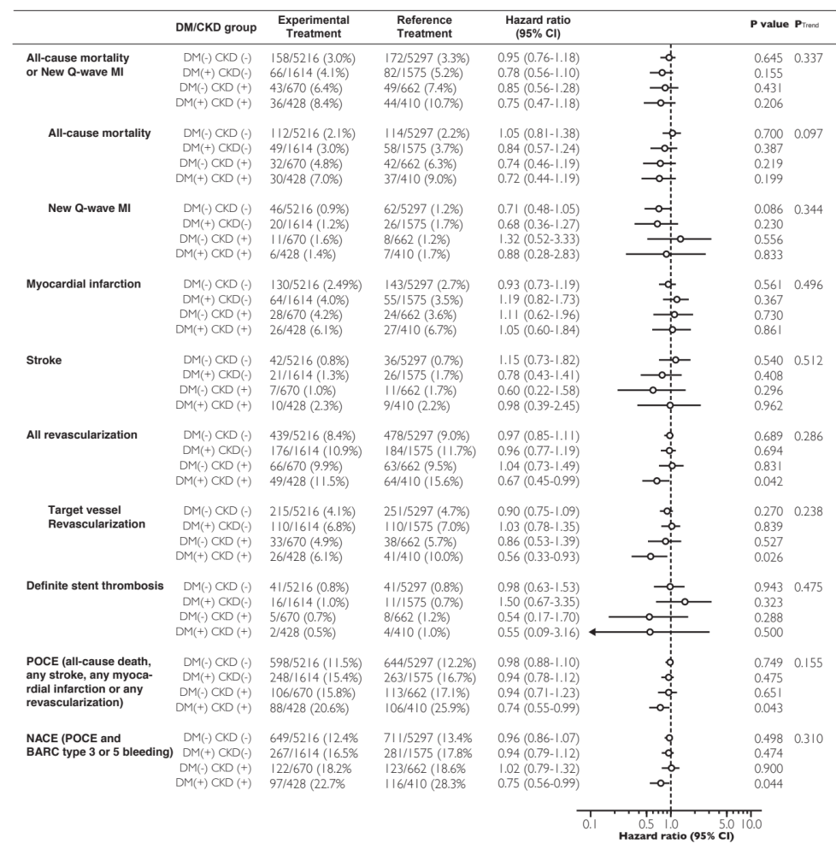

Supplement Table 2 Forest plot of the bleeding endpoints according to treatment regimen and DM/CKD status
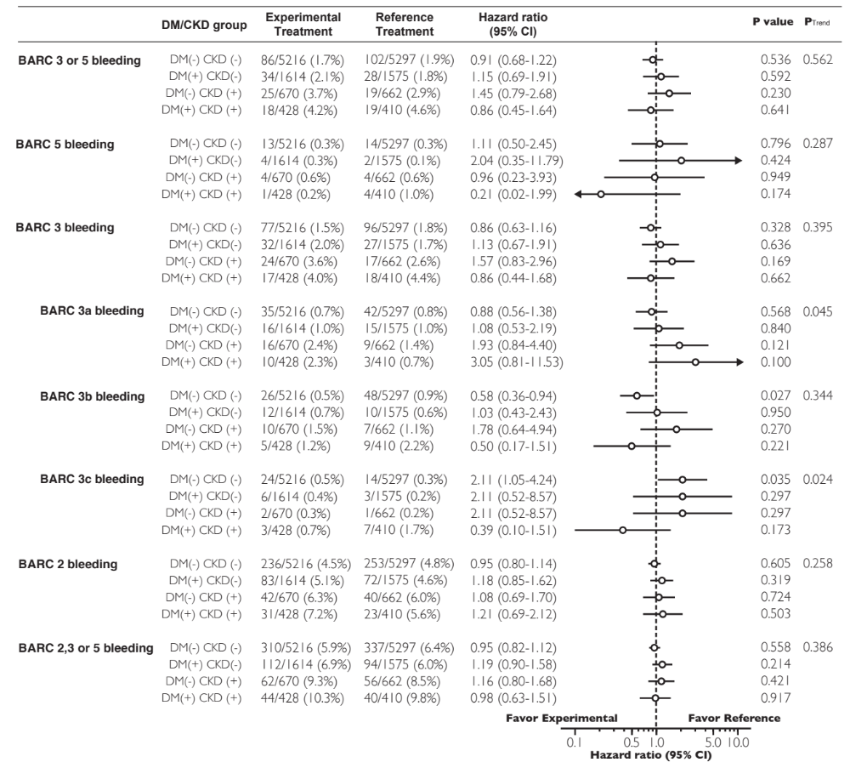

Supplement Table 3 Forest plot of sensitive analyses (stage II to V CKD by KDIGO classification) showing outcomes according to treatment regimen and DM/CKD status
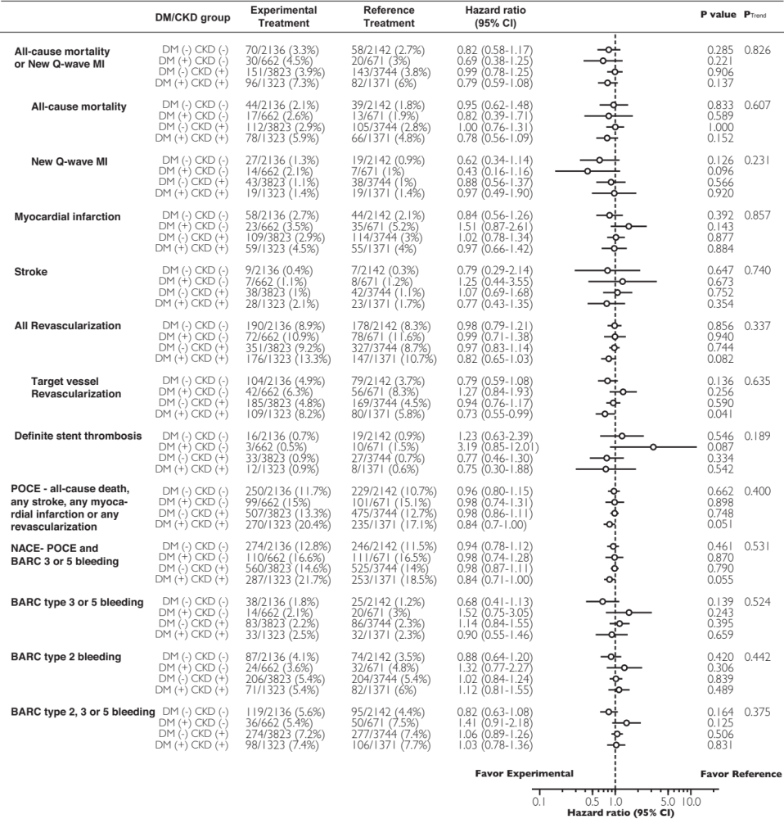

Supplement Table 4 Forest plot of landmark analyses (0-365 days) showing outcomes of reference versus experimental treatment according to DM/CKD status
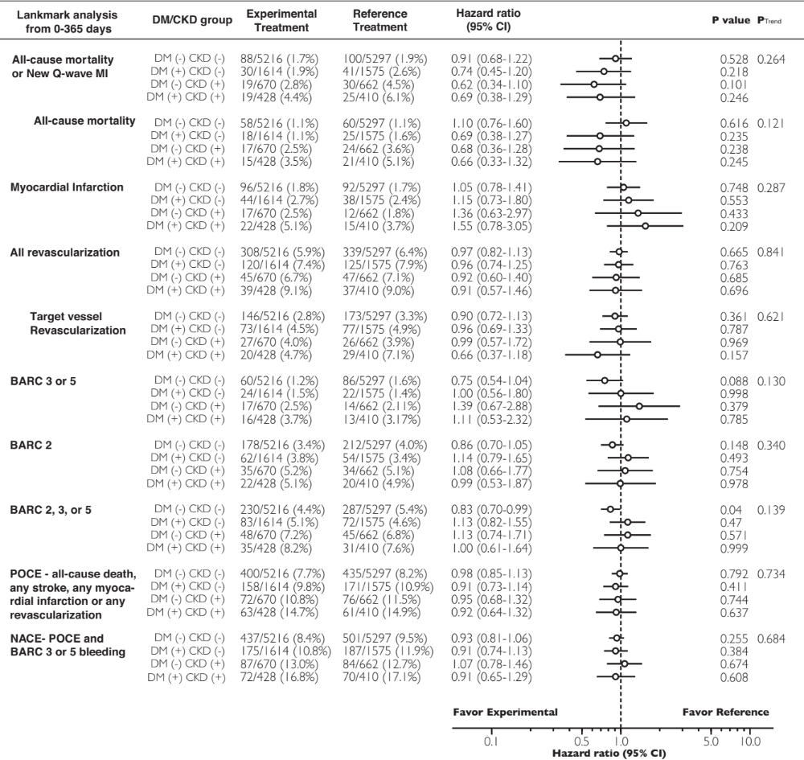

Supplement Figure 1 Kaplan-Meier curves of the landmark analysis showing outcomes of treatment regimen according to DM/CKD status
