Table 4: N-gram analysis of negative sentiment tweets of Topic 1 | Table 5: N-gram analysis of positive sentiment tweets of Topic 1
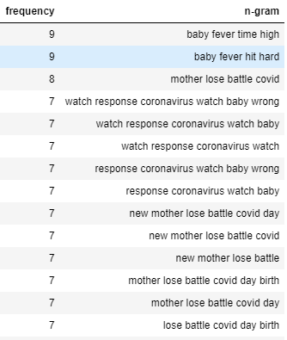 | 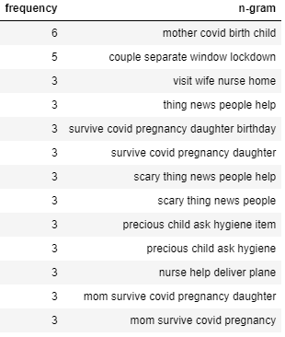

Table 6: N-gram analysis of negative sentiment tweets of Topic 2 | Table 7: N-gram analysis of positive sentiment tweets of Topic 2
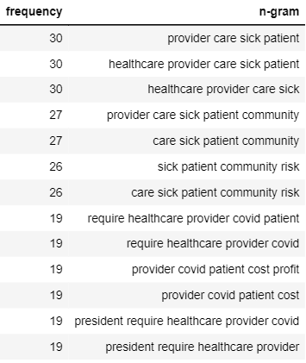 | 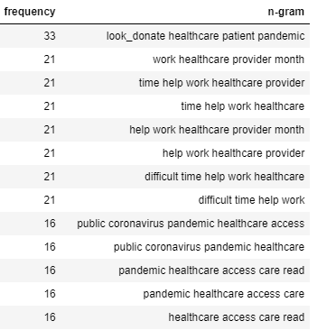

Table 8: N-gram analysis of negative sentiment tweets of Topic 3 | Table 9: N-gram analysis of positive sentiment tweets of Topic 3
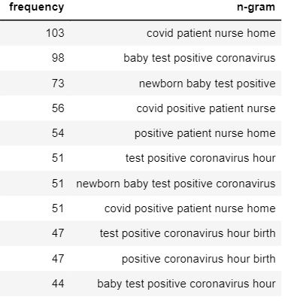 | 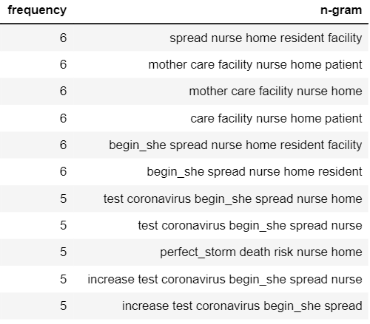

Table 10: N-gram analysis of racial inequality tweets
