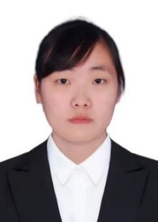

Bin Ma obtained her Master’s degree in the Detection technology and automation device at from Xinjiang University in 2012, after graduation, she was employed as a lecturer at Hubei Automotive Industry Institute, her current research focused on the reliability of numerical control equipment, machine vision, and image processing technology.



Ming Ma obtained a master's degree in the Systems Analysis and Integration from Hubei University in 2010. Currently, she worked as an senior lab assistant at Hubei Automotive Industry Institute, and her major research was the big data technology, and the computer-vision processing technology.


Ruiguang Li is currently pursuing a Bachelor's degree in Artificial Intelligence at Jinan University, Zhuhai, China. His research interests include computer vision, object detection and pattern recognition.



Jiawei Zheng is currently pursuing a Bachelor's degree in Artificial Intelligence at Jinan University, China. His research interest lies in computer vision.


Deping Li received the B.S. degree from the College of Physics and Photoelectric Engineering, Guangdong University of Technology, Guangzhou, China, in 2011, and the Ph.D. degree from the Hefei Institute of Physical Science, Chinese Academy of Sciences, Hefei, China, in 2016. In 2016, he joined the College of Information Science and Technology, Jinan University, Guangzhou. In 2021, he joined School of Intelligent Systems Science and Engineering/JNU-Industry School of Artificial Intelligence, Jinan University, Zhuhai. His research interests include artificial intelligence, 3D object recognition, shape matching, robotic vision, and semantic segmentation.

