Computational analysis of substituent effects on the proton affinity and gas-phase basicity of TEMPO derivatives and their hydrogen bonding interactions with water molecules

Abolfazl Shiroudi∗^{1,2}, Maciej Śmiechowski¹, Jacek Czub^{1,2}
& Mohamed A. Abdel-Rahman³

¹ Department of Physical Chemistry, Gdańsk University of Technology, Narutowicza 11/12, Gdańsk 80-233, Poland
² BioTechMed Center, Gdańsk University of Technology, Gdańsk 80-233, Poland
³ Department of Chemistry, Faculty of Science, Suez University, P.O. Box:43221, Suez, Egypt

Supplementary Information

Table S1. Cartesian coordinates of TEMPO derivatives and the protonated forms as well as hydration of the protonated forms optimized at the B3LYP/6-311++G(d,p) level of theory.
TEMPO

0 2

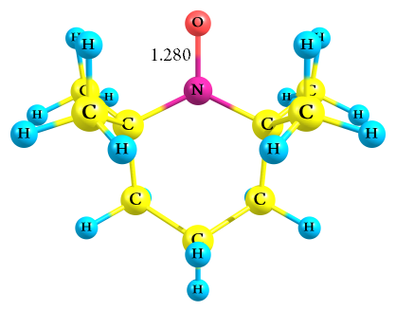
N -0.75060800 0.19830700 0.00000000
C -0.07133400 0.02719900 1.33348300
O -2.02276700 0.05555300 0.00000000
C -0.07133400 0.02719900 -1.33348300
C 1.39603100 0.48972100 1.24494700
C -0.17248400 -1.45024700 1.76608300
C -0.82457400 0.90408700 2.34514200
C -0.82457400 0.90408700 -2.34514200
C -0.17248400 -1.45024700 -1.76608300
C 1.39603100 0.48972100 -1.24494700
C 2.12496400 -0.01303100 0.00000000
H 1.90677900 0.16743200 2.15767900
H 1.41924800 1.58573200 1.24329700
H 0.17409400 -1.55724700 2.79772600
H 0.43075100 -2.10918500 1.13912600
H -1.21158400 -1.77966700 1.71363200
H -0.33014700 0.84126900 3.31841500
H -1.85809500 0.57664200 2.45111700
H -0.82661100 1.94871400 2.02464000
H -0.33014700 0.84126900 -3.31841500
H -0.82661100 1.94871400 -2.02464000
H -1.85809500 0.57664200 -2.45111700
H 0.17409400 -1.55724700 -2.79772600
H -1.21158400 -1.77966700 -1.71363200
H 0.43075100 -2.10918500 -1.13912600
H 1.90677900 0.16743200 -2.15767900
H 1.41924800 1.58573200 -1.24329700
H 2.19054800 -1.10592700 0.00000000
H 3.15552800 0.35504500 0.00000000

Zero-point correction= 0.260688 (Hartree/Particle)
Thermal correction to Energy= 0.272734
Thermal correction to Enthalpy= 0.273678
Thermal correction to Gibbs Free Energy= 0.223984
Sum of electronic and zero-point Energies= -483.595372
Sum of electronic and thermal Energies= -483.583326
Sum of electronic and thermal Enthalpies= -483.582382
Sum of electronic and thermal Free Energies= -483.632076

TEMPO-CH₃

0 2

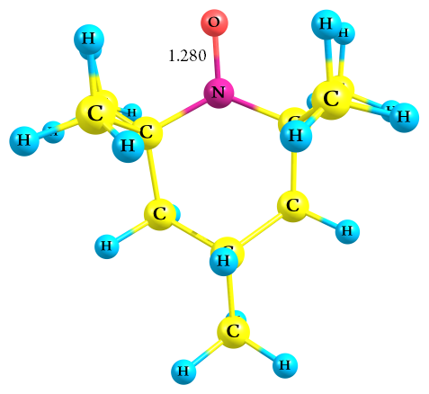
N -1.05578700 0.00000000 -0.24482300
C -0.39204100 1.33034800 -0.01651800
O -2.33559700 0.00000000 -0.21419000
C -0.39204100 -1.33034800 -0.01651800
C 1.10957300 1.23877900 -0.34726700
C -0.62475600 1.76808300 1.44481700
C -1.06172100 2.34216100 -0.95917400
C -1.06172000 -2.34216100 -0.95917400
C -0.62475500 -1.76808300 1.44481700
C 1.10957300 -1.23877900 -0.34726700
C 1.81303100 0.00000000 0.21417000
H 1.58946900 2.15327700 0.01712700
H 1.23200100 1.23619500 -1.43771900
H -0.28305700 2.79804400 1.58038000
H -0.08792800 1.13965300 2.15753900
H -1.68988700 1.72289400 1.67826100
H -0.57578400 3.31576100 -0.85165000
H -2.12094700 2.44724500 -0.72722800
H -0.96822800 2.02134700 -1.99950600
H -0.57578300 -3.31576100 -0.85165000
H -0.96822800 -2.02134700 -1.99950600
H -2.12094600 -2.44724500 -0.72722800
H -0.28305700 -2.79804400 1.58038000
H -1.68988600 -1.72289400 1.67826100
H -0.08792800 -1.13965300 2.15753900
H 1.58946900 -2.15327700 0.01712700
H 1.23200100 -1.23619500 -1.43771900
H 1.72462900 0.00000000 1.30711800
C 3.30626100 0.00000000 -0.13199400
H 3.80716300 0.88395000 0.27359900
H 3.80716300 -0.88394900 0.27359900
H 3.45662900 0.00000000 -1.21680800

Zero-point correction= 0.288239 (Hartree/Particle)
Thermal correction to Energy= 0.301845
Thermal correction to Enthalpy= 0.302789
Thermal correction to Gibbs Free Energy= 0.249797
Sum of electronic and zero-point Energies= -522.893395
Sum of electronic and thermal Energies= -522.879790
Sum of electronic and thermal Enthalpies= -522.878846
Sum of electronic and thermal Free Energies= -522.931838

TEMPO-NH₂

0 2

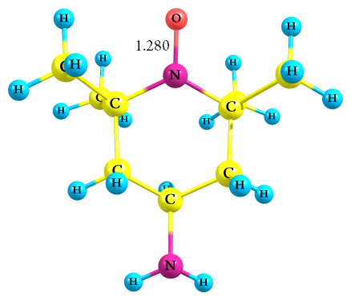
N -1.04624400 0.00000000 -0.23345000
C -0.37962600 1.33154500 -0.01786800
O -2.32525100 0.00000000 -0.18474900
C -0.37962600 -1.33154500 -0.01786800
C 1.11795100 1.23678200 -0.36224500
C -0.60507100 1.77885600 1.44201300
C -1.05451200 2.33759600 -0.96310800
C -1.05451200 -2.33759500 -0.96310800
C -0.60507100 -1.77885600 1.44201300
C 1.11795000 -1.23678300 -0.36224500
C 1.81397900 0.00000000 0.20175500
H 1.60529000 2.14939700 -0.00091600
H 1.24640200 1.22002900 -1.44962300
H -0.25121900 2.80537400 1.57259800
H -0.07576100 1.14709100 2.15749600
H -1.67054100 1.74752900 1.67618300
H -0.57051300 3.31286400 -0.86257200
H -2.11283600 2.44092900 -0.72613800
H -0.96432400 2.01179600 -2.00200500
H -0.57051500 -3.31286400 -0.86257200
H -0.96432500 -2.01179500 -2.00200500
H -2.11283700 -2.44092800 -0.72613900
H -0.25122100 -2.80537400 1.57259800
H -1.67054100 -1.74752900 1.67618300
H -0.07576100 -1.14709100 2.15749600
H 1.60529000 -2.14939800 -0.00091600
H 1.24640200 -1.22002900 -1.44962300
H 1.72248300 0.00000000 1.29817200
N 3.22105400 -0.00000100 -0.22543200
H 3.70704400 0.81665700 0.13296300
H 3.70704400 -0.81665900 0.13296200

Zero-point correction= 0.277599 (Hartree/Particle)
Thermal correction to Energy= 0.291064
Thermal correction to Enthalpy= 0.292008
Thermal correction to Gibbs Free Energy= 0.239309
Sum of electronic and zero-point Energies= -538.945849
Sum of electronic and thermal Energies= -538.932384
Sum of electronic and thermal Enthalpies= -538.931440
Sum of electronic and thermal Free Energies= -538.984140

TEMPO-CHO

0 2

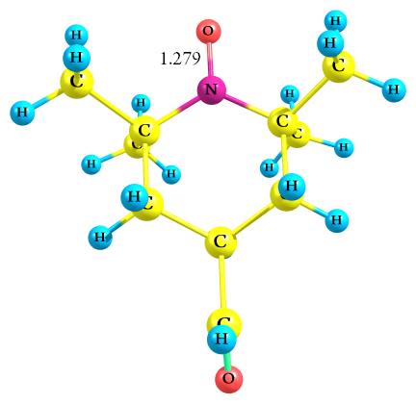
N 1.32243900 0.00004500 -0.21406700
C 0.64994800 -1.32960600 -0.01381500
O 2.59814400 0.00010300 -0.11723000
C 0.64982800 1.32963700 -0.01382100
C -0.82924900 -1.24621700 -0.43914600
C 0.78986700 -1.75815700 1.46143500
C 1.37327100 -2.34836800 -0.90817600
C 1.37305800 2.34846000 -0.90818700
C 0.78970800 1.75820600 1.46142700
C -0.82936200 1.24611200 -0.43915100
C -1.55697400 -0.00008600 0.08859500
H -1.32957500 -2.15782900 -0.09893500
H -0.88316000 -1.24389200 -1.53439500
H 0.44055100 -2.78715000 1.58200500
H 0.21138500 -1.12640400 2.13718600
H 1.83871600 -1.71173200 1.75890600
H 0.88042300 -3.32063300 -0.82450700
H 2.41525900 -2.45338500 -0.60900100
H 1.34701200 -2.03412200 -1.95424500
H 0.88012600 3.32068300 -0.82451900
H 1.34682400 2.03420900 -1.95425500
H 2.41503900 2.45356900 -0.60901500
H 0.44029400 2.78716700 1.58199400
H 1.83856200 1.71188300 1.75889600
H 0.21128800 1.12640000 2.13718100
H -1.32977100 2.15767800 -0.09894200
H -0.88327300 1.24377700 -1.53440100
H -1.59541700 -0.00008300 1.18040800
C -2.98970200 -0.00014000 -0.39866000
H -3.10543700 -0.00012300 -1.50690300
O -3.96292800 -0.00002600 0.31322900

Zero-point correction= 0.269533 (Hartree/Particle)
Thermal correction to Energy= 0.283797
Thermal correction to Enthalpy= 0.284741
Thermal correction to Gibbs Free Energy= 0.229215
Sum of electronic and zero-point Energies= -596.935545
Sum of electronic and thermal Energies= -596.921281
Sum of electronic and thermal Enthalpies= -596.920337
Sum of electronic and thermal Free Energies= -596.975863

TEMPO-NO₂

0 2

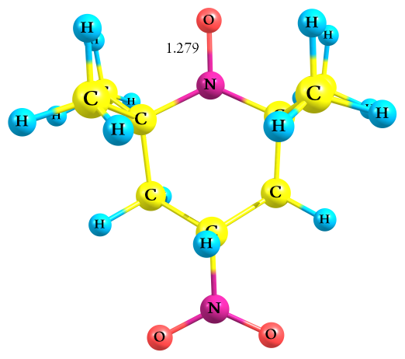
N -1.54002100 0.00000200 -0.25998000
C -0.88096800 1.33047000 -0.01618700
O -2.81887500 0.00000700 -0.24638100
C -0.88097700 -1.33046700 -0.01616300
C 0.62574700 1.24850100 -0.33443800
C -1.12923100 1.76660400 1.44272500
C -1.53279500 2.34609400 -0.96662500
C -1.53281200 -2.34610300 -0.96658400
C -1.12924400 -1.76657300 1.44275500
C 0.62573800 -1.24851500 -0.33441600
C 1.26939000 -0.00000500 0.24740400
H 1.11223800 2.14819900 0.04187700
H 0.76648100 1.23525700 -1.41995900
H -0.78704100 2.79503500 1.58413000
H -0.60741500 1.13754500 2.16664600
H -2.19756400 1.72315800 1.66008000
H -1.04854000 3.31889000 -0.84908600
H -2.59464200 2.44950800 -0.74761300
H -1.42573200 2.02768800 -2.00613400
H -1.04856300 -3.31890000 -0.84902900
H -1.42574900 -2.02771500 -2.00609800
H -2.59465900 -2.44950600 -0.74756900
H -0.78706200 -2.79500400 1.58417900
H -2.19757600 -1.72311500 1.66011000
H -0.60742300 -1.13750600 2.16666600
H 1.11222200 -2.14821100 0.04191400
H 0.76647400 -1.23529200 -1.41993700
H 1.22347900 0.00000600 1.34017000
N 2.78775300 -0.00000600 -0.01023400
O 3.34679300 -1.08253000 -0.08311400
O 3.34681400 1.08251800 -0.08296500

Zero-point correction= 0.263223 (Hartree/Particle)
Thermal correction to Energy= 0.277079
Thermal correction to Enthalpy= 0.278024
Thermal correction to Gibbs Free Energy= 0.223661
Sum of electronic and zero-point Energies= -688.155840
Sum of electronic and thermal Energies= -688.141983
Sum of electronic and thermal Enthalpies= -688.141039
Sum of electronic and thermal Free Energies= -688.195401

TEMPO-H⁺ [H-atom bonded to the nitrogen atom of the NO moiety]

1 2

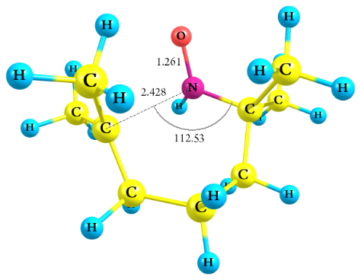
N -0.39053000 -0.91604200 -0.45766100
C -1.50969300 0.00908500 -0.02823900
O -0.24034600 -2.05062300 0.07073000
C 1.80786600 0.01520100 -0.01478900
C -1.10948600 1.44131700 -0.43845900
C -1.75708600 -0.15434800 1.47054400
C -2.74924800 -0.43654500 -0.83039300
C 2.47755600 -0.86011300 -1.00691600
C 1.91526100 -0.37565200 1.40750300
C 1.46996400 1.41024300 -0.39411200
C 0.17013200 2.02281300 0.17548200
H -1.94875000 2.08695900 -0.16680700
H -1.04248400 1.49744800 -1.53266100
H -2.58787600 0.49182600 1.75961100
H -0.89316800 0.11903200 2.07633300
H -2.02576300 -1.18246900 1.71134700
H -3.58934600 0.21814200 -0.58810700
H -3.02536500 -1.46154300 -0.57703000
H -2.57899800 -0.37357400 -1.90900200
H 3.54908700 -0.60276800 -0.96898200
H 2.15610300 -0.67657100 -2.03311800
H 2.39958800 -1.91801900 -0.75216400
H 2.98701900 -0.47677900 1.63534600
H 1.48999300 -1.37094500 1.57148600
H 1.48019500 0.34164700 2.09922700
H 2.31827900 1.99753600 0.00308000
H 1.49985800 1.52902600 -1.48025100
H 0.15316100 1.95255500 1.26503800
H 0.20297500 3.08993600 -0.05426900
H -0.17962600 -0.87615900 -1.46502600

Zero-point correction= 0.269235 (Hartree/Particle)
Thermal correction to Energy= 0.282761
Thermal correction to Enthalpy= 0.283705
Thermal correction to Gibbs Free Energy= 0.230488
Sum of electronic and zero-point Energies= -483.901831
Sum of electronic and thermal Energies= -483.888305
Sum of electronic and thermal Enthalpies= -483.887360
Sum of electronic and thermal Free Energies= -483.940578

TEMPO-CH₃-H⁺ [H-atom bonded to the nitrogen atom of the NO moiety]

1 2

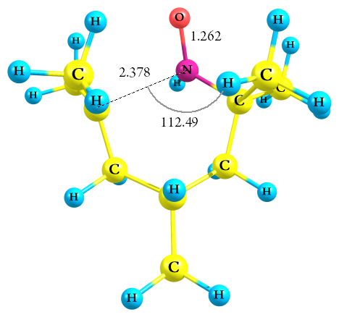
N -0.61666200 -1.11778300 -0.46929400
C -1.54206700 -0.00584500 -0.02201400
O -0.70532200 -2.27620500 0.02313800
C 1.66732300 -0.64173700 -0.00930100
C -0.88046700 1.33474600 -0.40004900
C -1.83128300 -0.15235700 1.47126200
C -2.83727300 -0.19388200 -0.83910300
C 2.17134800 -1.60772200 -1.01845500
C 1.70749700 -1.07452900 1.40670000
C 1.62012900 0.79997000 -0.35776100
C 0.48232000 1.67982300 0.22588400
H -1.59404800 2.11447400 -0.11993900
H -0.79560900 1.40052400 -1.49330900
H -2.52837900 0.63270800 1.76970200
H -0.93815900 -0.05951800 2.08872300
H -2.29207600 -1.11604900 1.68635300
H -3.54130800 0.60175300 -0.58563200
H -3.30277300 -1.15392500 -0.60933800
H -2.64971700 -0.14132800 -1.91541300
H 3.27117300 -1.55986600 -0.96740200
H 1.90101000 -1.34437700 -2.04209400
H 1.88960900 -2.63647700 -0.78985300
H 2.75173200 -1.34122000 1.62888700
H 1.13295700 -1.99334300 1.55453200
H 1.39163700 -0.31055600 2.11287800
H 2.57353100 1.18670800 0.04771000
H 1.67547700 0.93532000 -1.44179600
H 0.43507900 1.52665100 1.30754900
H -0.39791300 -1.09384600 -1.47553300
C 0.82025000 3.15747300 -0.02361600
H 0.05198500 3.80469800 0.40407100
H 1.77549100 3.42894800 0.43230600
H 0.88286000 3.37719800 -1.09373200

Zero-point correction= 0.297089 (Hartree/Particle)
Thermal correction to Energy= 0.312051
Thermal correction to Enthalpy= 0.312996
Thermal correction to Gibbs Free Energy= 0.256801
Sum of electronic and zero-point Energies= -523.199575
Sum of electronic and thermal Energies= -523.184613
Sum of electronic and thermal Enthalpies= -523.183669
Sum of electronic and thermal Free Energies= -523.239863

TEMPO-NH₂-H⁺ [H-atom bonded to the nitrogen atom of the NO moiety]

1 2

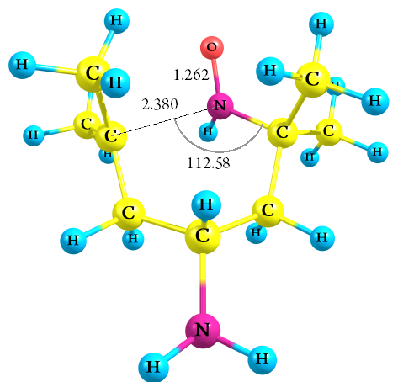
N -0.54798200 -1.13640300 -0.47130400
C -1.53642900 -0.08201700 -0.01947200
O -0.57242600 -2.30051400 0.01510900
C 1.70771500 -0.53293400 -0.00837100
C -0.95350900 1.29424000 -0.39276400
C -1.82203100 -0.25491900 1.47221100
C -2.81709600 -0.33819100 -0.84141000
C 2.26619400 -1.45837300 -1.02632700
C 1.77086000 -0.97669400 1.40367900
C 1.57480700 0.90262700 -0.34924000
C 0.38391500 1.71274100 0.23703000
H -1.70904300 2.03182000 -0.10571200
H -0.86098400 1.38013200 -1.48224400
H -2.55989800 0.49051500 1.77430700
H -0.93725800 -0.12161700 2.09416600
H -2.23368400 -1.24271500 1.67736100
H -3.56712000 0.41283200 -0.58389000
H -3.22567600 -1.32543300 -0.61903300
H -2.63049700 -0.26686200 -1.91663200
H 3.36157400 -1.34850700 -0.97378400
H 1.98275900 -1.19949800 -2.04745000
H 2.04334500 -2.50372300 -0.80809800
H 2.83269000 -1.15722400 1.63065900
H 1.27343800 -1.94113000 1.53795900
H 1.39109800 -0.24843500 2.11603400
H 2.49744000 1.35182100 0.06288100
H 1.61344200 1.06547900 -1.42854300
H 0.34565800 1.55350200 1.32253400
H -0.32940300 -1.09415400 -1.47694400
N 0.62933700 3.10483000 -0.12629700
H -0.16441600 3.69809500 0.08984900
H 1.43991700 3.49134700 0.34689300

Zero-point correction= 0.286206 (Hartree/Particle)
Thermal correction to Energy= 0.301061
Thermal correction to Enthalpy= 0.302005
Thermal correction to Gibbs Free Energy= 0.246052
Sum of electronic and zero-point Energies= -539.251135
Sum of electronic and thermal Energies= -539.236280
Sum of electronic and thermal Enthalpies= -539.235336
Sum of electronic and thermal Free Energies= -539.291288

TEMPO-CHO-H⁺ [H-atom bonded to the nitrogen atom of the NO moiety]

1 2

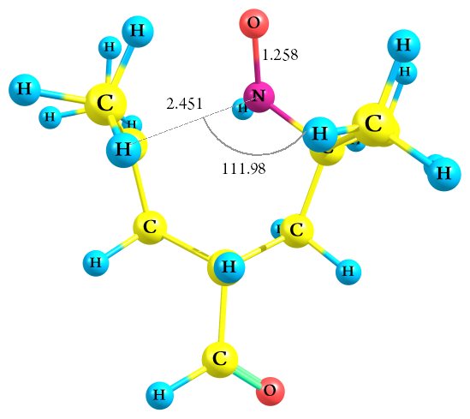
N -1.35049300 0.66824300 -0.47799400
C -0.22176500 1.56157000 -0.01076600
O -2.50081800 0.74329700 0.02449400
C -0.89137000 -1.69815300 -0.03389600
C 1.10335300 0.86316400 -0.37000400
C -0.38706000 1.85010200 1.48032800
C -0.35533900 2.86227300 -0.83000200
C -1.82481400 -2.15169300 -1.09266700
C -1.38271600 -1.73296000 1.35972000
C 0.56460700 -1.66099700 -0.32737200
C 1.38329100 -0.49362400 0.28328300
H 1.91243700 1.54470800 -0.09939900
H 1.17949300 0.75711300 -1.45929200
H 0.42848800 2.49975600 1.80281500
H -0.36412800 0.94927300 2.09449400
H -1.32868900 2.36220600 1.67597100
H 0.45399100 3.54261500 -0.55613100
H -1.30717000 3.35373500 -0.62185200
H -0.28158600 2.67462200 -1.90491800
H -1.80961400 -3.25427100 -1.06572400
H -1.51177200 -1.86756200 -2.09841900
H -2.85515300 -1.84887400 -0.89912800
H -1.74780800 -2.75280800 1.55275500
H -2.25957300 -1.08717700 1.47844700
H -0.63017100 -1.48588700 2.10528200
H 0.94911600 -2.60656400 0.10019800
H 0.74078200 -1.71591400 -1.40477700
H 1.18929700 -0.45046600 1.36269200
H -1.32748400 0.45470000 -1.48556000
C 2.87105600 -0.86446800 0.18443000
H 3.11752200 -1.88635600 0.54558300
O 3.71957000 -0.12727700 -0.22891800

Zero-point correction= 0.277660 (Hartree/Particle)
Thermal correction to Energy= 0.293298
Thermal correction to Enthalpy= 0.294242
Thermal correction to Gibbs Free Energy= 0.235573
Sum of electronic and zero-point Energies= -597.234482
Sum of electronic and thermal Energies= -597.218845
Sum of electronic and thermal Enthalpies= -597.217900
Sum of electronic and thermal Free Energies= -597.276570

TEMPO-NO₂-H⁺ [H-atom bonded to the nitrogen atom of the NO moiety]

1 2

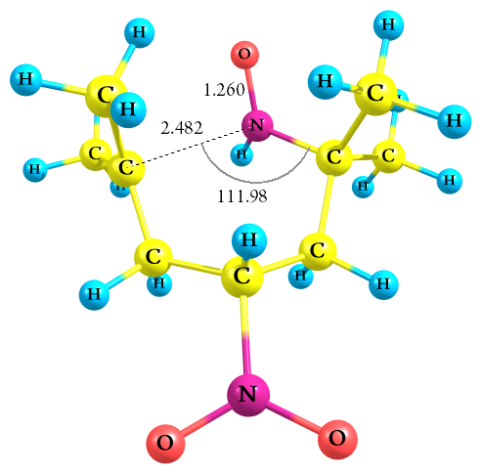
N 1.77386200 -0.21288300 -0.44850000
C 0.99062300 -1.44587700 -0.05008000
O 2.84715300 0.09657700 0.13369800
C 0.50612400 1.87531500 -0.00941300
C -0.48073700 -1.23202800 -0.46767700
C 1.17235700 -1.70023800 1.44598500
C 1.58280700 -2.60845800 -0.87228700
C 1.27786600 2.67345100 -0.98933800
C 0.86820500 2.02592600 1.41468800
C -0.80060600 1.31552600 -0.42188400
C -1.18927200 -0.04153800 0.17646500
H -1.02476600 -2.13902100 -0.20288200
H -0.54926300 -1.14297900 -1.55840800
H 0.59948100 -2.58673600 1.72342500
H 0.83400200 -0.87015300 2.06748800
H 2.21997000 -1.88269700 1.68262800
H 1.03848400 -3.52728100 -0.64332700
H 2.63427600 -2.75759100 -0.62171100
H 1.49822200 -2.43022900 -1.94800000
H 0.85683300 3.69275800 -0.95761000
H 1.16601600 2.32781000 -2.01767700
H 2.33000800 2.76385000 -0.71389100
H 0.89065400 3.10190100 1.64043800
H 1.89528100 1.67992700 1.58281100
H 0.18916900 1.53635800 2.10902600
H -1.54748000 2.05395500 -0.07329600
H -0.89290700 1.28898800 -1.50996800
H -1.06438300 -0.05187500 1.26069700
H 1.74854700 -0.00235900 -1.45646600
N -2.73220800 -0.20193100 0.03294500
O -3.16972600 -1.33152900 0.09245900
O -3.38716900 0.81952700 -0.07780100

Zero-point correction= 0.271177 (Hartree/Particle)
Thermal correction to Energy= 0.287415
Thermal correction to Enthalpy= 0.288359
Thermal correction to Gibbs Free Energy= 0.226811
Sum of electronic and zero-point Energies= -688.446809
Sum of electronic and thermal Energies= -688.430571
Sum of electronic and thermal Enthalpies= -688.429627
Sum of electronic and thermal Free Energies= -688.491174

TEMPO-H⁺ [H-atom bonded to the oxygen atom of the NO moiety]

1 2
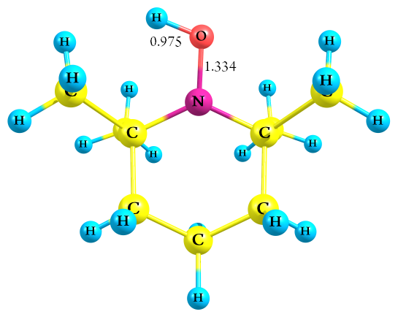
N 0.00149217 -0.68198905 -0.14464466
C -1.35428271 -0.02921464 -0.01223934
O 0.05053875 -2.01388824 -0.08157878
C 1.36445740 -0.05477763 -0.01554261
C -1.23614023 1.41742138 -0.53472599
C -1.76276447 -0.07653609 1.47920026
C -2.36027748 -0.82227650 -0.86628510
C 2.35139500 -0.85753438 -0.87955535
C 1.77785032 -0.12729576 1.47397260
C 1.26492509 1.39964222 -0.52274809
C 0.01761720 2.14615712 -0.05245189
H -2.14231854 1.94211933 -0.22293718
H -1.24333001 1.39854657 -1.62932688
H -2.78945361 0.28684821 1.55677817
H -1.13120199 0.55614445 2.10053550
H -1.73488665 -1.09340597 1.87675419
H -3.29705280 -0.26312756 -0.88551404
H -2.61716638 -1.80361521 -0.44825885
H -2.02009441 -0.93975021 -1.89716043
H 3.30220159 -0.32148095 -0.87987429
H 2.00667919 -0.93347549 -1.91264647
H 2.52559015 -1.85855904 -0.48718290
H 2.80976369 0.22105896 1.54794789
H 1.73835568 -1.15285216 1.84356007
H 1.16113241 0.50633722 2.11063073
H 2.17374311 1.91021039 -0.19667475
H 1.28651962 1.39056529 -1.61721819
H 0.01224462 2.26571474 1.03473282
H 0.02485109 3.15667018 -0.46653615
H -0.85701270 -2.35643379 -0.18021335

Zero-point correction= 0.273030 (Hartree/Particle)
Thermal correction to Energy= 0.285460
Thermal correction to Enthalpy= 0.286404
Thermal correction to Gibbs Free Energy= 0.236029
Sum of electronic and zero-point Energies= -483.933967
Sum of electronic and thermal Energies= -483.921537
Sum of electronic and thermal Enthalpies= -483.920593
Sum of electronic and thermal Free Energies= -483.970968

TEMPO-CH₃-H⁺ [H-atom bonded to the oxygen atom of the NO moiety]

1 2
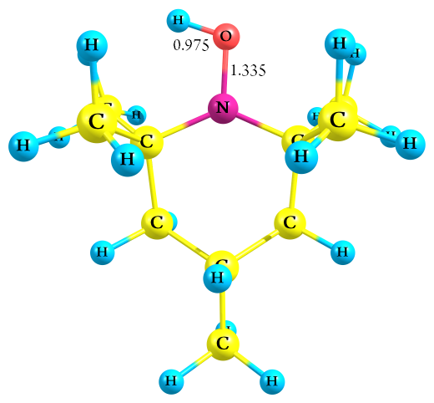
N 0.98600900 -0.03876900 -0.19009400
C 0.31881500 -1.37293000 -0.00129300
O 2.31484500 -0.14132700 -0.25883300
C 0.40300000 1.33874800 0.00362200
C -1.17490300 -1.20921800 -0.35037000
C 0.53342800 -1.80408400 1.46986500
C 0.98243200 -2.38531400 -0.95077400
C 1.13870900 2.31292100 -0.93538000
C 0.62634200 1.74811700 1.47915500
C -1.09341700 1.27646700 -0.36193700
C -1.83906800 0.05897300 0.19595000
H -1.68327000 -2.10126900 0.02401600
H -1.28504900 -1.22265300 -1.44041200
H 0.14539000 -2.81877000 1.57696500
H 0.00371500 -1.16373100 2.17452700
H 1.59396000 -1.81728900 1.72485900
H 0.41019800 -3.31321300 -0.89739700
H 2.01168800 -2.60350600 -0.66882900
H 0.96139100 -2.03501300 -1.98455300
H 0.61817400 3.27113200 -0.89883900
H 1.13136300 1.96753600 -1.97113800
H 2.16891500 2.53016100 -0.62651700
H 0.30743500 2.78637900 1.59051500
H 1.67919400 1.68746300 1.76344600
H 0.04500300 1.13875100 2.16901600
H -1.54419800 2.20495700 -0.00166400
H -1.19257600 1.28241100 -1.45313400
H -1.77028900 0.06252700 1.28962800
C -3.32573100 0.10843300 -0.17641700
H -3.85843500 -0.75502800 0.22844300
H -3.80050900 1.00840400 0.22139100
H -3.46247500 0.10792600 -1.26205100
H 2.68190800 0.75213100 -0.39147700

Zero-point correction= 0.300685 (Hartree/Particle)
Thermal correction to Energy= 0.314641
Thermal correction to Enthalpy= 0.315585
Thermal correction to Gibbs Free Energy= 0.261997
Sum of electronic and zero-point Energies= -523.232670
Sum of electronic and thermal Energies= -523.218714
Sum of electronic and thermal Enthalpies= -523.217770
Sum of electronic and thermal Free Energies= -523.271358

TEMPO-NH₂-H⁺ [H-atom bonded to the oxygen atom of the NO moiety]

1 2
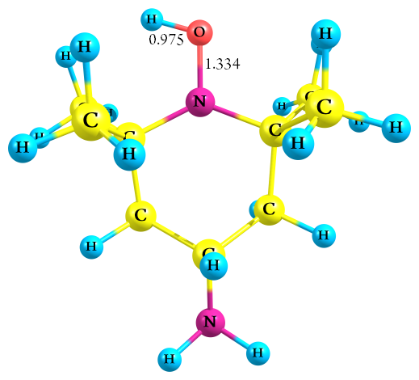
N 0.97306639 -0.06130151 -0.18533655
C 0.27280743 -1.37943827 -0.00065022
O 2.29880975 -0.19587350 -0.24662750
C 0.42191758 1.33032616 0.00341449
C -1.21395027 -1.17855999 -0.35153094
C 0.48266038 -1.82335301 1.46766070
C 0.90884287 -2.40298099 -0.95773685
C 1.17702693 2.28215595 -0.94338943
C 0.66076116 1.74179604 1.47637543
C -1.07284296 1.30094667 -0.36378240
C -1.84409243 0.10304824 0.19908696
H -1.74663199 -2.05746444 0.02182481
H -1.33815665 -1.17249124 -1.43846165
H 0.06071450 -2.82451895 1.57389827
H -0.01919002 -1.16792161 2.17888806
H 1.54404620 -1.87446861 1.71412503
H 0.31616427 -3.31798319 -0.90601008
H 1.93394507 -2.64485116 -0.68005962
H 0.89087231 -2.04751234 -1.98966014
H 0.68056801 3.25309402 -0.90967315
H 1.15668276 1.93163852 -1.97708757
H 2.21342616 2.47441047 -0.63884356
H 0.35544695 2.78430855 1.58611774
H 1.71506242 1.67011002 1.75281116
H 0.07738831 1.14203156 2.17298229
H -1.50568127 2.23948026 -0.00610658
H -1.18831977 1.29269457 -1.45164148
H -1.77232592 0.10425595 1.29757227
N -3.22296541 0.18316309 -0.27441896
H -3.77026851 -0.61715282 0.02620368
H -3.69204213 1.01499490 0.06988766
H 2.68833024 0.68765764 -0.38214500

Zero-point correction= 0.289843 (Hartree/Particle)
Thermal correction to Energy= 0.303687
Thermal correction to Enthalpy= 0.304632
Thermal correction to Gibbs Free Energy= 0.251264
Sum of electronic and zero-point Energies= -539.283833
Sum of electronic and thermal Energies= -539.269989
Sum of electronic and thermal Enthalpies= -539.269045
Sum of electronic and thermal Free Energies= -539.322412

TEMPO-CHO-H⁺ [H-atom bonded to the oxygen atom of the NO moiety]

1 2
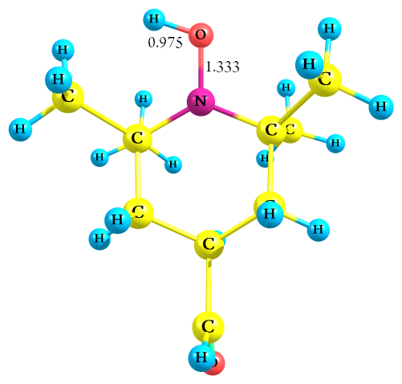
N 1.25113290 -0.00300872 -0.16017503
C 0.59852850 -1.35384082 -0.00057859
O 2.58357633 0.04161001 -0.15427601
C 0.63556330 1.36032053 0.00016354
C -0.86899997 -1.22995617 -0.45848397
C 0.70923408 -1.76929720 1.48573876
C 1.34399008 -2.36322562 -0.89355165
C 1.39796457 2.34689656 -0.90099731
C 0.77673277 1.77432899 1.48472204
C -0.84065151 1.27003503 -0.44047050
C -1.58037355 0.02524188 0.06693574
H -1.38173951 -2.13475863 -0.12285743
H -0.90170893 -1.23255534 -1.55349992
H 0.33790149 -2.79206453 1.57642527
H 0.11447577 -1.13383641 2.13956609
H 1.74428590 -1.75526257 1.83377565
H 0.77886680 -3.29663381 -0.88970758
H 2.34099565 -2.62696096 -0.51983001
H 1.41805889 -2.02061022 -1.92767207
H 0.86595963 3.29959159 -0.87447896
H 1.42494038 2.00306887 -1.93684057
H 2.41652370 2.51727641 -0.55504656
H 0.43104130 2.80584557 1.57504537
H 1.81902358 1.73642681 1.80386483
H 0.17520052 1.15742840 2.15153707
H -1.32946507 2.18076815 -0.08644361
H -0.88438050 1.29297963 -1.53479129
H -1.63809869 0.01494302 1.15764015
C -3.02623239 0.03729023 -0.42850817
H -3.15228289 0.09891164 -1.53160837
O -3.97518499 -0.01832744 0.30344898
H 2.92080566 -0.86651760 -0.26705596

Zero-point correction= 0.281568 (Hartree/Particle)
Thermal correction to Energy= 0.296272
Thermal correction to Enthalpy= 0.297217
Thermal correction to Gibbs Free Energy= 0.240494
Sum of electronic and zero-point Energies= -597.265126
Sum of electronic and thermal Energies= -597.250422
Sum of electronic and thermal Enthalpies= -597.249478
Sum of electronic and thermal Free Energies= -597.306200

TEMPO-NO₂-H⁺ [H-atom bonded to the oxygen atom of the NO moiety]

1 2
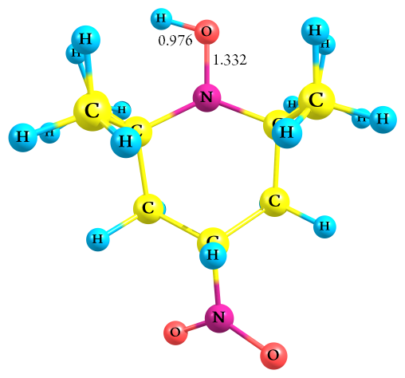
N -1.46079500 0.03017800 -0.21587900
C -0.80245000 1.37687400 -0.06399600
O -2.78286700 0.12721700 -0.34257800
C -0.88403100 -1.33526000 0.07869800
C 0.70147400 1.20463600 -0.35767500
C -1.06687400 1.87869400 1.37576600
C -1.42530600 2.34270700 -1.08653200
C -1.58017800 -2.36344500 -0.83189800
C -1.16002300 -1.66364300 1.56562100
C 0.62433300 -1.29832300 -0.24378200
C 1.30215300 -0.04332400 0.28355200
H 1.21468300 2.09684300 0.00191300
H 0.85459600 1.15260600 -1.43999600
H -0.67982400 2.89677400 1.44766400
H -0.56800700 1.27501400 2.13378500
H -2.13611800 1.90511100 1.58901900
H -0.85551100 3.27308100 -1.05469100
H -2.46389500 2.57162800 -0.85224700
H -1.36601000 1.94362200 -2.10084200
H -1.06006400 -3.31646000 -0.72305800
H -1.53533500 -2.07642900 -1.88432700
H -2.61978300 -2.56548600 -0.54653400
H -0.83530100 -2.69008400 1.74737500
H -2.22416900 -1.60091200 1.80243300
H -0.61697900 -1.01094200 2.24754900
H 1.07423500 -2.19588500 0.18226200
H 0.77107600 -1.35585700 -1.32477000
H 1.27534300 0.01844800 1.37283100
N 2.80696900 -0.06201200 -0.02403600
O 3.25543600 -1.02396000 -0.61995600
O 3.43267100 0.90665600 0.36392400
H -3.14865400 -0.77104200 -0.44861100

Zero-point correction= 0.275395 (Hartree/Particle)
Thermal correction to Energy= 0.290507
Thermal correction to Enthalpy= 0.291452
Thermal correction to Gibbs Free Energy= 0.233614
Sum of electronic and zero-point Energies= -688.479365
Sum of electronic and thermal Energies= -688.464252
Sum of electronic and thermal Enthalpies= -688.463308
Sum of electronic and thermal Free Energies= -688.521145

TEMPO-H₂O [H-atom bonded to the O-atom of the NO moiety in planar mode]

0 2

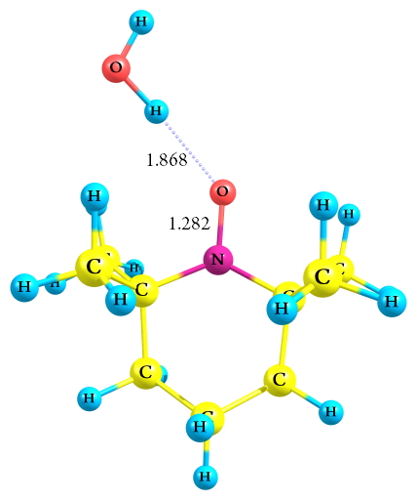
N 0.10223900 -0.34143500 -0.34287100
C -1.24390200 -0.93880900 -0.02226300
O 1.06096100 -1.18579500 -0.45057100
C 0.48875200 1.09751900 -0.11056000
C -2.35304900 0.11165000 -0.22439100
C -1.22287700 -1.46443300 1.42814000
C -1.46862300 -2.11308600 -0.98692700
C 1.56157600 1.46869500 -1.14687200
C 1.07095400 1.24509400 1.31075600
C -0.74147800 2.00508400 -0.31122400
C -2.01241600 1.48328000 0.35493900
H -3.27385100 -0.28507500 0.21405200
H -2.54041400 0.22342200 -1.29868600
H -2.13344700 -2.03746400 1.62299100
H -1.16968500 -0.65782700 2.16120900
H -0.36336000 -2.12073600 1.57396000
H -2.46517700 -2.53010400 -0.81888700
H -0.72755200 -2.89615300 -0.83224900
H -1.40473900 -1.77928700 -2.02533500
H 1.77501100 2.53806400 -1.06620900
H 1.20603400 1.26533700 -2.15994300
H 2.49021700 0.92314400 -0.98637500
H 1.45997400 2.25914800 1.43705700
H 1.89506300 0.54649200 1.46194800
H 0.32105500 1.07441400 2.08543300
H -0.48286600 3.00122000 0.05995900
H -0.92892400 2.11036300 -1.38622500
H -1.89147000 1.43014400 1.44162100
H -2.83836300 2.17738600 0.17244900
H 2.87368800 -1.09564400 -0.00738700
O 3.78922400 -0.97578000 0.30136100
H 4.20803100 -1.83415600 0.19479900

Zero-point correction= 0.284843 (Hartree/Particle)
Thermal correction to Energy= 0.300427
Thermal correction to Enthalpy= 0.301371
Thermal correction to Gibbs Free Energy= 0.242604
Sum of electronic and zero-point Energies= -560.039944
Sum of electronic and thermal Energies= -560.024360
Sum of electronic and thermal Enthalpies= -560.023416
Sum of electronic and thermal Free Energies= -560.082184

TEMPO-CH₃-H₂O [H-atom bonded to the O-atom of the NO moiety in planar mode]

0 2

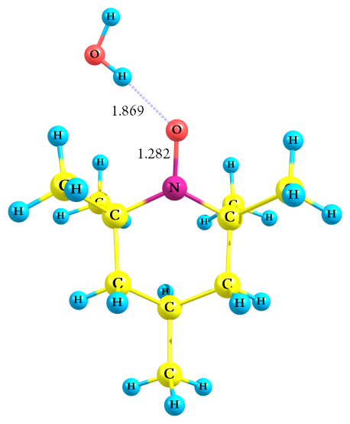
N 0.52240500 0.39790700 -0.33757300
C 0.40668800 -1.08899400 -0.12366100
O 1.70707700 0.88068800 -0.42336000
C -0.55786800 1.39865100 -0.02492300
C -1.05179700 -1.53466600 -0.34573700
C 0.89261300 -1.43904000 1.29830100
C 1.30704100 -1.78317800 -1.15886600
C -0.37450000 2.58888000 -0.97951200
C -0.38426100 1.88071300 1.43053200
C -1.94558000 0.77043000 -0.25043400
C -2.10393300 -0.64211000 0.31681300
H -1.13994600 -2.56577900 0.01176000
H -1.25426100 -1.56046900 -1.42378900
H 0.92094600 -2.52619800 1.41196400
H 0.23329000 -1.03826000 2.07023200
H 1.90033400 -1.05614200 1.46501800
H 1.15318400 -2.86370300 -1.09316500
H 2.36210400 -1.57796800 -0.98380100
H 1.05048900 -1.46102700 -2.17103000
H -1.17927300 3.31024300 -0.81442100
H -0.41387900 2.26019700 -2.02079600
H 0.58172800 3.08273000 -0.81144200
H -1.06414000 2.71484400 1.62384900
H 0.63931600 2.22438200 1.58855500
H -0.60039000 1.09497700 2.15601900
H -2.69149000 1.44660300 0.18024000
H -2.14596000 0.73111700 -1.32840200
H -1.92691800 -0.61848100 1.39866300
C -3.52041100 -1.18162900 0.08889100
H -3.63135100 -2.18867800 0.50135700
H -4.26932400 -0.54123000 0.56401800
H -3.75424800 -1.23191700 -0.97988200
H 3.38304600 0.18420400 0.02202300
O 4.20503500 -0.23753300 0.32933000
H 4.88506200 0.43562300 0.23985700

Zero-point correction= 0.312524 (Hartree/Particle)
Thermal correction to Energy= 0.329605
Thermal correction to Enthalpy= 0.330549
Thermal correction to Gibbs Free Energy= 0.268741
Sum of electronic and zero-point Energies= -599.337947
Sum of electronic and thermal Energies= -599.320866
Sum of electronic and thermal Enthalpies= -599.319922
Sum of electronic and thermal Free Energies= -599.381730

TEMPO-NH₂-H₂O [H-atom bonded to the O-atom of the NO moiety in planar mode]

0 2

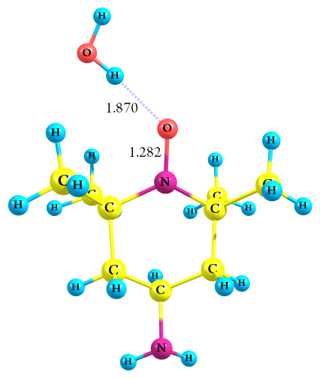
N 0.50727500 0.40373800 -0.33209600
C 0.41358000 -1.08614700 -0.12653900
O 1.68434800 0.90534000 -0.40906800
C -0.59089200 1.38733600 -0.02584900
C -1.03707500 -1.55101000 -0.35549300
C 0.90729900 -1.43648600 1.29303900
C 1.32305100 -1.76121000 -1.16650100
C -0.42603100 2.57565800 -0.98651400
C -0.42612500 1.88024000 1.42725600
C -1.96598200 0.73610900 -0.25606800
C -2.09347400 -0.67486600 0.31326500
H -1.11467800 -2.58427200 0.00027600
H -1.25429100 -1.56971000 -1.42861300
H 0.94283100 -2.52370200 1.40422800
H 0.24937100 -1.04096100 2.06892700
H 1.91355000 -1.04812300 1.45594400
H 1.18760400 -2.84439300 -1.10522400
H 2.37454700 -1.53873900 -0.99109300
H 1.05907300 -1.43923200 -2.17659800
H -1.24130300 3.28588600 -0.82504800
H -0.46090300 2.24100800 -2.02586600
H 0.52286400 3.08392800 -0.81992600
H -1.12664300 2.69757300 1.61869500
H 0.58870500 2.25106200 1.58007800
H -0.61929000 1.09253800 2.15711300
H -2.72607400 1.39591300 0.17684000
H -2.17282600 0.67825800 -1.32967800
H -1.91042800 -0.64829600 1.39780900
N -3.42906000 -1.20270600 -0.00034700
H -3.53689300 -2.14762300 0.35606200
H -4.15239400 -0.63681400 0.43337100
H 3.37256400 0.23021400 0.02995600
O 4.19768800 -0.18638600 0.33543500
H 4.87471300 0.48888500 0.23934300

Zero-point correction= 0.301837 (Hartree/Particle)
Thermal correction to Energy= 0.318806
Thermal correction to Enthalpy= 0.319750
Thermal correction to Gibbs Free Energy= 0.258165
Sum of electronic and zero-point Energies= -615.390398
Sum of electronic and thermal Energies= -615.373429
Sum of electronic and thermal Enthalpies= -615.372485
Sum of electronic and thermal Free Energies= -615.434071

TEMPO-CHO-H₂O [H-atom bonded to the O-atom of the NO moiety in planar mode]

0 2

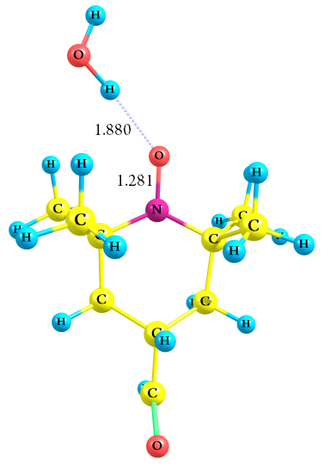
N -0.82872000 0.40003300 -0.34301200
C 0.13367100 1.51237500 -0.02573600
O -2.06429100 0.73816200 -0.36622900
C -0.52923400 -1.06683300 -0.18398100
C 1.57599900 1.07533400 -0.34465700
C -0.02198100 1.90649800 1.45734400
C -0.23428400 2.71126200 -0.91395000
C -1.39043100 -1.83597200 -1.19942500
C -0.89245600 -1.51734400 1.24619200
C 0.95803900 -1.33143200 -0.49590300
C 1.92269100 -0.33326900 0.16108000
H 2.25370800 1.81851300 0.08574900
H 1.72236100 1.10252700 -1.43098300
H 0.56147700 2.80835900 1.66053000
H 0.32185300 1.12368400 2.13486800
H -1.07028700 2.11618300 1.67548000
H 0.48849200 3.51501000 -0.75144100
H -1.23092800 3.08057900 -0.67713000
H -0.21232500 2.43370300 -1.97041700
H -1.09958100 -2.88972500 -1.18435300
H -1.23495900 -1.44992500 -2.20971400
H -2.45073300 -1.77241000 -0.96007000
H -0.77954200 -2.60205800 1.32197900
H -1.93068500 -1.27069100 1.47190400
H -0.25148200 -1.06048100 2.00188100
H 1.18613000 -2.35342800 -0.17995300
H 1.10367800 -1.29495400 -1.58210600
H 1.86277400 -0.38582100 1.25066000
C 3.34915600 -0.67258100 -0.21502800
H 3.55639500 -0.67121000 -1.30972200
O 4.22799800 -0.92935100 0.56930300
H -3.62731900 -0.17158300 0.14772200
O -4.34612200 -0.73135500 0.48873000
H -5.13569100 -0.18437400 0.45615300

Zero-point correction= 0.293714 (Hartree/Particle)
Thermal correction to Energy= 0.311478
Thermal correction to Enthalpy= 0.312422
Thermal correction to Gibbs Free Energy= 0.248081
Sum of electronic and zero-point Energies= -673.379753
Sum of electronic and thermal Energies= -673.361990
Sum of electronic and thermal Enthalpies= -673.361046
Sum of electronic and thermal Free Energies= -673.425386

TEMPO-NO₂-H₂O [H-atom bonded to the O-atom of the NO moiety in planar mode]

0 2

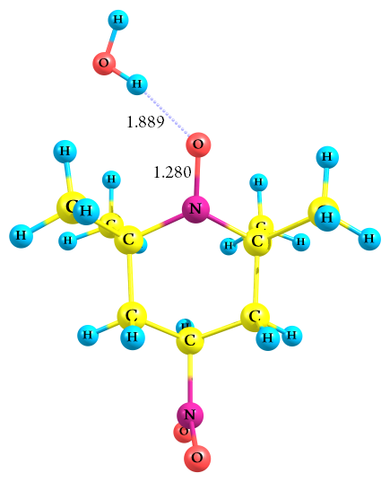
N 1.06313900 0.39782400 -0.34862600
C 0.71365700 -1.05315300 -0.14096700
O 2.30750200 0.68354200 -0.44537200
C 0.16606000 1.55668000 -0.00218700
C -0.79775700 -1.26042800 -0.37401800
C 1.13448500 -1.49271600 1.27678400
C 1.48274400 -1.87801000 -1.18589400
C 0.52801700 2.71988100 -0.93855100
C 0.42307300 1.97582900 1.45987700
C -1.30917900 1.17526700 -0.23555300
C -1.64650500 -0.20256200 0.32142000
H -1.06111400 -2.26057200 -0.01998400
H -1.01658800 -1.22191100 -1.44399700
H 0.97036400 -2.56815800 1.38359900
H 0.56466300 -0.98815000 2.05920300
H 2.19533700 -1.29685800 1.43697100
H 1.15073500 -2.91802300 -1.13165200
H 2.55592800 -1.85340700 -1.00446600
H 1.28635900 -1.50565600 -2.19385100
H -0.14904300 3.55741100 -0.75248000
H 0.43089900 2.42125300 -1.98462300
H 1.55172400 3.04958300 -0.76820500
H -0.11407700 2.90292600 1.67599600
H 1.48940200 2.15083200 1.61004100
H 0.09558200 1.22229000 2.17804500
H -1.93759700 1.94331800 0.22361900
H -1.52588600 1.17051100 -1.30651600
H -1.55894100 -0.24661400 1.40478100
N -3.12279700 -0.49817600 0.07392900
H 3.85816600 -0.28647500 0.02745000
O 4.53661300 -0.89280200 0.37010100
H 5.36966600 -0.41936600 0.29522500
O -3.51139300 -0.50073100 -1.08431600
O -3.82091300 -0.71440700 1.05312000

Zero-point correction= 0.287750 (Hartree/Particle)
Thermal correction to Energy= 0.305985
Thermal correction to Enthalpy= 0.306930
Thermal correction to Gibbs Free Energy= 0.241114
Sum of electronic and zero-point Energies= -764.600829
Sum of electronic and thermal Energies= -764.582594
Sum of electronic and thermal Enthalpies= -764.581650
Sum of electronic and thermal Free Energies= -764.647466

TEMPO-H₂O [H-atom bonded to the O-atom of the NO moiety in top mode]

0 2

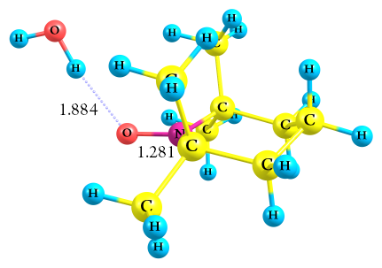
N 0.17704500 0.00008400 0.55869700
C -0.36142600 1.33503300 0.11246600
O 1.36641600 0.00038000 1.03443700
C -0.36075300 -1.33514500 0.11250200
C -1.88927300 1.24591600 -0.07093800
C 0.34112300 1.75459400 -1.19618600
C -0.03688500 2.35445500 1.21446200
C -0.03565500 -2.35437500 1.21451200
C 0.34197900 -1.75436900 -1.19616100
C -1.88864600 -1.24679900 -0.07086100
C -2.34782900 -0.00058000 -0.82580300
H -2.21906900 2.15674900 -0.57985500
H -2.36330700 1.25004700 0.91765600
H 0.06889100 2.78582700 -1.43768000
H 0.05566000 1.12629600 -2.04133900
H 1.42522300 1.70159100 -1.08415800
H -0.47768800 3.31923700 0.94965800
H 1.03868200 2.47967500 1.33102700
H -0.45228500 2.03581600 2.17349200
H -0.47596600 -3.31939000 0.94974000
H -0.45119300 -2.03593200 2.17354800
H 1.03998000 -2.47903800 1.33105100
H 0.07027200 -2.78574800 -1.43761800
H 1.42605400 -1.70079600 -1.08416700
H 0.05616200 -1.12624300 -2.04132300
H -2.21800700 -2.15782700 -0.57970900
H -2.36265200 -1.25109500 0.91774700
H -1.96174100 -0.00051700 -1.84992500
H -3.43879200 -0.00085800 -0.91025600
H 2.93839900 0.00058300 -0.00442000
O 3.63649200 0.00061600 -0.68163000
H 4.46300500 0.00068000 -0.19075500

Zero-point correction= 0.284667 (Hartree/Particle)
Thermal correction to Energy= 0.300322
Thermal correction to Enthalpy= 0.301266
Thermal correction to Gibbs Free Energy= 0.241550
Sum of electronic and zero-point Energies= -560.039435
Sum of electronic and thermal Energies= -560.023779
Sum of electronic and thermal Enthalpies= -560.022835
Sum of electronic and thermal Free Energies= -560.082552

TEMPO-CH₃-H₂O [H-atom bonded to the O-atom of the NO moiety in top mode]

0 2

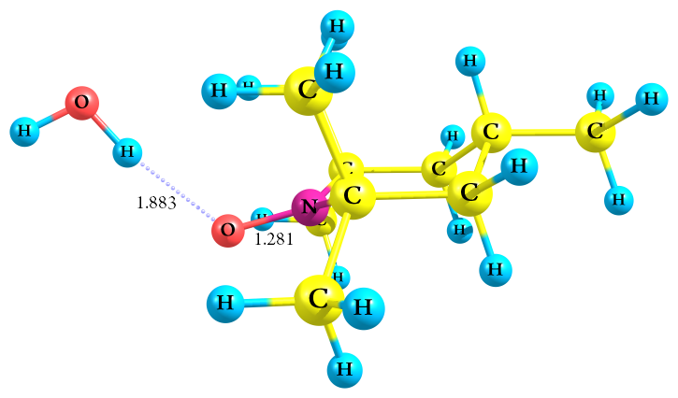
N 0.55360600 0.00004900 0.57843800
C -0.03068900 1.33198800 0.18985600
O 1.78537200 0.00011000 0.93007300
C -0.03057900 -1.33195100 0.18989200
C -1.56855700 1.23958400 0.17011700
C 0.53189200 1.75339100 -1.18432000
C 0.40542200 2.35413800 1.25058800
C 0.40561600 -2.35403400 1.25065200
C 0.53203300 -1.75334900 -1.18427300
C -1.56845400 -1.23967200 0.17015300
C -2.12532500 -0.00007700 -0.53525900
H -1.95152800 2.15281700 -0.29707300
H -1.93538900 1.23964100 1.20421300
H 0.22893900 2.78205800 -1.39847400
H 0.16736500 1.12119600 -1.99517300
H 1.62220000 1.70879400 -1.18138600
H -0.06193200 3.31790900 1.03189400
H 1.48722700 2.48066800 1.25298600
H 0.09356200 2.03668300 2.24842700
H -0.06166000 -3.31784900 1.03198700
H 0.09373400 -2.03657600 2.24848300
H 1.48743200 -2.48047900 1.25305100
H 0.22915100 -2.78204200 -1.39840100
H 1.62233800 -1.70867700 -1.18134400
H 0.16746000 -1.12120000 -1.99514200
H -1.95135200 -2.15295000 -0.29700700
H -1.93528300 -1.23972700 1.20425000
H -1.79128400 -0.00007800 -1.57916300
C -3.65818300 -0.00014000 -0.53866200
H -4.05256000 0.88373200 -1.04844100
H -4.05248700 -0.88405700 -1.04842000
H -4.05329300 -0.00014500 0.48283000
H 3.25154600 -0.00002000 -0.25219100
O 3.89046200 -0.00002400 -0.98540200
H 4.75484900 -0.00000100 -0.56480000

Zero-point correction= 0.311866 (Hartree/Particle)
Thermal correction to Energy= 0.328254
Thermal correction to Enthalpy= 0.329198
Thermal correction to Gibbs Free Energy= 0.269524
Sum of electronic and zero-point Energies= -599.337841
Sum of electronic and thermal Energies= -599.321454
Sum of electronic and thermal Enthalpies= -599.320510
Sum of electronic and thermal Free Energies= -599.380183

TEMPO-NH₂-H₂O [H-atom bonded to the O-atom of the NO moiety in top mode]

0 2

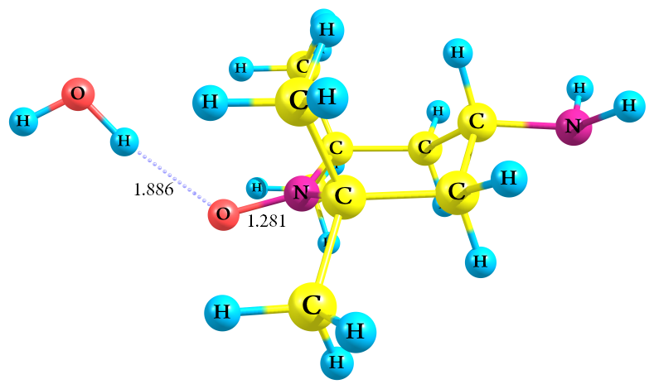
N -0.54276500 -0.00005000 0.57816100
C 0.04298100 -1.33312400 0.19395500
O -1.77510600 -0.00011000 0.92647000
C 0.04286400 1.33308800 0.19399100
C 1.57969400 -1.23744200 0.16881200
C -0.52921700 -1.76423100 -1.17353900
C -0.38359800 -2.34937800 1.26431700
C -0.38380900 2.34928200 1.26437300
C -0.52936600 1.76417500 -1.17349600
C 1.57958400 1.23754000 0.16885300
C 2.12029500 0.00008400 -0.54438100
H 1.96452100 -2.14904700 -0.30161400
H 1.9651 6500 -1.22266200 1.19367500
H -0.21672300 -2.78980200 -1.38881900
H -0.18197700 -1.12933100 -1.98994200
H -1.61983400 -1.73242300 -1.15834700
H 0.08008800 -3.31506300 1.04656200
H -1.46560600 -2.47361300 1.27664800
H -0.06142600 -2.02696100 2.25708700
H 0.07979700 3.31501100 1.04664000
H -0.06161700 2.02687300 2.25713900
H -1.46582700 2.47342400 1.27669600
H -0.21695800 2.78977800 -1.38875300
H -1.61998000 1.73226700 -1.15831300
H -0.18206000 1.12932500 -1.98991100
H 1.96433600 2.14919400 -0.30154100
H 1.96505200 1.22275800 1.19371700
H 1.77033600 0.00008600 -1.58681000
N 3.58844800 0.00014700 -0.46471300
H 3.97452200 -0.81619200 -0.92967900
H 3.97445400 0.81651700 -0.92968300
H -3.24138800 -0.00007500 -0.26028900
O -3.87713400 0.00000800 -0.99607000
H -4.74330700 0.00010400 -0.57909600

Zero-point correction= 0.301285 (Hartree/Particle)
Thermal correction to Energy= 0.317521
Thermal correction to Enthalpy= 0.318466
Thermal correction to Gibbs Free Energy= 0.259130
Sum of electronic and zero-point Energies= -615.390221
Sum of electronic and thermal Energies= -615.373985
Sum of electronic and thermal Enthalpies= -615.373041
Sum of electronic and thermal Free Energies= -615.432376

TEMPO-CHO-H₂O [H-atom bonded to the O-atom of the NO moiety in top mode]

0 2

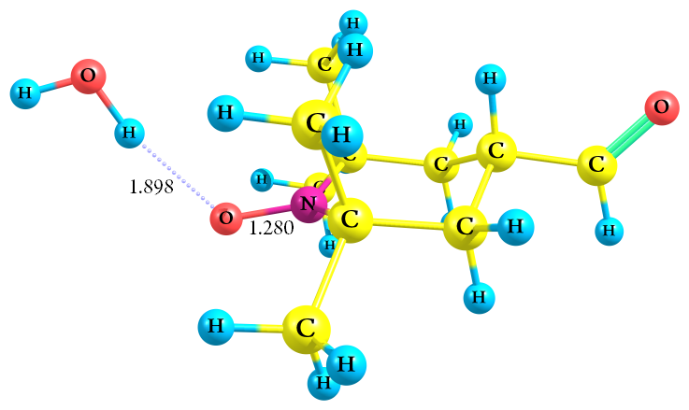
N 0.85224400 0.00005600 -0.59895800
C 0.24103100 -1.33162200 -0.25456800
O 2.10732700 0.00010300 -0.85075500
C 0.24094600 1.33168000 -0.25451600
C -1.29288900 -1.24678900 -0.37980000
C 0.67006400 -1.74489700 1.16893400
C 0.77140500 -2.35943100 -1.26570900
C 0.77124700 2.35956600 -1.26561600
C 0.66996500 1.74492100 1.16900200
C -1.29297000 1.24675700 -0.37974500
C -1.90077800 -0.00005100 0.28099500
H -1.71567300 -2.15777200 0.05417600
H -1.56141700 -1.24570500 -1.44302700
H 0.36300200 -2.77807900 1.35227300
H 0.21709200 -1.12042100 1.94007400
H 1.75422400 -1.68249500 1.27438900
H 0.28311300 -3.32114100 -1.08862700
H 1.84777200 -2.48846500 -1.16306100
H 0.55884100 -2.04495400 -2.29016900
H 0.28288700 3.32123400 -1.08849300
H 0.55870300 2.04511600 -2.29008900
H 1.84760500 2.48866700 -1.16296100
H 0.36286500 2.77808500 1.35238300
H 1.75412800 1.68254900 1.27444700
H 0.21701800 1.12039800 1.94012000
H -1.71580900 2.15769300 0.05427700
H -1.56150200 1.24570600 -1.44297100
H -1.72121700 -0.00006800 1.35852900
C -3.40214900 -0.00009100 0.08694600
H -3.73520500 -0.00010300 -0.97637300
O -4.21457400 -0.00010700 0.97768900
H 3.45360800 -0.00011000 0.48747500
O 3.95806200 -0.00008800 1.31814100
H 4.88250600 -0.00004200 1.05419800

Zero-point correction= 0.293274 (Hartree/Particle)
Thermal correction to Energy= 0.311207
Thermal correction to Enthalpy= 0.312151
Thermal correction to Gibbs Free Energy= 0.246185
Sum of electronic and zero-point Energies= -673.379470
Sum of electronic and thermal Energies= -673.361537
Sum of electronic and thermal Enthalpies= -673.360593
Sum of electronic and thermal Free Energies= -673.426559

TEMPO-NO₂-H₂O [H-atom bonded to the O-atom of the NO moiety in top mode]

0 2

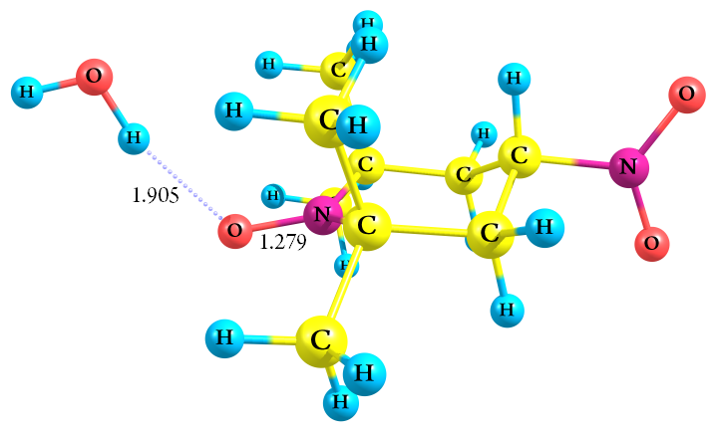
N 1.07049900 0.00904900 -0.60626900
C 0.48050200 -1.32711200 -0.23849700
O 2.31242000 0.01509400 -0.91302800
C 0.47092100 1.33793900 -0.22805100
C -1.05842700 -1.24809800 -0.30053300
C 0.97562600 -1.74550600 1.16204800
C 0.96483300 -2.34950600 -1.27746000
C 0.94730500 2.37199000 -1.25912800
C 0.96429900 1.74847300 1.17539900
C -1.06749600 1.24865000 -0.28974100
C -1.60327300 -0.00461 700 0.39328200
H -1.46637900 -2.15417300 0.15561000
H -1.38542200 -1.22658500 -1.34300400
H 0.67238500 -2.77731600 1.35828700
H 0.56777100 -1.12076300 1.95817500
H 2.06378100 -1.68846200 1.21403600
H 0.48934900 -3.31372300 -1.08114000
H 2.04529000 -2.47374200 -1.22421300
H 0.70312300 -2.03208200 -2.28914800
H 0.46497800 3.33118700 -1.05498600
H 0.68727900 2.06069000 -2.27314900
H 2.02688200 2.50349800 -1.20551800
H 0.65452100 2.77662200 1.38037000
H 2.05289500 1.69816400 1.22532000
H 0.56167200 1.11440300 1.96677600
H -1.48142300 2.14784700 0.17456800
H -1.39497000 1.23407100 -1.33216500
H -1.40943400 -0.00860900 1.46365100
N -3.12702400 -0.00987900 0.30988000
H 3.71558800 -0.00637100 0.37507100
O 4.21803500 -0.02060000 1.20633200
H 5.14362000 -0.01831000 0.94639500
O -3.63127300 -0.00552800 -0.80299000
O -3.74437700 -0.01819300 1.36417100

Zero-point correction= 0.287311 (Hartree/Particle)
Thermal correction to Energy= 0.304808
Thermal correction to Enthalpy= 0.305752
Thermal correction to Gibbs Free Energy= 0.242138
Sum of electronic and zero-point Energies= -764.600735
Sum of electronic and thermal Energies= -764.583238
Sum of electronic and thermal Enthalpies= -764.582294
Sum of electronic and thermal Free Energies= -764.645908

TEMPO-H₂O [H-atom bonded to the O-atom of the NO moiety in orthogonal mode]

0 2

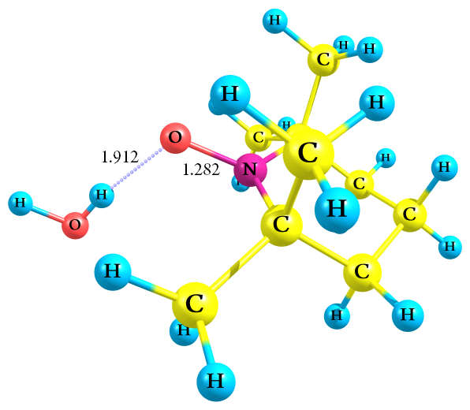
N -0.31723600 0.00018400 0.23934200
C 0.36126800 1.33553300 0.07720900
O -1.39989700 0.00059100 0.92561300
C 0.36031300 -1.33566600 0.07731900
C 1.44457500 1.24494900 -1.01488600
C 0.95850500 1.76071600 1.43470700
C -0.71033100 2.35063500 -0.34778500
C -0.71202000 -2.35001600 -0.34760400
C 0.95721900 -1.76114800 1.43487000
C 1.44371300 -1.24594200 -1.01476700
C 2.32286800 -0.00079800 -0.91070100
H 2.04718900 2.15705900 -0.96550800
H 0.95416400 1.24577800 -1.99502800
H 1.31340500 2.79284000 1.36992000
H 1.80012600 1.13465800 1.73582200
H 0.19223400 1.70730100 2.21002800
H -0.23055700 3.31142700 -0.55310500
H -1.45382300 2.49163400 0.43581200
H -1.22606200 2.01945600 -1.25163800
H -0.23296000 -3.31121400 -0.55269000
H -1.22739200 -2.01862000 -1.25158200
H -1.45572500 -2.49028700 0.43592000
H 1.31136900 -2.79353500 1.37019100
H 0.19097200 -1.70710400 2.21017200
H 1.79929200 -1.13567100 1.73593800
H 2.04568700 -2.15846700 -0.96527900
H 0.95331800 -1.24653900 -1.99491700
H 2.89249200 -0.00095100 0.02432100
H 3.06083900 -0.00109300 -1.71842700
H -3.03208700 0.00063400 -0.07101100
O -3.78427600 0.00031000 -0.68665500
H -4.56510200 0.00461000 -0.12617200

Zero-point correction= 0.284272 (Hartree/Particle)
Thermal correction to Energy= 0.299282
Thermal correction to Enthalpy= 0.300226
Thermal correction to Gibbs Free Energy= 0.242213
Sum of electronic and zero-point Energies= -560.039755
Sum of electronic and thermal Energies= -560.024745
Sum of electronic and thermal Enthalpies= -560.023801
Sum of electronic and thermal Free Energies= -560.081813

TEMPO-CH₃-H₂O [H-atom bonded to the O-atom of the NO moiety in orthogonal mode]

0 2

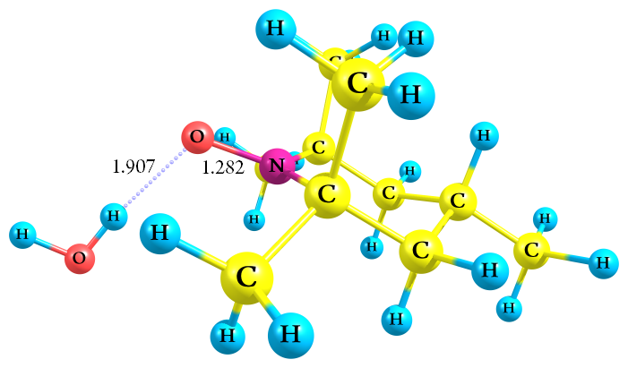
N -0.65883600 -0.00000800 0.26733200
C 0.03841200 1.33379600 0.24717100
O -1.86165200 -0.00001300 0.71060600
C 0.03843400 -1.33380200 0.24716400
C 1.33552100 1.23803300 -0.57831600
C 0.31972700 1.77160600 1.69976400
C -0.91307800 2 .34375500 -0.41248900
C -0.91303100 -2.34377900 -0.41250500
C 0.31975700 -1.77161700 1.69975500
C 1.33554400 -1.23801400 -0.57831900
C 2.18854400 0.00001700 -0.28972500
H 1.91032400 2.15302300 -0.40110400
H 1.07615700 1.23445900 -1.64424900
H 0.68615200 2.80169600 1.70603900
H 1.06893600 1.14509300 2.18651800
H -0.60077900 1.72791600 2.28433600
H -0.40363000 3.30656700 -0.50565200
H -1.81529600 2.48088100 0.18240500
H -1.20908700 2.00929500 -1.40905400
H -0.40355700 -3.30657500 -0.50568700
H -1.20905700 -2.00931100 -1.40906200
H -1.81524000 -2.48094000 0.18239500
H 0.68620700 -2.80169900 1.70602300
H -0.60075200 -1.72795500 2.28432400
H 1.06894900 -1.14508900 2.18651700
H 1.91036300 -2.15299400 -0.40110800
H 1.07618100 -1.23444300 -1.64425200
H 2.47789300 0.00001900 0.76799300
C 3.47432700 0.00003000 -1.12396400
H 4.08286200 0.88408800 -0.91263500
H 4.08287800 -0.88401700 -0.91263700
H 3.24699400 0.00002900 -2.19528600
H -3.26158700 -0.00002100 -0.58454700
O -3.89186100 -0.00000500 -1.32460200
H -4.75989600 0.00002400 -0.91184700

Zero-point correction= 0.311988 (Hartree/Particle)
Thermal correction to Energy= 0.329335
Thermal correction to Enthalpy= 0.330279
Thermal correction to Gibbs Free Energy= 0.266450
Sum of electronic and zero-point Energies= -599.337499
Sum of electronic and thermal Energies= -599.320152
Sum of electronic and thermal Enthalpies= -599.319208
Sum of electronic and thermal Free Energies= -599.383037

TEMPO-NH₂-H₂O [H-atom bonded to the O-atom of the NO moiety in orthogonal mode]

0 2

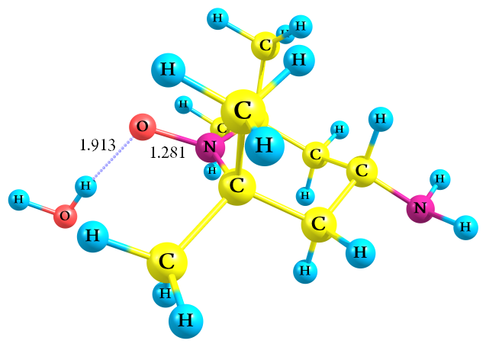
N -0.64411300 -0.00026100 0.26564500
C 0.05240600 1.33443900 0.23695100
O -1.84138900 -0.00058900 0.72205400
C 0.05299500 -1.33463700 0.23667900
C 1.33956800 1.23675100 -0.60170300
C 0.34238000 1.77661300 1.68682800
C -0.90529700 2.34129900 -0.41878300
C -0.90428200 -2.34177300 -0.41925400
C 0.34316900 -1.77698100 1.68646400
C 1.34010900 -1.23621600 -0.60196300
C 2.18687300 0.00042100 -0.30897600
H 1.92093400 2.14958200 -0.43042700
H 1.08527800 1.21940200 -1.66646200
H 0.71462100 2.80466600 1.68775100
H 1.08930200 1.14758100 2.17416600
H -0.57652100 1.74164000 2.27462600
H -0.39817 500 3.30448300 -0.52021900
H -1.80213300 2.47927300 0.18398100
H -1.20899500 2.00241400 -1.41139100
H -0.39675000 -3.30471900 -0.52089900
H -1.20813300 -2.00280200 -1.41178600
H -1.80104900 -2.48025500 0.18350000
H 0.71583300 -2.80488200 1.68717700
H -0.57573700 -1.74250000 2.27428200
H 1.08984000 -1.14774000 2.17391500
H 1.92187100 -2.14883100 -0.43087900
H 1.08580600 -1.21875400 -1.66671900
H 2.47394700 0.00037000 0.75328600
N 3.36260700 0.00077100 -1.19035500
H 3.94174600 0.81772400 -1.02136200
H 3.94201600 -0.81605100 -1.02165000
H -3.27253600 -0.00006700 -0.54703800
O -3.91868400 0.00031900 -1.27292900
H -4.77756700 -0.00143200 -0.84133400

Zero-point correction= 0.301180 (Hartree/Particle)
Thermal correction to Energy= 0.317580
Thermal correction to Enthalpy= 0.318524
Thermal correction to Gibbs Free Energy= 0.257737
Sum of electronic and zero-point Energies= -615.389961
Sum of electronic and thermal Energies= -615.373561
Sum of electronic and thermal Enthalpies= -615.372617
Sum of electronic and thermal Free Energies= -615.433404

TEMPO-CHO-H₂O [H-atom bonded to the O-atom of the NO moiety in orthogonal mode]

0 2

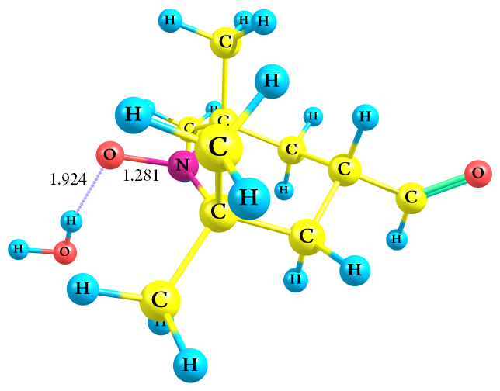
N 0.93903900 0.00002100 0.29489500
C 0.24219700 -1.33325700 0.30648100
O 2.15901800 0.00004600 0.68621300
C 0.24215900 1.33328000 0.30645300
C -1.07592200 -1.24521400 -0.48762100
C -0.00376400 -1.76241900 1.76747400
C 1.17142000 -2.34970000 -0.37487900
C 1.17135900 2.34973900 -0.37491800
C -0.00382300 1.76245600 1.76743800
C -1.07595500 1.24518400 -0.48765100
C -1.91468100 -0.00002200 -0.16382400
H -1.64646400 -2.15745000 -0.28957800
H -0.84325200 -1.24188600 -1.55897500
H -0.36572000 -2.79364 800 1.78934400
H -0.74260700 -1.13652200 2.27007100
H 0.93133100 -1.71199800 2.32754500
H 0.65338200 -3.30878300 -0.45703700
H 2.08337500 -2.49371300 0.20302200
H 1.45178700 -2.01594100 -1.37603500
H 0.65330400 3.30881200 -0.45707500
H 1.45172200 2.01598100 -1.37607600
H 2.08331800 2.49376900 0.20297400
H -0.36579800 2.79367800 1.78929000
H 0.93126700 1.71205800 2.32751900
H -0.74266000 1.13655100 2.27003500
H -1.64652000 2.15740900 -0.28963100
H -0.84328200 1.24183600 -1.55900500
H -2.23290600 -0.00001200 0.88138300
C -3.17462600 -0.00004600 -1.00319900
H -3.00277100 -0.00006200 -2.10382700
O -4.29718000 -0.00003500 -0.56316700
H 3.41721000 -0.00001100 -0.76968700
O 3.87786500 -0.00003900 -1.62496200
H 4.81419700 0.00001300 -1.40770400

Zero-point correction= 0.293220 (Hartree/Particle)
Thermal correction to Energy= 0.311253
Thermal correction to Enthalpy= 0.312197
Thermal correction to Gibbs Free Energy= 0.245690
Sum of electronic and zero-point Energies= -673.379457
Sum of electronic and thermal Energies= -673.361424
Sum of electronic and thermal Enthalpies= -673.360480
Sum of electronic and thermal Free Energies= -673.426987

TEMPO-NO₂-H₂O [H-atom bonded to the O-atom of the NO moiety in orthogonal mode]

0 2

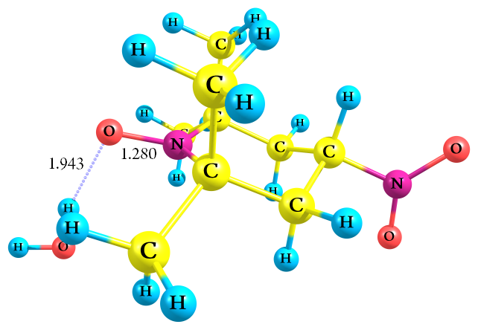
N 1.18833800 0.00004300 -0.32374100
C 0.49494600 1.33438600 -0.39739400
O 2.43856000 0.00003300 -0.59963200
C 0.49505800 -1.33433100 -0.39744200
C -0.88318300 1.24698700 0.28833700
C 0.37321800 1.76193600 -1.87464900
C 1.36057500 2.35260900 0.36056400
C 1.36084200 -2.35240500 0.36052500
C 0.37344200 -1.76187600 -1.8747 1000
C -0.88308600 -1.24706300 0.28828500
C -1.65638800 -0.00005800 -0.12350100
H -1.44641600 2.15069100 0.03988200
H -0.75465900 1.22628100 1.37312700
H 0.00905100 2.79104300 -1.92909200
H -0.31395100 1.13230000 -2.44275500
H 1.35387300 1.71745700 -2.35103700
H 0.83233300 3.30845500 0.40587000
H 2.31313900 2.50374200 -0.14547900
H 1.56360000 2.01430600 1.37840900
H 0.83285600 -3.30840000 0.40560700
H 1.56358900 -2.01417700 1.37845000
H 2.31354700 -2.50320600 -0.14536400
H 0.00940300 -2.79102700 -1.92917400
H 1.35410900 -1.71727700 -2.35106500
H -0.31378000 -1.13232100 -2.44283800
H -1.44623900 -2.15080300 0.03978300
H -0.75457600 -1.22639700 1.37307900
H -1.91142800 -0.00004300 -1.18102200
N -3.01790300 -0.00011500 0.56583400
H 3.48515300 0.00000200 1.03701000
O 3.74999700 0.00000800 1.97099500
H 4.71120600 -0.00018300 1.96417600
O -3.03250800 -0.00009900 1.78697300
O -4.00684900 -0.00007200 -0.15237500

Zero-point correction= 0.287446 (Hartree/Particle)
Thermal correction to Energy= 0.305869
Thermal correction to Enthalpy= 0.306813
Thermal correction to Gibbs Free Energy= 0.239692
Sum of electronic and zero-point Energies= -764.600099
Sum of electronic and thermal Energies= -764.581676
Sum of electronic and thermal Enthalpies= -764.580731
Sum of electronic and thermal Free Energies= -764.647853

Table S2. Summary of important second-order delocalization energies (E₂) for the orbital interactions of TEMPO derivatives, determined using NBO analysis at the B3LYP/6-311++G(d,p) level of theory.
Donor  NBO(i) | ED(i) (a.u.), X=H | Acceptor  NBO(j) | ED(j) (a.u.), X=H | Interaction type | E₂ (kcal/mol)
 |  |  |  |  | −H | −CH₃ | −NH₂ | −CHO | −NO₂
σ_{N1−C2} | 0.99034 | σ*_{N1−C4} | 0.03911 | σ _{N1−C2} → σ*_{N1−C4} | 0.26 | 0.26 | 0.26 | 0.27 | 0.27
 |  | σ*_{C4−C8} | 0.00885 | σ _{N1−C2} → σ*_{C4−C8} | 0.34 | 0.35 | 0.40 | 0.35 | 0.35
 |  | σ*_{C5−H12} | 0.00616 | σ _{N1−C2} → σ*_{C5−H12} | 0.66 | 0.68 | 0.63 | 0.66 | 0.61
 |  | σ*_{C6−H14} | 0.00296 | σ _{N1−C2} → σ*_{C6−H14} | 0.60 | 0.68 | 0.64 | 0.67 | 0.66
σ_{N1−O3} | 0.99616 | σ*_{N1−C2} | 0.03911 | σ_{N1−O3} → σ*_{N1−C2} | 0.30 | 0.30 | 0.30 | 0.31 | 0.31
 |  | σ*_{C2−C5} | 0.01529 | σ_{N1−O3} → σ*_{C2−C5} | 0.42 | 0.43 | 0.44 | 0.43 | 0.43
π_{N1−O3} | 0.98799 | σ*_{C2−C5} | 0.01529 | π_{N1−O3} → σ*_{C2−C5} | 0.28 | 0.28 | 0.27 | 0.32 | 0.32
 |  | σ*_{C2−C6} | 0.01155 | π_{N1−O3} → σ*_{C2−C6} | 1.20 | 1.21 | 1.19 | 1.24 | 1.23
 |  | σ*_{C2−C7} | 0.00885 | π_{N1−O3} → σ*_{C2−C7} | 0.30 | 0.31 | 0.32 | 0.30 | 0.31
 |  | σ*_{C6−H14} | 0.00296 | π_{N1−O3} → σ*_{C6−H14} | 0.27 | 0.27 | 0.27 | 0.26 | 0.26
σ_{C2−C5} | 0.98525 | σ*_{N1−O3} | 0.00772 | σ_{C2−C5} → σ*_{N1−O3} | 1.47 | 1.47 | 1.55 | 1.44 | 1.42
 |  | σ*_{C2−C6} | 0.01155 | σ_{C2−C5} → σ*_{C2−C6} | 0.40 | 0.42 | 0.38 | 0.39 | 0.37
 |  | σ*_{C5−C11} | 0.00682 | σ_{C2−C5} → σ*_{C5−C11} | 0.48 | 0.55 | 0.48 | 0.57 | 0.56
 |  | σ*_{C6−H16} | 0.00298 | σ_{C2−C5} → σ*_{C6−H16} | 0.69 | 0.68 | 0.66 | 0.67 | 0.66
σ_{C2−C6} | 0.98018 | π*_{N1−O3} | 0.00772 | σ_{C2−C6} → π*_{N1−O3} | 1.65 | 1.67 | 1.65 | 1.66 | 1.62
 |  | σ*_{C2−C5} | 0.01529 | σ_{C2−C6} → σ*_{C2−C5} | 0.43 | 0.46 | 0.42 | 0.45 | 0.41
 |  | σ*_{C2−C7} | 0.00885 | σ_{C2−C6} → σ*_{C2−C7} | 0.41 | 0.41 | 0.36 | 0.43 | 0.45
 |  | σ*_{C5−H13} | 0.00803 | σ_{C2−C6} → σ*_{C5−H13} | 0.90 | 0.95 | 0.93 | 0.95 | 0.92
 |  | σ*_{C7−H19} | 0.00283 | σ_{C2−C6} → σ*_{C7−H19} | 0.87 | 0.87 | 0.88 | 0.86 | 0.85
σ_{C2−C7} | 0.98456 | π*_{N1−O3} | 0.00772 | σ_{C2−C7} → π*_{N1−O3} | 0.34 | 0.35 | 0.25 | 0.33 | 0.34
 |  | σ*_{N1−C4} | 0.03911 | σ_{C2−C7} → σ*_{N1−C4} | 1.45 | 1.45 | 1.52 | 1.47 | 1.46
 |  | σ*_{C2−C5} | 0.01529 | σ_{C2−C7} → σ*_{C2−C5} | 0.52 | 0.56 | 0.57 | 0.55 | 0.56
 |  | σ*_{C2−C6} | 0.01155 | σ_{C2−C7} → σ*_{C2−C6} | 0.46 | 0.46 | 0.39 | 0.47 | 0.49
 |  | σ*_{C5−C11} | 0.00682 | σ_{C2−C7} → σ*_{C5−C11} | 1.11 | 1.10 | 1.05 | 1.14 | 1.19
 |  | σ*_{C6−H15} | 0.00346 | σ_{C2−C7} → σ*_{C6−H15} | 0.93 | 0.93 | 0.92 | 0.92 | 0.94
σ_{C5−C11} | 0.99057 | σ*_{C2−C5} | 0.01529 | σ_{C5−C11} → σ*_{C2−C5} | 0.47 | 0.50 | 0.48 | 0.41 | 0.48
 |  | σ*_{C2−C7} | 0.00885 | σ_{C5−C11} → σ*_{C2−C7} | 1.09 | 1.00 | 1.01 | 1.00 | 0.99
 |  | σ*_{C10−H26} | 0.00616 | σ_{C5−C11} → σ*_{C10−H26} | 0.99 | 1.06 | 1.04 | 0.98 | 0.89
σ_{C5−H12} | 0.98848 | σ*_{N1−C2} | 0.03911 | σ_{C5−C12} → σ*_{N1−C2} | 2.19 | 2.20 | 2.30 | 2.15 | 2.14
 |  | σ*_{C10−C11} | 0.00682 | σ_{C5−C12} → σ*_{C10−C11} | 1.34 | 1.41 | 1.35 | 1.35 | 1.50
σ_{C6−H14} | 0.99082 | σ*_{N1−C2} | 0.03911 | σ_{C6−C14} → σ*_{N1−C2} | 2.31 | 2.30 | 2.22 | 2.34 | 2.35
σ_{C6−H15} | 0.99382 | σ*_{N1−C2} | 0.03911 | σ_{C6−C15} → σ*_{N1−C2} | 0.29 | 0.29 | 0.34 | 0.29 | 0.29
 |  | σ*_{C2−C5} | 0.01529 | σ_{C6−C15}→ σ*_{C2−C5} | 1.82 | 1.85 | 1.87 | 1.89 | 1.90
 |  | σ*_{C2−C7} | 0.00885 | σ_{C6−C15} → σ*_{C2−C7} | 1.62 | 1.61 | 1.62 | 1.62 | 1.60
σ_{C11−H28} | 0.98935 | σ*_{C5−H13} | 0.00803 | σ_{C11−H28} → σ*_{C5−H13} | 1.34 | 1.52 | 1.39 | 1.34 | 1.31
LP(1)_{O3} | 0.99118 | σ*_{N1−C2} | 0.03911 | LP(1)_{O3} → σ*_{N1−C2} | 1.63 | 1.63 | 1.64 | 1.64 | 1.66
LP(2)_{O3} | 0.96106 | σ*_{N1−C2} | 0.03911 | LP(2)_{O3} → σ*_{N1−C2} | 4.94 | 4.93 | 4.95 | 4.96 | 4.99
 |  | σ*_{C2−C5} | 0.01529 | LP(2)_{O3} → σ*_{C2−C5} | 0.57 | 0.57 | 0.57 | 0.58 | 0.59

Table S3. Summary of important second-order delocalization energies (E₂) for the orbital interactions of protonated TEMPO derivatives (O-protonation), determined using NBO analysis at the B3LYP/6-311++G(d,p) level of theory.
Donor  NBO (i) | ED(i) (a.u.), X=H | Acceptor  NBO(j) | ED(j) (a.u.), X=H | Interaction type | E₂ (kcal/mol)
 |  |  |  |  | −H | −CH₃ | −NH₂ | −CHO | −NO₂
σ_{N1−C2} | 0.99147 | σ*_{N1−C4} | 0.03421 | σ _{N1−C2} → σ*_{N1−C4} | 0.41 | 0.41 | 0.42 | 0.41 | 0.39
 |  | σ*_{C4−C8} | 0.00847 | σ _{N1−C2} → σ*_{C4−C8} | 0.26 | 0.30 | 0.26 | 0.30 | 0.30
 |  | σ*_{C5−H12} | 0.00547 | σ _{N1−C2} → σ*_{C5−H12} | 0.55 | 0.57 | 0.58 | 0.55 | 0.52
 |  | σ*_{C6−H14} | 0.00236 | σ _{N1−C2} → σ*_{C6−H14} | 0.50 | 0.49 | 0.49 | 0.49 | 0.48
σ_{N1−O3} | 0.99688 | σ*_{C2−C5} | 0.01468 | σ_{N1−O3} → σ*_{C2−C5} | 0.34 | 0.35 | 0.35 | 0.35 | 0.34
π_{N1−O3} | 0.99498 | σ*_{C2−C6} | 0.00996 | π_{N1−O3} → σ*_{C2−C6} | 0.43 | 0.42 | 0.42 | 0.42 | 0.42
σ_{C2−C5} | 0.97992 | σ*_{N1−O3} | 0.01509 | σ_{C2−C5} → σ*_{N1−O3} | 1.94 | 1.79 | 1.96 | 1.74 | 1.69
 |  | π*_{N1−O3} | 0.10008 | σ_{C2−C5} → π*_{N1−O3} | 0.28 | 0.35 | <0.25 | 0.38 | 0.38
 |  | σ*_{C2−C6} | 0.00996 | σ_{C2−C5} → σ*_{C2−C6} | 0.53 | 0.53 | 0.57 | 0.50 | 0.49
 |  | σ*_{C5−C11} | 0.00616 | σ_{C2−C5} → σ*_{C5−C11} | 0.41 | 0.48 | 0.40 | 0.51 | 0.51
 |  | σ*_{C6−H16} | 0.00254 | σ_{C2−C5} → σ*_{C6−H16} | 0.69 | 0.66 | 0.68 | 0.64 | 0.62
 |  | σ*_{C7−H18} | 0.00325 | σ_{C2−C5} → σ*_{C7−H18} | 0.84 | 0.70 | 0.82 | 0.69 | 0.69
σ_{C2−C6} | 0.96225 | π*_{N1−O3} | 0.10008 | σ_{C2−C6} → π*_{N1−O3} | 3.50 | 3.39 | 3.53 | 3.36 | 3.27
 |  | σ*_{N1−C4} | 0.03421 | σ_{C2−C6} → σ*_{N1−C4} | 0.51 | 0.58 | 0.52 | 0.57 | 0.57
 |  | σ*_{C2−C5} | 0.01468 | σ_{C2−C6} → σ*_{C2−C5} | 0.55 | 0.53 | 0.57 | 0.51 | 0.47
 |  | σ*_{C2−C7} | 0.00934 | σ_{C2−C6} →σ*_{C2−C7} | 0.37 | 0.42 | 0.38 | 0.44 | 0.46
 |  | σ*_{C5−H13} | 0.00724 | σ_{C2−C6} →σ*_{C5−H13} | 0.77 | 0.82 | 0.81 | 0.83 | 0.79
 |  | σ*_{C7−H19} | 0.00262 | σ_{C2−C6} →σ*_{C7−H19} | 0.81 | 0.79 | 0.80 | 0.78 | 0.77
σ_{C2−C7} | 0.98134 | π*_{N1−O3} | 0.10008 | σ_{C2−C7} → π*_{N1−O3} | 0.53 | 0.85 | 0.58 | 0.80 | 0.80
 |  | σ*_{N1−C4} | 0.03421 | σ_{C2−C7} → σ*_{N1−C4} | 1.54 | 1.64 | 1.54 | 1.65 | 1.64
 |  | σ*_{C2−C5} | 0.01468 | σ_{C2−C7} → σ*_{C2−C5} | 0.59 | 0.63 | 0.65 | 0.62 | 0.64
 |  | σ*_{C2−C6} | 0.00996 | σ_{C2−C7} → σ*_{C2−C6} | 0.48 | 0.52 | 0.48 | 0.53 | 0.54
 |  | σ*_{C5−C11} | 0.00616 | σ_{C2−C7} → σ*_{C5−C11} | 0.91 | 0.97 | 0.91 | 0.99 | 1.07
 |  | σ*_{C6−H15} | 0.00306 | σ_{C2−C7} → σ*_{C6−H15} | 0.79 | 0.82 | 0.79 | 0.81 | 0.83
σ_{C5−C11} | 0.99033 | σ*_{C2−C5} | 0.01468 | σ_{C5−C11} → σ*_{C2−C5} | 0.40 | 0.41 | 0.39 | 0.34 | 0.40
 |  | σ*_{C2−C7} | 0.00934 | σ_{C5−C11} → σ*_{C2−C7} | 1.23 | 1.03 | 1.14 | 1.03 | 1.01
 |  | σ*_{C10−C11} | 0.00616 | σ_{C5−C11} → σ*_{C10−C11} | 0.32 | 0.37 | 0.46 | 0.42 | 0.53
 |  | σ*_{C10−H26} | 0.00533 | σ_{C5−C11} → σ*_{C10−H26} | 0.90 | 1.01 | 0.97 | 0.93 | 0.81
σ_{C5−H12} | 0.98609 | σ*_{N1−C2} | 0.03710 | σ_{C5−C12} → σ*_{N1−C2} | 2.45 | 2.44 | 2.48 | 2.41 | 2.41
 |  | σ*_{C10−C11} | 0.00616 | σ_{C5−C12} → σ*_{C10−C11} | 1.33 | 1.45 | 1.30 | 1.41 | 1.54
σ_{C5−C13} | 0.98846 | σ*_{C2−C6} | 0.00996 | σ_{C5−C13} → σ*_{C2−C6} | 1.97 | 1.95 | 2.01 | 1.90 | 1.90
σ_{C6−H14} | 0.98353 | σ*_{N1−C2} | 0.03710 | σ_{C6−C14} → σ*_{N1−C2} | 2.72 | 2.66 | 2.71 | 2.70 | 2.72
 |  | π*_{N1−O3} | 0.10008 | σ_{C6−C14} → π*_{N1−O3} | 0.49 | 0.50 | 0.48 | 0.51 | 0.51
σ_{C6−H15} | 0.99329 | σ*_{C2−C5} | 0.01468 | σ_{C6−C15} → σ*_{C2−C5} | 1.74 | 1.81 | 1.76 | 1.84 | 1.86
 |  | σ*_{C2−C7} | 0.00934 | σ_{C6−C15} → σ*_{C2−C7} | 1.73 | 1.65 | 1.72 | 1.66 | 1.64
σ_{C11−H28} | 0.98931 | σ*_{C5−H13} | 0.00724 | σ_{C11−H28} → σ*_{C5−H13} | 1.32 | 1.48 | 1.33 | 1.34 | 1.24
LP(1)_{O3} | 0.99033 | σ*_{N1−C2} | 0.03710 | LP(1)_{O3} → σ*_{N1−C2} | 2.99 | 2.98 | 3.00 | 3.01 | 3.05
 |  | σ*_{C2−C5} | 0.01468 | LP(1)_{O3} → σ*_{C2−C5} | 0.28 | 0.29 | 0.29 | 0.29 | 0.29
Table S4. Summary of important second-order delocalization energies (E₂) for the orbital interactions of protonated TEMPO derivatives (N-protonation), determined using NBO analysis at the B3LYP/6-311++G(d,p) level of theory.
Donor  NBO (i) | ED(i) (a.u.), X=H | Acceptor  NBO(j) | ED(j) (a.u.), X=H | Interaction type | E₂ (kcal/mol)
 |  |  |  |  | −H | −CH₃ | −NH₂ | −CHO | −NO₂
σ_{N1−C2} | 0.99204 | σ*_{N1−O3} | 0.00507 | σ _{N1−C2} → σ*_{N1−O3} | 0.33 | 0.35 | 0.35 | 0.31 | 0.32
 |  | σ*_{C5−H12} | 0.00493 | σ _{N1−C2} → σ*_{C5−H12} | 0.65 | 0.67 | 0.68 | 0.65 | 0.61
 |  | σ*_{C6−H14} | 0.00233 | σ _{N1−C2} → σ*_{C6−H14} | 0.58 | 0.57 | 0.57 | 0.56 | 0.56
σ_{N1−O3} | 0.99696 | σ*_{C2−C5} | 0.01599 | σ_{N1−O3} → σ*_{N1−C2} | 0.26 | 0.26 | 0.26 | 0.27 | 0.26
 |  | σ*_{N1−O3} | 0.00507 | σ_{N1−O3} → σ*_{N1−O3} | 0.35 | 0.36 | 0.36 | 0.33 | 0.35
 |  | σ*_{C2−C5} | 0.01599 | σ_{N1−O3} → σ*_{C2−C5} | 0.26 | 0.28 | 0.28 | 0.27 | 0.27
π_{N1−O3} | 0.96862 | σ*_{C2−C6} | 0.01131 | π_{N1−O3} → σ*_{C2−C5} | 0.48 | 0.46 | 0.46 | 0.50 | 0.57
 |  | σ*_{C2−C7} | 0.00922 | π_{N1−O3} → σ*_{C2−C7} | 1.05 | 1.05 | 1.05 | 1.04 | 1.06
σ_{N1−H29} | 0.99146 | π*_{N1−O3} | 0.03001 | σ_{N1−H29} → π*_{N1−O3} | 0.50 | 0.53 | 0.54 | 0.48 | 0.48
 |  | σ*_{C2−C6} | 0.01131 | σ_{N1−H29} → σ*_{C2−C6} | 0.98 | 0.99 | 0.99 | 0.98 | 0.98
σ_{C2−C5} | 0.98367 | σ*_{N1−O3} | 0.00507 | σ_{C2−C5} → σ*_{N1−O3} | 1.50 | 1.51 | 1.50 | 1.47 | 1.37
 |  | σ*_{C2−C6} | 0.01131 | σ_{C2−C5} → σ*_{C2−C6} | 0.51 | 0.53 | 0.53 | 0.52 | 0.47
 |  | σ*_{C5−C11} | 0.00696 | σ_{C2−C5} → σ*_{C5−C11} | 0.38 | 0.46 | 0.40 | 0.49 | 0.47
 |  | σ*_{C6−H16} | 0.00272 | σ_{C2−C5} → σ*_{C6−H16} | 0.68 | 0.67 | 0.66 | 0.66 | 0.65
σ_{C2−C6} | 0.98663 | σ*_{N1−H30} | 0.02648 | σ_{C2−C6} → σ*_{N1−H30} | 1.31 | 1.30 | 1.29 | 1.31 | 1.31
 |  | σ*_{C2−C5} | 0.01599 | σ_{C2−C6} → σ*_{C2−C5} | 0.56 | 0.60 | 0.58 | 0.59 | 0.54
 |  | σ*_{C2−C7} | 0.00922 | σ_{C2−C6} → σ*_{C2−C7} | 0.50 | 0.49 | 0.50 | 0.51 | 0.54
 |  | σ*_{C5−H13} | 0.00725 | σ_{C2−C6} → σ*_{C5−H13} | 0.83 | 0.88 | 0.86 | 0.85 | 0.86
 |  | σ*_{C7−H19} | 0.00278 | σ_{C2−C6} → σ*_{C7−H19} | 0.78 | 0.78 | 0.78 | 0.76 | 0.76
σ_{C2−C7} | 0.97279 | π*_{N1−O3} | 0.03001 | σ_{C2−C7} → π*_{N1−O3} | 2.58 | 2.61 | 2.58 | 2.61 | 2.50
 |  | σ*_{C2−C6} | 0.01131 | σ_{C2−C7} → σ*_{C2−C6} | 0.52 | 0.51 | 0.51 | 0.52 | 0.55
 |  | σ*_{C5−C11} | 0.00696 | σ_{C2−C7} → σ*_{C5−C11} | 1.27 | 1.29 | 1.27 | 1.33 | 1.40
 |  | σ*_{C6−H15} | 0.00313 | σ_{C2−C7} → σ*_{C6−H15} | 0.90 | 0.90 | 0.91 | 0.90 | 0.90
σ_{C5−C11} | 0.99034 | σ*_{C2−C5} | 0.01599 | σ_{C5−C11} → σ*_{C2−C5} | 0.45 | 0.49 | 0.46 | 0.47 | 0.46
 |  | σ*_{C2−C7} | 0.00922 | σ_{C5−C11} → σ*_{C2−C7} | 0.96 | 0.88 | 0.89 | 0.88 | 0.84
 |  | σ*_{C10−H26} | 0.00511 | σ_{C5−C11} → σ*_{C10−H26} | 0.61 | 0.71 | 0.66 | 0.64 | 0.61
σ_{C5−H12} | 0.98385 | σ*_{N1−C2} | 0.04401 | σ_{C5−C12} → σ*_{N1−C2} | 2.54 | 2.59 | 2.58 | 2.54 | 2.48
 |  | σ*_{C10−C11} | 0.00767 | σ_{C5−C12} → σ*_{C10−C11} | 1.75 | 1.78 | 1.69 | 1.93 | 1.77
σ_{C5−C13} | 0.98844 | σ*_{C2−C6} | 0.01131 | σ_{C5−C13} → σ*_{C2−C6} | 2.06 | 2.07 | 2.08 | 2.07 | 1.95
 |  | σ*_{C11−H28} | 0.00730 | σ_{C5−C13} → σ*_{C11−H28} | 1.43 | 1.51 | 1.44 | 1.63 | 1.55
σ_{C6−H15} | 0.99261 | σ*_{N1−C2} | 0.04401 | σ_{C6−C15} → σ*_{N1−C2} | 2.86 | 2.88 | 2.87 | 2.87 | 2.85
 |  | σ*_{C2−C5} | 0.01599 | σ_{C6−C15}→ σ*_{C2−C5} | 2.09 | 2.12 | 2.13 | 2.13 | 2.15
 |  | σ*_{C2−C7} | 0.00922 | σ_{C6−C15} → σ*_{C2−C7} | 1.78 | 1.78 | 1.76 | 1.78 | 1.77
σ_{C11−H28} | 0.98958 | σ*_{C5−H13} | 0.00725 | σ_{C11−H28} → σ*_{C5−H13} | 1.29 | 1.42 | 1.30 | 1.28 | 1.24
LP(1)_{O3} | 0.99276 | σ*_{N1−C2} | 0.04401 | LP(1)_{O3} → σ*_{N1−C2} | 1.43 | 1.42 | 1.41 | 1.44 | 1.44
 |  | σ*_{N1−H30} | 0.02648 | LP(1)_{O3} → σ*_{N1−H30} | 0.46 | 0.45 | 0.45 | 0.46 | 0.45
LP(2)_{O3} | 0.95768 | σ*_{N1−C2} | 0.04401 | LP(2)_{O3} → σ*_{N1−C2} | 5.62 | 5.54 | 5.59 | 5.69 | 5.74
 |  | σ*_{N1−H30} | 0.02648 | LP(2)_{O3} → σ*_{N1−H30} | 6.73 | 6.64 | 6.61 | 6.84 | 6.77
 |  | σ*_{C2−C5} | 0.01599 | LP(2)_{O3} → σ*_{C2−C5} | 0.26 | 0.27 | 0.27 | 0.25 | 0.26

Optimized structure | X=H | X=CH₃ | X=NH₂ | X=CHO | X=NO₂
HOMO orbitals | E = −5.323 eV | E = −5.322 eV | E = −5.360 eV | E = −5.634 eV | E = −5.843 eV
LUMO orbitals | E = −0.375 eV | E = −0.375 eV | E = −0.496 eV | E = −1.341 eV | E = −2.430 eV
MEP  maps | 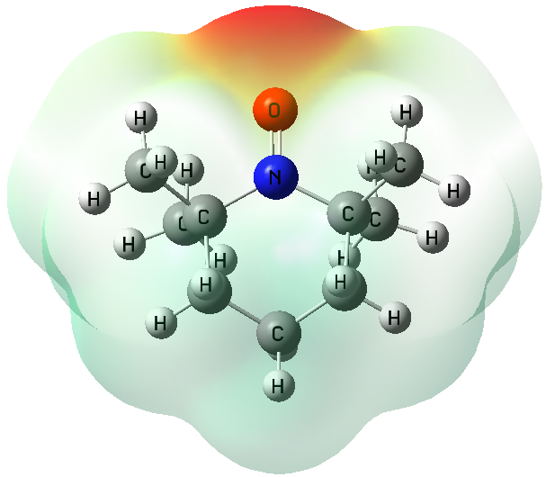 | 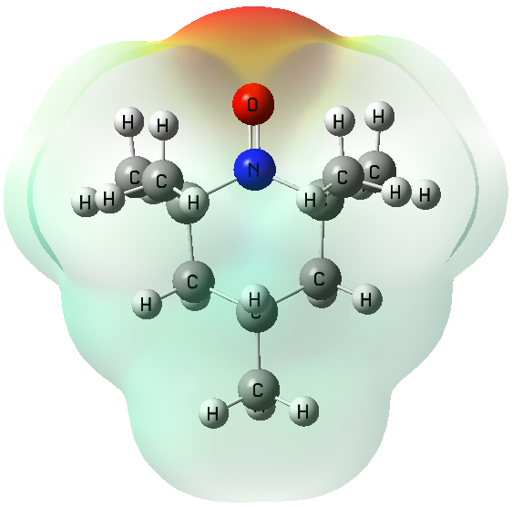 | 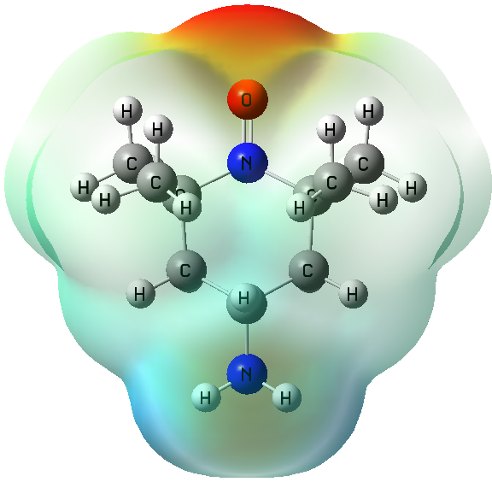 | 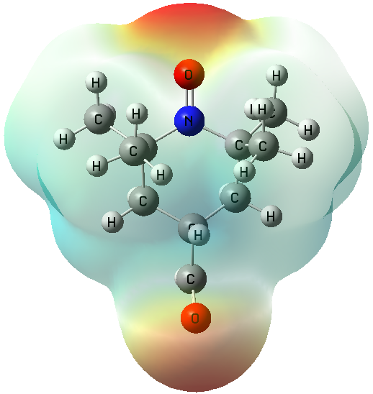 | 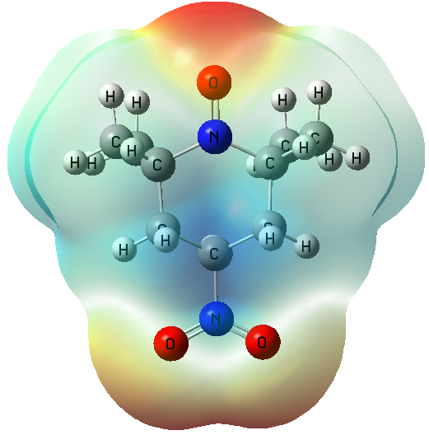
Figure S1. The representative molecular structures of the HOMO and LUMO orbitals and the total electron density mapped with the electrostatic potential surface of the considered TEMPO derivatives calculated at the B3LYP/6-311++G(d,p) level of theory.
Optimized structure | X=H | X=CH₃ | X=NH₂ | X=CHO | X=NO₂
HOMO orbitals | E = −11.917eV | E = −11.870 eV | E = −10.204 eV | E = −10.523 eV | E = −11.702 eV
LUMO orbitals | E = −4.190 eV | E = −4.161 eV | E = −4.191eV | E = −4.522 eV | E = −5.504 eV
MEP
maps
Figure S2. The shapes of the HOMO and LUMO orbitals calculated at the B3LYP/6-311++G(d,p) level of theory for the O-protonation of the studied TEMPO derivatives.
Optimized structure | X=H | X=CH₃ | X=NH₂ | X=CHO | X=NO₂
HOMO orbitals | E = −10.811 eV | E = −10.860 eV | E = −10.510 eV | E = −10.863 eV | E = −11.066 eV
LUMO orbitals | E = −7.343 eV | E = −7.182 eV | E = −7.223 eV | E = −7.586 eV | E = −7.796 eV
MEP
maps
Figure S3. The shapes of the HOMO and LUMO orbitals calculated at the B3LYP/6-311++G(d,p) level of theory for the N-protonation of the studied TEMPO derivatives.

Figure S4. AIM features at the bond critical point of the some TEMPO derivatives (X: H, CH₃, and NO₂). The molecular graph was obtained at the B3LYP/6-311++G(d,p) level of theory.

Corresponding authors: E-mails: abolfazl.shiroudi@pg.edu.pl (A. Shiroudi); Mohamed.Abdel-Rahman@sci.suezuni.edu.eg (M.A. Abdel-Rahman)

