Supplementary Figures
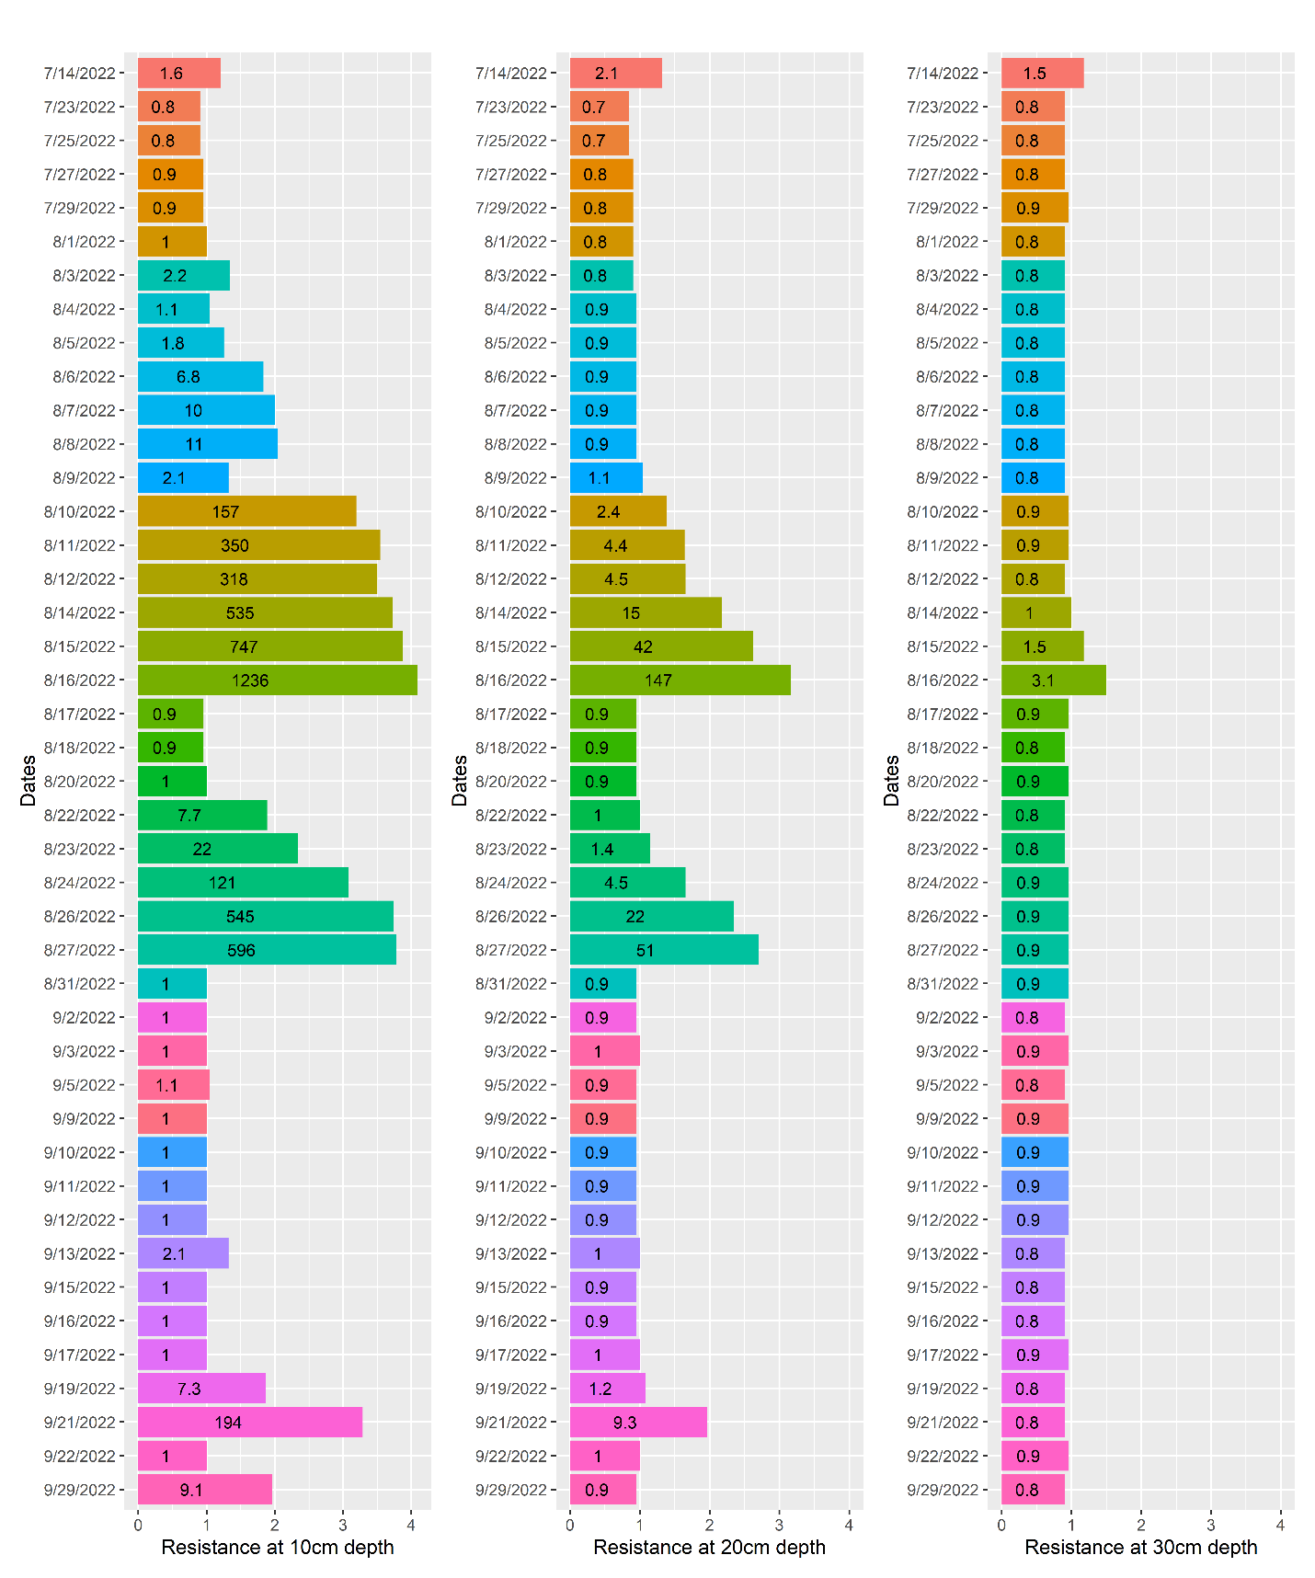
Supplementary Figure 1: Soil water potential in Kilo-Ohms as measured by three Chameleon sensors installed at different soil depths under non-stress conditions (Seasonal Chameleon colour pattern breakdown was 86% Blue, 10% Green, 7% Red).
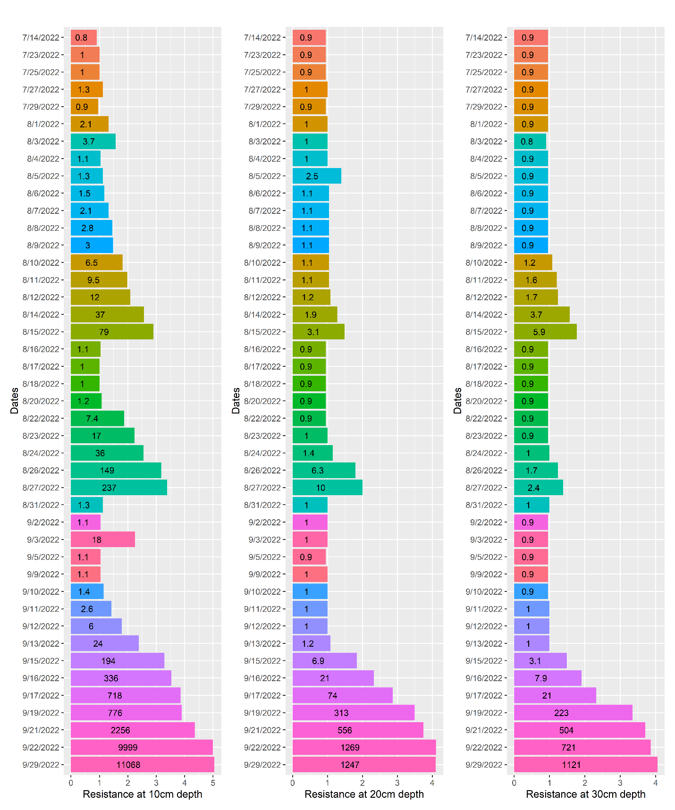
Supplementary Figure 2: Soil water potential in Kilo-Ohms as measured by three Chameleon sensors installed at different soil depths under drought-stress conditions (Seasonal Chameleon colour pattern breakdown was 69% Blue, 11% Green, 20% Red).

