Supplementary Information
Implications of predator species richness in terms of zoonotic spillover transmission of filovirus diseases in Africa

Taehee Chang, M.P.H., Sung-il Cho, M.D., Ph.D., Kyung-Duk Min, D.V.M., Ph.D.

Table of Contents
Table 1. The list of species belonging to order Accipitriformes used in the Maxent modeling……………….…. 4
Table 2. The list of species belonging to order Strigiformes used in the Maxent modeling.……………….….… 5
Table 3. The list of species belonging to order Carnivora used in the Maxent modeling.…………………...… 6-7
Table 4. The list of species belonging to family Colubridae used in the Maxent modeling………………..….. 8-9
Table 5. The list of species belonging to order Chiroptera used in the Maxent modeling……………………10-14
Table 6. Detailed information of covariates used in this study…………………………………………………. 15
Table 7. The list of species belonging to order Accipitriformes, collected from the IUCN website and overlapping the species list used in the Maxent model……………………………………………………………………. 15-17
Table 8. The list of species belonging to order Strigiformes, collected from the IUCN website and overlapping the species list used in the Maxent model………………………………………………………………………. 17
Table 9. The list of species belonging to order Carnivora, collected from the IUCN website and overlapping the species list used in the Maxent model…………………………………………………………………….… 18-19
Table 10. The list of species belonging to family Colubridae, collected from the IUCN website and overlapping the species list used in the Maxent model………………………………………………………………..…. 19-20
Table 11. The list of species belonging to order Chiroptera, collected from the IUCN website and overlapping the species list used in the Maxent model………………………………………………………………………. 20-24
Table 12. The list of species belonging to order Accipitriformes, used in the Maxent modeling and reported to prey on bats…………………………………………………………………………………………………....... 25
Table 13. The list of species belonging to order Strigiformes, used in the Maxent modeling and reported to prey on bats………..…………………………………………………………………………………………………. 25
Table 14. The list of species belonging to order Carnivora, used in the Maxent modeling and reported to prey on bats.………..……………………………………………………………………………………………………. 26
Table 15. The list of species belonging to order Squamata, used in the Maxent modeling and reported to prey on bats.……..………………………………………………………………………………………………...…. 26-27
Table 16. Locations of filovirus outbreak in Africa…………………………………………………………. 27-30
Table 17. The results of the Durbin-Watson test. ………………………………………………………………. 30
Table 18. Assessing the models with DIC and WAIC values. …………………………………………………. 30
Table 19. Associations of predator species richness with Ebolavirus incidence in Model 1. …………………. 31
Table 20. Associations of predator species richness with Ebolavirus incidence in Model 2..……………… 31-32
Table 21. Associations of predator species richness with Ebolavirus incidence in Model 3.………………. 32-33
Table 22. Associations of predator species richness with Ebolavirus incidence in Model 4..…………………. 33
Table 23. Associations of predator species richness with Ebolavirus incidence in Model 5..…………………. 34
Table 24. Associations of predator species richness with Marburgvirus incidence in the fully adjusted model……………….……………………………………………………………………………………..…. 34-35
Table 25. Associations of predator species richness with Ebolavirus incidence in Model 1. The model parameters were calculated with “R-INLA” package. ………………………………………..……………………….…35-36
Table 26. Associations of predator species richness with Ebolavirus incidence in Model 2. The model parameters were calculated with “R-INLA” package..………………………………………..………………………..…... 36
Table 27. Associations of predator species richness with Ebolavirus incidence in Model 3. The model parameters were calculated with “R-INLA” package. ……………………………………………………………………... 37
Table 28. Associations of predator species richness with Ebolavirus incidence in Model 4. The model parameters were calculated with “R-INLA” package.……………………………………………………….……..…….37-38
Table 29. Associations of predator species richness with Ebolavirus incidence in Model 5. The model parameters were calculated with “R-INLA” package. ……………………………………………………………..…….38-39
Table 30. Associations of predator species richness with Ebolavirus incidence in Model 1, using the species richness variables calculated with IUCN polygons. …………………………………………………………39-40
Table 31. Associations of predator species richness with Ebolavirus incidence in Model 1, using the species richness variables calculated with IUCN polygons. …………………………………………………………….40
Table 32. Associations of predator species richness with Ebolavirus incidence in Model 3, using the species richness variables calculated with IUCN polygons. …………………………………………………………….41
Table 33. Associations of predator species richness with Ebolavirus incidence in Model 4, using the species richness variables calculated with IUCN polygons. . ……………………………………………....…….…. 41-42
Table 34. Associations of predator species richness with Ebolavirus incidence in Model 5, using the species richness variables calculated with IUCN polygons. . ……………………………………………....…….…. 42-43
Table 35. Associations of predator species richness with Ebolavirus incidence in Model 1, constructed using the species richness variables calculated with Maxent modeling results, and the only species reported to prey on bats were included. . ………………………………….…. ……………………………………………….……..….. 43
Table 36. Associations of predator species richness with Ebolavirus incidence in Model 2, constructed using the species richness variables calculated with Maxent modeling results, and the only species reported to prey on bats were included. . ………………………………….…. ……………………………………………….…..…….. 44
Table 37. Associations of predator species richness with Ebolavirus incidence in Model 3, constructed using the species richness variables calculated with Maxent modeling results, and the only species reported to prey on bats were included. . ………………………………….…. ……………………………………………..…..…… 44-45
Table 38. Associations of predator species richness with Ebolavirus incidence in Model 4, constructed using the species richness variables calculated with Maxent modeling results, and the only species reported to prey on bats were included. . ………………………………….…. ………………………………………………..………... 45
Table 39. Associations of predator species richness with Ebolavirus incidence in Model 5, constructed using the species richness variables calculated with Maxent modeling results, and the only species reported to prey on bats were included. ………………………………….…. ………………………………………………..…….…… 46
Table 40. Associations of predator species richness with Marburgvirus incidence in fully adjusted model, using the species richness variables calculated with IUCN polygons. ………………………………………….… 46-47
Table 41. Associations of predator species richness with Marburgvirus incidence in fully adjusted model, constructed using the species richness variables calculated with Maxent modeling results, and the only species reported to prey on bats were included. …………………….…………………………………………..……… 47

Fig 1. Variable collinearity heatmap. Pearson correlation coefficient for a given pair of predictive variables in Ebolavirus model. ……………………………………………….……………………………………………… 48
Fig 2. Variable collinearity heatmap. Pearson correlation coefficient for a given pair of predictive variables in Marburgvirus model. …………………………………………….…………………………………………...… 49
Fig 3. Directed acyclic graph of the final models in the study……….……….……………………….…...…… 50
Fig 4. Global Moran’s I plot and Moran’s I statistics for Ebolavirus incidence……………………….…..…… 50
Fig 5. Global Moran’s I plot and Moran’s I statistics for Marburgirus incidence………………………………. 51
Fig 6. Estimated ORs for Ebolavirus incidence according to the degree of species richness. (A) The result of Model 1. (B) The result of Model 2. (C) The result of Model 3. (D) The result of Model 4. (E) The result of Model 5. The dots indicate the estimated ORs, with error bars representing the corresponding 95 % Wald’s credible intervals. Red means that the error bar does not intersect 1. The models were fitted with “R-INLA” package. The y-axis is shown on a logarithmic scale. The authors generated draws of each predator. ………………………. 52
Fig 7. Estimated ORs for Ebolavirus incidence according to the degree of species richness. (A) The result of Model 1. (B) The result of Model 2. (C) The result of Model 3. (D) The result of Model 4. (E) The result of Model 5. The dots indicate the estimated ORs, with error bars representing the corresponding 95 % Wald’s credible intervals. Red means that the error bar does not intersect 1. The models were constructed using the species richness variables calculated with IUCN polygons. The y-axis is shown on a logarithmic scale. The authors generated draws of each predator. …………………………………………………………………………………………. 53
Fig 8. Estimated ORs for Ebolavirus incidence according to the degree of species richness. (A) The result of Model 1. (B) The result of Model 2. (C) The result of Model 3. (D) The result of Model 4. (E) The result of Model 5. The dots indicate the estimated ORs, with error bars representing the corresponding 95 % Wald’s credible intervals. Red means that the error bar does not intersect 1. The reference categories are when the species does not exist. The models were constructed using the species richness variables calculated with Maxent modeling results, and the only species reported to prey on bats were included. The y-axis is shown on a logarithmic scale. The authors generated draws of each predator………………………………………………………………….. 54
Fig 9. Estimated ORs for Marburgvirus incidence according to the degree of species richness. The dots indicate the estimated ORs, with error bars representing the corresponding 95 % Wald’s credible intervals. The model was constructed using the species richness variables calculated with IUCN polygons. The y-axis is shown on a logarithmic scale. The authors generated draws of each predator. ……………………………………………... 55
Fig 10. Estimated ORs for Marburgvirus incidence according to the degree of species richness. The dots indicate the estimated ORs, with error bars representing the corresponding 95 % Wald’s credible intervals. The reference categories are when the species does not exist. The models were constructed using the species richness variables calculated with Maxent modeling results, and the only species reported to prey on bats were included. The y-axis is shown on a logarithmic scale. The authors generated draws of each predator. ……………………………... 56
Table 1. The list of species belonging to order Accipitriformes used in the Maxent modeling.
No. | Species | Frequency
1 | Accipiter badius | 10179
2 | Accipiter brevipes | 56
3 | Accipiter castanilius | 93
4 | Accipiter erythropus | 451
5 | Accipiter melanoleucus | 6044
6 | Accipiter minullus | 6691
7 | Accipiter nisus | 92
8 | Accipiter ovampensis | 1526
9 | Accipiter rufiventris | 575
10 | Accipiter tachiro | 7796
11 | Accipiter toussenelii | 817
12 | Aquila africana | 894
13 | Aquila chrysaetos | 105
14 | Aquila pomarina | 54537
15 | Aquila spilogaster | 9471
16 | Aquila verreauxii | 4554
17 | Aviceda cuculoides | 2680
18 | Butastur rufipennis | 2537
19 | Buteo augur | 27842
20 | Buteo auguralis | 2869
21 | Buteo buteo | 7648
22 | Buteo rufofuscus | 135
23 | Circaetus cinerascens | 4100
24 | Circaetus cinereus | 13230
25 | Circaetus gallicus | 552
26 | Circaetus pectoralis | 12690
27 | Circus aeruginosus | 19130
28 | Circus pygargus | 7537
29 | Circus ranivorus | 6457
30 | Dryotriorchis spectabilis | 487
31 | Elanus axillaris | 310
32 | Elanus caeruleus | 26387
33 | Gypohierax angolensis | 12757
34 | Gyps fulvus | 61
35 | Haliaeetus vocifer | 47858
36 | Hieraaetus ayresii | 1867
37 | Hieraaetus pennatus | 2633
38 | Hieraaetus wahlbergi | 12197
39 | Kaupifalco monogrammicus | 17786
40 | Lophaetus occipitalis | 18209
41 | Melierax canorus | 9193
42 | Melierax metabates | 8735
43 | Melierax poliopterus | 8638
44 | Micronisus gabar | 13878
45 | Milvus aegyptius | 4886
46 | Milvus migrans | 57400
47 | Pandion haliaetus | 30231
48 | Pernis apivorus | 2201
49 | Polyboroides typus | 23945
50 | Urotriorchis macrourus | 654

Table 2. The list of species belonging to order Strigiformes used in the Maxent modeling.
No. | Species | Frequency
1 | Asio capensis | 37
2 | Bubo africanus | 1694
3 | Bubo capensis | 448
4 | Bubo cinerascens | 152
5 | Bubo lacteus | 2557
6 | Bubo poensis | 16
7 | Glaucidium capense | 1386
8 | Glaucidium perlatum | 5971
9 | Glaucidium tephronotum | 20
10 | Otus ireneae | 93
11 | Otus scops | 43
12 | Otus senegalensis | 2783
13 | Ptilopsis granti | 1020
14 | Ptilopsis leucotis | 113
15 | Scotopelia bouvieri | 12
16 | Scotopelia peli | 326
17 | Strix woodfordii | 2090
18 | Tyto alba | 3893
19 | Tyto capensis | 40

Table 3. The list of species belonging to order Carnivora used in the Maxent modeling.
No. | Species | Freq
1 | Arctocephalus pusillus | 168
2 | Atilax paludinosus | 317
3 | Bdeogale crassicauda | 28
4 | Bdeogale nigripes | 76
5 | Canis adustus | 805
6 | Canis aureus | 60
7 | Canis lupaster | 299
8 | Canis lupus | 69
9 | Canis mesomelas | 894
10 | Caracal aurata | 16
11 | Caracal caracal | 171
12 | Civettictis civetta | 1521
13 | Crocuta crocuta | 2529
14 | Crossarchus alexandri | 296
15 | Crossarchus obscurus | 248
16 | Crossarchus platycephalus | 25
17 | Cynictis penicillata | 139
18 | Felis catus | 56
19 | Felis silvestris | 421
20 | Galerella sanguinea | 711
21 | Genetta angolensis | 179
22 | Genetta genetta | 470
23 | Genetta maculata | 1209
24 | Genetta pardina | 41
25 | Genetta servalina | 197
26 | Genetta thierryi | 89
27 | Genetta tigrina | 101
28 | Helogale hirtula | 30
29 | Helogale parvula | 536
30 | Herpestes ichneumon | 232
31 | Herpestes naso | 93
32 | Ichneumia albicauda | 442
33 | Ictonyx striatus | 123
34 | Laphyctis eremia | 38
35 | Leptailurus serval | 709
36 | Mellivora capensis | 350
37 | Mungos gambianus | 28
38 | Mungos mungo | 1063
39 | Nandinia binotata | 318
40 | Otocyon megalotis | 347
41 | Paracynictis selousi | 45
42 | Poecilogale albinucha | 41
43 | Poiana richardsonii | 11
44 | Proteles cristata | 133
45 | Suricata suricatta | 62
46 | Vulpes chama | 41
47 | Vulpes pallida | 54

Table 4. The list of species belonging to family Colubridae used in the Maxent modeling.
No. | Species | Freq
1 | Afronatrix anoscopus | 176
2 | Crotaphopeltis braestrupi | 13
3 | Crotaphopeltis degeni | 61
4 | Crotaphopeltis hippocrepis | 101
5 | Crotaphopeltis hotamboeia | 561
6 | Crotaphopeltis tornieri | 311
7 | Dasypeltis atra | 76
8 | Dasypeltis confusa | 11
9 | Dasypeltis fasciata | 113
10 | Dasypeltis gansi | 15
11 | Dasypeltis medici | 32
12 | Dasypeltis scabra | 261
13 | Dipsadoboa brevirostris | 84
14 | Dipsadoboa duchesnii | 19
15 | Dipsadoboa flavida | 19
16 | Dipsadoboa underwoodi | 99
17 | Dipsadoboa unicolor | 102
18 | Dipsadoboa viridis | 107
19 | Dipsadoboa weileri | 84
20 | Dispholidus typus | 309
21 | Grayia ornata | 29
22 | Grayia smithii | 171
23 | Grayia tholloni | 16
24 | Hapsidophrys lineatus | 123
25 | Hapsidophrys smaragdinus | 43
26 | Hydraethiops melanogaster | 33
27 | Meizodon coronatus | 32
28 | Meizodon regularis | 84
29 | Meizodon semiornatus | 75
30 | Natriciteres fuliginoides | 199
31 | Natriciteres olivacea | 423
32 | Natriciteres sylvatica | 17
33 | Natriciteres variegata | 117
34 | Philothamnus angolensis | 168
35 | Philothamnus battersbyi | 135
36 | Philothamnus bequaerti | 28
37 | Philothamnus carinatus | 177
38 | Philothamnus heterodermus | 146
39 | Philothamnus heterolepidotus | 197
40 | Philothamnus hoplogaster | 267
41 | Philothamnus irregularis | 172
42 | Philothamnus macrops | 35
43 | Philothamnus nitidus | 89
44 | Philothamnus punctatus | 103
45 | Philothamnus semivariegatus | 231
46 | Philothamnus thomensis | 22
47 | Platyceps florulentus | 18
48 | Rhamnophis aethiopissa | 20
49 | Scaphiophis albopunctatus | 45
50 | Telescopus dhara | 32
51 | Telescopus semiannulatus | 64
52 | Telescopus variegatus | 95
53 | Thelotornis capensis | 31
54 | Thelotornis kirtlandii | 241
55 | Thelotornis usambaricus | 72
56 | Thrasops flavigularis | 12
57 | Thrasops jacksonii | 33
58 | Thrasops occidentalis | 82
59 | Toxicodryas blandingii | 222
60 | Toxicodryas pulverulenta | 94

Table 5. The list of species belonging to order Chiroptera used in the Maxent modeling.
No. | Species | Freq
1 | Afronycteris helios | 57
2 | Afronycteris nanus | 1354
3 | Cardioderma cor | 1145
4 | Chaerephon aloysiisabaudiae | 17
5 | Chaerephon ansorgei | 187
6 | Chaerephon bemmeleni | 70
7 | Chaerephon bivittatus | 266
8 | Chaerephon chapini | 17
9 | Chaerephon leucogaster | 91
10 | Chaerephon major | 126
11 | Chaerephon nigeriae | 159
12 | Chaerephon pumilus | 2125
13 | Cloeotis percivali | 192
14 | Coleura afra | 844
15 | Doryrhina cyclops | 267
16 | Eidolon helvum | 489
17 | Epomophorus angolensis | 13
18 | Epomophorus crypturus | 507
19 | Epomophorus dobsonii | 25
20 | Epomophorus gambianus | 2784
21 | Epomophorus labiatus | 1013
22 | Epomophorus minor | 258
23 | Epomophorus pusillus | 1319
24 | Epomophorus wahlbergi | 2245
25 | Epomops buettikoferi | 191
26 | Epomops franqueti | 1053
27 | Eptesicus hottentotus | 13
28 | Glauconycteris argentata | 148
29 | Glauconycteris beatrix | 39
30 | Glauconycteris humeralis | 14
31 | Glauconycteris poensis | 68
32 | Glauconycteris variegata | 85
33 | Hipposideros abae | 36
34 | Hipposideros beatus | 112
35 | Hipposideros caffer | 2782
36 | Hipposideros curtus | 27
37 | Hipposideros fuliginosus | 1098
38 | Hipposideros jonesi | 74
39 | Hipposideros megalotis | 11
40 | Hipposideros ruber | 1063
41 | Hipposideros tephrus | 928
42 | Hypsignathus monstrosus | 200
43 | Kerivoula argentata | 23
44 | Kerivoula cuprosa | 12
45 | Kerivoula lanosa | 14
46 | Laephotis botswanae | 16
47 | Laephotis capensis | 411
48 | Lavia frons | 427
49 | Lissonycteris angolensis | 452
50 | Macronycteris commersonii | 113
51 | Macronycteris gigas | 95
52 | Macronycteris vittatus | 258
53 | Megaloglossus woermanni | 390
54 | Mimetillus moloneyi | 714
55 | Miniopterus africanus | 209
56 | Miniopterus arenarius | 80
57 | Miniopterus fraterculus | 80
58 | Miniopterus inflatus | 533
59 | Miniopterus minor | 406
60 | Miniopterus mossambicus | 28
61 | Miniopterus natalensis | 554
62 | Miniopterus schreibersii | 511
63 | Miniopterus villiersi | 15
64 | Mops bakarii | 21
65 | Mops brachypterus | 147
66 | Mops condylurus | 2337
67 | Mops congicus | 43
68 | Mops demonstrator | 23
69 | Mops leucogaster | 82
70 | Mops midas | 60
71 | Mops nanulus | 168
72 | Mops niveiventer | 48
73 | Mops petersoni | 50
74 | Mops sarasinorum | 25
75 | Mops spurrelli | 177
76 | Mops thersites | 524
77 | Myonycteris angolensis | 418
78 | Myonycteris torquata | 216
79 | Myotis bocagii | 189
80 | Myotis tricolor | 277
81 | Myotis welwitschii | 57
82 | Nanonycteris veldkampii | 557
83 | Neoromicia guineensis | 18
84 | Neoromicia somalica | 89
85 | Neoromicia zuluensis | 96
86 | Nycteris arge | 100
87 | Nycteris gambiensis | 495
88 | Nycteris grandis | 106
89 | Nycteris hispida | 563
90 | Nycteris macrotis | 636
91 | Nycteris nana | 23
92 | Nycteris thebaica | 1405
93 | Nycteris woodi | 19
94 | Nycticeinops crassulus | 25
95 | Nycticeinops schlieffenii | 247
96 | Otomops harrisoni | 44
97 | Otomops martiensseni | 276
98 | Pipistrellus aero | 27
99 | Pipistrellus hesperidus | 188
100 | Pipistrellus inexspectatus | 20
101 | Pipistrellus kuhlii | 66
102 | Pipistrellus nanulus | 75
103 | Pipistrellus rusticus | 63
104 | Platymops setiger | 79
105 | Pseudoromicia brunnea | 24
106 | Pseudoromicia rendalli | 115
107 | Pseudoromicia tenuipinnis | 219
108 | Rhinolophus alcyone | 163
109 | Rhinolophus alticolus | 62
110 | Rhinolophus blasii | 181
111 | Rhinolophus clivosus | 567
112 | Rhinolophus darlingi | 57
113 | Rhinolophus deckenii | 113
114 | Rhinolophus denti | 153
115 | Rhinolophus eloquens | 370
116 | Rhinolophus fumigatus | 460
117 | Rhinolophus hildebrandtii | 263
118 | Rhinolophus hilli | 46
119 | Rhinolophus landeri | 459
120 | Rhinolophus lobatus | 66
121 | Rhinolophus mossambicus | 20
122 | Rhinolophus simulator | 194
123 | Rhinolophus swinnyi | 156
124 | Rhinopoma hardwickii | 14
125 | Rhinopoma macinnesi | 73
126 | Rhinopoma microphyllum | 27
127 | Rousettus aegyptiacus | 3869
128 | Saccolaimus peli | 40
129 | Sauromys petrophilus | 16
130 | Scotoecus albigula | 24
131 | Scotoecus albofuscus | 26
132 | Scotoecus hindei | 213
133 | Scotoecus hirundo | 265
134 | Scotonycteris bergmansi | 38
135 | Scotonycteris zenkeri | 85
136 | Scotophilus andrewreborii | 11
137 | Scotophilus colias | 39
138 | Scotophilus dinganii | 540
139 | Scotophilus leucogaster | 183
140 | Scotophilus nigrita | 56
141 | Scotophilus nigritellus | 23
142 | Scotophilus nux | 47
143 | Scotophilus viridis | 268
144 | Stenonycteris lanosus | 209
145 | Tadarida aegyptiaca | 299
146 | Tadarida fulminans | 22
147 | Tadarida lobata | 35
148 | Tadarida ventralis | 43
149 | Taphozous hildegardeae | 378
150 | Taphozous mauritianus | 197
151 | Taphozous nudiventris | 18
152 | Taphozous perforatus | 142
153 | Triaenops afer | 421
154 | Triaenops persicus | 211
155 | Vansonia rueppellii | 194

Table 6. Detailed information of covariates used in this study.
Variables | Spatial resolution | Temporal range  (resolution) | Calculation method for values in each grid
Human foot print score | 1 km² | 2000 - 2018 (annual) | average
Elevation | 0.008 km² | - | average
Precipitation  (annual average) | 20 km² | 1970-2000  (monthly average) | average
Temperature  (annual average) | 20 km² | 1970-2000  (monthly average) | average
Population density  (per km²) | 1 km² | 2000 - 2020 (annual) | sum
Gross Domestic Product (per capita) | 80 km² | 1991 - 2015 (annual) | average
Human Development  Index | 80 km² | 1991 - 2015 (annual) | average
Forest cover (%) | 0.0009 km² | 2000 - 2021 (annual) | the proportion of forest in each grid
Agricultural land use  (% of IGBF class) | 30 km² | 2000 - 2021 (annual) | the proportion of IGBF class in each grid

Table 7. The list of species belonging to order Accipitriformes, collected from the IUCN website and overlapping the species list used in the Maxent model.
No. | Species
1 | Accipiter badius
2 | Accipiter erythropus
3 | Aquila spilogaster
4 | Aviceda cuculoides
5 | Circaetus beaudouini
6 | Circaetus cinerascens
7 | Circaetus cinereus
8 | Elanus caeruleus
9 | Gypohierax angolensis
10 | Gyps africanus
11 | Haliaeetus vocifer
12 | Hieraaetus wahlbergi
13 | Kaupifalco monogrammicus
14 | Lophaetus occipitalis
15 | Macheiramphus alcinus
16 | Melierax metabates
17 | Micronisus gabar
18 | Milvus aegyptius
19 | Necrosyrtes monachus
20 | Polemaetus bellicosus
21 | Polyboroides typus
22 | Terathopius ecaudatus
23 | Trigonoceps occipitalis
24 | Accipiter melanoleucus
25 | Buteo auguralis
26 | Neophron percnopterus
27 | Stephanoaetus coronatus
28 | Aquila africana
29 | Accipiter ovampensis
30 | Aquila rapax
31 | Urotriorchis macrourus
32 | Chelictinia riocourii
33 | Sagittarius serpentarius
34 | Accipiter castanilius
35 | Circaetus pectoralis
36 | Accipiter minullus
37 | Aquila verreauxii
38 | Buteo augur
39 | Accipiter tachiro
40 | Accipiter rufiventris
41 | Circus ranivorus
42 | Melierax canorus
43 | Buteo oreophilus
44 | Gyps coprotheres
45 | Melierax poliopterus
46 | Circaetus fasciolatus

Table 8. The list of species belonging to order Strigiformes, collected from the IUCN website and overlapping the species list used in the Maxent model.
No. | Species
1 | Bubo cinerascens
2 | Glaucidium perlatum
3 | Otus senegalensis
4 | Ptilopsis leucotis
5 | Strix woodfordii
6 | Tyto alba
7 | Bubo lacteus
8 | Bubo poensis
9 | Scotopelia peli
10 | Glaucidium tephronotum
11 | Glaucidium capense
12 | Scotopelia bouvieri
13 | Bubo africanus
14 | Asio capensis
15 | Ptilopsis granti
16 | Tyto capensis
17 | Bubo capensis
18 | Otus ireneae

Table 9. The list of species belonging to order Carnivora, collected from the IUCN website and overlapping the species list used in the Maxent model.
No. | Species
1 | Aonyx capensis
2 | Atilax paludinosus
3 | Canis adustus
4 | Caracal aurata
5 | Caracal caracal
6 | Civettictis civetta
7 | Crocuta crocuta
8 | Felis silvestris
9 | Genetta pardina
10 | Genetta thierryi
11 | Herpestes ichneumon
12 | Hydrictis maculicollis
13 | Ichneumia albicauda
14 | Leptailurus serval
15 | Mellivora capensis
16 | Mungos gambianus
17 | Mungos mungo
18 | Nandinia binotata
19 | Panthera pardus
20 | Genetta genetta
21 | Ictonyx striatus
22 | Lycaon pictus
23 | Panthera leo
24 | Crossarchus obscurus
25 | Hyaena hyaena
26 | Genetta maculata
27 | Genetta servalina
28 | Herpestes naso
29 | Crossarchus platycephalus
30 | Poecilogale albinucha
31 | Helogale parvula
32 | Paracynictis selousi
33 | Canis mesomelas
34 | Genetta angolensis
35 | Proteles cristata
36 | Otocyon megalotis
37 | Bdeogale crassicauda
38 | Acinonyx jubatus
39 | Vulpes pallida
40 | Helogale hirtula

Table 10. The list of species belonging to family Colubridae, collected from the IUCN website and overlapping the species list used in the Maxent model.
No. | Species
1 | Crotaphopeltis hotamboeia
2 | Dasypeltis confusa
3 | Dasypeltis gansi
4 | Dispholidus typus
5 | Hapsidophrys smaragdinus
6 | Meizodon coronatus
7 | Philothamnus irregularis
8 | Philothamnus semivariegatus
9 | Telescopus variegatus
10 | Thelotornis kirtlandii
11 | Thrasops occidentalis
12 | Toxicodryas blandingii
13 | Dipsadoboa unicolor
14 | Crotaphopeltis hippocrepis
15 | Meizodon regularis
16 | Toxicodryas pulverulenta
17 | Dasypeltis fasciata
18 | Dipsadoboa brevirostris
19 | Rhamnophis aethiopissa
20 | Philothamnus heterodermus
21 | Philothamnus nitidus
22 | Philothamnus heterolepidotus
23 | Scaphiophis albopunctatus
24 | Philothamnus carinatus
25 | Hapsidophrys lineatus
26 | Dipsadoboa underwoodi
27 | Dipsadoboa weileri
28 | Dipsadoboa duchesnii
29 | Dipsadoboa viridis
30 | Philothamnus angolensis
31 | Thrasops flavigularis
32 | Thrasops jacksonii
33 | Dasypeltis scabra
34 | Philothamnus hoplogaster
35 | Philothamnus bequaerti
36 | Telescopus semiannulatus
37 | Thelotornis capensis
38 | Philothamnus punctatus
39 | Meizodon semiornatus
40 | Dasypeltis atra
41 | Philothamnus battersbyi
42 | Crotaphopeltis degeni
43 | Platyceps florulentus
44 | Dasypeltis medici
45 | Dipsadoboa flavida
46 | Thelotornis usambaricus
47 | Crotaphopeltis braestrupi
48 | Philothamnus macrops

Table 11. The list of species belonging to order Chiroptera, collected from the IUCN website and overlapping the species list used in the Maxent model.
No. | Species
1 | Chaerephon pumilus
2 | Coleura afra
3 | Eidolon helvum
4 | Epomophorus gambianus
5 | Epomops buettikoferi
6 | Hipposideros abae
7 | Hipposideros ruber
8 | Hypsignathus monstrosus
9 | Lissonycteris angolensis
10 | Macronycteris gigas
11 | Mops condylurus
12 | Neoromicia guineensis
13 | Neoromicia somalica
14 | Nycteris gambiensis
15 | Nycteris grandis
16 | Nycteris hispida
17 | Nycteris macrotis
18 | Nycteris thebaica
19 | Pipistrellus nanulus
20 | Rhinolophus denti
21 | Rhinolophus fumigatus
22 | Rhinolophus landeri
23 | Scotoecus albofuscus
24 | Scotoecus hirundo
25 | Scotonycteris bergmansi
26 | Scotophilus dinganii
27 | Scotophilus leucogaster
28 | Glauconycteris variegata
29 | Lavia frons
30 | Pipistrellus rusticus
31 | Rhinolophus alcyone
32 | Scotophilus nigrita
33 | Scotophilus viridis
34 | Hipposideros jonesi
35 | Glauconycteris poensis
36 | Macronycteris vittatus
37 | Mimetillus moloneyi
38 | Mops thersites
39 | Taphozous mauritianus
40 | Mops brachypterus
41 | Myotis bocagii
42 | Myotis welwitschii
43 | Chaerephon bemmeleni
44 | Chaerephon nigeriae
45 | Hipposideros fuliginosus
46 | Kerivoula lanosa
47 | Nanonycteris veldkampii
48 | Nycteris arge
49 | Rousettus aegyptiacus
50 | Mops nanulus
51 | Hipposideros beatus
52 | Scotophilus nux
53 | Pipistrellus inexspectatus
54 | Mops spurrelli
55 | Chaerephon major
56 | Miniopterus inflatus
57 | Rhinolophus simulator
58 | Saccolaimus peli
59 | Myotis tricolor
60 | Kerivoula cuprosa
61 | Mops demonstrator
62 | Glauconycteris beatrix
63 | Nycteris nana
64 | Chaerephon aloysiisabaudiae
65 | Otomops martiensseni
66 | Chaerephon ansorgei
67 | Epomops franqueti
68 | Chaerephon chapini
69 | Taphozous nudiventris
70 | Epomophorus wahlbergi
71 | Glauconycteris argentata
72 | Megaloglossus woermanni
73 | Myonycteris torquata
74 | Scotonycteris zenkeri
75 | Triaenops afer
76 | Epomophorus labiatus
77 | Triaenops persicus
78 | Miniopterus minor
79 | Rhinolophus swinnyi
80 | Epomophorus angolensis
81 | Rhinolophus darlingi
82 | Tadarida aegyptiaca
83 | Neoromicia zuluensis
84 | Rhinolophus clivosus
85 | Miniopterus natalensis
86 | Pipistrellus hesperidus
87 | Mops congicus
88 | Mops niveiventer
89 | Epomophorus crypturus
90 | Glauconycteris humeralis
91 | Kerivoula argentata
92 | Rhinolophus hildebrandtii
93 | Rhinopoma microphyllum
94 | Taphozous perforatus
95 | Miniopterus fraterculus
96 | Eptesicus hottentotus
97 | Hipposideros caffer
98 | Tadarida fulminans
99 | Tadarida ventralis
100 | Epomophorus minor
101 | Cloeotis percivali
102 | Laephotis botswanae
103 | Chaerephon bivittatus
104 | Nycteris woodi
105 | Rhinolophus blasii
106 | Rhinolophus mossambicus
107 | Tadarida lobata
108 | Mops midas
109 | Rhinolophus eloquens
110 | Sauromys petrophilus
111 | Miniopterus africanus
112 | Rhinopoma macinnesi
113 | Rhinopoma hardwickii
114 | Rhinolophus deckenii
115 | Cardioderma cor
116 | Platymops setiger
117 | Otomops harrisoni
118 | Hipposideros megalotis
119 | Scotophilus andrewreborii
120 | Pipistrellus aero
121 | Taphozous hildegardeae

Table 12. The list of species belonging to order Accipitriformes, used in the Maxent modeling and reported to prey on bats.
No. | Species
1 | Accipiter badius
2 | Accipiter castanilius
3 | Accipiter minullus
4 | Accipiter rufiventris
5 | Accipiter tachiro
6 | Aviceda cuculoides
7 | Buteo oreophilus
8 | Circaetus pectoralis
9 | Elanus caeruleus
10 | Hieraaetus wahlbergi
11 | Macheiramphus alcinus
12 | Melierax metabates
13 | Micronisus gabar
14 | Milvus migrans
15 | Polyboroides typus
16 | Stephanoaetus coronatus
17 | Urotriorchis macrourus

Table 13. The list of species belonging to order Strigiformes, used in the Maxent modeling and reported to prey on bats.
No. | Species
1 | Asio capensis
2 | Bubo africanus
3 | Bubo capensis
4 | Bubo lacteus
5 | Bubo poensis
6 | Glaucidium perlatum
7 | Otus scops
8 | Tyto alba
9 | Tyto capensis
Table 14. The list of species belonging to order Carnivora, used in the Maxent modeling and reported to prey on bats.
No. | Species
1 | Nandinia binotata

Table 15. The list of species belonging to order Squamata, used in the Maxent modeling and reported to prey on bats.
No. | Species
1 | Antaresia childreni
2 | Bogertophis subocularis
3 | Boiga dendrophila
4 | Boiga forsteni
5 | Boiga irregularis
6 | Bothriechis schlegelii
7 | Bothropoides pauloensis
8 | Corallus annulatus
9 | Corallus blombergi
10 | Corallus hortulanus
11 | Corallus ruschenbergerii
12 | Crotalus horridus
13 | Crotalus pusillus
14 | Dendroaspis jamesoni
15 | Drymarchon melanurus
16 | Elaphe anomala
17 | Epicrates inornatus
18 | Epicrates maurus
19 | Gonyosoma oxycephalum
20 | Lampropeltis pyromelana
21 | Lampropeltis zonata
22 | Lycodon aulicus
23 | Oligodon cyclurus
24 | Ovophis okinavensis
25 | Pantherophis alleghaniensis
26 | Pantherophis bairdi
27 | Pantherophis spiloides
28 | Philodryas aestiva
29 | Philodryas nattereri
30 | Philodryas viridissima
31 | Platyceps ventromaculatus
32 | Pseudelaphe flavirufa
33 | Pseustes poecilonotus
34 | Pseustes sulphureus sulphureus
35 | Python regius
36 | Python sebae
37 | Senticolis triaspis
38 | Senticolis triaspis mutabilis
39 | Siphlophis cervinus
40 | Spilotes pullatus
41 | Telescopus semiannulatus
42 | Toxicodryas blandingii
43 | Trimorphodon biscutatus
44 | Ungaliophis panamensis

Table 16. Locations of filovirus outbreak in Africa
Outbreak_ID | Date range | Species | Country | Apparent Origin | Lat | Long
1 | 1976-06 ~ 1976-11 | SUDV | Sudan | Nzara (Cotton Factory) | 4.63912 | 28.25115
2 | 1976-09 ~ 1976-10 | EBOV | DRC/ Zaire | Yambuku village | 2.82535 | 22.22567
3 | 1977-06 ~ 1977-07 | EBOV | DRC/ Zaire | Bonduni village (20km east of Tanda) | 3.16 | 19.066
4 | 1979-07 ~ 1979-10 | SUDV | Sudan | Nzara town | 4.63912 | 28.25115
5 | 1994-11 ~ 1994-11 | TAFV | Cote d'Ivoire | Tai National Park | 5.69 | -6.939
6 | 1994–11 ~ 1995-02 | EBOV | Gabon | Mekouka and Andock mining camps | 1.317 | 14.067
7 | 1995-01 ~ 1995-07 | EBOV | DRC | Mwembe (15km from Kikwit) | -5.02 | 18.843
8 | 1996-01 ~ 1996-03 | EBOV | Gabon | Mayibout | 1.11667 | 13.1
9 | 1996–07 ~ 1997-01 | EBOV | Gabon | Logging camp nr Booue | 0.1 | 11.95
10 | 2000–10 ~ 2001-02 | SUDV | Uganda | Rwot-Obilo | 2.94998 | 32.19997
11_1 | 2001–10 ~ 2002-03 | EBOV | Gabon | Memdemba | 0.70055 | 14.15543
11_2 | 2001–10 ~ 2002-03 | EBOV | Republic of the Congo | Oloba, Mbomo district | 0.62049 | 14.37774
11_3 | 2001–10 ~ 2002-03 | EBOV | Gabon | Ekata | 0.67705 | 14.28902
12_1 | 2002–12 ~ 2003-04 | EBOV | Republic of the Congo | Yembelangoye village (Cuvette Ouest) | 0.13418 | 14.20981
12_2 | 2002–12 ~ 2003-04 | EBOV | Republic of the Congo | Mvoula camp (Cuvette Ouest) | 0.06823 | 14.41997
13 | 2003-10 ~ 2003-12 | EBOV | Republic of the Congo | Mbandza forest near village (Mbomo district, Cuvette Ouest) | -0.29 | 16.568
14 | 2004-04 ~ 2004-06 | SUDV | Sudan (South Sudan) | Forest 40km South of Yambio town | 4.39 | 28.404
15 | 2005-04 ~ 2005-05 | EBOV | Republic of the Congo | Odzala National Park (Etoumbi) | 1.32 | 14.845
16 | 2007-05 ~ 2007-11 | EBOV | DRC | Bamoukamba 2 | -5.25956 | 21.40954
17 | 2007-08 ~ 2007-12 | BDBV | Uganda | Kabango village (Kasitu subcounty, Bundibugyo district) | 0.7706 | 30.13041
18 | 2008–11 ~ 2009-02 | EBOV | DRC | Luebo health zone | -5.352 | 21.419
19 | 2011-05 ~ 2011-05 | SUDV | Uganda | Nakisamata village (Luwero District) | 0.62415 | 32.73669
20 | 2012-07 ~ 2012-11 | BDBV | DRC | Isiro health zone | 2.772 | 27.62
21 | 2012-07 ~ 2012-10 | SUDV | Uganda | Nyanswiga village, Nyamarunda, Buyanja (Kibaale District) | 0.716 | 31.049
22 | 2012–11 ~ 2013-01 | SUDV | Uganda | Luwero district | 0.872 | 32.564
23 | 2014-03 ~ 2016-06 | EBOV | Guinea | Gueckedou (Guinea Forest Region) | 8.6225 | -10.0642
24 | 2014-08 ~ 2014-11 | EBOV | DRC | Boende town, Equateur province | -0.284 | 20.885
25 | 2017-05 ~ 2017-07 | EBOV | DRC | Likati health zone of the province of Bas Uélé | 3.364 | 23.884
26 | 2018-05 ~ 2018-07 | EBOV | DRC | Bikoro | -0.733 | 18.136
27 | 2018-08 ~ 2020-06 | EBOV | DRC & Uganda | Mangina health area which is 30 kilometres from the city of Beni | 0.56 | 29.359
28 | 2020-06 ~ 2020-11 | EBOV | DRC | Mbandaka, Equateur Province | 0.026 | 18.297
29 | 2021-02 ~ 2021-05 | EBOV | DRC | Biena Health Zone, North Kivu Province | 0.266 | 28.869
30 | 2021-02 ~ 2021-06 | EBOV | Guinea | N’Zérékoré Prefecture | 7.759 | -8.812
31 | 2021-10 ~ 2021-12 | EBOV | DRC | Beni Health Zone, North Kivu Province | 0.488 | 29.461
32 | 2022-04 ~ | EBOV | DRC | Mbandaka health zone, Equateur Province | 0.015 | 18.286
33 | 1975-02 ~ 1975-03 | Marburg | Zimbabwe | Chinoyi caves | -17.3562 | 30.13009
34 | 1980-01 ~ 1980-02 | Marburg | Kenya | Nzoia | 0.951 | 35.203
35 | 1980-08 ~ 1980-09 | Marburg | Kenya | Kitum Cave in Kenya’s Mount Elgon National Park. | 1.032 | 34.6758
36 | 1998-10 ~ 2000-08 | Marburg | DRC | A gold mine in Durba | 3.117 | 29.583
37 | 2004-10 ~ 2005-07 | Marburg | Angola | Uige Province | -7.05033 | 15.51665
38 | 2007-06 ~ 2007-09 | Marburg | Uganda | Kitaka gold mine in Kamwenge District | 0.225204 | 30.48242
39 | 2007-12 ~ 2008-01 | Marburg | Uganda | Python cave in Maramagambo forest | -0.30897 | 29.97948
40 | 2008-07 ~ 2008-07 | Marburg | Uganda | Python cave in Maramagambo forest | -0.30897 | 29.97948
41 | 2012-08 ~ 2012-12 | Marburg | Uganda | Kabale, Ibanda district | -1.2939 | 29.9691
42 | 2014-09 ~2014-10 | Marburg | Uganda | Mpigi, Mawakota distirct | 0.227 | 32.325
43 | 2017-10 ~ 2017-12 | RAVN | Uganda | Kween district | 1.133 | 34.55
44 | 2021-08 ~ 2021-08 | Marburg | Guinea | Guéckédou prefecture, Nzérékoré Region | 8.564 | -10.131

Table 17. The results of the Durbin-Watson test.
Models | lag | Autocorrelation | D-W statistic | p-value
Ebolavirus model | 1 | 0.13 | 1.73 | < 0.05
Marburgvirus model | 1 | -0.03 | 2.06 | 0.87

Table 18. Assessing the models with DIC and WAIC values.
Model no. | Model expression | DIC | WAIC
1  (UH) | $$\ln\left(\frac{p}{1-p}\right) = β₀ + βₙXₙ + vₙ$$ | 225.93 | 251.22
2  (ICAR) | $$\ln\left(\frac{p}{1-p}\right) = β₀ + βₙXₙ + vₙ + uₙ$$ | 224.83 | 240.78
3  (ICAR + time trend) | $$\ln\left(\frac{p}{1-p}\right) = β₀ + βₙXₙ + vₙ + uₙ + ɑ₁t$$ | 309.95 | 330.68
4  (ICAR + randomwalk) | $$\ln\left(\frac{p}{1-p}\right) = β₀ + βₙXₙ + vₙ + uₙ + ϒₘ$$ | 324.37 | 344.70
5  (ICAR + random walk + interaction) | $$\ln\left(\frac{p}{1-p}\right) = β₀ + βₙXₙ + vₙ + uₙ + ϒₘ + φₙₘ$$ | 304.25 | 331.34

Table 19. Associations of predator species richness with Ebolavirus incidence in Model 1.
Variables | β (SE) | Odds ratio  (95 % CI)
Species richness of order Strigiformes (no. species)
< 1 | Reference | Reference
< 2 | -0.20 | 0.82 (0.07 - 6.16)
< 3 | -2.87 | 0.05 (0.00 - 1.67)
3 ≤ | -2.01 | 0.08 (0.00 - 0.49)
Species richness of order Carnivora (no. species)
< 4 | Reference | Reference
< 7 | -2.32 | 0.09 (0.01 - 1.17)
< 15 | -0.88 | 0.41 (0.01 - 8.65)
15 ≤ | 3.76 | 3.19 (0.55 - 9.34)
Species richness of family Colubridae (no. species)
< 3 | Reference | Reference
< 5 | -1.15 | 0.32 (0.03 - 4.21)
< 9 | -1.59 | 0.20 (0.02 - 0.98)
9 ≤ | -0.41 | 0.66 (0.05 - 1.55)
Human foot print score | 0.20 | 1.22 (1.09 - 1.44)
Precipitation (annual average) | 0.04 | 1.01 (0.99 - 1.04)
Temperature (annual average) | -0.30 | 1.02 (1.04 - 1.05)
Land cover class (% of deciduous broadleaf forests) | -0.75 | 0.46 (0.39 - 0.57)
Land cover class (% of mixed forests) | 0.12 | 1.13 (0.94 - 1.39)
Land cover class (% of grasslands) | -0.22 | 0.82 (0.80 - 0.83)

Table 20. Associations of predator species richness with Ebolavirus incidence in Model 2.
Variables | β (SE) | Odds ratio  (95 % CI)
Species richness of order Strigiformes (no. species)
< 1 | Reference | Reference
< 2 | -0.19 | 0.82 (0.04 - 8.85)
< 3 | -3.60 | 0.03 (0.00 - 1.97)
3 ≤ | -2.68 | 0.04 (0.00 - 0.98)
Species richness of order Carnivora (no. species)
< 4 | Reference | Reference
< 7 | -2.21 | 0.56 (0.07 - 3.06)
< 15 | -0.58 | 0.63 (0.10 - 2.71)
15 ≤ | 1.98 | 7.21 (0.44 - 9.55)
Species richness of family Colubridae (no. species)
< 3 | Reference | Reference
< 5 | -1.44 | 0.23 (0.01 - 5.38)
< 9 | -1.91 | 0.15 (0.00 - 0.81)
9 ≤ | -0.77 | 0.46 (0.01 - 1.09)
Human foot print score | 0.22 | 1.25 (0.90 - 1.85)
Precipitation (annual average) | 0.02 | 1.02 (0.98 - 1.03)
Temperature (annual average) | 0.03 | 1.03 (0.45 - 2.51)
Land cover class (% of deciduous broadleaf forests) | -2.93 | 0.05 (0.00 - 0.48)
Land cover class (% of mixed forests) | -0.20 | 0.82 (0.25 - 1.61)
Land cover class (% of grasslands) | -0.47 | 0.62 (0.38 - 0.87)

Table 21. Associations of predator species richness with Ebolavirus incidence in Model 3.
Variables | β (SE) |  | Odds ratio  (95 % CI)
Species richness of order Strigiformes (no. species)
< 1 | Reference |  | Reference
< 2 | -0.78 |  | 0.45 (0.02 - 9.94)
< 3 | -3.86 |  | 0.04 (0.00 - 0.43)
3 ≤ | -2.19 |  | 0.09 (0.00 - 0.33)
Species richness of order Carnivora (no. species)
< 4 | Reference |  | Reference
< 7 | -1.89 |  | 0.15 (0.02 - 5.95)
< 15 | 0.52 |  | 1.69 (0.02 - 8.53)
15 ≤ | 1.87 |  | 6.48 (0.87 - 9.52)
Species richness of family Colubridae (no. species)
< 3 | Reference |  | Reference
< 5 | -1.75 |  | 0.17 (0.01 - 6.68)
< 9 | -1.99 |  | 0.13 (0.00 - 0.95)
9 ≤ | -1.81 |  | 0.16 (0.00 - 1.21)
Human foot print score | 0.29 |  | 1.33 (1.07 - 1.61)
Precipitation (annual average) | 0.06 |  | 1.06 (1.03 - 1.09)
Temperature (annual average) | 0.07 |  | 1.07 (0.50 - 2.30)
Land cover class (% of deciduous broadleaf forests) | -0.43 |  | 0.64 (0.33 - 1.16)
Land cover class (% of mixed forests) | 0.01 |  | 1.00 (0.65 - 1.26)
Land cover class (% of grasslands) | -0.26 | 0.77 (0.58 - 0.98)

Table 22. Associations of predator species richness with Ebolavirus incidence in Model 4.
Variables | β (SE) |  |  | Odds ratio  (95 % CI)
Species richness of order Strigiformes (no. species)
< 1 | Reference |  |  | Reference
< 2 | -0.51 |  |  | 0.65 (0.12 - 5.72)
< 3 | -3.04 |  |  | 0.05 (0.00 - 0.79)
3 ≤ | -2.75 |  |  | 0.08 (0.00 - 0.23)
Species richness of order Carnivora (no. species)
< 4 | Reference |  |  | Reference
< 7 | -1.76 |  |  | 0.17 (0.01 - 1.58)
< 15 | -0.83 |  |  | 0.43 (0.03 - 3.41)
15 ≤ | 1.69 |  |  | 5.46 (0.97 - 8.23)
Species richness of family Colubridae (no. species)
< 3 | Reference |  |  | Reference
< 5 | -1.16 |  |  | 0.31 (0.03 - 3.30)
< 9 | -2.22 |  |  | 0.11 (0.01 - 0.89)
9 ≤ | -1.38 |  |  | 0.25 (0.02 - 0.94)
Human foot print score | 0.20 |  |  | 1.23 (1.09 - 1.35)
Precipitation (annual average) | 0.03 |  |  | 1.02 (0.98 - 1.03)
Temperature (annual average) | -0.15 |  |  | 0.88 (0.60 - 1.30)
Land cover class (% of deciduous broadleaf forests) | -1.14 |  |  | 0.64 (0.05 - 2.77)
Land cover class (% of mixed forests) | -0.07 |  |  | 1.01 (0.01 - 1.26)
Land cover class (% of grasslands) |  | -0.21 | 0.80 (0.56 - 0.99)

Table 23. Associations of predator species richness with Ebolavirus incidence in Model 5.
Variables | β (SE) |  |  | Odds ratio  (95 % CI)
Species richness of order Strigiformes (no. species)
< 1 | Reference |  |  | Reference
< 2 | -0.26 |  |  | 0.77 (0.05 - 6.58)
< 3 | -3.51 |  |  | 0.02 (0.00 - 0.84)
3 ≤ | -2.70 |  |  | 0.07 (0.00 - 0.42)
Species richness of order Carnivora (no. species)
< 4 | Reference |  |  | Reference
< 7 | -1.45 |  |  | 0.23 (0.05 - 0.94)
< 15 | 1.37 |  |  | 3.93 (0.78 - 7.97)
15 ≤ | 1.92 |  |  | 6.82 (0.98 - 9.55)
Species richness of family Colubridae (no. species)
< 3 | Reference |  |  | Reference
< 5 | -2.03 |  |  | 0.13 (0.00 - 1.46)
< 9 | -1.87 |  |  | 0.15 (0.01 - 0.73)
9 ≤ | -0.62 |  |  | 0.53 (0.03 - 0.84)
Human foot print score | 0.33 |  |  | 1.39 (0.86 - 1.99)
Precipitation (annual average) | 0.12 |  |  | 1.13 (1.07 - 1.21)
Temperature (annual average) | -0.17 |  |  | 0.84 (0.37 - 2.64)
Land cover class (% of deciduous broadleaf forests) | -0.01 |  |  | 0.99 (0.48 - 1.78)
Land cover class (% of mixed forests) | -0.09 |  |  | 0.91 (0.28 - 2.61)
Land cover class (% of grasslands) |  | -0.33 | 0.72 (0.60 - 0.85)

Table 24. Associations of predator species richness with Marburgvirus incidence in the fully adjusted model.
Variables | β (SE) | Odds ratio (95 % CI)
Species richness of order Strigiformes (no. species)
< 2 | Reference | Reference
2 ≤ | -0.24 (0.34) | 0.81 (0.01 - 1.97)
Species richness of order Carnivora (no. species)
< 3 | Reference | Reference
3 ≤ | -0.83 (1.62) | 0.43 (0.10 - 2.55)
Species richness of family Colubridae (no. species)
< 4 | Reference | Reference
4 ≤ | 0.57 (0.78) | 1.67 (0.20 - 2.75)
Human foot print score | -0.05 (0.16) | 1.09 (0.92 - 1.29)
Precipitation (annual average) | 0.01 (0.01) | 1.02 (0.98 - 1.03)
Temperature (annual average) | -0.32 (0.23) | 0.88 (0.60 - 1.30)
Gross Domestic Product (per capita) | 0.00 (0.00) | 1.00 (1.00 -1.00)
Population density (per km^2) | 0.01 (0.01) | 1.00 (0.98 - 1.01)
Agricultural land use class (% of deciduous broadleaf forests) | -0.30 (5.62) | 0.54 (0.01 - 1.07)
Land cover class (% of mixed forests) | -0.56 (4.14) | 1.03 (0.01 - 1.26)
Land cover class (% of savannas) | -0.02 (0.02) | 0.99 (0.96 - 1.02)
Land cover class (% of grasslands) | -0.06 (0.05) | 0.82 (0.39 - 0.98)
Land cover class (% of cropland/natural vegetation mosaics) | 0.03 (0.03) | 1.01 (0.96 - 1.10)

Table 25. Associations of predator species richness with Ebolavirus incidence in Model 1. The model parameters were calculated with “R-INLA” package.
Variables | β (SE) |  | Odds ratio  (95 % CI)
Species richness of order Strigiformes (no. species)
< 1 | Reference |  | Reference
< 2 | 0.56 (0.62) |  | 1.81 (0.46 - 5.51)
< 3 | -1.89 (1.64) |  | 0.18 (0.01 - 2.41)
3 ≤ | -2.71 (1.80) |  | 0.08 (0.01 - 1.26)
Species richness of order Carnivora (no. species)
< 4 | Reference |  | Reference
< 7 | -1.33 (0.72) |  | 0.28 (0.05 - 1.06)
< 15 | -0.48 (0.89) |  | 0.64 (0.09 - 3.21)
15 ≤ | 2.32 (1.61) |  | 7.03 (0.61 - 9.96)
Species richness of family Colubridae (no. species)
< 3 | Reference |  | Reference
< 5 | -0.97 (0.72) |  | 0.39 (0.08 - 1.44)
< 9 | -1.66 (0.70) |  | 0.19 (0.05 - 0.76)
9 ≤ | -0.76 (0.78) |  | 0.47 (0.09 - 2.27)
Human foot print score | 0.13 (0.10) |  | 1.14 (0.95 - 1.39)
Precipitation (annual average) | 0.01 (0.01) |  | 1.01 (0.99 - 1.04)
Temperature (annual average) | -0.04 (0.20) |  | 0.95 (0.65 - 1.45)
Land cover class (% of deciduous broadleaf forests) | -1.06 (1.14) |  | 0.40 (0.03 - 2.16)
Land cover class (% of mixed forests) | 0.04 (0.22) |  | 1.07 (0.63 - 1.48)
Land cover class (% of grasslands) | -0.38 (0.18) | 0.69 (0.46 - 0.94)

Table 26. Associations of predator species richness with Ebolavirus incidence in Model 2. The model parameters were calculated with “R-INLA” package.
Variables | β (SE) |  | Odds ratio  (95 % CI)
Species richness of order Strigiformes (no. species)
< 1 | Reference |  | Reference
< 2 | 0.69 (0.53) |  | 2.01 (0.70 - 5.69)
< 3 | -1.75 (1.50) |  | 0.19 (0.01 - 2.21)
3 ≤ | -2.39 (1.56) |  | 0.10 (0.01 - 1.33)
Species richness of order Carnivora (no. species)
< 4 | Reference |  | Reference
< 7 | -1.29 (0.77) |  | 0.29 (0.05 - 0.96)
< 15 | -0.50 (0.83) |  | 0.63 (0.10 - 2.71)
15 ≤ | 2.03 (1.34) |  | 7.26 (0.58 - 13.55)
Species richness of family Colubridae (no. species)
< 3 | Reference |  | Reference
< 5 | -0.95 (0.65) |  | 0.40 (0.09 - 1.38)
< 9 | -1.71 (0.65) |  | 0.18 (0.05 - 0.61)
9 ≤ | -0.81 (0.62) |  | 0.45 (0.10 - 1.07)
Human foot print score | 0.20 (0.05) |  | 1.23 (1.09 - 1.35)
Precipitation (annual average) | 0.01 (0.01) |  | 1.02 (0.98 - 1.03)
Temperature (annual average) | -0.04 (0.16) |  | 0.88 (0.60 - 1.30)
Land cover class (% of deciduous broadleaf forests) | -0.60 (0.98) |  | 0.64 (0.05 - 2.77)
Land cover class (% of mixed forests) | 0.05 (0.17) |  | 1.03 (0.01 - 1.26)
Land cover class (% of grasslands) | -0.24 (0.15) | 0.80 (0.56 - 0.99)

Table 27. Associations of predator species richness with Ebolavirus incidence in Model 3. The model parameters were calculated with “R-INLA” package.
Variables | β (SE) |  | Odds ratio  (95 % CI)
Species richness of order Strigiformes (no. species)
< 1 | Reference |  | Reference
< 2 | 0.64 (0.49) |  | 1.89 (0.71 - 4.94)
< 3 | -1.54 (1.29) |  | 0.23 (0.01 - 2.03)
3 ≤ | -1.02 (1.56) |  | 0.39 (0.04 - 2.33)
Species richness of order Carnivora (no. species)
< 4 | Reference |  | Reference
< 7 | -1.38 (0.77) |  | 0.26 (0.05 - 0.95)
< 15 | -0.09 (0.77) |  | 0.94 (0.19 - 3.66)
15 ≤ | 1.78 (0.94) |  | 6.06 (0.87 - 8.52)
Species richness of family Colubridae (no. species)
< 3 | Reference |  | Reference
< 5 | -0.54 (0.55) |  | 0.59 (0.18 - 1.68)
< 9 | -1.59 (0.57) |  | 0.21 (0.06 - 0.61)
9 ≤ | -0.82 (0.62) |  | 0.44 (0.12 - 1.01)
Human foot print score | 0.19 (0.05) |  | 1.23 (1.07 - 1.32)
Precipitation (annual average) | 0.01 (0.01) |  | 1.02 (0.99 - 1.03)
Temperature (annual average) | -0.04 (0.16) |  | 0.88 (0.60 - 1.30)
Land cover class (% of deciduous broadleaf forests) | -0.25 (0.45) |  | 0.83 (0.27 - 1.55)
Land cover class (% of mixed forests) | -0.02 (0.18) |  | 1.00 (0.65 - 1.26)
Land cover class (% of grasslands) | -0.03 (0.02) | 0.74 (0.55 - 0.92)

Table 28. Associations of predator species richness with Ebolavirus incidence in Model 4. The model parameters were calculated with “R-INLA” package.
Variables | β (SE) |  | Odds ratio  (95 % CI)
Species richness of order Strigiformes (no. species)
< 1 | Reference |  | Reference
< 2 | 0.64 (0.49) |  | 1.90 (0.72 - 4.95)
< 3 | -1.55 (1.29) |  | 0.23 (0.01 - 2.04)
3 ≤ | -1.04 (1.05) |  | 0.38 (0.03 - 2.33)
Species richness of order Carnivora (no. species)
< 4 | Reference |  | Reference
< 7 | -1.38 (0.77) |  | 0.27 (0.04 - 0.95)
< 15 | -0.11 (0.75) |  | 0.92 (0.18 - 3.59)
15 ≤ | 1.78 (0.95) |  | 6.10 (0.87 - 8.55)
Species richness of family Colubridae (no. species)
< 3 | Reference |  | Reference
< 5 | -0.55 (0.56) |  | 0.59 (0.18 - 1.66)
< 9 | -1.59 (0.58) |  | 0.21 (0.06 - 0.61)
9 ≤ | -0.81 (0.52) |  | 0.44 (0.12 - 0.91)
Human foot print score | 0.19 (0.05) |  | 1.23 (1.09 - 1.35)
Precipitation (annual average) | 0.01 (0.01) |  | 1.02 (0.98 - 1.03)
Temperature (annual average) | -0.04 (0.16) |  | 0.88 (0.60 - 1.30)
Land cover class (% of deciduous broadleaf forests) | -0.26 (0.45) |  | 0.64 (0.05 - 2.77)
Land cover class (% of mixed forests) | -0.02 (0.17) |  | 1.01 (0.01 - 1.26)
Land cover class (% of grasslands) | -0.31 (0.15) | 0.80 (0.56 - 0.99)

Table 29. Associations of predator species richness with Ebolavirus incidence in Model 5. The model parameters were calculated with “R-INLA” package.
Variables | β (SE) |  | Odds ratio  (95 % CI)
Species richness of order Strigiformes (no. species)
< 1 | Reference |  | Reference
< 2 | 0.64 (0.49) |  | 1.89 (0.72 - 4.96)
< 3 | -1.55 (1.29) |  | 0.23 (0.01 - 2.04)
3 ≤ | -1.04 (1.05) |  | 0.38 (0.04 - 2.33)
Species richness of order Carnivora (no. species)
< 4 | Reference |  | Reference
< 7 | -1.39 (0.77) |  | 0.26 (0.05 - 0.94)
< 15 | -0.11 (0.75) |  | 0.92 (0.18 - 3.97)
15 ≤ | 1.79 (0.98) |  | 6.10 (0.87 - 36.55)
Species richness of family Colubridae (no. species)
< 3 | Reference |  | Reference
< 5 | -0.55 (0.56) |  | 0.59 (0.18 - 1.68)
< 9 | -1.58 (0.57) |  | 0.21 (0.06 - 0.61)
9 ≤ | -0.82 (0.64) |  | 0.44 (0.12 - 0.75)
Human foot print score | 0.20 (0.05) |  | 1.23 (1.09 - 1.35)
Precipitation (annual average) | 0.01 (0.01) |  | 1.02 (0.98 - 1.03)
Temperature (annual average) | -0.12 (0.13) |  | 0.88 (0.60 - 1.30)
Land cover class (% of deciduous broadleaf forests) | -0.20 (0.39) |  | 0.84 (0.33 - 1.49)
Land cover class (% of mixed forests) | 0.01 (0.14) |  | 1.03 (0.72 - 1.26)
Land cover class (% of grasslands) | -0.24 (0.15) | 0.60 (0.60 - 0.97)

Table 30. Associations of predator species richness with Ebolavirus incidence in Model 1, using the species richness variables calculated with IUCN polygons.
Variables | β (SE) |  | Odds ratio  (95 % CI)
Species richness of order Strigiformes (no. species)
< 6 | Reference |  | Reference
< 8 | 0.28 |  | 1.33 (0.40 - 3.26)
< 9 | -0.35 |  | 0.70 (0.15 - 5.23)
9 ≤ | 0.31 |  | 1.36 (0.73 - 2.17)
Species richness of order Carnivora (no. species)
< 13 | Reference |  | Reference
< 17 | -0.37 |  | 0.69 (0.09 - 6.25)
< 19 | -0.41 |  | 0.66 (0.01 - 9.04)
19 ≤ | 1.10 |  | 2.79 (0.56 - 6.78)
Species richness of family Colubridae (no. species)
< 20 | Reference |  | Reference
< 23 | -0.23 |  | 0.79 (0.61 - 0.98)
23 ≤ | -0.26 |  | 0.77 (0.62 - 1.05)
Human foot print score | 0.02 |  | 1.02 (0.86 - 1.23)
Precipitation (annual average) | 0.03 |  | 1.02 (0.99 - 1.07)
Temperature (annual average) | 0.28 |  | 1.33 (0.80 - 2.41)
Land cover class (% of deciduous broadleaf forests) | -1.37 |  | 0.25 (0.02 - 2.90)
Land cover class (% of mixed forests) | -0.07 |  | 0.93 (0.36 - 1.63)
Land cover class (% of grasslands) | -0.33 | 0.71 (0.55 - 0.94)

Table 31. Associations of predator species richness with Ebolavirus incidence in Model 2, using the species richness variables calculated with IUCN polygons.
Variables | β (SE) |  | Odds ratio  (95 % CI)
Species richness of order Strigiformes (no. species)
< 6 | Reference |  | Reference
< 8 | 0.27 |  | 1.30 (0.86 - 3.57)
< 9 | -0.30 |  | 0.72 (0.35 - 2.23)
9 ≤ | -0.29 |  | 0.73 (0.13 - 0.97)
Species richness of order Carnivora (no. species)
< 13 | Reference |  | Reference
< 17 | 0.31 |  | 1.35 (0.04 - 2.01)
< 19 | -0.49 |  | 0.61 (0.01 - 4.94)
19 ≤ | 1.42 |  | 4.13 (0.88 - 9.78)
Species richness of family Colubridae (no. species)
< 20 | Reference |  | Reference
< 23 | -0.28 |  | 0.76 (0.68 - 0.99)
23 ≤ | -0.35 |  | 0.66 (0.22 - 0.93)
Human foot print score | 0.04 |  | 1.04 (0.88 - 1.28)
Precipitation (annual average) | 0.03 |  | 1.03 (1.00 - 1.06)
Temperature (annual average) | 0.05 |  | 1.05 (0.57 - 1.99)
Land cover class (% of deciduous broadleaf forests) | -0.82 |  | 0.43 (0.12 - 1.07)
Land cover class (% of mixed forests) | -0.08 |  | 0.92 (0.29 - 1.54)
Land cover class (% of grasslands) | -0.91 | 0.40 (0.31 - 0.56)

Table 32. Associations of predator species richness with Ebolavirus incidence in Model 3, using the species richness variables calculated with IUCN polygons.
Variables | β (SE) |  | Odds ratio  (95 % CI)
Species richness of order Strigiformes (no. species)
< 6 | Reference |  | Reference
< 8 | 0.21 |  | 1.30 (0.86 - 4.26)
< 9 | -0.28 |  | 0.75 (0.55 - 1.09)
9 ≤ | -0.22 |  | 0.80 (0.53 - 0.97)
Species richness of order Carnivora (no. species)
< 13 | Reference |  | Reference
< 17 | 0.86 |  | 2.38 (0.54 - 9.01)
< 19 | -0.84 |  | 0.43 (0.01 - 5.74)
19 ≤ | 1.63 |  | 5.10 (0.98 - 9.78)
Species richness of family Colubridae (no. species)
< 20 | Reference |  | Reference
< 23 | -0.17 |  | 0.84 (0.61 - 0.98)
23 ≤ | -0.18 |  | 0.84 (0.62 - 1.03)
Human foot print score | -0.02 |  | 0.98 (0.88 - 1.08)
Precipitation (annual average) | 0.03 |  | 1.03 (1.01 - 1.06)
Temperature (annual average) | 0.11 |  | 1.10 (0.75 - 1.63)
Land cover class (% of deciduous broadleaf forests) | -0.32 |  | 0.72 (0.35 - 1.14)
Land cover class (% of mixed forests) | -0.03 |  | 0.97 (0.55 - 1.28)
Land cover class (% of grasslands) | -0.21 | 0.81 (0.67 - 0.92)

Table 33. Associations of predator species richness with Ebolavirus incidence in Model 4, using the species richness variables calculated with IUCN polygons.
Variables | β (SE) |  | Odds ratio  (95 % CI)
Species richness of order Strigiformes (no. species)
< 6 | Reference |  | Reference
< 8 | 0.49 |  | 1.63 (0.86 - 4.06)
< 9 | 0.18 |  | 1.01 (0.85 - 2.23)
9 ≤ | -0.50 |  | 0.60 (0.33 - 0.97)
Species richness of order Carnivora (no. species)
< 13 | Reference |  | Reference
< 17 | 0.76 |  | 2.14 (0.41 - 7.58)
< 19 | -3.23 |  | 0.04 (0.00 - 0.56)
19 ≤ | 0.69 |  | 1.99 (0.84 - 5.78)
Species richness of family Colubridae (no. species)
< 20 | Reference |  | Reference
< 23 | -0.50 |  | 0.61 (0.21 - 0.95)
23 ≤ | -0.51 |  | 0.60 (0.18 - 0.98)
Human foot print score | -0.09 |  | 0.92 (0.72 - 1.21)
Precipitation (annual average) | 0.05 |  | 1.05 (1.01 - 1.09)
Temperature (annual average) | 0.23 |  | 1.26 (0.48 - 4.33)
Land cover class (% of deciduous broadleaf forests) | -0.30 |  | 0.74 (0.39 - 1.38)
Land cover class (% of mixed forests) | 0.17 |  | 1.19 (0.72 - 1.77)
Land cover class (% of grasslands) | -0.74 | 0.47 (0.40 - 0.57)

Table 34. Associations of predator species richness with Ebolavirus incidence in Model 5, using the species richness variables calculated with IUCN polygons.
Variables | β (SE) |  | Odds ratio  (95 % CI)
Species richness of order Strigiformes (no. species)
< 6 | Reference |  | Reference
< 8 | 0.38 |  | 1.46 (0.91 - 3.96)
< 9 | -0.44 |  | 0.64 (0.55 - 0.94)
9 ≤ | -0.37 |  | 0.68 (0.51 - 0.96)
Species richness of order Carnivora (no. species)
< 13 | Reference |  | Reference
< 17 | 0.94 |  | 2.55 (0.94 - 7.01)
< 19 | -0.21 |  | 0.81 (0.61 - 2.02)
19 ≤ | 0.62 |  | 1.86 (0.84 - 2.78)
Species richness of family Colubridae (no. species)
< 20 | Reference |  | Reference
< 23 | -0.37 |  | 0.69 (0.41 - 1.02)
23 ≤ | -0.40 |  | 0.66 (0.32 - 0.99)
Human foot print score | -0.06 |  | 0.94 (0.80 - 1.10)
Precipitation (annual average) | 0.04 |  | 1.04 (1.02 - 1.07)
Temperature (annual average) | 0.17 |  | 1.19 (0.67 - 1.97)
Land cover class (% of deciduous broadleaf forests) | -0.27 |  | 0.77 (0.42 - 1.26)
Land cover class (% of mixed forests) | -0.08 |  | 0.92 (0.39 - 1.41)
Land cover class (% of grasslands) | -0.56 | 0.57 (0.52 - 0.65)

Table 35. Associations of predator species richness with Ebolavirus incidence in Model 1, constructed using the species richness variables calculated with Maxent modeling results, and the only species reported to prey on bats were included.
Variables | β (SE) | Odds ratio  (95 % CI)
Presence of order Strigiformes
without the predator | Reference | Reference
with the predator | -0.20 | 0.82 (0.19 - 2.86)
Presence of order Carnivora
without the predator | Reference | Reference
with the predator | -2.14 | 0.13 (0.01 - 1.29)
Presence of order Squamata
without the predator | Reference | Reference
with the predator | 1.46 | 4.32 (0.35 - 5.84)
Bat species richness (order Chiroptera) | -0.02 | 0.97 (0.93 - 1.15)
Human foot print score | -0.02 | 0.97 (0.91 - 1.12)
Precipitation (annual average) | 0.01 | 1.02 (0.98 - 1.03)
Temperature (annual average) | -0.16 | 0.88 (0.60 - 1.30)
Land cover class (% of deciduous broadleaf forests) | -0.61 | 0.54 (0.01 - 1.07)
Land cover class (% of mixed forests) | 0.03 | 1.03 (0.01 - 1.26)
Land cover class (% of grasslands) | -0.20 | 0.82 (0.39 - 0.98)

Table 36. Associations of predator species richness with Ebolavirus incidence in Model 2, constructed using the species richness variables calculated with Maxent modeling results, and the only species reported to prey on bats were included.
Variables | β (SE) | Odds ratio  (95 % CI)
Presence of order Strigiformes
without the predator | Reference | Reference
with the predator | 0.46 | 1.61 (0.62 - 3.84)
Presence of order Carnivora
without the predator | Reference | Reference
with the predator | -1.86 | 0.17 (0.01 - 1.42)
Presence of order Squamata
without the predator | Reference | Reference
with the predator | 1.63 | 5.73 (0.57 - 9.59)
Bat species richness (order Chiroptera) | -0.05 | 0.95 (0.86 - 1.03)
Human foot print score | -0.01 | 0.98 (0.91 - 1.12)
Precipitation (annual average) | 0.01 | 1.02 (0.98 - 1.03)
Temperature (annual average) | -0.04 | 0.88 (0.60 - 1.30)
Land cover class (% of deciduous broadleaf forests) | -0.60 | 0.64 (0.05 - 2.77)
Land cover class (% of mixed forests) | 0.05 | 1.03 (0.01 - 1.26)
Land cover class (% of grasslands) | -0.24 | 0.80 (0.56 - 0.99)

Table 37. Associations of predator species richness with Ebolavirus incidence in Model 3, constructed using the species richness variables calculated with Maxent modeling results, and the only species reported to prey on bats were included.
Variables | β (SE) | Odds ratio  (95 % CI)
Presence of order Strigiformes
without the predator | Reference | Reference
with the predator | 0.27 | 1.24 (0.56 - 3.24)
Presence of order Carnivora
without the predator | Reference | Reference
with the predator | -1.74 | 0.37 (0.01 - 1.89)
Presence of order Squamata
without the predator | Reference | Reference
with the predator | 1.36 | 4.01 (0.45 - 6.44)
Bat species richness (order Chiroptera) | -0.02 | 0.97 (0.93 - 1.15)
Human foot print score | 0.09 | 1.08 (0.97 - 1.25)
Precipitation (annual average) | 0.01 | 1.02 (0.98 - 1.03)
Temperature (annual average) | -0.16 | 0.88 (0.60 - 1.30)
Land cover class (% of deciduous broadleaf forests) | -0.61 | 0.54 (0.01 - 1.07)
Land cover class (% of mixed forests) | 0.03 | 1.03 (0.01 - 1.26)
Land cover class (% of grasslands) | -0.20 | 0.82 (0.39 - 0.98)

Table 38. Associations of predator species richness with Ebolavirus incidence in Model 4, constructed using the species richness variables calculated with Maxent modeling results, and the only species reported to prey on bats were included.
Variables | β (SE) | Odds ratio  (95 % CI)
Presence of order Strigiformes
without the predator | Reference | Reference
with the predator | 0.26 | 1.37 (0.84 - 2.81)
Presence of order Carnivora
without the predator | Reference | Reference
with the predator | -1.65 | 0.29 (0.01 - 1.32)
Presence of order Squamata
without the predator | Reference | Reference
with the predator | 1.11 | 5.13 (0.68 - 8.59)
Bat species richness (order Chiroptera) | -0.05 | 0.95 (0.86 - 1.03)
Human foot print score | 0.20 | 1.18 (1.01 - 1.31)
Precipitation (annual average) | 0.01 | 1.02 (0.98 - 1.03)
Temperature (annual average) | -0.04 | 0.88 (0.60 - 1.30)
Land cover class (% of deciduous broadleaf forests) | -0.60 | 0.64 (0.05 - 2.77)
Land cover class (% of mixed forests) | 0.05 | 1.03 (0.01 - 1.26)
Land cover class (% of grasslands) | -0.24 | 0.80 (0.56 - 0.99)

Table 39. Associations of predator species richness with Ebolavirus incidence in Model 5, constructed using the species richness variables calculated with Maxent modeling results, and the only species reported to prey on bats were included.
Variables | β (SE) | Odds ratio  (95 % CI)
Presence of order Strigiformes
without the predator | Reference | Reference
with the predator | 0.07 | 1.08 (0.43 - 2.51)
Presence of order Carnivora
without the predator | Reference | Reference
with the predator | -1.13 | 0.35 (0.05 - 1.74)
Presence of order Squamata
without the predator | Reference | Reference
with the predator | 1.06 | 4.08 (0.09 - 7.06)
Bat species richness (order Chiroptera) | 0.03 | 1.02 (0.93 - 1.12)
Human foot print score | 0.19 | 1.16 (1.01 - 1.31)
Precipitation (annual average) | 0.01 | 1.02 (0.98 - 1.03)
Temperature (annual average) | -0.12 | 0.88 (0.60 - 1.30)
Land cover class (% of deciduous broadleaf forests) | -0.20 | 0.84 (0.33 - 1.49)
Land cover class (% of mixed forests) | 0.01 | 1.03 (0.72 - 1.26)
Land cover class (% of grasslands) | -0.24 | 0.60 (0.60 - 0.97)

Table 40 Associations of predator species richness with Marburgvirus incidence in fully adjusted model, using the species richness variables calculated with IUCN polygons.
Variables | β (SE) | Odds ratio (95 % CI)
Species richness of order Strigiformes (no. species)
< 9 | Reference | Reference
9 ≤ | 0.22 (0.39) | 1.25 (0.58 - 2.83)
Species richness of order Carnivora (no. species)
< 18 | Reference | Reference
18 ≤ | 0.16 (0.38) | 1.18 (0.57 - 1.65)
Species richness of family Colubridae (no. species)
< 20 | Reference | Reference
20 ≤ | 0.05 (0.16) | 1.05 (0.76 - 1.46)
Bat species richness (order Chiroptera) | 0.05 (0.06) | 1.05 (0.87 - 1.20)
Human foot print score | -0.15 (0.11) | 0.86 (0.57 - 1.04)
Precipitation (annual average) | 0.01 (0.02) | 1.02 (0.94 - 1.08)
Temperature (annual average) | -0.32 (0.28) | 0.71 (0.33 - 1.39)
Gross Domestic Product (per capita) | 0.00 (0.00) | 1.00 (1.00 -1.00)
Population density (per km^2) | 0.01 (0.01) | 1.00 (0.98 - 1.01)
Land cover class (% of savannas) | 0.01 (0.02) | 1.01 (0.99 - 1.02)
Land cover class (% of grasslands) | -0.06 (0.07) | 0.94 (0.77 - 1.06)
Land cover class (% of cropland/natural vegetation mosaics) | 0.08 (0.05) | 1.08 (0.99 - 1.22)
Land cover class (% of deciduous broadleaf forests) | -0.10 (0.28) | 0.94 (0.47 - 1.38)
Land cover class (% of mixed forests) | 0.08 (0.13) | 1.11 (0.82 - 1.32)

Table 41. Associations of predator species richness with Marburgvirus incidence in fully adjusted model, constructed using the species richness variables calculated with Maxent modeling results, and the only species reported to prey on bats were included.
Variables | β (SE) | Odds ratio (95 % CI)
Species richness of order Strigiformes (no. species)
< 9 | Reference | Reference
9 ≤ | 0.56 (0.58) | 1.77 (0.12 - 2.43)
Species richness of order Carnivora (no. species)
< 18 | Reference | Reference
18 ≤ | -1.84 (0.77) | 0.13 (0.01 - 2.81)
Species richness of family Colubridae (no. species)
< 20 | Reference | Reference
20 ≤ | -2.22 (0.60) | 0.07 (0.01 - 3.61)
Bat species richness (order Chiroptera) | -0.07 (0.16) | 0.93 (0.65 - 1.24)
Human foot print score | -0.05 (0.16) | 1.09 (0.92 - 1.29)
Precipitation (annual average) | 0.01 (0.01) | 1.02 (0.98 - 1.03)
Temperature (annual average) | -0.32 (0.23) | 0.88 (0.60 - 1.30)
Gross Domestic Product (per capita) | 0.00 (0.00) | 1.00 (1.00 -1.00)
Population density (per km^2) | 0.01 (0.01) | 1.00 (0.98 - 1.01)
Land cover class (% of savannas) | -0.30 (5.62) | 0.54 (0.01 - 1.07)
Land cover class (% of grasslands) | -0.56 (4.14) | 1.03 (0.01 - 1.26)
Land cover class (% of cropland/natural vegetation mosaics) | -0.02 (0.02) | 0.99 (0.96 - 1.02)
Land cover class (% of deciduous broadleaf forests) | -0.06 (0.05) | 0.82 (0.39 - 0.98)
Land cover class (% of mixed forests) | 0.03 (0.03) | 1.01 (0.96 - 1.10)

Fig 1. Variable collinearity heatmap. Pearson correlation coefficient for a given pair of predictive variables in Ebolavirus model.
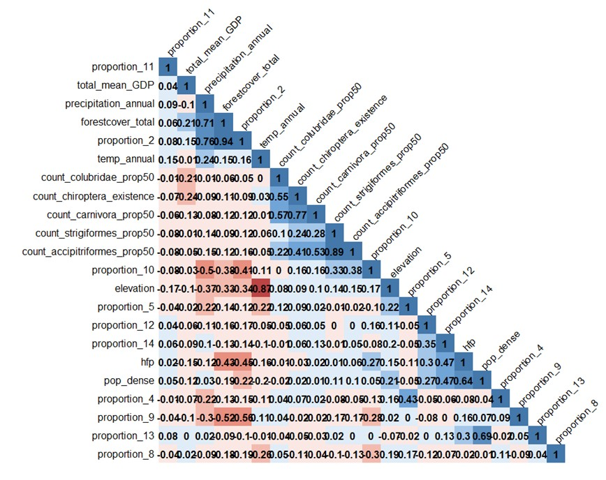

Fig 2. Variable collinearity heatmap. Pearson correlation coefficient for a given pair of predictive variables in Marburgvirus model.
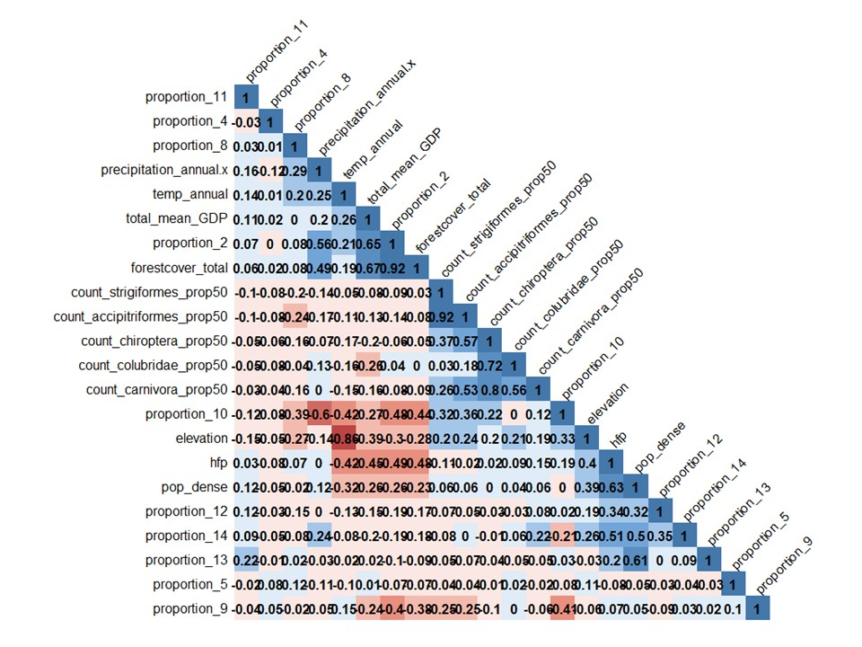

Fig 3. Directed acyclic graph of the final models in the study.
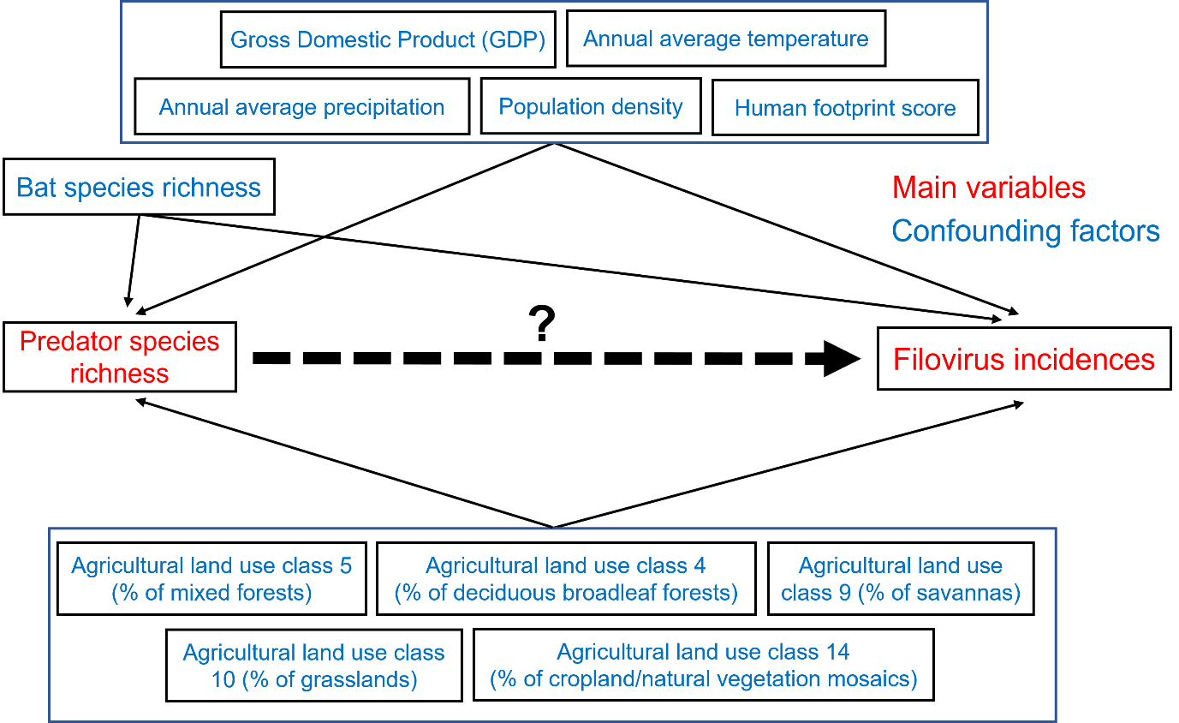

Fig 4. Global Moran’s I plot and Moran’s I statistics for Ebolavirus incidence
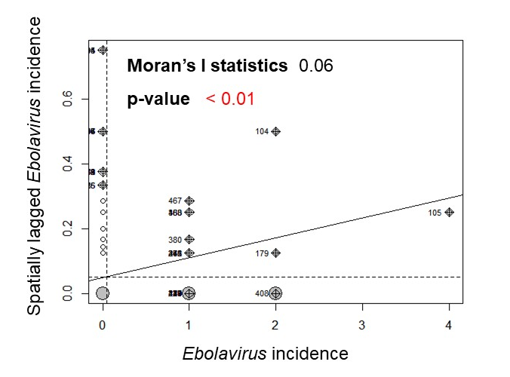
Fig 5. Global Moran’s I plot and Moran’s I statistics for Marburgirus incidence
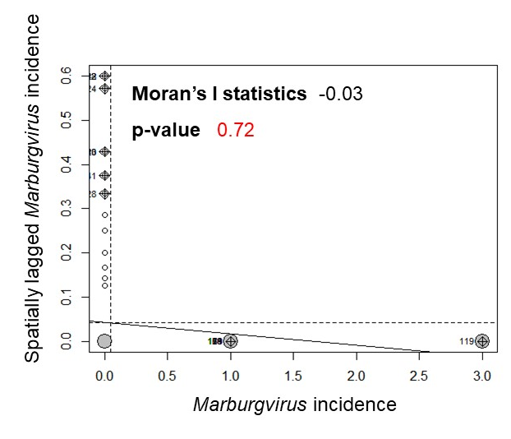

Fig 6. Estimated ORs for Ebolavirus incidence according to the degree of species richness. (A) The result of Model 1. (B) The result of Model 2. (C) The result of Model 3. (D) The result of Model 4. (E) The result of Model 5. The dots indicate the estimated ORs, with error bars representing the corresponding 95 % Wald’s credible intervals. Red means that the error bar does not intersect 1. The models were fitted with “R-INLA” package. The y-axis is shown on a logarithmic scale. The authors generated draws of each predator.
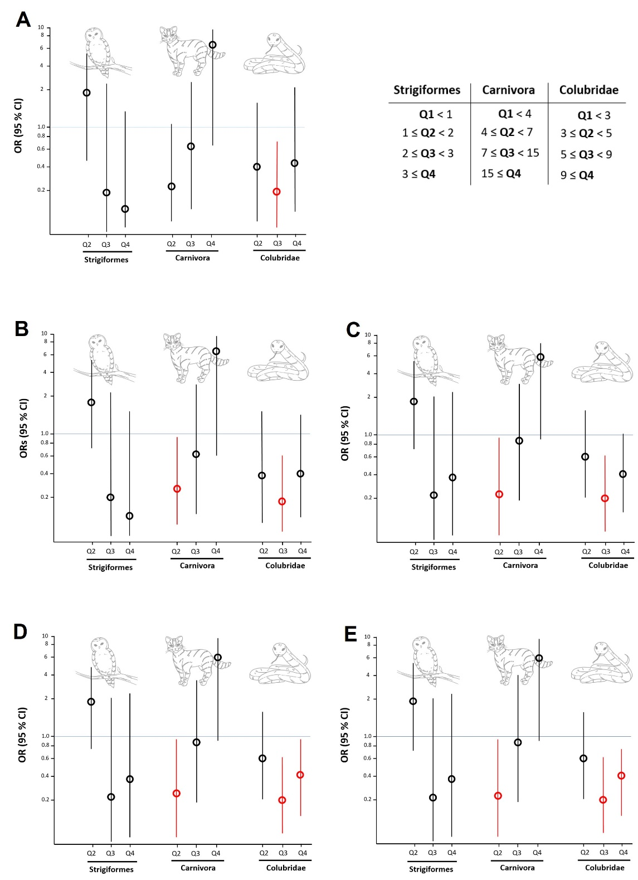
Fig 7. Estimated ORs for Ebolavirus incidence according to the degree of species richness. (A) The result of Model 1. (B) The result of Model 2. (C) The result of Model 3. (D) The result of Model 4. (E) The result of Model 5. The dots indicate the estimated ORs, with error bars representing the corresponding 95 % Wald’s credible intervals. Red means that the error bar does not intersect 1. The models were constructed using the species richness variables calculated with IUCN polygons. The y-axis is shown on a logarithmic scale. The authors generated draws of each predator.
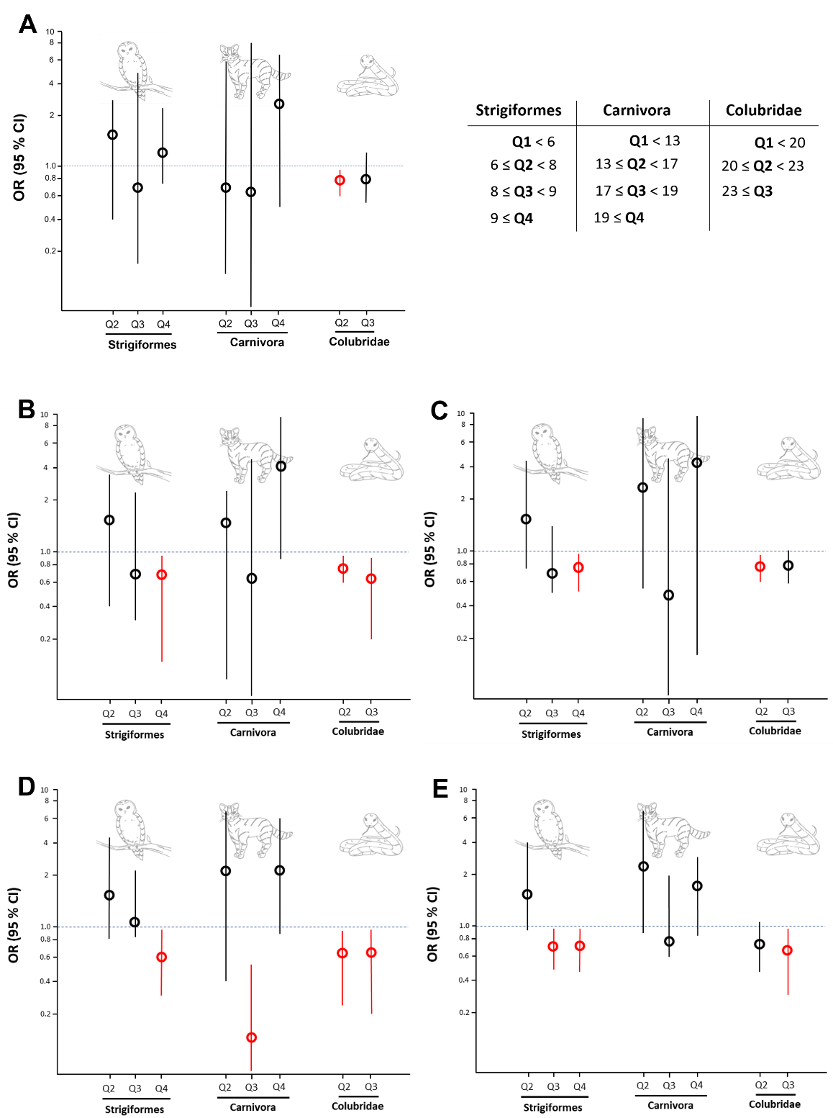
Fig 8. Estimated ORs for Ebolavirus incidence according to the degree of species richness. (A) The result of Model 1. (B) The result of Model 2. (C) The result of Model 3. (D) The result of Model 4. (E) The result of Model 5. The dots indicate the estimated ORs, with error bars representing the corresponding 95 % Wald’s credible intervals. Red means that the error bar does not intersect 1. The reference categories are when the species does not exist. The models were constructed using the species richness variables calculated with Maxent modeling results, and the only species reported to prey on bats were included. The y-axis is shown on a logarithmic scale. The authors generated draws of each predator.
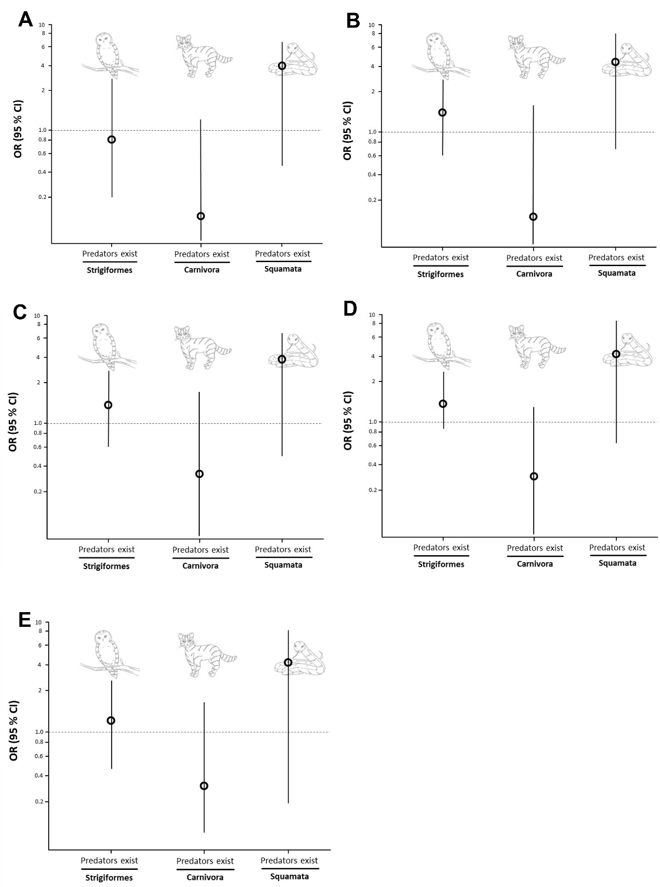
Fig 9. Estimated ORs for Marburgvirus incidence according to the degree of species richness. The dots indicate the estimated ORs, with error bars representing the corresponding 95 % Wald’s credible intervals. The model was constructed using the species richness variables calculated with IUCN polygons. The y-axis is shown on a logarithmic scale. The authors generated draws of each predator.
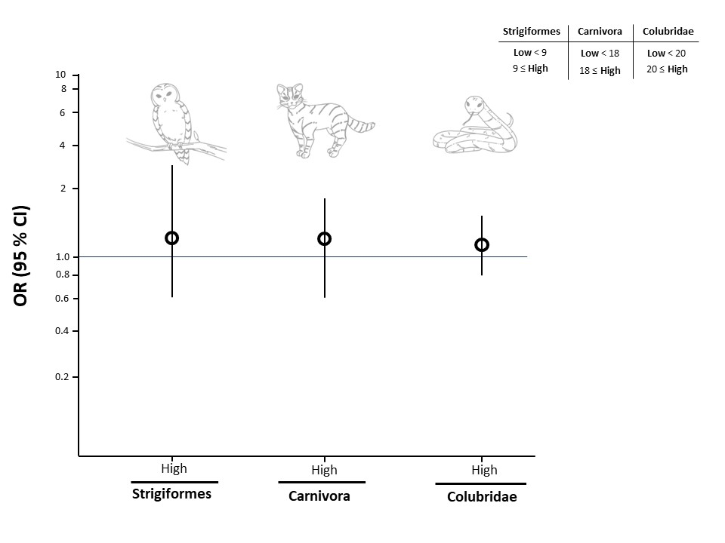

Fig 10. Estimated ORs for Marburgvirus incidence according to the degree of species richness. The dots indicate the estimated ORs, with error bars representing the corresponding 95 % Wald’s credible intervals. The reference categories are when the species does not exist. The models were constructed using the species richness variables calculated with Maxent modeling results, and the only species reported to prey on bats were included. The y-axis is shown on a logarithmic scale. The authors generated draws of each predator.
