Table S1 Variables and threshold values for simplified risk assessment model
Variables | Low risk | Intermediate risk | High risk
A：WHO FC | I、II | III | IV
B：6MWD | >440m | 165~440m | <165m
C：NT-proBNP  or RAP | <300ng/L  <8mmHg | 300-1400ng/L  8-14mmHg | >1400ng/L  >14mmHg
D：CI  or SvO2 | ≥2.5L/min/m²  >65% | 2.0~2.4L/min/m²  60~65% | <2.0L/min/m²  <60%
Note: Evaluation Criteria: A comprehensive analysis based on the ABCD criteria.
Abbreviations: NT-proBNP, N-terminal pro-brain natriuretic peptide; CI, cardiac index; RAP, right atrial pressure; 6MWD, 6-minute walk distance; SvO2, mixed venous oxygen saturation;
1 mmHg = 0.133 kPa
Table S2 Details on sST2 variations in patients with CTD-PAH at baseline and during 3-12 months follow-up
Group | Patients | sST2 at baseline | sST2 at re-examination | Clinical worsening event
sST2:N-N | 23 | 22.56(12.40-30.74) | 13.91(9.17-18.88) | 1
sST2:H-N | 13 | 45.77(40.28-55.35) | 17.01(12.82-20.23) | 1
sST2:N-H | 3 | 18.13 ± 9.55 | 45.72 ± 13.75 | 1
sST2:H-H | 5 | 54.48(44.61-65.09) | 50.89(36.13-63.56) | 2
sST2: N-N (sST2 steady < 35 ng/mL), sST2: H-N (sST2 ≥ 35 ng/mL decreased < 35 ng/mL), sST2: N-H (sST2 < 35 ng/mL increased ≥ 35 ng/mL), sST2: H-H (sST2 steady ≥ 35 ng/mL)

Figure S1 Flow diagram of exclusion and enrollment of study patients
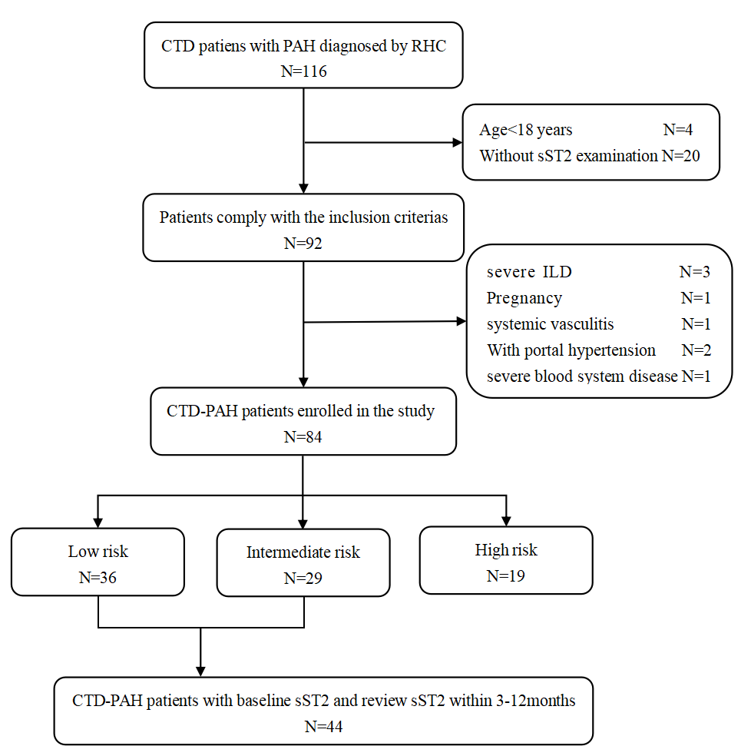
Abbreviations: CTD, connective tissue disease; PAH, pulmonary arterial hypertension; RHC, right heart catheterization; sST2, soluble suppression of tumorigenicity 2; ILD, interstitial lung disease.

Figure S2 Kaplan-Meier curves for overall CTD-PAH patients
Figure S3 Kaplan-Meier curves for intermediate risk CTD-PAH patients with different sST2 levels

Figure S4 Comparative analysis of sST2 levels in CTD-PAH patients at low and intermediate risk, with and without clinical worsening event

Figure legends
Figure S1 Flow diagram of exclusion and enrollment of study patients
Figure 1 describes the exclusion and enrollment of study patients.

Figure S2 Kaplan-Meier curves for overall CTD-PAH patients
Kaplan-Meier survival curves of the overall CTD-PAH cohort.

Figure S3 Kaplan-Meier curves for intermediate risk CTD-PAH patients with different sST2 levels
Kaplan-Meier analysis showed significant differences in the prognosis between the intermediate risk CTD-PAH patients with sST2<35 ng/mL and sST2≥35 ng/mL.

Figure S4 Comparative analysis of sST2 levels in CTD-PAH patients at low and intermediate risk, with and without clinical worsening event
There were significantly different serum sST2 levels among patients at low and intermediate risk, with and without clinical worsening event[50.51(37.20-65.81) vs 30.74(17.89-42.10)ng/mL, P=0.005].

