Appendix 1 Woodland Cover Map of the Study Area

Objective
To assess the woodland cover in the Tabora and Katavi regions in the West of Tanzania.

Method

Data collection
The images used were sentinel-2 images (10 m) from 2020/2021, obtained from the Earth Explorer. These acquired images were from the dry period and covered the Katavi and Tabora regions.

Data Processing
Supervised classification based on a random forest classifier in R software was employed to classify the Sentinel-2 imagery tile-wise into woodland and non-woodland classes. The output classified maps were then mosaicked.

Validation
The woodland and non-woodland cover map produced was validated using 688 randomly selected samples, with 535 from the woodland class and 153 from the non-woodland class within tracts.

Results
The findings revealed that miombo woodland covers an area of 27332 km² within the Mlele and Tanganyika districts in the Katavi Region, as well as the Tabora and Sikonge districts in the Tabora Region (Fig.1). The overall classification accuracy and kappa statistics were found to be 0.80 and 0.53, respectively (Table 1).
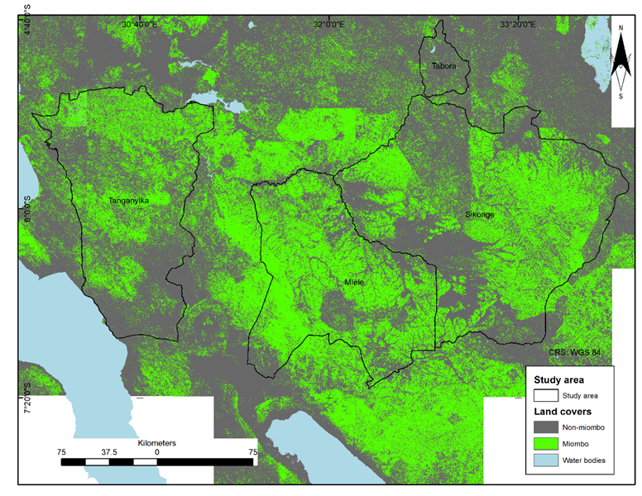
Fig. 1 Distribution of miombo woodland and non-miombo woodland covers in the study area

Table 1 Confusion matrix table
Reference image
Classified image |  | Woodland | Non-Woodland | Total | User's accuracy
Classified image | Woodland | 414 | 14 | 428 | 0.97
Classified image | Non-Woodland | 121 | 139 | 260 | 0.53
Classified image | Total | 535 | 153 | 688
Classified image | Producer's accuracy | 0.77 | 0.91

Appendix 2 Accuracy assessment of Planetscope classification

Method

Ground data collection
The ground data on the presence of miombo were collected from April to September 2022. These ground-level measurements served as crucial validation points for the accuracy of the maps produced through the NDVI classification of Planetscope satellite imagery.

Analysis
The miombo canopy cover, mapped within tracts through NDVI classification of PlanetScope imagery, was validated against 167 ground-based presence/absence data of miombo woodland using a confusion matrix. The results were presented in a table, and metrics including overall classification accuracy, kappa statistic, producer's accuracy, and user's accuracy were used to assess the classification accuracy.

Results
The overall accuracy of the classification of PlanetScope imagery using the NDVI threshold within tracts is 0.94, with a Kappa statistic of 0.61 (Table 1).
Table 1 Confusion matrix table
Reference image
Classified image |  | Woodland | Non-Woodland | Total | User's accuracy
Classified image | Woodland | 148 | 4 | 152 | 0.97
Classified image | Non-Woodland | 6 | 9 | 15 | 0.60
Classified image | Total | 154 | 13 | 167
Classified image | Producer's accuracy | 0.96 | 0.69

Appendix 3 The H.T. estimator formula
Area with miombo woodland and canopy cover in the area with miombo woodland

$$T_{HT}=N* Ȳ (1)$$
Where
$$Ȳ=\frac{1}{n}\sum_{j∈S}^{n}{ŷ_{J}} (2)$$
and
$$ŷ_{j}=\sum_{h=1}^{k}{ŷ_{h}}$$
$$ŷ_{h}=\sum_{hp=1}^{h}{\left(\frac{\left(M_{h}*a\right)}{m_{h}}\right)*m_{hp}}$$
Variance of total

$$V \left(T_{HT}\right)=N^{2}* \frac{\left(1-f_{y}\right)}{n}*{S_{y}}^{2} \left(3\right)$$
Where
$f_{y}=\frac{n}{N}$ , and ${S_{y}}^{2} =\frac{1}{n-1} \sum_{j=1}^{n}{{{(ŷ}_{j}-Ȳ)}^{2}}$

Canopy cover
$$Ǭ =\frac{1}{n}\sum_{j∈S}^{n}{Q_{j} } (4)$$
$$Ǭ_{K}=\frac{1}{n}\sum_{j∈S}^{n}{Q_{k}} (5)$$
Where
$${Ǭ }_{j}=\frac{1}{k} \sum_{kj=1}^{k}{Q_{k}} (6)$$

$$Q_{k}=\frac{1}{m_{hp}}\sum_{i=1}^{k}{Q_{p}} (7)$$

Variance of canopy cover

$V \left(Ǭ\right)= \frac{\left(N-n\right)}{N}*\frac{{S_{Q}}^{2}}{n} (8)$

Where
T_{HT} = Estimated total area with miombo woodland/ Estimated total canopy cover in the area with miombo woodland
N= Total number of tracts (j) in the study area
Ȳ = Mean of characteristic y
n = Number of sampled tracts
ŷ_{j} = Total of characteristic y in the tract j
$ŷ_{h}$ = Value of characteristic y in stratum h
k = Stratum of sizes
M_{h} = Total plots in the stratum h
m_{h} = Sample size in the stratum h
m_{hp} = Sample size of the new strata according to planetscope within the stratum h
a = Plot area
Var(T_{HT}) = Variance of the estimated total area with miombo woodland/estimated total canopy cover in the area with miombo woodland
S_{y}² = Variance of characteristic y in the tract j
S_{Q}² = Variance canopy cover in the tract j
Q _{p} = Canopy cover for a plot within statum k according to planetscope
Q _{k} = Canopy cover within miombo woodland at statum k
Q_{j} = Canopy cover within miombo woodland area in the tract j
Q = Canopy cover within miombo woodland area for the study area
V(Q) = Variance of canopy cover within miombo woodland area for the study area

