Supplementary Information (SI)
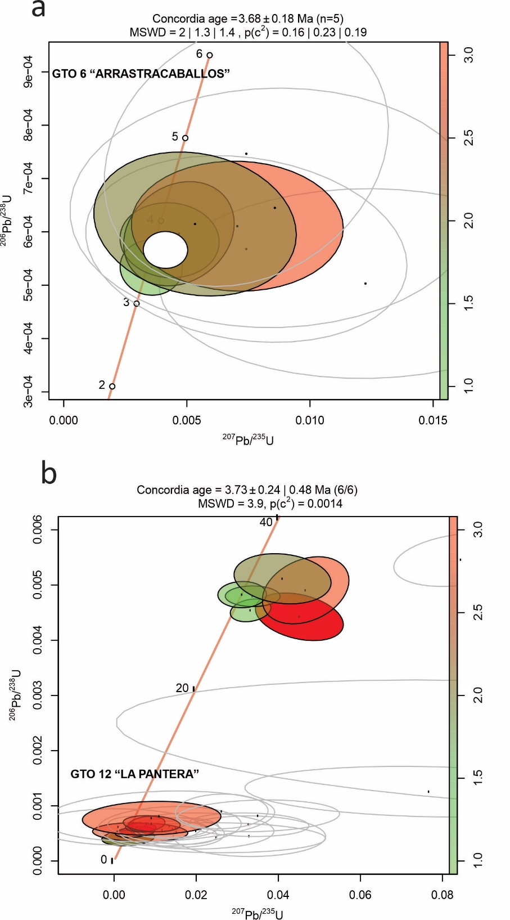
SI Fig. 1. Radiometric ages of the localities in the San Miguel de Allende Basin, Guanajuato, Mexico: a. locality GTO 6 “Arrastracaballos”, b. locality GTO 12 “La Pantera”. The analysis were doing in the Laboratorio de Estudios Isotópicos, Centro de Geociencias, Universidad Nacional Autónoma de México (LEI). We analyzed 206Pb/238U in the youngest and most concordant zircon population collected in volcanic ashes, the method was by laser ablation in a single/crystal using a coupled plasma-mass spectrometry (ICP-MS).
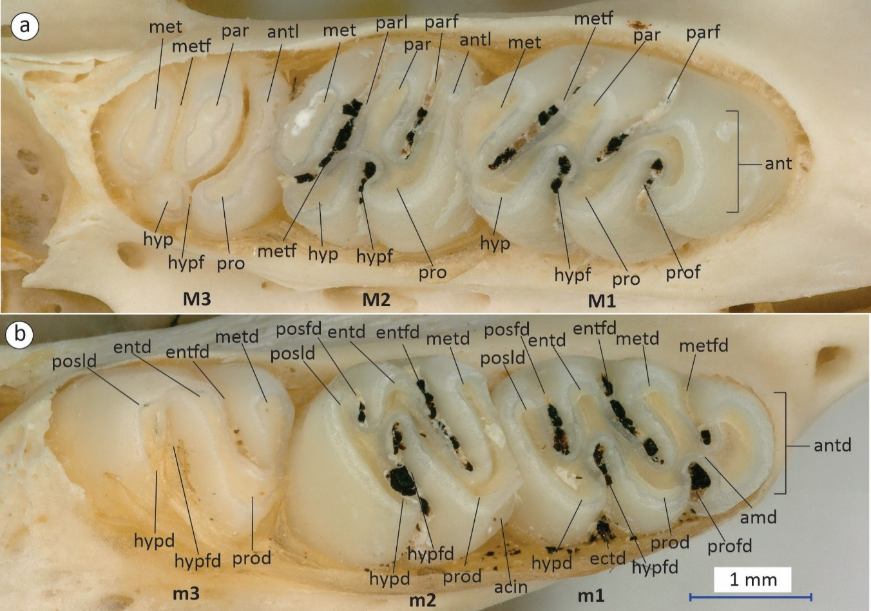
SI Fig. 2. Dental terminology used in this study illustrated with the upper and lower jaws of Sigmodon hispidus saturatus LACMm 18846. a. Right maxillary with the molar one (M1), molar two (M2) and molar three (M3); b. Right dentary with the molar one (m1), molar two (m2) and molar three (m3). The nomenclature was based on Reig (1977) and Martin et al (2020). Anatomical abbreviations: acin, anterior cingulum; amd, anterior murid; ant, anterocone; antd, anteroconid; antl, anteroloph; ectd, ectostylid (structure not seen in modern Sigmodon); entd, entoconid; entfd, entoflexid; hyp, hypocone; hypd, hypoconid; hypf, hypoflexus; hypfd, hypoflexid; met, metacone; metd, metaconid; metf, metaflexus; metfd, metaflexid; par, paracone; parf, paraflexus; parl, paralophule; posfd posteroflexid; posld, posterolophid; pro, protocone; prod, protoconid; prof, protoflexus; profd, protoflexid.
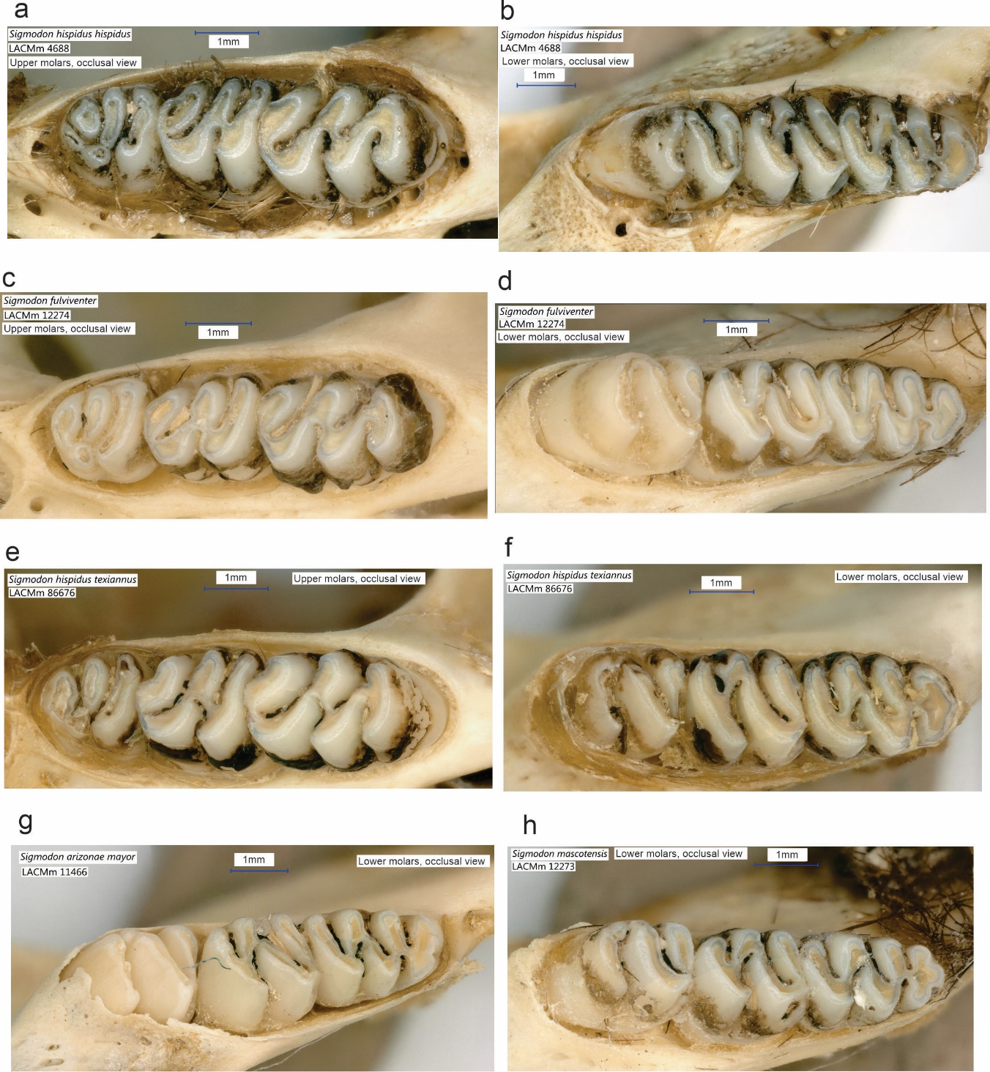
SI Fig. 3. Upper and lower molars of modern species of Sigmodon. a-b, LACMm 4688, Sigmodon hispidus hispidus, upper molars (a) and lower molars (b); c-d, LACMm 12274, Sigmodon fulviventer, upper molars (c) and lower molars (d); e-f, LACMm 86676, Sigmodon hispidus texiannus, upper molars (e) and lower molars (f); g, LACMm 11466, Sigmodon arizonae, lower molars; h, LACMm 12273, Sigmodon mascotensis, lower molars.

SI. Table 1. Estimation of body mass (West) of Sigmodon minor from the early Blancan of San Miguel de Allende basin, Guanajuato, Central Mexico. The estimation West was made following Martin et al. (2022), which considers the anteroposterior length of the first lower molar.

#Catalog | Locality | m1 Length | West (gr)
MPGJ 6007 | GTO 6 | 2.24 | 95.7
MPGJ1907 | GTO 12 | 2.22 | 89.4
MPGJ 2650 | GTO 19 | 2.15 | 75.8
MPGJ 2651 | GTO 19 | 2.27 | 103.7
MPGJ 2654 | GTO 19 | 1.95 | 43.0
MPGJ 2660 | GTO 19 | 2.11 | 67.0
MPGJ 2669 | GTO 19 | 2.40 | 142.2
MPGJ 2671 | GTO 19 | 2.08 | 62.5
MPGJ 2673 | GTO 19 | 2.06 | 59.0
MPGJ 2678 | GTO 19 | 2.09 | 64.2
MPGJ 2681 | GTO 19 | 2.00 | 49.6
MPGJ 2689 | GTO 19 | 2.19 | 84.6
MPGJ 2695 | GTO 19 | 2.15 | 75.6
MPGJ 2708 | GTO 19 | 2.16 | 76.8
MPGJ 2709 | GTO 19 | 2.07 | 59.4
MPGJ 2712 | GTO 19 | 2.12 | 69.6
MPGJ 2715 | GTO 19 | 2.40 | 142.2
MPGJ 2717 | GTO 19 | 2.32 | 115.7
MPGJ 2725 | GTO 19 | 2.01 | 50.4
MPGJ 2726 | GTO 19 | 2.19 | 82.6
MPGJ 2729 | GTO 19 | 2.22 | 89.7
MPGJ 2730 | GTO 19 | 2.08 | 61.8
MPGJ 2731 | GTO 19 | 2.06 | 58.7
MPGJ 2733 | GTO 19 | 2.11 | 66.8
MPGJ 2736 | GTO 19 | 2.22 | 90.9
MPGJ 2655 | GTO 19 | 2.18 | 81.7

