Impact of Cymbopogon flexuosus (Poaceae) essential oil and primary components on the eclosion and larval development of Aedes aegypti

Ruth Mariela Castillo-Morales¹, Sugey Ortiz Serrano¹, Adriana Lisseth Rodríguez Villamizar², Stelia Carolina Mendez-Sanchez²*, Jonny E. Duque¹*

1. Centro de Investigaciones en Enfermedades Tropicales - CINTROP. Facultad de Salud. Escuela de Medicina, Departamento de Ciencias Básicas, Universidad Industrial de Santander, Guatiguará Technology and Research Park, Km 2 Vía El Refugio, Piedecuesta, Santander, Colombia. Phone number: 57-7-6344000 Ext. 3503
2. Grupo de Investigación en Bioquímica y Microbiología (GIBIM). Escuela de Química, Universidad Industrial de Santander, Bucaramanga A.A. 678, Colombia
*Corresponding Author: jonedulu@uis.edu.co

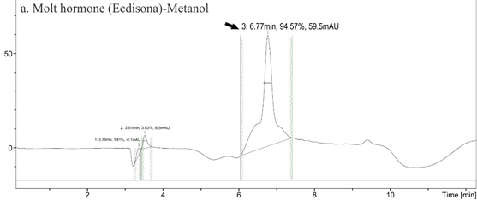
Supplementary Figure 1. Molt Hormone (MH) HPLC-Mass spectrometry chromatograms Aedes aegypti larvae (L4) without treatment. Y-axes: signal intensity (mAU). X-axes: retention time in minutes. a. Methanol-water mobile phase chromatogram. The retention time of 6.77 min, molecular mass detected by the mass spectrometer: 481.1 g.mol⁻¹.

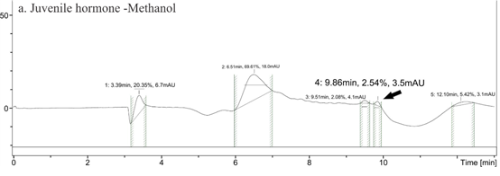
Supplementary Figure 2. Juvenile hormone III (JH III) HPLC-Mass spectrometry chromatograms Aedes aegypti larvae (L4) without treatment. Y-axes: signal intensity (mAU). X-axes: retention time in minutes. a. Methanol-water mobile phase chromatogram. The retention time of 9.86 min. b. Acetonitrile (ACN)-water mobile phase chromatogram. The retention time of 10.06 min, molecular mass detected by the mass spectrometer: 481.1 g.mol⁻¹.
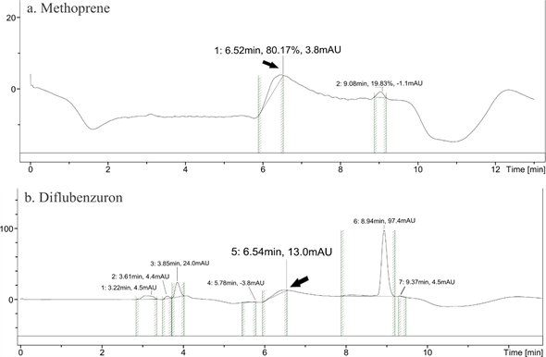
Supplementary Figure 3. Methoprene and Diflubenzuron HPLC-Mass spectrometry chromatograms Aedes aegypti larvae (L4). Y-axes: signal intensity (mAU). X-axes: retention time in minutes. a. Aedes aegypti larvae (L4) chromatogram treated with Methoprene. The retention time of 6.52 min and molecular mass detected by the mass spectrometer of 481.0 g.mol⁻¹, corresponding to MH. b. Aedes aegypti larvae (L4) chromatogram treated with Diflubenzuron. The retention time of 6.54 min, molecular mass detected by the mass spectrometer of 481.1 g.mol⁻¹, corresponding to MH.
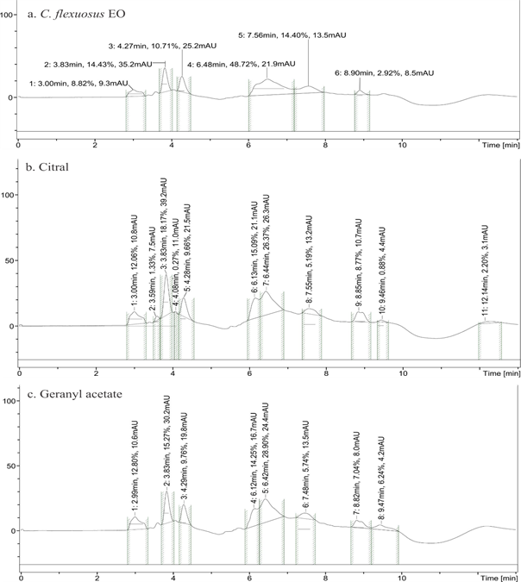
Supplementary Figure 4. Major compounds (Citral and Geranyl acetate) HPLC-Mass spectrometry chromatograms Aedes aegypti larvae (L4) treated with C. flexuosus EO and its major compounds (Citral and Geranyl acetate). Y-axes: signal intensity (mAU). X-axes: retention time in minutes. Don´t detect any titter corresponding to MH or JH III. a. Aedes aegypti larvae (L4) chromatogram treated with C. flexuosus EO. b. Aedes aegypti larvae (L4) chromatogram treated with the major compound Citral. c. Aedes aegypti larvae (L4) chromatogram treated with the major compound Geranyl acetate.

