Supplementary materials
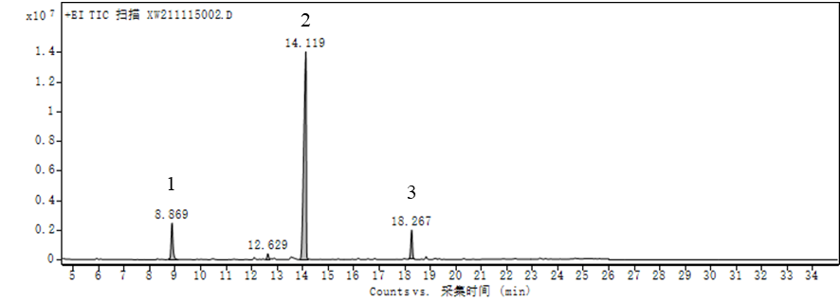
Fig. S1. GC-MS total ion chromatogram of MBP-2

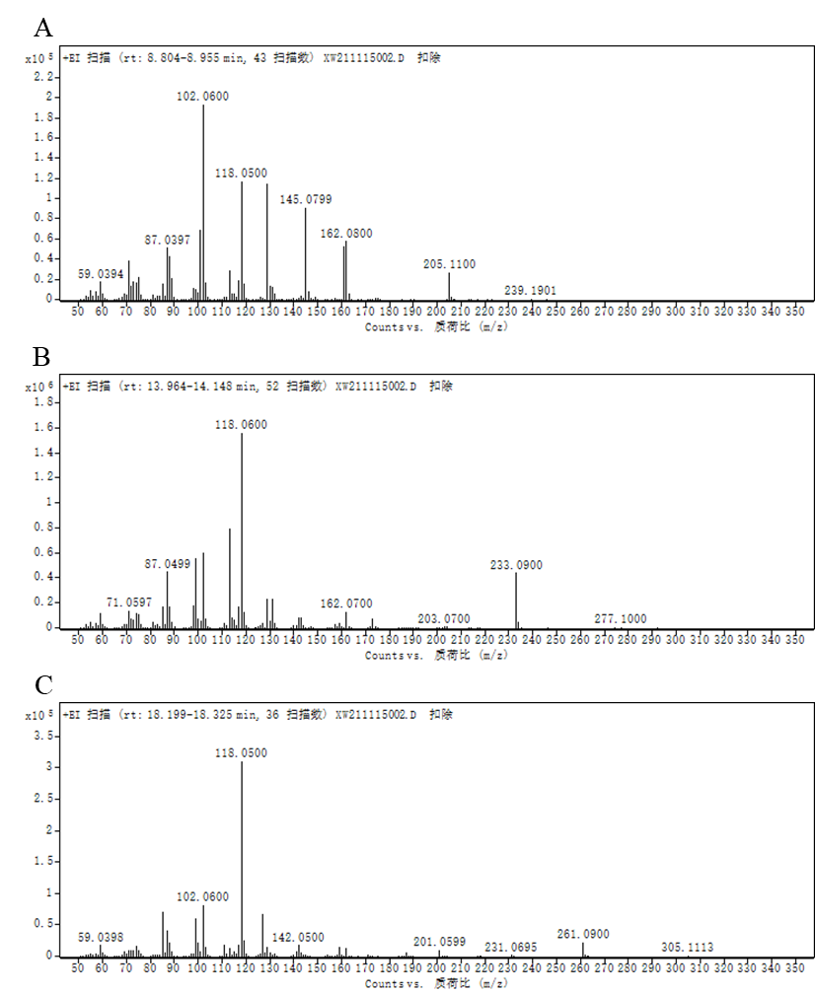
Fig. S2. Secondary mass spectrum of peak 1 (A), 2 (B) and 3 (C) in GC-MS

