Supporting Information
Assembly of Genetically Engineered Ionizable Protein Nanocage-based Nanozymes for Mitigating Ischemia-reperfusion Injury
Qiqi Liu^{a,b#}, Zhanxia Gao^{a#}, Xiangyun Zhang^{b#}, Qiannan Duan^{b}, Yue Zhang^{c}, Adam C. Midgley^{b}, Li jiao^{b}, Ruming liu^{b}, Mingsheng Zhu^{b}, Deling Kong^{b}, Jie Zhuang^{a*}, Xinglu Huang^{b*}

ªSchool of Medicine, Nankai University, Tianjin 300071, China.
^{b}Key Laboratory of Bioactive Materials for the Ministry of Education, College of Life Sciences, Nankai University, Tianjin 300071, China; State Key Laboratory of Medicinal Chemical Biology, Frontier of Science Center for Cell Response, College of Life Sciences, Nankai University, Tianjin 300071, China.
^{c}Tianjin Key Laboratory of Cellular Homeostasis and Disease, Department of Physiology and Pathophysiology, Tianjin Medical University, Tianjin 300070, China.

#These authors contributed equally to this work.
*Email: zhuangj@nankai.edu.cn; huangxinglu@nankai.edu.cn

Figure S1. Characterization of iFTn containing different proportions of H₂E-FTn. A, SDS-PAGE analysis of the proportions of H₂E-FTn subunits in the assembled iFTn. The iFTn was in-situ assembled in E. coli using expressed FTn and H₂E-FTn subunits, obtained by the customizing plasmids. B, Zeta potential measurements of FTn and various iFTn at pH 7.0 and pH 5.0, revealing ionizable property of iFTn. C, Flow cytometry analysis of cellular uptake of FTn and different iFTn. ****P<0.0001.

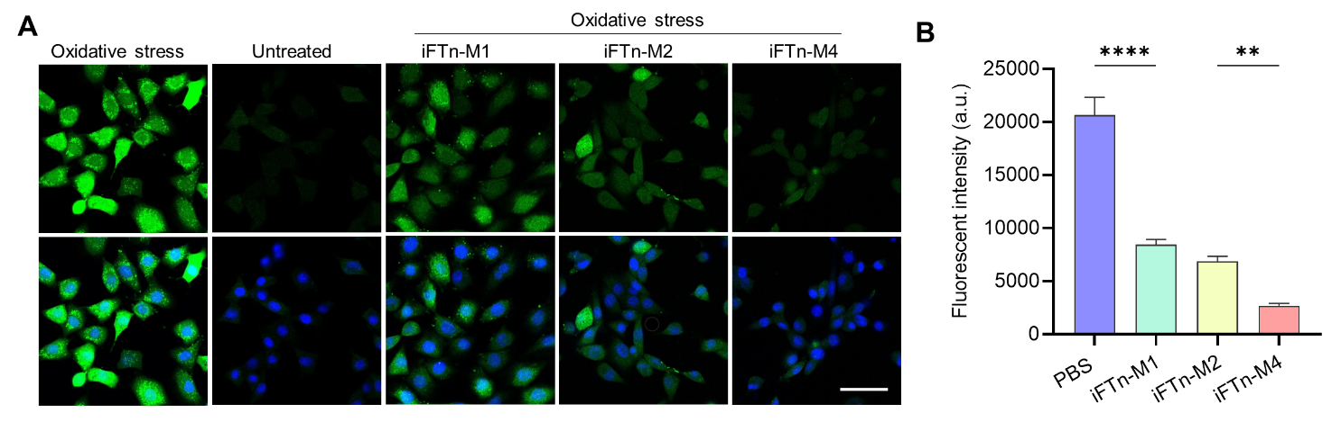
Figure S2. ROS levels in H9C2 cells following different treatments. A, Confocal imaging showing ROS levels in H9C2 cells under normal conditions and oxidative stress after various treatments, utilizing DCFH-DA as an ROS indicator. Scale bar = 50 µm. B, Flow cytometry analysis of the effect of iFTn-M nanozymes on intracellular ROS levels in H9C2 cells following different treatments, with DCFH-DA used as an ROS indicator. **P<0.01, ****P<0.0001.

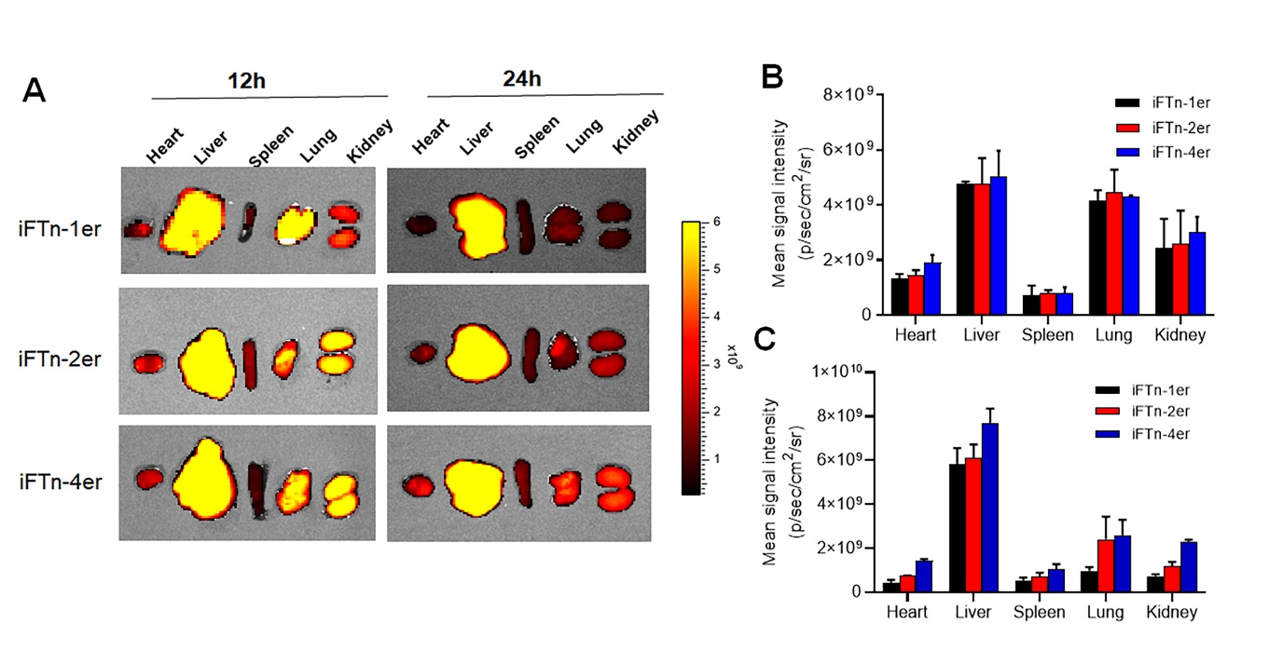
Figure S3. Biodistribution of Cy5-labeled iFTn and its assemblies following i.v. administration. A, Ex vivo IVIS fluorescence imaging of Cy5-labeled iFTn and its assemblies in different organs after 12 and 24 hours of injection. Quantification analysis of the biodistribution of Cy 5-labeled iFTn and its assemblies in different organs following (B) 12 hours and (C) 24 hours of administration.

Figure S4. Histopathological analysis of systemic toxicities in different organs. Histopathological analysis of systemic toxicities in different organs isolated from mice without or with iFTn-M4, iFTn-R4 and iFTn-MR4. Slices from different organs were stained using standard Hematoxylin and Eosin (H&E) staining procedures. Scale bar = 100 μm.

