Supplementary Information
Revealing the atomic and electronic mechanism of human manganese superoxide dismutase product-inhibition
Jahaun Azadmanesh¹, Katelyn Slobodnik¹, Lucas R. Struble¹, William E. Lutz¹, Leighton Coates², Kevin L. Weiss³, Dean A. A. Myles³, Thomas Kroll⁴, and Gloria E. O. Borgstahl¹*
¹Eppley Institute for Cancer and Allied Diseases, 986805 Nebraska Medical Center, Omaha, NE 68198-6805, USA
²Second Target Station, Oak Ridge National Laboratory, 1 Bethel Valley Road, Oak Ridge, TN 37831, USA
³Neutron Scattering Division, Oak Ridge National Laboratory, 1 Bethel Valley Road, Oak Ridge, TN 37831, USA
⁴Stanford Synchrotron Radiation Lightsource, SLAC National Accelerator Laboratory, Menlo Park, CA 94025, USA
*gborgstahl@unmc.edu

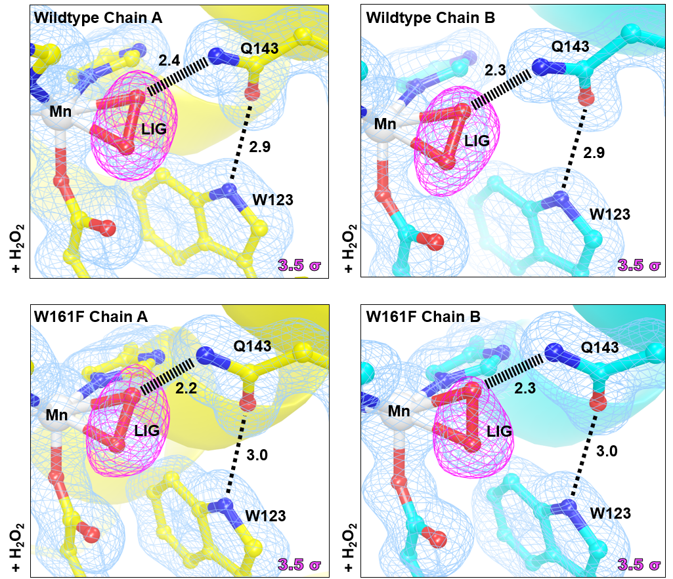
Supplementary Figure 1. X-ray structures of Wildtype and Trp161Phe MnSOD soaked with H₂O₂. Magenta omit |F_{o}| - |F_{c}| difference electron density is displayed at 3.5σ. Light blue 2|F_{o}| - |F_{c}| density is displayed at 1.0σ. Distances are in Å. Dashed lines indicate typical hydrogen bonds and hashed lines indicate SSHBs that are hydrogen bonds < 2.8 Å. Note that due to photoreduction effects, the dioxygen species are refined at partial occupancy and have side-on binding orientations compared to the neutron structure counterpart that is absent of photoreduction and was refined at full occupancy and has an end-on binding orientation.

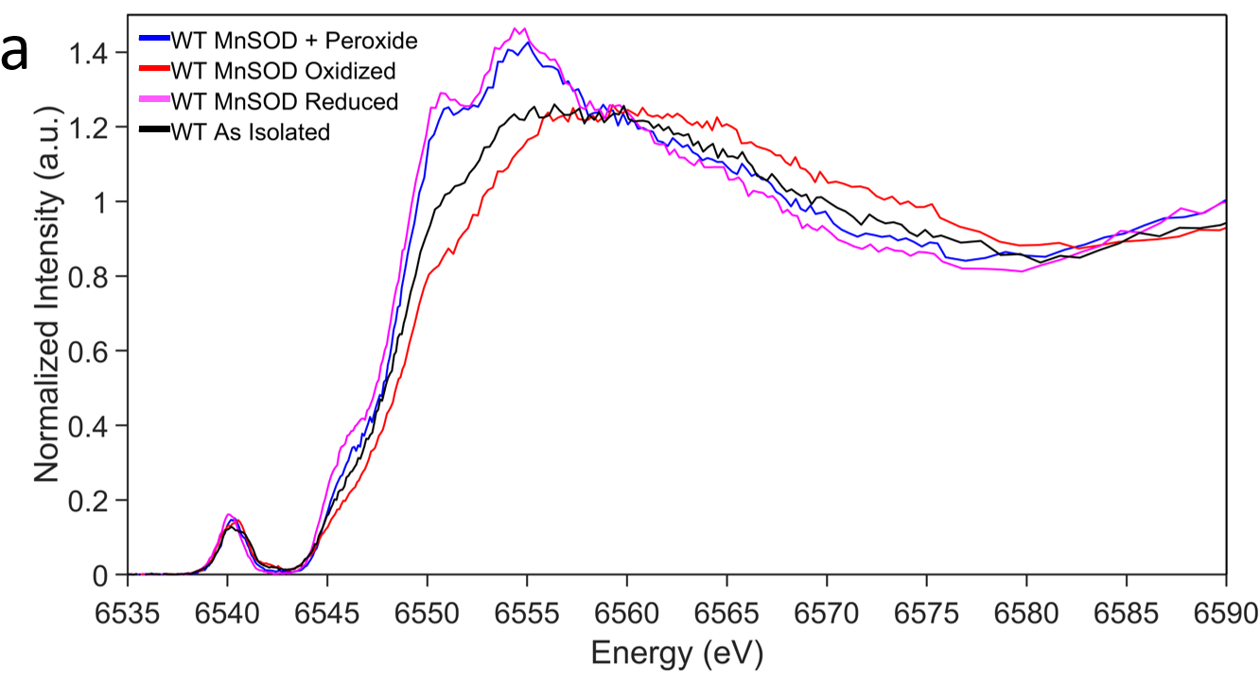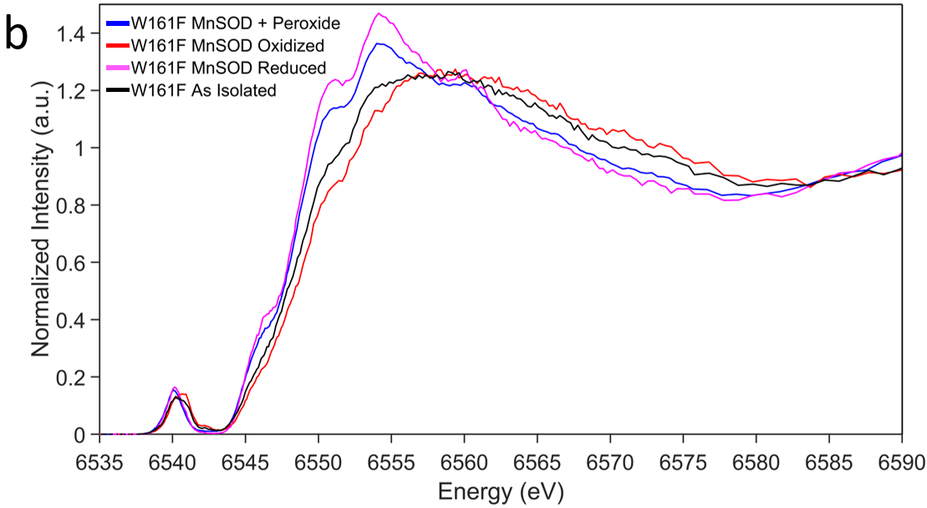
Supplementary Figure 2. Kα HERFD-XANES spectra of MnSOD. a HERFD-XANES of wildtype MnSOD in the peroxide-soaked, oxidized, reduced, and as isolated forms. b HERFD-XANES of Trp161Phe MnSOD in the peroxide-soaked, oxidized, reduced, and as isolated forms. The oxidized and reduced samples correspond to Mn³⁺SOD and Mn²⁺SOD resting states.

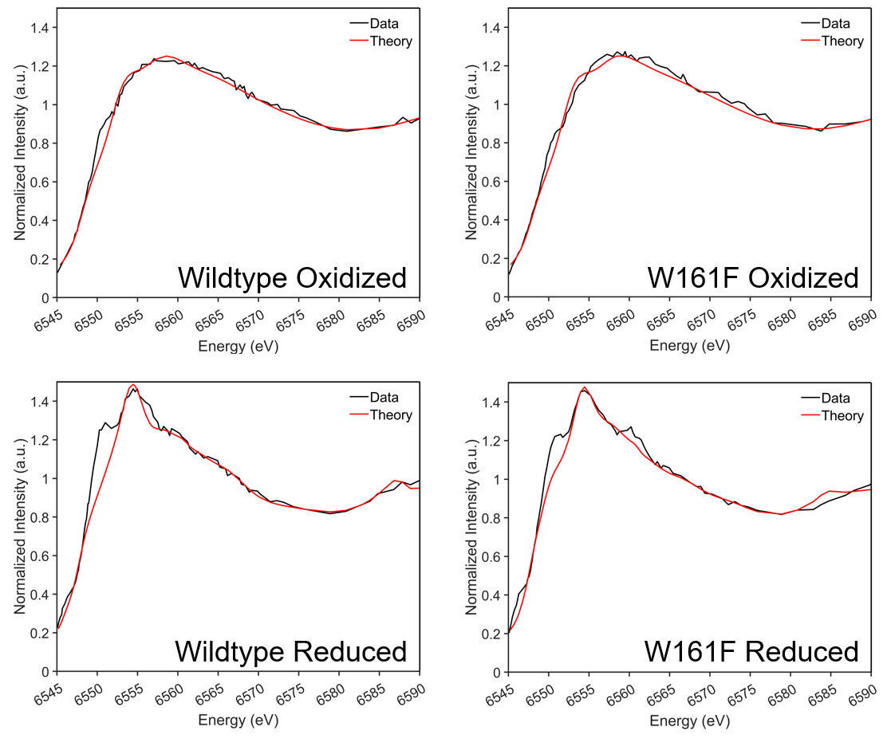Supplementary Figure 3. Fit of oxidized and reduced HERFD-XANES spectra for wildtype and Trp161Phe MnSOD. Oxidized and reduced samples correspond to Mn³⁺SOD and Mn²⁺SOD resting states. Spectra were simulated with FDMNES, and fits were performed using FITIT code.

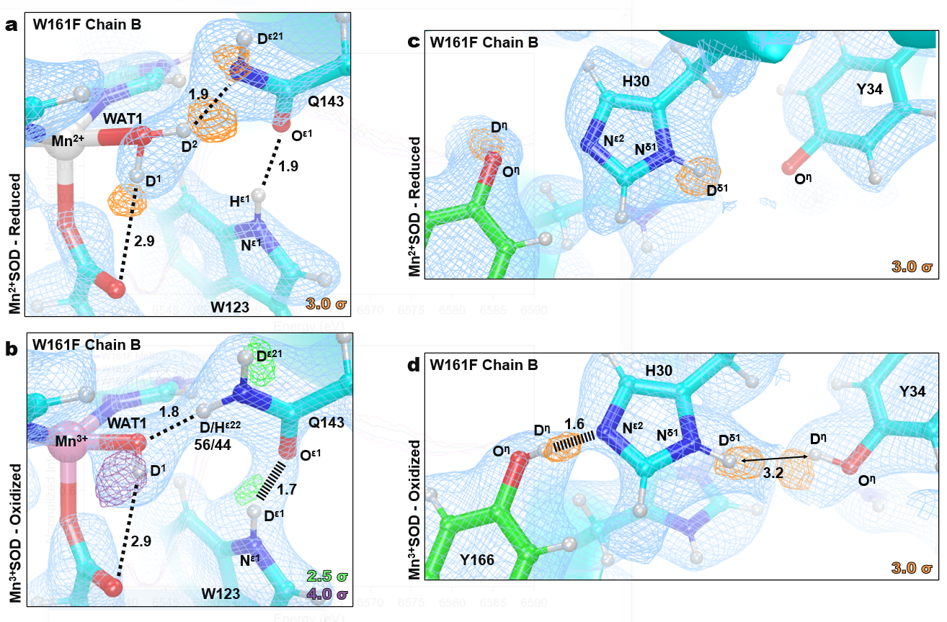
Supplementary Figure 4. Neutron Structure and protonation states at the active site of Trp161Phe Mn²⁺SOD and Trp161Phe Mn³⁺SOD. a Neutron structure of Trp161Phe Mn²⁺SOD at the active site of chain B with orange omit |F_{o}| - |F_{c}| difference neutron scattering length density of protons displayed at 3.0σ. b Neutron structure of Trp161Phe Mn³⁺SOD at the active site of chain B with green and purple omit |F_{o}| - |F_{c}| difference neutron scattering length density of protons displayed at 2.5σ and 4.0σ, respectively. For the D^{ε22}(Q143), positive omit difference density was not present above 2.0σ due to density cancellation with the negative neutron scattering length density of hydrogen. As an alternative, the proton position was occupancy refined to yield a ratio of 56% deuterium and 44% hydrogen. c Neutron structure of second-sphere residues at the active site of Trp161Phe Mn²⁺SOD chain B with orange omit |F_{o}| - |F_{c}| difference neutron scattering length density of protons displayed at 3.0σ. Due to a lack of interpretable density for Tyr34, a protonation state was not definitively assigned. d Neutron structure of second-sphere residues at the active site of Trp161Phe Mn³⁺SOD chain B with orange omit |F_{o}| - |F_{c}| difference neutron scattering length density of protons displayed at 3.0σ. Light blue 2|F_{o}| - |F_{c}| density is displayed at 1.0σ. Distances are in Å. Dashed lines indicate typical hydrogen bonds, and hashed lines indicate SSHBs, hydrogen bonds < 1.8 Å.

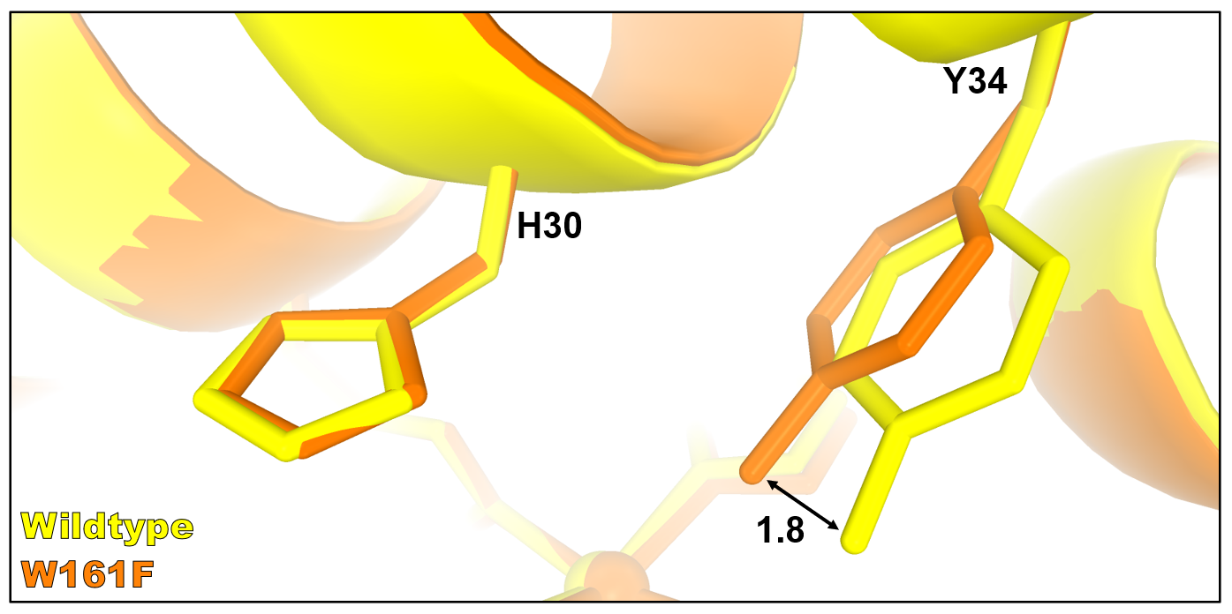
Supplementary Figure 5. Movement of Tyr34 in the Trp161Phe MnSOD variant. Active site overlay of wildtype (yellow) and Trp161Phe (orange) MnSOD highlighting a 1.8 Å movement of the Tyr34 hydroxyl group.

Supplementary Table 1. Active Site Mn Bond Lengths of MnSOD Neutron Structures.
 | Trp161Phe  D₂O₂-Soaked^{b} |  | Trp161Phe  Mn³⁺SOD |  | Trp161Phe  Mn²⁺SOD |  | Wildtype  Mn³⁺SOD |  | Wildtype  Mn²⁺SOD^{c}
Mn Bonds (Å) | A | B | A | B | A | B | A | B | A | B
Mn-N^{ε2}(H26) | 2.13 | 2.20 | 2.01 | 2.01 | 2.20 | 2.11 | 2.07 | 2.07 | 2.26 | 2.10
Mn-N^{ε2}(H74) | 2.13 | 2.28 | 2.15 | 2.15 | 2.19 | 2.16 | 2.13 | 2.12 | 2.19 | 2.25
Mn-O^{ε2}(D159) | 2.20 | 2.05 | 2.01 | 2.01 | 2.13 | 2.20 | 1.95 | 1.94 | 2.44 | 2.15
Mn-N^{ε2}(H163) | 2.25 | 2.17 | 2.15 | 2.15 | 2.14 | 2.15 | 2.06 | 2.14 | 2.23 | 2.21
Mn-O(WAT1) | 2.13 | - | 1.84 | 1.84 | 2.37 | 2.24 | 1.78 | 1.76 | 2.12 | 2.22
Mn-O¹(LIG)ª | - | 1.94 | - | - | - | - | - | - | - | -
Mn-O(OL) | - | - | - | - | - | - | - | - | 1.82 | -
ªO¹(LIG) refers to the closest oxygen atom of the dioxygen species.
^{b}Only chain B of D₂O₂-soaked Trp161Phe MnSOD is bound by a dioxygen species, denoted as LIG. Chain A is in the typical five-coordinated state bound by WAT1.
^{c}For chain A of wildtype Mn²⁺SOD, an ⁻OD molecule is observed binding opposite of Asp159 and is six-coordinate. Chain B is in the typical five-coordinated state.
Supplementary Table 2. EXAFS Fitting Results for H₂O₂-soaked Trp161Phe MnSOD.
Mn-O |  |  | Mn-N |  |  | Mn⸱⸱⸱C |  |  | Mn⸱⸱⸱O |  |  | Mn⸱⸱⸱O⸱⸱⸱O
n | r (Å) | σ² x 10³ (Å²) | n | r (Å) | σ² x 10³ (Å²) | n | r (Å) | σ² x 10³ (Å²) | n | r (Å) | σ² x 10³ (Å²) | n | r (Å) | σ² x 10³ (Å²)
2 | 2.04 | 2.5 | 3 | 2.20 | 2.5 | 7 | 3.15 | 10 | 1 | 2.52 | 0 | 2 | 2.63 | 0
Mn⸱⸱⸱C⸱⸱⸱O |  |  | Mn⸱⸱⸱C⸱⸱⸱N |  |  | χ² |  |  | Reduced χ² |  |  | R-Factor
n | r (Å) | σ² x 10³ (Å²) | n | r (Å) | σ² x 10³ (Å²) | 14.28 |  |  | 3.56 |  |  | 0.0197
2 | 3.26 | 0 | 12 | 3.48 | 2.5

Supplementary Table 3. Comparison of MnSOD bond lengths from various methods.
Trp161Phe Mn³⁺SOD
Bond | Neutron Structure (Å) | DFT (Å) | XANES Fit (Å)
Mn-N^{ε2}(H26) | 2.01 | 2.02 | 1.96
Mn-N^{ε2}(H74) | 2.15 | 2.11 | 2.04
Mn-N^{ε2}(H163) | 2.15 | 2.08 | 2.06
Mn-O^{δ2}(D159) | 2.01 | 1.97 | 1.96
Mn-O(WAT1) | 1.84 | 1.82 | 1.80
Trp161Phe Mn²⁺SOD
Bond | Neutron Structure (Å) | DFT (Å) | XANES Fit (Å)
Mn-N^{ε2}(H26) | 2.20 | 2.20 | 2.14
Mn-N^{ε2}(H74) | 2.19 | 2.20 | 2.26
Mn-N^{ε2}(H163) | 2.14 | 2.19 | 2.11
Mn-O^{δ2}(D159) | 2.13 | 2.07 | 2.08
Mn-O(WAT1) | 2.37 | 2.11 | 2.37
Wildtype Mn³⁺SOD
Bond | Neutron Structure (Å) | DFT (Å) | XANES Fit (Å)
Mn-N^{ε2}(H26) | 2.07 | 2.02 | 1.99
Mn-N^{ε2}(H74) | 2.12 | 2.11 | 2.08
Mn-N^{ε2}(H163) | 2.14 | 2.09 | 2.09
Mn-O^{δ2}(D159) | 1.94 | 1.96 | 1.95
Mn-O(WAT1) | 1.76 | 1.82 | 1.80
Wildtype Mn²⁺SOD
Bond | Neutron Structure (Å) | DFT (Å) | XANES Fit (Å)
Mn-N^{ε2}(H26) | 2.10 | 2.18 | 2.06
Mn-N^{ε2}(H74) | 2.25 | 2.24 | 2.34
Mn-N^{ε2}(H163) | 2.21 | 2.22 | 2.25
Mn-O^{δ2}(D159) | 2.15 | 2.10 | 2.02
Mn-O(WAT1) | 2.22 | 2.12 | 2.25

Supplementary Table 4. Data collection and refinement statistics for MnSOD.
Data Collection Statistics
 | Neutron |  |  | X-ray
Variant | Trp161Phe | Trp161Phe | Trp161Phe | Trp161Phe | Wildtype | Trp161Phe
Chemical State | D₂O₂-Soaked | Reduced | Oxidized | H₂O₂-Soaked | H₂O₂-Soaked | Reduced
PDB Code | 8VHW | 8VHY | 8VJ0 | 8VJ4 | 8VJ5 | 8VJ8
Diffraction Source | MaNDi |  |  | Rigaku FR-E SuperBright
Temperature (K) | 100 | 100 | 296 | 100 | 100 | 100
Space group | P6₁22 |  |  | P6₁22
a, b, c (Å) | 77.80, 77.80, 236.80 | 78.11, 78.11, 236.32 | 80.75, 80.75, 239.43 | 77.66, 77.66, 234.20 | 78.35, 78.35, 236.63 | 77.91, 77.91, 235.14
α, β, γ (°) | 90, 90, 120 |  |  | 90, 90, 120
Wavelengths (Å) | 2-4 |  |  | 1.5418
No. of images | 12 | 11 | 13 | 252 | 202 | 252
Exposure time | 48 h | 36 h | 20 h | 300 s | 300 s | 300 s
No. of unique reflections | 19467 | 18253 | 20479 | 48362 | 38708 | 46382
Total No. of reflections | 189145 | 76061 | 122164 | 256135 | 235186 | 456697
Resolution range (Å) | 14.82-2.30 (2.38-2.30) | 14.74-2.30  (2.42-2.30) | 14.89-2.30  (2.42-2.30) | 50.00 – 1.68  (1.72-1.68) | 50.00 – 1.76  (1.80-1.76) | 50.00 – 1.70 (1.74-1.70)
Multiplicity | 9.7 (7.0) | 4.2 (3.8) | 6.0 (5.5) | 5.3 (4.1) | 6.1 (3.9) | 9.8 (5.4)
I/σ(I) | 9.7 (5.6) | 4.8 (3.1) | 5.9 (3.8) | 11.41 (2.02) | 5.96 (2.24) | 16.51 (1.99)
R_{merge} | 0.279 (0.286) | 0.247 (0.306) | 0.202 (0.279) | - | - | -
R_{meas} | 0.294 (0.306) | 0.278 (0.347) | 0.220 (0.307) | 0.135 (0.391) | 0.289 (0.602) | 0.122 (0.579)
CC _{1/2} | 0.919 (0.607) | 0.840 (0.407) | 0.978 (0.368) | 0.920 (0.769) | 0.872 (0.732) | 0.950 (0.814)
R_{pim} | 0.086 (0.102) | 0.122 (0.155) | 0.083 (0.125) | 0.056 (0.194) | 0.104 (0.278) | 0.036 (0.244)
Data completeness (%) | 99.0 (98.0) | 92.6 (87.2) | 96.6 (96.4) | 99.3 (97.2) | 88.4 (78.8) | 97.6 (92.5)
Refinement Statistics
R_{work} | 0.2488 | 0.2752 | 0.2806 | 0.1952 | 0.1993 | 0.1913
R_{free} | 0.2774 | 0.3005 | 0.3089 | 0.2422 | 0.2183 | 0.2237
ªNo. of atoms  Protein  ^{b}Solvent  Mn | 6385  725  2 | 6540  1392  2 | 6228  479  2 | 3168  460  2 | 3174  614  2 | 3168  570  2
R.m.s. deviations  Bond lengths (Å)  Bond angles (°) | 0.003  0.58 | 0.002  0.53 | 0.003  0.53 | 0.011  1.05 | 0.003  0.58 | 0.004  0.69
Average B-factor  Protein  Water  Mn  Peroxide | 20.71  21.13  17.40  19.40  21.58 | 11.67  11.44  13.25  7.12  - | 17.42  17.62  13.76  9.37  - | 19.34  18.59  24.55  14.11  13.22 | 21.90  20.15  30.85  14.47  14.63 | 16.48  15.20  23.26  10.93  -
ªNo. of atoms is inclusive of H/D atoms for neutron structures.
^{b}The neutron structure of oxidized Trp161Phe was collected at room temperature and, as a result, has significantly less observed solvent atoms compared to the other structures.

