Beyond traditional metrics: A novel method for measuring mood instability in bipolar disorder

Sarah H. Sperry, Ph.D. (corresponding author; sperrys@umich.edu; 734-232-5734) ^{1,2}

Anastasia K. Yocum, Ph.D.¹

Melvin G. McInnis, M.D.¹

¹ Department of Psychiatry, University of Michigan, 4250 Plymouth Road, Ann Arbor, MI, 48109, USA

² Department of Psychology, University of Michigan, 530 Church Street, Ann Arbor, MI, 48109, USA

Supplemental Materials

Table of Contents
Tables 2
Supplemental Table 1. ASRM Summary Statistics 2
Supplemental Table 2. GAD-7 Summary Statistics 3
Supplemental Table 3. PHQ-9 Summary Statistics 4
Supplemental Table 4. SF-12 Summary Statistics 5
Figures 6
Supplemental Figure 1. Within and Between Person Spearman Rho Zero-Order Correlation Coefficients 6

Tables

Supplemental Table 1. ASRM Summary Statistics

Between-Person | BD | HC | PC | Total
Between-Person | (N=325) | (N=140) | (N=64) | (N=529)
Average 12-month Rolling Variance
Mean (SD) | 7.69 (6.55) | 2.63 (3.85) | 4.62 (4.89) | 5.98 (6.17)
Median [Min, Max] | 6.50 [0, 41.9] | 1.00 [0, 23.7] | 3.20 [0, 25.4] | 4.00 [0, 41.9]
Within-Person | (N=6327) | (N=12529) | (N=2343) | (N=21199)
Z-score 12-month Rolling Variance
Mean (SD) | -0.38 (0.53) | 0.22 (1.17) | -0.18 (0.61) | -0.01 (1.00)
Median [Min, Max] | -0.54 [-0.56, 5.37] | -0.22 [-0.56, 14.4] | -0.42 [-0.56, 4.43] | -0.40 [-0.56, 14.4]
Raw 12-month Rolling Variance
Mean (SD) | 1.28 (3.70) | 5.46 (8.26) | 2.64 (4.28) | 3.90 (7.07)
Median [Min, Max] | 0.167 [0, 41.8] | 2.40 [0, 105] | 0.967 [0, 35.2] | 1.10 [0, 105]
Z-score 12-month Rolling Mean
Mean (SD) | -0.48 (0.72) | 0.21 (1.03) | 0.03 (1.02) | -0.01 (0.99)
Median [Min, Max] | -0.79 [-0.86, 5.18] | -0.01 [-0.86, 6.46] | -0.37 [-0.86, 4.19] | -0.37 [-0.86, 6.46]
Raw 12-month Rolling Mean
Mean (SD) | 0.91 (1.68) | 2.53 (2.40) | 2.09 (2.40) | 1.99 (2.33)
Median [Min, Max] | 0.17 [0, 14.2] | 2.00 [0, 17.2] | 1.17 [0, 11.8] | 1.17 [0, 17.2]

Supplemental Table 2. GAD-7 Summary Statistics

Between-Person | BD |  | HC |  | PC |  | Total
Between-Person | (N=325) |  | (N=140) |  | (N=64) |  | (N=529)
Average 12-month Rolling Variance
Mean (SD) | 16.0 (11.8) |  | 2.68 (4.28) |  | 10.1 (9.90) |  | 11.6 (11.6)
Median [Min, Max] | 14.2 [0, 77.5] |  | 1.20 [0, 34.4] |  | 6.40 [0, 35.9] |  | 8.40 [0, 77.5]
Within-Person | (N=6327) |  | (N=12529) |  | (N=2343) |  | (N=21199)
Z-score 12-month Rolling Variance
Mean (SD) | -0.53 (0.38) |  | 0.24 (1.09) |  | -0.09 (0.99) |  | -0.01(0.99)
Median [Min, Max] | -0.65 [-0.69, 3.24] |  | -0.14 [-0.69, 8.67] |  | -0.47 [-0.69, 6.54] |  | -0.41 [-0.69, 8.67]
Raw 12-month Rolling Variance
Mean (SD) | 1.96 (4.52) |  | 11.2 (13.1) |  | 7.30 (12.0) |  | 8.26 (12.0)
Median [Min, Max] | 0.57 [0, 47.4] |  | 6.70 [0, 113] |  | 2.67 [0, 87.1] |  | 3.37 [0, 113]
Z-score 12-month Rolling Mean
Mean (SD) | -0.79 (0.35) |  | 0.38 (1.00) |  | -0.29 (0.81) |  | -0.01 (1.00)
Median [Min, Max] | -0.93 [-1.05, 1.66] |  | 0.27 [-1.05, 2.92] |  | -0.58 [-1.05, 2.89] |  | -0.30 [-1.05, 2.92]
Raw 12-month Rolling Mean
Mean (SD) | 1.40 (1.84) |  | 7.58 (5.29) |  | 4.03 (4.30) |  | 5.51 (5.27)
Median [Min, Max] | 0.67 [0, 14.3] |  | 7.00 [0, 21.0] |  | 2.50 [0, 20.8] |  | 4.00 [0, 21.0]

Supplemental Table 3. PHQ-9 Summary Statistics

Between-Person | BD | HC | PC | Total
Between-Person | (N=325) | (N=140) | (N=64) | (N=529)
Average 12-month Rolling Variance
Mean (SD) | 20.2 (17.4) | 2.70 (4.15) | 8.47 (8.62) | 14.1 (16.1)
Median [Min, Max] | 16.2 [0, 155] | 1.55 [0, 31.8] | 4.95 [0, 37.4] | 9.40 [0, 155]
Within-Person | (N=6327) | (N=12529) | (N=2343) | (N=21199)
Z-score 12-month Rolling Variance
Mean (SD) | -0.46 (0.30) | 0.27 (1.17) | -0.18 (0.68) | -0.00 (0.99)
Median [Min, Max] | -0.54 [-0.57, 6.36] | -0.14 [-0.57, 11.9] | -0.44 [-0.57, 5.50] | -0.38 [-0.57, 11.9]
Raw 12-month Rolling Variance
Mean (SD) | 1.91 (5.30) | 14.7 (20.4) | 6.88 (11.9) | 9.96 (17.4)
Median [Min, Max] | 0.57 [0, 122] | 7.50 [0, 219] | 2.40 [0, 106] | 3.47 [0, 219]
Z-score 12-month Rolling Mean
Mean (SD) | -0.76 (0.31) | 0.43 (1.01) | -0.31 (0.73) | -0.01(0.99)
Median [Min, Max] | -0.87 [-0.99, 2.06] | 0.23 [-0.99, 4.22] | -0.58 [-0.99, 2.77] | -0.32 [-0.99, 4.22]
Raw 12-month Rolling Mean
Mean (SD) | 1.22 (1.61) | 7.38 (5.25) | 3.52 (3.78) | 5.10 (5.14)
Median [Min, Max] | 0.67 [0, 15.8] | 6.33 [0, 27.0] | 2.17 [0, 19.5] | 3.50 [0, 27.0]

Supplemental Table 4. SF-12 Summary Statistics

Between-Person | BD | HC | PC
MCS T-Score
Mean (SD) | 39.56 (3.22) | 54.45 (2.40) | 47.57 (3.27)
PCS T-Score
Mean (SD) | 45.38 (2.41) | 52.96 (2.41) | 48.72 (2.93)

Note. MCS = Mental Health Functioning; PCS = Physical Health Functioning

Figures

Supplemental Figure 1. Within and Between Person Spearman Rho Zero-Order Correlation Coefficients

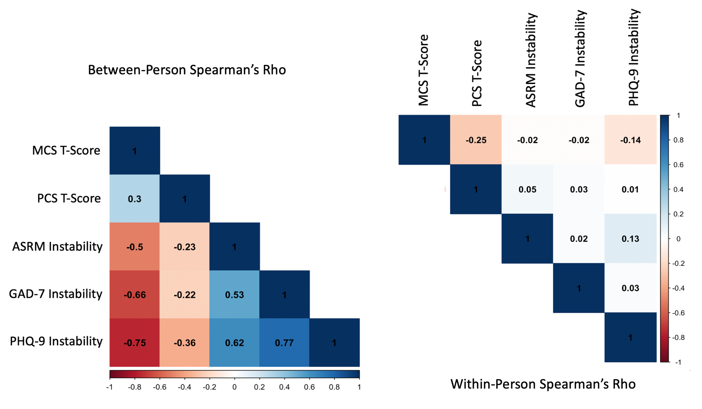

Note. Instability = The raw 12-month rolling variance score for each mood measure respectively.

