Supplemental Material: A pan cancer agent for solid tumor screening, resection, and wound monitoring via SWIR and NIR fluorescence imaging

Authors: Benedict Edward Mc Larney^{1,*}, Ali Sonay^{1,#}, Elana Apfelbaum^{1,2,#}, Nermin Mostafa¹, Sébastien Monette³, Dana Goerzen^{1,4}, Nicole Aguirre⁵, Elizabeth Isaac^{1,2}, Ngan Bao Phung^{1,2}, Magdalena Skubal¹, Mijin Kim¹, Anuja Ogirala¹, Darren Veach^{6,7}, Daniel A. Heller^{1,2}, Jan Grimm^{1,2,6,7,8,*}

Affiliations:

¹Molecular Pharmacology Program, Memorial Sloan Kettering Cancer Center; New York, NY, USA
²Pharmacology Program, Weill Cornell Medical College, New York, NY, USA
³Laboratory of Comparative Pathology, Memorial Sloan Kettering Cancer Center, Weill Cornell Medicine, and The Rockefeller University, New York, NY, USA
⁴Department of Physiology, Biophysics, and Systems Biology, Weill Cornell Medicine, Cornell University, New York, NY, USA
⁵Colorectal Service, Department of Surgery, Memorial Sloan Kettering Cancer Center; New York, NY, USA
⁶Department of Radiology, Memorial Sloan Kettering Cancer Center; New York, NY, USA
⁷Department of Radiology, Weill Cornell Medical Center; New York, NY, USA
⁸Molecular Imaging Therapy Service, Memorial Sloan Kettering Cancer Center; New York, NY, USA

#Equal contribution second author

*Corresponding Authors: Benedict Edward Mc Larney (mclarneb@mskcc.org) & Jan Grimm (grimmj@mskcc.org)

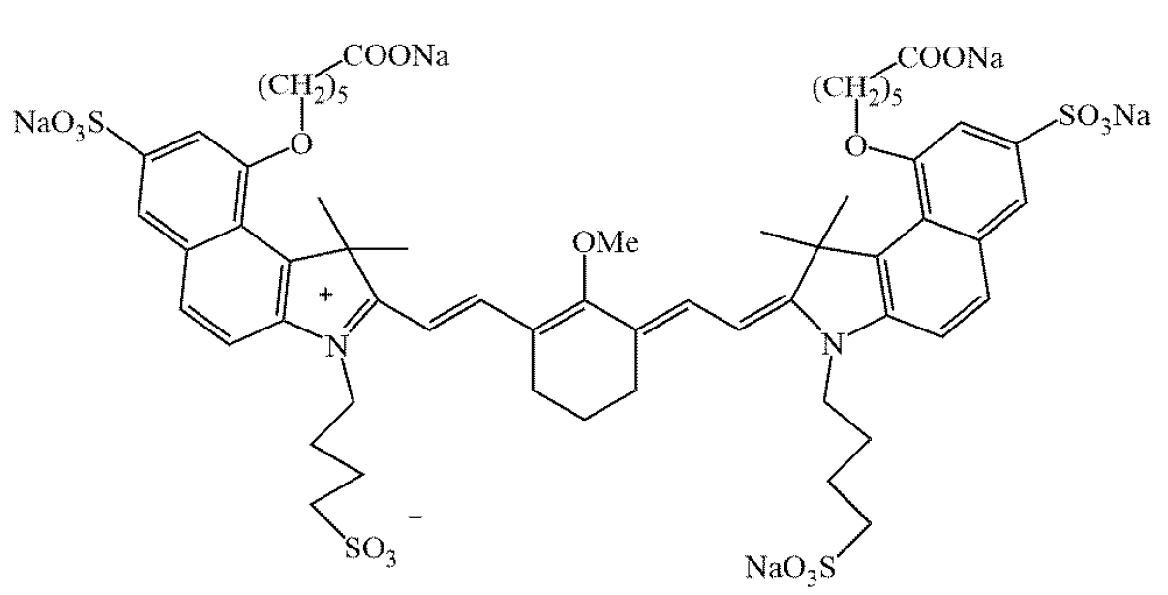
Supplemental Figure 1. Chemical structure of CJ215. The chemical structure of CJ215, patent filed by Proimaging.¹
Supplemental Figure 2. Effect of pH on CJ215 absorption in dextrose and fetal bovine serum (FBS). The absorption profile of CJ215 was assessed in fetal bovine serum (FBS) and dextrose adjusted to a pH of 4, 6, 7.4, 8 and 10 and tested at 0, 30, 60 and 150 minutes after CJ215 addition, incubated at 37°C and at 300 RPM. Each profile has been corrected by subtracting a respective blank vehicle solution and then normalized to the 0 min timepoint. In all cases CJ215 degrades in dextrose, especially at a pH of 4. When dissolved in FBS little to no degradation is seen. Absorption profiles were acquired at 10nm resolution. Each trace represents the average of n=3 technical replicates corrected by subtraction of a dye free reference from n=1 experiment.

Supplemental Figure 3. CJ215 stability in Dextrose, HSA and FBS at a pH of 7.4 at 37°C. Left, absorption profile of CJ215 (in optical density, O.D.) from 0 minutes to 96h incubated in Dextrose, HSA and FBS at 37°C at 300 rpm. Note FBS assessment at 96h was not feasible due to degradation of FBS itself. The absorption profile does not diminish dramatically in HAS or FBS remains. Right, respectively normalized absorption profiles of CJ215, highlighting the peak absorption wavelength. A clear 10nm red shift is seen in HSA (805nm) followed by a slow blue shift and peak smearing back to 795nm. A larger red shift is seen in FBS to 810nm, with a similar blue shift. CJ215 is highly stable in sera over time. Absorption profiles were acquired at 5nm resolution. Each trace represents the average of n=3 technical replicates corrected by subtraction of a dye free reference from n=1 experiment.

Supplemental Figure 4. CJ215 stability in dextrose, diluted blood (100:1 in PBS, defibrinated sheep’s blood) and pure blood (also defibrinated sheep’s blood). A) Representative absorption profiles of diluted blood (100:1 in PBS) and diluted blood with CJ215 (both defibrinated sheep’s blood, in optical density, O.D.). Measurement of pure blood was not possible due to the high O.D. B) Fluorescent emission profiles of CJ215 in dextrose, diluted and pure blood from 780 to 840 nm, under 740 nm excitation from 0.5 hrs to 72 hrs in solution. There is a red shift of 25nm from 813 to 838 nm when CJ215 is dissolved in blood, with fluorescence emission remaining stable up to 72 hrs unlike dextrose where a clear decay is seen. C) SWIR emission profile of CJ215 from 950 to 1550 nm under 808 nm excitation, in all 3 solutions at 24h post addition. D) SWIR emission profile of CJ215 from 1100 to 1500 nm. E) Absorption profiles of CJ215 from 0.5 to 72 hrs in solution. At 72 hrs the diluted blood solution begins to degrade, artificially increasing the O.D. F) Respectively normalized absorption profiles of CJ215 in dextrose or diluted blood, highlighting a slow red shift to 818nm followed by a blue shift to 814 nm. No similar shift is seen in dextrose. The ~25nm red shift of CJ215 in dextrose to blood is similar in both absorption and emission profile peaks. Absorption and fluorescence profiles were acquired at 2nm resolution. Each trace represents the average of n=3 technical replicates corrected by subtraction of a dye free reference from n=1 experiment.

Supplemental Figure 5. Extended emission assessment of CJ215. Left, SWIRFI images of a OD 1 solution of CJ215 in a multiwell plate from 900 (open, spectral response of sensor) to 1300 nm at 100 nm cutoffs using appropriate long pass filters without and with 5 mm of scattering tissue (chicken breast). Right, full width at half maximum (FWHM) quantification of CJ215 through tissue. Each trace represents the average of the horizontal and vertical profiles as indicated.

Supplemental Figure 6. Indocyanine green (ICG) uptake in HT1080 cells under induced apoptotic conditions. Comparison of non-treated (Cntrl), staurosporine treated (Sta, apoptosis), and Sta with zVad (reduced apoptosis) treated cells. No significant difference was determined between any group based upon Brown-Forsythe and Welch ANOVA tests without matching or pairing with Dunnet T3.

Supplemental Figure 7. Cellular (4T1 cells) uptake of CJ215 in the presence of serum (FBS). A) Representative image of a 6 well plate containing 4T1 cells in serum free media (top) for 3 hrs prior to 3hrs of incubation with CJ215 showing increased CJ215 brightness compared to cells in the presence of serum (bottom). Dotted lines highlight well boundaries. B) Quantification of CJ215 brightness where uptake is reduced by 54.3% in the presence of serum, highlighting the binding of CJ215 to serum components and the potential in vivo tumor delivery mechanism. Data was collected from n=2 experiments, comprising n=3 six well plates. Each plate consisted of n=3 serum free and n=3 serum containing incubations for n=9 technical replicates (dots). Data was normalized by dividing by the average of the serum free (brightest) wells for respective plates. Statistical significance (p value) is shown based on a Welch’s corrected t-test, unpaired, parametric.

Supplemental Figure 8. Stability of CJ215 in PFA over time. A) Images of CJ215 uptake in serum free media at 1, 24 and 216h post fixation. Cells were stored at 4C in 4% PFA and imaged at 1, 24 and 216 h post fixation. Images are presented with the same thresholding. B) Quantification of the fluorescence intensity (stability) of CJ215 over time. The mean (dot) and SD are shown from n=3 wells for each condition from n=1 experiment. Note, 1h images and data are the same as those shown in Supplemental Figure 6.

Supplemental Figure 9. SWIRFI of CJ215 uptake in 4T1 (breast) tumors. A) SWIR white light (940 nm reflection image) and SWIRFI images (>900 nm) from all CJ215 injected female FoxN1^{nu} mice bearing orthotopic mammary pad 4T1 (breast) tumors at all tested timepoints. B) CJ215 tumor fluorescence intensity of at all timepoints (1 ms exposure time). C) Signal to noise ratio (SNR) quantification of all tumors, acceptable 5 dB threshold is highlighted (gray dotted line). D) CNR quantification of all tumors from 24 hrs post injection to screening end point, acceptable 3 dB threshold is highlighted (Rose criterion, gray dotted line). For B), the mean (red dot) and standard deviation (SD) are shown based upon all mice and for C) and D) the mean (solid black bar), SD and each individual replicate are shown (red dots, n=4 mice).

Supplemental Figure 10. SWIRFI of CJ215 uptake in PC3-PSMA (prostate) tumors. A) SWIR white light (940 nm reflection image) and SWIRFI images (>900 nm) from all CJ215 injected male SCID mice bearing heterotopic subcutaneous prostate tumors at all tested timepoints. B) CJ215 tumor fluorescence intensity of at all timepoints (1 ms exposure time). C) Signal to noise ratio (SNR) quantification of all tumors, acceptable 5 dB threshold is highlighted (gray dotted line). D) CNR quantification of all tumors from 24 hrs post injection to screening end point, acceptable 3 dB threshold is highlighted (gray dotted line). For B), the mean (red dot) and standard deviation (SD) are shown based upon all mice and for C) and D) the mean (solid black bar), SD and each individual replicate are shown (red dots, n=4 mice).

Supplemental Figure 11. SWIRFI of CJ215 uptake in HT1080 (fibrosarcoma) tumors. A) SWIR white light (940 nm reflection image) and SWIRFI images (>900 nm) from all CJ215 injected female FoxN1^{nu} mice bearing orthotopic subcutaneous fibrosarcoma tumors at all tested timepoints. In M1 and M4 highly fluorescent tail regions due to sub-optimal intravenous injections have been cropped to improve contrast at the tumor sites. B) CJ215 tumor fluorescence intensity of at all timepoints (1 ms exposure time). C) Signal to noise ratio (SNR) quantification of all tumors, acceptable 5 dB threshold is highlighted (gray dotted line). D) CNR quantification of all tumors from 24 hrs post injection to screening end point, acceptable 3 dB threshold is highlighted (gray dotted line). For B), the mean (black dot) and standard deviation (SD) are shown based upon all mice and for C) and D) the mean (solid black bar), SD and each individual replicate are shown (black dots, n=4 mice).

Supplemental Figure 12. SWIRFI of CJ215 uptake in CT26 (colon) tumors. A) SWIR white light (940 nm reflection image) and SWIRFI images (>900 nm) from all CJ215 injected female BALB/c mice bearing heterotopic subcutaneous colon tumors at all tested timepoints. B) CJ215 tumor fluorescence intensity of at all timepoints (2 ms exposure time). C) Signal to noise ratio (SNR) quantification of all tumors, acceptable 5 dB threshold is highlighted (gray dotted line). D) CNR quantification of all tumors from 24 hrs post injection to screening end point, acceptable 3 dB threshold is highlighted (gray dotted line). For B), the mean (black dot) and standard deviation (SD) are shown based upon all mice and for C) and D) the mean (solid black bar), SD and each individual replicate are shown (black dots, n=4 mice).
Supplemental Figure 13. SWIRFI resection confirmation of 4T1 (breast) tumors. A) Representative SWIRFI images at >900 (spectral response of sensor). For M2 (top row) the process of confirming complete tumor resection is shown where solid arrows highlight the first identified tumor; dotted arrows highlight the second identified lesion. B) SNR of all resected lesions. C) CNR of all resected lesions based upon the tumor bed. In all cases sufficient SNR and CNR thresholds are shown along with the mean (center bar) and SD, and each replicate representing n=5 lesions from n=4 mice (red dots).

Supplemental Figure 14. SWIRFI resection confirmation of PC3-PSMA (prostate) tumors. A) Representative SWIRFI images at >900 (spectral response of sensor). For M1 (top row) and M3 (bottom row) the process of confirming complete tumor resection is shown where solid arrows highlight the first identified tumor; dotted arrows highlight the second identified lesion. B) SNR of all resected lesions. C) CNR of all resected lesions based upon the tumor bed. In all cases sufficient SNR and CNR thresholds are shown along with the mean (center bar) and SD, and each replicate representing n=6 lesions from n=4 mice (red dots).

Supplemental Figure 15. SWIRFI resection confirmation of HT1080 (fibrosarcoma) tumors. A) Representative SWIRFI images at >900 (spectral response of sensor, gray dotted circle represents cropping applied in post processing for easier comparison to long pass filter-based images). For M1 (top row) and M3 (bottom row) the process of confirming complete tumor resection is shown where solid arrows highlight the first identified tumor; dotted highlight the tumor bed (free of fluorescence). B) SNR of all resected lesions. C) CNR of all resected lesions based upon the tumor bed. In all cases sufficient SNR and CNR thresholds are shown along with the mean (center bar) and SD, and each replicate representing n=4 lesions from n=4 mice (black dots).
Supplemental Figure 16. SWIRFI resection confirmation of CT26 (colon) tumors. A) Representative SWIRFI images at >1300 (gray dotted circle represents cropping applied in post processing due to filter cropping the FOV). For M3 (top, bottom row) and M4 (bottom row) the process of confirming complete tumor resection is shown where solid arrows highlight the first identified tumor; dotted arrows highlight the second identified lesion.

Supplemental Figure 17. SWIRFI extended emission assessment of CJ215 uptake in both HT1080 (fibrosarcoma) and CT26 (colon) tumors. A) Representative SWIRFI images at >900 (spectral response of sensor), >1100 and >1300 nm at 1 and 168 hrs post injection of CJ215 tumor uptake. The mice are the same as those used in Supplemental Figures 5 & 6. Filter cropping (dotted gray circle) reduces the field of view and is shown. For CT26 mice at 168hrs, tail uptake was cropped to improve tumor contrast. B) Top, SNR and CNR quantification of HT1080 CJ215 uptake at all timepoints and with all utilized filters. Middle, SNR and CNR quantification of CT26 CJ215 uptake at all timepoints and with all utilized filters. CJ215 tumor fluorescence intensity of at all timepoints (2 ms exposure time). Bottom, combined SNR and CNR assessment of all tumor lines. In this case sufficient SNR was achieved at all timepoints and with all filters however, >1300 nm did perform the worst. The same can be said for CNR assessment with no major advantage found with extended emission, especially considering the loss of video rate acquisition at >1100 and >1300 nm. In all cases sufficient SNR and CNR thresholds are shown along with the mean (center point) and SD, representing n=4 mice for each respective tumor line and n=8 mice for combined data.

Supplemental Figure 18. NIRFI necropsy based biodistribution of CJ215 in 4T1 bearing mice. A) NIRFI (IVIS, 745nm excitation, 840nm emission) images of all organs (tumor, liver kidney, heart, lung, brain, spleen, pancreas, bone, stomach, small intestine (int.), large int., skin, and muscle) from all mice. M5 did bear a tumor but received no injection of CJ215. The red arrow highlights remnant kidney fluorescence due to the expected renal clearance of CJ215. B) Quantification of all injected mouse organs where the mean (gray bar), SD (black lines) and each replicate are shown (red dots) with corresponding select tumor:organ ratios based on the average from all organs (n=5 lesions from n=4 mice).

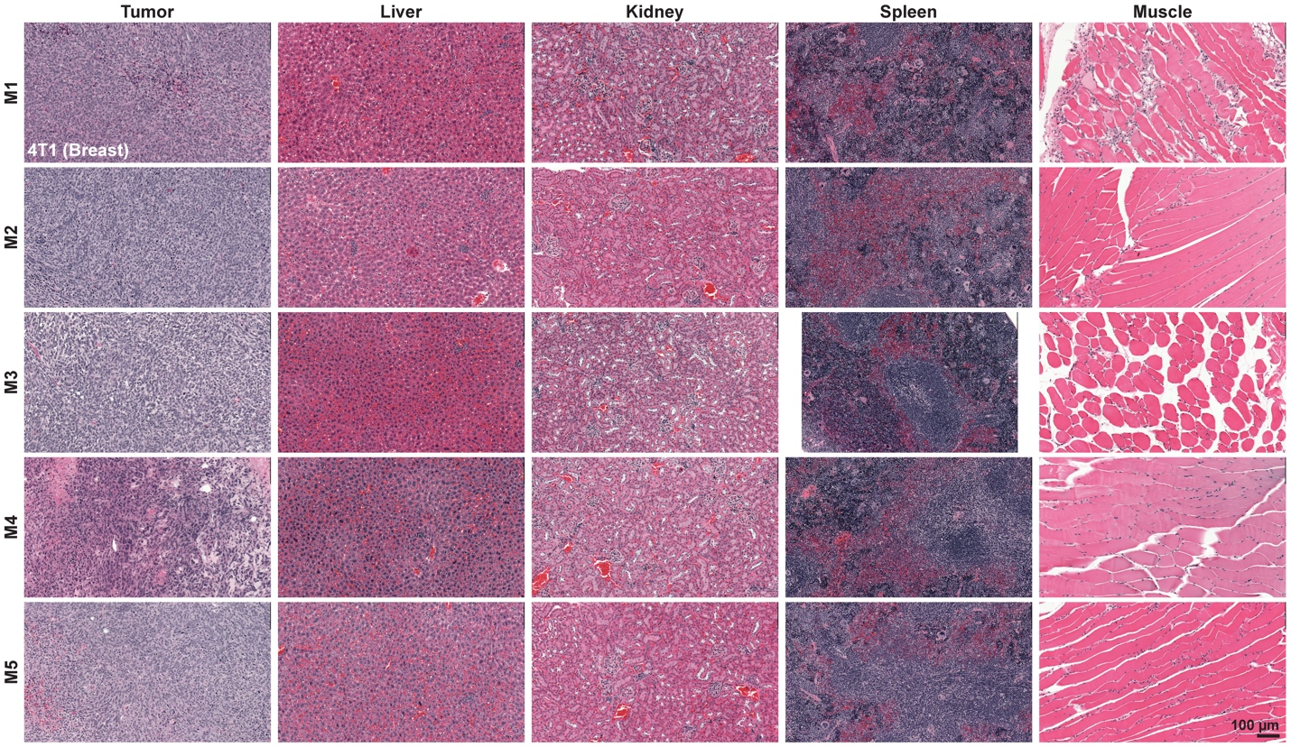
Supplemental Figure 19. Histology of select organs from all 4T1 (breast) tumor bearing mice. H&E staining is shown confirming tumor as identified with normal liver, kidney, spleen, and muscle tissue. Note, the second lesion identified during resection of M2 was unfortunately lost during processing and so could not be confirmed as tumor. Images are at 20x magnification.

Supplemental Figure 20. NIRFI necropsy based biodistribution of CJ215 in PC3-PSMA (prostate) tumor bearing mice. A) NIRFI (IVIS, 745nm excitation, 840nm emission) images of all organs (tumor, liver kidney, heart, lung, brain, spleen, pancreas, bone, stomach, small intestine (int.), large int., skin, and muscle) from all mice. The white arrow highlights the kidney, which in this line has minimal residual fluorescence. M5 received no injection of CJ215. B) Quantification of all injected mouse organs where the mean (gray bar), SD (black lines) and each replicate are shown (red dots) with corresponding select tumor:organ ratios based on the average from all organs (n=6 lesions from n=4 mice).

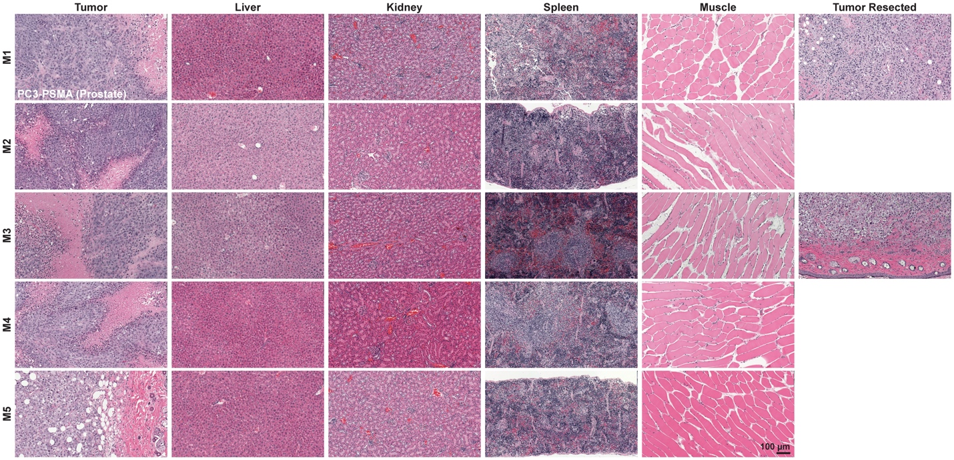
Supplemental Figure 21. Histology of select organs from all PC3-PSMA (prostate) tumor bearing mice. H&E staining is shown confirming tumor as identified with normal liver, kidney, spleen, and muscle tissue. Remnant lesions identified during resection of M1 and M3 were confirmed to be tumorous. Images are at 20x magnification.

Supplemental Figure 22. NIRFI necropsy based biodistribution of CJ215 in HT1080 (fibrosarcoma) tumor bearing mice. A) NIRFI (IVIS, 745nm excitation, 840nm emission) images of all organs (tumor, liver kidney, heart, lung, brain, spleen, pancreas, bone, stomach, small intestine (int.), large int., skin, and muscle) from all mice. The black arrow highlights the kidney, which in this line has high residual fluorescence. Note the high skin fluorescence is likely due to lymph node uptake in the skin due to slightly less successful tail vein injections. B) Quantification of all injected mouse organs where the mean (gray bar), SD (black lines) and each replicate are shown (red dots) with corresponding select tumor:organ ratios based on the average from all organs (n=4 lesions from n=4 mice).

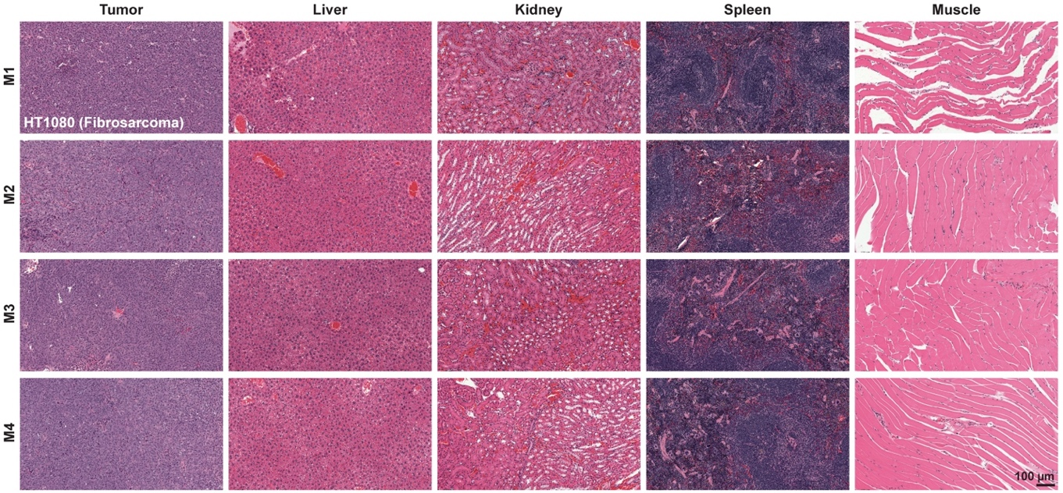
Supplemental Figure 23. Histology of select organs from all HT1080 (fibrosarcoma) tumor bearing mice. H&E staining is shown confirming tumor as identified with normal liver, kidney, spleen, and muscle tissue. Images are at 20x magnification.
Supplemental Figure 24. NIRFI necropsy based biodistribution of CJ215 in CT26 (colon) tumor bearing mice. A) NIRFI (IVIS, 745nm excitation, 840nm emission) images of all organs (tumor, liver kidney, heart, lung, brain, spleen, pancreas, bone, stomach, small intestine (int.), large int., skin, and muscle) from all mice. The black arrow highlights the kidney, which in this line has high residual fluorescence. Note the high skin fluorescence is likely due to lymph node uptake in the skin due to slightly less successful tail vein injections. B) Further quantification of regions identified during resection (M3) and necropsy (M4). Bottom, regions of interest versus tumor muscle ratios. C) Quantification of all injected mouse organs where the mean (gray bar), SD (black lines) and each replicate are shown (red dots) with corresponding select tumor:organ ratios based on the average from all organs (n=4 lesions from n=4 mice).

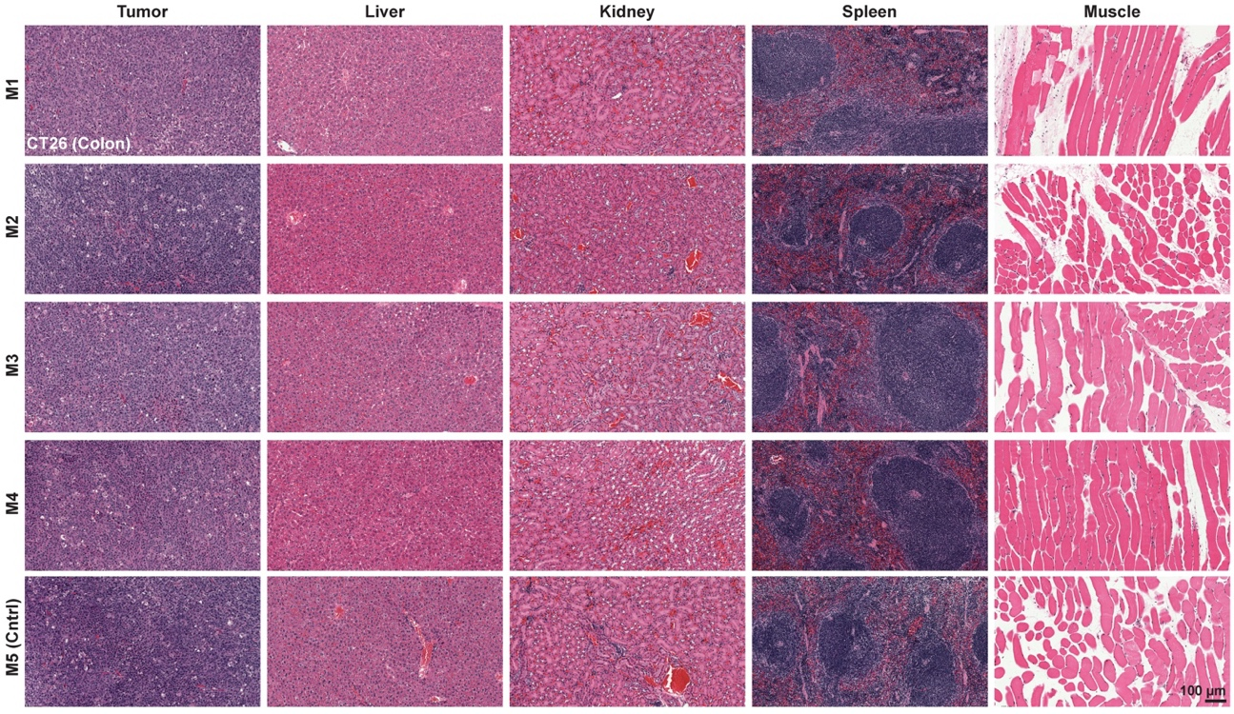
Supplemental Figure 25. Histology of select organs from all CT26 (colon) tumor bearing mice. H&E staining is shown confirming tumor as identified with normal liver, kidney, spleen, and muscle tissue. Images are at 20x magnification.
Supplemental Figure 26. Cleaved Caspase-3 (CC3) immunohistochemistry of primary CT26 tumors. CC3 staining confirmed the highly apoptotic core of all investigated tumors (M5, control mouse, received no injection of CJ215). Images are shown at various magnifications to highlight the entire tumor and core regions.
Supplemental Figure 27. SWIRFI of CJ215 uptake in SW1222 (intraperitoneal colorectal) tumors (>1300nm). A) SWIR white light (940 nm reflection image) and SWIRFI images (>900 nm) from all CJ215 injected female FoxN1^{nu} mice bearing orthotopic disseminated intraperitoneal colorectal tumors at all tested timepoints. Due to the improved delineation at 1300nm through tissue, data from this cutoff is shown but tumors could not be conclusively identified. However, in M3 a lesion was growing just subcutaneously which did show uptake. Quantification has not been performed due to insufficient number of identified tumors. Lesion uptake seen in M4 at the surface was found to be minor skin wounds.

Supplemental Figure 28. CJ215 assessment in a colorectal peritoneal carcinomatosis model (SW1222). A) Necropsy based biodistribution of CJ215 in the SW122 model. Tumor uptake of the dye is present in small tumors from various locations within the peritoneum but appears highly stochastic. The red arrow highlights splenic tumors found in all mice. B) Quantification of dye distribution in the SW1222 model. Tumor to organ ratios are provided with CJ215 highlighting its renal clearance.

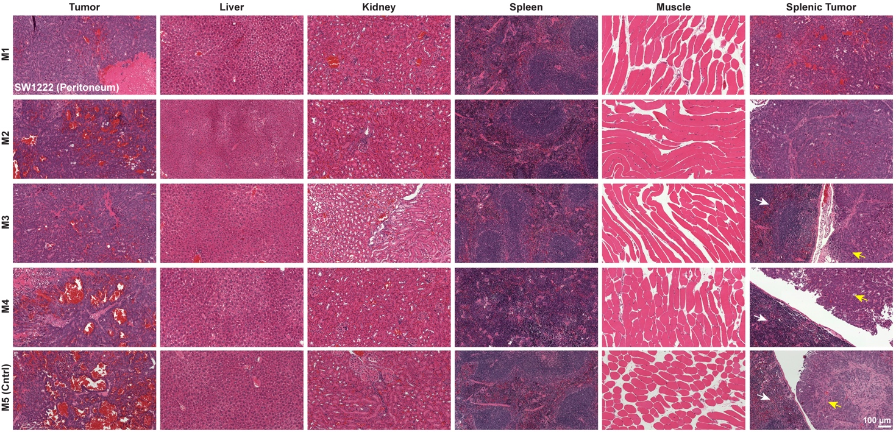
Supplemental Figure 29. Histology of select organs from all SW1222 (intraperitoneal) tumor bearing mice. H&E staining is shown confirming tumor as identified, with highly necrotic areas along with disrupted blood vessels, with normal liver, kidney, spleen, and muscle tissue. Also shown are lesions identified in proximity to the spleen (splenic tumor). Where possible the spleen (white arrow) and adjacent tumor are shown (yellow arrow). Splenic bound tumors also comprised some pancreatic tissue and appeared less necrotic than primarily identified tumors. Images are at 20x magnification.

Supplemental Figure 30. Tumor and wound monitoring in CT26 (colon) tumor bearing mice. A) Visible light image of M2 from CT26 tumor bearing group, post hair depilation (trimmer and depletion cream). Wound site and tumor sites are highlighted. B) Visible light image of M4 from CT26 tumor bearing group, post hair depilation (trimmer and depletion cream). Images are shown at 24 and 96 hrs post hair depilation and CJ215 injection. Wound site and tumor sites are highlighted with image thresholds adjusted to highlight both the wound and tumor. At 96hrs the tumor is the dominant signal for nearly all sites.

Supplemental Figure 31. Assessment of SWIRFI to detect CJ215 through commercially available bandages. A) In all cases the visible light image of the phantom (comprised of a transparent, hydrogel, liquid spray (dried on saran wrap) or hydrocolloid bandage placed over a multi well plate), SWIR WL (940 nm reflection image), >900 (spectral response of sensor), >1100, and >1300 nm images without and with bandages. The red arrow highlights the respective well containing 100µL of CJ215 in dextrose. B) Quantification of the SWIRFI intensity loss when imaging through various bandages is shown for each wavelength cut off. C) Quantification of the SNR change (in dB) when imaging through a bandage. The slight increase in SNR seen at 1100 nm is attributed to the slightly increased water absorption, with respective bandages providing a homogenous imaging site reducing SD and thus improving SNR. For B) and C) values are shown for n=5 technical replicates (consecutive frames) from n = 1 imaging experiment per bandage.

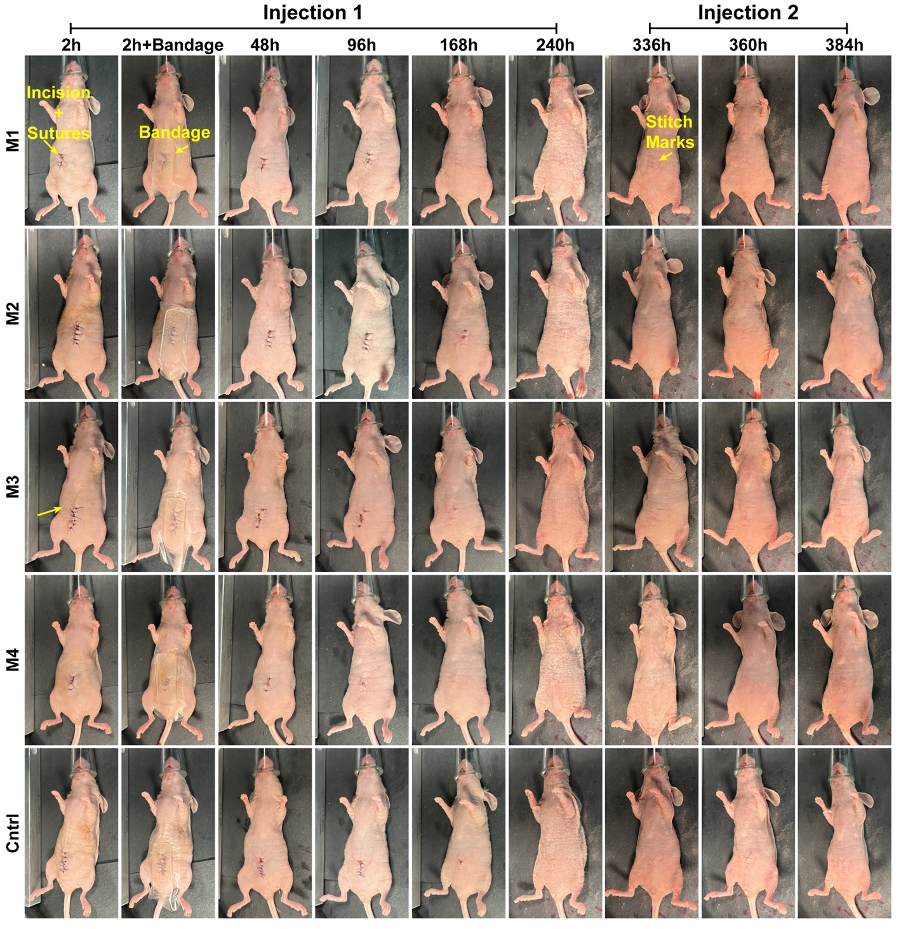
Supplemental Figure 32. Visible light images from all wound healing mice. Images are shown without the hydrogel bandage at all timepoints from all mice, and with the hydrogel bandage utilized at 2 and 168 h post injection. At 336 hrs post-surgery when mice had fully healed, they received a second injection of CJ215, and were again imaged from 1-48 hrs post injection. The control mouse (Cntrl) received no injection of CJ215 and healed similarly to injected mice. Absorbable sutures were used in all cases. At 72hrs post-surgery mice were changed from a Sulfatrim food diet to a low auto-fluorescence one to mitigate peritoneal signals, mice proceeded to develop a mild skin infection (visible at 240 hrs) and were then administered Sulfatrim via their water bottle along with low autofluorescence food. Skin infection was resolved by the 336hr timepoint.

Supplemental Figure 33. SWIRFI (>900nm) images of all CJ215 injected wound healing mice. A) Visible light images are shown from all mice, including corresponding SWIR WL (940 nm reflection image) at 2 hr post-surgery and injection of CJ215 without and with hydrogel bandage application. B) Wound healing monitoring of from 48 to 240 hrs post-surgery and first injection of CJ215. Longer exposure times were utilized from 96 to 240 hrs to ensure sufficient signal detection. C) SWIRFI of the same mice 336 hrs post-surgery (fully healed) and from 1 to 48 hrs post second injection of CJ215. No delineating signal could be determined from the wound area, with signal from the intestines being the prominent signal.

Supplemental Figure 34. SWIRFI (>1100nm) images of all CJ215 injected wound healing mice. A) Visible light images are shown from all mice, including corresponding SWIR WL (940 nm reflection image) at 2 hr post-surgery and injection of CJ215 without and with hydrogel bandage application. B) Wound healing monitoring of from 48 to 240 hrs post-surgery and first injection of CJ215. Longer exposure times were utilized from 96 to 240 hrs to ensure sufficient signal detection. C) SWIRFI of the same mice 336 hrs post-surgery (fully healed) and from 1 to 48 hrs post second injection of CJ215. No delineating signal could be determined from the wound area, with signal from the intestines being the prominent signal.

Supplemental Figure 35. SWIRFI (>1300nm) images of all CJ215 injected wound healing mice. A) Visible light images are shown from all mice, including corresponding SWIR WL (940 nm reflection image) at 2 hr post-surgery and injection of CJ215 without and with hydrogel bandage application. B) Wound healing monitoring of from 48 to 240 hrs post-surgery and first injection of CJ215. Longer exposure times were utilized from 96 to 240 hrs to ensure sufficient signal detection. C) SWIRFI of the same mice 336 hrs post-surgery (fully healed) and from 1 to 48 hrs post second injection of CJ215. No delineating signal could be determined from the wound area, with signal from the intestines being the prominent signal.

Supplemental Figure 36. NIRFI necropsy based biodistribution of CJ215 in wound monitoring mice. A) NIRFI (IVIS, 745nm excitation, 840nm emission) images of all organs (wound area, liver kidney, heart, lung, brain, spleen, pancreas, bone, stomach, small intestine (int.), large int., skin, and muscle) from all mice. The arrow highlights the kidney, which again has high residual fluorescence as do the intestines as observed by SWIRFI images. C) Quantification of all injected mouse organs where the mean (gray bar), SD (black lines) and each replicate are shown (red dots). No significant difference could be determined between the wound site and non-affected skin, highlighting CJ215s selective uptake during wound healing. This data also represents the expected biodistribution of the dye in non-tumor bearing (healthy) mice with the biodistribution being in line with that seen at later timepoints.

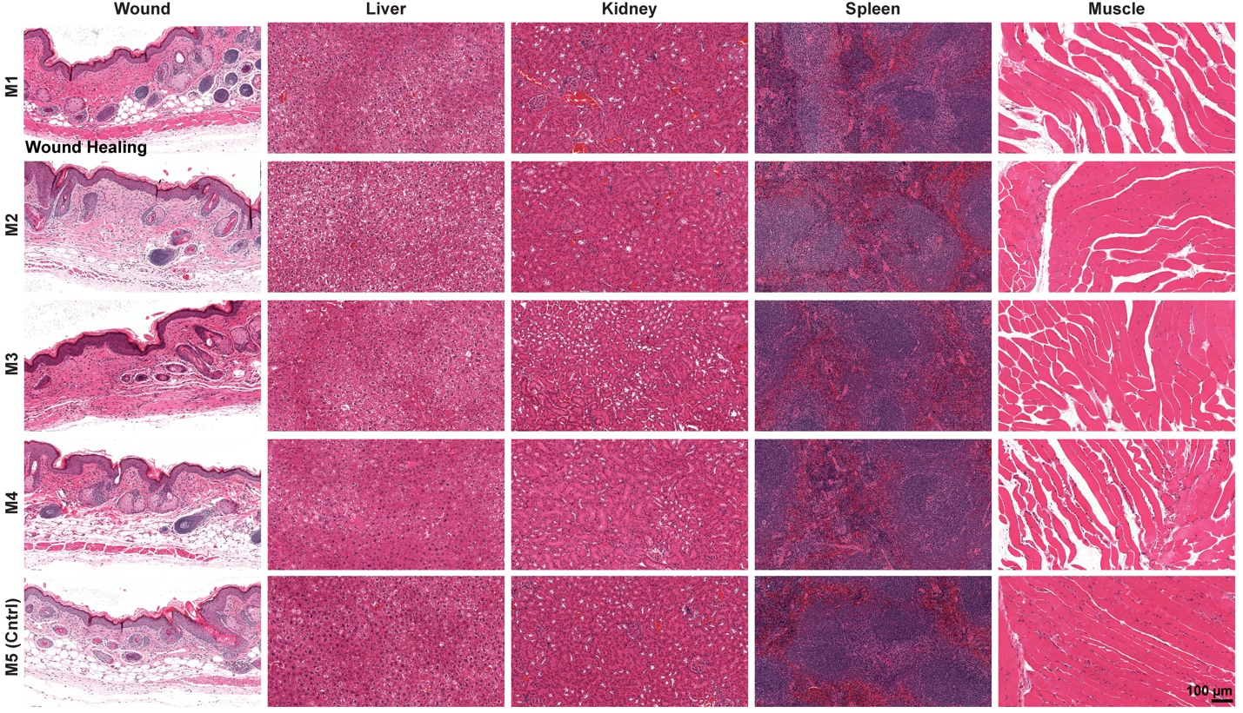
Supplemental Figure 37. Histology of select organs from all wound monitoring mice. H&E staining is shown confirming normal skin tissue at the wound site with normal liver, kidney, spleen, and muscle tissue. Images are at 20x magnification.

References:
1 Tran-Guyon, J., Guyon, V. & Scherninski, F. (Google Patents, 2023).

