Supplementary Appendix:

Contents
Appendix S1: Search Strategy 1
Appendix S2: PRISMA Flow chart 3
Appendix S3: Cochrane Risk of Bias assessment for all trials. 4
Appendix S4: Protocol: 5
Appendix S5: Cardiovascular outcomes in GLP-1RA with inclusion of FREEDOMCVO in age subgroup of 75 years 7
Appendix S6: Meta-analysis results for 3P-MACE and all-cause mortality in subgroups of patients </ ≥65 years and </ ≥75 years for trials with DPP-4is 10
Appendix S7: Meta-analysis results for cardiovascular death, myocardial infarction & stroke in subgroups of patients </ ≥65 years and </ ≥75 years for trials with DPP-4is. 11

Appendix S1: Search Strategy
Date criteria: March 1, 2008 – August 31, 2022
In Pubmed for DPP4-inhibitors, GLP1-RA, SGLT2-inhibitors
- ("Cardiovascular Diseases"[Mesh] OR "Myocardial Infarction"[Mesh] OR "Stroke"[Mesh] OR "major cardiovascular event" OR MACE OR (cardiovascular AND (disease* OR event* OR fail* OR death OR mortality)) OR myocardial infarction OR stroke) AND ("Diabetes Mellitus, Type 2"[Mesh] OR type 2 diabetes) AND ("Dipeptidyl-Peptidase IV Inhibitors"[Mesh] OR Dipeptidyl-Peptidase IV Inhibitors [Pharmacological Action] OR "Linagliptin"[Mesh] OR "Vildagliptin"[Mesh] OR DPP4-inhibitor OR dipeptidyl peptidase-4 inhibitor OR saxagliptin OR alogliptin OR sitagliptin OR linagliptin OR vildagliptin)
- ("Cardiovascular Diseases"[Mesh] OR "Myocardial Infarction"[Mesh] OR "Stroke"[Mesh] OR "major cardiovascular event" OR MACE OR (cardiovascular AND (disease* OR event* OR fail* OR death OR mortality)) OR myocardial infarction OR stroke) AND ("Diabetes Mellitus, Type 2"[Mesh] OR type 2 diabetes) AND ("Glucagon-Like Peptide-1 Receptor"[Mesh] OR "Glucagon-Like Peptide 1"[Mesh] OR "Exenatide"[Mesh] OR glucagon-like peptide-1 receptor agonist* OR GLP1-RA OR lixisenatide OR exenatide OR liraglutide OR semaglutide OR albiglutide OR dulaglutide)
- ("Cardiovascular Diseases"[Mesh] OR "Myocardial Infarction"[Mesh] OR "Stroke"[Mesh] OR "major cardiovascular event" OR MACE OR (cardiovascular AND (disease* OR event* OR fail* OR death or mortality)) OR myocardial infarction OR stroke) AND ("Diabetes Mellitus, Type 2"[Mesh] OR type 2 diabetes) AND ("Sodium-Glucose Transporter 2 Inhibitors"[Mesh] OR "Canagliflozin"[Mesh] OR SGLT-2 OR SGLT-2 inhibitor* OR empagliflozin OR canagliflozin OR dapagliflozin OR ertugliflozin)

In Cochrane CENTRAL trials database for DPP4-inhibitors, GLP1-RA, SGLT2-inhibitors
- ("major cardiovascular event" OR MACE OR (cardiovascular AND (disease* OR event* OR fail* OR death OR mortality)) OR myocardial infarction OR stroke):ti,ab,kw AND ((dipeptidyl peptidase 4 inhibitor OR saxagliptin OR alogliptin OR sitagliptin OR linagliptin OR vildagliptin)):ti,ab,kw
- ("major cardiovascular event" OR MACE OR (cardiovascular AND (disease* OR event* OR fail* OR death OR mortality)) OR myocardial infarction OR stroke):ti,ab,kw AND (glucagon like peptide1 receptor agonist OR GLP1 R OR lixisenatide OR exenatide OR liraglutide OR semaglutide OR albiglutide OR dulaglutide OR sitagliptin):ti,ab,kw
- ("major cardiovascular event" OR MACE OR (cardiovascular AND (disease* OR event* OR fail* OR death OR mortality)) OR myocardial infarction OR stroke):ti,ab,kw AND (Sodium Glucose Transporter 2 Inhibitors OR SGLT 2 inhibitor* OR empagliflozin OR canagliflozin OR dapagliflozin OR ertugliflozin):ti,ab,kw

Appendix S2: PRISMA Flow chart
Records identified through database search of Pubmed | Records identified through database search of Cochrane
- DPP4-inhibitors (n=1422) | - DPP4-inhibitors (n=633)
- GLP1-RA (n=2131) | - GLP1-RA (n=992)
- SGLT2-inhibitors (n=2486)  - Total records (n=6039) | - SGLT2-inhibitors (n=1223)  - Total records (n=2848)
Not clinical trials (n=4796)
Duplicate records removed (n= 1317)

Studies screened (n=2774)

Abstracts did not fulfil the eligibility criteria (n=2182)

Full text articles assessed for eligibility (n= 592)
Full texts excluded
Not a subgroup of interest= 291
Not an outcome of interest= 181
Not an RCT= 47
Article in language other than English=16

57 studies included for qualitative and quantitative analysis from 19 randomized control trials
- 17 records for 5 trials in DPP4-inhibitors
- 21 records for 9 trials in GLP1-RA
- 19 records for 5 trials in SGLT2-inhibitors

Appendix S3: Cochrane Risk of Bias assessment for all trials.
Drug Class | Study | Random sequence generation (selection bias) | Allocation concealment (selection bias) | Blinding of participants and personnel (performance bias) | Blinding of outcome assessment (detection bias) | Incomplete outcome data (reporting bias) | Other bias
SGLT2-i | EMPA-REG | Low | Low | Low | Low | Low | Low
SGLT2-i | DECLARE-TIMI 58 | Low | Low | Low | Low | Low | Low
SGLT2-i | CANVAS | Low | Low | Low | Low | Low | Low
SGLT2-i | CREDENCE | Low | Low | Low | Low | Low | Low
SGLT2-i | VERTIS-CV | Low | Low | Low | Low | Low | Low
GLP1-RA | ELIXA | Low | Low | Low | Low | Low | Low
GLP1-RA | LEADER | Low | Low | Low | Low | Low | Low
GLP1-RA | SUSTAIN-6 | Low | Low | Low | Low | Low | Low
GLP1-RA | EXSCEL | Low | Low | Low | Low | Low | Low
GLP1-RA | HARMONY Outcomes | Low | Low | Low | Low | Low | Low
GLP1-RA | REWIND | Low | Low | Low | Low | Low | Low
GLP1-RA | PIONEER-6 | Low | Low | Low | Low | Low | Low
GLP1-RA | AMPLITUDE-O | Low | Low | Low | Low | Low | Low
GLP1-RA | FREEDOM-CVO | Low | Low | Low | Low | Low | Low
DPP4-i | EXAMINE | Low | Low | Low | Low | Low | Low
DPP4-i | SAVOR-TIMI-53 | Low | Low | Low | Low | Low | Low
DPP4-i | TECOS | Low | Low | Low | Low | Low | Low
DPP4-i | CARMELINA | Low | Low | Low | Low | Low | Low
DPP4-i | CAROLINA | Low | Low | Low | Low | Low | Low

Appendix S4: Protocol:
Title: Effects of new antidiabetic agents on cardiovascular outcomes in older adults: systemic review and meta-analysis
Search engines:
- PubMed,
- the Cochrane Database of Systematic Reviews, and
- ClinicalTrials.gov. (http://www.clinicaltrials.gov)
Date of publication: March 1, 2008 – August 31, 2022
Assess Risk of Bias: Cochrane risk-of-bias tool
Inclusion criteria:
- Randomised, controlled, event-driven, cardiovascular or kidney outcome trials versus active or placebo control.
- Participants aged > 18 years.
- Trials with at least 1000 participants.
- Published trials with newer anti-hyperglycemic drugs: like incretin-based therapies (Dipeptidyl peptidase-4 inhibitors and glucagon-like peptide-1 receptor agonists) and sodium/glucose cotransporter inhibitors.
- Studies with at least 12 months follow up.
- Studies reporting 3P-MACE/ 4P-MACE as an outcome.
- Studies with sub-group analysis by age.
Exclusion criteria:
- Studies which are not randomized controlled trials.
- Studies with less than 1000 patients
- Studies in pediatric population
- Studies with less than 12 months of follow-up.
- Studies which do not have sub-group analysis by age
- Studies completed before the Food and Drug Administration (FDA) guidance in 2008.
Assess Risk of Bias: Cochrane risk-of-bias tool
Search Terms:
- cardiovascular outcome trials, CVOTs, type 2 diabetes, randomized clinical trial, placebo, older adults, elderly
  - MACE or major adverse cardiovascular events,
  - cardiovascular death,
  - myocardial infarction,
  - stroke,
  - mortality
- Pharmacological classes:
  - DPP4-inhibitors, dipeptidyl peptidase-4 inhibitors, saxagliptin, alogliptin, sitagliptin, linagliptin, vildagliptin.
  - GLP1-RA, glucagon-like peptide-1 receptor agonists, lixisenatide, exenatide, liraglutide, semaglutide, albiglutide, dulaglutide, Efpeglenatide
  - SGLT- inhibitors, empagliflozin, canagliflozin, dapagliflozin, ertugliflozin, sotagliflozin

Appendix S5: Cardiovascular outcomes in GLP-1RA with inclusion of FREEDOMCVO in age subgroup of 75 years
Favors GLP-1RA
Favors Placebo
3P_MACE  Greater than/ = 75 years  Less than 75 years | 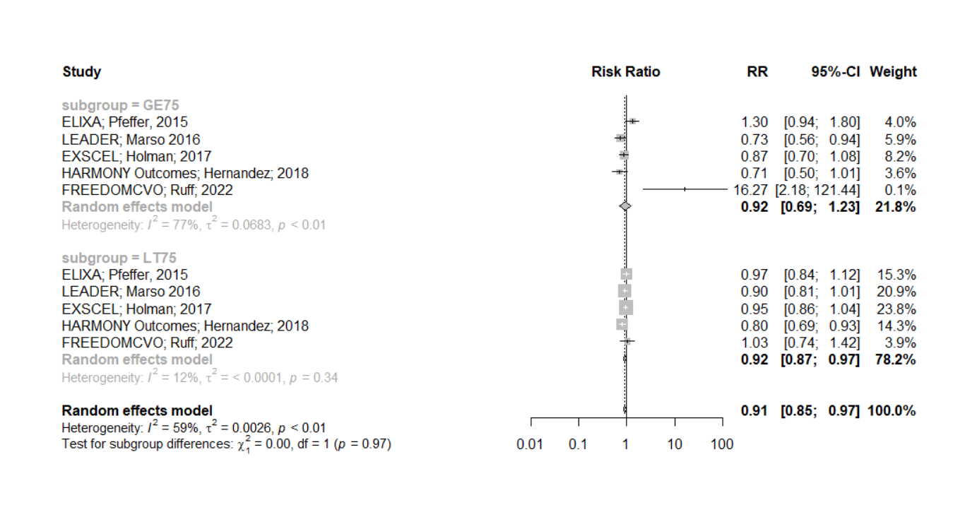
All-Cause mortality  Less than 75 years  Greater than / = 75 years | 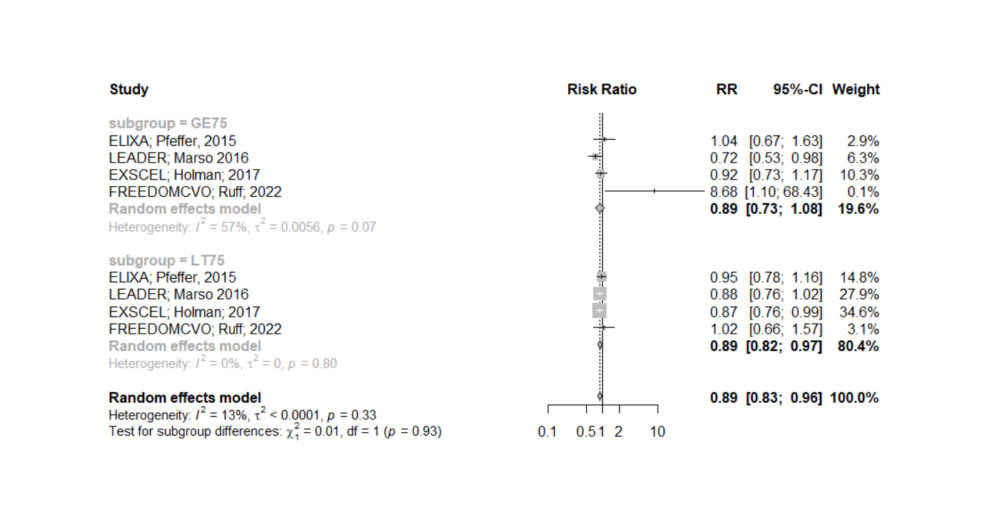
Cardiovascular  Death  Less than 75 years  Greater than /= 75 years | 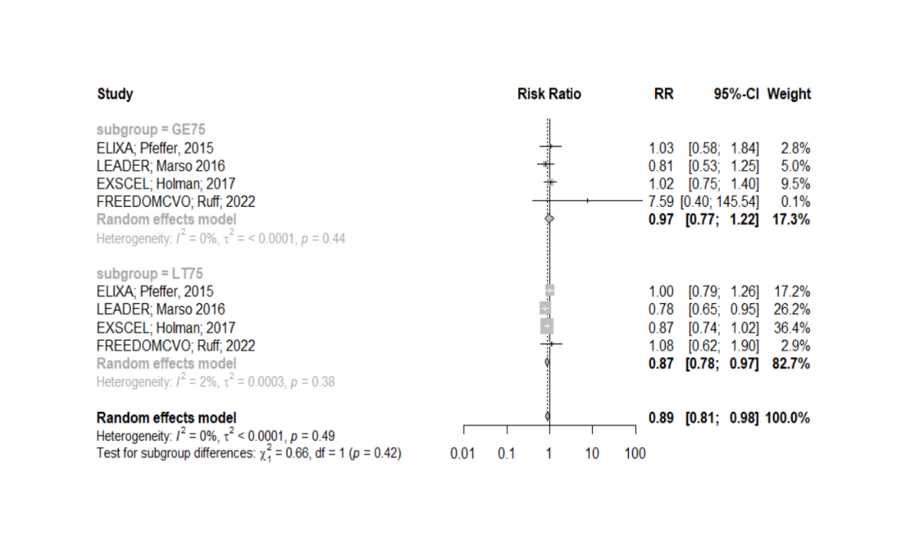
Myocardial  Infarction  Greater than /= 75 years  Less than 75 years | 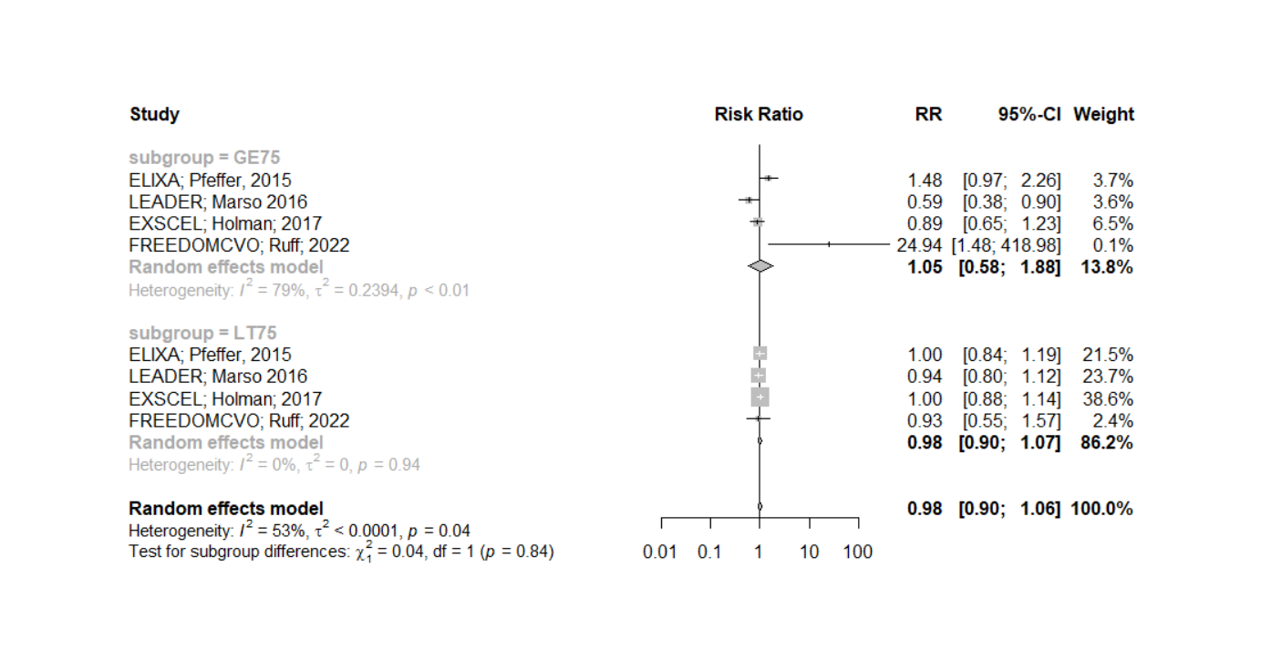  Favors GLP-1RA Favors Placebo
Stroke  Less than 75 years  Greater than /= 75 years | 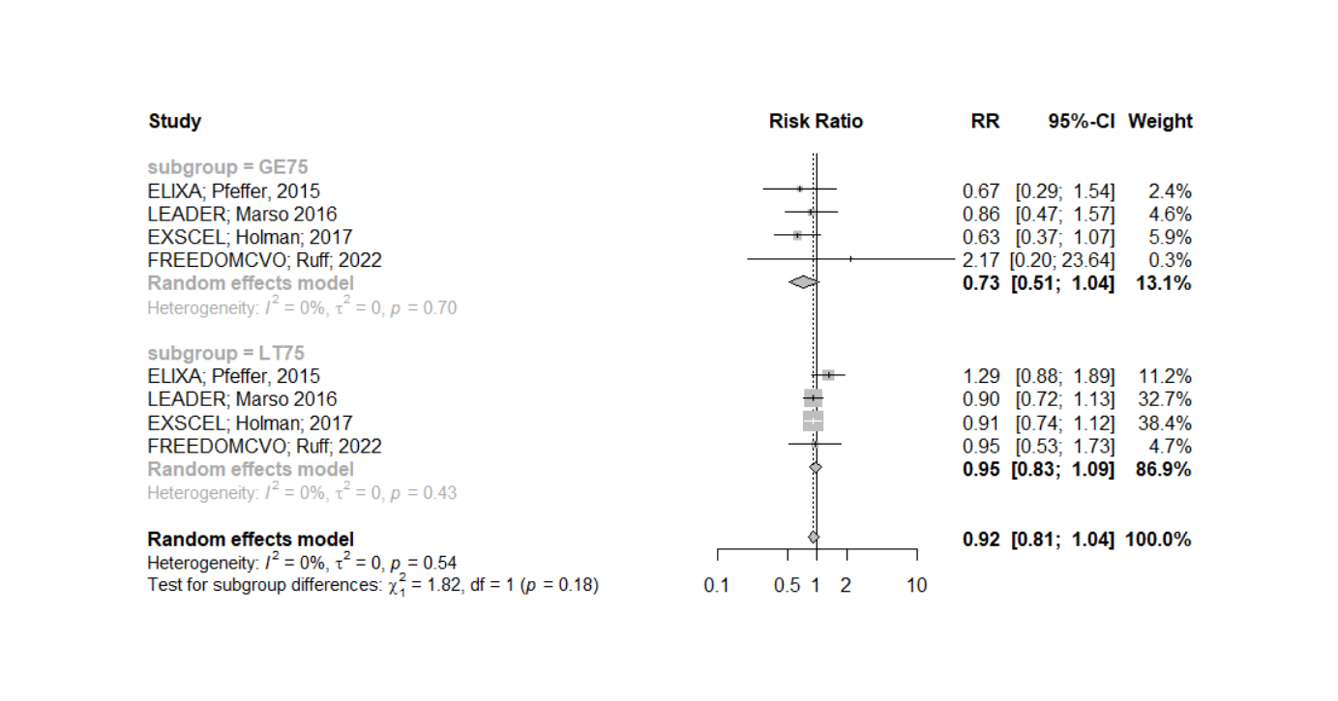
Favors GLP-1RA Favors Placebo

Appendix S6: Meta-analysis results for 3P-MACE and all-cause mortality in subgroups of patients </ ≥65 years and </ ≥75 years for trials with DPP-4is
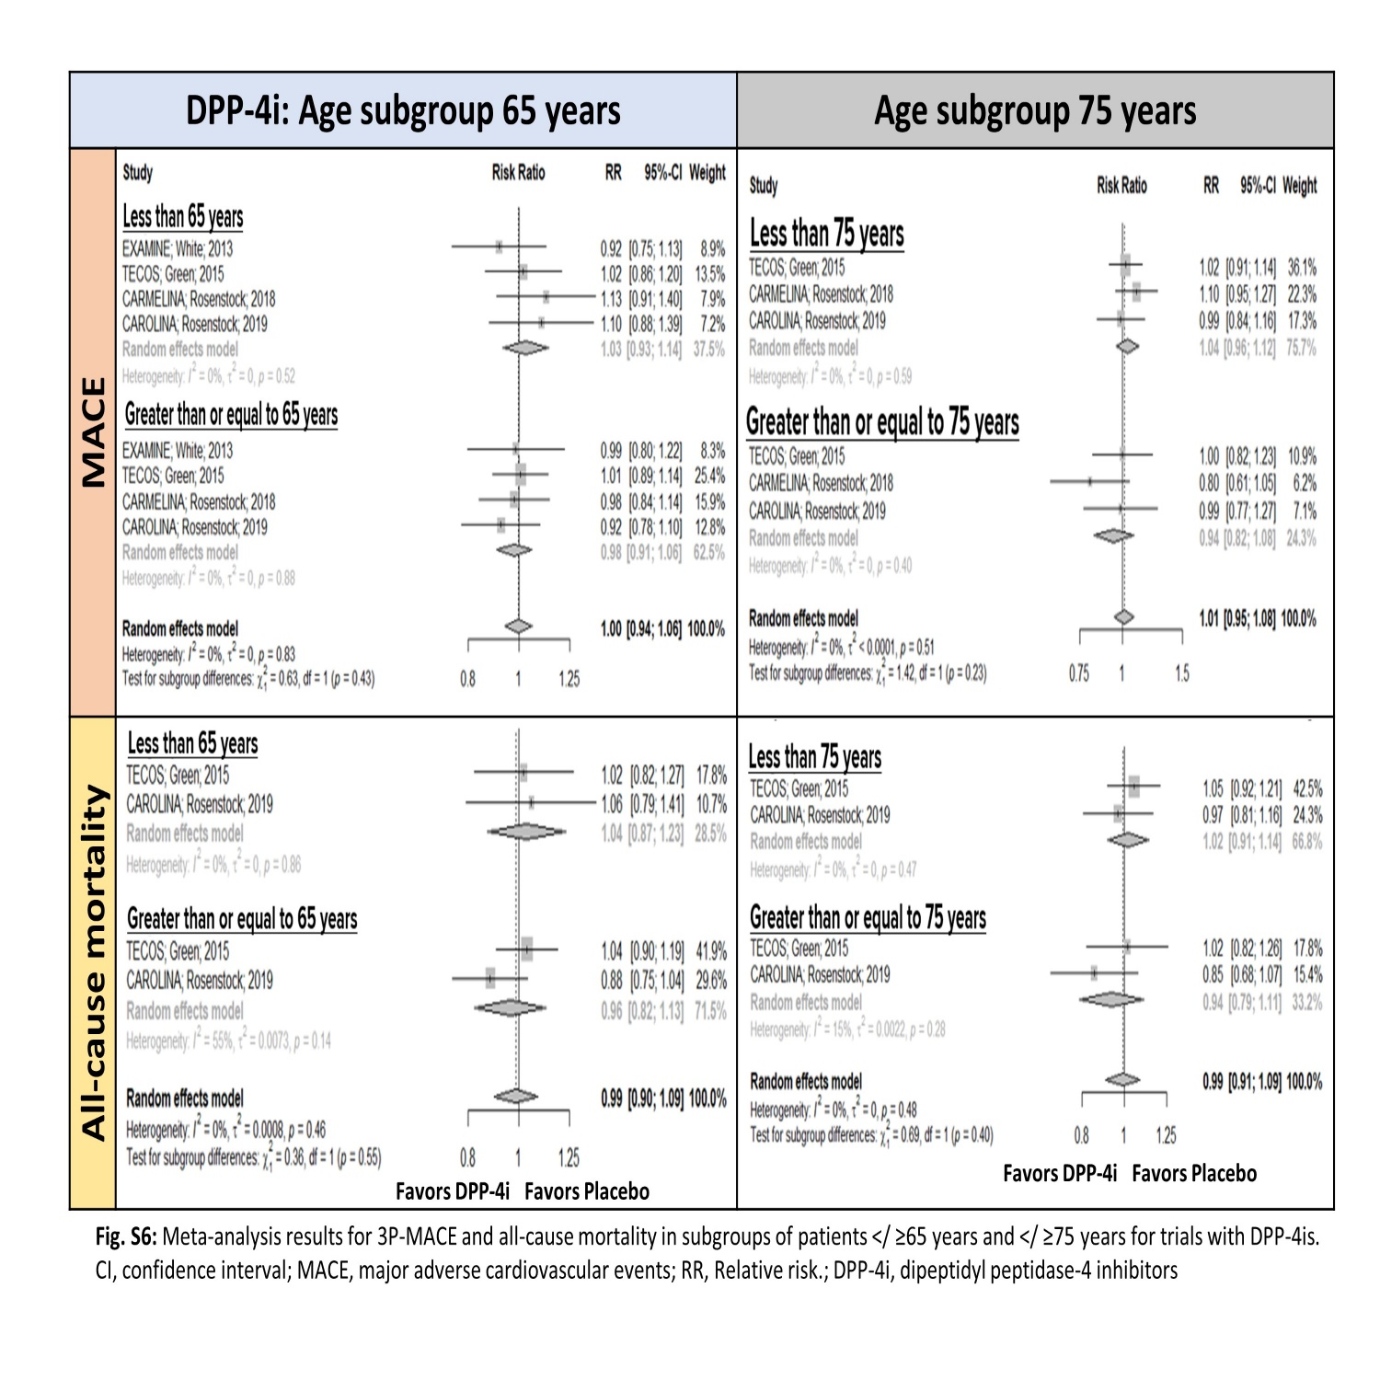

Appendix S7: Meta-analysis results for cardiovascular death, myocardial infarction & stroke in subgroups of patients </ ≥65 years and </ ≥75 years for trials with DPP-4is.
