Supplementary information (ESM1)
Phytoextracts and hypoglycemic potential of I. sonorae, C. limetta, and B. media
Iza F. Pérez-Ramírezª, Julio C. Rubio-Rodríguez^{a,b}, Luis M. Salgado^{b}, Ofelia Mora^{c}, María L González-Dávalos^{c}, Rosalía Reynoso-Camacho^{a*}
ªUniversidad Autónoma de Querétaro (Facultad de Química), Querétaro (Querétaro), México.
^{b}Instituto Politecnico Nacional (CICATA), Querétaro (Queretaro), Mexico.
^{c}Universidad Nacional Autónoma de México (Instituto de Neurobiología), Querétaro (Querétaro), México.
*Correspondence: rrcamachomx@yahoo.com.mx

1. Materials and methods
1.1. Herbal material and preparation of herbal aqueous extracts
Ibervillea sonorae roots, Citrus limetta roots, and Briza media leaves and stems were obtained from local markets in Querétaro, México. Extracts were prepared using two g of dried material in 100 mL of water and boiled for 30 min, afterwards all extracts were filtered using a 0.5 mm pore size filter and were stored at 4 ºC protected from the light.
1.2. Animal protocol experiments
Thirty male Wistar rats of 220-240 g were acquired from the Universidad Nacional Autónoma de México (Juriquilla, Querétaro, Mexico). The housing room was maintained at 23 ºC and 50% relative humidity, under a 12 h light-dark cycle, animals were housed individually with free access to standard diet (La Rodent Diet 5001) and water. Experiments were performed in accordance with the Animal Care and Use Protocol (NOM-062-ZOO-1999), and protocol was approved by the Bioethics Committee, Faculty of Natural Sciences of the Universidad Autónoma de Querétaro (Querétaro, México; approval number: 5FCN2015).
1.3. Oral starch tolerance test
After one week of acclimatization, rats were fasted for 12 h and were randomly allocated in five groups of six rats each. The negative control group was administered water (vehicle) via intragastric cannulation, the positive control group was administered acarbose (10 mg/kg b.w.), and the treatments groups were administered each herbal extract: I. sonorae, C. limetta, and B. media (6 mL/kg) [1]. After 5 min, a starch solution (5 g/kg b.w.) was administered to all rats. Glucose was measured at 0, 15, 30, 60, 90, 120, 150, and 180 min using blood obtained from the tail vein with an Accu-Chek System (Roche Diagnosis, Germany).
1.4. Evaluation of in vitro α-amylase and α-glucosidase enzymes inhibitory activity
Herbal extracts were evaluated against α-amylase and α-glucosidase according to the methods described by Apostolidis et al. [2], respectively. Results were reported as percentage of inhibition.
1.5. Cell culture
3T3-L1 preadipocytes (1 x 10⁴ cells) were cultured until confluence in Dulbecco’s modified Eagle’s medium (DMEM) with 10% fetal bovine serum (FBS, Gibco by Life Technologies, New York, USA) and 1% penicillin/streptomycin (Invitrogen). The differentiation of adipocytes was induced with 5 μg/mL insulin (Life Technologies), 0.25 μM dexamethasone (Sigma-Aldrich, Missouri, USA), 0.5 mM IBMX (Invitrogen), 2% FBS, and 1% penicillin/streptomycin in DMEM for 2 days. Then, the medium was replaced with DMEM with 5 μg/mL insulin, 2% FBS, and 1% penicillin/streptomycin for 1 day. Finally, the medium was replaced with DMEM with 2% FBS and 1% penicillin/streptomycin for 4 days. Mediums were changed every two days during adipocytes proliferation and differentiation.
1.6. In vitro glucose uptake assay
Differentiated cells were serum-starved for 4 h and were treated with 0.5 and 1.0 mg/mL of lyophilized herbal extracts dissolved in 0.1% dimethyl sulfoxide (DMSO, Sigma-Aldrich). These concentrations of herbal extracts have been previously reported in similar studies [3]. Negative control cells were incubated with 0.1% DMSO, whereas positive control cells were incubated with 100 nM of insulin. Glucose uptake assays were performed as described previously by Urso et al. [4]. Cells were incubated at 37 ºC for 30 min. Glucose concentration was determined using colorimetric-commercial kit (Spinreact, Girone, Spain). All experiments were assessed in triplicate.
1.7. Relative quantification of Glut4, Irs1, and Pi3k gene transcripts
As in glucose uptake assay, fully differentiated adipocytes were incubated at 37 ºC for 30 min with each treatment. Afterwards, cells were lysed with 1 mL of Trizol reagent (Thermo Fisher Scientific, Delaware, USA) for the isolation of total RNA according to the instructions of manufacturer. RNA was quantified with a NanoDrop 1000 spectrophotometer (Thermo Fisher Scientific). RNA quality was assessed with 260/280 and 260-230 ratios, whereas RNA integrity was assessed by electrophoresis on a 1% denaturing agarose gel.
The synthesis of cDNA was carried out with 1 µg of total RNA, 4 µL of M-MLV 5X reaction buffer (Invitrogen, Ca, USA), 1 µL of 5 µM oligo dT (Invitrogen), 1 µL of 10 mM dNTP mix (Invitrogen), 1 µL (200 U) of M-MLV RT (Invitrogen), 3 µL of 0.1 M DTT (Invitrogen), 1 µL of RNase inhibitor (Invitrogen), and RNAse-free water (Sigma-Aldrich), reaching a final volume of 20 µl. The reaction was incubated at 42 °C for 50 min and was stopped by incubating at 70 °C for 15 min.
The RT-PCR reaction was carried out with Sybr Green qPCR master mix (Thermo Scientific) according to the instructions of the manufacture using a StepOne Real-Time PCR System (Applied Biosystems. California, USA). Target transcripts were amplified using the following primers: Glut4: sense 5’-TCATCAGGATAAACAGCAG-3’ and antisense 5’-TACTATTGTGTTCCTTTGC-3’, Pi3k: sense 5’-CATGTTCTGGAAACTTCACCA-3’ and antisense 5’CCTGGGGAAACATAAACTTG-3’, and Irs1: sense 5’-CCTCACAGTCTTCAGTGGCT-3’ and antisense 5’-ATAGTCCCCATTTCCTTTGC-3’. Gene expression was assessed in duplicate. Relative quantification was carried out with the 2-ΔΔCT method [6] using Actin (sense 5’- GCTACAGCTTCACCACCACA-3’ and antisense 5’- AGTTTCATGGATGCCACAGG-3’) and 18S (sense 5’- GGAGCGATTTGTCTGGGTTA-3’ and antisense 5’- GTAGGGTAGGCACACGCTGA-3’) as reference genes.
1.8. Polyphenol profile
The polyphenol profile was assessed by Ultra-Performance Liquid Chromatography (UPLC) coupled to a Quadrupole-Time of Flight (QTOF) with an atmospheric pressure Electrospray Ionization (ESI) interphase (Vion, Waters Co, MA, USA). The column used was an Acquity BEH C18 (100 x 2.1 mm, 1.7 μm) using the conditions reported previously by Rodríguez-Gonzalez et al. [7]. Data acquisition was carried out with UNIFI Scientific Information System (Waters Co). Polyphenols were identified by comparison of elemental composition with the exact mass of the pseudo molecular ion (error mass <5 ppm) using Phenol-Explorer database (http://phenol-explorer.eu), analysis of fragmentation pattern and isotopic distribution. The high-resolution mass spectra of the main polyphenols identified in the herbal extracts are shown in Figures 1S-9S.
References
1. Hernández-Saavedra D, Pérez-Ramírez IF, Ramos-Gómez M, Mendoza-Díaz S, Loarca-Pina G, Reynoso-Camacho R (2016) Phytochemical characterization and effect of Calendula officinalis, Hypericum perforatum, and Salvia officinalis infusions on obesity-associated cardiovascular risk. Med Chem Res 25:163-172. https://doi.org/10.1007/s00044-015-1454-1
2. Apostolidis E, Kwon YI, Shetty K (2007) Inhibitory potential of herb, fruit, and fungal-enriched cheese against key enzymes linked to type 2 diabetes and hypertension. Innov Food Sci Emerg Technol 8:46-54. https://doi.org/10.1016/j.ifset.2006.06.001
Pérez-Ramírez IF, González-Dávalos ML, Mora O, Gallegos-Corona MA, Reynoso-Camacho R (2017) Effect of Ocimum sanctum and Crataegus pubescens aqueous extracts on obesity, inflammation, and glucose metabolism. J Funct Foods 35:24-31. https://doi.org/10.1016/j.jff.2017.05.028
4. Urso B, Cope D, Kallo H, Hayward A, Whitehead J, O'Rahilly S, Siddle K (1999) Differences in signaling properties of the cytoplasmic domains of the insulin receptor and insulin-like growth factor receptor in 3T3-L1 adipocytes. J Biol Chem 274:30864-30873. https://doi.org/10.1074/jbc.274.43.30864
5. Livak KJ, Schmittgen TD (2001) Analysis of relative gene expression data using real-time quantitative PCR and the 2^{-ΔΔCt} method. Methods 25:402-408. https://doi.org/10.1006/meth.2001.1262
6. Rodríguez-González S, Pérez-Ramírez IF, Castaño-Tostado E, Amaya-Llano S, Rodríguez-García ME, Reynoso-Camacho R (2018) Improvement of physico-chemical properties and phenolic compounds bioavailability by concentrating dietary fiber of peach (Prunus persica) juice by-product. J Sci Food Agric 98:3109. https://doi.org/10.1002/jsfa.8812
Figure 1S. High resolution MS^{E} spectra of protocatechuic acid hexoside.
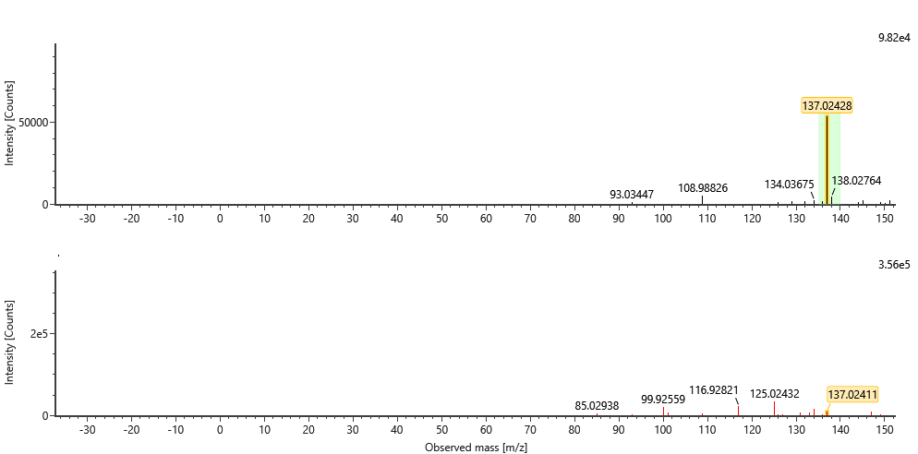
Figure 2S. High resolution MS^{E} spectra of hydroxybenzoic acid.
Figure 3S. High resolution MS^{E} spectra of dicaffeoylquinic acid.
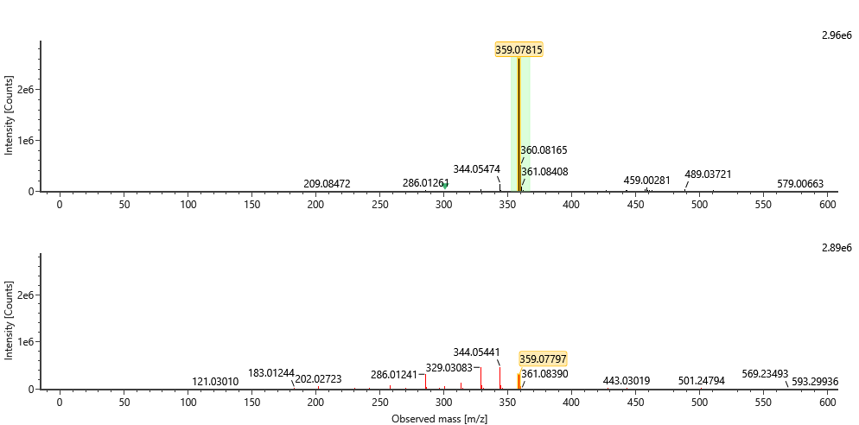
Figure 4S. High resolution MS^{E} spectra of rosmarinic acid.
Figure 5S. High resolution MS^{E} spectra of naringin.
Figure 6S. High resolution MS^{E} spectra of hesperidin.
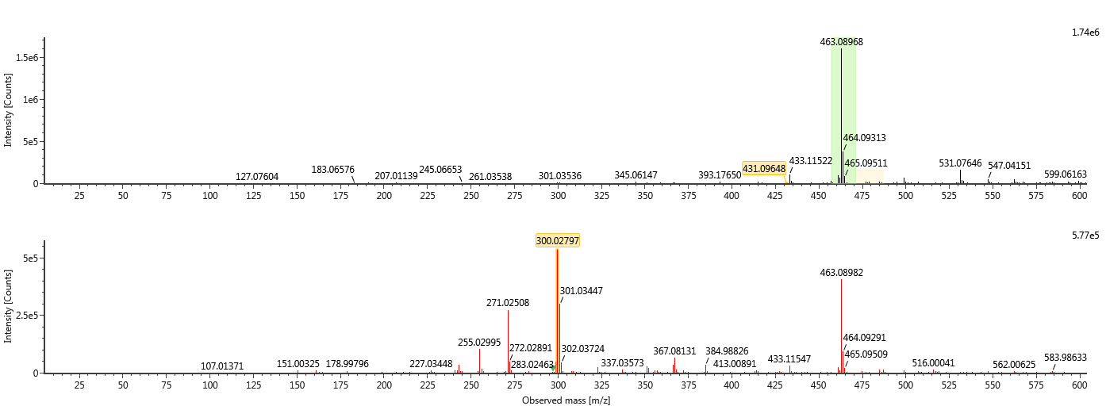
Figure 7S. High resolution MS^{E} spectra of quercetin hexoside.
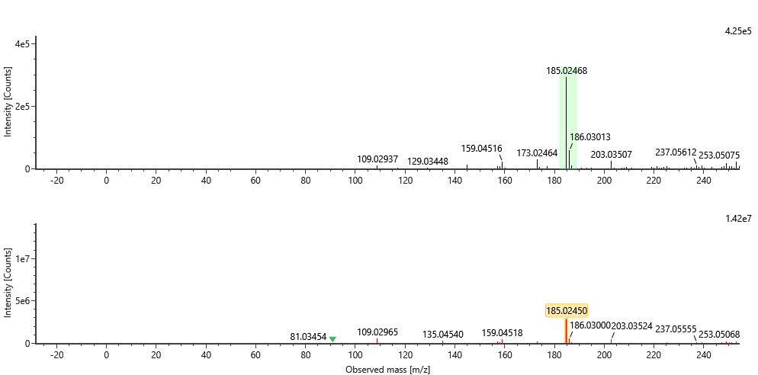
Figure 8S. High resolution MS^{E} spectra of psoralen.
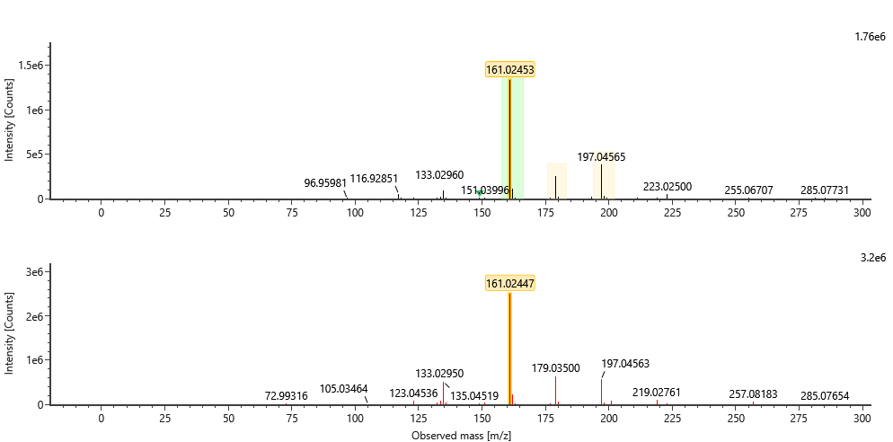
Figure 9S. High resolution MS^{E} spectra of hydroxycoumarin.

