Table 2. Results of each group stained with hematoxylin and eosin (H&E)
normal group | KOA model group | ZQFTN group | TLR4-inhibitor group | ZQFTN+TLR4 group
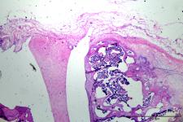 | 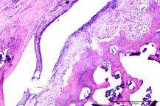 | 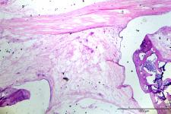 | 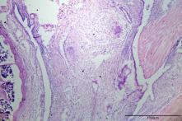 | 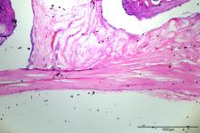
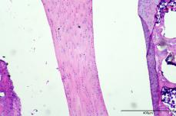 | 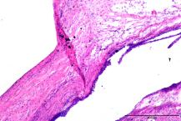 | 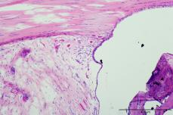 | 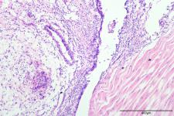 | 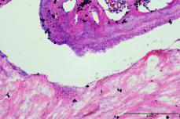
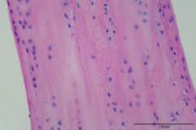 | 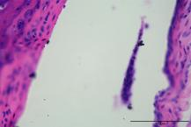 | 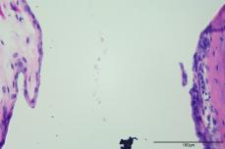 | 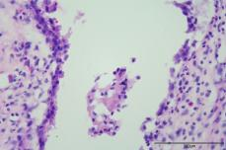 | 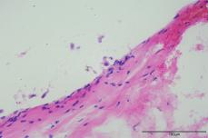
The articular cartilage surface exhibits smoothness without any discernible pathological changes. | Cartilage experiences tears and microfibrosis, accompanied by the soft and excessive proliferation of joint edges resulting in the formation of cartilaginous osteophytes. These osteophytes undergo ossification, transforming into osteophytes that subsequently detach and enter the joint cavity, becoming arthrophytes. | This process is characterised by the emergence of cracks, the appearance of new blood vessels, proliferation of joint edges, and the detachment of small pieces. | Further progression involves the development of cracks, the appearance of new blood vessels, proliferation of joint edges, and the detachment of larger pieces. | The articular cartilage undergoes deformation, presenting a roughened surface with the detachment of small pieces.

