SUPPLEMENTAL DATA
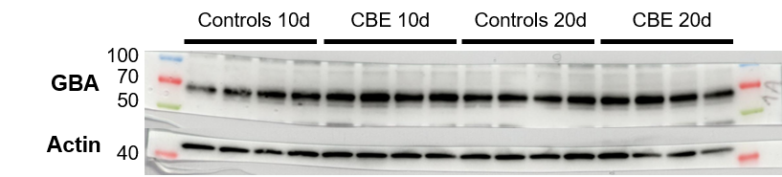
Figure 2: Western-blot of GBA proteins in 10-days and 20-days CBE and controls

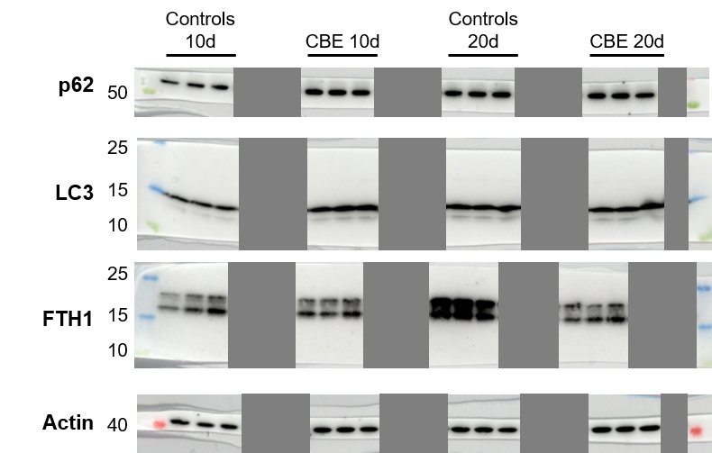
Figure 3: Western-blots of p62, LC3 and FTH1 proteins in 10-days and 20-days CBE and controls. Gray boxes hide bands that are not used in this article because these are other conditions not investigated in this study.
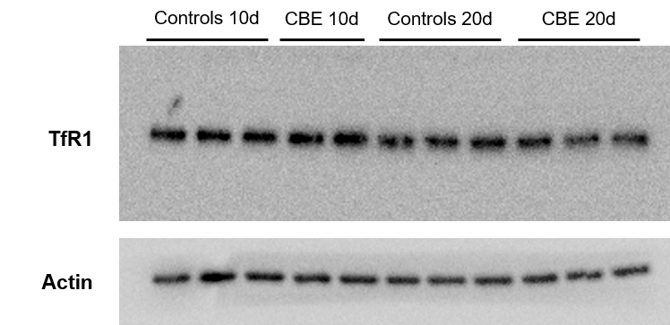
Figure 4: Western-blot of TfR1 proteins in 10-days and 20-days CBE and controls.
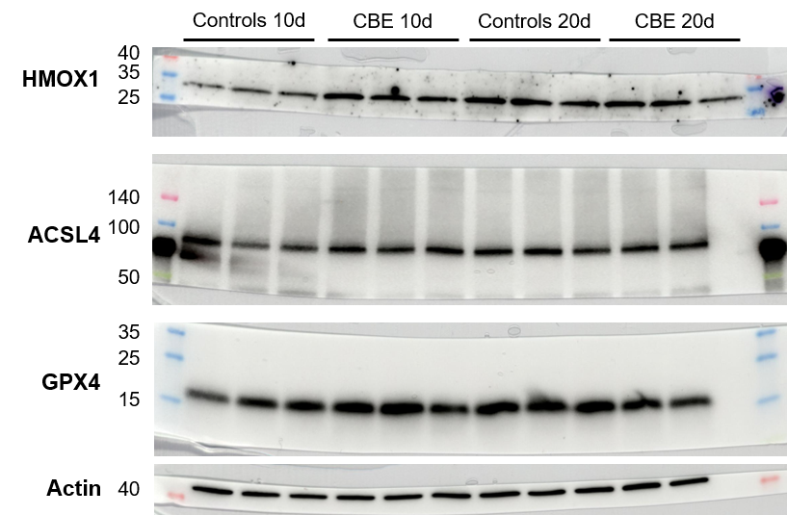
Figure 5: Western-blots of HMOX1, ACSL4, GPX4 proteins in 10-days and 20-days CBE and controls.

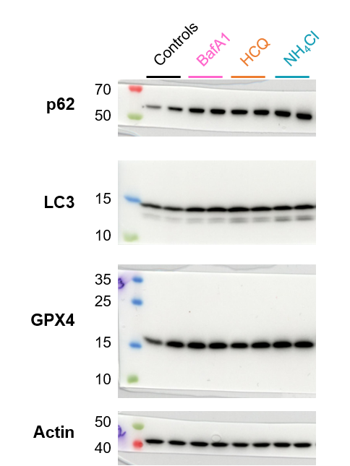
Figure 6: Western-blots of p62, LC3 and GPX4 proteins in cells exposed to inhibitors of autophagic flux.

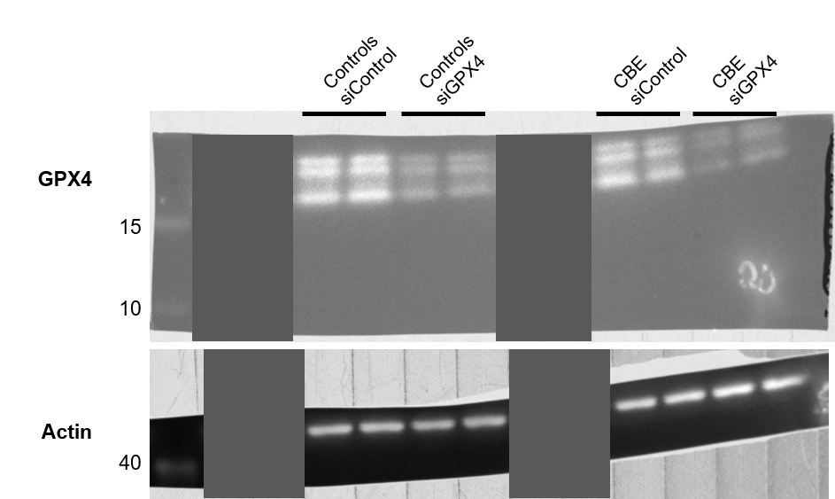
Figure 7: Western-blots of GPX4 proteins in cells transfected with siGPX4. Gray boxes hide bands that are not used in this article because these are other conditions not investigated in this study.

