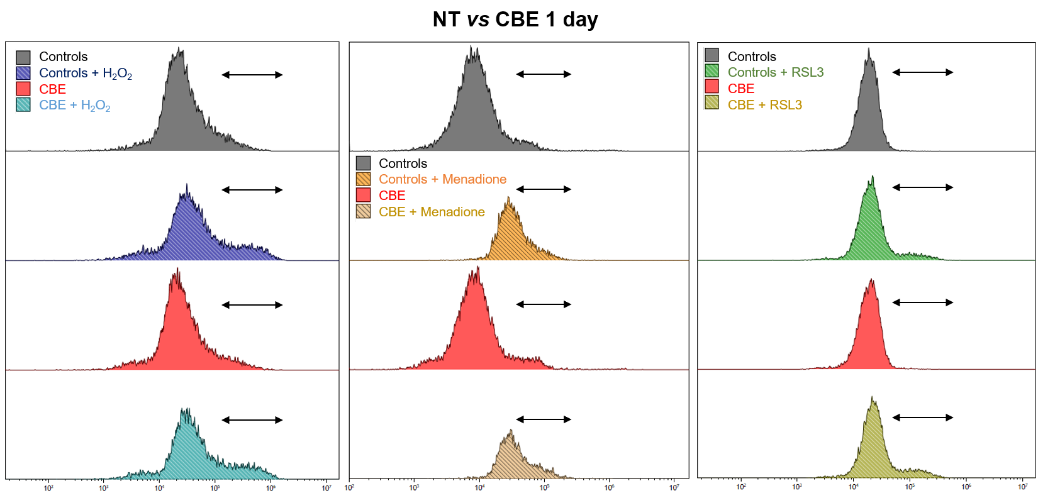
Figure 8: Flow cytometry experiments in 1-day CBE cells and controls. LUHMES cells were treated with H₂O₂, menadione or RSL3 +/- CBE. Following the treatment, cells were stained with CM-H2DCFDA (left, cytosolic ROS), MitoSOX (middle, mitochondrial ROS) or C-11-BODIPY 581/591 (right, lipid ROS) probes. The arrows represent the measured parts.

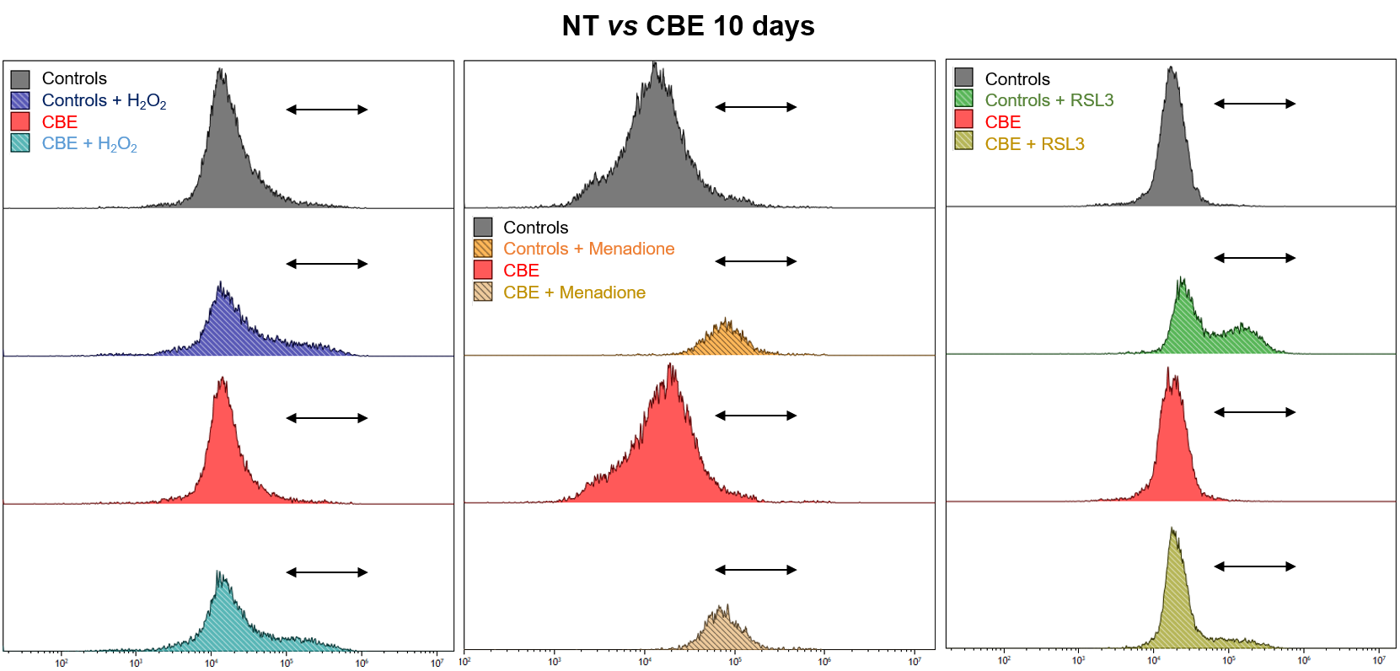
Figure 9: Flow cytometry experiments in 10-days CBE cells and controls. LUHMES cells were treated with H₂O₂, menadione or RSL3 +/- CBE. Following the treatment, cells were stained with CM-H2DCFDA (left, cytosolic ROS), MitoSOX (middle, mitochondrial ROS) or C-11-BODIPY 581/591 (right, lipid ROS) probes. The arrows represent the measured parts.
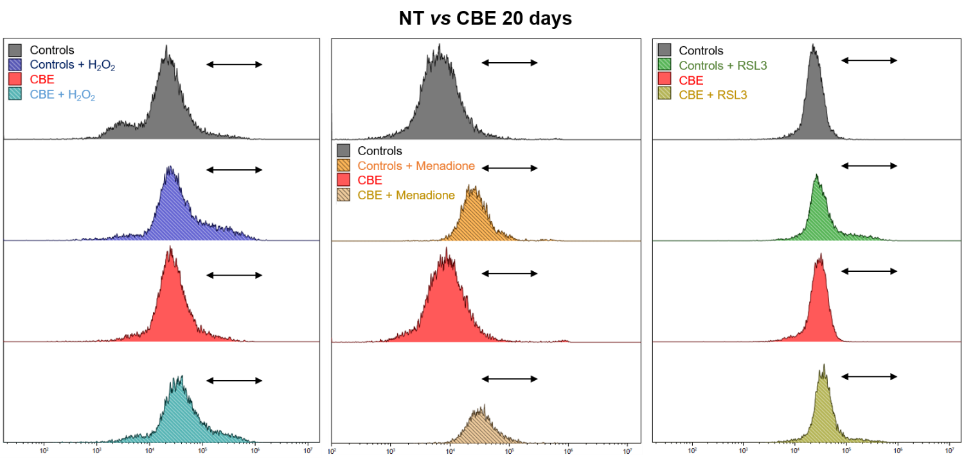
Figure 10: Flow cytometry experiments in 20-days CBE cells and controls. LUHMES cells were treated with H₂O₂, menadione or RSL3 +/- CBE. Following the treatment, cells were stained with CM-H2DCFDA (left, cytosolic ROS), MitoSOX (middle, mitochondrial ROS) or C-11-BODIPY 581/591 (right, lipid ROS) probes. The arrows represent the measured parts.
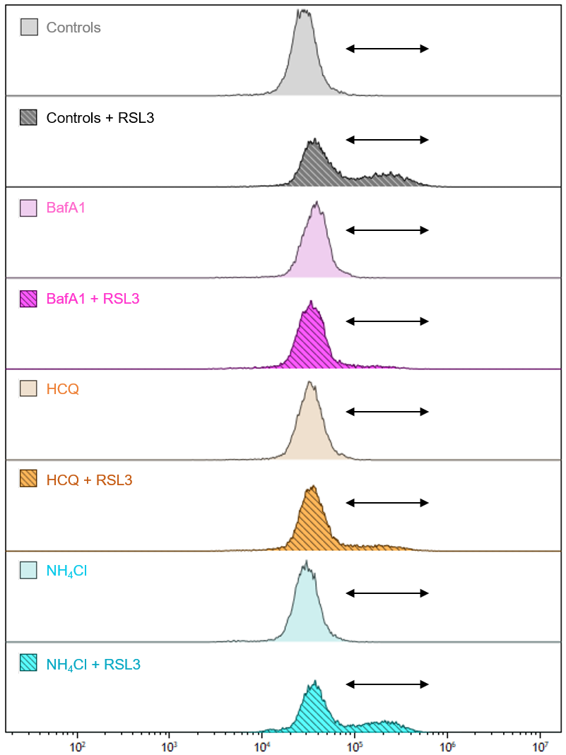
Figure 11: Overlay of flow cytometry experiments in cells exposed to inhibitors of autophagic flux. LUHMES cells were pre-treated with BafA1, HCQ or NH₄Cl and were treated with RSL3 to induce lipid ROS. Following the treatment, cells were stained with C-11-BODIPY 581/591 probes to measure lipid ROS. The arrows represent the measured parts.

