Supplementary Material

Starting values for the parameters |  |  | Model output
t_{c} -start | a-start | τ-start | t_{c} | A | τ
2.1 | 6 | 5 | 2.24 (2.66; 0.84; 0.40) | 5.97 (3.26; 1.83; 0.07) | 4.83 (0.57; 8.37; <0.0001)
10 | 6 | 5 | 2.24 (2.65; 0.85; 0.40) | 5.99 (3.27; 1.83; 0.07) | 4.82 (0.58; 8.38; <0.0001)
19 | 6 | 5 | 2.30 (2.03; 1.13; 0.26) | 5.91 (2.46; 2.41; 0.02) | 4.83 (0.58; 8.34; <0.0001)
2.2 | 1 | 5 | 2.30 (2.03; 1.13; 0.26) | 5.91 (2.46; 2.40; 0.17) | 4.83 (0.58; 8.34; <0.0001)
2.2 | 10 | 5 | 2.24 (2.66; 0.84; 0.40) | 5.98 (3.27; 1.83; 0.07) | 4.83 (0.58; 8.37; <0.0001)
2.2 | 19 | 5 | 2.30 (2.03; 1.13; 0.26) | 5.91 (2.46; 2.41; 0.02) | 4.83 (0.58; 8.34; <0.0001)
2.2 | 6 | 1 | 2.24 (2.66; 0.84; 0.40) | 5.97 (3.27; 1.83; 0.07) | 4.83 (0.58; 8.37; <0.0001)
2.2 | 6 | 10 | 2.30 (2.03; 1.13; 0.26) | 5.90 (2.46; 2.40; 0.02) | 4.83 (0.58; 8.34; <0.0001)
2.2 | 6 | 19 | 2.25 (2.67; 0.84; 0.40) | 5.97 (3.27; 1.83; 0.07) | 4.84 (0.58; 8.36; <0.0001)
6 | 6 | 6 | 2.29 (2.02; 1.13; 0.26) | 5.92 (2.46; 2.41; 0.02) | 4.83 (0.58; 8.34; <0.0001)
11 | 11 | 11 | 2.29 (2.03; 1.31; 0.26) | 5.92 (2.46; 2.41; 0.02) | 4.83 (0.58; 8.34; <0.0001)
19 | 19 | 19 | 2.24 (2.66; 0.84; 0.40) | 5.97 (3.27; 1.83; 0.07) | 4.83 (0.58; 8.36; <0.0001)
Table S1. Examples of starting values for the nlsLM model parameters and their corresponding output results. The nlsLM function is sensitive to the choice of starting values for the model parameters. This sensitivity can result in differences in the model results for the same dataset, or a complete failure to fit the model. The nlsLM model converged with 65% of starting values: t_{c} starting value ranged from 2 to 19 years; a starting value ranged from 1 to 19 MSEC units per year; τ starting value ranged from 1 to 19 year. Modeling output results are presented as: Estimate (Std.Error; t-value; p-value).

Starting values for the parameters |  |  | Model output
t_{c} -start | a-start | τ-start | t_{c} | A | τ
2.15 | 6 | 5 | 2.28 (2.15; 1.06; 0.29) | 5.80 (2.51; 2.33; 0.02) | 4.98 (0.61; 8.20; <0.0001)
2.2 | 6 | 5 | 2.28 (2.15; 1.06; 0.29) | 5.90 (2.51; 2.35; 0.02) | 4.99 (0.60; 8.28; <0.0001)
2.2 | 6 | 4.75 | 2.28 (2.15; 1.06; 0.29) | 5.90 (2.63; 2.24; 0.02) | 4.75 (0.57; 8.32; <0.0001)
2.2 | 6 | 19 | 2.29 (2.10; 1.09; 0.27) | 5.86 (2.51; 2.34; 0.02) | 4.84 (0.59; 8.26; <0.0001)
2.2 | 8 | 5 | 2.24 (2.71; 0.83; 0.41) | 5.92 (3.27; 1.81; 0.07) | 4.87 (0.59; 8.28; <0.0001)
Table S2. Examples of starting values for the nlme model parameters and their corresponding output results. The nlme function is also sensitive to the choice of starting values for the model parameters. This sensitivity can result in differences in the model outcomes for the same dataset, or a complete failure to fit the model. The nlme model converged with 10% of starting values: t_{c} starting value ranged from 2 to 19 years; a starting value ranged from 1 to 19 MSEC units per year; τ starting value ranged from 1 to 19 year. Modeling output results are presented as: Estimate (Std.Error; t-value; p-value).

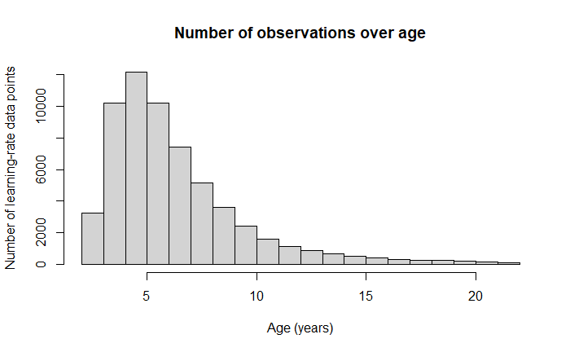 Figure S1. Histogram of learning-rate data points over age.

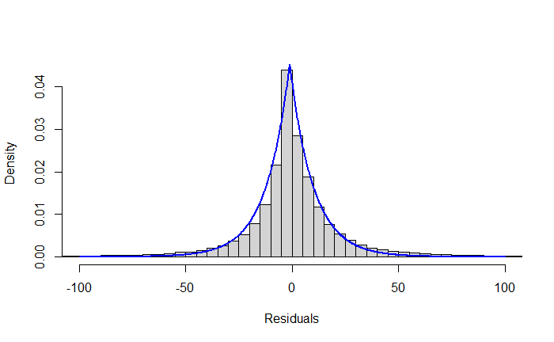
Figure S2. Density histogram of residuals from the nlsLM model. Blue line: LaPlace distribution.

Figure S3. Density histogram of residuals from the nlme model. Blue line: LaPlace distribution.
Starting values | Model output
t_{c} -start | Mild ASD t_{c} | Moderate ASD t_{c} | Severe ASD t_{c}
1 | 3.15 (0.27; 11.5; <0.0001) | 2.00 (0.30; 6.63; <0.0001) | 1.35 (0.43; 3.11; 0.002)
2 | 3.15 (0.27; 11.5; <0.0001) | 2.00 (0.30; 6.63; <0.0001) | 1.35 (0.43; 3.11; 0.002)
3 | 3.15 (0.27; 11.5; <0.0001) | 2.00 (0.30; 6.63; <0.0001) | 1.35 (0.43; 3.11; 0.002)
4 | 3.15 (0.27; 11.5; <0.0001) | 2.00 (0.30; 6.63; <0.0001) | 1.35 (0.43; 3.11; 0.002)
5 | 3.15 (0.27; 11.5; <0.0001) | 2.00 (0.30; 6.63; <0.0001) | 1.35 (0.43; 3.11; 0.002)
6 | 3.15 (0.27; 11.5; <0.0001) | 2.00 (0.30; 6.63; <0.0001) | 1.35 (0.43; 3.11; 0.002)
7 | 3.15 (0.27; 11.5; <0.0001) | 2.00 (0.30; 6.63; <0.0001) | 1.35 (0.43; 3.11; 0.002)
8 | 3.15 (0.27; 11.5; <0.0001) | 2.00 (0.30; 6.63; <0.0001) | 1.35 (0.43; 3.11; 0.002)
9 | 3.15 (0.27; 11.5; <0.0001) | 2.00 (0.30; 6.63; <0.0001) | 1.35 (0.43; 3.11; 0.002)
10 | 3.15 (0.27; 11.5; <0.0001) | 2.00 (0.30; 6.63; <0.0001) | 1.35 (0.43; 3.11; 0.002)
11 | 3.15 (0.27; 11.5; <0.0001) | 2.00 (0.30; 6.63; <0.0001) | 1.35 (0.43; 3.11; 0.002)
12 | 3.15 (0.27; 11.5; <0.0001) | 2.00 (0.30; 6.63; <0.0001) | 1.35 (0.43; 3.11; 0.002)
13 | 3.15 (0.27; 11.5; <0.0001) | 2.00 (0.30; 6.63; <0.0001) | 1.35 (0.43; 3.11; 0.002)
14 | 3.15 (0.27; 11.5; <0.0001) | 2.00 (0.30; 6.63; <0.0001) | 1.35 (0.43; 3.11; 0.002)
15 | 3.15 (0.27; 11.5; <0.0001) | 2.00 (0.30; 6.63; <0.0001) | 1.35 (0.43; 3.11; 0.002)
16 | 3.15 (0.27; 11.5; <0.0001) | 2.00 (0.30; 6.63; <0.0001) | 1.35 (0.43; 3.11; 0.002)
17 | 3.15 (0.27; 11.5; <0.0001) | 2.00 (0.30; 6.63; <0.0001) | 1.35 (0.43; 3.11; 0.002)
18 | 3.15 (0.27; 11.5; <0.0001) | 2.00 (0.30; 6.63; <0.0001) | 1.35 (0.43; 3.11; 0.002)
19 | 3.15 (0.27; 11.5; <0.0001) | 2.00 (0.30; 6.63; <0.0001) | 1.35 (0.43; 3.11; 0.002)
Table S3. Starting values for the nlsLM model parameter t_{c} and corresponding output results in mild (level 1), moderate (level 2), or severe (level 3) ASD. To make an unambiguous comparison, the number of the model parameters was reduced to one, the critical inflection point t_{c}. Starting values for t_{c} ranged from 1 to 19 years; a was set to 5.9 MSEC units per year; τ was set to 4.9 years. The nlsLM model converged with 100% of starting values. Modeling output results are presented as: Estimate (Std.Error; t-value; p-value).

Starting values | Model output
t_{c} -start | Mild ASD t_{c} | Moderate ASD t_{c} | Severe ASD t_{c}
1 | 3.13 (0.27; 11.4; <0.0001) | 2.00 (0.30; 6.64; <0.0001) | 1.36 (0.43; 3.15; 0.002)
2 | 3.17 (0.27; 11.6; <0.0001) | 2.00 (0.30; 6.64; <0.0001) | 1.35 (0.43; 3.11; 0.002)
3 | 3.15 (0.27; 11.5; <0.0001) | 2.00 (0.30; 6.64; <0.0001) | 1.35 (0.43; 3.11; 0.002)
4 | 3.17 (0.27; 11.6; <0.0001) | 2.00 (0.30; 6.71; <0.0001) | 1.38 (0.43; 3.20; 0.014)
5 | 3.15 (0.27; 11.5; <0.0001) | 2.00 (0.30; 6.63; <0.0001) | 1.35 (0.43; 3.11; 0.002)
6 | 3.17 (0.27; 11.6; <0.0001) | 1.98 (0.30; 6.56; <0.0001) | 1.35 (0.43; 3.11; 0.002)
7 | 3.15 (0.27; 11.5; <0.0001) | 2.00 (0.30; 6.67; <0.0001) | 1.35 (0.43; 3.12; 0.002)
8 | 3.17 (0.27; 11.6; <0.0001) | 2.00 (0.30; 6.63; <0.0001) | 1.36 (0.43; 3.15; 0.002)
9 | 3.15 (0.27; 11.5; <0.0001) | 1.99 (0.3; 6.58; <0.0001) | 1.35 (0.43; 3.11; 0.002)
10 | 3.15 (0.27; 11.5; <0.0001) | 2.00 (0.30; 6.63; <0.0001) | 1.35 (0.43; 3.10; 0.002)
11 | 3.16 (0.27; 11.5; <0.0001) | 2.00 (0.30; 6.63; <0.0001) | 1.35 (0.43; 3.11; 0.002)
12 | 3.15 (0.27; 11.5; <0.0001) | 2.00 (0.30; 6.64; <0.0001) | 1.37 (0.43; 3.18; 0.002)
13 | 3.17 (0.27; 11.6; <0.0001) | 2.01 (0.30; 6.70; <0.0001) | 1.35 (0.43; 3.11; 0.002)
14 | 3.15 (0.27; 11.5; <0.0001) | 2.00 (0.30; 6.63; <0.0001) | 1.35 (0.43; 3.11; 0.002)
15 | 3.15 (0.27; 11.5; <0.0001) | 2.00 (0.30; 6.64; <0.0001) | 1.34 (0.43; 3.09; 0.002)
16 | 3.16 (0.27; 11.6; <0.0001) | 1.98 (0.31; 6.54; <0.0001) | 1.37 (0.43; 3.18; 0.002)
17 | 3.20 (0.27; 11.7; <0.0001) | 2.00 (0.30; 6.63; <0.0001) | 1.33 (0.43; 3.06; 0.002)
18 | 3.15 (0.27; 11.5; <0.0001) | 2.00 (0.30; 6.64; <0.0001) | 1.34 (0.43; 3.09; 0.002)
19 | 3.15 (0.27; 11.5; <0.0001) | 1.99 (0.3; 6.58; <0.0001) | 1.36 (0.43; 3.15; 0.002)
Table S4. Starting values for the nlme model parameter t_{c} and corresponding output results in mild (level 1), moderate (level 2), or severe (level 3) ASD. To make an unambiguous comparison, the number of the model parameters was reduced to one, the critical inflection point t_{c}. Starting values for t_{c} ranged from 1 to 19 years; a was set to 5.9 MSEC units per year; τ was set to 4.9 years. The nlme model converged with 100% of starting values. Modeling output results are presented as: Estimate (Std.Error; t-value; p-value).

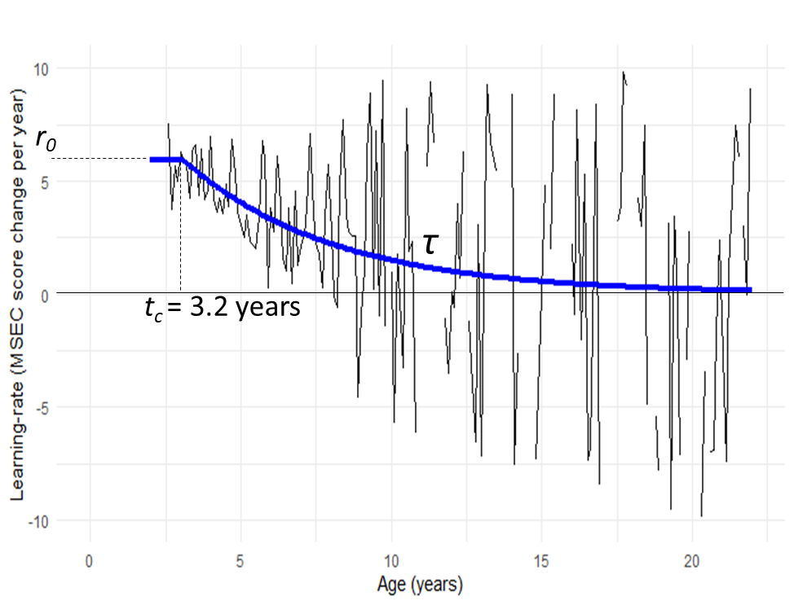
Figure S4. Thin black line: learning-rate in participants diagnosed with mild ASD averaged in 0.1-year bins, measured as MSEC score change per year (positive MSEC score change indicates improvement). Thick blue line: graphical representation of modeling results.

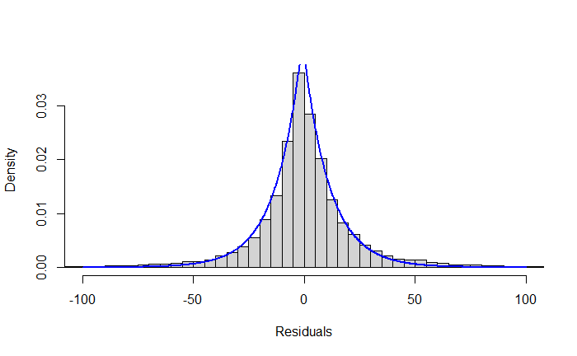
Figure S5. Density histogram of residuals from the nlsLM model in participants diagnosed with mild ASD. Blue line: LaPlace distribution.

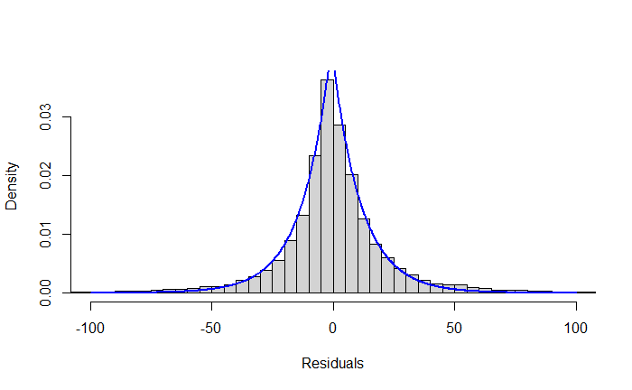
Figure S6. Density histogram of residuals from the nlme model in participants diagnosed with mild ASD. Blue line: LaPlace distribution.

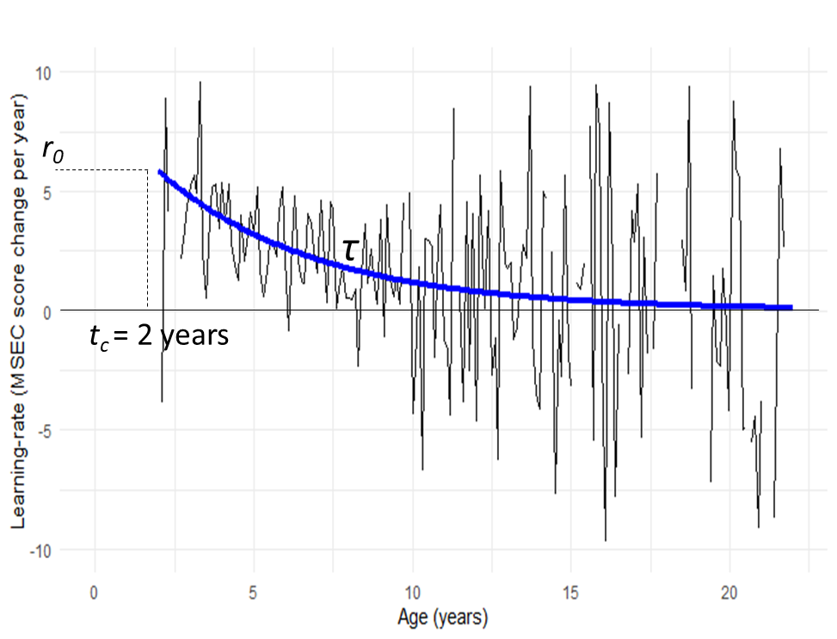
Figure S7. Thin black line: learning-rate in participants diagnosed with moderate ASD averaged in 0.1-year bins, measured as MSEC score change per year (positive MSEC score change indicates improvement). Thick blue line: graphical representation of modeling results.

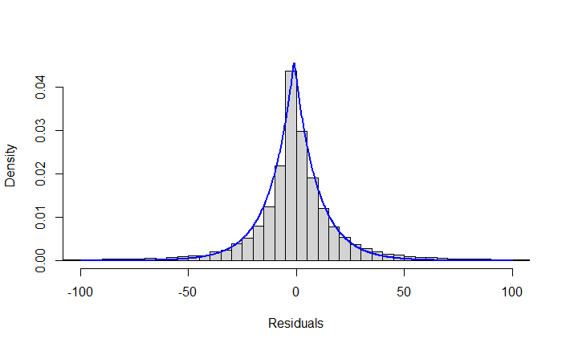
Figure S8. Density histogram of residuals from the nlsLM model in participants diagnosed with moderate ASD. Blue line: LaPlace distribution.

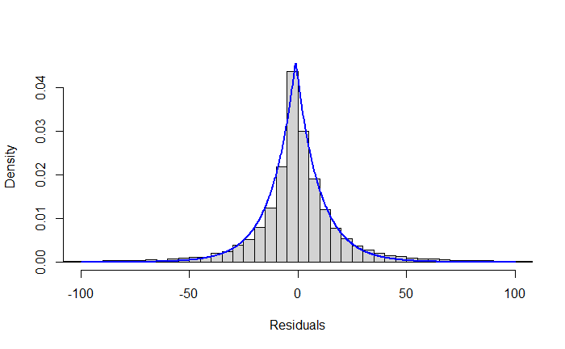
Figure S9. Density histogram of residuals from the nlme model in participants diagnosed with moderate ASD. Blue line: LaPlace distribution.

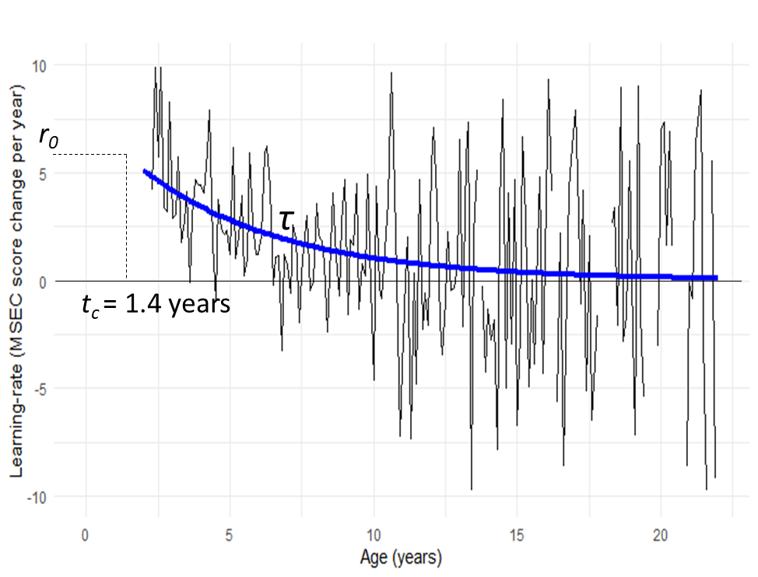
Figure S10. Thin black line: learning-rate in participants diagnosed with severe ASD averaged in 0.1-year bins, measured as MSEC score change per year (positive MSEC score change indicates improvement). Thick blue line: graphical representation of modeling results.

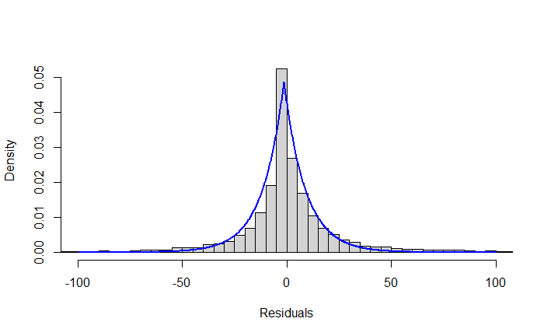
Figure S11. Density histogram of residuals from the nlsLM model in participants diagnosed with severe ASD. Blue line: LaPlace distribution.

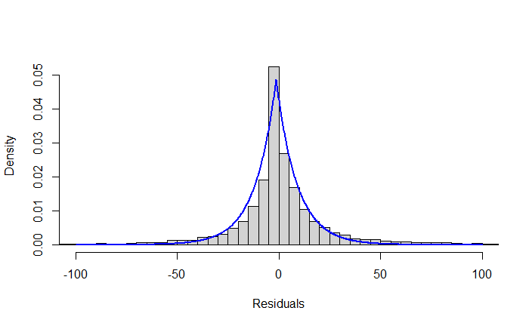
Figure S12. Density histogram of residuals from the nlme model in participants diagnosed with severe ASD. Blue line: LaPlace distribution.

