Supplementary information for
Observation of canalized phonon polaritons in a single-layer α-MoO₃ flake
Kun Wang^{1#}, Hua Long^{1#}, Langlang Xiong^{2#}, Kai Wang^{1,3*}, Nan Deng¹, Bing Wang¹, Guangwei Hu^{2*} and Peixiang Lu^{1,4*}
¹Wuhan National Laboratory for Optoelectronics and School of Physics, Huazhong University of Science and Technology, Wuhan 430074, China
²School of Electrical & Electronic Engineering, Nanyang Technological University, 639798, Singapore
³School of Electronic and Information Engineering, Hubei University of Science and Technology, Xianning 437100, China
⁴Hubei Key Laboratory of Optical information and Pattern Recognition, Wuhan Institute of Technology, Wuhan 430205, China
#These authors contributed equally to this work.
*Corresponding authors:
kale_wong@hust.edu.cn (KW) guangwei.hu@ntu.edu.sg (GWH) lupeixiang@hust.edu.cn (PXL)

This PDF file includes:
Section 1 (S1): The Permittivity of the α-MoO₃ crystal and calculations for the complex reflectivity of the multilayer structure.
Section 2 (S2): Analytical dispersion relationships and loss induced canalization in the α-MoO₃ crystal.
Section 3 (S3): The Mechanism of PiFM detection for imaging PhPs of the α-MoO₃ flake.
Figure S5. Real-space PiFM images for experimentally mapping the dispersion relation curve of PhPs along x-direction of the α-MoO₃ sample.
Figure S6. Real-space PiFM images for experimentally mapping the dispersion relation curve of PhPs along y-direction of the α-MoO₃ sample.
Table S1. Parameters used in calculating the relative permittivities of the α-MoO₃ crystal.

Section 1 (S1): The Permittivity of the α-MoO₃ crystal and calculations for the complex reflectivity of the multilayer structure.
In the infrared region, the optical response of the pristine α-MoO₃ crystal arises from the optical phonon absorption. The permittivity along three axes of the α-MoO₃ crystal can thus be calculated by the multiple Lorentz oscillator model^{1, 2}:
$ε_{j}\text{=}ε_{∞}^{j}\left(\frac{{ω_{LO}^{j}}^{2}-ω^{2}-iωГ^{ j}}{{ω_{TO}^{j}}^{2}-ω^{2}-iωГ^{ j}}\right)$, j = x, y, z (S1)
where $ε_{∞}^{j}$, $ω_{TO}^{j}$, and $ω_{LO}^{j}$denote the high-frequency permittivity, the energy of the transverse (TO) and longitudinal (LO) optical phonon mode, respectively. $Γ$ denotes for the damping factor of the α-MoO₃ crystal and j = x, y, z stands for three principle directions which correspond to the crystalline directions [100], [001], and [010] of the α-MoO₃, respectively. The detailed parameters used in our calculation are given in Table S2²:
The PhPs dispersion relation of the α-MoO₃ flake can be manifested by the complex reflectivity $r_{p}(ω, q)$ of a multilayer structure consisted of air/α-MoO₃/SiO₂. The $r_{p}(ω, q)$ of this system is determined by^{1, 2}:
$r_{p}=\frac{r_{1}+r_{3}e^{i2k_{2}^{b}d}}{1+r_{1}r_{3}e^{i2k_{2}^{b}d}}$ (S2)
$r_{1}=\frac{ε_{⊥}k_{1}^{b}-ε_{1}k_{2}^{b}}{ε_{⊥}k_{1}^{b}+ε_{1}k_{2}^{b}}$ (S3)
$r_{3}=\frac{ε_{3}k_{2}^{b}-ε_{⊥}k_{3}^{b}}{ε_{3}k_{2}^{b}+ε_{⊥}k_{3}^{b}}$ (S4)
$k_{2}^{b}=\sqrt{ε_{⊥}{\left(\frac{ω}{c}\right)}^{2}-{\frac{ε_{⊥}}{ε_{Ⅱ}}q}^{2}}$ (S5)
$k_{i}^{b}=\sqrt{ε_{i}{\left(\frac{ω}{c}\right)}^{2}-q^{2}}$, i= 1, 3 (S6)
where the subscripts “1”, “2”, and “3” denote the air, α-MoO₃, and SiO₂, respectively. $q$ is the in-plane wavevector of PhPs in the α-MoO₃ flake. The parameter $d$ is the thickness of the α-MoO₃ flake with $d=$80 nm. The parameters $r_{1}$ and $r_{3}$ delegate the reflectivities at the air/α-MoO₃ and α-MoO₃/SiO₂ interfaces, respectively. The $ε_{j}$ (j = 1, 3 and ⊥) refers to the relative permittivities of the air, SiO₂³, and the z-axis component ([010] direction, b axis) of the α-MoO₃ flake. To calculate the dispersion relation of the PhPs propagating along the [001] direction ([100] direction), the $ε_{⊥}$ is substituted by $ε_{y}$ or $ε_{x}$, which are obtained from the Equation S1. The parameter $k_{i}^{b}$ (i=1, 3) is the momentum component of the propagating wave along the b axis of air and SiO₂ substrate with $k_{2}^{b}$ is that in α-MoO₃ flakes. The imaginary part of the complex reflectivity was plotted in Fig. 2d, in which PhPs dispersion can be clearly visualized along different in-plan directions.

Section 2 (S2): Analytical dispersion relationships and loss induced canalization in the α-MoO₃ crystal.
The analytical dispersion relation of air/α-MoO₃/SiO₂ multilayered structure is⁴:
$k_{ρ}=\frac{ψ}{d}\left[atan\left(\frac{ε_{1}}{ε_{z}}ψ\right)+atan\left(\frac{ε_{3}}{ε_{z}}ψ \right)+lπ\right]$, (S7)
$ψ=\sqrt{\frac{ε_{z}}{ε_{x} cos^{2}\left(θ\right)+ε_{y}sin^{2}(θ)}}$
where $k_{ρ}=k_{x}^{2}+k_{y}^{2}$, $k_{x}=k_{ρ}cos\left(θ\right)$, $k_{y}=k_{ρ}sin(θ)$, $l∈Z$. The band structures under different frequencies were obtained by applying the analytical equations, as illustrated in Figure S1, where the black and red lines correspond to the real and imaginary parts of $k_{x}$, respectively. A closed curve topology is observed in the large ranges of wavevector, while a hyperbolic topology is evident within the excitable range. Notably, the imaginary part of $k_{x}$ is relatively small, indicating low loss.

Figure S1. The band structure under different laser frequencies that calculated by Equation S7, in which the black lines correspond to the real part of $k_{x}$ and red lines indicate the imaginary part.
The minimal loss can be demonstrated by Equation S7 with $k_{y}=0$, and we can compute $k_{x}$ as follows:
$k_{x}=k_{xr}+ik_{xi}=i\sqrt{\frac{ε_{z}}{ε_{x}d^{2}}}[\operatorname{atan}\left(i\sqrt{\frac{ε_{1}^{2}}{ε_{x}ε_{z}}}\right)+\operatorname{atan}\left(i\sqrt{\frac{ε_{3}^{2}}{ε_{x}ε_{z}}}\right)+lπ]$ (S8)
Within the frequency range of interest, we observe only negligible change in $ε_{z}$ with frequency, allowing us to treat it as an invariant. Hence, from Equation S8, as $\left|ε_{x}\right|=|ε_{xr}+iε_{xi}|→∞$, the imaginary component of $k_{x}$ approaches zero, regardless of whether $ε_{xr}→±∞$, or $ε_{xi}→∞$.
To support our claim, we consider the resonance frequency of 820 cm⁻¹ and vary the imaginary part of $ε_{x}$ to evaluate the imaginary part of $k_{x}$. At this frequency, the imaginary part of $ε_{x}$ ($ε_{xi}≈332$) is much large than its real part ($ε_{xr}≈4$), indicating significant loss intuitively. However, by fixing the real part of $ε_{xr}=4$ and increasing its imaginary part, we observe that $k_{xi}$ initially increases rapidly and then decreases to a very low level in Figure S2 . The red line in the plot indicates the value of $ε_{xi}$ at the resonance frequency 820 cm⁻¹, and we can see that $k_{xi}$ is very close to zero, proving there is low loss, and the similar results also can be found in Fig. 1(f) main text.
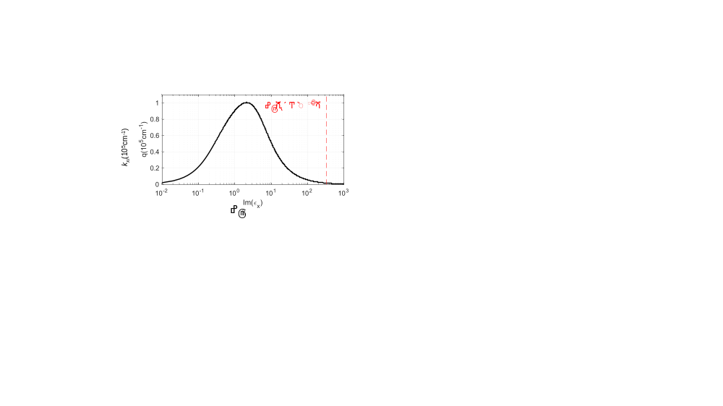
Figure S2. $ε_{xi}$ versus $k_{xi}$, where $ε_{xr}$ is fixed as 4, and the red line means $ε_{x}$ at resonance frequency 820 cm⁻¹.

Section 3 (S3): The Mechanism of PiFM detection for imaging PhPs of the α-MoO₃ flake.
The origin of the photo-induced interaction force detected by photo-induced force microscopy is usually described in terms of an interaction force between a light-induced dipole in an AFM tip and its mirror image in the sample while the tip is brought close to the surface of the sample. This interaction could be contributed by three classes: the material component, the round-trip component, and the direct component⁵. The material component represents the dispersive part of the material polarizability, which mostly depends on the optical properties of the topmost material and is the only component that contributes to the detected signal when no guided modes or localized resonances are supported by the sample. However, when phonon polaritons are present, a local spatial modulation of the electric field at the surface is also present. This also affects the tip-sample interaction and may produce, by means of interference with the material component, characteristic features (PiFM fringes) in the near-field optical image (polariton components). Importantly, we use the term components for referring to the interaction between the AFM tip and a local field that has a complex amplitude (amplitude and phase) that is associated with the specific phonon path.
In our configuration, two polariton components are considered in principle^{5,6}: (1) a roundtrip component (λ_{p}/2-period fringes), which produces fringes in the near-field optical image with the periodicity of half the phonon-polariton wavelength (λ_{p}). This component originates directly beneath the AFM tip, which firstly launches a polariton by the illuminating laser. Then, this polariton propagates as an anisotropic wave to the edge of the flake, where it is reflected back to the AFM tip, yielding an interference pattern between the tip-lunched and edge-reflected PhPs and thus the near-field fringes are observed parallel to the edge of the sample; (2) a direct component (λ_{p}-period fringes), which arise from plasmon polaritons launched by the sample edge other than the tip, generating the same periodicity as the polariton mode.
Figure S3 to Figure S6 are representative examples of PiFM images close to the edge of a single α-MoO₃ flake at various incident laser frequencies, respectively. Here, the experimental periodicities (PiFM fringes) correspond to the roundtrip component only, which was verified by analytical calculations (see Fig. 2d).
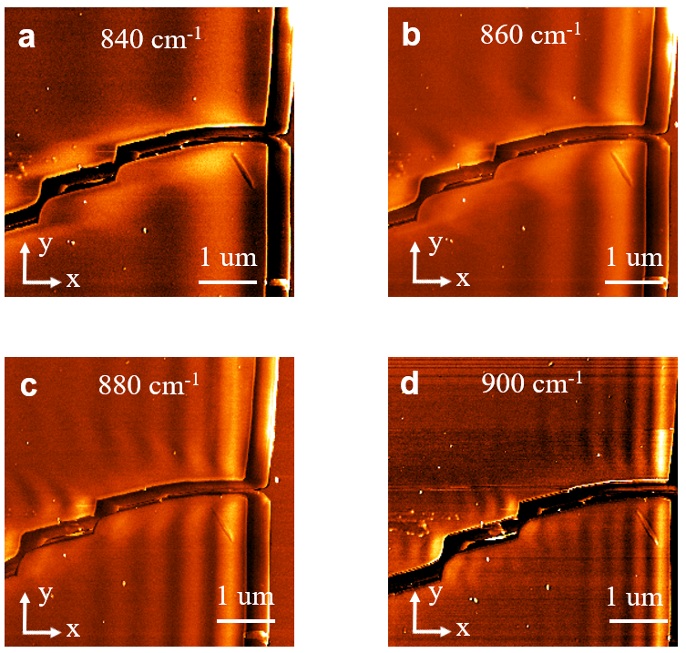
Figure S3. a-d, PiFM images of PhPs around the sample edge of a single α-MoO₃ flake under various incident frequencies. Labels with arrows indicate crystalline directions of the α-MoO₃ flake.
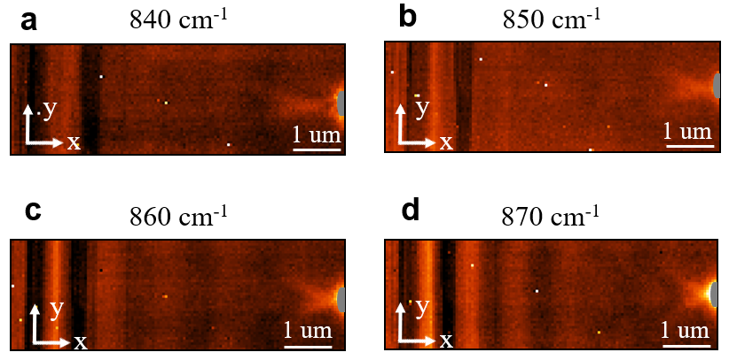
Figure S4. a-d, PiFM images of PhPs around the sample edge (left side) and near the apex of a nanorod denoted by the gray semicircle icon (right side) of a single α-MoO₃ flake under various frequencies. Labels with arrows indicate crystalline directions of the α-MoO₃ flake.
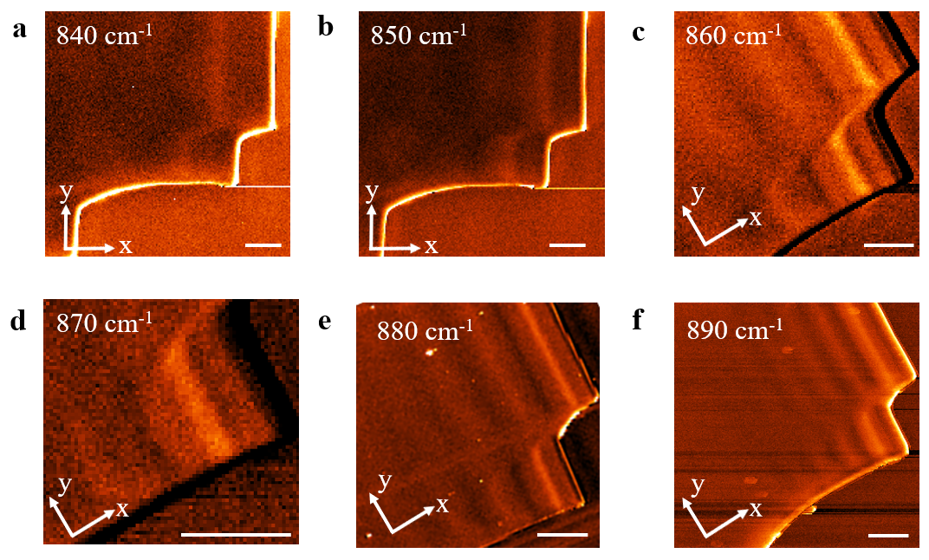
Figure S5. Real-space PiFM images for experimentally mapping the dispersion relation curve of PhPs along x-direction of the α-MoO₃ sample. a-g, PiFM images of PhPs in α-MoO₃ sample taken at the RB Ⅱ. Labels with arrows indicate crystalline directions of the α-MoO₃ flake.
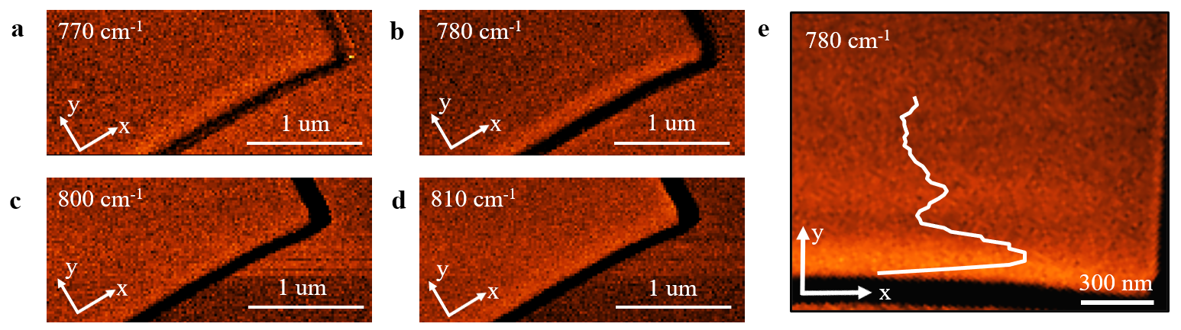
Figure S6. Real-space PiFM images for experimentally mapping the dispersion relation curve of PhPs along y-direction of the α-MoO₃ sample. a-g, PiFM images of PhPs in the α-MoO₃ sample taken at the RB I. Labels with arrows indicate crystalline directions of the α-MoO₃ flake.
The crystal direction | x [100] | y [001] | z [010]
$$ε_{∞}$$ | 4.0 | 5.2 | 2.4
$${w_{LO}}/{cm^{-1}}$$ | 972 | 851 | 1004
$${w_{TO}}/{cm^{-1}}$$ | 820 | 545 | 958
$$Γ/{cm^{-1}}$$ | 4 | 4 | 2
Table S2. Parameters used in calculating the relative permittivities of the α-MoO₃ crystal (Equation S1)².

References
- Dai S, et al. Tunable phonon polaritons in atomically thin van der Waals crystals of boron nitride. Science 343, 1125-1129 (2014).
- Zheng Z, et al. Highly Confined and Tunable Hyperbolic Phonon Polaritons in Van Der Waals Semiconducting Transition Metal Oxides. Adv. Mater. 30, e1705318 (2018).
- Fei Z, et al. Infrared nanoscopy of dirac plasmons at the graphene-SiO₂ interface. Nano lett. 11, 4701-4705 (2011).
- Álvarez-Pérez G, Voronin KV, Volkov VS, Alonso-González P, Nikitin AY. Analytical approximations for the dispersion of electromagnetic modes in slabs of biaxial crystals. Phy. Rev. B 100, 235408 (2019).
- Ambrosio A, et al. Selective excitation and imaging of ultraslow phonon polaritons in thin hexagonal boron nitride crystals. Light Sci. Appl. 7, 27 (2018).
- Liu J, et al. Near-Field Characterization of Graphene Plasmons by Photo-Induced Force Microscopy. Laser Photonics Rev. 12, 1800040 (2018).

