sFigure 1. Distribution of number of RT-PCR tests among confirmed cases
Mean: 4.35 times
SD: 1.85 times

sFigure 2. Estimated parameters on the dynamics of Ct levels in the pre-symptomatic and symptomatic compartments and recovery or death for two VOCs of SARS-Cov-2
- Alpha (b) Omicron
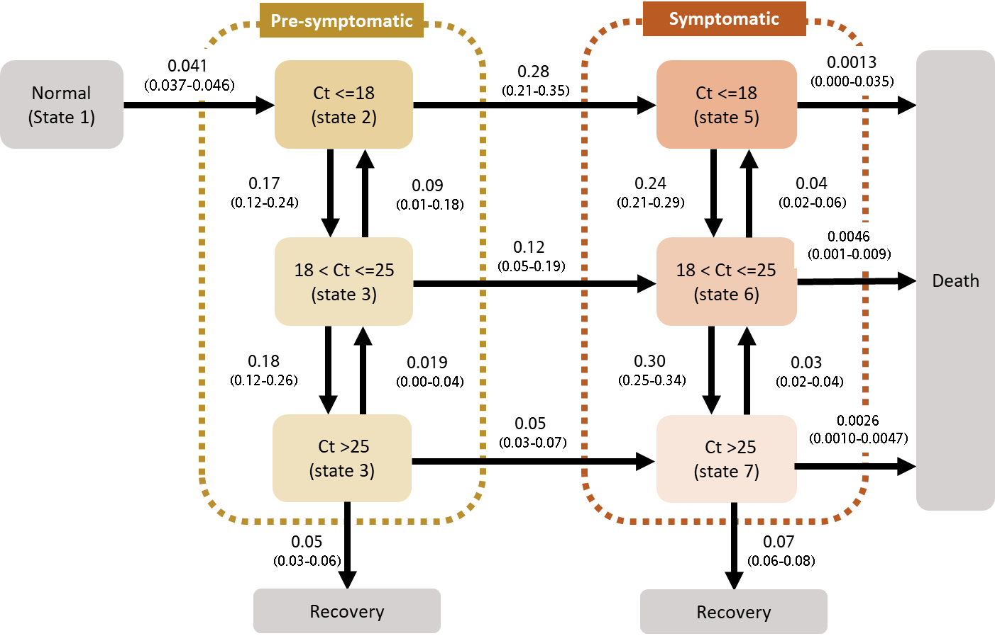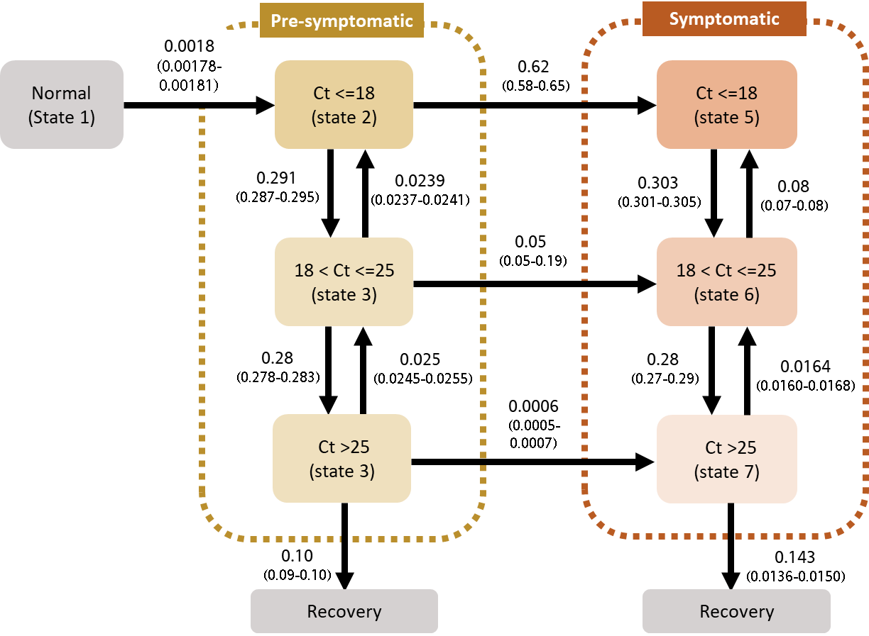

sFigure 3. Dynamics of the epidemic curve from the pre-symptomatic phase through the symptomatic phase until recovery
- Alpha (Pre-symptomatic) (b) Alpha (Symptomatic)
- Omicron (Pre-symptomatic) (d) Omicron (Symptomatic)

- Unvaccinated Omicron (Pre-symptomatic) (f) Unvaccinated Omicron (Symptomatic)
- Vaccinated Omicron (Pre-symptomatic) (h) Vaccinated Omicron (Symptomatic)

