Supplementary Materials
for
Bio-inspired multimodal learning with organic neuromorphic electronics for behavioral conditioning in robotics

Imke Krauhausen,^{1,2,3} Sophie Griggs,⁴ Iain McCulloch,⁴ Jaap M. J. den Toonder,^{1,2} Paschalis Gkoupidenis,³* Yoeri van de Burgt^{1,2}*
¹Institute for Complex Molecular Systems, Microsystems, Eindhoven University of Technology, The Netherlands.
²Institute for Complex Molecular Systems, Microsystems, Eindhoven University of Technology, The Netherlands.
³Max Planck Institute for Polymer Research, Mainz, Germany.
⁴Department of Chemistry, University of Oxford, United Kingdom.

This PDF file includes:
- Supplementary Figures S1-S6
Additional supplementary materials for this manuscript include:
- Supplementary Movies S1-S6

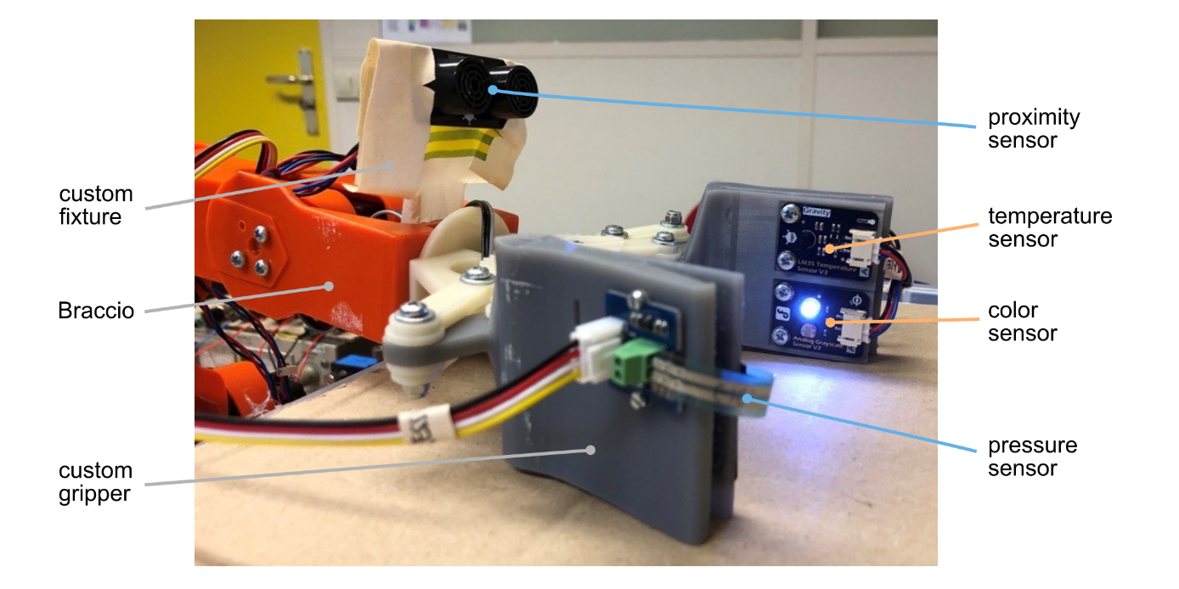
Fig. S1. Robotic setup. The robotic arm (orange) is built from the TinkerKit Braccio by Arduino. It has a custom-made 3D-printed hand to accommodate all sensors. The robotic arm is controlled via the Braccio Arduino shield on top of an Arduino Uno. A second Arduino Uno is used to collect the data from the sensors and the neuromorphic electronics via bipolar analog-digital converters as the Arduino itself is limited to reading positive voltages.

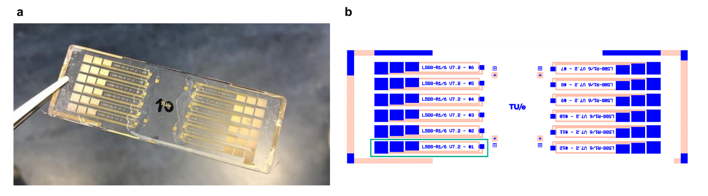
Fig. S2. Layout of the organic neuromorphic device. (a) Photograph of an exemplary glass slide with twelve organic neuromorphic devices. The ionic gel is visible on top of the gate and channel area of the devices. (b) Exemplary mask layout (W/L=1/6, L=500μm) for the organic neuromorphic device (blue=polymer, orange=gold). The glass slide contains twelve devices, one device is marked with a green box.

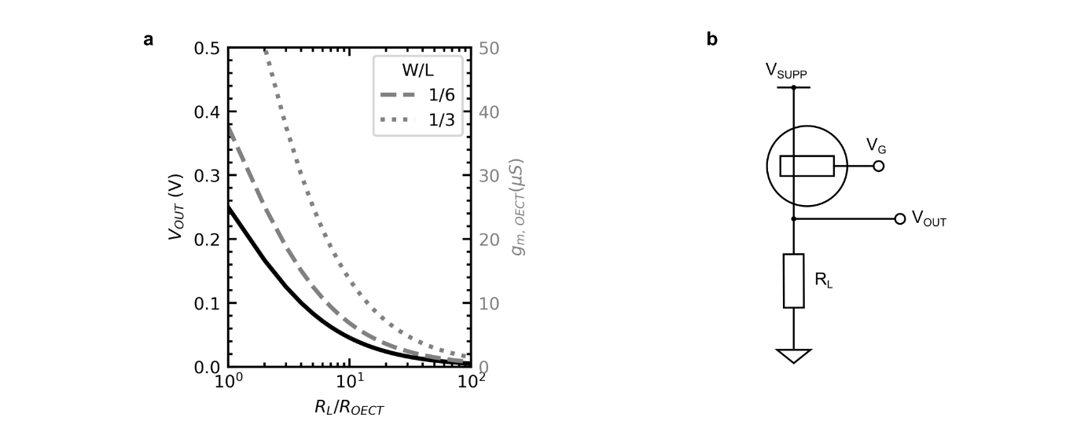
Fig. S3. Volatile characteristics for the organic electrochemical transistor with different resistance loads. (a) Dependence of the OECT signals on the ratio between OECT resistance and a load resistance. (b) Exemplary circuit of an OECT with a load resistance.

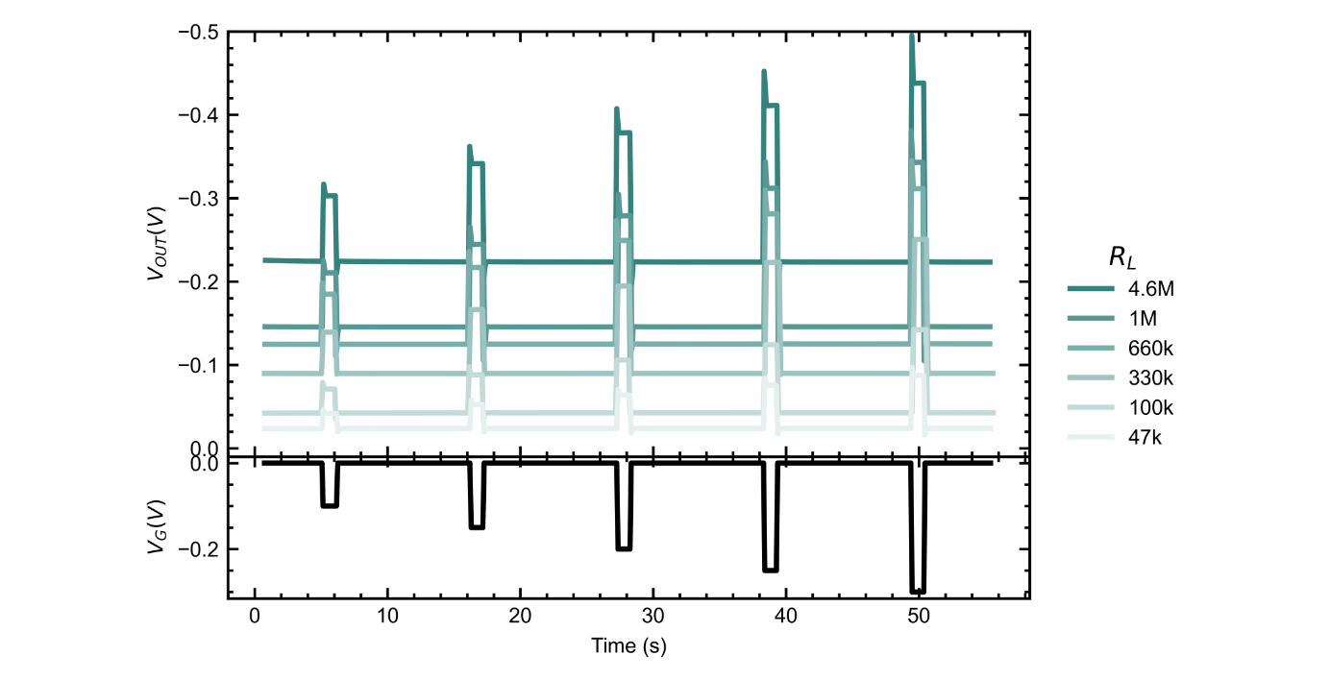
Fig. S4. Measurement of the output voltage of an OECT with different load resistances.

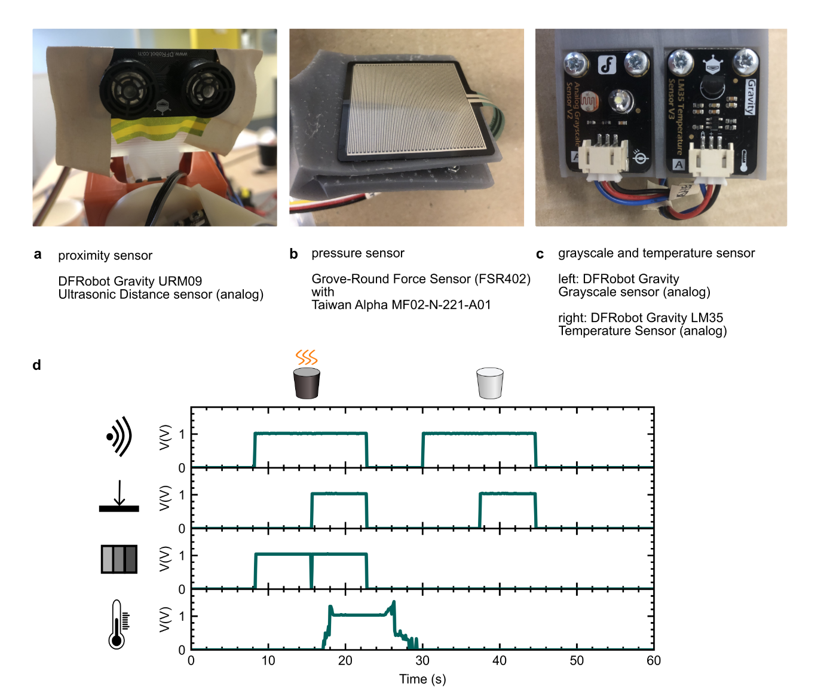
Fig. S5. Sensor setup. (a) Proximity sensor attached to custom fixture. (b) Pressure sensor attached to right custom gripper. (c) Grayscale and temperature sensor attached to left custom gripper. (d) Exemplary measurement of the sensor signals with +1V sensor output voltage for a hot, dark cup and a cold, white cup.

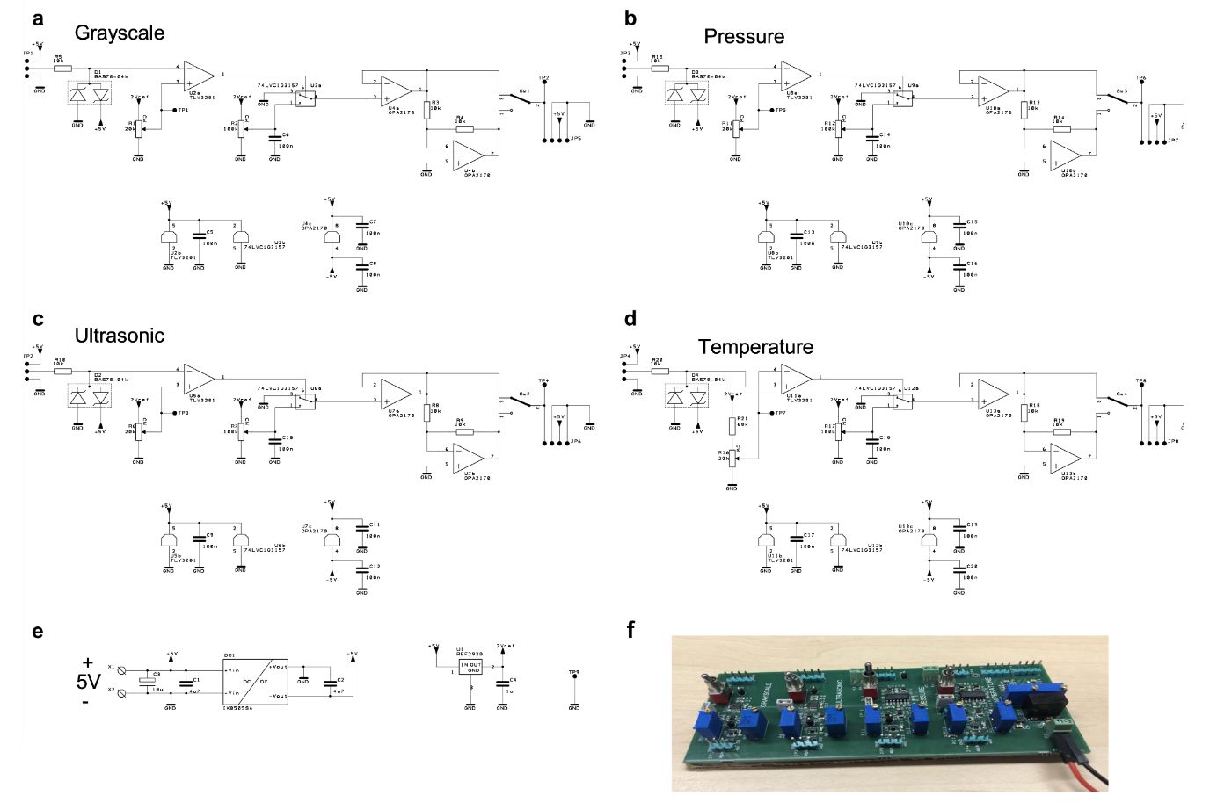
Fig. S6. Additional hardware circuitry to condition sensor signals. Circuit diagram of the additional hardware circuitry used to condition the sensor signals. Each sensor signal (grayscale, ultrasonic, pressure and temperature) can be defined in signal strength (voltage) and polarity (-/+) and a threshold can be determined below/above each sensor outputs no signal (0 V). (a) For color sensor. (b) For pressure sensor. (c) For proximity sensor. (d) For temperature sensor. (e) Circuit to provide different levels and polarities of supply voltage via the Arduino Uno 5V analog output. (f) Photograph of the printed circuit board without connected signals and cables.

Movie S1. Random, explorative behavior of the robot in its untrained, unconditioned initial state.
Movie S2. Behavior of the robot during the training of the (+)-branch.
Movie S3. Changed behavior of the robot after the training of the (+)-branch.
Movie S4. Robotic behavior before the training of the (-)-branch.
Movie S5. Behavior of the robot during the training of the (-)-branch.
Movie S6. Final changed behavior of the robot after training of the (+)- and (-)-branch.

