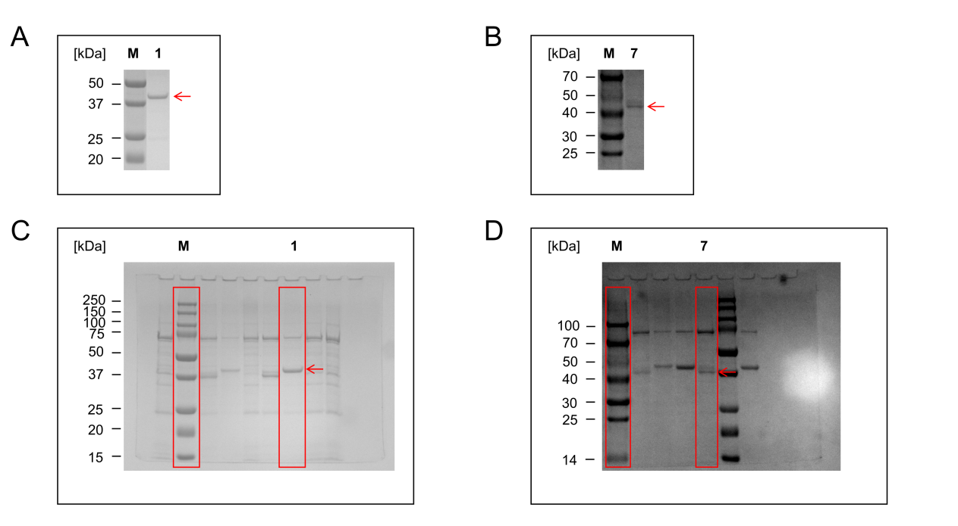
Fig. SDS PAGE analysis of purification of Sb2ODDs proteins.
A. lane 1, markers (M); lane 2, Sb2ODD1 protein (1); B. lane 1, markers (M); lane 2, Sb2ODD7 protein (7); C. Sb2ODD1 protein full uncropped gel and blot image; M, markers; 1, Sb2ODD1 protein; D. Sb2ODD7 protein full uncropped gel and blot image; M, markers; 7, Sb2ODD7 protein.

