Supplementary material for manuscript: Use of digital food records in clinical settings - lessons in translation from a randomised controlled trial

Table S1: Guidelines for Reporting Reliability and Agreement Studies checklist
Section | Detail | Completed
Title and Abstract | Identify in title or abstract that interrater/intrarater reliability or agreement was investigated. | Page 1- Abstract
Introduction | Name and describe the diagnostic or measurement device of interest explicitly. | Page 2- Introduction
 | Specify the subject population of interest | Page 2-Introduction
 | Specify the rater population of interest (if applicable) | N/A
 | Describe what is already known about reliability and agreement and provide rationale for the study (if applicable) | Page 2 and 3- Introduction
Methods | Explain how the sample size was chosen. State the determined number of raters, objects and replicate observations | Page 6- Data analysis, Method
 | Describe the sampling method | Page 3- Participants and Recruitment, Method
 | Describe the measurement/rating process (e.g. tie interval between repeated measurements, availability of clinical information, blinding). | Page 5 and 6 – Dietary assessment, Method
 | State whether measurements/rating were conducted independently | Page 3 and 4 – Dietary assessment, Method
 | Describe the statistical analysis | Page 6 and 7 – Data analysis, Method
Results | State the actual number of raters and subjects/objects which were included and the number of replicate observations which were conducted | Page 7 and 8- Participant characteristics
 | Describe the sample characteristics of raters and subjects (e.g., Training experience). | Page 10 – Agreement, Results
 | Report estimates of reliability and agreement including measures of uncertainty. | Page 10 – Agreement, Results
Discussion | Discuss the practical relevance of results | Page 12& 14- Discussion
9Auxiliary material | Provide detailed results if possible ( e.g. Online) | Supplementary material
Table S2: Consolidated criteria for reporting qualitative research checklist
No. Item | Guide questions/description | Reported on page #; section  Additional information (if relevant)
Domain 1: Research team and reflexivity
Personal Characteristics
- Interviewer/facilitator | Which author/s conducted the interview or focus group? | Page 7; Surveys and Interviews
- Credentials | What were the researcher’s credentials? E.g. PhD, MD | MNutr&Diet and BEx&NutrSc
- Occupation | What was their occupation at the time of the study? | PhD candidate and dietitian
- Gender | Was the researcher male or female? | Female
- Experience and training | What experience or training did the researcher have? | Page 7; Surveys and Interviews
Relationship with participants
- Relationship established | Was a relationship established prior to study commencement? | Page 6; Data Collection
- Participant knowledge of the interviewer | What did the participants know about the researcher? e.g. personal goals, reasons for doing the research | Page 7; Surveys and Interviews
- Interviewer characteristics | What characteristics were reported about the interviewer/facilitator? e.g. Bias, assumptions, reasons and interests in the research topic | Not reported
Domain 2: study design
Theoretical framework
- Methodological orientation and Theory | What methodological orientation was stated to underpin the study? e.g. grounded theory, discourse analysis, ethnography, phenomenology, content analysis | Page 9; Data Analysis
Participant Selection
- Sampling | How were participants selected? e.g. purposive, convenience, consecutive, snowball | Page 7; Surveys and Interviews
- Method of approach | How were participants approached? e.g. face-to-face, telephone, mail, email | Page 7; Surveys and Interviews
- Sample size | How many participants were in the study? | Page 10; Results (Participant characteristics)
- Non-participation | How many people refused to participate or dropped out? Reasons? | Page 10; Results (Participant characteristics)
Setting
- Setting of data collection | Where was the data collected? e.g. home, clinic, workplace | Page 7; Surveys and Interviews
- Presence of non-participation | Was anyone else present besides the participants and researchers? | Page 7; Surveys and Interviews
- Description of sample | What are the important characteristics of the sample? e.g. demographic data, date | Page 4; Participants & Recruitment
Data collection
- Interview guide | Were questions, prompts, guides provided by the authors? Was it pilot tested? | Page 7; Surveys and Interviews
- Repeat interviews | Were repeat interviews carried out? If yes, how many? | No repeat interviews were conducted
- Audio/visual recording | Did the research use audio or visual recording to collect the data? | Page 7 and 8; Surveys and Interviews
- Field notes | Were field notes made during and/or after the interview or focus group? | No field notes were taken during the interviews.
- Duration | What was the duration of the interviews or focus group? | Data not available
- Data saturation | Was data saturation discussed? | Page 9; Data Analysis
- Transcripts returned | Were transcripts returned to participants for comment and/or correction? | Transcripts were not returned to participants for comment and/or correction
Domain 3: analysis and findings
Data analysis
- Number of data coders | How many data coders coded the data? | Page 9; Data analysis
- Description of coding tree | Did authors provide a description of the coding tree? | No description of coding tree was provided.
- Derivation of themes | Were themes identified in advance or derived from the data? | Page 9; Data Analysis
- Software | What software, if applicable, was used to manage the data? | Page 9; Data Analysis
- Participant checking | Did participants provide feedback on the findings? | No
Reporting
- Quotations presented | Were participant quotations presented to illustrate the themes / findings? Was each quotation identified? e.g. participant number | Page 10; Data analysis
- Data and findings consistent | Was there consistency between the data presented and the findings? | Pages 15 to 17; Discussion
- Clarity of major themes | Were major themes clearly presented in the findings? | Pages 12 to 14 Results
- Clarity of minor themes | Is there a description of diverse cases or discussion of minor themes? | Pages 12 to 14
Table S3: Implausible participant-unadjusted data
Dietary Variables | Participantª 1 | Participantª 2 | Participantª 3 | Participant^{b} 4 | Participant^{b} 5
Macronutrients
Protein (g/d) | 17434.9 | 9879.1 | 606.201 | 292.976 | 196.8
Fat (g/d) | 48014.2 | 10557 | 579.331 | 203.677 | 70.4
Carbohydrate (g/d) | 127550 | 4651.7 | 3272.502 | 169.891 | 408.7
Food groups
Grains (serves/d) | 77.02 | 11.29 | 118.753 | 3.746 | 3.35
Fruit (serves/d) | 0.48 | 46.48 | 0.599 | 1.157 | 0.39
Vegetables (serves/d) | 17239.58 | 214.54 | 76.127 | 0.408 | 0
Meat and meat alternatives (serves/d) | 1.11 | 816.76 | 1.055 | 17.76 | 0.04
Dairy foods and milk alternatives (serves/d) | 7.56 | 6.03 | 0.023 | 4.044 | 17.64
Other nutrient and food components
Unsaturated oils (tsp/d) | 10379.9 | 1882.9 | 120.944 | 11.54 | 1
Solid fat^{c}(tsp/d) | 25.3 | 385.4 | 2.804 | 42.729 | 9.7
Wholegrains percent (%/d) | 0 | 0 | 0 | 24.812 | 0
Processed meats (serves/wk) | 0 | 0.15 | 0 | 0.145 | 0
Seafood (serves/wk) | 6.23 | 0 | 5.544 | 1.715 | 0
Nuts & Seeds (serves/wk) | 0 | 3590.86 | 0 | 4.445 | 0.28
Alcoholic drinks (standard drinks/d) | 205.89 | 0 | 0 | 0 | 0
Legumes (serves/wk) | 0 | 0 | 0 | 0 | 0
SFA (g/d) | 3774.5 | 1776.9 | 115.313 | 63.286 | 47.4
MUFA (g/d) | 27609 | 5497 | 182.461 | 82.924 | 14.5
PUFA (g/d) | 13383.1 | 2709.1 | 230.188 | 25.288 | 3.7
Fibre (g/d) | 23059.4 | 2089.1 | 346.412 | 15.263 | 11.2
Sugars (g/d) | 49537.5 | 2011.2 | 1317.342 | 91.718 | 312.5
Added Sugars (g/d) | 369.3 | 14.9 | 859.891 | 3.664 | 11.6
Energy (kJ/d) | 17434.9 | 654041.6 | 89494.16 | 15529.13 | 12906.8
ª These participants had more than one item that was implausible
^{b} These participants had only one item in their digital food record that was implausible.
^{c} Solid Fat refers to fats from animal based produce, hydrogenated oils, shortening, palm oil and coconut oil.
Abbreviations: g, grams; d, day; tsp, teaspoon; wk, week; IQR, interquartile range; SFA, saturated fatty acids; MUFA, monounsaturated fatty acids; PUFA, polyunsaturated fats.

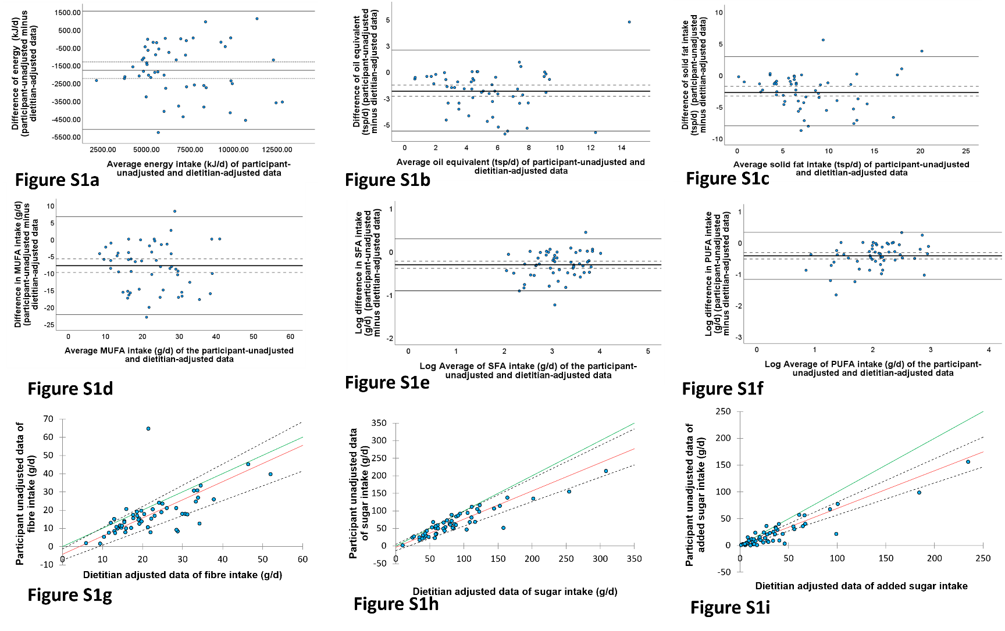

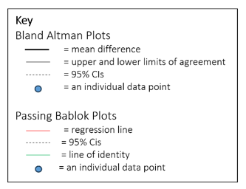

Figure S1a- i: Bland Altman and Passing and Bablok regression plots for other nutrient and food components, n=54.
Legend: Figure S1a-f are Bland Altman plots which show the difference between participant-unadjusted and dietitian-adjusted data versus the average of participant-unadjusted and dietitian-adjusted data. Figures Sfg-i are Passing Bablok regression plots which show the participant-unadjusted data versus the dietitian-adjustment data for other nutrient and food components.

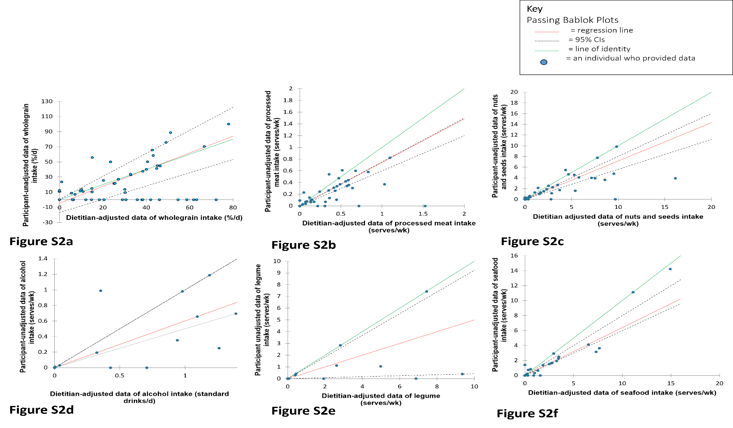

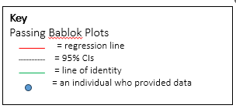

Figure S2a-f: Passing and Bablok regression plots for other food and nutrient components which had limited data due to several records with no consumption of the corresponding component recorded, n=54.
Legend: Passing plots show the difference between participant-unadjusted and dietitian-adjusted data versus the average of participant-unadjusted and dietitian-adjusted data.

Survey item | Very easy | Easy | Neither | Difficult | Very difficult | Did not use
Using the food diary app to enter  your diet information and review  your nutrition intake was... | 9 (18) | 23(46) | 6 (12) | 7 (14) | 2 (4) | 3(6)
Table S4: Survey item on ease of use of the digital foo record (n=50).

