Supplementary
Table S1. Friedman test results for absolute error ratio mean in DP test
N | 100
Chi-Square | .740
df | 2
p-value | .691

Table S2. Friedman test results for absolute error ratio mean in SP test
N | 100
Chi-Square | 9.500
df | 2
p-value | .009

Table S3. Sign test results for absolute error ratio mean in SP test
 |  | N
Absolute error ratio means for EG1 - Absolute error ratio means for CG | Negative Differences | 37
 | Positive Differences | 63
 | Ties | 0
 | Total | 100
Absolute error ratio means for EG2 - Absolute error ratio means for EG1 | Negative Differences | 62
 | Positive Differences | 38
 | Ties | 0
 | Total | 100
Absolute error ratio means for EG2 - Absolute error ratio means for CG | Negative Differences | 53
 | Positive Differences | 47
 | Ties | 0
 | Total | 100

Table S4. Friedman test results for time response in DP test
N | 100
Chi-Square | 1.940
df | 2
p-value | .379

Table S5. Friedman test results for time response in SP test
N | 100
Chi-Square | 6.020
df | 2
p-value | .049

Table S6. U Sign test results for response time in SP test
 | Response time for SP Mars - Response time for SP CG | Response time for SP Space - Response time for SP EG1 | Response time for SP Space - Response time for SP EG2
Z | -.700 | -2.900 | -.900
p-value | .484 | .004 | .368

Table S7. Sign test results for response time in SP test
 |  | N
Response time for SP EG1- Response time for SP CG | Negative Differences | 54
Response time for SP EG1- Response time for SP CG | Positive Differences | 46
Response time for SP EG1- Response time for SP CG | Ties | 0
Response time for SP EG1- Response time for SP CG | Total | 100
Response time for SP EG2 - Response time for SP EG1 | Negative Differences | 65
Response time for SP EG2 - Response time for SP EG1 | Positive Differences | 35
Response time for SP EG2 - Response time for SP EG1 | Ties | 0
Response time for SP EG2 - Response time for SP EG1 | Total | 100
Response time for SP EG2 - Response time for SP CG | Negative Differences | 55
Response time for SP EG2 - Response time for SP CG | Positive Differences | 45
Response time for SP EG2 - Response time for SP CG | Ties | 0
Response time for SP EG2 - Response time for SP CG | Total | 100

Table S8. Test of normality for absolute error ratio mean in DP test
 | Gender | Shapiro-Wilk
 | Gender | Statistic | df | p-value
Absolute error ratio means for DP CG | Male | .975 | 74 | .148
Absolute error ratio means for DP CG | Female | .914 | 26 | .032
Absolute error ratio means for DP EG1 | Male | .974 | 74 | .132
Absolute error ratio means for DP EG1 | Female | .978 | 26 | .823
Absolute error ratio means for DP EG2 | Male | .980 | 74 | .288
Absolute error ratio means for DP EG2 | Female | .973 | 26 | .714

Table S9. Test of homogeneity of variances (parametric) for absolute error ratio mean in DP test
 |  | Sum of Squares | df | Mean Square | F | p-value
Absolute error ratio means for DP EG1 | Between Groups | .014 | 1 | .014 | 4.814 | .031
Absolute error ratio means for DP EG1 | Within Groups | .287 | 98 | .003
Absolute error ratio means for DP EG1 | Total | .301 | 99
Absolute error ratio means for DP EG2 | Between Groups | .012 | 1 | .012 | 3.799 | .054
Absolute error ratio means for DP EG2 | Within Groups | .319 | 98 | .003
Absolute error ratio means for DP EG2 | Total | .331 | 99

Table S10. Point-biserial correlation for absolute error ratio mean in DP test and gender
 |  | Absolute error ratio means for DP Space | Gender
Absolute error ratio means for DP EG2 | Pearson Correlation | 1 | .193
Absolute error ratio means for DP EG2 | p-value |  | .054
Absolute error ratio means for DP EG2 | N | 100 | 100
Gender | Pearson Correlation | .193 | 1
Gender | p-value | .054
Gender | N | 100 | 100

Table S11. Point-biserial correlation for absolute error ratio mean in DP test and gender
 |  | Absolute error ratio means for DP Space | Gender
Absolute error ratio means for DP EG2 | Pearson Correlation | 1 | .193
Absolute error ratio means for DP EG2 | p-value |  | .054
Absolute error ratio means for DP EG2 | N | 100 | 100
Gender | Pearson Correlation | .193 | 1
Gender | p-value | .054
Gender | N | 100 | 100

Table S12. Test of homogeneity of variances (non-parametric) for absolute error ratio mean in DP test
Individual Difference |  | Sum of Squares | df | Mean Square | F | p-value
DP CG | Between Groups | 198.832 | 1 | 198.832 | 1.045 | .309
DP CG | Within Groups | 18638.891 | 98 | 190.193
DP CG | Total | 18837.723 | 99
DP EG1 | Between Groups | 54.618 | 1 | 54.618 | .267 | .606
DP EG1 | Within Groups | 20031.090 | 98 | 204.399
DP EG1 | Total | 20085.709 | 99

Table S13. Mann-Whitney U test results for absolute error ratio mean in DP test
 | Absolute error ratio means for
 | DP CG | DP EG1
Mann-Whitney U | 733.000 | 688.000
Z | -1.800 | -2.153
p-value | .072 | .031

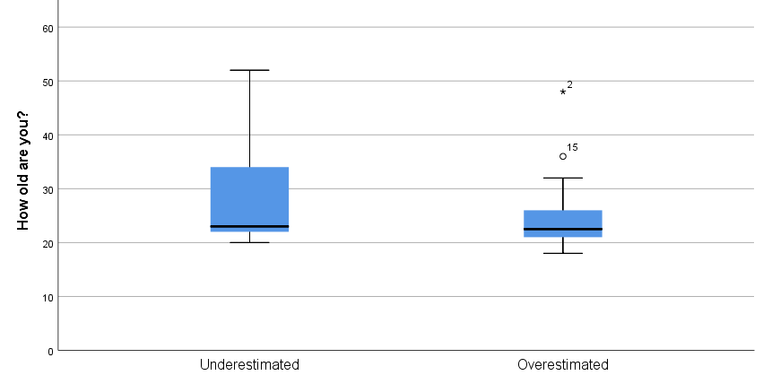
Figure S1. Boxplots for each category in the DP test under CG circumstances.
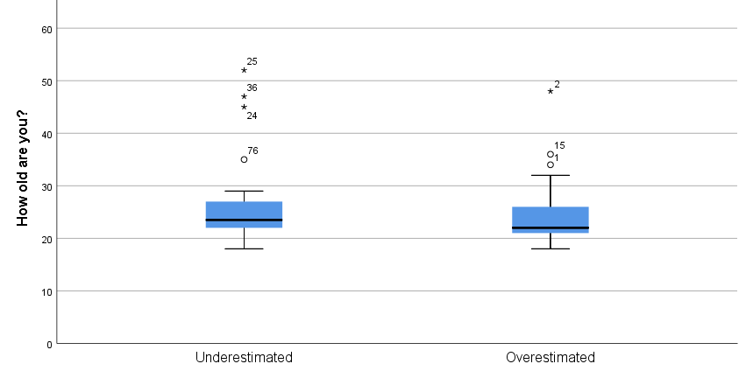
Figure S2. Boxplots for each category in the DP test under EG1 circumstances.

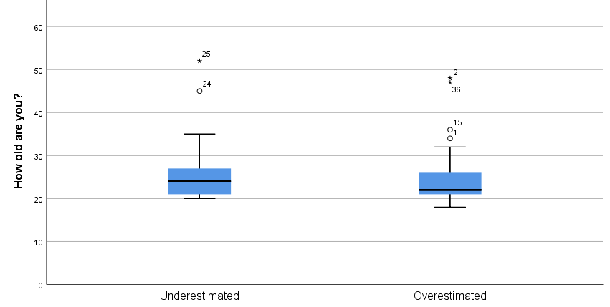
Figure S3. Boxplots for each category in the DP test under EG2 circumstances
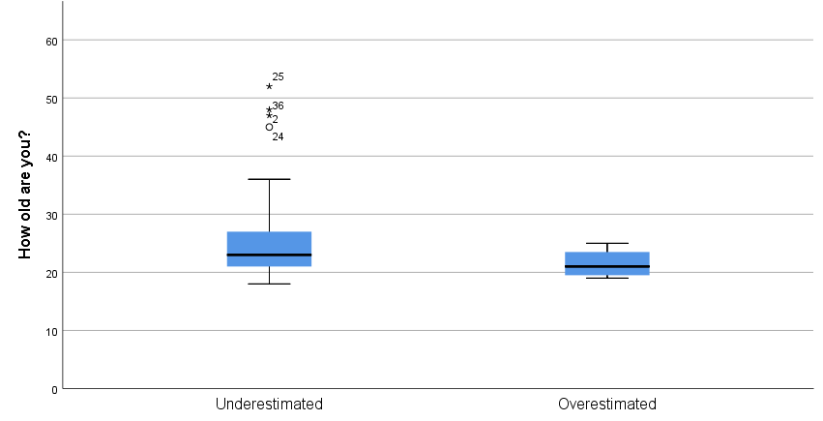
Figure S4. Boxplots for each category in the SP test under CG circumstances
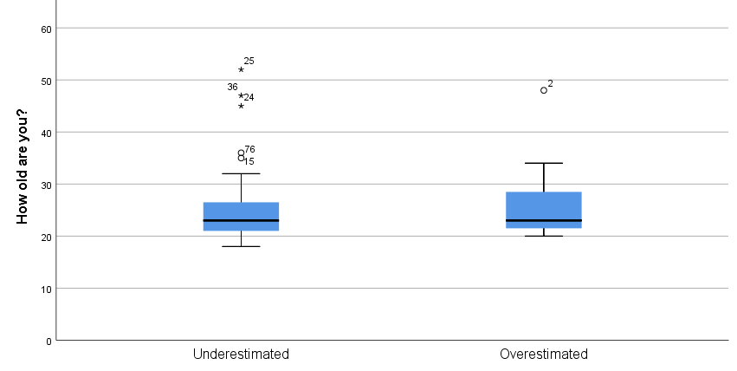
Figure S5. Boxplots for each category in the SP test under EG1 circumstances
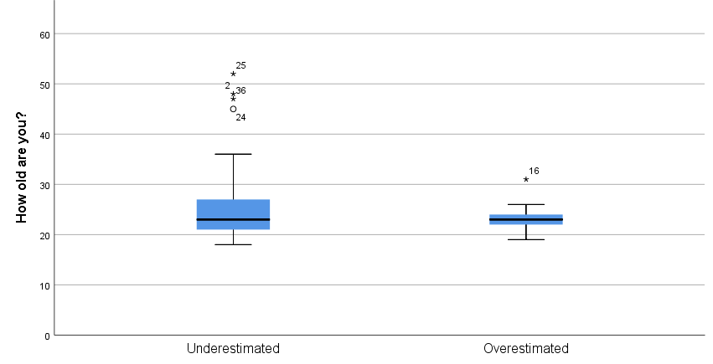
Figure S6. Boxplots for each category in the SP test under EG2 circumstances

