Supplemental materials

Supplemental Table 1 Averaged environmental conditions over the experimental growth period in different lighting
Per supplemental light treatment the average relative humidity, temperature and CO2 concentrations that were measured in the greenhouses are displayed with their standard deviations. The average solar light hours due to outside global radiation per day and an estimate of the solar light perceived by the plants in the greenhouse is shown. The presented values are averages over the growth period from the transfer of the plants to the two different light conditions until the end of the experiment.

Supplemental lighting type | HPS | LED | HPS | LED
Supplemental light | on | on | off | off
Relative humidity (in %) | 71.7 ± 6.4 | 74.3 ± 6.4 | 72.6 ± 5.5 | 72.5 ± 6.3
Temperature (in °C) | 22.6 ± 1.4 | 22.3 ± 1.5 | 19.1 ± 1.3 | 19.2 ± 1.4
CO₂ (in ppm) | 488 ± 76 | 461 ± 74 | 495 ± 55 | 465 ± 70
Estimated average solar light at plant height (in µmol m⁻² s⁻¹) | 72.1 |  | 0.2
Average solar light hours per day (in h) | 8.7 |  | 0.2

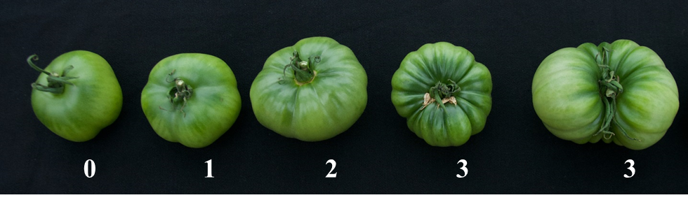Supplemental Figure 1 Examples for fruit shape
The fruit are sorted from left to right as round “0” and facetted “1” to “3” (the two right most tomatoes would both be scored as 3)
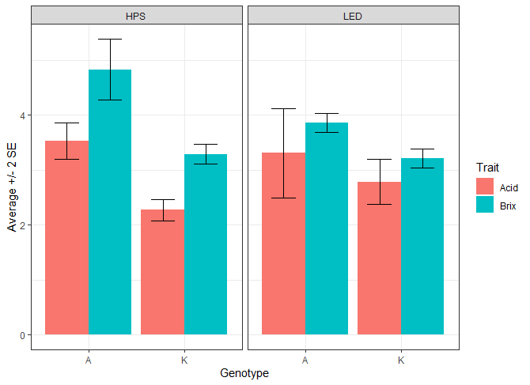
Supplemental Figure 2 Difference in Brix and acidity between the parents of the RIL population
Average and standard error of the mean for 6 to 11 replicates per genotype and condition.

A) 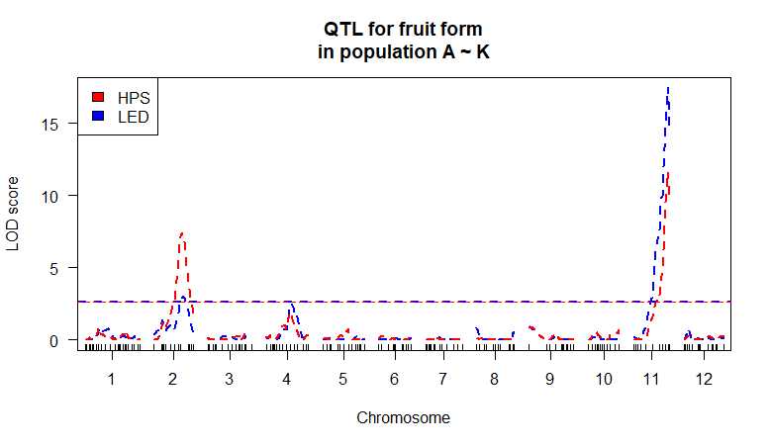
B) 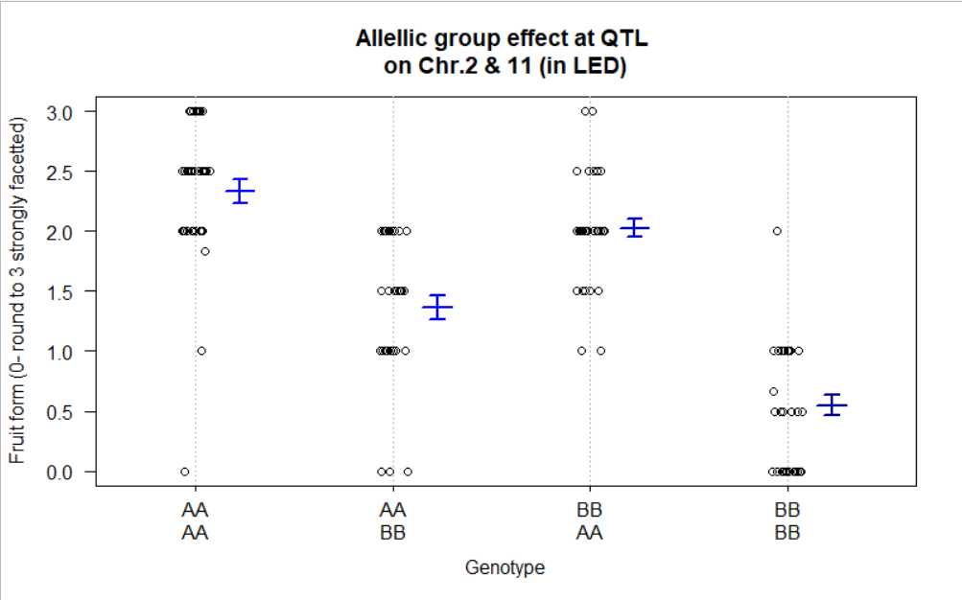
Supplemental Figure 3 QTL analysis for fruit shape
The fruit shape was scored from 0 as round to 3 as highly facetted in all genotypes of the RIL population. A QTL analysis revealed two QTLs one on chromosome 2 (22%/ 9% of explained variance) and one on chromosome 11 (38%/ 50% of explained variance) in both lighting conditions, HPS and LED (A). Grouping the genotypes by their allelic value at those QTL and determining the average fruit form score showed that carrying on both QTL the allele A from Kentucky Beefsteak conferred stronger faceting to the fruit (B; here exemplary shown for LED, same trend in HPS light).

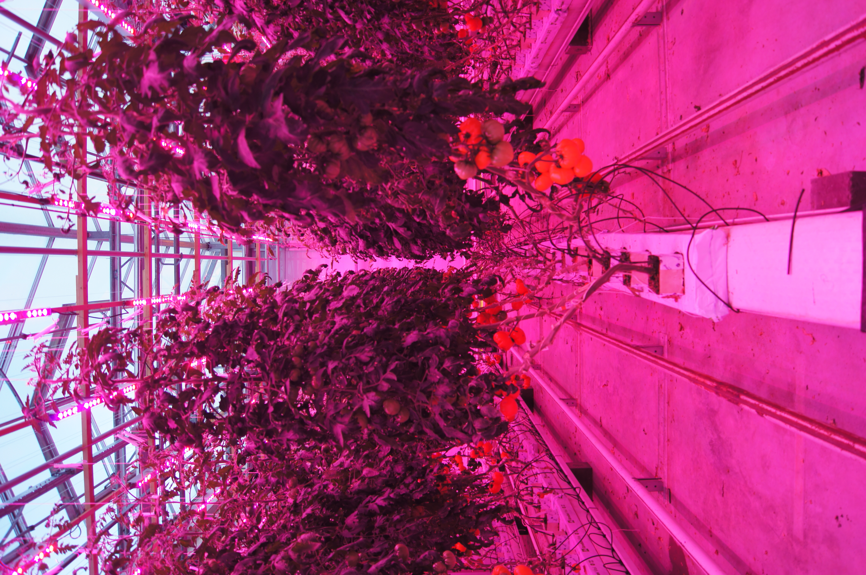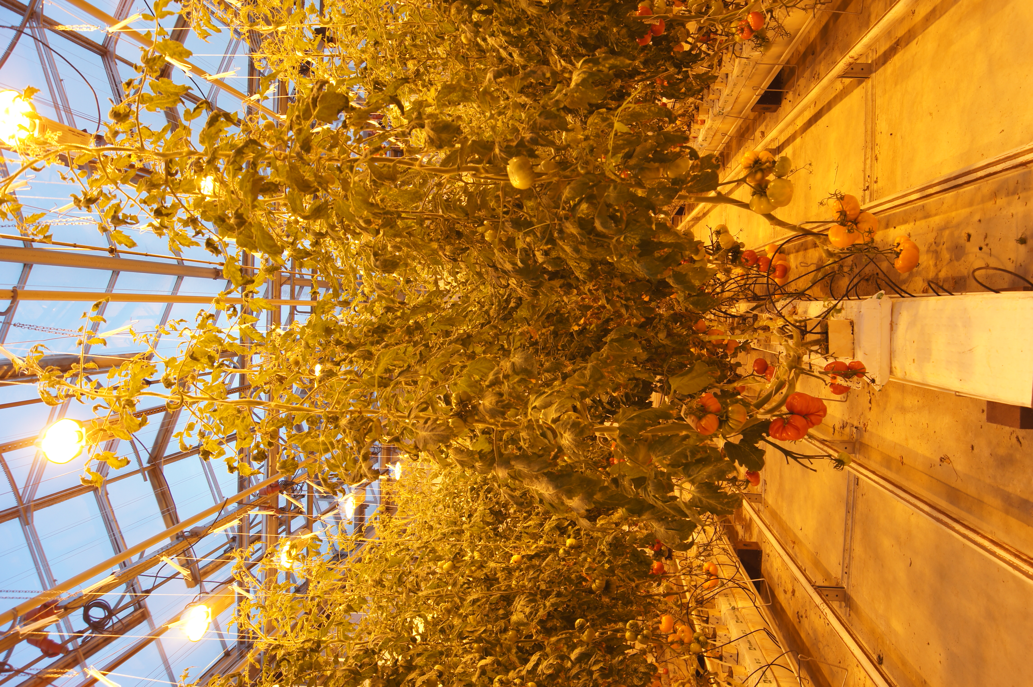
Supplemental Figure 4 Growth differences between LED and HPS light
The internode length of plants in LED light was shorter than under HPS and the plants on one growth bed bend further away from each other.

