Refinements Cr33Ni66 and CoCrNi
Final Recrystallized – separate fit from Cr and Ni-K edges, average scattering model
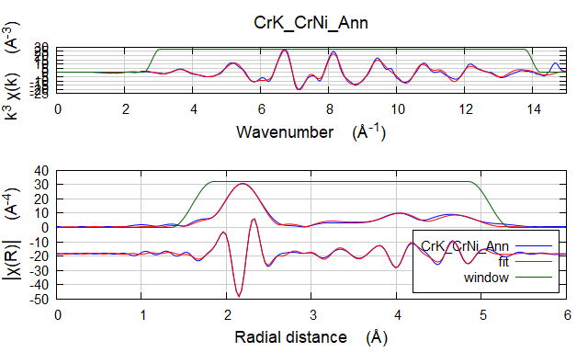

Independent points : 24.6083984
Number of variables : 8
Chi-square : 8456.8227239
Reduced chi-square : 509.1895378
R-factor : 0.0070757
Number of data sets : 1

guess parameters:
amp = 0.66186492 # +/- 0.03020024 [0.66186]
dEnot = 7.20896255 # +/- 0.42221496 [7.20896]
dR01 = -0.01099071 # +/- 0.00280312 [-0.01099]
ss01 = 0.00653384 # +/- 0.00037649 [0.00653]
dR02 = -0.01834845 # +/- 0.01172538 [-0.01835]
dR03 = -0.00303322 # +/- 0.00729345 [-0.00303]
dR04 = 0.00789822 # +/- 0.00794607 [0.00790]
thetaCr = 360.31970845 # +/- 10.26664169 [360.31971]

set parameters:
temperature = 300.00000000

name N S02 sigma^2 e0 delr Reff R
=================================================================================================
[feff_CrCo] Co1.1 12.000 0.662 0.00653 7.209 -0.01099 2.51450 2.50351
[feff_CrCo] Co1.2 6.000 0.662 0.00993 7.209 -0.01835 3.55600 3.53765
[feff_CrCo] Co1.1 Co1.1 48.000 0.662 0.00884 7.209 -0.01099 3.77170 3.76071
[feff_CrCo] Co1.1 Co1.1 24.000 0.662 0.00963 7.209 -0.02198 4.29250 4.27052
[feff_CrCo] Co1.1 Co1.2 48.000 0.662 0.00988 7.209 -0.01467 4.29250 4.27783
[feff_CrCo] Co1.3 24.000 0.662 0.01023 7.209 -0.00303 4.35520 4.35217
[feff_CrCo] Co1.1 Co1.1 48.000 0.662 0.00975 7.209 -0.02198 4.69210 4.67012
[feff_CrCo] Co1.1 Co1.3 96.000 0.662 0.01021 7.209 -0.00701 4.69210 4.68509
[feff_CrCo] Co1.4 12.000 0.662 0.01036 7.209 0.00790 5.02890 5.03680
[feff_CrCo] Co1.1 Co1.1 12.000 0.662 0.00971 7.209 -0.02198 5.02890 5.00692
[feff_CrCo] Co1.1 Co1.4 24.000 0.662 0.01036 7.209 0.00790 5.02890 5.03680
[feff_CrCo] Co1.1 12.000 0.662 0.00971 7.209 -0.02198 5.02890 5.00692
[feff_CrCo] Co1.1 Co1.4 Co1.1 12.000 0.662 0.01036 7.209 0.00790 5.02890 5.03680

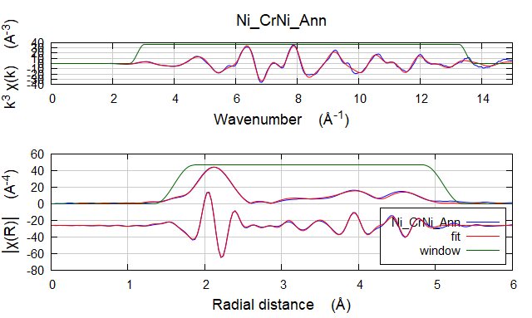

Independent points : 23.5048828
Number of variables : 8
Chi-square : 4192.8105081
Reduced chi-square : 270.4187164
R-factor : 0.0056804
Number of data sets : 1

guess parameters:
amp = 1.07114199 # +/- 0.04658692 [0.96401]
dEnot = -6.73652318 # +/- 0.48006996 [-6.84497]
dR01 = -0.02422250 # +/- 0.00299631 [-0.02564]
ss01 = 0.00659365 # +/- 0.00036690 [0.00584]
dR02 = -0.01542126 # +/- 0.01003819 [-0.01635]
dR03 = -0.01805636 # +/- 0.00650291 [-0.02058]
dR04 = -0.01878745 # +/- 0.00717312 [-0.01993]
thetaCo = 364.21963624 # +/- 9.75399045 [380]

set parameters:
temperature = 300.00000000

name N S02 sigma^2 e0 delr Reff R
=================================================================================================
[feff_NiCo] Co1.1 12.000 1.071 0.00659 -6.737 -0.02422 2.51450 2.49028
[feff_NiCo] Co1.2 6.000 1.071 0.00913 -6.737 -0.01542 3.55600 3.54058
[feff_NiCo] Co1.1 Co1.1 48.000 1.071 0.00827 -6.737 -0.02422 3.77170 3.74748
[feff_NiCo] Co1.1 Co1.1 24.000 1.071 0.00918 -6.737 -0.04845 4.29250 4.24406
[feff_NiCo] Co1.1 Co1.2 48.000 1.071 0.00918 -6.737 -0.01982 4.29250 4.27268
[feff_NiCo] Co1.3 24.000 1.071 0.00941 -6.737 -0.01806 4.35520 4.33714
[feff_NiCo] Co1.1 Co1.1 48.000 1.071 0.00943 -6.737 -0.04845 4.69210 4.64365
[feff_NiCo] Co1.1 Co1.3 96.000 1.071 0.00944 -6.737 -0.02114 4.69210 4.67096
[feff_NiCo] Co1.4 12.000 1.071 0.00953 -6.737 -0.01879 5.02890 5.01011
[feff_NiCo] Co1.1 Co1.1 12.000 1.071 0.00951 -6.737 -0.04845 5.02890 4.98046
[feff_NiCo] Co1.1 Co1.4 24.000 1.071 0.00953 -6.737 -0.01879 5.02890 5.01011
[feff_NiCo] Co1.1 12.000 1.071 0.00951 -6.737 -0.04845 5.02890 4.98046
[feff_NiCo] Co1.1 Co1.4 Co1.1 12.000 1.071 0.00953 -6.737 -0.01879 5.02890 5.01011

Final Aged – simultaneous fit from Cr and Ni-K edges, separating Cr and Ni contributions
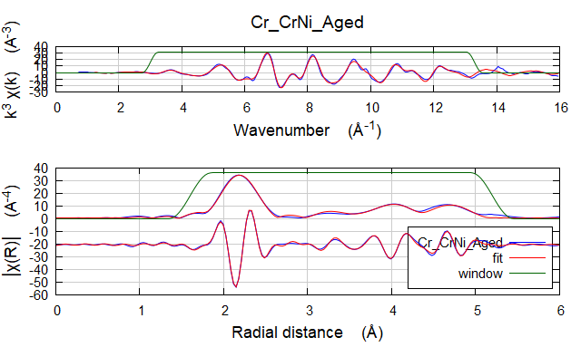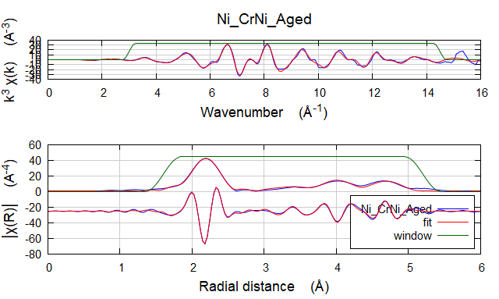

Independent points : 49.1640625
Number of variables : 16
Chi-square : 17366.1937672
Reduced chi-square : 523.6449475
R-factor : 0.0078170
Number of data sets : 2

guess parameters:
dRCrCr = 0.01418623 # +/- 0.04326918 [0.01419]
dRNiCr = -0.02269765 # +/- 0.00714948 [-0.02270]
dRNiNi = -0.02536639 # +/- 0.00501140 [-0.02537]
ssNiCr = 0.00595111 # +/- 0.00025179 [0.00595]
ssNiNi = 0.00566862 # +/- 0.00038485 [0.00567]
N(Ni-Cr) = 3.71088307 # +/- 1.10750454 [3.71088]
N(Cr-Cr) = 1.96366208 # +/- 1.26656793 [1.96366]
thetaCo = 378.12042740 # +/- 6.61587402 [378.12043]
dRNi1st = -0.02316179 # +/- 0.01463549 [-0.02316]
dRNi2nd = -0.01378242 # +/- 0.01217153 [-0.01378]
dRNi3rd = -0.03279579 # +/- 0.00688938 [-0.03280]
dRNi4th = -0.03066818 # +/- 0.01094734 [-0.03067]
dRCr1st = -0.01199041 # +/- 0.01166625 [-0.01199]
dRCr2nd = -0.02031936 # +/- 0.01122429 [-0.02032]
dRCr3rd = -0.01704414 # +/- 0.00612417 [-0.01704]
dRCr4th = -0.00955132 # +/- 0.01008192 [-0.00955]

set parameters:
ampNi = 0.84000000
dEnotNi = 5.77018000
ampCr = 0.70000000
dEnotCr = 6.85381000
ssCrCr = 0.00661000
temperature = 300.00000000

=================================================================================================
[feff_CrCr] Cr1.1 1.000 1.375 0.00661 6.854 0.01419 2.51450 2.52869
[feff_CrNi] Ni1.1 1.000 7.025 0.00595 6.854 -0.02270 2.51450 2.49180
[feff_CrCr] Cr1.2 6.000 0.233 0.00962 6.854 -0.02032 3.55600 3.53568
[feff_CrNi] Ni1.2 6.000 0.466 0.00908 6.854 -0.02032 3.55600 3.53568
[feff_CrCo] Co1.1 Co1.1 48.000 0.700 0.00807 6.854 -0.01199 3.77170 3.75971
[feff_CrCo] Co1.1 Co1.1 24.000 0.700 0.00879 6.854 -0.02398 4.29250 4.26852
[feff_CrCo] Co1.1 Co1.2 48.000 0.700 0.00902 6.854 -0.01615 4.29250 4.27635
[feff_CrCo] Co1.3 24.000 0.700 0.00934 6.854 -0.01704 4.35520 4.33816
[feff_CrCo] Co1.1 Co1.1 48.000 0.700 0.00890 6.854 -0.02398 4.69210 4.66812
[feff_CrCo] Co1.1 Co1.3 96.000 0.700 0.00932 6.854 -0.01452 4.69210 4.67758
[feff_CrCo] Co1.4 12.000 0.700 0.00945 6.854 -0.00955 5.02890 5.01935
[feff_CrCo] Co1.1 Co1.1 12.000 0.700 0.00886 6.854 -0.02398 5.02890 5.00492
[feff_CrCo] Co1.1 Co1.4 24.000 0.700 0.00945 6.854 -0.00955 5.02890 5.01935
[feff_CrCo] Co1.1 12.000 0.700 0.00886 6.854 -0.02398 5.02890 5.00492
[feff_CrCo] Co1.1 Co1.4 Co1.1 12.000 0.700 0.00945 6.854 -0.00955 5.02890 5.01935

name N S02 sigma^2 e0 delr Reff R
=================================================================================================
[feff_NiCr] Cr1.1 1.000 3.117 0.00595 5.770 -0.02270 2.51450 2.49180
[feff_NiNi] Ni1.1 1.000 6.963 0.00567 5.770 -0.02537 2.51450 2.48913
[feff_NiCr] Cr1.2 6.000 0.280 0.00907 5.770 -0.01378 3.55600 3.54222
[feff_NiNi] Ni1.2 6.000 0.559 0.00852 5.770 -0.01378 3.55600 3.54222
[feff_NiCo] Co1.1 Co1.1 48.000 0.840 0.00771 5.770 -0.02316 3.77170 3.74854
[feff_NiCo] Co1.1 Co1.1 24.000 0.840 0.00855 5.770 -0.04632 4.29250 4.24618
[feff_NiCo] Co1.1 Co1.2 48.000 0.840 0.00856 5.770 -0.01847 4.29250 4.27403
[feff_NiCo] Co1.3 24.000 0.840 0.00877 5.770 -0.03280 4.35520 4.32240
[feff_NiCo] Co1.1 Co1.1 48.000 0.840 0.00878 5.770 -0.04632 4.69210 4.64578
[feff_NiCo] Co1.1 Co1.3 96.000 0.840 0.00880 5.770 -0.02798 4.69210 4.66412
[feff_NiCo] Co1.4 12.000 0.840 0.00887 5.770 -0.03067 5.02890 4.99823
[feff_NiCo] Co1.1 Co1.1 12.000 0.840 0.00886 5.770 -0.04632 5.02890 4.98258
[feff_NiCo] Co1.1 Co1.4 24.000 0.840 0.00887 5.770 -0.03067 5.02890 4.99823
[feff_NiCo] Co1.1 12.000 0.840 0.00886 5.770 -0.04632 5.02890 4.98258
[feff_NiCo] Co1.1 Co1.4 Co1.1 12.000 0.840 0.00887 5.770 -0.03067 5.02890 4.99823

Comparison between results and simulations (just the plot)

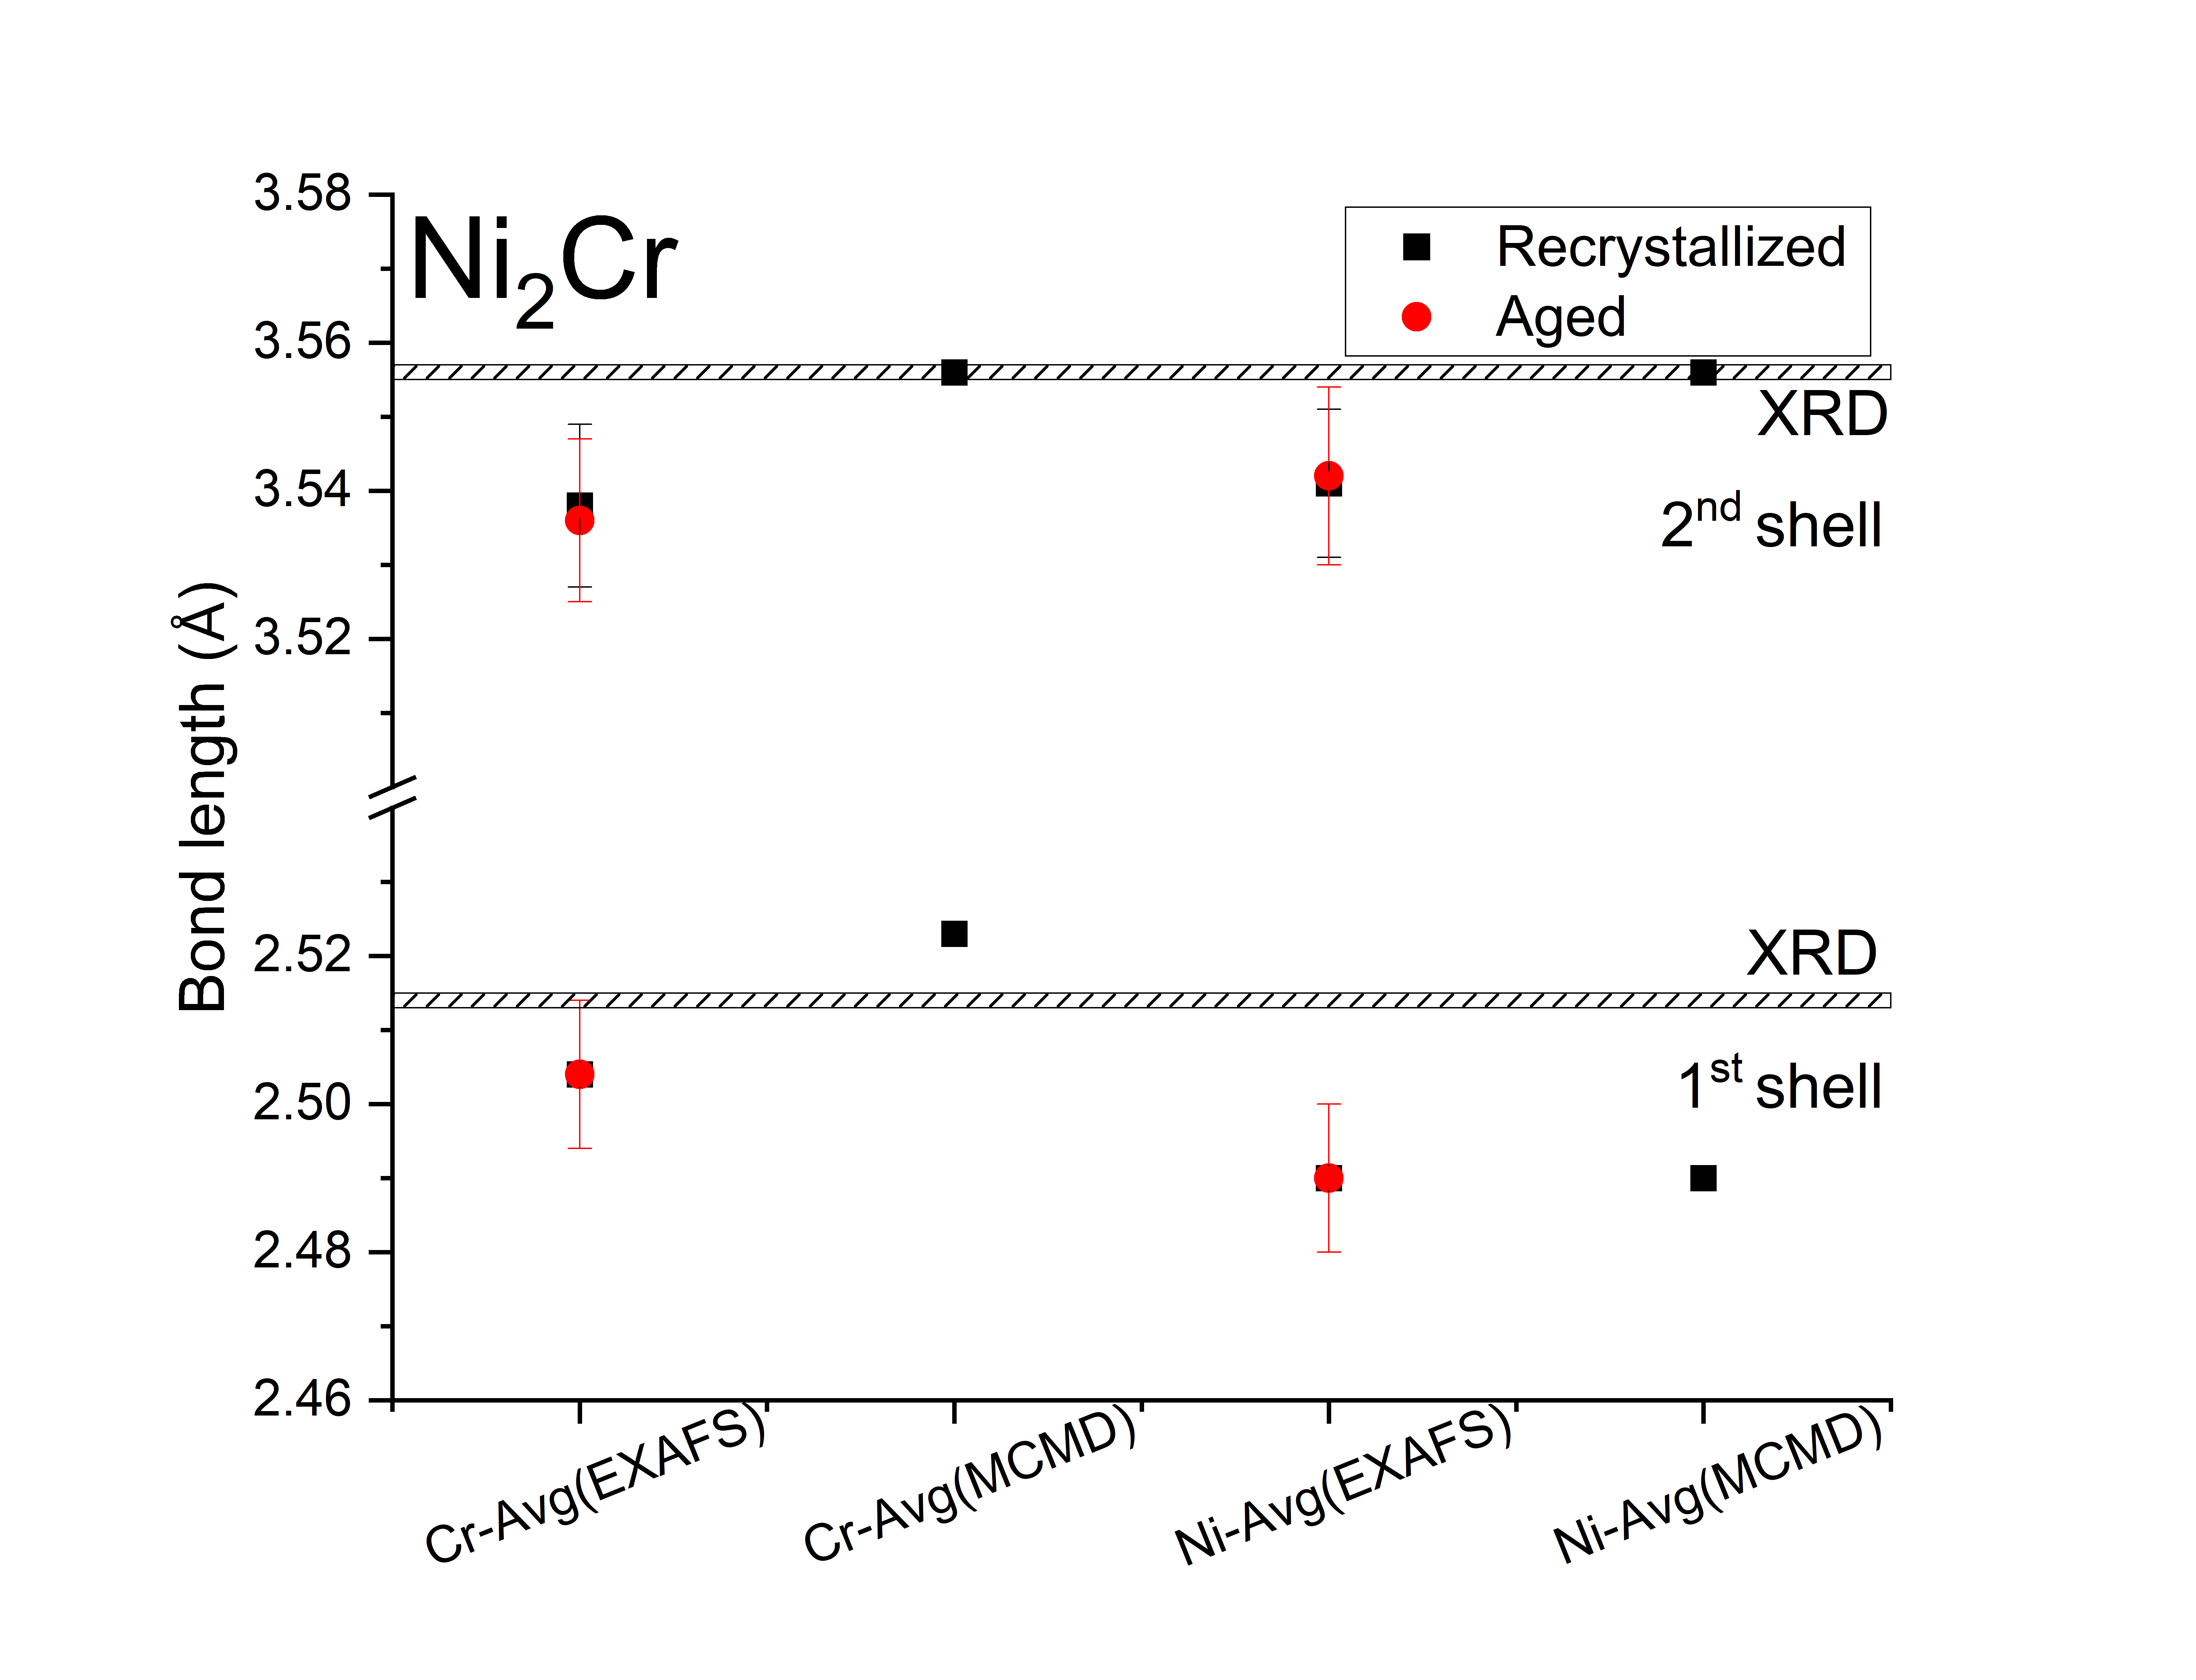

Final CrCoNi Recrystallized – separate fit from Cr, Co and Ni-K edges, average scattering model

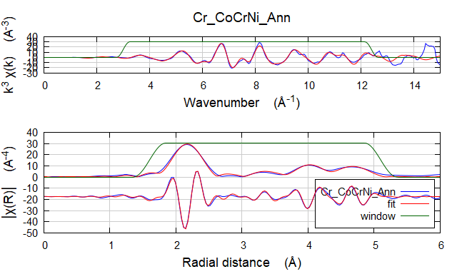

Independent points : 20.6357422
Number of variables : 8
Chi-square : 10102.3248904
Reduced chi-square : 799.5038788
R-factor : 0.0142418
Number of data sets : 1

guess parameters:
amp = 0.54692668 # +/- 0.04037598 [0.54913]
dEnot = 6.65859871 # +/- 0.70711775 [7.13945]
dR01 = -0.00675651 # +/- 0.00510384 [-0.00322]
dR02 = -0.02089059 # +/- 0.01953265 [-0.03536]
dR03 = 0.01256723 # +/- 0.01185215 [0.01098]
dR04 = 0.00086960 # +/- 0.01248821 [0.00497]
thetaFe = 414.35427273 # +/- 24.38983461 [410.50251]
ss01 = 0.00483831 # +/- 0.00066922 [0.00474]

set parameters:
temperature = 300.00000000

: name = Cr_CoCrNi_Ann
: k-range = 3.000 - 12.4
: dk = 0.5
: k-window = Hanning
: k-weight = 1,2,3
: R-range = 1.6 - 5.1
: dR = 0.5
: R-window = Hanning
: fitting space = r
: background function = no
: phase correction = no
: background removal = E0: 6021, Rbkg: 1.0, range: [0:16.03], clamps: 0/24, kw: 2
: user-supplied epsilon_k = 0
: epsilon_k by k-weight = 4.988e-004
: epsilon_r by k-weight = 2.725e-001
: R-factor by k-weight = 1 -> 0.01616, 2 -> 0.01214, 3 -> 0.01442

name N S02 sigma^2 e0 delr Reff R
=================================================================================================
[feff_CrFe] Fe1.1 12.000 0.547 0.00484 6.659 -0.00676 2.51450 2.50774
[feff_CrFe] Fe1.2 6.000 0.547 0.00788 6.659 -0.02089 3.55600 3.53511
[feff_CrFe] Fe1.1 Fe1.1 48.000 0.547 0.00710 6.659 -0.00676 3.77170 3.76494
[feff_CrFe] Fe1.1 Fe1.1 24.000 0.547 0.00781 6.659 -0.01351 4.29250 4.27899
[feff_CrFe] Fe1.1 Fe1.2 48.000 0.547 0.00790 6.659 -0.01382 4.29250 4.27868
[feff_CrFe] Fe1.3 24.000 0.547 0.00812 6.659 0.01257 4.35520 4.36777
[feff_CrFe] Fe1.1 Fe1.1 48.000 0.547 0.00797 6.659 -0.01351 4.69210 4.67859
[feff_CrFe] Fe1.1 Fe1.3 96.000 0.547 0.00813 6.659 0.00291 4.69210 4.69501
[feff_CrFe] Fe1.4 12.000 0.547 0.00821 6.659 0.00087 5.02890 5.02977
[feff_CrFe] Fe1.1 Fe1.1 12.000 0.547 0.00799 6.659 -0.01351 5.02890 5.01539
[feff_CrFe] Fe1.1 Fe1.4 24.000 0.547 0.00821 6.659 0.00087 5.02890 5.02977
[feff_CrFe] Fe1.1 12.000 0.547 0.00799 6.659 -0.01351 5.02890 5.01539
[feff_CrFe] Fe1.1 Fe1.4 Fe1.1 12.000 0.547 0.00821 6.659 0.00087 5.02890 5.02977

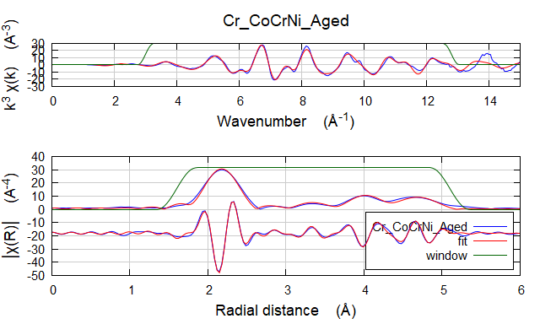

Independent points : 21.5185547
Number of variables : 8
Chi-square : 15905.1278589
Reduced chi-square : 1176.5405568
R-factor : 0.0142916
Number of data sets : 1

guess parameters:
amp = 0.54912573 # +/- 0.03881106 [0.54692]
dEnot = 7.13945247 # +/- 0.67908980 [6.65861]
dR01 = -0.00321630 # +/- 0.00469246 [-0.00676]
dR02 = -0.03536284 # +/- 0.01853659 [-0.02089]
dR03 = 0.01097554 # +/- 0.01145123 [0.01257]
dR04 = 0.00496866 # +/- 0.01198775 [0.00087]
thetaFe = 410.50250613 # +/- 22.62164124 [414.35571]
ss01 = 0.00473579 # +/- 0.00060907 [0.00484]

set parameters:
temperature = 300.00000000

: name = Cr_CoCrNi_Aged
: k-range = 3.000 - 12.8
: dk = 0.5
: k-window = Hanning
: k-weight = 1,2,3
: R-range = 1.6 - 5.1
: dR = 0.5
: R-window = Hanning
: fitting space = r
: background function = no
: phase correction = no
: background removal = E0: 6021, Rbkg: 1.0, range: [0:16.03], clamps: 0/24, kw: 2
: user-supplied epsilon_k = 0
: epsilon_k by k-weight = 3.107e-004
: epsilon_r by k-weight = 1.697e-001
: R-factor by k-weight = 1 -> 0.01625, 2 -> 0.01202, 3 -> 0.01460

name N S02 sigma^2 e0 delr Reff R
=================================================================================================
[feff_CrFe] Fe1.1 12.000 0.549 0.00474 7.139 -0.00322 2.51450 2.51128
[feff_CrFe] Fe1.2 6.000 0.549 0.00802 7.139 -0.03536 3.55600 3.52064
[feff_CrFe] Fe1.1 Fe1.1 48.000 0.549 0.00722 7.139 -0.00322 3.77170 3.76848
[feff_CrFe] Fe1.1 Fe1.1 24.000 0.549 0.00795 7.139 -0.00643 4.29250 4.28607
[feff_CrFe] Fe1.1 Fe1.2 48.000 0.549 0.00804 7.139 -0.01929 4.29250 4.27321
[feff_CrFe] Fe1.3 24.000 0.549 0.00826 7.139 0.01098 4.35520 4.36618
[feff_CrFe] Fe1.1 Fe1.1 48.000 0.549 0.00811 7.139 -0.00643 4.69210 4.68567
[feff_CrFe] Fe1.1 Fe1.3 96.000 0.549 0.00827 7.139 0.00388 4.69210 4.69598
[feff_CrFe] Fe1.4 12.000 0.549 0.00836 7.139 0.00497 5.02890 5.03387
[feff_CrFe] Fe1.1 Fe1.1 12.000 0.549 0.00813 7.139 -0.00643 5.02890 5.02247
[feff_CrFe] Fe1.1 Fe1.4 24.000 0.549 0.00836 7.139 0.00497 5.02890 5.03387
[feff_CrFe] Fe1.1 12.000 0.549 0.00813 7.139 -0.00643 5.02890 5.02247
[feff_CrFe] Fe1.1 Fe1.4 Fe1.1 12.000 0.549 0.00836 7.139 0.00497 5.02890 5.03387

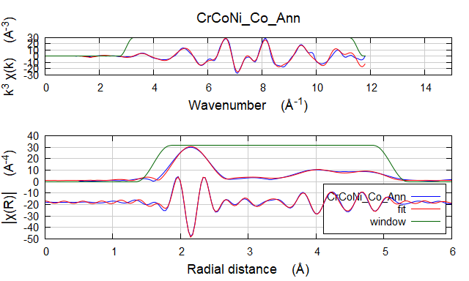

Independent points : 18.6494141
Number of variables : 8
Chi-square : 8176.6815941
Reduced chi-square : 767.8057728
R-factor : 0.0085672
Number of data sets : 1

guess parameters:
amp = 0.61621518 # +/- 0.04246234 [0.63012]
dEnot = 7.11715023 # +/- 0.62226683 [7.03264]
dR01 = -0.01798888 # +/- 0.00430752 [-0.01837]
dR02 = -0.02531639 # +/- 0.01484601 [-0.02352]
dR03 = 0.00759016 # +/- 0.00931197 [0.00681]
dR04 = -0.00545175 # +/- 0.00982368 [-0.00730]
thetaFe = 432.40176972 # +/- 26.97793084 [451.01375]
ss01 = 0.00464287 # +/- 0.00062159 [0.00300]

: name = CrCoNi_Co_Ann
: k-range = 3.000 - 11.5
: dk = 0.5
: k-window = Hanning
: k-weight = 1,2,3
: R-range = 1.6 - 5.1
: dR = 0.5
: R-window = Hanning
: fitting space = r
: background function = no
: phase correction = no
: background removal = E0: 7764, Rbkg: 1.0, range: [0:11.861], clamps: 0/24, kw: 2
: user-supplied epsilon_k = 0
: epsilon_k by k-weight = 3.952e-004
: epsilon_r by k-weight = 7.521e-002
: R-factor by k-weight = 1 -> 0.00910, 2 -> 0.00740, 3 -> 0.00920

name N S02 sigma^2 e0 delr Reff R
=================================================================================================
[feff_CoFe] Fe1.1 12.000 0.616 0.00464 7.117 -0.01799 2.51450 2.49651
[feff_CoFe] Fe1.2 6.000 0.616 0.00684 7.117 -0.02532 3.55600 3.53068
[feff_CoFe] Fe1.1 Fe1.1 48.000 0.616 0.00629 7.117 -0.01799 3.77170 3.75371
[feff_CoFe] Fe1.1 Fe1.1 24.000 0.616 0.00703 7.117 -0.03598 4.29250 4.25652
[feff_CoFe] Fe1.1 Fe1.2 48.000 0.616 0.00694 7.117 -0.02165 4.29250 4.27085
[feff_CoFe] Fe1.3 24.000 0.616 0.00704 7.117 0.00759 4.35520 4.36279
[feff_CoFe] Fe1.1 Fe1.1 48.000 0.616 0.00727 7.117 -0.03598 4.69210 4.65612
[feff_CoFe] Fe1.1 Fe1.3 96.000 0.616 0.00709 7.117 -0.00520 4.69210 4.68690
[feff_CoFe] Fe1.4 12.000 0.616 0.00712 7.117 -0.00545 5.02890 5.02345
[feff_CoFe] Fe1.1 Fe1.1 12.000 0.616 0.00737 7.117 -0.03598 5.02890 4.99292
[feff_CoFe] Fe1.1 Fe1.4 24.000 0.616 0.00712 7.117 -0.00545 5.02890 5.02345
[feff_CoFe] Fe1.1 12.000 0.616 0.00737 7.117 -0.03598 5.02890 4.99292
[feff_CoFe] Fe1.1 Fe1.4 Fe1.1 12.000 0.616 0.00712 7.117 -0.00545 5.02890 5.02345

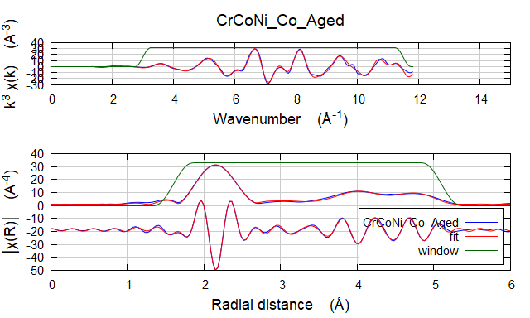

Independent points : 18.6494141
Number of variables : 8
Chi-square : 7646.2143868
Reduced chi-square : 717.9939048
R-factor : 0.0049259
Number of data sets : 1

guess parameters:
amp = 0.66124434 # +/- 0.03505682 [0.63012]
dEnot = 6.99335970 # +/- 0.47871981 [7.03264]
dR01 = -0.01699921 # +/- 0.00333455 [-0.01837]
dR02 = -0.01698742 # +/- 0.01129044 [-0.02352]
dR03 = 0.00636104 # +/- 0.00705910 [0.00681]
dR04 = -0.00368393 # +/- 0.00747188 [-0.00730]
thetaFe = 426.84238750 # +/- 19.74103707 [451.01375]
ss01 = 0.00499710 # +/- 0.00048158 [0.003]

set parameters:
temperature = 300.00000000

: name = CrCoNi_Co_Aged
: k-range = 3.000 - 11.5
: dk = 0.5
: k-window = Hanning
: k-weight = 1,2,3
: R-range = 1.6 - 5.1
: dR = 0.5
: R-window = Hanning
: fitting space = r
: background function = no
: phase correction = no
: background removal = E0: 7764, Rbkg: 1.0, range: [0:11.857], clamps: 0/24, kw: 2
: user-supplied epsilon_k = 0
: epsilon_k by k-weight = 3.737e-004
: epsilon_r by k-weight = 7.111e-002
: R-factor by k-weight = 1 -> 0.00656, 2 -> 0.00415, 3 -> 0.00407

name N S02 sigma^2 e0 delr Reff R
=================================================================================================
[feff_CoFe] Fe1.1 12.000 0.661 0.00500 6.993 -0.01700 2.51450 2.49750
[feff_CoFe] Fe1.2 6.000 0.661 0.00701 6.993 -0.01699 3.55600 3.53901
[feff_CoFe] Fe1.1 Fe1.1 48.000 0.661 0.00644 6.993 -0.01700 3.77170 3.75470
[feff_CoFe] Fe1.1 Fe1.1 24.000 0.661 0.00721 6.993 -0.03400 4.29250 4.25850
[feff_CoFe] Fe1.1 Fe1.2 48.000 0.661 0.00711 6.993 -0.01699 4.29250 4.27551
[feff_CoFe] Fe1.3 24.000 0.661 0.00721 6.993 0.00636 4.35520 4.36156
[feff_CoFe] Fe1.1 Fe1.1 48.000 0.661 0.00745 6.993 -0.03400 4.69210 4.65810
[feff_CoFe] Fe1.1 Fe1.3 96.000 0.661 0.00727 6.993 -0.00532 4.69210 4.68678
[feff_CoFe] Fe1.4 12.000 0.661 0.00730 6.993 -0.00368 5.02890 5.02522
[feff_CoFe] Fe1.1 Fe1.1 12.000 0.661 0.00755 6.993 -0.03400 5.02890 4.99490
[feff_CoFe] Fe1.1 Fe1.4 24.000 0.661 0.00730 6.993 -0.00368 5.02890 5.02522
[feff_CoFe] Fe1.1 12.000 0.661 0.00755 6.993 -0.03400 5.02890 4.99490
[feff_CoFe] Fe1.1 Fe1.4 Fe1.1 12.000 0.661 0.00730 6.993 -0.00368 5.02890 5.02522

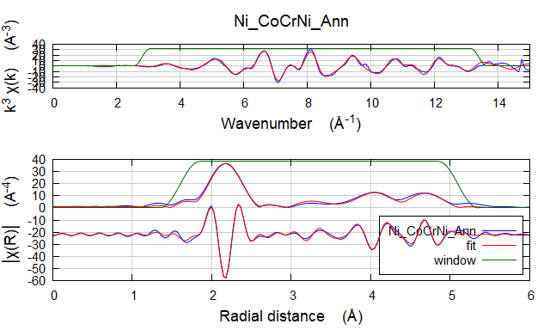

Independent points : 23.2841797
Number of variables : 8
Chi-square : 15812.7233120
Reduced chi-square : 1034.5810920
R-factor : 0.0140262
Number of data sets : 1

guess parameters:
amp = 0.62910849 # +/- 0.04006960 [0.62911]
dEnot = 6.35572958 # +/- 0.60229900 [6.35564]
dR01 = -0.01340902 # +/- 0.00410465 [-0.01341]
dR02 = -0.02368845 # +/- 0.01618051 [-0.02369]
dR03 = 0.00154842 # +/- 0.00956871 [0.00155]
dR04 = -0.01747976 # +/- 0.00985096 [-0.01748]
thetaFe = 422.23735735 # +/- 21.44420845 [422.23807]
ss01 = 0.00465399 # +/- 0.00052625 [0.00465]

set parameters:
temperature = 300.00000000

: name = Ni_CoCrNi_Ann
: k-range = 2.8 - 13.4
: dk = 0.5
: k-window = Hanning
: k-weight = 1,2,3
: R-range = 1.6 - 5.1
: dR = 0.5
: R-window = Hanning
: fitting space = r
: background function = no
: phase correction = no
: background removal = E0: 8396, Rbkg: 1.0, range: [0:16.233], clamps: 0/24, kw: 2
: user-supplied epsilon_k = 0
: epsilon_k by k-weight = 5.106e-004
: epsilon_r by k-weight = 2.914e-001
: R-factor by k-weight = 1 -> 0.01701, 2 -> 0.01176, 3 -> 0.01331

name N S02 sigma^2 e0 delr Reff R
=================================================================================================
[feff_NiFe] Fe1.1 12.000 0.629 0.00465 6.356 -0.01341 2.51450 2.50109
[feff_NiFe] Fe1.2 6.000 0.629 0.00716 6.356 -0.02369 3.55600 3.53231
[feff_NiFe] Fe1.1 Fe1.1 48.000 0.629 0.00657 6.356 -0.01341 3.77170 3.75829
[feff_NiFe] Fe1.1 Fe1.1 24.000 0.629 0.00735 6.356 -0.02682 4.29250 4.26568
[feff_NiFe] Fe1.1 Fe1.2 48.000 0.629 0.00726 6.356 -0.01855 4.29250 4.27395
[feff_NiFe] Fe1.3 24.000 0.629 0.00738 6.356 0.00155 4.35520 4.35675
[feff_NiFe] Fe1.1 Fe1.1 48.000 0.629 0.00760 6.356 -0.02682 4.69210 4.66528
[feff_NiFe] Fe1.1 Fe1.3 96.000 0.629 0.00743 6.356 -0.00593 4.69210 4.68617
[feff_NiFe] Fe1.4 12.000 0.629 0.00746 6.356 -0.01748 5.02890 5.01142
[feff_NiFe] Fe1.1 Fe1.1 12.000 0.629 0.00771 6.356 -0.02682 5.02890 5.00208
[feff_NiFe] Fe1.1 Fe1.4 24.000 0.629 0.00746 6.356 -0.01748 5.02890 5.01142
[feff_NiFe] Fe1.1 12.000 0.629 0.00771 6.356 -0.02682 5.02890 5.00208
[feff_NiFe] Fe1.1 Fe1.4 Fe1.1 12.000 0.629 0.00746 6.356 -0.01748 5.02890 5.01142

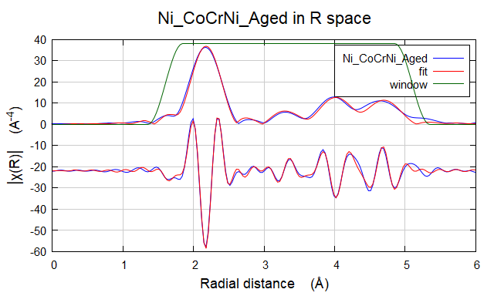

Independent points : 22.4013672
Number of variables : 8
Chi-square : 12226.4262886
Reduced chi-square : 848.9767763
R-factor : 0.0110368
Number of data sets : 1

guess parameters:
amp = 0.65075255 # +/- 0.03831662 [0.62911]
dEnot = 6.17814969 # +/- 0.54729435 [6.35564]
dR01 = -0.01094697 # +/- 0.00382318 [-0.01341]
dR02 = -0.02146111 # +/- 0.01507255 [-0.02369]
dR03 = 0.00115295 # +/- 0.00893224 [0.00155]
dR04 = -0.01619206 # +/- 0.00928024 [-0.01748]
thetaFe = 416.83369693 # +/- 19.74606809 [422.23807]
ss01 = 0.00463929 # +/- 0.00049869 [0.00465]
: name = Ni_CoCrNi_Aged
: k-range = 2.8 - 13
: dk = 0.5
: k-window = Hanning
: k-weight = 1,2,3
: R-range = 1.6 - 5.1
: dR = 0.5
: R-window = Hanning
: fitting space = r
: background function = no
: phase correction = no
: background removal = E0: 8396, Rbkg: 1.0, range: [0:14], clamps: 0/24, kw: 2
: user-supplied epsilon_k = 0
: epsilon_k by k-weight = 2.797e-004
: epsilon_r by k-weight = 1.596e-001
: R-factor by k-weight = 1 -> 0.01233, 2 -> 0.00911, 3 -> 0.01167

name N S02 sigma^2 e0 delr Reff R
=================================================================================================
[feff_NiFe] Fe1.1 12.000 0.651 0.00464 6.178 -0.01095 2.51450 2.50355
[feff_NiFe] Fe1.2 6.000 0.651 0.00733 6.178 -0.02146 3.55600 3.53454
[feff_NiFe] Fe1.1 Fe1.1 48.000 0.651 0.00673 6.178 -0.01095 3.77170 3.76075
[feff_NiFe] Fe1.1 Fe1.1 24.000 0.651 0.00753 6.178 -0.02189 4.29250 4.27061
[feff_NiFe] Fe1.1 Fe1.2 48.000 0.651 0.00743 6.178 -0.01620 4.29250 4.27630
[feff_NiFe] Fe1.3 24.000 0.651 0.00756 6.178 0.00115 4.35520 4.35635
[feff_NiFe] Fe1.1 Fe1.1 48.000 0.651 0.00779 6.178 -0.02189 4.69210 4.67021
[feff_NiFe] Fe1.1 Fe1.3 96.000 0.651 0.00761 6.178 -0.00490 4.69210 4.68720
[feff_NiFe] Fe1.4 12.000 0.651 0.00764 6.178 -0.01619 5.02890 5.01271
[feff_NiFe] Fe1.1 Fe1.1 12.000 0.651 0.00789 6.178 -0.02189 5.02890 5.00701
[feff_NiFe] Fe1.1 Fe1.4 24.000 0.651 0.00764 6.178 -0.01619 5.02890 5.01271
[feff_NiFe] Fe1.1 12.000 0.651 0.00789 6.178 -0.02189 5.02890 5.00701
[feff_NiFe] Fe1.1 Fe1.4 Fe1.1 12.000 0.651 0.00764 6.178 -0.01619 5.02890 5.01271

Comparison between results and simulations (just the plot)
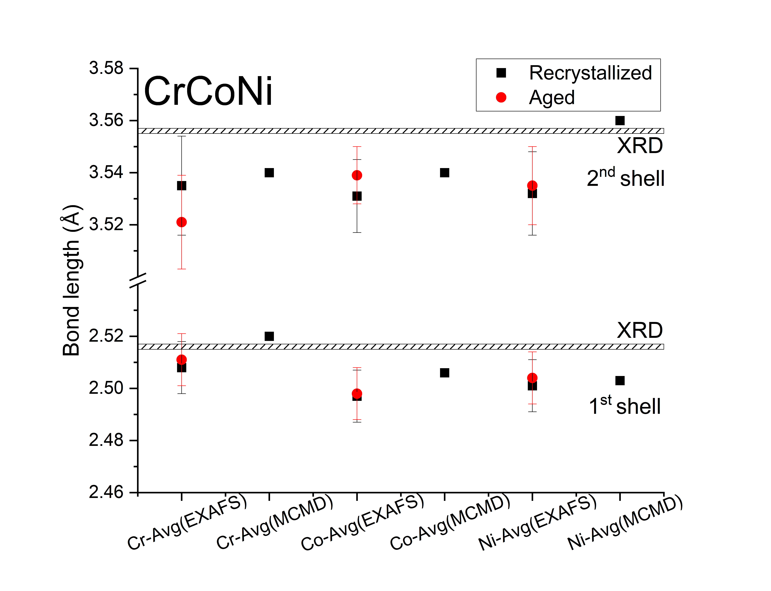

Simulations from Pedro
Table 1: First and second peaks positions ( ̊A) on the radial distribution functions when were re-scaled by experimental lattice parameter.
Ni2Cr
1st peak 2nd peak
Cr-Cr 2.53 3.55
Cr-Ni 2.52 3.57
Ni-Ni 2.49 3.55
NiCoCr
1st peak 2nd peak
Cr-Cr 2.54 3.51
Cr-Co 2.51 3.54
Cr-Ni 2.51 3.57
Co-Co 2.50 3.53
Co-Ni 2.51 3.55
Ni-Ni 2.49 3.56

Table 2: Lattice parameters ( ̊A): simulated without aging and experimental ones.
Ni2Cr
298 K 3.5493
600 K 3.5662
Recrystallized 3.5559
NiCoCr
298 K 3.5347
600 K 3.5501
Recrystallized 3.5609

Table 3: Probabilities of having element i around an element j in the first three shells of neighbors.
Ni2Cr
Shells 1 2 3
Cr-Cr 0.3156 0.3173 0.3307
Cr-Ni 0.6844 0.6827 0.6693
Ni-Cr 0.3349 0.3340 0.3275
Ni-Ni 0.6651 0.6660 0.6726
NiCoCr
Cr-Cr 0.3156 0.3173 0.3307
Cr-Co 0.3437 0.3387 0.3396
Cr-Ni 0.3407 0.3439 0.3297
Co-Cr 0.3329 0.3281 0.3289
Co-Co 0.3355 0.3387 0.3347
Co-Ni 0.3316 0.3332 0.3364
Ni-Cr 0.3366 0.3400 0.3260
Ni-Co 0.3384 0.3400 0.3434
Ni-Ni 0.3247 0.3199 0.3307

Table 4: Warren-Cowley short-range order parameter αmij = 1 −pmij/cj(×10−2) of having element i around an element j in the first three shells of neighbors.
Ni2Cr
Shells 1 2 3
Cr-Cr 3.940 3.410 -6.671
Cr-Ni -1.923 -1.669 0.326
Ni-Ni 0.943 0.8164 -0.160
NiCoCr
Cr-Cr 3.940 3.410 -0.667
Cr-Co -1.333 0.129 -0.115
Cr-Ni -2.534 -3.503 0.777
Co-Co 1.073 0.129 1.321
Co-Ni 0.223 -0.259 -1.235
Ni-Ni 2.278 3.728 0.493

