Supplementary information for
Semi-empirical modeling of weaving process for high-quality and property parts in plasma arc directed energy deposition

Min-Kyeom Kim^{a,1}, Yongjian Fang^{a,1}, Juwon Kimª, Sungho Heo^{b}, Youngseob Jang^{b},
Heesung Ahn^{b}, Yonghwi Kimª, Wanki Leeª, Jonghwan Suhr^{a,*}
a. Department of Mechanical Engineering, Sungkyunkwan University, 2066, Seobu-ro, Jangan-gu, Gyeonggi-do, Republic of Korea.
b. BEES, Inc., 34016, #415, Hanshin S Meca, Techno 3-ro, Yuseong, Daejeon, Republic of Korea.

* Corresponding author (e-mail address: suhr@skku.edu)
1. These authors contributed equally to this work.

 | C | Mn | Si | Cr | Ni | Mo | P | S | N | Cu | Fe | Cr_{eq}/Ni_{eq}
Wire | 0.01 | 1.61 | 0.59 | 18.70 | 11.60 | 2.51 | 0.01 | 0.00 | 0.04 | 0.16 | Bal. | 1.76
As-built | 0.01 | 1.49 | 0.67 | 18.79 | 11.78 | 2.48 | 0.02 | 0.00 |  | 0.18 | Bal. | 1.84
Table. S1. Chemical composition of wire filament and as-built parts in STS 316L

Table S2. STS 316L build platform dimension on which molten path is deposited, as illustrated in Fig. 1
 |  | Dimension
Base plate 1 | L₁ | 180 mm
Base plate 1 | t₁ | 10 mm
Base plate 1 | W₁ | 50 mm
Base plate 2 | L₂ | 280 mm
Base plate 2 | W₂ | 110 mm
Base plate 2 | W₃ | 65 mm
Base plate 2 | t_{2,} t₃ | 25 mm

Table S3. Weaving process parameters, designed with 18-mm weaving width.
Weaving width (mm) | Printing speed (mm/min) | Arc power (W) | Number of experiments
18 | 90 | 1365-2684 | 6
18 | 120 | 1613-3213 | 13
18 | 180 | 1786-2684 | 5
18 | 240 | 1908-2806 | 4

Table S4. The weaving parameters established on the GMAW equipment, along with the weaving width and printing speed determined via analytical modeling of the weaving path.
Weaving width (mm), $W_{w}$ | 18 | 12 | 9
Printing speed (mm/min), $V_{s}$ | 120 | 180 | 240
Weaving time (s), $t_{w}$ | 0.713 | 0.551 | 0.477
Pause time at edges (s), $t_{p}$ | 0.1

Table S5. Arc powers and weaving parameters to determine the printable region.
Weaving width (mm) | Printing speed (mm/min) | Arc power (W) | Number of data
18 | 120 | 1780–3213 | 14
12 | 180 | 1440–2925 | 10
9 | 240 | 1424–2925 | 9

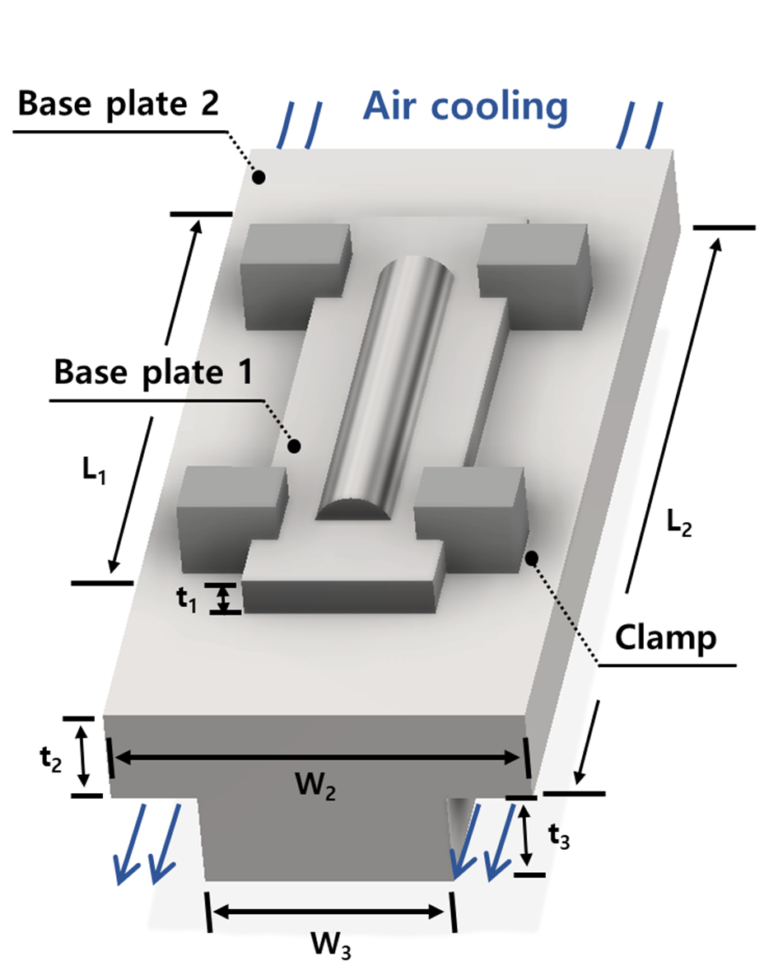
Fig. S1. Build platform and experimental setup, of which size was listed in Table S2, for depositing the bead.

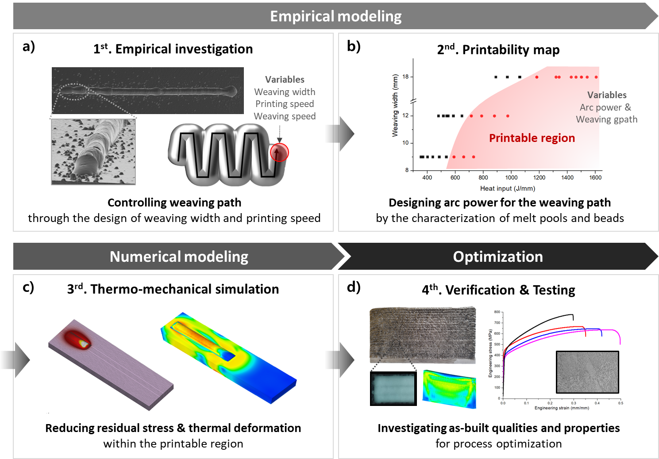
Fig. S2. Workflow for the establishment of semi-empirical modeling and its verification, following these steps: empirical modeling, numerical modeling, and optimization.

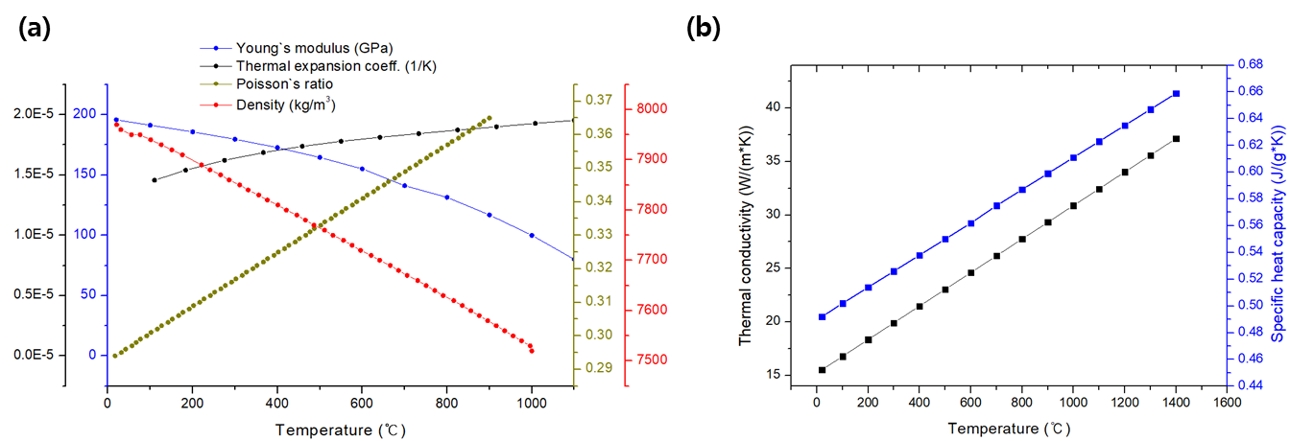
Fig. S3. Temperature dependent material properties of austenite 316L stainless steel: (a) Young`s modulus, coefficient of thermal expansion, Poisson`s ratio, and density, and (b) thermal conductivity and specific heat capacity.

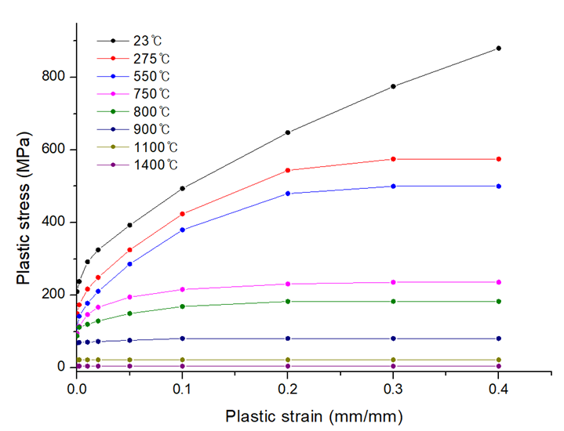
Fig. S4. Flow curves of 316L stainless steel from the room (23 $℃$) to high (1400 $℃$) temperature.

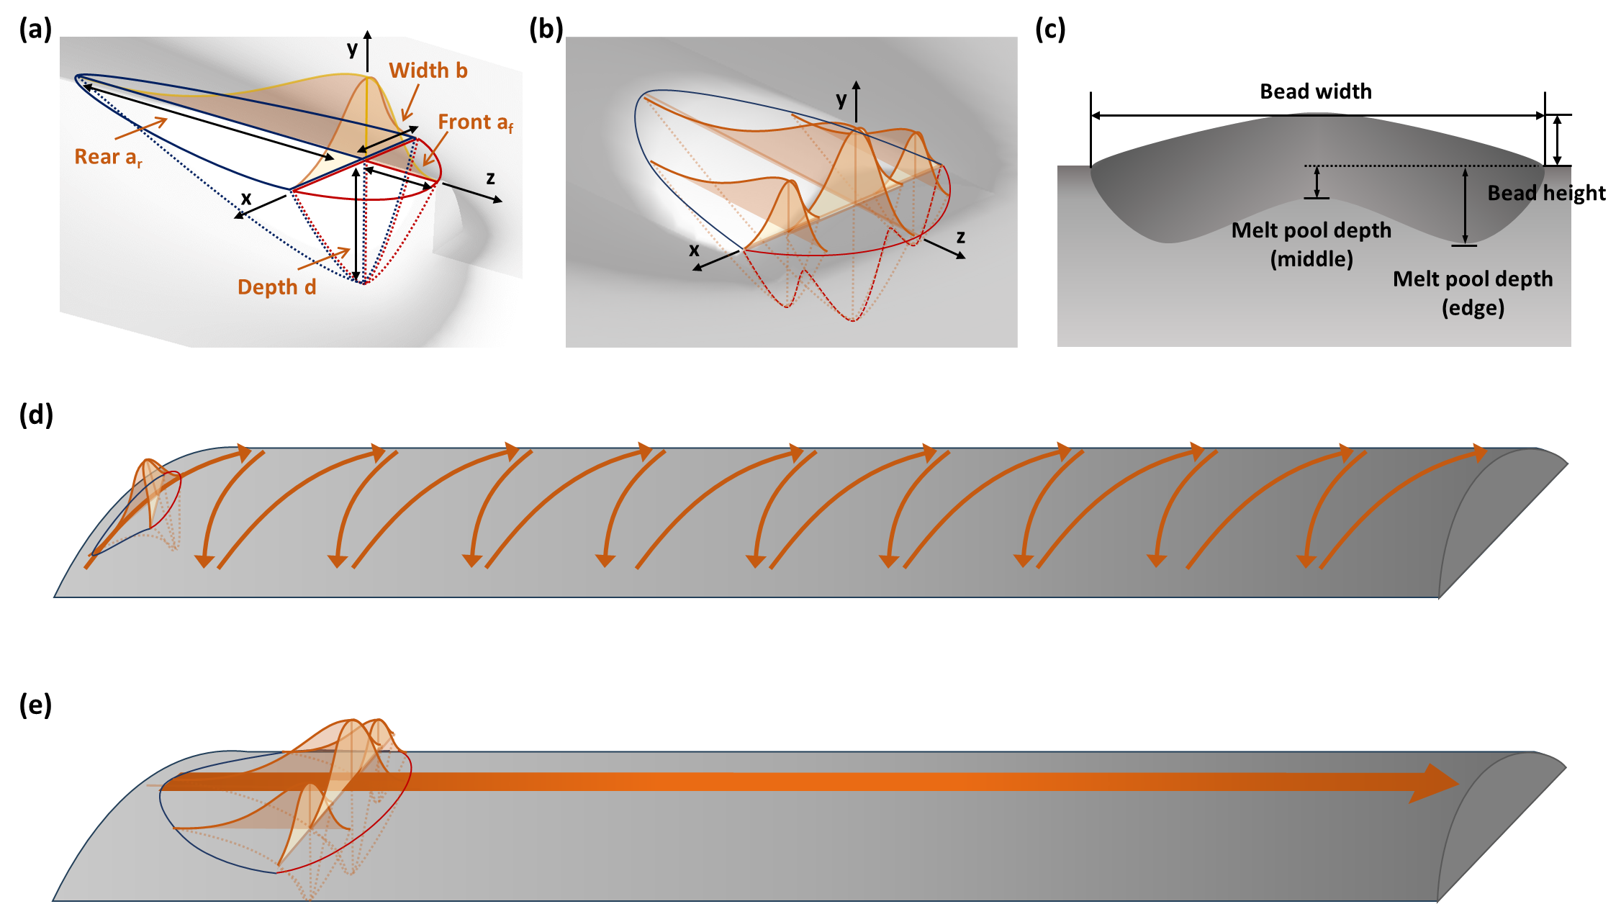
Fig. S5. Schematics of (a) a Gaussian single heat source and Gaussian parameters; (b) multi-heat source; (c) melt pool morphology of the weave bead; and the trajectories of (d) a single heat source and (e) a multi-heat source for weaving deposition simulation.
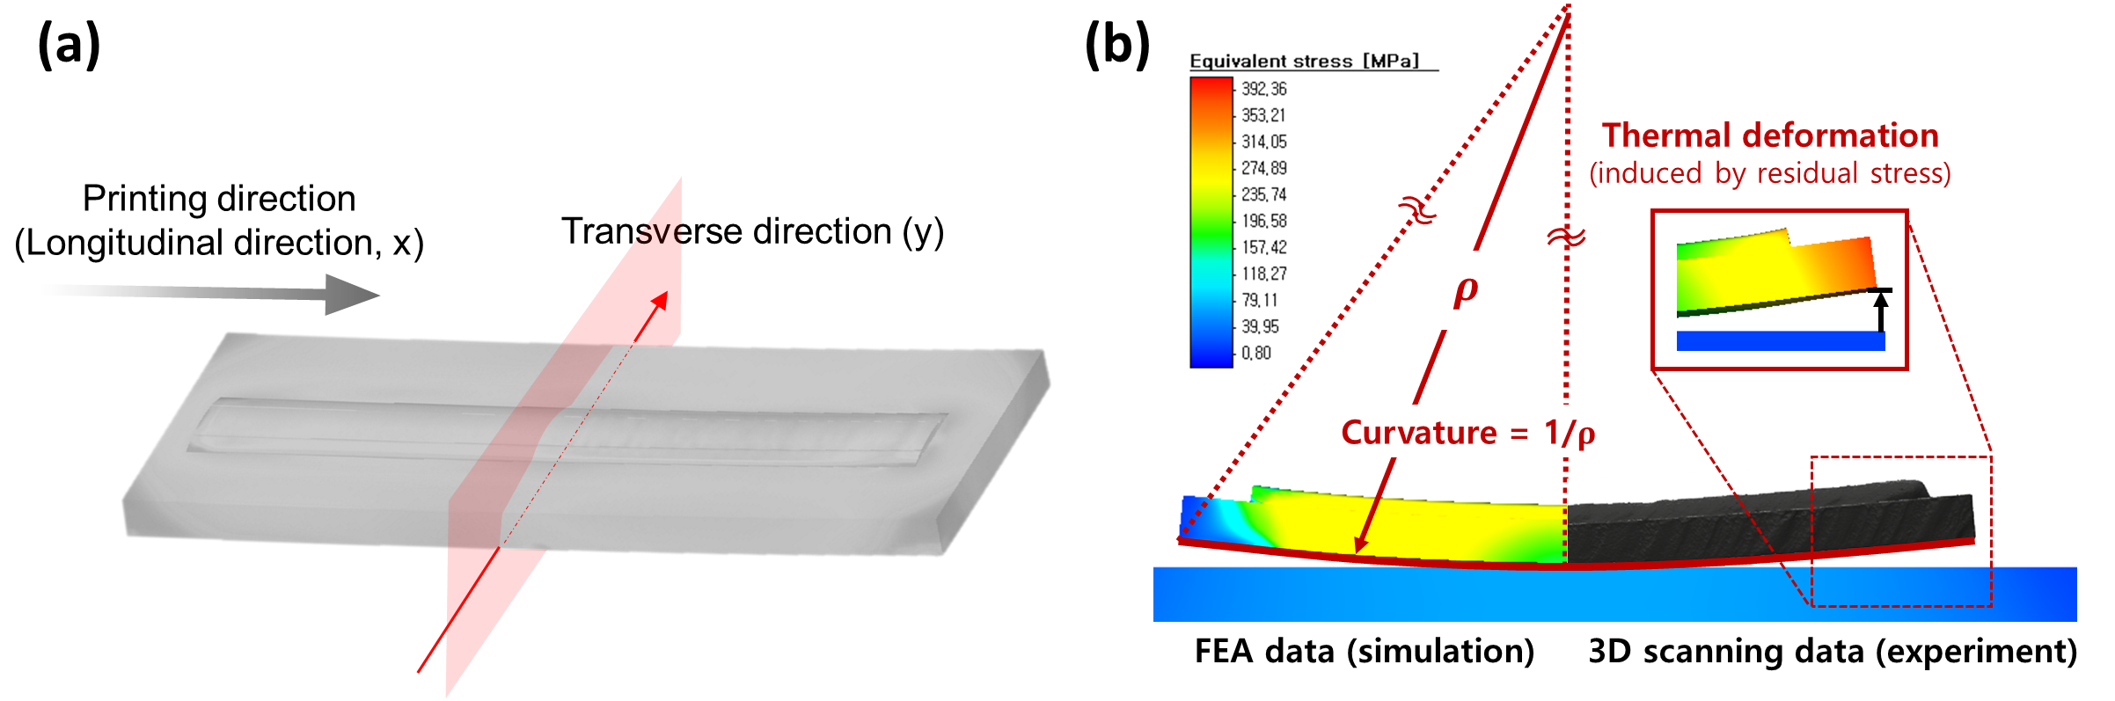
Fig. S6. (a) Schematic of the printing direction (x-direction) and the points of stress extraction. (b) Schematics of curvature measurement of a build platform using 3D scanning technology and its comparison with simulation result.

S.1. Heat source models
Gaussian heat source models were used in this study, and their parameters for the plasma arc directed energy deposition (DED) were determined based on the bead and melt pool size ¹ as given in Table 1 and S6. The power density distributions for the region in the front and rear quadrants were defined as follows:
$q_{f}\left(x,y,z,t\right)=\frac{6\sqrt{3}f_{f}Q}{a_{f}bcπ\sqrt{π}}e^{-3[\frac{x^{2}}{b^{2}}+\frac{y^{2}}{d^{2}}+\frac{{\left[z+v\left(τ-t\right)\right]}^{2}}{a_{f}^{2}}]}$ (1)
$q_{r}\left(x,y,z,t\right)=\frac{6\sqrt{3}f_{r}Q}{a_{r}bcπ\sqrt{π}}e^{-3[\frac{x^{2}}{b^{2}}+\frac{y^{2}}{d^{2}}+\frac{{\left[z+v\left(τ-t\right)\right]}^{2}}{a_{r}^{2}}]}$ (2)
$f_{f}+f_{r}=2$ (3)
In the above, a_{f} and a_{r} are the lengths of the front and rear of the quadrants, respectively; b and c are the width and depth of the heat source, respectively; Q is the net arc power (for which the arc power is multiplied by the energy efficiency); and f_{f} and f_{r} are the parameters for determining the ratio of the power density between the front and rear of the heat source.
Table S6. Heat source models and Gaussian parameters of stringer and weave beads, manufactured with the plasma arc DED process conditions listed in Table 1.
 | Weaving width | Printing speed  (mm/min) | Arc current  (A) | Arc voltage  (V) | Arc power  (W) | Heat source type | Efficiency  (%) | Gaussian parameter, M | Rear, ar  (mm) | Length, af  (mm) | Width, b  (mm) | Depth, d  (mm) | Heat front scaling factor | Net power
Stringer bead | - | 120 | 100 | 19.4 | 1940 | - | 0.82 | 0.5 | 6.807 | 3 | 4.8 | 7.8 | 0.612 | 1588.8
Stringer bead | - | 120 | 110 | 19.6 | 2156 | - | 0.83 | 1 | 7.62 | 3 | 4.6 | 8.3 | 0.565 | 1788.5
Stringer bead | - | 120 | 120 | 19.7 | 2364 | - | 0.83 | 1 | 8.127 | 4 | 5 | 8 | 0.660 | 1961.4
Stringer bead | - | 120 | 150 | 20 | 3000 | - | 0.85 | 3 | 9.165 | 4 | 10 | 11 | 0.608 | 2550.2
Weave bead | 18 mm | 120 | 120 | 19.7 | 2364 | Middle | 0.75 | 1 | 3 | 3 | 4 | 2 | 1 | 403.75
 |  |  |  |  |  | edge | 0.75 | 2 | 3 | 3 | 4 | 2 | 1 | 684
Weave bead | 18 mm | 120 | 130 | 19.2 | 2496 | Middle | 0.85 | 1 | 6 | 4.5 | 12 | 1 | 1.143 | 452.7
 |  |  |  |  |  | edge | 0.85 | 3 | 6 | 6 | 6 | 2 | 1 | 833
Weave bead | 18 mm | 120 | 140 | 19.3 | 2702 | Middle | 0.92 | 2 | 3 | 2 | 5 | 3 | 1.2 | 840.84
 |  |  |  |  |  | edge | 0.92 | 1 | 4 | 3 | 4 | 2 | 1.143 | 825
Weave bead | 12 mm | 180 | 110 | 19.5 | 2145 | Middle | 0.89 | 3 | 4 | 4 | 5 | 2 | 1 | 302.4
 |  |  |  |  |  | edge | 0.89 | 1 | 3 | 3 | 5 | 3 | 1 | 800.32
Weave bead | 12 mm | 180 | 120 | 19.7 | 2364 | Middle | 0.93 | 3 | 3 | 3 | 3 | 3 | 1 | 338.66
 |  |  |  |  |  | edge | 0.93 | 3 | 2 | 2 | 3 | 2 | 1 | 930
Weave bead | 12 mm | 180 | 130 | 19.2 | 2496 | Middle | 0.89 | 3 | 3 | 3 | 4 | 2 | 1 | 428.61
 |  |  |  |  |  | edge | 0.89 | 1 | 3 | 3 | 3 | 2.5 | 1 | 892.4
Weave bead | 9 mm | 240 | 110 | 19.5 | 2145 | Middle | 0.82 | 1 | 5 | 5 | 8 | 2 | 1 | 227.25
 |  |  |  |  |  | edge | 0.82 | 1 | 3 | 3 | 4 | 2 | 1 | 768
Weave bead | 9 mm | 240 | 120 | 19.7 | 2364 | Middle | 0.92 | 2 | 6 | 6 | 6 | 1.5 | 1 | 293.56
 |  |  |  |  |  | edge | 0.92 | 1 | 3 | 3 | 4 | 4 | 1 | 938.4
Weave bead | 9 mm | 240 | 130 | 19.2 | 2496 | Middle | 0.88 | 1 | 4 | 4 | 3 | 3 | 1 | 573.3
 |  |  |  |  |  | edge | 0.88 | 3 | 4 | 4 | 2 | 1.5 | 1 | 810

S.2. Droplet and melt pool behaviors in plasma arc DED
The metal transfer modes for droplet behaviors include short-circuiting, globular, spray, streaming, and streaming rotating behaviors, and are functions of the wire feed rate and arc power ². The short-circuiting and globular modes are developed at lower arc powers, whereas the streaming and streaming rotating modes exhibit unstable metal transfer and occur at higher arc powers ³. There have been attempts to disclose the behaviors of droplets and melt pools and their effect on the bead qualities via computational fluid dynamics or in-situ monitoring ^{4, 5}. The studies give an insight to understand the mechanism of the melt pool flow during the process, but substantial costs and time are incurred for observing the droplet behaviors under various parameters. Therefore, based on the understanding of the mechanisms, systematic experiments for obtaining a stable bead are generally recommended.
The process of metal transfer in plasma arc DED determines the productivity of the welding and weld quality, such as the melt pool stability, defects, and spatter. The behaviors of the droplet generated by the arc, shielding gas, and welding wire arise from the droplet formation, detachment, and transfer in the arc (Fig. 4) ⁶. Therefore, understanding and characterizing the detaching droplet, which relies on the process parameters, is important for predicting and designing the plasma arc DED process. The droplet and melt pool are affected by several factors, including the surface tension, electromagnetic force, momentum flux force, gravity, vaporization force, drag force by shielding gas flow, and force by arc pressure ^{7, 8}. Detaching forces cause the droplet to detach from the electrode tip, and represent the accumulated gravity, drag, electromagnetic, and momentum flux forces, whereas the surface tension force inhibits detachment from the tip owing to the cohesive force in the molten alloy. The forces are significantly affected by process conditions such as the current and wire feed speed. Therefore, the mode of metal transfer, which depends on the forces, is mainly determined by the designed parameters in this study, i.e., the arc power, printing speed, and weaving trajectory. The mode of metal transfer is characterized by examining the plasma arc DED process in which the wire is melted and becomes a droplet deposited on the melt pool. In the metal transfer in an arc, there are several modes, such as short-circuiting, globular, spray, streaming, and streaming rotating droplets; these modes are functions of the arc power ⁹. A higher arc power induces a change in the metal transfer mode from short-circuiting to globular, spray, streaming, and streaming rotating droplets in sequence. Among the transfer modes, in this work, short-circuiting under lower arc power was potentially generated during the process. This is because a relatively low arc power in the range of 1940–2702 W was designed, so as to relieve the residual stress and corresponding thermal deformation.

References
1. Azar AS, Ås SK, Akselsen OM. Determination of welding heat source parameters from actual bead shape. Computational materials science 54, 176-182 (2012).
2. Iordachescu D, Quintino L. Steps toward a new classification of metal transfer in gas metal arc welding. Journal of materials processing technology 202, 391-397 (2008).
3. Kim Y-S. Metal transfer in gas metal arc welding.). Massachusetts Institute of Technology (1989).
4. Cheon J, Kiran DV, Na S-J. CFD based visualization of the finger shaped evolution in the gas metal arc welding process. International Journal of Heat and Mass Transfer 97, 1-14 (2016).
5. Cheon J, Kiran DV, Na S-J. Thermal metallurgical analysis of GMA welded AH36 steel using CFD–FEM framework. Materials & Design 91, 230-241 (2016).
6. Choudhary T, Chaudhary K. A Study on Metal Transfer Mechanism in Gas Metal Arc Welding.). IJSET (2017).
7. Arif N, Lee JH, Yoo CD. Modelling of globular transfer considering momentum flux in GMAW. Journal of Physics D: Applied Physics 41, 195503 (2008).
8. Jones L, Mendez P, Weiss D, Eager T. Dynamic behavior of gas metal arc welding. In: 9th Annual conference on iron and steel technology, Phoang, Korea) (1997).
9. Choi J. A study on metal transfer in gas metal arc welding.). MS Thesis (1998).

