Supplementary Information

A heart derived-soluble factor which controls kidney and cardiovascular function after acute cardiorenal syndrome

Authors: Yoshio Funahashi¹, Jessica F Hebert¹, Adam Munhall¹, Kevin Burfeind¹, Elizabeth MI Nguyen^{2,3}, Tahnee Groat¹, Megan Nickerson¹, Mahaba B Eiwaz¹, Nicole K. Andeen⁴, Motoko Yanagita^{5,6}, Susan B. Gurley⁷, Michael P. Hutchens*^{1,8}

¹Department of Anesthesiology & Perioperative Medicine, Oregon Health & Science University, Portland, OR 97239.
²Department of Pediatrics, University of Washington, Seattle, WA 98195.
³Center for Developmental Biology & Regenerative Medicine, Seattle Children’s Research Institute, Seattle, WA 98101.
⁴Department of Pathology, Oregon Health and Science University, Portland, OR 97239.
⁵Department of Nephrology, Graduate School of Medicine, Kyoto University, Kyoto, Japan.
⁶Institute for the Advanced Study of Human Biology, Kyoto University, Kyoto, Japan.
⁷Division of Nephrology, and Hypertension, Department of Medicine, Keck School of Medicine, University of Southern California. Los Angeles, CA, 90033.
⁸Operative Care Division, Portland Veterans Administration Medical Center, Portland, OR 97239.

*Corresponding author: Michael Hutchens, MD, MA
Portland Veterans Administration Medical Center
Operative Care Division, R&D 5
3100 US Veterans Hospital Road
Portland OR, 97239

Supplemental Figure 1. Ischemia titration study to establish IRI model with equivalent kidney injury to CA/CPR

Supplemental Figure 2. Acute kidney injury (AKI) caused by heart-induced kidney ischemia is distinct from that by time-equivalent, kidney-only ischemia

Supplemental Figure 3. Chronic kidney disease (CKD) resulting from acute cardiorenal syndrome is distinct from that resulting GFR-equivalent kidney-only ischemia

Supplemental Figure 4. Phenotyping of iCSRP3KO mice

Supplemental Figure 5. Representative images of cardiac echocardiography in iCSRP3KO mice and littermate controls

Supplemental Figure 6. hPTEC highly expresses epithelial marker and megalin

Supplemental Figure 7. Deletion of proximal tubule megalin ameliorates 49-day GFR loss in a sexually dimorphic manner

Supplemental Figure 8. Characterization of RNASeq data obtained after administering recombinant human CSRP3 to human proximal tubular epithelial cells

Supplemental Figure 9. Cilastatin treated CSRP3-IRI demonstrated higher BUN than vehicle treated CSRP3-IRI

Supplemental Figure 10. Full-length western blot images

Supplemental Table 1. List of reagents and resources used in this study

Supplemental Table 2. Sequences of PCR primers used in this study

Supplemental Table 3. Assay IDs of qPCR probes primers used in this study

Supplemental Table 4. Sequences of siRNAs used in this study

Supplemental Table 5. Inclusion and exclusion criteria for the research designated human donor kidneys

Supplemental Table 6. List of reagents and recipes for hPTEC culturing

Supplemental Figures

Supplemental Figure 1. Ischemia titration study to establish IRI model with equivalent kidney injury to CA/CPR
(A) Experimental protocol for the ischemia time titration. (B) GFR at 24h after CA/CPR or IRI (n=4-5). (C) Plasma BUN at 24h after CA/CPR or IRI (n=3-8). (B, C) One-way ANOVA followed by a Tukey post hoc test.

Supplemental Figure2. Acute kidney injury (AKI) caused by heart-induced kidney ischemia is distinct from that by time-equivalent, kidney-only ischemia
(A) Experimental protocol for CA/CPR, 8min (ischemia time equivalent) IRI, 27min (24h GFR equivalent) IRI and sham. (B) GFR at 24h after CA/CPR, 8min IRI, 27min IRI, or Sham (n=4-6). (C) BUN at 24h after CA/CPR, 8min IRI, 27min IRI, or Sham (n=5-8). (D) Immunofluorescence images of KIM-1 at 24h and its quantification by unbiased stereology (VKIM-1/Vkidney) (n=5-8). Scale bar=100μm.
(B-D) One-way ANOVA followed by a Tukey post hoc test. *P<0.05, and ****P<0.0001. ns indicates not significant.
Supplemental Figure3. Chronic kidney disease (CKD) resulting from acute cardiorenal syndrome is distinct from that resulting GFR-equivalent kidney-only ischemia
(A, B) BUN (A) and plasma Cystatin-C (B) at 49 days after CA/CPR, 8min IRI, 27min IRI, or sham (n=5-8). (C) GFR at 49 days after CA/CPR in male and female (n=8)
(A,B) One-way ANOVA followed by a Tukey post hoc test. *P<0.05, **P<0.01, *** P<0.001, and ****P<0.0001. ns indicates not significant. (C) Student’s t-test, *P<0.05

Supplemental Figure 4. Phenotyping of iCSRP3KO mice
(A) Blood pressure was not altered by induction of cre recombinase. (B) Ejection fraction (EF) and (C) Cardiac output (CO) were reduced in 8-12 week-old mice with cardiac-specific CSRP3 gene deletion. Student’s t-test. ns indicates not significant. *P<0.05,
Supplemental Figure 5. Representative images of cardiac echocardiography in iCSRP3KO mice and littermate controls
(A, B) Long axis views and short axis views of cardiac echocardiography in iCSRP3KO mice and littermate controls. CSRP3 knockout mice demonstrated reduced cardiac wall motion compared with controls.
Supplemental Figure 6. hPTEC highly expresses epithelial marker and megalin
(A) Purity validation of the epithelial marker (CD10, CD13) positive cells in hPTEC. (B) Quantitative reverse transcription–polymerase chain reaction (qPCR) validation of lrp2 expression in hPTEC cells and HK2 cells (n=6). (C) Validation of the megalin expression by immunofluorescence imaging in hPTEC cells and HK2 cells. Megalin (green), DNA (blue), scale bar=20µm. (D) qPCR validation of lrp2 interference in hPTEC cells (n=4). (E) Correlation of megalin intensity and DNA intensity in hPTEC cells. R square=0.00018 by Pearson’s test.
(B, D) Student’s t-test. **P<0.01, and **** P<0.0001.

Supplemental Figure 7. Deletion of proximal tubule megalin ameliorates 49-day GFR loss in a sexually dimorphic manner
(A) Immunofluorescence of megalin in the kidney of iMegKO or littermate control mice (Scale bar=100µm) demonstrates deletion of megalin after tamoxifen administration in iMegKO. (B) 24h urine albumin excretion in iMegKO or littermate control mice (n=10). (C) GFR at 24h after CA/CPR in iMegKO or littermate control mice (n=7-10). (D) Kaplan-Meier survival curve showing survival rates in both strains following CA/CPR. (E) GFR 49 days after CA/CPR in iMegKO or littermate control, showing both sexes (n=8-10).
(B) Student’s t-test. (D) Log-rank test, (C, E) Two-way ANOVA followed by a Tukey post hoc test. *P<0.05, **P<0.01. ns indicates not significant.

Supplemental Figure 8. Characterization of RNASeq data obtained after administering recombinant human CSRP3 to human proximal tubular epithelial cells
(A) PCA plot demonstrates that CSRP3 was associated primarily with change along PC2, which explained 31% of variance in samples. There was some heterogeneity. Take-one-away analysis did not alter results of later analysis. (B) Volcano plot of all mRNA transcripts demonstrates regulation of specific transcripts by CSRP3 administration.

Supplemental Figure 9. Cilastatin treated CSRP3-IRI demonstrated higher BUN than vehicle treated CSRP3-IRI
(A) Blood urea nitrogen (BUN) at 49 days after IRI (n=9). Student’s t-test.*P<0.05
Supplemental Figure 10. Full-length western blot images
(A) Full-length blot image for Figure 3A. (B) Full-length blot image for Figure 3B. (C) Full-length blot image for Figure 3C. (D) Full-length blot image for Supplemental Figure 4A.
Supplemental tables

Supplemental table 1: List of reagents and resources used in this study
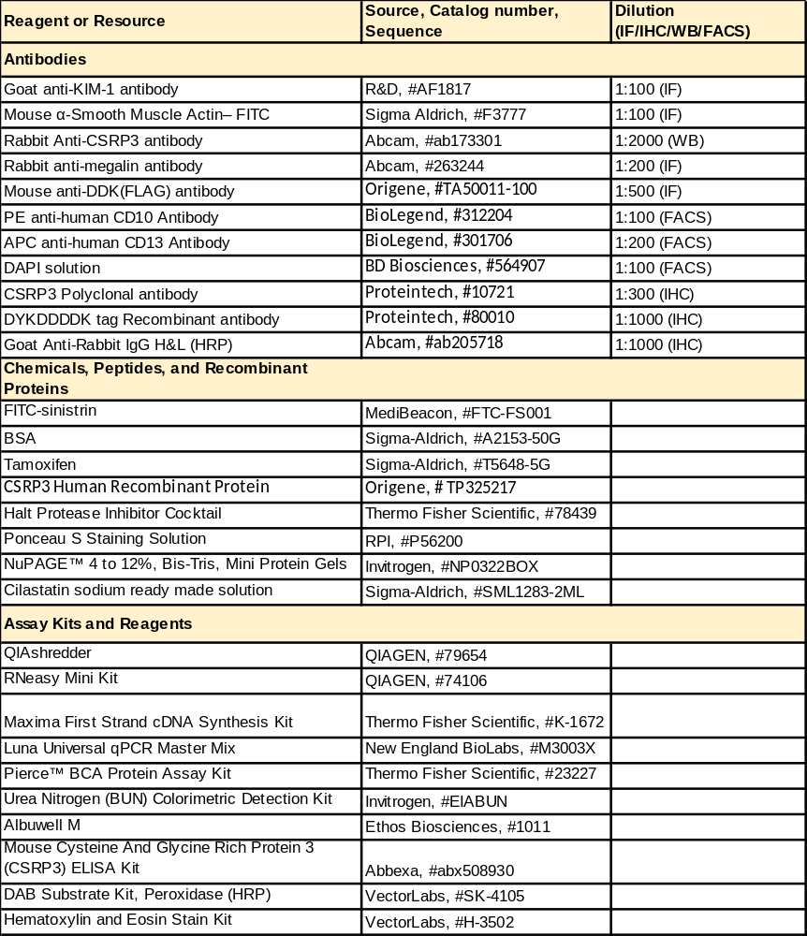

Supplemental table 2: Sequences of PCR primers used in this study
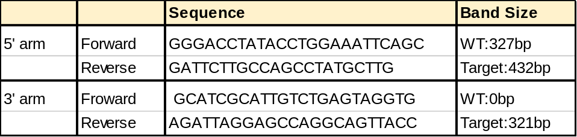

Supplemental table 3: Assay IDs of qPCR probes primers used in this study
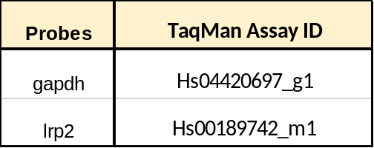

Supplemental table 4: Sequences of siRNAs used in this study
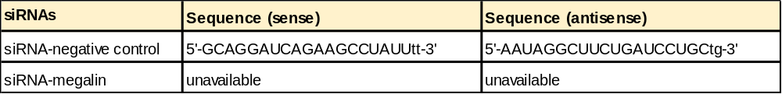

Supplemental table 5: Inclusion and exclusion criteria for the research designated human donor kidneys
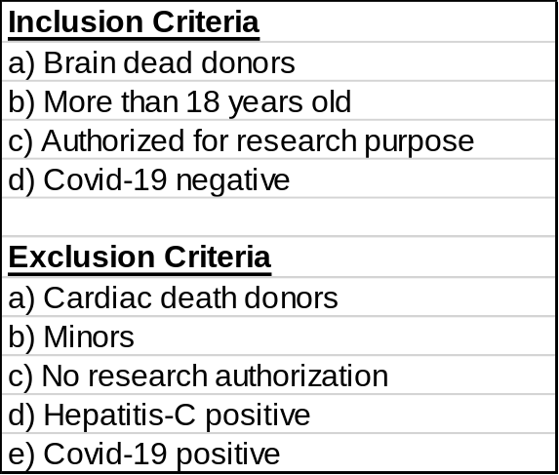

Supplemental table 6: List of reagents and recipes for hPTEC culturing
