Correlative, ML-based and non-destructive 3D-analysis of intergranular fatigue cracking in SAC305-Bi solder balls
Charlotte Cui¹, Fereshteh Falah Chamasemani¹, Priya Paulachan¹, Rahulkumar Sinojiya¹, Jördis Rosc¹, Jaroslaw Wosik¹, Michael Reisinger², Peter Imrich², Walter Hartner³, Roland Brunner^{1,*}
* roland.brunner@mcl.at
¹ Materials Center Leoben Forschung GmbH, Roseggerstraße 12, 8700 Leoben, Austria
² Kompetenzzentrum für Automobil- und Industrieelektronik GmbH, Europastraße 8, 9524 Villach, Austria
³ Infineon Technologies AG, Wernerwerkstraße 2, 93049 Regensburg, Germany

Supplementary notes

In this study, a ML-based workflow for the analysis of non-destructive 3D μ-XCT scans is developed. The aim is the segmentation and quantification of fatigue cracks from TCoB, as well as the segmentation of flux pores and metallisations. The outputs from the ML-algorithms are then statistically correlated with various properties of the solder balls in order to find causes for their fatigue cracking behaviour. The results from the 3D segmentations are correlated with FESEM EBSD analyses and FEM simulation. Moreover, high-magnification FESEM EDX analyses are acquired to investigate the intergranular crack propagation sites, i.e. recrystallised grain boundaries. Details about the ML-algorithms, FEM simulation and FESEM analyses from the study are presented in the following.

Supplementary note 1: 2D localisation model
The 2D localisation model is a feed-forward conventional neural network (CNN) adapted from¹. Its input layer and all hidden convolutional layers have a 3 × 3 kernel, a stride of 1 x 1 and ReLu activation functions. The localisation model consists of one 2D convolutional layer with a filter-size of 32, followed by a 2 × 2 pooling layer, another 2D convolutional layer with a 64 filter-size, another 2 × 2 pooling layer and a 2D convolutional layer with a filter-size of 128. The output layer is a convolutional layer with a filter-size of 1 and a 21 × 21 kernel and a sigmoid activation function. The model architecture is schematically depicted in Supp. Fig. 1. Both the training images and the sliding-window size for the localisation model have dimensions of 100 × 100 pixels². The x-y-localisation model is trained with 1208 training images (628 positive and 580 negative images), of which 33% are split into the validation set. Exemplary training images are shown in Supp. Fig. 1. The localisation model is trained for 40 epochs with a learning rate of 10⁻³ using Python 3.8.13, tensorflow 2.9.1, keras 2.9.0, Adam optimiser and a binary cross-entropy loss function on an Intel Core i5-8265U CPU with 16 GB RAM. The final training and validation accuracies amount to 100.00% and 99.25%, whereas training and validation losses yield 7.53e-04% and 5.53%, respectively, see Supp. Fig. 1. The precision of the localisation model, applied to training-set independent data, is calculated as $precision=\frac{TruePositives}{TruePositives+ FalsePositives}$. For the 2D localisation model, the precision amounts to 100.00%, as it detects each and every ball in all independent testing sets, without detecting any false positives.

Supplementary note 2: 3D segmentation model
The ML-localisation is applied to the middle µ-XCT slice in order to determine the location of the solder balls in the µ-XCT scan. Its outputs consist of the coordinates of boxes which contain the x-y-view of the solder balls in the given slice. The coordinates of those boxes are then used to extract the 3D volumes from the raw µ-XCT data, which contain the entire solder ball. These volumes are then padded and cut to cubes of 96 × 96 × 96 voxels³, which are then passed on to the 3D segmentation model (U-Net), the architecture of which is schematically shown in supp. Fig. 1. The 3D segmentation model is built from the Python library segmentation models 3D². It is trained with keras 2.8.0, tensorflow 2.8.2, Python 3.9.16, and scikit-learn 1.2.1 for 300 epochs, using softmax activation functions, categorical cross entropy loss functions and the Adam optimiser with learning rate of 10⁻⁴. The model is trained NVIDIA A40 GPU with 48GB RAM. Imagenet encoder weights and the inceptionv3 backbone² are used. The encoder part of the original U-Net is replaced with the inception network and the decoder part includes 5 blocks (i.e., Upsampling3D, Concatenation, Conv3D, BatchNormalization, Conv3D, and BatchNormalization with ReLU activation). The convolution layer filter-sizes increase from 16 to 256. The 3D segmentation model is trained to distinguish five classes: background, solder bulk, copper metallisation, cracks and pores. 61 manually refined 96 × 96 × 96 voxels³ re-assembled outputs from the 2D segmentation model are used as training data, whereby the test size is 5%. The raw data is normalised to compensate intensity variations in the images. Exemplary training data and model training histories are also shown in Supp. Fig. 1. The training accuracy amounts to 99.40%. The precision of the 3D segmentation model amounts to 91.90%, calculated with the same formula as for the localisation model. Manually labelled data, independent from the training and validation data, serves as the ground truth for the precision calculation.

Supplementary note 3: 2D segmentation model
In order to efficiently generate a sufficient amount of training data for the 3D segmentation model, a 2D segmentation model is interposed, which segments x-z-slices from µ-XCT. The training data for the 2D segmentation model is manually labelled using ilastik 7.1.0³. Just like the 3D segmentation model, the 2D segmentation model distinguishes between five features: background, solder bulk, copper metallisation, crack and pore. Its schematic architecture, exemplary training images, training and validation history are shown in Supp. Fig. 1. The architecture of the 2D segmentation model is adapted from⁴. The encoder and decoder paths of the 2D U-Net structure consist of 5 layers. Each layer of the encoder path includes convolution, dropout, convolution, and pooling layers. Each convolutional layer has a 3 × 3 kernel and a ReLU activation function. The filter size starts at 32 and increases to 512. The model is trained for 200 epochs on a NVIDIA A40 GPU with 48GB RAM. The decoder path consists of a transposed convolution layer and a concatenation layer, followed by the same three convolution and dropout layers as in the encoder path. The activation function of the output layer is set to softmax. The model is fitted with the Adam optimiser, using a categorical cross entropy loss function and a batch size of 10. The model is trained on 4992 manually labelled 96 × 96 pixels x-z-slices with a test size of 20%. The final training and validation accuracies amount to 99.60% and 99.10%, whereas the losses amount to 0.049% and 4.30%, respectively. The precision of the 2D segmentation model is 76.20%. Hence, the 2D segmentation outputs are further manually refined before they are fed into the 3D segmentation model for training. Just as for the 3D segmentation model, manually labelled data is used as the ground truth for the precision calculation.

Supplementary Figure 1: Detailed information about the developed ML-models
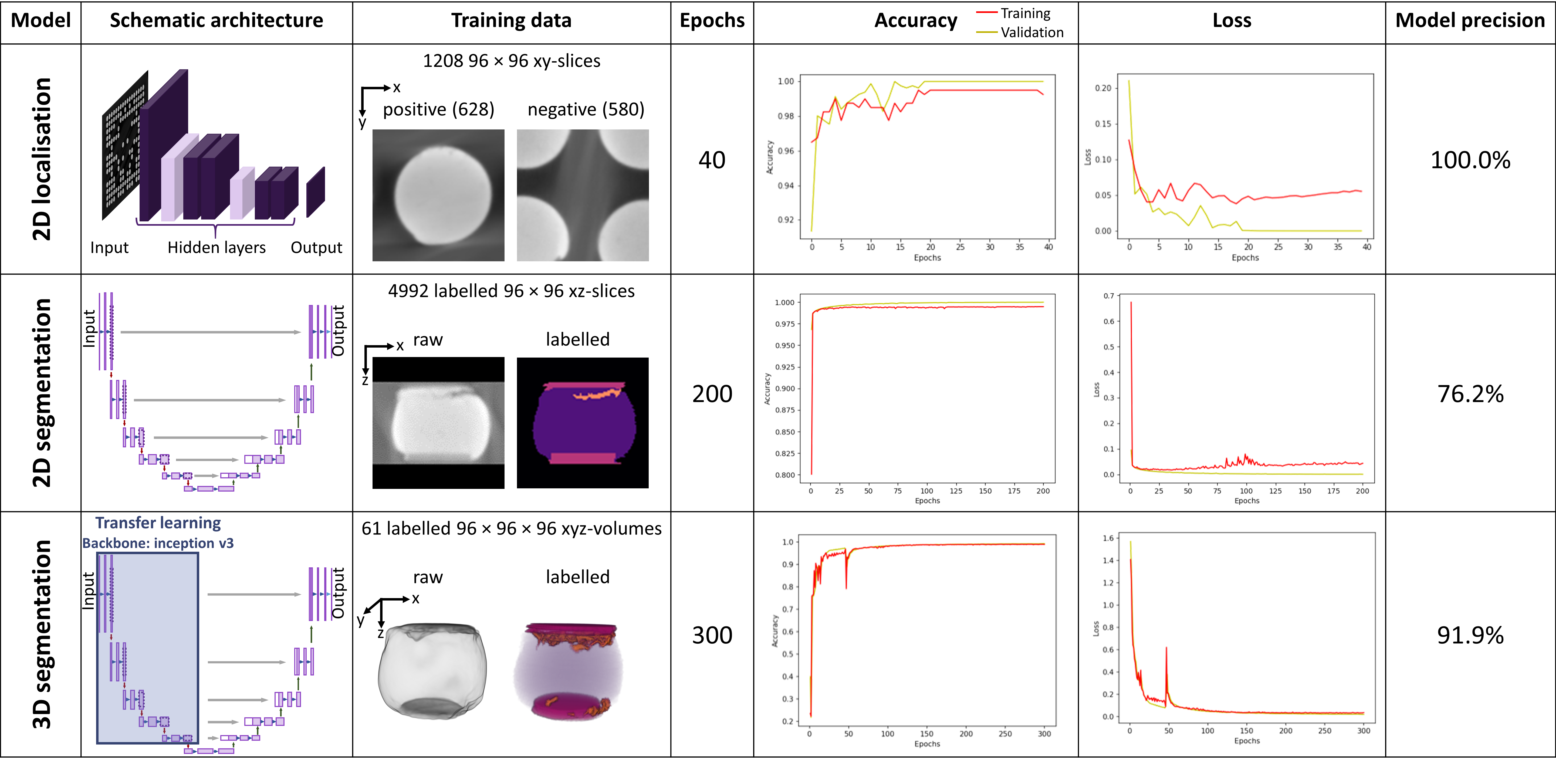

The ML-based analysis of a BGA is done using three models: 2D localisation in one x-y-slice to find the position of solder balls in the μ-XCT scan, 3D feature segmentation and am interposed 2D segmentation model in order to generate enough training data for the 3D segmentation model. Here, details about the training, validation and testing of these three models are shown, including their schematic architecture, exemplary training data, training and validation histories, as well as their respective precisions.

Supplementary note 4: Separation distance and crack distribution on the BGA
Evaluation of the 3D segmentations outputted by the ML-workflow is crucial for insights into the mechanisms of fatigue crack initiation and propagation. To that end, the 3D segmentations are further processed. In order to visualise fatigue crack initiation sites and the extent of fatigue crack propagation in the solder balls, voxels that are segmented as cracks and pores are summed up along the y-direction which results in x-z-projections of these inhomogeneities in the solder ball. Similarly, the crack- and pore-segmentations are summed up along the z-axis for the chip- and PCB-side, respectively, yielding x-y-projections of fatigue crack propagation in bird-view. the dividing line for the chip- and PCB-side is set at the middle of the z-direction of the image. Onto these projections, the outlines of the segmented solder ball are then overlaid. These overlays visualise the crack initiation at notches on the solder ball surface, as well as flux pores, which act as internal notches. Moreover, the crack propagation from these notches into the surrounding solder ball is illustrated.
Visualisation of the distribution of crack volume on the entire BGA, can provide fast visual evaluation on potential fatigue cracking patterns. Hence, heatmaps for the crack volume distribution are plotted for the BGA-layout. For that, the crack-segmentations from the 3D ML-outputs are put in relation with the respective solder ball-segmentations to calculate the volume-percentages of fatigue cracks in the solder balls. Utilising the outputs from the localisation algorithm, these fatigue crack volumes are plotted in the BGA-layout. The shading of the crack volume heatmaps in Fig. 3 can be easily interpreted by humans and are therefore suitable for the fast identification of solder ball failure, which can then be studied in more detail, e.g. cross-sectional SEM analyses, in the reliability and quality control process.

Supplementary Table 1: Spearman correlation coefficients for the investigated CV – property relationships
Bi-content | r (CV – PV_{chip}) | r (CV – PV_{PCB}) | r (CV – d) | r (CV – f_{g})
0 wt.% | -0.029 | 0.241 | 0.171 | 0.410
1.1 wt.% | 0.218 | 0.058 | 0.162 | 0.021
1.9 wt.% | 0.069 | 0.131 | 0.362 | 0.189

Supplementary Table 2: Spearman correlation coefficients for the investigated CV_{chip} – property relationships
Bi-content | r (CV_{chip} – PV_{chip}) | r (CV_{chip} – PV_{PCB}) | r (CV_{chip} – d) | r (CV_{chip} – f_{g})
0 wt.% | 0.149 | -0.103 | -0.133 | -0.270
1.1 wt.% | 0.253 | -0.050 | 0.103 | -0.104
1.9 wt.% | 0.216 | -0.046 | 0.016 | -0.152

Supplementary Table 3: Spearman correlation coefficients for the investigated CV_{PCB} – property relationships
Bi-content | r (CV_{PCB} – PV_{chip}) | r (CV_{PCB} – PV_{PCB}) | r (CV_{PCB} – d) | r (CV_{PCB} – f_{g})
0 wt.% | -0.083 | 0.277 | 0.253 | 0.502
1.1 wt.% | -0.047 | 0.404 | 0.186 | 0.293
1.9 wt.% | -0.052 | 0.239 | 0.497 | 0.458

Supplementary note 5: FEM simulation
In order to gain insight into the mechanical load caused by CTE-misfits between the various components in the multi-material device during TCoB, FEM simulations are done with ANSYS MAPDL 2022R2. To simulate the β-Sn matrix, an anisotropic elastic material model is implemented. The 3D geometry of an exemplary solder ball is extracted from μ-XCT. As shown in Fig. 5a, considering the 3D geometry, we used the 2D plane from the centre of the solder ball to understand the stress gradient. The 2D model is meshed using triangular elements with the type of PLANE223 in order to consider the temperature as a degree of freedom in addition to the displacements. Plane stress conditions are considered for the 2D model in order to understand the stress gradients in cross-section of the solder ball. Mesh convergence is successfully performed to save the computational resources. Once the geometry is set up, the boundary conditions are set to simulate the model realistically. The attachment of the solder ball to the substrates is implemented as fixed nodes at the top and the bottom of the solder ball. A thermal transient analysis is carried out on the model. It is then heated from -40°C to 125°C, followed by cooling to -40°C in order to simulate one exemplary TCoB-cycle. The ramp and dwell times are set to 15 minutes, respectively, the same as during TCoB. The temperature profile for the FEM simulation is shown in Supp. Fig. 2, alongside cross-sectional in plane stress distributions for a selection of timesteps. The room temperature elastic tensor for β-Sn and the room temperature CTE are implemented according to⁵.Moreover, the intrusion of the PCB-metallisation is implemented as Cu with elastic and CTE values from⁶.The elastic constants and CTEs are considered constant for the simulation, as the aim of the FEM simulation is merely the qualitative visualisation of the stress distribution in the solder ball during TCoB. For the same reason, only elastic stresses are considered, since it is assumed that plastic stresses are proportional to the elastic ones. Despite these simplifications, the stress distribution from FEM is well consistent with the experimental findings from FESEM EBSD.
The FEM simulation shows high stress concentrations at the solder surface towards the fixed nodes on the chip-side. These fixed nodes represent the notches between the solder ball and the chip metallisation. This result is consistent with the projections of the 3D μ-XCT segmentations in Fig. 3a, which suggest that fatigue crack initiation happens at those notches at the solder ball surface. The 2D cross-sectional view of the FEM simulation reveals an hourglass-shaped stress distribution, which is consistent with the hourglass-shape of the recrystallisation front in cross-sectional EBSD-maps in Fig. 5. Moreover, the FEM simulation shows another high-stress area at the notches of the PCB metallisation intrusion. This stress concentration is reflected in the EBSD maps in Fig. 5b, where recrystallisation and crack initiation on the PCB-side can be seen to start in those same areas.

Supplementary Figure 2: FEM stress distribution in a solder ball during one TCoB cycle
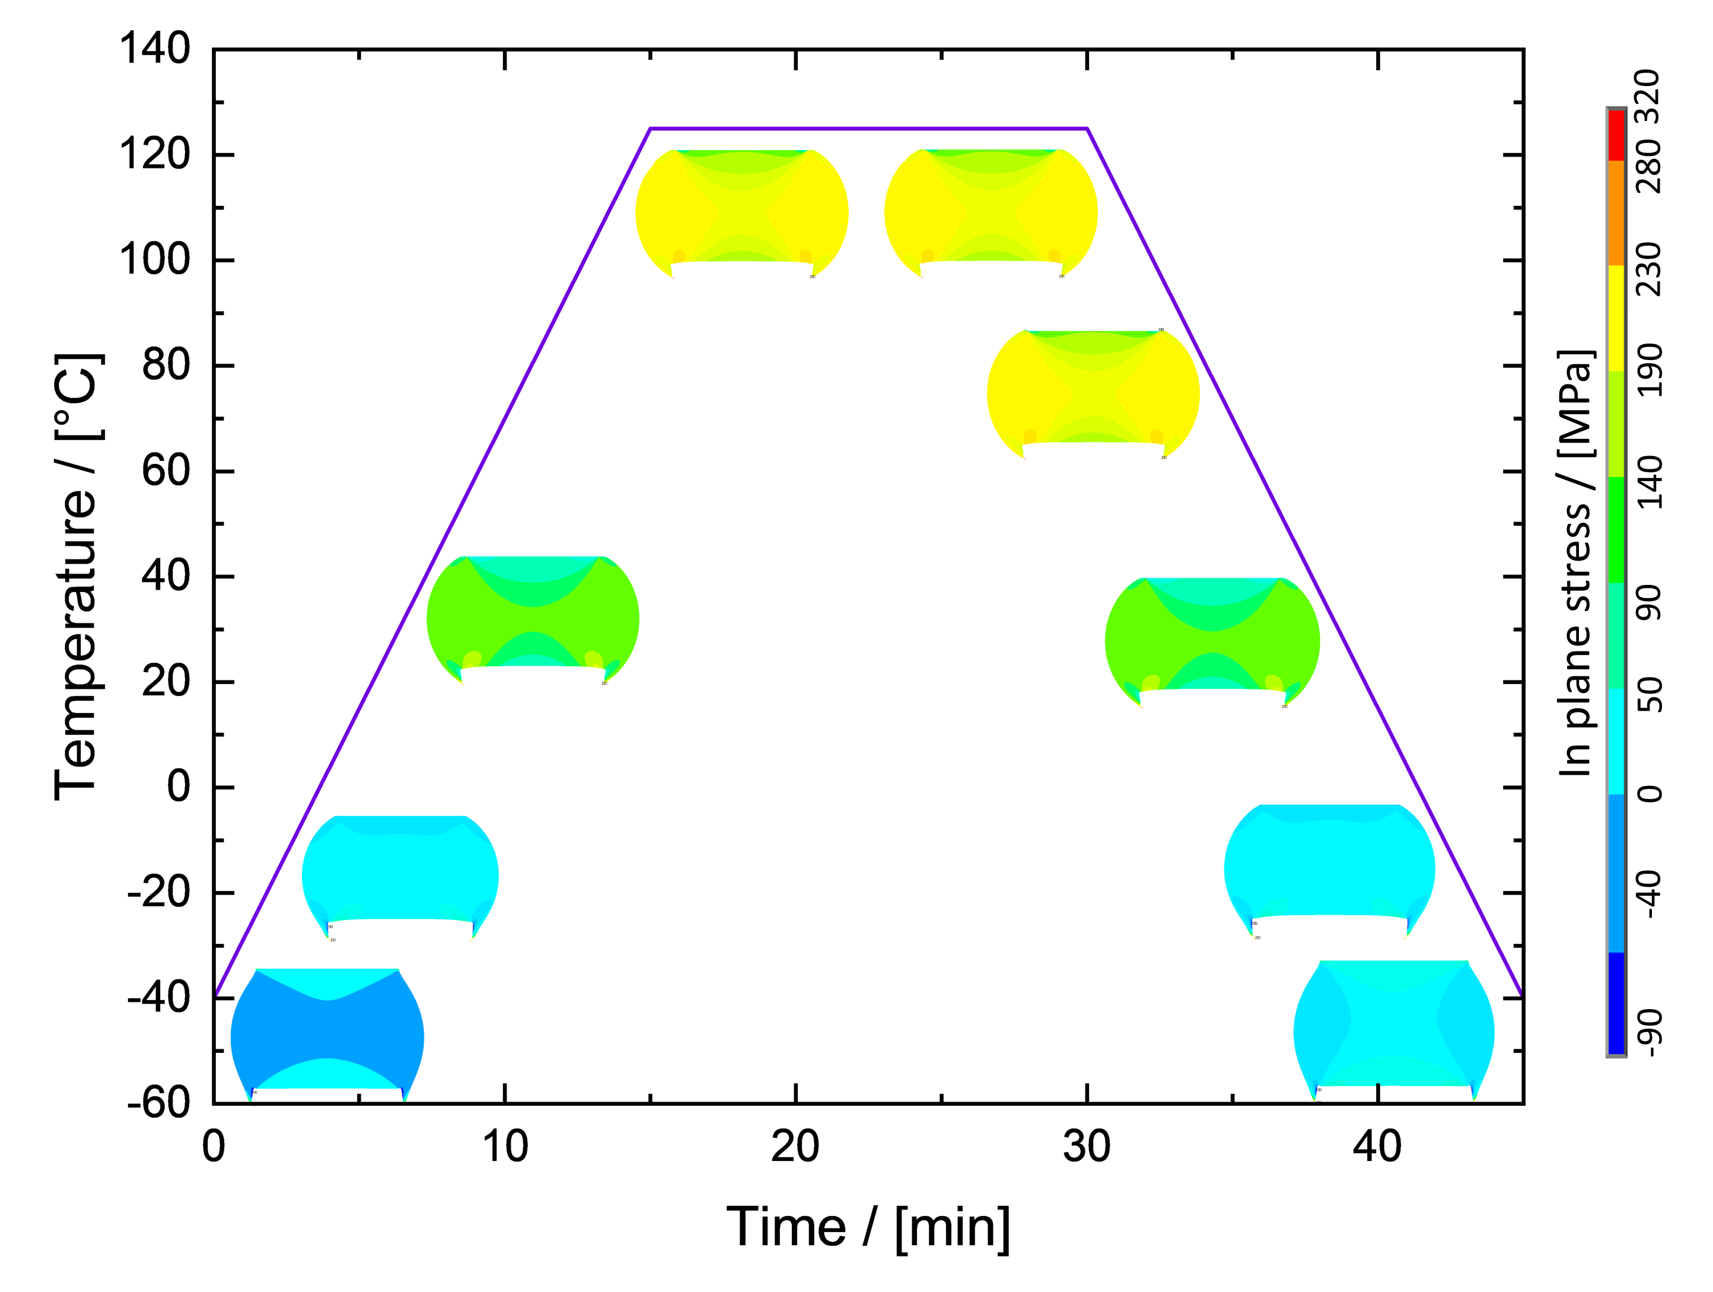
Temperature profile for FEM simulation with exemplary cross-sectional in plane stress distributions for a selection of timesteps. The evolution of the hourglass-shaped stress distribution can be seen.

Supplementary note 6: FESEM EBSD
In order to characterise the nature of the fatigue cracks that are visible in μ-XCT and segmented using the ML-algorithms developed in this study, cross-sectional FESEM EBSD maps are acquired. A Zeiss 450 Gemini FESEM and an Oxford Instruments Symmetry detector are used for EBSD mapping with 10 kV acceleration voltage. From these EBSD maps, shown in Fig. 5b and Supp. Fig. 3, it can be concluded that the fatigue cracks resulting from TCoB are intergranular cracks which propagate along recrystallised grain boundaries. The hourglass-shape of the recrystallisation front is in keeping with the stress distribution from the FEM simulation in Fig. 5a and Supp. Fig. 2. Moreover, KAM-maps in Fig. 5b and Supp. Fig. 3 qualitatively show the strain distribution over the solder cross-section after TCoB. Notably, non-recrystallised areas exhibit higher KAM-values than already recrystallised grains. Hence, it is deduced that recrystallisation relieves mechanical stress in the solder ball. The IPFs of the cross-sectional EBSD maps, also shown in Fig 5b and Supp. Fig. 3, convey highly localised crystal orientations. These orientations represent the initial as-reflowed crystal orientations, as the investigated solder balls solidify as single or few-grained crystals. However, even after recrystallisation, the newly formed grains do not deviate much from the initial crystal orientation, resulting in ‘smeared out’ spots in the IPFs. Therefore, the recrystallised grains are distorted around the initial crystal orientation, separated by small-angle grain boundaries. This indicates that the primary fatigue mechanism during TCoB is continuous recovery and polygonization rather than a sudden onset of statistical recrystallisation of a highly deformed crystal. Because the driving force for recovery and polygonization is the local dislocation density in the material, dislocation nucleation and mobility play a crucial role in grain refinement and subsequent intergranular crack initiation and propagation. Hence, higher yield strength of the material, achieved by solid solution strengthening by Bi, is expected to delay polygonization and cracking of the solder balls.

Supplementary Figure 3: Exemplary cross-sectional FESEM EBSD and KAM maps and IPFs
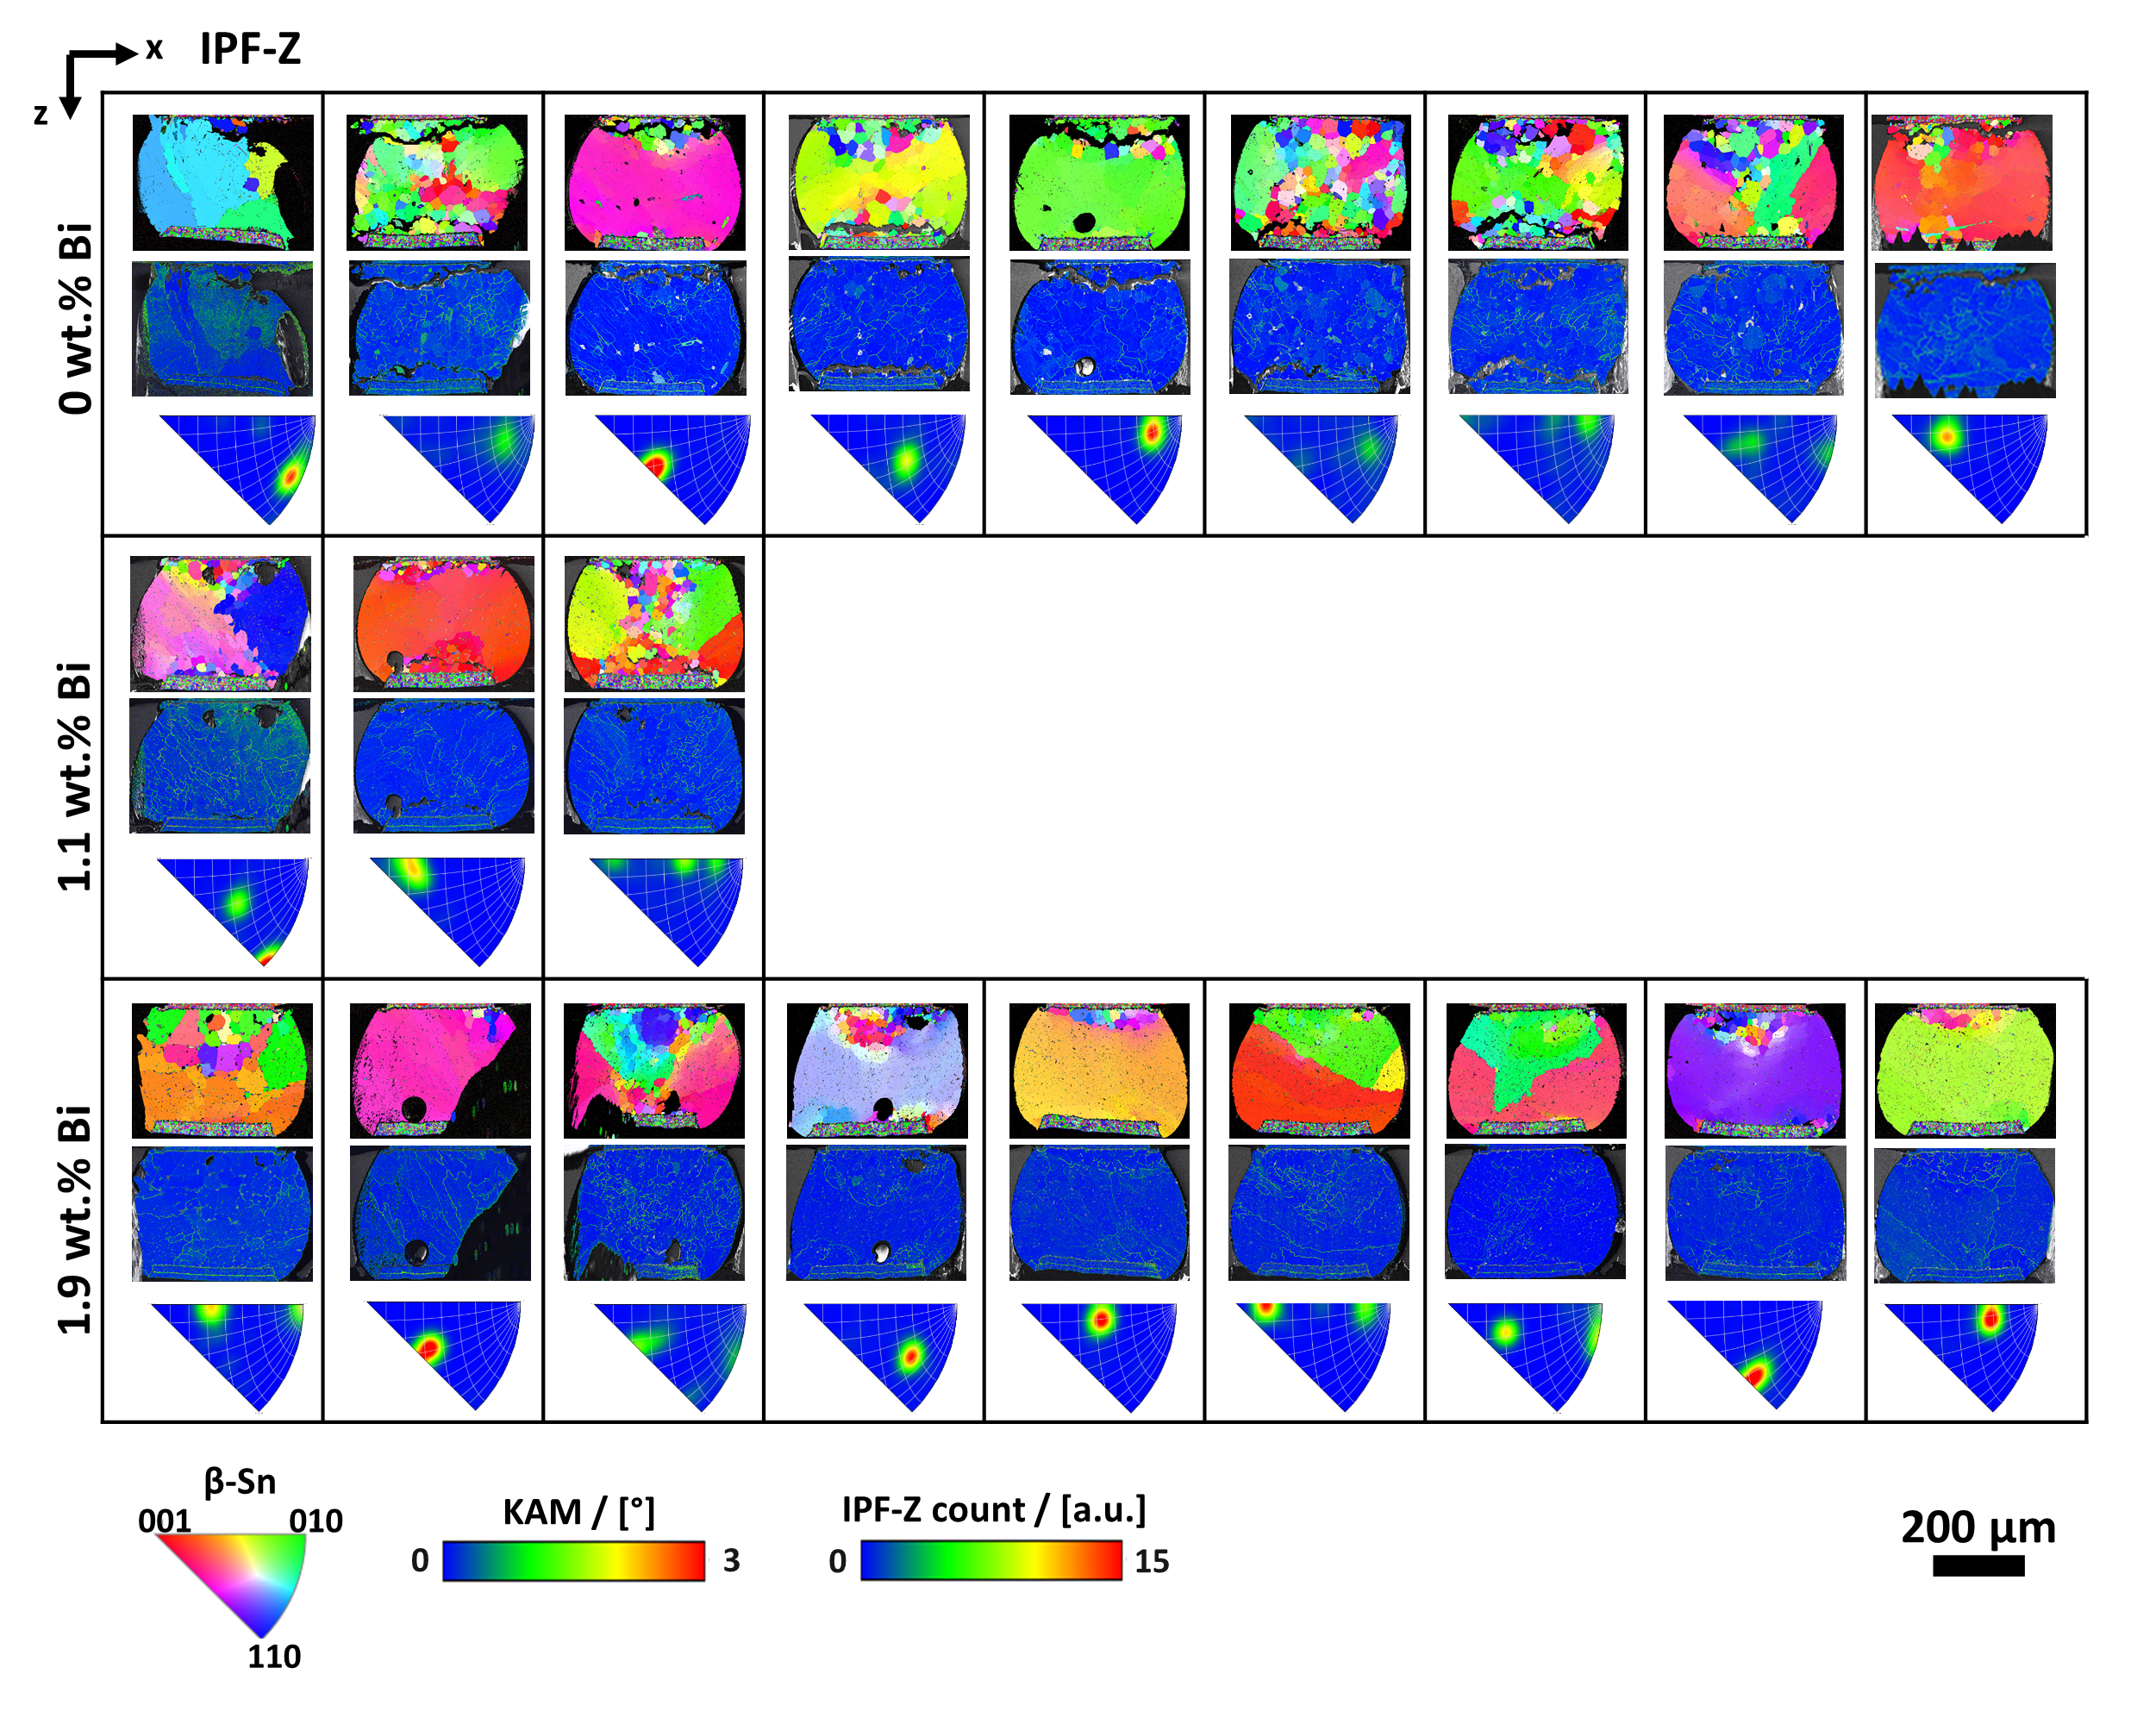
Exemplary cross-sectional EBSD- and KAM-maps, alongside the corresponding IPFs for each investigated Bi-content. The hour-glass shaped recrystallisation front and intergranular cracks are visible. IPFs reveal that recrystallised grains are oriented around the initial crystal orientation.

Supplementary note 7: FESEM EDX
In addition to EBSD, EDX-maps are also acquired in order to study the fatigue crack propagation paths, i.e. recrystallised grain boundaries. A Zeiss 450 Gemini FESEM and an Oxford Instrument Ultim detector are used. For BSE imaging and EDX mapping, an acceleration voltage of 5 kV is applied. Exemplary BSE micrographs and EDX maps of the three investigated alloys are shown in Supp. Fig. 4. In addition to the bulk Ag₃Sn and Cu₆Sn₅ precipitates, Cu-enrichment along recrystallised grain boundaries can be seen. The coverage of grain boundaries may promote intergranular crack propagation. The crystallographic and elemental structure of these grain boundaries in the three investigated alloys will be subject of a future study.
Furthermore, the EDX maps in Supp. Fig. 4 do not exhibit any primary Bi-precipitates. Hence, Bi is assumed to be solved in the β-Sn matrix, acting as solid solution strengthener, enhancing its yield strength and delaying grain refinement and subsequent intergranular cracking.

Supplementary Figure 4: FE-SEM EDX maps of recrystallised areas
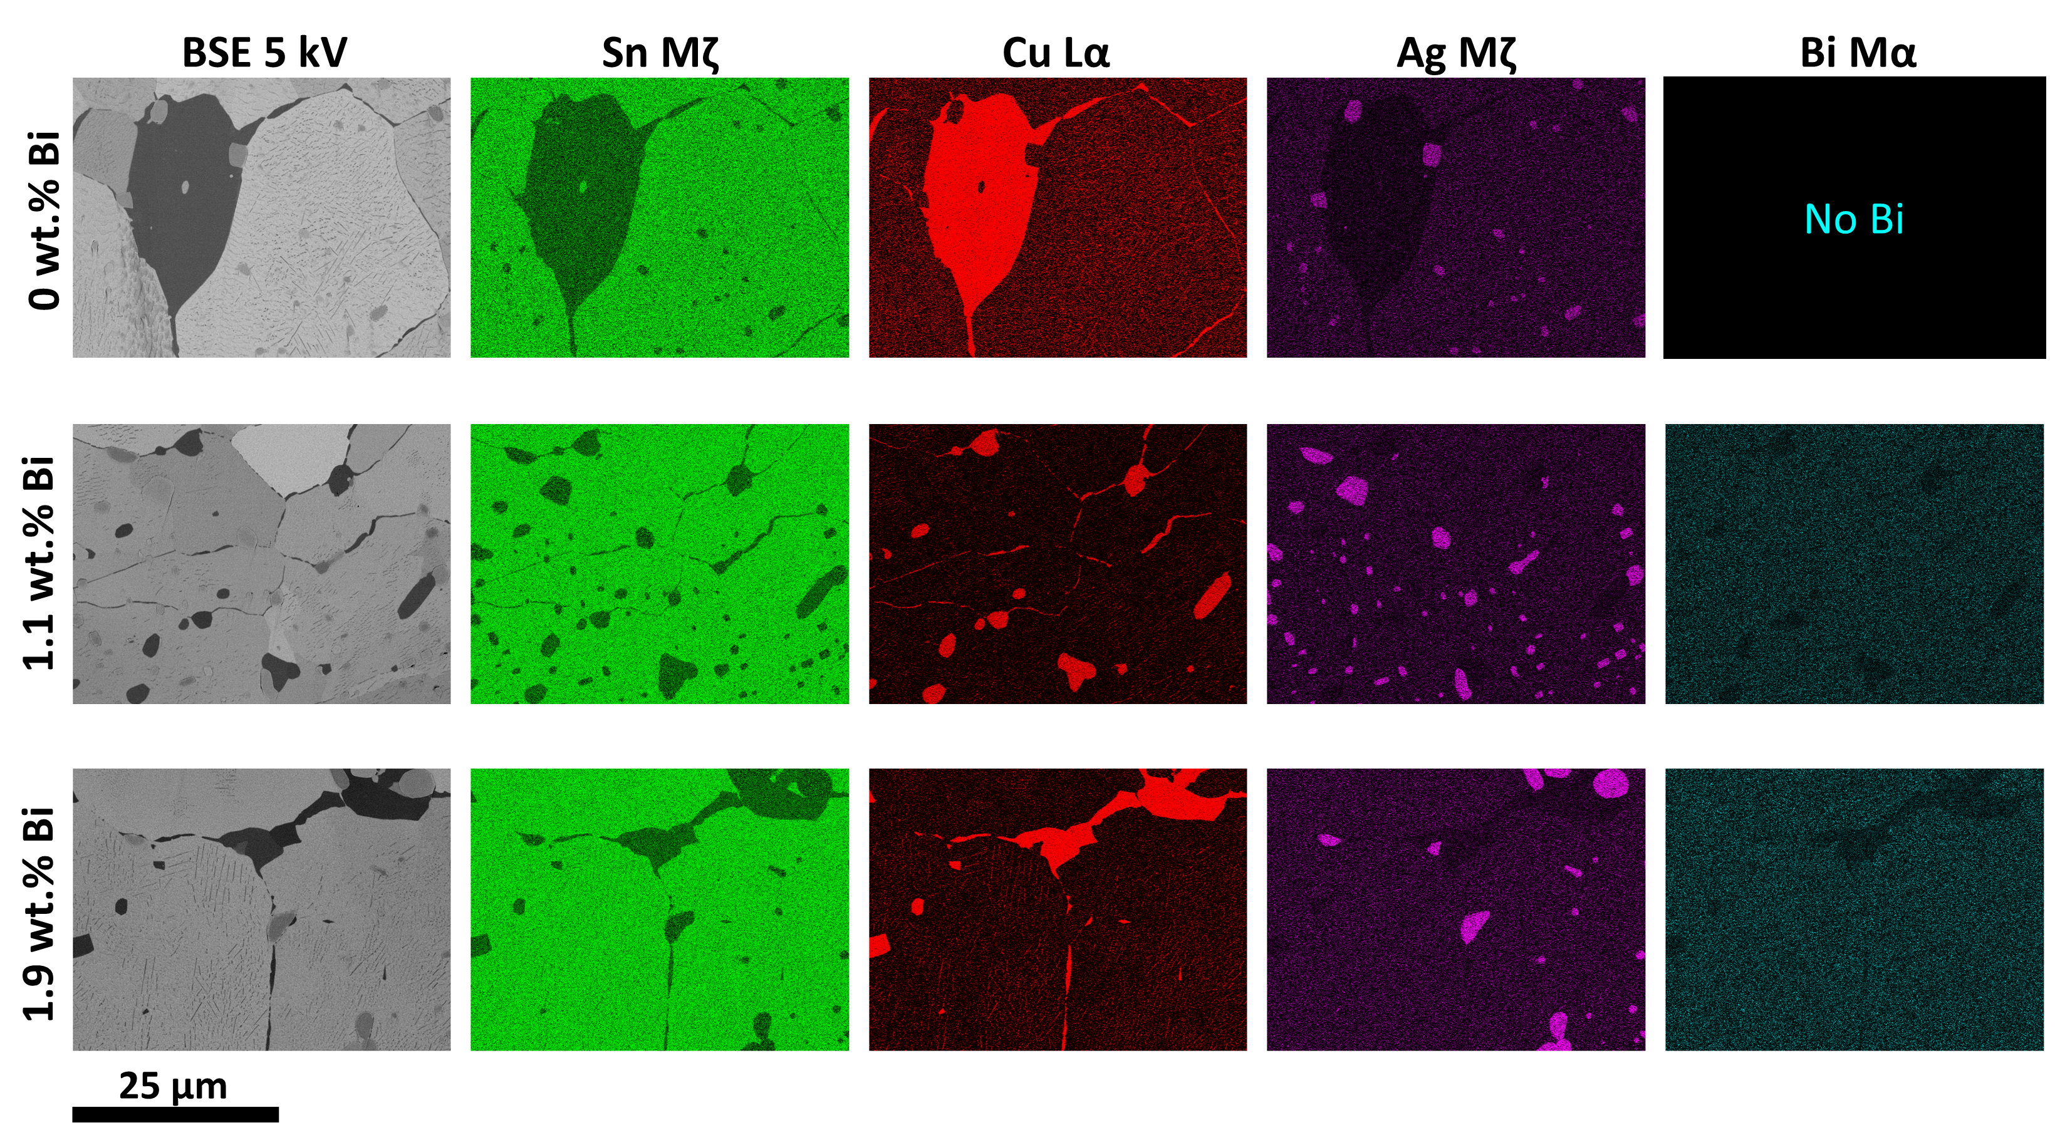
EDX-maps of recrystallised areas in one exemplary 0 wt.% Bi, 1.1 wt.% Bi and 1.9 wt.% Bi ball, respectively. In addition to the bulk intermetallic precipitates, Cu enrichment at recrystallised grain boundaries can also be seen. Moreover, no primary Bi-precipitates are visible.

References
1. Paulachan P, Siegert J, Wiesler I et al. (2023) An end-to-end convolutional neural network for automated failure localisation and characterisation of 3D interconnects. Sci Rep 13:9376. https://doi.org/10.1038/s41598-023-35048-0
2. Solovyev R, Kalinin AA, Gabruseva T (2022) 3D convolutional neural networks for stalled brain capillary detection. Comput Biol Med 141:105089. https://doi.org/10.1016/j.compbiomed.2021.105089
3. Berg S, Kutra D, Kroeger T et al. (2019) ilastik: interactive machine learning for (bio)image analysis. Nature Methods. https://doi.org/10.1038/s41592-019-0582-9
4. Ronneberger O, Fischer P, Brox T U-Net: Convolutional Networks for Biomedical Image Segmentation
5. The Materials Project (2020) Materials Explorer: Sn (mp-55), database version v2022.10.28. https://doi.org/10.17188/1267399. https://next-gen.materialsproject.org/materials/mp-55?_limit=75&formula=Sn#how_to_cite
6. Ross RB (1992) Metallic Materials Specification Handbook, 4th edn. 1. Ross Materials Technology Ltd, East Kilbride, Glasgow

