Graphical Abstract

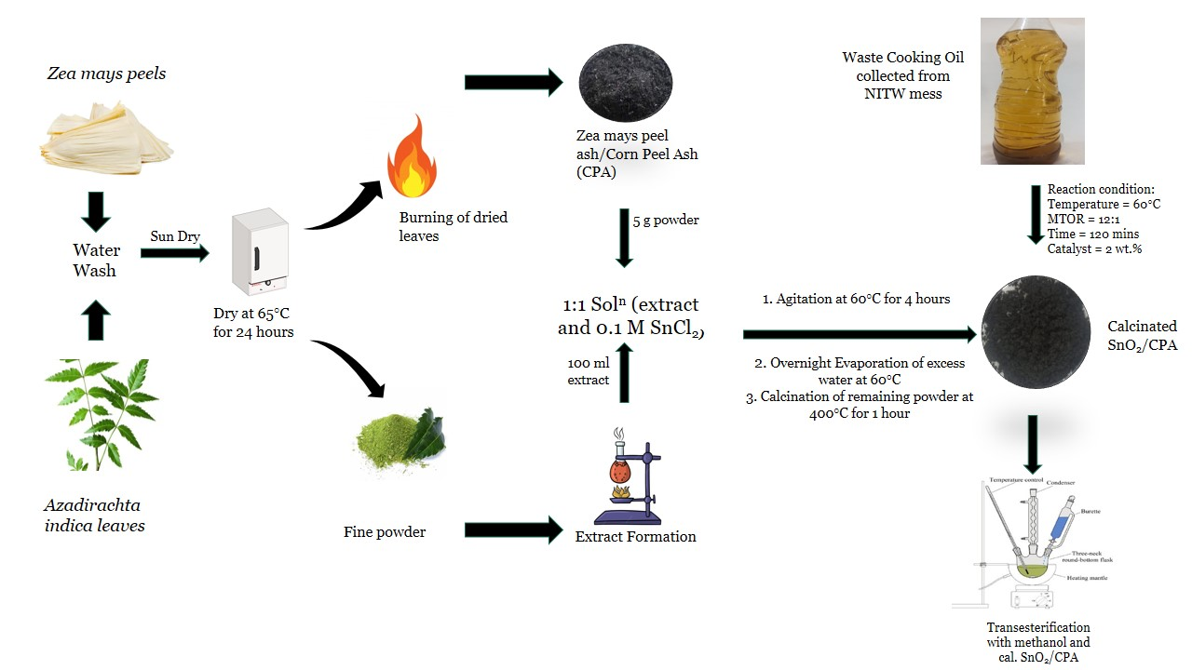
Highlights
- Biogenic synthesis of SnO₂/CPA nanocompositeusing leaf extract of Azadirachta indica.
- The biomolecules present in the leaf extract act as a complexing as well as a capping agent.
- SnO₂/CPA nanocomposite was employed as heterogeneous catalyst for conversion of waste cooking to biodiesel.
- The novel catalyst is environmental friendly with high surface area and good catalytic activity.

Fig. S1 of Supplementary Information

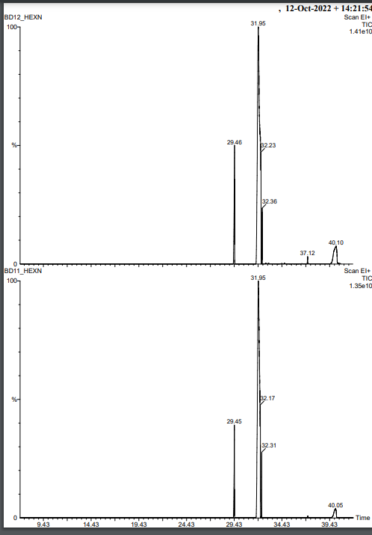

Fig. S1 Gas chromatographic analysis of biodiesel showing fatty acids methyl ester (FAME) content

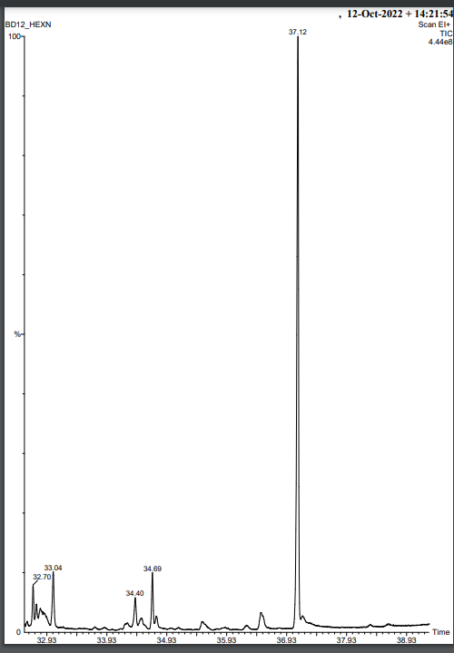
Fig. S1 Gas chromatographic analysis of biodiesel showing fatty acids methyl ester (FAME) content

