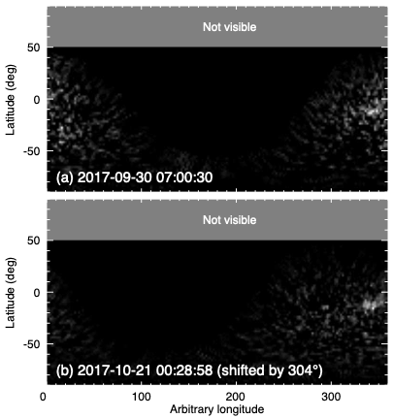
Figure S1: Background-subtracted cylindrical projections at 1100km altitude of two HST/STIS auroral images obtained on 30th Sept. and 21st Oct. 2017 (panels k-l in Figures 3 and S5). The cross-correlation in longitude between the two images yields a 304±6° phase shift which was used to infer a 17.247±0.010h rotation period.

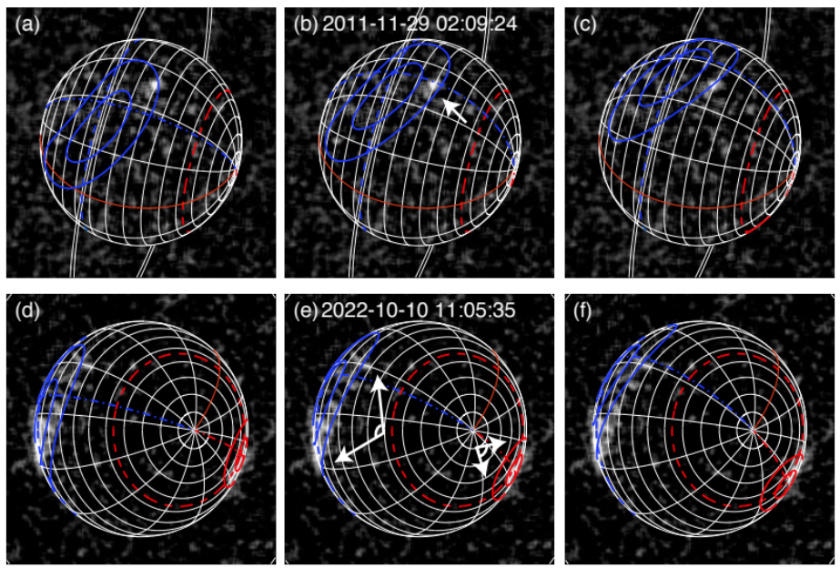
Figure S2: Illustration of the fitting of auroral emissions with Q₃ model ovals for two HST auroral images, either (a-c) poorly or (d-f) strongly constrained. The best-fitted model ovals are displayed in central panels (b) and (e) of both rows. The min-max fitted ovals, measuring the error on the best-fit, are displayed in left- and right-handed panels (a,c) and (d,f). In these examples, the uncertainty on the longitude of the best-fit ovals is +15°/-21° and ±12°, respectively.

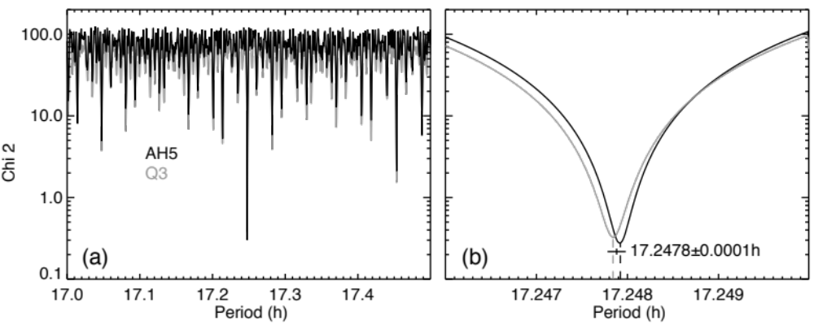
Figure S3: χ² data-model test between (i) the longitude of the magnetic poles derived from the (black) AH₅ and (gray) Q₃ model auroral ovals fitted to the 6 HST images of Fig. 1 and (ii) the longitude of the magnetic poles modeled for a variable rotation period (see Methods section). For each rotation period, we tested all possible longitudes of the magnetic axis with a 1° step and retained the minimal χ² value. Panel (a) displays results obtained for the 17-17.5h interval and panel (b) zooms in the deepest χ² minimum. Both χ² curves minimize for nearby periods, separated by 5.10⁻⁵h. The inferred average period is 17.2478±0.0001h.

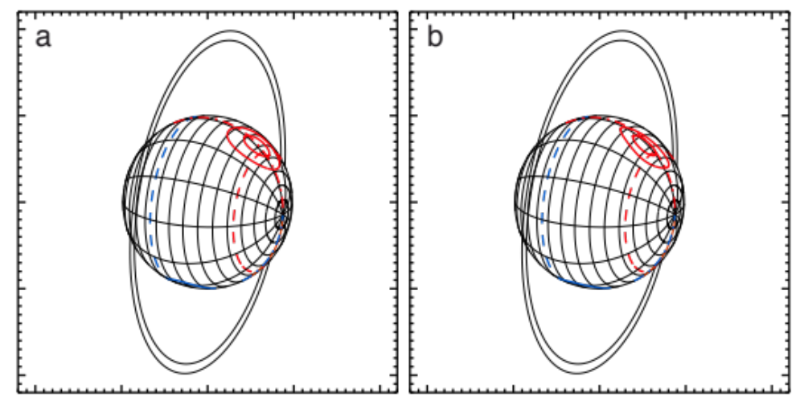
Figure S4: Uranus as seen from Voyager 2 on 1986-01-24 18:00:00 UT (CA). In the new IAU_{new} longitude system, the sub-Voyager 2 longitude is CML = 251.4°. The latitude and longitude of the southern (northern) OTD magnetic pole are indicated by dashed and dotted-dashed red (blue) lines. The southern (northern) model auroral ovals, as reconstructed from the (a) Q₃ and (b) AH₅ magnetic field models, are displayed by pairs of solid red (blue) lines.

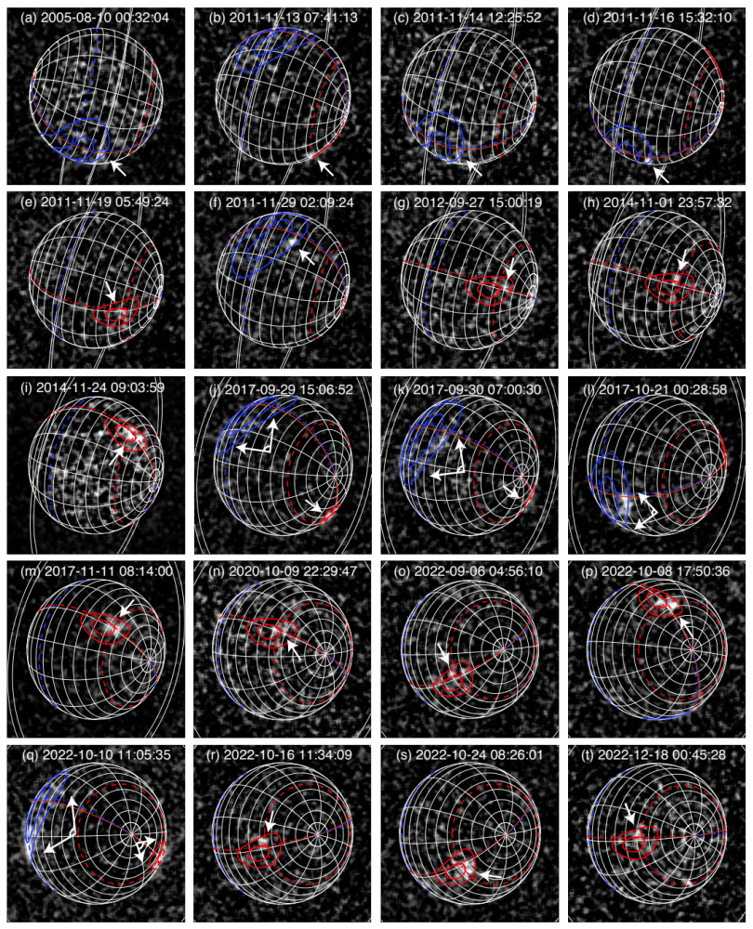
Figure S5: Same as Figure 3 with model auroral ovals built from the AH₅ field model instead.

