Supplementary Materials

Supplementary material 1:
fNIRS cap
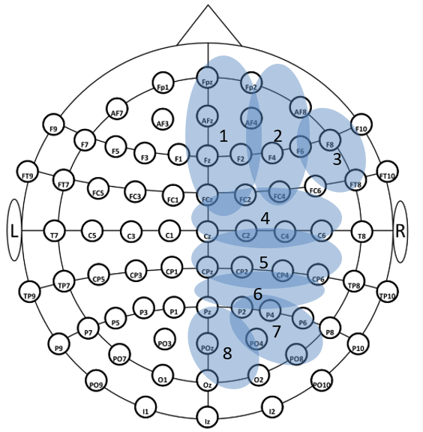
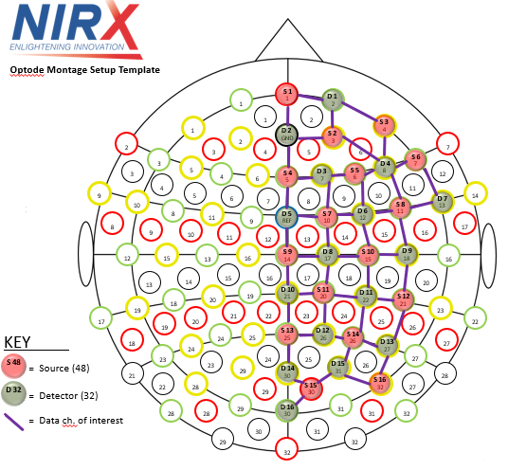

Note. Left figure presents optodes disposition on fNIRS cap. Right figure shows Regions of Interest (ROIs) - 1: medial prefrontal cortex, 2: dorsolateral pre-frontal cortex, 3: lateral pre-frontal cortex, 4: pre-central gyrus, 5: post-central gyrus, 6: superior parietal cortex, 7: inferior parietal cortex, 8: occipital cortex. Images adapted from NIRx Medical Techonologies, Glenn Head, NY; and Morais et al. (2018).

Supplementary material 2
Optodes and channels identification

Channel Index | Source | Detector | EEG 10-20 | ROI
1 | 1 | 1 | Fpz-Fp2 | 1
2 | 1 | 2 | Fpz-AFz | 1
3 | 2 | 1 | Af4-Fp2 | 1
4 | 2 | 2 | Af4-Afz | 1
5 | 2 | 4 | Af4-F6 | 2
6 | 3 | 1 | AF8-Fp2 | 2
7 | 3 | 4 | Af8-F6 | 3
8 | 4 | 2 | Fz-Afz | 1
9 | 4 | 3 | Fz-F2 | 1
10 | 4 | 5 | Fz-FCz | 1
11 | 5 | 3 | F4-F2 | 2
12 | 5 | 4 | F4-F6 | 2
13 | 5 | 6 | F4-FC4 | 2
14 | 6 | 4 | F8-F6 | 3
15 | 6 | 7 | F8-FT8 | 3
16 | 7 | 3 | FC2-F2 | 1
17 | 7 | 5 | FC2-FCz | 1
18 | 7 | 6 | FC2-FC4 | 2
19 | 7 | 8 | FC2-C2 | 4
20 | 8 | 4 | FC6-F6 | 3
21 | 8 | 6 | FC6-FC4 | 2
22 | 8 | 7 | FC6-FT8 | 3
23 | 8 | 9 | FC6-C6 | 4
24 | 9 | 5 | Cz-FCz | 4
25 | 9 | 8 | Cz-C2 | 4
26 | 9 | 10 | Cz-CPz | 5
27 | 10 | 6 | C4-FC4 | 4
28 | 10 | 8 | C4-C2 | 4
29 | 10 | 9 | C4-C6 | 4
30 | 10 | 11 | C4-CP4 | 5
31 | 11 | 8 | CP2-C2 | 5
32 | 11 | 10 | CP2-CPz | 5
33 | 11 | 11 | CP2-CP4 | 5
34 | 11 | 12 | CP2-P2 | 6
35 | 12 | 9 | CP6-C6 | 5
36 | 12 | 11 | CP6-CP4 | 5
37 | 12 | 13 | CP6-P6 | 6
38 | 13 | 10 | Pz-CPz | 6
39 | 13 | 12 | Pz-P2 | 6
40 | 13 | 14 | Pz-POz | 8
41 | 14 | 11 | P4-CP4 | 6
42 | 14 | 12 | P4-P2 | 7
43 | 14 | 13 | P4-P6 | 7
44 | 14 | 15 | P4-PO4 | 7
45 | 15 | 14 | O2-Poz | 8
46 | 15 | 15 | O2-PO4 | 8
47 | 15 | 16 | O2-Oz | 8
48 | 16 | 13 | PO8-P6 | 7
49 | 16 | 15 | PO8-PO4 | 7

Note. Identification of channels, source and detectors and their positions according to 10-20 eeg system.
Supplementary Material 3:
HbO statistics

Channel | P value | W statistic
1 | 0.127 | 220
2 | 0.002* | 272
3 | 0.275 | 204
4 | 0.107 | 223
5 | 0.812 | 172
6 | 0.287 | 203
7 | 0.895 | 157
8 | 0.352 | 198
9 | 0.141 | 218
10 | 0.090 | 226
11 | 0.148 | 217
12 | 0.832 | 171
13 | 0.263 | 120
14 | 0.958 | 165
15 | 0.339 | 126
16 | 0.832 | 154
17 | 0.560 | 140
18 | 0.275 | 204
19 | 0.396 | 195
20 | 0.127 | 105
21 | 0.252 | 119
22 | 0.287 | 122
23 | 0.474 | 135
24 | 0.751 | 175
25 | 0.542 | 186
26 | 0.312 | 201
27 | 0.080 | 228
28 | 0.916 | 167
29 | 0.287 | 203
30 | 0.051 | 90
31 | 0.937 | 166
32 | 0.832 | 154
33 | 0.490 | 136
34 | 0.560 | 185
35 | 0.937 | 166
36 | 0.979 | 164
37 | 0.832 | 171
38 | 0.874 | 156
39 | 0.791 | 173
40 | 0.916 | 158
41 | 0.427 | 193
42 | 0.042* | 238
43 | 0.071 | 230
44 | 0.427 | 193
45 | 0.812 | 172
46 | 0.578 | 184
47 | 0.339 | 126
48 | 0.751 | 150
49 | 0.916 | 167

Note. Results of Wilcoxon tests comparing HbO levels in each channel between attentive and inattentive conditions.
*P < 0,05

Supplementary Material 4:
Hb statistics

Channel | P value | W statistic
1 | 0.381 | 129
2 | 0.007* | 64
3 | 0.164 | 110
4 | 0.062 | 93
5 | 0.560 | 185
6 | 0.134 | 106
7 | 0.731 | 149
8 | 0.300 | 123
9 | 0.220 | 116
10 | 0.691 | 147
11 | 0.832 | 154
12 | 0.812 | 153
13 | 0.173 | 214
14 | 1 | 162
15 | 0.210 | 210
16 | 0.812 | 172
17 | 0.381 | 196
18 | 0.832 | 154
19 | 0.937 | 159
20 | 0.458 | 191
21 | 0.615 | 182
22 | 0.396 | 195
23 | 0.241 | 207
24 | 0.937 | 159
25 | 0.426 | 193
26 | 0.164 | 110
27 | 0.958 | 165
28 | 0.474 | 190
29 | 0.411 | 194
30 | 0.200 | 211
31 | 0.381 | 196
32 | 0.426 | 193
33 | 0.853 | 170
34 | 0.682 | 179
35 | 0.508 | 188
36 | 0.120 | 221
37 | 0.731 | 176
38 | 0.711 | 177
39 | 0.937 | 159
40 | 0.711 | 177
41 | 0.895 | 168
42 | 0.263 | 120
43 | 0.096 | 100
44 | 0.791 | 173
45 | 0.525 | 138
46 | 0.381 | 129
47 | 0.633 | 181
48 | 0.542 | 186
49 | 1 | 162

Note. Results of Wilcoxon tests comparing Hb levels in each channel between attentive and inattentive conditions.

*p < 0,05
Supplementary material 5:
Time courses of neurophysiological data.

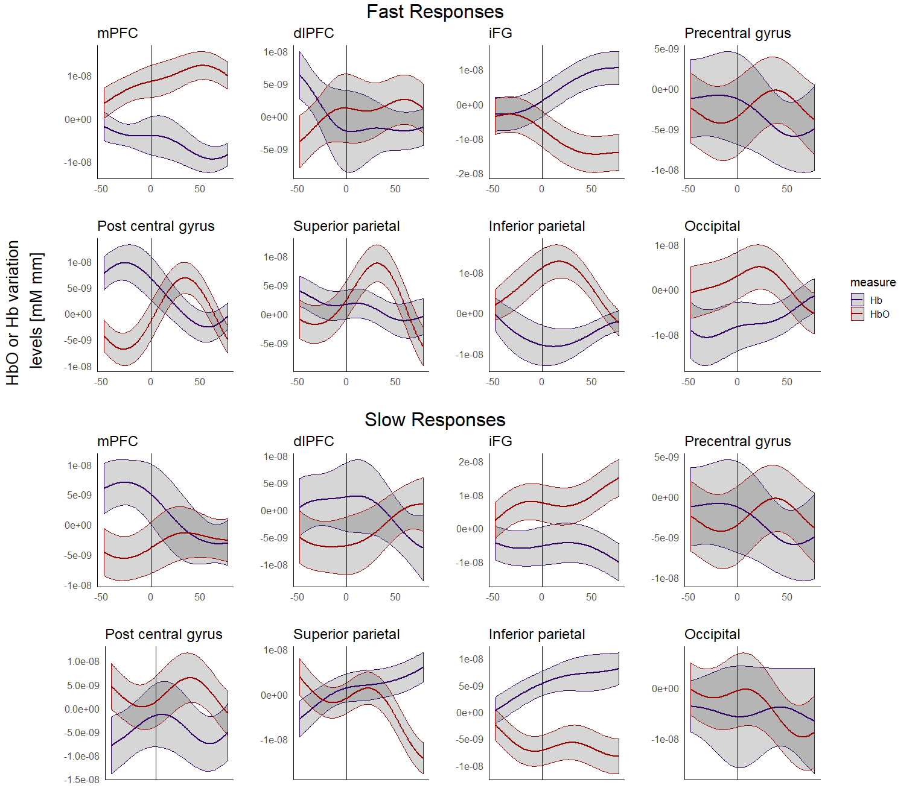
Note. Averaged time course across all participants of HbO and Hb concentration changes between fast and slow responses. The count of 50 frames on y axis corresponds to approximately 6s. Black vertical line represents stimulus presentation.

