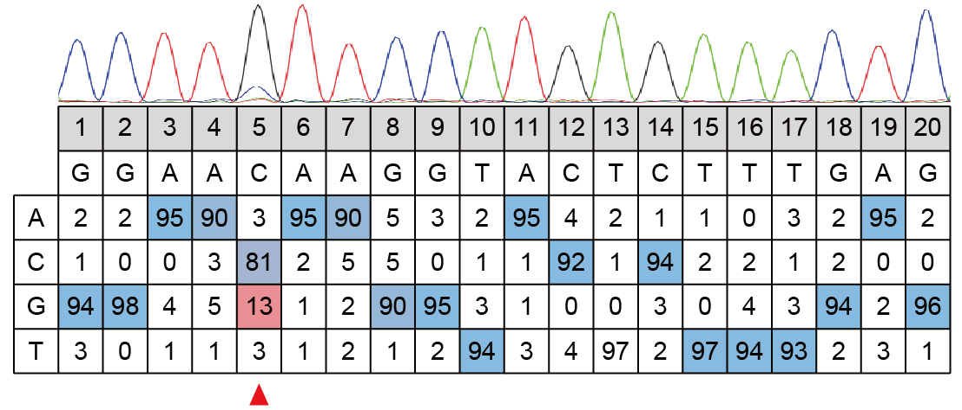
Extended Data Fig. 1 | Sanger sequencing of AjTadA.v1 at PIK3CA loci.
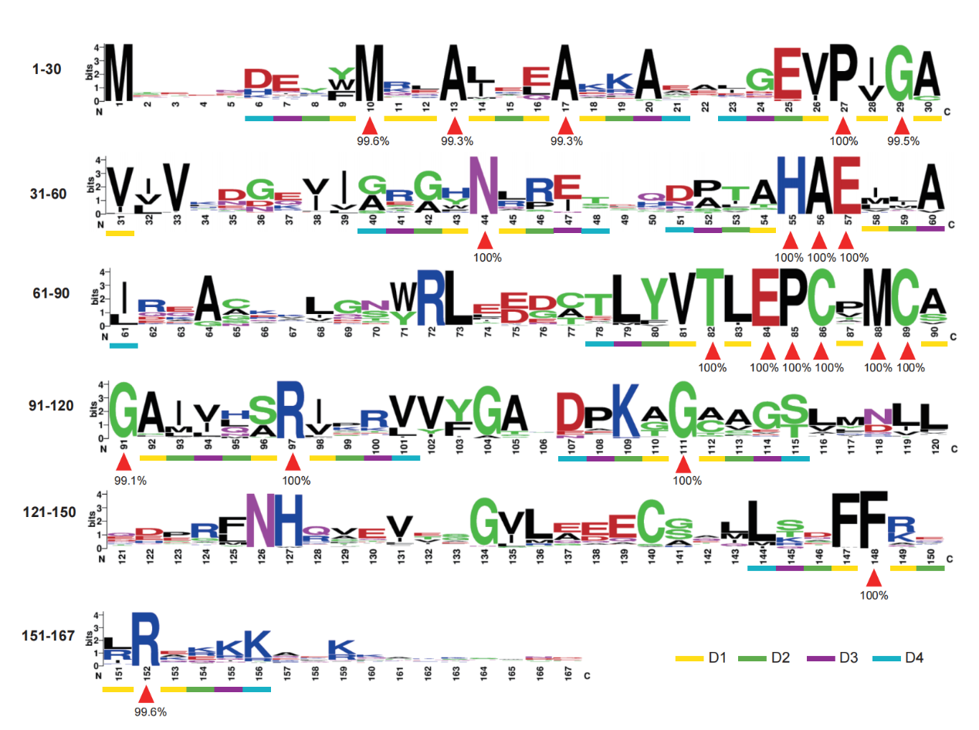
Extended Data Fig. 2 | Conservative site analysis of TadA protein sequence based on multiple sequence alignment. The red triangle indicates highly conserved amino acids. The yellow, green, purple and blue squares represent adjacent amino acids with different distances from highly conserved sites.

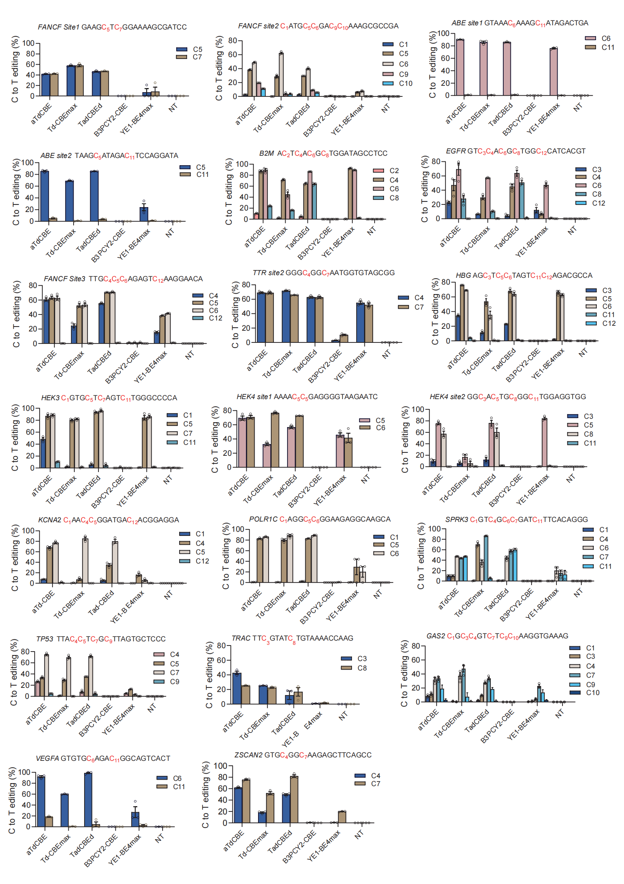
Extended Data Fig. 3 | AjTadA enables robust C-to-T genomic editing in mammalian cells. Data are presented as means ± s.d. Values represent n = 3 independent biological replicates.

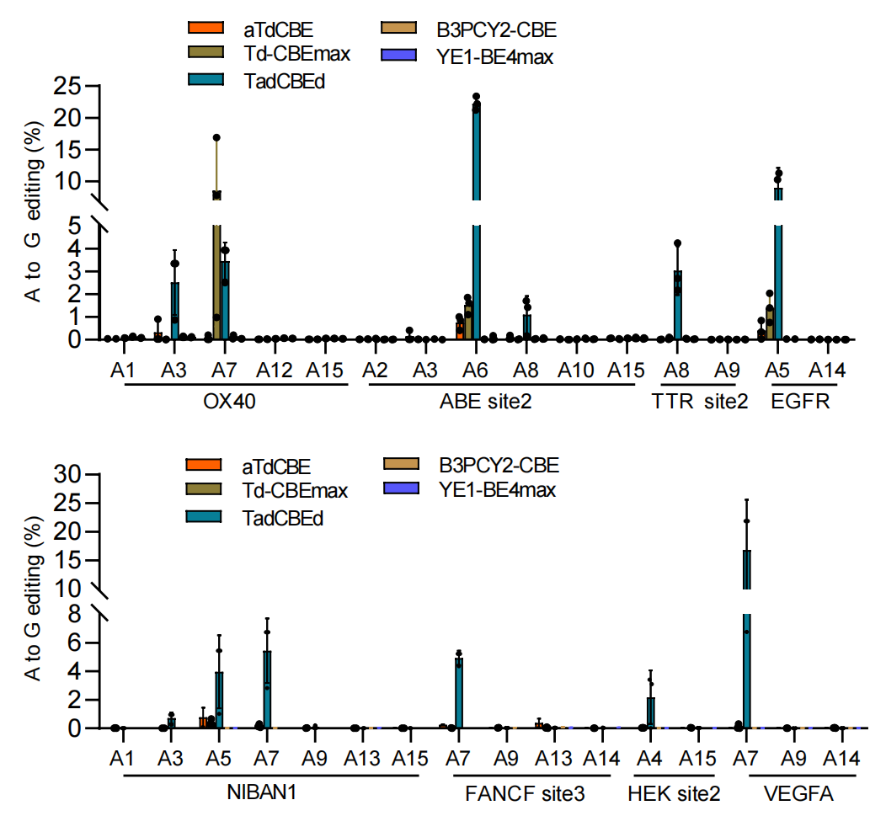
Extended Data Fig. 4 | A-to-G genomic editing of base editors in mammalian cells. Data are presented as means ± s.d. Values represent n = 3 independent biological replicates.
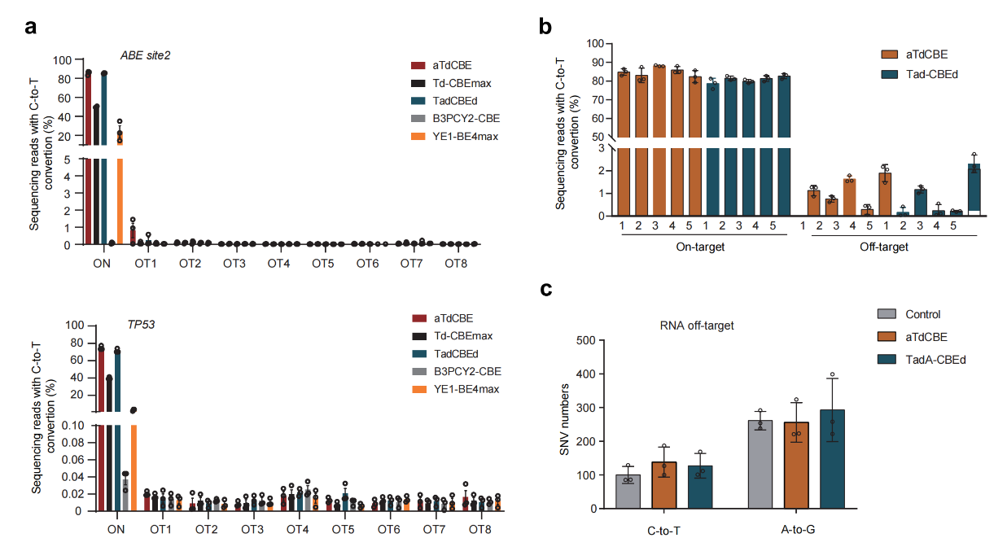
Extended Data Fig. 5 | AjTadA-derived base editors with high specificity in mammalian cells.
a. The gRNA-dependent off-target levels at the potential off-target sites. b. The gRNA-independent off-target activity at five R-loops formed by dSaCas9. c. Transcriptome-wide off-target analysis of aTdCBE and TadA-CBEd. Data are presented as means ± s.d. Values represent n = 3 independent biological replicates.
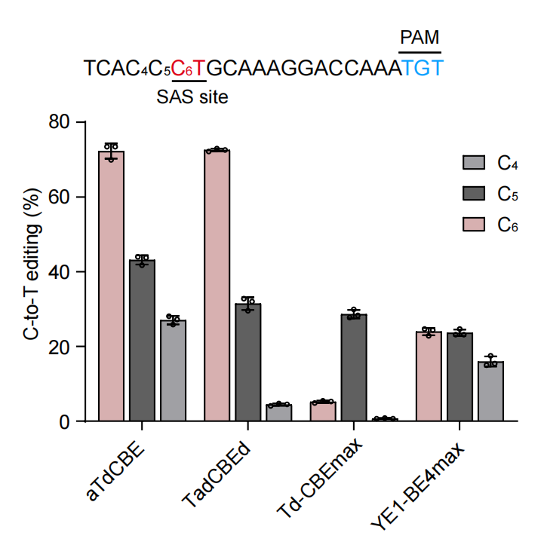
Extended Data Fig. 6 | Comparing the editing efficiency of CBEs at the exon 55 SAS of DMD gene in HEK293T cells. SpG Cas9 were used to targeting the SAS-containing sequence with 3’-TGT PAM. Data are presented as means ± s.d. Values represent n = 3 independent biological replicates.
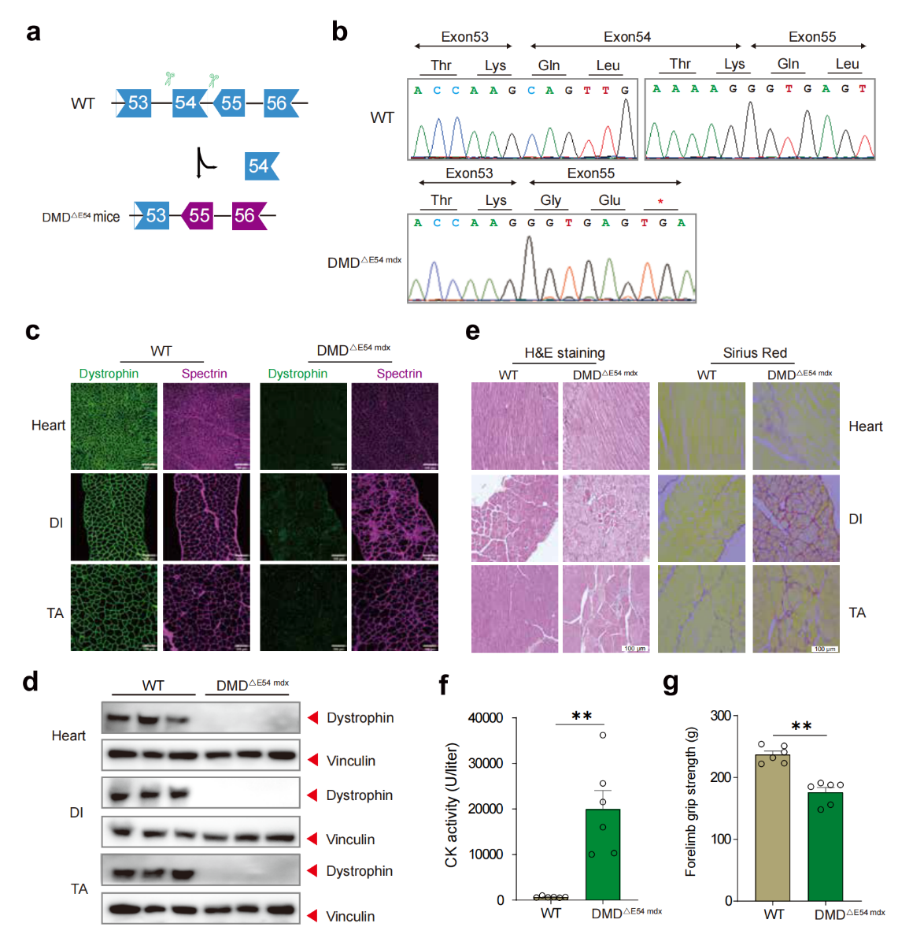
Extended Data Fig. 7 | Establishment and characterization of a humanized DMD mouse model.
a. Strategy for generating a humanized DMD mouse model. CRISPR-Cas9 editing was employed to delete human DMD exon54. b. RT-PCR analysis of TA muscles to validate deletion of human exon 54. c. Dystrophin immunohistochemistry from indicated muscles of WT and DMD^{ΔE54 mdx} mice. Dystrophin (Abcam, ab15277) and spectrin (Millipore, MAB1622) are shown in green and mangenta, respectively. d. Western blot confirming the absence of dystrophin (Sigma, D8168) in indicated muscle tissues. f. Serum CK, a marker of muscle damage and membrane leakage, was measured in WT and DMD^{ΔE54 mdx} mice (n=6). e. Sirius red staining and HE staining of TA, DI, and heart muscle of WT and DMD^{ΔE54 mdx} mice. g. WT and DMD^{ΔE54 mdx} mice were subjected to forelimb grip strength testing to measure muscle performance (n=6). All mice were 4 weeks old at the time of the experiment. Data are represented as mean ± s.e.m. Each dot represents an individual mouse. **P < 0.05 using unpaired two-tailed Student’s t test. Scale bar, 100 μm.

