SUPPORTING INFORMATION

Chemical Analyses and Geographical Origins
of Residential Attic Dust in Central South Africa

Deidré van der Westhuizenª, Megan Welman-Purchase^{b}, Janine Wichmann^{c} and Karel G. von Eschwege ª*
a. Department of Chemistry, PO Box 339, University of the Free State, Bloemfontein, 9300, South Africa; didivdwesthuizen@gmail.com , veschwkg@ufs.ac.za
b. Department of Geology, PO Box 339, University of the Free State, Bloemfontein, 9300, South Africa; purchasemd@ufs.ac.za
c. School of Health Systems and Public Health, Faculty of Health Sciences, University of Pretoria, Pretoria, South Africa; janine.wichmann@up.ac.za.
* Correspondence: KGvE: vEschwKG@ufs.ac.za; Tel.: +27-51-4012923/2194

Table S1. Location of Sampling Sites
Suburb | City | Coordinates
Langenhoven Park | Bloemfontein -West | -29.103, 26.162
Universitas | Bloemfontein - West | -29.096, 26.170
Heidedal | Bloemfontein - East | -29.142, 26.261
Maselspoort | Bloemfontein - East | -29.034, 26.404
South Ridge | Kimberley - South | -28.771, 24.762
Monument Heights | Kimberley - South | -28.767, 24.760
Casandra | Kimberley - East | -28.741, 24.794
SE3 1 | Vanderbijlpark - South | -26.741, 27.849
SE3 2 | Vanderbijlpark - South | -26.736, 27.850

Figure S1 SEM particle morphology images for the LHP sites were captured at magnifications of 90 (top left), 110 (top right), 130 (bottom left) and 180 (bottom right) times.

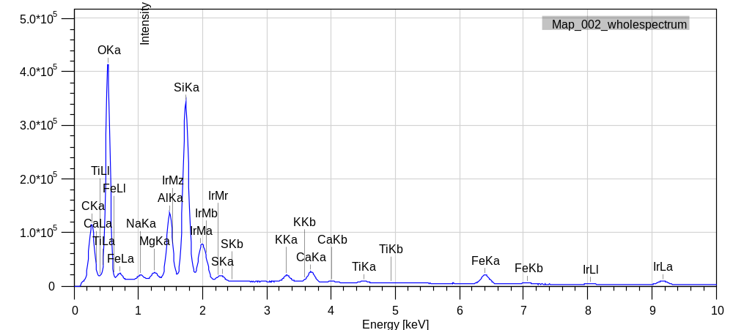
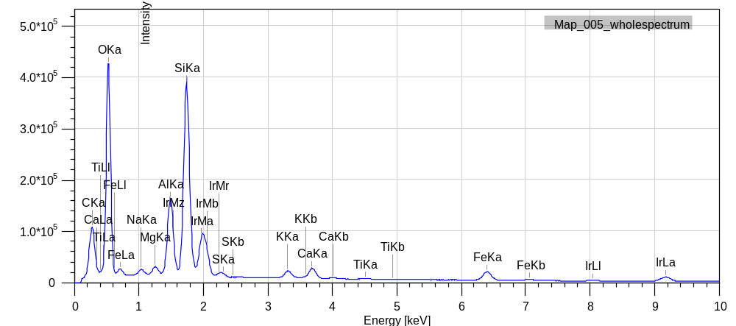
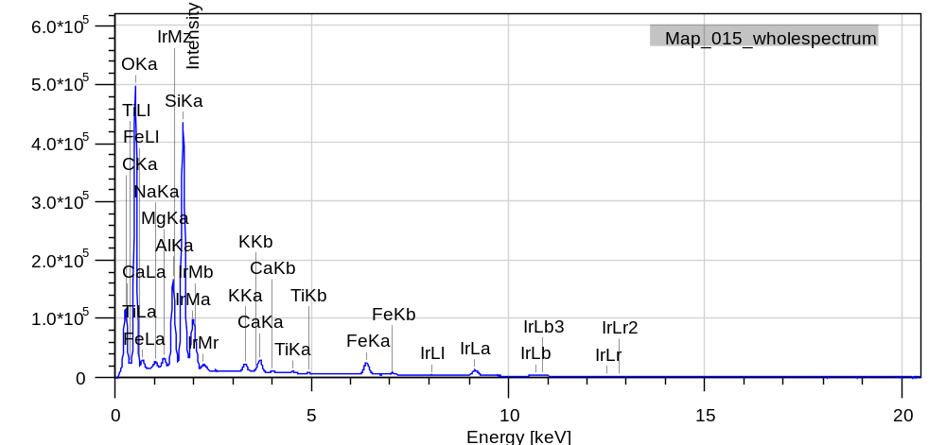
A
B
C
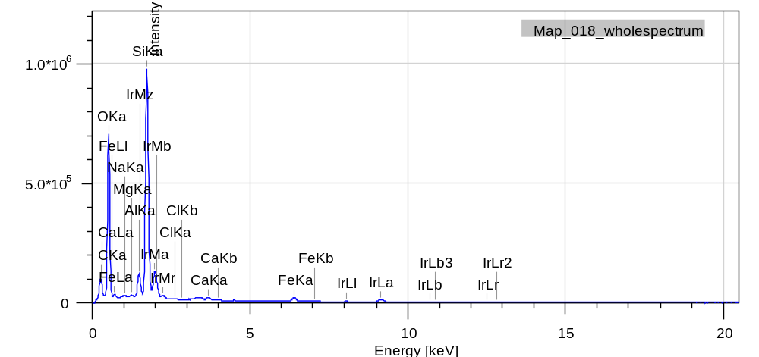
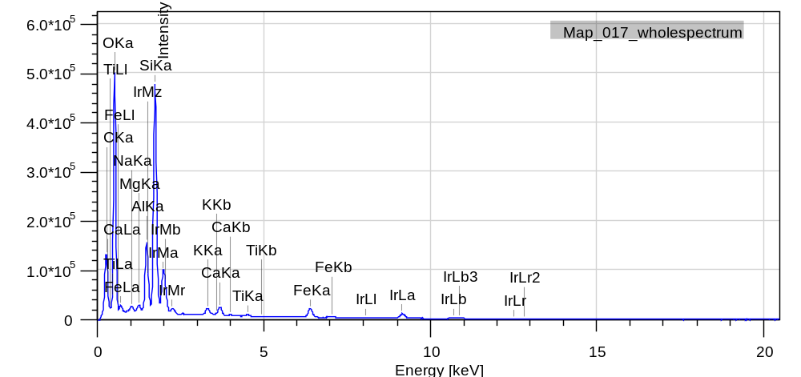
E
D

Figure S2 SEM-EDS elemental composition illustrations for particles observed in SEM analysis at the LHP site, Bloemfontein.

Figure S3 SEM particle morphology images for the U sites were captured at magnifications of 110 (top left), 120 (top right), 160 (bottom left) and 230 (bottom right) times.

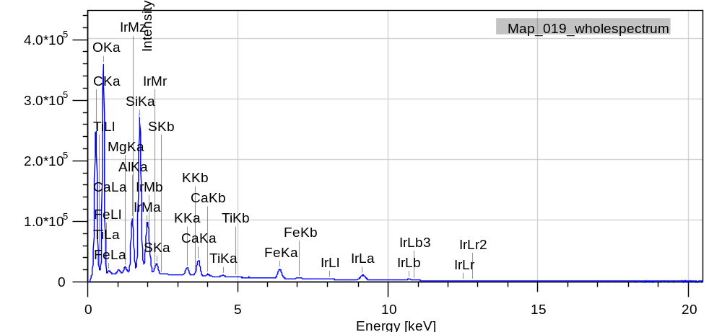
A

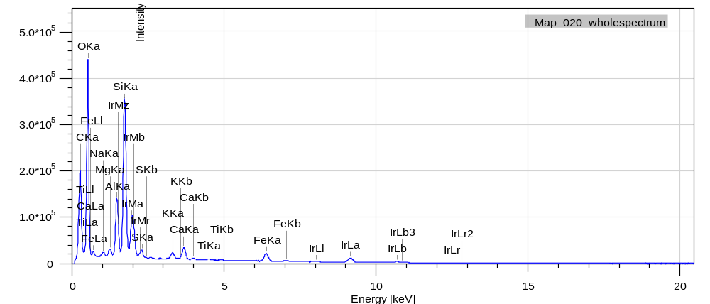
B

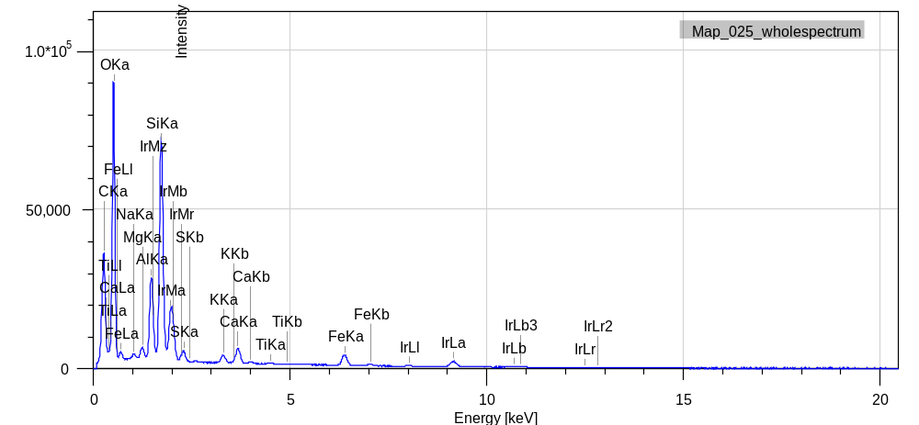
C

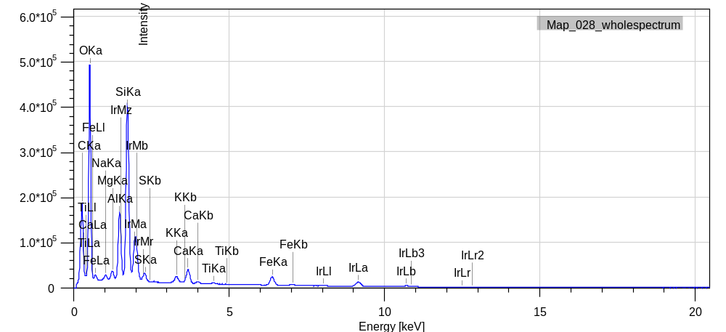
E
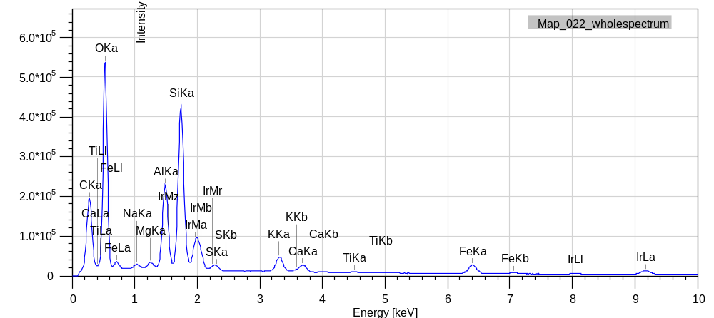
D
Figure S4 SEM-EDS elemental composition illustrations for particles observed in SEM analysis at the U site, Bloemfontein.

Figure S5 SEM particle morphology images for the H sites were captured at magnifications of 160 (top left), 250 (top right), 250 (bottom left) and 750 (bottom right) times.

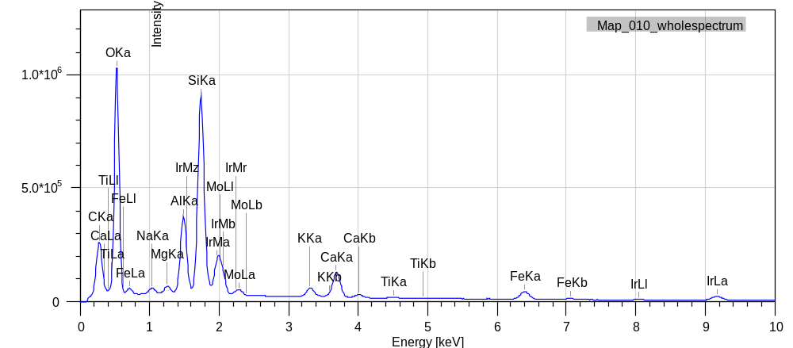
A

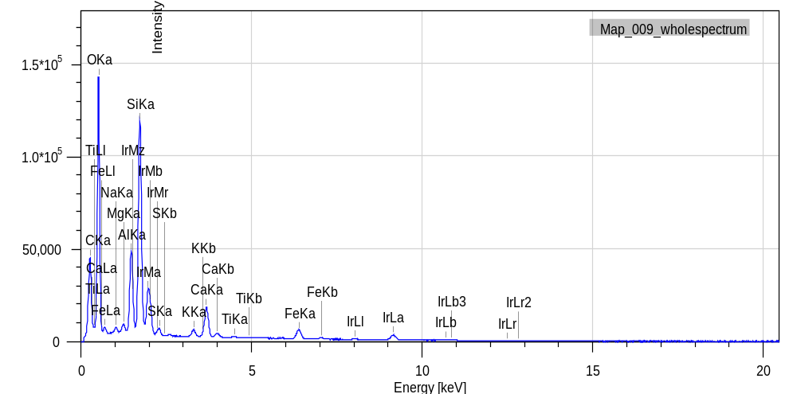
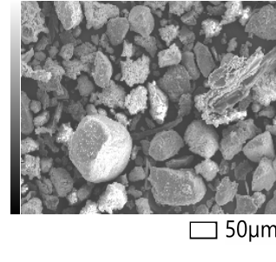
B

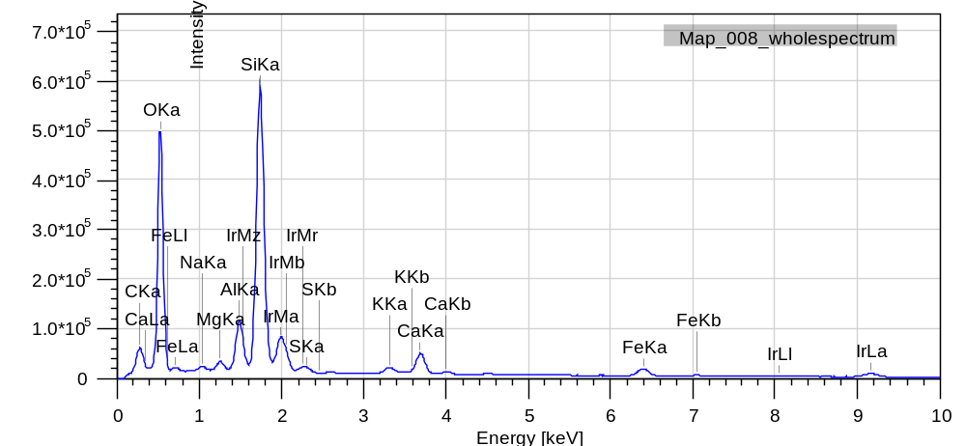
C

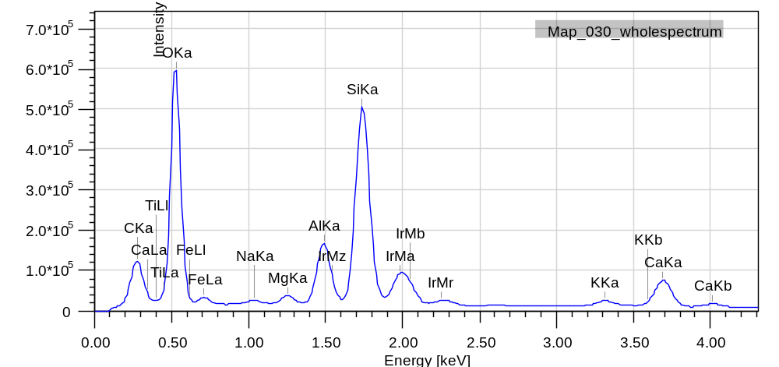
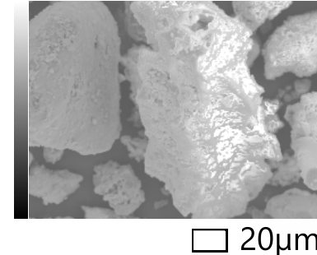
D
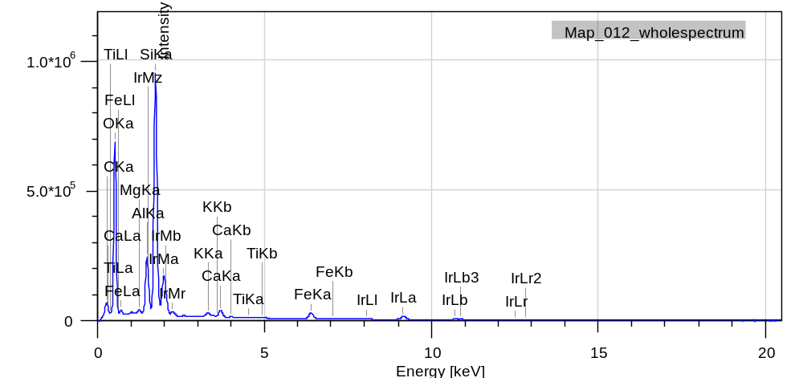
E

Figure S6 SEM-EDS elemental composition illustrations for particles observed in SEM analysis at the H site, Bloemfontein.

Figure S7 SEM particle morphology images for the M sites were captured at magnifications of 35 (top left), 35 (top right), 190(bottom left) and 100(bottom right) times.

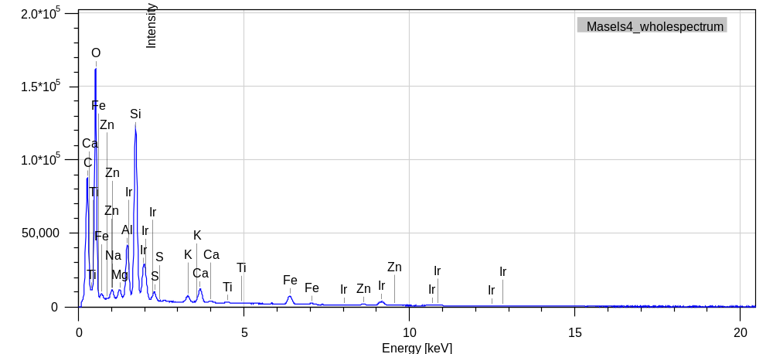
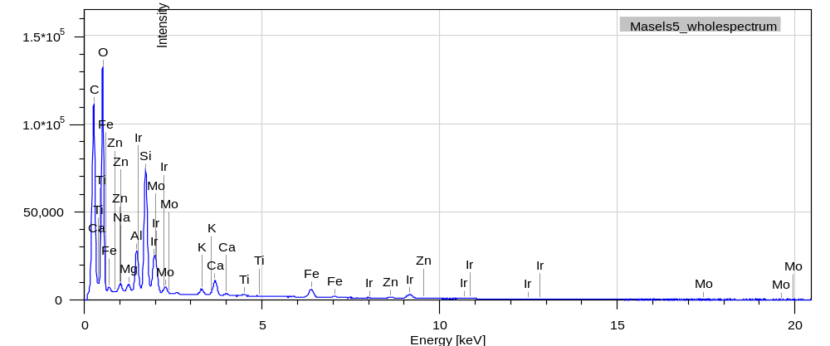
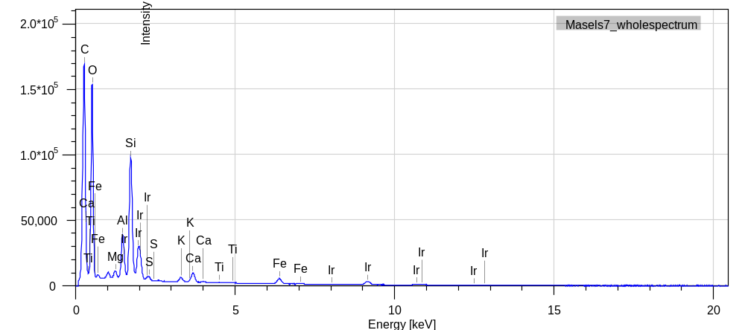
C
B
A
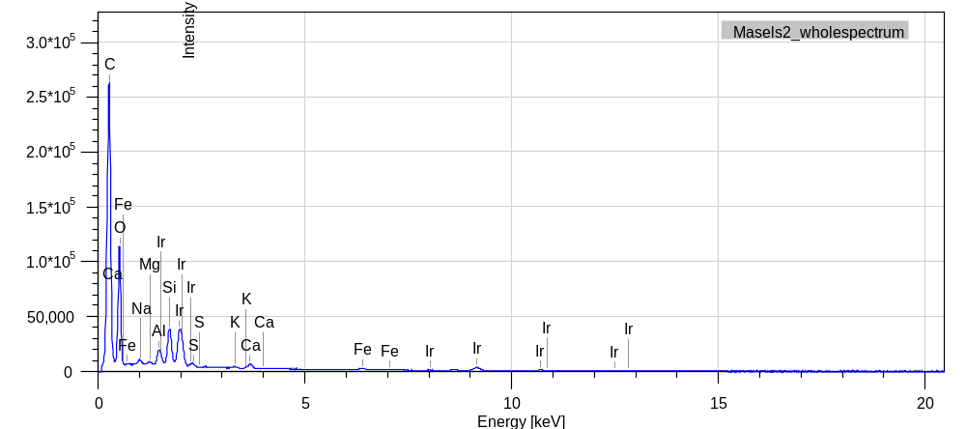
D
Figure S8 SEM-EDS elemental composition illustrations for particles observed in SEM analysis at the M site, Bloemfontein.

Figure S9 SEM particle morphology images for the SR sites, Kimberley, were captured at magnifications of 33 (top left), 33 (top right), 80 (bottom left) and190 (bottom right) times.

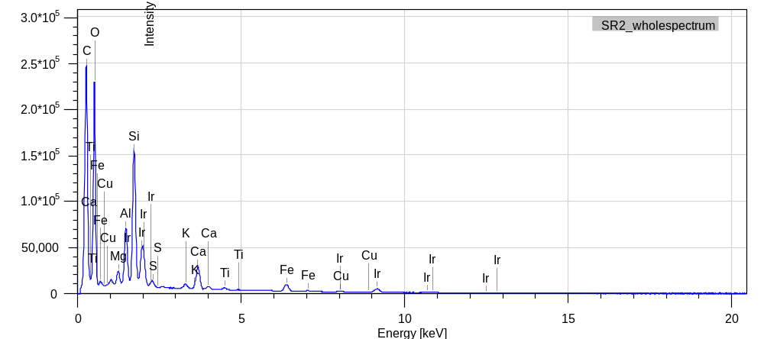
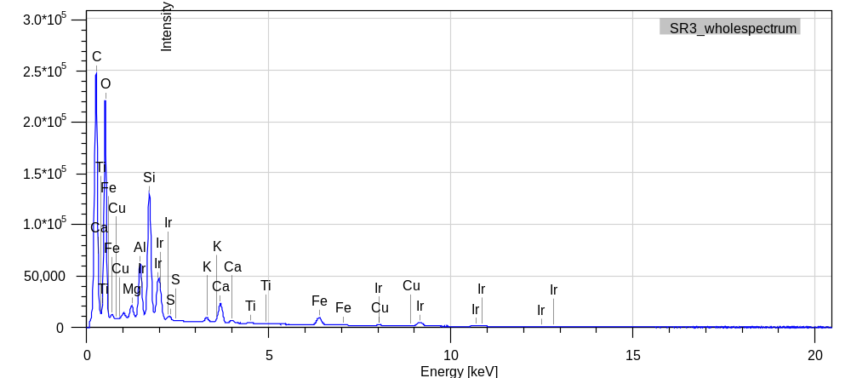
A
B

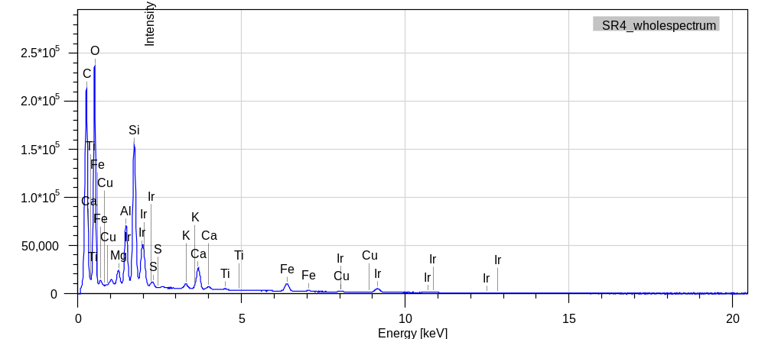
C
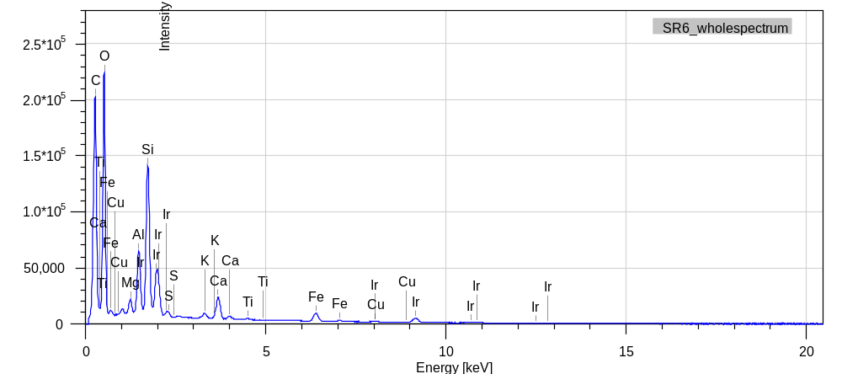
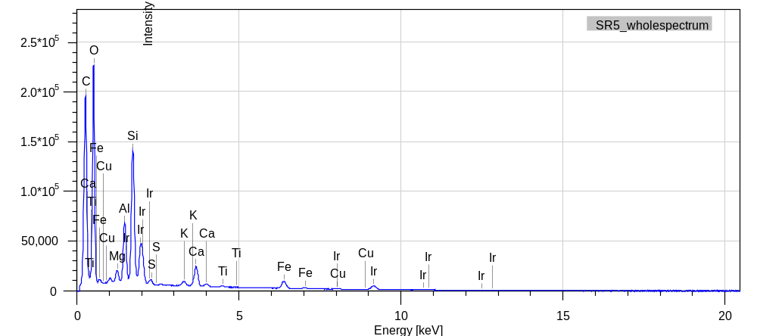
Figure S10 SEM-EDS elemental composition illustrations for particles observed in SEM analysis at the SR site, Kimberley.
D
E

Figure S11 SEM particle morphology images for the MH sites were captured at magnifications of 35 (top left), 100 (top right), 190 (bottom left), 230 (bottom right)

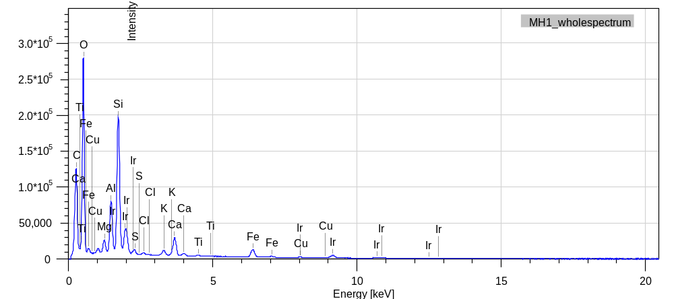
A

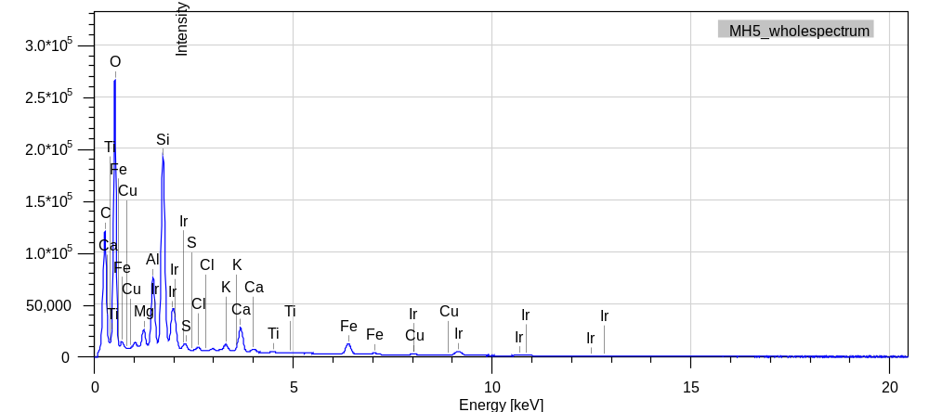
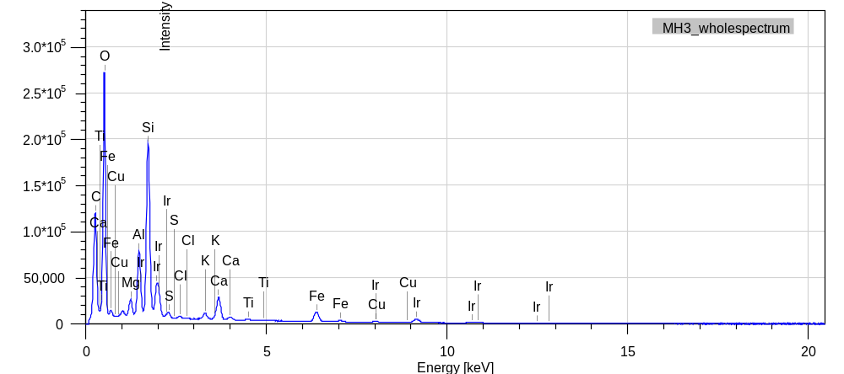
C
B

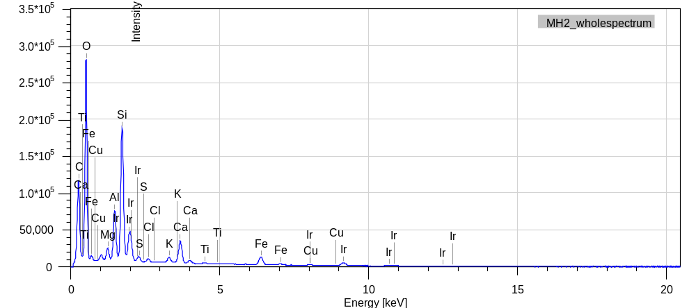
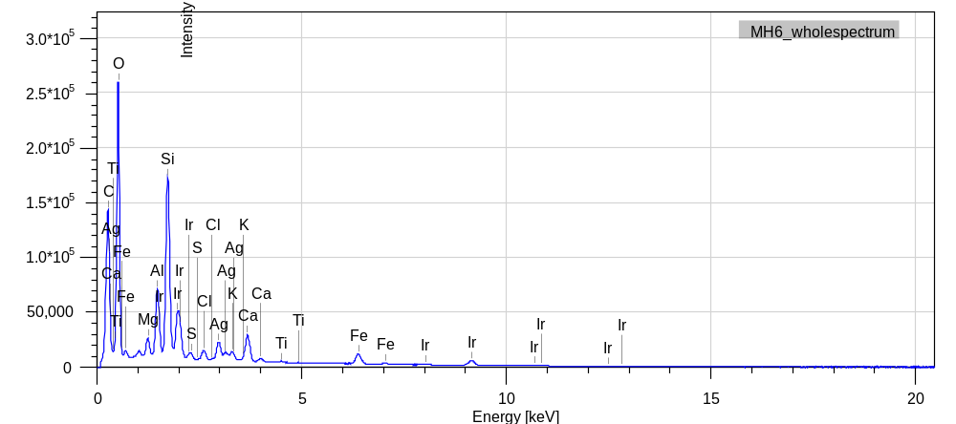
E
D
Figure S12 SEM-EDS elemental composition illustrations for particles observed in SEM analysis at the MH site, Kimberey.

Figure S13 SEM particle morphology images for the C sites were captured at magnifications of 37 (top left), 70 (top right), 110 (middle left) and 160 (bottom right) times.

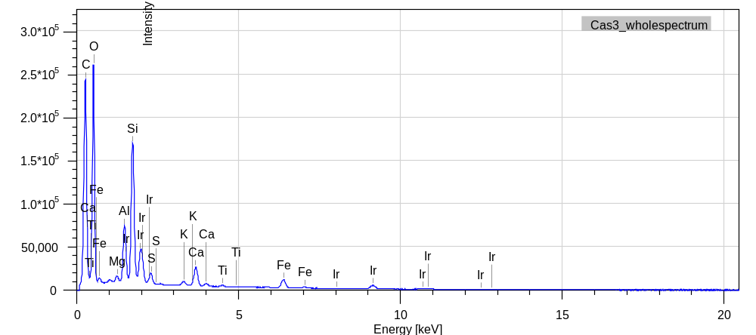
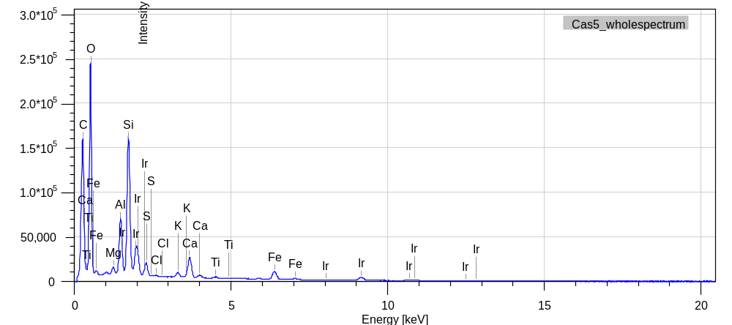
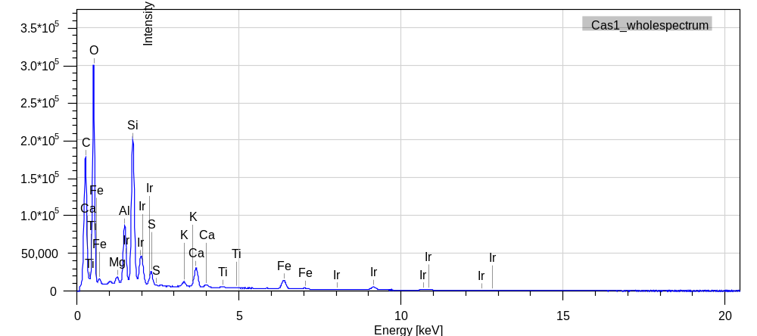
C
A
B

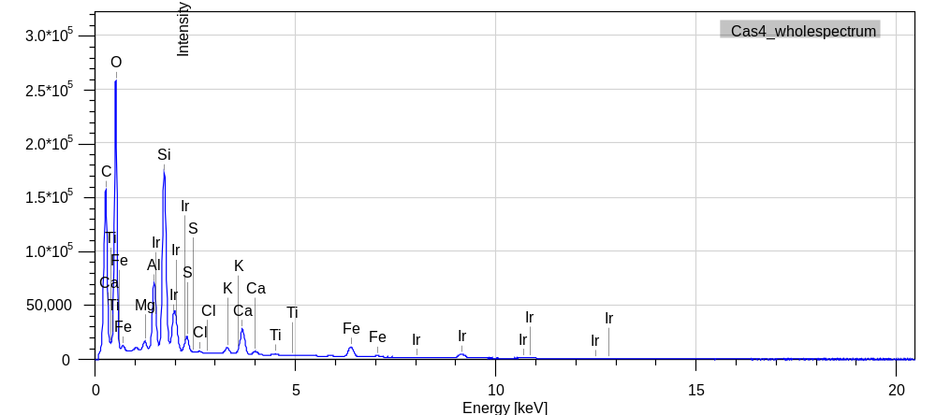
D

Figure S14 SEM-EDS elemental composition illustrations for particles observed in SEM analysis at the C site, Kimberley.

Figure S15 SEM particle morphology images for the SE3 1 sites were captured at magnifications of 30 (top left), 60 (top right),80 (bottom left) and 85 (bottom right).
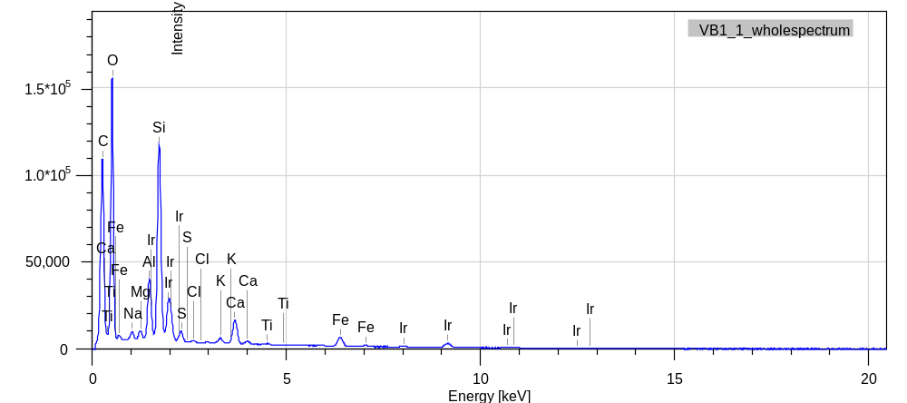
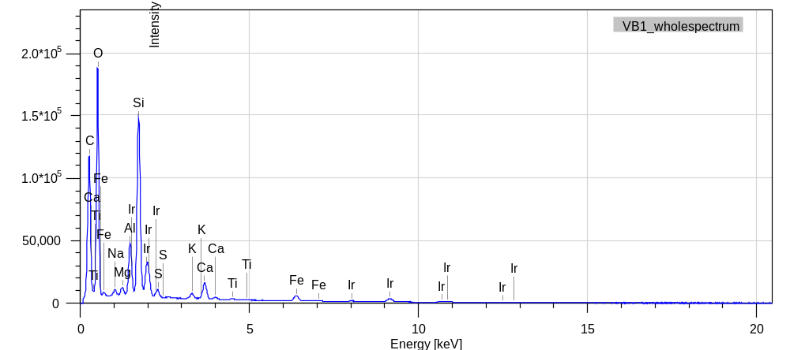
B
A

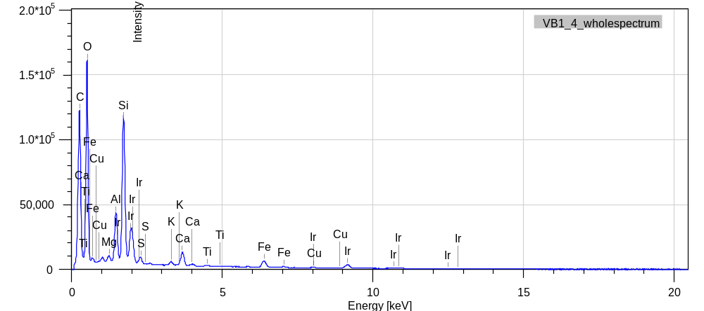
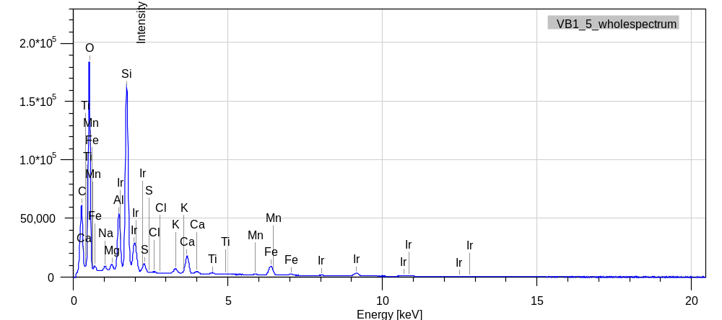
D
C
Figure S16 SEM-EDS elemental composition illustrations for particles observed in SEM analysis at the SE3 1 site, Vanderbijlpark.

Figure S17 SEM particle morphology images for the VB2 sites were captured at magnifications of 70 (top left), 95 (top right), 150 (bottom left) and 55 (bottom right) times.

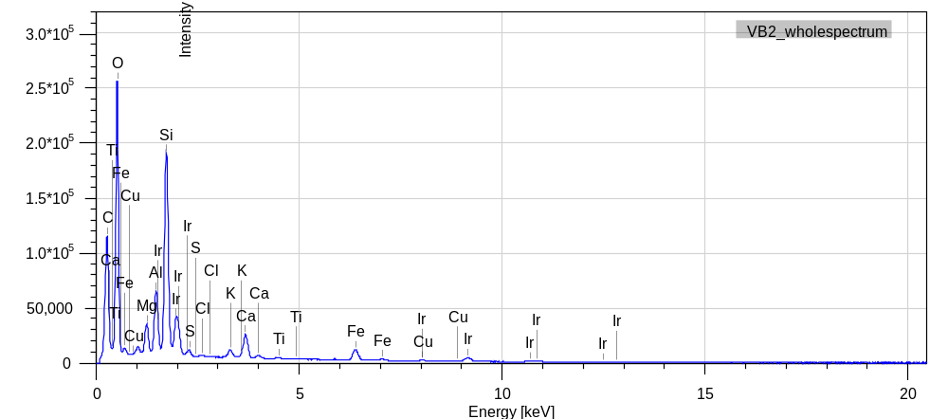
A

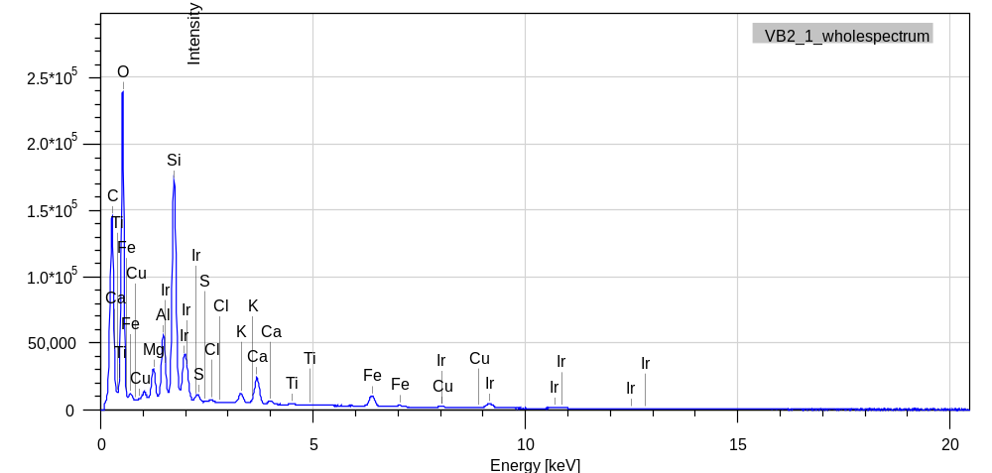
B

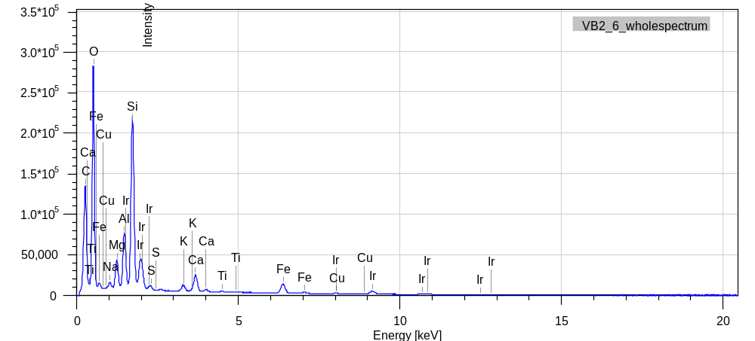
C

Figure S18 SEM-EDS elemental composition illustrations for particles observed in SEM analysis at the SE3 2 site, Vanderlbijlpark.
Figure S19 XRD diffractogram of the SE3 1 sample, Vanderbijlpark

Figure S20 XRD diffractogram of the SE3 2 sample, Vanderbijlpark
Figure S21 XRD diffractogram of the South Ridge sample, Kimberley

Figure S22 XRD diffractogram of the Monument Heights sample, Kimberley

Figure S23 XRD diffractogram of the Casandra sample, Kimberley

Figure S24 XRD diffractogram of the Langenhoven Park sample, Bloemfontein
Figure S25 XRD diffractogram of the Universitas sample, Bloemfontein

Figure S26 XRD diffractogram of the Heidedal sample, Bloemfontein
Figure S27 XRD diffractogram of the Maselspoort sample, Bloemfontein

Table S2 Semi-quantitative XRD results.
XRD semi-quantitative results (wt%) | Quartz | Plagioclase | Calcite | Ankerite | Stilbite | Ilmenite | Anatase | Goethite | K-feldspar/ rutile | Magnetite | Mica | Hematite | Kaolinite | Gypsum
SE3 1 | 67 |  |  |  |  | 6 | 4 |  | 10 |  |  | 4 |  | 9
SE3 2 | 60 | 10 |  |  | 11 |  |  |  |  |  |  |  |  | 19
Southridge | 73 | 16 | 7 |  |  |  |  |  |  |  |  | 4
Monument Heights | 47 | 30 | 8 |  |  |  |  |  |  | 8 | 7
Casandra | 35 | 20 | 8 | 12 | 25
Langenhoven Park | 44 | 14 | 5 |  |  | 7 |  |  | 11 |  | 12 | 7
Universitas | 40 | 16 | 3 | 4 |  | 3 |  |  | 7 |  | 8 | 3 | 8 | 8
Heidedal | 41 | 18 | 7 |  |  | 4 | 4 | 6 |  |  | 10 | 5 |  | 5
Maselspoort | 43 | 20 | 6 |  |  |  |  |  | 17 |  |  | 7 |  | 7

Table S3 The X-ray Fluorescence results. The results are displayed in wt.%. The Fe₂O₃ content represents the total iron content and is not a depiction of the valency of the ion.
XRF major element results (wt.%) | SE3 1 | SE3 2 | Southridge | Monument Heights | Casandra | Langenhoven Park | Universitas | Heidedal
SiO₂ | 64.78 | 48.79 | 41.08 | 54.19 | 50.39 | 61.43 | 53.82 | 63.09
TiO₂ | 0.48 | 0.58 | 0.61 | 0.71 | 0.64 | 0.84 | 0.72 | 0.72
Al₂O₃ | 6.47 | 9.49 | 10.04 | 9.75 | 9.71 | 8.97 | 10.20 | 9.03
Fe₂O₃ (t) | 4.57 | 6.38 | 4.62 | 4.90 | 5.56 | 5.90 | 5.20 | 4.14
MnO | 0.17 | 0.27 | 0.09 | 0.10 | 0.11 | 0.82 | 0.30 | 0.13
MgO | 0.78 | 1.12 | 1.96 | 2.19 | 4.72 | 0.88 | 1.19 | 1.16
CaO | 2.85 | 4.14 | 5.27 | 4.82 | 4.93 | 1.98 | 2.96 | 4.92
Na₂O | 0.25 | 0.20 | 0.61 | 0.91 | 1.02 | 0.68 | 0.74 | 0.68
K₂O | 0.78 | 0.96 | 0.84 | 1.19 | 1.27 | 1.41 | 1.43 | 1.25
P₂O₅ | 0.20 | 0.31 | 0.49 | 0.27 | 0.34 | 0.18 | 0.21 | 0.18
SO₃ | 0.81 | 1.86 | 0.68 | 0.60 | 0.55 | 0.29 | 0.92 | 0.46
Cr₂O₃ | 0.05 | 0.05 | 0.02 | 0.03 | 0.04 | 0.02 | 0.02 | 0.03
NiO | 0.01 | b.d. | 0.01 | 0.00 | 0.02 | b.d. | b.d. | b.d.
H₂O- | 1.02 | 1.95 | 2.06 | 1.57 | 2.65 | 1.27 | 1.85 | 0.94
LOI | 15.78 | 23.24 | 30.81 | 17.56 | 17.49 | 14.33 | 19.56 | 12.39
Sum | 99.00 | 99.36 | 99.17 | 98.79 | 99.46 | 98.99 | 99.11 | 99.12

Table S3.1 EPMA-EDS results (in wt.%) of different grains from within the dust samples of SE3 1, SE3 2 and Southridge.
 | SE3 1 |  |  |  | SE3 2 |  | Southridge
SiO₂ | 32.55 | 100.25
TiO₂ |  |  |  |  |  |  | 3.82 |  | 58.3
Al₂O₃ |  |  |  |  |  |  | 9.97
FeO |  |  | 44.21 (as Fe) | 98.09 (as Fe) | 99.38 | 99.65 (as Fe) | 40 | 99.55 | 42.48
MnO |  |  |  |  |  |  | 0.28
MgO |  |  |  |  |  |  | 2.03
CaO
Na₂O
K₂O
P₂O₅
SO₃ |  |  | 56.03 (as S)
Cr₂O₃ |  |  |  |  |  |  | 44.75
BaO
ThO₂
Ce₂O₃
La₂O₃
Nd₂O₃
ZnO
ZrO₂ | 67.4
Total | 99.95 | 100.25 | 100.24 | 98.09 | 99.38 | 99.65 | 100.85 | 99.55 | 100.78
Mineral | Zircon | Quartz | Pyrite | Fe metal | Magnetite/Hematite | Fe metal | Chromite | Magnetite/Hematite | Ilmenite

Table S3.2 EPMA-EDS results (in wt.%) of different grains from within the dust samples of Momentum Heights and Casandra in Kimberley.
 | Monument Heights |  |  |  |  |  |  | Casandra
SiO₂ |  | 51.48 |  | 29.32 | 61.92 |  |  |  |  | 58.07
TiO₂ | 1.26 |  | 52.54 | 34.79 |  | 51.54 | 90.96 | 52.76
Al₂O₃ | 11.82 | 29.35 |  |  | 18.06 |  |  |  |  | 6.22
FeO | 30.24 |  | 47.6 |  |  | 47.09 | 7.45 | 46.25 | 100.15 | 12.64 | 99.52 (as Fe)
MnO |  |  | 0.71 |  |  | 0.69 | 0.94 | 0.88
MgO | 8.16 |  |  |  |  |  |  |  |  | 21.2
CaO |  | 14.51 |  | 36.07 |  |  |  |  |  | 1.37
Na₂O |  | 4.96 |  |  | 2.05
K₂O |  | 0.26 |  |  | 16.73
P₂O₅
SO₃
Cr₂O₃ | 48.5
BaO
ThO₂
Ce₂O₃
La₂O₃
Nd₂O₃
ZnO
ZrO₂
Total | 99.98 | 100.56 | 100.85 | 100.18 | 98.76 | 99.32 | 99.35 | 99.89 | 100.15 | 99.5 | 99.52
Mineral | Chromite | Plagioclase | Ilmenite | Titanite | K-feldspar | Ilmenite | Magnetite | Ilmenite | Magnetite/Hematite | Pyroxene | Fe metal

Table 3.3 EPMA-EDS results (in wt.%) of different grains from within the dust samples of Langenhoven Park and Universitas in Bloemfontein.
 | Langenhoven Park |  |  |  |  | Universitas
SiO2 |  |  | 99.74 |  |  |  |  |  | 36.08
TiO2 | 43.97 |  |  |  | 47.29 |  | 53.28 | 95.26
Al2O3
FeO | 55.2 | 95 |  |  | 50.44 |  | 45.26 | 4.39 | 38.52
MnO | 1.77 | 4.02 |  | 99.33 | 2.03 |  | 0.74
MgO |  |  |  |  |  |  |  |  | 25.11
CaO |  |  |  |  |  | 0.72 |  |  | 0.13
Na₂O
K₂O
P₂O₅ |  |  |  |  |  | 27.67
SO₃
Cr₂O₃
BaO
ThO₂ |  |  |  |  |  | 5.87
Ce₂O₃ |  |  |  |  |  | 35.82
La₂O₃ |  |  |  |  |  | 15.4
Nd₂O₃ |  |  |  |  |  | 15.25
ZnO
ZrO₂
Total | 100.94 | 99.02 | 99.74 | 99.33 | 99.76 | 100.73 | 99.28 | 99.65 | 99.84
Mineral | Ilmenite | Magnetite/Hematite | Quartz | Pyrolusite | Ilmenite | Monazite | Ilmenite | Rutile | Olivine

Table 3.4 EPMA-EDS results (in wt.%) of different grains from within the dust samples of Heidedal and Maselsoort in the Manguang area.
 | Heidedal |  |  | Maselspoort
SiO₂ |  |  | 49.88
TiO₂ | 42.7 |  |  | 40.36
Al₂O₃ |  |  | 37.4
FeO | 56.49 | 46.39 (as Fe) | 1.44 | 57.44
MnO | 0.75 |  | 2.42 | 1.88
MgO |  |  | 2.05
CaO |  |  | 6.56
Na₂O
K₂O
P₂O₅
SO₃ |  | 53.33 (as S) |  |  |  | 31.56
Cr₂O₃
BaO |  |  |  |  |  | 69.71
ThO₂
Ce₂O₃
La₂O₃
Nd₂O₃
ZnO |  |  |  |  | 99.98 |  | 99.85 (as Zn)
ZrO₂
Total | 99.94 | 99.72 | 99.75 | 99.68 | 99.98 | 101.27 | 99.85
Mineral | Ilmenite | Pyrite | Plagioclase | Ilmenite | Zincite | Barite | Zn Metal

